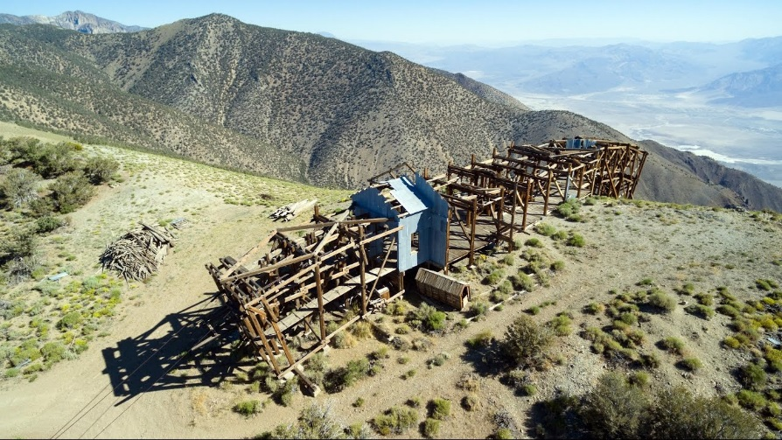
GEOLOGY FIELD TRIP
SALT TRAM LOOP AND CERRO GORDO
4X4 ADVENTURE
JULY 13, 2019

Dr. Gregg Wilkerson, 661-246-9485, yosoygeologo@gmail.com
FOR CSUB GEOLOGY CLUB

Explore the Southern Inyo Mountains and learn about the mining history and geology on this one-day adventure.

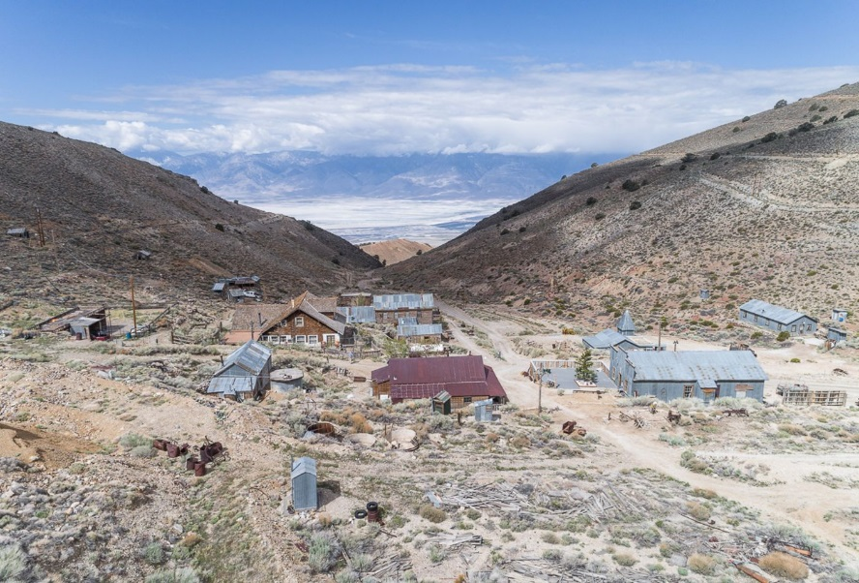
8:00 AM Lone Pine Visitor’s Center
9:00 AM Southern White Aggregate
Mine
10:00 AM Swansee Smelters
12:00 PM Salt Tram Towers (lunch NOT
provided)
3:00 PM Cerro Gordo
5:00 PM Keeler Smelter

WHAT WILL I LEARN?

-Geology and mining history of
a. Southern Inyo Mountains
b. Saline Valley Salt Tram
c. Cerro Gordo Silver Mining District Tour ($15.00 in addition to Adventure Aide Fee;
https://store.cerrogordomines.com/products/cerro-gordo-tour )
d. Owens Valley
-Biological and Cultural resources of the Southern Inyo Mountains
-Beautiful vistas and scenery

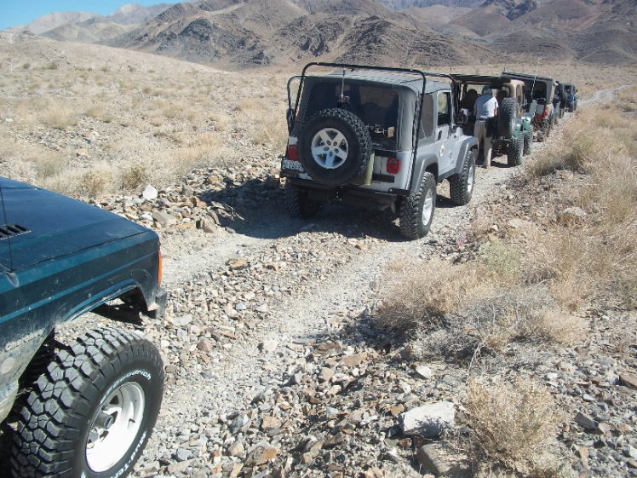
WHAT IS REQUIRED?

-Positive attitude for learning, adventure and exploration
-High Clearance 4x4 vehicle
-Knowledgeable and experienced 4x4 driver
-Boots, full-length pants, shirt, sunscreen
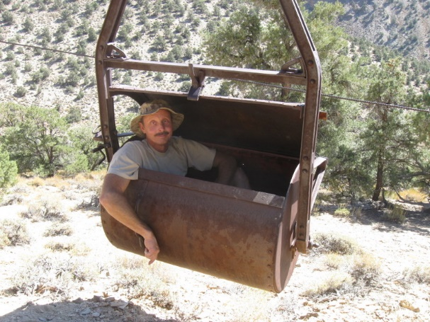
-Food and water

REGISTER THROUGH ADVENTURE AIDE: $20 PER PERSON
https://www.adventureaide.com/adventures/1548

