PROPOSED COLLECTING SITES

CAMBRIAN

SITE 02A: Cambrian: White Mountains, Windgate Pass Area
T.07S R.34E Sec. 24 MDM 37.3210454 -118.1866976
Poleta Formation
Geology by Neelson, 1966
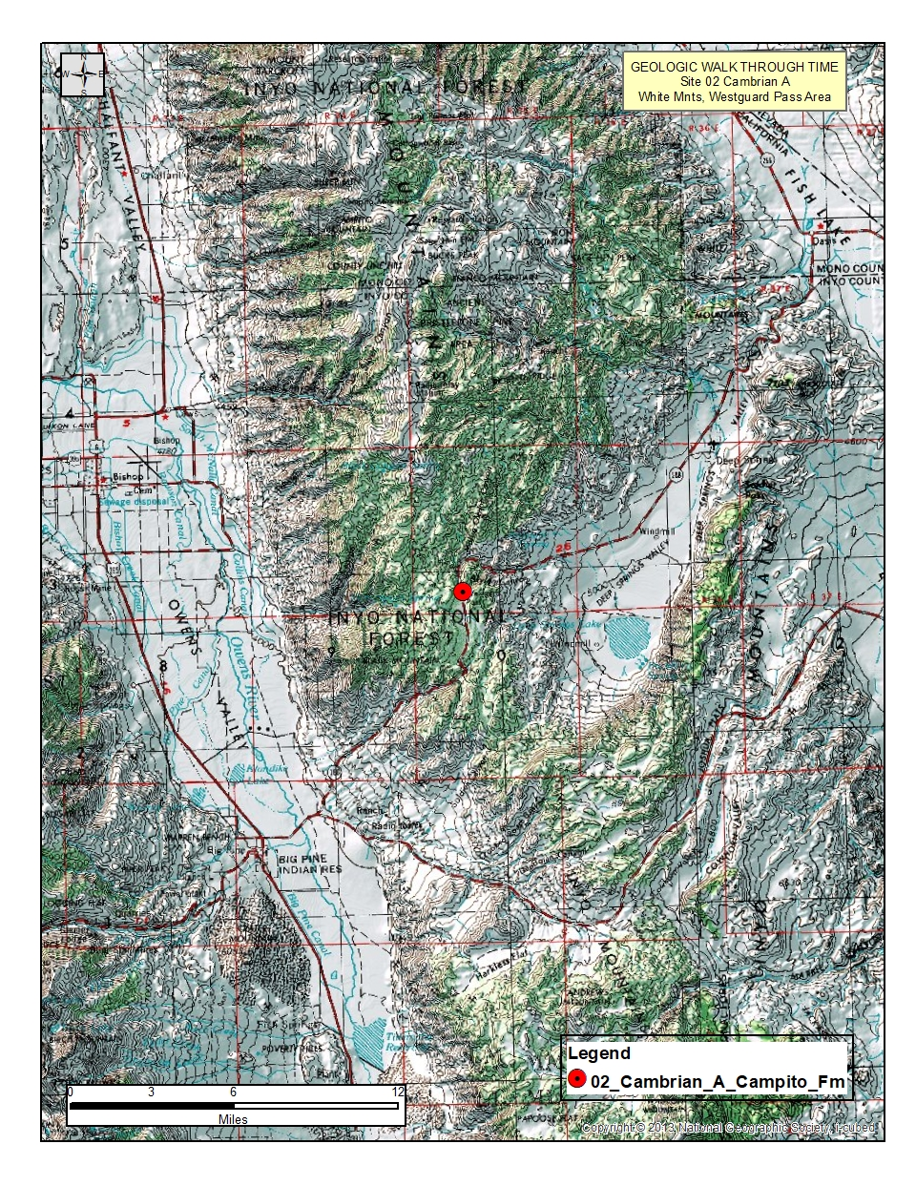
Figure 1. Regional topographic map
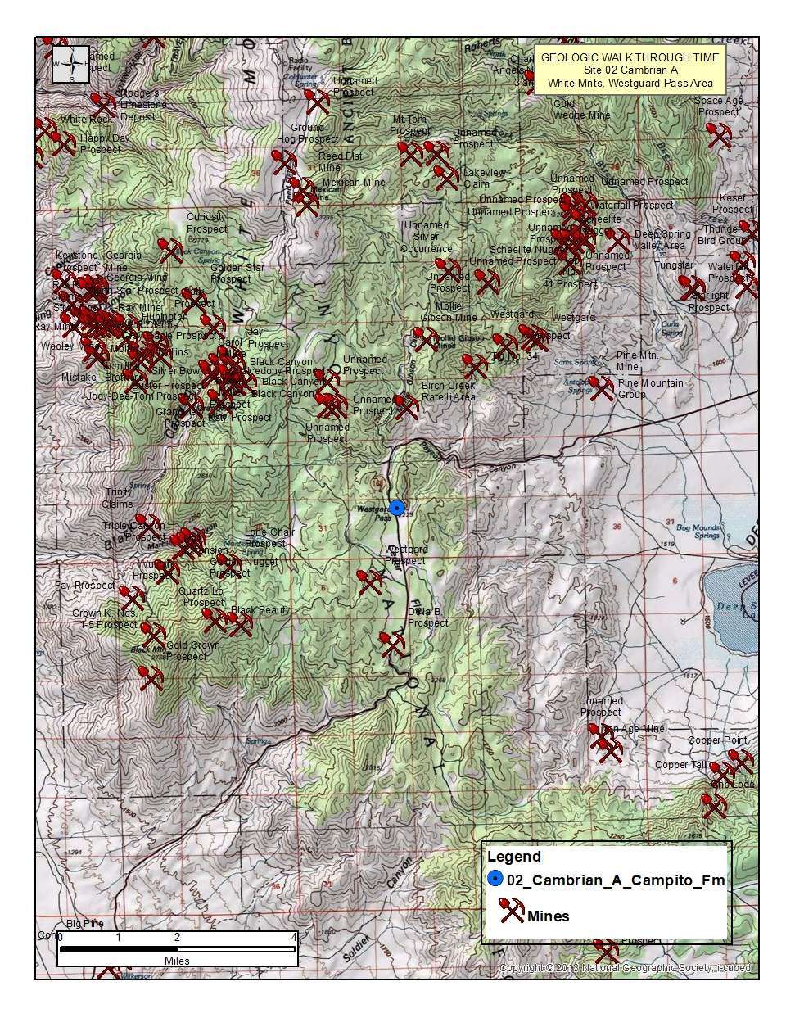
Figure 2. Area topographic map
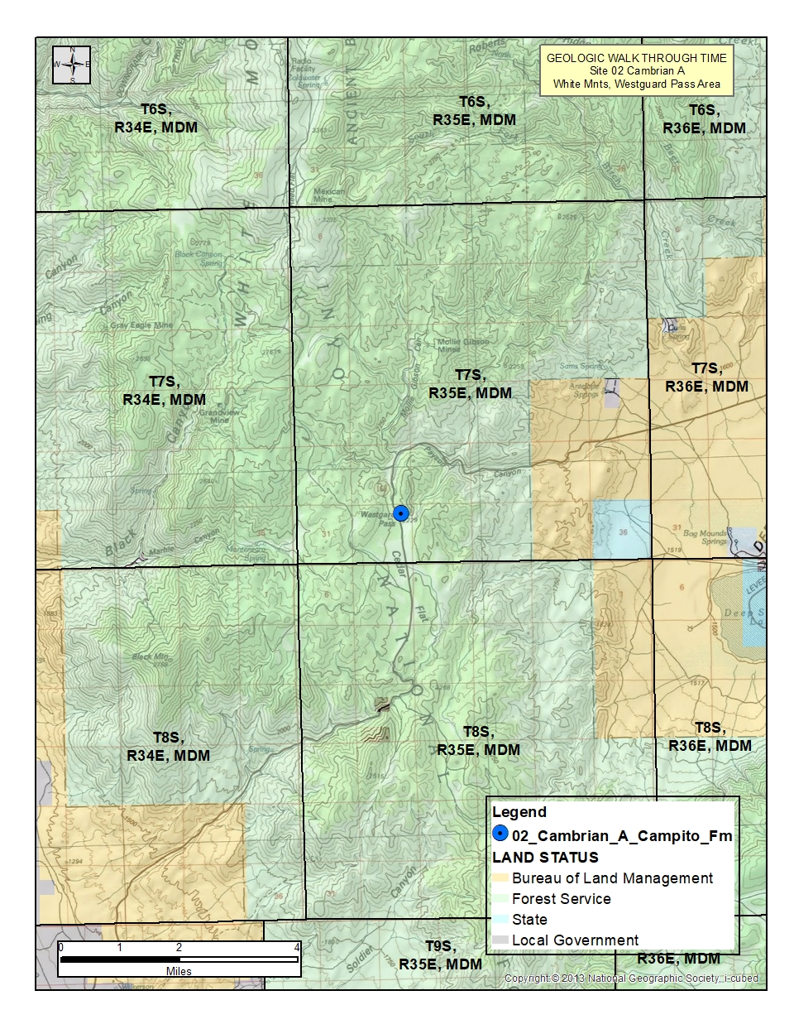
Figure 3. Land Status Map with PLSS data
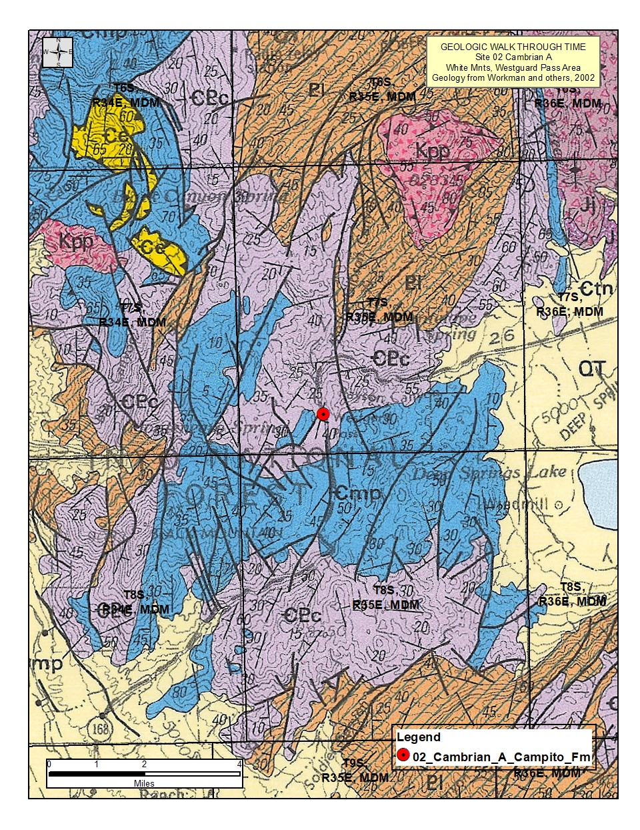
Figure 4. Regional Geologic map
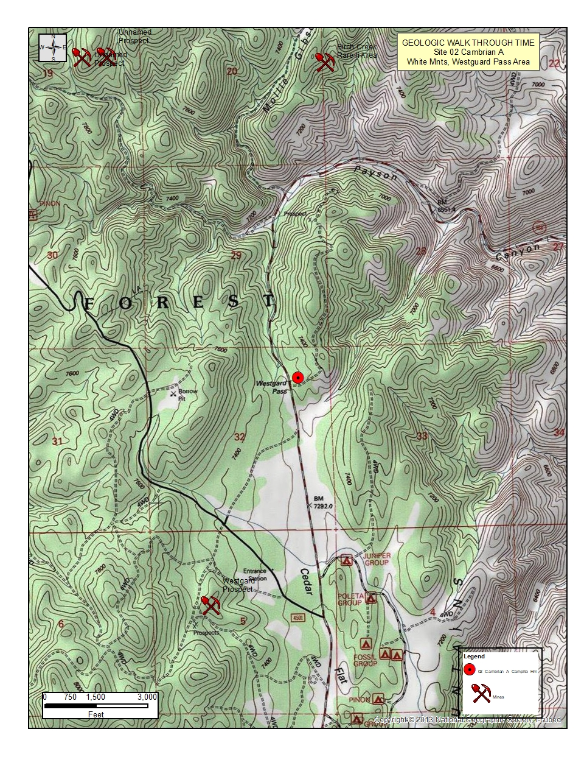
Figure 5. Site topographic map
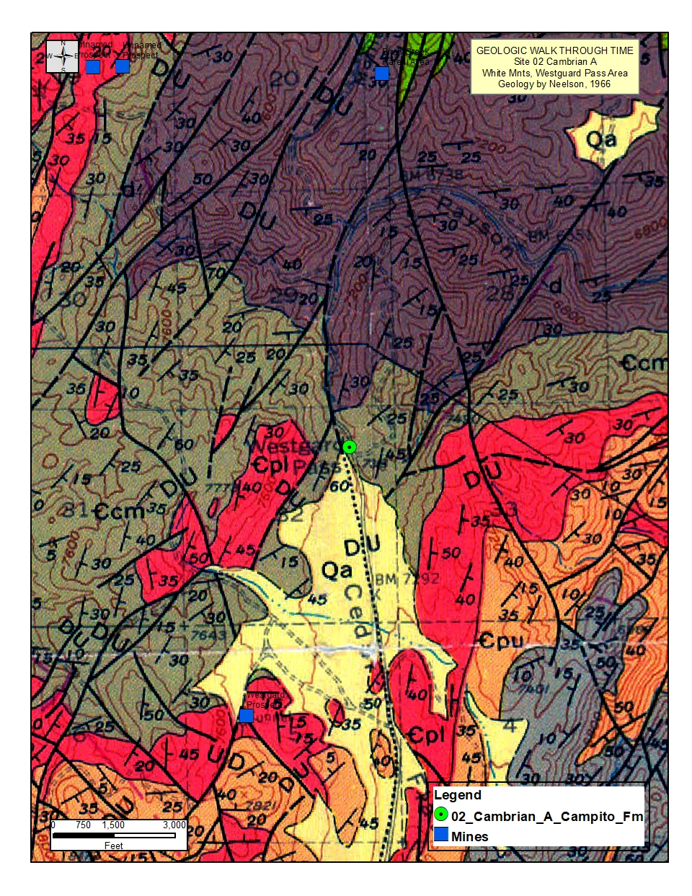
Figure 6. Site geologic map
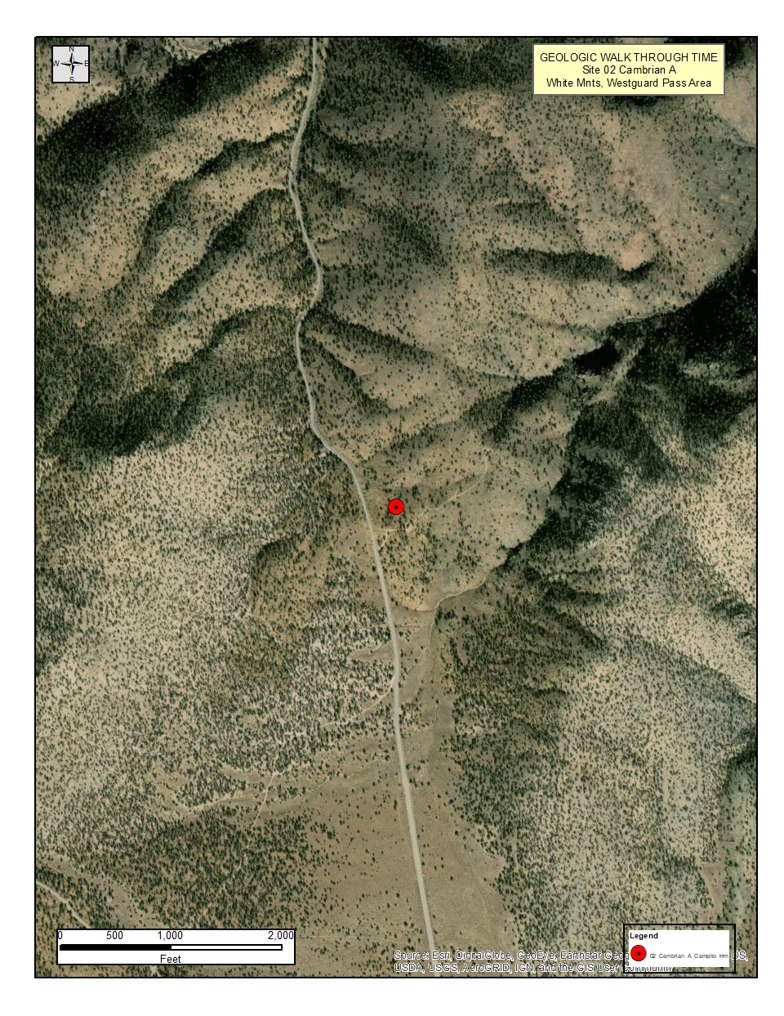
Figure 7. Aerial photograph
REFERENCES

Bartow, J.A., 1986, Geologic Map of the Oil Center Quadrangle, U.S. Geological Survey, Open File Report, OF-86-188.
Bartow, J.A., 1996, Geologic Map and Cross Sections of the Southeastern Margin of the San Joaquin Valley, California, U.S. Geological Survey, Miscellaneous Investigations Series Map I-1496

Dibblee, T.W., Jr., 1952, Geology of the Saltdale quadrangle, California: California Division of Mines and Geology, Bulletin 160, scale 1:62,500.

Dibblee, Thomas W., Jr., 1994, Geologic map of the Santa Maria and Twitchell Dam Quadrangles, Santa Barbara and San Luis Opispo Counties, California, Dibblee Foundation, Map DF-51, Scale 1:62,500.

Dibblee, Thomas W., Jr., 2005a, Geologic map of the Elkhorn Hills Quadrangle, Kern County, California, Dibblee Foundation, Map DF-108, Scale 1:24,000.

Dibblee, Thomas W., Jr., 2005b, Geologic map of the Chimineas Ranch Quadrangle, San Luis Obispo County, California, Dibblee Foundation, Map DF-99, Scale 1:24,000.

Dibblee, Thomas W., Jr., 2005c, Geologic map of the Reward Quadrangle, San Luis Obispo and Kern Counties, California, Dibblee Foundation, Map DF-100, Scale 1:24,000.

Dibblee, Thomas W., Jr., 2005d, Geologic map of the Eagle Rest Peak/South ¼ of Conner SW Quadrangle, Kern County, California, Dibblee Foundation, Map DF-172, Scale 1:24,000.

Dibblee, Thomas W., Jr., 2005e, Geologic map of the Tent Hills Quadrangle, San Luis Obispo, Monterey, Kings and Kern Counties, California, Dibblee Foundation, Map DF-177, Scale 1:24,000.

Dibblee, Thomas W., Jr., 2005F, Geologic map of the Santiago Creek Quadrangle, Kern and Ventura Counties, California, Dibblee Foundation, Map DF-171, Scale 1:24,000.

Dibblee, Thomas W., Jr., 2006a, Geologic map of the Frazier Mountain and Lebec 15 Minute Quadrangles, Los Angeles, Ventura and Kern Counties, California, Dibblee Foundation, Map DF-198, Scale 1:24,000.

Dibblee, Thomas W., Jr., 2006b, Geologic map of the Pyramid Hills Quadrangle, Kings and Kern Counties, California, Dibblee Foundation, Map DF-282, Scale 1:24,000.

Dibblee, Thomas W., Jr., 2006c, Geologic map of the Miranda Pine Mountain Quadrangle, San Luis Obispo and Santa Barbara Counties, California, Dibblee Foundation, Map DF-264, Scale 1:24,000.

Dibblee, Thomas W., Jr., 2006d, Geologic map of the Chimney Canyon Quadrangle, San Luis Obispo and Santa Barbara Counties, California, Dibblee Foundation, Map DF-265, Scale 1:24,000.

Dibblee, Thomas W., Jr., 2006e, Geologic map of the Cuddy Valley Quadrangle, Ventura and Kern Counties, California, Dibblee Foundation, Map DF-199, Scale 1:24,000.

Dibblee, Thomas W., Jr., 2006f, Geologic map of the Huasna Peak Quadrangle, San Luis Obispo and Santa Barbara Counties, California, Dibblee Foundation, Map DF-207, Scale 1:24,000.

Dibblee, Thomas W., Jr., 2008a, Geologic map of the Edison and Breckenridge Mountain 15 Minute Quadrangles, Kern County, California, Dibblee Foundation, Map DF-419, Scale 1:62,500.

Dibblee, Thomas W., Jr., 2008b, Geologic map of the Cross Mountain and Saltdale 15 Minute Quadrangles, Kern County, California, Dibblee Foundation, Map DF-399, Scale 1:62,500.

Hall, W.E., 1958, Structure and ore deposits of the Darwin quadrangle, Inyo County, California: U.S. Geological Survey, Open-File Report OF-58-42, scale 1:40,000

Hall, W.E., and MacKevett, E.M., 1962, Geology and ore deposits of the Darwin quadrangle, Inyo County, California: U.S. Geological Survey, Professional Paper 368, scale 1:48,000.

Jennings, Charles W., John L. Burnett and Bennie W. Troxel, 1962, Trona Sheet, Geologic Map of California, California Division of Mines and Geology, Olaf P. Jenkins Edition.

Louke, Gladys, 1965, Geology of the Emerald Mountain 15 Minute Quadrangle, Kern County, California, unpublished map for California Division of Mines and Geology, Bakersfield Sheet.

Nelson, C.A., 1966, Geologic map of the Blanco Mountain quadrangle, Inyo and Mono Counties, California: U.S. Geological Survey, Geologic Quadrangle Map GQ-529, scale 1:62,500.

Ross, Donald C., 1986, Basement-rock correlations across the White Wolf-Breckenridge-Southern Kern Canyon Fault Zone, Southern Sierra Nevada, California: U.S. Geological Survey, Bulletin 1651, scale 1:125,000.

Ross, Donald C., 1995, Reconnaissance Geologic Map of the Southern Sierra Nevada, Kern, Tulare and Inyo Counties, California, U.S. Geological Survey, Miscellaneous Investigations Series Map I-2295, Scale 1:125,000.

Sisson, Thomas W, and James G. Moore, 2013, Geologic map of the southwestern Sequoia National Park, Tulare County, California, U.S. Geological Survey, Open File Report OFR 2013-1096, Map 01.

Smith, Arthur R., 1964, Geologic Map of California: Bakersfield Sheet, Olaf P. Jenkins edition, Scale 1:250,000.

Stone, Paul, George C. Dunne, James E. Conrad, Brian J. Swanson, Calvin H. Stevens and Zenon C. Valin, 2004, Geologic map of the Cerro Gordo Peak 7.5 minute Quadrangle, Inyo County, California, U.S. Geological Survey, Scientific Investigations Map 2851, Scale 1:24,000

Workman, J.B., Menges, C.M., Page, W.R., Taylor, E.M., Ekren, E.B., Rowley, P.D., Dixon, G.L., Thompson, R.A., and Wright, L.A., 2002, Geologic map of the Death Valley ground-water model area, Nevada and California, USGS Miscellaneous Field Studies Map MF-2381-A, Scale 1:250,000

Woodring, W.P. and Ralph Stewart, 1949, Geologic Map of the Kettleman Hills, California and Generalized Stratigraphic Sections of Exposed Formations, U.S. Geological Survey Professional Paper 195, Plate 3.

