Physical Geology Laboratory
Volcanoes and Plutons
Dr. Gregg Wilkerson and Michael Oldershaw
In this lab we will take a look at two distinct types of features that are formed from essentially the same material. We will look at the different forms of plutons, which are bodies of igneous rock that cool (crystallize) underground and compare those to volcanoes, which are formed when igneous rocks cool above the ground.

Plutons
Let’s start with the plutons, which are classified by their shape, how they get along with other rocks, and their size. All of these bodies are made from magma that has intruded pre-existing rocks and crystalized in place. You can refer to the bodies and the resulting rocks as intrusive or plutonic.

First, plutons come in two general shapes, irregular (having no recognizable shape), and tabular (which means shaped like a table top; a planar feature). We name two irregular plutons, the larger is called a batholith, which must have an area greater than 100 sq. km. The smaller version is called a stock. If you look at the geologic map of California on the wall you can see a dark read area making up the Sierra Nevada Mountains. This is the Sierra Nevada Batholith. Batholiths and stocks are not formed all at once, but over time from the accumulation of a series of intrusions. If you think of an upside-down teardrop shape several km in diameter you will have the idea of the individual events.

The tabular plutons are classified based on how they interact with the pre-existing rocks, the polite ones are called concordant, and the rude ones discordant. The most common pluton is a dike, which cuts across the existing rocks (discordant). Dikes are formed when magma intrudes into a crack in the existing rock. The crack is widened by the magma which subsequently cools in place. You have certainly seen these features in road cuts such as in the Kern Canyon. The dikes are typically a different colored rock cutting through at all angles. In some cases, notably in Oregon and Washington, dikes have
intersected the earth’s surface allowing lava to spread over a very wide area as a fissure eruption.

Some of the plutons are emplaced concordantly along bed boundaries, such as between two layers of rock. This is a sill, and the emplacement actually lifts the overlying beds. In some cases, there is enough magma to actually cause a portion of the sill to bow up, raising the overlying beds into an arch. This pluton is called a laccolith.

Take a look at the figure below and answer the following:

- What pluton is represented at Feature A?

- What plutons can you see at Feature B?

- What are the plutons labeled Feature C?

- What is Feature D?

- What would Feature D result in?

- Consider that these features are all produced from magma which is very hot. How would you be able to tell the difference between an ancient buried lava flow, and an ancient buried sill?

- In the figure are several intrusions. What would you call a group of these formed into a single body that covered 46 sq. km?
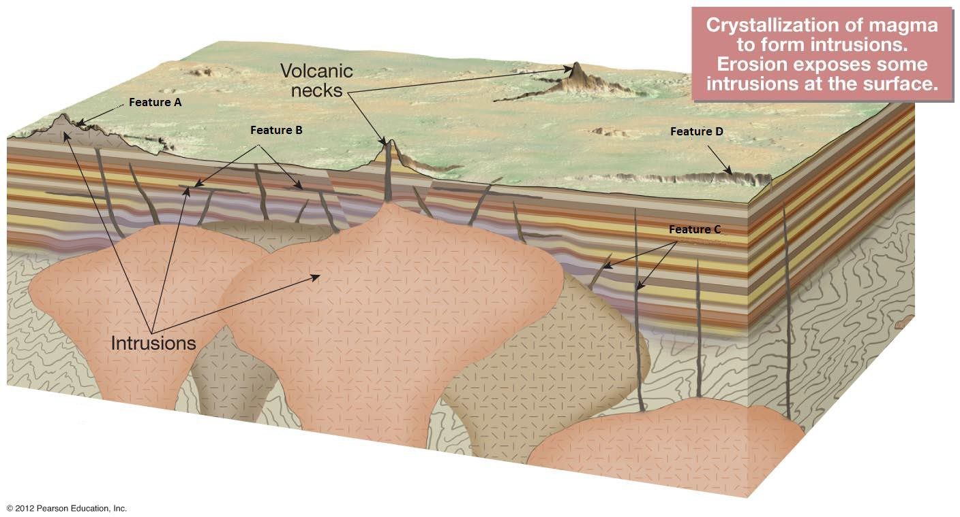

Volcanoes
The type of volcano that forms is dependent on the type of magma. The main criterion is viscosity of the lava, where viscosity is the resistance to flow. Very thick lava will tend to form steep sided volcanoes, and will tend to form plugs that can result in explosive eruptions. Less viscous lava will form broad, flat volcanoes that have relatively quiet eruptions. Lava viscosity is influenced by silica content and by temperature. Higher temperature makes the lava less viscous (think maple syrup from the refrigerator vs. from the microwave). The silica in the lava tends to form chains in the minerals, and so lava with a lot of higher silica minerals (felsic minerals, quartz and feldspar), will also be more viscous. In order of decreasing silica content the common lavas are rhyolite, dacite, andesite, and basalt. In order of increasing melting temperature the lavas are ranked rhyolite, dacite, andesite, and basalt. So if you have material to make rhyolite, dacite, or andesite, the resultant volcano will tend to be steep sided, and have more explosive eruptions. If the material is basalt the eruptions will be relatively quiet and the volcano relatively broad and flat.

Volcanoes are essentially steam powered. When water that is contained within the lava is allowed to turn to steam, it expands dramatically creating tremendous pressure. Lowering the confining pressure on the top of volcano, perhaps with a landslide as at Mt. St. Helens, will allow the water to flash to steam, and may trigger a violent eruption.

Volcanoes are distinguished from other mountains in part by the vent at the top. Generally this is called a crater, and it is formed by the material escaping from the magma chamber during an eruption. In some cases the vent is very large, and is formed not by the explosion but by the collapse of the top of the mountain following eruptions emptying the magma chamber below. These large vents, caused by collapse, are generally more than a km across and are called calderas.

Cinder Cones
The smallest volcano is a cinder cone. These are piles of generally un-compacted pyroclastic material (cinders and ash) stemming from a volcanic vent. These generally rise between 30-300 m in height. They may be associated with lava flows, and in some cases the lava comes out from the base of the cone. Cinder cones are locally associated with other volcanoes, where they may form on the flanks of a larger structure. In that case the cinder cone is called a parasitic cone.

Composite Cones or Stratovolcanoes
When most people think of a volcano they picture Mount St. Helens, Mount Shasta, or Mount Fuji, all of which are steep-sided large volcanoes. These mountains are made of several layers of material including volcanic ash, volcanic mudflows lahars, and lava flows particularly of dacite or andesite with some rhyolite. In some cases these eruptions can also be associated with basalt lava. Several layers of different material give them the name of composite cones, while stratovolcano refers to their size and steep flanks. These volcanoes have the potential for very explosive eruptions and may produce clouds of incandescent (glowing) gas that are extremely dangerous. These volcanoes are associated with the volcanic arcs that form adjacent to subduction zones, such as the volcanoes in the Pacific Ring of Fire.

In some cases, once a volcano goes extinct, only the relatively hard material left in the central vent is preserved. This is known as a volcanic neck. There are some famous versions of these including Ship Rock in New Mexico, and Devils Tower in Wyoming (featured in the movie Close Encounters of the Third Kind – but decidedly not created by aliens). Most people who live in Bakersfield during the summer have traveled to the coast to see another of these necks – Morro Rock.

Shield Cones
By far the largest volcanoes are the shield cones that are formed from vast amounts of basaltic lava. Because of the low viscosity, these eruptions form broad, gently sloping mountains. Also because of the low viscosity, the eruptions are relatively calm, for volcanoes. Examples include the volcanoes Mauna Kea, Mauna Loa, and Kilauea that together make up the island of Hawaii.

Despite the relatively gentle slope these can be very large, and in fact, measured from the base (which in deep in the Pacific) Mauna Loa is taller than Mount Everest. The largest mountain so far seen is a shield cone on Mars named Olympus Mons (23 km high and 595 km wide).

Relative Size of Volcanoes
In the space below, make a simple sketch of two volcanoes. Using a scale of 1 cm = 10 km, draw Mt. Shasta (4.3 km tall and 40 km wide) and Mauna Loa (9.2 km tall and 119 km wide). Make a mark near the peak of Mauna Loa at 8.8 km for Mt. Everest.

DO THIS! It is Part of the Lab! Volcano Relative Size (Drawing)

Menan Buttes Exercises
On the Menan Buttes quadrangle map you will see two volcanoes. Answer the following questions about them. You will also have to look at the Idaho Geologic map on the east wall.

- Using the contour lines, find the tallest elevation of the peaks and then the approximate elevation at the base (where the contour spacing widens). What is the estimated height of the tallest volcano (the contours are in feet)?

- Based on this size, what type of volcano are the Menan Buttes?

To answer the next questions, Construct a Topographic Profile Diagonally across the North Butte (from SW to NE)
Use a piece of the grid paper downloaded with the lab Start at 4800’ at the base of the grid
Use a vertical scale of one grid = 20’ elevation
Begin to the SW with the left side of your paper on Bench Mark (BM) 4826’ End to the NE with the right side of your paper on BM 4805’
Only plot the index contours (but do this carefully)

- Buttes are flat-topped erosional structures created by lava flows protecting underlying rock from erosion. Are the Menan Buttes correctly named (Yes/No)?

- What is your evidence for your answer above?

- Does the vertical scale exaggerate the steepness?

- What vertical scale would you use to avoid exaggeration?

- Are the Buttes symmetrical (is the central feature actually in the center)?

- Why do you think this is so (Hint: consider wind direction during formation)?

- If wind played a part, in which direction was it coming from?

- Just below the Menan Buttes on your map, the southwest corner of the map is located at 43° 45’ North Latitude and 112° 00’ West Longitude. Find these coordinates on the Idaho Geologic wall map. Looking at the color, pattern, and symbol on the map in this area, find the Menan Buttes rock unit on the map legend.

- What is the symbol, age, and name of this formation?

- What is the term used on the map legend for the Menan Buttes?

Sutter Buttes Exercise

Geologic Map and Cross Section of the Sutter Buttes
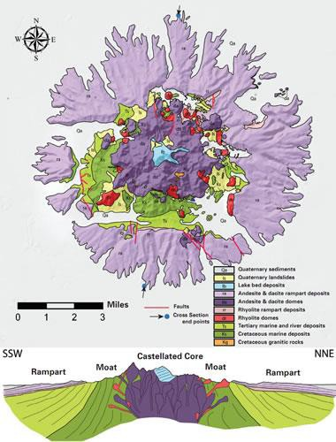
Geologic map and diagrammatic cross section of the Sutter Buttes. Geology compiled from Williams and Curtis (1977), Thamer (1961), and new mapping by Brian Hausback. The cross section is vertically exaggerated 3X to emphasize the topography.

http://geology.com/usgs/sutter-buttes/

The volcanic eruptions that produced the Sutter Buttes began about 1.6 million years ago (MYA) and ended 1.4 MYA. The initial eruptions were of rhyolite, a very high-temperature, silica-rich material that is generally light in color and often banded. Subsequent eruptions were of dacite and andesite, relatively lower temperature and lower silica content lavas that are light to dark gray in color and locally

contain phenocrysts (early formed crystals) to produce a porphyritic texture. All the eruptions were associated with volcanic mudflows (lahars), and debris flows and these are preserved as the “rampart” deposits around the central domes.

Looking carefully at the map and cross section, you can see that the volcanic material intruded pre- existing marine (ocean) and fluvial (river) deposits, forcing these sediments upward around the dome. The eruptions were punctuated by the deposits of hot mud (lahar) and debris flows around the central volcanic core. At some time toward the end of this activity a deep lake formed in the center of the body, as evidenced by lake bottom sediments made of the surrounding volcanic rock. Some of the last volcanic events truncate the lake sediments.

- Given the size of the structure, the high-silica, high-temperature rocks, and the mixture of materials including lava, hot mudflows, and debris flows – what type of volcano is this?

- The remnants of these events are preserved as a series of volcanic spires towering over 2000’ above the surrounding valley floor. These are surrounded by the flows produced on the flanks of the extinct volcano. The central rocks form the core the structure, and are erosional remnants of the volcanoes. What is the term for these spires?
- Looking at the rock units in the map legend you can put together a very simplified history of this part of the Sacramento Valley. When we talk about geologic time you will learn more about the time scale, but the cretaceous marked the end of the time of dinosaurs, the tertiary saw the formation of most of the material around Bakersfield, and the quaternary is distinguished by an ice age. Using the cretaceous marine deposits, tertiary marine and river deposits, and the Sutter Buttes rocks. Describe how this area changed over time (list the sequence of environments this area has seen from oldest to youngest).

- Do you think any dinosaurs witnessed the eruptions of Sutter Buttes (hint, look up the Cretaceous time period in your lecture text).

