QUIZ NO. 8: VOLCANOES
Choose the BEST answer

- Magma contains the following components except….
- Gas
- Phenocrysts
- Carbon Dioxide
- Solidified materials

- Mechanisms for magma formation include the following except….
- Density variation
- Pressure release
- Heat transfer
- Volatile addition

- Intrusive volcanic features include the following except…
- Dike
- Laccolith
- Sill
- Flow
- Batholith

- In Bowens reaction series, olivine crystalizes ___________ biotite in a cooling magma
- Before
- After
- Simultaneously

- Rhyolite has __________ silica content than andesite
- Higher
- Lower
- The same

- The volcanic equivalent of gabbro is
- Rhyolite
- Breccia
- Andesite
- Basalt
- Pyroxenite

- These volcanic rocks have two distinct sizes of crystals
- Breccia
- Porphyry
- Lamprophyre
- Gabbro

- Magmas cool and solidify by a process known as
- Magmatic differentiation
- Partial Melting
- Fractional crystallization
- Precipitation
- Dehydration

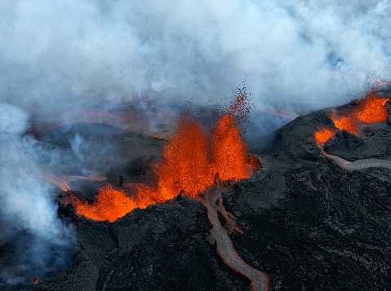
- This is an example of a
- caldera
- Composite volcano
- Aa flow
- Fissure eruption
- Magmatic differentiation

- This is an example of a
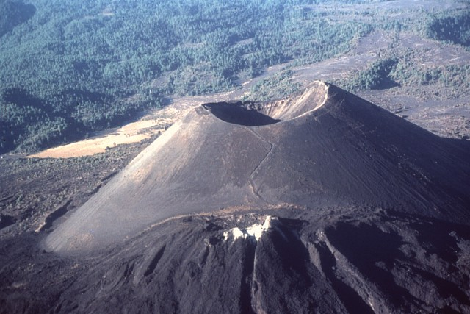
- Composite volcano,
- shield volcano
- cinder cone
- dome volcano

