DISCUSSION QUESTIONS
SESSION 9: GEOLOGIC TIME

- Distinguish between Relative and Absolute geologic dating
- Explain the principles of
- Original horizontality
- Superposition (oldest on bottom, youngest on top)
- Cross-cutting relationships
- Strata younger than faults that displace them
- Dikes, sills, laccoliths, stocks, batholiths all younger than rocks then invade

- Principle of Inclusions
- Compare and contrast: Catastrophism and Uniformitarianism
- Who was Archbishop Ussher? What effect did he have in thinking about the age of the earth and processes that formed it?
- Who James Hutton? What was his contribution to the science of Geology?
- Which is older? Granite or Sandstone?
- 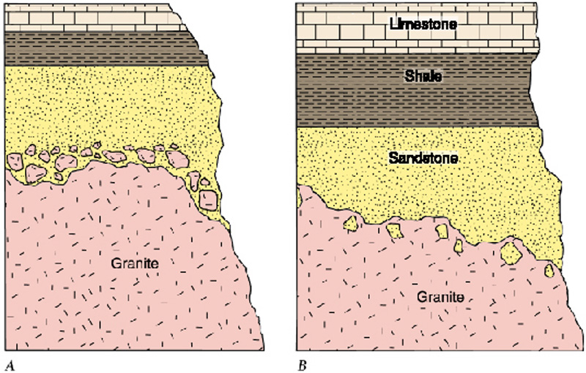
- Distinguish between disconformity, angular unconformity, and nonconformity
- What is required to make a fossil?
- Who was William Smith? What was his contribution to Geology?
- Explain the following radiometric dating methods: What is the half life of each radioactive isotope?
- U238-Pb206
- U235-Pb207
- Th232-Pb 208
- Rb87-St87
- K40-Ar40
- Sm147-Nd143

- The earth’s oldest rocks are in South Africa (3.2 billion), Northern Canada (4.0 billion). Earth formed 4.55 billion years ago.
- What fossils are found in the Cenozoic Era, Mesozoic Era and Paleozoic Era?
- What is the name of the geologic stratigraphic units for the Age of Reptiles?
- What is the name of the geologic stratigraphic units for Amphibians?
- What is the name of the geologic stratigraphic units for Age of Fishes
- What is the name of the geologic stratigraphic units for Invertebrates?

