QUIZ
SESSION 9: GEOLOGIC TIME

Choose the BEST answer

- Who said “The Grand Canyon would be the Book of Revelation in the Bible of Geology”?
- Aristotle
- Kepler
- Hutton
- Ussher
- Powell

- Who wrote the principles of stratigraphy?
a. Aristotle
b. Kepler
c. Hutton
d. Ussher
e. Steno

- Who was the “Father of Geology”?
- Ussher
- Steno
- Lyell
- Hutton
- Einstein

- According to the principle of cross cutting relationships a fault is _________ than the rock formations it cuts across.
- Older
- Younger
- Same Age

5. The smallest division of geologic time is the
a. eon
b. era
c. periods
d. epochs
e. biostratigraphic zone

6. . Fossils give _____________ time and radioactive isotopes give ____________ time.
a. living, chemical
b. accurate, inaccurate
c. relative, absolute
d. absolute, relative
e. evolution, chemical

7. The green line is a disconformity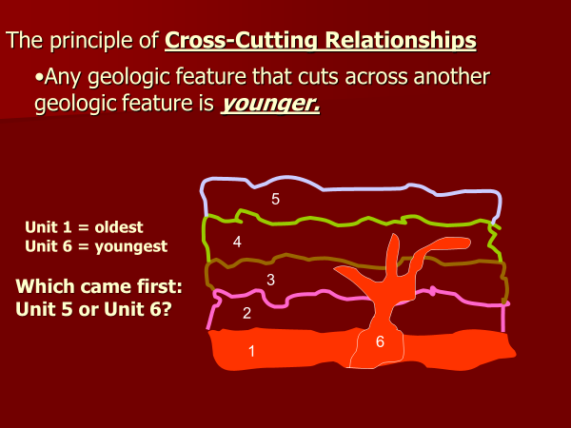
a. Unit 5
b. Unit 6

8. 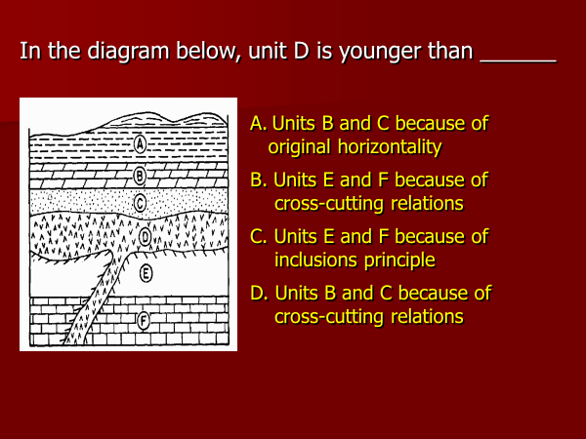
a. A b. B
c. C d. D

9. Uranium decays to _________________
a. thorium
b. plutonium
c. lead
d. cerium
e. sulfur

10 The Precambrian Eon occupies ____% of Geologic Time
a. 50 b. 65
c. 72 d. 88
e. 99

