PHYSICAL GEOLOGY

DESERTS

DR. Gregg Wilkerson and Michael Oldershaw

One way to define a desert or arid climate is by low average annual rainfall. A common definition is less than 25 cm/year on average. This is about 10” of rainfall and in our area the average is closer to
6”/year. Arid and semi-arid (<20”) are the most common climatic types on Earth, comprising about 30% of the surface.

Why is this so common when we are surrounded by water? Most deserts are the result of the atmospheric cooling coupled with the wind circulation around the globe. These are called subtropical high deserts referring to atmospheric high pressure areas that circle the Earth at about 30° north and south latitudes (aka mid-latitude deserts). This is easiest to imagine if we start at the equator which is a high temperature area with lots of rainfall. The rainfall is caused by the hot air rising above the equator and cooling with altitude. Because cold air cannot carry as much moisture as warm air, the moisture falls as rain. The rising air, now cool and dry heads north and south and descends at these mid-latitudes causing high pressure and arid climates. Because of the Earth’s rotation, these circulation patterns
encircle the globe, and most of the world’s driest areas are covered. This includes the Sahara, Gobi, Great Sandy, Simpson, Kalahari, Atacama, and Arabian deserts.

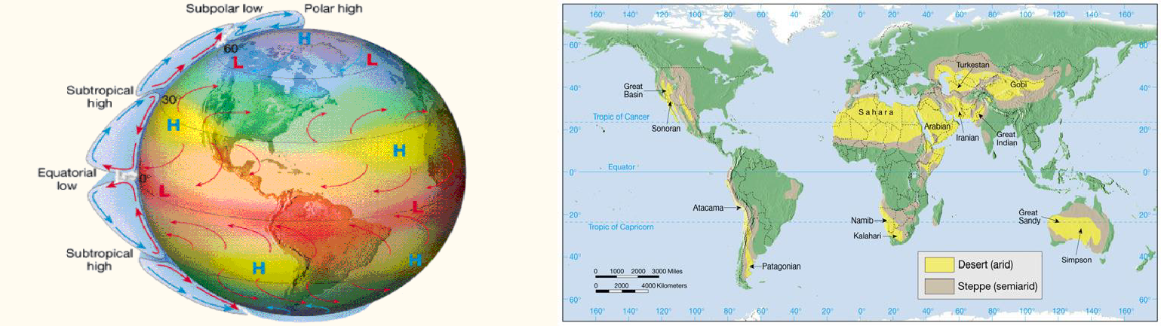

We have another mechanism close to home, but it relies on the same principal that if you cool air it will began to lose its moisture. To the west of the Great Central Valley (south half is San Joaquin, north half is Sacramento) are the Coast Ranges. To the east of the valley are the Sierra Nevada Mountains. Warm moist air blowing inland from the Pacific Ocean must rise over the Coast Ranges where it is cooled causing rain to fall on the mountains, and the valley is much drier than is the coast. The same process repeats as the air is forced over the Sierras where just about all of the remaining moisture is squeezed out leaving the air very dry by the time it reaches the Mojave Desert. This is the rain-shadow effect.

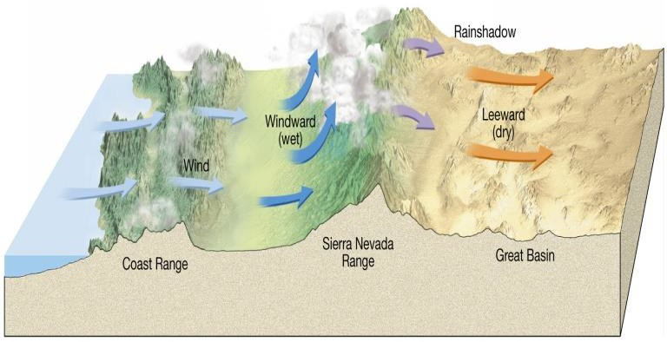

Desert Features
Most of us probably start by picturing sand dunes when we think of a desert. Wind-blown (aeolian) deposits are locally important but not the main features in a desert. Despite being defined as an area of low rainfall, the most important force shaping desert features is running water. This is because water can move a lot of material and because rainfall in the desert is typically of short duration but heavy and the water does not have time to soak in. When you look across the desert in the area of Death Valley you will see mountain ranges in the process of merging with intervening valleys. The result is a landscape with very few level surfaces, and which was created by running water. The mountains are being eroded and the material transported into the valleys to form broad sloping deposits. Only out in the middle of these valleys is there level ground, where the occasional rainwater pools into shallow lakes.

Fluvial Deposits

- Alluvial Fans are stream deposits at the base of a hill or mountain. As the stream slows when it runs into a lower slope, it begins to deposit the largest grains. Over time the stream works back and forth across the area creating a broad fan shape.
- Bajadas form where the stream canyons draining the mountains are close enough for the fans to merge into a single feature.
- Playas are flat areas in the middle of the valleys that have been covered in salt deposits. When the rains wash down the mountains and across the fans the water absorbs salts. When the water reaches the middle of the valley it can go no further and forms a shallow playa lake. There is no place for the water to go except up, and though the process of evaporation, pure water leaves leaving the salts behind to form a light colored playa.

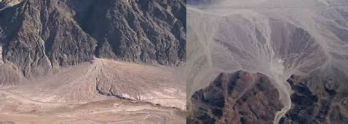
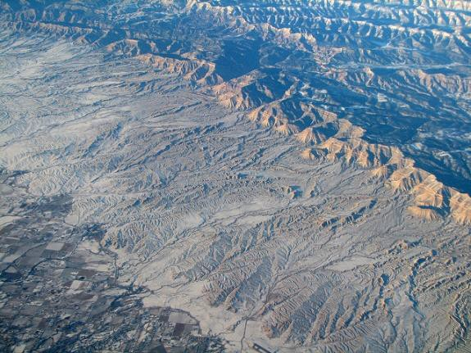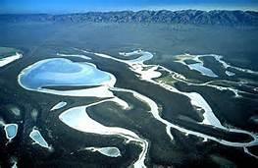

Aeolian Deposits
In terms of capacity and competence air currents operate just like moving water. When the air is moving quickly it can carry sand-sized grains close to the ground, and will deposit these grains when the air slows. These deposits are of course sand dunes.

Just as will fluvial deposits, you can usually tell the current direction by looking for the mechanism for the deposits produces cross-bedding, just as it does in water, but the cross-beds in sand dunes can be much larger. Dunes have a shallow upwind or stoss slope, and a steep downwind lee (or slip off) slope. The stoss and lee slopes meet at the dune crest. Erosion on the stoss slope and deposition on the lee cause the dunes to migrate downwind.
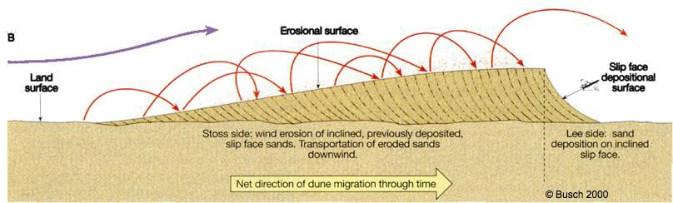

We characterize dunes by their shape or how the crest relates to the wind direction.

- Barchan dunes form on relatively hard surfaces and where there is not as much sand. They have a distinctive elongated crescent shape with the horns pointing down wind.
- Longitudinal dunes form in areas where there is limited sand and slightly variable wind direction. The variable direction moves the sand into elongated dunes arranged essentially parallel to the average wind direction.
- Transverse dunes form where there is a lot of sand. These can form sand seas, where the dunes can cover hundreds of square kilometers. The dune crests are across the wind.
- Star dunes form where the wind direction varies. These are characterized by having several crests radiating from a central high point.
- Parabolic dunes form where the sand is anchored by some vegetation. They also have a parabolic shape, but it is not as long as a barchan and the horns point into the wind on a parabolic dune.
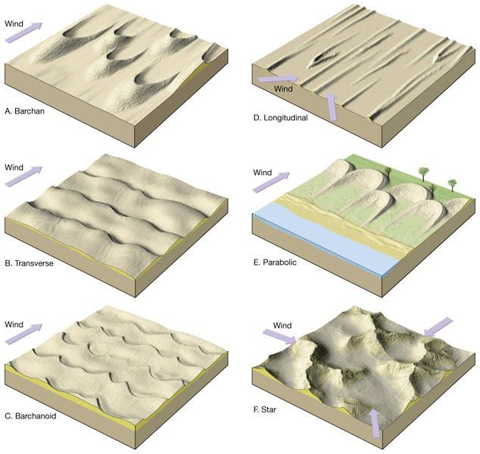

- Loess is windblown silt, and in some areas this is a significant part of the local geology. In one estimate it makes up about 10% of the deposits on Earth. Windblown loess can travel for significant distance and is what makes a dust storm. Once significant source of Loess is glacial sediments, and agricultural exposure of these deposits, combined with a significant drought led to the dust bowl of the 1930s.

Aeolian Erosional Features
The wind can also erode although compared to moving water, wind has a much lower competence and cannot move as large a particle. Where wind is common it will gradually remove all of the smaller grains.

- Desert Pavement results from the removal of all the small grains leaving only the larger grains in what appears to be a graveled surface.
- Deflation is caused by this removal and lowers the ground surface.
- A Blowout forms where a concentration of wind can remove quite a bit of material leaving a depression. In some cases this is limited only by reaching groundwater level.

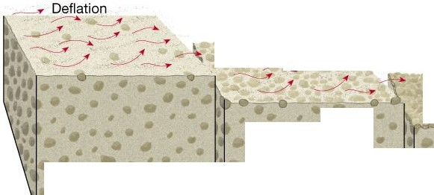
,,. ,,, Deflation
--
.,.- J(
,. ,,,A
' ---...

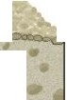Desert pavement
..,.......
•
•
•
 |  | Desert pavement established, deflation ends
Deflation begins | Deflation continues to remove finer particles

Name:

Death Valley National Monument and Vicinity
- What are the dry lake beds on this map?

- Give the location (by name) of an aeolian depositional feature.

- What is the depositional feature formed along the SW flank of the Amargosa Mountains (hint, look at the contour lines just east of Beatty Junction).

- What type of fault separates Death Valley from the Amargosa Mountains?

- Why are playas light colored (hint, think where the water goes once it gets into the Badwater Basin)?

Badwater, California 7.5’ Quadrangle Map
- What feature has formed to the west of Coffin Canyon?

- Where are coarsest and finest grains on this feature?

- What has formed west of the Black Mountains?

- What is the relief of this map in feet (show your work)?

- Which direction does the Amargosa River flow?

Trona, California Topographic Quadrangle
- Prior to ten thousand years ago there was enough water in this area to make lakes in a series of basins that are now quite dry and covered in salt. Looking at the contour lines surrounding the basin, determine the maximum lake level for the following ancient lakes.

  - Lake Manley (Death Valley)

  - Searles Lake

  - Panamint Lake

  - Silver Lake

- Did Silver Lake Drain into or out of Lake Manley?

- What was the source of all this water?

- Where did the salt come from?

- What causes this area so dry now (compare to Santa Barbara and to Bakersfield)?

