PHYSICAL GEOLOGY
Dr. Gregg Wilkerson and Michael Oldershaw

Streams Lab

In geology we consider any flow confined to a channel a stream, so the term does not mean “little river”. Using the term this way, the Mississippi and Amazon Rivers are streams. In this lab we will look at a few different ways to classify streams, and learn about how they work.

Even though streams carry only a very small fraction of the Earth’s water, they are the single most important agent in shaping Earth’s surface. Even in the deserts, streamflow provides most of the landscape sculpting.

Moving water has a lot of force, and that force can be used to erode and carry sediment, and with a little change in force the sediment will be deposited. Let’s start with some terms that will help us to understand how a stream erodes and when it will deposit. If you think about the last time you saw moving water, you will remember that unless it was flowing over hard rock, the water was colored because of all the stuff it was carrying. We describe this in a couple of ways. A stream’s capacity
denotes the amount of material the stream is carrying or dragging along. This is directly related to the size of the stream – the Mississippi carries a lot more stuff than does the Kern. A stream’s competence denotes the size of particle the stream can move, and that is directly related to the velocity of the flow. The faster the stream is flowing, the larger the particle. When the water moves faster the stream will erode, and the velocity can vary based on location in the channel. Conversely, when the water slows it loses competence and begins to drop things and the largest particles the first to be deposited. Stream deposits are also known as alluvium.

The falling water gets energy from starting at a high point. This is potential energy and the higher the drop from headwaters to mouth, the greater the energy the stream has. Once the water starts to flow, the potential energy is converted to kinetic energy (energy of motion).

Stream Profile
Erosion and deposition work together to produce an idealized stream profile or cross section. The stream will be steeper at the top or headwaters and will gradually flatten toward the mouth or end of the stream. As you will recall from our first lab, we can describe the average slope as the gradient.
Looking at a typical profile, the gradient is high at the top and low at the base. The elevation of the mouth of the stream is the base level and this is typically where the stream reaches a body of water such as a lake or the ocean. If the base level is “temporary” such as a lake this is the local base level. Where the stream enters the ocean is the ultimate base level.

The profile will change if we move either base level of headwaters. Consider building a dam for example which will create a lake which will raise the base level for the stream. The stream will respond by depositing material as it nears and enters the lake, producing the flatter profile at the mouth. If we break the dam, the stream will now have a lot more potential energy, and will turn that into kinetic energy, increase velocity and cut through the deposits. The same thing would happen if we were to raise the headwaters by building the mountain.

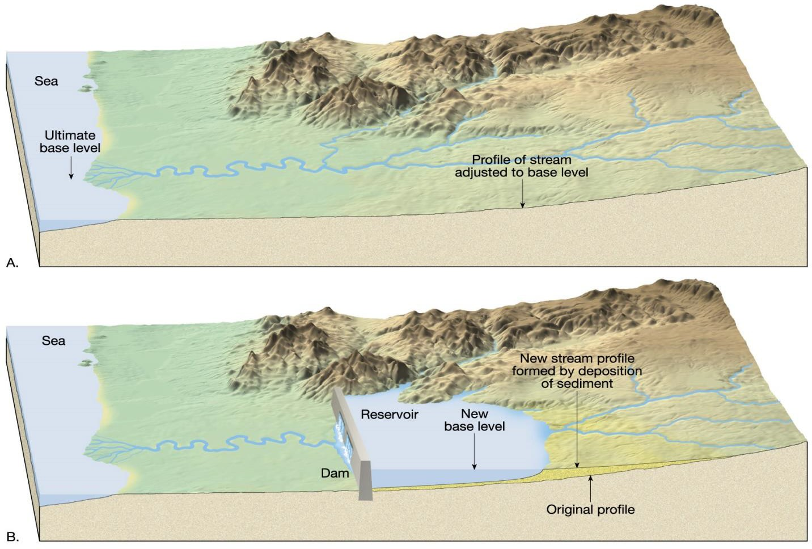

This is something we can see right around BC. The college is built on the Kern River Formation which was deposited by the Kern River. But now the river is hundreds of feet below the college! Uplift of the Sierra Nevada to the east raised the headwaters, gave the river a lot more energy which was converted to velocity to cut through its own deposits to create the Panorama Bluffs.

Stream Types
Streams can be divided into two types, meandering where the stream has a single, sinuous channel, and braided, where the streams has many interweaving channels. Meandering streams are typical where there is a lot of water, in wetter climates for example, and they are typical with lower gradient streams. Comparing the amount of water to the amount of sediment moved shows that meandering stream has a low sediment to water ratio. Conversely, braided streams have more sediment than water and are always depositing stuff everywhere making a lot of interwoven (anastomosing) channels. Braided streams are typical where there is not much water, such as arid areas, or where there is a lot of sediment to move, such as the end of a glacier. A braided stream channel is broad and shallow in cross section.

A meandering stream channel is deeper and is asymmetric (the sides are not evenly shaped). Where the channel turns a corner, the outside of the channel is steep and the inside has a much more gradual slope. The tendency for something in motion to want to stay in motion and go the same direction is

called inertia – the resistance to change in the rate or direction of movement. You know about this from your experience driving a car. When you go around a corner, say to the left, you and everything in the car do not wish to turn and want to go straight which feels like pulling to the right. This is centrifugal force and that resistance to change in direction affects the water in a stream too. When the stream bends to the left, the water does not want to turn and sloshes up against the right side of the channel.
This is also the part where the water is going the fastest, has the highest competence, and does the most erosion. It cuts the outside of the turn making the bank steep. On the inside of the bend, the water is going much slower, and has lower competence and will deposit. River (fluvial) deposits are generally known as bars. The outside of a meandering stream curve is called the cut bank, the inside is called the point bar.

Flood Plain Features
In many areas both stream types occupy flood plains, or broad flat areas where the streams will migrate over time. Braided streams may have channels that completely fill the flood plain, but meandering streams will move back and forth over this area. When the river floods, water can occupy the entire area.

Because geology is studied all over the world, some features have colorful terms. One such is from the New Orleans area for a tributary flowing roughly parallel to the main river. This is a yazoo tributary.
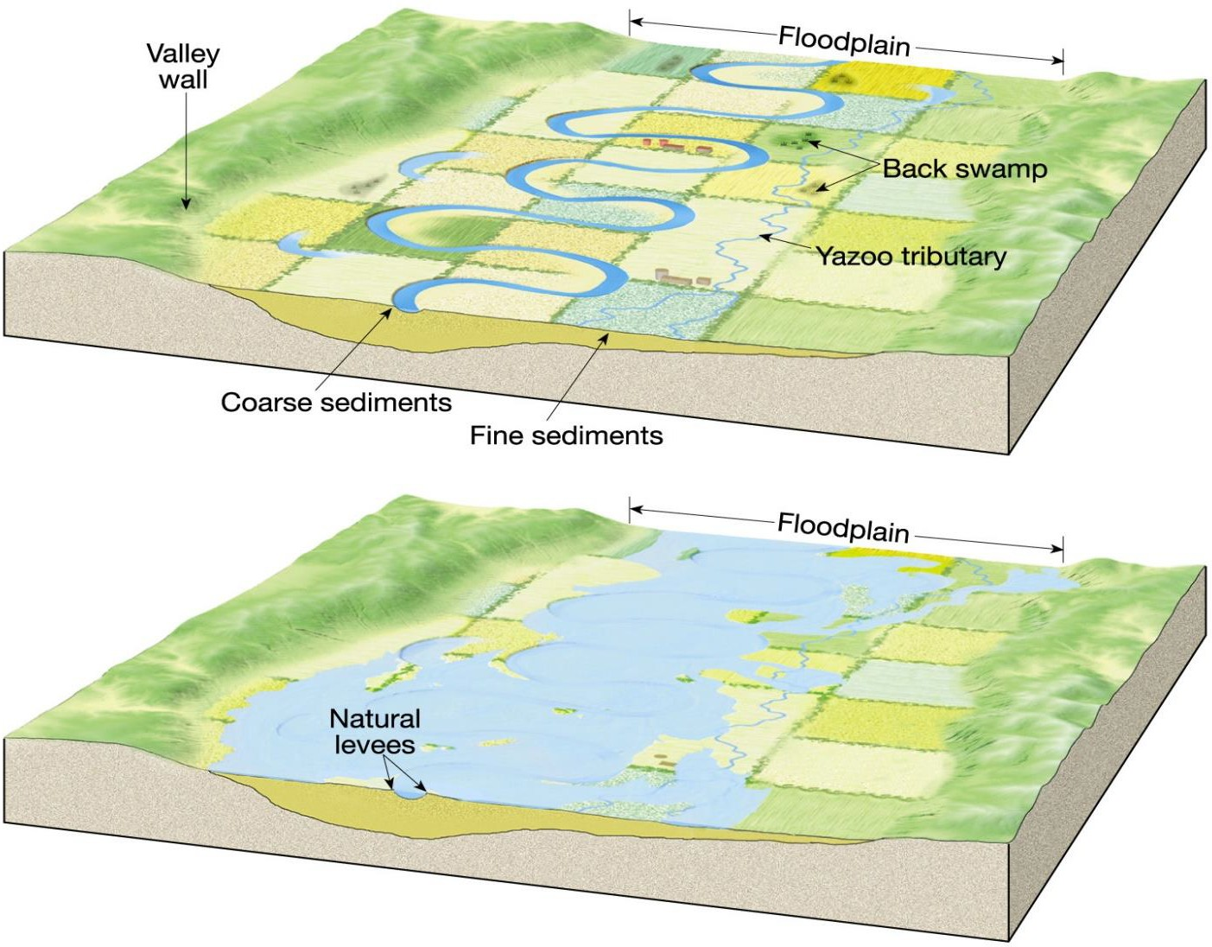

Erosion and Stream Migration
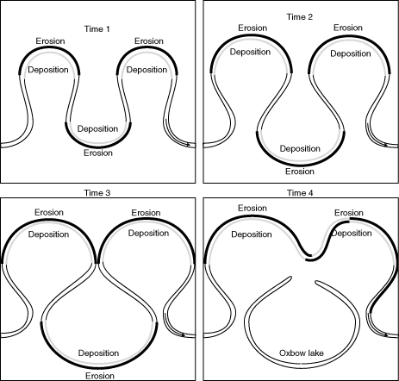Because a meandering stream is eroding at the cut bank and depositing on the point bar it migrates over time, moving back and forth across the flood plain. In addition the meander loops tend to widen and this leads to loops intersecting. When this happens it provides an opportunity for the river to take a shorter route by cutting off the meander loop. The result is an abandoned meander loop as the stream will always take the shorter path. The abandoned loop is called an oxbow lake while it has water in it, and when it dries it is just an oxbow. If you look at an air photo, a google earth image, or a topo map of a meandering stream you will be able to see the oxbows.

Cut Bank Point Bar

Drainage Basins and Divides
Consider the Kern River compared to the Mississippi. Even after a very wet winter with the Kern running at very high levels, it is very small compared to the Mighty Mississippi. The size of a river is determined by climate and the area the river draws water from, known as the drainage basin. The Kern draws water from the Sierra Nevada Mountains and part of the valley. Drainage basins are bounded by divides. For example, rainwater falling on one side of the Sierras will make its way into the Kern, but if it falls on the other side the water will end up in another river. When you think about the Mississippi
you’ll note that it has a very large drainage basin, essentially most of the center of the country from the Rockies to the Appalachians and so the river has a lot of water to move. Now consider the Amazon.
This is the largest river on Earth in terms of discharge (water flow), and that is because the drainage

basin is most of the northern portion of South America, and because that area is on the equator, with some of the highest rainfall.

Stream Drainage Patterns
One other way we can classify streams is by their drainage pattern, or the shape of the streams and all of their tributaries. When you look at these on a map you have to ignore everything but the water itself. The most common of these is the dendritic pattern which looks like the roots of a plant. The entire root system joins together to form the stem of the plant, and in a dendritic stream, all of the tributaries join together to form the main river.

Think about a volcano. Streams draining such a mountain flow outward, away from the crater. The stream pattern is like the spokes on a bicycle wheel and this pattern is called radial.

In areas where the mountains have been uplifted recently, the stream pattern may not have had a chance to develop and will be controlled by cracks in the rock (these are called joints). This pattern is called rectangular and is characterized by straight streams joined at sharp angles.

In the desert area to the east of the Sierras, there are a series of elongated mountains and narrow valleys. The mountains and valleys are created by a series of normal faults (more about this in the structure lab). These mountains are drained by streams that flow into the valley at right angles and then join a central stream. This drainage patter looks like a lattice for plants, and is called a trellis pattern.

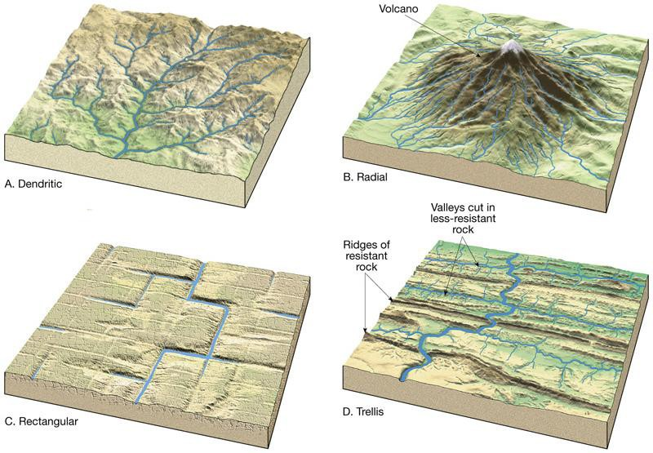

Subsequent, and Consequent Streams
Most streams are consequent, that is their pattern is just determined by the slope of the land, and a dendritic or radial patterns are examples. In some cases, the stream flow is determined by the underlying geology, such as the rectangular pattern, or a stream that is flowing along a geologic feature (such as the Kern River above Kernville that flows perfectly straight along a fault). These are subsequent streams.

Antecedent Streams and Incised Meanders
Where streams flow can change over time, and in some cases we can learn a little about the local tectonic history by looking at the stream pattern or where the stream used to be. For example, in the area near the Tejon Outlets just this side of the Grapevine there is a hillside of to the west of I-5 that is cut by stream channels. How can this happen? Did the stream repeatedly bump into the hill until it cut through? A better explanation is that the stream was there before the hill. For a time as the hill was uplifted by tectonic forces (there are a series of thrust faults in this area, all driven by compression from a bend in the San Andreas Fault), the stream was able to keep its course and cut through the rising hill. In some cases that is still the case and we refer to that as a water gap. In the cases to the south, the stream could not keep up with the tectonics and eventually turned away from the hill. Where the stream-cut canyon no longer as water in it, it is referred to as a wind gap. In fact, one of the California Aqueduct pumping plants is called “Wind Gap”. These streams “came first”, before the tectonics, and the term to use is antecedent stream.

We can see other evidence of erosion over time in incised meanders. Normally a meandering stream is one that is working side-to-side and is free to migrate laterally, reworking its own sediment over and over. These streams are working in an area with very little topographic relief, and the banks will be pretty flat. However, where for example, uplift gives the stream more energy and it cuts down into a harder material, it can become strapped in the meandering pattern, even though it is eroding vertically rather than horizontally. Looking at a topo map, we can recognize incised meanders as those that have the meandering shape but very steep sides.

We can see other evidence of uplift where a stream has cut down into its own flood plain. We will see this on one of the field trip stops, and you can see it with BC sitting on the bluff above the river (mentioned above).

Exercises

- Tom’s Brook, Virginia, 7.5’ Topographic Quadrangle

1-What type of streams are Mine Run and Little Passage Creek (see photo)? Both are the same type.

2-What is the stream type for the North Fork of the Shenandoah River (look at the photo of migrating channel, but also carefully look at the topography of the banks)?

3-What kind of feature is Mine Gap (photo)?

4-What kind of feature is Boyer Gap (photo)?

Hanna, Louisiana, 7.5’ Topographic Map

1-What term is applied to Hollingworth Cutoff (photo)?

2-What is Bayou Nicholas (photo)?

3-In general, what deposits are in the middle of the channel?

4-What more specific term applies to the sediments deposited inside the curve of the stream on the map?

5-For both cases, describe why the sediment is deposited in these locations.

6- Identify and name a flood control feature on the map (photo)?

Ennis, Montana, 15’ Topographic Map

1-What is drainage pattern for Cedar Creek, west of Lawton Ranch (photo)?

2-What is the shaded area around the Madison River (photo)?

3-Which river type is the Madison River?

4-Which river type is the Madison River (above photo)-?

5-Based on the above, is the Madison River likely to have a High Sediment to Water Ratio or Low Sediment to Water Ratio?

Extra Credit

You do not need the map to do this one but the data is taken from one of maps in this lab. The Red River runs for 16 miles across the map. In that distance the river is only crossed by one contour line at100 ' elevation. If the Contour Interval for the map is 10', what is the maximum gradient for the Red River in this area?

