EARTH SCIENCE
QUIZ 14
BEYOND THE SOLAR SYSTEM
Choose the BEST answer

- The 3rd planet from the sun is ________
- Mercury
- Mars
- Earth
- Venus
- Asteroid belt

- In the photo the oblong asteroid is
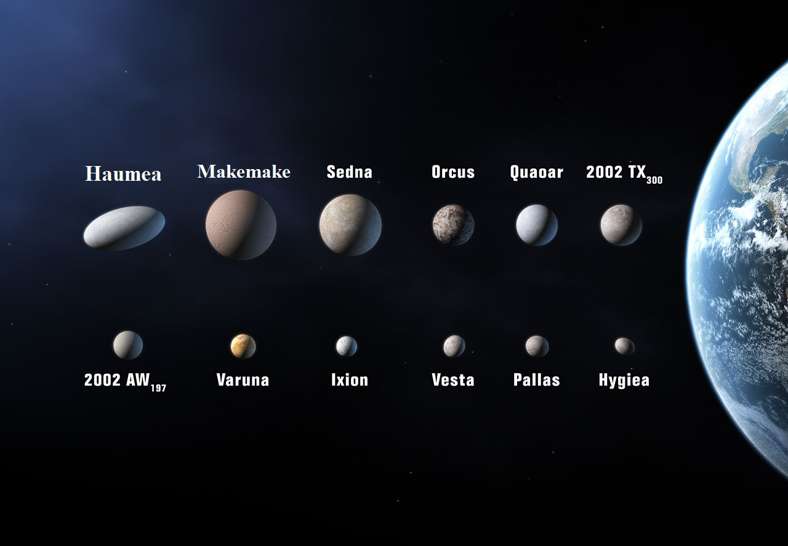
- Haumea
- Makemake
- Quaoar
- Pallas
- Hygia

- The 951 Gaspara asteroid was visited by the __________ spacecraft
- Pioneer
- Voyager
- Galileo
- New Horizons
- Near Shoemaker

- This Japanese probe sent a lander to sample the 25143 Itokawa asteroid:
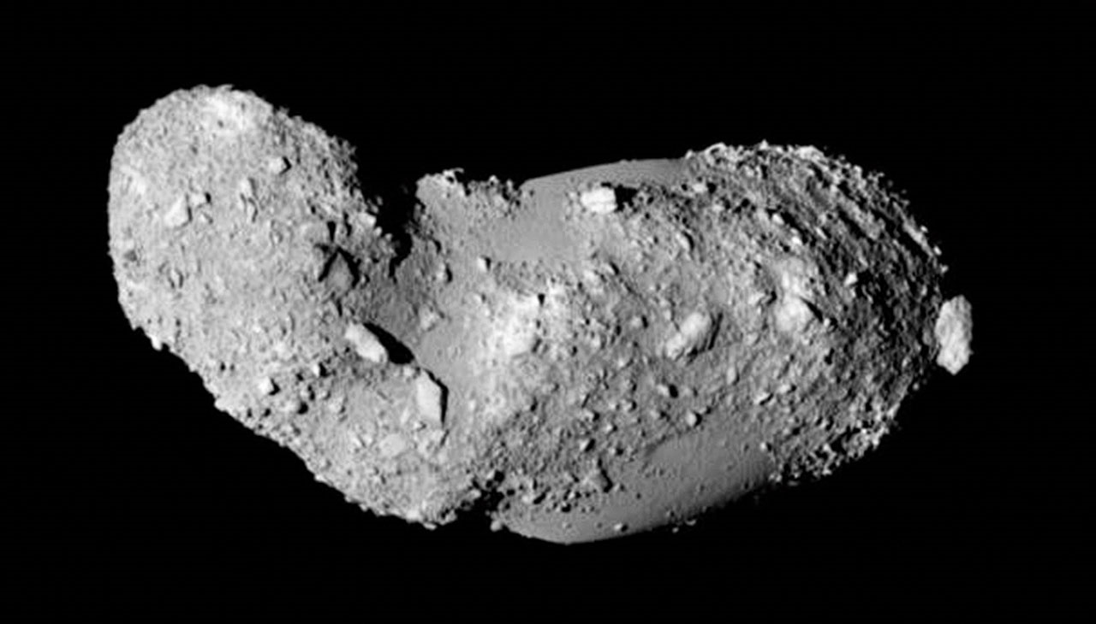
- Cassini
- Voyager
- Hayabusha
- Pioneer
- Galileo

- The Asteroid belt is made of _______ particles and the Kuiper Belt is made of _________particles
- Rocky, icy
- Icy, Rocky
- Gas, Solid
- Solid, Gas
- Water, Methane

- These probes escaped the Solar System, except for
- Pioneer
- Voyager
- Apollo
- New Horizons

- Halley’s Comet was seen by the following, except for
- Chinese, 466BC
- Babylonians, 164 BC
- William the Conqueror, 1006 AD
- Edmond Halley; 1742

- The _________________ spacecraft appeared in the Star Trek: The Motion Picture (1979)
- Cassini
- Pioneer
- Voyager
- New Horizons
- Deep Space 1

- The Cassini spacecraft was unique because it did all the following except,
- Deployed the Huygens Titan Lander
- Was first spacecraft to orbit Saturn
- Flyby Jupiter
- Flyby 2685 Masursky Asteroid
- Flyby Mercury

- Where do Comets come from?
- The Ort Cloud
- Asteroid Belt
- Collisions with planets
- Outer Space

