PROPOSED COLLECTING SITES

MIOCENE

SITE 16H
Celite Mine
T.06N R.34W Sec. 15 SBM
Sisquoc Formation, Lompoc
Geology from Dibblee and Ehrenspeck, 1988

Note: This mine is where Diatomite is produced.

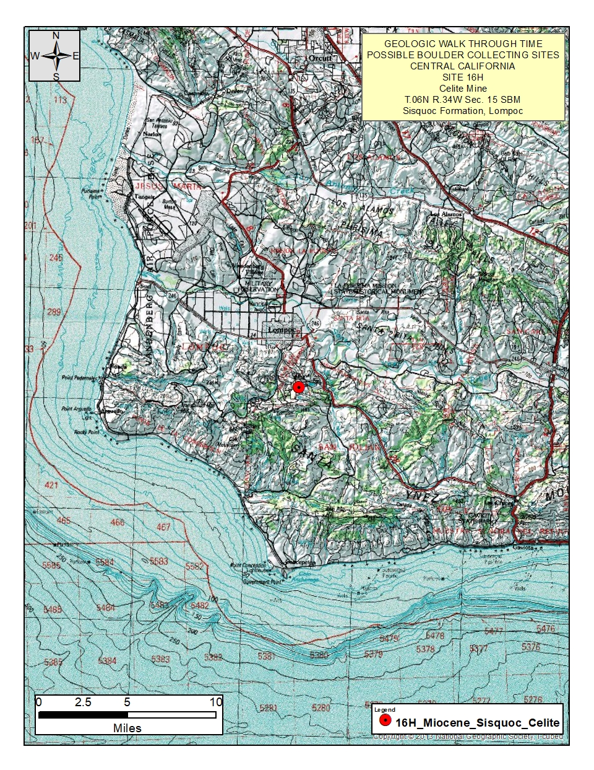
Figure 1. Regional topographic map
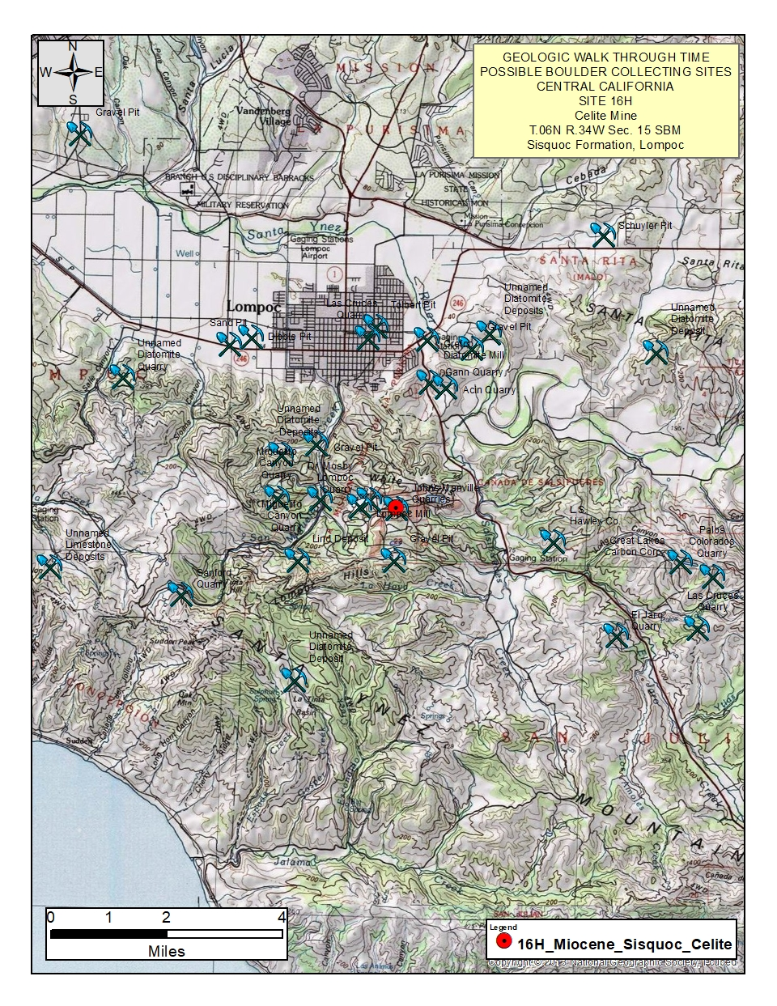
Figure 2. Area topographic map
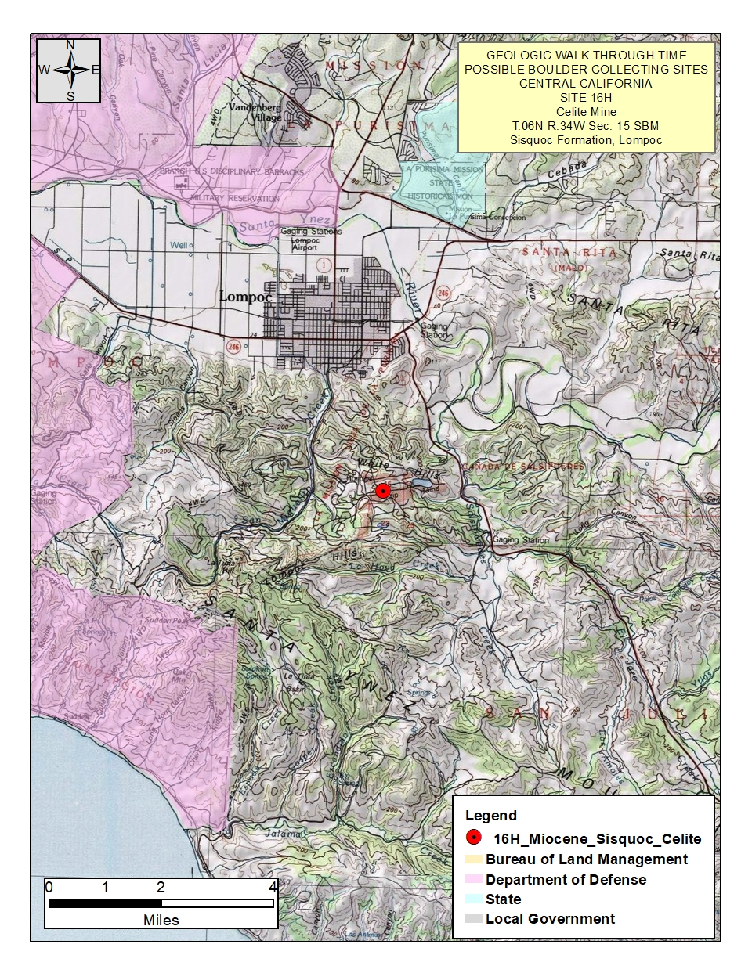
Figure 3 Land Status Map with PLSS data
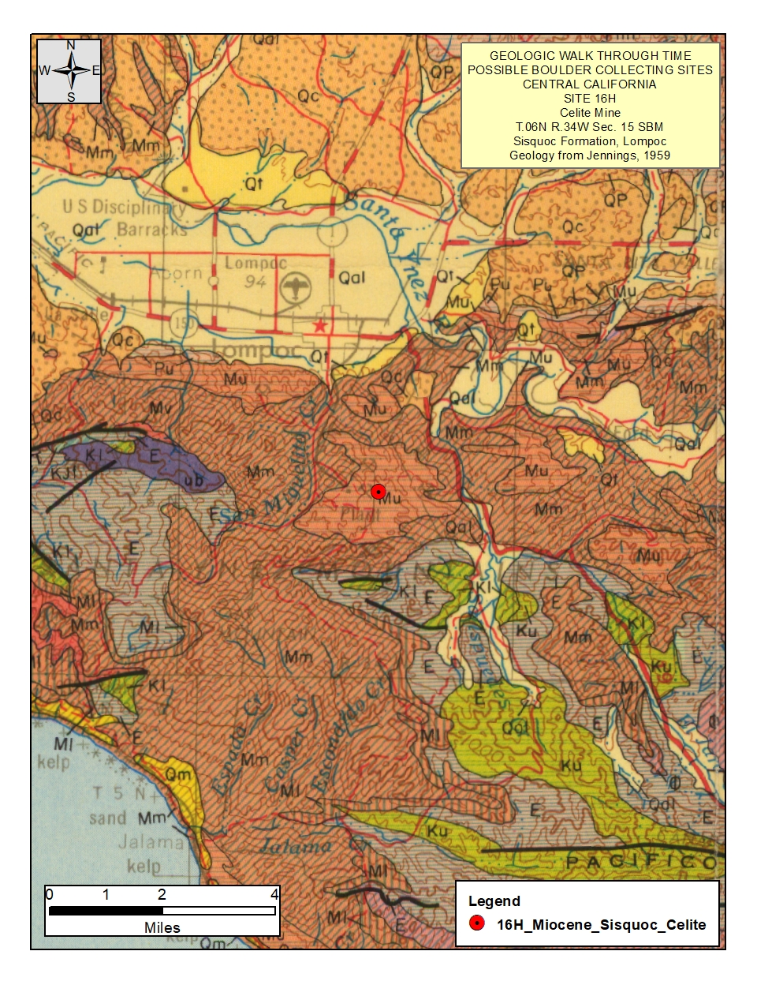
Figure 4. Regional Geologic map
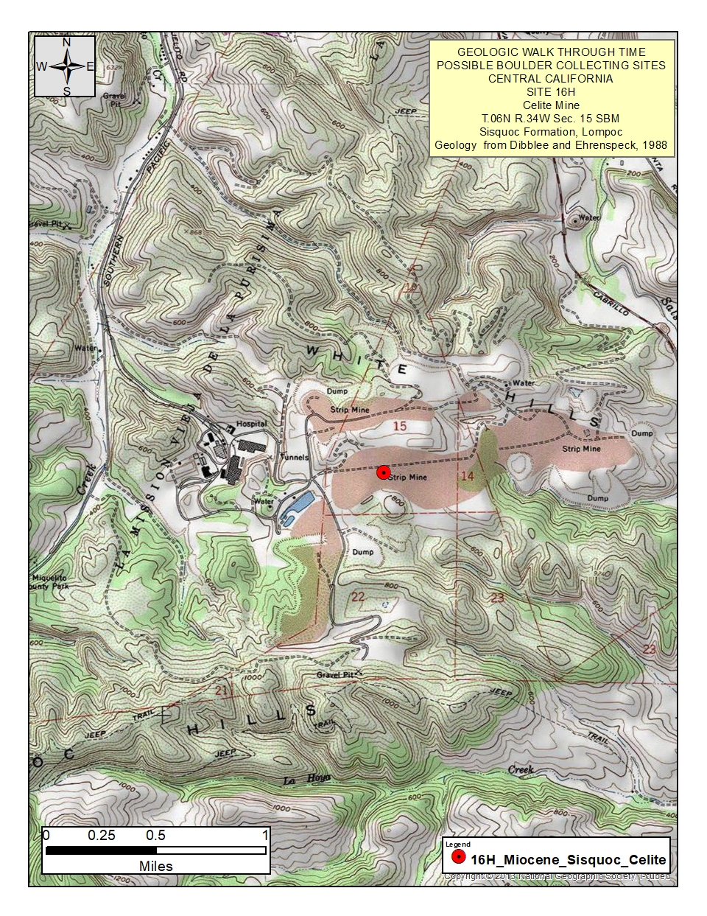
Figure 5. Site topographic map
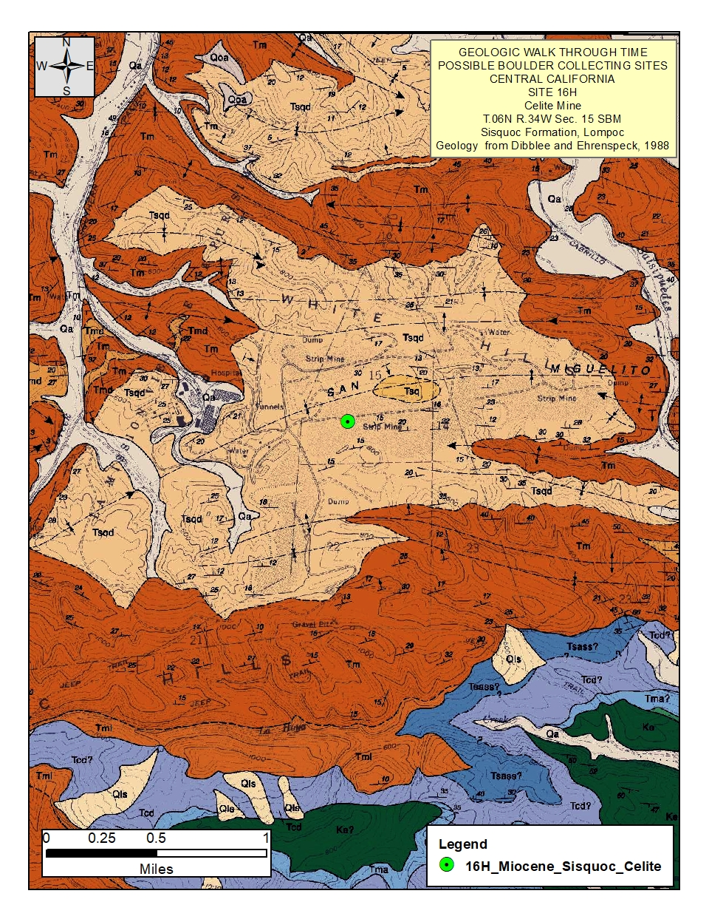
Figure 6. Site geologic map
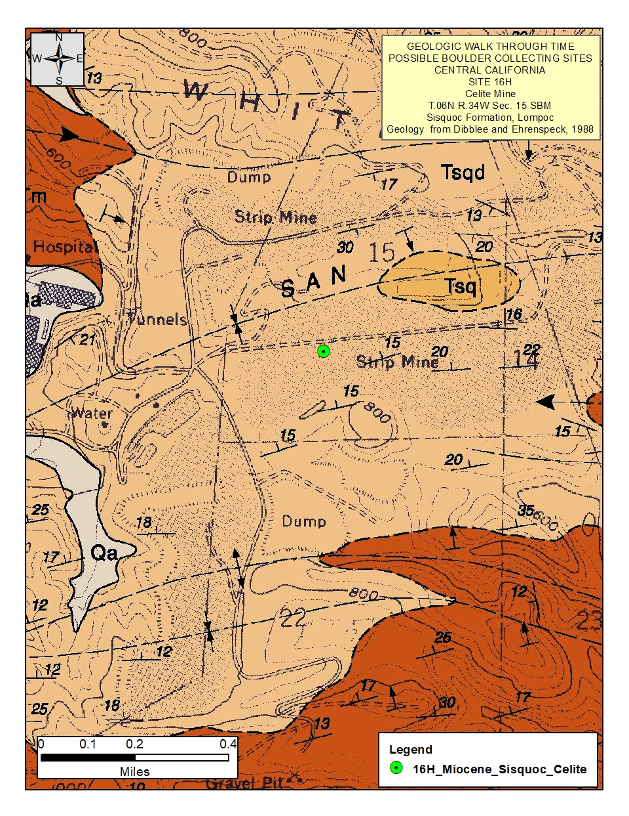
Figure 7. Detail of Map 6.
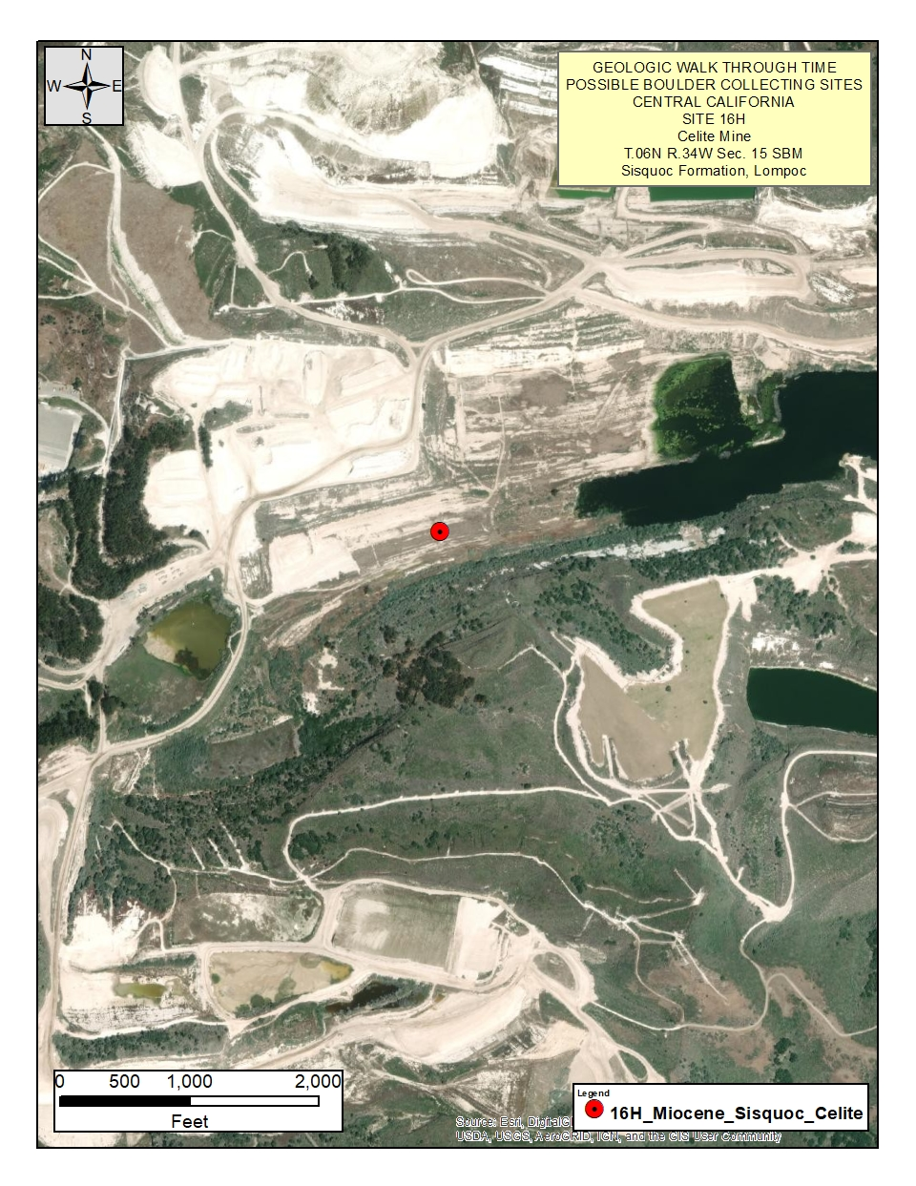
Figure 8. Aerial photograph
REFERENCES AND BIBLIOGRAPHY

Bartow, J.A., 1981, Geologic map of the Rio Bravo Ranch quadrangle, California: U.S. Geological Survey, Open-File Report OF-81-152, scale 1:24,000.

Bartow, J.A., 1986, Geologic Map of the Oil Center Quadrangle, U.S. Geological Survey, Open File Report, OF-86-188.

Bartow, J.A., 1996, Geologic Map and Cross Sections of the Southeastern Margin of the San Joaquin Valley, California, U.S. Geological Survey, Miscellaneous Investigations Series Map I-1496

Bartow, J.A., and Doukas, M.P., 1976, Geology of the Oil Center, Rio Bravo Ranch, Lamont, and Edison quadrangles, California: U.S. Geological Survey, Open-File Report OF-76-592, scale 1:62,500.

Bateman, P.C., 1988, Pre-Tertiary bedrock geologic map of the Mariposa 1 degree by 2 degree quadrangles: U.S. Geological Survey, Open-File Report OF-87-670, scale 1:200,000.

Bateman, P.C., 1992, Pre-Tertiary bedrock geologic map of the Mariposa 1 degree by 2 degrees quadrangle, Sierra Nevada, California, Nevada: U.S. Geological Survey, Miscellaneous Investigations Series Map I-1960, scale 1:250,000

Bortango, E.J and T.R. Spittle, 1986, Geologic Map of the San Bernardino Quadangle, Geologic Atlas of California, California Division of Mines and Geology.

Bowen, O.E., and Ver Planck, W.E., 1965, Stratigraphy, structure, and mineral deposits in the Oro Grande series near Victorville, California: California Division of Mines and Geology, Special Report 84, scale 1:12,000.

Calzia, J.P., Troxel, B.W., Wright, L.A., Burchfiel, B.C., Davis, G.A., and McMackin, M.R., 2000, Geologic map of the Kingston Range, southern Death Valley, California: U.S. Geological Survey, Open-File Report OF-2000-412, scale 1:31,680.

Calzia, J.P., Frisken, J.G., Jachens, R.C., McMahon, A.B., and Rumsey, C.M., 1987, Mineral resources of the Kingston Range Wilderness Study Area, San Bernardino County, California: U.S. Geological Survey, Bulletin 1709-D, scale 1:62,500.

Clark, L.D., Stromquist, A.A., and Tatlock, D.B., 1963, Geologic map of the San Andreas quadrangle, Calaveras County, California: U.S. Geological Survey, Geologic Quadrangle Map GQ-222, scale 1:62,500

Delattre, M.P., and Wiegers, M.O., 2014, Preliminary geologic map of the Nipomo 7.5' quadrangle, San Luis Obispo County, California: A digital database version 1.0: California Geological Survey, Preliminary Geologic Maps, scale 1:24,000.

Dibblee, T.W., Jr., 1952, Geology of the Saltdale quadrangle, California: California Division of Mines and Geology, Bulletin 160, scale 1:62,500.

Dibblee, T.W., 1960, Preliminary geologic map of the Victorville quadrangle, California: U.S. Geological Survey, Mineral Investigations Field Studies Map MF-229, scale 1:62,500.

Dibblee, T.W., 1963, Geology of the Willow Springs and Rosamond quadrangles, California: U.S. Geological Survey, Bulletin 1089-C, scale 1:62,500.

Dibblee, T.W., 1979, Geologic map of the central Diablo Range between Hollister and New Idria, San Benito, Merced, and Fresno Counties, California: U.S. Geological Survey, Open-File Report OF-79-358, scale 1:125,000.

Dibblee, T.W., and Ehrenspeck, H.E., ed., 1988,Geologic map of the Lompoc Hills and Point Conception quadrangles, Santa Barbara County, California: Dibblee Geological Foundation, Dibblee Foundation Map DF-18, scale 1:24,000.

Dibblee, T.W., and Ehrenspeck, H.E., ed., 1992, Geologic map of the Moorpark quadrangle, Ventura County, California: Dibblee Geological Foundation, Dibblee Foundation Map DF-40, scale 1:24,000.

Dibblee, Thomas W., Jr., 1994a, Geologic map of the Santa Maria and Twitchell Dam Quadrangles, Santa Barbara and San Luis Opispo Counties, California, Dibblee Foundation, Map DF-51, Scale 1:62,500.

Dibblee, T.W., Ehrenspeck, H.E., and Bartlett, W.L., 1994b, Geologic map of the Tepusquet Canyon quadrangle, Santa Barbara County, California: Dibblee Geological Foundation, Dibblee Foundation Map DF-52, scale 1:24,000.

Dibblee, Thomas W., Jr., 2005a, Geologic map of the Elkhorn Hills Quadrangle, Kern County, California, Dibblee Foundation, Map DF-108, Scale 1:24,000.

Dibblee, Thomas W., Jr., 2005b, Geologic map of the Chimineas Ranch Quadrangle, San Luis Obispo County, California, Dibblee Foundation, Map DF-99, Scale 1:24,000.

Dibblee, Thomas W., Jr., 2005c, Geologic map of the Reward Quadrangle, San Luis Obispo and Kern Counties, California, Dibblee Foundation, Map DF-100, Scale 1:24,000.

Dibblee, Thomas W., Jr., 2005d, Geologic map of the Eagle Rest Peak/South ¼ of Conner SW Quadrangle, Kern County, California, Dibblee Foundation, Map DF-172, Scale 1:24,000.

Dibblee, T.W., and Minch, J.A., 2005e, Geologic map of the Chimineas Ranch quadrangle, San Luis Obispo County, California: Dibblee Geological Foundation, Dibblee Foundation Map DF-99, scale 1:24,000.

Dibblee, Thomas W., Jr., 2005f, Geologic map of the Tent Hills Quadrangle, San Luis Obispo, Monterey, Kings and Kern Counties, California, Dibblee Foundation, Map DF-177, Scale 1:24,000.

Dibblee, Thomas W., Jr., 2005g, Geologic map of the Santiago Creek Quadrangle, Kern and Ventura Counties, California, Dibblee Foundation, Map DF-171, Scale 1:24,000.

Dibblee, T.W., and Minch, J.A. (ed.), 2005h, Geologic map of the Taylor Canyon quadrangle, San Luis Obispo and Santa Barbara Counties, California: Dibblee Geological Foundation, Dibblee Foundation Map DF-183, scale 1:24,000.

Dibblee, T.W., and Minch, J.A., 2005i, Geologic map of the Fellows quadrangle [Kern and San Luis Obispo Counties, California]: Dibblee Geological Foundation, Dibblee Foundation Map DF-96, scale 1:24,000.

Dibblee, T.W., and Minch, J.A., 2005j, Geologic map of the Taft and Mouth of Kern quadrangles, Kern County, California: Dibblee Geological Foundation, Dibblee Foundation Map DF-95, scale 1:24,000.

Dibblee, T.W., and Minch, J.A., 2005k, Geologic map of the Maricopa and Pentland [quadrangles], San Luis Obispo and Kern Counties, California: Dibblee Geological Foundation, Dibblee Foundation Map DF-94, scale 1:24,000.

Dibblee, T.W., and Minch, J.A., 2005l, Geologic map of the West Elk Hills quadrangle, Kern County, California: Dibblee Geological Foundation, Dibblee Foundation Map DF-102, scale 1:24,000.

Dibblee, Thomas W., Jr., 2006a, Geologic map of the Frazier Mountain and Lebec 15 Minute Quadrangles, Los Angeles, Ventura and Kern Counties, California, Dibblee Foundation, Map DF-198, Scale 1:24,000.

Dibblee, Thomas W., Jr., 2006b, Geologic map of the Pyramid Hills Quadrangle, Kings and Kern Counties, California, Dibblee Foundation, Map DF-282, Scale 1:24,000.

Dibblee, Thomas W., Jr., 2006c, Geologic map of the Miranda Pine Mountain Quadrangle, San Luis Obispo and Santa Barbara Counties, California, Dibblee Foundation, Map DF-264, Scale 1:24,000.

Dibblee, Thomas W., Jr., 2006d, Geologic map of the Chimney Canyon Quadrangle, San Luis Obispo and Santa Barbara Counties, California, Dibblee Foundation, Map DF-265, Scale 1:24,000.

Dibblee, Thomas W., Jr., 2006e, Geologic map of the Cuddy Valley Quadrangle, Ventura and Kern Counties, California, Dibblee Foundation, Map DF-199, Scale 1:24,000.

Dibblee, Thomas W., Jr., 2006f, Geologic map of the Huasna Peak Quadrangle, San Luis Obispo and Santa Barbara Counties, California, Dibblee Foundation, Map DF-207, Scale 1:24,000.

Dibblee, T.W., and Minch, J.A., 2006g, Geologic map of the Miranda Pine Mountain quadrangle, San Luis Obispo and Santa Barbara Counties, California: Dibblee Geological Foundation, Dibblee Foundation Map DF-265, scale 1:24,000.

Dibblee, T.W., and Minch, J.A., 2006i, Geologic map of the Branch Mountain quadrangle, San Luis Obispo County, California: Dibblee Geological Foundation, Dibblee Foundation Map DF-263, scale 1:24,000.

Dibblee, T.W., and Minch, J.A., 2006j, Geologic map of the Apache Canyon quadrangle, Ventura & Kern Counties, California: Dibblee Geological Foundation, Dibblee Foundation Map DF-201, scale 1:24,000.

Dibblee, T.W., and Minch, J.A., 2006k, Geologic map of the Nipomo quadrangle, San Luis Obispo County, California: Dibblee Geological Foundation, Dibblee Foundation Map DF-208, scale 1:24,000.

Dibblee, T.W., and Minch, J.A., 2006l, Geologic map of the Los Viejos quadrangle, Kings County, California: Dibblee Geological Foundation, Dibblee Foundation Map DF-281, scale 1:24,000.

Dibblee, T.W., and Minch, J.A., 2006m, Geologic map of the Kettleman Plain quadrangle, Kings County, California: Dibblee Geological Foundation, Dibblee Foundation Map DF-280, scale 1:24,000.

Dibblee, T.W., and Minch, J.A., 2007a, Geologic map of the North Chalone Peak quadrangle, Monterey and San Benito Counties, California: Dibblee Geological Foundation, Dibblee Foundation Map DF-303, scale 1:24,000.

Dibblee, T.W., and Minch, J.A., 2007b, Geologic map of the Santa Rita Peak quadrangle, Fresno and San Benito Counties, California: Dibblee Geological Foundation, Dibblee Foundation Map DF-296, scale 1:24,000.

Dibblee, Thomas W., Jr., 2008a, Geologic map of the Edison and Breckenridge Mountain 15 Minute Quadrangles, Kern County, California, Dibblee Foundation, Map DF-419, Scale 1:62,500.

Dibblee, Thomas W., Jr., 2008b, Geologic map of the Cross Mountain and Saltdale 15 Minute Quadrangles, Kern County, California, Dibblee Foundation, Map DF-399, Scale 1:62,500.

Dibblee, T.W., and Minch, J.A., 2008c, Geologic map of the Cummings Mountain & Techachapi [Tehachapi] 15 minute quadrangles, Kern County, California: Dibblee Geological Foundation, Dibblee Foundation Map DF-397, scale 1:62,500.

Dibblee, T.W., and Minch, J.A., 2008d, Geologic map of the Randsburg 15 minute quadrangle, Kern & San Bernardino Counties, California: Dibblee Geological Foundation, Dibblee Foundation Map DF-400, scale 1:62,500.

Dibblee, T.W., and Minch, J.A., 2008e, Geologic map of the Alvord Mountain & Cave Mountain 15 minute quadrangles, San Bernardino County, California: Dibblee Geological Foundation, Dibblee Foundation Map DF-398, scale 1:62,500.

Dibblee, T.W., and Minch, J.A., 2008f, Geologic map of the Shadow Mountains & Victorville 15 minute quadrangles, San Bernardino & Los Angeles Counties, California: Dibblee Geological Foundation, Dibblee Foundation Map DF-387, scale 1:62,500.

Dibblee, T.W., and Minch, J.A., 2008g, Geologic map of the Neenach & Willow Springs 15 minute quadrangles, Kern & Los Angeles Counties, California: Dibblee Geological Foundation, Dibblee Foundation Map DF-383, scale 1:62,500.

Dibblee, T.W., and Minch, J.A., 2008h, Geologic map of the Borrego & Borrego Mountain 15 minute quadrangles, San Diego and Imperial Counties, California: Dibblee Geological Foundation, Dibblee Foundation Map DF-409, scale 1:62,500.

Hall, W.E., 1958, Structure and ore deposits of the Darwin quadrangle, Inyo County, California: U.S. Geological Survey, Open-File Report OF-58-42, scale 1:40,000

Hall, W.E., and MacKevett, E.M., 1962, Geology and ore deposits of the Darwin quadrangle, Inyo County, California: U.S. Geological Survey, Professional Paper 368, scale 1:48,000.

Hall, C.A., and Corbato, C.E., 1967, Stratigraphy and structure of Mesozoic and Cenozoic rocks, Nipomo quadrangle, southern Coast Ranges, California: Geological Society of America, Bulletin v.78, n.5, scale 1:48,000.

Hall, C.A., 1978, Geologic map of Twitchell Dam and parts of Santa Maria and Tepusquet Canyon quadrangles, Santa Barbara County, California: U.S. Geological Survey, Miscellaneous Field Studies Map MF-933, scale 1:24,000.

Hernandez, J.L., Brown, H.J., and Cox, B.F., 2008, Geologic map of the Victorville 7.5-minute quadrangle, San Bernardino County, California: A digital database: California Geological Survey, Preliminary Geologic Maps, scale 1:24,000.

Hulin, C.D., 1925, Geology and ore deposits of the Randsburg quadrangle, California: California Division of Mines and Geology, Bulletin no. 95, scale 1:62,500.

Janecke, S.U., Dorsey, R.J., Forand, David, Steely, A.N., Kirby, S.M., Lutz, A.T., Housen, B.A., Belgarde, Benjamin, Langenheim, V.E., and Rittenour, T.M., 2011, High geologic slip rates since Early Pleistocene initiation of the San Jacinto and San Felipe fault zones in the San Andreas fault system: southern California, USA [geologic map of the Borrego Mountain area, Imperial County, California]: Geological Society of America, Special Paper 475, Fig. 8, scale 1:55,500.

Jennings, Charles W., 1958a, Death Valley Sheet, Geologic Atlas of California, California Division of Mines and Geology, Olaf P. Jenkins Edition.

Jennings, Charles W., 1958b, San Luis Obispo Sheet, Geologic Atlas of California, California Division of Mines and Geology, Olaf P. Jenkins Edition.

Jennings, Charles W., 1959, Santa Maria Sheet, Geologic Atlas of California, California Division of Mines and Geology, Olaf P. Jenkins Edition.

Jennings, Charles W., John L. Burnett and Bennie W. Troxel, 1962, Trona Sheet, Geologic Atlas of California, California Division of Mines and Geology, Olaf P. Jenkins Edition.

Jennings, Charles W., and Rudolph Strand, 1958, Santa Cruz Sheet, Geologic Atlas of California, California Division of Mines and Geology, Olaf P. Jenkins Edition. (Includes Santa Cruz and Monterey 250K quadrangles).

Jennings, Charles W., and Rudolph Strand, 1969, Los Angeles Sheet, Geologic Atlas of California, California Division of Mines and Geology, Olaf P. Jenkins Edition.

Johnson, B.K., 1957, Geology of a part of the Manly Peak quadrangle, southern Panamint Range, California: University of California, University of California Publications in Geological Sciences v. 30, n. 5, scale 1:51,400.

Lettis, W.R., 1982, Late Cenozoic stratigraphy and structure of the western margin of the central San Joaquin Valley, California [maps of Orestimba Peak, Newman, Gustine, Howard Ranch, Ingomar, San Luis Ranch, Turner Ranch, San Luis Dam, Volta, Los Banos, Delta Ranch, Santa Rita Bridge, Los Banos Valley, Ortigalita Peak, Charleston School, Dos Palos, Oxalis, Poso Farm, Ortigalita Peak, Laguna Seca Ranch, Hammonds Ranch, Broadview Farms, and Firebaugh quadrangles]: U.S. Geological Survey, Open-File Report OF-82-526, scale 1:24,000.

Louke, Gladys, 1965, Geology of the Emerald Mountain 15 Minute Quadrangle, Kern County, California, unpublished map for California Division of Mines and Geology, Bakersfield Sheet.
Merriam, C.W., R.C. Douglass, E.M. MacKevett and W.C. Smith, 1946-1952, in U.S. Geological Survey Professional Paper 408.

Marchand, D.E., 1976, Preliminary geologic maps showing Quaternary deposits of the northern Merced area (Crows Landing, Hatch, Turlock, Cressey, Winton, Yosemite Lake, Haystack Mountain, and Indian Gulch 7-1/2' quadrangles), eastern San Joaquin Valley, Merced and Stanislaus Counties, California: U.S. Geological Survey, Open-File Report OF-76-836, scale 1:24,000.

Meriam, Charles Warrn, 1963, Geology of the Cerro Gordo Mining District, Inyo County, California, U.S. Geological Survey Professional Paper 408

Miller, E.L., 1981, Geology of the Victorville region, California [Quartzite Mt. to Sidewinder Mt.]: Geological Society of America, Bulletin v.92, n.4, scale 1:4,350.

Matthews, Robert and John Burnett, 1965, Fresno Sheet, Geologic Atlas of California, California Division of Mines and Geology, Olaf P. Jenkins Edition.

Morton, D.M., 1976, Reconnaissance surficial geologic maps of the Fillmore, Moorpark, Piru, and Simi 7.5' quadrangles, Ventura County, southern California: U.S. Geological Survey, Open-File Report OF-76-210, scale 1:24,000.

Nelson, C.A., 1966, Geologic map of the Blanco Mountain quadrangle, Inyo and Mono Counties, California: U.S. Geological Survey, Geologic Quadrangle Map GQ-529, scale 1:62,500.

Rogers, Thomas H., 1966, San Jose Sheet, Geologic Atlas of California, California Division of Mines and Geology, Olaf P. Jenkins Edition. Third printing 1977.

Ross, Donald C., 1967, Generalized Geologic Map of the Inyo Mountains Region, California, U.S. Geological Survey, Miscellaneous Geologic Investigations, Map I-506, Scale 1:125,000.

Ross, Donald C., 1986, Basement-rock correlations across the White Wolf-Breckenridge-Southern Kern Canyon Fault Zone, Southern Sierra Nevada, California: U.S. Geological Survey, Bulletin 1651, scale 1:125,000.

Ross, Donald C., 1995, Reconnaissance Geologic Map of the Southern Sierra Nevada, Kern, Tulare and Inyo Counties, California, U.S. Geological Survey, Miscellaneous Investigations Series Map I-2295, Scale 1:125,000.

Sass, J.H., Galanis, S.P., Marshall, B.V., Lachenbruch, A.H., Munroe, R.J., and Moses, T.H., 1978, Conductive heat flow in the Randsburg area, California: U.S. Geological Survey, Open-File Report OF-78-756, scale 1:230,000.

Schmidt, K.M., and McMackin, Matthew, 2006, Preliminary surficial geologic map of the Mesquite Lake 30' x 60' quadrangle, California and Nevada: U.S. Geological Survey, Open-File Report OF-2006-1035, scale 1:100,000.

Schmidt, K.M., and Menges, C.M., 2008, Debris-flow deposits and watershed erosion rates from the Kingston Range, CA: U.S. Geological Survey, Open-File Report OF-2007-1424, scale 1:47,000.

Sisson, Thomas W, and James G. Moore, 2013, Geologic map of the southwestern Sequoia National Park, Tulare County, California, U.S. Geological Survey, Open File Report OFR 2013-1096, Map 01.

Smith, Arthur R., 1964, Geologic Map of California: Bakersfield Sheet, Olaf P. Jenkins edition, Scale 1:250,000.

Stone, Paul, 2006, Preliminary geologic map of the Black Mountain area northeast of Victorville, San Bernardino County, California: U.S. Geological Survey, Open-File Report OF-2006-1347, scale 1:12,000.

Stone, Paul, George C. Dunne, James E. Conrad, Brian J. Swanson, Calvin H. Stevens and Zenon C. Valin, 2004, Geologic map of the Cerro Gordo Peak 7.5 minute Quadrangle, Inyo County, California, U.S. Geological Survey, Scientific Investigations Map 2851, Scale 1:24,000

Stone, Paul, and Cossette, P.M., 2000, Geologic map and digital database of the Apache Canyon 7.5' quadrangle, Ventura and Kern Counties, California: U.S. Geological Survey, Open-File Report OF-2000-359, scale 1:24,000.

Strand, R.G., 1967, Geologic map of California : Mariposa sheet: California Division of Mines and Geology, scale 1:250,000.

Tsujimori, Tatsuki, Liou, J.G., and Coleman, R.G., 2007, Finding of high-grade tectonic blocks from the New Idria serpentinite body, Diablo Range, California: petrologic constraints on the tectonic evolution of an active serpentinite diapir: Geological Society of America, Special Paper 419, scale 1:454,500.

Taylor, G.C., 1997, Aggregate resource zones (ARAs) in the Ducor, Fountain Springs, Porterville, and Success Dam quadrangles: California Division of Mines and Geology, Open-File Report 97-01, scale 1:48,000.

Vedder, J.G., Howell, D.G., McLean, Hugh, and Joyce, J.M., 1986, Geologic map of Branch Mountain quadrangle and part of Chimineas Ranch quadrangle, California: U.S. Geological Survey, Open-File Report OF-86-636, scale 1:24,000.

Vedder, J.G., Howell, D.G., and McLean, Hugh, 1989, Geologic map of Miranda Pine Mountain quadrangle and part of the Taylor Canyon quadrangle, California: U.S. Geological Survey, Open-File Report OF-89-469, scale 1:24,000.

Vedder, J.G., Howell, D.G., McLean, H., Stanley, R.G., and Wiley, T.J., 1991, Preliminary geologic map of Tepusquet Canyon and Manzanita Mtn. quadrangle, California: U.S. Geological Survey, Open-File Report OF-91-109, scale 1:24,000.

Wagner, D.L., Jennings, C.W., Bedrossian, T.L., and Bortugno, E.J., 1981, Geologic map of the Sacramento quadrangle, California, 1:250,000: California Division of Mines and Geology, Regional Geologic Map 1A, scale 1:250,000.

Walker, J.D., Klepacki, D.W., and Bruchfiel, B.C., 1986, Late Precambrian tectonism in the Kingston Range, southern California: Geological Society of America, Geology v. 14, n. 1, scale 1:41,800.

Workman, J.B., Menges, C.M., Page, W.R., Taylor, E.M., Ekren, E.B., Rowley, P.D., Dixon, G.L., Thompson, R.A., and Wright, L.A., 2002, Geologic map of the Death Valley ground-water model area, Nevada and California, USGS Miscellaneous Field Studies Map MF-2381-A, Scale 1:250,000

Woodring, W.P. and Ralph Stewart, 1949, Geologic Map of the Kettleman Hills, California and Generalized Stratigraphic Sections of Exposed Formations, U.S. Geological Survey Professional Paper 195, Plate 3.

Yerkes, R.F., and Campbell, R.H., 1995, Preliminary geologic map of the Moorpark 7.5' quadrangle, southern California: U.S. Geological Survey, Open-File Report OF-95-827, scale 1:24,000.

Yerkes, R.F., and Campbell, R.H., 1997, Preliminary geologic map of the Moorpark 7.5' quadrangle, southern California: a digital database: U.S. Geological Survey, Open-File Report OF-97-260, scale 1:24,000.

