DESCRIPTIVE MODEL OF HOT-SPRING Au-Ag
MODEL 25a
By Byron R. Berger
DESCRIPTION Fine-grained silica and quartz in silicified breccia with gold, pyrite, and Sb and As sulfides (see fig. 105).
Figure 105. Cartoon cross section of hot-spring Au-Ag deposit.
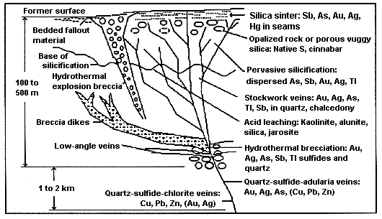
GENERAL REFERENCE Berger (1985).
GEOLOGICAL ENVIRONMENT
Rock Types Rhyolite.
Textures Porphyritic, brecciated.
Age Range Mainly Tertiary and Quaternary.
Depositional Environment Subaerial rhyolitic volcanic centers, rhyolite domes, and shallow parts of related geothermal systems.
Tectonic Setting(s) Through-going fracture systems related to volcanism above subduction zones, rifted continental margins. Leaky transform faults.
Associated Deposit Types Epithermal quartz veins, hot-spring Hg, placer Au.
DEPOSIT DESCRIPTION
Mineralogy Native gold + pyrite + stibnite + realgar; or arsenopyrite ± sphalerite ± chalcopyrite ± fluorite; or native gold + Ag-selenide or tellurides + pyrite.
Texture/Structure Crustified banded veins, stockworks, breccias (cemented with silica or uncemented). Sulfides may be very fine grained and disseminated in silicified rock.
Alteration Top of bottom of system: chalcedonic sinter, massive silicification, stockworks and veins of quartz + adularia and breccia cemented with quartz, quartz + chlorite. Veins generally chalcedonic, some opal. Some deposits have alunite and pyrophyllite. Ammonium feldspar (buddingtonite) may be present.
Ore Controls Through-going fracture systems, brecciated cores of intrusive domes; cemented breccias important carrier of ore.
Weathering Bleached country rock, yellow limonites with jarosite and fine-grained alunite, hematite, goethite.
Geochemical Signature Au + As + Sb + Hg + Tl higher in system, increasing Ag with depth, decreasing As + Sb + Tl + Hg with depth. Locally, NH4, W.
EXAMPLES
McLaughlin, USCA (Averitt, 1945and Becker, 1888)
Round Mountain, USNV (Tingley and Berger, 1985)
Delamar, USID (Lindgren, 1900)

