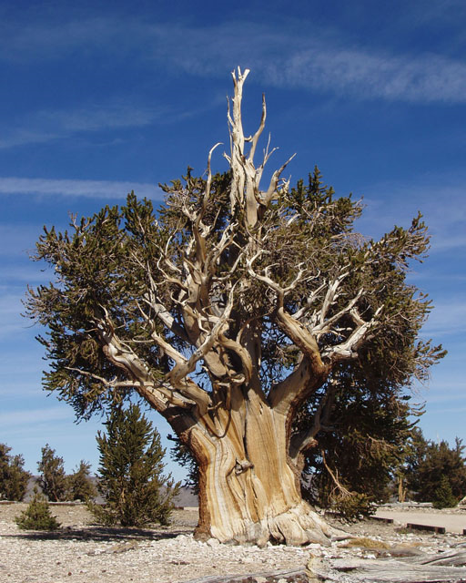
GEOLOGY FIELD TRIP
BRISTLECONE PINE NATIONAL FOREST
AND WHITE MOUNTAIN RESEARCH STATION
4x4 ADVENTURE
JULY 14, 2019

Dr. Gregg Wilkerson, 661-246-9485
yosoygeologo@gmail.com
FOR CSUB GEOLOGY CLUB

Join us in exploring the Bristlecone Pine National Forest and the White Mountains for this one-day adventure

8:00 AM Entrance to Bristlecone Pine National
Forest
10:00 AM Visitor’s Center
12:00 PM Bancroft Research Center
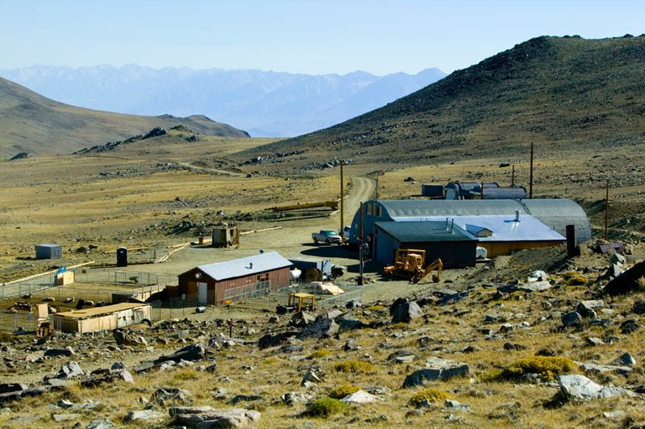
5:00 PM Return to Bristlecone Pine National
Forest Entrance

WHAT WILL I LEARN?

-Geology and mining history of the White Mountains
-Bristlecone Pine Trees, natural history and preservation
-Other flora and fauna
-High altitude scientific study programs and history of the Barcroft Station
-Scenic landscapes and breathtaking views

WHAT IS REQUIRED?

-Positive attitude for learning, adventure and exploration
-High Clearance 4x4 vehicle
-Knowledgeable and experienced 4x4 driver
-Boots, full-length pants, shirt, sunscreen, hat
-Food and water

RESERVATIONS: $20;
REGISTER THROUGH ADVENTURA AID AT: https://www.adventureaide.com/adventures/1548

