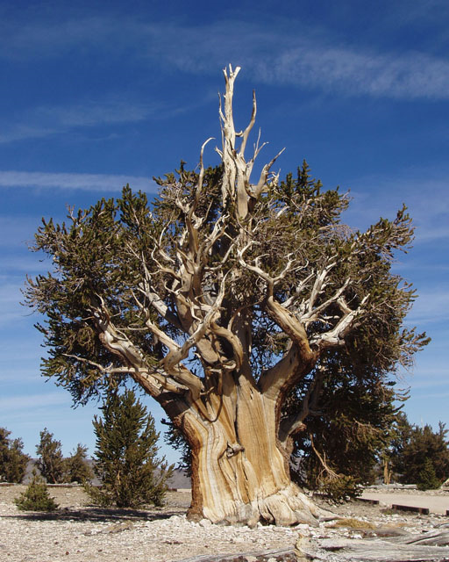
GEOLOGY FIELD TRIP
BRISTLECONE PINE NATIONAL FOREST
AND WHITE MOUNTAIN RESEARCH STATION
JULY 14, 2019

Join us in exploring the Bristlecone Pine National Forest and the White Mountains for this one-day adventure

8:00 AM Entrance to Bristlecone Pine National
Forest
10:00 AM Visitor’s Center
12:00 PM White Mountain Research Center
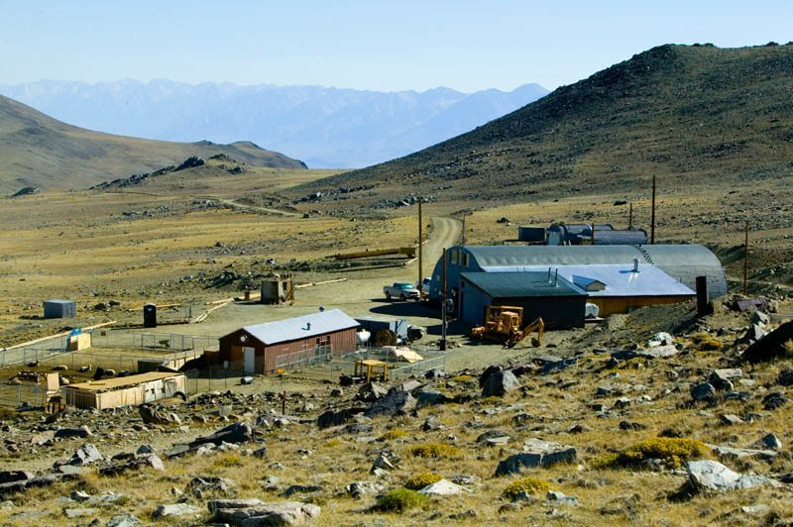
5:00 PM Return to Bristlecone Pine National
Forest Entrance

WHAT WILL I LEARN?

-Geology and mining history of the White Mountains
-Bristlecone Pine Trees
-Other flora and fauna
-High altitude scientific study programs and history of the Barcroft Station

WHAT IS REQUIRED?

-Positive attitude for learning, adventure and exploration
-High Clearance 4x4 vehicle
-Knowledgeable and experienced 4x4 driver
-Boots, full-length pants, shirt, sunscreen
-Food and water

COLLEGE CREDIT

You can receive 1 unit of Continuing Education College Credit through California State University Extension, Bakersfield, California

FACILITATOR AND TOUR GUIDE
Dr. Gregg Wilkerson
Adjunct Instructor
California State University, Bakersfield
Gwilkerson1@csub.edu
661-246-9495

RESERVATIONS: $20;
REGISTER THROUGH ADVENTURA AID AT:

