CHAPTER 2: THE EDITORS AND CANON OF THE OLD TESTAMENT
Contents
MYTH TO HISTORY, AND HISTORY TO MYTH 132
EVIDENCE OF EDITING 132
THE DOCUMENTARY HYPOTHESIS 137
Arguments for the Documentary Hypothesis 138
Parallel Accounts of the Same Event: Convergence 138
Linguistic Variations 139
Terminology 139
Consistent Content 140
Connections with Other Parts of the Bible 143
Sources’ Relationship to Each Other and to History 143
Arguments against the Documentary Hypothesis 153
Parallel Structure 153
Style variations 154
Theological Unity of the J/E/D/P documents 155
LOST TEXTS 155
In the Torah 155
In the Former Prophets (Joshua, Judges, Samuel and Kings) 156
In Chronicles and Nehemiah 156
THE MINISTERIAL FEUD: PRIESTS VS. LEVITES 157
EZRA/NEHEMIAH 158
EDITORS AND EDITORIAL SCHOOLS OF THE OLD TESTAMENT 158
CANON OF THE OLD TESTAMENT 159
Introduction 159
Tripartite Division of the Old Testament 160
Numerical Symmetry of the Hebrew Bible 160
22 or 24 Books? 161
The Canonization Sequence: Law then Prophets then Writings 162
Preservation vs Canonization 162
Early Importance of Torah 163
Samaritan Pentateuch (cir 432 BC) 163
Pre-Septuagint 163
Septuagint 164
20th Century Organization of the Old Testament 164
Apocrypha 165
Ecclesiasticus: Wisdom of Jesus ben Sirach (circa 170 BC) 166
Prologue of Ecclesiasticus: (cir 132 BC) 166
1 and 2 Maccabees (125-70 BC) 166
Old Testament Canon and the Dead Sea Scrolls 167
History of Discovery 167
Archaeological Context of the Dead Sea Scrolls and Qumran 180
Content of the Dead Sea Scrolls 183
The Old Testament Canon in New Testament times 184
The First Jewish Revolt: 70 AD 185
4 (2) Esdras 185
Flavius Josephus’ Contra Apionium (cir 100 AD) 185
Councils of Jamina (90 and 118 AD) 186
Jewish Doubts About the Hebrew Canon (2nd cent. AD) 186
Sopherim: 500 BC to 500 AD 187
Masorites: 500 AD to 1650 AD 187
The Christian Church Canon of the Old Testament 189
Eastern or Oriental Church 189
Western or Occidental Church 189
Protestant Canon of the Old Testament 190

The Old Testament that we read today is the result of a series of literary compilations, supplements and editions made by several people from a variety of backgrounds and theological persuasions over a period of several millennium.

Even the most extreme conservative fundamentalist will postulate that the Old Testament is the result of an editorial process. They would say that Genesis was written and transmitted by the Patriarchs themselves, that Moses compiled the Pentateuch, and that the writings about the Exodus, Conquest, Judges, United Monarchy, Divided Kingdoms and Exile were all pretty much literary creations of several different individuals that lived during, or shortly after, the events described. The common liberal (minimalist) idea is that the Old Testament is largely a mythical fabrication created during the Babylonian Exile to create a new Jewish nationalism.

It is not a question of if the Old Testament experienced editing by frail (but inspired!) humans. The better questions are: Who were the editors? When did they work? Where did the editing take place? What changes did the editors introduce? What was the cultural background and influences on those editors? We have before us the Final Edition. What did the "draft" versions look like?

MYTH TO HISTORY, AND HISTORY TO MYTH

In the process of compiling and editing, humans will do one of two things. They will either take historical events and metamorphose them into myths, or they will take myths and metamorphose them into history. When I was in elementary school, my teacher instructed me about George Washington. She told me that Washington chopped down a cherry tree and throwing a silver dollar across the Potomac River. To me, in the third grade, those stories were history. Now I know they were myths. But good ones. And I pass them on to my children.

Likewise, many Bible stories have basis in fact (history), but have been embellished or expanded upon to make fantastic tales. This is the process of mythologicalization. On the other hand, some stories, like the parable of Jonah and the Great Fish, take on the flavor of history over time. That is the process of historicalization. This is not to say that the stories, whether mythologized or historicized, are not true. There is truth in both myth and history. But it takes a discerning eye to tell them apart.

EVIDENCE OF EDITING

Many of the oldest written records have evidence of editorial process applied to them. The editorial correction process is sometimes observed in surviving texts themselves as the photographs below illustrate:

PHOTO LINK: SCRIPTS 009 Insertion of phrase. Millard, 1982, B&S, 11:2-3-4:39
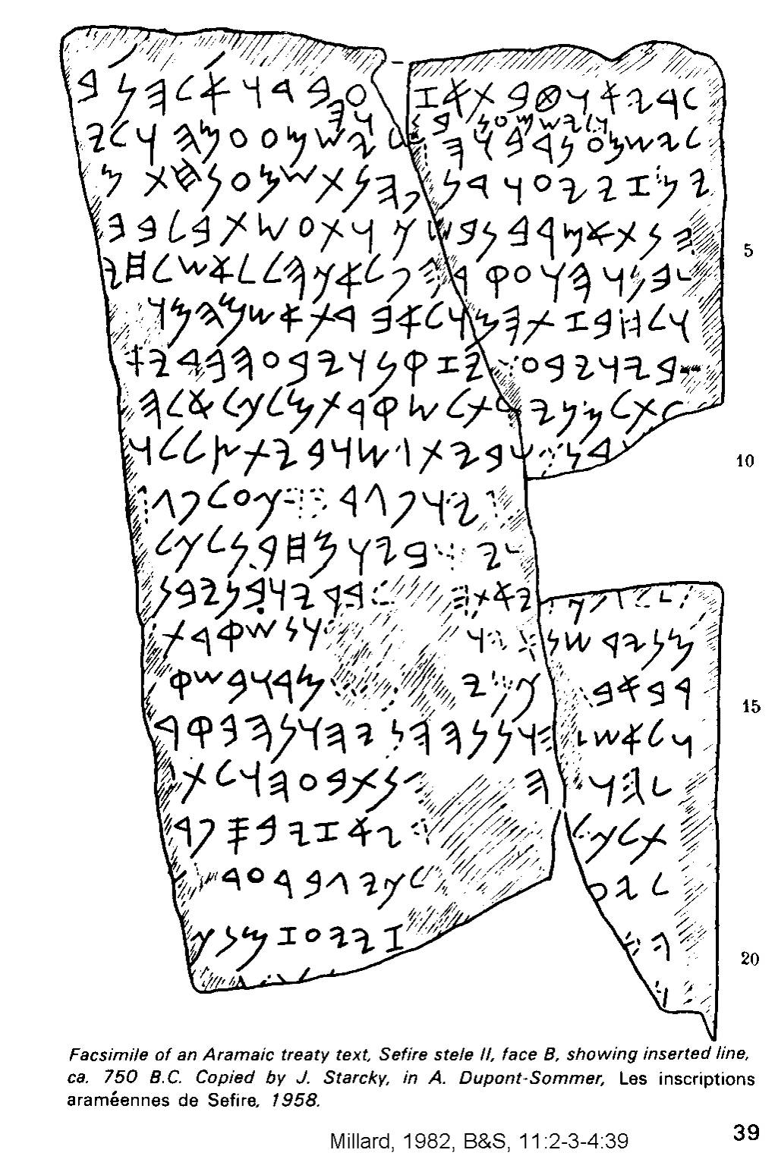

PHOTO LINK: SCRIPTS 009B Insertion of phrase (highlighted). Millard, 1982, B&S, 11:2-3-4:39.
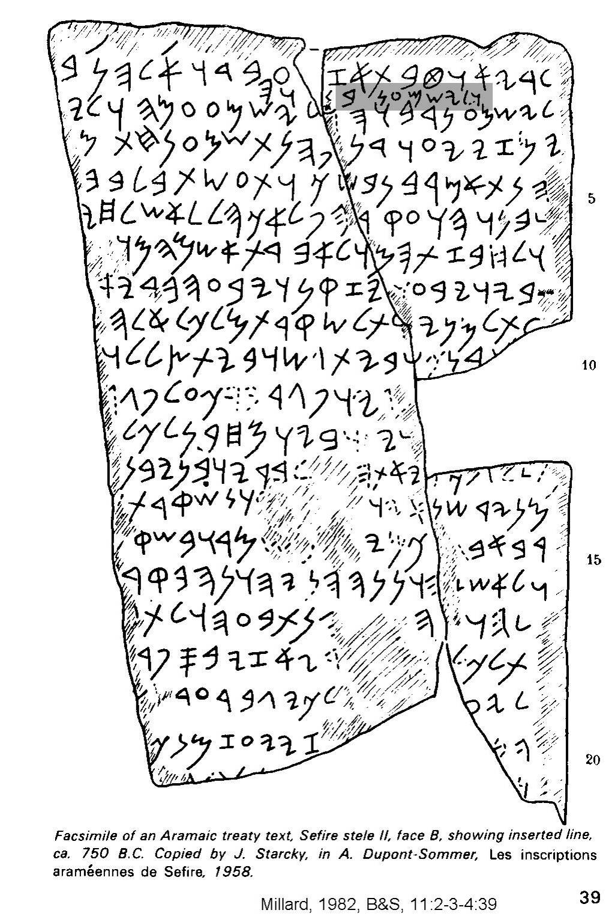

PHOTO LINK: SCRIPTS 010 Insertion of word in Balaam inscription; Millard, 1982, B&S, 11:2-3-4:41.
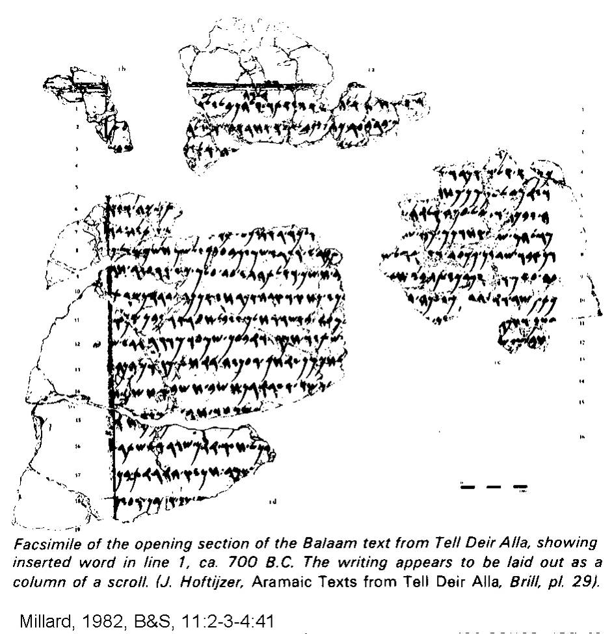

PHOTO LINK: SCRIPT 010B Balaam text with word insertion highlighted. Millard, 1982, B&S, 11:2-3-4:41.
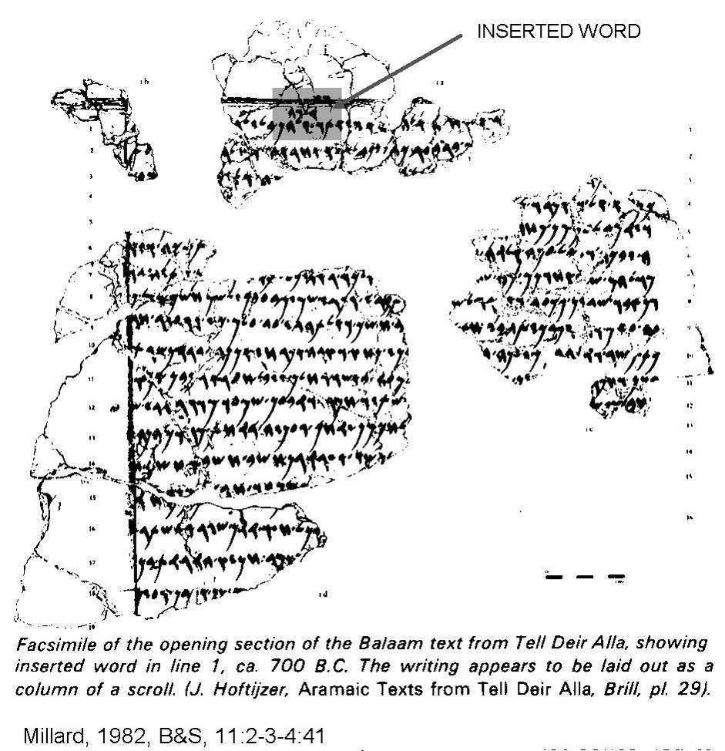

There is internal evidence in the Hebrew Bible that it is the result of a series of editorial revisions and additions. For example, in Judges 18:31, after the discussion of Micah, his personal Levite priest and personal idol, it is recorded that:

“Then they set up the carved image, and they appointed Jonathan…as their priest. This family continued as priests for the tribe of Dan until the Exile.”

The story of Micah itself shows blasphemous syncretism. It reflects accepted (tolerated) religious practices for Israelites before the Golden Age of the Monarchy under David and Solomon. But the verse had to have been written in the 5th century or later, well after the Fall of Jerusalem in 586 BC. Had the remnant Judeans or Israelites in captivity been inventing a pre-history, it is odd that they would include such non-Yahwistic and henotheistic syncretism in their national history as is illustrated in the story of Micah in Judges17 and 18.

THE DOCUMENTARY HYPOTHESIS

To answer the questions identified above, a methodology has evolved since the 1800’s CE. which is based on the premise that editorial phases of Old Testament compilation can be deduced from the style, content and certain word forms of in the Old Testament texts. In some form, this methodology is used, almost universally, to evaluate the Books of Moses and is today embraced by most liberal (minimalist) and some conservative (maximalist) scholars. It is a methodology that is fiercely opposed by fundamentalists. The methodology is called the "Documentary Hypothesis." It was originally proposed by Jean Astruc (d.1766 AD), K.H. Graft, and Julius Wellhausen. The central idea is that names of the Deity and associated theological motifs or dogmas found in different portions of the Hebrew Bible are related to an independent editor. There where four primary editors: J(ahwist), E(lohist), D(euteronomist) and P(riestly source). Later scholars expanded these four editorial sources with H(oliness code) and R(edactor). The use of the name YHWH (Yahweh, or "Jehovah"), known as the "tetragrammation", is a personal name of God used by the J editor. E(lohim), usually translated “God”, is believed to be the name for Deity used by the E editor. Theological revisionists amplified and altered the biblical texts throughout the Divided Kingdom, Exile, Second Temple and Persian periods.

A summary and defense of the Documentary Hypothesis is found in Friedman (2005). A summary of the Documentary Hypothesis sources is found below:

Letter | Name | Place | Date | First Line
J | Yahweh | Judah | 922-722 BC | In the day that YHWH made heaven and earth (Gen 2:4b)
E | Elohim (El) | Israel | 922-722 BC | And he lived between Kadesh and Shur (Gen. 20:1b)
RJE | Redactor of J and E | Judah | Post-722 BC | And Abraham traveled there to the Negeb country (Gen. 20:1a)
P | Priestly | Jerusalem | Post-722, not long after RJE, perhaps in Hezekiah’s reign (715-687 BC) | In the beginning, God created (Gen. 1:1)
D | Deuteronomy | Judah Jerusalem? | Dtr1: First edition King Josiah (640-609 BC)  Dtr2: Second Edition post Exile (post 587 BC) | These are the words that Moses spoke (Deut 1:1)
R | Redactor (Ezra the priest?) | Jerusalem | Mid-5th century BC | These are the records of the skies and earth, when they were created (Gen 2:4a)
Table adapted from Friedman (2005:20)

The content of the different Documentary Hypothesis sources is summarized in the table below:

Letter | Content
J | Garden of Eden, Cain and Able, The Flood, Tower of Babel, Patriarchal Narratives, Sodom and Gomorrah. Joseph, Moses, Sinai Covenant, Desert Wanderings, the Exodus
E | No creation or flood stories. Mid-Abraham, Isaac, Jacob, Joseph, Moses, Plagues of Egypt, Sinai Covenant, Desert Wanderings, Near Sacrifice of Isaac
RJE | After Assyrian conquest of Israel in 722 BC, synthesis of J and E
P | An alternative history to the JE stories, includes tradition that named YHWH not known until time of Moses
D | Deuteronomistic History: Deuteronomy, Joshua, Judges, 1 and 2 Samuel, 1 and 2 Kings
R | Final compiler and editor, final 5 books of the Pentateuch
Information from Friedman, 2005

Arguments for the Documentary Hypothesis

Parallel Accounts of the Same Event: Convergence

Doublets, stories or laws that are repeated, are found over 30 times in the Torah. Doublets are considered evidence for compilation from different sources (Friedman, 2005:49).

For example, there is evidence for editing in the two creation stories of Genesis 1 and 2. Adam has one line of descendants through Cain in Genesis 4:17-21 through Cain and another line, through Seth (with some like-sounding names) in Gen. 5. In the Noah story, there are two descriptions of birds: Genesis. 7:2 prescribes seven of each type of bird and Gen. 7:8 prescribes that only two be taken aboard the Ark. Other evidence of parallel stories merged together through editing are discussed by Hurowitz (1996):

Abraham makes to covenants with God (at Salem?, Gen. 15 and at Mamre? Gen. 17). Jacob leaves home twice and for different reasons (Gen 27:43-45 and Gen 27:46-28:9), God reveals His name to Moses twice (at Midian, Ex. 3:13-16 and in Egypt Ex 6:2-3), and there are two stories about Aaron and Moses drawing water from the rock (Ex. 17:1-7 [at "desert of Sin"] and Num 20:1-6 [at "desert of Zin"]). Laws given in Exodus are revised or contradicted by laws in Leviticus, Numbers and Deuteronomy. The Tent of Meeting is at times a portable Temple within the camp in which God resides (Ex. 25-31, 36-40) and at other times it is a tent outside the camp where Moses retires when he wants a revelation (Ex. 33:7 -11). The Ark of the Covenant in one place is an acacia-wood box plated with gold (Ex. 25:10-22), and at others it is simply an unadorned wooden box (Deut. 10:1-5). The camp is led in one text by Horeb (Num. 10:29-39), and in another by a cloud and pillar of fire (Num. 10:11-28). The Ark goes before the camp a distance of three days in one instance (Num. 10:33), but is carried in the midst of the camp in another (Num. 2:16-17; Hurowitz, 1996; Friedman, 2005:49).

Additional examples of inconsistencies, presumably the result of multi-stage editing, within the Old Testament text are provided in Appendix 1.

Linguistic Variations

Just as the English spoken in the 6th century AD is different from modern English, ancient Hebrew went through an evolution. The earliest forms of Hebrew are used in the J and E sources. P comes from a later stage, and D even later. P uses language that the Hebrews used prior to the Book of Ezekiel, written during the Babylonian Exile (Friedman, 2005:21)

Terminology

Certain words are diagnostic of certain time periods in evolution of language and in a people’s history. In English, for example, literature with the word “groovy” could be dated to the 1960’s, while the word “rad” could be dated to the late 1990’s and early 2000’s. Some words and phrases occur in only one source. Some examples are given below from Friedman (2005:21):

Word or phrase | J | E | P | D
Mountain of the Mosaic Covenant | Sinai | Horeb or Mountain of God | Sinai | Horeb or Mountain of God
“Place where YHWH causes his name to dwell” | Never | Never | Never | 10 times in D
“Gathered to his people” = death | Never | Never | 11 times in P | Never
“to know” = sex | 5 times in J | Never | Never | Never
Sheol = place of the dead | 6 times in J | Never | Never | Never
“be fruitful and multiply” | Never | Never | 12 times in P | Never
“with all your heart and soul” | Never | Never | Never | 9 times in D
“congregation” | Never | Never | Over 100 times in P | Never
“to suffer” | 7 times in J | Never | Never | Never

Consistent Content

Certain ideas are unique to particular sources, and treated constantly within those sources (Friedman, 2005:23).

God’s Name

Different sources have different traditions about when God’s name was revealed. J relates that the name YHWH was known to the earliest generations of humans. According to J, the name YHWH began to be used after the flood. In Genesis 4:26, J states “Then it was begun to invoke the name of YHWH”. E and P have a different theory. They say that the name was not revealed until the time of Moses, In the E and P traditions, YHWH tells Abraham that his name is El Shadday in Genesis 17:1 (Friedman, 2005:23).

“YHWY appeared to Abram and said to him,
I am El Shadday”

In the E and P tradition, relating of Moses, they say, in Exodus 6:2-3:

“And God spoke to Moses and said to him “I am YHWH. And I appeared to Abraham, to Isaac and to Jacob as El Shadday, and I was not known to them by my name YHWH.”

Sacred Objects

The different sources have different ideas about sacred objects. For example, P is very concerned with the Tabernacle and discusses it at length. But J and D never mention it. As for E, the tabernacle is mentioned only three times. As for the Ark of the Covenant, it is described as being critical to Israel’s wanderings and military exploits by J in Numbers 10:33-36, 14:44. But the Ark of the Covenant is not mentioned in E (Friedman, 2005:23).

In E, miracles are performed with Moses’ staff (Ex. 4:2-5,17,20. 7:15-17,20b, 9:23, 10:13, 17:5-6,8). But in P, miracles are performed with the staff of Aaron, reflecting the priest’s preoccupation with Aaronic succession and authority (Ex. 7:9-12,19, 8:1-2,12-13, Num. 17:16-26, 20:8; Friedman, 2005, 23).

Continuity of Narrative

When the different, now merged, sources are identified and separated, each source can be read separately. An example is Exodus 14 where two interwoven stories of the Red Sea are given. Each story could be read separately (Friedman, 2005:23).

PHOTO LINK: DOCUMENTARY HYPOTHESIS 001 Color coded text of Exodus 14. Friedman, 2005, BR, 21:4:47.
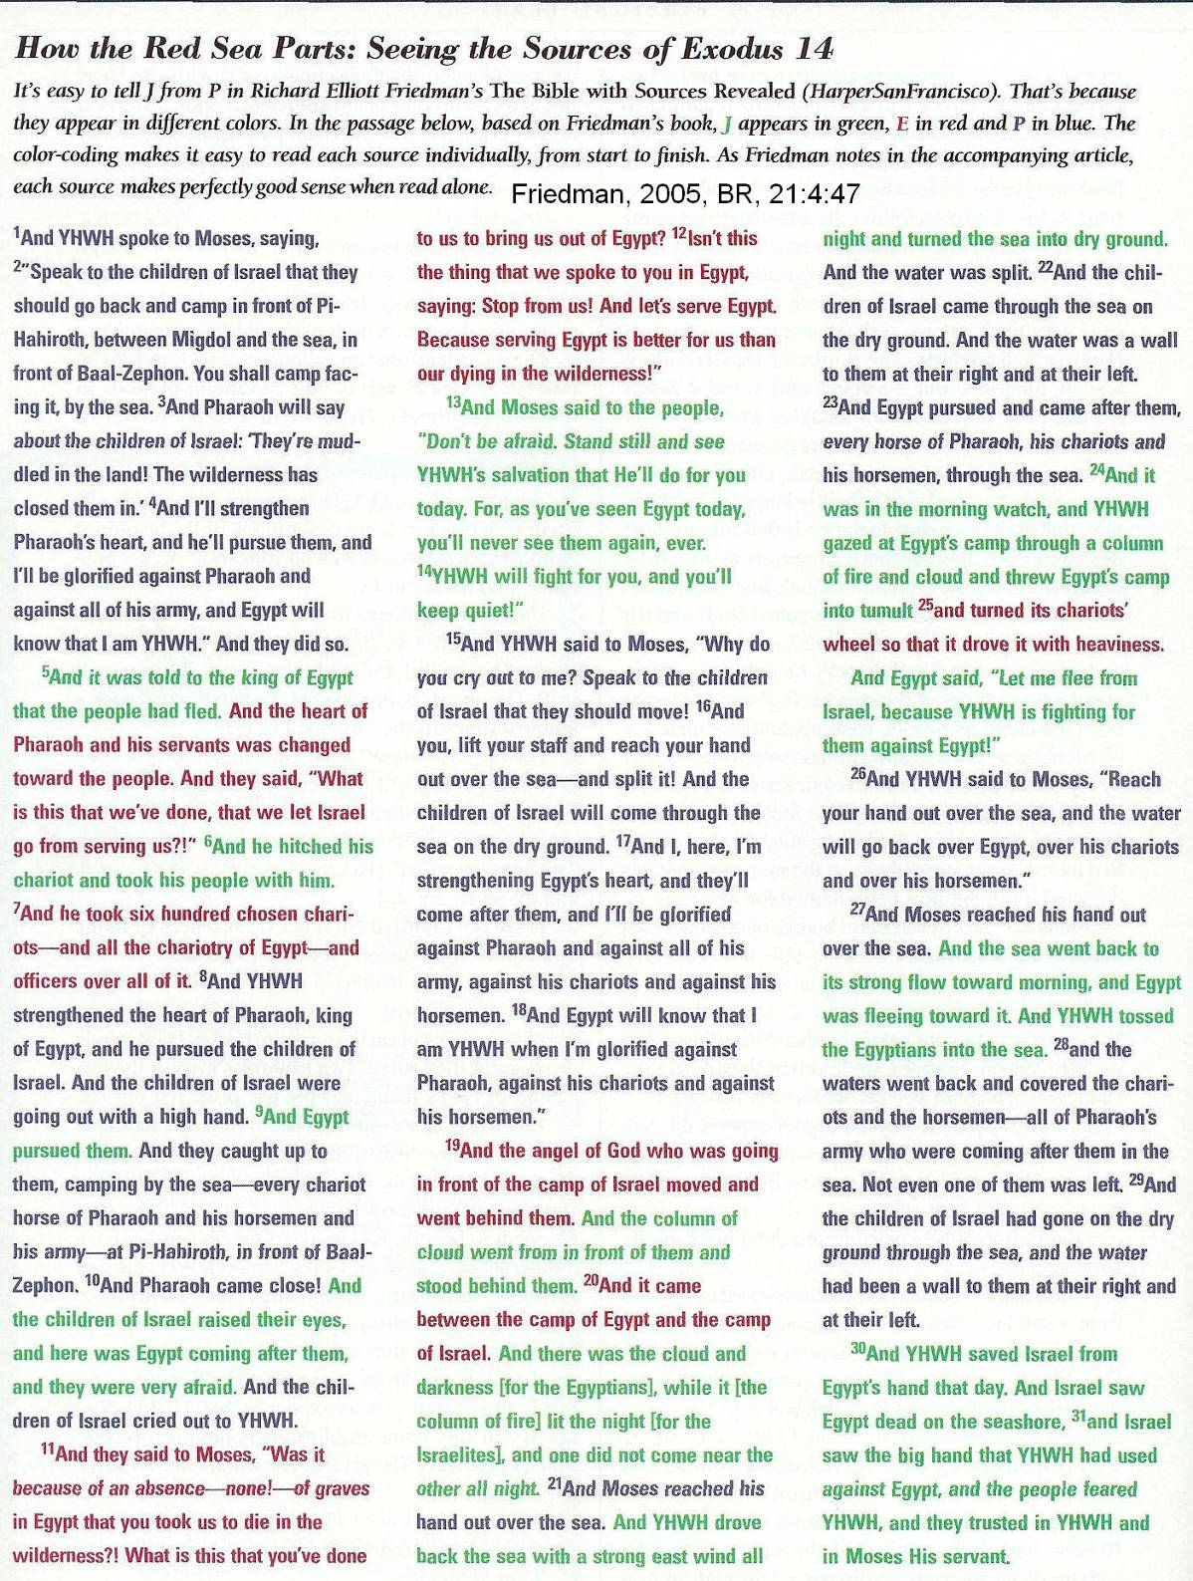

Connections with Other Parts of the Bible

The different sources have specific affinities with other parts of the Bible (Friedman, 2005:23):

Source | Affinity
D | Book of Jeremiah
P | Book of Ezekiel
J and E | Book of Hosea
J | Court History of David in Second Book of Samuel

Sources’ Relationship to Each Other and to History

Because the different editorial sources, or editorial schools, of the Documentary Hypothesis operated at different points in the history of the Hebrews, they have theological and geographic prejudices. They also have predictable relationships to each other (Friedman, 2005:23).

J (Yahweh)

J has numerous passages that focus on the southern kingdom of Judah. The J source is believed to be produced there. In the J version of the Abraham narrative, he lives in Hebron/Mamre (Genesis 13:18, 18:1). This may be because Hebron was Judah’s capital. The scouts of the Promised land sent out by Moses, in the J source, report obout Hebron and other Judahite towns. What would become the northern Israelite towns are not mentioned by J (Num 17-20, 22-24).
Only in the J source does Judah, a son of Jacob and patriarch of the Judean tribe, get any attention (Friedman, 2005:23).

In J, the births and naming of the first four sons of Jacob, Reuben, Simeon, Levi and Judah are discussed. The next eight sons are ignored. But in E, stories of births and naming do not include the first four sons of Jacob, but instead tell about the other eight: Dan, Naphtali, Gad, Asher, Issachar, Zebulon, Benjamin, as well as the half-tribes of Ephriam and Manasseh (Friedman, 2005:23).

E (Elohim)

In contrast, the E source is more concerned with telling the histories of the Northern tribes. E is very interested in the relationship of the Levites to the northern tribes and to the priesthood at Shiloh. In E, stories of births and naming do not include the first four sons of Jacob (as does the J tradition), but instead tell about the other tribes: Dan, Naphtali, Gad, Asher, Issachar, Zebulon, Benjamin, as well as the half-tribes of Ephriam and Manasseh (Friedman, 2005:23).

In E, Jacob fights with God at Penuel, a site in the northern kindom. That site later became the capitol for Israel’s first king, Jeroboam I (1 Kings 12:25; Friedman, 2005:23).

J and E have very different views of David and Solomon. To J they are heroes and examples of godlyness. Not so with E. The E source uses the same words to describe the Egyptian enslavement of the Hebrews (Ex. 1:11) and the Solomonic enslavement of Israelites (1 Kings 12:18; Friedman, 2005:23).

The long-standing feud between priests and Levites can be identified in E. The writer of E knew and respected the priests of the northern Israelite city of Shiloh. King Solomon alienated that priesthood by expelling Shiloh’s chief priest, Abiathar. Then Solomon replaced Abiathar with Aaronid priests, persons tracing their ancesry to Aaron. Those Aaronite priests consistently get top billing in E. It was no accident that in the E tradition, the prophet Ahijah from Shiloh instigated Jeroboam’s rebellion against Solomon which resulted in the northern Israelite federation (Friedman, 2005:23).

P (Priestly Code)

P is associated with the reforms of Hezekiah, king of Judah (715-678 BC). The ministerial feud between priests and Levites is exacerbated by P. In the P tradition, only Aaronide priests may serve at the Temple and offer sacrifices. The non-Aaronide priests are relegated to less prestigious duties like singing and caring for cult objects (Friedman, 2005:48). The Book of Chronicles (parts 1 and 2), are a history of Israel with the political spin of pro-Davidic, anti-Aaronide priesthood. Early classifiers of Chronicles placed it along side the “Writings” with Psalms, Proverbs and Song of Songs. It was not grouped with Kings because, even during the Exile and return under the Persians, it was realized that the history presented in Chronicles is biased. Significantly, the Chronicler (2 Chron. 31:2) describes the distinction between Aaronic priests and Levites:

“Then Hezekiah installed the priests and the Levites in office, division by division, allotting to each priest of Levite his own particular duty, for whole-offerings or shared-offerings, to give thanks or to sing raise, or to serve in the gates of the several quarters of the Lord’s house.”

P has a different opinion about the proper place of worship and sacrifice than does J and E. In the P tradition, sacrifice can happen legitimately only at the Tabernacle or at the Jerusalem Temple. But to J and E, sacrifice at other locations is OK. The centralization of the YHWH cult at the Jerusalem Temple happened during the reign of Hezekiah as did the rise of the Aaronite priesthood associated with that centralization. The P tradition knew of the J and E sources. Therefore, the sequence of stories (Creation-Fall-Flood-Tower of Babel-Abraham) in P is the same as in J and E. But P had a different agenda. The Redactor merged the J, E and P traditions but did not blend them. So the P narrative can still be recognized as its own original composition. When read on its own, it still flows as a continuous text.

The theological understanding and political motivations of P can be detected at several points. P is dedicated to the centralization of worship at the Tabernacle. So P mentions no sacrifices until Exodus 40 (Friedman, 2005:48).

Sacrifice | J | E | P
Cain and Able (Gen. 4:3-5) | Yes | Yes | No
Noah (after Flood, Gen. 8:20) | Yes | No | No
Abraham (Gen. 12:7) | Yes | Yes | No
Near-Sacrifice of Isaac (Gen. 22:6-8) | No | Yes | No
Moses (Ex. 40) | Yes | Yes | Yes

P has a very different understanding of how God communicates with people than does J and E. To P, the only way for people to know about God is through priests. P does not talk about angels, dreams or talking animals and avoids anthropomorphisms, as are common in J and E (Friedman, 2005:48).

Story | J | E | P
Garden of Eden (YHYH walks with Adam and Eve, Gen 3:8) | Yes | No | No
Fall (talking Snake, Gen 3:4) | Yes | No | No
Baalam and the talking mule (Num. 22:22-32) | Yes | Yes | No
Three angelic visitors and Abraham (Gen. 18:2) | Yes | No | No
Jacob wrestles with God (Gen. 32:24-28) | No | Yes | No
Angel and the Burning Bush (Ex. 3:2-3) | Yes | No | No
Joseph’s Dreams (Gen 37:9-11; 40:9-10; 41:15-36) | Yes | Yes | Joseph, yes but dreams, no

D and Deuteronomy

The book of Deuteronomy means “Second Telling”. Like all second versions, it differs in subtle and drastic ways from the original “telling” in Exodus, Numbers and Leviticus. The “evolution” of Hebrew theology from the times of Genesis through the time of Exile can be deducted from differences between Deuteronomy and older textural traditions (Weinfeld, 1996). Deuteronomy is part of a seven-book collection that tells the history of Israel from Moses to the Exile in Babylon (Deuteronomy, Joshua, Judges, 1 and 2 Samuel, 1 and 2 Kings). It is called the Deuteronomistic History because it tells is based on the theological presuppositions of Deuteronomy (Friedman, 2005:48). A counter-deuteronomistic History is given in Chronicles.

The Deuteronomist editors were active in the reign of Josiah, king of Judah (640-609 BC) and were responsible for what has been called the Second Jewish Reformation (Weinfeld 1996; Friedman, 2005:48).

The Deuteronomist editorial activities stem from the "discovery" in 622 of an early version of Deuteronomy (2 Kings 22:8; 2 Chronicles 34:14) by High Priest Hilkiah in the Jerusalem temple. Hilkiah and King Josiah centralized worship in the Jerusalem Temple. They dismantled and destroyed outlying rural shrines. The provincial Levites were dispossessed by this policy but were allowed to serve in the Jerusalem Temple. Animal sacrifices were authorized only at the Jerusalem Temple. In compensation, the provinces were given an abstract religion, one without sacrifice or iconography. It was a religion of prayer and liturgical practice. This change was resisted and unauthorized “country” worship flourished in various forms (Weinfeld, 1996).

One element of this shift in official theological policy was that the Temple no longer was formerly described as a place for Yahweh to physically dwell (2 Sam 7:5-6; 1 Kings 6:1-2; 8:13). Instead, in Deuteronomy his name dwells in the Temple (Deut 12:11,21; 14:23-24; 16:2,6,11; 26:2; 2 Sam 7:13; 1 Kings 3:2, 8:17-20,44,48). In Deuteronomy, God's residence is heaven, not the Temple (1 Kings 8:43-45; Deut 26:15). At Mount Sinai, God is physically present in the burning bush of Exodus 19:18,20. But in the parallel account in Deuteronomy 4:36 it is his voice that is present. Pre-Deuteronomic texts tell of death as a result of seeing God (Gen. 32:31; Ex 33:20, "Man shall not see me and Live"). But in Deuteronomy (4:33; 5:23) the danger is hearing his voice (Weinfeld, 1996).

Also, the status and function of the Ark of the Covenant changed. It was originally part of Yahweh's throne room, his footstool (Ex 25:18-22; Ps 80:2 "You are enthroned upon the cherubim"; Is 37:16; 2 Kings 19:15; 1 Sam 4:4; 2 Sam 6:2). In Deuteronomy the Ark holds the tablets of the Law, without any cherubim. In Pre-Deuteronomic texts, the Ark goes with the Israelites into battle, (Num 14:44; 1 Sam 4:7), but in Deuteronomy no mention of the Ark is made (Deut 23:15; Weinfeld, 1996).

PHOTO LINK: CHERUBIM 001 Nimrud ivory Cherubim. Hurowitz, 1994:BR, 10:2:53.
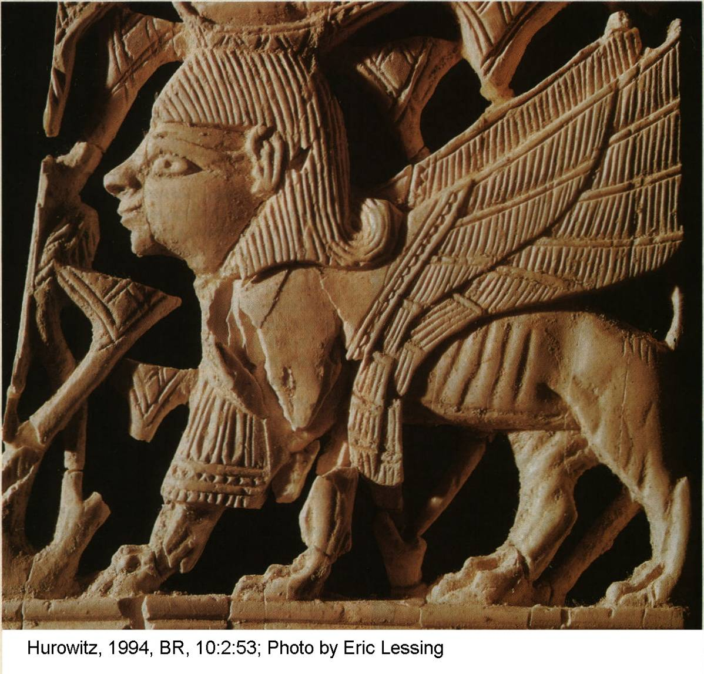

PHOTO LINK: CHERUBIM 003 Bronze cult stand with cherubim Cypriot-Phoenician, 8th century BC. Borowski, 1995, BAR, 21:4:3.
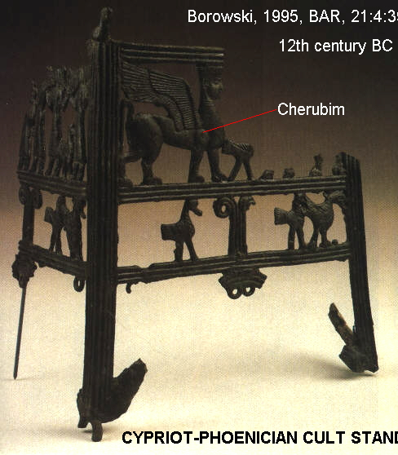

PHOTO LINK: CHERUBIM 002 Ivory Cherubim, 8th century BC Arsian Tash, Syria; Ezekiel 1:10. Borowski, 1995, BAR, 31:4:front cover. Photo by David Harris. Bible Lands Museum.
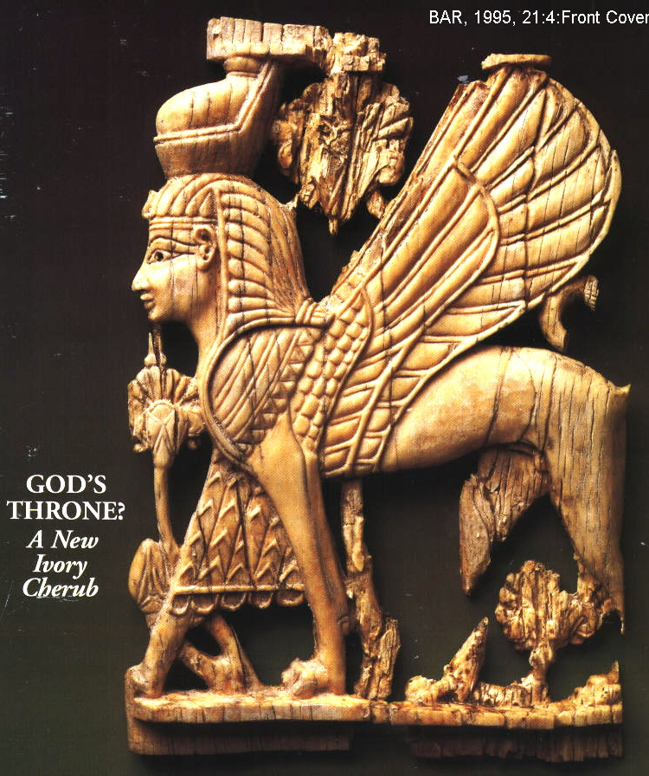

PHOTO LINK: CHERUBIM 004 Sphinx vs Cherubim; Arslan Tash ivory of cherubim and Nimrod ivory of sphinx. Borowski, 1995, BAR, 21:4:40.

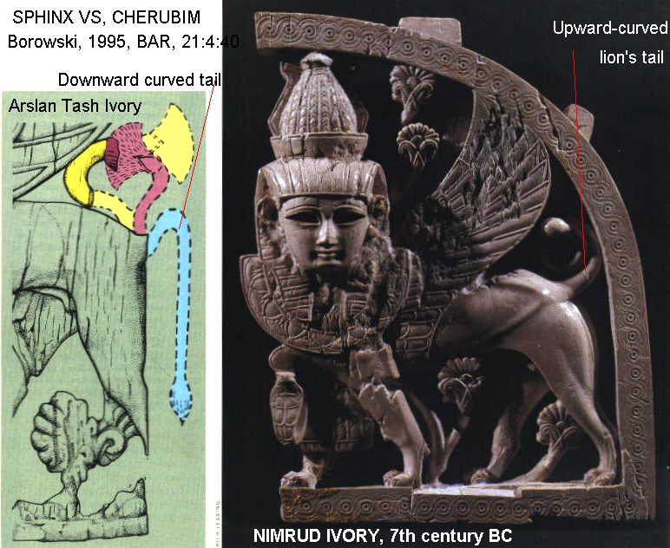

Deuteronomy seeks to eliminate angels from Israelite religion. In Ex 23:20-23 and Num 20:15-16 an angel leads the people to the promised land while in Deut 7 and 4:37, the Lord himself performs this act. Deuteronomy expiates sin through prayer (see Deut 21:1-9), while in Leviticus (1:9,13,17; 21:6,8,17,21) a "pleasing order" of burnt sacrifice is needed. The prayer ritual of Deuteronomy is conducted by elders without priestly intermediaries. Deuteronomic sacrifices are consumed in the sanctuary by the people offering them or distributed to destitute members of Israelite society (Deut 16:11). Pre-Deuteronomic sacrifices were holocaust offerings where everything was burned, or eaten only by the priests (Weinfeld, 1996).

The 4th commandment in Exodus (20:11; 31:17) is modeled on Creation and God's seventh day of rest. In Deuteronomy 5:15 the reason for the 4th commandment is the Exodus ("you were slaves in the land of Egypt"). Deuteronomic editing can be identified by the following issues and their associated phraseology: 1) struggle against idolatry and syncretism, 2) centralization of the cult in Jerusalem, 3) covenant and election of Israel, 4) monotheistic creed, 5) observance of the law 6) inheritance of the land, 7) retribution, 8) fulfillment of prophecy, and 9) Dravidic dynasty (Weinfeld, 1996). The theological and liturgical shifts that accompanied Josiah’s reforms and the Deuteronomist theory are listed in the table below:

Topic | Pre-Deuteronomy | Deuteronomy
God | Personal, anthropomorphic, walks with men comes down from heaven (Exodus 19:18,20), present in the temple which is God’s house.(2 Sam. 7:5-6, 1 Kings 6:1,2;;8:13). God is the supreme true god among many. | Detached, cosmic, in heaven (1Kings 8:43-45), spirit, his “name” dwells in the temple. (Deut 12:11,23;;14:23-24;;16:2,6,11;;26:2, 15). There is only one creator God. Others are fabrications (idols).
Place of Worship | In local worship centers (“high places”) with alters throughout the land | Centralized worship in Jerusalem
Primary religious leaders | Local Levites | Temple Priesthood. Provincial Levites imported to Jerusalem and receive equal shares with the priests (Deut. 18:6-8) and share in holy feasts and gifts (Deut 12:12,18::14:27,29::16:1-14}.
Type of Worship | Local animal sacrifice | Animal sacrifice only at Jerusalem temple, local provincial shines converted to places of prayer and liturgy
Significance of Sacrifice | Sacrifice is “pleasing odor” or food for God (Leviticus 1:9,13,17;;21:6,8,17,21). Sin-and-guilt offerings (Leviticus 4 and 5). Transference of sin to scapegoat (Leviticus 16:21) | Prayer expiates sin (Deut 21:1-9, common guilt for unresolved murder). No ceremonial slaughter, sprinkling of blood (Leviticus 4:17) or scapegoat. Instead, offerings are voluntary and votive (Deut 12:6,11,17,27).
Focus of Sacrifice | Communal repentance. Aaron and his sons consume the un-burnt portions of sacrifice (Leviticus 2:3;;6:18). Yahweh gets the fat and some internal organs of most offerings, except Holocaust (Leviticus 3:17) | Personal gratitude. Sacrifice consumed by supplicant (Deut 12:6,11,17,27). At religious festivals, sacrifice also consumed by slaves, alien resident, orphan widow and Levite (Deut 16:11-12).
Nature of Religion | Earthy, connected to life cycles | Abstract
Seeing God | Results in death (Exodus 33:20; Gen. 32:31) | See only manifestations of God, e.g. fire. His voice from the fire can kill (Deut 4:24; 5:23-25)
Ark of the Covenant and Cherubim | God’s thrown. (Exodus 25:18-22; Psalms 80:1-2; Isaiah 37:16; 2 Kings 19:15; 1 Samuel 4:4; 2 Samuel 6:2). Brought out for special occasions (Numbers 10:33-36; 1 Samuel 4:5-7) | No cherubim. Only function of Ark is to hold the tables of the covenant. In parallel passages about the Ark outside the temple, no mention is made of the Ark (compare Deut 23:15 with 1 Samuel 4:5-7)
Angels | Divine messengers and participants in God’s work (Exodus 23:20-23, angels escorts Israelites into Canaan; Numbers 20:15-16, God sends angel to lead Israelites out of Egypt) | God alone performs his work (Compare Deut. 7, 8 and 9 where no angels are mentioned in connection with entry into Canaan; Deut 4:37, God himself leads Israelites out of Egypt)
Reason for the Sabbath | God’s model in creation (Exodus 20:11; 31:17) | Israelites were slaves in Egypt (Deut 5:15)

D is a promoter for Josiah. He compares Moses to Josiah. While Deut. 34:10 says “There has never yet risen in Israel a prophet like Moses”, 2 Kings 23:25 says of Josiah that “after him, none rose like him”. That expression “none like him” is applied to no other king in the Hebrew Bible except Josiah (Friedman, 2005:48).

In D, Moses instructs the people to “love YHWH your God with all your heart and with all your soul and with all your might”. In a parallel construction, it is said of Josiah that he alone turned to YHWH “with all his heart and with all his soul and with all his might (2 Kings 23:25). This three-fold criteria: heart-soul-strength applies no where else but in these two verses (Friedman, 2005:48).

In the D source, there is the “Law of the King” which outlines the requirements of covenant and the monarchy. This law requires the king to do exactly as instructed by the priesthood and “not turn from the commandment, right of left” (Deut. 17:11,10). Only king Josiah is reported to have behaved this way (2 Kings 22:2; Friedman, 2005:48).

The D enthusiasm for Josiah is a direct result of Josiah’s religious reforms. Again Josiah’s actions are parallels to earlier actions by Moses. When Moses burned the golden calf, he ground it “thin as dust” (Deut. 9:21). When Josiah destroys the golden calf erected by King Jeroboam at Bethel, he imitated Moses and “made it as thin as dust” (2 Kings 22:2). In the Hebrew Bible the phrase “thin as dust” occurs only in the context of Moses or Josiah (Friedman, 2005:4)8.

A further praise for Josiah is made by D in the Deuteronomistic History when Jeroboam first makes the golden calf at Bethel, a “man of God” declares that someday a king descended from David will ruin the Bethel alter, and adds “Josiah is his name!” (1 Kings 13:2; Friedman, 2005:48).

Josiah also obeyed the commandment of Deut. 12:3: “You shall demolish their alters…and burn their Asherah.” It is recorded of Josiah in 2 Kings 6:12 that he “took the symbol (pole) of Asherah from the house of the Lord…outside Jerusalem…burnt it there and pounded it to dust…” (Friedman, 2005:49)

These correlations between Moses and Josiah indicate that D wrote his history during the reign of Josiah, or shortly thereafter.

Arguments against the Documentary Hypothesis

Parallel Structure

Objections to the Documentary Hypothesis, which is a guiding light for textural criticism, include the parallel structures in the Hebrew Bible that use more than one divine name. An example is the parallel structure of Exodus 6:2c-3 (Garrett, 1993):

A: I am Yahweh
B: And I made myself known to Abraham, to Isaac, and to Jacob as El Shaddai.
A': And My name is Yahweh
B': Did I not make Myself known to them

The name Yahweh emphasizes who God is (savior). While El(ohim) emphasizes what God is (creator; see Garrett, 1993). This distinction in meaning would not be possible based only the verses with Elohim or Yahweh.

Repetition (doublets) and, parallel accounts (redundancy) are not easily explained the Documentary Hypothesis (Garrett, 1993), unless one is willing to accept them as carefully crafted plagiarisms from earlier authors. An example of a doublet is the parallel structure of Genesis 7:21-22:

A: They perished
B: Every living thing that moves on earth...
B': Everything that has the breath of the living spirit...
A': They died

Another example of the careful structure of some Old Testament stories is the Flood of Genesis 6:10-9:19. The chiastic structure is illustrated in Figure 3 of Garret (1993).

PHOTO LINK: FLOOD 001 Chiastic Structure of the Flood Story. Garrett, 1993, B&S, 6:2:44.
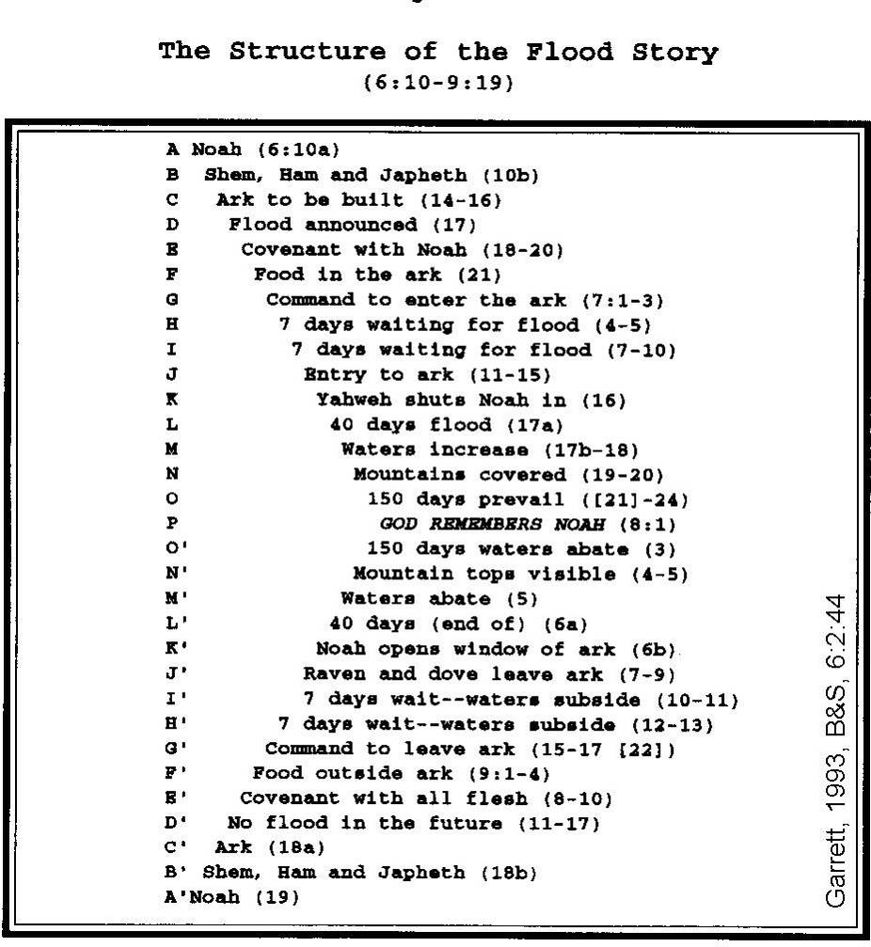

Style variations

Documentary Hypothesis advocates say they can detect different authors by variations in their writing style. Those who object to the Documentary Hypothesis point out that this technique is a subjective analysis that lacks credibility. The same authors may change their style and word choices when writing on different topics or at different periods in their own lives. The editors from different eras may have used the same stylistic inventions. For example, a contemporary playwright may tell a newly created story about Victorian England, full of Old English works like “thee” and “thou” and “doth”. But that style does not mean the newly created story was written in the 1700’s. Using the Documentary Hypothesis, that would be the (erroneous) conclusion.

Theological Unity of the J/E/D/P documents

Conservative scholars say that the theological unity of the Old Testament is not what would be expected from a series of different author/editors. But is that argument based on interpretation or evidence? Certainly, some Old Testament texts paint a different portrait of the Deity and His plan for humanity (or certain segments of humanity, e.g. the Hebrews) than other texts do. The unity we perceive today may be the result of careful editing of contradictory theology by the “final” editors. Fortunately, that homogenization in a quest for theological unity was never completed.

The following verses are often cited in debates about the Documentary Hypothesis. The illustrate the lack of consistency between the Biblical writers:

Gen 4:26 Seth had a son...at that time people began to pray to the Lord (YHWH)

Ex 6:3 Then the Elohim said to Moses, “I am YHWH . I appeared to Abraham, Isaac and Jacob by the name El Shaddai (God Almighty), but they did not know me by my name, YHWH.

Gen 1:1 to 2:3 In verses before Genesis 2:4, the creation story uses Elohim to refer to God. In the rest of Genesis, the Lord (YHWH), or Lord God (YHWH Elohim) is used.

LOST TEXTS

The Hebrew Bible contains several references to literary works that have not survived. These lost books are identified by Christensen (1998:29) and reproduced below:

In the Torah

-The Book of the Wars of Yahweh
(Numbers 21:14-15) This book speaks of Vaheb and Suphah and the gorges

In the Former Prophets (Joshua, Judges, Samuel and Kings)

-The Book of Jashar (Joshua 10:12-13; 2 Samuel 1:19-27; and 1 Kings 8:12-13 [in LXX])
Josh 10:12-13; “So the sun stood still...is written in the Book of Jashar (or Book of the Upright)”
II Sam 1:18; “David made this lament over Saul...it was written down..in the Book of Jashar”

-The Chronicles of the Kings of Judah
(mentioned 15 times)

-The Chronicles of the Kings of Israel
(mentioned 18 times)

-The Acts of Solomon (or Book of the Affairs of Solomon) (1 Kings 11:41)
“The events of Solomon’s reign...recorded in the annals of Solomon”

In Chronicles and Nehemiah

-Book of the Kings of Israel
(1 Chronicles 9:1; 2 Chronicles 20:34)

-Book of the Kings of Judah and Israel
(2 Chronicles 18:11)

-Book of the Kings of Israel and Judah
(2 Chronicles 27:7)

-Acts {or Chronicles) of the Kings of Israel
(2 Chronicles 33:18)

-Acts (or Chronicles) of Samuel the Seer, Gad the Seer and Nathan the Seer
(1 Chronicles 29:29) “The events of King David’s reign...recorded in the book of Samuel the seer, of Nathan the prophet and of Gad the seer”

-History of Nathan the Prophet and Prophecy of Ahijah the Shilonite
(2 Chronicles 9:29) “acts of Solomon’s reign...recorded in the history of Nathan the prophet, in the prophecy of Ahijah of Shiloh, and in the visions of Iddo the seer”

-Visions of Iddo the Seer
(2 Chronicles 9:29)

-Acts (or Chronicles) of Shemaiah the Prophet and Iddo the Seer
(2 Chronicles 12:15); “events of Rehoboam’s reign...recorded in the histories of Shemaiah the prophet and Iddo the seer”

-Acts (or Chronicles) of Jehu Son of Hanani ("recorded in the Book of the Kings of Israel") (2 Chronicles 20:34)

-Acts (or Chronicles) of the Seers
(2 Chronicles 33:19)

-Midrash (Story) of the Prophet Iddo
(2 Chronicles 13:22)

-Midrash (Commentary) on the Book of Kings
(2 Chronicles 24:27)

-Book by the prophet Isaiah, the son of Amoz, containing the history of Uzziah
(2 Chronicles 26:22)

-Vision of Isaiah the prophet, the son of Amoz
(2 Chronicles 32:32; cf. Isaiah 1:1), in the Book of the Kings of Judah and Israel

-Book of the Chronicles (Nehemiah 12:23)

-Prophecy of Enoch
(Jude verse 14)

THE MINISTERIAL FEUD: PRIESTS VS. LEVITES

Throughout the Old Testament there is an on-going dispute between Israelite religious leaders. It is important for understand the effects of this feud on the editorial process through which the Hebrew Bible was assembled. While the original plan for Israel was for the tribe of Levi to be the main religious leaders for the community, the descendants of Moses' brother Aaron quickly assumed a superior status. Since the final edition of the Old Testament was under the control of the Aaronic/Zadokite priesthood, that faction consistently gets "top billing" in our Old Testament texts. See, for example, the story of the Censers and the rebellion of Korah in Numbers 16 and 17. While Levites were originally consecrated to perform all religious function of the Tabernacle (Numbers 8), in Numbers 17:5 we read that "...no layman, no one outside Aaron's line, may come near Yahweh with incense to burn..." This feud is illustrated in Chronicles where the term "Levite" is used instead of the phrase "the [Aaronite] priests and Levites" as is common in Kings. This change was the work of the Chronicler who had a goal of resisting conquest of the priesthood by Aaronites.

The rabbis who debated the Hebrew Canon in the middle ages knew that the Chronicler had an ax to grind. While his work is important, it was biased. That is why Chronicles is included in the Writings. This should give us pause in interpreting Chronicles. When the Chronicler disagrees with the writers of Kings, in most cases, we should defer to Kings for the true history.

EZRA/NEHEMIAH

A good example of an editorial process leading to the canon of the Old Testament is found in the books of Ezra and Nehemiah. They occur as one book in the Hebrew Bible and are grouped with the "Writings" (as is Chronicles) instead of in the Historical Books (Joshua, Judges, Kings). In the Writings they come before Chronicles, even though the events therein described occurred after the events catalogued in Chronicles. The book Ezra/Nehemiah has three sources: 1) a historical introduction (Ezra 1-6), 2) the "Ezra Source" (Ezra 7-10 plus Nehemiah 8-10, written in the 3rd person) and 3) the "Nehemiah Memoir" (Nehemiah 1-7, 11-13, written in the 1st person, probably by Nehemiah himself). The present version of the book(s) is thought to be a compilation of an editor called the "Redactor" who added his own comments and information from other sources. His main contribution was the introduction to Ezra/Nehemiah.

EDITORS AND EDITORIAL SCHOOLS OF THE OLD TESTAMENT

The editors of the Old Testament text during the periods of creation, the Flood, the Patriarchs and Judges are mostly conjectural. Many liberal scholars do not accept the historicity of individuals like Adam, Noah, Abraham, Isaac, Jacob, Joseph, Moses or the Judges. For some scholars, David and Solomon are as historical as King Arthur. Nevertheless, the traditions surrounding these individuals may, with some confidence, be related to editorial schools or to individual scribes during the different phases of Israelite cultural development.

Period | Editor | Documentary Hypothesis Equivalent
Creation | Adam | Elohist
Flood | Noah-Seath | Elohist
Patriarchs (1900 BC) | Abraham, Joseph, etc. | Elohist
Exodus/Conquest (1400BC) | Moses | Yahwist
Judges | Scribes of the Judges | Yahwist
Golden Age | David, Solomon | Psalms, Proverbs
Divided Kingdom | Prophetic Schools
 | 1010-420 BC) | Priestly Source
 | Josiah (622 BC) | Deuteronomist
Exile in Babylon | None | None
Second Temple Period | Ezra/Nehemiah (458-420 BC | Redactor or Second Deuteronomist
Persian Period | Daniel | Holiness Code

Priestly trident and the Terateuch were the work of editing and supplementing of the old Epic sources. They were completed by the Late 6th century BC. There may have been two Deuteronomistic editors. The first editor (or school) was the Josiahic Deuteronomist who worked about 622 BC. To this editor, the Davidic promises of the Prophets would be fulfilled in Josiah (1 Kings 13:1-2, cf. 2 Kings 23:15-16). After the fall of the divided kingdoms, there arose a Post-Exilic Deuteronomist editor (or school). This editor wrote in the motif of a lawsuit against Israel for violating the covenant. This editor places arbitrary blame on Manasseh (in spite of his repentance! See 2 Chron. 33) for the Exile. Ezekiel (20:19-26) goes further back in Israelite history and fixes blame for the Exile to Babylon on the generation that revolted in the wilderness.

CANON OF THE OLD TESTAMENT

Introduction

Our word “Canon” comes from the Greek “kanon” or Hebrew “kaneh” meaning “reed” or “measuring rod.” It describes the holy books of our current Bible. The Canon identifies what writings are holy and which are is profane. The profane writings, in the words of the 1st century A.D, Talmud, were something that would "defile the hands," an allusion to Lev. 16:24 where the High Priest would wash his hands on the Day of Atonement. The unholy writings were taboo, unclean in comparison to the holy books (Freedman, 1994; Horn, 1988; Robinson, 1939; Woude, 1995).

There are two extreme theological views of the Canon. Fundamentalist interpretation is that the words of Scripture were authoritative as soon as they were originally spoken or written. Liberals believe that the authoritativeness of the Canon is the result of an evolution involving historical usage, contemporary popular opinion and most importantly Church Councils. It was these Councils which formally determined which literature to include in the Canon (Freedman, 1994; Horn, 1988; Robinson, 1939; Woude, 1995).

Fundamentalist |  | Liberal
Canon as soon as spoken |  | Historical usage
 |  | Popular opinion
 |  | Church councils
 | Contrasting Views of the Canon

Tripartite Division of the Old Testament

The 24 books of the Old Testament in today’s Protestant Bibles are arranged differently than those in the Hebrew Bible. The Hebrew Bible is organized in three parts, its “tripartite division.” This organization is shown below:

Tripartite Division of the Old Testament

Part 1 | Part 2 | Part 3
Genesis | 4 Former Prophets | Psalms
Exodus | Joshua | Proverbs
Leviticus | Judges | Job
Numbers | 1+2 Samuel (1 book) | 5 Minor Scrolls (Megillot)
Deuteronomy | 1+2 Kings (1 book) | Song of Songs
 | Later Prophets | Ruth
 | Isaiah | Lamentations
 | Jeremiah | Ecclesiastes
 | Ezekiel | Ester
 | 12 Minor Prophets (1 book) | Daniel
 |  | 1+2 Chronicles (1 book)

Numerical Symmetry of the Hebrew Bible

Approximate Word Counts and Book Counts (IF DANIEL IS OMITTED).

The numerical symmetry in the Hebrew Bible is shown below:

SOURCE | WORDS | BOOKS
TORAH | 80,000 | 5
FORMER PROPHETS | 70,000 | 4
Subtotal | 150,000
LATTER PROPHETS | 72,000 | 4
WRITINGS | 78,000 | 5 major books and 5 minor books
Subtotal | 150,000
Total | 300,000 (+/- 300 words)

This numerical symmetry does not work if Daniel is included. Daniel is the only book in a 250-year gap of authoritative revelation, added about 150 BC. In transmission of the text at this time, scribes would count words and letters on each section of a scroll. So using a numerical word count to crystallize the canon was seen as a legitimate means of selecting the a works to be included in the canon following the Jews return from the Babylonian captivity. This numerical symmetry was created by Ezra-Nehemiah from materials they compiled (445-433 BC). Five (5) little books were added to writings to make symmetry work: Ruth, Song of Songs, Ecclesiastes, Lamentations and Ester (10,000 words; Freedman, 1994; Horn, 1988; Robinson, 1939; Woude, 1995).

22 or 24 Books?

Appending Ruth to Judges and Lamentations to Jeremiah gives a Hebrew Canon with the same number of books, 22, as there are letters in the Hebrew alphabet. Jerome says there are 22 books in the Old Testament Canon, but adds that "Some count both Ruth and Lamentations among the Hagiographa and so get 24" (Freedman, 1994; Horn, 1988; Robinson, 1939; Woude, 1995).

The Apocryphal book of 4 Esdras (85-96 AD) also says that there are 24 books in the Old Testament. Significantly, the Septuagint Greek version of the Old Testament (LXX) does not have tripartite division. This indicates that the Tripartite Division was lost from non-Hebrew compilations of the Old Testament by 250-150 A.D. (Freedman, 1994; Horn, 1988; Robinson, 1939; Woude, 1995).

The Tripartite division of the Hebrew canon yields some common questions:

-Why are Kings and Chronicles not in same division? Perhaps even in Nehemiah’s day it was recognized the Chronicles is a pseudo-history of Israel that glorifies its three hero-kings: David, Hezekiah and Josiah and is better grouped with poetic Writings than with the Prophets (Historical Books, including Kings).

-Why is Daniel not included in the Prophets? Daniel is a late addition to the Hebrew Canon, post-dating the earliest canon of Ezra-Nehemiah.

The Canonization Sequence: Law then Prophets then Writings

The core of Israelite religion is the Law (Torah). It was probably collected and recognized as authoritative before other parts of the Hebrew Bible. Present-day Samaritans retain a tradition of only accepting the Torah in their canon (Freedman, 1994, Horn, 1988, Robinson, 1939, Woude, 1995; see discussion below).

Prophets and Writings were collected synchronously so divisions within them are due to substance or content of the writings as well as their chronology.

Preservation vs Canonization

Much of what survives of ancient Israelite literature is now considered canonical. An additional body of literature existed. We have some clues, but unfortunately almost none of these “inferior” texts have been preserved. See for example 2 Chronicles 9:29 were the writings of “Iddo the Seer” are mentioned (Freedman, 1994, Horn, 1988, Robinson, 1939, Woude, 1995; additional references to lost texts is given above).

There are numerous passages about contemporary written record of Old Testament (Appendix 2). The Biblical phrase "it is written" equates to “it is authoritative”. This phrase, found within the Prophets and Writings indicate that the Torah was regarded as canonical by 444 BC at the latest. This early importance of Torah is shown in the following passages (Freedman, 1994, Horn, 1988, Robinson, 1939, Woude, 1995):

Early Importance of Torah

The early, and continuing importance of Torah is recognized in the following verses:

Ex 40:20 | The Testimony, 2 tablets of Law, are set in Ark of the Covenant
Deut 31:9,24-36 | Law as a standard of faith and action
1 King 8:9 | Solomon had Ark and tablets taken to the Temple
2 King 22:8 | Rediscovery of "Book of Law", Josiah's reforms
Neh 8:8 | Reading and interpreting the Law: (444 BC)
Zec 7:12 | Respect for written Law
Dan 9:2 | "Meditate on Thy Law day and night" (quoting Psalms of King David, 1011-971 BC)

Samaritan Pentateuch (cir 432 BC)

In 432 BC Nehemiah expelled Jerus Manasseh the polygamous grandson of Eliashib the high priest and son-in-law of Sanballat (Neh 13:28) from the Jerusalem religious community. In response, Manasseh founded the schismatic community of Samaritans and built a temple on Mt. Gerizim to rival the one in Jerusalem. Today there are several thousand remnants of this community. Then as now they only consider the Torah to be authoritative revelation. This indicates that the Law (Genesis-Deuteronomy) was canonical for all Hebrews in 432 BC. Some scholars argue that the Samaritans would not adopt the Prophets because those books glorify the temple in Jerusalem and the centralized worship of Yahweh there. But that it is an argument from silence. Rejection of the Prophets may have been a sectarian rendering to justify the political schism with Jerusalem (Freedman, 1994; Horn, 1988; Robinson, 1939; Woude, 1995)

Pre-Septuagint

The first Hebrew canons were developed by Jerusalem scribes following their return from Babylon. Their selection excluded the proto-Samaritan Pentateuch and the Hebrew predecessor of the Septuagint. Mainstream Judaism rejected the textural tradition of the Septuagint at a very early stage, and revisions of the Septuagint to make it more like the proto-Masoretic text began quite early and continued though New Testament times (Woude, 1995).

Septuagint (cir 250-150 BC)

The Septuagint was the first Greek translation of Hebrew Bible. As the first translation of any great book it indicates the high literary esteem of Old Testament by the Greeks. It is represented by the notation “LXX”, referring to a tradition that it was translated by 70 scholars over a period of 70 days. The original translation was started by Ptolemy Philadelphus (285-247 BC) who wanted a Greek version of the Law. This work continued for at least a century to include other books of the Old Testament. There are many Greek translations of the Hebrew Bible, and all of them are different, except for the Law which is the same in all versions. A subscription in LXX at end of Ester states that Lysimachus, son of Ptolemy translated it in Jerusalem. The whole of LXX was completed before Jesus ben Sirach wrote his Prologue to Ecclesiasticus (cir 132 BC). The LXX texts are not homogenous (not by one hand), and were not from same time. These variations may be due to license of Greek translators, or they worked from a early Hebrew version that differed from the Hebrew Masoretic text (Woude, 1995).

PHOTO LINK: ALEXANDRINUS CODEX 001. Oldest complete translation of the Septuagint. Marcus and Sanders, 2013, BAR, 39:6:64. Photograph by British Museum.
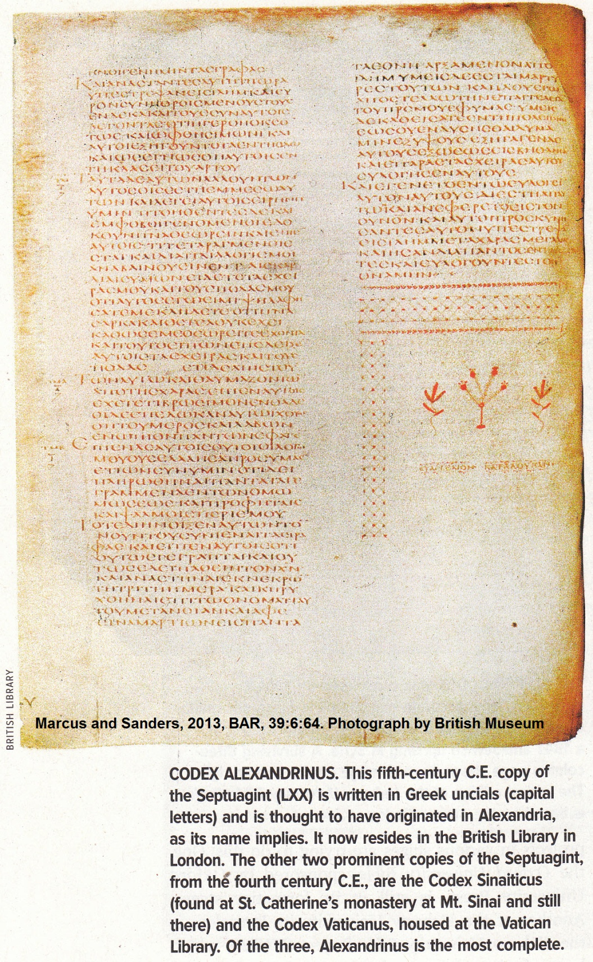

The order of books in our English Old Testament Bibles reflect that of LXX through the Vulgate translation of St. Jerome. So like LXX, our Bibles do not have the Tripartite Division. In the list below, apocryphal books excluded from Protestant bibles are shown with an asterisk (Freedman, 1994, Horn, 1988, Robinson, 1939, Woude, 1995) :

20th Century Organization of the Old Testament

Pentateuch (Genesis, Exodus, Leviticus, Deuteronomy) = Torah = Law
Joshua
Judges
Ruth
1 and 2 Samuel
1 and 2 Kings
1 and 2 Chronicles
1 and 2 Esdras (originally 1,2,3,4 Esdras)*
Nehemiah
Tobit*
Judith*
Ester (with Apocryphal additions at 10:4-16:24)
Job
Psalms
Proverbs
Ecclesiastes
Wisdom of Solomon*
Ecclesiasticus*
Hosea
Amos
Micah
Joel
Obadiah
Jonah
Nahum
Habakkuk
Zephaniah
Haggai
Zechariah
Malachi
Isaiah
Jeremiah (one eighth is omitted from the Septuagint [LXX])
Baruch*
Lamentations
Epistle of Jeremy*
Ezekiel (much in Hebrew is not in the Greek version)
Daniel (with Apocryphal additions at 3:24-90)
1,2,3 Maccabees*

Apocrypha

In the 2nd century AD, Alexandrian Jews adopted Aquila's Greek version of Old Testament which excluded the Apocryphal books. Acceptance of the Apocrypha was not widespread. The writer Philo of Alexandria (20 BC-50 AD), for example, does not quote from Apocrypha. But information contained in the Apocrypha give hints as to when the Old Testament canon developed (Freedman, 1994; Horn, 1988; Robinson, 1939; Woude, 1995) .The Apocryphal books listed above were accepted by the Catholic church but rejected by the Protestants.

Ecclesiasticus: Wisdom of Jesus ben Sirach (circa 170 BC)

This apocryphal book resembles Proverbs. The book is the chief monument of primitive Sadduceeism. There is a section called "Hymn of Fathers" eulogizing mighty heroes of Israel from Enoch to Nehemiah. Ecclesiasticus makes explicit mention of the Twelve (Minor) Prophets. The statement in Ecclesiasticus 24:33 "I will yet pour out doctrine as prophecy and leave it unto generations of ages" suggests that the canon of the Old Testament was not complete. Ecclesiasticus suggest that by 170 BC the Law and the Prophets had been canonized, but not the Writings .(Freedman, 1994, Horn, 1988, Robinson, 1939, Woude, 1995)

Prologue of Ecclesiasticus: (cir 132 BC)

The Prologue was written by a grandson of Jesus ben Sirach who shared his grandfather's name. This grandson translated his grandfather's proverbs into Greek while living in Egypt. There are three references in the Prologue to the tripartite division of the Old Testament. The relevant section of the Prologue states (Freedman, 1994, Horn, 1988, Robinson, 1939, Woude, 1995) :

"Whereas many and great things have been delivered unto us by the Law and the Prophets, and by others...my grandfather, Jesus, when he had given himself to reading of the Law and the Prophets, and the other books of our Fathers, and had gotten therein good judgment, was drawn on also himself to write something pertaining to learning and wisdom...For the same things uttered in Hebrew and translated into another tongue, have not the same force in them; and not only these things, but the Law itself, and the Prophets, and the rest of the books, have no small difference, when they are spoken in their own language."

Thus, the Prologue indicates that by 132 BC the Writings had not yet been canonized. In fact, his grandfather's work might have be added to them!

1 and 2 Maccabees (125-70 BC)

1 Maccabees was-written originally in Hebrew . The writer knew of deeds of John Hyrcanus (135-105 BC) but not of conquest of Pal by Pompey (63 BC). Maccabees contains several allusions to Daniel and Psalms, suggesting that these books were already canonical at this time (Freedman, 1994; Horn, 1988; Robinson, 1939; Woude, 1995) :
1 Macc 1:54 alludes to Dan 9:24-27 "abomination of desolation"
1 Macc 2:59-60 alludes to Dan 1:7;3:36;6:23) Ananias, Azarias and Misael in fiery furnace, Daniel in lion's den
1 Macc 7:16-17 alludes to Ps 79:2
1 Macc 1:56-57. Antiochus tried to stamp out Jews by destroying their books.

2 Maccabees was written originally in Greek (cir 124 BC). Some passages in this book indicate that forces were gathering to finalize a Hebrew bible canon:

2 Macc 2:13: Nehemiah "founding a library, gathered together the acts of the kings, and the prophets, and of David, and the epistles of the kings concerning holy gifts"
2 Macc 2:14 : "In like manner also Judas gathered together all things that were lost by reason of the war we had, and they remain with us"

Old Testament Canon and the Dead Sea Scrolls

History of Discovery

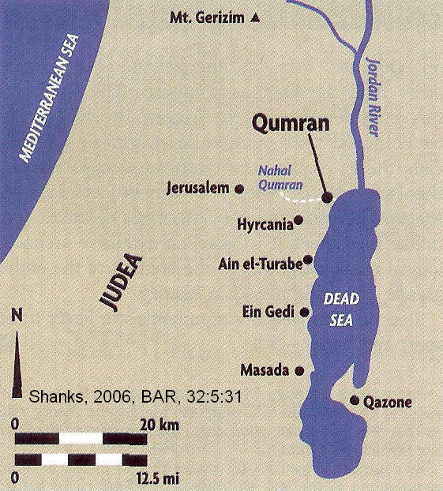
Some of the most important documents for understanding the development of the Old Testament canon come from the Dead Sea Scrolls. They were found in caves on the western side of the Dead Sea near the wilderness settlements of Qumran and Ein Gedi. After those discoveries, other manuscripts were found throughout Palestine.

PHOTO LINK: QUMRAN 017 Location map. Shanks, 2006, BAR, 32:5:31.

PHOTO LINK: QUMRAN 012 Aerial photo. Shanks, 2008, BAR, 32:5:27.
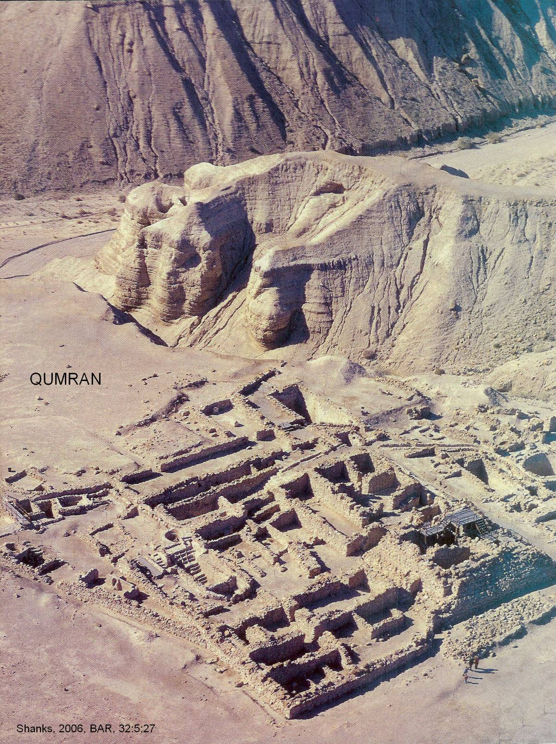

PHOTO LINK: DSS065 Dead Sea Scrolls: Map of Manuscript Discoveries near the Dead Sea; BWP, DSS-065.
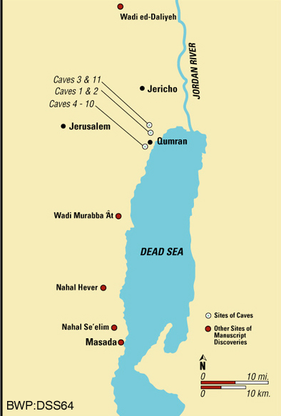

PHOTO LINK: QUMRAN 001 Panorama of Qumran. Crown and Candale, 1994, BAR, 20:5:25 and 25.
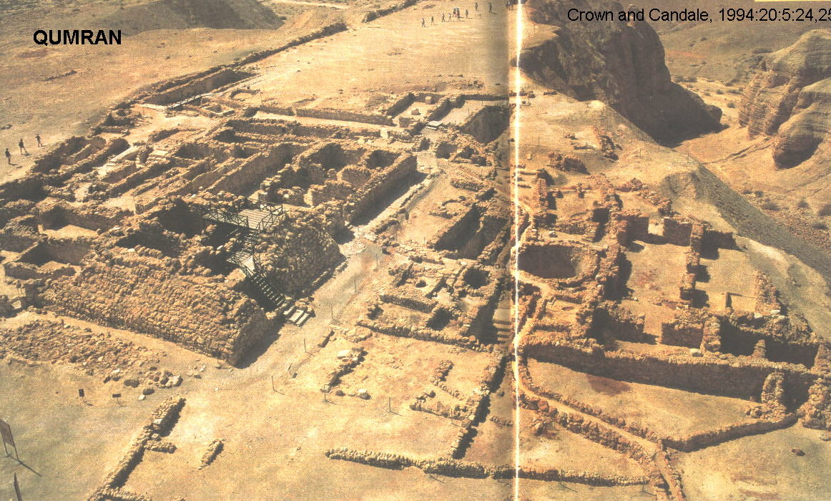

PHOTO LINK: DSS11 Dead Sea: Cave 1, General View, Limestone Cliffs. BWP, DSS-011.
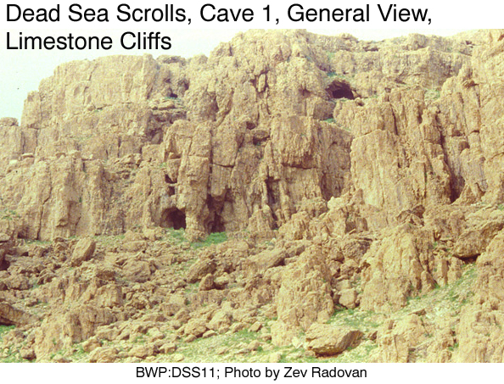

PHOTO LINK: QUMRAN 002 Map of Ein Gedi and Dead Sea. Crown and Candale, 1994, BAR, 20:5:26.
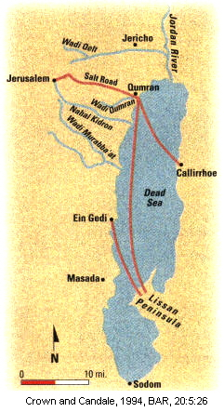

PHOTO LINK: QUMRAN 003 Plan of Qumran. Crown and Cansdale, 1994, BAR, 20:5:27.
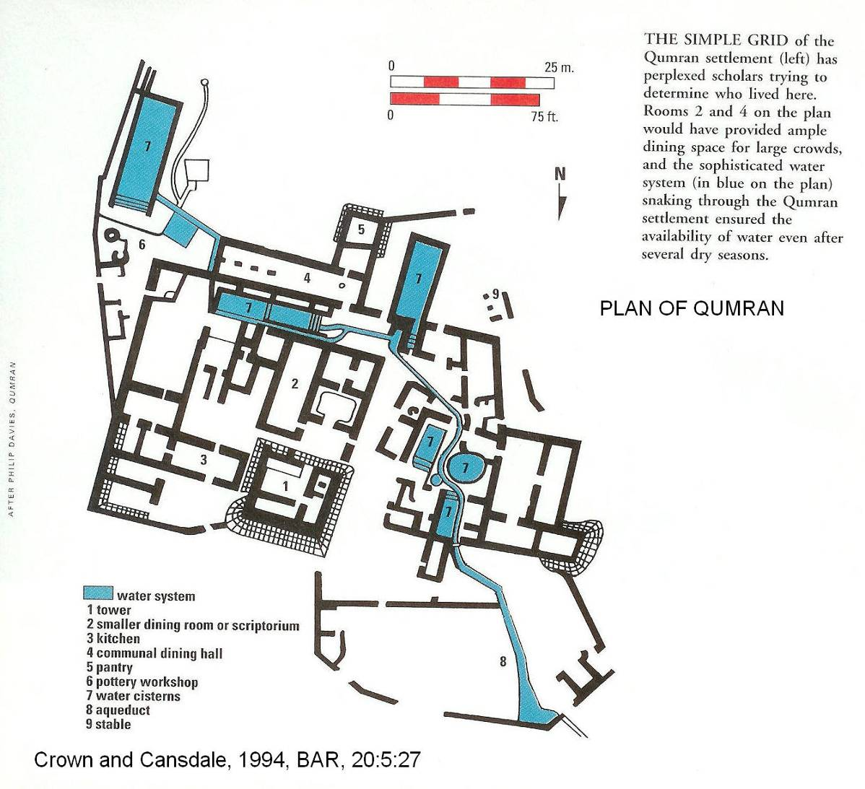

PHOTO LINK: QUMRAN 004 Photo of pottery, Room 5 at Qumran. Crown and Cansdale, 1994, BAR, 20:5:27.
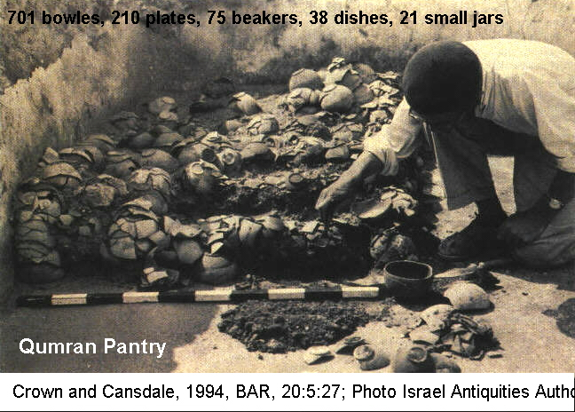

PHOTO LINK: QUMRAN 005 Aerial photo of Qumran. Crown and Cansdale, 1994:20:5:29.
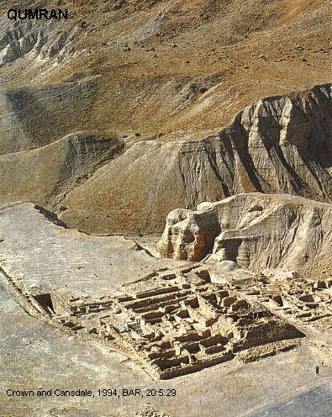

PHOTO LINK: QUMRAN 006 Map of Dead Sea scroll caves. Crown and Cansdale, 1994:20:5:29.

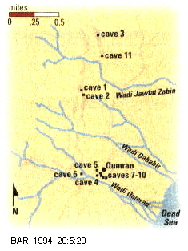
PHOTO LINK: QUMRAN 007 Wilderness of Ein Gedi and nature preserve. Crown and Cansdale, 1994:20:5:31.

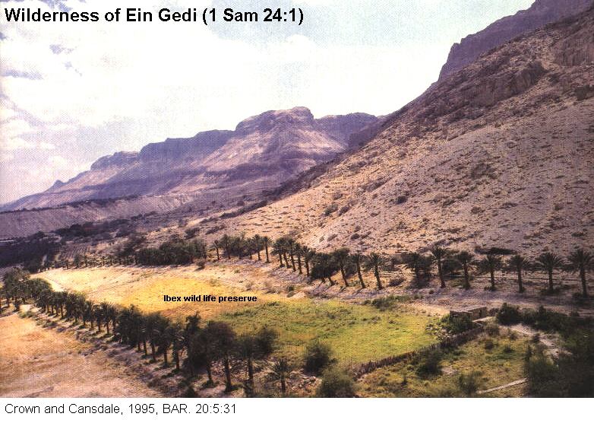

PHOTO LINK: QUMRAN 008 High altitude aerial photo of Qumran showing drop in level of Dead Sea. Crown and Cansdale, 1994, BAR, 20:5:30.

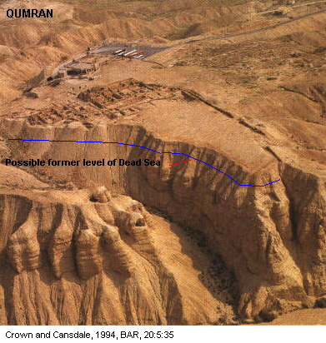

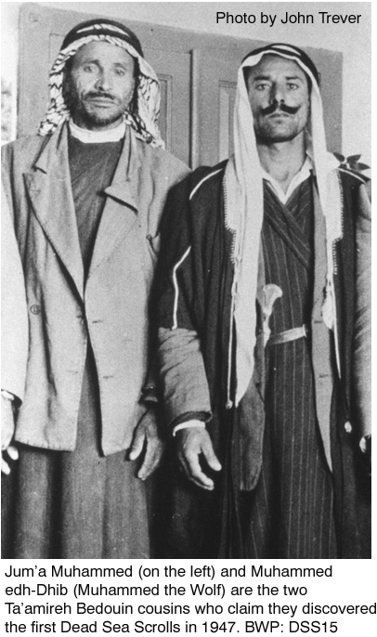
The first discoveries of the Dead Sea Scrolls were made by Jum’a Muhammed (on the left in DDS15) and Muhammed edh-Dhib (Muhammed the Wolf), two Ta’amireh Bedouin cousins. They claimed to have discovered the first Dead Sea Scrolls in 1947 from what later was identified as “Cave 1”..

PHOTO LINK: DSS015 Bedouin discoverers of first Dead Sea Scrolls (LEFT). BWP; DSS-015.

There was a much clandestine activity associated with the delivery of the scrolls to the academic community. Antiquities dealers and negotiators like Khalil Iskander Shahin (known as “Kando”) purchased scrolls for $20 (US) and sold them for extraordinary profits.

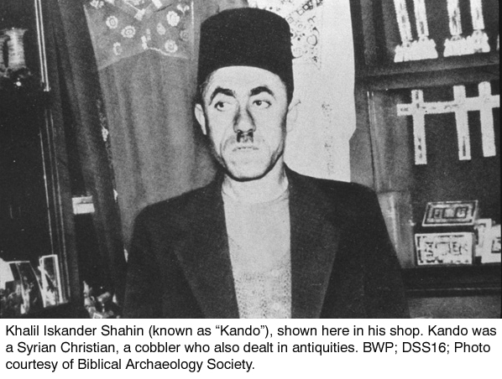
PHOTO LINK: DSS016 Dead Sea Scrolls: Antiquities Dealer “Kando”. BWP, DSS-016 (RIGHT):

The scrolls appeared at a time of political tension in Palestine when the state of Israel was formed following WWII. Hebrew scholar Sukenik undertook a perilous journey into Arab-occupied sections of Jerusalem just as Israelite nationhood was being established. He was the first scholar to see the scrolls and obtained several important ones:

Sukenik obtained a pass to enter the Arab sector so that he could examine additional fragments. On November 29th, 1947, on the eve of the United Nations resolution, he boarded an Arab bus, the only Jew riding to Bethlehem, hoping to see three scrolls Faidi Salahi had given to an antiquities dealer named Ohan. In an atmosphere of ethnic anger and mounting fear, Ohan and Sukenik relied upon an age-old Middle Eastern tradition of showing each other respect and honor. With a handshake, Sukenik affirmed his serious interest in buying the scrolls for Hebrew University, and Ohan agreed to let him take them for closer examination. Single-handedly, Eleazar Sukenik brought back to Jerusalem the War Scroll, the Thanksgiving Psalms Scroll and the second of the two Isaiah scrolls, an invaluable legacy from the last days of the ancient Jewish state. He arrived in Jerusalem on the eve of the birth of the new Jewish state (Biblical World in Pictures, caption to photo DDS17).

PHOTO LINK: DSS017 Dead Sea Scrolls: Eleazar L. Sukenik. BWP, DSS-017.
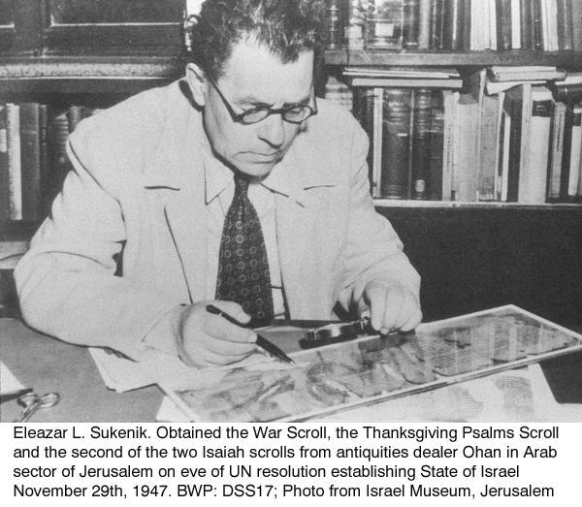

Yigael Yadin was one of the first and most influential of the Dead Sea Scroll scholars and helped to acquire remaining scrolls from Cave 1 and the Temple Scroll of Cave 11

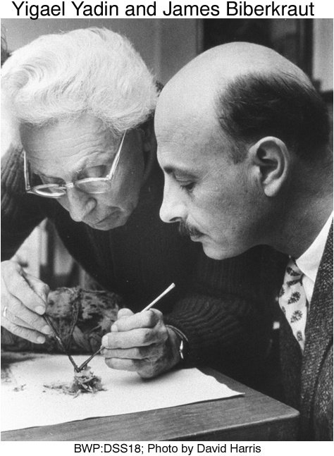
PHOTO LINK: DSS018 Dead Sea Scrolls: Yigael Yadin and James Biberkraut . BWP, DSS-018 (RIGHT)

Another important liaison and middle-man in the acquisition of the Dead Sea Scrolls was Metropolitan (Archbishop) Samuel of the Jacobite Syrian Christians in Jerusalem. He purchased four scrolls from “Kando” for about $97. After several failed negotiations, those four scrolls made there way through Syria to a bank vault in New York. Prior to that, Samuel had allowed some of the scrolls to be photographed.

PHOTO LINK: DSS019 Dead Sea Scrolls: Metropolitan Samuel. BWP, DSS-019.
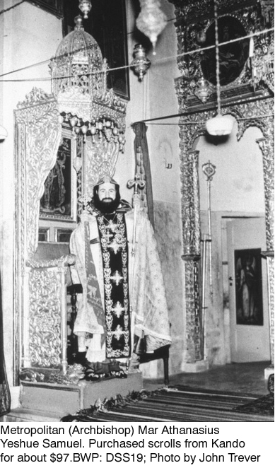

Six years later, Samuel placed an advertisement in the Wall Street Journal for the four scrolls on June 1, 1954.

PHOTO LINK: DSS020 Dead Sea Scrolls: Wall Street Journal Advertisement. BWP, DSS-020.

Eventually Yigael Yadin arranged for purchase of the scrolls for $250,000 (Biblical World in Photos, caption to photograph DSS20).

Archaeological Context of the Dead Sea Scrolls and Qumran

The caves from which the scrolls came also had distinctive pottery forms.

PHOTO LINK: DSS014 Dead Sea: Qumran Pottery Vessels. BWP, DSS-014.
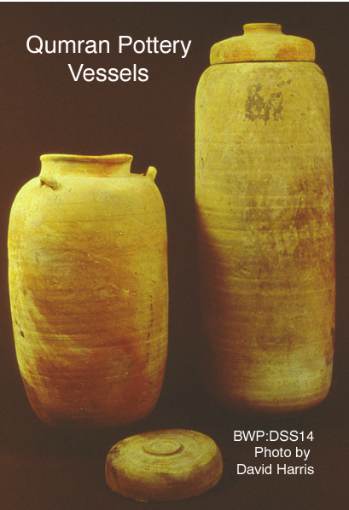

The scrolls are associated with the religious community of Qumran where many of the scrolls were produced.

PHOTO LINK: BA064 Scriptorium and Study Rooms, Qumran. BWP, BA-064.

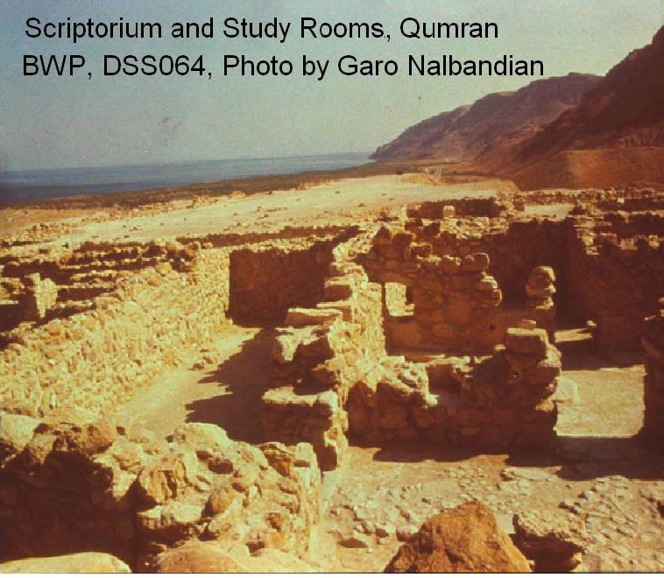

Qumran may have been a pottery manufacturing center, and not a religious institution. The Qumran mikveh may be a reservoir for pottery making, not a ritual bath for Essenes. There is a late synagogue there dating to 68 BC, just before the Roman destruction (Shanks, 2006:32).

PHOTO LINK: QUMRAN 012 Aerial photo; (See ABOVE, p.40 ; ctrl+click to follow link)
PHOTO LINK: QUMRAN 014 Plan. Shanks, 2006, BAR, 32:5:29.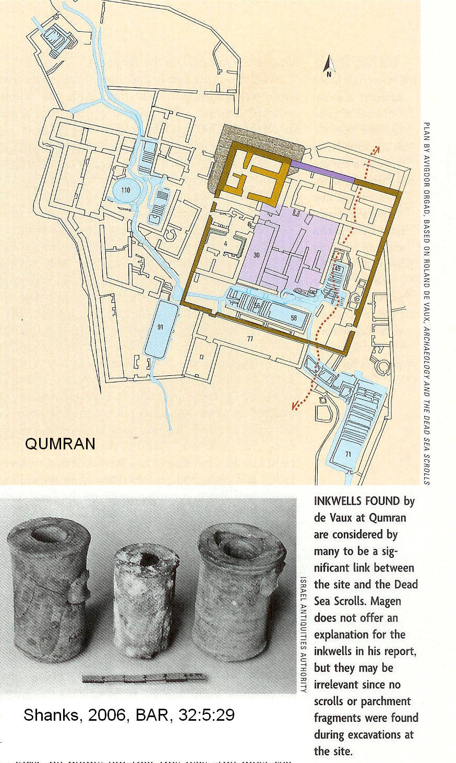

PHOTO LINK: QUMRAN 013 Qumran mikveh, ceremonial bath, or reservoir for pottery making. Shanks, 2006, BAR, 32:5:28.
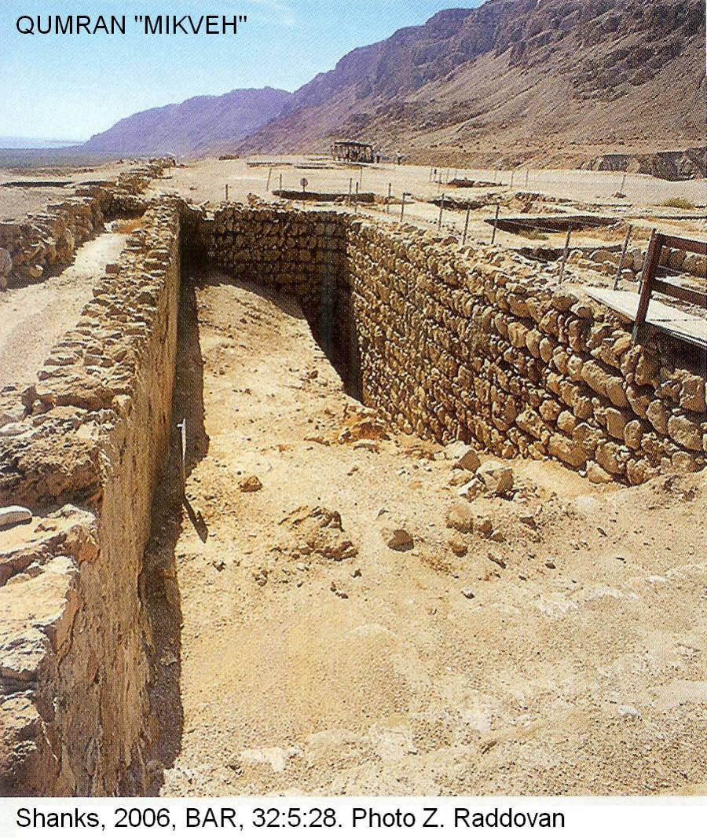

Content of the Dead Sea Scrolls

The Dead Sea Scrolls (DSS) have fragments, portions, or whole copies of all Old Testament Books of the tripartite division, except Ester. These are found in about 200 fragmentary manuscripts, some dated as early as the 3rd century BC. Most material is from the 1st and 2nd centuries B.C. The older manuscripts were brought in from outside (e.g. not made at Qumran). The Qumran community was founded in 150 BC. The DSS have 3 textural sources: 1) Babylonian (proto-Masoretic), 2) Old Palestinian (Samaritan Pentateuch, made in Jerusalem and Tiberius), and 3) Egyptian (Alexandrian; Septuagint). All 3 sources were used in New Testament era. The available information from DSS shows that canonization occurred earlier than some "liberal" scholars supposed, but the Qumran community had no "canon" and no standardized text between 150 BC and 70 AD. The DSS indicate that at Qumran there were two divergent versions of Jeremiah, one like the Masoritic text, the other like the Septuagint version, which is about a seventh shorter. There is an Exodus manuscript which represents a harmonization of the Samaritan Pentateuch with the Masoritic tradition. A Leviticus scroll, written in paleo-hebrew characters (used before the Babylonian Exile and occasionally used in an archaizing manner at Qumran) is neither Masoretic, nor Septuagintal, nor Samaritan. The book of Isaiah was in the form we find it in our bibles today in 2nd century BC Dead Sea Scrolls texts. Generally the manuscripts at Qumran had 95% agreement with Masoritic text formed 400 years later and which is the basis for our modern bibles. The textural diversity at Qumran was not like that found at Masada (First Jewish Revolt, 66-70 AD) nor like that in the caves of Wadi Murrabba'at (Second Jewish Revolt, 132-135 AD) which show a more uniform “proto-Masoretic” textural tradition. While no doctrinal issues are influenced by variations, the presence of some differences help identify when and where a canon developed (Freedman, 1994, Horn, 1988, Robinson, 1939, Woude, 1995).

The Old Testament Canon in New Testament times

By the time the New Testament was written (from 40? to 130? BC) there was an Old Testament canon. The common New Testament reference to "the scripture" (John 19:36, 2 Pet 1:20), "and the scripture cannot be broken" (John 10:35 ), "the scriptures" (Matt 22:29, Acts 18:24), "holy scriptures" (Rom 1:2), "sacred writings" (2 Tim 3:15) and "the Law" (John 10:34, John 12:34, John 15:25) all point to a consensus about a body of texts were considered to be authoritative. Sometimes no distinction was made between Law and prophecy (see1 Cor 14:21 which quotes Isaiah 28:11 as part of Law). At times a the phrase "the Law and Prophets" is used to identify the canon (Matt 5:17, Matt 7:12, Matt 22:40, Luke 16:16). Luke 24:44 talks of "the Law the Prophets and the Psalms" (not the Writings), as do Acts 13:15 and Acts 28:23 (Freedman, 1994, Horn, 1988, Robinson, 1939, Woude, 1995).

Final order of canon is reflected in Matt. 23:35, cf Lk 11:51: "That upon you may come all the righteous blood of Abel the righteous unto the blood of Zachariah son of Barachiah, whom you slew between the sanctuary and the alter." The murder of Zachariah (2 Chron 24:20-21) is last episode in Chronicles which was last book in Hebrew tripartite division of Old Testament (Freedman, 1994, Horn, 1988, Robinson, 1939, Woude, 1995).

If chronologic overview was intended by Matt 23:35, then the last murdered prophet would be Uriah son of Shemaiah who was murdered in Jehoiakim's reign in 9th cent. BC (Jer 26:23). Jesus would have said "From Abel to Uriah"

There is extensive quoting of Old Testament by New Testament writers, but only two or three from the Apocryphal books are quoted by them as "scripture"(Freedman, 1994, Horn, 1988, Robinson, 1939, Woude, 1995).

The First Jewish Revolt: 70 AD

Woude (1995) writes that the Hebrew Canon was crystallized by Pharisees, the only religious party to survive the debacle of 70 AD, following the First Jewish Revolt.

4 (2) Esdras

The Apocryphal book of 4 Esdras (cir 81-96 AD) (2 Esdras in English Apocrypha) gives some information about the Old Testament canon in early New Testament times. It was originally written in Greek. Chapter 4:19-48 relates a legend about how Ezra was given spiritual illumination to reproduce the Law. He is said to have dictated to five scribes continuously for 40 days. The result was 94 books f which 70 are kept secret and 24 are published (Freedman, 1994, Horn, 1988, Robinson, 1939, Woude, 1995).

"And it came to pass that the Most High spake, saying 'The first that thou hast written, publish it openly, that the worthy may read it; but keep the 70 last, that thou mayest deliver them only to such as be wise among the people; for in them is the spring of understanding, the fountain of wisdom, and the stream of knowledge.' And I did so" (4 Esd 14:45-48)

Flavius Josephus’ Contra Apionium (cir 100 AD)

This Jewish historian, soldier and bureaucrat was born 37 AD and became a priest and Pharisee. His Contra Apionium is a literary rebuttal to anti-Jewish grammarian Apioneum -I, 8 reads (Freedman, 1994, Horn, 1988, Robinson, 1939, Woude, 1995):

"For it is not he case with us to have vast numbers of books disagreeing and conflicting with one another. We have but 22, containing the history of all time, books that are justly believed in. And of these, 5 are the books of Moses, which comprise the laws and earliest traditions from the creation of mankind down to the time of his (Moses') death. This period falls short by a little of 3,000 years. From the death of Moses to the rein of Artaxerxes, king of Persia, the successor of Xerxes, the prophets who succeeded Moses wrote the history of the events occurring in their own time; in 13 books. The remaining 4 documents comprise hymns to God and practical precepts to men. From the days of Artaxerxes to our own time every event has indeed been recorded. But these recent records have not been deemed worthy of equal credit with those which preceded them, because the exact succession of the prophets ceased. But what faith we have placed in our writings is evident by our conduct; for though so great an interval of time [i.e. since they were written] has now passed, not a soul has ventured either to add, or remove, or alter a syllable. But it is instinctive in all Jews at once from their very birth to regard them as commands of God, and to abide by them, and, if need be, willing to die for them.

Josephus' tripartite division of the Old Testament is as follows:

"5 of Moses" | = Pentateuch
"13 Prophets" | = 8 Prophetic Books (Former+Latter+Minor with Jeremiah-Lamentations as one book)+ Daniel, Job, Chronicles, Ezra-Nehemiah, and Ester
"4 hymns and maxims" | = Psalms, Proverbs, Song of Songs, Ecclesiastes
Total = 22 books of Hebrew Bible.

Councils of Jamina (90 and 118 AD)

The town of Jamina is south of Joppa on Mediterranean coast. At these councils, Ecclesiastes and Chronicles were debated and their canonicity ratified. Rabbi Akiba lead the councils and saw a need for one symbol for Diaspora Jews to rally around. From the Jamina councils came the final form or our Masoritic text (Freedman, 1994, Horn, 1988, Robinson, 1939, Woude, 1995).

The councils of Jamina had the following criteria for selecting canonical books:

1. The books MUST be written before 400 BC
2. The books MUST be written WITHIN Palestine
3. The books MUST be written in the Hebrew language
4. The books MUST conform to the information and contained in the Potlatch

Jewish Doubts About the Hebrew Canon (2nd cent. AD)

The councils at Jamina did not stop debate and speculation about the canon. The books of Proverbs, Song of Songs, Ecclesiastes, and Ester continued to be popular topics for analysis and discussion. Inconsistencies were noted in Proverbs. There were objections that The Song of Songs is about man, not God. Ecclesiastes, like all wisdom literature has inconsistencies but quotes Torah from the beginning to the end. God is not mentioned even once in Ester. These and other factors resulted in their lack of authority from the 2nd through 6th centuries (Freedman, 1994, Horn, 1988, Robinson, 1939, Woude, 1995).

Sopherim: 500 BC to 500 AD

From the Persian period to the time of the Masorites, the canonical writings were copied and transmitted by scribes or "Sopherim". For descriptions of this office and profession see Ezra 7:6,11,12 and Nehemiah 8:13 (Freedman, 1994, Horn, 1988, Robinson, 1939, Woude, 1995) .

Masorites: 500 AD to 1650 AD

Beginning about 500 AD and lasting to the invention of printing, the Masorites copied the holy writings by hand. The "Masoretic Text" is basis for 90% of our English bibles. The Masorites added vowel signs to the text. This was extremely helpful because before the Masorites, Hebrew was written only in consonants. An example of the confusion that words without vowels can create involve, the tetragram, the holy name of God, which is "YHWH" in old Hebrew. Since the Sopherim and Masorites thought the name of God so special that it was not to be written or spoken, we don’t know for sure how they may have pronounced it. Working with YHWH in the Masoritic text, the tetragram of God was translated in King James Bible as "Jehovah". Modern scholars translate it as "Yahweh" (Freedman, 1994, Horn, 1988, Robinson, 1939, Woude, 1995).

There were 3 main groups of Masorites: Babylonian, Palestinian and Tiberian. With time, the Tiberian school gained prominence. The 10th century Tiberian Codices* of Ben Asher Ben Naphtali are the basis for our current "Masoretic Text". The Leningrad Codex, in the St. Petersburg Public Library, dates to about 1008 AD is the oldest complete text of the Hebrew Bible.

PHOTO LINK: ESN030 Codex Syrus Sinaiticus (Visible Light Image), 4TH or 5th century AD. BWP, ESN-030.
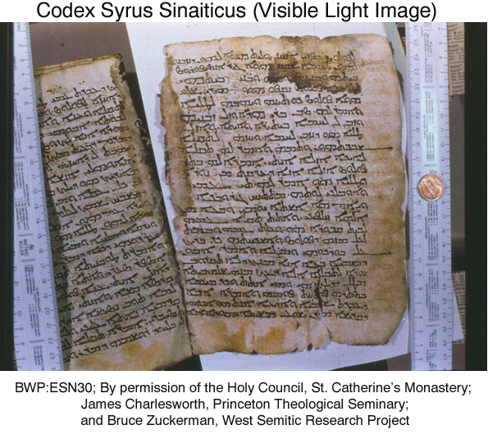
PHOTO LINK: ESN031 Codex Syrus Sinaiticus (Ultra Violet Light Image), 4TH or 5th century AD. BWP, ESN-031.
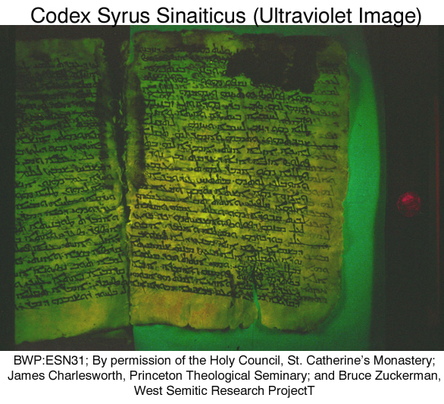
A Codex is a book made of animal skin parchment. The oldest codex dates from 950 C.E. It is called the Aleppo Codex.

PHOTO LINK: LENINGRAD CODEX 001 Inscription within Star of David framed with scriptures from Deuteronomy and Psalms. Marcus and Sanders, 2013, BAR, 39:6:61. Photograph by Bruce and Kenneth Zuckerman, West Semitic Research
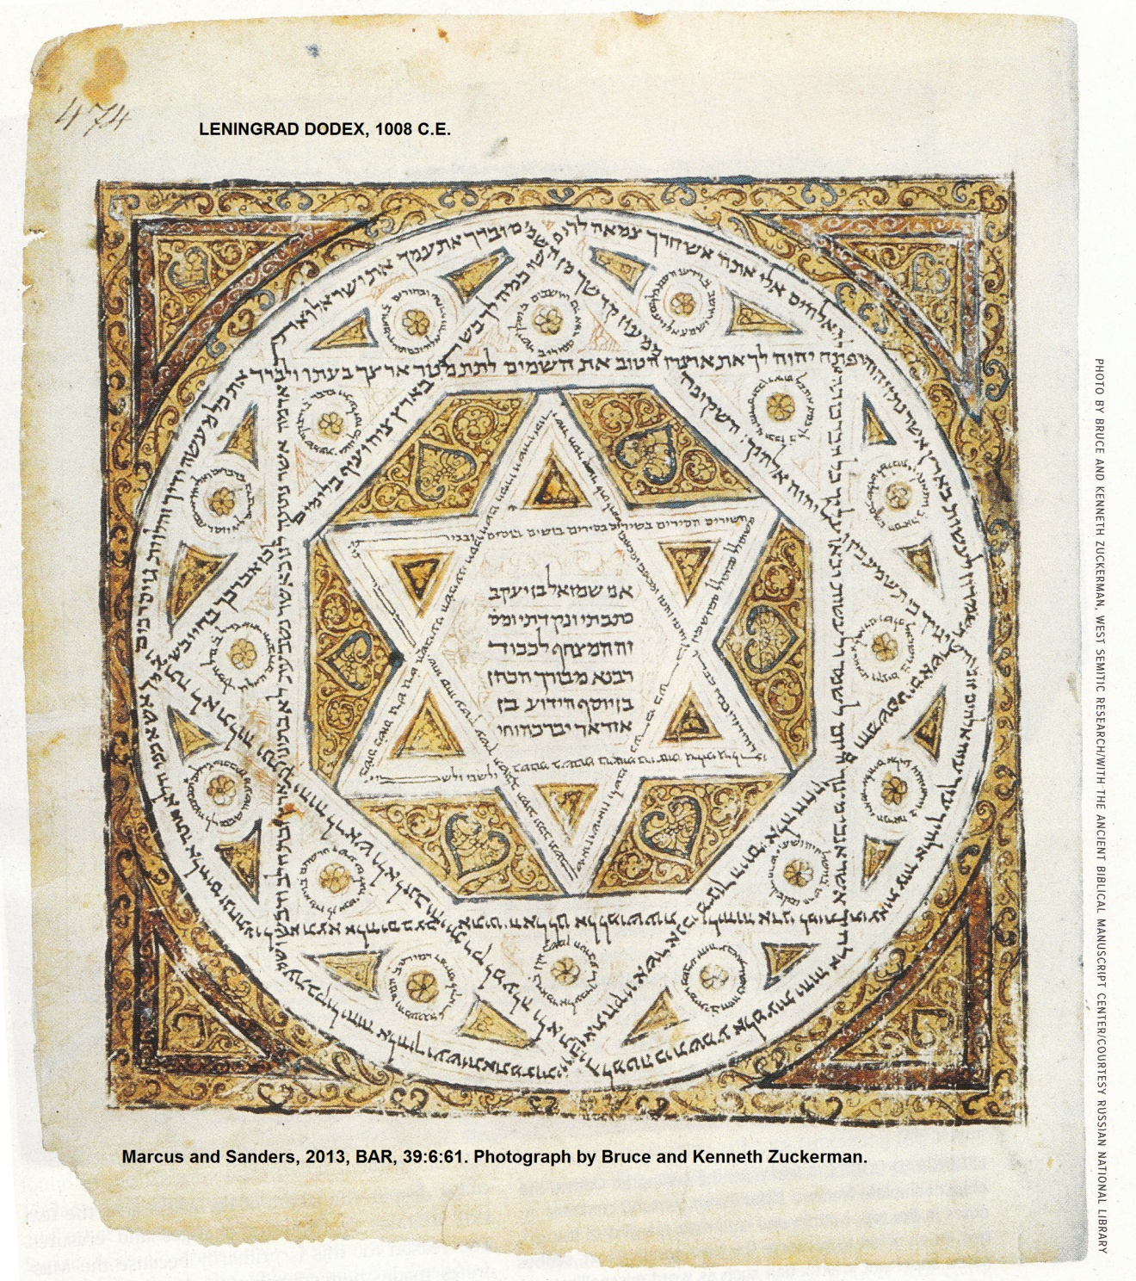

As the Israelites stopped speaking Hebrew, and started speaking Aramaic and other languages, there arose the targums, or competing translations in non-Hebrew tongues. These were often paraphrases. Several targums developed: Hebrew to Aramaic, Hebrew to Greek, etc (Freedman, 1994, Horn, 1988, Robinson, 1939, Woude, 1995).

The Christian Church Canon of the Old Testament

Eastern or Oriental Church

The Pesh or Syriac version of Old Testament (cir 150 AD) omits Chronicles. Justin Martyr (264 AD) held to Old Testament of Jews. The canon of Melito, bishop of Sardis (cir 170 AD) omits Ester. Origin (d.254 AD) says there are 22 books. The Council of Laodicea (cir 363 AD), kept the Hebrew Old Testament, and rejected the Apocrypha. Athanasius (d.365 AD) omits Ester but notes that "Ester is considered canonical by the Hebrews" and includes Baruch and Epistle of Jeremiah with Jeremiah. Amphilochas, bishop of Iconium (cir 380 AD) says only some accept Ester. Cyril, bishop of Jerus (cir 386 AD) recognizes the Hebrew canon plus Baruch and Epistle of Jeremiah. Gregory of Nazianzus in Cappadocia (d.390 AD) also omits Ester. Anastasius, patriarch of Antioch (560 AD) held to the 22 book Hebrew canon as did Leontius of Byzantium (580 AD). At this time, the Nestorians doubted Ester while Theodore of Mopsuestia (cir 390-457) disputed Chronicles , Ezra, Nehemiah, Ester and Job.(Freedman, 1994, Horn, 1988, Robinson, 1939, Woude, 1995).

Western or Occidental Church

The leadership of the Western (“Catholic) church held to a strict canon, but homiletically used a larger one. They often quoted from Apocrypha. Extensive use of the Septuagint lead to blurring of Old Testament and Apocrypha. Tertullian of Carthage (cir 150-230) gives 24 books for the Old Testament canon, the same as Talmud. The heretic Marcion published a canon in 140 AD which pressured church leaders to establish an official canon. Poitier of France (350-368 AD) gives 22 book including "Jer and his Epistle." Rufinus of Aquileia in Italy (d.410) gives 22 books. Jerome of Bethlehem (d.420 AD), who compiled the Latin Vulgate translation of the Bible, gives 22 books and says they equal the 22 letters of the Hebrew alphabet, keeping to the strict canon of the Jews. Augustine, Bishop of Hippo (N. Africa, 353-430 AD) lead three great councils at Hippo (393) and Carthage (397 and 419). These councils lead to the adoption of 44 books (including 20 Deutero-canonical Apocrypha books) for the Bible. Papal action enforced this canon at the Council of Carthage (345-419 AD). Martin Luther (16th century) published a version of the Bible with the Apocrypha in between the Old Testament and New Testament, a practice which continues to this day. The Western church’s reaction to these developments was the Council of Trent (1546) which declared the Apocrypha canonical. The Vatican Council of 1870 reiterated the determinations made at the Council of Trent .(Freedman, 1994, Horn, 1988, Robinson, 1939, Woude, 1995).

PHOTO LINK: VULGATE 001. Page from Codex Amiatinus, oldest nearly complete text of Latin Vulgate. Marcus and Sanders, 2013, BAR, 39:6:65. Photograph by British Museum.
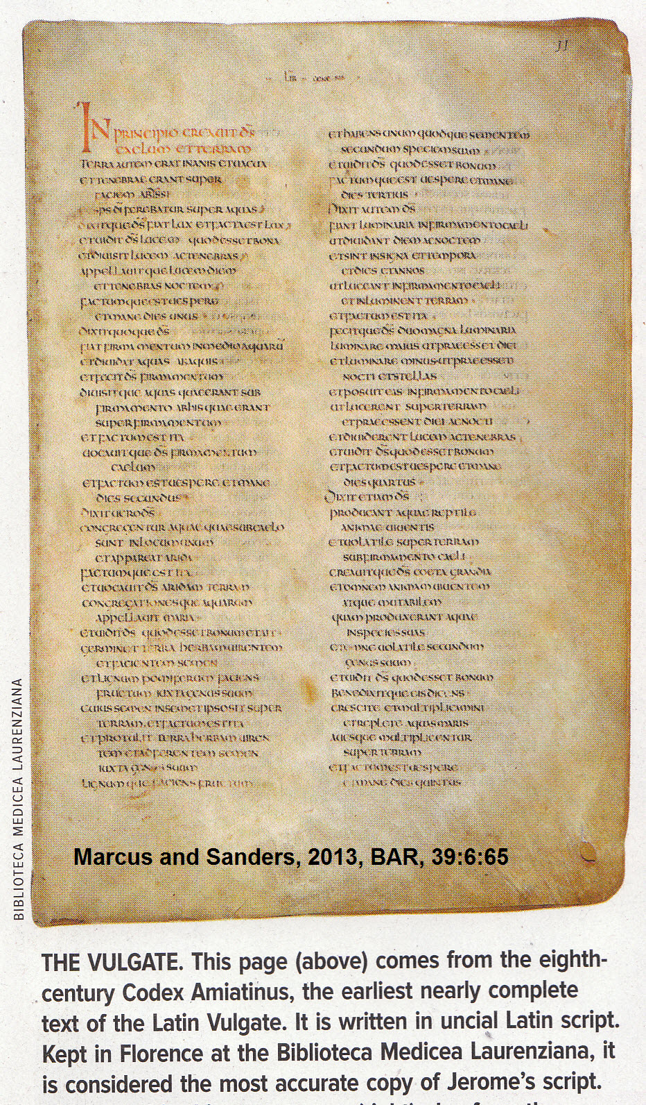

Protestant Canon of the Old Testament

Leaders of the protestant Reformation followed their Jewish contemporaries and accepted a Hebrew canon as identified 1300 years earlier at the Jamina counsels.(Freedman, 1994, Horn, 1988, Robinson, 1939, Woude, 1995).

