CHAPTER 4: SCRIPTS OF THE OLD TESTAMENT

Contents

ORIGIN OF WRITING 222
ORIGIN OF THE ALPHABET 229
MATERIALS 239
EPIGRAPHY AND PALEOGRAPHY 240
SCRIPTS AND LANGUAGE 245
TYPES OF SCRIPTS 247
TYPES OF WRITING 248
Monumental Inscriptions 248
Professional Writings 249
Occasional Writings 250
SCRIPTS OF MESOPOTAMIA 253
Cuneiform 253
Sumerian Language 256
Sumerian Pictographs and Cuneiform 256
Babylonian Scribal Practices 267
Hurrian Language 270
SCRIPTS OF EGYPT 272
Egyptian Sources 272
Egyptian Language 275
Egyptian Hieroglyphs 276
Egyptian Demotic Script 279
SCRIPTS OF THE LEVANT 282
Aramaic Language 282
Aramaic Alphabetic Script 284
Canaanite Language 287
Proto-Sinaitic (Canaanite) Alphabetic Script at Serabit el-Khadem 288
Proto-Sinaitic (Canaanite) Alphabetic Script at Wadi el-Hol 303
Early Canaanite script 304
Canaanite and North Semitic Alphabetic Script 307
Northwest Semitic Sources, 2000 to 550 BC 308
North Semitic Script 311
Neo-Philistine Script 315
Ugaritic Alphabetic Script 317
Hebrew Language 319
Old-Hebrew Script 320
Khirbet Qeiyafa (Qeayafa) Ostracon 320
Gezer Calendar 329
Tel Zayit Abecedary 332
^{c}Izbet Sartah Ostracon 334
Samaritan Ostraca 337
Silver Scroll Amulets of Ketef Hinnom 338
Lachish fragment 342
Siloam Inscription 342
Inscription on the tomb of Shebnayahu 343
Mesad Hashavyahu Inscription 345
Lachish Ostraca 345
Inscribed “lmlk” jar handles 346
Stone seals 347
Inscribed weights and measures 348
Amulets 348
Paleo-Hebrew script 349
Ammonite script 351
Phoenician Script 355
Square Hebrew Aramaic Script 359
EARLY WEST SEMITIC SCRIBAL PRACTICES 360
AEGEAN SCRIPTS 364
DEMOCRATIZATION OF CULTURE THROUGH WRITING 367

Literary records (both biblical and extra-biblical) provide detailed information available about the human history of biblical lands. Because of their importance, this chapter introduces them and their role for deciphering and understanding biblical parable (myth) and history. Many people today have the impression that ancient people of biblical times were illiterate. The available evidence from a variety of sites and cultures indicates, that in time of Moses (circa 1500 BC), there were at least eight languages recorded in five completely different systems of writing. Writing was not the exclusively domain of the upper classes in these cultures, or of the scribes.

ORIGIN OF WRITING

Writing developed out of economic necessity. Clay counting objects were an early way of keeping track of commercial transactions. If a purchase was made, the seller would place these counting objects (sometimes made in facsimile of the object sold) inside clay balls. When the shipment was received, the clay ball was “opened” and the number of items to be delivered verified. Later, markings indicating the were number of objects inside were inscribed on outside of the clay ball. This redundancy was eliminated when the counting objects were replaced with counting symbols. Miniature replicas of cargo in the clay balls were replaced by pictographs of the cargo. Pictographs were the earliest form of writing. (Cross and Shanks, 1994). Why go to the trouble of making a clay token, when you can just scratch an abstract design on a clay tablet? Human laziness is the mother of invention!

PHOTO LINK: SCRIPTS 033 Earliest writing 3 artifacts. Shanks, 2002, BAR, 28:5:28. Photos from Schøyen Collection.
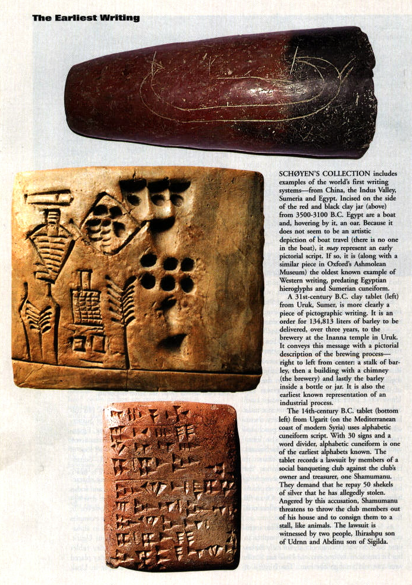
PHOTO LINK: SCRIPTS 050 Mesopotamian clay counting ball and tokens. O’Connor, ODY, 7:5:41.
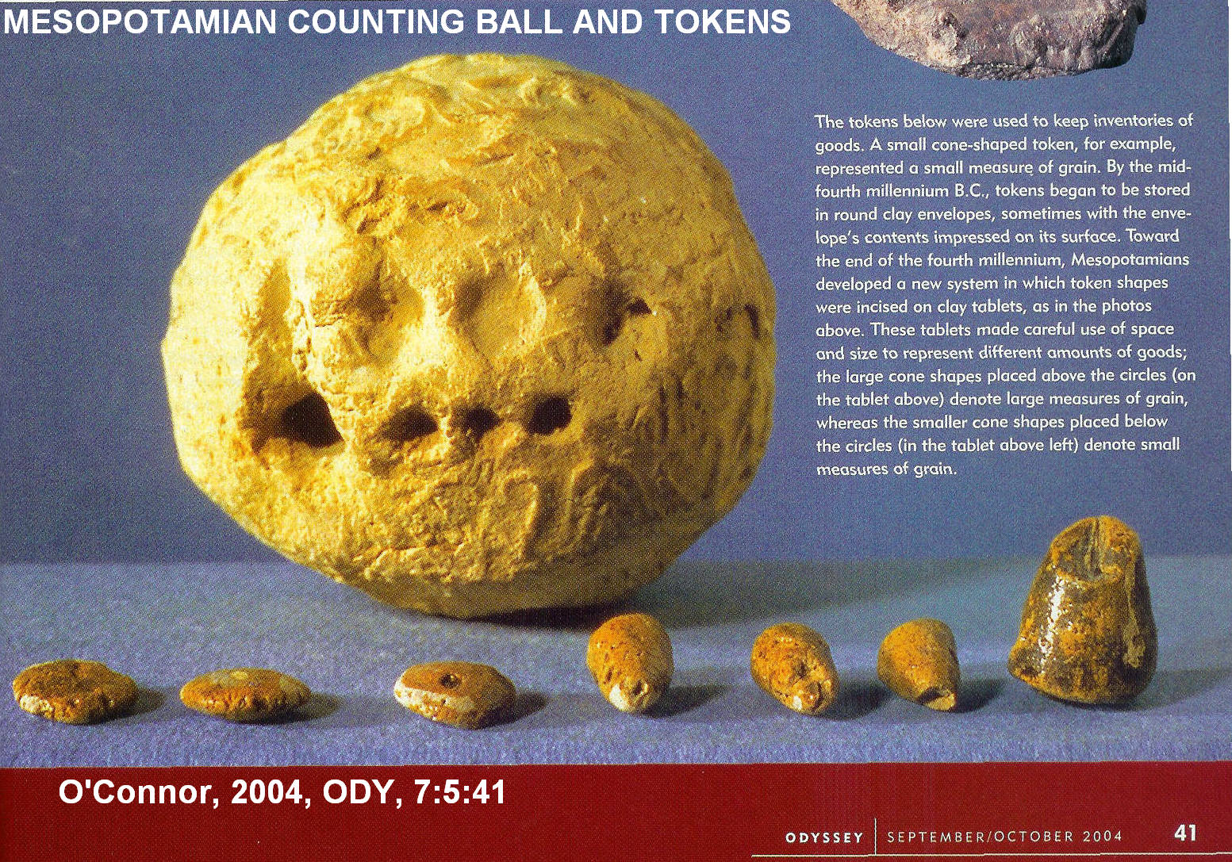

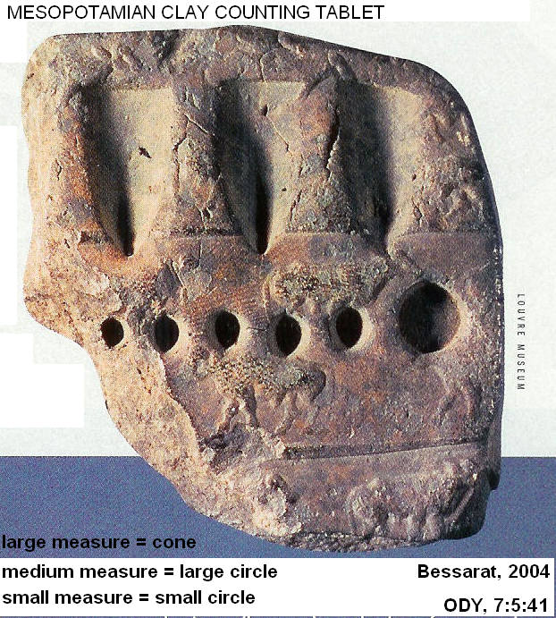
PHOTO LINK: SCRIPTS 051 Mesopotamian Clay counting tablet . O’Connor, ODY, 7:5:41.

PHOTO LINK: SCRIPTS 052 Mesopotamian Clay counting tablet 02, O’connor, 2004, ODY, 7:5:41.
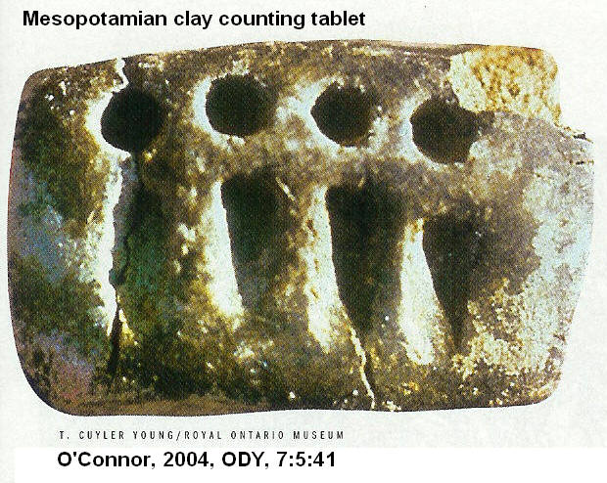

PHOTO LINK: SCRIPTS 053 Location map SCRIPTS 050-052. Schmant-Besserat, 2004, ODY, 5:7:38
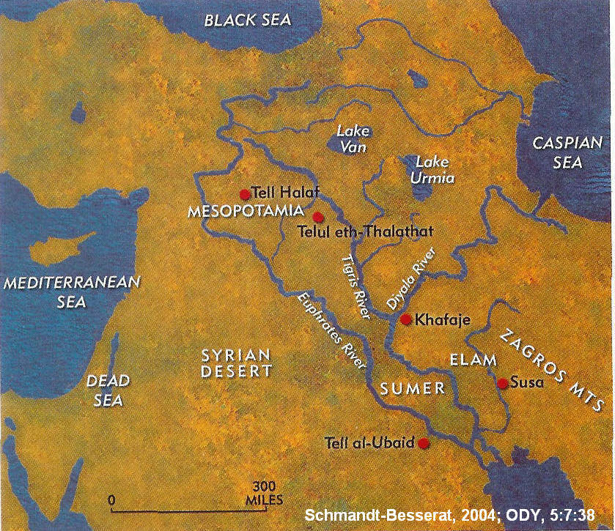

The invention of writing is reflected in a change in artistic depiction. Art before writing tended to be geometric, stylized and static. Art, after writing was invented, became flowing and told a narrative story (Schmandt-Besserat, 2004).

PHOTO LINK: ART 001A Geometric designs. Schmant-Besserat, 2004, ODY, 5:7:43.

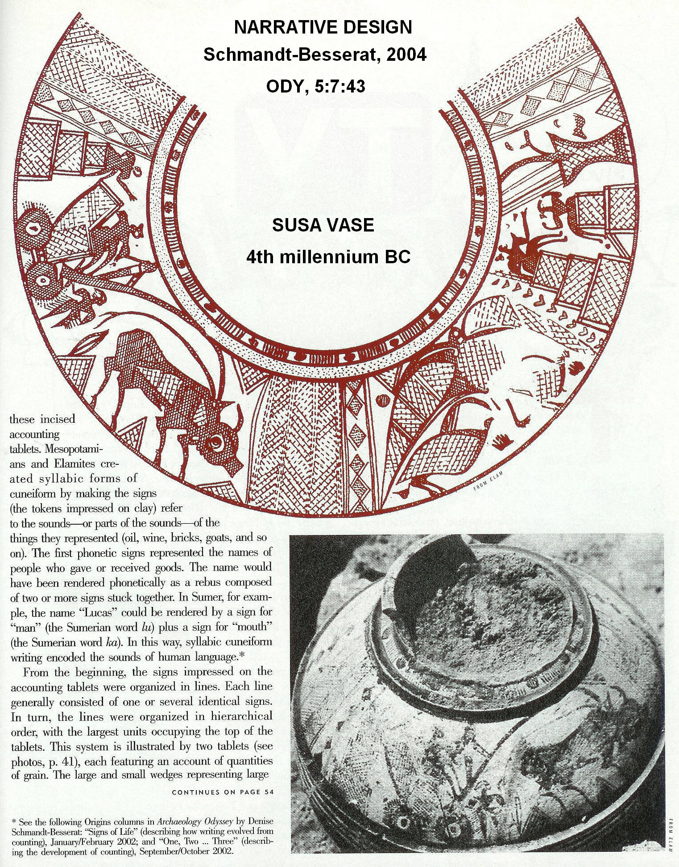
PHOTO LINK: ART 001B Geometric designs. Schmant-Besserat, 2004, ODY, 5:7:38,39
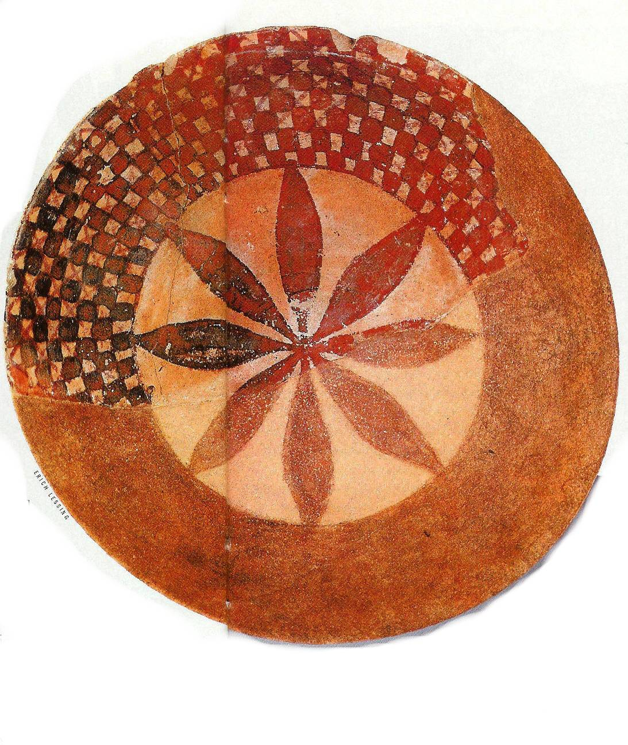
PHOTO LINK: ART 002 Narrative designs. Schmant-Besserat, 2004, ODY, 5:7:39..
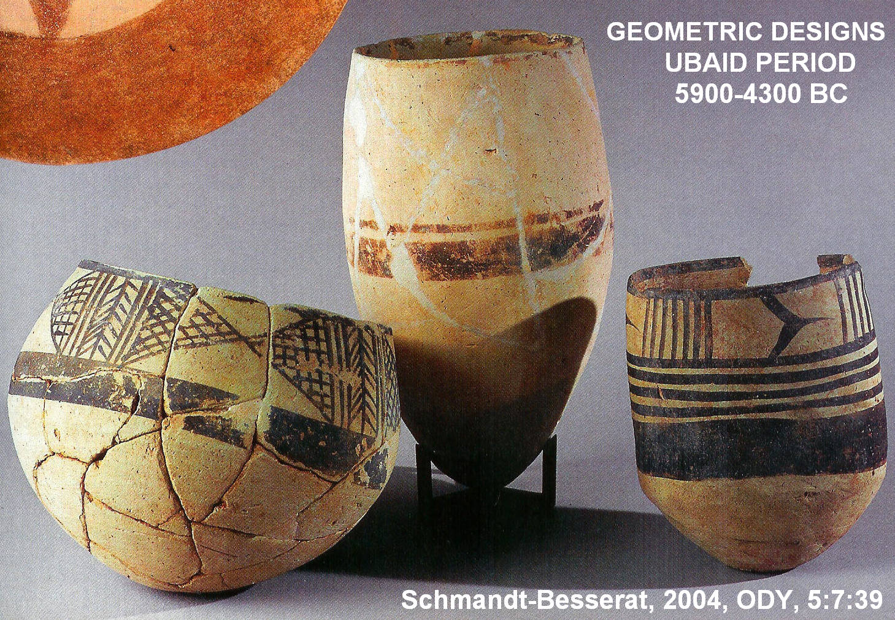

PHOTO LINK: ART 004 Location map for ART 001-003 (missing)

ORIGIN OF THE ALPHABET

The Alphabet was only invented once, in the 18th century BC when West Semitic Hyksos ruled the Egyptian Delta in Greater Canaan. It originated in an area between two great civilizations which had two different writing systems: Mesopotamian cuneiform and Egyptian hieroglyphics. Each of these civilizations had developed non-alphabetic writing systems about 3,000 BC (Cross and Shanks, 1994).

The earliest picture-writing (pictographs) known is from 3,000 BC at Sumner. Pictographs are story symbols that can be "read" in any language. Many road signs of today are pictographs. A humorous example of pictographic writing is shown below:

PHOTO LINK: PICTOGRAPHIC WRITING 001 Humor; http://www.wtv-zone.com/MINDISMOM/sedona/koko/joke1.html Oct. 19, 2013.
"Holy Macrel! Dig the ass on that woman!” (Early Canaanite is read right to left)

The early Canaanite pictorial scripts used the Acrophonic principle where a symbol represented the first sound in the object depicted by the symbol. For example, pictographs of a cat, apple and ball would mean “CAB” (Cross and Shanks, 1994c).

PHOTO LINK SCRIPTS 021 Acrophonic Principle. Shanks and Cross, 1992:BR, 8:6:21.
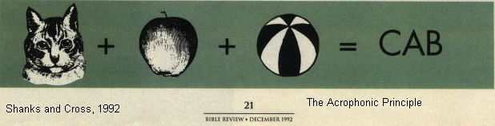

Canaanite and West Semitic dialects have only three vowel areas and each syllable begins with a consonant. So you could write without vowels, using consonants only. The vowel sounds were known by the reader in context. Greek, by comparison, uses vowels to initiate words, so they invented vowel letters, most coming from Phoenician consonants with no Greek equivalent. Thus there was a simplification and borrowing of pictographs to make letters of the alphabet (Cross and Shanks, 1994).

The Sumarian pictographic writing is named Old Canaanite script. It was too cumbersome to be practical and was replaced (after several centuries) by proto-Sinaitic inscriptions. These have been found at Serabit el-Kahdem in the southwest Sinai desert. They are dated to 1,500 BC (about time of the Exodus [early date] and occur near a turquoise mining site at its associated temple which was dedicated to Egyptian goddess Hathor (Baalat) (Cross and Shanks, 1994).

PHOTO LINK: SCRIPTS 017 Sumerian pictographs. Shanks and Cross, 1992, 8:6:19. Photo University Museum.
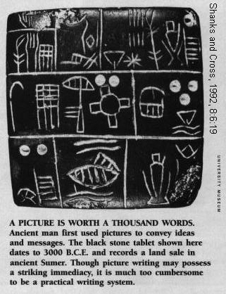

PHOTO LINK: SCRIPTS 033 Earliest writing 3 artifacts (See page 4, ABOVE; ctrl+click to follow link). Shanks, 2002, BAR, 28:5:28.

PHOTO LINK: SCRIPTS 034 Pictograph for order of barley, Uruk, Sumner . Shanks, 2002, BAR, 28:5:28. Photo from Schøyen Collection.
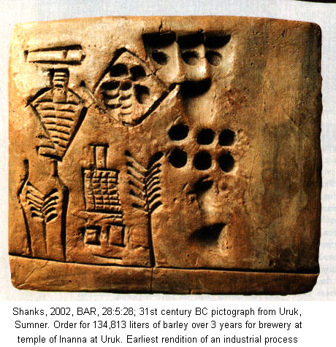

PHOTO LINK: SCRIPTS 022 Proto-Sianitic inscriptions at Serabit-el Kahdem. Shanks and Cross, BR. 8:6:22. Photo by H. Shanks.
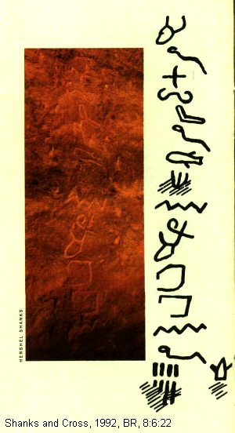

PHOTO LINK: SCRIPTS 024 Proto-Sianitic inscriptions at Serabit-el Kahdem. Shanks and Cross, 1992, BR, 8:6:23.. Photos by Avaram Hai and Hershel Shanks.
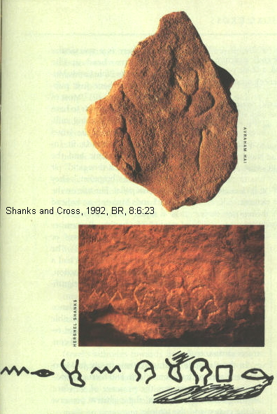

PHOTO LINK: SCRIPTS 002 Sumerian pictographs to cuneiform script. Livingston, 1980, B&S, 9:2:36.
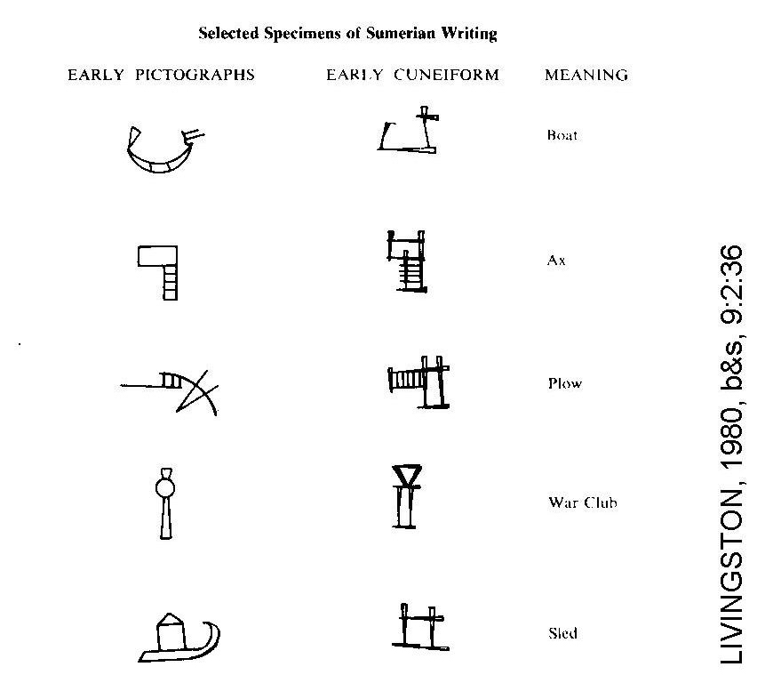

The next phase of alphabet development is found on inscribed arrowheads from 1,100 BC (Cross and Shanks, 1994).

PHOTO LINK: SCRIPTS 026 Inscribed Arrowheads. Shanks and Cross, 1992, BR, 8:6:27.
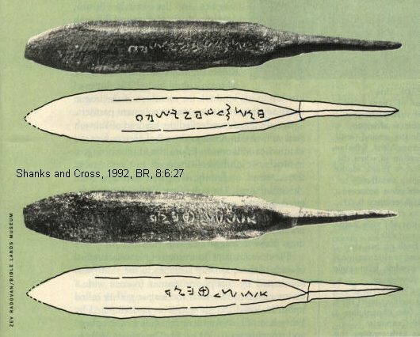

PHOTO LINK: ALPHABET 001 Inscribed Arrowheads Mid 11 to early 10th centuries BC. McCarter, Jr., 1999, BAR, 25:3:42. Photos by McCarter.
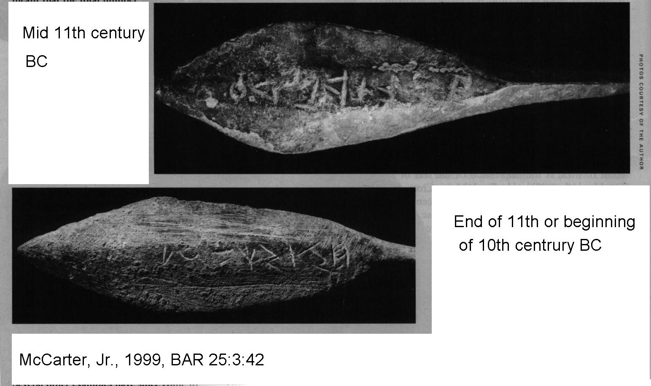

PHOTO LINK: ALPHABET 002 Inscribed arrowheads missing link between Proto-Canaanite and Early Phoenician. McCarter, Jr., 1996, BAR, 22:2:39. Photos by Rev Zadovan.
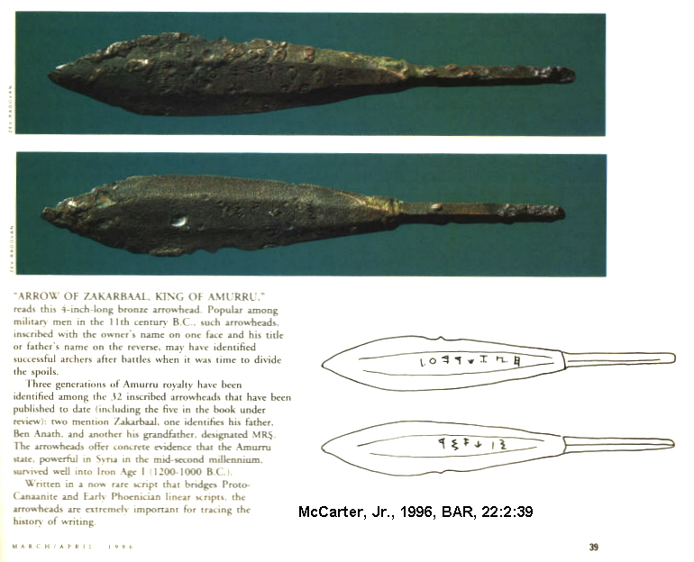
The next phase in development of an alphabet is found at in Ugarit abecedaries and syllabic cuneiform dating from the 14th century BC.

PHOTO LINK: SCRIPTS 035 Alphabetic cuneiform, Ugarit, 14th century BC. Shanks, 2002, BAR, 2000, 28:5:28.
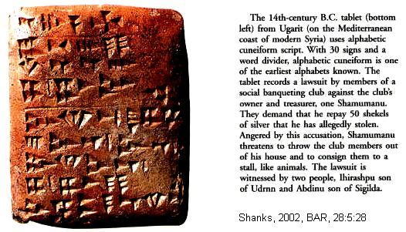
In these abecedaries, the Canaanite alphabet was modified to be written with cuneiform wedges. On clay tablets, these are much more abundant compared to the proto-Sinaitic inscriptions or those found on arrowheads or even the later Early Phoenician linear script (Cross and Shanks, 1994).

PHOTO LINK: UGARITIC SCRIPT 002 Alphabetic Ugaritic cuneiform.. Goldwasser, 2010, BAR, 36:2:50.
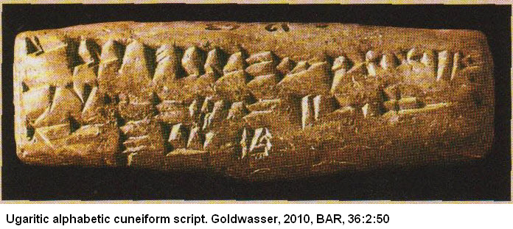

Alphabetic script evolution was as follows: Proto-Sianitic–> Ugaritic arrowheads –> Early Phoenician linear–> Old Hebrew –> Old Aramean –> Early Greek scripts (Cross and Shanks, 1994c).

PHOTO LINK: ALPHABET 005 Chart showing evolution of alphabet pictographs to modern scripts
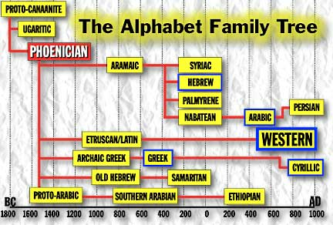

MATERIALS

Both Mesopotamian cuneiform and Egyptian hieroglyphic writing was done on materials that included baked or unbaked clay, inscribed stones (stele) and pottery fragments (ostraca) (Livingston, H., 1980).

PHOTO LINK: SCRIPTS 004 Egyptian writing equipment. Livingston, 1980, 9:2:39.
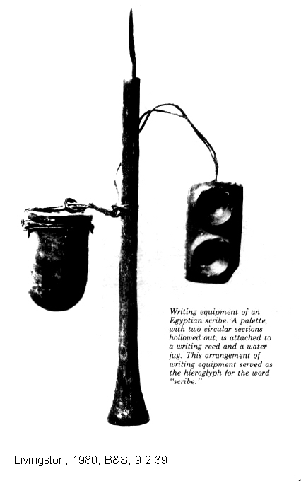

EPIGRAPHY AND PALEOGRAPHY

The science of Epigraphy is the study of the meaning of ancient inscriptions. Paleography is the science of analyzing the shape and changes in the scripts (“letters”) that make up the inscriptions (Livingston, H., 1980). The shape of letters change with time, as illustrated in the chart, below:

PHOTO LINK: SCRIPTS 032 Modern, Roman, Old and New Hebrew scripts. Deutsch, 2002, BAR, 28:4:28.
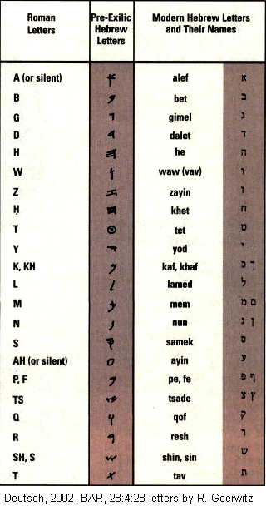
PHOTO LINK: SCRIPTS 042 Paleo Hebrew compared to Old Hebrew. Cross, BAR, 27:2:45.
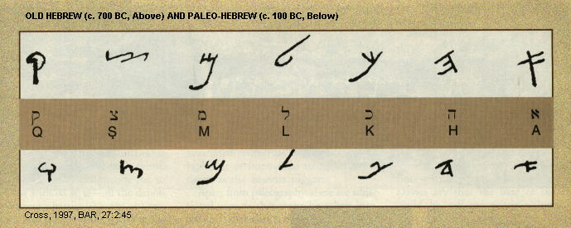

PHOTO LINK: SCRIPTS 038 Comparison chart, Modern Hebrew, English, Ammonite, Old Hebrew and PHOTO LINK: SCRIPTS 016 Development of Aleph (A) over time . Shanks and Cross, 1992, BR, 8:5:26.
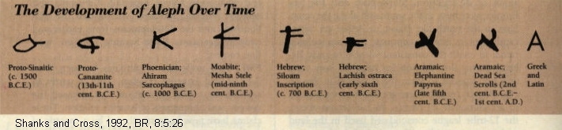

PHOTO LINK: SCRIPTS 008 Evolution of selected letters. Livingston, 1908, B&S, 9:2:49.
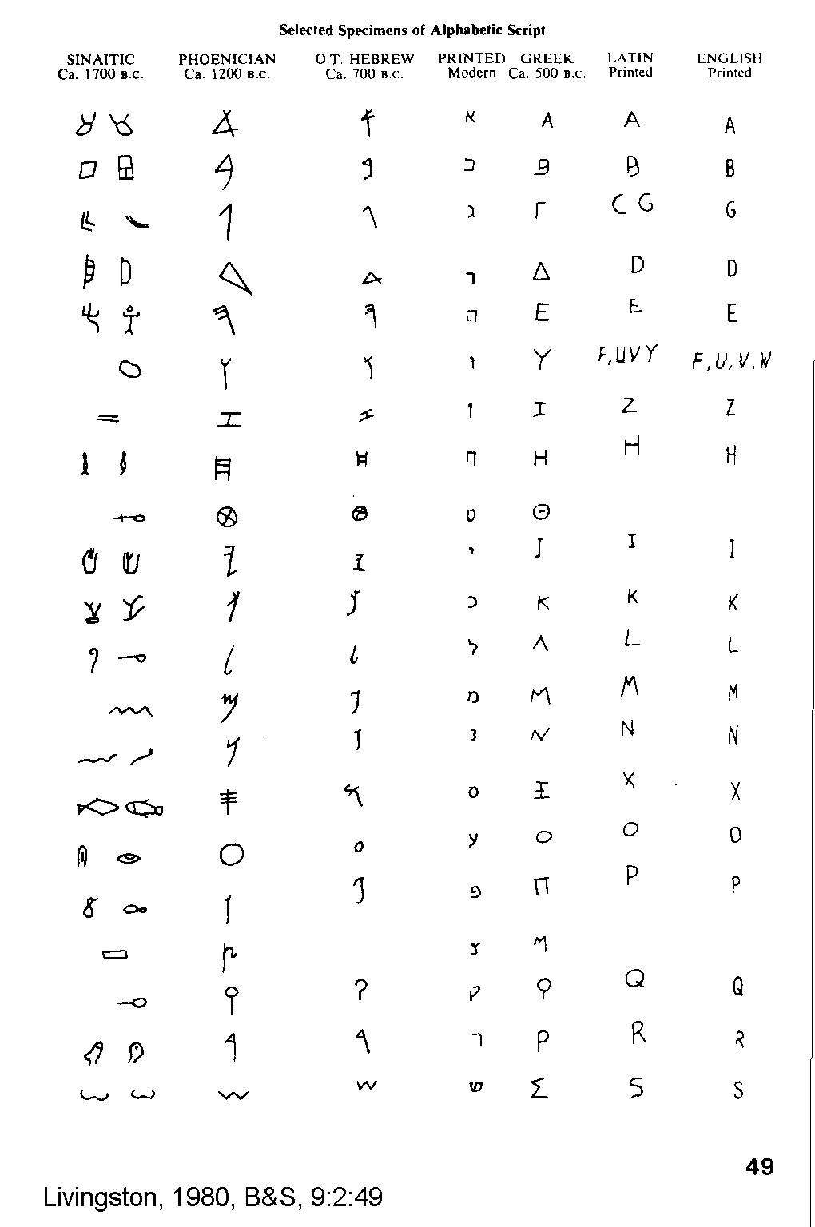

PHOTO LINK: SCRIPTS 013 Pictographs to early Cuneiform, Sumerian. Millard, 1992, BR, 8:2:23.
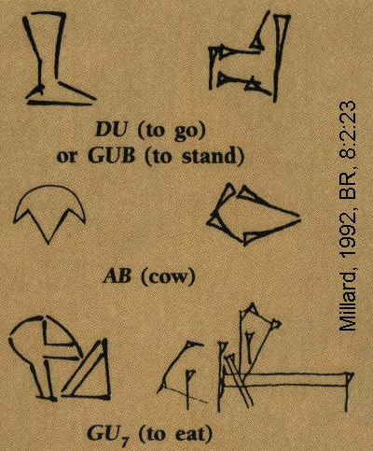

PHOTO LINK: SCRIPTS 012 Chart Pictographs to Alphabet. Sewell, 1994, ABR, 7:1:29.
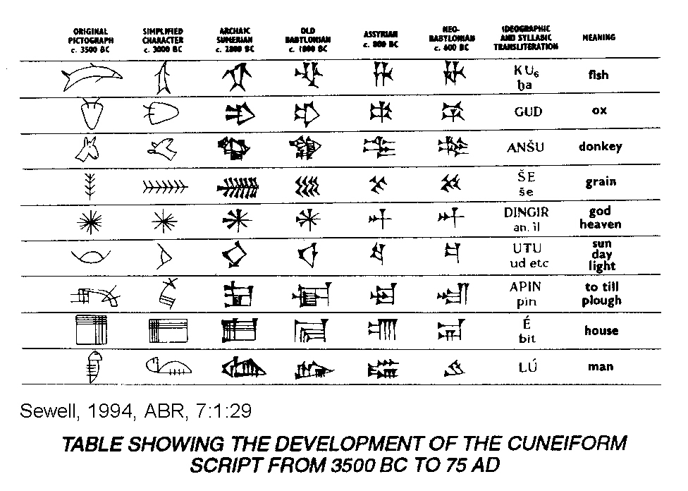
As the alphabet developed, there were competing shapes, inclinations and orientations to the letters (Grapheme is the term epigraphers use). The direction of writing also varied. Some scripts here read right-to-left (sinistrograde), and others were left-to-right (dextrograde). Other scripts were written in alternating sinstrograde/dextrograde directions. This type is named boustrophedon (“as the ox plows”). Sometimes script would be written vertically, in columns. (Rollston, 2012:34)

The Proto-Sinaitic (or “Early Alphabetic”) scripts included as many as 27 or 28 consonants. Later Phoenician had just 22 letters. (Rollston, 2012:34)

At the end of the second millennium BC, several things happened at about the same time:

1) The stance of the letters became more stabilized and standardized
2) The direction of writing became only sinstograde (right to left).
3) Consonants were merged, and were reduced to 22 in number
4) There were no vowels.

These changes coalesced around the middle of the 11th century BC and resulted in the Phoenician script, considered the heir of the Proto-Sinaitic/Early Alphabetic script (Rollston, 2012:34)

SCRIPTS AND LANGUAGE

There is no automatic correlation between a script and a language. Several different languages can share a common script. Fore example, English, French, German, and most Western European languages all use a Latin alphabetic script. A parallel situation existed in the Levant in early 2nd millennium BC. (Rollston, C.A., 2012:33).

The Nortwest Semitic languages included Ugaritic (extinct), Canaanite (including Hebrew) and Aramaic (May 17, 2012 in http://en.wikipedia.org/wiki/Northwest_Semitic_languages)

It is not always possible to identify what language an ancient script is written in. For example, the same set of consonates may exist in different languages. But those letters my have different meanings, depending on the language being represented by those letters. So we can have an inscription that has the same consonates, and look the same, but the language behind those consonates may be Hebrew, Moabite, Ammorite, Ugaritic, Aramaic, etc. (Rollston, 2012:36).

Rollston (2012:36-37) gives a summary of other problems in deducing the proper relationships between scripts and languages:

For example, the standard Hebrew word for "dog" is written with these consonants: klb. But no trained epigrapher would read this word in an inscription and automatically assume that it must be Hebrew, for the word dog is spelled klb not just in Old Hebrew, but also in languages such as Phoenician and Aramaic. Similarly with the word for "son," which is spelled bn in Hebrew, but bn is also “son” in Phoenician, Ammonite and Moabite.

Words with the same consonants may also have been pronounced differently in different languages, and the writing systems of the Iron Age Levant (e.g., Hebrew, Aramaic, Phoenician, Ammonite, Moabite, Edomite, Philistine) did not represent vowels with any precision even after they were introduced. And Phoenician writing was strictly consonantal throughout most of the Iron Age; vowels are not represented in this script

Hebrew writing was primarily consonantal, but early on Hebrew began using matres lectionis ("mothers of reading"), that is, using certain consonants to signify certain vowels also. At first, these matres lectionis were used to represent only long vowels that occurred at the end of a word. Thus, a final yud (y) could be signifying a vowel and pronounced i, rather than simply being the consonant y. Just when you think it's clear, however, it becomes more complicated: A final heh (scholars write it simply he), normally pronounced h, was used to signify not just the consonant heh but it could also be used to signify three different vowels: ä, ë or ö. This of course creates some additional ambiguity.

Then, at the end of the eighth century B.C.E., Old Hebrew scribes also began using matres lectionis for certain internal long vowels, that is, for vowels within a word. Thus waw was sometimes used for fi, and yod was sometimes used for E A similar development occurred in Iron Age Aramaic.

The long and short of it is that we are often not certain about the actual pronunciation of words in Iron Age Northwest Semitic languages—or even what language it is. Sometimes we can make such determinations; sometimes we cannot It just depends on the nature and content of the inscription.

Another factor that can be important in determining the language of an inscription is provenance: Where did the inscription come from? An Iron Age inscription discovered in Moab is likely to Moabite. But inscriptions can travel. For example, and inscribed seal found in a tomb in Amman that you might suppose would be Ammonite (or perhaps Aramaic) was actually written the Moabite script (Talet, 1985:21-29). And there is an Old Hebrew inscription that was found in Nimrud (Assyria, see Millard, 1962:45-49).

A final difficulty is that we are often dealing with partially preserved languages. Most of the texts produced in antiquity simply did not survive the ravages of time. There is much about these ancient languages that remain unknown – and will likely never be known,

TYPES OF SCRIPTS

There are four general types of scripts. The oldest are pictographs and were introduced above. In contrast, ideographs are signs for abstract ideas. The icons on most personal computers of today are ideographs. Advanced ideographs represent words and may contain phonetic component. These are also known as "analytic transitional script.” The fourth type of script are phonemes: graphic symbols for speech sounds (not self-interpreting pictures) and tied to mechanics of language (Livingston, H., 1980).

PHOTO LINK: IDEOGRAM 003 No right turn http://www.israellycool.com/wordpress/wp-content/uploads/no-left-turn.jpg. Oct. 19. 2013.

PHOTO LINK: IDEOGRAM 002B Chinese http://www.theepochtimes.com/n2/images/stories/large/2008/08/18/jia.jpg ideogram. Oct. 19, 2013.

PHOTO LINK: IDEOGRAM 001 School zone crosswalk. http://highwaytrafficsupply.com/images/regulatory_signs.html/S2-1.jpg, Oct. 16, 2013

TYPES OF WRITING

Monumental Inscriptions

The practice of making inscriptions on monuments is an important source of information on history, scripts and language in bible lands. Examples of monumental inscriptions are the Siloam Tunnel Inscription (Hezekiah/Sennacherib 701 BC), the Stele of Samaria, and the Silwan tomb epitaphs (Livingston, H., 1980).

PHOTO LINK: HEZEKIAH TUNNELL 020 Siloam Tunnel Inscription. Parker, 1994, BAR, 20:4:37.
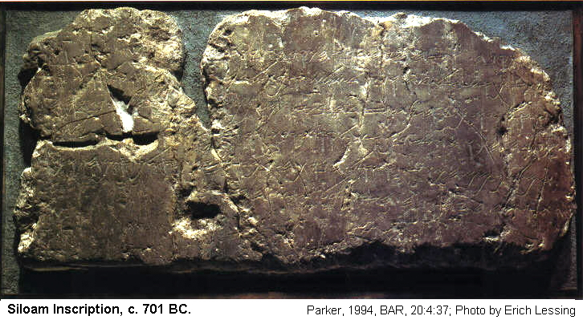

PHOTO LINK: SILWAN TOMB EPITAPH 001. http://cojs.org/cojswiki/Image:Royal_Steward_Inscription.jpg; Oct. 19, 2013.

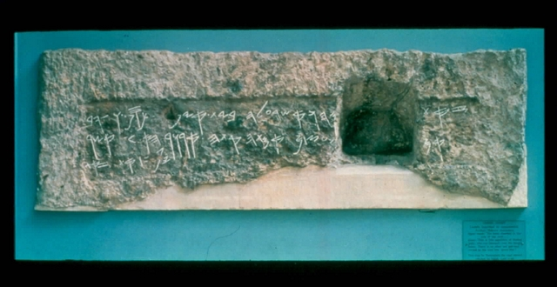

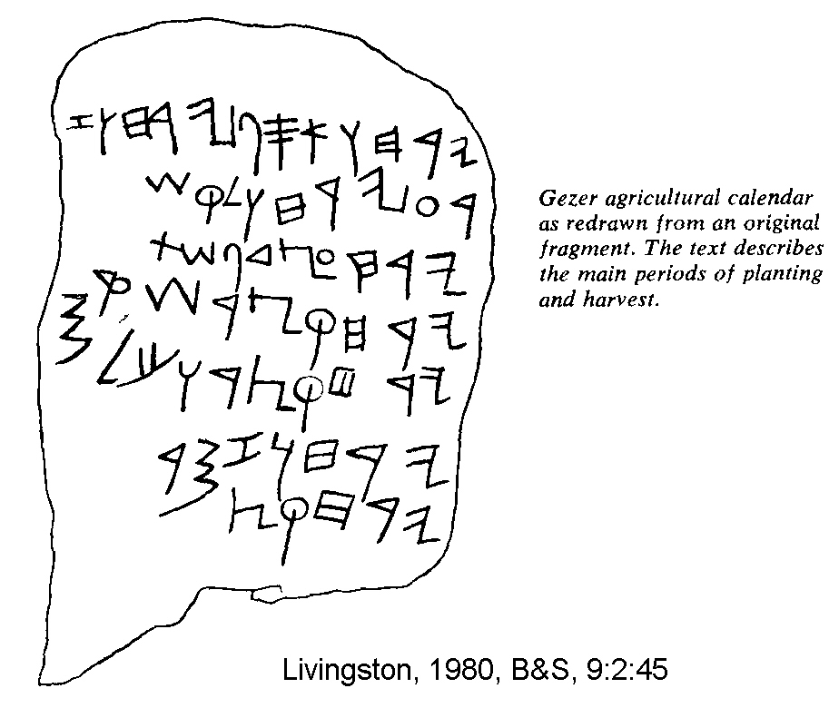
Professional Writings

Administrative and business records of various types and on various mediums are a second class of writing. These include the Samaria ostraca of Jeroboam II (d.753 BC), the Wadi Murabba'at papyrus, inscribed weights and seals, the Gezer Calendar and Solomonic, the earliest inscription known is circa 966 BC (Livingston, H., 1980).

PHOTO LINK: SCRIPTS 007 Gezer calendar and paleohebrew script. Livingston, 1980, B&S, 9:2:45. (RIGHT)

PHOTO LINK: BA113 Iron Age "Gezer Calendar" Alphabetic Script on Tablet, Gezer, 10th century BC,. BWP, BA-113.

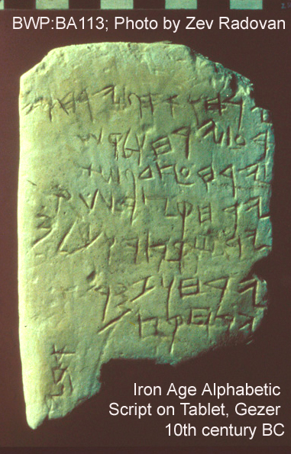

Occasional Writings

These records include stone scribbling and writings for mundane and routine purposes. The frequent discovery of this type of artifact suggests writing was widespread in antiquity. This class of writing include ostraca, short records made on pieces of broken pottery. Most occasional writing was done on scrolls of, papyrus or leather. These materials are perishable and are rarely preserved (Livingston, H., 1980).

PHOTO LINK: POTTERY 011 Philistine monochrome ware, ostraca and bowl. Wood, 1991, BAR, 17:6:48. Photographs by Terry Smith.
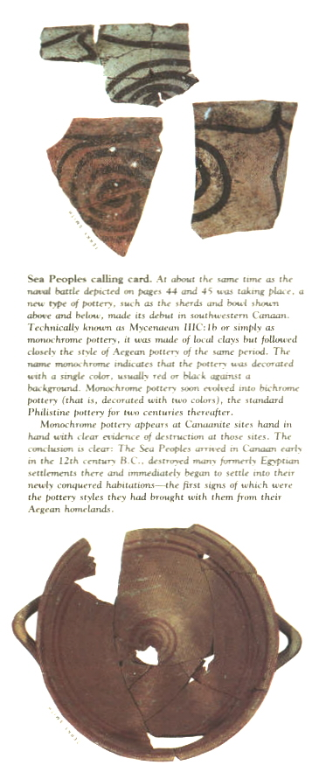
PHOTO LINK: SCRIPTS 037 Comparison of Ammonite ostraca. Herr, 1993, BAR, 19:6:30.
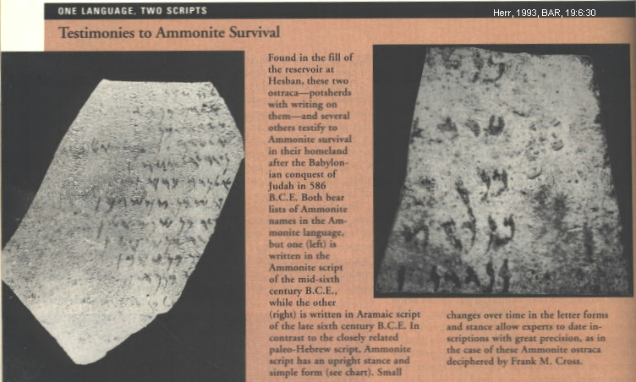

PHOTO LINK: SCRIPTS 031B Ostracon from Qumran. Strugnell and Eshel, 2002, BR, 17:3:44. Photo by Ester Eshel.
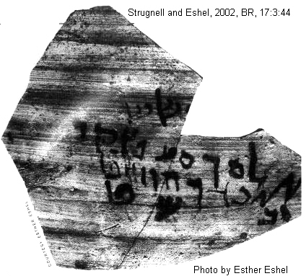

SCRIPTS OF MESOPOTAMIA

Cuneiform

Mesopotamian cuneiform (Latin for "wedge-shaped") was based on a system of highly stylized pictographs. With pictographs, a realistic rendition of cow's head, for example, meant "cow". A realistic drawing of a foot meant "to stand", "to go" or "to walk". Gradually the pictures became stylized and were unrecognizable unless seen in developmental context from their pictographic beginnings (Millard, 1992, p. 23).

PHOTO LINK:'APIRU 001 Tell et-Amarna letter cuneiform tablet. 'Apiru lead by Lab'ayyu. Shanks and Cross, 1992, BR, 8:4:32. Photograph by Staatliche Musseen.
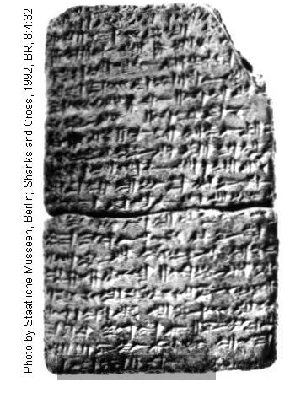
PHOTO LINK: EBLA 012 Details of tablet written in Eblaite cuneiform. Livingston, 1992, ABR, 5:3:95
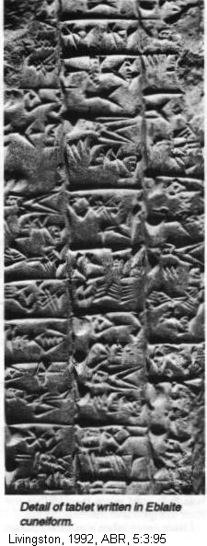
PHOTO LINK: NUZI TABLETS 002 Chart: Cuneiform script 3500 BC to 75 AD. Livingston, 1994, B&S, 7:1:29.
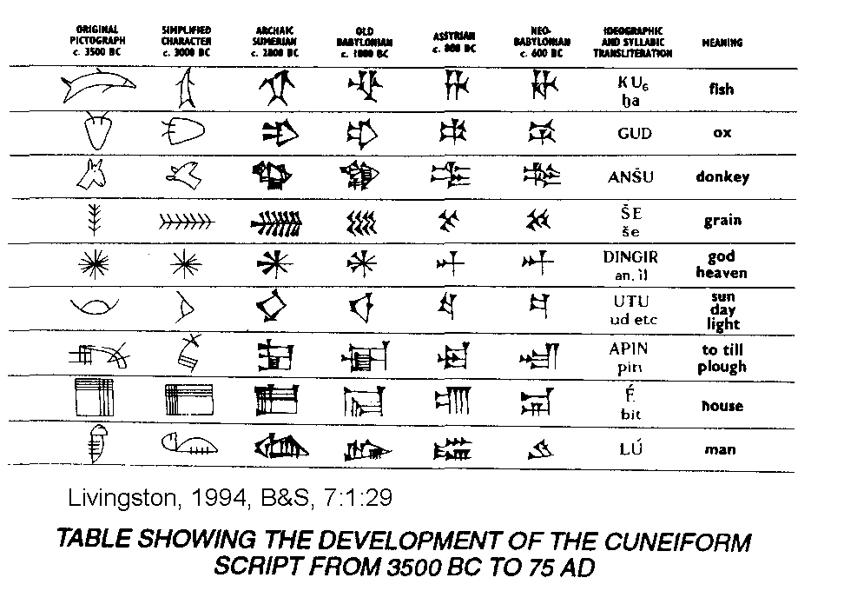

PHOTO LINK: NUZI TABLETS 003. Livingston, 1994, B&S, 7:1:27.
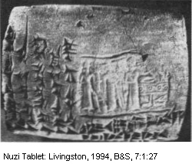
PHOTO LINK: NUZI TABLETS 005 Three Nuzi tablets. http://www.diggingsonline.com/pages/rese/books/comment/nuzitablets.jpg . Oct. 19, 2013.

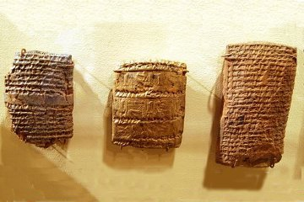

PHOTO LINK: SCRIPTS 013 Early and late cuneiforms at Ebla;
(See p.23, ABOVE; ctrl+click to follow link)

PHOTO LINK: SCRIPTS 019 Ebla cuneiform tablet. Cross, 1992, BR, 8:6:20. Photograph by Erich Lessing.
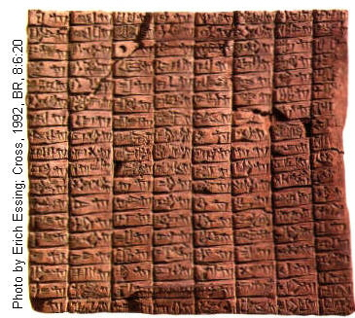

PHOTO LINK: BA112 Late Bronze Cuneiform Writing on Tablet, Megiddo, 15th-14th century . BWP, BA-112.
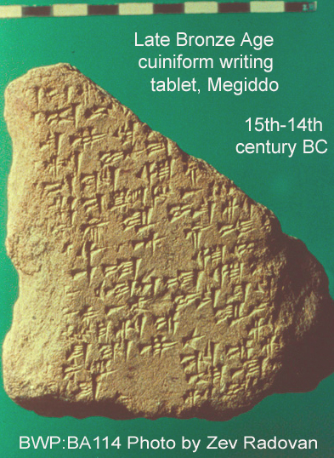

Sumerian Language
(cir. 3500-2050 BC)

The origin of the Sumerian language is unknown, but it is NOT a Semitic language. Although dead in 2050 BC it was studied by scribes of later cultures (Babylonian, Assyrian, Elamite, Hurrian, Hittite, Canaanite) for several centuries. A Sumerian essay about suffering parallels Biblical Job story (Wood, M.L., 1979). The Sumerians had the Ur-Nammu code of law (300 yrs older than Code of Hammurabi, c.2150 BC)) and the Lipit-Ishtar code of law (150 yrs older then Hammurabi, c. 1900 BC). The script was agglutinative (running together). Knowledge of the language comes from 250,000 tablets and fragments found at Sumerian sites (Livingston, H., 1980).

Sumerian Pictographs and Cuneiform

The oldest samples of Sumerian writing (1,000 tablets) come from Erech, circa 3000 BC. They consist of pictographs on clay tablets drawn with stylus (a reed?) and are temple records. With time, the pictographs were replaced by stylized wedge-shaped marks (cuneiform) and the signs became more phonetic. The language had signs which represented a consonant AND a vowel (i.e. ba, bi, bu, ub, ib, ab). This system resulted in hundreds of signs (900 are known at Erech alone!) (Livingston, H., 1980).

PHOTO LINK: SCRIPTS 017 Sumarian Pictographs (See p.11 , ABOVE; ctrl+click to follow link)

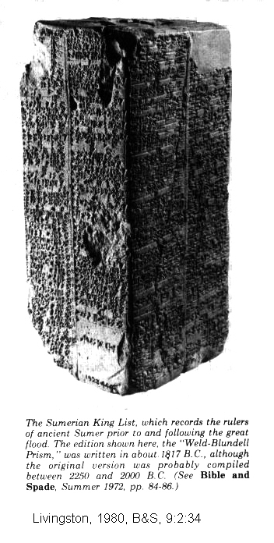
PHOTO LINK: SCRIPTS 001 Prism Sumerian King List 2250-2000 B.C. (RIGHT) Livingston, 1980, B&S, 9:2:34.

PHOTO LINK: SCRIPTS 002 Examples Sumerian writing. Livingston, 1980, B&S, 9:2:36.

PHOTO LINK: SCRIPTS 003 Adapa Tablet Ashurbanipal library Nineveh 7th cent BC. Livingston, 1980, B&S, 9:2:37.

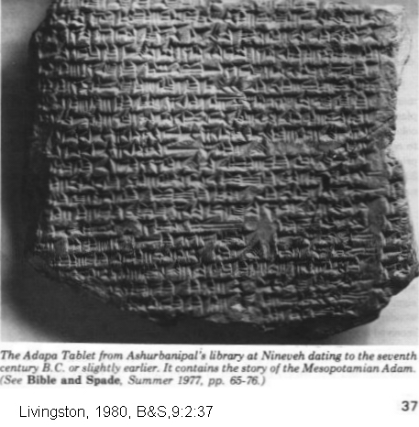

PHOTO LINK: SUMERIAN KING LIST 001 Sumerian king list Prism of Nippur
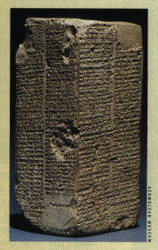

PHOTO LINK: SUMERIAN KING LIST 002 Sumerian king list prism; Livingston, 1980, B&S 9:2:34.
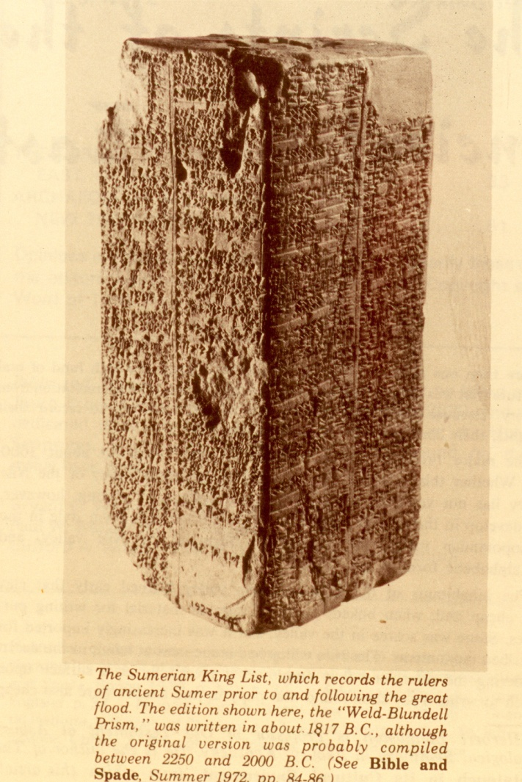

Cuneiform was established as a writing method by the time of Semitic Empire of Sargon I (end of 3rd millennium BC). It was originally arranged (like Chinese/Japanese) in columns written left to right. Later, for reasons unknown, columns were turned on their sides creating horizontal patterns of writing. To keep the original writing orientation, the signs were turned on their sides as well (Livingston, H., 1980).
Akkadian Language

Akkadian is an Eastern Semitic language. It was spread throughout the Assyrian Empire by Sargon I (third millennium BC). There are two dialects. The oldest is Babylonian. The Babylonian dialect was the language of the Code of Hammurabi at Susa (circa 1728 BC) and most of the Tell el-Amarna letters (Middle Babylonian, 14th century). Neo Babylonian was the language that king Nebuchadnezzar (605-562 BC) used for his royal inscriptions which were written in the ancient Babylonian language style (Livingston, H., 1980).

The second dialect of Akkadian is Assyrian. It was the main language of Anatolia and faded out of usage with the Assyrian empire's disruption in 612 BC. It is the parent of Hebrew (Livingston, H., 1980).
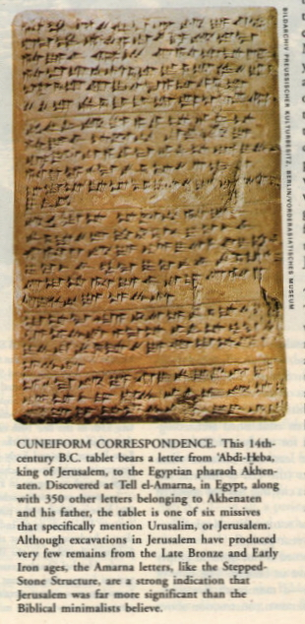
Akkadian Cuneiform

Akkadian cuneiform lasted as a writing medium for 1,800 years. Semitic Acadians, lead by Sargon I, adapted Sumerian cuneiform to make the Akkadian script. This in turn was adapted by the Old Babylonian Empire of Hammurabi (late 18th, early 17 centuries BC). By the 14th century BC Akkadian was used in international communication by the Hurrians, Hittites, Assyrian, Canaanites. Akkadian cuneiform is the script for the Tell el-Armana letters. It was a language and script used by Assyrians, neo-Babylonians and Persians. It declined in popularity during the Greek Empire and disappeared by 75 AD (Livingston, H., 1980).

PHOTO LINK: JERUSALEM 004 Tell et-Armana letter cuneiform tablet. Correspondence about Urusalem. (RIGHT). Shanks, 2002, BAR, 26:5:36. Photograph from Berlin Museum / Bildarchiv Preussischer Kulturbesitz, Berlin / Vorderasiatishes Museum.

PHOTO LINK: GENESIS COLOPHON HAMMURABI 001 Tablet Babylonian Hammurapi showing similarity to the Genesis tablets and colophon, DeWitt, 1997, B&S, 6:2:48.
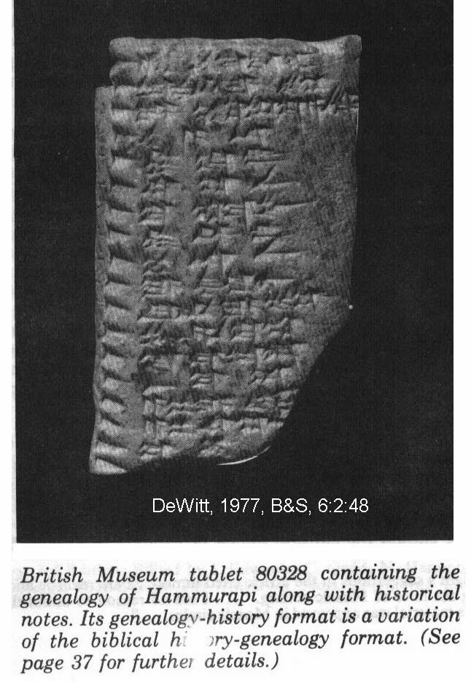
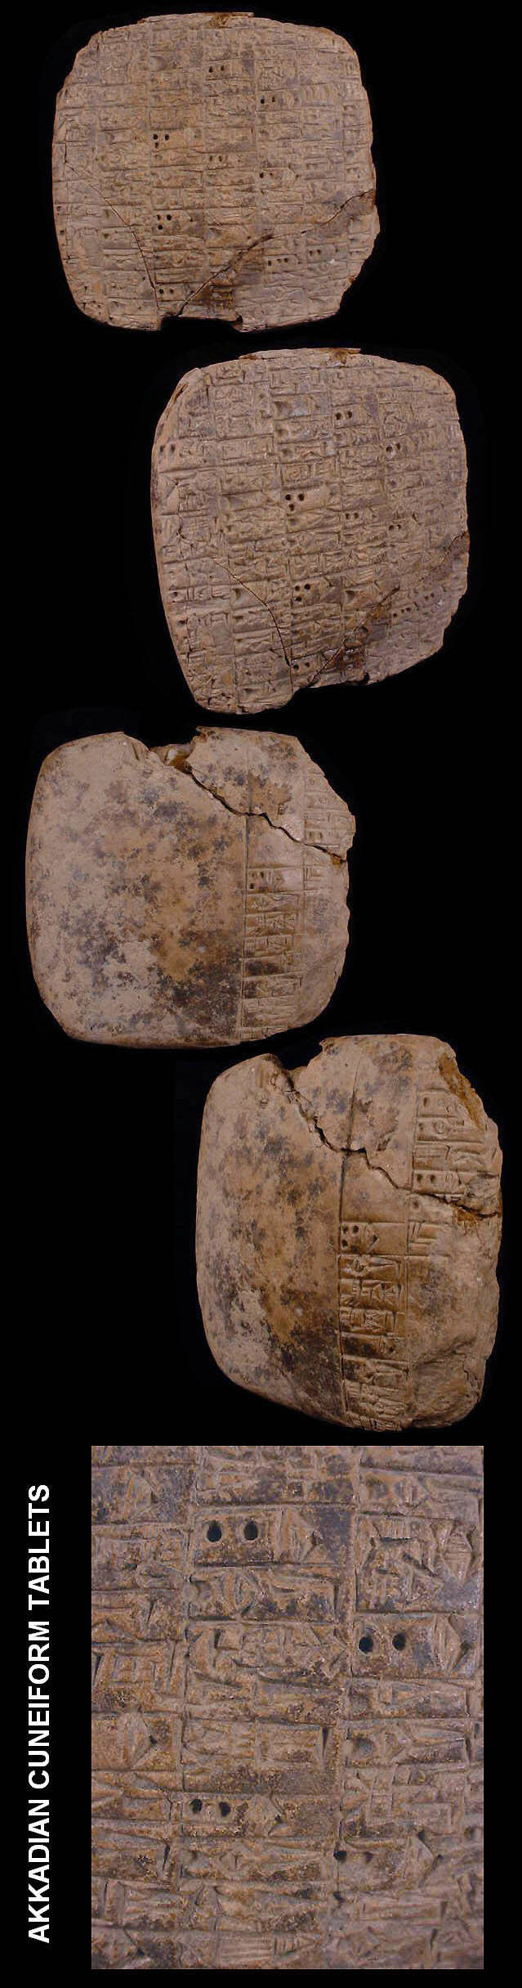

PHOTO LINK: AKKADIAN CUNEIFORM 001 Akkadian tablet with holes; http://www.bcgalleries.com.au/08306.html ; May 1, 2005 (ABOVE, RIGHT)
PHOTO LINK: HITTITE 005 Hittite cuneiform tablet. Livingston, 1995, B&S, 8:1:14.
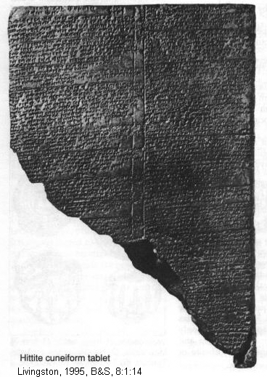

PHOTO LINK: HITITE SCRIPT 002; http://historicconnections.webs.com/hittite.htm; Oct. 19, 2013.

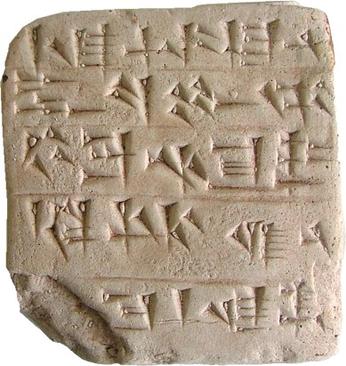

PHOTO LINK: FLOOD 002 Akkadian Flood Tablet. Horn, 1980, 9:3-4, 97.
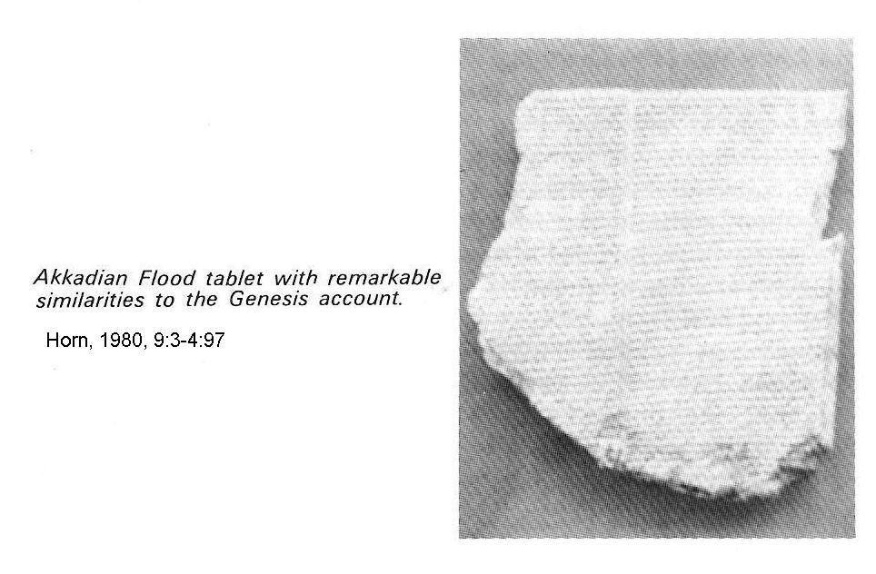

PHOTO LINK: AKKADIAN FLOOD TABLET 001. Tablet inscribed in Akkadian with a fragment of the Babylonian Flood story of Epic of Athrasis. http://www.themorgan.org/collections/collections.asp?id=729. Oct. 19, 2013.

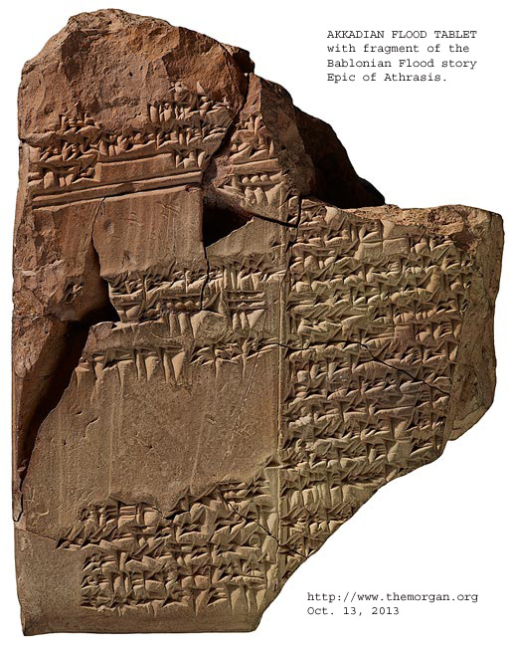

Babylonian Scribal Practices

The colophon, a marginal notation at the beginning and end of cuneiform tablets, was a scribal tool in use by Babylonian scribes from 3,000 to 1 BC. It gave the name of the scribe and sometimes gave the name of scribe's colleague, senior, inspector or collator. It sometimes gave details of exemplar such as "copied from a tablet from Babylon." They sometimes recorded damage to exemplars by writing "break" or "recent break” in smaller script. The scribes were careful not to split words or phrases between lines of text and they justified the line spacing to avoid word/phrase splits. They used punctuation similar to our “colons” to mark unavoidable word breaks or glosses (text additions) or (1st millennium) word doublets (synonym or variant). They were careful to distinguished original text from commentary. They spelled words with syllables and used word-signs in order to easy the reader's task when ambiguities of pronunciation were present (Millard, 1982).

The scribe became a specialized profession in Babylon, as indicated by the tablet illustrated below. This tablet also contains a colophon even though it is a practice document produced by a student.

PHOTO LINK: SCRIPTS 036 Babylonian student tablet 19th century BC with colophon. Shanks, 2002, BAR, 28:5:29. Photograph from Schøyen Collection.

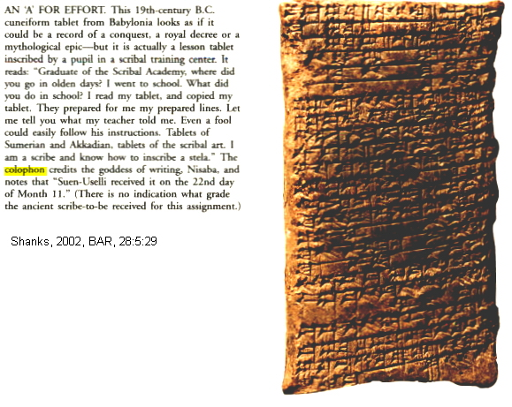

These colophons contained notes about the total number of lines on the tablet. If the scribe was preparing a long text, every 10th line is marked and subtotals entered at the base of each cuneiform column. A check was made after the tablets were copied. Sometimes corrections were made in the text, and if a line was found to have been omitted, it was written on the edge of the tablet with a horizontal line marking it's correct position in the text (e.g. Snake Charm text from Ras Shamra and Atrahasis Epic) (Millard, 1982).

Examples of accuracy of the retransmission of text by Babylonian scribes are listed below (Millard, 1982):

1. A Sumerian hymn of praise is nearly identical to its Old Babylonian version. This is so despite age difference of 7 or 8 centuries.
2. Hammurabi Law Code as depicted in early 2nd millennium (Hammurabi) and 1st millennium (Nebuchadnezzar) versions are nearly same, except for spelling modernizations.
3. The poem "Return of Ninurta to Nippur" is known from 54 different Old and Middle Babylonian, Middle Assyrian, Neo-Assyrian and Neo-Babylonian texts. These collectively show only 64 variants in 207 lines of manuscript. Of these only 12 variants have real alteration of meaning of the text.

PHOTO LINK: NINURTA 001 Shell inlay Ninurta slays 7-headed sea monster. Hurowitz, 2005, BR, 21:2:46. Photography by M. Amar and M. Greyevski, Bible Lands Museum.

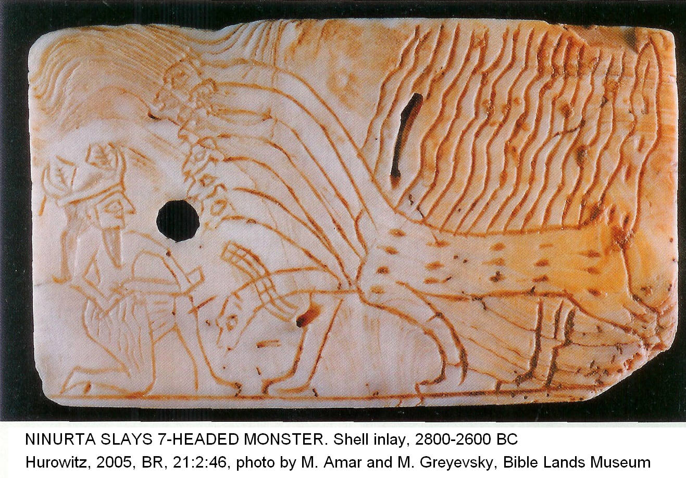

Hurrian Language

The Hurrian language was discovered in some Tell el-Armana letters.

PHOTO LINK: AMARNA LETTERS 002 Varicolored tablets. Byers, 2002, B&S, 15:4:112. Photograpoh by Bryan Wood.

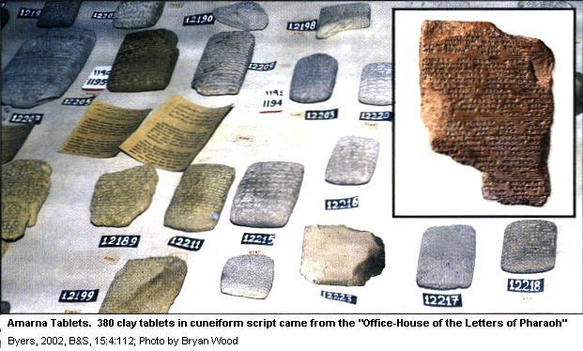

It is also known from the Nuzi tablets (15th, 14th centuries BC).

PHOTO LINK: NUZI TABLETS 001 Map Location. Sewell, 1994, B&S, 7:1:28.
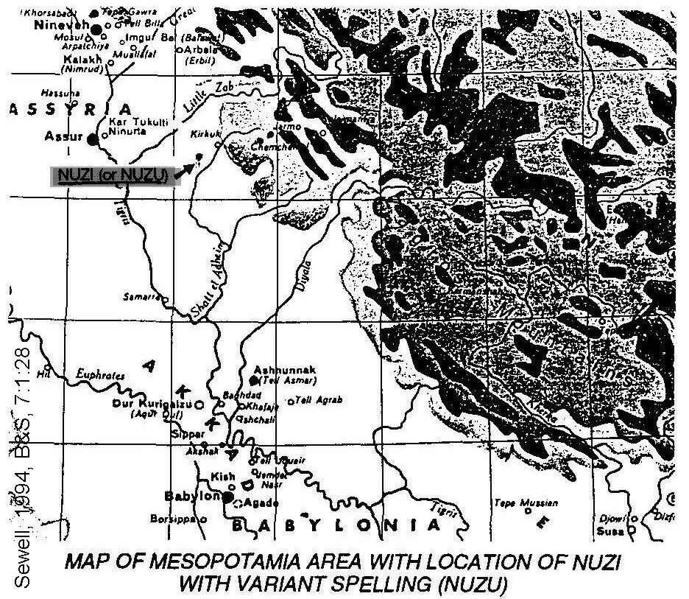
PHOTO LINK: NUZI TABLETS 002 Chart: Cuneiform script 3500 BC to 75 AD; (See p. 30, ABOVE; ctrl+click to follow link)

PHOTO LINK: NUZI TABLETS 003 Nuzi tablet (See p30, ABOVE; ctrl+click to follow link)

Hurrian is unrelated to Sumerian, Akkadian, or any Indo-European language. It may have some affinity to ancient Armenian (Livingston, H., 1980).

For a table showing development of cuneiform script from 3550 BC to 75 AD see Livingston (1994, p.29) and PHOTO LINK: NUZI TABLETS 002.

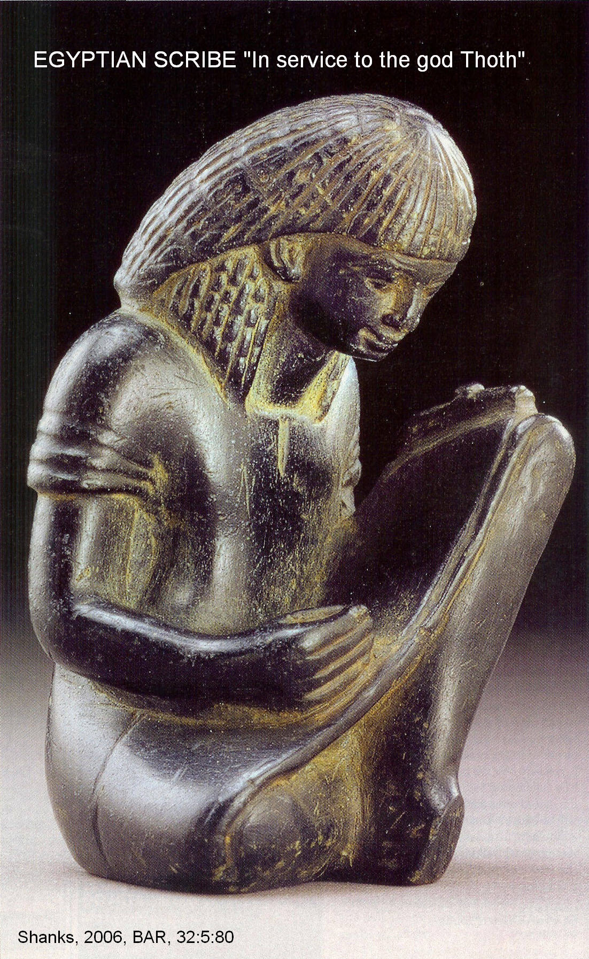
SCRIPTS OF EGYPT

Egyptian Sources

PHOTO LINK: SCRIPTS 059 Egyptian scribe figurine “In service to the god Thoth”, patron god of writing (RIGHT). Shanks, 2006, BAR, 32:5:80.

Our knowledge of the Egyptian language comes from (Livingston, H., 1980):

- hieroglyphics found on Middle Kingdom Reliefs (2000-1800 BC)
- Execration Texts (1925 to 1825 BC)
- Story of Sinuhe (20th century BC)
- New Kingdom reliefs and inscriptions (18th to 20th centuries BC)
- New Kingdom dynastic records (1570 to 1150 BC)
- Report of Wenamum (1060 BC)
- Shishak List of Towns (925 BC) commemorating his invasion of many cities including some in Judah, Edom, and Israel, and in the Tombs of Tanis

PHOTO LINK: ZOAN 001 Temple of Amun at Zoan, 21st Dynasty, 1055-1004 BC Greek name is Tanis. Byers, 2005, B&S, 18:1:8. Photograph by Michael Luddeni.
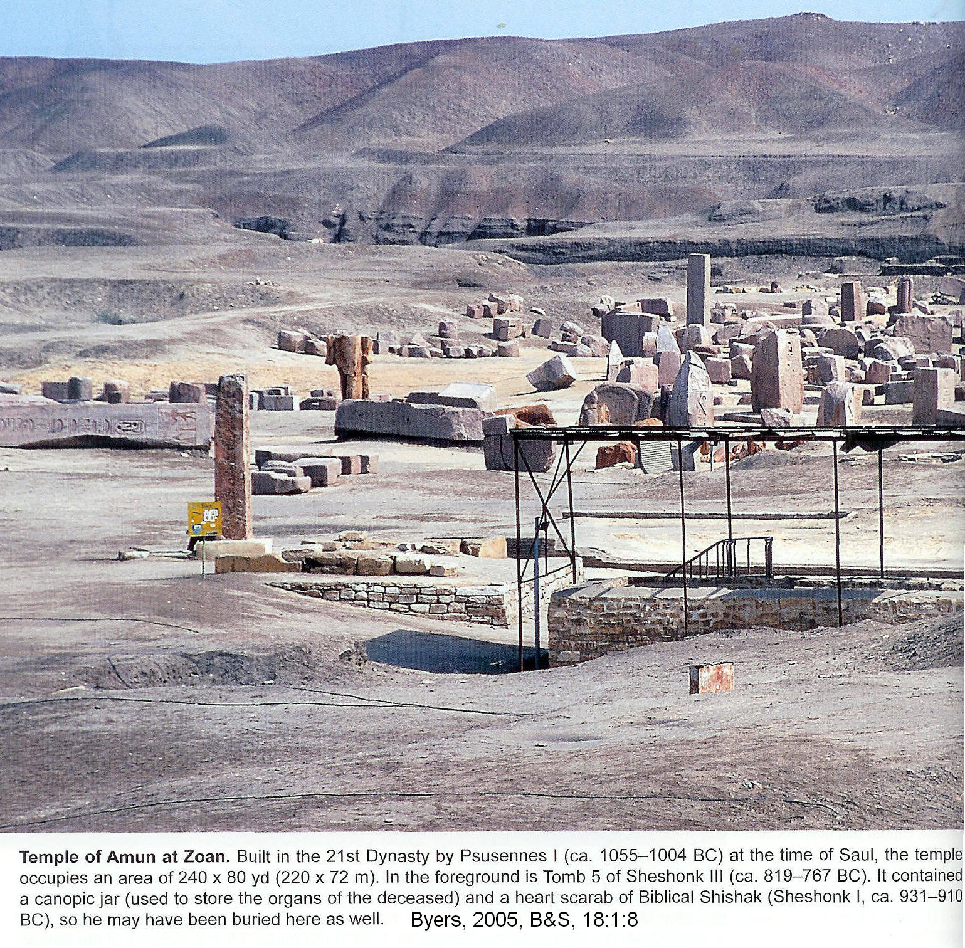
The Rosetta stone, discovered by Napoleon’s army in 1799, lead to the deciphering of Egyptian hieroglyphics. It dates to 196 BC. It was written in Egyptian Demotic, Greek and in Egyptian hieroglyphics. Since Greek was understood, the other two scripts could be deciphered.

PHOTO LINK: ROSETTA STONE 001 Color photo. http://rosetta.com/-images/RosettaStone.gif ; March 28, 2005

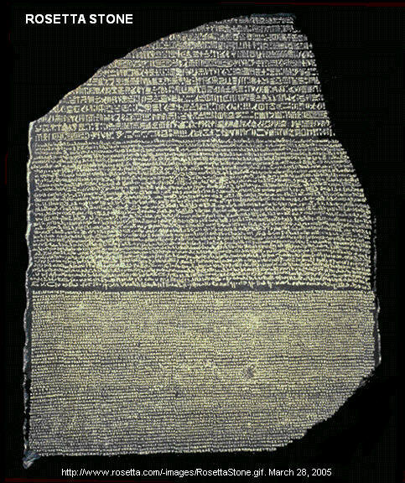

The Bubastis stone, discovered in 2004 56 miles northeast of Cairo dates to 238 BC and, like the Rosetta stone, has scripts of the same message in Demotic, Greek and hieroglyphics (Meinhardt, 2005:12).

PHOTO LINK: BUBASTIS STONE 001 238 BC. Meinhardt, 2005, ODY, 8:4:12. Photograph by Christian Tiezi; European Press Photo Agency, DPA
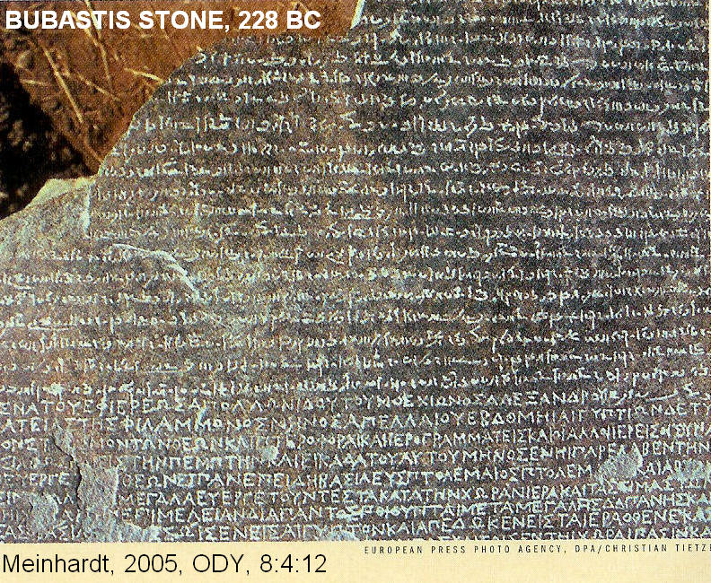

The Bubastis stone tells of activities of Pharaoh Ptolemy III Eurgetes I (246-221 BC). He imported grain from Syria Phoenicia and Cyprus to feed the population during a famine, and it also mentions reform of the ancient Egyptian calendar (Meinhardt, 2005:12)

Egyptian Language

The origin of the Egyptian language is unknown. It has several affinities to Semitic languages and by 3000 BC it was a distinct language. Middle Egyptian became the standard for literature until the 14th century BC when it became a dead language. Egyptian contained many words for everyday life but few words for abstractions or emotions. It had no vowels. As the language evolved, there was a trend toward simplification. Hieroglyphic scripts began to fade with Ikenaton's (Akenaten's d.1358 BC) phonetic revolution (Late Egyptian, Hieratic Script) and in the resulting Demotic script. When Egypt was ruled by Greeks, the Coptic script (Hellenistic Ptolmies) was adopted with a Greek style alphabet (Livingston, H., 1980).

Egyptian Hieroglyphs

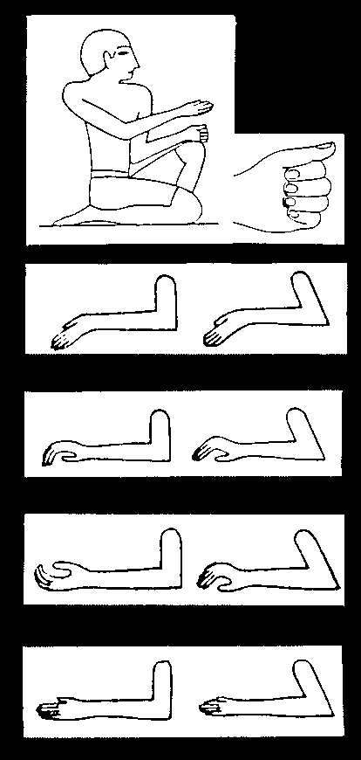
The word “hieroglyphic” is Greek for "sacred carving." There are four varieties of Egyptian hieroglyphics. Collectively, they are a set of letters without an alphabet and consist of images that depict (Livingston, H., 1980):

1. objects or words
2. the sound of 2 or 3 consonants
3. the sound of only one consonant, or
4. a determinative which had no phonetic value but classified an accompanying word to clarify its meaning

PHOTO LINK: PSALMS 004 Egyptian Hieroglyphics as musical signs (RIGHT). Wheeler, 1992, ABR, 2:4:14. Drawings by Gene Frackler.

PHOTO LINK: SCRIPTS 018 Egyptian hieroglyphics. Shanks and Cross, 1992, BR, 8:6:20.
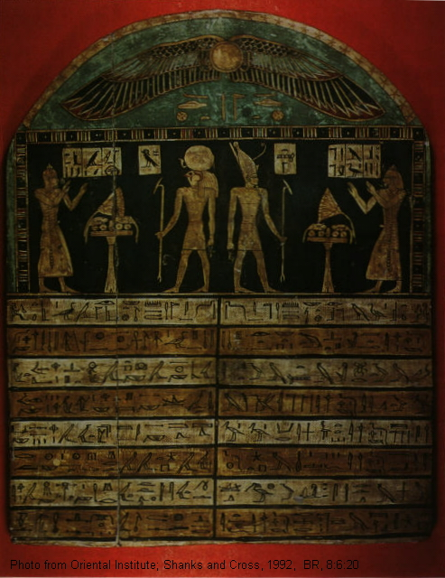

The Egyptian hieroglyphics form a complex syllablery of 300 or 400 different signs and 604 different symbols with no “pure” vowels and several vowel-consonant combinations. They were employed according to a complicated set of rules that evolved from scribal convention (spelling rules). The complexity of this system kept writing a secret of the priestly and ruling classes throughout Egyptian history (Livingston, H., 1980).

As with Mesopotamian script development, pictographs were used by Egyptians in 3000 BC. The pictograph represented an object of ancient life or action of that object. The pictographs soon were assigned signs with phonetic values or determinatives or modifiers and became hieroglyphics. They were written top to bottom, left or right (normal) or right to left. They contained 604 basic symbols. There were no separate vowels (like in cuneiform). Some signs represented groups of 3 consonants. About 75 signs represented 2 consonants. There were 24 (later 30) signs for single consonants. This latter set could have provided a simple alphabetic script for Egyptians but that never happened. Instead they mixed the signs according to complicated scribal rules (Livingston, H., 1980).

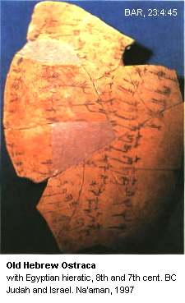
The hieroglyphics became an artistic medium and were brilliantly colored on their monumental inscriptions. The hieroglyphics were too complex of a writing system to have practical use internationally. The last hieroglyphic inscription that is known from ancient times were produced by priests of Isis on island of Philae in 394 AD (Livingston, H., 1980). A summary of Egyptian hieroglyphic writing related to scribes is found in Thimes (2000).
Egyptian Hieratic Script

The Hieratic script is an abbreviated form of hieroglyphic writing. Right to left is the only direction of Hieratic writing. It was used for religious literature and some business documents. Most surviving examples are on papyrus, and there are some on wooden boards, and pottery from mid 3rd millennium BC. Hieratic writing was given great impetus through reforms of Ikenaton (Akenaten, d.1358 BC; Livingston, H., 1980).

PHOTO LINK: SCRIPTS 047 Old Hebrew script with Egyptian hieratic signs and numerals (RIGHT). Na’aman, 1997, BAR, 23:4:45.

PHOTO LINK: SCRIPTS 055 Evolution of Hieratic Script from hieroglyphics. Hieratic scrips and their parent hieroglyphs from http://www.omniglot.com/writing/egyptian_hieratic.htm June 1, 2005

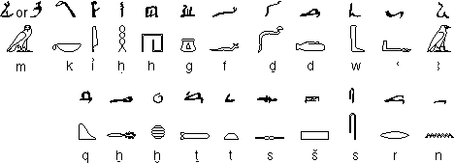

PHOTO LINK: HIERATIC SCRIPT 001 Example of cursive Hieratic Egyptian Script http://www.omniglot.com/writing/egyptian_hieratic.htm June 1, 2005

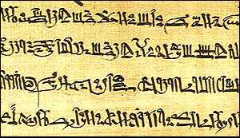

Egyptian Demotic Script

Demotic writing (pre-700 BC) was the Egyptian script used by Greek and Roman empires. They were used for commerce and government records. Writing mediums for this script were papyrus, wood and pottery. The last known Demotic inscription, from 476 AD, was written right to left (Livingston, H., 1980).

PHOTO LINK: SCRIPTS 063 Demotic Egyptian Script on ostracon. http://en.wikipedia.org/wiki/File:Demotic_Ostrakon.jpg. Oct. 19, 2013

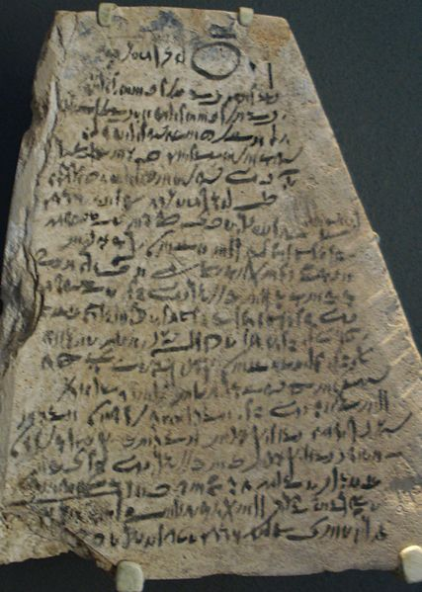

PHOTO LINK: SCRIPTS 049 Demotic Script
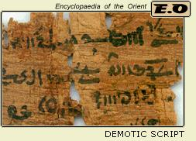

PHOTO LINK: BUBASTIS STONE 001 Demotic script . Meinhard, 2005, ODY, 8:4:12.

SCRIPTS OF THE LEVANT

Aramaic Language

Aramaic inscriptions appear at 1000 BC. This language had several variations. Old Aramaic is known from North Syrian inscriptions (10th-8th centuries BC). Aramaic is found in official Assyrian tablets from the 8th and 7th centuries. Aramaic is found in Neo-Babylonian (Persian) tablets of 605-538 BC. Levantine Aramaic is known from Syria and Palestine after 721 BC. Aramaic replaced Akkadian as the lingua franca of international diplomacy during Assyrian Empire. It became the language of common people in the Mesopotamian valley so Hebrews adopted it while in exile there. Palestinian Jewish Aramaic became the common language of the people from 420 BC to 100 AD following the return of the exiles from Babylon (Livingston, H., 1980).

PHOTO LINK: SCRIPTS 009B Sefire stele II, face B, treaty showing insertion 750 BC Aramaic (highlighted). Millard, 1982, B&S, 11:2-3-4:39.
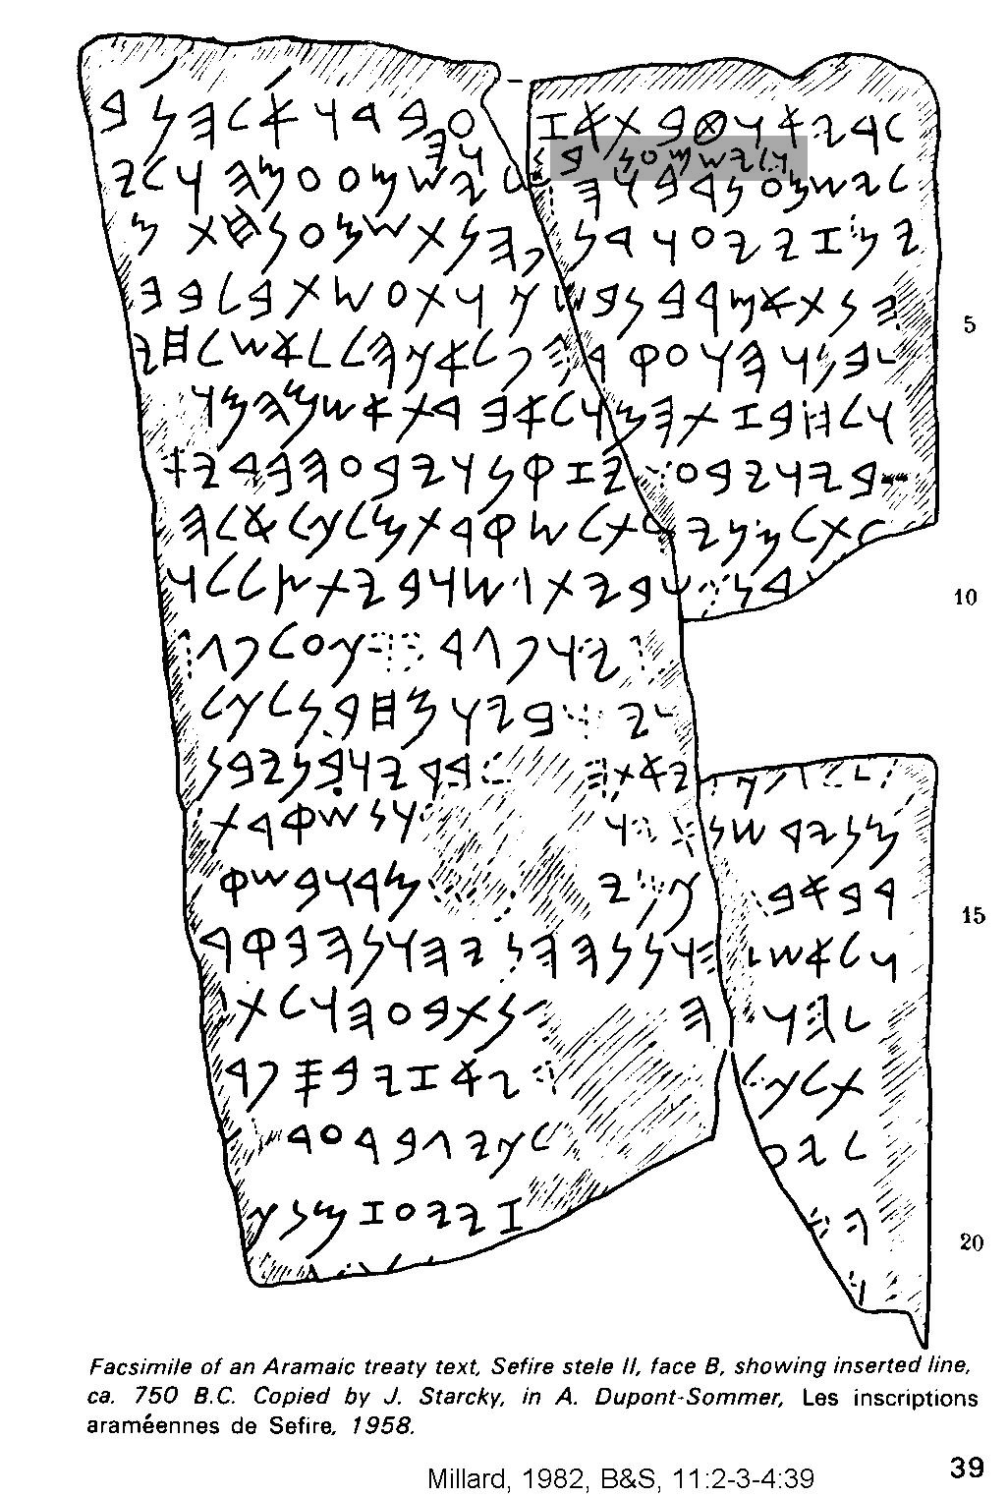
PHOTO LINK: QOS 001 Roman freeze of Qos with Aramaic ostraca. Lemaire, 2004, BAR, 30:4:44. Photograph by Cinncinati Art Museum.
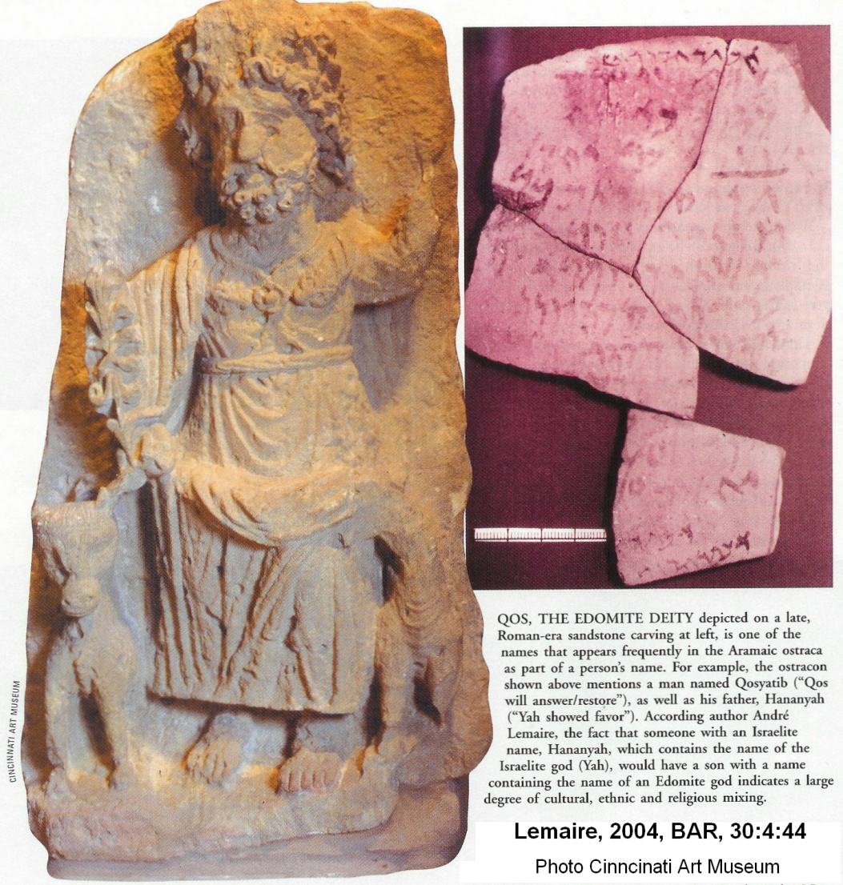

Aramaic Alphabetic Script

This script is the father of some eastern scripts (Phoenician was father of Western scripts). The Hebrews abandoned the Phoenician style of scripts and transliterated Old Testament scriptures into a derivative of Aramaic form of writing. Examples of the use of Aramaic in the Old Testament are found in Genesis 31:47 (the only Aramaic phrase from the Pentateuch), Ezra 4:8-6:18; 7:12-26 and Daniel 2:4b-7:28 and Jeremiah 10:11 (Livingston, H., 1980).

Early Aramaic looked much like the paleo-Hebrew which was borrowed from Phoenician, but which developed differently. Examples of alphabetic Aramaic scripts are (Livingston, 1980):

- Tell Halaf inscription (1000 BC)
- Ben Hadad royal inscription (late 9th century BC)
- Arslan Tash ivory tablet of Cappadocia (late 9th century. BC), and
- Zakir stele at Aleppo (cir. 775 BC). Millard, 1982, B&S, 11:2-3-4:43.

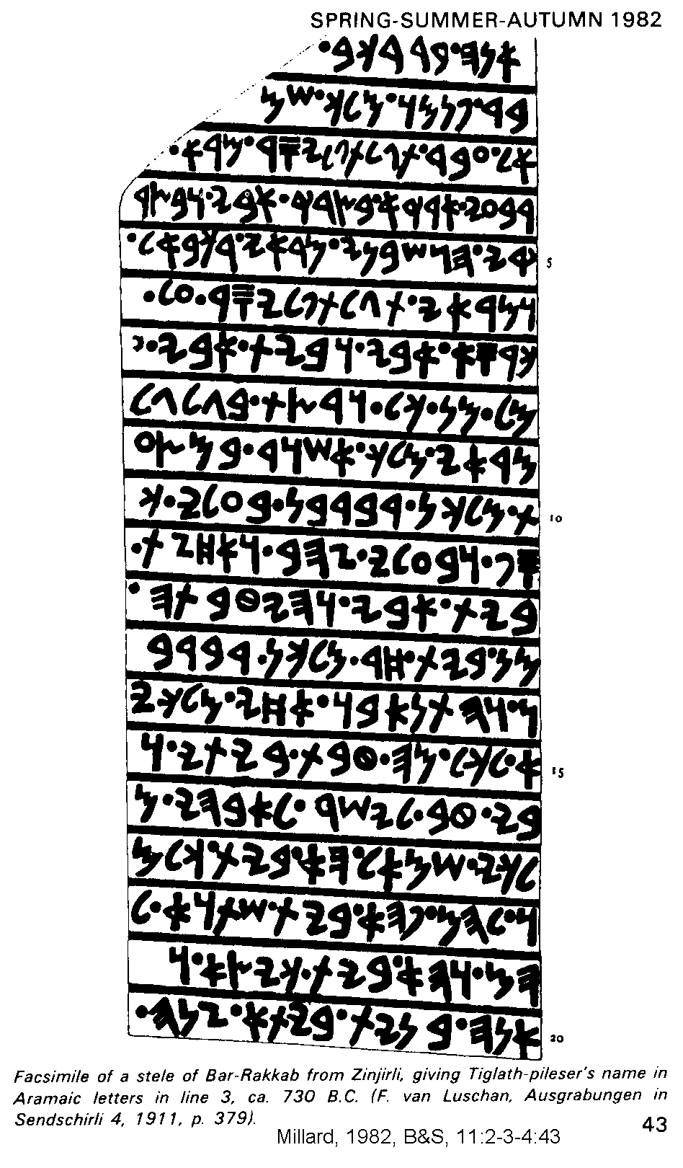
Several hundred short inscriptions (7th to 3rd centuries. BC) have been found, some as far away as northwest India. There is Aramaic papyrus and ostraca in Egypt. A good example of these is the Elephantine Papyri (5th century. BC) which was written by local Jews. Aramaic was used by the Arameans themselves up to 7th century BC. In the 8th and predominantly in the 7th century BC, Aramaic script was adopted by the Assyrian government along with Aramaic language for international communication. This arrangement is illustrated by an Assyrian sculpture showing two scribes at work, one with cuneiform, other with an (Aramaic?) scroll (Livingston, H., 1980).

PHOTO LINK SCRIPTS 011 Stele of Bar-Rakkab with Tiglath-pileser's name in Aramaic 750 BC (LEFT)

PHOTO LINK TEL HALAF INSCRIPTION 001. http/ http://books.google.com/books. Oct. 13. 2013.

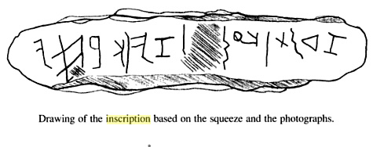
http://books.google.com/books?id=ra0QmH4np4kC&pg=PA15&lpg=PA15&dq=Tell+Halaf+inscription&source=bl&ots=7G3ltAeMwi&sig=X6VqF0J5IruTdnKowqnrnvqQiA8&hl=en&sa=X&ei=tzJjUuL-HaPgiALj6oHYBA&ved=0CDQQ6AEwAQ#v=onepage&q=Tell%20Halaf%20inscription&f=false

PHOTO LINK SCRIPTS 015 Elephantine Aramaic papyrus. Millard, 1922, BR, 8:3:46. Photograph by Brooklyn Museum.
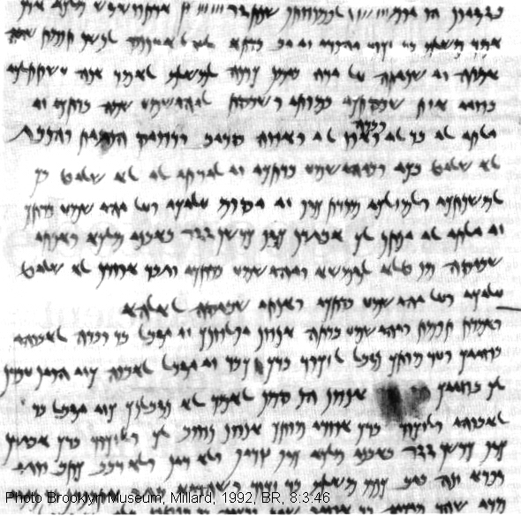

Canaanite Language

Canaanite is a northwest branch of Semitic tongues. It was called "Phoenician" by Greeks. Examples are known from the Ugarit (Ras Shamrah) tablets (pre-1200 BC) at the northeastern tip of Mediterranean Sea. Canaanite employed vowels. The Canaanite language gives insight to the meaning of many Old Testament words and phrases, especially in Psalms and Wisdom literature (Livingston, H., 1980).

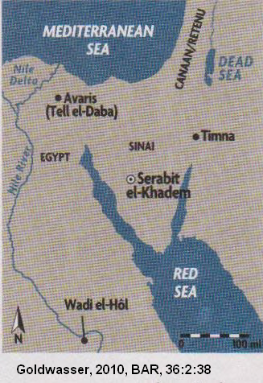
Proto-Sinaitic (Canaanite) Alphabetic Script at Serabit el-Khadem

This script is known from Serabit el-Kahdem (SW Sinai peninsula, Beit-Arieh, 1984). It dates to 1,500 BC (about time of the Exodus [early date]). The site is associated with a Turquoise mining operation. Inscriptions come from artifacts from a temple to the cow goddess Hathor (Baalat). Semitic miners (who were slaves or supervised by Egyptians) borrowed hieroglyphic symbols and invented an alphabet. Another possibility is that this alphabet was an earlier invention of Semites in Canaan of which the Sinaitic script is a later variety (Livingston, H., 1980; Shanks and Cross,1992c).

PHOTO LINK: SERABIT EL-KHADEM 005: Location Map (RIGHT). Goldwasser, 2010, BAR, 36:2:38.

PHOTO LINK: SERABIT EL-KHADEM 006: Drawing of Temple of Hathor. Goldwasser, 2010, BAR, 36:2:39.

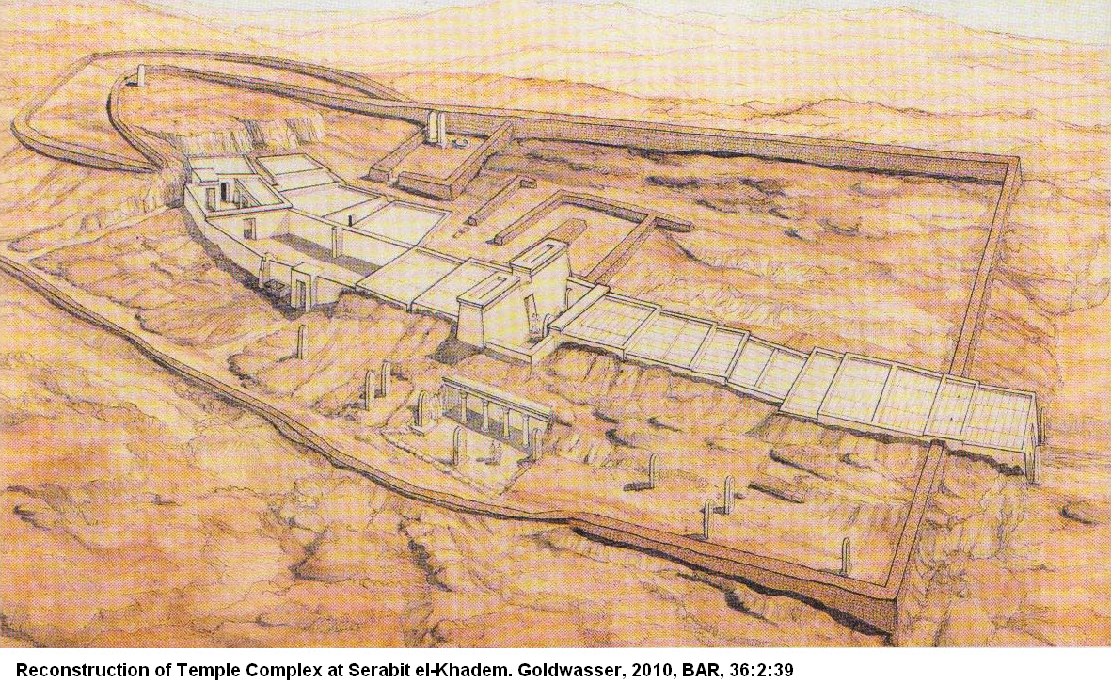

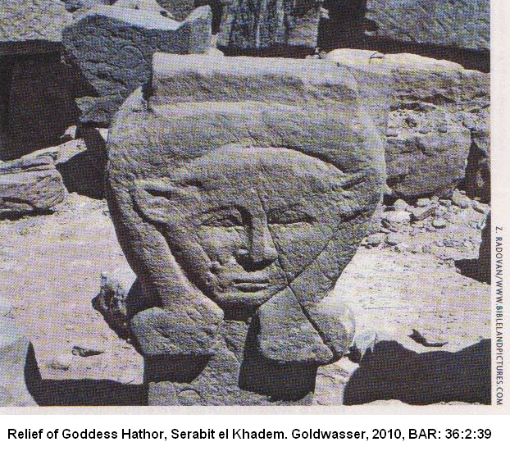
The Hathor temple was first built by Sesostris I, first king of the XIIth Dynasty (c1953-1908 BC). The temple existed for 800 years, and was enlarged by Amenemhet II and Amenemhet IV, who also expanded turquoise mining operations there (Goldwasser, 2010, 38-39).

PHOTO LINK: SERABIT EL-KHADEM 007: Relief of cow-goddess Hathor . Goldwasser, 2010, BAR, 36:2:39. (RIGHT)

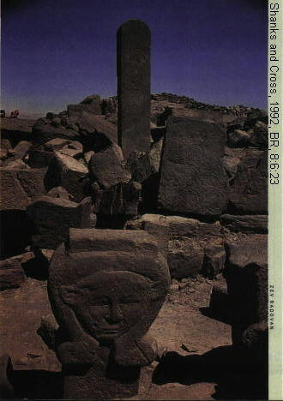

PHOTO LINK: SERABIT EL KHADEM 004 Hathor Temple. Shanks and Cross, 1992, BR, 8:6:23. (RIGHT)

Turquoise was a high-value commodity in Egypt during the Middle Kingdom. Twenty eight expeditions to Serabit el-Khadem are recorded during the reign of Amenemhet III alone (Goldwasser, 2010:38).

PHOTO LINK: AR039 Serabit el-Khadem, Hathor Temple Standing Stones, Bronze Age. BWP, AP-039.

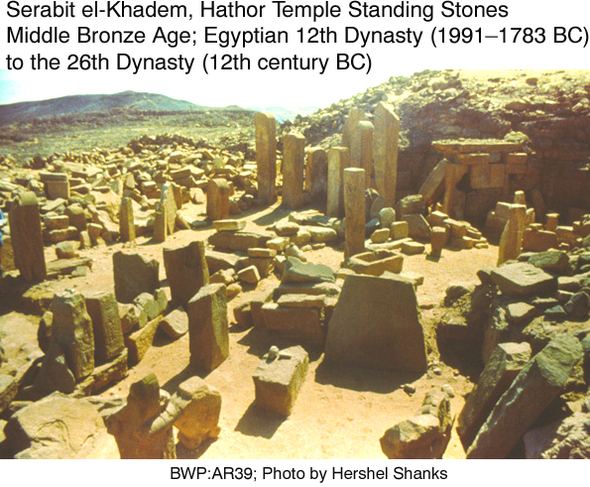

PHOTO LINK: SCRIPTS 023 Mines at Serabit el-Khadem. Shanks and Cross, 1992, BR, 8:6:27 and BWP, ESN-023.
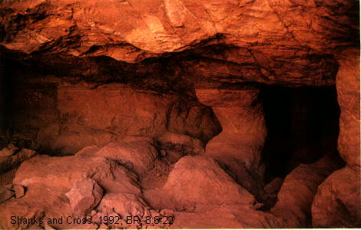

PHOTO LINK: SERABIT EL-KHADEM 013: Mining with pillars to support the roof. Goldwasser, 2010, BAR, 36:2:44.
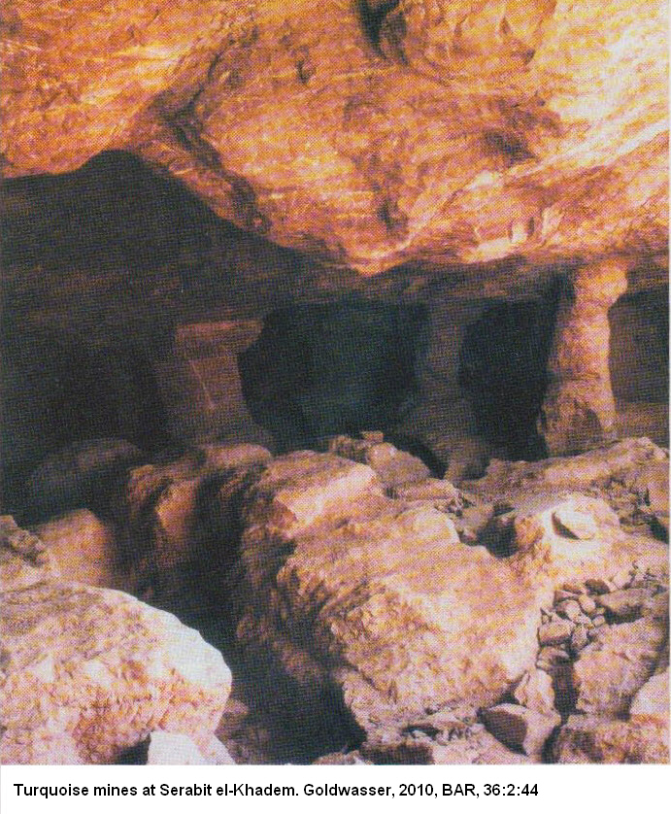

The Proto-Sinaitic script at Serabit el-Khadem were inscribed on objects and on reliefs. Inscriptions on a 10-inch long sphinx are shown below.

PHOTO LINK: SERABIT EL-KHADEM 008: Sphinx A with inscription
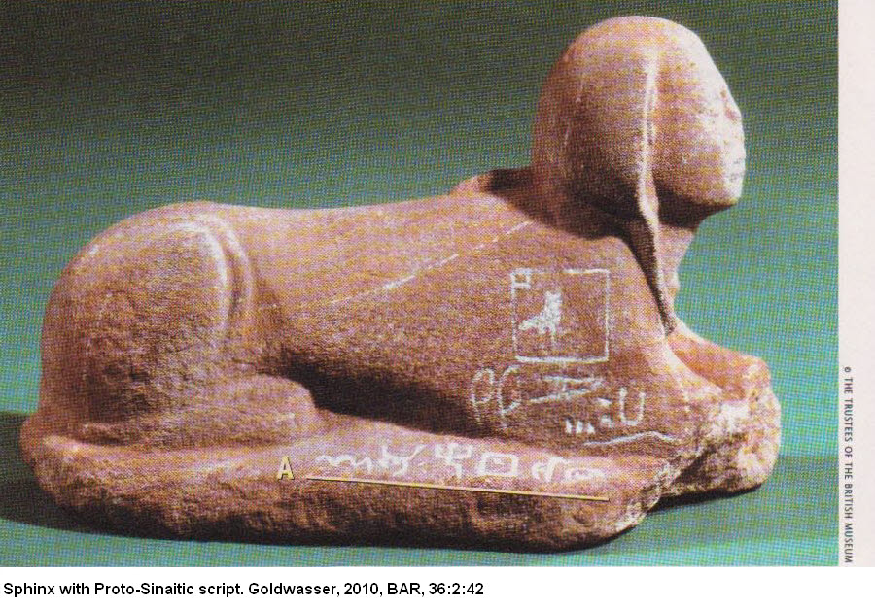

PHOTO LINK: SERABIT EL-KHADEM 009: Inscriptions A and B. Goldwasser, 2010, BAR, 36:2:45.
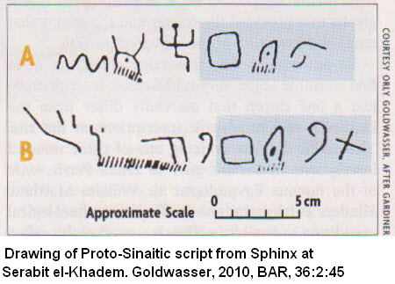

The script in blue, denote the word “Baalat”, a Canaanite word also meaning “Mistress.”

PHOTO LINK: SERABIT EL-KHADEM 009: Sphinx B with inscription. Goldwasser, 2010, BAR, 36:2:42.
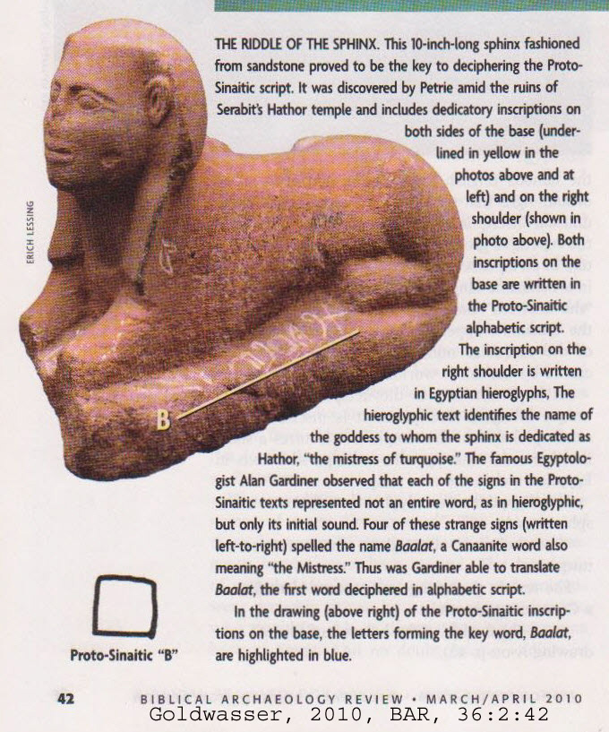

PHOTO LINK: SCRIPTS 022 Proto Sinaitic (Canaanite) Script Serabit el-Khadem. Shanks and Cross, 1992, BR, 8:6:22. Photograph by Hershel Shanks.

PHOTO LINK: SCRIPTS 024 Proto Sinaitic (Canaanite) Script Serabit el-Khadem second illustration. Shanks and Cross, 1992, BR, 8:6:23. Photographs by Avraham Hai and Hershel Shanks.

PHOTO LINK: ESN025 Proto-Sinaitic Inscription 02; Serabit el-Khadem; BWP, ESN-025.
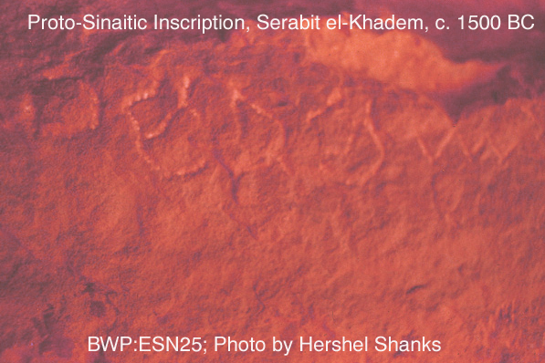

PHOTO LINK: ESN024 Proto-Sinaitic Inscription; Serabit el-Khadem. BWP, ESN-024.
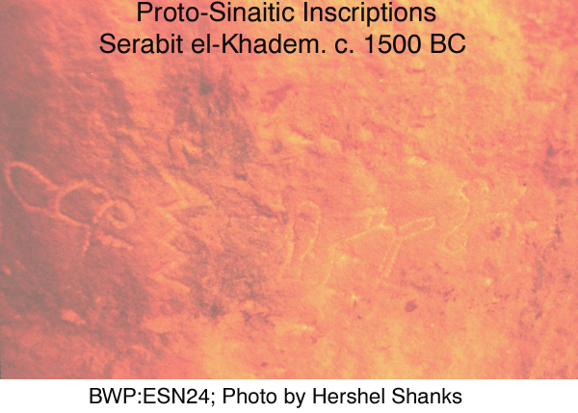

PHOTO LINK: SERABIT EL-KHADEM 014: Inscription "Thow, O Shaphan, collect from 'Adaba eight? Minas (of turquoise); Goldwasser, 2010, BAR, 36:2:44

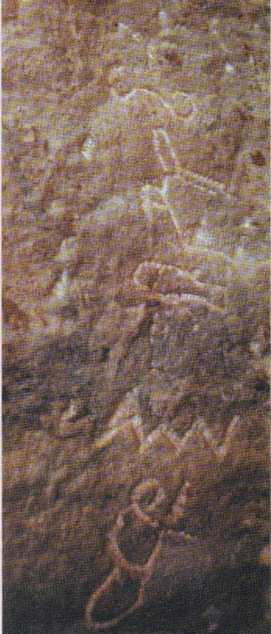
PHOTO LINK: SERABIT EL-KHADEM 015: Inscription; Goldwasser, 2010, BAR, 36:2:44

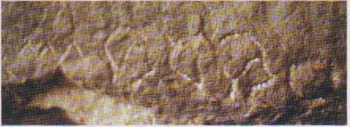

Almost all of the known examples of Proto-Sinaitic script comes from Serabit el-Khadem. This alphabetic script used pictographs. The alphabetic sound for the pictograph corresponded to the first sound in the word that the pictograph represented. For example, the Proto-Sinaitic pictograph for “B”, was a symbol for “house”, or Canaanite “beth” (See PHOTO LINK SERABIT EL-KHADEM 009); Goldwasser, 2010, 42).

PHOTO LINK: SERABIT EL-KHADEM 021: Khebeded's "house" pictogram compared to Proto-Sinaitic "B"; Goldwasser, 2010, BAR, 36:2:46
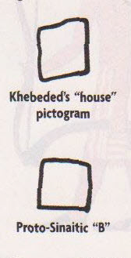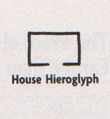

This process of using a the first sound in a word-picture as a mnemonic for remembering the sound value of the symbol is called the “acrophonic principle”. It is illustrated below:

PHOTO LINK: SCRIPTS 021 Acrophonic principle, Shanks and Cross, 1992, BAR, 8:6:21.

The Proto-Sinaitic script was invented during the Middle Kingdom, probably during the reign of Amenemhet III. This is inferred because of similarities between Egyptian hieroglyphs of the Sinai and the new script (Goldwasser, 2010:42; Goldwasser, 2006:121-160, cited by Goldwasser, 2010: 74).

The Canaanite supervisor or overseer at Serabit el-Khadem at this time was named Khebeded. There is a relief of him riding a donkey in some kind of precession.

Goldwasser,(2010:46) suggests that he was the one who invented, or at least directed making of the Proto-Sinaitic inscriptions.

PHOTO LINK: SERABIT EL-KHADEM 018, 019 and 020. Goldwasser, 2010, BAR, 36:2:46

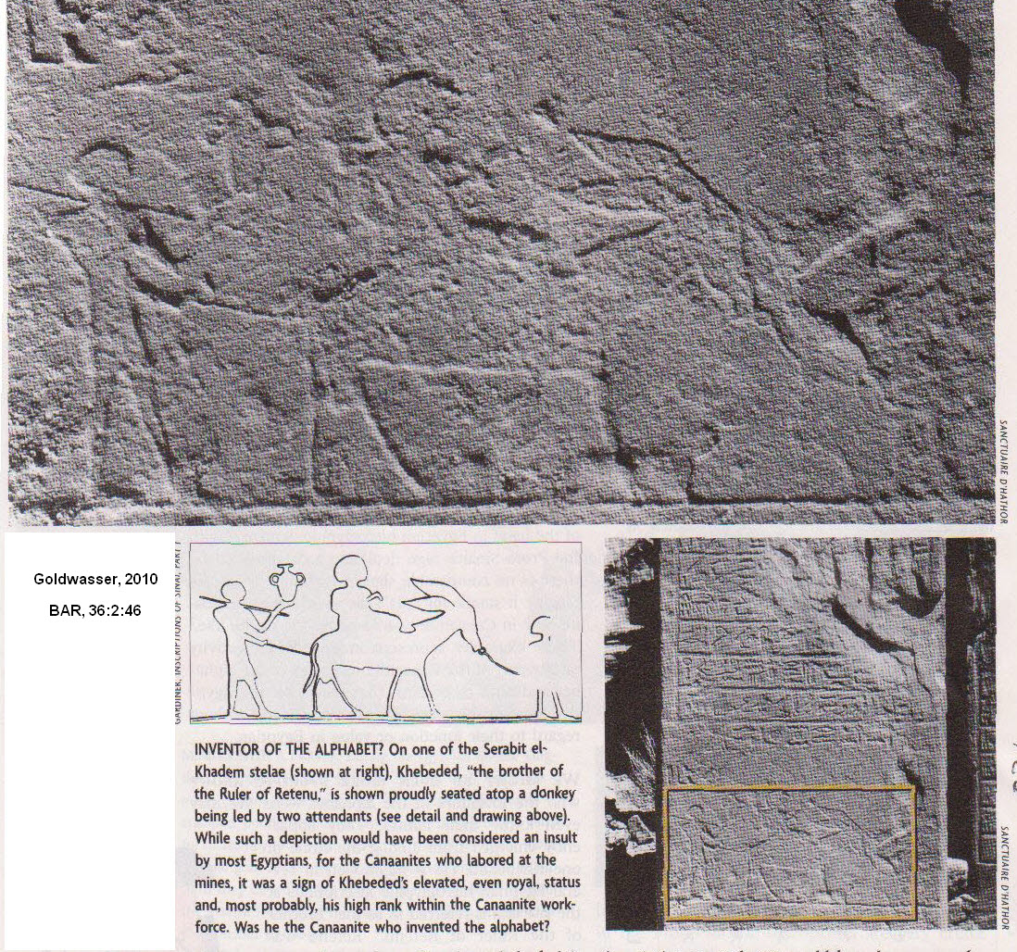

Khededed, like many of the turquoise miners at Serabit el-Khadem, were Canaanites. They are represented in reliefs and in statues as having a distinctive mushroom-shaped headdress.

PHOTO LINK: SERABIT EL-KHADEM 022 and 023: Drawing of relief and statue with mushroom- shaped hairdo. Goldwasser, 2010, BAR, 36:2:47.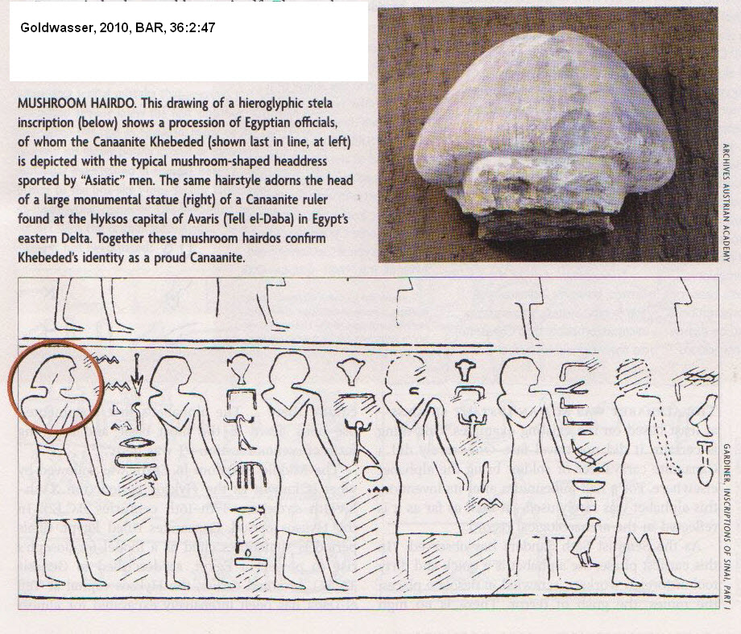

The invention of the Proto-Sinaitic script was done by people who knew about Egyptian hieroglyphs, but who where not trained in how to read them. They borrowed some of the hieroglyphic signs to make their own alphabetic script. The script had few rules. Some inscriptions are horizontal while others are verticle. Some are read left to right, and otheres right to left (Goldwasser, 2010:44). The script has fewer than 30 signs (Goldwasser, 2010:40).

This borrowing can be seen from some mistakes that the workers made in carving some hieroglyphic inscriptions. (Goldwasser, 2010, 43).

PHOTO LINK: SERABIT EL-KHADEM 024: Inscriber mistakes hieroglyphic vs proto-Sinaitic script. Goldwasser, 2010, BAR, 36:2:49.
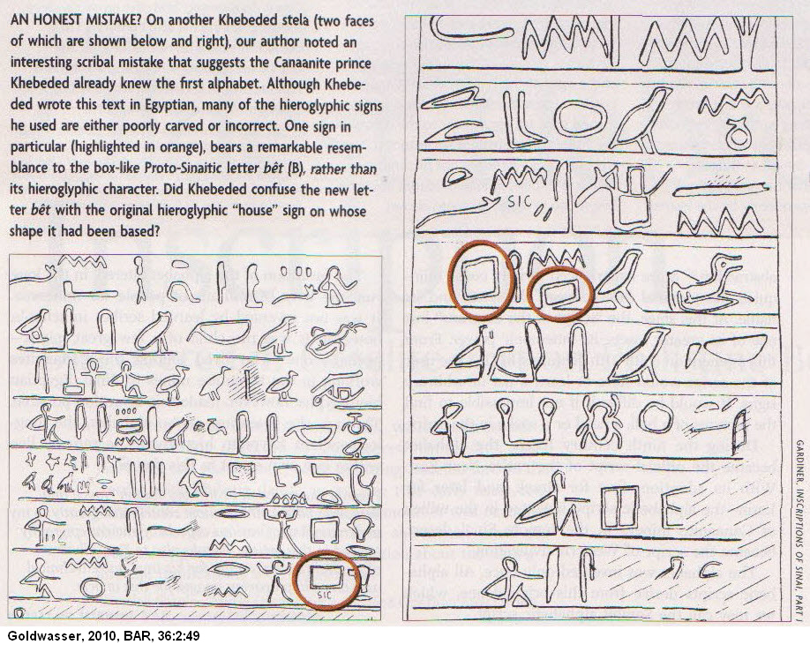

The evolution of the alphabet from the Proto-Sinaitic pictographic script is illustrated in the table, below:

PHOTO LINK: SERABIT EL-KHADEM 016: The evolving alphabet. Goldwasser, 2010, BAR, 36:2:45.

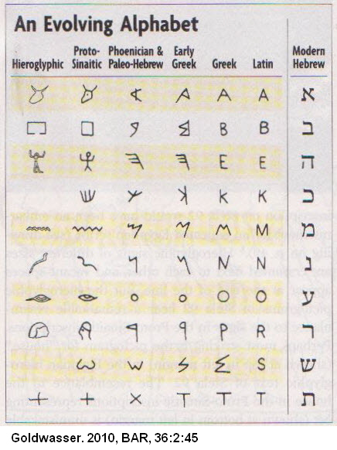

Proto-Sinaitic (Canaanite) Alphabetic Script at Wadi el-Hol

This inscription is slightly later than the Serabit el-Khadem inscriptions. It is a faintly carved inscription made on a limestone wall on the ancient road between Thebes and Abydos (Goldwasser, 2010:48).

PHOTO LINK: WADI EL-HOL INSCRIPTION 001 Goldwasser, 2010, BAR, 36:2:48.

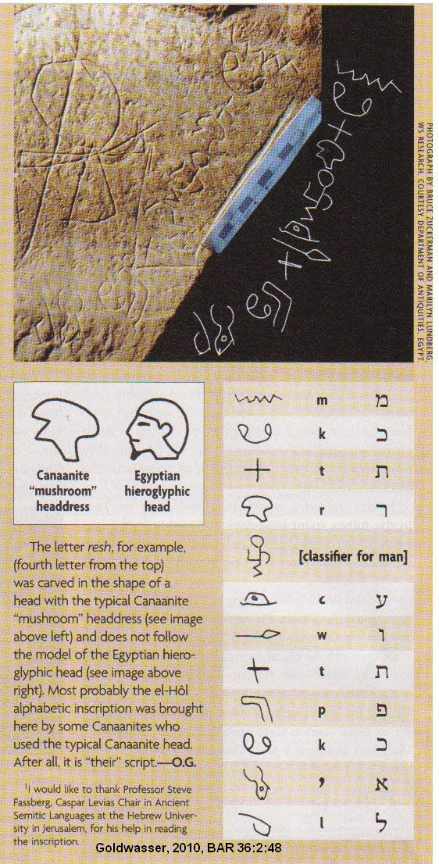

The Proto-Sinaitic script was never adopted by any governmental or religious establishement. It was a script used by caravaneers. The acrophonic principle of this script influenced the scribes of Ugarit in the 13th and 14th centuries (Goldwasser, 2010:50).

During the 13th and 12th centuries BC, the cuneiform Ugaritic Script was used by professional scribes in the urban centers and the Proto-Sinaitic script was used by the common caravaneers and the miners at Serabit el-Khadem. During the adaption of the Proto-Sinaitic pictographs to the wedge-shaped cuineiform, the mnemonic Proto-Sinaitic picture-letters were lost. The Ugarit cuneiform alphabetic script disappeared during the 12th century BC along with the fall of aht great Late Bronze Age civilizations.

PHOTO LINK: UGARITIC SCRIPT 002Alphabetic cuneiform script. Goldwasser, 2010, BAR, 36:2:50.

With the fall of Egyptian and Mesopotamian civilization, new peoples: Israelites, Phoenician, Moabites and Arameans, appeared in Canaan and the Levant. They prefered the old Proto-Sinaitic script to the hieroglyphs of Egypt, or the cunieform of Mesopotiamia. During this time social change, the new script became institutionalized. It underwent a process of linearization and abstraction. As professional scribes adopted the old Prot-Sinaitic script, they relinquished the pictorial l link between a letter and its name. The script of the caravaneers lost its mnemonic poser. From the 12th-11th centuries onward, scribes had to learn arbitary signs instead. During the 9th century, the alphabet became the offical script of the entire Near East. It was learned by the Greeks from the Phoenecians, and later by the Latin Romans. That script later became the basis for all scripts of Western civilization (Goldwasser, 2010:49-50).

Early Canaanite script

There are three groups of early Canaanite script. The oldest dates from the 18th-17th centuries BC (Patriarchal Period). Examples are (Livingston, H., 1980):

- Gezer Potsherd
- Shem Stone Plaque
- Lachish Dagger
4) Jar from Gezer

PHOTO LINK: GEZER 007 Gezer Potsherd. Kings and Stager, 2002, BAR, 28:2:45. Photo by Zev Radovan.
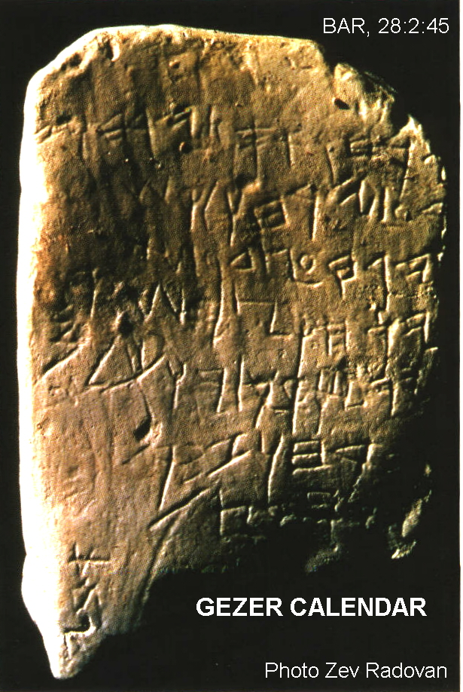

PHOTO LINK: SCRIPTS 025 Proto Canaanitic Script diagram of jar "dag" = fish from Gezer. Shanks and Cross, 1992, BR, 8:6:25.
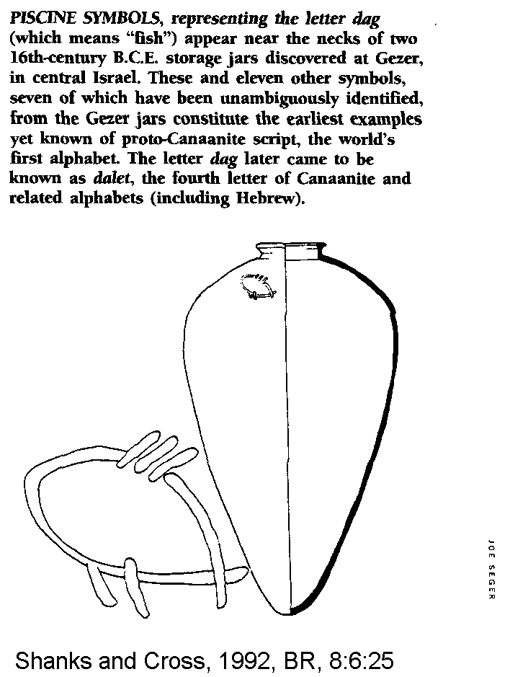

The second group of scripts are from the late 15th to early 14th centuries BC (Conquest Period). This script is known from (Livingston, H., 1980):

- Oblong Seal of Lashish, a similar unnamed seal of Lashish
- Lachish Censer Lid
- Lachish Bowl No. 1
- Tell el-Hesi Potsherd
- A Tell el-'Ajjul Pot, and
- Beth-Shemesh Ostracon.

The third group is from the 13th century BC (Judges Period). Examples of this group are found on (Livingston, H., 1980):

- Lashish Ewer
- Lashish Bowl No. 2
- Lachish Sherd No. 6 and a few bowl fragments
- Megiddo Golden Bracelet
- Jerusalem Temple Foundation Stone Inscription, and
- Raddan Jar Handle of Ramallah.

Canaanite and North Semitic Alphabetic Script

The first Canaanite alphabetic script was invented by Semites in Levant between 2000-1700 BC, probably in 18th century when Hyksos invaders ruled lower Nile Delta. This Canaanite script employed a one sign-one sound principle and with it the acrophonic principle was well established (Livingston, H., 1980).

PHOTO LINK: SCRIPTS 021 Acrophonic principle. Shanks and Cross, 1992, BAR, 8:6:21.

A bilingual Canaanite scribe (or school), being familiar with both the Egyptian and Mesopotamian systems was in a position to see the possibility of a simpler writing system. That is why alphabetic writing developed in Canaan. That system used some hieroglyphs for some of its phonetic signs (Livingston, H., 1980).

PHOTO LINK: SCRIPTS 020 Chart: How Egyptian hieroglyphs became Semitic letters Shanks and Cross, 1992, BAR, 8:6:21.
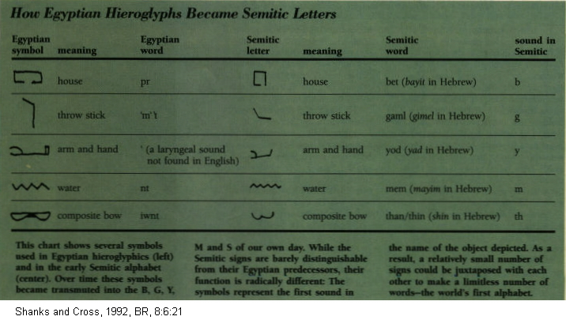

Northwest Semitic Sources, 2000 to 550 BC

The oldest northwest Semitic script is Proto-Sinaitic inscriptions dating from the 15th century BC. Next oldest are the Ugaritic Tablets at Ras Shamrah which display Canaanite-Paleo Hebrew scripts from the 13th century BC. The latest northwest Semitic sources are Phoenician inscriptions from 10th century BC Byblos (Livingston, H., 1980).

The northwest script is also known from royal inscriptions at Damascus, Hamath, Arpad, and Sham'al. Other sources are (Livingston, H., 1980):

- Moabite Stone (Mesha, king of Moab), 830 BC (MOABITE STONE 001)
- Gezer Calendar, 925 BC (BA113, GEZER 007)
- Ostraca of Samaria, 775 BC
- Siloam Inscription, 700 BC (In water tunnel), (HEZEKIAH TUNNEL 020) and
- Lachish Ostraca, 589 BC.

PHOTO LINK: MOABITE STONE 001 Mesha Stella. Shanks and Cross, 1992, BR, 8:4:29.
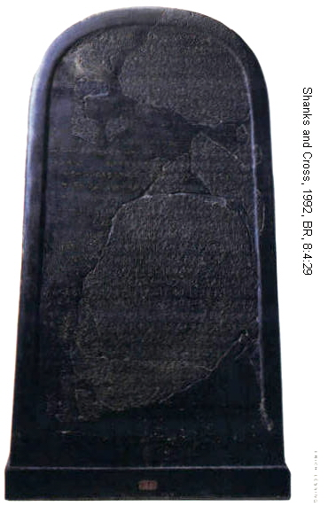

PHOTO LINK: GEZER 007 Color photo of Gezer Calendar. King and Stager, 2002, BAAR, 28:2:45.

PHOTO LINK: HEZEKIAH TUNNEL 020 Siloam Inscription. Parker, 1994, BAR, 20:4:37. Photograph by Eric Lessing.

North Semitic Script

Examples of North Semitic Script are (Livingston, H., 1980):

1) Mesha Stele (or Moabite Stone, 850 BC,( MOABITE STONE 001)
2) Bowl sherds dedicated to Baal of Lebanon found in Cyprus (8th or 9th century BC)
3) Ahiram epitaph of Byblos (12th century BC)
4) Abdo Ostraca (14th century BC)
5) Shafatba'a' inscription (13th to 14th centuries. BC)
6) Asdrubal spatula (cir. 12th century BC)
7) Yehimilk of 11th century BC
8) Roueisseh spearhead (11th century BC)
9) Abiba'al inscription (10th century BC); and
10) Eliba'al inscription (10th century BC).

PHOTO LINK: AHIRAM INSCRIPTION 001. Sarcophagus, inscription around lid. http://en.wikipedia.org/wiki/File:Ahiram_sarcophag_from_Biblos_XIII-XBC.jpg, Oct. 17, 2013.
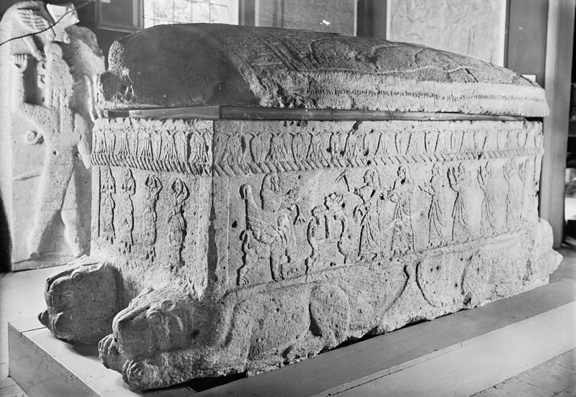

PHOTO LINK: AHIRAM INSCRIPTION 002. Text of inscription. http://en.wikipedia.org/wiki/Ahiram, Oct. 17, 2013.(LEFT)

PHOTO LINK: ABIBA’AL INSCRIPTION 001. http://www.jtsa.edu/Documents/pagedocs/JANES/1983%2015/Wallenfels15.pdf. Oct. . 17, 2013.

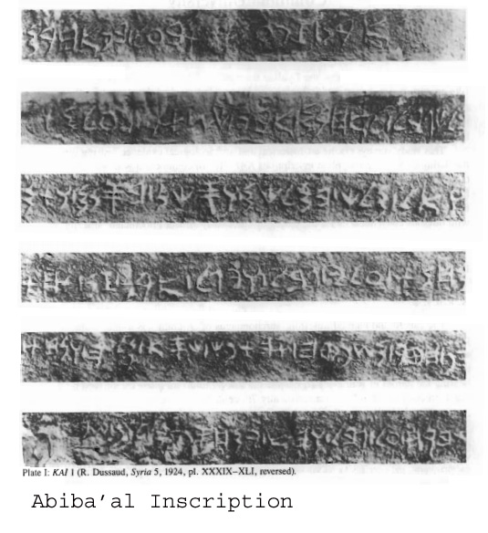

PHOTO LINK: ELIBA’AL INSCRIPTION 001. http://lila.sns.it/mnamon/index.php?page=Esempi&id=23&lang=en&PHPSESSID=fpxoeogttmuhz. Oct. 17, 2013

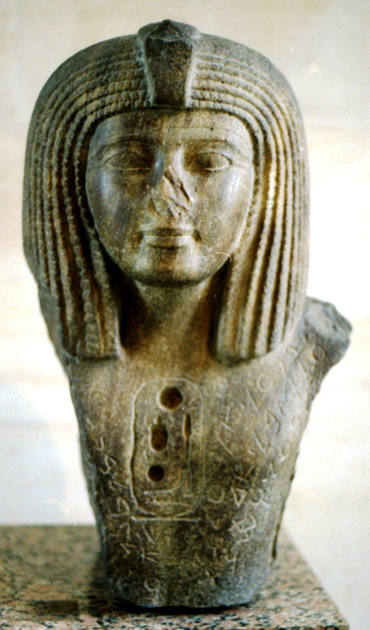
This script was used by Syrians, and was essentially same as the script used in Palestine (Livingston, H., 1980).

The North Semitic script had 22 letters, all consonants. It was written right to left. This script was adopted by Greeks about 1100-1000 BC (but Classicists say 9th century) (Livingston, H., 1980).

Neo-Philistine Script

Ostraca from Askelon (7the century B.C.) suggests that Neo-Philistine script was more akin to Hebrew than to Phoenician. This is surprising and may be due to political domination of Philistine cities by Israel during the period of the United Monarchy (Stager, 1996).

PHOTO LINK: PHILISTINE 009-B Neo-Philistine script from Askelon ostracon Stager, 1996, BAR, 22:1:64.
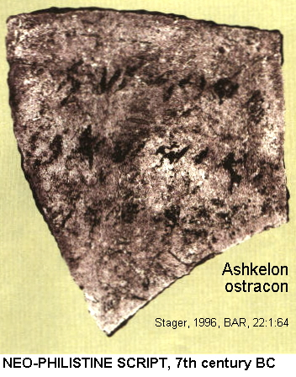

PHOTO LINK: SCRIPTS 058B Oldest Philistine script 10th to 9th cent BC, from Gath Shanks, 2006, BAR, 32:2:16.
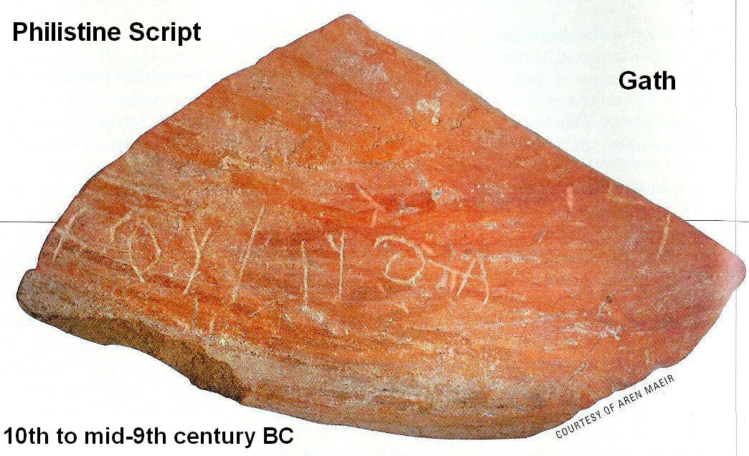

PHOTO LINK: PHILISTINE 009 Ostracon Askelon w Neo-Philistine script. Shanks and others, BAR, 19:5:53. Photograph Israel Antiquities Authority.
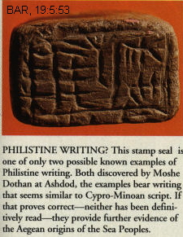

Ugaritic Alphabetic Script

This script is known from excavations at Ugarit (Ras Shamrah). These tablets date from 1500 to 1200 BC. Ugaritic used a Canaanite alphabet in Akkadian cuneiform. It had 32 signs with 27 consonants, 3 vowels and 2 others of signs of minor value. The only similarity with Akkadian cuneiform is wedge-shaped markings. The language was very different. It was written left to right. In the oldest tablet with an A-B-C-D list (“abecediary”), there are 30 letters, 22 of which are equivalent to 22 of the North Semitic alphabet and in same order. There are 2 examples of this right-to-left script from Palestine: the Beth Shemesh clay tablet (1400-1300 BC) and the Mt Tabor copper knife (1300-1200 BC). Use of cuneiform with the Ugarit alphabet apparently ceased with destruction of that city (Livingston, H., 1980).

PHOTO LINK: SCRIPTS 006, Ugaritic adze inscription. Livingston, 1980, B&S, 9:2:43.
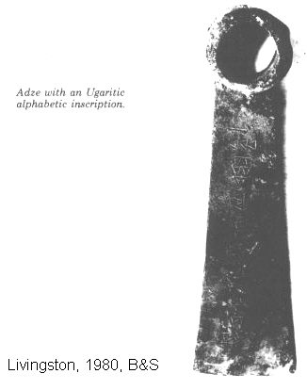

PHOTO LINK: UGARITIC SCRIPT 001 1450-1200 BC. Duane Smith. http://www.telecomtally.com/blog/2005/02/the_oldest_alphabets.html; Oct. 30, 2007
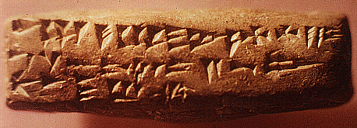

PHOTO LINK: UGARITIC SCRIPT 003 . Greenstein, 2010, BAR, 36:6:53. Photograph by Wayne Pitard and Andrew Vaugh / West Semitic Resources / Louvre Museum
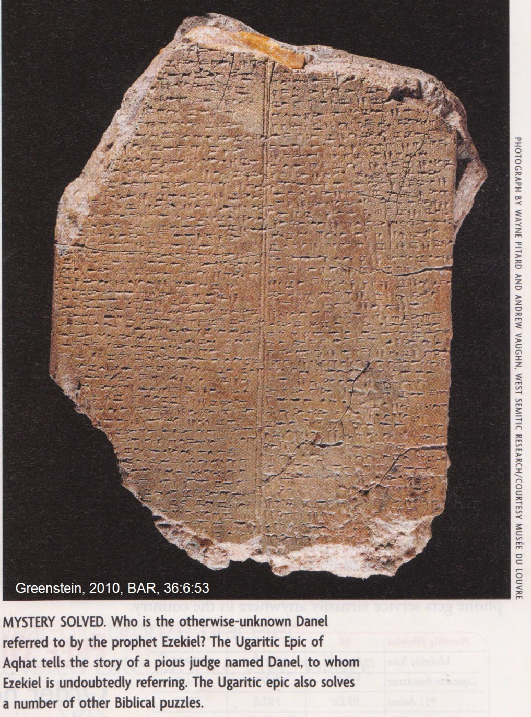

Hebrew Language

This language is never called "Hebrew" in the Old Testament. Rather, it is termed "the Jew's language (2 King 13:26 and Neh 13:24) or "the language of Canaan" (Isaiah 19:18). Hebrew is a highly mixed tongue, containing elements of Akkadian, Canaanite, Aramaic and Arabic. Abraham spoke Akkadian, later, as he moved into what we now call the “Promised Land”, he learned and spoke Canaanite. Jacob learned Aramaic while he was living with Laban. Hebrew language further evolved in land of Goshen while the Israelites were captives there. After the Exile, Aramaic became common in everyday speech and Hebrew was used in only in religious activities. Hebrew became a dead language after 2nd Jewish Revolt in 135 AD. It was revived as the national language of Israel after World War II (Livingston, H., 1980).

Hebrew is a Semitic language. Greenstein describes it as a “south Canaanite dialect” and classifies it as a “Northwest Semitic” language. (Greenstein, 2010:48-50). It has root words of 3 consonants and highly variable vowels modify meanings of these roots. Hebrew thinking and language was optical with prodigious use of similes and metaphors. The language has few particles, adjectives and adverbs. It is not at all like Greek with logical syllogisms. With time, Hebrew lost most of its case endings (a form of simplification). It uses short, blunt sentences (Livingston, H., 1980).

The verb tenses of Hebrew not like Indo-European languages. They are not based on tense and are moot. The time element in Hebrew is gained mostly from context. Instead, Hebrew stresses actions and identifies if that action is complete, incomplete, continuous, intensive or caused. The language has strong emotional overtones (often lost in translation). Word meanings changed with time (Livingston, H., 1980).

Some important Hebrew words have no English equivalent: "religion", "person", "brain". Weights and measures are generally transliterated and explained in footnotes (e.g. shekel, omer, ephah; Livingston, H., 1980).

The Hebrew language existed prior to the 9th century BC. There are no Old Hebrew inscriptions known from before this time. The Hebrew Bible has texts that probably date before the 9th century BC. These (according to Rollston, 2012:35) include:

Song of the Sea (Exodus 20)
Song of Deborah (Judges 5)
Blessing of Moses (Deuteronomy 33)
Jacob’s Prophecy (Genesis 49)

So we have examples of Old Hebrew texts (language) before we can identify a distinctive Hebrew script (Rollston, 2012:35).

Old-Hebrew Script

Old Hebrew script cannot be distinguished from the older Phoenician script until the 9th century BC (Rollston, 2012:35)

The Old Hebrew script is only slightly different then that used by older Canaanites. The early signs were more conventional, angular and prong-like in Old Hebrew. The consonants and right to left writing were the same as old Canaanite. There were no vowels (Livingston, 1980).

Khirbet Qeiyafa (Qeayafa) Ostracon

One of the earliest known examples of Hebrew writing is the Khirbet Qeayafa Ostracon. It advocates care for widows and orphans and encourages the king—who at that time had the responsibility of curbing social inequality—to be involved in improving Israelite society. The inscription is similar in content to Biblical scriptures such as Exodus 23:2, Psalm 72:4, Isaiah 1:17, and others, but according to the translator, Professor Gershon Galil of the Department of Biblical Studies at the University of Haifa, it is not copied from any one Biblical text (Wood, 2010 web).

PHOTO LINK KHIRBET QEIYAFA 012: Aerial photograph. Shanks, 2010, BAR, 36:2:52. Photograph by Sky View.
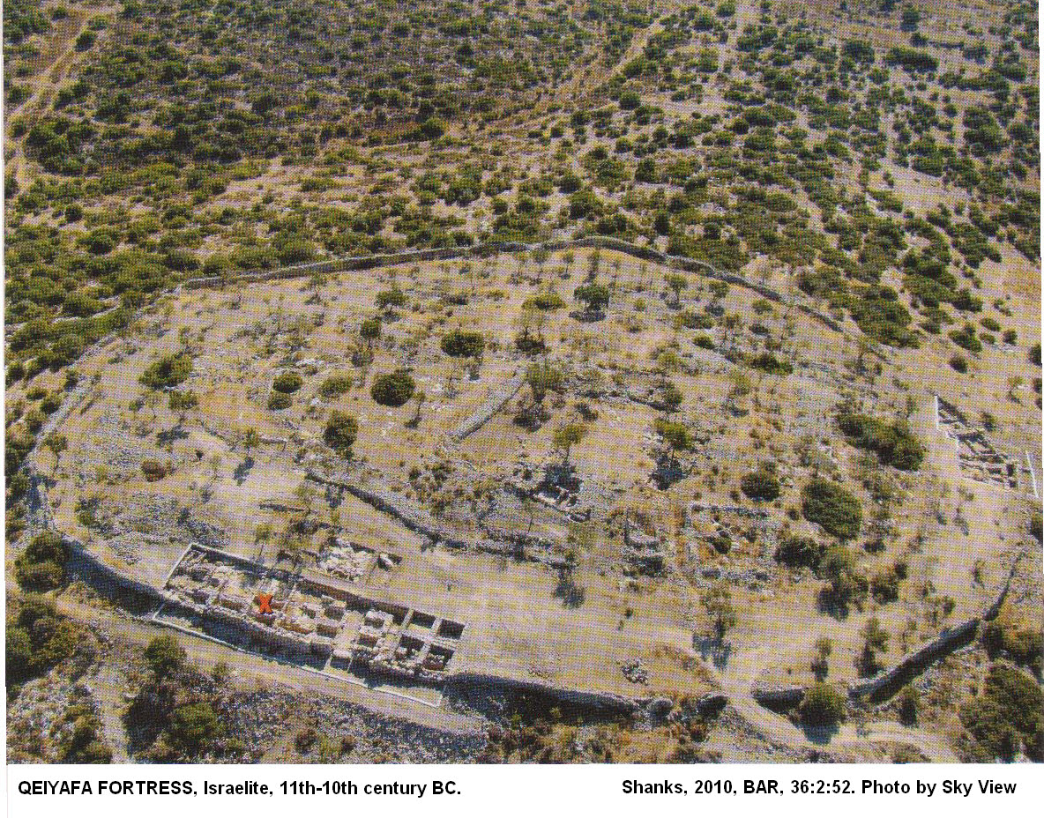

PHOTO LINK KHIRBET QEIYAFA 001 Aerial photo of Khirbet Qeiyfa fortified city Iron Age IIa. Shanks, 2009, BAR, 35:1:3. Photograph by Sky Balloon.
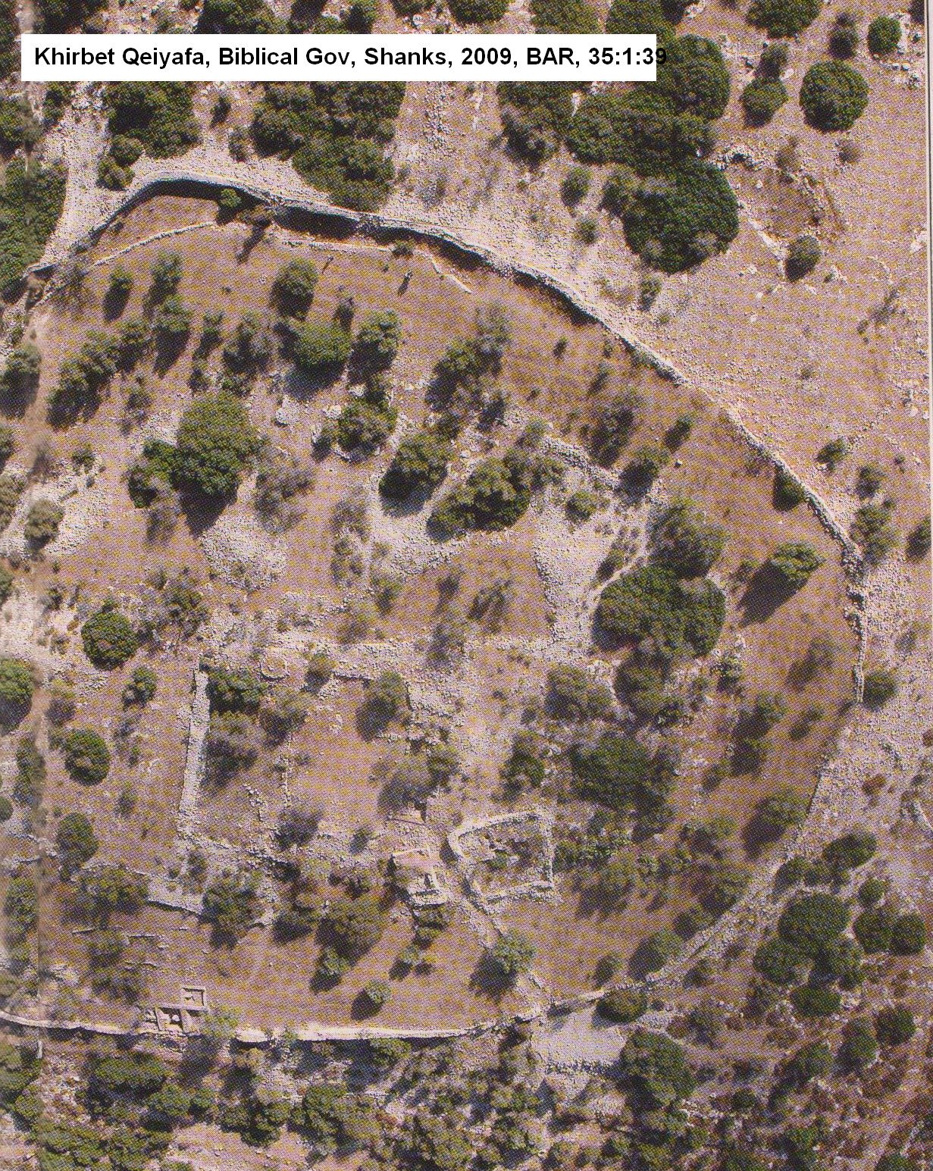

PHOTO LINK KHIRBET QEIYAFA 002 Location map. Shan ks, 2009, BAR, 35:1:41

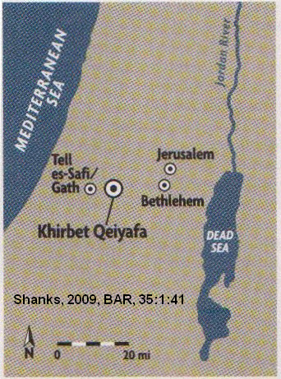
PHOTO LINK KHIRBET QEIYAFA 003 Plan of Khirbet Qeiyafa. Shan ks, 2009, BAR, 35:1:41
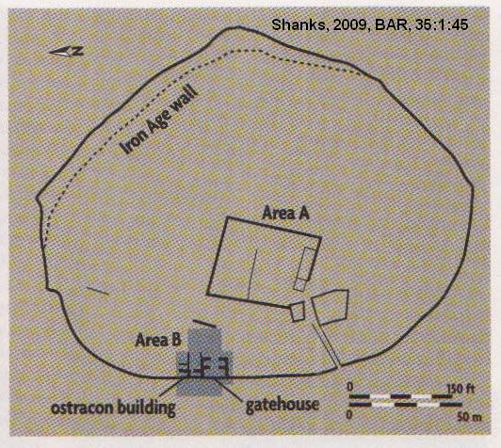

PHOTO LINK KHIRBET QEIYAFA 006 content Location map of Khirbet Qeiyafa. http://www.biblearchaeology.org/post/2010/01/10/Ancient-Hebrew-Inscription-Dated-to-time-of-David.aspx. Oct. 19, 2013.
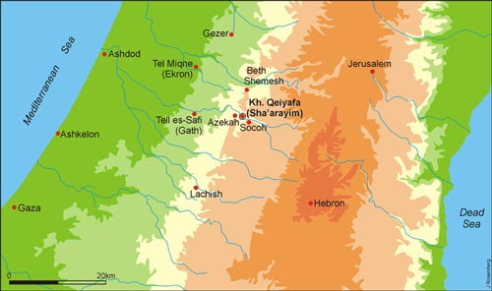

PHOTO LINK KHIRBET QEIYAFA 005 Potsherd ostracon with proto-Canaanite inscription. Shanks, 2009, BAR, 35:1:43.

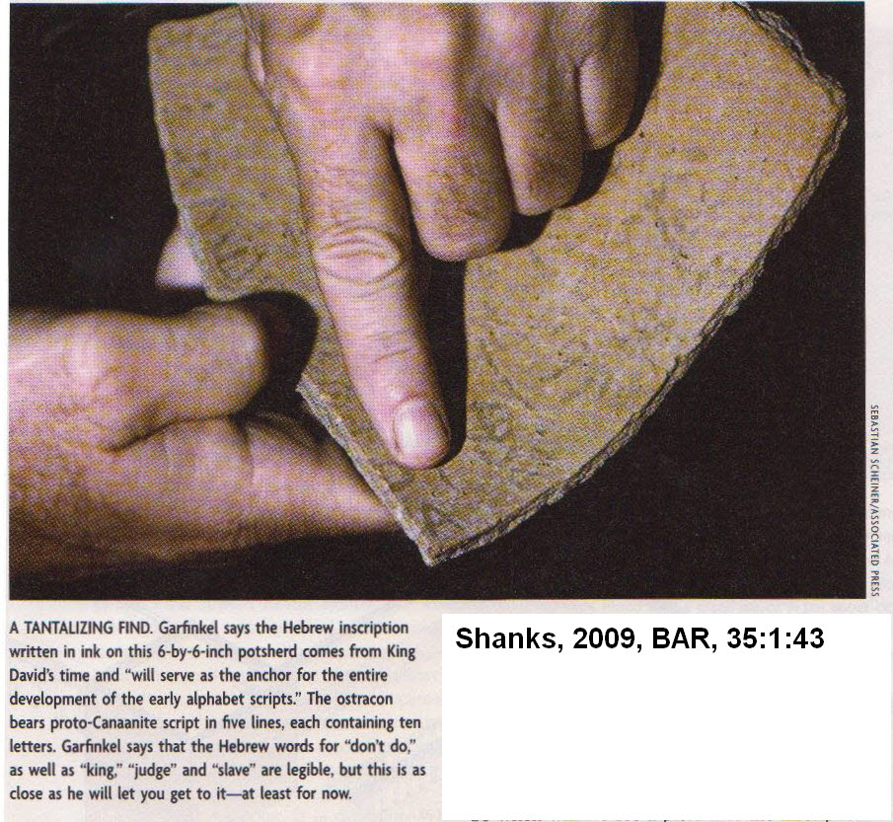
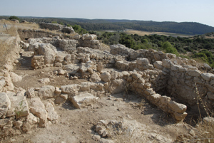
PHOTO LINK: KHIRBET QEIYAFA 008 Building where the inscribed sherd was found on the north side of the four-chamber gate. (Michael Luddeni http://www.biblearchaeology.org/post/ 2010/01/10/Ancient-Hebrew-Inscription-Dated-to-time-of-David.aspx, Jan 21, 2010)

PHOTO LINK KHIRBET QEIYAFA 004 Four chambered gate with rooms on each side, Khirbet Qeiyafa early Iron Age. Shanks, 2009, BAR, 35:1:42.
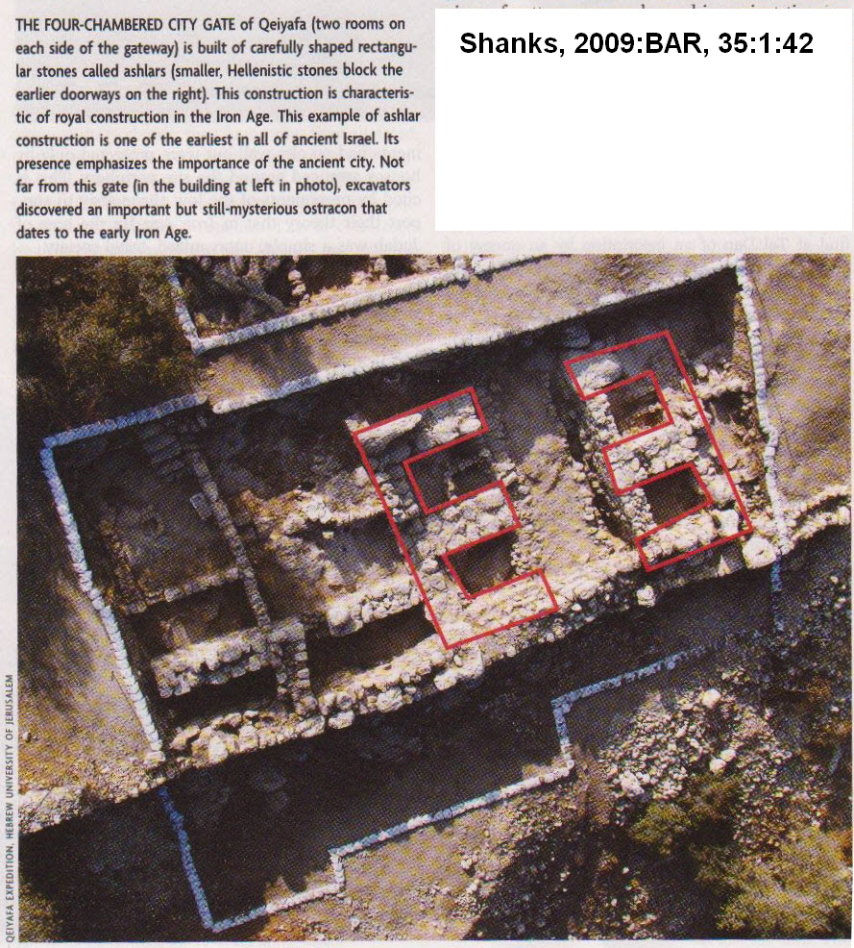

Situated on the west side of the Elah Valley, the valley where David fought Goliath, Kh. Qeiyafa (also called “The Elah Fortress”) was a small but important site on the road to Jerusalem. It was a border fortress strategically located between the kingdoms of Philistia to the west and Israel to the east.(Khirbet Qeiyafa Archaeological Project. http://www.biblearchaeology.org/post/2010/01/10/Ancient-Hebrew-Inscription-Dated-to-time-of-David.aspx, Jan 21, 2010)

PHOTO LINK KHIRBET QEIYAFA 009 content Khirbet Qeiyafa Ostracon: Tenth-century BC Hebrew text discovered at Kh. Qeiyafa July 8, 2008. It has been subjected to detailed photographic enhancement in order to clarify the faded text. (Khirbet Qeiyafa Archaeological Project. http://www.biblearchaeology.org/post/2010/01/10/Ancient-Hebrew-Inscription-Dated-to-time-of-David.aspx, Jan 21, 2010)

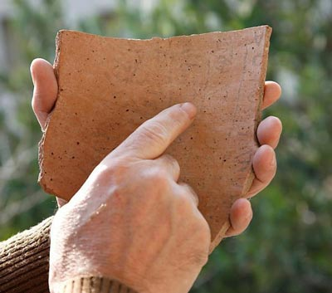

PHOTO LINK: KHIRBET QEIYAFA 010 content Drawing of the inscription on the Qeiyafa Ostracon. (Courtesy of the University of Haifa. http://www.biblearchaeology.org/post/2010/01/10/Ancient-Hebrew-Inscription-Dated-to-time-of-David.aspx, Jan 21, 2010)

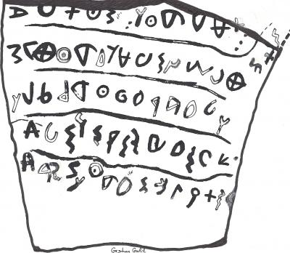

PHOTO LINK: KHIRBET QEIYAFA 013: Qeiyafa ostracon drawing. Shanks, 2010, BAR, 36:2:53.
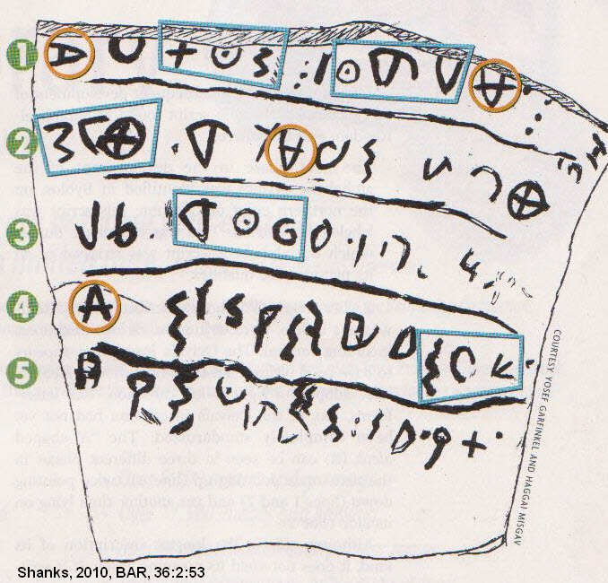
PHOTO LINK: KHIRBET QEIYAFA 019 Drawing of Qeiyafa ostracon showing variations in letter orientation and shape. Rollston, 2012, BAR, 38:3:34.

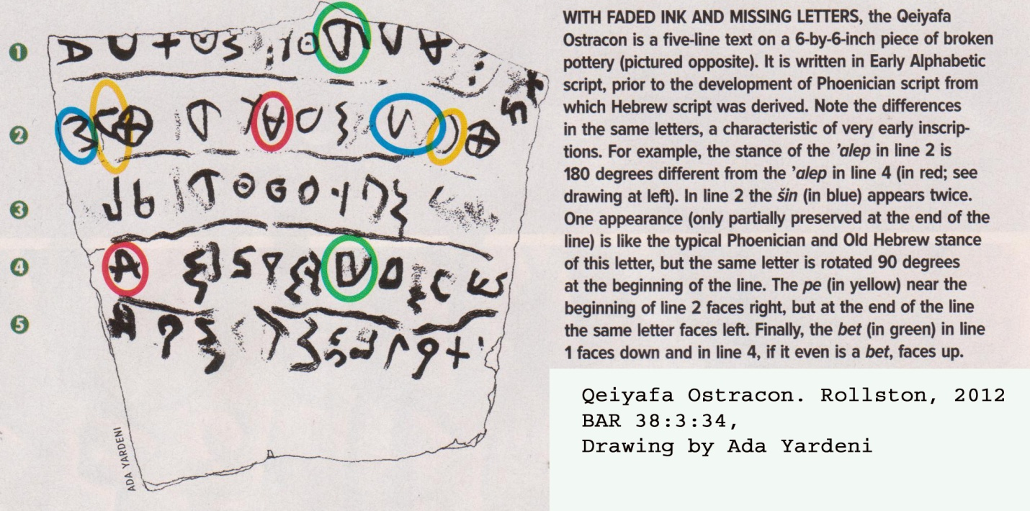

PHOTO LINK: KHIRBET QEIYAFA 020 Photo of Qeiyafa ostracon. Rollston, 2012, BAR, 38:3:34
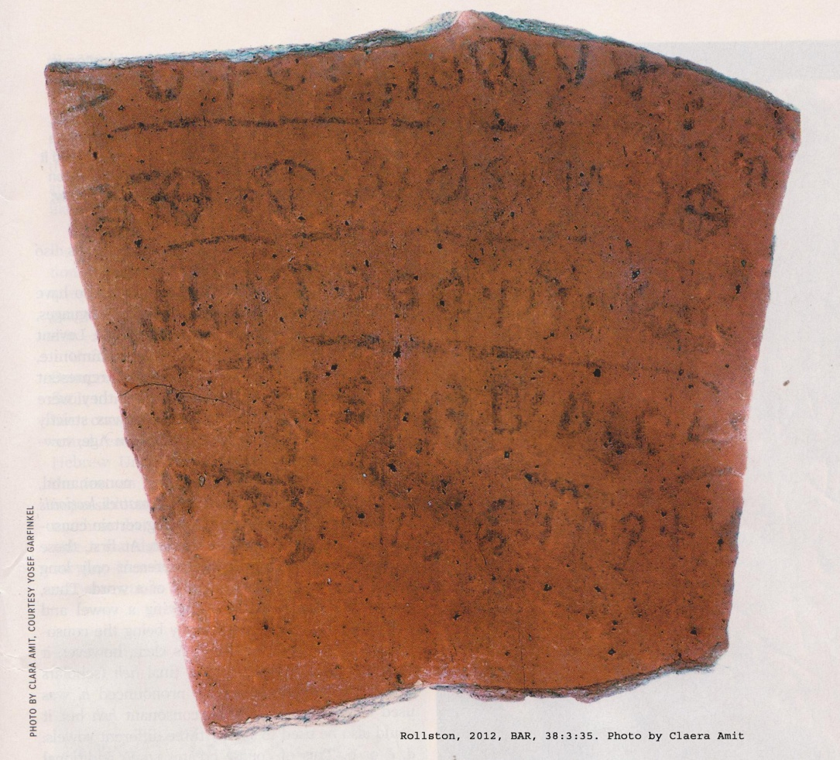

This 5-line ostracon is faded, and translation is difficult. It is not a business or commercial document. The text has words like “king”, “servant”, and “judge”, so C.A. Rollston thinks it is part of a literary or ethical text. There is just not enough information on the artifact to indicate if the script is Hebrew (Rollston, 2012:37)

The script is Early Alphabetic (or “Proto-Sinaitic” or “Canaanite” see Rollston, 2012:39).

Émile Puech (Laval, 2012:42) dates the ostracon to “about 1000 B.C.E.”

The ostracon is written left-to-right (dextrograde), but Old Hebrew as written right to left (sinistograde). Several letters in the ostracon are written in different orientations. Some experts suggest that the language is Hebrew (Yosef Garfinkel, Haggai Misgav, Gershon Galil). Others think it could be Canaanite or Hebrew (Émile Puech). Alan Milard suggests Hebrew, Canaanite, Phoenician or Moabite (Millard, 2011:11). Rolland concludes that there is not enough evidence to make a decisive determination of the ostracon (Rollston, 2012:39).

Gezer Calendar

This inscription dates to 1000-950 BC. It is an agricultural 8 month calendar, beginning in October. It may have been a school boy's exercise slate) (Livingston, 1980). The artifact is only 3.5 x 6.0 inches in size and dates to the late 10th or early 11th centuries BC (Rollston, 2012:39 and 40).

PHOTO LINK: GEZER 007, Gezer Calendar (See p.328, ABOVE; ctrl+click to follow link)

The transcription of the Calendar is as follows (Rollston, 2012:37):

1) His two months are (olive) harvest two months are

2) grain planting, his two months are late planting;

3) his month is hoeing up the flax;

4) his month is barley harvest;

5) his month is harvest and festivity;

6) his two months are vine-tending;

7) his month is summer fruit

PHOTO LINK: BA113 Gezer Calendar . BWP, BA-113.

PHOTO LINK: GEZER 015 Gezer Calendar Photo. Rollston, 2012, BAR, 38:3:36
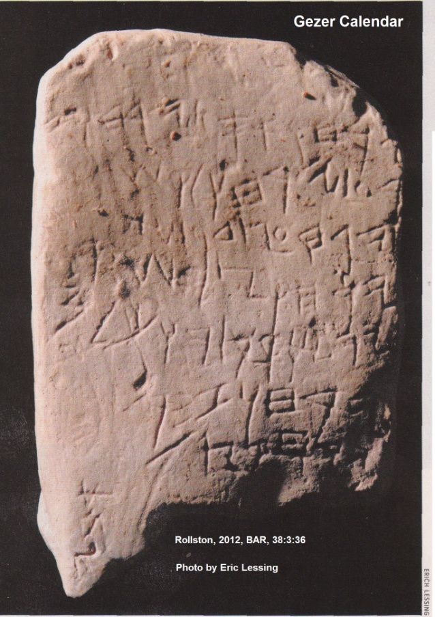

PHOTO LINK GEZER 014 Location map of Old Hebrew inscription sites. Rollston, 2012, BAR, 38:3:34.

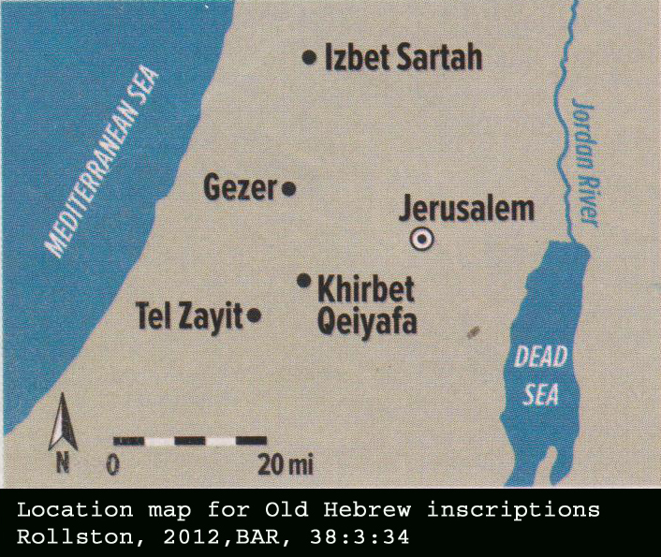

At the bottom of the artifact, on the left, and written at a right angle to the rest of the inscription are letters that Kyle McCarter interprets as “Abiya”, possibly the name of the scribe/student. The language was identified by William Foxwell Albright (1943) as “clasical Hebrew”. Later epigraphers were less convinced . These included Frank Moore Cross (1995, 2003), Kyle McCarter (1996), Joseph Naveh (1987), and Dennis Pardee (2012). Although found at an Israelite site, the is “simply no lexeme or linguistic feature in the Gezer Calendar that can be considered distinctively Hebrew” (Rollston, 2012:40).

Tel Zayit Abecedary

This artifact was disovered in 2005. It dates to the late 10th or very early 9th centuries BC. Kyle McCarter (Tappy et al, 2006) interprets the script as transitional between Phoenician and Hebrew, and Christopher Rollston considers it “pure Phoenician” (Rollston, 2012:66).

PHOTO LINK: ZAYIT 001 Computer drawing of Tel Zayat inscription (http://upload.wikimedia.org/wikipedia/commons/5/57/Tel-Zayit-Stone-Inscription.jpg, May 15, 2012).
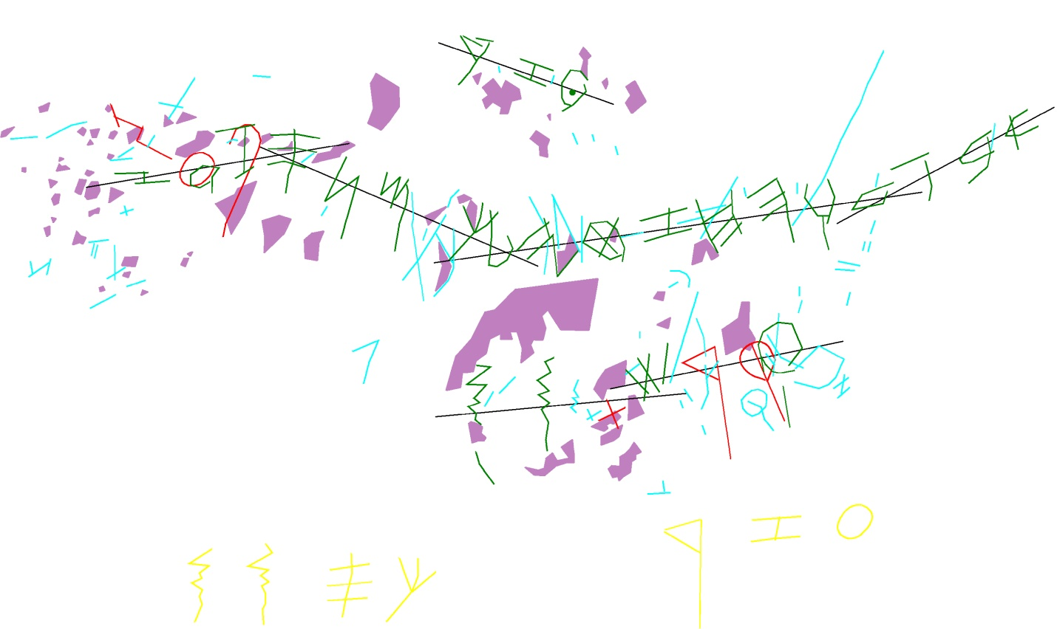

PHOTO LINK: ZAYIT 002 Photograph of Tel Zayit inscription. Rollston, 2012, BAR, 38:3:36
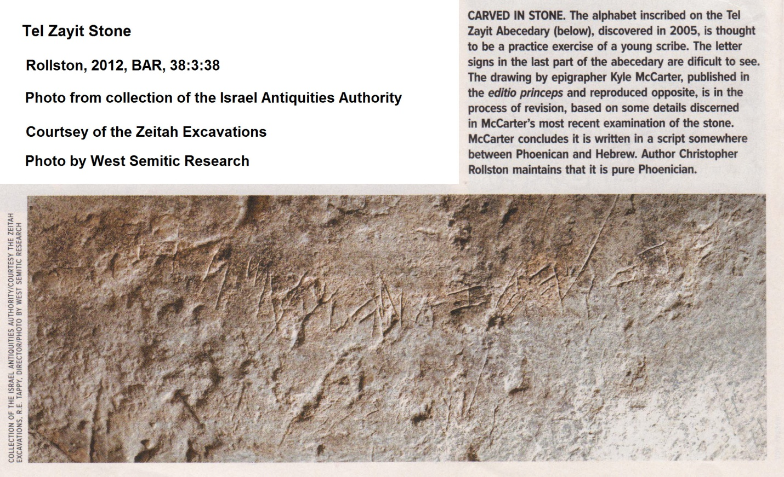
PHOTO LINK: ZAYIT 003 Drawing of Tel Zayit inscription. Rollston, 2012, BAR, 38:3:38
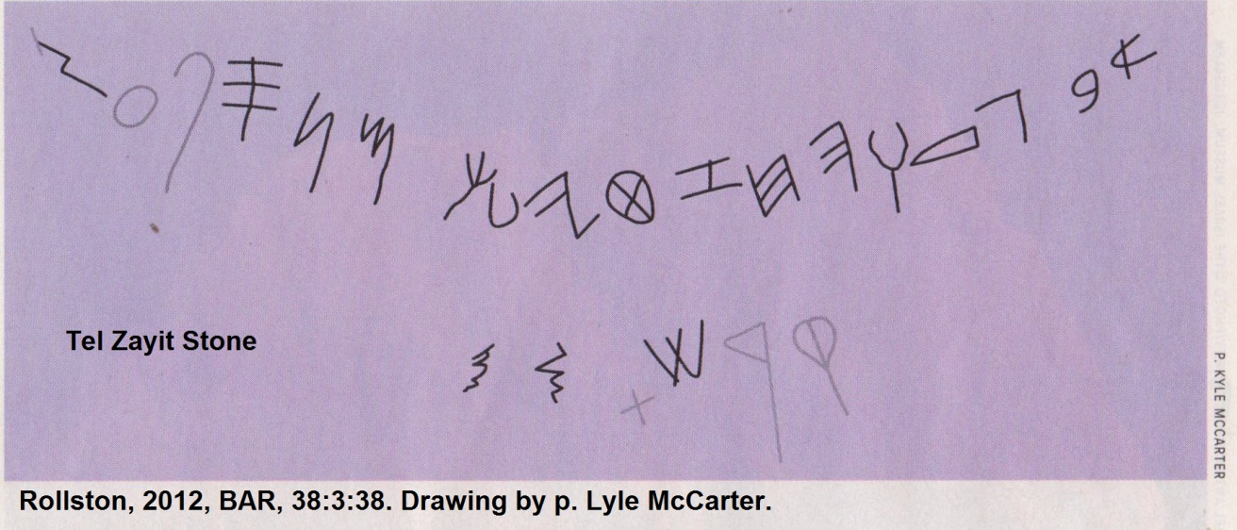

^{c}Izbet Sartah Ostracon

This ostracon is described by Kochavi (1977) Shea (1990), Livingston (1980) and Rollston (2012). This latter artifact has an abcdeciary in line 5, lines 1-4 may reflect events of 1 Sam 4-5.

The artifact dates to about 1200 BC, making it one of the earliest known candidates for an Old Hebrew inscription. The script is Early Alphabetic, also termed “Proto-Sinaitic”, or “Canaanite”. This inscription is from a time when a Hebrew national script tradition was breaking away from the Old Canaanite, or Early Phoenician script (Rollston, 2012:66, quoting Frank Cross, 1980).

PHOTO LINK: IZBET SARTAH OSTRACON 006 Photograph of ostracon. Rollston, 2012, BAR, 38:3:40.
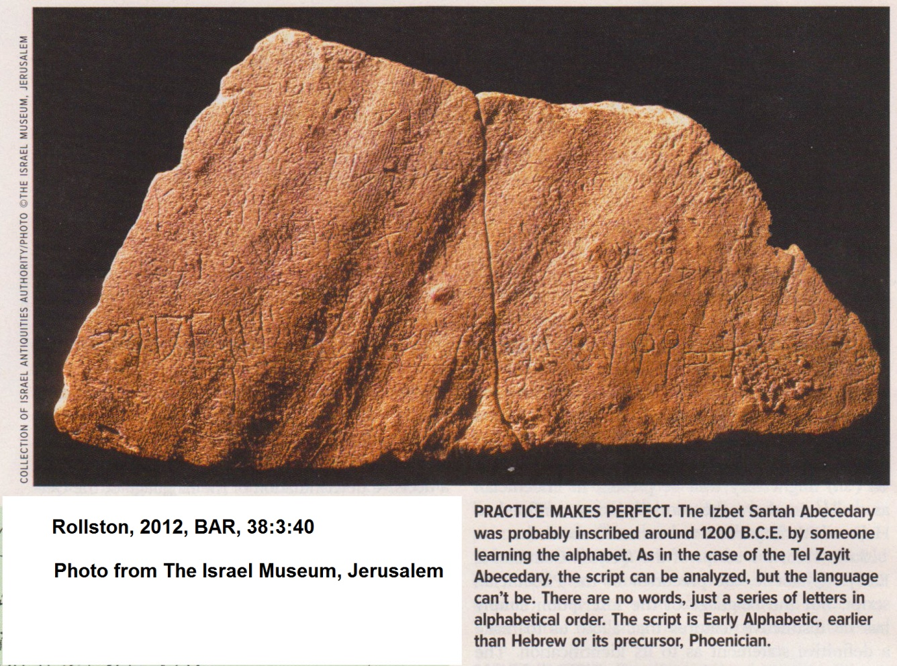

PHOTO LINK: IZBET SARTAH OSTRACON 007 Drawing of ostracon. Rollston, 2012, BAR, 38:3:40.
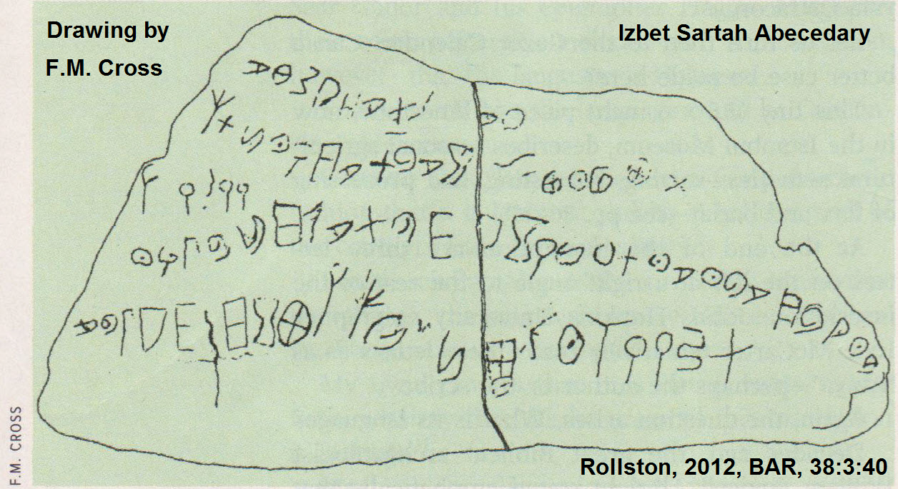
This abedecary has no clear word divisions. The use of word dividers was used in later periods (Livingston, H., 1980). See PHOTO LINK: SCRIPTS 014 on page 349.

PHOTO LINK: IZBET SARTAH OSTRACON 004 ^{c}Izbet Sartah Ostracon Photo and
Drawing

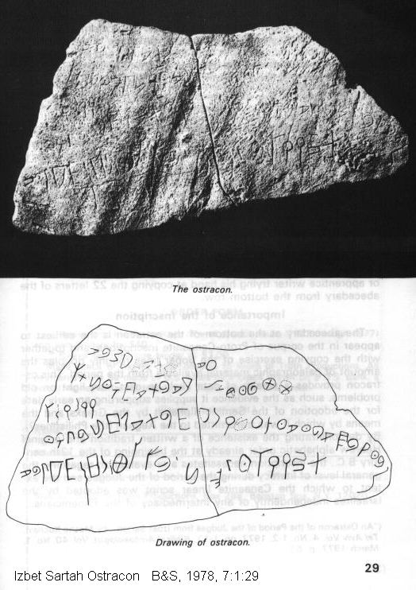

PHOTO LINK: SCRIPTS 014, Dot word dividers Old Hebrew script, Millard, 1992, BR, 8:3:44.
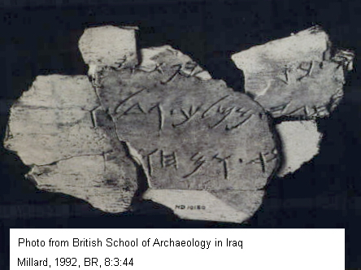

Samaritan Ostraca

This example of Old Hebrew script is in 8 pieces and dates to, cir. 750 BC. (Livingston, 1980)

Silver Scroll Amulets of Ketef Hinnom

One of the earliest known artifacts with Hebrew writing is the Silver Scroll Amulets of Ketef Hinnom. They date from the 7th century BC. Found in tomb burials, these silver scrolls were small (4 inches x 1 inch; 1.5 inches x 0.5 inch)(Caesar. 2006).

PHOTO LINK: SCRIPTS 039 Silver Scroll Amulets of Ketef Hinnom. Coogan, 1995, BAR, 21:3:46. (LEFT)
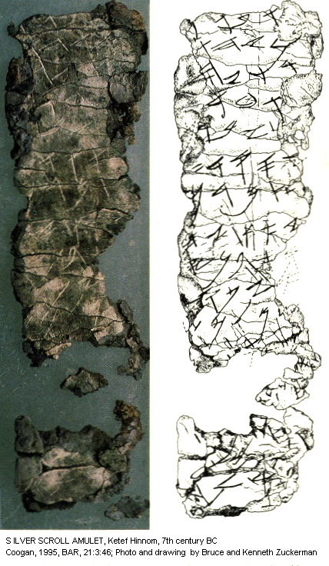

PHOTO LINK: SILVER SCROLLS 001 St. Andrew's church as seen from the Hinnon Valley. Caesar, 2006, B&S, 19:2:59.
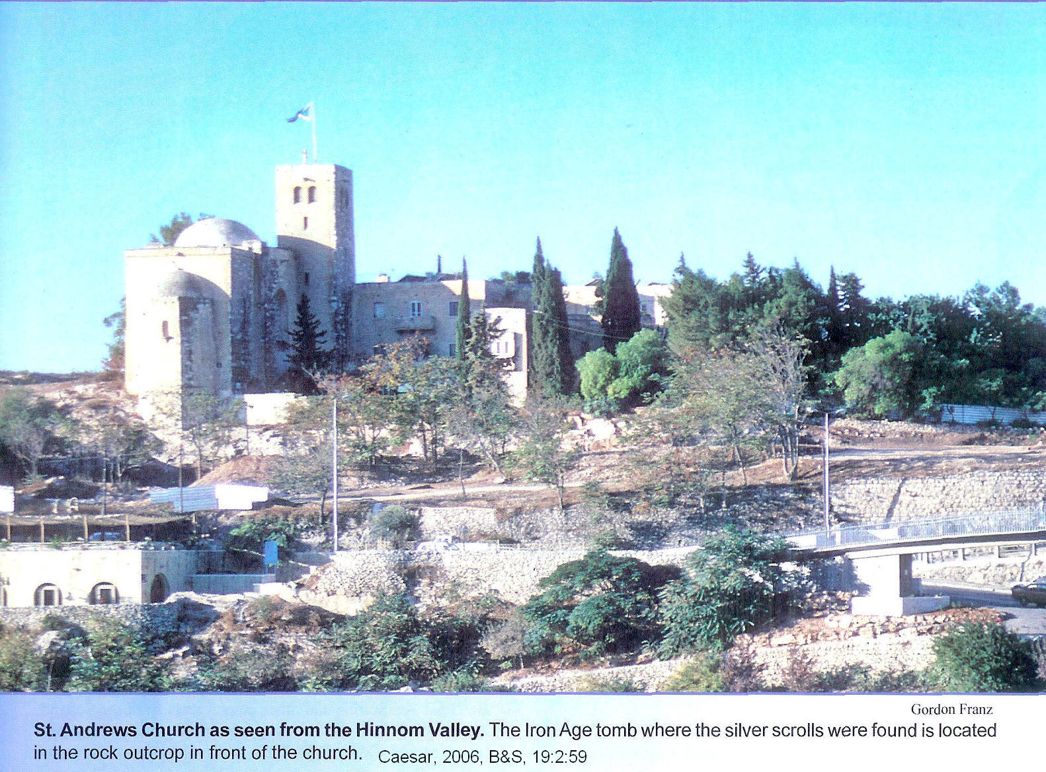
PHOTO LINK: SILVER SCROLLS 002 One of the silver scroll amulets before it was unrolled and silhouette of Gabriel Barka. Caesar, 2006, B&S, 19:2:60.
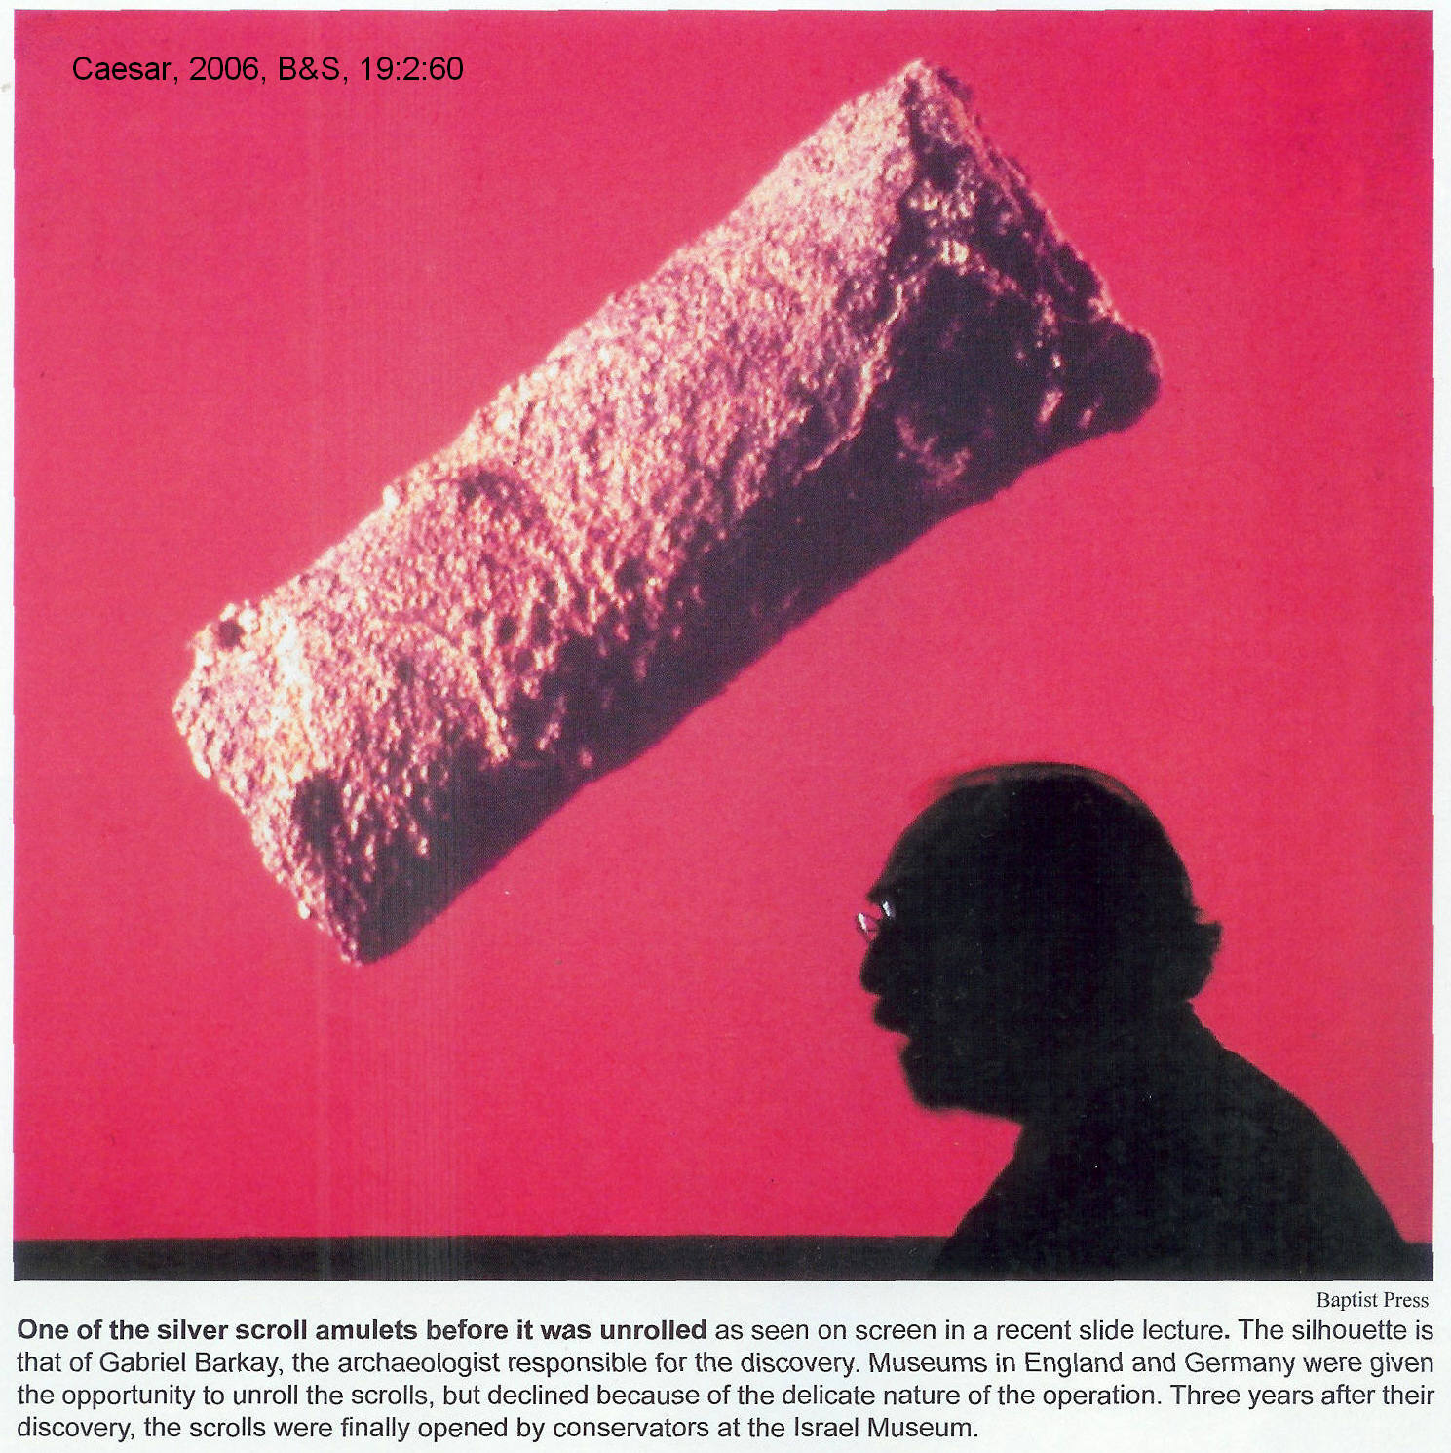

PHOTO LINK: SILVER SCROLLS 003 Ketef Hinnon Amulets I and II. Caesar, 2006, B&S, 19:2:60.

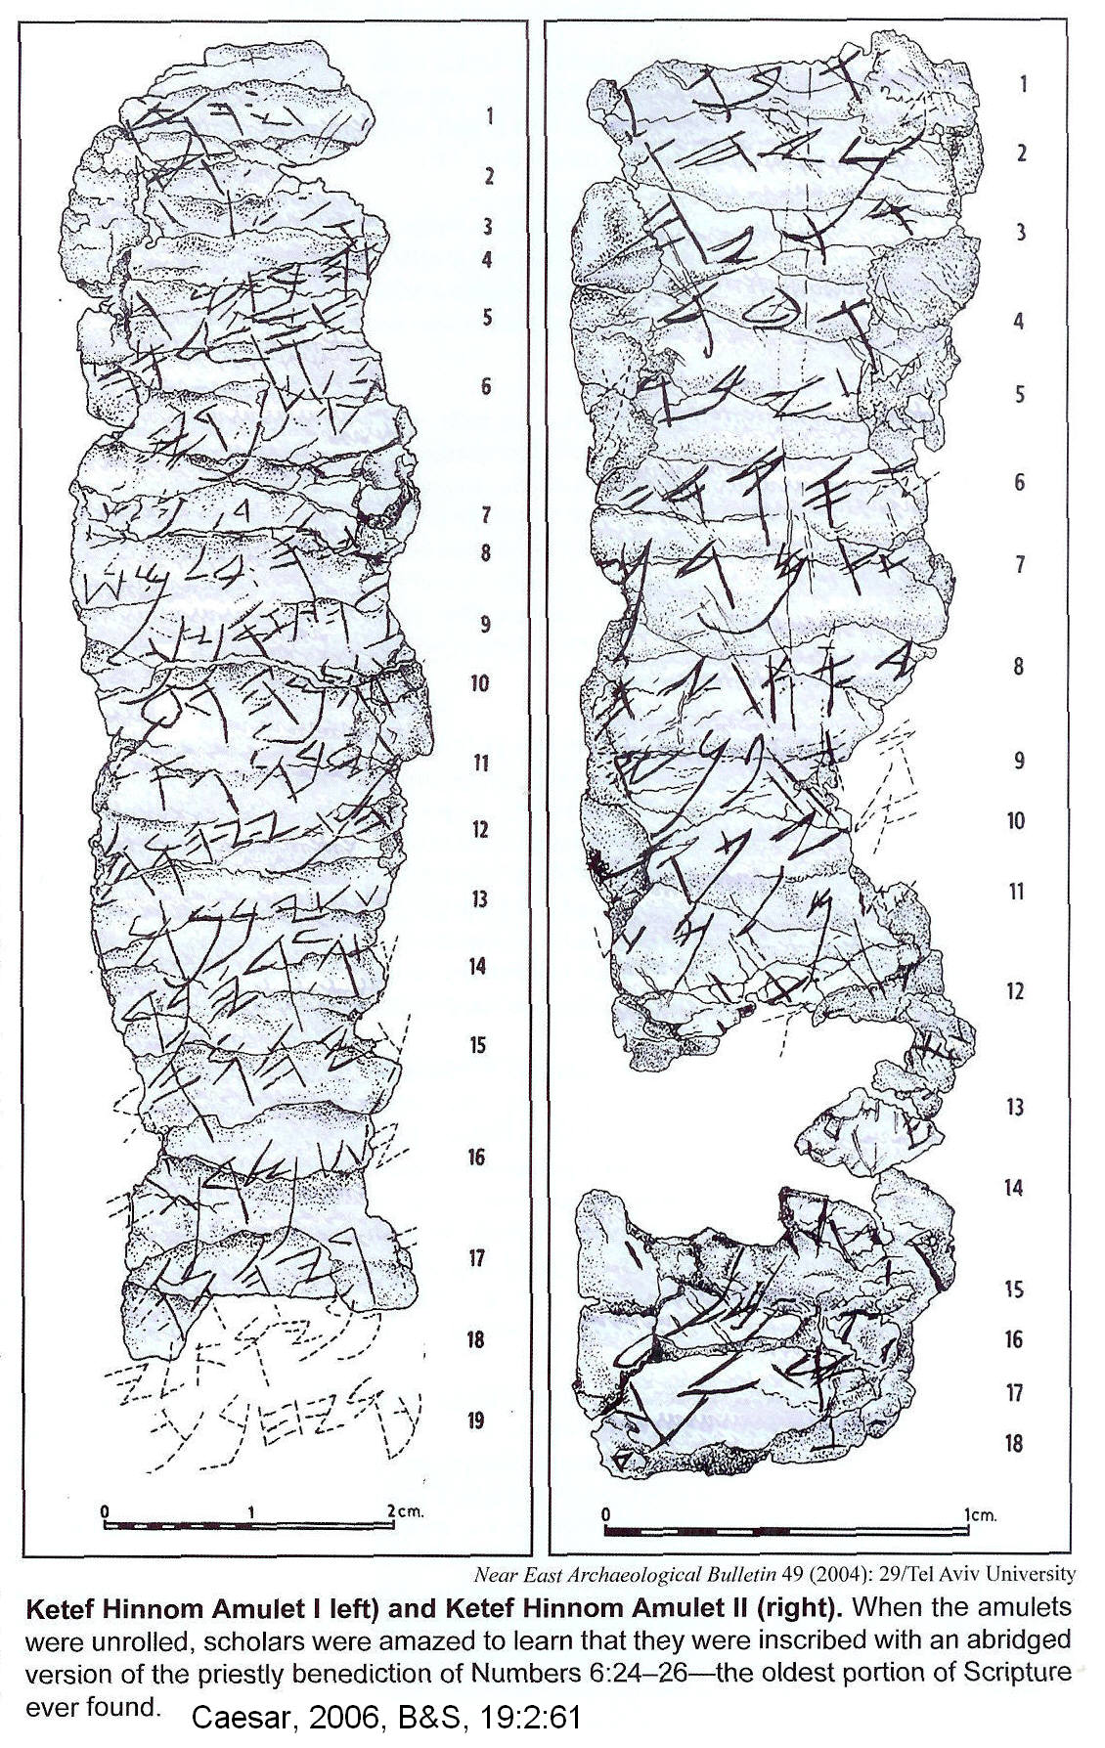

Each scroll was inscribed on the inside with the following blessing:

“May Yahweh bless and keep you. May Yahweh cause his face to shine upon you and grant you peace”

This blessing is similar to the Priestly blessing of Numbers 6:24-26 (Coogan, 1995).

Lachish fragment

This fragment is from the 12th or 11th century BC. (Livingston, 1980.)

Siloam Inscription

This inscription is found in an ancient Jerusalem water tunnel made by Hezekiah cir 700 BC), (Livingston, 1980).

PHOTO LINK: HEZEKIAH TUNNEL 020 Siloam Inscription in Old Hebrew Script (See p. 75 , ABOVE; ctrl+click to follow link)

PHOTO LINK: HEZEKIAH TUNNEL 023 Drawing and Modern Hebrew translation on Siloam Inscription. Hackett, 1997, BAR, 27:2:43.
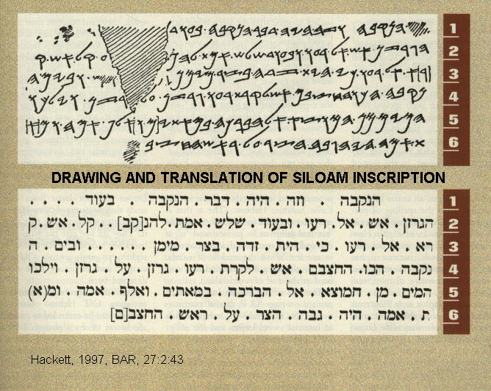

Inscription on the tomb of Shebnayahu

This inscription is in the tomb of a Royal Steward of Hezekiah (Livingston, 1980).

PHOTO LINK: HEZEKIAH 002 Inscription to tomb of Shebnayahu, Royal Steward of Hezekiah. Beit-Arieh, 1996, BAR, 22:6:33.
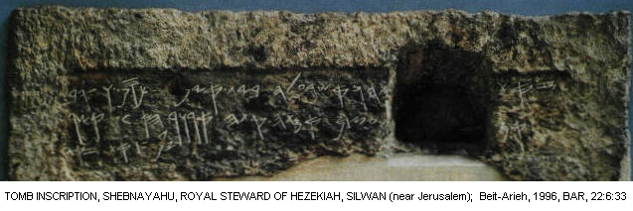
PHOTO LINK: SCRIPTS 043 Tomb of the Royal Steward of Hezekiah in Old Hebrew script. McCarter, 1997, BAR, 23:2:46.
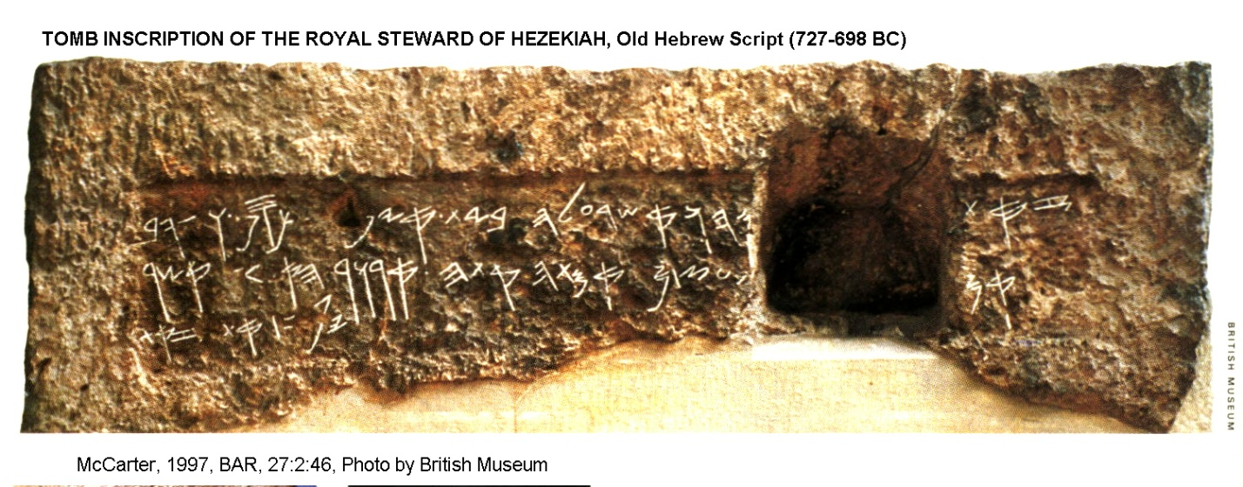

Mesad Hashavyahu Inscription

This inscription was discovered at Tel Aviv and dates to cir. 650 BC. (Livingston, 1980)

PHOTO LINK: MESAD HASHAVYAHU INSCRIPTION 001 Replica; http://upload.wikimedia.org/wikipedia/commons/thumb/7/72/Mesad_Hashavyahu_Ostracon_Replica.JPG/300px-Mesad_Hashavyahu_Ostracon_Replica.JPG; Oct. 7, 2010
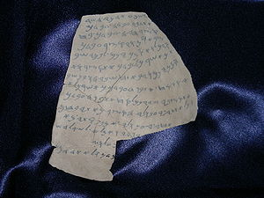

Lachish Ostraca

These artifacts are in 21 pieces and date to 600-589 BC. (Livingston, 1980)

Inscribed “lmlk” jar handles

There are hundreds of these from around the kingdom of Judah. (Livingston, 1980).

PHOTO LINK: SCRIPTS 044 lmlk “belonging to the king” (Hezekiah) stamp in Old Hebrew. McCarter, 1997, BAR, 23:2:46.

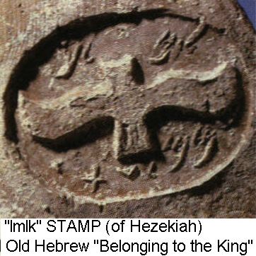
Stone seals

There are over 150 seals in Old Hebrew script (Livingston, 1980.

PHOTO LINK: HOSHEA KING 002 Seal “Belonging to Abni Servant of Hoshea” 732-722 BC in Old Hebrew. Lemaire, 1995:BAR, 21:6:48.

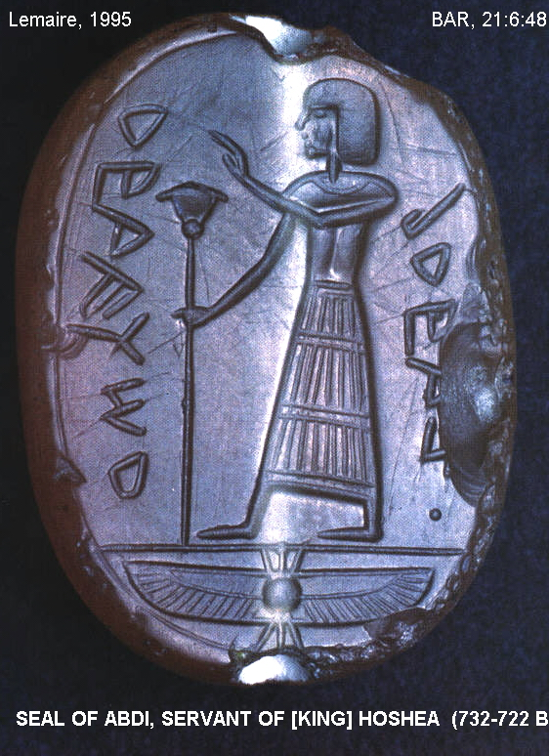

Inscribed weights and measures

There are several of these in Old Hebrew script (Livingston, 1980).

Amulets

Old Hebrew script was also used in votive amulets (Livingston, 1980).

PHOTO LINK: AR129 Jerusalem, Amulet Unrolled, 3.82 inches long. BWP, AR-129.
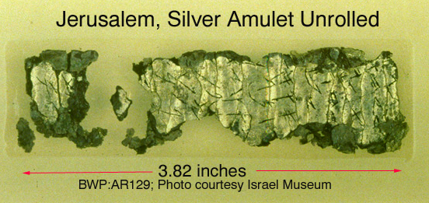

PHOTO LINK: AR130 Jerusalem, Drawing of Amulet Inscription. BWP, AR-130.
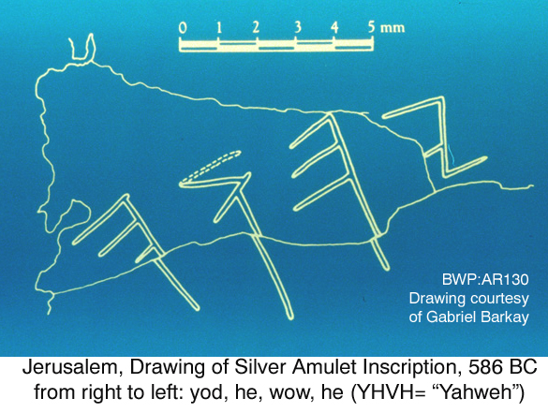

Paleo-Hebrew script

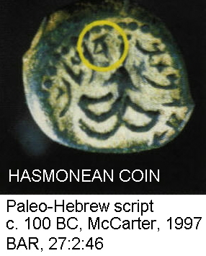
The Old-Hebrew script was discarded during the Exile. After the Exile, the Hebrews used the square Aramaic Script. But some post-Exilic writings were made using an archaizing script called Paleo-Hebrew. Some Dead Sea Scrolls are written in paleo-Hebrew as are the script on Maccabean period Jewish coins. These finds suggest that there was a limited revival of a form of the Old-Hebrew script just before New Testament times. There are subtle differences between Old Hebrew and Paleo-Hebrew scripts that make them distinguishable (Livingston, H., 1980, Cross, 1997; McCarter, 1997).

PHOTO LINK: SCRIPTS 045 Hasmonean coin 1st century BC Paleo-Hebrew script. McCarter, 1997, BAR, 23:2:46

PHOTO LINK: SCRIPTS 046 Dead Sea Scroll “Exodus Scroll” written in Paleo-Hebrew script. McCarter, 1997, BAR, 27:2:45.
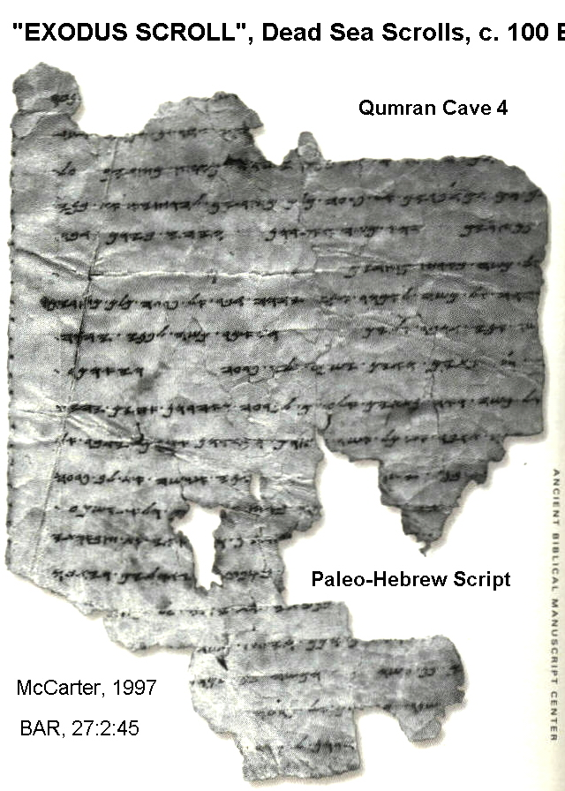
The Samaritan community developed a variation of paleo-Hebrew Script which they preserved in the Samaritan Pentateuch (Livingston, H., 1980).

To distinguish where one word ended and another began, dots were placed between the words in Paleo-Hebrew scripts (Millard, 1992, p. 45).

PHOTO LINK: SCRIPTS 042 Chart comparing Old Hebrew and Paleo-Hebrew scripts. Cross, 1997, BAR 27:2:25.

Ammonite script

The neighboring Moabites, Ammonites, and Edomites employed a similar script as Hebrews. The evolution of Ammonite script is known from the many decades of ostraca deposited in the Pool of Heshbon from the 4th through 5th centuries BC (Herr, 1993).

PHOTO LINK: EDOM 003 Edomite seal of Shubnaqos found at Horvat Qitmit. Beit-Arieh, 1996, BAR, 22:5:33.
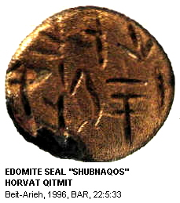

PHOTO LINK: EDOM 007 Ostracon of Horvat ‘Uza, request for grain shipment. Beit-Arieh, 1996, BAR, 22:5:335

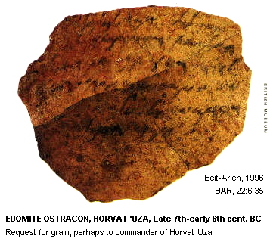

Moabite is known from the Mesha ("Moabite") Stele and from 2 other Moabite seals. Ammonite is known from the Balu'al Stele (13th century BC), the El Kerak inscription (9th century BC), the Amman Citadel inscription (9th century BC), the Amman inscribed statuette (5th century BC) and from three seals. Edomite is found on the Ezion-berber inscription (6 letters, 7th century BC) and inscribed jar handles (12 handles, 7th century BC; Livingston, H., 1980).

PHOTO LINK: MOABITE STONE 002. Shanks, 1997, BR, 13:2:35;

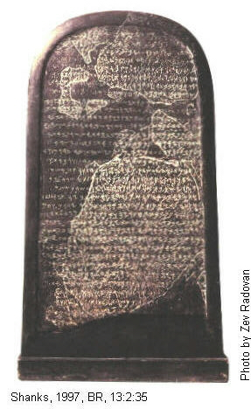
PHOTO LINK: EL KERAK 001 Inscription, 9th Century BC http://www.kchanson.com/ANCDOCS/westsem/elkerak.html; Dec. 12, 2007 (BELOW)

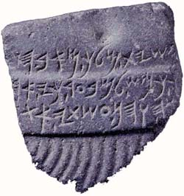
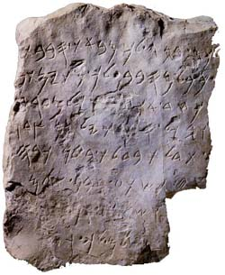

PHOTO LINK: AMMAN CITADEL INSCRIPTION 001; Jebel Qal'ah (Citadel Hill)
Amman, Jordan, (ancient Rabbath-Ammon);
http://www.kchanson.com/ ANCDOCS/westsem/citadel.html; Dec. 12, 2007 (RIGHT)

PHOTO LINK: AMMONITE 006 Ammonite ostracon, Tell el-'Umeiri. Herr, 1993, BAR, 19:6:32.
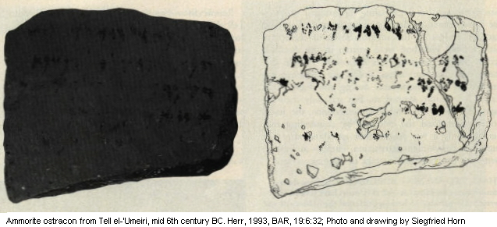

PHOTO LINK: AMMONITE 006-B Ammonite ostracon, Tell el-'Umeiri. Herr, 1993, BAR, 19:6:32.

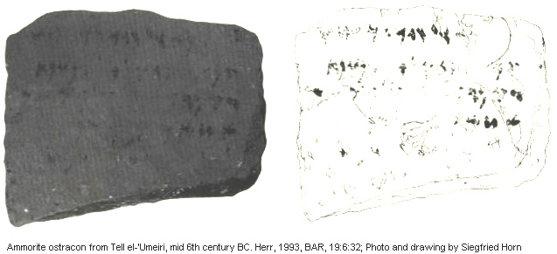

Phoenician Script

The Phoenician script was common among Phoenicians of Tyre, Sidon and other communities on islands and along coast of Mediterranean Sea. Most surviving examples are from Persian Period and are brief. These include (Millard, 1982):

- Yehawmilk (Yehimilk) inscription of Byblos (5th to 4th centuries. BC)
- Three inscriptions from Zinjirli, Syria of which two were produced by Kilamuwa (9th century BC) and one by Barrakab (730 BC)
- Three different versions of Phoenician Script at Karatepe, Anatolia (Turkey, 9th to 8th century BC)
- Three inscriptions on island of Sardinia including the Nora Stone ("Fragment", early 9th century BC)
- Cyprus inscriptions (9th or 8th century BC)
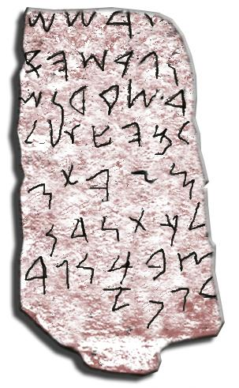
- A Spanish inscription (5 lines, 8th century BC) and Punic Script, a late variety of Phoenician script.

This later script is found at Marseilles, France (3rd or 2nd century BC), in the Carthage inscription (3rd or 2nd century BC), and other inscriptions in Malta, Sicily and Greece (Millard, 1982).

PHOTO LINK: NORA STONE 001; Nora Stone Fragment; http://en.wikipedia.org/wiki/File:Piedra_de_nora224.jpg, Oct. 8, 2010 (RIGHT)

PHOTO LINK: YEHAWMILK STELE OF BYBLOS 002 http://www.memo.fr/en/article.aspx?ID=ANT_PHE_006. Oct 29, 2013
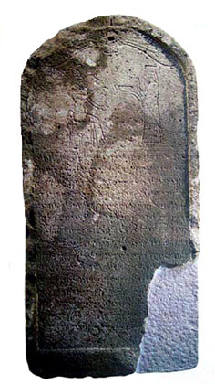

PHOTO LINK: KILAMUWA INSCRIPTION ZINJIRLI SYRIA 002; http://www.usc.edu/dept/LAS/wsrp/educational_site/ancient_texts/MI_VAMKLMW_R1D_T.jpg. Oct. 25, 2013.

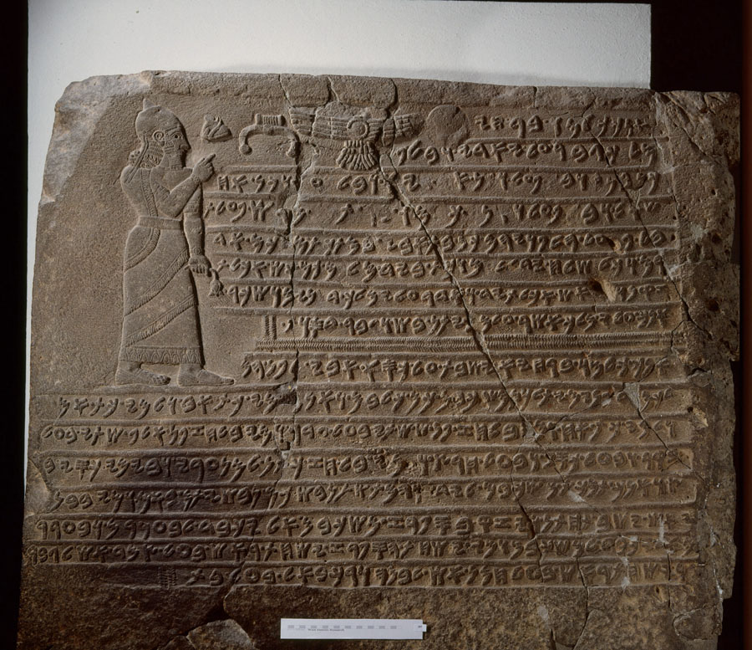

Kilamuwa's inscription was discovered in 1902 at the entrance to his royal palace. It depicts a regal, long robed figure, presumably king Kilamuwa himself. He holds in his hand a wilting lotus, the symbol of deceased kings. With his other hand he points to several symbols of deities. Beneath these is carved in bas relief the well-preserved sixteen line Phoenician inscription. Though the language and alphabet are Phoenician, the bas relief style of the letters imitates the style of Luwian hieroglyphics.(jJeffry Rose, Oct. 24, 2013; http://www.usc.edu/dept/LAS/wsrp/educational_site/ancient_texts/kilamuwa.)

PHOTO LINK: ALPHABET 006 Phoenician Alphabet: May 31, 2005 http://www.ancientscripts.com/phoenician.html

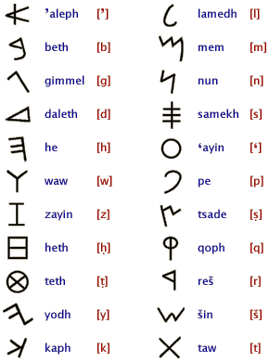

The Phoenician script is the father of all Western scripts, and came to us mainly through the Greeks. They borrowed the alphabet from Phoenicians as early as 11th century BC (but Classicists argue 9th century BC). The Greeks made modifications to the Phoenician script by adding vowels and 2 new characters (Phoenician had 22 while Greek had 24 letters). There were various directions of writing. Some was left to right (LXX, 3rd century BC). In others one line was read one way and next line the opposite way. Others were read right to left (Millard, 1982).

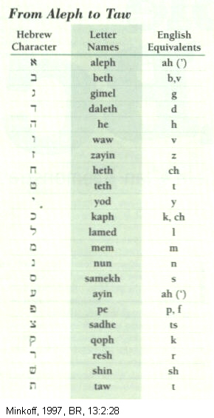
Square Hebrew Aramaic Script

This classic script developed during Exile (6th to 5th cents. BC). At this time the Hebrews decided to transliterate their Scripture into the common language of the time, Aramaic, in Aramaic script. Parts of Daniel and Ezra written in Aramaic. The earliest known square Hebrew script is from the 3rd century BC. It is also found on. Jewish ossuaries (burial boxes with bones) from the 2nd and 1st century BC. It is the script on the Nash Papyrus (cir. 100 BC) and the Dead Sea Scrolls (100 BC-70 AD). This script records the 8,000 words in the Biblical Hebrew lexicon, of which some 1,700 are hapax legomena or words occurring only once (Dahood, 1980, p.66). Many of these are in Job and Genesis (especially the poetic parts). The more nearly square form was used in Aramaic (Millard, 1982).

PHOTO LINK: SCRIPTS 028 Hebrew Script. Minkoff, 1997, BR, 13:2:28. (RIGHT)

The square Hebrew script has 22 letters in its alphabet. All letters are consonants. Two letters lost their sound value. Four letters were used as signs for long vowels as spoken Hebrew died out (except in synagogue and school applications). In the Middle Ages, vowel development occurred in 3 schools. The Babylonian school used small consonantal letters above line of text to depict vowels. The Palestinian school used a system of dots above line of text. The Tiberian school used dots and dashes above and below line of text to depict vowels with some dots within or beside the consonants. Group or markings denote accent patterns. These markings are not found on synagogue scrolls. Cursive styles of Square Hebrew script developed in Enlightenment and Industrial Revolution periods (Millard, 1982).

EARLY WEST SEMITIC SCRIBAL PRACTICES

In the Late Bronze Age (cir 1200-1100 BC) Babylonian influence in the Levant weakened. The rise of alphabets with between 22 and 30 letters ended the scribal monopoly on literacy, but they still had high social standing for production of documents and official communiqués. Hebrew scribes would break words between lines of text if space ran out, and they divided each word from its neighbor by a space or a point (dot). The Balaam inscription on walls at Deir Alle (mid 8th century BC) where words are separated by dots (Lemaire, 1985. p.278). This practice is observed on the Siloam tunnel inscription (8th century BC, 2 King 20:20, see photo above), the Nimrud inscription (8th century BC), and in dots between words on ancient Hebrew seals. The Elephantine papyri have spaces between words (5th century BC) as do the Dead Sea Scrolls (230 BC-68 AD), and Bar-Kokhba documents of the 2nd Jewish Revolt (132-135 AD; Millard, 1982).

Modern emendations are routinely made today too. Some commentators change hypothetical word beginnings and endings in the received texts (for example: see "Was Eve Cursed?" in Bledstein, 1993). These analyses sometimes turn traditional interpretations of Bible verses upside down (much to the horror and consternation of conservative scholars).

An important scribal practice was error correction. Examples of this procedure are found in three stele from Sefire near Aleppo (treaties, 750 BC). In the 175 lines of this treaty, there are 14 mistakes made by stone cutters who misread the scribe's ink template. Corrections are also found in the Balaam inscription at Tell Deir Alla (700 BC; Millard, 1982).
PHOTO LINK: SCRIPTS 015 Elephantine papyri with spaces between words, 5th century BC. Millar, 1992, BR, 8:3:46, Photograph from Brooklyn Museum.

PHOTO LINK SCRIPTS 010B Inserted word. Millard, 1982, B&S, 11:2-3-4:41.
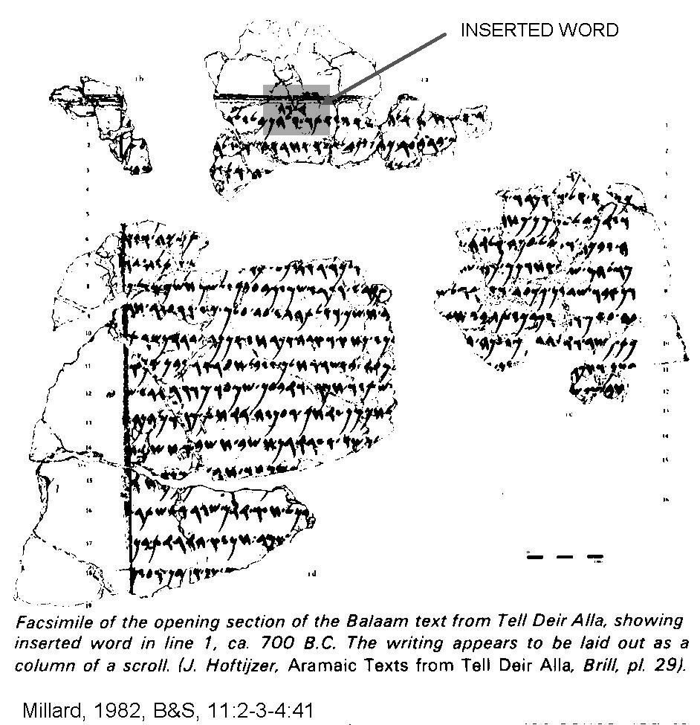

PHOTO LINK SCRIPTS 009B Inserted phrase. Millard, 1982, B&S, 11:2-3-4:39

The oldest known practice of putting literature in book or scroll form is the "Proverbs of Ahiquar”, Elephantine papyri at Aswan (5th century BC, time of Ezra; Millard, 1982).

Scribal accuracy in the Old Testament manuscripts is shown in the spelling of foreign names (compare modern Colonel Khadafy vs Gadahfy). Ancient examples are found in the names of Tiglath-pileser, Sargon, and Xerxes (Ahasuerus). It is interesting to note that the Septuagint (LXX) generally fails to accurately translate names (Millard, 1982).

AEGEAN SCRIPTS

Writing was developed in the Aegean around 1800 BC under the influence of Mesopotamian writing traditions. The oldest is a hieroglyphic Cretan script represented by some seals and seal impressions dating from 1800-1600 BC (Powell, 2004).

PHOTO LINK: CRETAN SCRIPT 001 Seals from Knossos c. 1650 BC. Powell, 2004, ODY, 7:2:39.

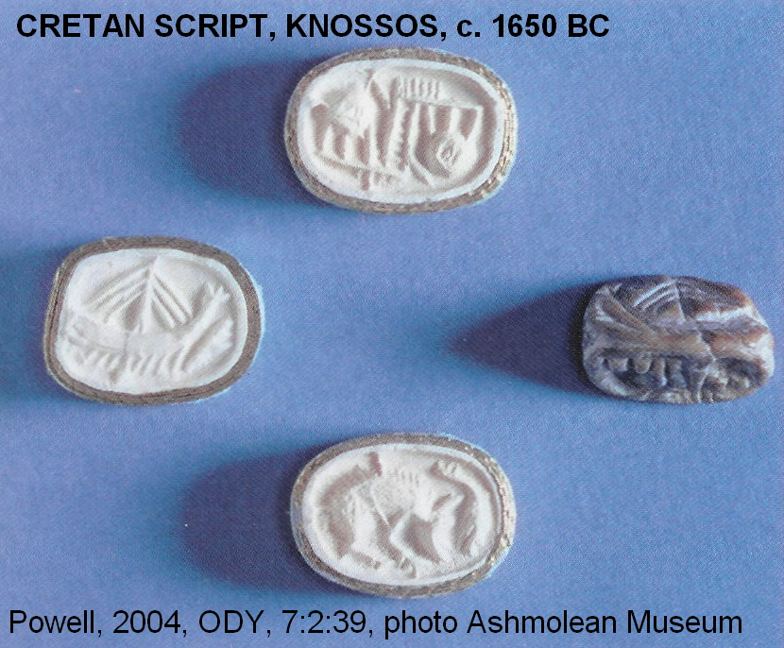

PHOTO LINK: CRETAN SCRIPT 002 Table of hieroglyphic script and other equivalents. Powell, 2004, ODY, 7:2:42

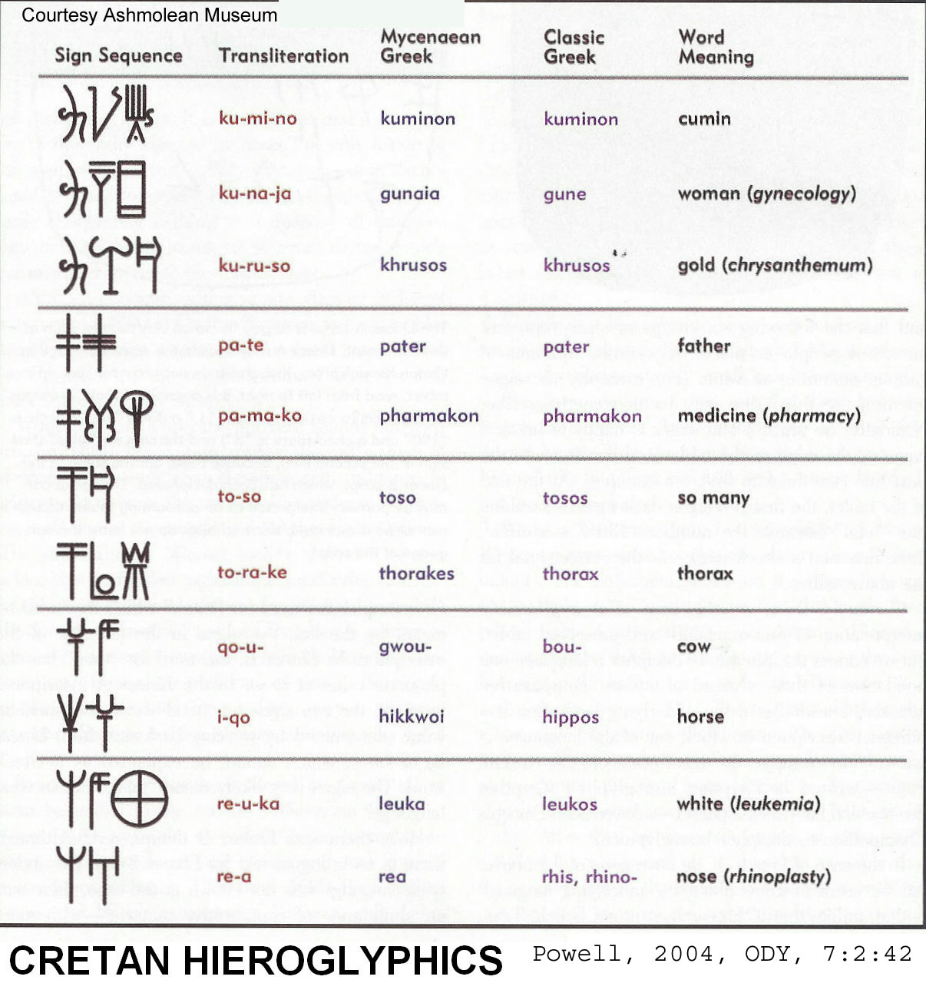

An enigmatic Aegean script is called Linear A. It has yet to be deciphered.

PHOTO LINK: LINEAR A 001 Clay tablet with Linear A. Powell, 2004, ODY, 7:2:41

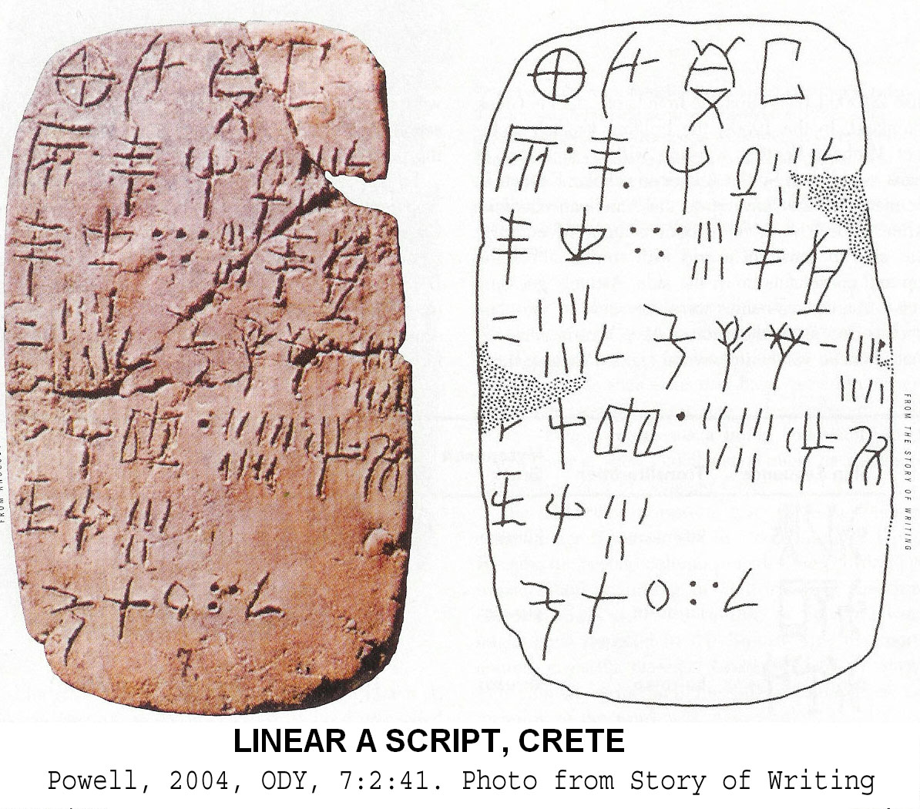

The later script named Linear B, also found on Crete, is syllabic and had been deciphered.

PHOTO LINK: LINEAR B 001 Clay tablet with Linear B c 1450 BC. Powell, 2004, ODY, 7:2:43.41. Photo f
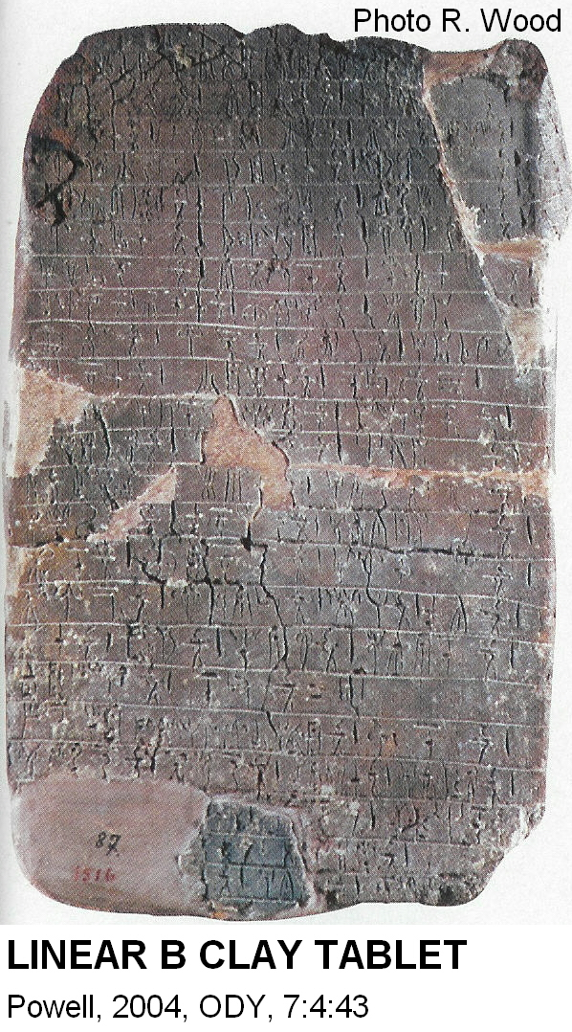

DEMOCRATIZATION OF CULTURE THROUGH WRITING

Once invented, the alphabet spread throughout world in only about 1,000 years. A result of this intellectual revolution was that learning and culture were no longer under control of tiny elite. Religious lore (myth, ritual, magic, medicine) was no longer exclusive property of professional interpreters of sacred knowledge, it made it possible for ideas of all types to enjoy a wider audience. This made for better and faster accumulation, preservation and transmission of knowledge. The early writing system was completely phonetic with 22 characters after 1200 BC. This simple system (which we have complicated by dialects and changes in vocalization) made for easier analysis, criticism and logical perusal of ideas. Pre-alphabetic societies (Mesopotamia, Egypt) became decadent, moribund, static, hierarchical and oppressive compared to the innovative, prospering and more democratic societies (e.g. Hebrews, Greeks and Romans) that used alphabets (Cross and Shanks, 1994).

There were two families of cultures after the alphabet was invented: the Greeks and the Hebrews. From these, all Western societies have descended. There is a debate about when Greeks borrowed the alphabet from the Semites. One school favors the mid-11th century but most classicist scholars prefer the 9th century. These two cultural families had some very basic differences:

GREEKS | HEBREWS
philosophy, skepticism, "proto-humanism"  -divine hierarchy: kingship on earth based on divine kingship  -religious ritual used to enforce and maintain the king's power  -older pantheon quickly and easily adopted | -Prophetic Principle  -common critique of king and temple  -provisional, late monarchy  -limits on kingship  -kings are stewards of God  -concern for social justice  -high moral standards  -covenant community

This divergence of political and religious thought continues to this day. These ideologies are labeled communism and the American value system (Vazsonyi, 1998).

PHOTO LINK: SCRIPTS 008, Selected examples of alphabetic script. Livingston, 1980, B&S, 9:2:49.

Also termed “Early Alphabetic” or “Canaanite”. See Rollston, 2012:34.

