CHAPTER 7: CREATION AND (OR) EVOLUTION
Contents
YOUNG-EARTH CREATIONISM 512
PROGRESSIVE CREATIONISM 513
THEISTIC EVOLUTION 514
AGNOSTIC NATURALISM 515
TWO CREATION STORIES (GENESIS 1 AND 2) 515
Liberal Theory 516
Conservative Theory 516
EGYPTIAN CREATION TRADITIONS 516
Ptah the Creator 516
Atum the Creator (southern Egypt) 518
Khepri the Creator God (southern Egypt) 526
Creation Myth of Northern Egypt 527
Comparison of Hebrew and Egyptian creation stories 529
MESOPOTAMIAN CREATION TRADITIONS 530
Sumerian Dilmun Story and the Fall 530
Atrahasis (Atra-Hasis) Epic (1630 BC) 532
Comparison of Atrahasis and Hebrew Epics 538
Enuma Elish Creation Epic 538
Creation of the firmament and earth 551
Creation of Luminaries 553
Creation of Man 555
The "Rest" after Creation 555
Harab Myth 558
Primordial Battles with the Sea and Sea Monsters 560
The Rivers of Eden 563
UNITY OF MESOPOTAMIAN CREATION-FLOOD NARRATIVES 569
PHOTO LINK: SUMERIAN KING LIST 001. Nippur list. (Web photo) 569
Comparison of Mesopotamian and Hebrew Creation Traditions 570
Separation of Waters in Mesopotamian and Egyptian Traditions 570
Conclusions 571

No one topic has occupied more debate in the study of the Bible than the question of origins. Several organizations have come into being in the past 50 years, each having a mission to support a certain belief about creation and to further theological, social and political agendas based on this belief. More books and articles have been written on this topic in the past two decades than for any other doctrine. My purpose in this chapter is to introduce the debate, not to provide a comprehensive analysis of it.

YOUNG-EARTH CREATIONISM

Young earth creationism has, among its chief defenders, fundamentalist scholars of the Institute for Creation Research (Christian Heritage College, San Diego, California), the Creation Research Society (Anne Arbor, Michigan) and Associates for Biblical Research (Akron, Pennsylvania).
Web site links:

Institute for Creation Research: creationonline.org
Creation Research Society: creationresearch.org icinet.org/pub/resources/text/crs/crs-home.html
Associates for Biblical Research: http://www.biblearchaeology.org/

Young earth creationists hold the following positions:

-the Universe is about 10,000 yrs old
-literal interpretation of Genesis
-Noah's Flood made all fossil-bearing strata
-Evolution beyond created “kinds” did not and does not occur
-Created "kinds" of Gen 1 = +/- what biologists classify as Genera
-all scientific observations are explained by a Theory of Design

Evidence cited to support their view of a young earth are summarized in Ackerman (1986) and in monthly newsletters of ICR (see their web site to order them).

The strengths of Young Earth Creationism are that it has Fundamentalist appeal and it presents a simplistic means of understanding origins.

Young Earth Creationism does not provide a satisfactory explanation for many scientific observations. These include:

1) Isotopic ratios (radiometric dating)
2) Biostratigraphy
3) Cooling rates of plutons
4) Cyclothems keyed to Melankovich cycles
5) Daily growth rates for shells keyed to slowing of earth's rotational speed.
6) Isotopic ratios of Sr isotopes in fossilized seawater recorded in the some marine fossils

(For detailed exposition of these topics, see Appendix 4). Young Earth Creationism is viewed by many Christians and most non-Christians as an annoying equivalent of the Flat Earth Society. The tragedy of Young Earth Creationism is that it has turned more away from Christ than towards Him and has brought more dishonor than honor to the Gospel.

Publications dedicated to refuting Young Earth Creationism interpretations are found in The Skeptical Inquirer and other humanistic journals as well as organizations supporting theistic evolution (e.g. American Scientific Affiliation) and ones supporting evangelical Christianity but do not require a Young Earth Creationism cosmology (e.g. Access Research Network, Reasons to Believe).

Web site links:

Skeptical Inquirer http://www.csicop.org/si/

American Scientific Affiliation http://cesc.montreat.edu/ceo/ASA/
Access Research Network http://www.arn.org/

Reasons to Believe http://www.reasons.org/index.shtml

Another disadvantage of Young Earth Creationism is that it presents a narrow view of God. It requires that God be very human and confines God’s godness. It requires God to act on human time scales. It also requires bazaar ad-hoc hypothesis in order to preserve literal understandings of Genesis and other biblical passages. For example, since Genesis says that there was no death before Adam’s sin, and (according to their interpretations) dinosaurs and Adam lived contemporaneously (because, Adam named all the animals), young earth creationists postulate that Tyrannosaurus Rex was created a vegetarian and only became a carnivore after the Fall.

PROGRESSIVE CREATIONISM

Old Earth Creationism or Progressive Creationism has the following characteristics:

-Accepts Big Bang Theory Cosmology
-Universe 18 billion years old
-Earth 4.55 billion years old
-Major biological force is Stasis, not Evolution (there is limited biologic change within created "kinds")
-Succession of creation events in accordance with Biostratigraphy
-Geologic record mostly the result of a succession of catastrophes
-Noah’s Flood not global, but culturally “universal”. May have been a local flood in the Tigres-Euphrates valleys, or is a parable
-Genesis 1 told from point of reference of an observer on earth
-Understand Bible in its cultural context, with its metaphors, parables and similes
-Supports a Theory of Design

Defenders and promoters of Old Earth Creationism include Huge Ross and his organization Reasons to Believe.

The strengths of Old Earth creationism are that it is consistent with most scientific observations about the earth and cosmos and at the same time preserves most conservative theological doctrines. For elaboration of this Theory of Design (earth geologic and cultural history is part of a cosmic plan) see Nelson (1993).

Weaknesses of Old Earth creationism are that its theories seem arbitrary and convenient or appear to fundamentalists as an unwarranted compromise with evolution-supporting humanists. Critics of the Old Earth viewpoint are young earth creationists (ICR) as well as theistic evolutionists (ASA) and humanistic evolutionists (Skeptical Inquirer).

THEISTIC EVOLUTION

The theories of theistic evolution have been around almost as long as theories of agnostic evolution. In theistic evolution, God directs evolution while using natural selection to perform the “creating” process as part of a divine plan. Characteristics of theistic evolution are:

-Accepts Big Bang Theory
-Old earth (4.55 billion) and universe (18 billion years)
-evolution is a guiding force in creation of species: man from amoeba
-Uniformitarian geologic processes made the bulk of the geologic record. Catastrophes are responsible for some of the geologic record (e.g. extinctions due to meteorite impacts).
-Rejects Theory of Design (too many imperfections in nature)

One of the chief defendants of theistic evolution in America is the American Scientific Affiliation.

The strengths of theistic evolution are that it limits unfruitful scientific debate and lets one get on to really important questions of life (e.g. who was Jesus? Is he your Savior?). Theistic evolution has broad popular appeal among scientists and academicians.

Weaknesses of theistic evolution are that it opens a door to apostasy and is perceived to be intellectually shallow. It is seen by fundamentalists and theological conservatives as an unnecessary and undesirable capitulation to post-modernism. It is viewed as an ad-hoc and unwanted addendum to evolutionary theory by humanists. Most alarming to evangelicals is that, to them, theistic evolution is inconsistent with biblical idea of man as special creation of God.

AGNOSTIC NATURALISM

“Mainstream” secular atheistic/agnostic naturalism permits no supernatural influences or effects in the “real world” or in the understanding of science. Agnostics view themselves as having a monopoly on the rules of "science” and true scientific interpretation. God may exist, but left no evidence for that existence in nature. They argue for a clean division (“separation”) between the spiritual and non-spiritual. By denying the spiritual, a priori, materialistic, naturalistic explanations are always believed to be the best (e.g. “true”) ones even though the scientific data does not indicate those theories to be accurate.. This philosophy is promoted by the American Humanist Magazine.

Tenants of the humanistic naturalism belief are:

-Accepts Big Bang Theory
-the earth and universe are billions of years old
-Evolution and Chance are the creators of everything
-Human intelligence is the result of undirected evolution (man from amoeba)
-there are no absolutes
-There is no master plan to cosmic history.

This philosophy of origins (and of life) are used it to deny existence of God or any responsibility to Him (a trait seen by deists as its chief weakness!). The agnostic view fits in with the scientific “establishment.” Current evolution theory is so flexible that it can fit almost any set of facts.

Weaknesses of agnostic naturalism is that it has a limited view of reality (being confined to the physical universe only). Such a philosophy makes it practically impossible to perceive the Creator behind and active in the Creation. It makes for an unbalanced understanding of the Universe and our place in it. It is fruitful soil for the evils of social darwinism, partisanship and class conflict. Chance is the “Creator” in all evolutionary models.

TWO CREATION STORIES (GENESIS 1 AND 2)

The debate about creation starts with what appear to be two separate, but inter-woven creation stories in Genesis 1 and 2.

Liberal Theory

The liberal (‘minimalist”) scholarly interpretation of the Genesis 1 and 2 creation accounts is that Genesis 1 was composed in Jerusalem after Jews return from Exile (500 BC). In this “school”, the textural strata of Genesis 1 tradition uses the God-name "Elohim". Genesis 2 is interpreted as being Judean or Edomite and pre-Exilic (600 BC). God in this earlier textural tradition is named YHWH (Yahweh). These scholars say there is no Mosaic authorship, and that the creation stories were borrowed from other cultures (see Babylonian and Egyptian creation stories below). The "Books of Moses" are a post-exilic fictional (but unifying) tool that brought together Jews from the lands to which they had been dispersed and create a new Jewish (“Judean”) nationalism. The goal of this (alleged) fabrication is, like all Ancient Near Eastern documents, is to control men through religion. In short, the Genesis stories are borrowed myth with a political agenda (Livingston, 1992).

Conservative Theory

The conservative analysis of the two Genesis stories is that they are one story: Genesis 1 tells about the origin of Universe while Genesis 2 is about the origin of man. In this interpretation, Genesis 2 is a elaboration of Day 6 of the creation week described in Genesis 1. Conservative (“maximalist”) theories propose that Moses compiled older written archives previously edited by Noah, Abraham, Issac, and Jacob into a form similar to the received text of the Pentateuch (Livingston, 1992).

The creation stories of Mesopotamia and Egypt are seen to have evolutionary themes, with the chief god a “survivor of the fittest” or evolving from primordial materials.

EGYPTIAN CREATION TRADITIONS

There several Egyptian creation stories, depending on the location and date of their composition.

Ptah the Creator

Livingston (1992) identifies an interesting distinction between Genesis and a similar account in Egyptian creation mythology. The Egyptian god Ptah thinks and then creates by word of his mouth. By contrast, Yahweh-Elohim doesn't think about whether He should create. He just spontaneously does the work of creation. The Ptah story became a basis for the theology of godhood for Pharaoh.

PHOTO LINK: PTAH 001 Figurine of Ptah;
http://store6.yimg.com/I/anempires_1776_36071165 July 19, 2005
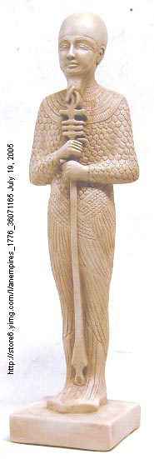

Atum the Creator (southern Egypt)
In the beginning there was only the swirling watery chaos, called Nu. Out of these chaotic waters rose Atum, the sun god of the city of Heliopolis. It is believed that he created himself, using his thoughts and will. In the watery chaos, Atum found no place on which to stand. In the place where he first appeared, he created a hill. This hill was said to be the spot on which the temple of Heliopolis was built. Other interpretations find that Atum was the hill. In this interpretation Atum may represent the fertile, life giving hills left behind by the receding waters of the Nile's annual flood. As early as the Fifth-Dynasty, we find Atum identified with the sun god Ra. By this time his emergence on the primeval hill can be interpreted as the coming of light into the darkness of Nu. As the god of the rising sun, his name is Khepri (http://members.aol.com/egyptart/crea.html#hepr, July 19, 2005).
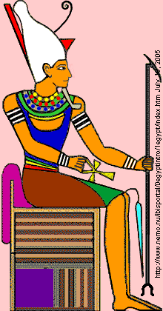
PHOTO LINK: ATUM 001 Drawing of Atum; http://www.nemo.nu/ibisportal/0egyptintro/1egypt/index.htm July 19, 2005

PHOTO LINK: ATUM 002 Statue of Atum; http://www.egyptianmyths.net/atum.htm July 20, 2005
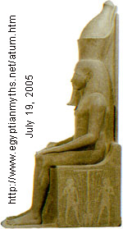

PHOTO LINK: RA 001 Drawing on papyrus of Ra; http://www.aldokkan.com/religion/ra.htm ; July 20, 2005
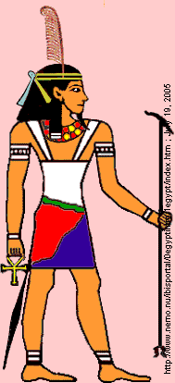
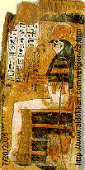
His next act was to create more gods. Because he was all alone in the world, without a mate, he made a union with his shadow through masturbation. This unusual way of procreating offspring was not considered strange to the Egyptians. We find Atum regarded as a bisexual god and was sometimes called the “Great He-She”, or “the complete one”. The Egyptians were thus able to present Atum as the one and only creative force in the universe. Originally, he was a serpent in Nun and will return to that form at the end of time. However, Atum was depicted in art as a man wearing the Double Crown of Upper and Lower Egypt. As such, he is the first living man god conceived of by the ancient Egyptians. Until then, their gods were all forms of animals. (http://members.aol.com/egyptart/crea.html#hepr, July 19, 2005; and http://www.egyptianmyths.net/atum.htm, July 20, 2005)
According to some texts the birth of Atum's children took place on the primeval hill. In other texts, Atum stayed in the waters of Nu to create his son and daughter. He gave birth to his son by spitting him out. His daughter he vomited. Shu represented the air and Tefnut was a goddess of moisture (http://members.aol.com/egyptart/crea.html#hepr, July 19, 2005).
PHOTO LINK: SHU 001 Drawing of standing Shu;
http://www.nemo.nu/ibisportal/0egyptintro/1egypt/index.htm ; July 19, 2005 (RIGHT)

PHOTO LINK: SHU 002 Drawing of sitting Shu; http://www.nemo.nu/ibisportal/0egyptintro/1egypt/index.htm ; July 19, 2005
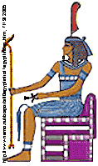
PHOTO LINK: SHU 003 Ivory carving Shu holding up sky as head rest for Tutankhamun; Rigby, 2005; http://www.touregypt.net/featurestories/shu.htm ; July 20, 2005

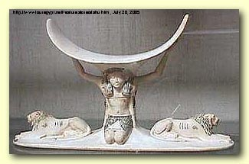

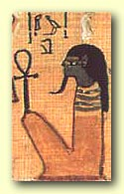
PHOTO LINK: SHU 004 Drawing of papyrus, Book of the Dead; (source unknown)(BELOW RIGHT)

PHOTO LINK: TEFNUT 001 Drawing of Tefnut;
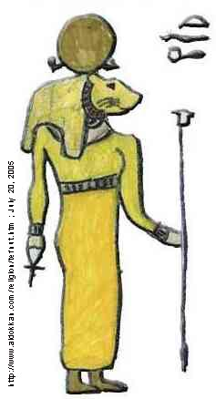
http://www.aldokkan.com/religion/tefnut.htm ; July 20, 2005

Shu and Tefnut continued the act of creation by establishing a social order. To this order Shu contributed the 'principles of Life' while Tefnut contributed the 'principles of order (http://members.aol.com/egyptart/crea.html#hepr, July 19, 2005).
After some time Shu and Tefnut became separated from their father and lost in the watery chaos of Nu. Atum, who had only one eye, which was removable. This was called the Udjat eye. Atum removed the eye and sent it in search of his children. In time they returned with the eye. At this reunion Atum wept tears joy, where these tears hit the ground, men grew. Now Atum was ready to create the world. So Shu and Tefnut became the parents of Geb, the earth and Nut, the sky. Geb and Nut gave birth to Osiris and Isis, Seth, Nephthys (http://members.aol.com/egyptart/crea.html#hepr, July 19, 2005).
PHOTO LINK: GEB 001 Drawing of Geb and Nut; http://www.aldokkan.com/religion/geb.htm ; July 20, 2005

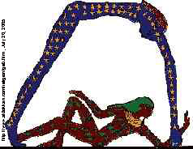
PHOTO LINK: OSIRIS 003 Painting of Osiris; http://www.fileane.com/photodenderah/denderahphotos2/11osirisvert.jpg ; Feb. 18, 2006
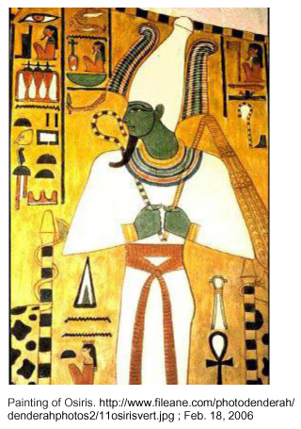

PHOTO LINK: ISIS 001 Drawing of Isis ;http://www.aldokkan.com/religion/isis.htm ; July 20, 2005; (Offspring of Geb and Nut, siblings were Osiris, Iseth and Nephthys)

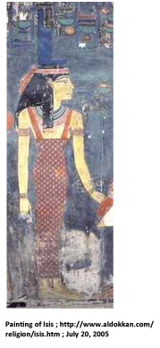

PHOTO LINK: SETH 001 Statue of Seth, Jackal head god http://www.aldokkan.com/religion/seth.htm ; July 20, 2005;
(Offspring of Geb and Nut, siblings were Osiris, Isis, and Nephthys)

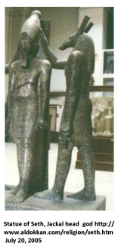

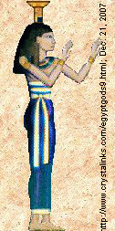
PHOTO LINK: NEPHTHYS 001 Drawing of Nephthys standing; http://www.crystalinks.com/egyptgods9.html; Dec. 21, 2007; (Offspring of Geb and Nut, siblings were Osiris, Isis, and Seth)

PHOTO LINK: NEPHTHYS 002 Drawing of Nephthys sitting (unknown source) (Offspring of Geb and Nut, siblings were Osiris, Isis, and Seth)

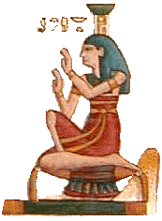

PHOTO LINK: NEPHYTHYS 002 Statue; http://en.wikipedia.org/wiki/Image:Nephthys_N4051_mp3h8832.jpg, Dec. 21, 2007; (Offspring of Geb and Nut, siblings were Osiris, Isis, and Seth)
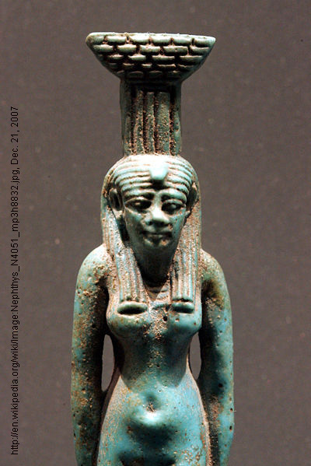

Khepri the Creator God (southern Egypt)
In one Egyptian creation myth, the sun god Ra takes the form of Khepri (also Khepra) , the scarab god who was usually credited as the great creative force of the universe. Khepri tells us,"Heaven and earth did not exist. And the things of the earth did not yet exist. I raised them out of Nu, from their stagnant state. I have made things out of that which I have already made, and they came from my mouth." It seems that Khepri is telling us that in the beginning there is nothing. He made the watery abyss known as Nu, from which he later draws the materials needed for the creation of everything. (http://members.aol.com/egyptart/crea.html#hepr, July 19, 2005).
PHOTO LINK: KHEPRI 001 Drawing; (source unknown)

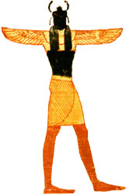
PHOTO LINK: KHEPRI 002 Khepri scarab sculpture; 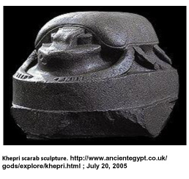

PHOTO LINK: KHEPRI 004 Tomb Painting of Khepri; http://www.crystalinks.com/egyptgods6.html; Dec. 21, 2007
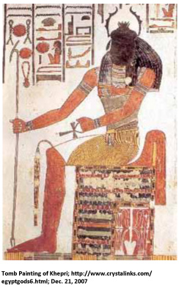
Khepri goes on to say, "I found no place to stand. I cast a spell with my own heart to lay a foundation in Maat. I made everything . I was alone. I had not yet breathed the god Shu, and I had not yet spit up the goddess Tefnut. I worked alone." We learn that by the use of magic Khepri creates land with its foundation in Maat (law, order, and stability). We also learn that from this foundation many things came into being. At this point in time Khepri is alone. The sun, which was called the eye of Nu, was hidden by the children of Nu. It was a long time before these two deities, Shu and Tefnut were raised out of the watery chaos of their father, Nu. They brought with them their fathers eye, the sun. Khepri then wept profusely, and from his tears sprang men and women. The gods then made another eye, which probably represents the moon. After this Khepri created plants and herbs, animals, reptiles and crawling things. In the mean time Shu and Tefnut gave birth to Geb and Nut, who in turn gave birth to Osiris and Isis, Seth, Nephthys (http://members.aol.com/egyptart/crea.html#hepr, July 19, 2005).

Creation Myth of Northern Egypt
At first there was only Nun, the primal ocean of chaos that contained the beginnings of everything to come. From these waters came Ra who, by himself, gave birth to Shu and Tefnut. Shu, the god of air, and Tefnut, the goddess of moisture gave birth to Geb and Nut, the earth god and the sky goddess. And so the physical universe was created. Men were created from Ra's tears. They proved to be ungrateful so Ra, and a council of gods, decided they should be destroyed. Ra created Sekhmet to do the job (http://www.aldokkan.com/religion/creation.htm ; July 19, 2005)
PHOTO LINK: SEKHMET 001 Painting of Sekhmet; http://www.tattooheaven.com/Sekhmet.html ; July 20, 2005 (LEFT)

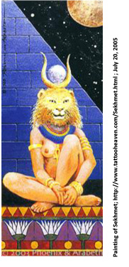
PHOTO LINK: SEKHMET 002 Statue of Sekhmet; Seawright, 2001; http://www.thekeep.org/~kunoichi/kunoichi/themestream/sekhmet.html ; July 20, 2005 (BELOW RIGHT)
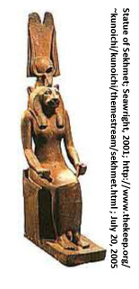
She was very efficient and slaughtered all but a few humans, when Ra relented and tricked her into stopping. Thus was the present world created. Against Ra's orders, Geb and Nut married. Ra was incensed and ordered Shu to separate them, which he did. But Nut was already pregnant, although unable to give birth as Ra had decreed she could not give birth in any month of any year. Thoth, the god of learning, decided to help her and gambling with the moon for extra light, was able to add five extra days to the 360-day calendar. On those five days Nut gave birth to Osiris, Horus the Elder, Set (Seth), Isis, and Nephthys successively. Osiris became the symbol of good, while Set became the symbol of evil. And thus the two poles of morality were fixed once and for all (http://www.aldokkan.com/religion/creation.htm ; July 19, 2005)

Comparison of Hebrew and Egyptian creation stories
The Egyptian creation stories, while clearly fantastical and mythological – they were never intended to be understood as factual historical accounts -- they do have some elements with parallels to Genesis:
Egyptian Myth | Biblical Parallel | Biblical Text
Ptah creates by his spoken word | Yahweh creates by spoken word “And God said let there be…” | Gen. 1
Created things come out of Kephri’s mouth | Yahweh creates by spoken word “And God said let there be…” | Gen. 1
There is a primordial nothing-ness (Chaos) | “The earth was without form and void” | Gen 1:2
There is a primordial ocean | “Darkness was upon the face of the deep and the Sprit of God hovered over the waters” | Gen 1:2-4
Sun and Moon created as chronometers | “Let there be lights in the expanse of the sky to separate the day from the night, and let them serve as signs to mark seasons and days and years…God made two great lights…” | Gen 1:14-15
The authors and editors of the Genesis tradition were knowledgeable of the Egyptian myths and used some of those motifs in the Hebrew Epic.

MESOPOTAMIAN CREATION TRADITIONS

Sumerian Dilmun Story and the Fall

The Sumerian myth of Enki and Ninhursag is a paradise story. In this story, the land of Dilmun is not a complete Paradise because, while it is “pure”, “clean”, “bright” and “a land for living” (it knows neither sickness nor death) it lacks fresh water. To correct this (mistake?) the Sumerian water god, Enki orders Utu (Assyrian Shamash), the sun god, to fill the earth with water brought up from within the earth. With the advent of water, Dilmun becomes a divine garden, green with fruit-laden fields and meadows. This hydrologic component of the Enki story has parallels with Genesis 2:6 where God causes a mist to rise from the ground to feed the rivers of the (then-rainless) world. The Great earth-mother Ninhursag caused eight divine plants to grow in the garden of Dilmun. Enki (usually a wise god) innocently eat them all. Ninhursag abandoned Enki, who is cursed, until at the intervention of a council of god, she relented. The cursing and abandonment is a motif similar to Adam and Eve eating the forbidden fruit (Tsumura, 1996 citing Kramer, 1963; Wood, M.L., 1979).

PHOTO LINK: ENKI 001 Enki walks out of water on to land. http://www.crystalinks.com/sumergods.html ; July 20, 2005
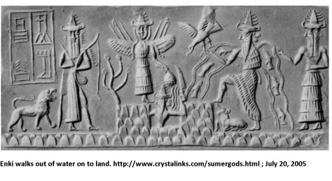

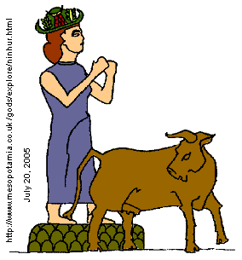
PHOTO LINK: NINHURSAG 001 Drawing of Ninhursag with cow; http://www.mesopotamia.co.uk /gods/explore/ninhur.html ; July 20, 2005

PHOTO LINK: HAMMURABI 001 Stela of Hammurabi before Shamash (Utu); Kitchen, 1995, BAR. 21:2:29. Photograph by Erich Lessing
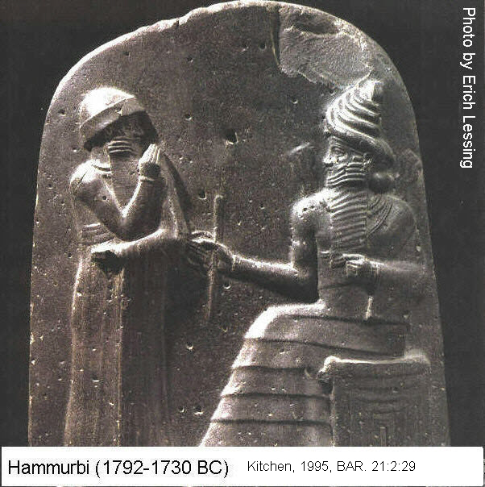99

In the Enki myth, one of Enki’s sick organs is his rib (Sumerian ti). The word ti can also mean “to make alive”. The goddess created for healing in the Sumerian pantheon was Nin-ti, “Lady of the Rib” or “Lady who makes live” (Tsumura, 1996 citing Kramer, 1963). The latter name is reminiscent of Genesis 3:19-20 where Eve (“Life”) is named the mother “of all who live”. So the writer of Genesis may have been using a pun to explain the unique relationship between men, woman and the creator God

Atrahasis (Atra-Hasis) Epic (1630 BC)

The Atrahasis “creation” epic of Babylon is a bilingual text which describes the creation of rivers and canals with no naming of the agent of creation. A translation of the Atrahasis Epic is reproduced in Appendix 10. Man is made to maintain the rivers and canals. "He built up a dam at the edge of the sea" [a dike to prevent sea floods], then drains a swamp. This Epic is not a creation story of the universe, but of some new land, city or empire. Following common cultural practice the patron god of area puts a "son" in charge as king. The Epic contains many crassly immoral sections (Livingston, 1979, 1992).

A synopsis of the Atrasis Epic was given by Hallo and Lawson (1997:450) and is reproduced below, The Epic…

explains the creation of man as intended to relieve the (lesser) deities of their toil, and the attempted destruction of humanity as divine response to the noise of the expanding human population which threatened the very rest that their creation had sought to provide for the gods. This destruction, decreed by Enlil, took several successive forms, culminating in the Deluge but, as in other flood-stories, its purpose was frustrated by the survival of the flood-hero, here called Atrahasis ("exceeding wise"), through the intervention of Ea, the divine friend of humanity. The problem of over-population is resolved by other means in a concluding aetiology. The composition is nearly complete in a Late Old Babylonian recension in three tablets (chapters), and is known as well in various fragmentary later recensions (Hallo and Larson, 1997:450)

A portion of this epic is given below:

"The gods took one hand in the other
They cast the lot, made division [among 2 deities of Sumerian-Akkadian pantheon]
Anu went up to heaven
Enlil...the earth to his subjects.
The lock, the bar of the sea
They gave to Enki, the prince"

PHOTO LINK: ENLIL 001 Standing figuine of Enlil Nippur/Nuffar. Early Dynastic II-III, c. 2550 BC. Limestone, h. 27.5 cm; (RIGHT)
http://www.minervamagazine.com/exclusives/iraq_05.php ; July 25, 2005
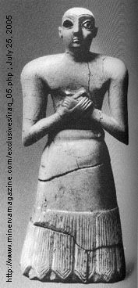

PHOTO LINK: ENLIL 002 White on black drawing; http://www.crystalinks.com/sumergods.html ; July 25, 2005
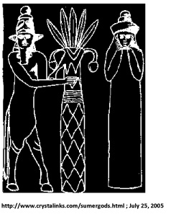

PHOTO LINK: ENKI 002 Cylindar seal impression of Enki = Ea with water flowing from his shoulder; http://www.ancientneareast.net/religion_mesopotamian/gods/enki_ea.html ; July 26, 2005

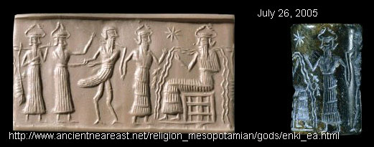

PHOTO LINK: ENKI AND NINHURSAG 001 Four fragments of reliefs of Enki and Ninhursag; http://www.gatewaystobabylon.com/gods/partnerships/enkininhur3.html ; July 26, 2005

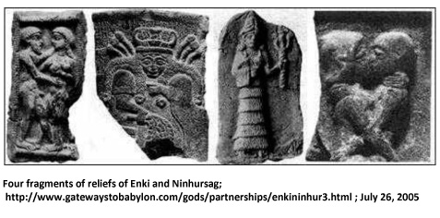

Anu was the god of heaven, Enlil the god of earth and Enki the ruling king

"When the gods, man-like
Bore the labor, carried the load
The gods' load was great
The toll grievous, the toll excessive
The great Annunnaku, the Seven
Were making the Igigu undertake the toil"

This section of the Epic teaches that the purpose of man is to free gods from their toil (digging the Tigrus and Euphrates rivers). The gods get a substitute workman: man

The gods instructed Mother-goddess (Ninhursag – Nintu -Ki) to:

"Create a human to bear the yoke, the task of Enlil,
Let man carry the load of the gods
Let them slaughter one god,
So that all gods may be purified by dipping.
With his flesh and blood
Let Nintu mix clay
So let gods and man be mingled
Together in the clay

After she had mixed the clay
She called the Anunna, the great gods
The Igigu, the great gods,
Spat upon the clay
Mami opened her mouth
And said to the great gods,
You commanded me a task
And I have finished it.
I have removed your toil
I have imposed your load on man."

PHOTO LINK: NINHURSAG 002 Sumarian female figuine and planet Venus. http://hum.lss.wisc.edu/~mfox/Religions%20of%20the%20ANE/Mesopotamia/inannavenus1.jpg ; July 25, 2005
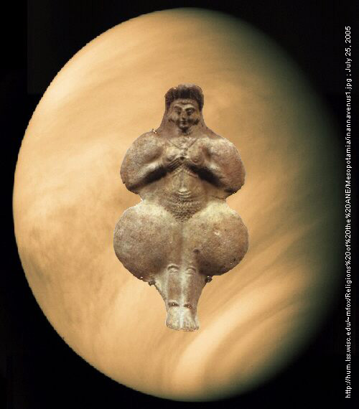

PHOTO LINK: NINHURSAG 003 Sumerian mother goddess. http://hum.lss.wisc.edu/~mfox/Religions%20of%20the%20ANE/Mesopotamia/MotherGd.jpg ; July 25, 2005
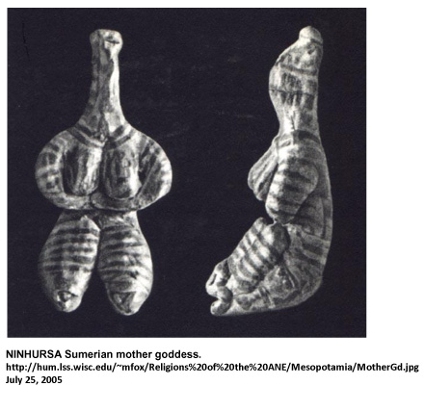

Enki the mother-goddess makes man from clay and flesh and blood of slain god We-ilu, "a god who has sense", so originated man's ability to reason. The use of clay as a primary ingredient to fashion man is similar to Genesis 2:7. But the “active” ingredient is different. In Genesis man “becomes a living soul” by God’s breath (wind), whereas the blood of We-ilu is the basis of man’s animation (and reason) in the Atarahis Epic. The purpose of the Atrahasis Epic was to justify a cast system with the king on top, functioning in the god's image. Priests set up the system and shared power.(Livingston 1979, 1992;Tsumara, 1996 citing Lambert and Millard, 1969).
More will be said about Atrahasis in my discussion of the Great Flood. The creation and flood sections of Atrahasis tell of three episodes of attempted “genocide” of mankind by the gods. First by plague, then by drought, and finally by flood. The Atrahasis Epic (111 vii 1) states:
In addition, let there be a third category among the peoples, Among the peoples women who bear and women who do not bear. Let there be among the peoples the Pashittu-demon to snatch the baby from the lap of her who bore it. Establish Ugbabtu-women, Entu-women, and Igisitu-women and let them be taboo and so stop childbirth.
Atrahasis is viewed as a story for providing a solution to overpopulation: urban birth control. That solution is compared to a Genesis solution for over-population that offers pastoral nomadic life and dispersal around the word (Tsumura, 1996c, citing Kikawada, 1975 and Kilmer; 1972). The over-population theory is rejected by some (Oden, 1981) and debated by others (Moran, 1987).

Comparison of Atrahasis and Hebrew Epics

Atrahasis | Bible | Reference
Man made to free gods of their labors | Man made to “work” [cultivate] and “keep” [take care of] the Garden that God planted, as a steward. | Gen. 2:15
Man made from clay mixed with slain god’s blood | Man made from dust. God breaths into his nostrils the breath of life | Gen. 2:7
Man is part physical part blood of an evil god | Man is part physical part spiritual. Thus mankind (as male and female) are the “image of god” | Gen. 1:26
Man inherently evil, created that way | Man “falls” from grace as a consequence of choice. Knows good and evil | Gen. 2:22
Justification of caste system with King at top as “son” of deity | Basis for social justice, mankind as willing steward of the Creation.
Control of urban over-population | Over-population controled by nomadic life and dispersal around the world. Mankind commanded to “be fruitful and multiply” | Gen. 9:1

Enuma Elish Creation Epic

The Enuma Elish (Enûma Eliš) was recited as part of the New Year Festival in Mesopotamia for nearly 2000 years (Livingston, 1992). A translation of the Enuma Elish Epic is reproduced in Appendix 11. The name is Acadian meaning “When Above”. The poem consists of 1,059 lines and is inscribed on seven tablets. Some scholars date the original composition to the early second millennium, during the Old Babylonian Period. Others date Enuma Elish to the time of Nebucadrezaar I at the end of the second millennium BC (Hurowitz, 2005:38, footnote 4, p. 52-53). The protagonist of the story is Tiamat. That word is linguistically similar to Hebrew T^{e}hôm, meaning chaos.

A synopsis of the Enuma Elish epic is found in Hurowitz (2005).

PHOTO LINK: ENUMA ELISH 001 Tablet. Livingston, 1990, ABR, 3:1:16. Photograph by British Museum
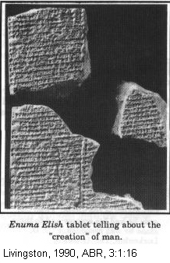

PHOTO LINK: ENUMA ELISH 003 Four piece reconstructed tablet, Ashmolean Museum, Oxford. Livingston, 2009, B&S, 22:2:37. Photograph by Ashmolean Museum, Oxford, England

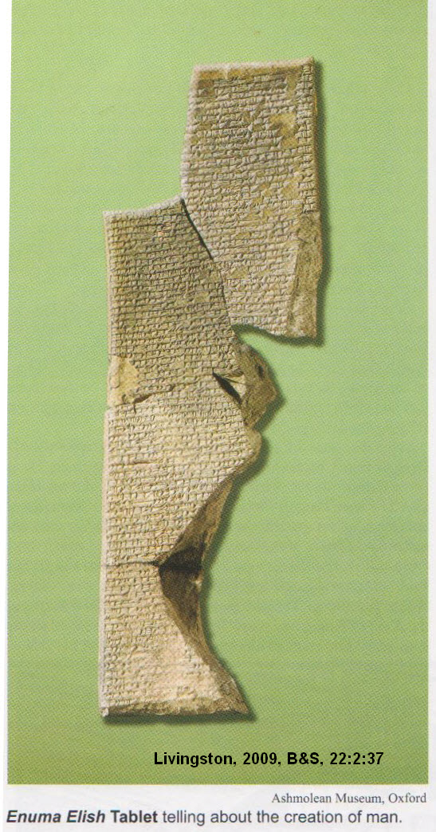

PHOTO LINK: ENUMA ELISH 002 Tablet No. 3. Hurowitz, 2005, BR, 21:1:39. Photograph by British Museum / The Image Works.
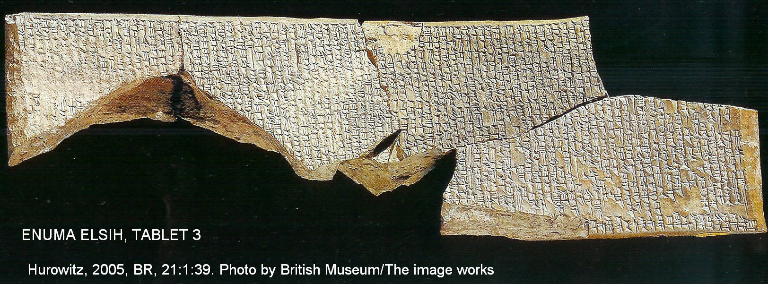

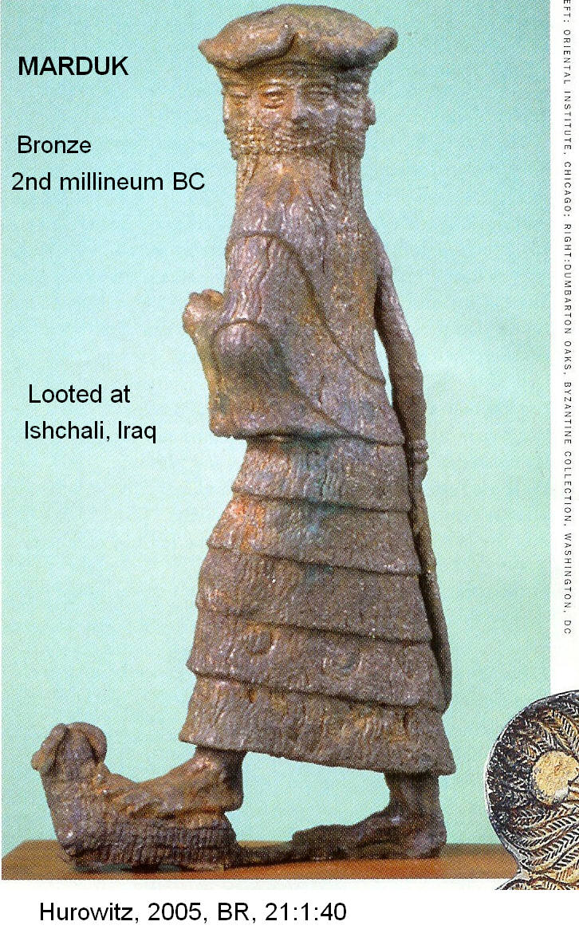
Tablet 1

As with Genesis 1:2, Enuma Elish opens with water chaos. There were two personified bodies of water: Tiamat (female sea water) and Apsû (male spring water). These entities were not gods themselves, but were proto-divine male and female figures that spent their time endlessly mingling their waters. This sexual activity lead to pregnancy of both partners and several gods were born. The grown gods were rowdy and partied at their home which was the watery realm of the body of Tiamat. This angered father Apsû who decided to kill all the gods and their offspring. The murders were planned with vizier Mummu. The plan became known and one of the younger gods, Ea, killed his great-great grandfather Apsû. Ea is the Acadian version of Sumerian Enki, god of waters. Ea removed the divine regalia of Apsû and used his body to construct his house. Ea and his spouse Damkina move into their new house and conceive Marduk (Hurowitz, 2004:38-39). Damkina is the Acadian version of Sumerian Ninhursag, the Great Earth Mother.

PHOTO LINK: MARDUK 001 Bronze figurine 4-faced Marduk from Ishchali, Iraq, 2nd millennium BC. Hurowitz, 2005, BR, 21:1:40. Photograph by Oaks Dumbarton, Byzantine Collection, Washington DC (ABOVE, RIGHT)

PHOTO LINK: TIAMAT 001 Drawing Marduk battling Tiamat ; http://www.gatewaystobabylon.com/gods/ladies/ladytiamat.html ; July 26, 2005

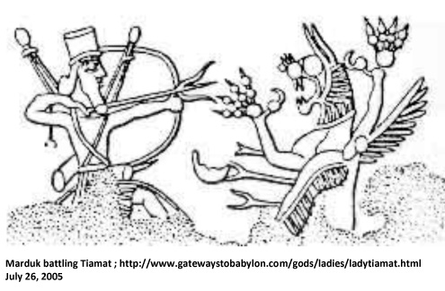

PHOTO LINK: TIAMAT 002 Color drawing of Tiamat ; http://www.mesopotamia.co.uk/gods/explore/tiamat.html# ; July 26, 2005

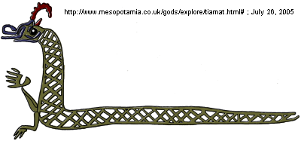

PHOTO LINK: APSU 001 Drawing of Apsu god of fresh water and Ea ;http://www.stenudd.com/myth/enumaelish/images/Ea-Apsu.jpg; April 15, 2010
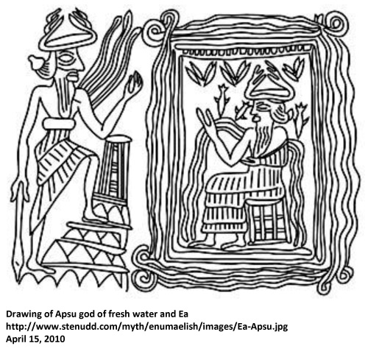

PHOTO LINK: APSU 002 Clay image of Apsu; http://www.nok-benin.co.uk/Imagenok/Gilamesh_spirit.jpg; April 15, 2010
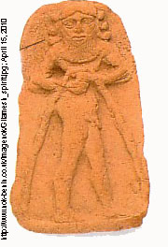

PHOTO LINK: EA 001 B&W drawing of Ea = Enki; http://www.balaams-ass.com/alhaj/ea.htm ; July 26, 2005

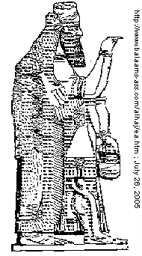

PHOTO LINK: EA 002 Modern color drawing of Ea ; http://www.mesopotamia.co.uk/gods/explore/ea.html# ; July 25, 2005
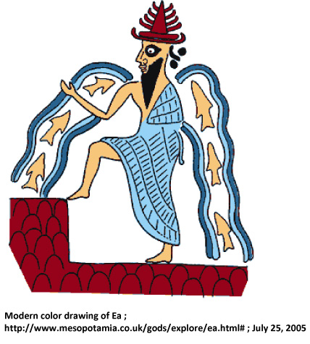

PHOTO LINK: EA 003 Cylinder seal of Ea in watery home of Apsu. http://www.crystalinks.com/sumergods.html ; July 26, 2005

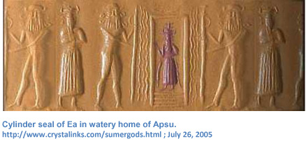

PHOTO LINK: ENKI 002 Cylinder seal impression of Enki = Ea with water flowing from shoulders

PHOTO LINK: MARDUK 002 Cylinder seal and silver chalice 'Ain Samiyah of Marduk and sea monster. Hurowitz, 2005, BR, 21:1:44. Photograph by Israel Museum, Jerusalem

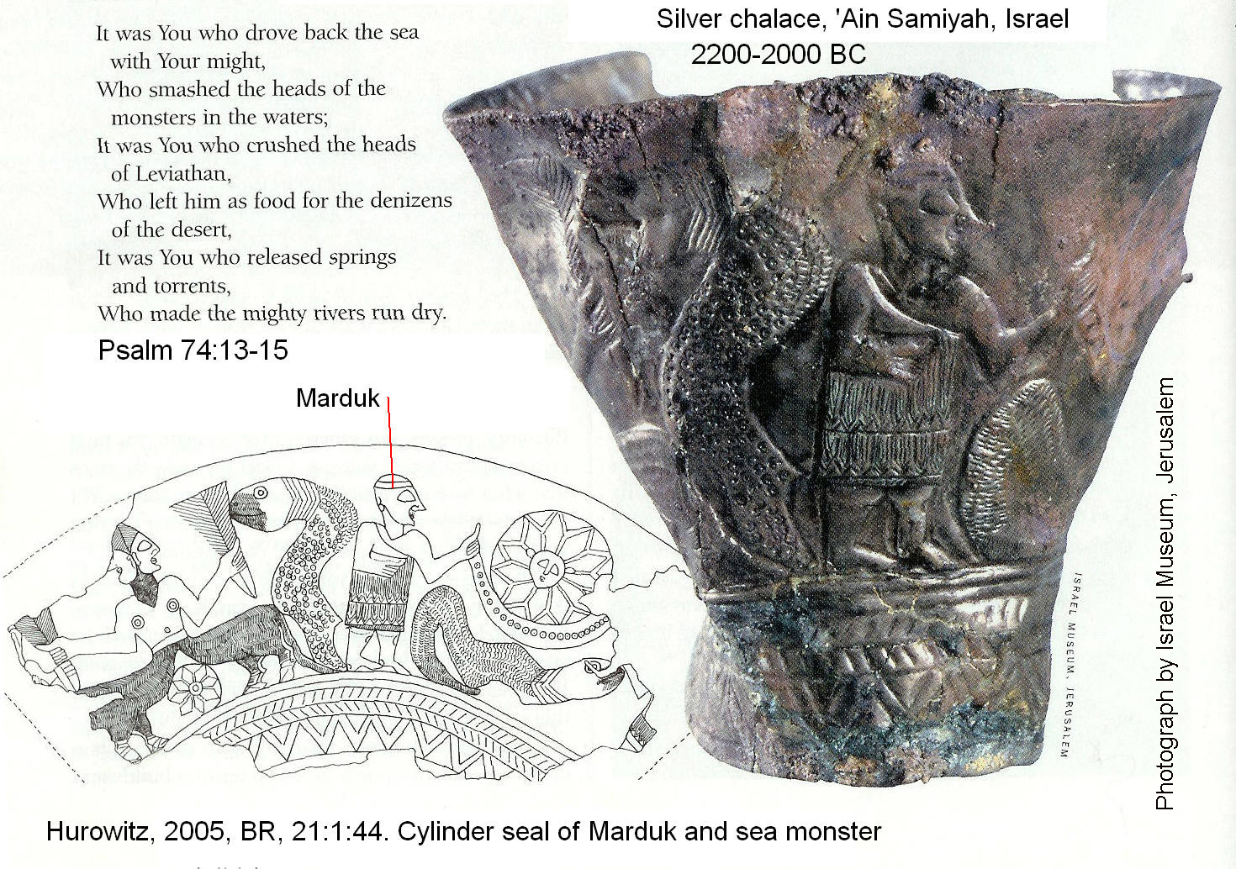

PHOTO LINK: MARDUK 003 Clay plaque 2nd millennium BC Khafaje, Iraq of Marduk slaying Tiamat. Hurowitz, 2005, BR, 21:1:44. Photograph by Iraq Museum, Bagdad / Scala / Art Resource, NY.

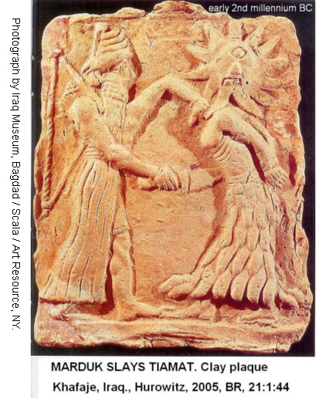
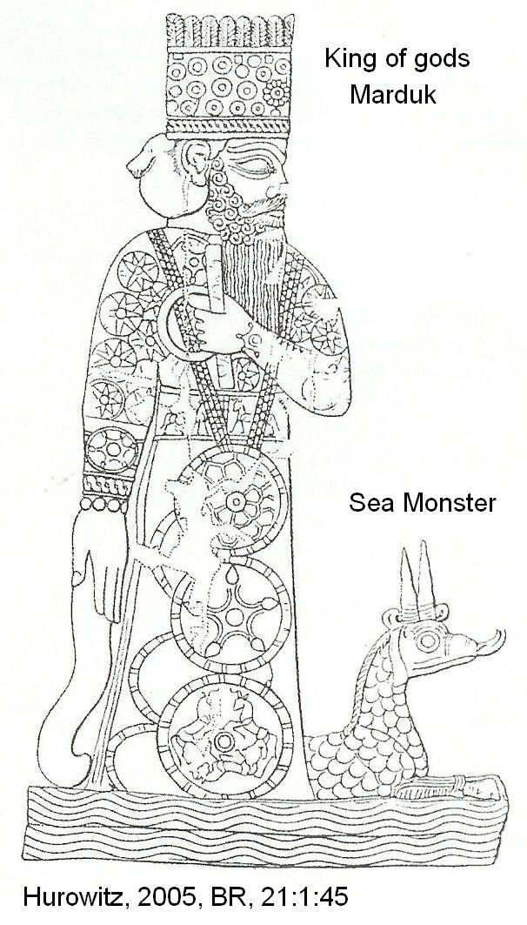
PHOTO LINK: MARDUK 004 Drawing of King and sea serpent. Hurowitz, 2005, BR, 21:1:45.

Marduk had four pairs of eyes and four pairs of ears. This motif is reflected in the four-faced creatures of Ezekiel 1:6. He had heightened attentiveness and peripheral vision. He was also boisterous and unruly. He enjoyed throwing dust into a set of four winds, the later a gift from grandfather Anum (the sky god). His actives also muddied the sea water of great-great-great grandmother Tiamat. This muddying was tolerated by Tiamat, but the gods within her were unnerved. Driven by guilt from not having intervened in the death of Apsû, the gods cajoled Tiamat and convinced her to take up arms against Marduk (Hurowitz, 2005:38-39).

Tiamat arranged for Ummu Huber (“Mother Noise”) to produce eleven raging, poisonous monsters. The head of this army of monsters was the god Kingu. (Hurowitz, 2004:38-39). He is Tiamat’s second consort (Her first bein Apsu, who was slain). Tiamat gave Kingu the Tablets of Destiny, which he wore as a breastplate and which gave him great power.

Tablet 2

The arrival of Kingu’s monster army made the younger gods afraid. They panicked and sought rescue from Ea. Having learned of Kingu’s attack, Ea enlisted the aid of his grandfather Anšar (deified sky and horizon) and father Anum (sun god, chief god of Sumerian pantheon). Despite reports that the situation for the young gods was dire, neither Anšar nor Anum came to rescue their offspring. So, in a twist of fate, the young gods turned to the ultimate source of all their woe, Marduk, for protection. As an opportunist, Marduk agreed to be their protector, and defeat Tiamat, if the gods accepted his authority over them (Hurowitz, 2005:39).

Tablet 3

In order to conclude the covenant with Marduk, an envoy named Gaga was sent to the parents of Anšar, Lahuma (“the hairy one”) and Iahämu (twin of Lahuma). All the gods gathered at a banquet. When inebriated, they ratified the Marduk agreement, and Marduk became the supreme god of the pantheon (Hurowitz, 2005:39).

Tablet 4

The portion of the Enuma Elish epic discussing the creation of the world is found on tablets 4 and 5. At the enthronement celebration, the gods asked Marduk to prove his power, and promise to defeat Tiamat, by making a constellation vanish and reappear. He performed this miracle immediately. With a parallelism to Yahweh’s speaking creation into existence in Genesis 1, Marduk spoke and the constellations disappeared and then reappeared. The gods then gave Marduk royal regalia and weapons, and sent him on his way to meet Tiamat. Stephanie Dalley’s translation of Tablets 4 and 5 (Hurowitz, 2005:39) is as follows:

The Lord [Marduk] trampled the lower part of Tiamat,
With his unsparing mace smashed her skull,
Severed the arteries of her blood,
And made the North Wind carry it off as good news.
His fathers saw it and were jubilant: they rejoiced,
Arranged to greet him with presents, greetings gifts.
The Lord rested, and inspected her corpse.
He divided the monstrous shape and created marvels (from it)
He sliced her in half like a fish for drying:
Half of her he put up to roof the sky,
Drew a bolt across and made a guard hold it.
Her waters he arranged so that they could not escape.
He crossed the heavens and sought out a shrine;
He leveled Apsü, dwelling of Nudimmud.
The Lord measured the dimensions of Apsü
And the large temple (Eshgalla), which he built in its image, was Esharra in the great shrine Esharra, which he had created as the sky, He founded cult centers for Ann, Ellil and Ea

In the duel with Tiamat, Maduk is armed with bow and arrow, mace, net, four winds (possibly Amun’s gifts), and seven special winds designed to enter Tiamat and give her gas. Marduk went to battle in a chariot drawn by the four winds, which could move, apparently, in any direction. As armor and headgear, Marduk had a divine radiance and in case of injury, had an incantation in his mouth. In his hand carried a plant to ward off poison. Thus equipped, Marduk engages Tiamat, first in a war of words and then in open battle. During the battle, Marduk opens his net to capture Tiamat when he broke wind in her face. The anal gas entered Tiamat causing her to have stomach cramps and constipation. In this condition, Marduk fired his arrows into Tiamat and split open her belly.

When Tiamat died, the gods supporting her went into hiding, and the eleven monsters of Kingu were captured and lead away. Finally, Kingu was captured along with the tablets of destiny entrusted to him by Tiamat before the battle. With the war over, Marduk returned to Tiamat’s body. He smashed her head open with the mace and had the wind blow away her blood. The heavens were made in the upper half of this blown-away blood. There is a parallelism in this part of the Epic with the separation of waters of the firmament in Genesis 1:6. The heavenly dwelling place was called Ešarra as the mirror-image of Ea’s dwelling place in the subterranean realm of Apsû (Hurowitz, 2005:39).

Tablet 5

The translation of Tablet 5 by Stephanie Dalley cited in Hurowitz (2005:39) is as follows:

He fashioned stands for the great gods.
As for the stars, he set up constellations
Corresponding to them.
He designated the year and marked out its divisions,
Apportioned three stars each to the twelve months.
When he had made plans of the days of the year,
He founded the stand of Neberu to mark out their courses,
So that none of them could go wrong or stray.
He fixed the stand of Ellil and Ea together with it.
Opened up gates in both ribs,
Made strong bolts to left and right.
With her liver he located the Zenith;
He made the crescent moon appear, entrusted night (to it)
And designated it the jewel of night to mark out the days.
Go forth every month without fail in a corona,
At the beginning of the month, to glow over the land.
He [Marduk] put into groups and made clouds scud. Raising winds, making rain, making fog billow, by collecting her poison,
He assigned for himself and let his own hand control it.
He placed her head, heaped up
Opened up springs: water gushed out.
He opened the Euphrates and the Tigris from her eyes,
Closed her nostrils, [ 1,
He piled up clear-cut mountains from her udder,
Bred waterholes to drain off the catch~water
He laid her tail across, tied it fast as the cosmic bond (?),
And [ ] the Apsu beneath his feet.
He set her thigh to make fast he sky
With half her to make fast the sky
With half of her he made a roof: he fixed the earth
He [ ] the work, made the insides of Tiamat surge,
Spread his net, made it extend completely,
He …. [ ] heaven and earth …

At this point, the epic describes the ordering of the known world. Working more or less from head to foot, Marduk installed in the appropriate parts of Tiamat’s corps, in the order listed in the following table. There are several parallels or tangential ideas with Genesis:

Enuma Elish | Bible | Verse
heavenly bodies in the heavens | Let there be lights in the expanse of the sky to separate the day from the night…and God made two great lights…He also made the stars | Gen 1:14-16
meteorological phenomena in atmosphere
mountains | Let the water under the sky be gathered to one place, and let dry ground appear | Gen. 1:9
subterranean waters | Let there be an expanse between the waters to separate water from water | Gen 1:6
Euphrates and Tigris rivers | The name of the third river is the Tigris…the fourth river is the Euphrates | Gen 2:14
bond of heaven and earth
netherworld
oceans in and on earth | God called the dry ground "land," and the gathered waters he called "seas." | Gen. 1:10

After this “creation”, Marduk gave trophies to his supporters and displayed the vanquished enemies. He put on royal garments, and the gods declared him their king. Marduk then proposed to build Babylon as a logging place for the gods who traveled between the subterranean water world of Apsû and the heavenly world of Ešarra. Marduk’s proposal is eagerly accepted by the gods. This section of Enuma Elish has a parallel with Jacob’s dream of Genesis 28:10-2. In that passage a stairway linking heaven and earth is described. The cosmology of Enuma Elish, Tablet 5, is also parallel to that described in Exodus 20:4.

Enuma Elish | Exodus 20:4
 | You shall not make for yourself a graven image of anything
Heaven (Ešarra) above | That is in the heavens above
Ziggurat of Babylon beneath | Or on the earth beneath
Subterranean waters (Apsû) under the earth | Or in the waters under the earth

Tablets 6 and 7

Before establishing Babylon as divine hotel for the traveling gods, Marduk decided to relieve the gods of their work by creating man. This task fell to Marduk’s father, Ea. Man is fashioned by Ea from the blood of Tiamat’s general, Kingu who was executed after Tiamat’s defeat. After man was created, the gods built Babylon. Of special interest was the main temple Esagila. The gods worked for a year to mold bricks for this temple. At the completion of the temple-stairway connecting Apsû and Ešarra, another banquet was celebrated. During this banquet reaffirming the Marduk covenant there is a proclamation of his 50 names. Each name had an intricate explanation. (Note:Marduk’s naming exercise has parallel with Adam’s naming of the animals in Gen. 1:19). The poem concludes:

He [wo]rd of Marduk who created the Igigi-gods
[His/Its] let them [ ], his name let them invoke
Let them sound abroad the song of Marduk
How he defeated Tiamat and took kingship

Enuma Elish is a blend of Creation Myth and Sacred Marriage story. In the story Marduk (previously a minor god named Enlil, later Asshur in the Assyrian version) became the chief god and creator of whole county. The purpose of Epic/Myth seems to be to explain how, by sexual intercourse between gods (represented by king and queen) prosperity (crops, political system etc.) was assured. The tradition lays foundation for the following world view: 1) men must be servants of the gods, 2) man's natural wickedness is due to his creation from the blood of the evil god Kingu, 3) the cosmic struggle never really ended; forces of chaos are always ready to challenge the established order of the gods (Livingston, 1992).

The Enuma Elish is not a “primary” creation myth, that is to say it really does not explain the origin of the cosmos. Rather it is a literary monument to Marduk, and explains why he took chief position in Babylonian pantheon by his victory over Tiamat. The story also justifies Babylonia (Marduk's city) as supreme. We see than in the Enuma Elish a political as well as religious treatise (Livingston, 1992).

The Enuma Elish has several parallels (or tangentialisms) to Genesis:

Creation of the firmament and earth

PHOTO LINK: ASTRONOMY 001 Large Megallanic Cloud; http://www.seds.org/messier/xtra/ngc/lmc.html ; July 31, 2005

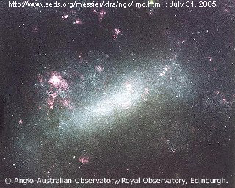

PHOTO LINK: EARTH 002 NASA photo of earth; 33http://www.dvidshub.net/image/851724/planet-earth#.Um3THvmTxAU
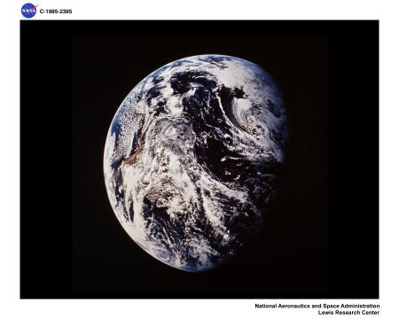

Part of the Enuma Elish states:

"The Lord (Marduk) trod upon the hinder part of Tiamat
And with unsparing club he split her skull
He cut the arteries of her blood
And caused the north wind to carry it to out-of-the-way places
When his fathers saw this, they were glad and rejoiced
And sent him dues and greeting-gifts
The Lord rested, examining her dead body,
To divide the abortion and to create ingenious things therewith
He split her open like a mussel into two;
Half of her he sat in place and formed the sky as a roof,
The Lord measured the dimensions of Apsu,
And the great structure, its counterpart, he established,
Namely Esharra [the earth] (compare Canaanite Asherah)
The great structure Esharra which he made as a canopy"

From the forgoing it can be observed that Enuma Elish is not a serious explanation of origins. Rather it gives glory to Marduk for an already existing socio-political order (Livingston, 1992).

Creation of Luminaries

PHOTO LINK: SUN 001; http://nssdc.gsfc.nasa.gov/image/solar/eit_sl_304.jpg ; July 31, 2005 ; He II (304 Å). Taken at 19:19 UT, 28 February 2000.

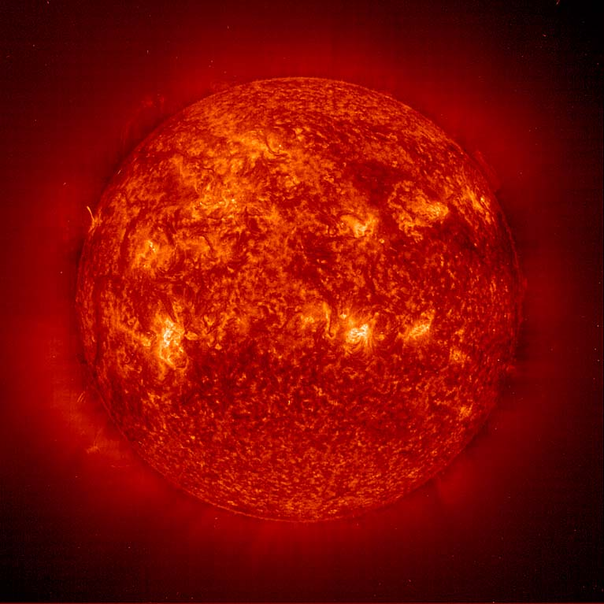
PHOTO LINK: MOON 001; http://nssdc.gsfc.nasa.gov/image/planetary/moon/gal_moon_color.jpg ; July 31, 2005 ; Three-filter color image of the Moon.

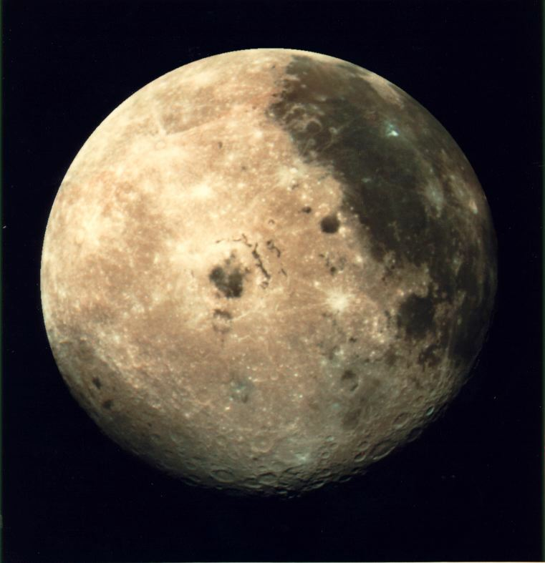

PHOTO LINK: STARS 001 Globular cluster of stars ; http://www.nasa.gov/images/content/2611main_MM_Image_Feature_27_rs4.jpg ; July 31, 200

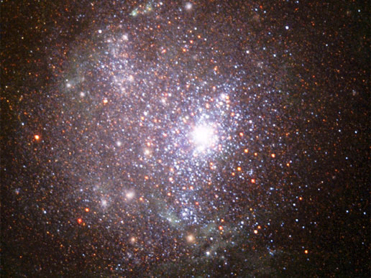

The Enuma Elish has this to say about creation of starts, sun and moon:

"He [Marduk?] created stations for the great gods;
The stars their likenesses, the signs of the zodiac, he set up
He determined the year, defined the divisions;
For each of the twelve months he set up three constellations"

Rather than functioning as revelation of an aspect of creation, Enuma Elish gives support to an already-existing astrological system, a critical part of the local religio-political establishment (Livingston, 1992).

PHOTO LINK: CONSTELLATION ORION 001; Photo of stars with constellation and star names; http://www.astromax.org/con-page/images/orion852.jpg; Oct. 7, 2010
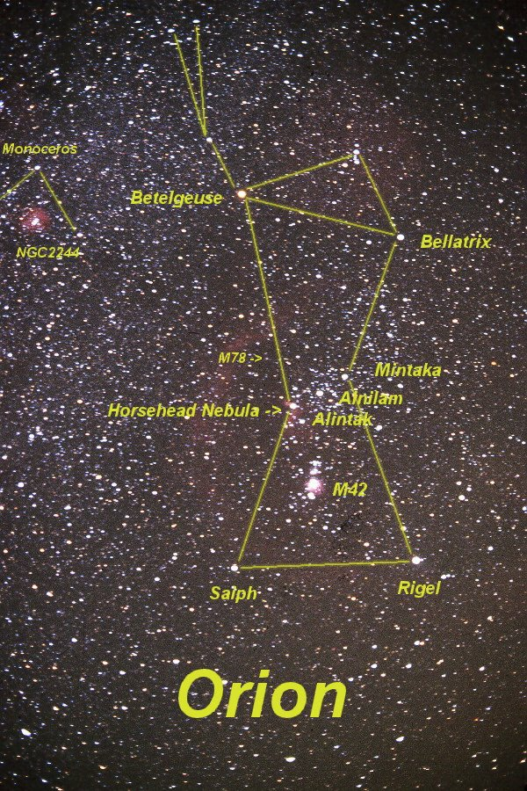

Creation of Man

As we saw in the quotation above, man is created to serve and feed the gods.

The "Rest" after Creation

A significant difference between the Enuma Elish and Jewish creation accounts is that, in Enuma Elish and other Mesopotamian creation stories, there is no Sabbath tradition outside Israel. The closest approximation would be 1/4 of a lunar month (28 days). The Babylonian word sabbatu is a monthly or by-monthly (based on a 15-day), lunar-based chronology system(Livingston, 1992)..

The relevant portion of the Enuma Elish reads:

"Now, O Lord, who has established our freedom from compulsory service;
What shall be the sign of our gratitude?;
Come, let us make something whose name shall be called "sanctuary";
It shall be a dwelling for our rest at night;
Come let us repose therein!;
There let us erect a throne dais [platform], a seat with a back support!;
On the day that we arrive [for the New Year's festival], we will repose in it."

Who will repose? The King, of course! This is political propaganda in religious cloak. The Enuma Elish “rest” is a rest of triumph, not a Sabbath rest from Creation (Livingston, 1992).

PHOTO LINK: CREATION MYTHS 001 Comparison chart. Livingston, 1992, ABR, 5:3:86.

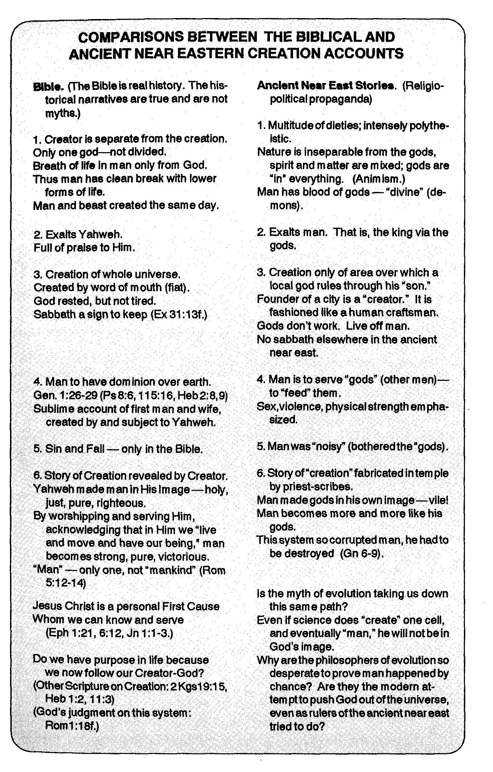

Genesis 1 is about the Creation, and Enuma Elish focuses on the creator-god Marduk. This difference is observed in the blessings at the end of the stories. In Genesis Yahweh blesses the Sabbath, his final creation. In Enuma Elish, Marduk is blessed by the subjugated gods. The stories also differ in tone, structure and style. Genesis has a tightly structured form, uses simple language, repetition, formulaic language and commandment-filling sequences. Enuma Elish is a dramatic narrative poem with cycles of tension and relief. It is also contains a comic hero motif and includes elements that are quite frivolous. Modern scholars sometimes take Enuma Elish more seriously than its contemporaries ever intended (Hurowitz, 2005:44).

When the entire context of the poem is considered, parallels to the Biblical account are not as close as some scholars suppose. Hurowitz (2005:52) observes:

In light of all this and more, it is impossible to accept today in a simplistic manner the claims of Smith or Delitzsch that the biblical authors took the Babylonian Story of Creation, that is, Enüma Elish, and simply applied it to YHWH, God of Israel. The specific parallels are fewer than originally thought, and even the best ones are not entirely certain. However, both the Bible and Enüma Elish are products of the ancient Near East, each accepting common beliefs and knowledge, and each developing them in their own unique manner. They should be studied by modern scholars as mutually illuminating not only for what they hold in common but for the unique ways in which each presents their common heritage.

Harab Myth

The Sumerian Harab myth I (also called the Theogony of Dunnum or Dunnu) is about a re-creation from a “wasteland” (harab) and is similar to the description in Genesis 2:4 of earth as a place where “no plant or herb, nor rain, nor anyone to till the ground”. As in Genesis, there is concern about the need for having someone till or care for the earth. In the Harab story, seawater (Tamtu, Acadian Tiamat) is created first and then the river god, Idu comes along in the second generation as Tamtu’s daughter. These parallel the Genesis 2 account of water as a first-created component of the new earth. Other similarities include a similar sequence of farming and shepherding, and in both tales, the first city is built between creation and the flood (see Genesis 4:17; Tsumaru, 1996).

A major difference between Harab and Genesis 2-3 is that in the Bible, Yahweh acts alone, without a female consort (That is so in the received text. Orthodox editors may have removed all traces of her between the time of Genesis and the time of Exile). The “Tree of Life” and the “Tree of the Knowledge of Good and Evil” of Genesis are grossly parallel with the depiction of Asherah “Trees” in Mesopotamian art.

PHOTO LINK: ASHERAH 001 Pharaoh Tuthmosis III life-giving tree. Coogan, 1995, BAR, 21:3:42. Photograph by Louvre Museum. Annotations added.
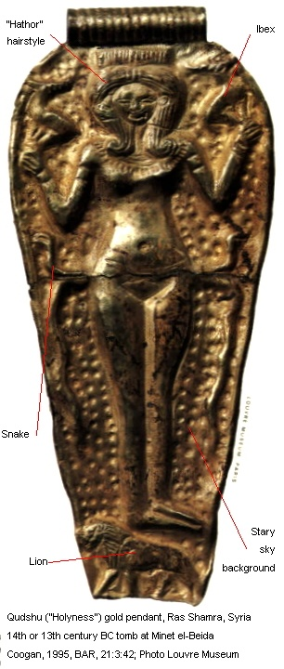
PHOTO LINK: ASHERAH 004 Other pendents with pubic triangles and trees of life. Hestrin, 1991, BAR, 17:5:57. Drawings by Israel Exploration Journal / Vol 37, No. 4, 1987

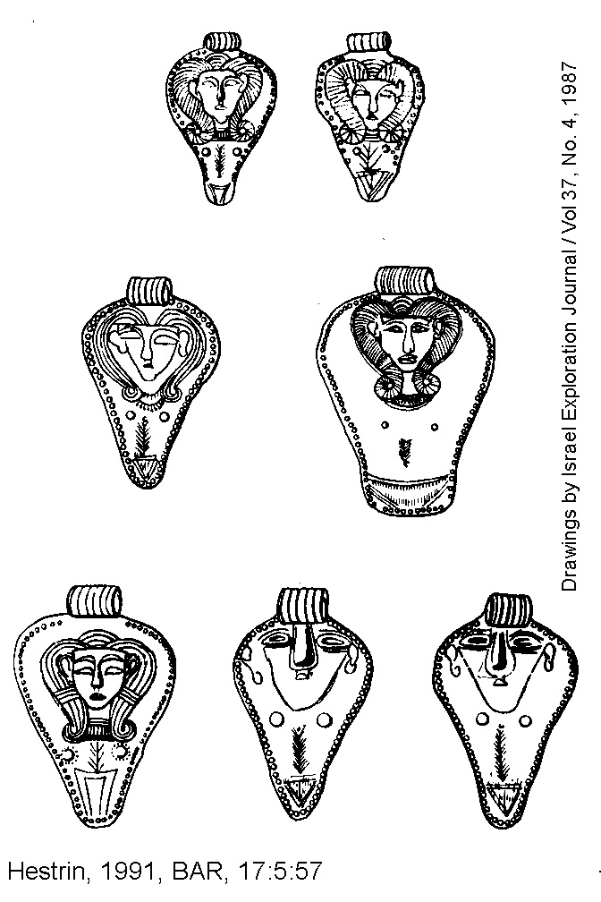

PHOTO LINK: ASHERAH 005 Ibex and tree of life drawing. Photograph by Israel Exploration Journal / 37:4

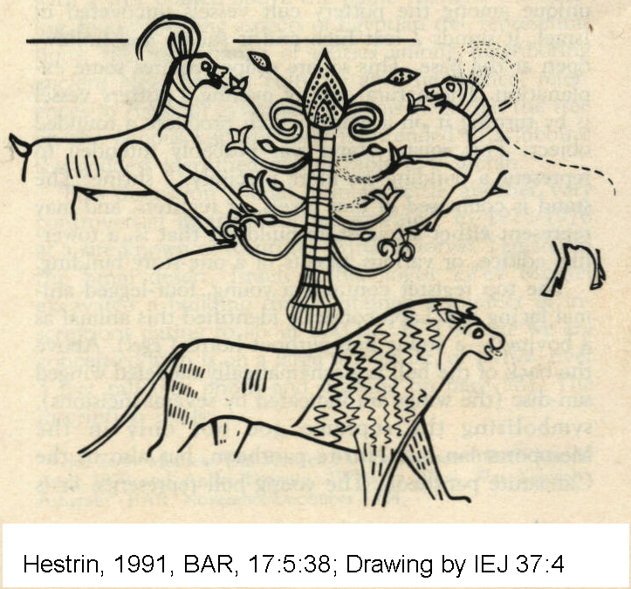
PHOTO LINK: ASHERAH 009 Four Asherah figures, Israelite, emphasizing breasts. Shanks and Cross, 1996, BAR, 22:5:36. Photograph by Zev Radovan.
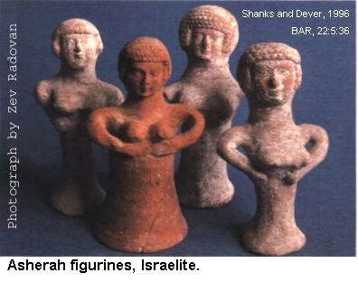

Primordial Battles with the Sea and Sea Monsters
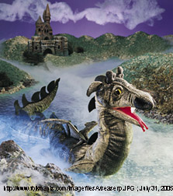
Vignettes of Mesopotamian creation stories involving the sea and sea monsters are found in some Old Testament passages. These include Job 9:13, Psalm 89:10-11, and Psalm 74:13-15. In Mesopotamian creation myths, the sea serpent was a personification of Chaos, whom the chief god defeats as the first act of creation (Hurowitz, 2005:44-45).

PHOTO LINK: SEA SERPENT 001 Painting; http://www.folkmanis.com/imagefilesA/ seaserp.JPG ; July 31, 2005

PHOTO LINK: SEA SERPENT 002 Drawing of sea serpent attacking ship ; http://www.unmuseum.org/seasnake.htm ; July 31, 2005

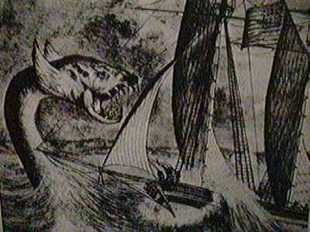

Job 9:3; “God never goes back on his anger, Rahab’s (Chaos’) minions still lie at his feet”

Psalm 89:10-11; “You split Rahab (Chaos) in two like a carcass and scattered your enemies with your mighty arm” (parallelism with Marduk’s splitting open Tiamat in the Enüma Elish epic)

Psalm 74:13:14; “It was You who drove back the sea with Your might, who smashed the heads of monsters in the waters; It was You who crushed the heads of Leviathan” (parallelism with Marduk’s defeat of the 11 sea monsters of Tiamat in the Enüma Elish epic and the Sumerian story of Nintura’s slaying of the 7-headed monster).

PHOTO LINK: NINTURA 001 Shell inlay 2800-2600 BC Nintura slays 7-headed monster. Hurowitz, 2005, BR, 21:2:46. Photograph by M. Amar and M. Greyevsky, Bible Lands Museum

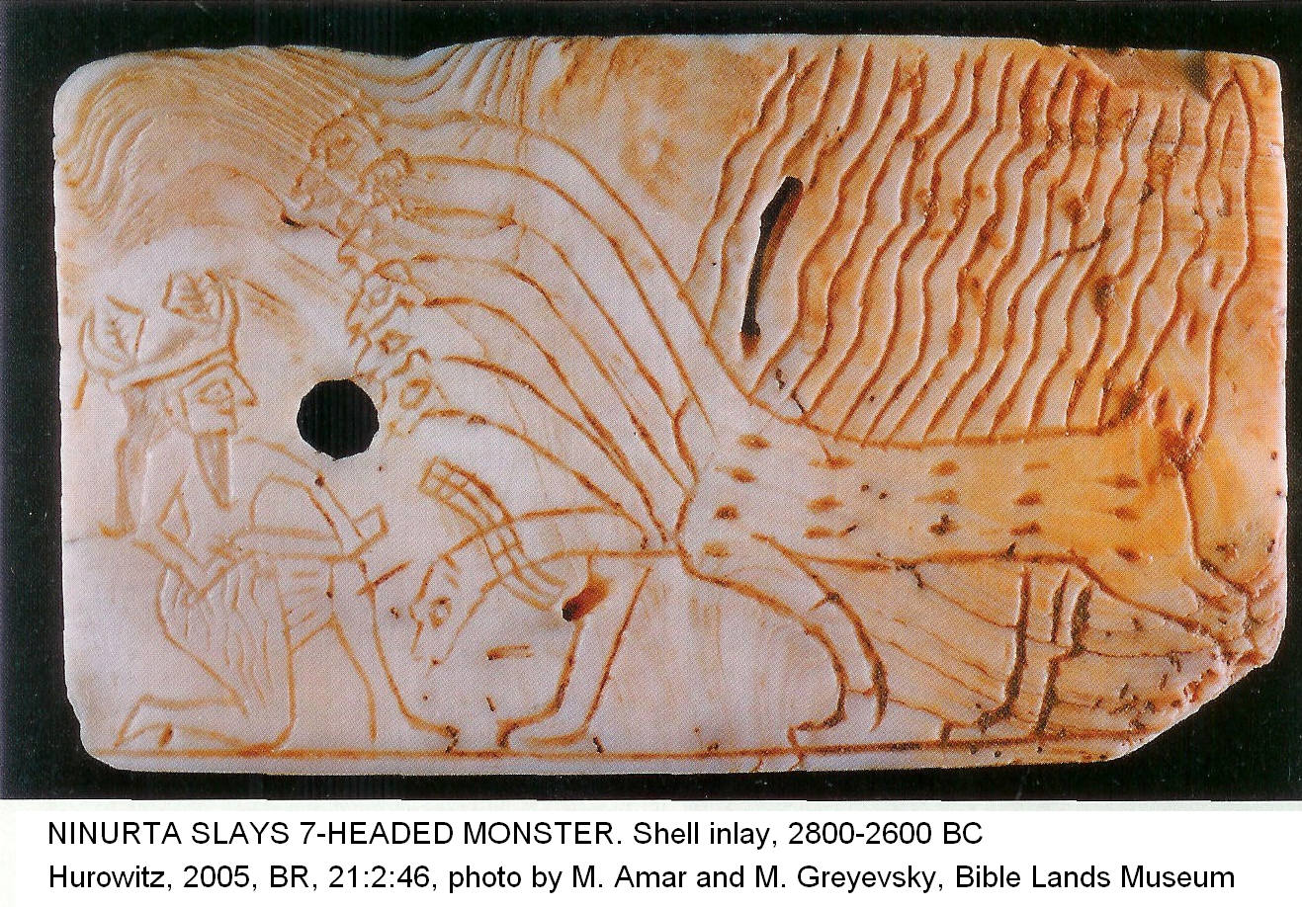

The biblical Leviathan has a parallel in ltn (Litan) in the Nintura story of Ugarit.

When you killed Litan, the Fleeing Serpent
Annihilated the Twisty Serpent
The Potentate with Seven Heads
The heavens grew hot they withered

Genesis 1:21; God [El / Elohim] created great sea serpents.

The word translated “sea serpents” is Tannǐn. This same creature appears as tnn, or Tunnan in a Ugaritic myth:

Surely I fought Yamm [Sea}, the beloved of El
Surely I finished off River, the Great God
Surely I bound Tunnan and destroyed (?) him

Again we see the motif of sea water and fresh water and a victory over them both (see the discussion of Enuma Elish, above; Hurowitz, 2005:46).

The Rivers of Eden

The description of the geography of the four rivers of Genesis indicates that the Garden of Eden was located somewhere in Armenia, near the headwaters of the Tigris and Euphrates rivers (Tsumaru, 1996, citing Wenham, 1987).

PHOTO LINK: TIGRIS RIVER 001. http://images.google.com/imgres?imgurl=http://images.encarta.msn.com/xrefmedia/sharemed/targets/images/pho/00012/00012BBA.jpg&imgrefurl=http://encarta.msn.com/media_461550825_761574188_-1_1/Tigris_River_Iraq.html&h=338&w=500&sz=36&tbnid=sjIEuYTneeUJ:&tbnh ; 2004

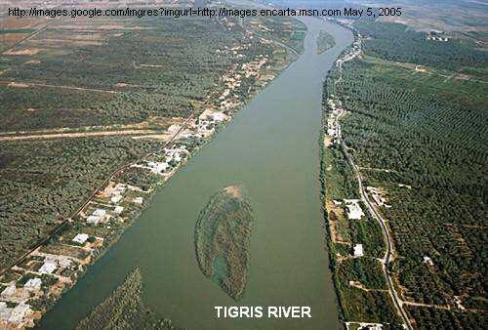

PHOTO LINK: EUPHRATES 001 Euphrates River and Valley; BWP, MA #002. BAR Slide set, 1993.
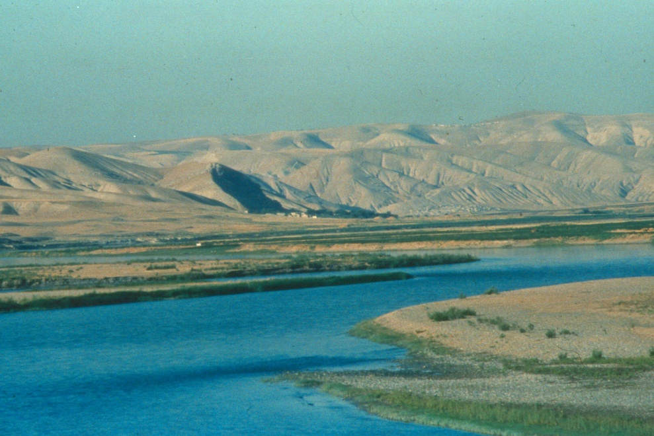

PHOTO LINK: NILE 001. Byers, 2004, B&S, 17:3:65. Photograph by Michael Luddeni.

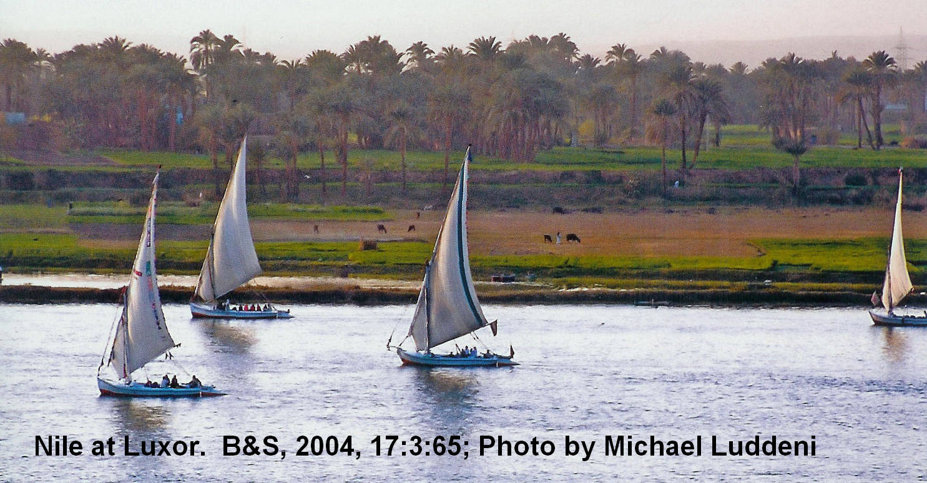

Genesis 2:10-14 relates that:

10A river watering the garden flowed from Eden; from there it was separated into four headwaters. 11The name of the first is the Pishon; it winds through the entire land of Havilah, where there is gold. 12(The gold of that land is good; aromatic resinF and onyx are also there.) 13The name of the second river is the Gihon; it winds through the entire land of Cush.G 14The name of the third river is the Tigris; it runs along the east side of Asshur. And the fourth river is the Euphrates.

The word “Eden” itself means “well-watered” or “a place where there is abundant water supply” (Genesis 2:6, 10; 13:10; Tsumaru, 1996).

Climate in the Holy Land was wetter at the end of the last ice age. Some of the Patriarchal narratives preserve a memory of this period of pre-history. Social changes seen in the archaeological record are due, in main or in part, to climatic change. Pollen studies from three boreholes in Hula Lake and from the Mediterranean coast document this change (Horowitz, 1971, 1974, 1978). The percentage of pollen from dense forest trees is interpreted as an indicator for climatic wetness (Sauer, 1996).

PERIOD | DATES BC | RELATIVE CLIMATIC WETNESS
Chalcolithic | 4,500-3,500 | Wet, ends with short dry period
Early Bronze Age I | 3,400-2,850 | Very wet
Early Bronze Age II-III | 2,850-2,350 | Moderately wet
Early Bronze Age IV | 2,350-2,000 | Increasing aridity

PHOTO LINK: CLIMATE CHANGE 001 Map of Middle East with indications of increased wetness. Sauer, 1996, BAR, 22:4:54.

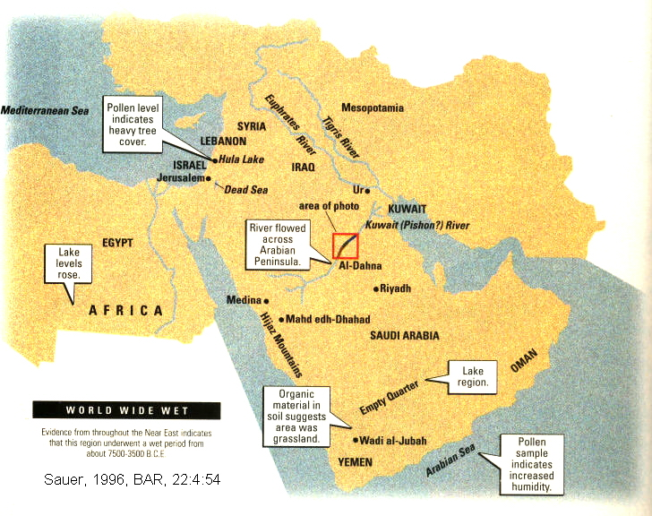

PHOTO LINK: CLIMATE CHANGE 002 Land Sat image of Kuate (Pishon?) River. Sauer, 1996, BAR, 22:4:55. Landsat Image annotated.
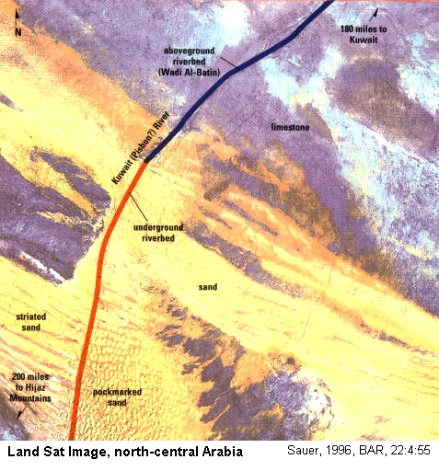

River gravels made of granite and basalt are abundant in Kuwait. Their source area is in the Hijas Mountains, about 650 miles to the west. They were transported to their present positions by an ancestral Kuwait River and deposited on a great fan-shaped delta. This now-dry river bed (Wadi Al-Batin) is believed by Sauer (1996) to be the Pishon river of Gen. 2:11-12. This river flowed "around the whole land of Havilah, where there is gold. The gold of that land is good, the bdellium and onyx stones are there." The land of Havilah is identified as the Arabian peninsula because this is an area with abundant bdellium (fragrant resins) and precious stones. The now-dry Kuwait River is adjacent to the "Cradel of Gold" (Mahd edh-Dhahab) gold mines of Saudi Arabia which were worked as early as 1,000 BC and possibly the "good gold" of Gen 2:12 (Sauer, 1996).

PHOTO LINK: MAHD EDH-DHAHAB 001 Modern gold mining project. Sauer, 1996, BAR, 22:4:57. Photograph by Richard B. Carten.

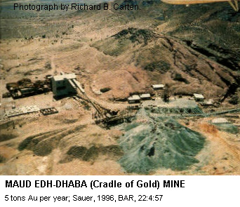

PHOTO LINK: MAHD EDH-DHAHAB 002 Photo micrograph of gold with quartz veins in green rock, Sauer, 1996, BAR, 22:4:47.Photograph by Garo Nalbandian,
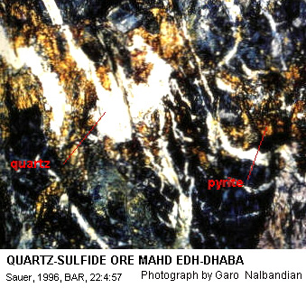

UNITY OF MESOPOTAMIAN CREATION-FLOOD NARRATIVES

Tsumura (1996, citing Millard, 1994) says that the Mesopotamian creation and flood legends, while now separated stories, had a unity that told a continuous narrative of the first era of human history, much as Genesis 1-11 does today. Compilation of legends from Sumner between 1600 and 600 BC lead Jacobsen (1994) to identify a unified legend that includes the following main episodes:

1) creation of man
2) institute of kingship
3) founding of first cities
4) a Great Flood

This creation-flood story is unified through the Sumerian King List (Coats, 1983; Clark, 1971). Archaeological evidence related to the traditions of the Great Flood will be examined in Chapter. 10.

PHOTO LINK: SUMERIAN KING LIST 002. Livingston, 2009, B&S, 22:2:34. Photograph by Michael Luddini.
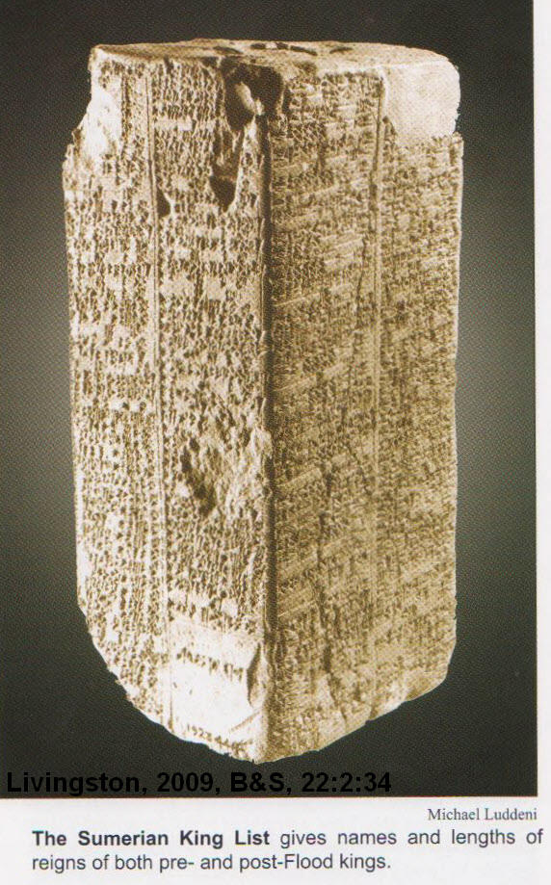

Comparison of Mesopotamian and Hebrew Creation Traditions

ENUMA ELISH AND OTHER NEAR-EASTERN CREATION ACCOUNTS | HEBREW CREATION TRADITION
Mythological | Historical
Creation and gods are interrelated and interdependent | Creation is separate from God
Chaos, then gods, then creation | God, then chaos, then creation
Gods in everything (Animism) | Physical universe apart from spiritual universe
Man made from blood of evil god (hence demonic) | Man made in God’s image mail and female. Has “breath of life” from God
Exalts man, especially the King | Exalts God
Separate creations. City-state creations and political authorities | Creation of whole universe under grand plan
Gods have toil, relieved of it by man. No equivalent of the Sabbath | God rests, but is not tired
Earth to have dominion over man. Man is to serve the forces of nature personified by the gods | Man to have dominion over the earth
Purpose, integrity, grace | Sex, violence, power, subjugation

Separation of Waters in Mesopotamian and Egyptian Traditions

In Genesis 1:6 there is a division of waters “below” and “above” the firmament. The waters below are the Eden river-spring waters (Gen. 2:5-6) and sub-sea waters (“of the great deep”; Gen. 7:11; 8:2). These separated waters are parallel to Ugaritic religion where there is a god of “Heaven-Water”, and a goddess of “Ocean-Water”. The separation of primeval waters is also found in Egyptian cosmology, where earth is an island floating on a great subterranean sea with “heaven” above. That model of creation is reflected in descriptions of source waters for the Flood (Gen. 8:2-3, “downpour of the skies” and “waters of the great deep”) and in the 2nd Commandment (Exodus 20:4 “...heaven above, or on earth beneath, on in the waters under the earth”).

In ancient Near East cosmologies, the rain gods (Ada, Hadad, Ba’al) are described as “a giver of abundant water-supply”. They are not only rain-givers, they are water-controllers. These are functions of Yahweh alone in Genesis 2. Given this duality of water sources, the abode of God (El) was understood in Canaanite society as the furthest horizon where “heaven” and “ocean” meet (Tsumara, 1996, p. 39).

Conclusions

The Hebrew creation epic has a few interesting parallels with Egyptian and Mesopotamian creation stories. Biblical writers and editors knew of them and they used some motifs from these stories (e.g. Leviathan) to describe some characteristics of Yahweh Elohim. But the content, tone, purpose and application are very different. The dates of these motifs (2nd, 3rd, and 4th millennium BC) show that the original Biblical records were contemporaneous with the events they described.

NON-HEBREW CREATION TRADITIONS | HEBREW CREATION TRADITIONS
Mythological | Historical Epic
Fantastical | Somber
Political | Practical
Arbitrary natures of the gods and man | Permanent natures of God and man
Manipulative | Unique revelation
Man as slave | Man as steward

