CHAPTER 8. ADAM, EVE AND OTHERS

Contents
PHYSICAL ANTHROPOLOGY 576
Homo sapiens (sapiens, modern) 579
Homo sapiens (Cro-Magnon) 30,000-32,000 BP, Western Europe 579
Homo Florosiensis (18,000 BP) 583
Homo Neanderthalis (28,000-230,000 BP) 587
Homo sapiens (Archaic, 300,000 BP) 590
Homo erectus (300,000-1,800,000 BP) 591
Homo habilis (1.5 million to 2.4 million years BP) 594
Austalopithecines (1.1 million to 4.2 million years BP) 596
Australopithecus sediba (1.98 million years BP) 596
Australopithecus robustus (1.5 TO 2.0 million years BP) 603
Australopithecus boisei (was Zinjanthropus boisei; 1.1 to 2.1 million years BP) 604
Australopithecus aethiopicus (2.6 to 2.3 million years BP) 604
Australopithecus garhi (2.5 million years BP) 605
Australopithecus africanus (3 to 2 million years BP) 608
Australopithecus anamensis (3.9 to 4.2 million years BP) 609
Ardipithecus ramidus (4.5 million years BP) 610
Sahelanthropus tchadensis (6 million to 7 million years BP) 613
MITOCONDRIAL DNA STUDIES 614
THE HUMAN EVOLUTIONARY BUSH 614
Ecological Preparation 615
A Definition of “Human” 615
Creation of Humans 618
Image of God 619
FROM HUNTING-GATHERING TO AGRICULTURALLY BASED SOCIETIES 619
OLDEST CITIES 624
ADAM AND ADAPA IN ANCIENT MESOPOTAMIAN TRADITIONS 626
WHO BORROWED FROM WHOM? 631
GENERATIONS OF GENESIS: THE COLOPHON 635
SUMMARY 643

PHYSICAL ANTHROPOLOGY

If we had the skeletons of Adam and Eve available for museum display, how would they fit into modern anthropological classifications for hominid fossils? Current models for human evolution and hominid classification are reviewed in this chapter. After those models are reviewed, archaeological and literary information about the first humans will be examined.

PHOTO LINK: HUMAN EVOLUTION/PHYS ANTHRO 001 Timeline.
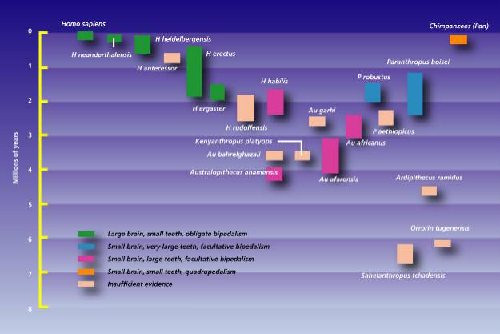

PHOTO LINK: HUMAN EVOLUTION/PHYS ANTHRO TIMELINE 002 Chart http://www.mnh.si.edu/anthro/humanorigins/ha/a_tree.html; 04-03-2005
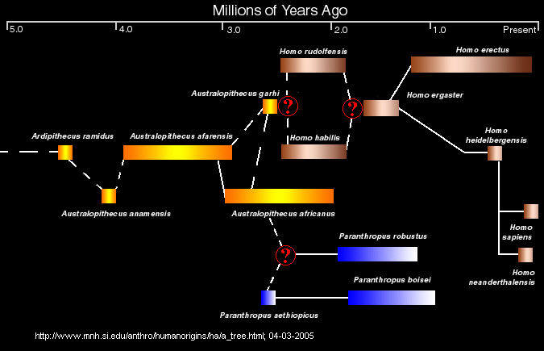

PHOTO LINK: HUMAN EVOLUTION/MODELS OF HUMAN EVOLUTION

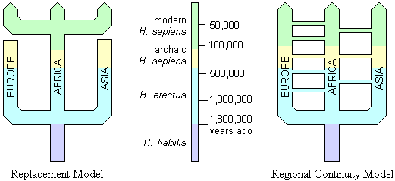

PHOTO LINK: HUMAN EVOLUTION/TABLE OF HUMAN EVOLUTION
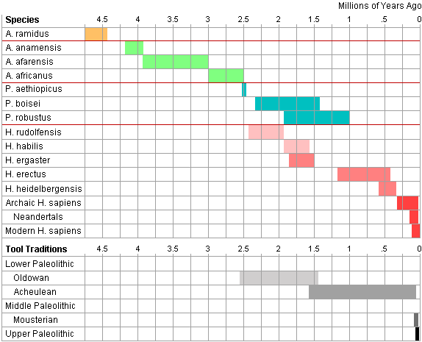

Homo sapiens (sapiens, modern)

Anatomically modern humans are known from 171,500 years ago.

PHOTO LINK: HUMAN EVOLUTION/HOMO SAPIENS MODERN 001 Skull
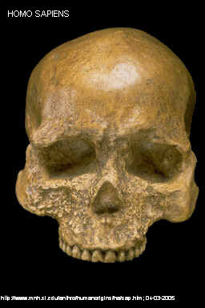

Homo sapiens (Cro-Magnon) 30,000-32,000 BP, Western Europe

About 40,000 years ago, with the appearance of the Cro-Magnon culture, tool kits started becoming markedly more sophisticated, using a wider variety of raw materials such as bone and antler, and containing new implements for making clothing, engraving and sculpting. Fine artwork, in the form of decorated tools, beads, ivory carvings of humans and animals, clay figurines, musical instruments, and spectacular cave paintings appeared over the next 20,000 years (Leaky, 1994).

PHOTO LINK: HUMAN EVOLUTION/CRO MAGNON 001 Skull http://www.talkorigins.org/faqs/homs/cromagnon.html; Nov. 26, 2004
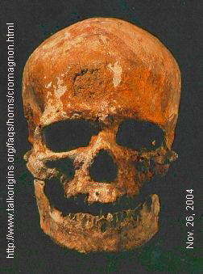

PHOTO LINK: HUMAN EVOLUTION/CRO MAGNON 002 Skull. http://www.talkorigins.org/faqs/homs/cromagnon.html; Nov. 26, 2004
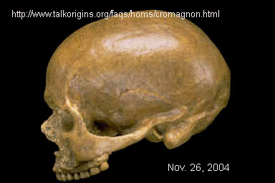

PHOTO LINK: HUMAN EVOLUTION/CRO MAGNON 003 Tools. http://www.wtisbury.mv.k12.ma.us/projects/7earlyweb/7-2earlymanweb/tools/Cromagnontools.html ; Aug. 4, 2005
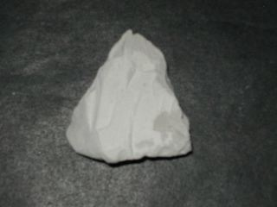

PHOTO LINK: HUMAN EVOLUTION/CRO MAGNON 004 Cave Painting. http://www.elephant.se/cro-magnon.php?open=Man%20and%20elephants ; Aug. 4, 2005
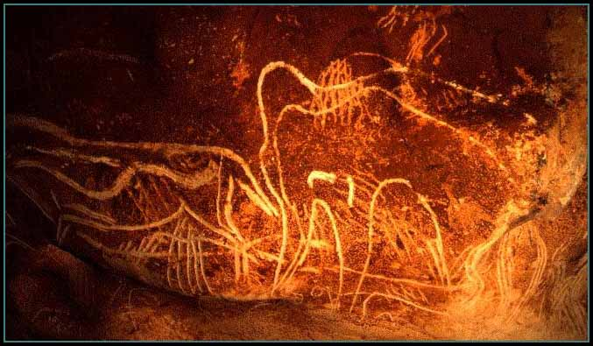

PHOTO LINK: HUMAN EVOLUTION/CRO MAGNON 005 Painting of Cro-Magnon male. http://www.elephant.se/cro-magnon.php?open=Man%20and%20elephants ; Aug. 4, 2005
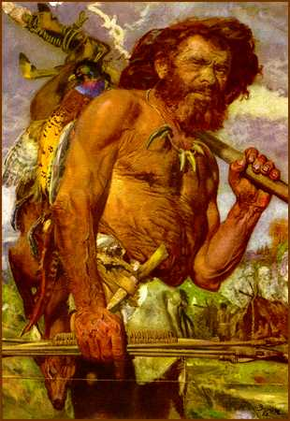

PHOTO LINK: HUMAN EVOLUTION/CRO MAGNON 006 Cave Painting France. http://www.alljames.com/france/caves.html ; Aug. 4, 2005
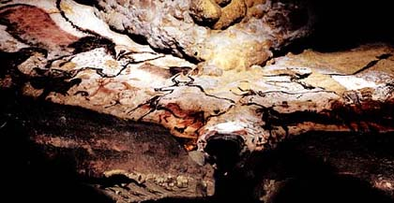

PHOTO LINK: HUMAN EVOLUTION/CRO MAGNON 007 Solutrean points. http://www.geocities.com/Heartland/Meadows/9777/Auel/cro-tool.htm ; Aug. 5, 2005
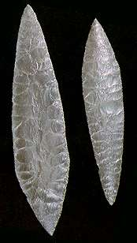

PHOTO LINK: HUMAN EVOLUTION/CRO MAGNON 008 End scraper. http://www.geocities.com/Heartland/Meadows/9777/Auel/cro-tool.htm ; Aug. 5, 2005

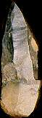

Homo Florosiensis (18,000 BP)

Homonid fossils of a miniaturized form of homo were found in Indonesia dating to 18,000 BP. The specimens are about 3 feet in height. They represent a line of homo that became extinct sometime after 18,000 BP.

PHOTO LINK: HUMAN EVOLUTION/ HOMO FLOROSIENSIS 001 Skull. Morewood et al, 2005, National Geographic 207:4:7. Photograph by Kenneth Garrett.

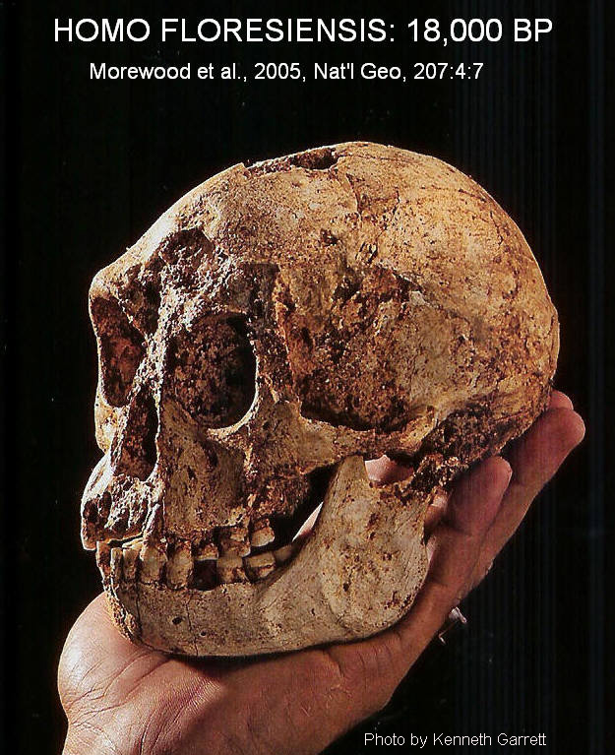

PHOTO LINK: HUMAN EVOLUTION/ HOMO FLOROSIENSIS 002 Comparison with modern humans. Morewood et al, 2005, National Geographic 207:4:6. Photograph by Kenneth Garrett.
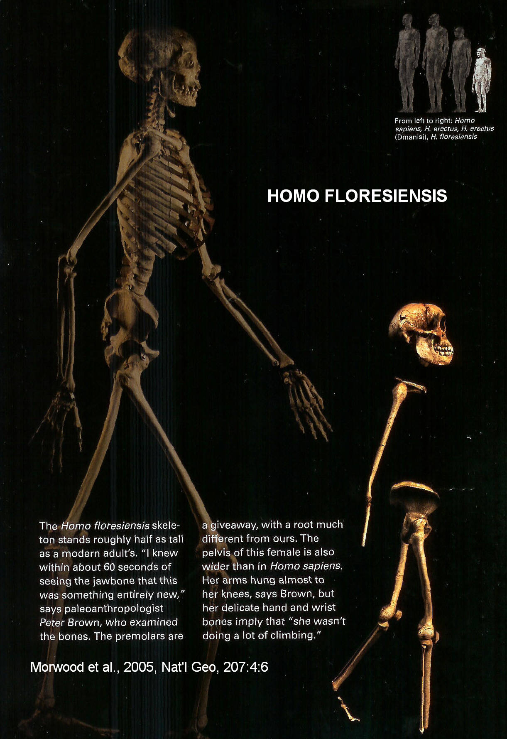

PHOTO LINK: HUMAN EVOLUTION/ HOMO FLOROSIENSIS 003 Reconstruction of head. Morewood et al, 2005, National Geographic 207:4:5. Photograph by Kenneth Garrett.
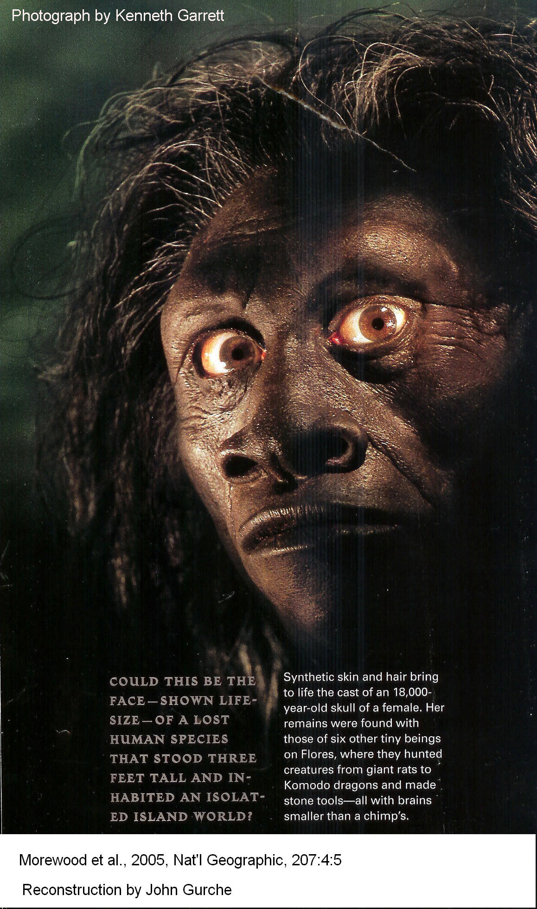

Homo Neanderthalis (28,000-230,000 BP)

The Neanderthals are known from Europe, Africa and Asia. They were contemporaneous with Cro Magnon. They are distinguishable from Homo sapiens by their prominent brow ridges, sagital crest (on top of the skull) deep eye sockets and larger jaw. Neanderthals became extinct during last Ice Age. DNA analysis of Neanderthal bone material indicates that modern humans descended from neanderthals

(http://cogweb.ucla.edu/Abstracts/Goodwin_00.html ; Aug 12, 2005).

“Neandertal (or Neanderthal) man existed between 230,000 and 30,000 years ago. The average brain size is slightly larger than that of modern humans, about 1450 cc, but this is probably correlated with their greater bulk. The brain case however is longer and lower than that of modern humans, with a marked bulge at the back of the skull. Like erectus, they had a protruding jaw and receding forehead. The chin was usually weak. The midfacial area also protrudes, a feature that is not found in erectus or sapiens and may be an adaptation to cold. There are other minor anatomical differences from modern humans, the most unusual being some peculiarities of the shoulder blade, and of the pubic bone in the pelvis. Neandertals mostly lived in cold climates, and their body proportions are similar to those of modern cold-adapted peoples: short and solid, with short limbs. Men averaged about 168 cm (5'6") in height. Their bones are thick and heavy, and show signs of powerful muscle attachments. Neandertals would have been extraordinarily strong by modern standards, and their skeletons show that they endured brutally hard lives. A large number of tools and weapons have been found, more advanced than those of Homo erectus. Neandertals were formidable hunters, and are the first people known to have buried their dead, with the oldest known burial site being about 100,000 years old. They are found throughout Europe and the Middle East. Western European Neandertals usually have a more robust form, and are sometimes called "classic Neandertals". Neandertals found elsewhere tend to be less excessively robust. (Trinkaus and Shipman 1992; Trinkaus and Howells 1979; Gore 1996)” Quote from http://www.talkorigins.org/faqs/homs/species.html, Nov. 26, 2004.

PHOTO LINK: HUMAN EVOLUTION/NEANDERTAL 001 Skull http://www.talkorigins.org/faqs/homs/chapelle.jpg; Nov. 26, 2004
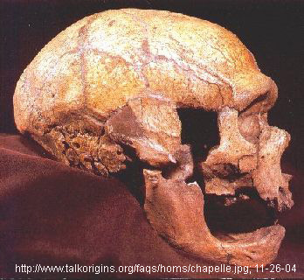

PHOTO LINK: HUMAN EVOLUTION/NEANDERTAL 002 Display mannequin . http://www.onelife.com/evolve/manev.html; Nov. 26, 2004
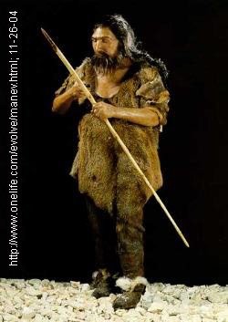
PHOTO LINK: NEANDERTHAL 001. Skull of modern human compared to Neanderthal skull. http://www.talkorigins.org/faqs/homs/chapelle.jpg; Nov. 26, 2004
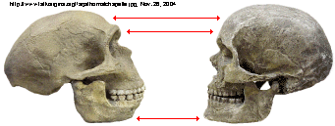

PHOTO LINK: GA014 Mt. Carmel Caves, Neanderthal skeleton 52,000 BC and Natufian burials 10,000-7500 BC. BWP, GA-014. Photograph by Zev Radovan.

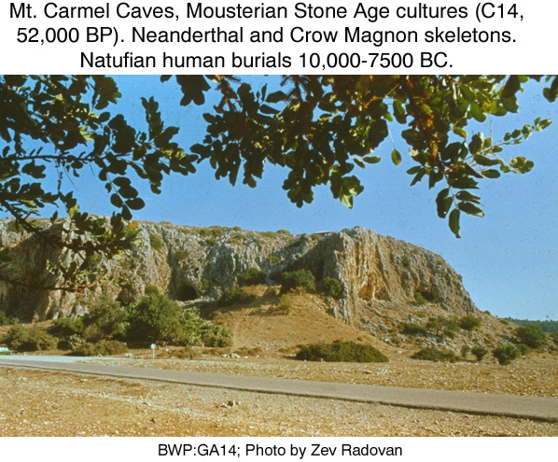

Homo sapiens (Archaic, 300,000 BP)

The most complete example of Homo sapiens (archaic) is named Atapuerca 5, Homo sapiens (archaic).
”Discovered in the Sima de los Huesos ("Pit of Bones") at the Atapuerca cave site in northern Spain in 1992 and 1993 by Juan-Luis Arsuaga. It is about 300,000 years old, with a brain size of 1125 cc. The face is broad with a huge nasal opening, and resembles Neandertals in some traits but not in others. This is the most complete pre-modern skull in the entire hominid fossil record. (Arsuaga et al. 1993; Johanson and Edgar 1996).” Quote from http://www.talkorigins.org/faqs/homs/specimen.html#neandertals; Nov. 26, 2004.

PHOTO LINK: HUMAN EVOLUTION/HOMO SAPIENS ARCHAIC 001 Skull. www.talkorigins.org/faqs/homs/atapuerca5.jpg; Nov, 26, 2004
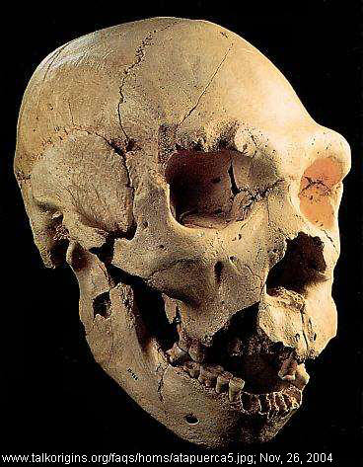

Homo erectus (300,000-1,800,000 BP)

“H. erectus existed between 1.8 million and 300,000 years ago. Like habilis, the face has protruding jaws with large molars, no chin, thick brow ridges, and a long low skull, with a brain size varying between 750 and 1225 cc. Early erectus specimens average about 900 cc, while late ones have an average of about 1100 cc (Leakey 1994). The skeleton is more robust than those of modern humans, implying greater strength. Body proportions vary; the Turkana Boy is tall and slender (though still extraordinarily strong), like modern humans from the same area, while the few limb bones found of Peking Man indicate a shorter, sturdier build. Study of the Turkana Boy skeleton indicates that erectus may have been more efficient at walking than modern humans, whose skeletons have had to adapt to allow for the birth of larger-brained infants (Willis 1989). Homo habilis and all the australopithecines are found only in Africa, but erectus was wide-ranging, and has been found in Africa, Asia, and Europe. There is evidence that erectus probably used fire, and their stone tools are more sophisticated than those of habilis” Quote from . http://www.talkorigins.org/faqs/homs/species.html; Nov. 26, 2004.

Homo erectus was a tool user and possibly made funerary artifacts. There is no unequivocal evidence that Home erectus buried his dead.

PHOTO LINK: HUMAN EVOLUTION/HOMO ERECTUS 001 Skull. http://www.talkorigins.org/faqs/homs/sangiran17.jpg; Nov. 26, 2004
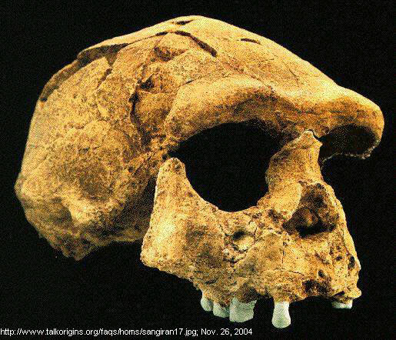

PHOTO LINK: HUMAN EVOLUTION/HOMO ERECTUS 002 Tools. http://www.archaeology.org/0001/newsbriefs/china.html ; Aug. 4, 2005
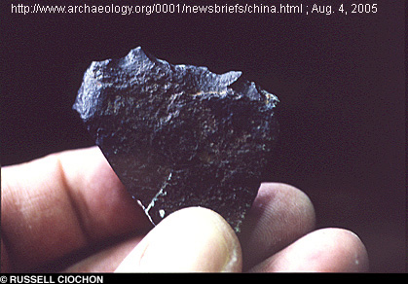

PHOTO LINK: HUMAN EVOLUTION/HOMO ERECTUS 003 Tools. http://www.archaeology.org/0001/newsbriefs/china.html ; Aug. 4, 2005
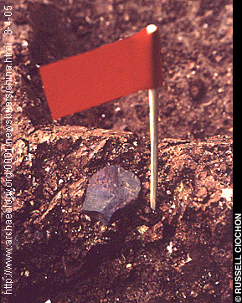

PHOTO LINK: HUMAN EVOLUTION/HOMO ERECTUS 004 Turkana boy. http://www.talkorigins.org/faqs/homs/15000.html ; Aug. 4, 2005
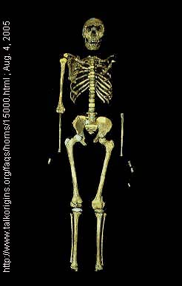

PHOTO LINK: HUMAN EVOLUTION/HOMO ERECTUS 005 Reconstruction. http://pharyngula.org/index/weblog/comments/homo_erectus_reconstruction/ ; Aug. 5, 2005
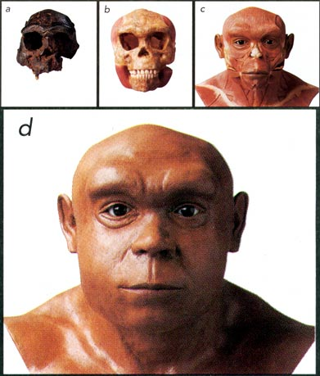

Homo habilis (1.5 million to 2.4 million years BP)

“H. habilis, "handy man", was so called because of evidence of tools found with its remains. Habilis existed between 2.4 and 1.5 million years ago. It is very similar to australopithecines in many ways. The face is still primitive, but it projects less than in A. africanus. The back teeth are smaller, but still considerably larger than in modern humans. The average brain size, at 650 cc, is considerably larger than in australopithecines. Brain size varies between 500 and 800 cc, overlapping the australopithecines at the low end and H. erectus at the high end. The brain shape is also more humanlike. The bulge of Broca's area, essential for speech, is visible in one habilis brain cast, and indicates it was possibly capable of rudimentary speech. Habilis is thought to have been about 127 cm (5'0") tall, and about 45 kg (100 lb) in weight, although females may have been smaller.

“Habilis has been a controversial species. Originally, some scientists did not accept its validity, believing that all habilis specimens should be assigned to either the australopithecines or Homo erectus. H. habilis is now fully accepted as a species, but it is widely thought that the 'habilis' specimens have too wide a range of variation for a single species, and that some of the specimens should be placed in one or more other species. One suggested species which is accepted by many scientists is Homo rudolfensis, which would contain fossils such as ER 1470.” Quote from http://www.talkorigins.org/faqs/homs/species.html; Nov. 26, 2004.

PHOTO LINK: HUMAN EVOLUTION/HOMO HABILIS 001 Twiggy Oldovai Gorge www.talkorigins.org/faqs/homs/oh24.html; Nov. 26, 2004;.
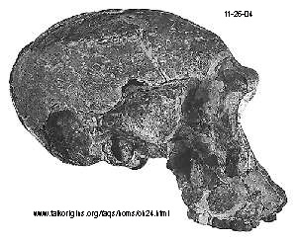
PHOTO LINK: HUMAN EVOLUTION/HOMO HABILIS 002 Skull restored. www.talkorigins.org/faqs/homs/oh24.html; Nov. 26, 2004
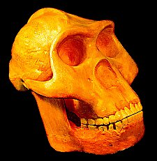

Austalopithecines (1.1 million to 4.2 million years BP)

Australopithecine classification continues to change with each new discovery. Currently there are five species identified. Some austalopithecines may have used crude tools. None created funerary artifacts or buried their dead. The austalopithecines range in age from 1.1 to 3.0 million years.

Australopithecus sediba (1.98 million years BP)

Skeletons of Australopithecus sebida where found at Malapa in South Africa (Fishman, 2011:122)

PHOTO LINK: AUSTRALOPITHECUS SEBIDA 008 Map of Malapa in South Africa. Flechman, 2011, National Geographic, 220:2:122.
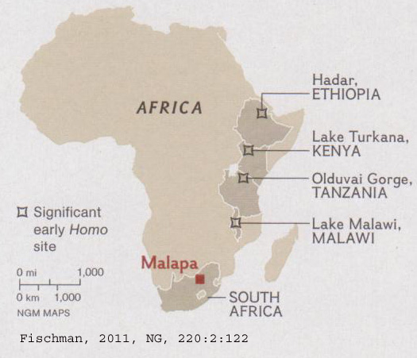

The fossils were preserved in an ancient “death trap” formed from the creation of caverns.

PHOTO LINK: AUSTRALOPITHECUS SEBIDA 003 Geologic cross section with "Death Trap". Fischman, 2011, National Geographic, 220:2:125.
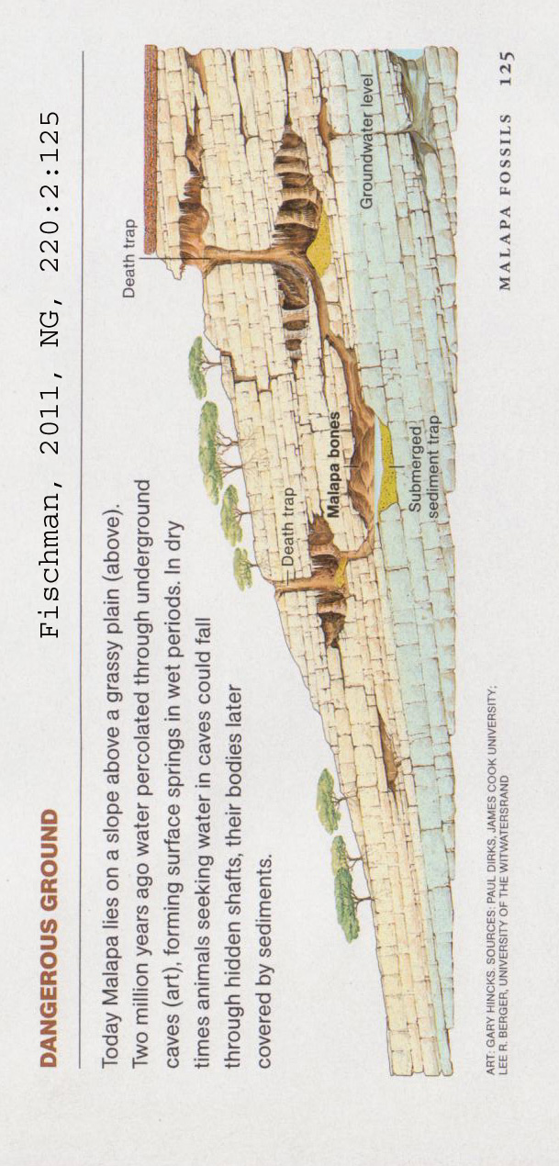

A. Sebida is intermediate in age and has several several anatomical characteristics in common with both A. afarnsis (Lucy) and Homo Erectus.

PHOTO LINK: AUSTRALOPITHECUS SEBIDA 005 Comparative paintings of Australopithecus Afarensis (Lucy) vs Australopithecus Sebida vs Homo Erectus. Flechman, 2011, National Geographic, 220:2:128.

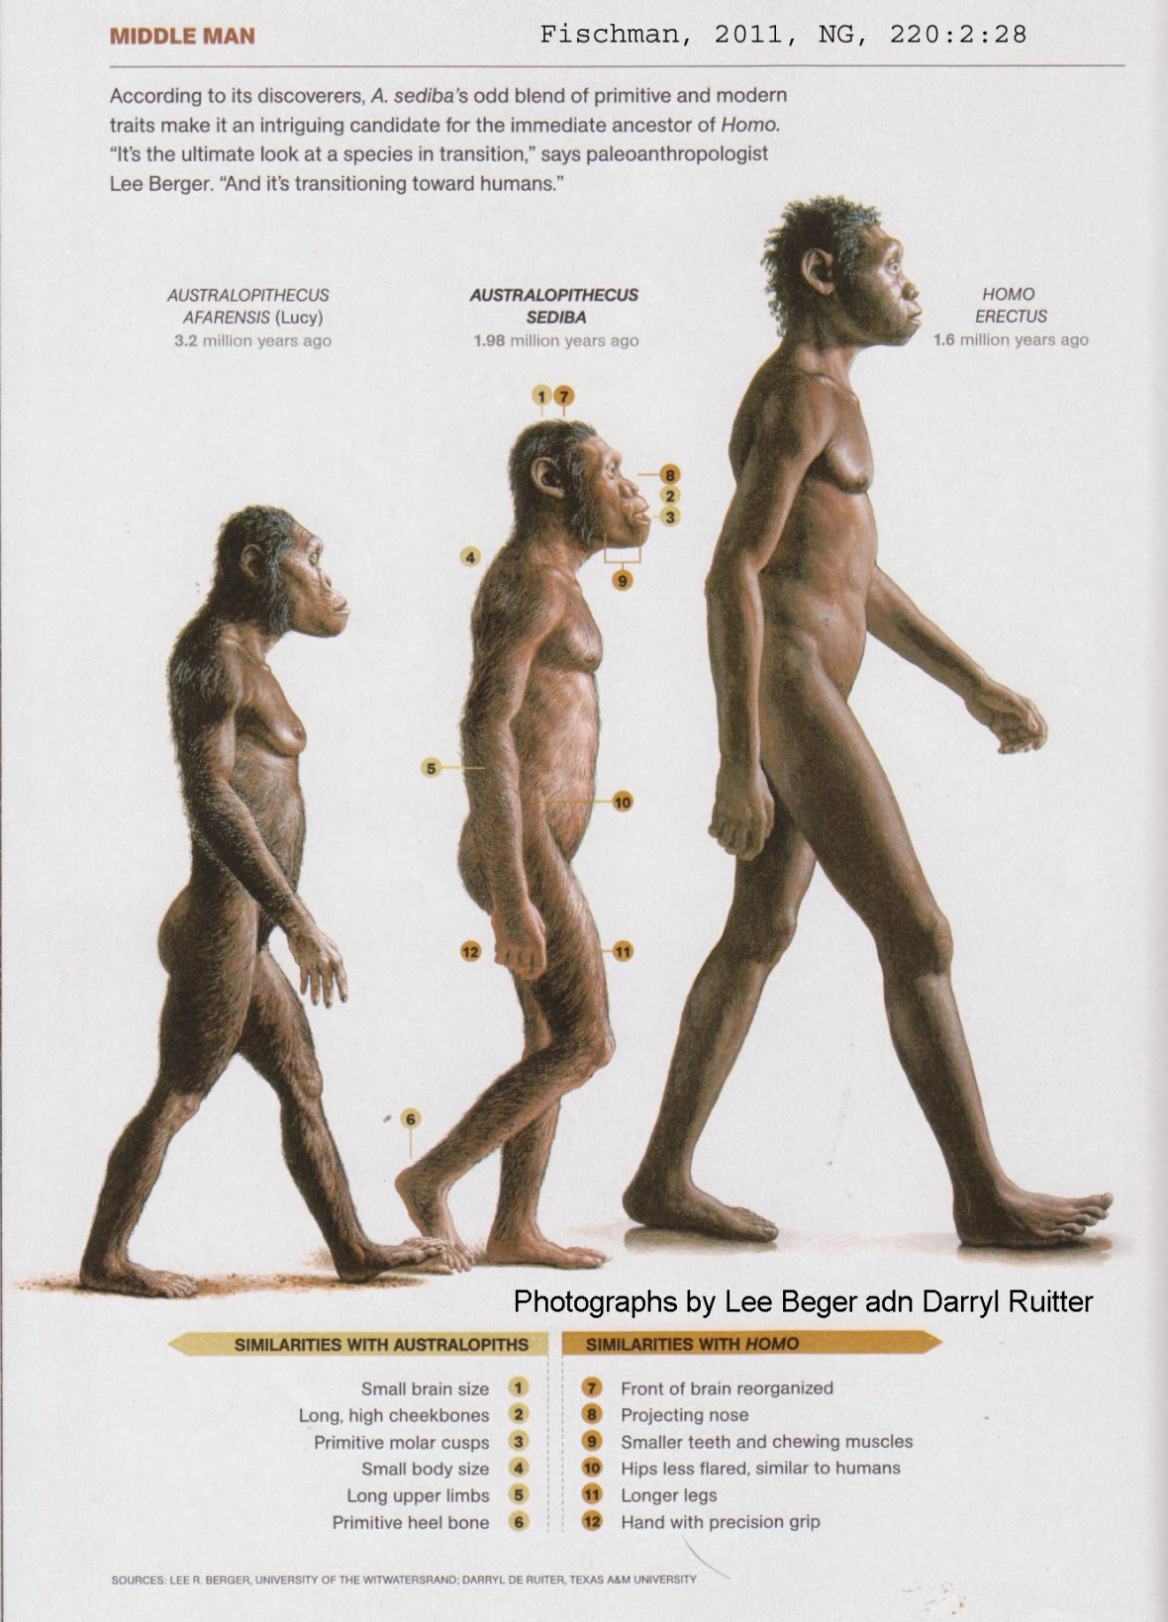

PHOTO LINK: AUSTRALOPITHECUS SEBIDA 004 Male and female partial skeletons from Malapa. Fischer, National Geographic, 220:2:127. Photograph by Brent Stirton.

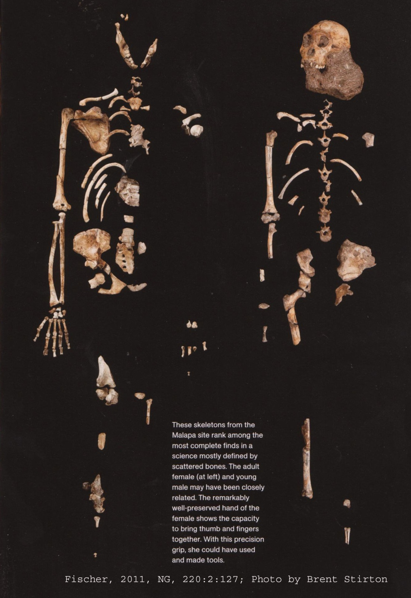
PHOTO LINK: AUSTRALOPITHECUS SEBIDA 002 Painting from reconstruction. Fischman, 2011, National Geographic, 220:2:121. Photograph by Brent Stirton.

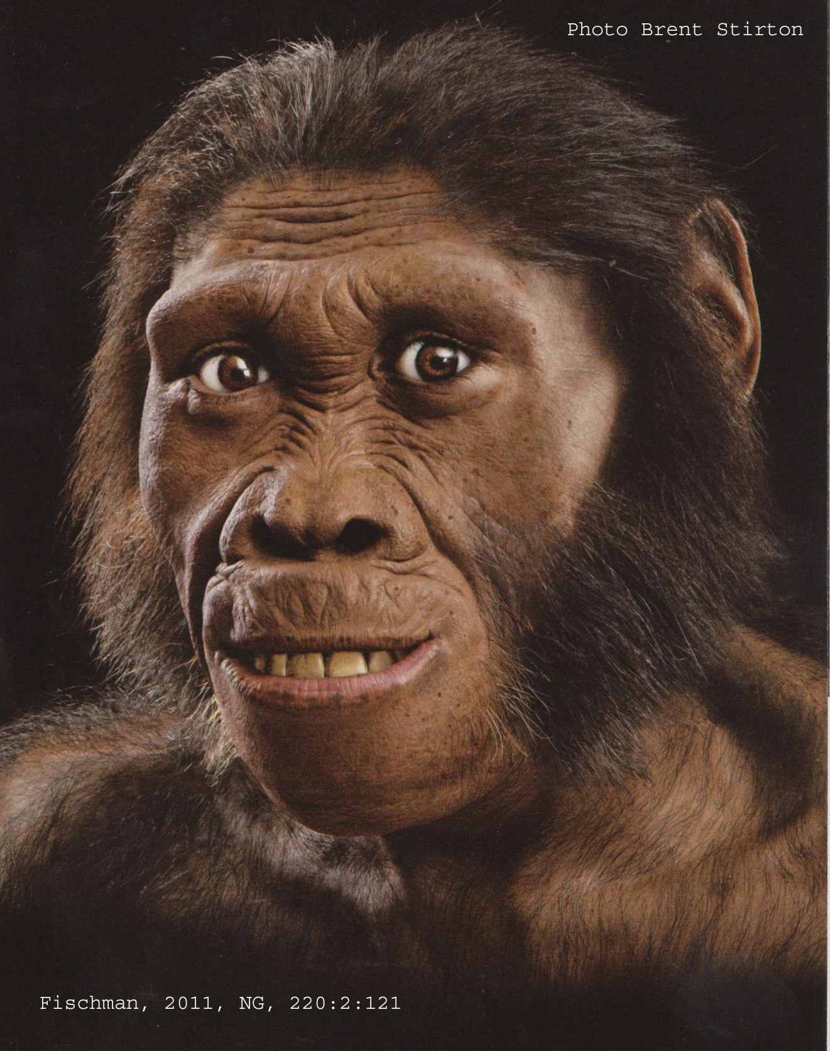

PHOTO LINK: AUSTRALOPITHECUS SEBIDA 007 Evolutionary table with photographs showing A. sebida as ancestor to Homo Erectus. Fischman, 2011, National Geographic, 220:2:130.

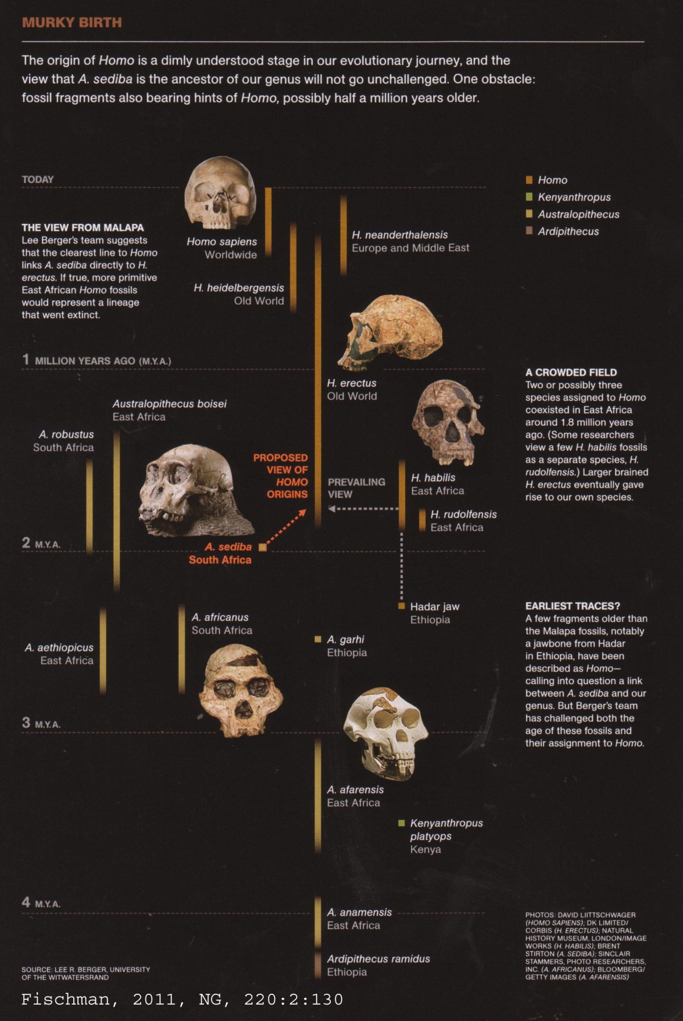

PHOTO LINK: AUSTRALOPITHECUS SEBIDA 006 Skull of Austalopithecus Sebida. Fischman, 2011, National Geographic, 220:2:129. Photograph by Brent Stirton.

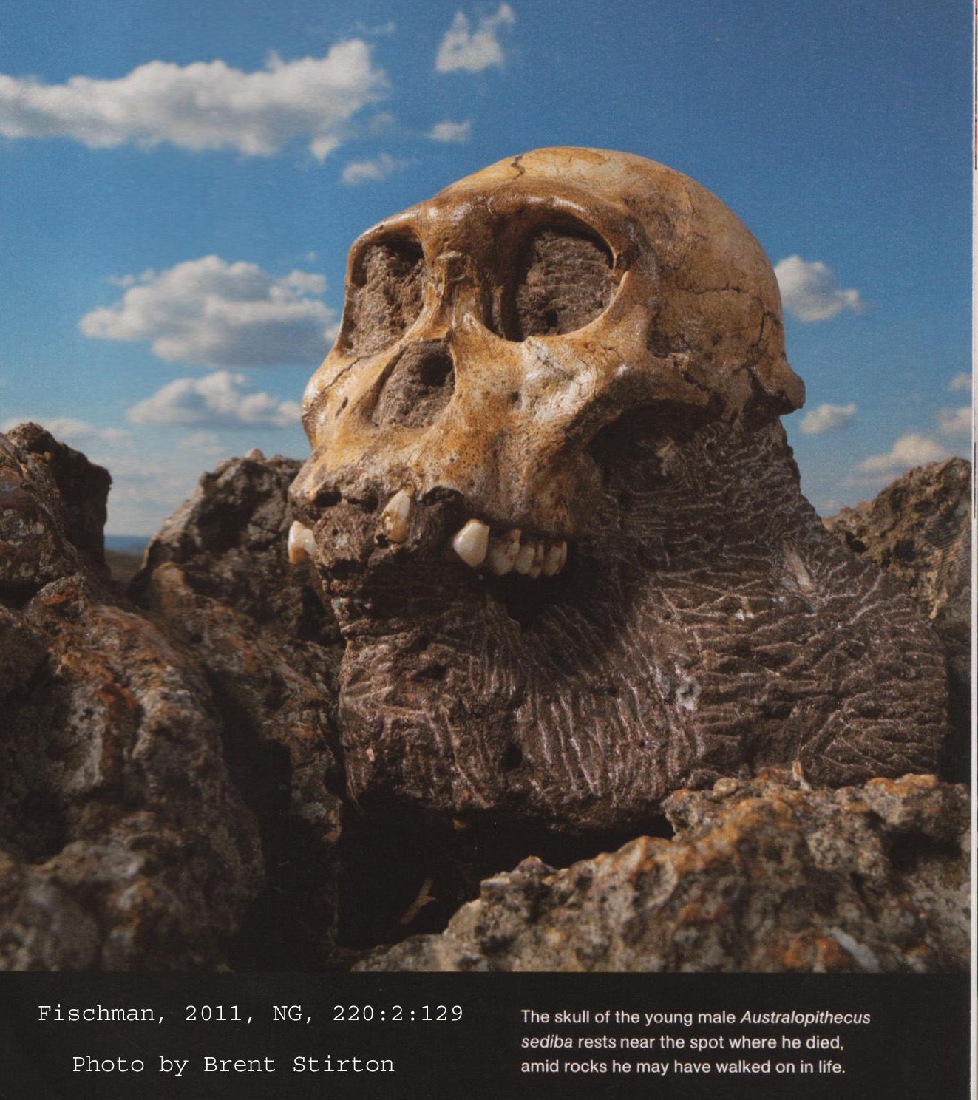

Australopithecus robustus (1.5 TO 2.0 million years BP)

“A. robustus had a body similar to that of africanus, but a larger and more robust skull and teeth. It existed between 2 and 1.5 million years ago. The massive face is flat or dished, with no forehead and large brow ridges. It has relatively small front teeth, but massive grinding teeth in a large lower jaw. Most specimens have sagittal crests. Its diet would have been mostly coarse, tough food that needed a lot of chewing. The average brain size is about 530 cc. Bones excavated with robustus skeletons indicate that they may have been used as digging tools.” Quote from http://www.talkorigins.org/faqs/homs/species.html; Nov. 26, 2004.

PHOTO LINK: HUMAN EVOLUTION/ AUSTRALOPITHECUS ROBUSTUS 001 Skull 2.3 to 1.3 MY . http://hannover.park.org/Canada/Museum/man/robustus1.html; 04-05-2005.
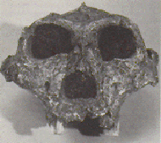

Australopithecus boisei (was Zinjanthropus boisei; 1.1 to 2.1 million years BP)

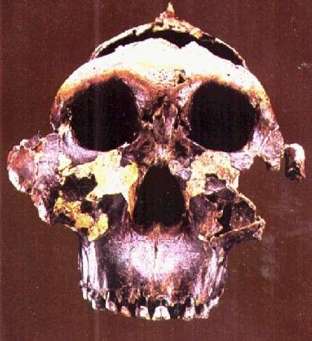
“A. boisei existed between 2.1 and 1.1 million years ago. It was similar to robustus, but the face and cheek teeth were even more massive, some molars being up to 2 cm across. The brain size is very similar to robustus, about 530 cc. A few experts consider boisei and robustus to be variants of the same species.

Australopithecus aethiopicus, robustus and boisei are known as robust australopithecines, because their skulls in particular are more heavily built. They have never been serious candidates for being direct human ancestors. Many authorities now classify them in the genus Paranthropus.” Quote from http://www.talkorigins.org/faqs/homs/species.html; Nov. 26, 2004.

PHOTO LINK: HUMAN EVOLUTION/ AUSTRALOPITHECUS BOISEI 001 Skull. http://www.talkorigins.org/faqs/homs/zinj.jpg; Nov. 26, 2004 (RIGHT)

Australopithecus aethiopicus (2.6 to 2.3 million years BP)

“A. aethiopicus existed between 2.6 and 2.3 million years ago. This species is known from one major specimen, the Black Skull discovered by Alan Walker, and a few other minor specimens which may belong to the same species. It may be an ancestor of robustus and boisei, but it has a baffling mixture of primitive and advanced traits. The brain size is very small, at 410 cc, and parts of the skull, particularly the hind portions, are very primitive, most resembling afarensis. Other characteristics, like the massiveness of the face, jaws and single tooth found, and the largest sagittal crest in any known hominid, are more reminiscent of A. boisei (Leakey and Lewin 1992). (A sagittal crest is a bony ridge on top of the skull to which chewing muscles attach.)” Quote from http://www.talkorigins.org/faqs/homs/species.html; Nov. 26, 2004.

PHOTO LINK: HUMAN EVOLUTION/ AUSTRALOPITHECUS AETHIOPICUS 001 Skull. http://www.archaeologyinfo.com/17000.htm; Nov. 26, 2004
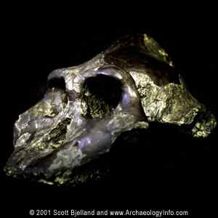

Australopithecus garhi (2.5 million years BP)

“This species was named in April 1999 (Asfaw et al. 1999). It is known from a partial skull. The skull differs from previous australopithecine species in the combination of its features, notably the extremely large size of its teeth, especially the rear ones, and a primitive skull morphology. Some nearby skeletal remains may belong to the same species. They show a humanlike ratio of the humerus and femur, but an apelike ratio of the lower and upper arm. (Groves 1999; Culotta 1999)

“Australopithecus afarensis and africanus, and the other species above, are known as gracile australopithecines, because of their relatively lighter build, especially in the skull and teeth. (Gracile means "slender", and in paleoanthropology is used as an antonym to "robust".) Despite this, they were still more robust than modern humans.” Quote from http://www.talkorigins.org/faqs/homs/species.html; Nov. 26, 2004.

PHOTO LINK: HUMAN EVOLUTION/ AUSTRALOPITHECUS GARHI 001 Top cranium+Upper Jaw. http://www.archaeologyinfo.com/australopithecusgarhi.htm; Nov. 26, 2004.

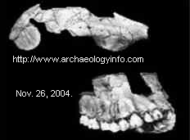
PHOTO LINK: HUMAN EVOLUTION/ AUSTRALOPITHECUS GARHI 002 Skull and painting with imanage of antelope jaw with stone cut marks. Shreeve, 2010, National Geographic, 218:1:54. Photograph by David L. Brill.
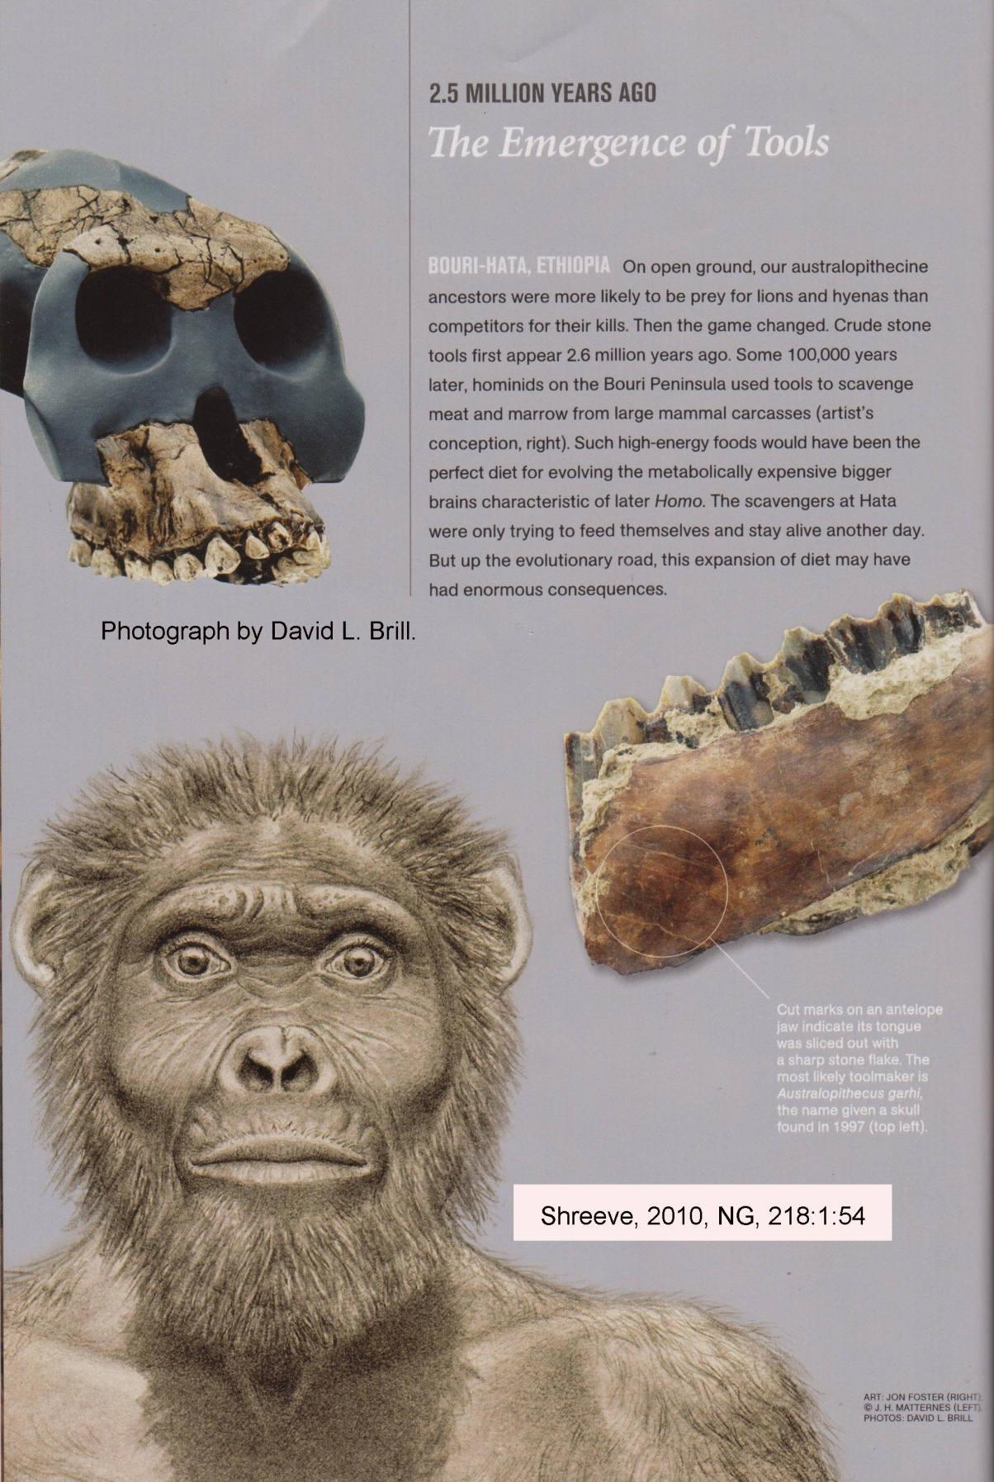

Australopithecus africanus (3 to 2 million years BP)

“A. africanus existed between 3 and 2 million years ago. It is similar to afarensis, and was also bipedal, but body size was slightly greater. Brain size may also have been slightly larger, ranging between 420 and 500 cc. This is a little larger than chimp brains (despite a similar body size), but still not advanced in the areas necessary for speech. The back teeth were a little bigger than in afarensis. Although the teeth and jaws of africanus are much larger than those of humans, they are far more similar to human teeth than to those of apes (Johanson and Edey 1981). The shape of the jaw is now fully parabolic, like that of humans, and the size of the canine teeth is further reduced compared to afarensis.” Quote from http://www.talkorigins.org/faqs/homs/species.html; Nov. 26, 2004.

PHOTO LINK: HUMAN EVOLUTION/ AUSTRALOPITHECUS AFRICANUS 001 Skull. http://www.talkorigins.org/faqs/homs/taung.jpg; Nov. 26, 2004
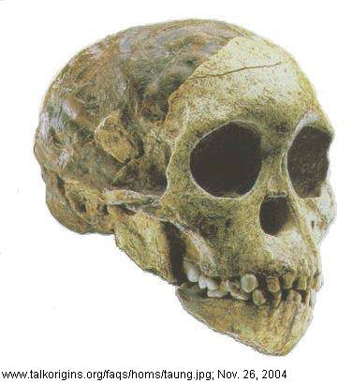

Australopithecus anamensis (3.9 to 4.2 million years BP)

“This species was named in August 1995 (Leakey et al. 1995). The material consists of 9 fossils, mostly found in 1994, from Kanapoi in Kenya, and 12 fossils, mostly teeth found in 1988, from Allia Bay in Kenya (Leakey et al. 1995). Anamensis existed between 4.2 and 3.9 million years ago, and has a mixture of primitive features in the skull, and advanced features in the body. The teeth and jaws are very similar to those of older fossil apes. A partial tibia (the larger of the two lower leg bones) is strong evidence of bipedality, and a lower humerus (the upper arm bone) is extremely humanlike. Note that although the skull and skeletal bones are thought to be from the same species, this is not confirmed.” Quote from http://www.talkorigins.org/faqs/homs/species.html; Nov. 26, 2004.

PHOTO LINK: HUMAN EVOLUTION/ AUSTRALOPITHECUS ANEMENSIS 001 Jawbone. http://www.geocities.com/palaeoanthropology/Aanamensis.html; Nov. 26, 2004
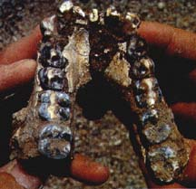

Ardipithecus ramidus (4.5 million years BP)

“This early fossil hominid was initially placed within the Australopithecus genus, with a new specific epithet - ramidus (from the Afar word "ramid", meaning "root") [White, et al, 1994]. Tim White and associates have subsequently reassigned the hominid to a new genus, noting the apparently extreme dissimilarities between ramidus and all other known Australopithecines. They proposed Ardipithecus (from "ardi", which means "ground" or floor" in the Afar language) to be the genus [White, et al, 1995]. Quote from http://www.archaeologyinfo.com/ardipithecusramidus.htm; April 5, 2005

PHOTO LINK: HUMAN EVOLUTION/ ARDIPITHECUS RAMIDUS 001 Molar . http://www.geocities.com/palaeoanthropology/Aramidus.html ; April 5, 2005

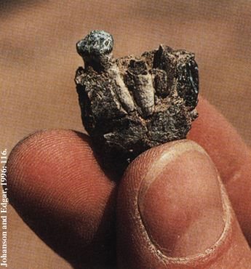

PHOTO LINK: HUMAN EVOLUTION/ ARDIPITHECUS RAMIDUS 002 Reconstructed skull model. Shreeve, 2010, National Geographic, 218:1:cover. Photograph by Tim D. White.
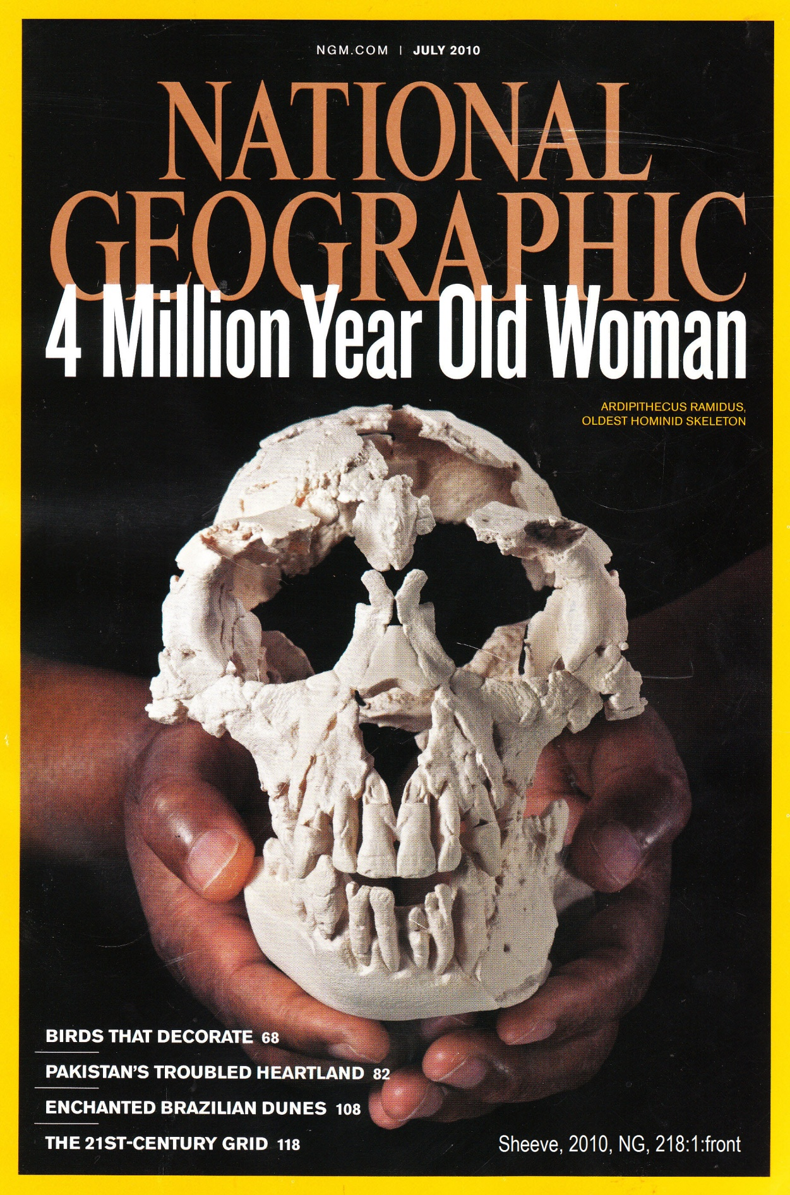

PHOTO LINK: HUMAN EVOLUTION/ARDIPITHECUS RAMIDUS 008 Painting of an Ardipithecus ramidus Ardi specimen. Shreeve, 2010, National Geographic, 218:1:63. Photograph by Jon Foster @ J.H. Matternes

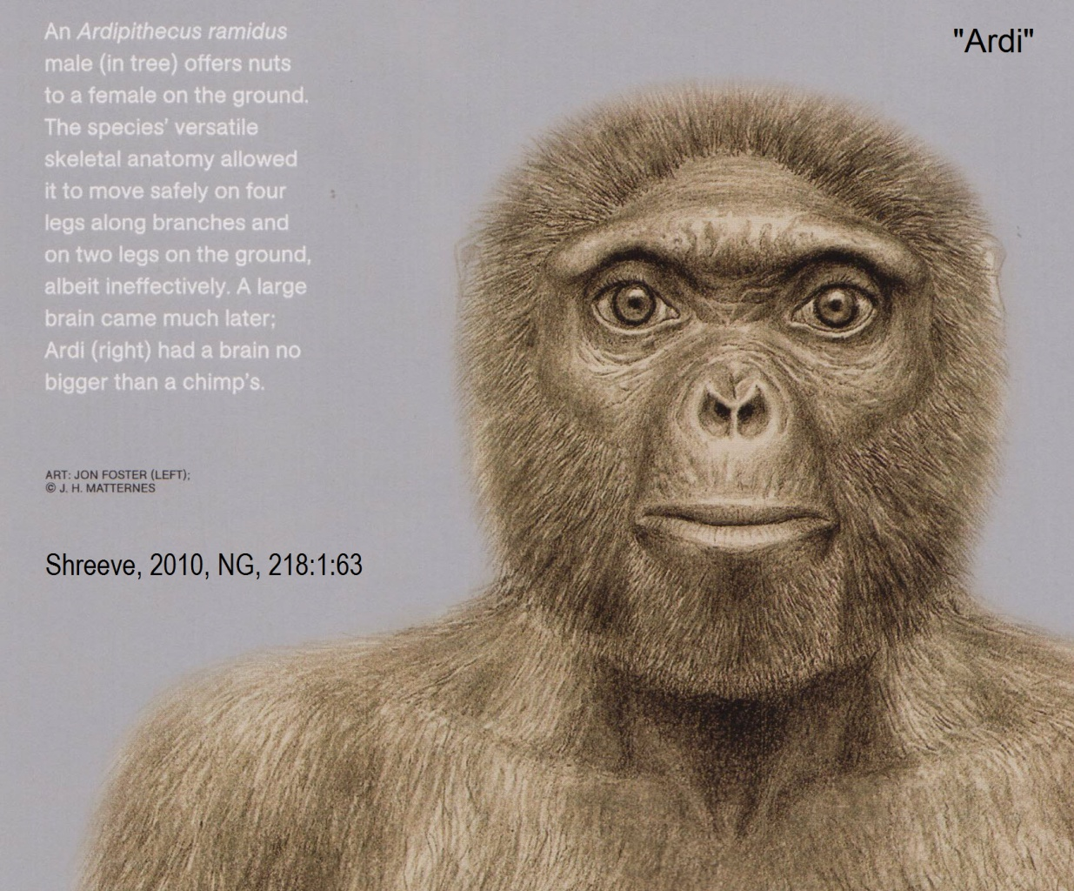

Sahelanthropus tchadensis (6 million to 7 million years BP)

“This species was named in July 2002 from fossils discovered in Chad in Central Africa (Brunet et al. 2002, Wood 2002). It is the oldest known hominid or near-hominid species, dated at between 6 and 7 million years old. This species is known from a nearly complete cranium nicknamed Toumai, and a number of fragmentary lower jaws and teeth. The skull has a very small brain size of approximately 350 cc. It is not known whether it was bipedal. S. tchadensis has many primitive apelike features, such as the small brainsize, along with others, such as the brow ridges and small canine teeth, which are characteristic of later hominids. This mixture, along with the fact that it comes from around the time when the hominids are thought to have diverged from chimpanzees, suggests it is close to the common ancestor of humans and chimpanzees.” Quote from http://www.talkorigins.org/faqs/homs/species.html; Nov. 26, 2004.

PHOTO LINK: HUMAN EVOLUTION/SAHELANTHROPUS TCHADENSIS 001 Skull fragments. http://www.talkorigins.org/faqs/homs/toumai.html; Nov. 26, 2004

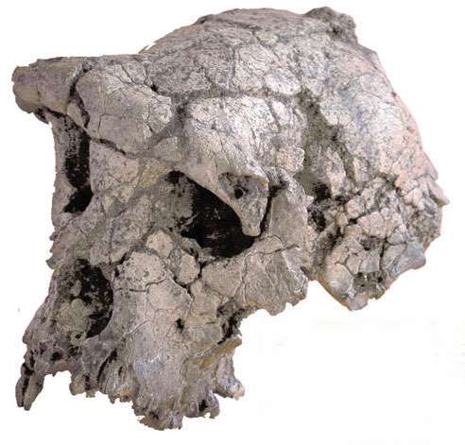

MITOCONDRIAL DNA STUDIES

The study of human origins has been helped since the 1970’s by the study of mitocondrial DNA. This is a type of DNA in the human body that only comes from the female and thus can be used to measure the degree to which different human populations have “drifted” genetically from each other. Mitocondrial DNA studies indicate that all modern humans are descended from a common female ancestor (or small group of female ancestors, Eve’s daughters) who lived in Africa 171,500 years ago.

PHOTO LINK: MITOCONDRIA 001. Diagram http://micro.magnet.fsu.edu/cells/mitochondria/mitochondria.html; Nov. 10. 2013.
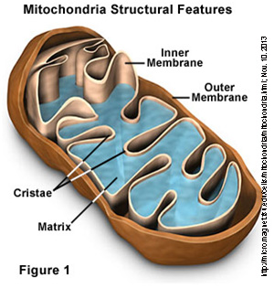

THE HUMAN EVOLUTIONARY BUSH

The available physical anthropological data have changed the picture of a evolutionary “tree” which, at one time, presented a clear path from a creature named Ramapithecus to homo sapiens. Now the “tree” has changed to an evolutionary bush with several different possible interpretations. There is no consensus that Australopithecus or Ardipithecus are in the line of decent of man from an unknown non-hominid common ancestor, but they remain prime candidates. The dissentions are seen in the interests of re-classifying some Australopithecus fossils in the genus Paranthropus.

Ecological Preparation

Human and non-human fossils are found in complex ecosystem settings that took millions of years to produce. The appearance of man in the fossil record occurred when a series of carefully orchestrated ecological changes resulted in an environment that favored man’s survival, migration and expansion. Modern humans appear during the last Ice Age and developed a set of skills that made them able to survive in almost any environment. The hominid predecessors to man, by their interaction with mammals, other animals and plants, had helped create an environmental system in which modern humans could thrive. These interrelationships are dynamic and interdependent because they formed through a process of adaptation/modification over long periods of time. The complex relationships were not created "as is". Our present ecosystems are the result of a series of catastrophes, incremental changes and slow and sudden appearance of new life forms. This biostratigraphy marks a series of progressive events that affected the ecologic history of the earth. In the Biblical account of creation, it is important to note that man was first created like all other animals and then later got a "soul" when God breathed into him "the breath of life." The timing of this spiritual change marks the theological creation of mankind. All forgoing geological history, up to the Pleistocene epoch, can be understood as a carefully engineered program to create the ideal ecological conditions under which mankind could live, interact with its Creator, and “fill the earth” with humans as proscribed in Genesis 1:28. An alternative is to sum it all up as accidents of nature, fortuity and coincidence.

A Definition of “Human”

What makes a human? According to the Bible, humans are distinguished from other animals by the possession of a soul. While scientific detection and measurement of the human soul may not be possible, the anthropological record can give clues as to its earliest existence by way of burials. If it is assumed that only humans bury their dead, the presence of burials made by members of the “Primate Family Bush” would indicate which had souls. Using this classification, the earliest humans may have been Homo erectus because at least some of them had an interest in an afterlife. If the Erectus burials were made by Erectus, the organism into which God breathed the “breath of life” may have been Homo Erectus. But archaic homo sapiens were contemporaneous with late Erectus. So apparent Erectus burials may have been made by archaic homo sapiens or neanderthalensis (Neanderthal) out of respect. Some animals, like Mammoths, bury their dead too. Furthermore, humans bury loved animals in pet cemeteries. So burials, in and of themselves, are not necessarily indicative of the human soul.
The word burial comes from the Anglo-Saxon word birgan, meaning to conceal. The earliest archaeological evidence for the deliberate treatment of the dead is in the form of ancient burials. Homo neanderthalensis dug holes to bury their dead. At Qazfeh in Israel, some 115,000 years ago, there is evidence of the deliberate burial and positioning of bodies in caves. In one example, the left hand of a buried child had been placed on a deer skull and antlers positioned on the child's neck. Neanderthal burials have also been found in southern France, the northern Balkans, Syria and Central Asia (http://www.deathonline.net/disposal/burial/index.cfm ; Aug. 9, 2005)
There is scant evidence that these hominids lived in the caves and only the bones of teenagers and young adults have been found, indicating that the bones may have been intentionally placed in the pit (http://www.deathonline.net/disposal/burial/index.cfm ; Aug. 9, 2005).
Neanderthal DNA is different from the DNA of Homo sapiens sapiens (http://cogweb.ucla.edu/Abstracts/Goodwin_00.html ; Aug 9, 2005). But modern humans contain upwards of 2% Neanderthal DNA in our genome.

PHOTO LINK: GENETICS 001 Duplicate mutation ; http://www.mydna.com/genes/genetics/genetics101/geneticdisorders_family.html ; Aug 11, 2005
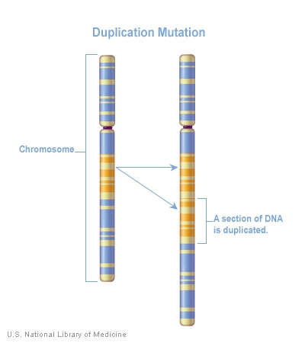

PHOTO LINK: GENETICS 002 Double helix ; http://www.mydna.com/genes/genetics/genetics101/genetics_dnagene.html ; Aug 11, 2005
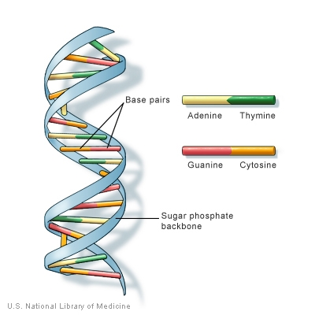
But some Neanderthals did exhibit behaviors that were human: they made tools and buried their dead. Neanderthals may have been a branch of proto-humans with that went extinct. They played an important role in preparing the ecology of various parts of the earth for the appearance of homo sapiens sapiens (Adam and Eve).

Creation of Humans

In the account of the creation of man in Genesis 2:7 it says "And the Lord God [Yahweh Elohim, later Adonai Elohim] formed man of the dust of the ground, and breathed into his nostrils the breath of life." The word for "formed" (yatsar) indicates the actions of a potter. The Hebrew word for "man" is adam and the word for "ground" is similar: adamah. The term "breath of life" is mishnat chayyim (Livingston, 1992). This breath of life is different than that of the animals (Gen 7:15. There is a mystical relationship between spirit, breath and wind in Genesis. Adonai Elohim’s breath gives life to dead earth (clay) and this breath is a critical component of man’s creation in the image of God. God placed his pinnacle of creation in a garden, in an ecosystem ideally suited for him. When man dies, his body returns to the earth (Gen 3:19; Eccl 3:20) and the spirit returns to God who gave it in the first place (Eccl 3:21; 1 Cor. 15).

Image of God

The statement that mankind was made “in the image of God” (Genesis 1:29) has parallels with Mesopotamian theology where the king is the image of God (Tsumura, 1996 citing Clines, 1968 and Bird, 1994). The Hebrew “twist” on the idea is that instead of humanity being made as servants for the gods, humanity is a royal family who collectively express the “image” of God. Adam and Eve were created like (resembling) God, but as creatures, they had to be male and female (like the animals). The divine/animal dualism was there from the beginning.

FROM HUNTING-GATHERING TO AGRICULTURALLY BASED SOCIETIES

Agriculture and herding both developed about 10,000 years ago. This is reflected in the job descriptions of Cain (a farmer) and his brother Able (a herder). In early human societies, gathering was the main activity. Hunting was secondary. Gathering was replaced by agricultural innovations as populations grew and climatic changes made gathering unreliable. These innovations included selective breeding, irrigation. The available evidence indicates that when productivity of gathering waned, a shift was made to agriculture. This process is illustrated in Genesis where Adam and Eve's situation changes from one of gathering (Gen 1:29 "See I give you every seed-bearing plant...every tree...they shall be yours for food") to cultivation (Gen 3:17-19 "By toil you shall eat...by the sweat of your brow shall you get bread to eat"). The Hebrew is not so clear as English for Genesis 2:15 where humans are placed in the Garden "to till it and tend it." The words are 'eved ('VD = to work, to serve) and shamar (SMR = watch, guard, keep). A better translation would be that Adam and Eve were placed in the Garden to "serve and to guard" it. So it wouldn't be right to say that they were gardeners or farmers. They were servant guardians like the cherubim of Genesis 3:24 where the same word is used (Beach and Pryor, 1995).

PHOTO LINK: CHERUBIM 002 Ivory Cherubim. Borowski, 1995, BAR, 21:4:cover. Photograph by David Harris / Bible Lands Museum
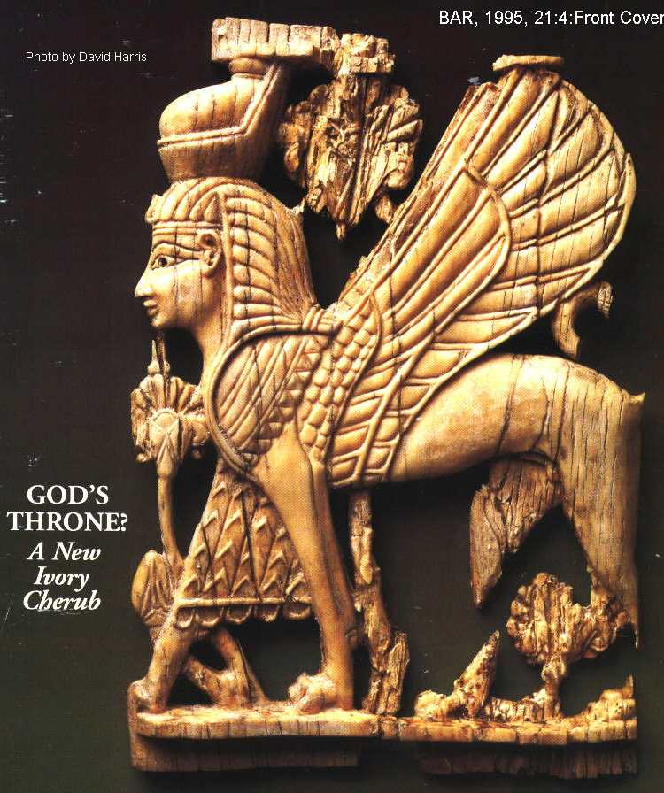

The archaeological record indicates that agriculture/herding societies preceded fully nomadic economies. This deduction is consistent with Genesis where true nomadic life is described as occurring six generations after the Fall when Lam arch's son Jabal is born. He "was the ancestor of all who dell in tents and amidst herds" (Gen 4:20; Beach and Pryor, 1995).

PHOTO LINK: HUNTER 001 Buffalo hunt in spring with snowshoes; ; http://www.collectionscanada.ca/canadian-west/052910/05291012_e.html ; Aug 12, 2005
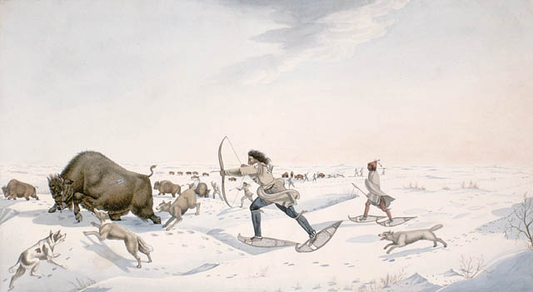

PHOTO LINK: HUNTER 002 Buffalo hunt in wolf disguise; George Catlin 1930's ; http://www.mce.k12tn.net/indians/reports4/plains2.htm ; Aug. 12, 2005
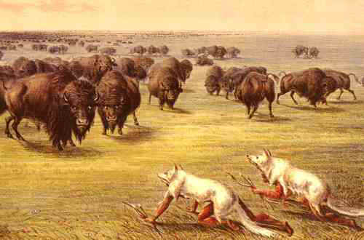

PHOTO LINK: GATHERING FOOD 001 Gathering food Western Asia, Julius Moessel ; http://www.fieldmuseum.org/research_collections/ ecp/ecp_sites/NPI_web/moessel/79708.htm ; Aug. 12, 2005
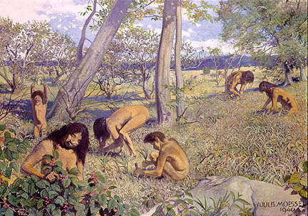

PHOTO LINK: FARMING 001 Grinding corn, Mexico ; Julius Moessel ; http://www.fieldmuseum.org/research_collections/ecp/ecp_sites/NPI_web/moessel/83278.htm ; Aug. 12, 2005
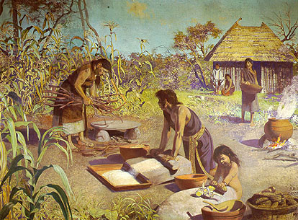

PHOTO LINK: FARMING 002 Planting rice Phillipines; Julius Moessel ; http://www.fieldmuseum.org/research_collections/ecp/ecp_sites/NPI_web/moessel/83277.htm ; Aug. 12, 2005
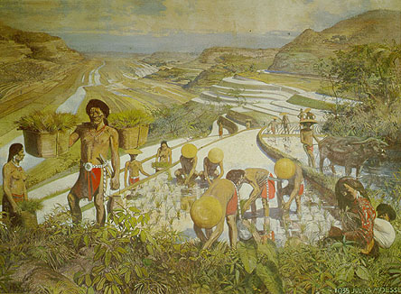

Adam's descendants did not have a very rewarding early agricultural experience as suggested by Genesis 4:3,5 where God reject's Cain’s offering from the "fruit of the soil". Later, after Abel's murder, YHWH imposes additional burdens "If you till the soil it shall no longer yield its strength to you" (Gen 4:12; Beach and Pryor, 1995).

Eating habits described in Genesis do not agree with the anthropological data. Genesis 1:29 suggests that Adam and Eve were vegetarians, but archaeological information indicates that humans have always been omnivores. A partly carnivorous diet is ordained by God following the Flood in Genesis. 9:3-9 (Beach and Pryor, 1995).

Hunting as an occupation is first described for Nimrod ("a mighty hunter before the Lord") in Genesis 10:9. Hunting's late mention in Genesis may reflect that hunting was not a very important element in Israel's view of its origins. It accords well with the anthropological information that early gathering-hunting societies were mostly gatherers with supplemental hunting activities (Beach and Pryor, 1995).

OLDEST CITIES

The Bible’s first mention of cities is in Genesis 4:17 where Cain built a city for his son Enoch. The Sumerian city of Eridu (a name that equates to Enoch's son Irad) is the oldest site (6th millennium BC) in Southern Mesopotamia. It is located 12 mi south-southwest of Ur. The next phase in urban development, the "city-states" or “city-kingdoms” date to the 2nd millennium BC (Alalakh, Ugarit Tell el-Armana; Wood, 1975).

PHOTO LINK: ERIDU 001 Ruins of Eridu at Tell Abu Shahrain ; http://ancientneareast.tripod.com/Eridu_Period.html ; Aug. 12, 2005
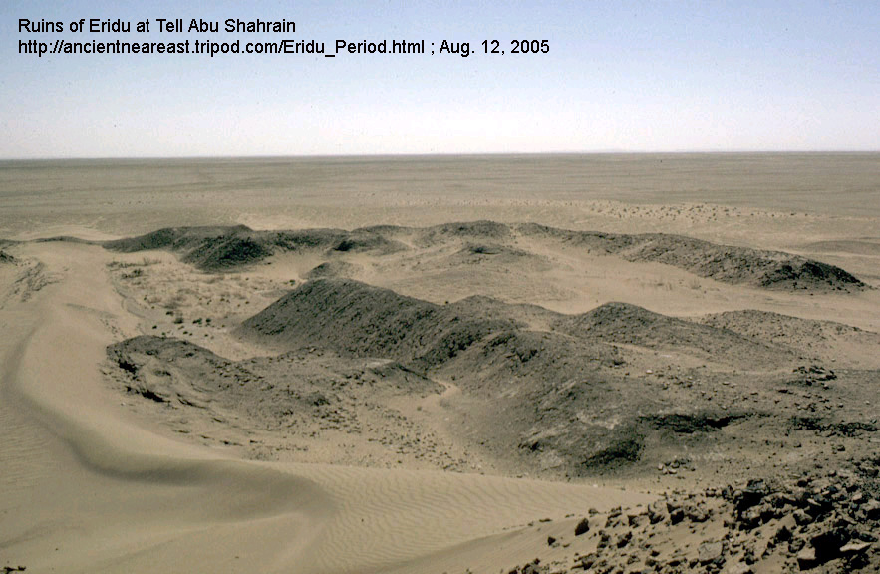

PHOTO LINK: ERIDU 002 Early excavations at Eridu, Tell Abu Sharhrain; ; http://ancientneareast.tripod.com/Eridu_Period.html ; Aug. 12, 2005
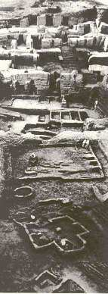

The oldest known city is Jericho which has urban remains to 10,000 years B.P.

PHOTO LINK: BA066 Neolithic Tower, Jericho
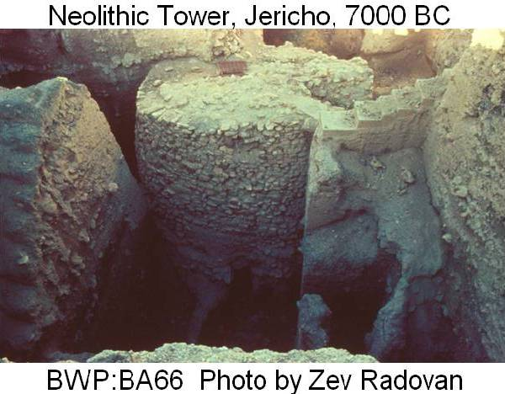

ADAM AND ADAPA IN ANCIENT MESOPOTAMIAN TRADITIONS

The Mesopotamian Story of Adapa has similarities to the Biblical story of Adam. Both heroes underwent a test before the deity and both failed the test. Their failure had consequences for all mankind. Both Adapa and Adam were members of the first generation of mankind (Shea, 1977).

PHOTO LINK: SCRIPTS 003 Adapa tablet Ashurbanipal library Nineveh 7th cent BC. Livingston, 1980, B&S, 9:2:37. Photograph by Pierpont Morgan Library, New York.
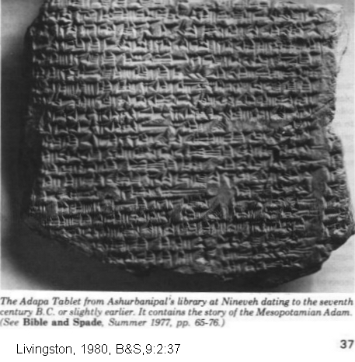

In Mesopotamian traditions, the Sumerian King List has eight extremely long-lived kings from five antediluvian cities. These kings are difficult to match with Sethite genealogy of Genesis 5. In Mesopotamia there were two lines of heroes before the flood: one of kings the other of wise men. A Biblical parallel to this system is found in the Cainite genealogy of Genesis 4 as compared to the Sethite genealogy of Genesis 5. Eridu was the first in the line of five cities that ruled before the Flood. The kings of that city are Alulim and Alalgar while the wise men are Adapa and Uanduga. So Adapa is a contemporary to first king, Alulim and strengthens the parallel with Adam as one who commits of first offence against the god(s) (Shea, 1977).

PHOTO LINK: SUMERIAN KING LIST 003. Livingston, 2009, B&S, 22:2:34. Photograph by Michael Luddini.
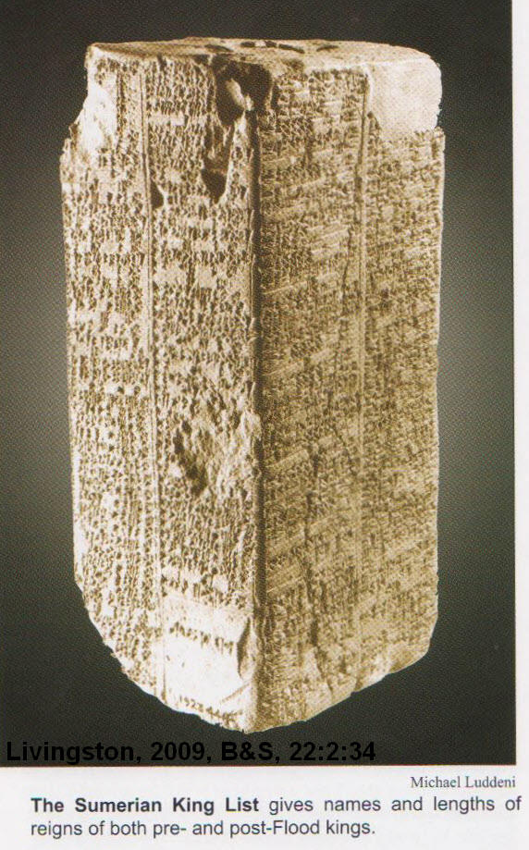

The names Adapa and Adam are similar linguistically (phonemes are interchangeable). The linguistic progression was probably: Adam > Adama > Adaba > Adapa. A similar change of labials (lip-made sounds) is found in other word shifts: Shamash to Shapsh (old Semitic word for sun or sun-god). The opposite change in pronunciation (Adapa to Adam) would have involved nasalization that is generally lost instead of gained during language evolution (Shea, 1977).

According to Shea (1977) the similarities between Genesis and the Adapa Epic are:

-the subjects underwent a test before the deity
-the test was based on something that was consumed
-Adapa/Adam failed the test
-failure resulted in loss of immortality
-the consequences of failure passed on to all mankind
-Adapa/Adam were members of the first generation of mankind
-the names are similar linguistically

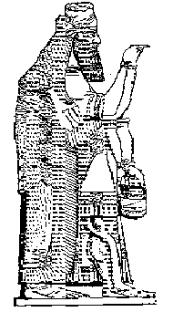
There are noteworthy differences between Genesis and Adapa story. Adapa was tested with bread and water (staples of ancient diet and end product of man's agricultural endeavor) while Adam and Eve were tested by exotic fruit (directly from hands of Creator) representing the knowledge of good and evil. Adapa experiences death by descending from heaven to earth, his former residence ("You shall not have life...Take him away and return him to his earth") while Adam is on earth's surface and is interned within it. Adapa's failure resulted in the "ill he has brought upon mankind, and the disease he brought upon the bodies of men" but Adam's failure results in difficulty in childbirth and in the farmer’s field followed by physical death. Adapa goes up to heaven in mourning clothes per advice of Ea, the god of wisdom. In heaven he accepts new garments and oil, but rejects the bread and water of life. Adam and Eve make garments for themselves from fig leaves (Gen 3:7) but God subsequently clothes them (Gen 3:21). Adapa encounters gatekeepers in heaven (Tammuz and Gizzida) who intercede for him while Adam has cherubim gatekeepers on earth (Gen 3:22) to keep him OUT of paradise and the cherubim have no intercessory role. Adapa goes through a hierarchy of heavenly beings to get to "Mr. Big" while in Genesis, Adam and Eve deal directly and in a personal way with God. Adapa is obedient to Ea and refuses to take bread and water of life (being told it was bread and water of death) and is deceived while God asks Adam to makes choices with consequences that are quite clear.

PHOTO LINK: EA 001 B&W drawing of Ea; http://www.balaams-ass.com/alhaj/ea.htm ; July 26, 2005 (RIGHT)

PHOTO LINK: EA 002 Modern drawing of Ea. http://www.mesopotamia.co.uk/gods/explore/ea.html# ; July 25, 2005
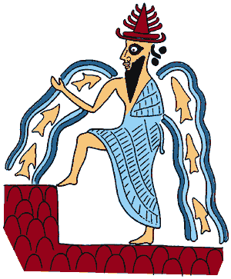

PHOTO LINK: EA 003 Ea in watery world home of Apsu, cylinder seal. http://www.crystalinks.com/sumergods.html ; July 26, 2005
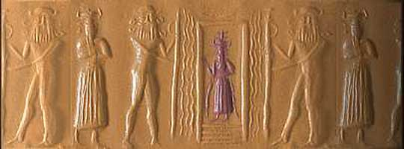

Ea is like the Serpent who deceives man, but the consequence is Ea's not man’s. In Genesis it is man's consequence that sin got a foothold. Ea's deception might be due to friction within the Mesopotamian pantheon. Adapa’s offense was to upset the course of nature (he curses the wind) while Adam's offense is moral. In the Adapa Epic 50% of action takes place in heaven, but in Genesis all of Adam's actions are on earth. Adapa receives royal summons to come to heaven but God goes to earth in search of Adam. Ninkarrak, goddess of healing, exerts an incantation for healing or bringing of disease: a functional shift in epic story telling (Shea, 1977). Her role is similar to that of the Serpent: promising life, but delivering death.

"Gen 1-11 constitutes a truly remarkable literary, religious, and historiographic achievement in the context of the pre-philosophic thought of the ancient world" (Shea, 1977).

WHO BORROWED FROM WHOM?

The similarities between Mesopotamian creation myths and the Genesis stories imply that one borrowed from the other. Liberals say Hebrews borrowed from Mesopotamians and demythologized or historicized the Mesopotamian original stories. Conservatives say Mesopotamians borrowed from Hebrews because of 1) mythological elements in Mesopotamian versions, 2) functions of Mesopotamian versions served socio-political (propaganda) context and 3) linguistic comparisons indicate Adam came before Adapa (see discussion above). Others say they both borrowed from a common source (Amorites). This theory of a common source for both Mesopotamian and Hebrew traditions are based on the presence of western elements in the eastern myths (Enuma Elish and in Atrahasis flood epic), widespread Amorite migrations in Mid Bronze Age and Abraham's migrations in time of Amorites (Shea, 1977).

PHOTO LINK: ENUMAH ELISH 001 CreationTablet. Livingston, 1990, ABR, 3:1:16. Photograph from British Museum.
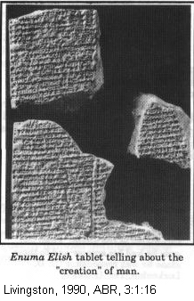

PHOTO LINK: ENUMA ELISH 002. Tablet No. 3, Hurowitz, 2005, BR, 21:1:39. Photograph from British Museum / The Image Works.
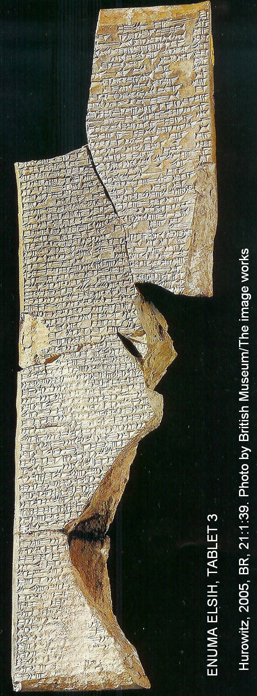

PHOTO LINK: ATRAHASIS 001 Atrahasis Epic clay tablet. Wood, 1978, B&S, 8:1:18. Photograph by British Museum.
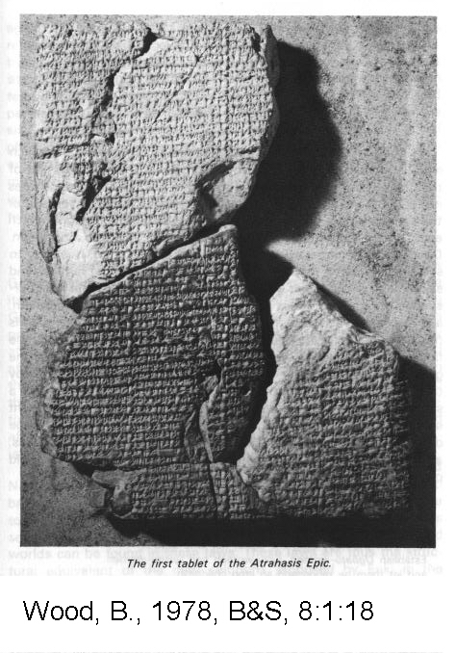

PHOTO LINK: ATRAHASIS 004 Clay tablet with cuniform script. http://en.wikipedia.org/wiki/File:Bm-epic-g.jpg. Nov. 10, 2013.

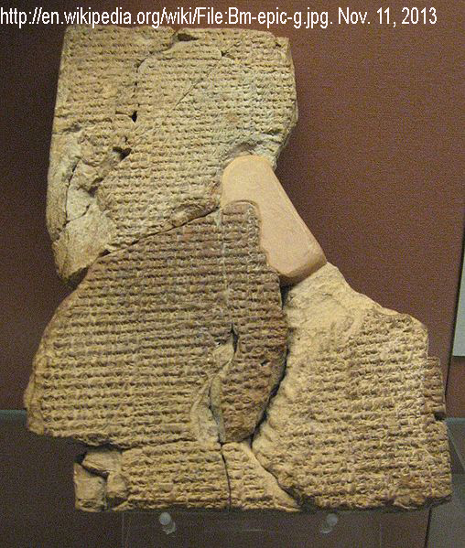

Another explanation for the parallels is that the Mesopotamian and biblical stories provide independent witness to common events but with functional shifts made between the Hebrew and Mesopotamian stories as a result of their divergent cultural base (Shea, 1977). Hurowitz (2005:46) points out that any the Hebrews would have more likely encountered Mesopotamian traditions through their contacts with their neighbors, the civilizations of Syria (Ugarite). The motifs and themes of ancient creation theories from different societies of the Near East can be similar and to prove that one depended on another may be an over-simplification of what actually happened. The writers and editors of Genesis were familiar with the Mesopotamian traditions, in both their early and late forms. They used some of those motifs in the Hebrew Epic. Likewise, Hebrew thinking probably influenced some Mesopotamian traditions too.

GENERATIONS OF GENESIS: THE COLOPHON

Genesis 5:2 identifies the "book of the generations of Adam.” In this verse, generations (Hebrew, sepher) refers to any type of writing material but in mesopotamia this was clay tablets (DeWitt, 1977).

In Mesopotamia, during the epoch of the Patriarchs, in the Early and Middle Bronze Age, the colophon was a widely used scribal devise. The colophon denoted both the history on the face of the tablet (or series of tablets) and an attached genealogy probably inscribed on the back (and sometimes on side of the tablet). Colophons were used when there was an emphasis on covenants (oral/written business or clan agreements). The colophon was an exclusively Mesopotamian practice for writing on clay tablets. The colophon was a notation at the end of the tablet identifying what preceded it (DeWitt, 1977).

An example of the use of the colophon comes from Nuzi tablets (1950 BC) 210 and 211. These clay tablets record a sale of a slave on ones side ("history") and list of officials or personal names ("genealogy") on the other. A Babylonian tablet with the genealogy of Hammurapi (1600 BC) has same format with colophon (DeWitt, 1977).

PHOTO LINK: GENESIS COLOPHON HAMMURABI 001 Hammurabi code tablet with colophon. DeWitt, 1977, B&S, 6:2:48. Photograph from British Museum / tablet 80328.
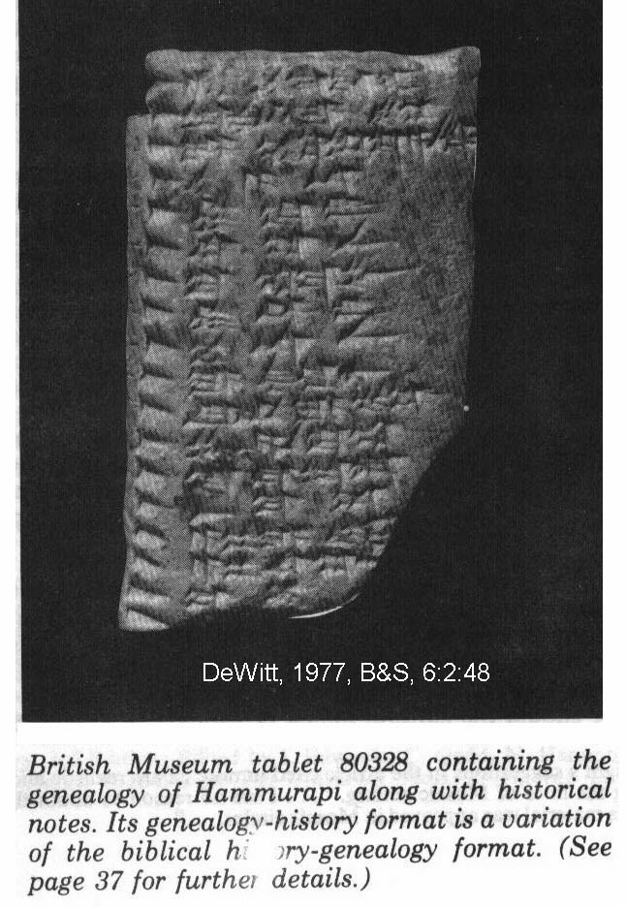

PHOTO LINK: GENESIS TABLETS 001 Tablet of Gen 2:4 (The Creation Tablet). From DeWitt, 1977, B&S, 6:2:9:39 .
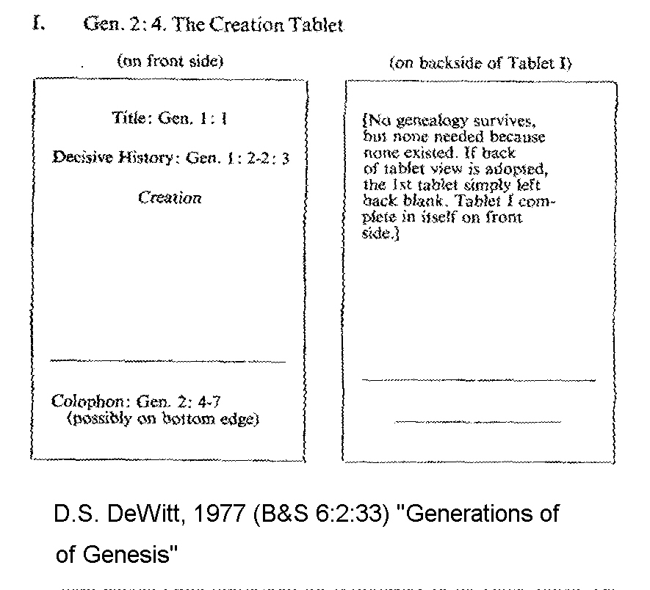

PHOTO LINK: GENESIS TABLETS 002 Tablet of Gen 5:1 (Adam Tablet): Tablet of Gen 6:9 (Noah Tablet). From DeWitt, 1977, B&S, 6:2:40.
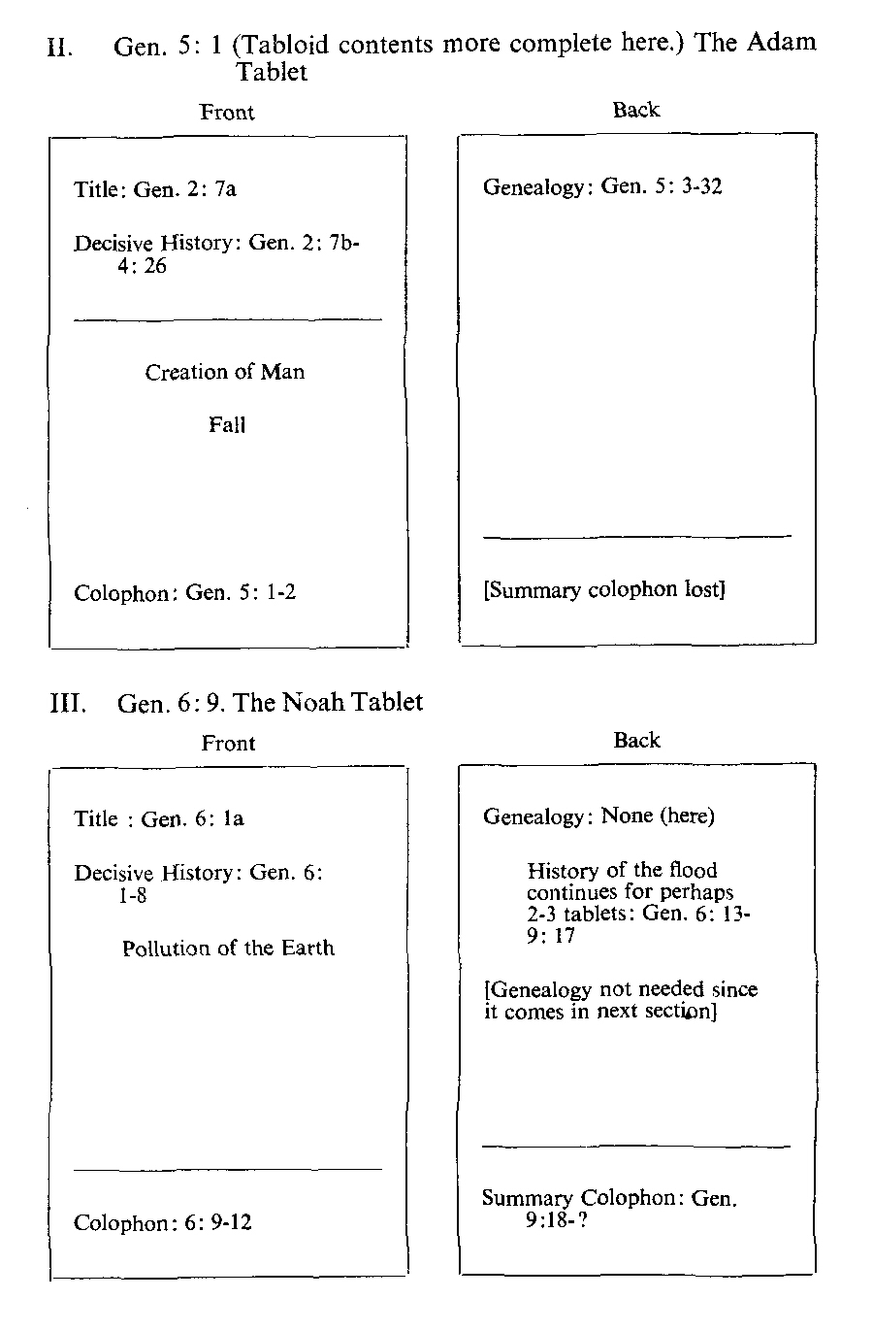

PHOTO LINK: GENESIS TABLETS 003 Tablet of Gen 10:1 (Sons of Noah Tablet): Tablet of Gen. 11:10 (Shem Tablet) From DeWitt, 1977, B&S, 6:2:41.

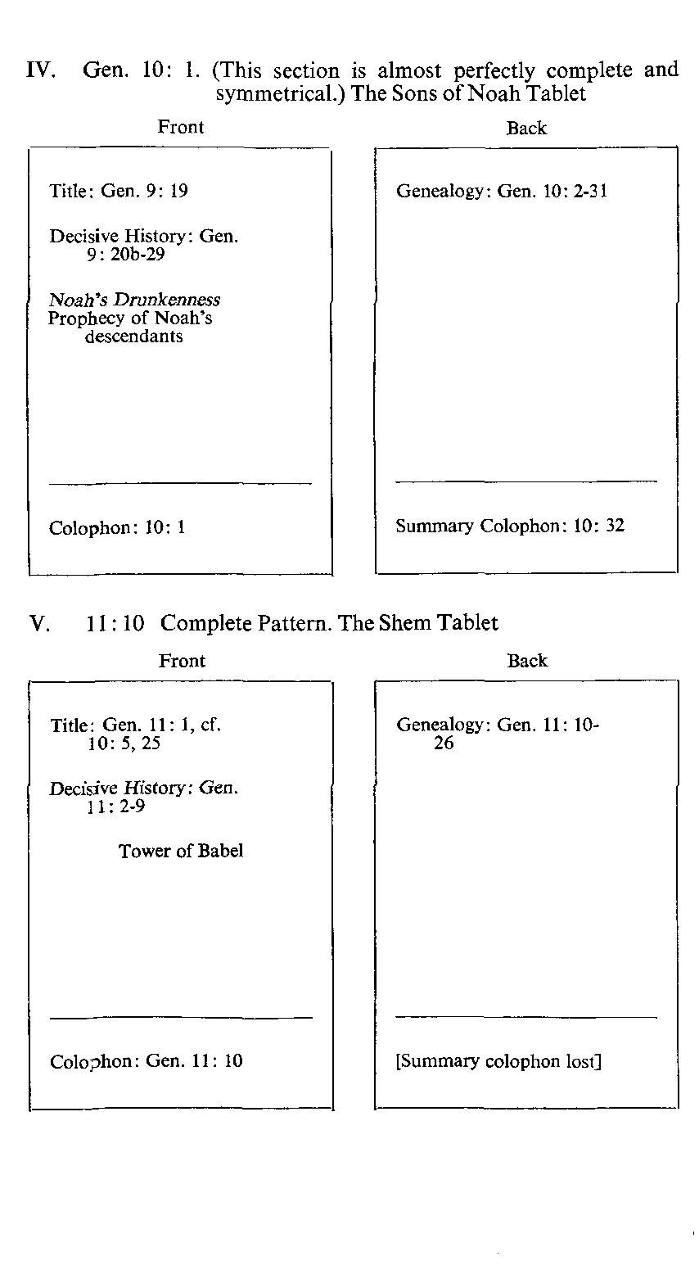

PHOTO LINK: GENESIS TABLETS 004 Tablet of Gen. 11:27 (Terah Tablet): Tablet of Gen. 25:12 (Ishmael Tablet) From DeWitt, 1977, B&S, 6:2:42.
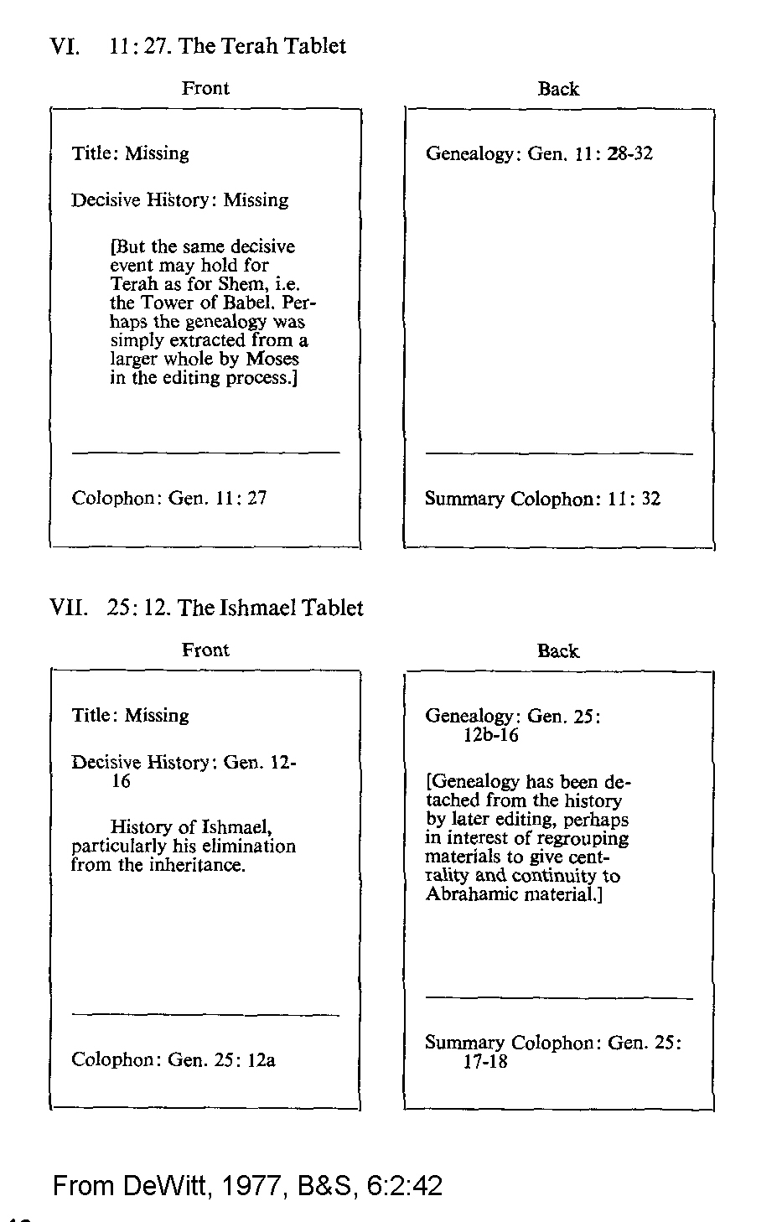

PHOTO LINK: GENESIS TABLETS 005 Tablet of Gen. 25:12 (Isaac Tablet): Tablet of Gen. 36:1 (Esau Tablet). From DeWitt, 1977, B&S, 6:2:43.
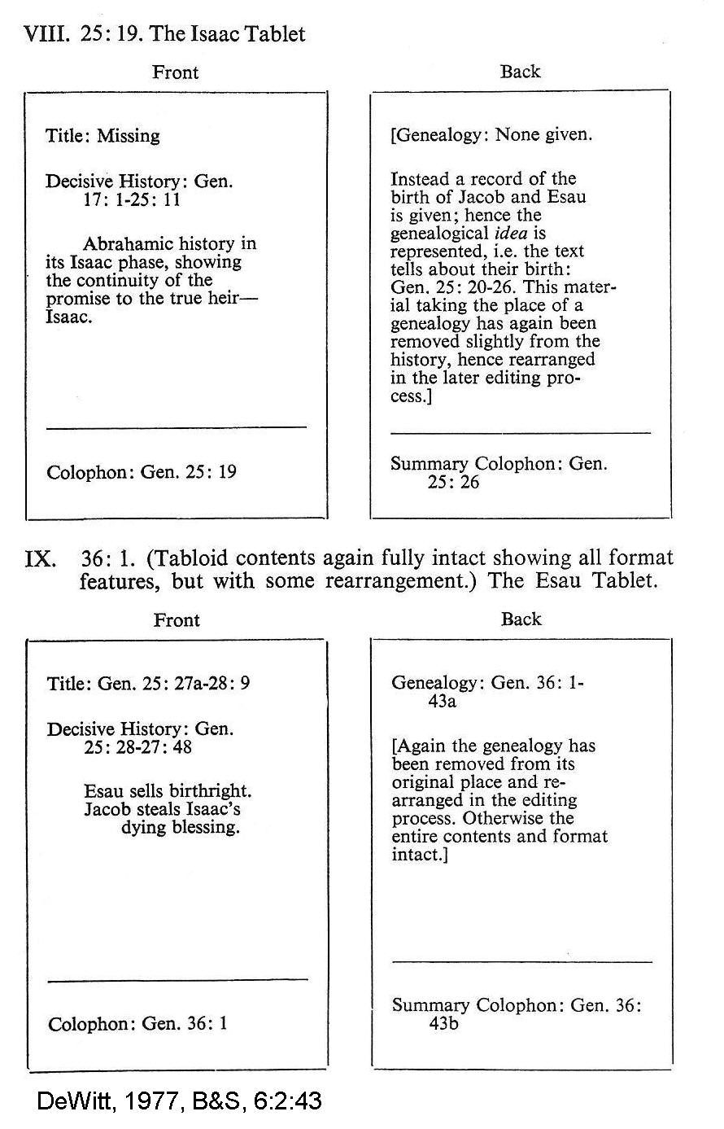

PHOTO LINK: GENESIS TABLETS 006 Tablet of Gen. 37:3 (Jacob Tablet) From DeWitt, 1977, B&S, 6:2:44.
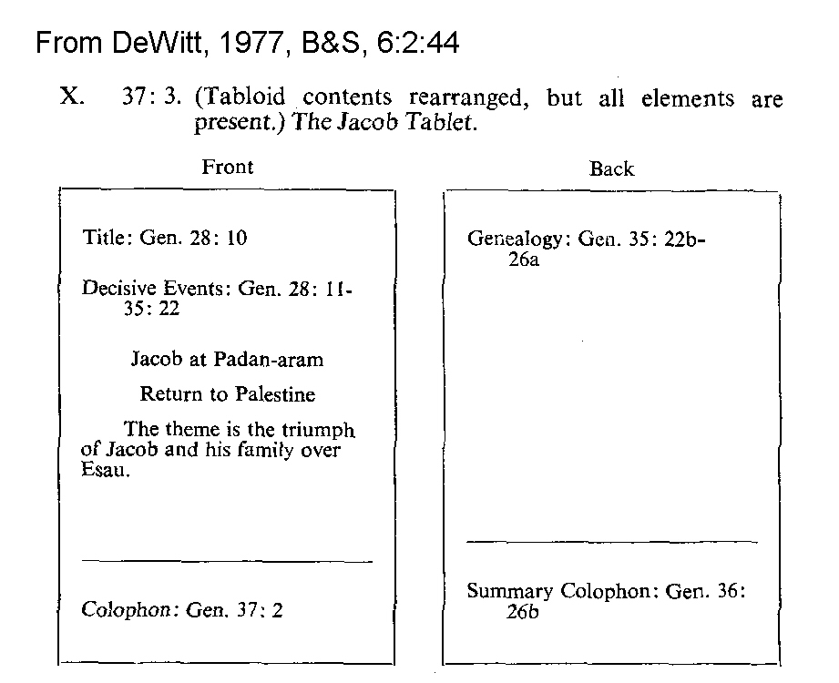

The colophon is marked in Genesis by the phrase “These are the generations of”. It is unknown who compiled the early patriarchal narratives (Genesis 1-36). Abraham or Isaac have been suggested (DeWitt, 1977).

It is significant that the colophon literary style is not present in the Joseph narratives (who would have preferred and Egyptian system; DeWitt, 1977).

The structure of the colophon system suggests that they were mnemonic devices for the recital of history-genealogies associated with burial rituals. Such use of the colophon has several Amorite parallels (Mari, Cappadocian, Alalakh texts). The kispu ceremony (pre-Sargonic Sumner to Neo-Babylonia) invited dead spirits to share meal with royal family. Similar ritual forms are seen in Genesis 23, 23, 48-50 (DeWitt, 1977).

Dewitt (1977) speculates that Jacob continued the work of compilation of patriarchal narratives. A table identifying possible authors for the Genesis tablets as reconstructed by colophons is provided in the following illustration:

PHOTO LINK: GENESIS TABLETS 007 Chart: Authors of Genesis. Sewell, 1994:B&S, 7:1:26. 33
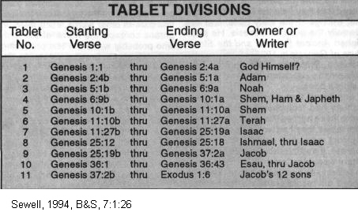

SUMMARY

The first appearance of modern humans occurred in the late Pleistocene geologic epoch, during a relatively warm interglacial period. The most likely location for the Garden of Eden is in equatorial Africa. Mitochondrial DNA studies also indicate this area for the original mothers of mankind. Later Mesopotamian traditions placed the Garden between the Tigris and Euphrates rivers. For millions of years prior to this time, ecologic conditions evolved for the arrival of man (God’s pinnacle of creation), an event that involved 18 billion years of careful preparation and planning. The physical anthropological and DNA records of early hominids indicate that modern homo sapiens sapiens are partly descended Neanderthals, and possibly other early primates. Mankind became a special creation of God, but more than a creature. Humans are the “image of god”, possessing spirit and soul. The historical record of these events is brief, and incomplete. But it is reflected in some aspects of Mesopotamian and Egyptian cosmologies and stories of the first humans. Early written traditions for record keeping were adopted by the Patriarchs and that practice is seen in the application of the colophon to telling of the great Hebrew Epic.

As sin and mankind multiplied after the Fall, climatic conditions also changed. The ice would come and when it melted, a great era of flooding would impact all of human civilization. The Flood Epoch was on its way.

