CHAPTER 9. THE GREAT FLOOD AND TOWER OF BABEL
Contents
YOUNG-EARTH CREATIONISM AND FLOOD GEOLOGY 632
OLD-EARTH CREATIONISM AND A LOCAL FLOOD 633
Floods of Glacial Lake Missoula 633
GEOLOGIC SETTING OF THE FLOOD STORIES 637
MESOPOTAMIAN FLOOD TRADITIONS 639
Gilgamesh Epic 639
Atra-Hasis Epic 647
Capital Punishment and the Atra-Hasis Epic 653
Sumerian Ziusudra Deluge Story 654
Writings of Babylonian Priest Berosus 654
The Epic of Enmerkar and the Lord of Aratta 654
Assyrian Tradition for Confusion of Languages 655
NIMROD 655
LONGEVITY OF THE PATRIARCHS AND THE SUMERIAN KING LIST 658
TOWER OF BABEL 659
Building Materials 666
Ziggurats: Gods in the image of men 666
Dating the Tower of Babel 667
EVOLUTION OF SEMITIC LANGUAGE 668
The Sumerian "Problem" 669

One of the most well known stories in the Old Testament is the Great Deluge, also called “Noah’s Flood”. Floods are common all over the world. Large floods have destroyed entire towns. As a common natural event, flood traditions are known from almost all cultures. Was Noah’s Flood history or parable (myth)? If a mixture of history and myth, is it some history with lots of myth or some myth with lots of history? This question has created impassioned debate since the mid-16th century (AD). In recent years, regular expeditions are made to Mount Ararate in search of Noah’s Ark and many Christian believers support those expeditions financially. After all, they want to show those liberal geologists and theologians that they are wrong, don’t they?

YOUNG-EARTH CREATIONISM AND FLOOD GEOLOGY

As with many sciences in the early phases of the Enlightenment, most geologists were bible-believing and understood the Old Testament as history. Most of the rocks which geologists could observe were believed to have been made during the Great Flood. This also included all the volcanic, plutonic and metamorphic rocks. Rhyolite, basalt, granite, schist: it all came out of solution during the one-year flood. Historic volcanic eruptions and flows were believed to be the result of underground coal fires that heated and melted the rocks. Ancient igneous rocks (volcanic and plutonic) were from the Flood. This early enlightenment view of the earth understood that geologic phenomena formed as a result of swift, large-scale catastrophes. This Deluvinist school was lead by persons like Wegner. In the mid-19th century, early “modern” geologists like Lyell and Hutton said that rocks were the result of a series of long, slow processes that are observed happening today. For example, sandstone formed by waves depositing sand on an ancient beach. This philosophy of science is called uniformitarianism. Ever since those early days of geology, there has been debate between the catastrophists and the uniformitarianists.. Uniformitarianism continues to be a dominant philosophy in geology and successfully explains a broad range of geologic phenomena. It is applied differently now than it was 30 years ago. Geologists now understand floods, volcanic explosions and earthquakes better and realize that, while natural processes are at work, what is usually preserved in the geologic record is the result of catastrophe (e.g. Mt. Etna, Mt. Saint Helens, earthquakes along the San Andreas Fault). What is uniform is the physics and chemistry of the natural interactions involved in those catastrophes and, within these constraints, the rates of the processes may be different than today than they were in the past.

After World War I, fundamentalist geologists began promoting a modern form of Deluvanism. They said that all fossiliferous strata of the earth's crust were formed during Noah's Flood over a one-year period in part due to a gushing of water from the "fountains of the great deep" as well as from the collapse of a great “vapor canopy ” which heretofore had been part of the “heavens”. Longevities of patriarchs were theorized to be due to decrease of cosmic/UV radiation by the vapor canopy of the pre-Flood world. Loss of the canopy had the opposite affect of increasing cosmic/UV radiation and decreasing life spans after the Flood. While rejecting the “Big Bang” cosmology, these “Flood geologists” did accept a modified form of plate tectonics because the Bible states that the "land was divided" in days of Peleg (Genesis 10:25).

Some young-earth creationists/Flood geologists date of Flood at 2900-3000 BC (Livingston, D., 1993). Others are willing to push it back to 10,000 yrs ago.

Present day deluvanism is promoted by the Institute for Creation Research (see http://www.icr.org/). Geologic facts that refute Flood Geology are summarized in Appendix 5. Associated with Flood Geology literature is a bulk of information on possible sightings and locations for the Ark of Noah. There is even debate about the location of Biblical Mount Ararat. Crouse and Franz (2008) suggested it was Mount Cudi. See a discussion of this idea in Lanzer (2008).

OLD-EARTH CREATIONISM AND A LOCAL FLOOD

Rather than having all fossiliferous rocks form in the Great Deluge, old earth creationists see the biostratigraphic record of Earth as the result of a series of catastrophes occurring over the past 4.7 billion years (For information on the how the age of the earth is deduced, see Dalrymple, 1991). There is no geologic evidence to support the idea of a great world-wide flood (Dietz, 1993). There is plenty of evidence that Earth has experienced floods, some quite large.

Floods of Glacial Lake Missoula

One of the best studied series of large floods in Earth’s history are the Great Floods of Lake Missoula, or the Missoula Floods. These floods were caused by the break-up of an ice dam on glacial lake Missoula. The dam was 2,000 feet high. The lake, at its maximum height, contained 500 cubic miles of water and was 200 miles long When the ice dam broke, the catastrophic release of water resulted in a large flood of ice- and dirt-filled water that rushed down the Columbia River drainage, across northern Idaho and eastern and central Washington, through the Columbia River Gorge, back up into Oregon's Willamette Valley, and finally pour into the Pacific Ocean at the mouth of the Columbia River. The flood released more water than 10 times the flow of all earth rivers combined. This towering mass of water and ice literally shook the ground as it thundered towards the Pacific Ocean, stripping away thick soils and cutting deep canyons in the underlying bedrock. With flood waters roaring across the landscape at speeds approaching 65 miles per hour, the lake would have drained in as little as 48 hours. The Missoula Floods carved out more than 50 cubic miles of earth, piled mountains of gravel 30 stories high, created giant ripple marks the height of three-story buildings, and scattered 200-ton boulders from the Rockies to the Willamette Valley. Grand Coulee, Dry Falls, Palouse Falls -- all were created by these flood waters, as were the Missoula and Spokane ground-water resources, numerous wetlands and the fertile Willamette Valley and Quincy.

PHOTO LINK: MISSOULA FLOODS 001 Map : http://vulcan.wr.usgs.gov/Glossary/Glaciers/IceSheets/Maps/map_missoula_floods.html ; April 10, 2005
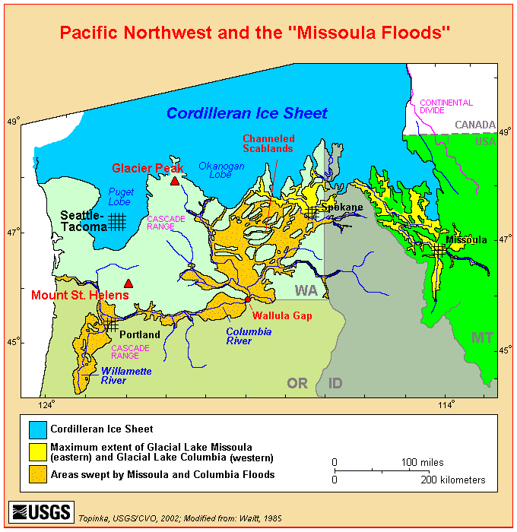

PHOTO LINK: MISSOULA FLOODS 002 Giant Coolees ; http://students.washington.edu/dfinlays/classes/geology201/floodpres/img6.htm April 10, 2005
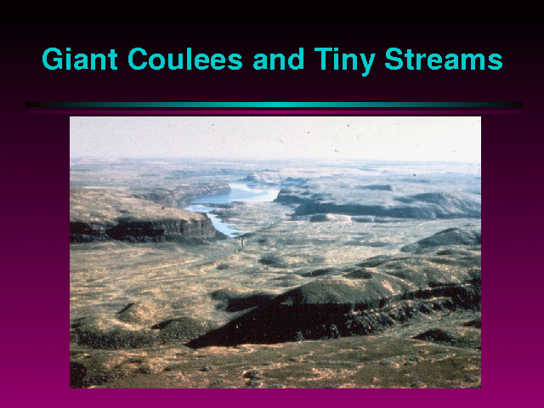

PHOTO LINK: MISSOULA FLOODS 003 Giant Sand Ripples ; http://students.washington.edu/dfinlays/classes/geology201/floodpres/img6.htm ; April 10, 2005
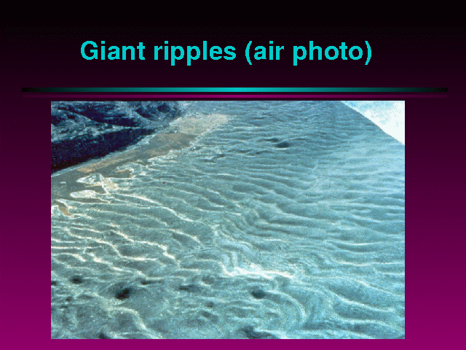
PHOTO LINK: MISSOULA FLOODS 004 Dry Falls; http://students.washington.edu/dfinlays/classes/geology201/floodpres/img7.htm ; April 10, 2005
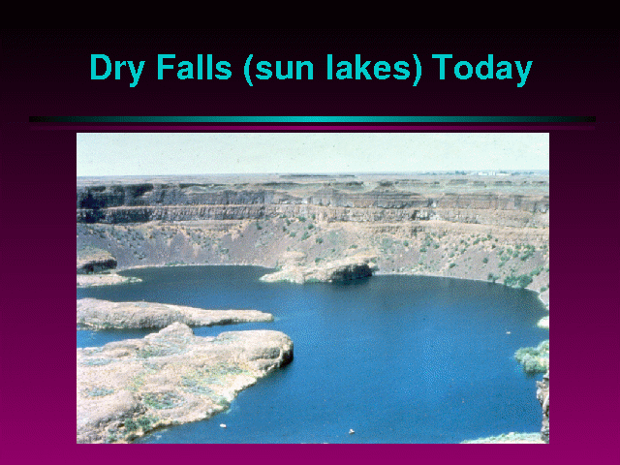

PHOTO LINK: MISSOULA FLOODS 005 Falls Reconstructon with water ; http://students.washington.edu/dfinlays/classes/geology201/floodpres/img8.htm ; April 10, 2005
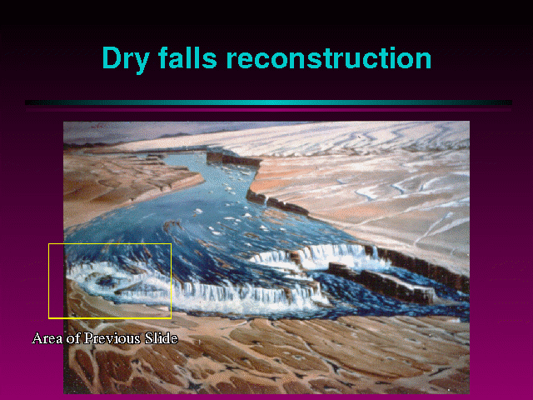

GEOLOGIC SETTING OF THE FLOOD STORIES

The geologic setting of the early patriarchal narratives is in the late Ice Age. Noah’s Flood is a memory of a Missoula Flood-like event where the Tigres-Euphrates valleys were flooded by the rapid draining of pluvial lakes. Additional flooding may have been caused or exacerbated by rising of sea level and landward encroachment of the Arabian Sea.

Local floods have been documented at several Mesopotamian cities (MacDonald, 1988). Excavation of royal tombs at Ur and Kish had evidence of flooding with flood levels sandwiched between layers of the Al Ubaid pre-historic cultural phase . The Ur flood in 3500 BC did not cover entire city mound and there are no flood deposits at Eridu, just seven miles away and separated from Ur by a low ridge. The flooding at Ur left eleven feet of flood debris.

PHOTO LINK: FLOOD 005 Sir Edward Wolley with 2nd millennium BC statuette at Ur. Sauer, 1996, BAR, 22:4:56. Photograph by British Museum.
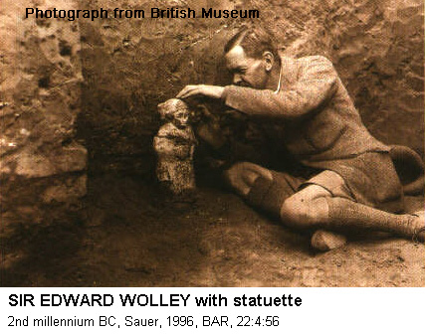

PHOTO LINK: FLOOD 006 Sir Edward Wolley's cross section showing flood deposits at Ur. Sauer, 1996, BAR, 22:4:56.
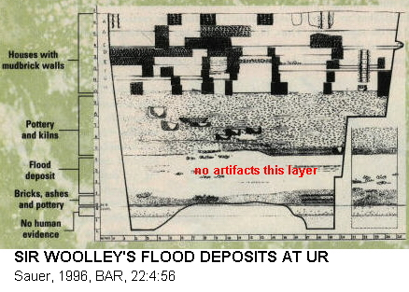
PHOTO LINK: FLOOD 007 Two Arab woman on either side of Woolley's "Flood" deposit. Sauer, 1996, BAR, 22:4:56. Photograph from British Museum.
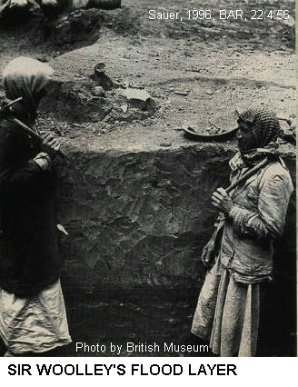

Flooding at Kish in 3000-2900 and 2600-2300 BC left ten inch debris layers. A flood at Shurappak (home of Sumerian Noah, Ziusudra) in 2950-2850 BC left a fifteen inch layer. These deposits were considered by Sir Leonard Wolley to have been made by the Deluge. He later retracted his identification because the “Flood” strata were too old to date from the time of Noah (Sauer, 1996:56)

These Holocene flood deposits corroborate other evidence (pollen, incised drainages) that the Middle East had a much wetter climate between 7500 and 3500 BC (Sauer, 1996:56).

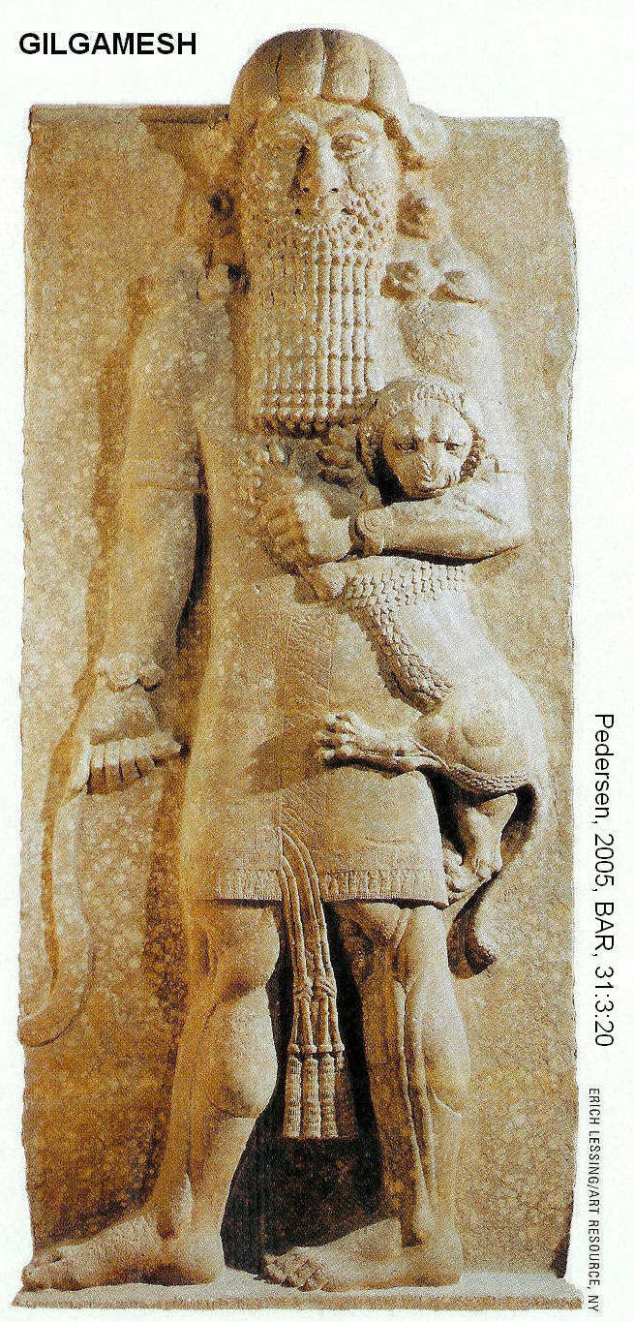
The main objection to old-earth local flood theories is that they require the Noah story be understood as a mythological allegory rather than pure history. Jesus and the Apostles (they assert) believed Noah’s Flood to be a historical event. Therefore, in the young-earth view, we should view them the same way. To do otherwise, they say, would undermine Jesus’ and the Apostle’s authority and credibility.

MESOPOTAMIAN FLOOD TRADITIONS

Gilgamesh Epic

The Gilgamesh Epic was first found at Nineveh, from tablets dated to the 7th century BC found at the library of Ashurbanipal (668-627 BC). The text was translated by George Smith in 1872. This epic was based on a historical person, later mythologized, who lived 2700-2600 BC. The flood portion of the Gilgamesh Epic appears as a sub-story in the main epic plot. For a complete summary of the Epic, see Appendix 8. In the 9th tablet of the Epic, Gilgamesh listens to a story about Flood and its hero Utnapishtim. According to the Epic, Gilgamesh lived several hundred years after the Flood which occurred in 2900-2800 BC. This date matches late flood layers at Kish and Shurappak (Livingston, 1979; Rapaport,1983; MacDonald, 1988).

PHOTO LINK: GILGAMESH 010 Relief of Gilgamesh 18th century Khorsebad, Pedersen, 2005, BAR, 31:3:20. Photograph by Eric Lessing / Art Resource.

A synopsis of the Gilgamesh Epic was given by Elwell (2001:533) and is reproduced, below. The Epic…

tells of how a strong ruler, Gilgamesh, became friends with Enkidu, a hunter the gods had created to overthrow him. Together the two killed the monster Huwawa. Ishtar, the goddess of love, made advances to Gilgamesh. In resisting her, he killed the sacred heavenly bull. Enkidu died as a punishment for that crime. Gilgamesh, overcome by grief, traveled the world seeking the source of immortality, finally arriving at the homeland of Utnapishtim. In Tablet XI Utnapishtim describes a devastating flood that drowned a large area of Mesopotamia. Through his piety Utnapishtim was saved and given immortality by the gods. The final tablet contains an expression of sadness over Gilgamesh's mortality (Elwell 2001: 533).

PHOTO LINK: GILGAMESH 007 Statue of Gilgamesh from Khorsabad Palace, Assyria. Toorn, 2000, BR, 16:1:29. Photograph from British Museum.
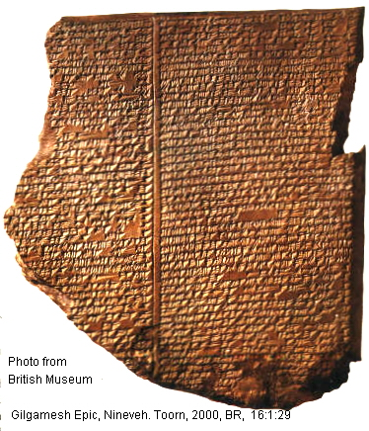

PHOTO LINK: GILGAMESH 001 Sumerian King List with ages of kings before and after flood with part of tablet. Livingston, 1990, ABR, 3:1:12.. Photographs by David Livingston.
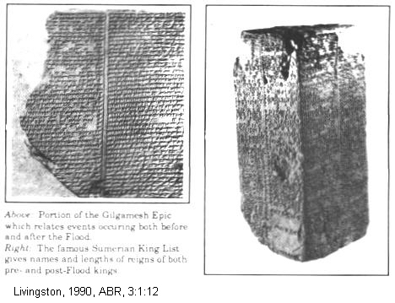

The following is a summary of the flood story portion of the Gilgamesh Epic from Tablex XI (TXI):

The great Mesopotamian primordial deities (Anu, Enlil, Ea, Huwawa) decided to bring about an abubu on the earth without any reason given.

PHOTO LINK: GILGAMESH 005 Mask of Huwawa, foe of Gilgamesh

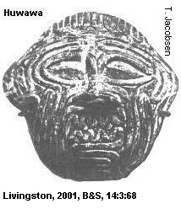

PHOTO LINK: HUWAWA 001. Clay mask of demond Huwawa from Sippar, Iraq, 1800-1600 BC. http://www.britishmuseum.org/explore/highlights/highlight_image.aspx?image=ps118355.jpg&retpage=18671
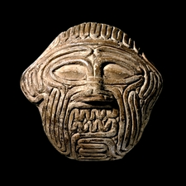

PHOTO LINK: GILGAMESH 011 Tablet fragment of Epic from Meggido, 15th century BC. Pedersen, 2005, BAR, 31:3:20. Photograph by Eric Lessing / Art Resource.

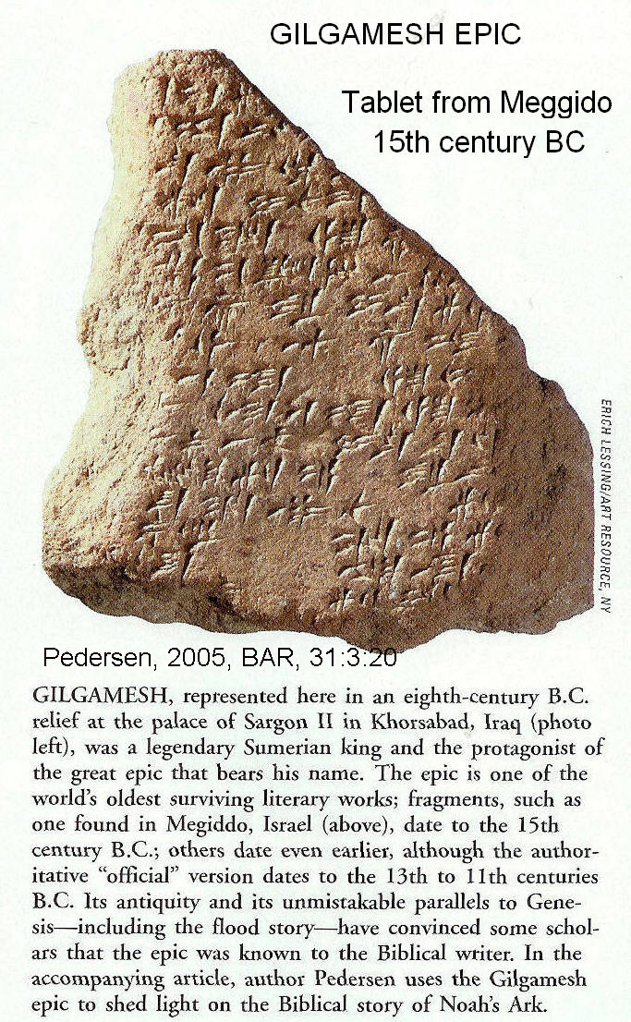

These deities lived in the city of Shuruppak by the Euphrates. Ea secretly divulged this decision to Utnapishtim (Akkadian for "he found life”), a resident of Shuruppak. Utnapishtim built a ship (not an ark) that took him out to sea to live with Ea for six days until the planned upheaval on the land was over. While Utnapishtim is protected by Ea, the other deities almost went berserk while the land was being destroyed and humanity exterminated. Annunaki gods set the land ablaze with torches. Following this devastation, birds were sent out by Utnapishtim. TXI indicates that this was done to test the weather after the cyclone. After the destruction, the deities came "like flies" to Utnapishtim's post-abubu offering. The goddess Ishtar tried to exclude Enlil from Utnapishtim's offering.

Enlil was angry that someone survived the abubu. After harsh words from Ea, Enlil went up to the ship, pulls out Utnapishtim and his good lady, and they are raised to status of deities. Then they are placed "at the mouth of the rivers" where they are presumably alive to this day (Livingston, 1979; Rapaport, 1983; MacDonald, 1988).

No reason for why the Flood was necessary is given in the Epic.

In the Akkadian text, Tablet XI (TXI, Rapaport), there are few similarities with the Genesis flood story to indicate that Gilgamesh Epic was a source for the biblical narratives. Significant differences are noted between the stories. The source of water in Genesis is "windows of heaven" and "fountains of the deep", but there is no source for the water in TXI. There is no mention of rain or water in TXI but 24 references to it in Genesis. TXI tells of dry upheaval that had nothing to do with a Flood:

TXI:128-132 (translation by C.J. Gadd)

For six days and nights
The wind, the storm raged, and the cyclone [aduba] overwhelmed the Land.
When the seventh day came the cyclone ceased,
the storm and battle which had fought like an army
The sea became quiet, the grievous wind went down, the cyclone ceased.

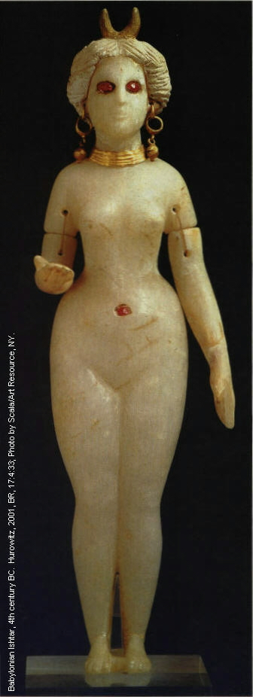
PHOTO LINK: IDOLS 009 Babylonian alabastarIshtar with gold earrings and ruby navel. Hurowitz, 2001, BR, 17:4:33. Photograph by Scala / Art Resource, NY.

PHOTO LINK: ENLIL 001 Standing figurine of Enlil Nippur/Nuffar Early Dynastic II-III, c. 2550 BC. Limestone, h. 27.5 cm. ; http://www.minervamagazine.com/exclusives/iraq_05.php ; July 25, 2005
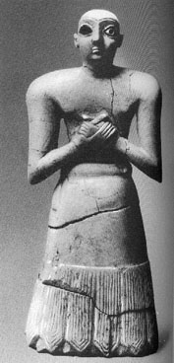

Excavation of Shuruppak, home to the hero of the Epic, yielded no indication of destruction by floods, but lots of evidence of destruction by fire. While Noah sought safety from Flood, Utnapishim sought escape from land upheaval (Livingston, 1979; Rapaport, 1983; MacDonald, 1988).

TXI is dated to the 7th cent BC (Ashurbanipal's [669-626] library in Nineveh). The present form of the Genesis Flood story dates from compilations in the 10th century BC. So Genesis was earlier. Liberal scholars think that the original material for the Gilgamesh Epic is older than Genesis and that the Hebrews borrowed the story (Frey-Kensky, 1978). Conservative scholars say that Genesis is the more-accurate and earlier version, corrupted in the Mesopotamian myths (Livingston, 1979; Rapaport, 1983; MacDonald, 1988).

imilarities between the Gilgamesh Epic and portions of Ecclesiasties have been noted (Van Der Toorn, 2000):

GILGAMESH EPIC (words of Shiduri the tavern keeper; from George, 1999. Cited by Van Der Toorn, 2000) | ECCLESIASTIES 9:7-9
But you, Gilgamesh, let your belly be full | Go, eat your bread with enjoyment, and drink your wine with a merry heart
enjoy yourself always by day and by night! | For God has already approved of what you do
Make merry each day.
Dance and play day and night!
Let your clothes be clean | Let your garments be always white
Let your head be washed, may you bathe in water! | Let not oil be lacking on your head
Gaze on the child who holds your hand
Let your wife enjoy your repeated embrace | Enjoy life with the wife whom you love
OTHER PARALLELS:
Who is there, my friend, can climb to the sky?  Only the gods dwell forever with the Sun-god  As for man, his days are numbered,  whatever he may do, he is but wind (George, 1999) | God is in heaven and you upon earth (Ecclesiastes 5:2)  What gain do they have from striving after wind? (Ecclesiastes 5:16)
The towed boat will not sink, a tow-rope of three stands shall not be cut (George, 1999) | A threefold cord is not easily cut (Ecclesiastes 4:12)

Refinements in our understanding of Akkadian have reduced the number of identified similarities between the Mesopotamian flood stories and Genesis. Akkadian adannu, once thought to mean "Flood," now is known to mean "appointed time". The Akkadian abubu replaced adannu as meaning "Flood" and was later translated "cyclone", "windstorm" or "heavy wind” (Livingston, 1979; Rapaport, 1983; MacDonald, 1988)

The similarities that remain suggest that the cosmopolitan compiler/author of Ecclesiastes was familiar with Gilgamesh and other Mesopotamian literary traditions. The Hebrew tradition was probably older.

Atra-Hasis Epic

PHOTO LINK: ATRAHASIS 001 photo of tablet. Wood, 1978, B&S, 8:1:18. Photograph by Trustees of British Museum.
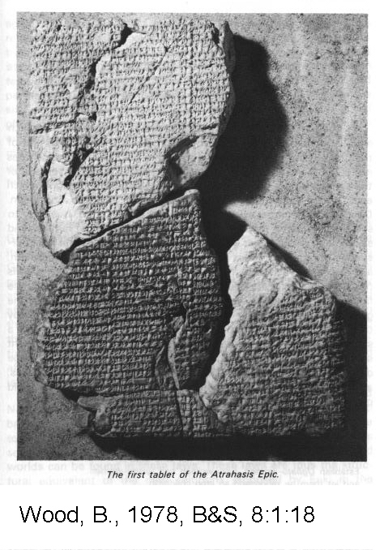

PHOTO LINK: ATRAHASIS 002 drawing of tablet. Wood, 1979, B&S, 8:1:24. Illustration from American Schools of Oriental Research.
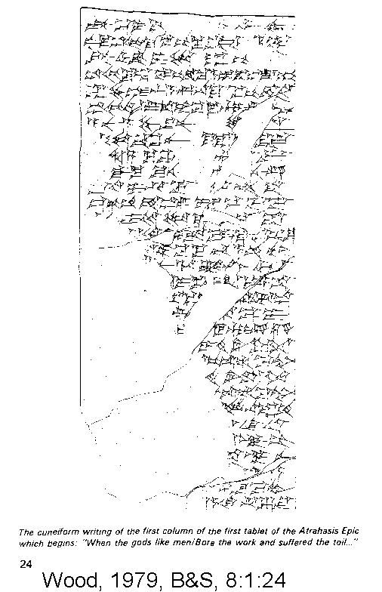

Another Mesopotamian flood story is the Atra-hasis Epic, composed around 1700 BC. Atra-hasis is Old Babylonian meaning "exceedingly wise”. It gives a primeval History similar to that found in Genesis. The primeval History was discussed in Chapter 8. After the primeval history, there is a story about a great Flood, which is often compared to the story of Noah (Wood, 1979):

Twelve hundred years [had not passed]
[when the land was extended] and the people multiplied
The [land] was bellowing [like a bull]
The gods were disturbed with [their uproar]
[Enlil heard] their noise
[and addressed] the great gods
"The noise of mankind [has become to intense for me]
[with their uproar] I am deprived of sleep

To solve problem of overpopulation, the gods brought a plague which ended when man, under advice of Enki, brought offerings to Namtar (Namtaru), god of the plague.

Plague was not a permanent solution to population control and the problem came up again 1,200 years later when gods caused a drought. The drought ended when men, (again by Enki's advice) bribed Adad (also named Ad). This personage appears in history as the Canaanite Hadad, the Hurrian Teshub, the Egyptian Reshephor Rimmon (“Lord of Elements”), the Phoenician Baal/Bel and the Sumerian Ishkur. Adad’s job was to make rain.

PHOTO LINK: HAMMURABI 001 Hammurabi Law code stela, top part; before Adad. Kitchen, 1995, BAR, 21:2:29. Photo by Erich Lessing.
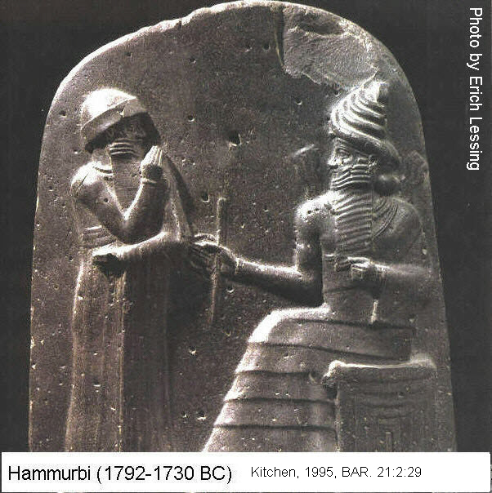

PHOTO LINK: ADAD 001 Baal-Adad bull stela Bethsaida, Samaria ; http://www.bibleorigins.net/KuntilletAjrudBaalAdadBetsaida.html ; Aug. 25, 2005
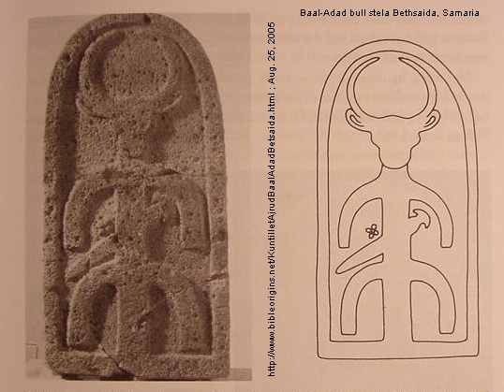

PHOTO LINK: ADAD 002 Baal-Adad bull stela 02. Bethsaida, Samaria ; http://www.bibleorigins.net/KuntilletAjrudBaalAdadBetsaida.html ; Aug. 25, 2005
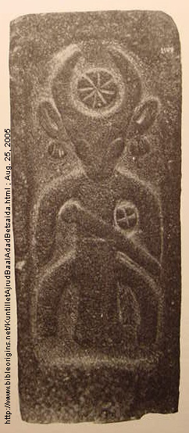

Mankind makes More problems for the gods, and this resulted in the gods bringing a famine and saline soil to the land. At last Enlil persuaded the gods to adopt a "final solution" to the humanity problem: the Flood. Enki thwarted the god’s plan by having Atra-hasis build an ark. Following the destruction of most of mankind, the gods regreted their actions (nobody was left to do the work! The gods are thirsty and hungry) and realized they need man. Atra-hasis brought a sacrifice and the gods came to eat. At the banquet, Enki presented solution to problem: inaugurate a new order. Enki summoned Nintu, birth goddess. She was the mother goddess of Mesopotamia. (Sumerian and Babylonian-Akkadian). She broke off fourteen pieces of primordial clay to form the womb deities, seven on the left and seven in the right with a brick between them. The womb deities produced the first seven pairs of human embryos. After the Flood she created new creatures and provided a solution to the overriding problem for mankind and the gods of overpopulation (Wood, 1979):

In addition, let there be a third category among the people
Among the peoples women who bear and women who do not bear
Let there be among the peoples the Pasittu-demon [miscarriage, stillbirth, infantside?]
to snatch the baby from the lap of her who bore it
Establish Ugbatu-women, Entu-women and Igisitu-women
and let them be taboo and so stop childbirth

We do not normally consider overpopulation to be an ancient social problem. That it was a problem is graphically illustrated when one compares the overpopulation at Carthage and child sacrifice practices there. Excavation of the cemetery there yielded 20,000 infant burials made between 400 and 200 BC (Currid, 1994).

PHOTO LINK: CHILD SACRIFICE 001 Carthage temple precinct; Ackerman, 1992, BR, 9:3:29. Photo by Gary Pratico. Inset photo by Eric Lessing.
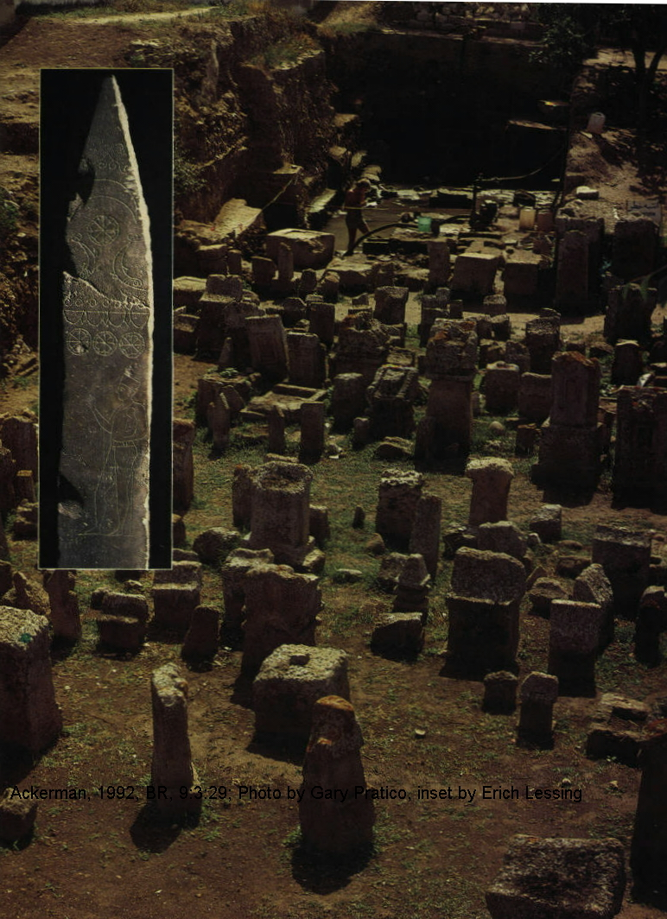

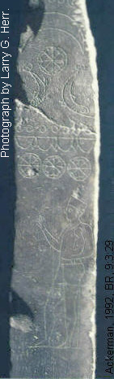
PHOTO LINK: CHILD SACRIFICE 002 Cathage stela (Phonecian) in Tiohet, sacred precinct. Ackerman, 1992, BR, 9:3:29. Photograph by Larry G. Herr.

After the Flood, as in Genesis, man still fouls up the created system (Wood, 1979).

Capital Punishment and the Atra-Hasis Epic

While Atra-hasis is a story about overpopulation, Noah’s Flood is a story about capital punishment. In Genesis all life was destroyed due to man's sin (Genesis 6:5-7). After the Flood, God promised not to destroy every living thing again, in spite of man's wickedness (Genesis 8:21), and with the rainbow as covenant reminder (Genesis 9:16). Laws were created and given to man to insure that pre-Flood moral conditions did not reappear. Man was no longer ruled by instincts alone. There were three post-flood commands:
1) be fruitful and multiply (Genesis 9:7, the same as in Genesis 1:28)
2) man may eat meat but no blood (Genesis 9:4)
3) no killing without being killed (Genesis 9:6)

In the Old Testament, blood is a very special substance: it carries the nephes, spirit. It has three rules of engagement:
1. cannot be eaten (Deut 12:23)
2. is a critical ingredient for redemption (Lev 17:4,11)
3. blood is spilled on the ground (Deut 12:24)

Capital punishment in the Old Testament was reserved for offenses against God (e.g. murder) and never applied to offenses against property. Murder is never compensated by payment of a monetary fine, it required execution of the murderer. Murderers (see Cain in Genesis 4:1-15 and Lamech in Genesis 4:19-24) were not executed before the Flood but after the Flood execution of murderers was specified by law. The ritual of spilling blood on the ground was a symbol of the pollution of the ground by murder (Genesis 4:10-12). At the time of the Flood the entire earth was filled with hamas, the entire spectrum of evil. The Flood removed the pollution from the ground. Then God promises:

I will not again curse the ground any more for man's sake; for the imagination of man's heart is evil from his youth; neither will I again smite any more every living thing, as I have done (Genesis 8:21).

Instead, God gave laws to Noah and his sons to prevent the earth from becoming polluted again. Murder, idolatry and sexual abominations (Lev 18:24-25, Jer 2:7, Ezek 36:18, Num 35:31-34) were prohibited. God gave the Israelites rituals for cleansing of sin, "breaking the heifer's neck" (Deut 21:7-8) thereby avoiding need for another Flood.

Sumerian Ziusudra Deluge Story

The Sumerian deluge myth of Ziusudra pre-dates Gilgamesh and Atra-hasis. It is very fragmentary and only understandable by comparison with other known Mesopotamian flood stories. Ziusudra means "life of long days" and is equivalent to Gilgamesh Akkadian Utnapishtim, "he found life” and to the words Atra-hasis meaning "exceedingly wise." (M. Wood, 1979)

Part of the Ziusudra "Flood" Legend relates:

All the windstorms, exceedingly powerful, attacked as one
At the same time, the flood sweeps over the cult centers
After, for seven days and seven nights
The flood has swept over the land,
And the huge boat has been tossed about by the windstorms on the great waters
Utu [sun god] came forth, who sheds light on heaven and earth
Ziusudra opened a window on the huge boat
The hero Utu brought his rays into the giant boat
Ziusudra, the king
Prostrated himself before Utu,
The king kills an ox, slaughters a sheep

As with Gilgamesh and Atra-hasis, there is a general parallel in plot with Genesis: Flood, a boat, and sacrifice (M.Wood, 1979).

Writings of Babylonian Priest Berosus

Surviving texts of Berosus date from the late 4th and early 3rd centuries BC discuss the Mesopotamian deluge stories.

The Epic of Enmerkar and the Lord of Aratta

The Sumerian epic of Enmerkar and the Lord Aratta dates from the early 3rd millennium (Aling, 2004:7 citing Kramer, 1970:108). This epic may preserve a memory of the confusion of language told in the Tower of Babel. Kramer’s translation (1968) is as follows:

Once upon a time there was no snake, there was no scorpion
There was no hyena, there was no lion
There was no wild dog, no wolf
There was no fear, no terror
Man had no rival
In those days, the land of Subur (and) Hamazi
Harmony-tongued (?) Sumer,the great land of the decrees of prince-ship
Uri, the land having all that is appropriate (?)
He land of Martu, resting in security
The whole universe, the people in unison (?)
To Enlil in one tongue [spoke]
[Then] Enki, the lord of abundance (whose) commandments are trustworthy
The lord of wisdom, who understand the land
The leader of gods,
Endowed with wisdom, the lord of Eridu
Changes the speech in their mouths, [brought (?)] contention into it,
Into the speech of man that (until then) had been one
Enki is the god of Eridu which is home of a ziggurat.

Assyrian Tradition for Confusion of Languages

Another extra-biblical account of the confusion of tongues is found in an Assyrian text (Strickling, 1974 cited by Aling, 2004:7). It is a legend that tells of the destruction of a building on a mound in Babylon by “the father of all gods”. This god also confounded the speech of the builders (Aling, 2004:7 citing Boscawen, 1877:303 and Smith, 1880:166). The badly damaged tablet reads:

“...he the father of all gods had repudiated; the thought of his heart was evil, ...of Babylon he hastens to the submission (?) [small] and great he confounded (on) the mound. ... Their walls all day he founded for their destruction (punishment) in the night...he did not leave a remainder. In his anger also (his)secret counsel he pours out; (to)confound (their) speeches he set his face. He gave the command, he made strange their counsel...(as revised by Sayce in Smith, 1880:164; cf Smith, 1876:160-161; Boscawen, 1876:131-132; 1877:304-398; all cited by Aling, 2004:7).

In this passage the word uballu is translated “confounded.” That Assyrian word is similar to Hebrew balal found in Genesis 11:7, and is also translated “confounded” (Aling, 2004:7 citing Boscawen, 1877:311 and Smith, 1880:166).

NIMROD

Livingston (2001) suggests that Nimrod was an evil rebel who was later mythologized as Gilgamesh.

PHOTO LINK: NIMROD 001 Stela with Nimrod leading army from http://www.essaysbyekowa.com/Nimrod.htm; August 26, 2005. The figure at the top is Gilgamesh, sometimes interpreted as a version of Nimrod.
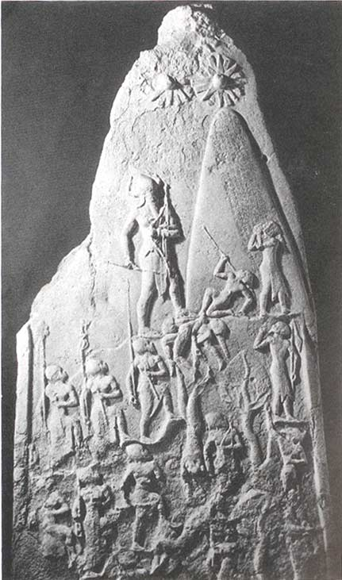

In the Gilgamesh Epic, Kish was the first city to be built after the Flood. A son of Ham was named Cush. He lived in the “Land of Shinar”, or Sumner in Mesopotamia. Kish was the center of kingship which “descended from heaven” after the Flood.

Nimrod’s name means “The Rebel” (Livingston, 2001 citing Kautzsch, 1910:137-2b and DBD, 1962:597). Like Gilgamesh, Nimrod established a kingdom (Gen. 10:8-11).

PHOTO LINK: ASSYRIA 030 Drawing of palace of Sennacherib in Nineveh. Livingston, 2001, B&S, 14:3:70. Photograph from ABR photo file.
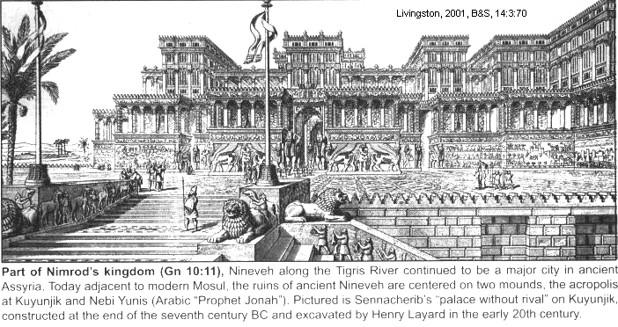

PHOTO LINK: ASSYRIA 029 Palace of Tiglath-pileser III at Calah, modern Nimrud (named after Nimrod), Iraq. Livingston, 2001, B&S, 14:3:70. Photograph from ABR photo library.
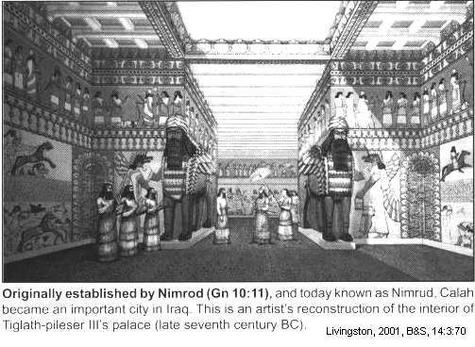

LONGEVITY OF THE PATRIARCHS AND THE SUMERIAN KING LIST

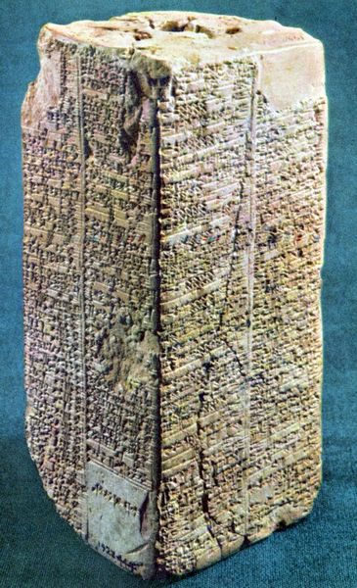
Genesis 5 indicates that average age of antediluvian patriarchs was 912 yrs (not including Enoch who was taken directly to heaven). The bones of ancient humans indicate that few lived beyond 50 (Clayton, 1978). This conflict between anthropological dating and the patriarchal narratives have produced several creative solutions. One method involves "fixing" ages of the Patriarchs to accommodate findings from the science of physical anthropology. Another solution is to count years as months (Clayston, 1978).

Young-earth creationists postulate that a pre-flood vapor canopy kept out harmful cosmic radiation and permitted longer life spans. While such speculations are intriguing, the reality is that there is little archaeological or anthropological evidence upon which to base a belief that patriarchal life spans are factual descriptions (Thompson, 1993).

PHOTO LINK: SUMERIAN KING LIST 005. www.losthistory.com, Oct. 16, 2013. (RIGHT)

Fantastic longevities of kings following the Flood are recorded in the Sumerian King List composed in 2100-1900 BC. Alulim, the first king in the list, lived 8 yars, or 28,800 years (see http://en.wikipedia.org/wiki/Sumerian_King_List; April 1, 2010). These traditions are also found in Babylonian and Assyrian texts (MacDonald, 1988). In the Sumerian List, the early kings have reigns of 1000's of years. The phrase "kingship descended from heaven" is found at the beginning of the list and is repeated throughout the tablet. Early contemporary dynasties are listed sequentially. Kingship "descended from heaven" again after the Flood. The earliest editions of the List omitted antediluvian kings and originally there may have not been any mention of the Flood in the List at all. The later editions of the King List may have borrowed the Flood motif from other (biblical?) sources (MacDonald, 1988). These are clearly allegorical or poetic. Their contemporaries would have understood them that way. But many Jews and Christians find it troubling to accept the Biblical stories of patriarchal longevity as allegorical or symbolic.

The extraordinary lifespan of the Patriarchs as preserved in the Old Testament may reflect elaborations, or embellishments and personifications of the records for of an original dynastic framework. This transformation of tradition came to be understood by the Hebrews as historical fact after the Exile. This resolution suggests that the long life spans recorded in Genesis represent not individuals, but Dynasties (Boreland, 1990) which became personalized with time. Criticisms of this theory are that not all Patriarchs fall into Dynastic divisions (Noah), and that the Bible clearly says that each father begat a son, not a dynasty (Thompson, 1993).

The stories of patriarchal longevities should be interpreted in light of general Hebrew theology at time those Hebrew scriptures were produced. Righteousness was equated with longevity (Job 5:26; Ps 21:4; 34:11-13; 91:16; Pr 3:2,16; 9:11; 10:27; Isa 65:20; 1Pe 3:10-11) and with prosperity (Lev 26:3-5; Dt 7:12-14; 15:4-5; 28:2-12; 29:9; 30:1-5,9-20; Jos 1:8; 1Ki 2:3-4; 9:3-9; 1Ch 22:13; 28:7-8; 2Ch 7:17-22; 26:5; 27:6; 31:10; Job 36:11; Isa 1:19; Jer 7:3-7; 11:1-5; 12:16; 17:24-27; 22:4-5,15-16; Mal 3:10-12). By the time the Hebrew Bible was editied and compiled during the Exile in the 5th century BC, a world view of decline was adopted by the Hebrews. All of humanity was on a downward course since the fall. Things were better in the “old days”. The only hope for today is that present levels of power and knowledge would not further deteriorate. This pessimistic world view is reflected by Jesus in Matt. 10:24-25: “24A student is not above his teacher, nor a servant above his master. 25It is enough for the student to be like his teacher, and the servant like his master.” Our modern ideas of a never-ending upward progression of reason and enlightenment came out of Renaissance. With this Hebrew world view, along with general decline (in morals and prosperity), there must have been a corresponding decrease in life span. The longevities of the early patriarchs may be parables designed to reinforce this world view.

TOWER OF BABEL

The story of the Tower of Babel is told in Genesis 11:1-9. It is set in a time period of 10 generations after Noah (the Flood) which occurred 10 generations after Adam (the Creation). That genealogical symmetry is discussed by Sasson (1994, cited by Tsumara, 1996).

PHOTO LINK: TOWER OF BABEL 001 Artist's reconstruction of ziggurat at Ur. Livingston, 1990, ABR, 3:1:19. Illustration by Charles Pfeiffer, The Biblical World.
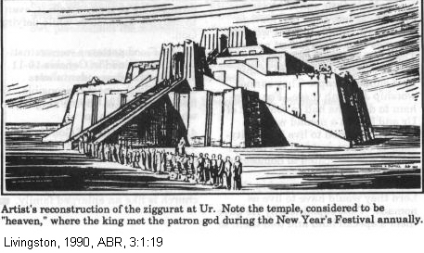

PHOTO LINK: TOWER OF BABEL 002 Painting of the Tower of Babel. Livingston, 1990, B&S, 14:3: cover. Photograph by Michael Luddini.
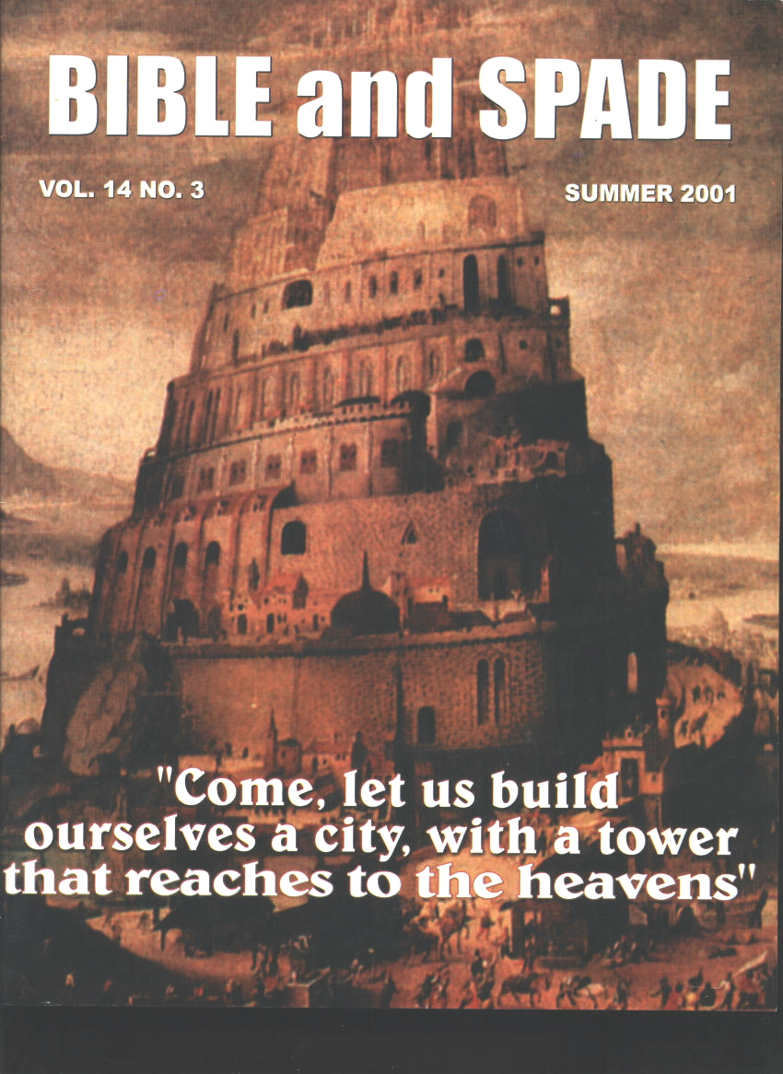

PHOTO LINK: TOWER OF BABEL 006 Painting Abel Grimmer 17th cent AD. Tigay, 2004, BR, 20:?:? Painting by Abel Grimmer, 17th century.
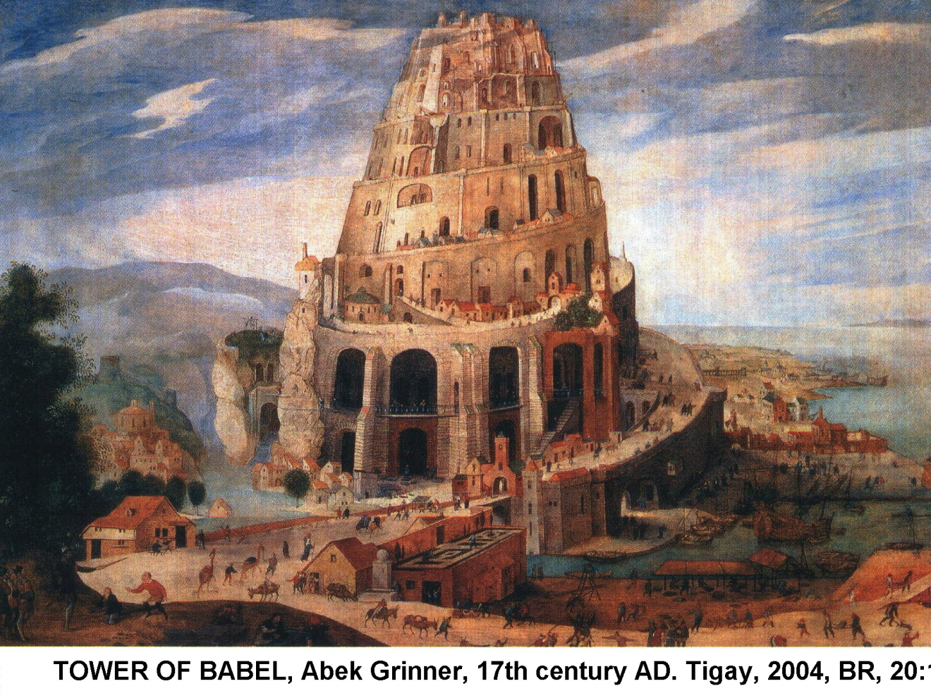

PHOTO LINK: TOWER OF BABEL 003 Baked bricks and asphalt mortar. Livingston, B&S, 14:3: cover. Photograph by Michael Luddeni.
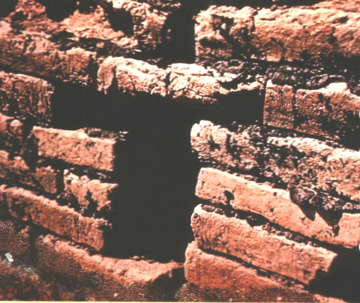

PHOTO LINK: TOWER OF BABEL 004 Ziggurat at Ur photograph. Livingston, 2001, B&S, 14:3:71. Photogrraph from ABR photo file.
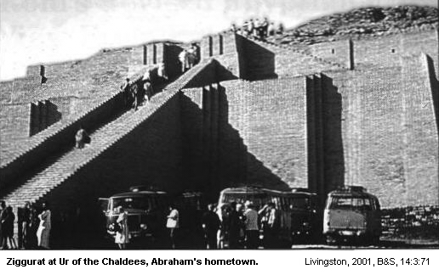

PHOTO LINK: TOWER OF BABEL 005 Ziggurat at Ur model. Livingston, 1990, B&S 14:3:71. Photograph from ABR photo library.
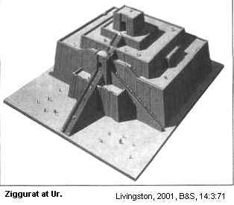
The Tower of Babel is a Mesopotamian Temple, a ziggurat. There are 30 of them distributed over a wide area:

Region of  Mesopotamia | Cities with ziggurats
Northeast | Mari and Tell-Brak
North | Dur-Sharrukin
South | Ur and Eridu
East | Susa and Choq Zambil

The earliest ziggurats are the Ubaid temples at Eridu. They date from the end of the 5th millennium (4300) BC. The latest ones are Selucid from the 3rd century BC (Walton, 1996). So the ziggurat architectural tradition spanned 4,000 years.

The smallest ziggurats are 20 meters on a side and the largest ones 90 meters. Ziggurats were built, filled and built over up to 16 times (Ur III, ziggurat of Amar-Sin 2046-2038 BC). The resulting stair-case geometry lead to conscious architectural design of a staged tower in the Early Dynastic period (2900-2350 BC; Walton, 1996 citing Crawford, 1977).

PHOTO LINK: UR 003 Restored ziggurat at Ur c 2100 BC. Aling, 2003, B&S, 17:1:4. Photograph by John F. Shaw / SPC
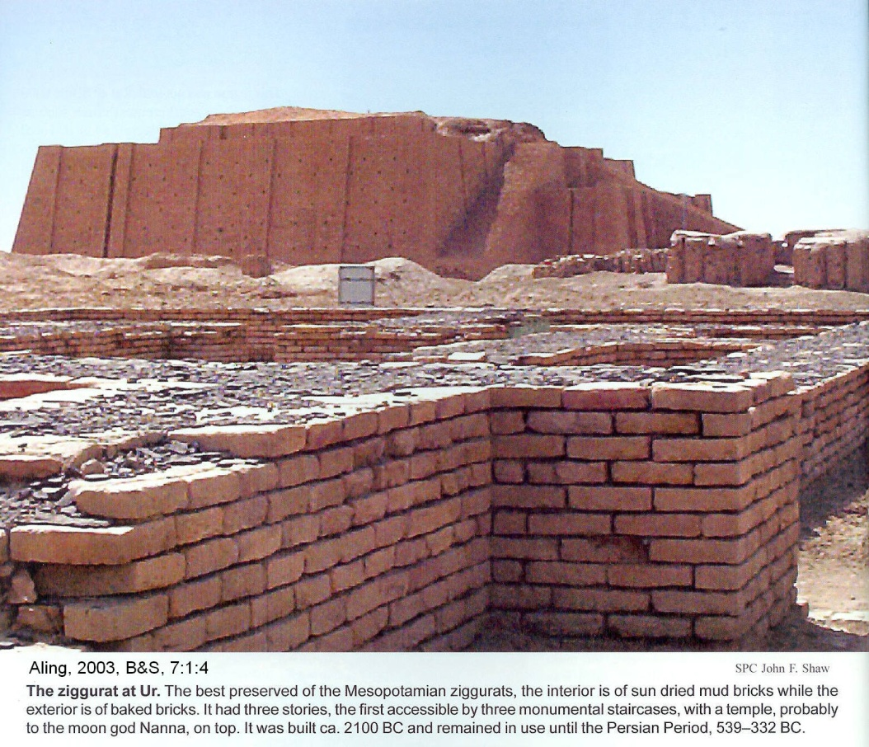

PHOTO LINK: ZIGGURAT 001: Reconstruction of Ziggurat at Ur. Walton, 1996, B&S, 9:3:cover. Illustration by Aramco World.
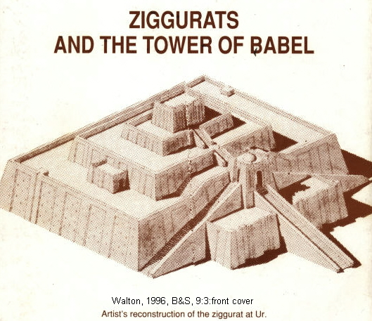

PHOTO LINK: UR 005 Base of ziggurat at Babylon possible Tower of Babel per Gen. 11. Aling, 2003, B&S, 7:1:6. Photo by C.A. Wilson.
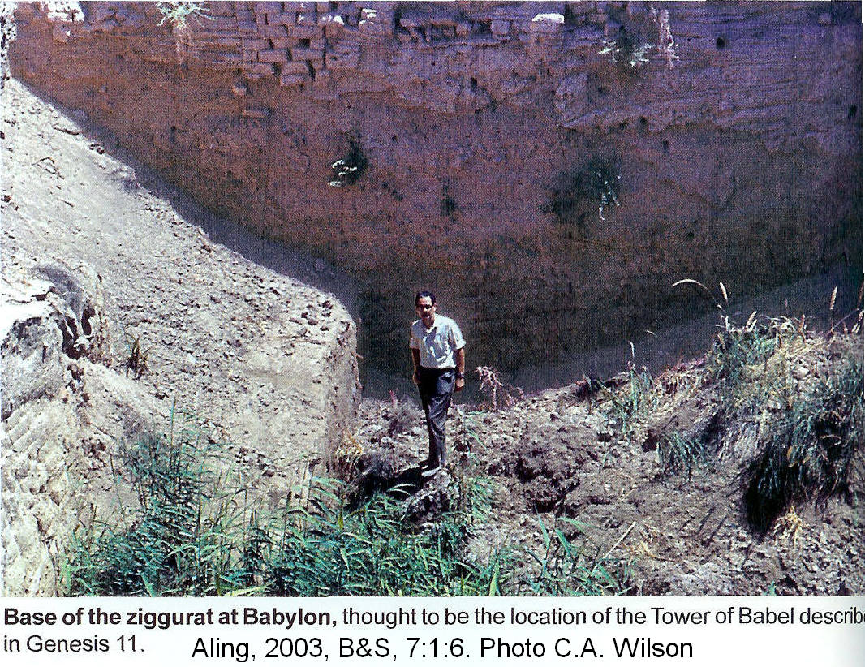

While the ziggurat bears superficial resemblance to the early stepped pyramid of Djoser at Saqqara, the ziggurats were NOT tombs. A clue to their intended function is found in their names:

 | NAME | LOCATION
1 | Temple of the Foundation of Earth and Heaven | Babylon
2 | Temple of the Wielder of the 7 Decrees of Heaven and Earth | Borsippa
3 | [...] gigir | Nippur
4 | Temple of the Mountain Breeze | Nippur
5 | Temple of Mystery | Nippur
6 | ? | Kurigatzu
7 | Temple of the Stairway to Pure Heaven | Sippar
8 | Temple of the god Dadia | Akkad
9 | ? | Dumuzi (?)
10 | Temple of the Admirable Throne/Sanctuary | Dumuzi (?)
11 | Temple of the Ziggurat, Exalted Dwelling Place | Kish
12 | Temple of the Exalted Mountain | Ehursagkalamma
13 | Temple of the Exalted Splendor | Enlil (at Kish?)
14 | Temple of the god Nanna | Kutha
15 | Temple of the Foundation of Heaven and Earth | Dilbat
16 | ? | Marad
17 | ? | Ur
18 | Temple which Links Heaven and Earth | Larsa
19 | Temple of Giparu | Uruk
20 | Temple of the Ziggurat | Eridu
21 | ? | Enegi
22 | ? | Enegi

In this list, temple # 7 has a title that reflects its magnificent stairway (simmiltu) which connects with the myth of Nergal and Ereshkigal. In that myth, a stairway is used by Namtar, messenger of Ereshkigal to journey from the netherworld to the gate of the gods Anu, Enlil and Ea (Watson, 1996 citing Gurney, 1960). There is a total absence of any description of use of ziggurats in cultic rituals. Collectively, this situation suggests that the ziggurat supplies a connection between heaven and earth for deities, but not for mortals (Yigay, 2004).

The mountain-like form of the ziggurat, and the term “mountain” in some of the ziggurat names reflect a common idea between many cultures that certain mountains were considered to be the dwelling place of a deity. In the Exodus 19, YHWH comes down on a mountain, Sinai. Mountains are popular places of sacrifice (Moriah, Gen. 22, Carmel 1 Kings 18). Moses, Aaron and Elijah all go up on a mountain to meet YHWH. In the Ugaritic Baal-Anat cycle legend, the temple of Baal is on Mount Zapon. These ideas were later adopted by the Greeks who put their gods on Mount Olympus (Watson, 1996). The etymology of Babel (Babylon) is uncertain. The Babylonian scribes understood it as “God’s Gate” (‘bab ‘ilim in Akkadian, the Babylonian language; Yigay, 2004:37)

The function of the ziggurat was to support a monumental stairway used by the gods to travel from one realm to another with a gate at the top, the entrance to the divine place (Walton, 1996, p. 83)

Building Materials

Genesis 11:3 states that the builders of the Babel ziggurat “make bricks and bake them hard; they used bricks for stone and bitumen for mortar.” In Palestine, use of baked mud bricks was unknown. Instead, inhabitants used dried mud brick for walls/superstructure and stones for foundations (Walton, 1996 citing Kenyon 1979). In Palestine, mud mortar was used to secure the bricks together. But in Mesopotamia, palaces, temples and other official building used baked brick with bitumen, which was expensive (Walton, 1996 citing Forbes 1955), but very strong (Walton, 1996 citing Singer, 1954).

The ziggurat is a public building requiring a huge investment and organization of labor, materials and money. Such development, centralization of economic authority, and urbanization happened together in Mesopotamia, much as it did in Egypt. The ziggurat became the center of economic growth and united different aspects of the society toward a common goal, much as Works Projects Administration did for the U.S. following World War I.

Ziggurats: Gods in the image of men

The creation of this huge economic/political/religious machine in Mesopotamia lead to an increase in material culture, a preference for urbanization and a resistance to becoming “scattered (dispersed) all over the earth” (Gen. 11:4).

Early Mesopotamian societies were quasi-democratic or republican, being run by general assemblies. But that system of government quickly changed to one of kingship. However, the general assembly form of government was preserved in Mesopotamian mythology where gods debate, vote and take collective action. As the urbanized state began to take shape, the universe came to be considered a state ruled by gods (Watson, 1996 citing Jacobsen, 1946).

The effect of this process was to create gods in the image of men, a circumstance particularly revolting to the Hebrew who took the theological position that it was the other way around: man was made in the image of God (Walton, 1996).

The story of the Tower of Babel shows an early Hebrew preference for farming and nomadic life over life in cities. Government in cities was dictatorial through kingship. But the nomads kept a more democratic tribal assembly form of government, as expressed in the 12 tribes of Israel. The story also highlights a difference between Mesopotamian and Hebrew philosophy about procreation. Genesis 1:28 and 9:7 command humans to “be fruitful and multiply…fill the earth…and subdue it”. While urban Mesopotamians had concerns for population control, the rural Hebrews wanted large families.

The confusion of language at the Tower of Babel caused a delay in urbanization. It gave God a chance to re-educate mankind about the correct view of God and man. That re-education began with revelation and the call of Abram, enactment of a Covenant, and formation of a chosen people through whom all people would come to know the true character of God and the true nature of man (Walton, 1996).

Dating the Tower of Babel

The early stage of urbanization described in Genesis 11:1-11 can be identified by understanding the dates for the following:

-baked brick-bitumen building technology developed at Jamdet Nasr ca. 3100 BC
-development of the ziggurat in the Early Dynastic Period, ca 2500 (earlier prototypes go back to Late Uruk phase ca 3200 BC)
-early urbanization in Early Dynastic Period, ca 2800 BC
-government by Ruling Assembly, Early Dynastic I, ca 2900 BC
-during the Ubaid period (5000-3500 BC), climatic changes caused less flooding and opened up more areas for settlement (Walton, 1996 citing Nissan,1988).

The setting for story of the Tower of Babel is in the early stage of Mesopotamian urbanization and ziggurat building, possibly 2800 BC. The setting may be as early as c. 3750 BC if the Tower of Babylon is associated with the Uruk culture (Aling, 2004).

If the Tower dates to 2800 BC, the tale cannot be about a ziggurat at Babylon because it didn’t have one until the Ur III period in the 21st century BC. So if Babel = Babylon, the site would have been deserted and abandoned for over a millennium before it was occupied again in Ur III (Walton, 1996).

EVOLUTION OF SEMITIC LANGUAGE

All Mesopotamian languages belong to the Semitic Language Group. All Semitic languages developed from a common parent language between 8000 and 6000 BC. They have many things in common, including the way word endings are formed, the similar sounds of their letters and words, and masculine and feminine genders. At an early stage of development, all of the Semitic languages shared certain characteristics with the rest of the Afro-Asiatic language family. These include a six-vowel system with both short and long a, i, and u; and three types of consonants--voiced, voiceless, and emphatic--as well as root words that are usually formed with three consonants (Compton's Interactive Encyclopedia, 1979).

In Semitic languages consonants are formed at the back of the mouth toward the throat. Root forms of words are composed of consonants, and added vowels can change their meaning. All of the languages have representative masculine and feminine genders and three main cases: subjective, objective, and possessive; or nominative, accusative, and genitive (Compton's Interactive Encyclopedia, 1979).

The Semitic languages can be divided into four geographical groups: northern peripheral, northern central, southern central, and southern peripheral. The northern peripheral group has Akkadian as its only language. The northern central group includes the ancient Canaanite, Ugaritic, ancient and modern Syriac and Hebrew, Moabite, Old Aramaic, Amorite, and Phoenician and its Punic dialect. The southern central region includes Arabic and Maltese, and the southern peripheral region includes South Arabian dialects and the languages of northern Ethiopia (Compton's Interactive Encyclopedia, 1979).

These languages are characterized as being in the ancient, middle, or new stage of development. Those in the ancient stage retain all of the common features they had when the languages were developed. Those in the middle stage retain two thirds of their original consonant system and at least half of their other early features. Those in the new stage have lost more than half of their early features. Literary Arabic and Hebrew are the only modern spoken languages that are not in the new stage (Compton's Interactive Encyclopedia, 1979).

The northern peripheral languages of Akkadian and its dialects, Babylonian and Assyrian, are considered to be in the ancient to middle phase. They were spoken in Mesopotamia from the 3rd millineum BC through the 1st century AD. Among the northern central languages, Canaanite, Ugaritic, and Amorite are in the ancient phase, and Phoenician-Punic, Hebrew, Moabite, and Old Aramaic are in the middle phase. Canaanite, Ugaritic, and Amorite were spoken from about 3000 to 2000 BC in Palestine, Phoenicia, Syria, and Mesopotamia (Compton's Interactive Encyclopedia, 1979).

Since several languages were present in ca 2800 BC, the Tower of Babel cannot have been an original diversifying force in world language development, if the Great Flood and the Tower occured in the late 2nd millenium.

The Sumerian "Problem"
.
Aling (2004) proposed that the effects of the Tower of Babel are shown in archaeological and philologistic evidence relative to the history of the Sumerians. Archaeological evidence from the Ubaid, Uruk and Proto-Literate (Jemdat Nasr Culture) peoples (see Chapter 10), spanning the years c.4100 to c.3100 BC depict a continuity of culture. But linguistic (philogistic) evidence suggests a disruption of culture at the start of the Uruk culture c.3750 BC. The difference of opinion between the archaeologists and philologists about the Sumerian civilizations is called the "Sumerian Problem". The Bible refers to the Sumerians as the people of the plains of Shinar (Gen. 11:1).

The Tower of Babel is clearly a ziggurat and those monuments were first built during the Uruk culture c.3500-3100 BC. If the Tower of Babel is set in Uruk society, it follows that:

"...the people of Mesopotamia spoke a now-unknown language, a few words of which are preserved in place names, river names and the words for some plants and animals. The Tower of Babel was built...God then confounded their speach, and several new language families (including Sumerian) were created. The Sumerian speakers stayed in Shinar, but the other groups moved on. Only the few words now found in Sumerian survive from the first language.

"If this solution is accepted, both the archaeologists and the linguists are correct. While many people left the area after God changed languages, no new major group came in, so the archaeologists are right. But the new language, Sumerian, came into existence, so the philologists are also correct." (Aling, 2004:6).

