CHAPTER 14: THE CONQUEST OF CANAAN

Contents
THE DATE OF THE CONQUEST 1396
Post-Hyksos Invasion of Egypt 1396
Two Competing Theories 1396
Late Date Theory 1397
Early Date Theory 1412
NATURE OF THE CONQUEST 1427
Overview 1427
Traditional Military Overthrow 1433
Assimilation-Infiltration 1434
The Assembly at Shechem 1436
Peasant Revolt 1437
‘Apiru and Hebrew 1440
Pottery 1443
Four Room House 1445
East of Jordan Theory 1446
Pottery 1446
Four Room House 1446
Diet 1447
Linguistics 1447
Immigration and Climate Cycles 1448
Shahu 1448
Synthesis Theory 1451
POTTERY STYLES 1452
CROSSING OF THE JORDAN 1454
JERICHO 1463
Garstang 1469
Kenyon 1473
Critique of Kenyon 1478
Pottery 1478
Full grain jars 1479
Stratigraphy 1481
Collapsed Wall 1481
Egyptian Scarabs 1486
Critique of Wood 1487
Wood’s answer to Bienkowski 1489
C-14 Dating of City IV 1490
Jericho Attack Rituals 1491
AI 1494
Et-Tell (Minimalist site for Ai) 1498
Beitin (Minimalist site for Bethel) 1499
El-Bireh (Maximalist site for Bethel) 1504
Khirbit Nisya (Maximalist site for Ai) 1506
Khirbit el-Maqatir (Maximalist alternative site for Ai) 1512
Typographical requirements for Biblical Ai: 1513
Archaeological requirements for Biblical Ai: 1515
Miscellaneous Finds at Kh. El-Maqatir 1527
MT EBAL AND JOSHUA'S ALTER 1530
MT GERIZIM, MT EBAL, AND SHECHEM 1535
The Shechem covenants (c.1404 and 1390? BC) 1540
Joseph’s Second Burial and Shechem (1404 BC) 1543
THE SOUTHERN CAMPAIGN (1404 BC) 1544
Treaty with the Gibeonites 1546
Long day of Joshua 1553
Libna and Lachish 1553
Gezer 1557
Eglon and Hebron 1561
Debir 1564
THE NORTHERN CAMPAIGN 1567
Battle of Merom 1568
Hazor 1568
Bronze Age Stratigraphy and Chronology at Hazor 1571
Rahotep-Ramesses II fragment 1594
Hivites and Anakim 1594
DEFEAT OF THE KINGS OF CANAAN 1596
DIVISION OF THE LAND (c. 1398 BC) 1598
Unoccupied territories and cities 1599
Megiddo 1602
Tribal Allotments 1604
City of Salt 1609
CITIES OF REFUGE AND CITIES OF THE PRIESTS 1609
ALTER OF WITNESS AT THE JORDAN 1612
JOSHUA’S FAREWELL EXHORATION 1616
Second Shechem covenant 1616

As we saw in Chapter 13, in Biblical archaeology, few topics generate as much debate as the nature, date and historicity of the Biblical Exodus and the Conquest of Canaan. Liberal scholars claim that the Exodus/Conquest is a fabrication. Conservatives believe it is historical fact.

THE DATE OF THE CONQUEST

Post-Hyksos Invasion of Egypt

All theories for the date of the Conquest agree that it post-dated the expulsion of the Hyksos by Ahmose (Amosis) in the mid-16th century BC. This event ended the 14th Dynasty and marked the beginning of the 15th Dynasty in Egypt. At this time, the name of the capital city for Northern Egypt, Aravis (formerly Rowaty, Tell el-Dab^{c}a), was renamed Peru-nefer, meaning “happy journey”. (Byers, 2005:5, citing Wood, 2004:45). Aravis, would later be named Tanis, Zoan and Rameses.

Two Competing Theories

There are two theories for the date of the Exodus/ Conquest, one in the 12th century and one in the 14th century BC. Early Dates (1220-1280) and Late Dates (1445-1470) have been reconstructed by a variety of scholars.

Late Date Theory

The late theory for the conquest is summarized by Cross (1992), Livingston (1988) and Shea (2003). The late date theory is based on the writings of Rowley (1950) with. elaborations by Thompson and others (1977), Kitchen (1982), Frerichs and Lesko (1997), Currid (1997), Hoffmeier (1997), and Breuggemann (1994). A review of Late Date theories is made in Ray (2004). The late date is generally preferred by liberal (“minimalist”) scholars (that is, if they think there was an Exodus/Conquest, many do not). They place the conquest in the reign of Rameses II (1279-1212 BC) or Merneptah I (1212-1202 BC) during Egypt's 19th dynasty. At this period, the “Store Cities” of Pithom and Rameses are believed to be places where the Hebrew were slaves.

A key verse used by Late Date theorists is Exodus 1:11, which states that the Israelites built the store cities of Pithom and Rameses. The long-lived ruler Rameses II was a great builder. It is easy to make the connection of Rameses II with the city of Rameses (Shea, 2003:43).

PHOTO LINK: RAMESES II 013 Statue of Rameses II
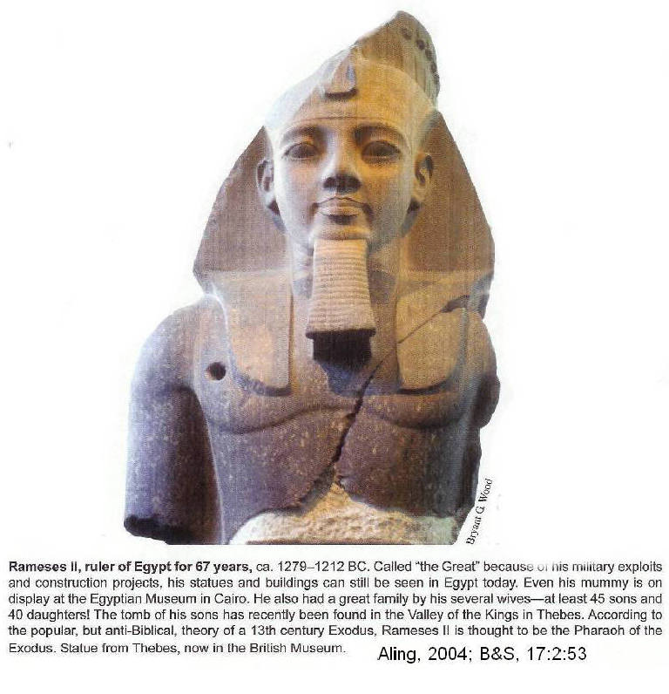
PHOTO LINK: CONQUEST 001 Chart comparing Early and Late Theories
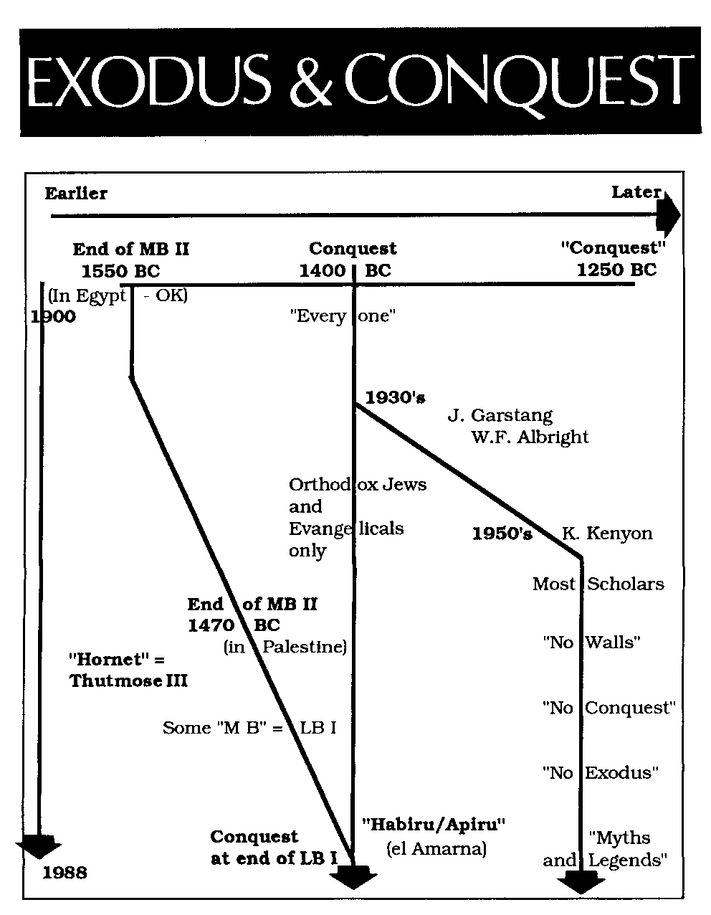

However, the city name Rameses is also described in the Patriarchal Narratives (Gen. 47:11) 430 years before the Exodus (Gen. 15:13; Exodus 12:40). Rameses II could not possibly have lived during the time of Abraham. The verses referring to Rameses in the Patriarchal Narratives must reflect updating of an older city name during later editing (i.e. it is anachronistic). Updating of an older city name to a newer one also occurs in Gen, 14:14 where the later name Dan is used for the contemporary Bronza Age name of Laish (Judges 18:7-20). Thus, a foundational element of the Late Date theory is not a very stable one for identifying the Pharaoh of the Exodus (Shea, 2003:43).

City Name | Date | Biblical Contemporary
Rowaty (Tell el-Dab^{c}a) | c. 1800 BC | Joseph, (Gen 47:11)
Peru-nefer (“happy journey)
Aravis
Tanis
Zoan
Rameses | c. 1301-1234 BC | Judge Ehud (Judges 3:12-31)

Rameses II mentions using slave labor of the ‘Apiru (or Habiru, a possible Egyptian word for "Hebrew"). However, the relationship between ‘Apiru/Habiru and Hebrew is NOT close (Rainey, 2008a, 2008b). This reconstruction places the Conquest/Judges no later than 1207 BC. This late date is indicated by the Merneptah Stele of 1212 BC, which relates:

”Ashkelon has been carried off
Gezer has been seized
Yano'am has been made into nothing
Israel is laid waste; his seed is not
Plundered is the [land] of Canaan...
Palestine (Hurru) has become a widow for Egypt"

The word "Israel" is marked with diminutive indicating it is a people not a place, an indication that they were nomads.

In late date theories, the historicity of the Twelve Tribes is placed in doubt. There is a question as to whether Levi was a tribe at this time. The status and composition of the half-tribes of Manasseh and Ephriam are also questioned. Another reason for questioning the historicity of the literal Biblical account are the improbable parallelism of the twelve tribes of Ishmael (Gen. 25:13-16) Edom (Gen. 36:10-19) and Seir (Gen. 36:20-30; Cross, 1992; Livingston, 1988).

PHOTO LINK: MERENPTAH STELA 001B Merneptah Stele with expanded section "Israel is laid waste; his seed is not" (RIGHT)
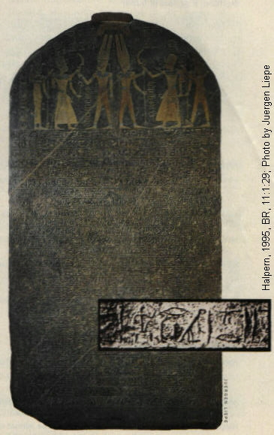
PHOTO LINK: MERENPTAH 003 Location map Campaign in Canaan
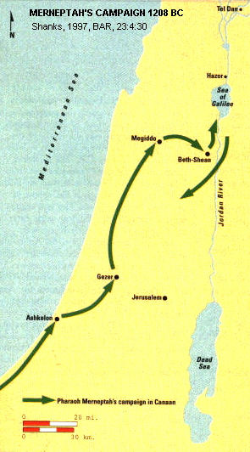

The late date was first based on thick destruction levels at Bethel, Tell Bit Mirsim = Deber(?), and Lachish circa 1250 BC. But there is no destruction from this date at Jericho or Ai (this is according to Kenyon, working in the 1950's, which she dated to 1550 BC and attributed to an Egyptian invasion). There was no walled city at Jericho circa 1250 BC. According to the late date chronology, there is no occupation of Jericho or Ai at biblically-dated time of conquest/settlement. At that time occupants of Jericho were just squatters (Israelite and Canaanite) who built their hovels on previously destroyed cities. In late date reconstructions, the Amorite capital of Hesbon was settled after Israel entered Transjordan and not conquered by Israelites (Livingston, 1988). An Amorite origin for at least part of the early Israelite confederation is suggested in Ezekiel 16:3 “Canaan is the land of your ancestry and there you were born. Your father was an Amorite and a Hittite was your mother.” Location maps and aerial photos of these sites are shown below.

PHOTO LINK: BETHEL 001 Location map of Bethel
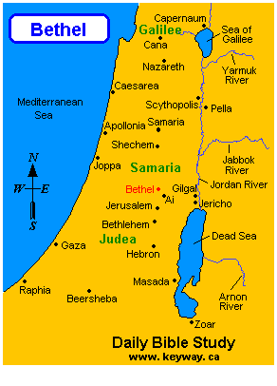
PHOTO LINK: AI 012 Modern Bireh = ABR's Bethel
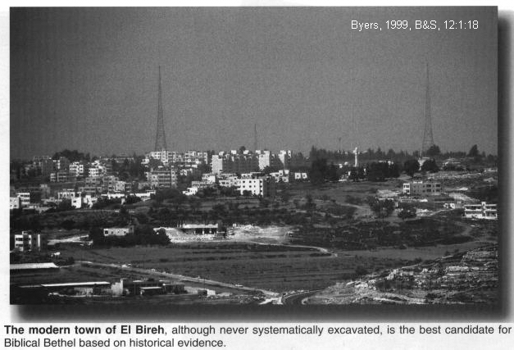
PHOTO LINK: AI 010 Location map of Ai and Bethel
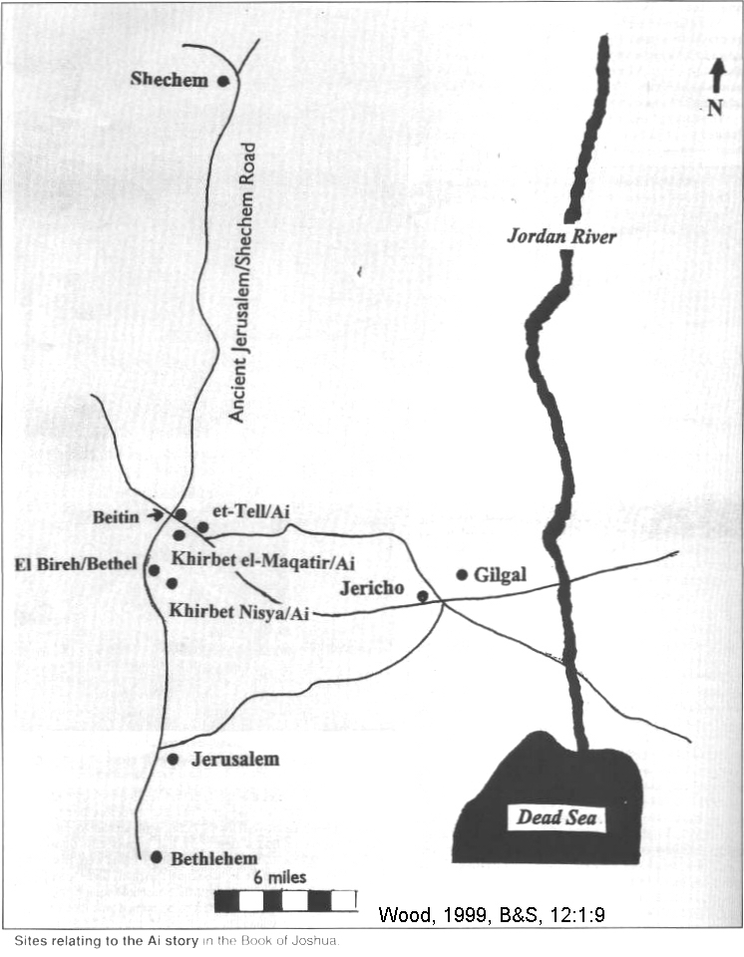

PHOTO LINK: LACHISH 034 Location map; http://www.keyway.ca/gif/lachish.gif; Oct. 14. 2010
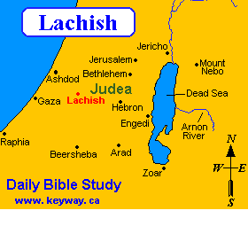

PHOTO LINK: LACHISH 020 Aerial photo of tel Lachish with view of siege ramp
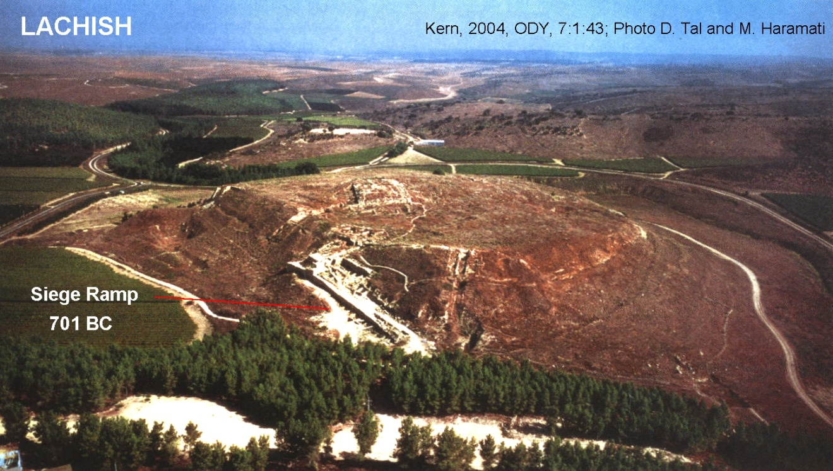

PHOTO LINK: CONQUEST ROUTE 002 Map of conquest (includes Hesbon)
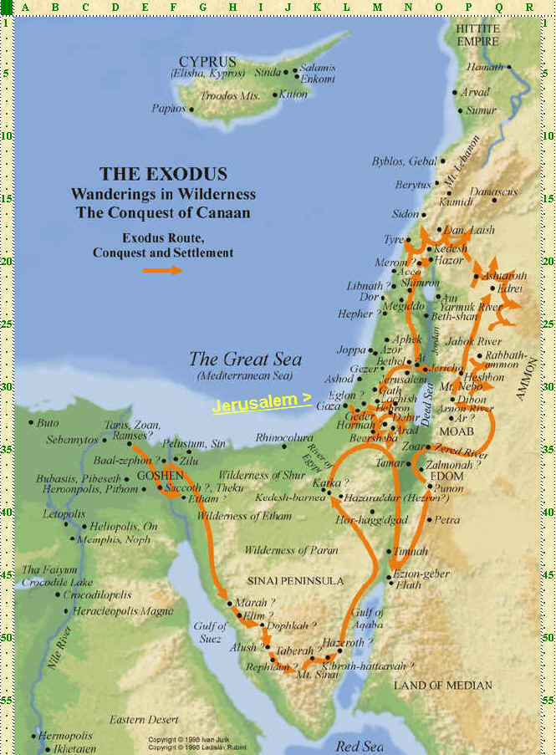

PHOTO LINK: HESHBON 001 Aerial photo of tell

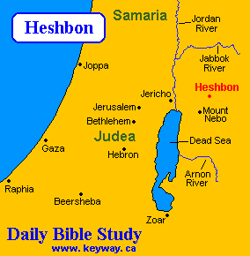
PHOTO LINK: JERICHO 041 Locaton map of Jericho
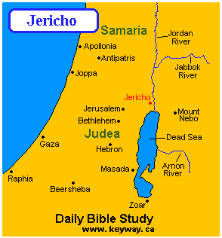
PHOTO LINK: JERICHO 028 Aerial photo of Jericho
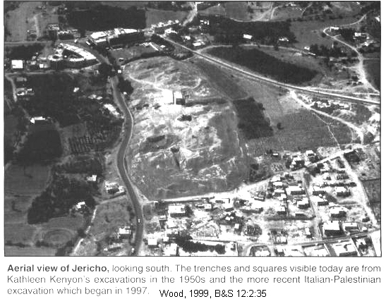

PHOTO LINK: AI 003 Map of area around Ai
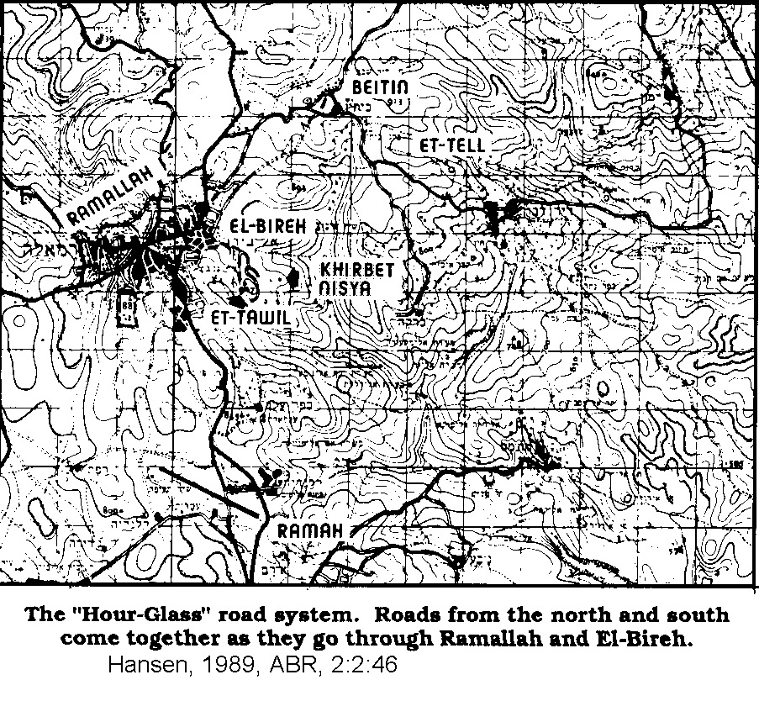

PHOTO LINK: AI 005 Aerial photo of Ai
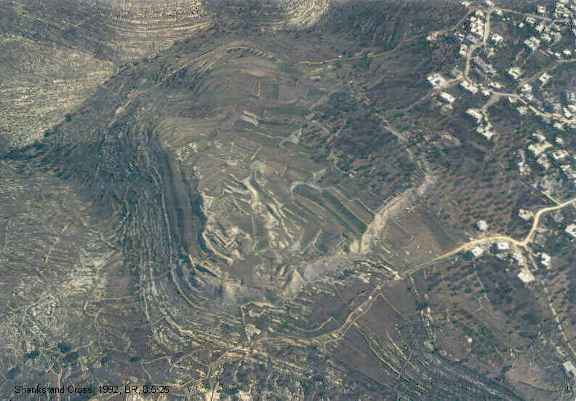

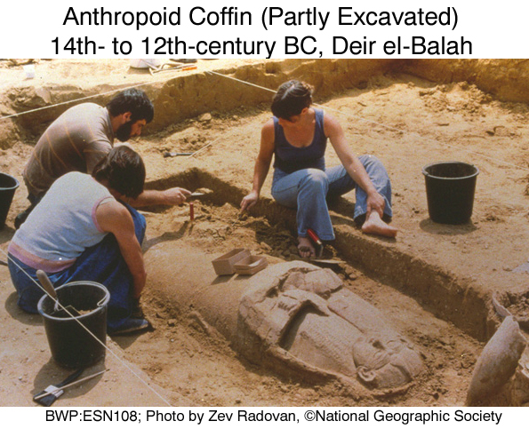
Throughout Palestine there are no other walled cities for Israelites to "conquer" circa 1250 BC. These observations led to the conclusion that the Exodus/Conquest stories were concocted under direction by leaders of the early Monarchy to give authority to their rule and to establish a sense nationalism. According to this interpretation, the destruction of Palestine city-states at the end of Middle Bronze Age II were performed by Egyptians as they chased the Hyksos out of Egypt.

Egyptian burial practices from this era are illustrated by anthropoid coffins.

PHOTO LINK: ESN108 Egyptian anthropoid Coffin (Partly Excavated); Deir el-Balah, 14th to 12th century BC (RIGHT)

PHOTO LINK: ESN109 An Open Coffin; Deir el-Balah, 14th to 12th century BC
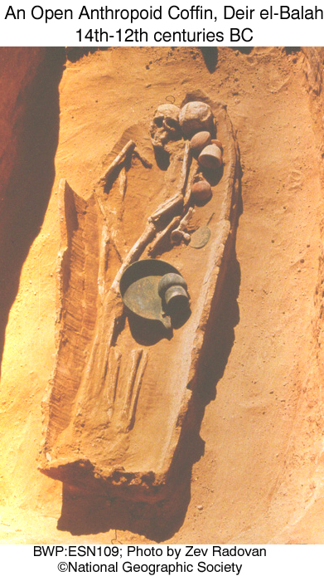

PHOTO LINK: ESN111 Carnelian Seal; Deir el-Balah
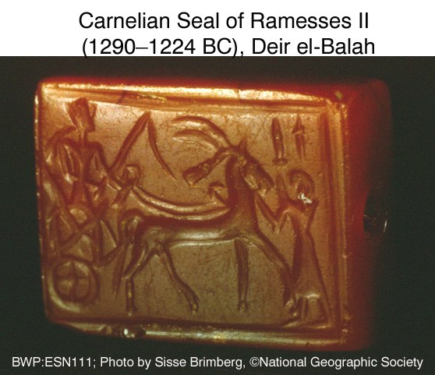

PHOTO LINK: ESN110 Jewelry of “Romeo” and “Juliet”; Deir el-Balah
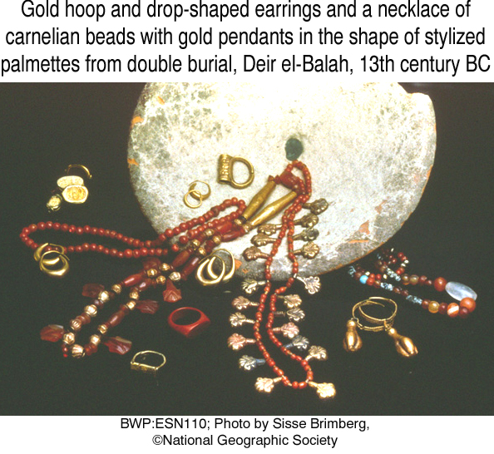
PHOTO LINK: ESN112 Anthropoid coffins on Display; Deir el-Balah
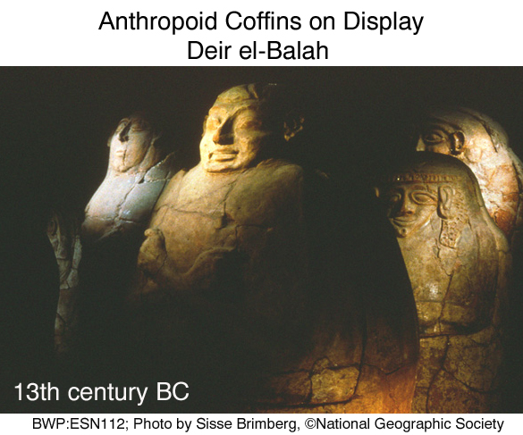

This explanation for Middle Bronze Age II destructions by a restored Egyptian monarchy has some shortcomings. These are theorized by Late Date advocates to have included punitive campaigns by Thutmose III (1483-1450 BC) at coastal cities of Gaza, Joppa, Gezer, Aphek, Megiddo, Beth Shan, Taanach, Hazor and others (Livingston, 1988).

Egyptians typically recorded military triumphs in large-scale monuments or reliefs. There is no Egyptian record of Thutmose III or any later pharaohs attacking the Palestinian hill-country. The Middle Bronze Age II (MBII) extended well into the 1400's BC in Palestine, especially in the interior (Livingston, 1988). Other chronologies of MBII contend that it ended circa 1580 BC (Stiebing, 1994).

Cross (1992), a late date supporter, suggests that there was an early Israelite group at Shechem ('Apiru or Shashu, see Rainey, 2008b) who banded together and formed into a covenant group of 'El-berit (El of the Covenant). Genesis 33:20 mentions a burial plot of land and alter set up "to El, the god of Israel" (i.e. Jacob’s God). A Moses group, devotees of Yahweh (“El of the South”) joined the early Shechem group later in early Iron Age. Covenant-making with other groups resulted in a twelve-league tradition.

PHOTO LINK: ESN113 Naturalistic Coffin Lid; Deir el-Balah
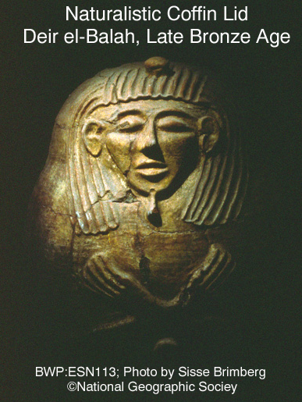

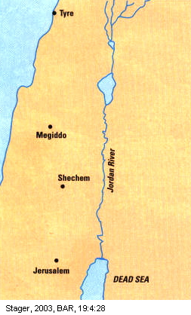
PHOTO LINK: SHECHEM 003 Location map of Shechem, Megiddo, Tyre and Jerusalem

PHOTO LINK: AR040 Shechem, Pillar (Joshua’s “Stone of Witness”?)
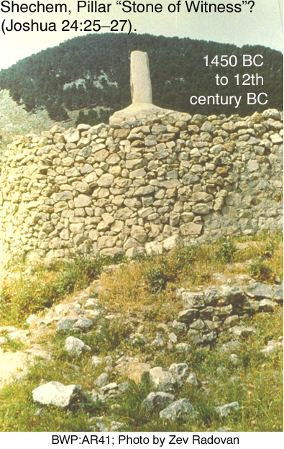

PHOTO LINK: ‘APIRU 001 Tell et-Amarna letter cuneiform tablet. 'Apiru lead by Lab'ayyu (Note this image of the tablet is upside down compared to AMARNA LETTERS 007, below).
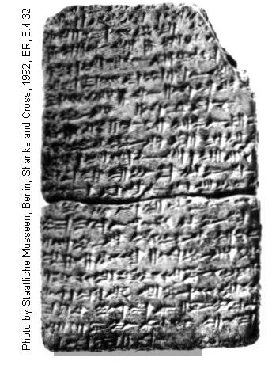
PHOTO LINK: AMARNA LETTERS 005 Location map of Tell el-Amarna
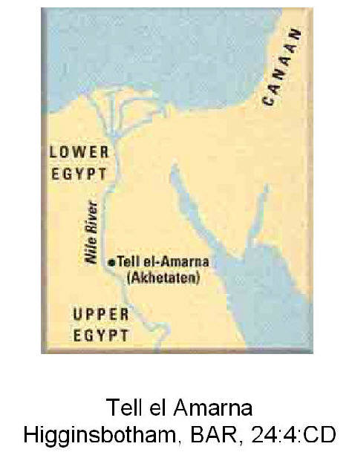

PHOTO LINK: SHECHEM 010 Ruins of MB age Shechem
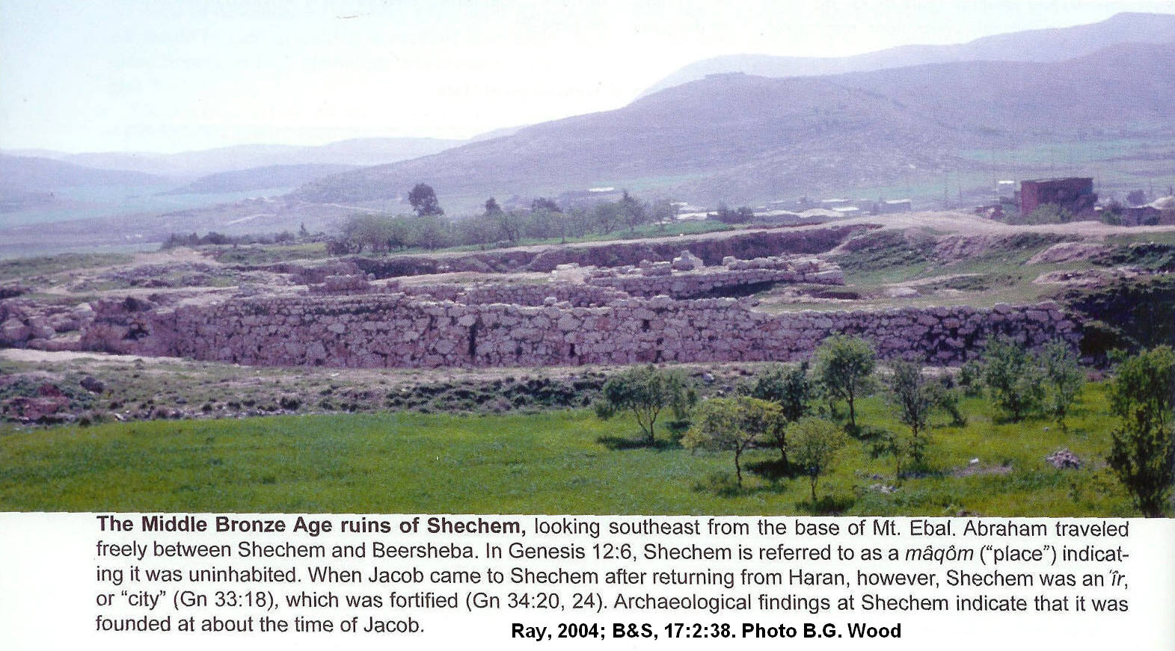

Early Date Theory

The Early Date is generally championed by conservative (maximalist) scholars. 1 King 6:1 indicates that, 480 years after the Exodus, Solomon began construction of the Jerusalem Temple in 966 BC (Whitcomb, 1968). Judges 11:26 says that Israel had been in land 300 years prior to this Temple’s construction. Subtracting 40 years for wilderness wanderings and the 300 years described in Judges 11:26 yields a date of 1445 for the start of the Exodus. Adding 40 years wandering, the Conquest starts in 1406 BC and ends in 1398 BC per Joshua 14:7,10 (Livingston, 1988).

The Amarna tablets (c. 1400 BC) record international correspondence under 18th Dynasty Pharaoh Amenhotep III with requests from Canaanite vassals for help to drive out the Habiru (or ‘Apiru) nomadic invaders. Habiru has been interpreted as an Egyptian word for “Israelites” (but this is not accepted by all scholars, Livingston, 1988; Rainey, 2008a).

PHOTO LINK: AMARNA LETTERS 007 Letter of Labayu, king of Shechem to Amenhotep III
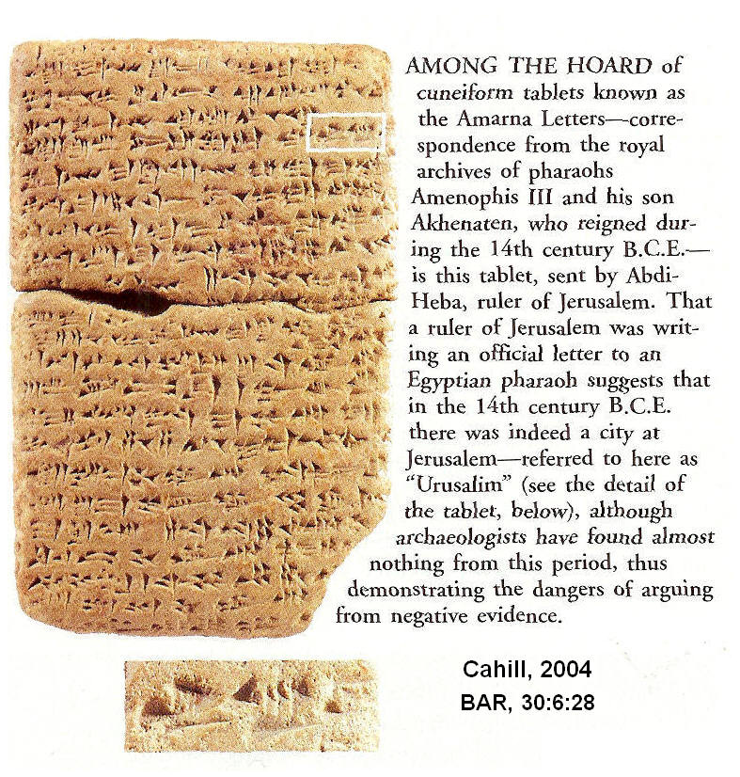

The early date for the conquest is supported by a partial hieroglyphic inscription from a column base dating to the reign of Ramesses II. The fragment, of unknown provenance, and now in the Egyptian Museum in Berlin lists Ashkelon, Canaan, and part of the name “Israel”. The spellings in the inscription suggest that the names were copied from an even earlier list of names from around the time of Amenhotep II (1553-1419 or 1427-1401). The spelling of reconstructed “Israel” on this column fragment is slightly different from the spelling on the Merenptah Stele (Görg, 2001, cited by Wood, 2005).

PHOTO LINK: CONQUEST 015 Egyptian column base fragment with partial inscription “Israel”
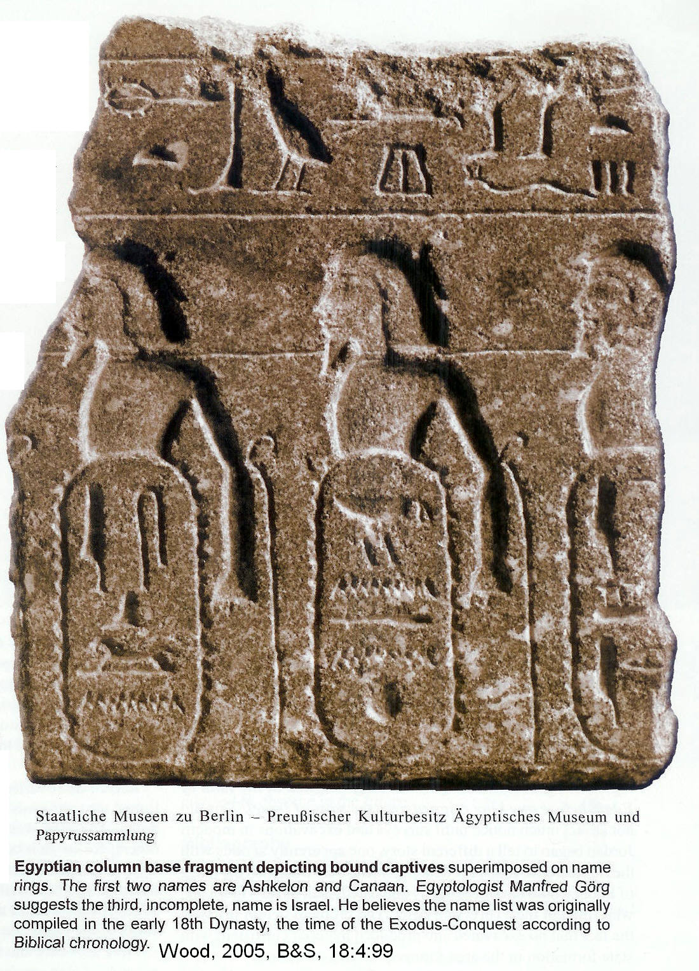

In Late Date reconstructions, The Exodus/Conquest occurred about 150 years after the end of Middle Bronze Age II when cities in the “Promised Land” were at their peak. Afterwards, they collapsed, as did almost all civilizations around the Middle East and Mediterranean. These conquests were made by a variety of invaders (Sea Peoples), including the Israelites. The Israelites, a relatively small and weak group of people, were in the right place at the right time (Livingston, 1988). The Early Date theory attributes destructions in the 1400's at Jericho, Ai, and Hazor to Joshua. These destructions did not necessarily bring an end to Canaanite control in the region, and there were many cities in the Promised Land that were not conquered during Joshua’s time, or even during the 300-year period of the Judges (Joshua 13:1; Judges 3:1-6). During the Conquest period, except for Ai, Jericho and Hazor, vanquished citizens were killed in religiously motivated genocide, but the Israelites tended to spare the cities themselves. They preferred to live in what they conquered rather than destroy perfectly good real estate. The archaeological record shows a punctuated conquest with short-term victories and a gradual expansion of Israelite hegemony over three centuries (Seiglie, 2003:39). This was expansion era was the period of the Judges.

Early date proponents counter a central anti-thesis of the Late Theory, namely that there were no walled cities in the Levant for the Israelites to conquer in LB IA-IB or LB IIA (c. 1480-1295 BC). The Early date advocates (Hansen, 2003) point out that LB fortified cities did exist in the Levant in the 14th century BC. An example is the LB I fortress at Khirbet el-Maqatir.

PHOTO LINK: AI 010B Regional map of cities related to Ai and Bethel ; Byers, 1999, B&S, 12:1:9
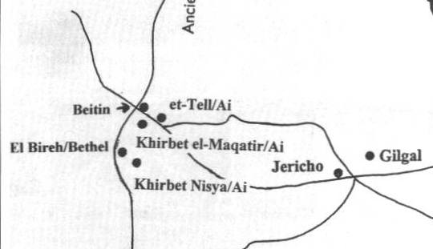

PHOTO LINK: KH EL-MAQATIR 014 Aerial photograph
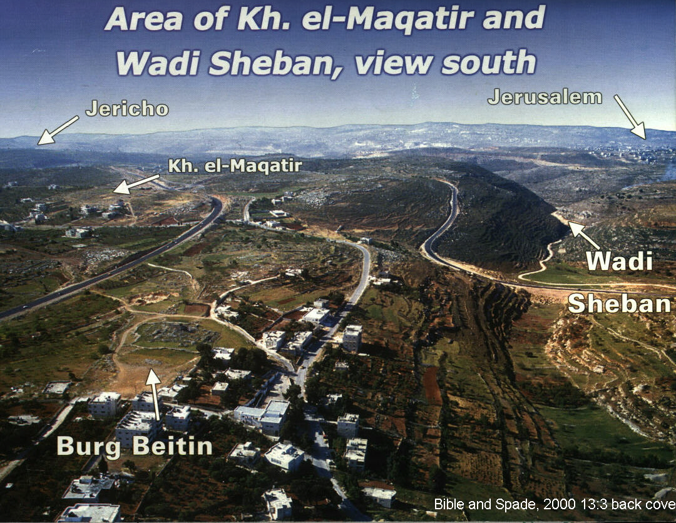

PHOTO LINK: KH EL-MAQATIR 001 Plan of North wall of LBI fortress
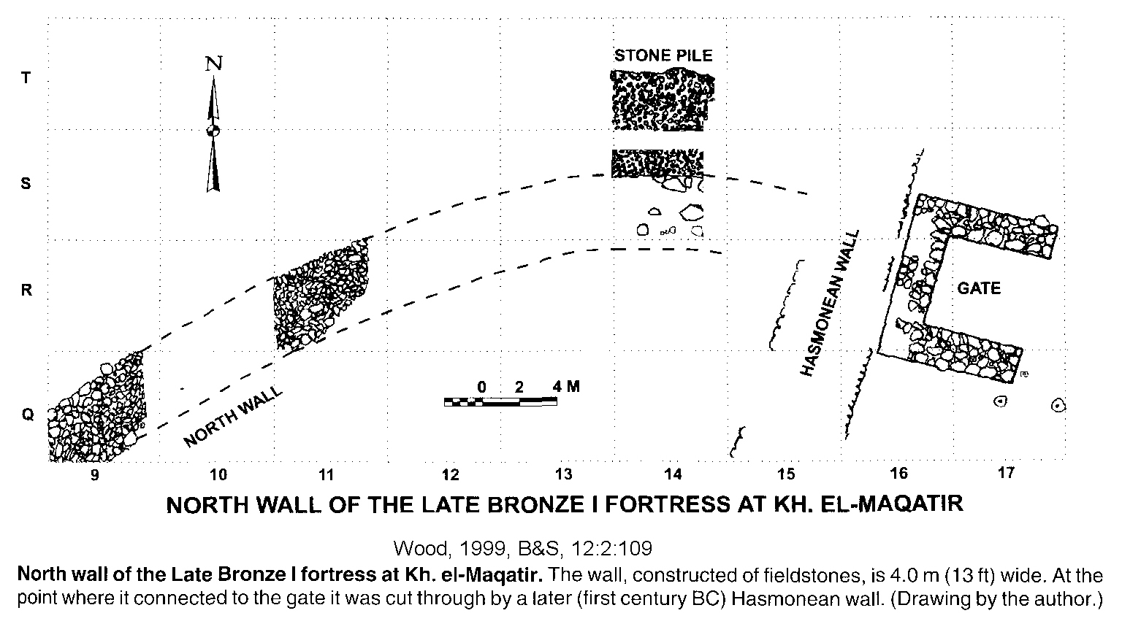

PHOTO LINK: KH EL-MAQATIR 004 North side of LBI fortress looking east
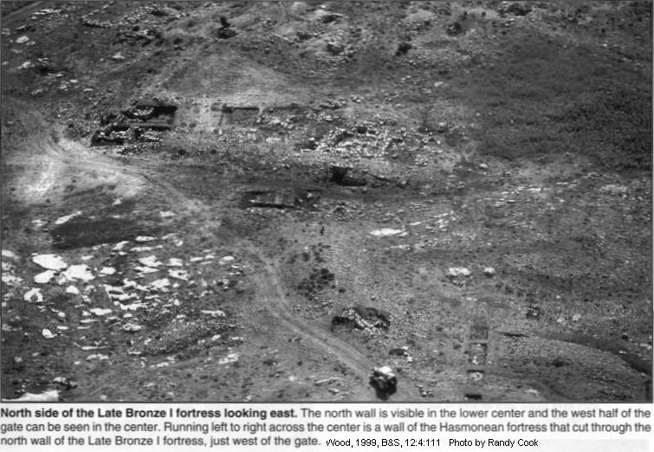
PHOTO LINK: KH EL-MAQATIR 016 Inner face of west wall of fortress 14 ft thick
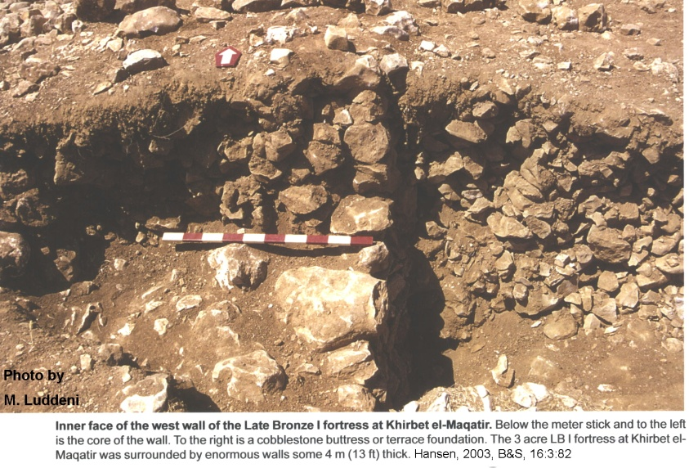
PHOTO LINK: KH EL-MAQATIR 009 Plan of LB1 fortress
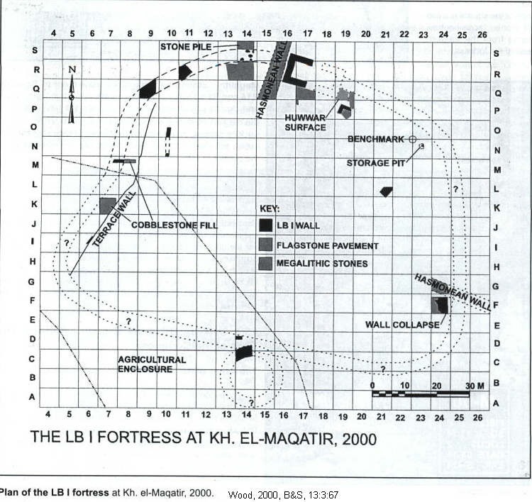

Further, Egyptian reliefs dated to the Late Bronze Age show that Canaanite cities had walls (Hansen, 2003:82).

Hanson (2000a, 2000b) conducted a survey of 51 LB sites in the region described in Numbers 13:21-22, 29 as the area that the scouts reconnoitered and described as having “walled cities”. This area is the Negev, hill-country, Hebron and Jebus regions. The results of this study are shown in the chart below:

PHOTO LINK: CONQUEST 004 Chart of 51 LB sites in the Levant
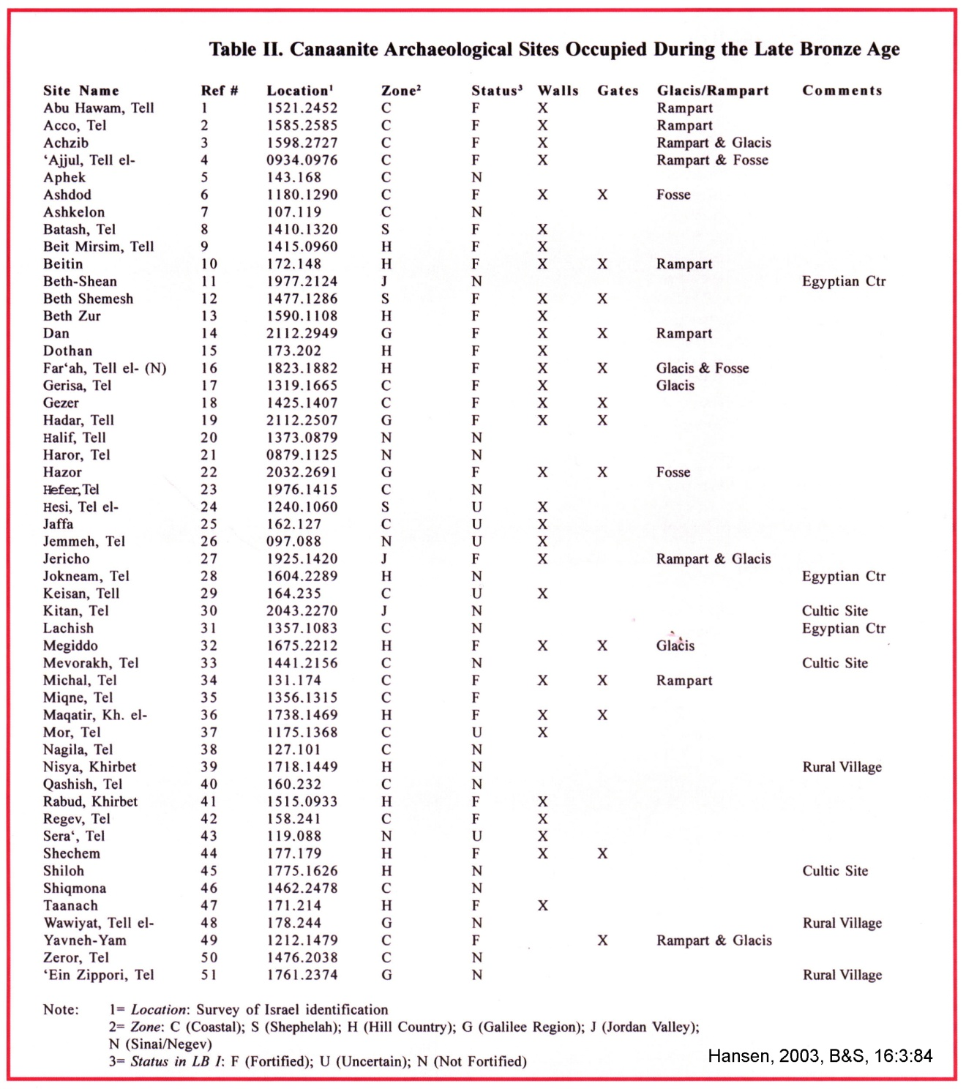

Of the 51 sites, 27 (53%) were fortified, 24 were unfortified and six were “uncertain”. Of the three unfortified Egyptian cities: Beth-Shean, Lachish and Jokneam were located on high mounds. The buildings on these high mounds linked to form a perimeter that may have appeared to be walls from a distance (Hansen, 2003:83)

PHOTO LINK: BETH SHEAN 001 Panorama of Beth Shean
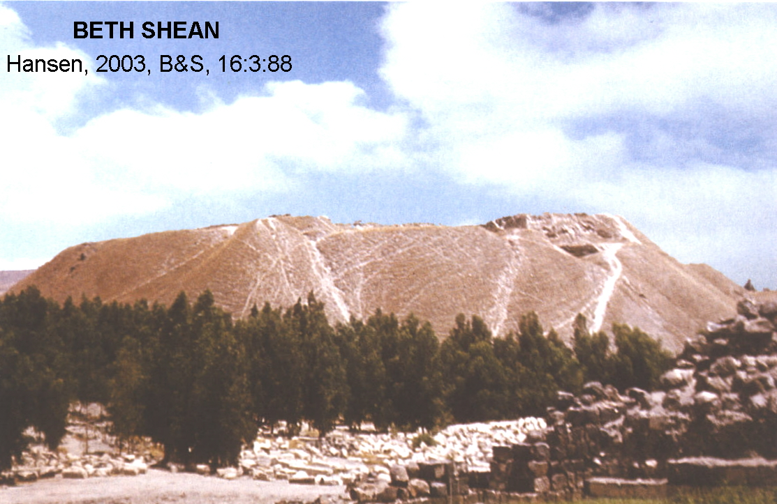

PHOTO LINK: LACHISH 035 Location map; (See ABOVE, ctrl+click to follow link)

PHOTO LINK: LACHISH 003 Plan map of LB Temple at Lachish
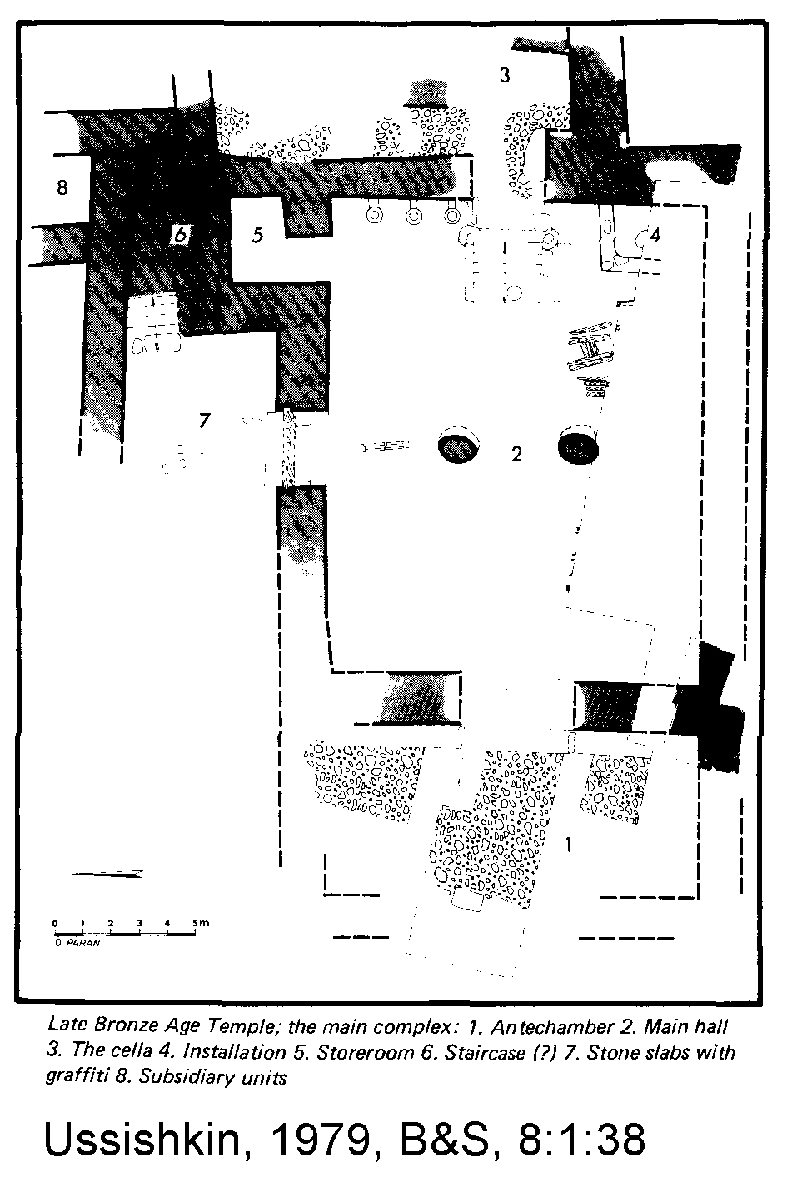

PHOTO LINK: AI 023 Plan of LBI fortress at Kh el-Maqati
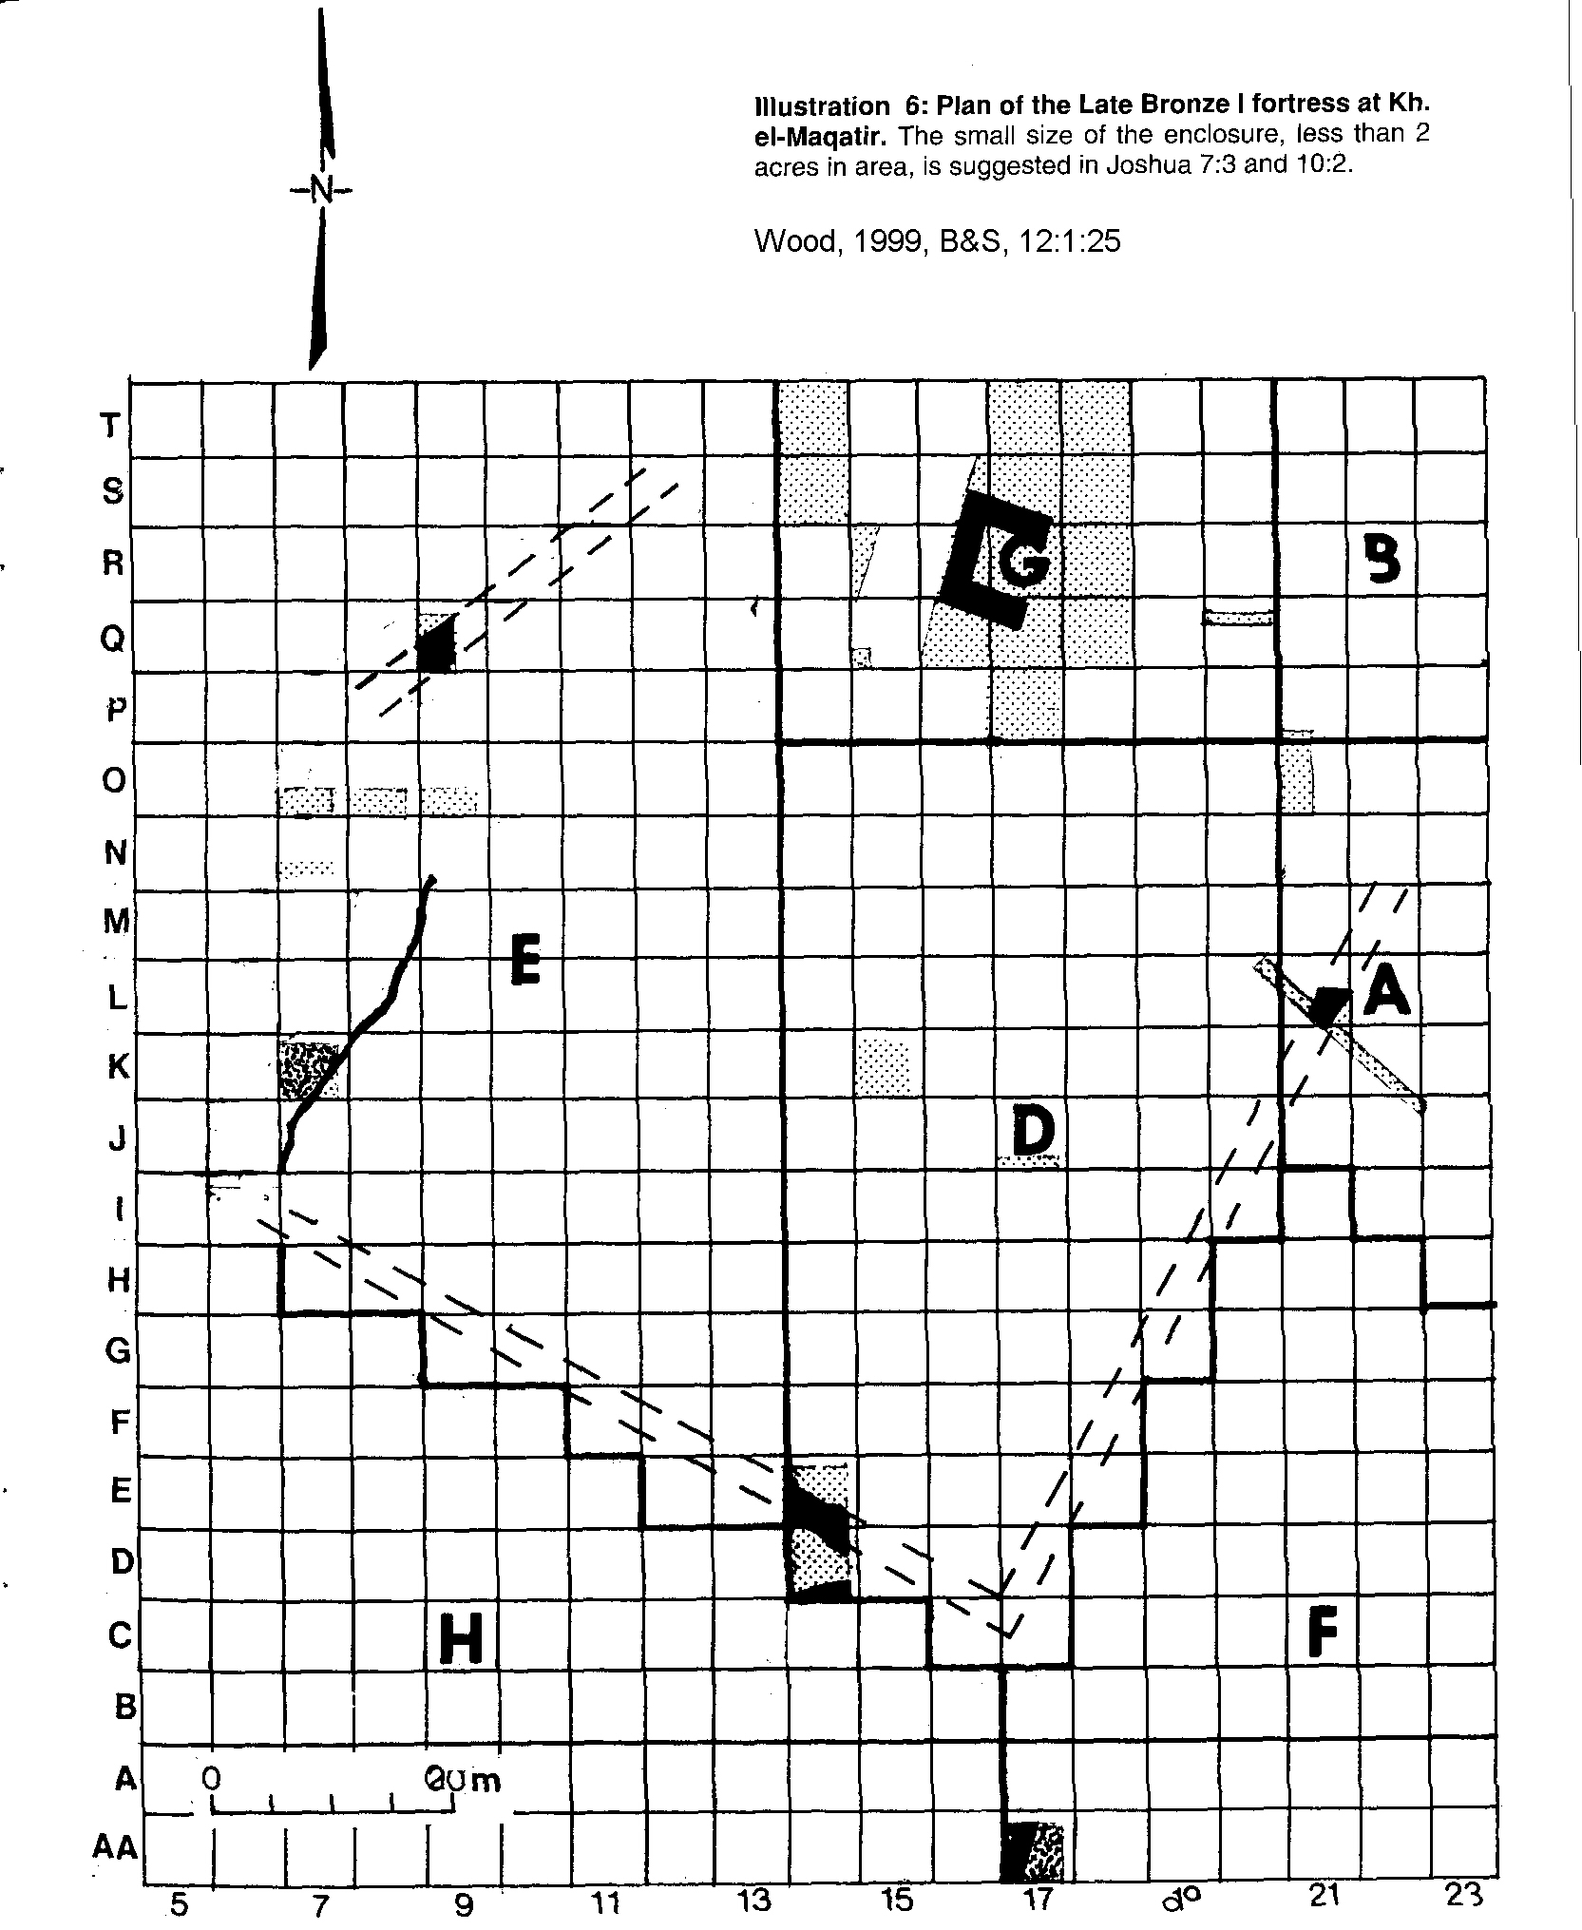

PHOTO LINK: BEITIN 002 Plan of MB-LB fortress
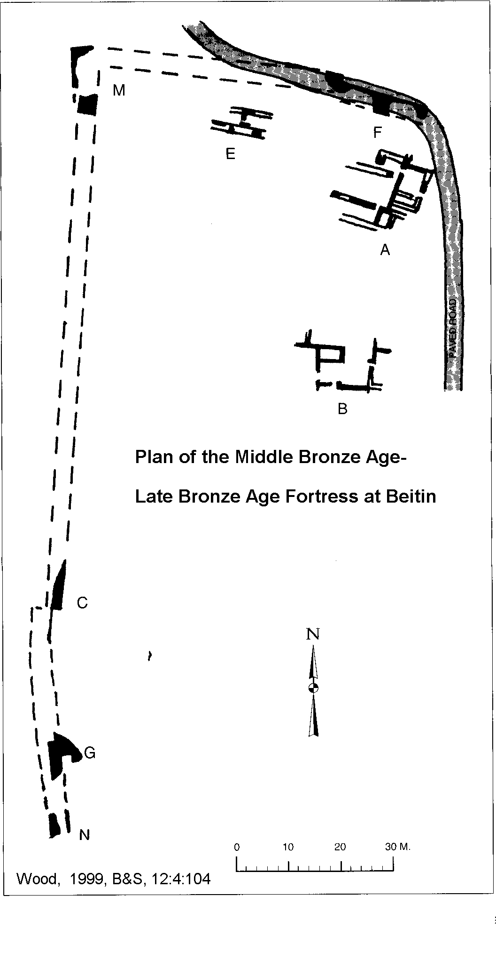

PHOTO LINK: GA022 Hazor, aerial photo
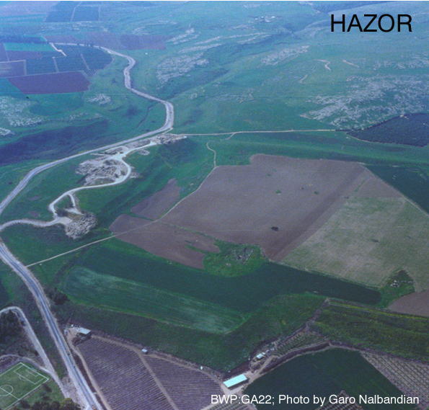

PHOTO LINK: GA040 Dan, Model of Middle Bronze Age Gate
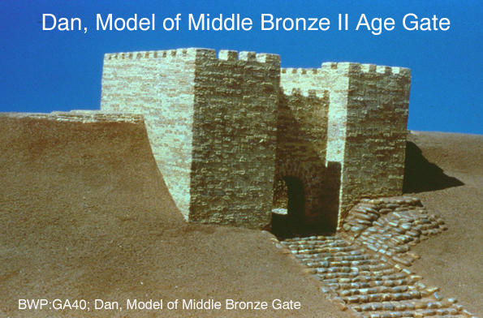
PHOTO LINK: JERICHO 038 Elgon's Palace at Jericho, LBIIA, 14th cent. BC
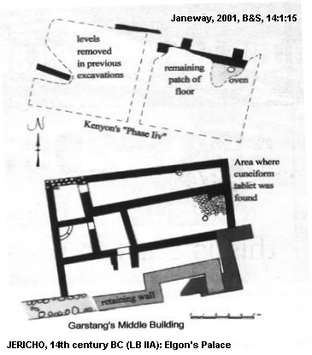

PHOTO LINK: GA041 Dan, Steps Leading to Middle Bronze Gate
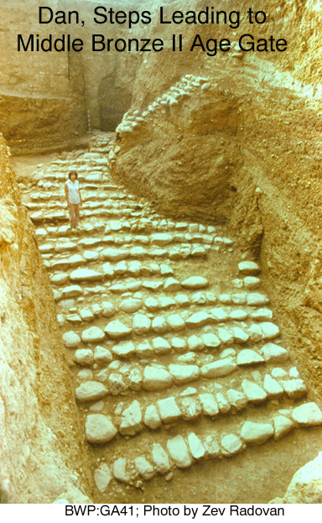

During the Conquest, not all Canaanite settlements were walled (Deut. 3:5), but many were (Num 13:28). The study by Hansen shows this to have been the case in Late Bronze age I (LB I).

Hanson also showed that 49 LB I sites can be identified with sites mentioned in the Book of Joshua. Of these, there is very close correspondence between the biblical descriptions of the character of these sites and the archaeological findings (Hansen, 2003; Table IV).

PHOTO LINK: CONQUEST 005 Table of 48 LB I sites identified in the Book of Joshua, part 1
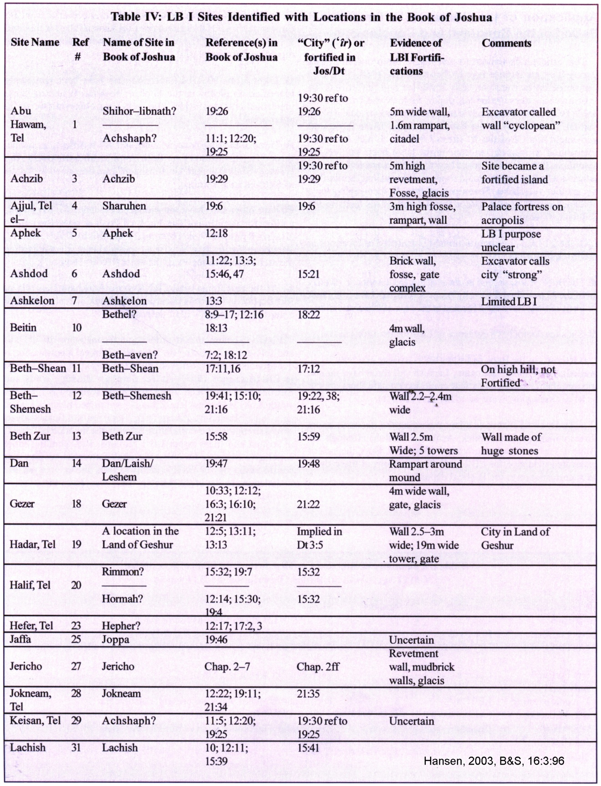

PHOTO LINK: CONQUEST 005B Table of 48 LB I sites identified in the Book of Joshua, part 2
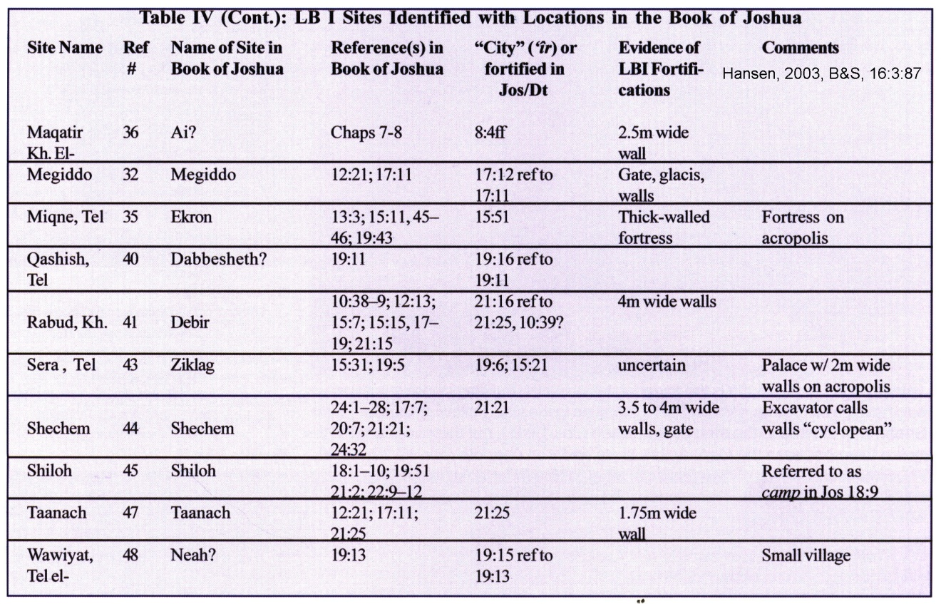

NATURE OF THE CONQUEST

Overview

The goal of archaeological and biblical studies in regards to the periods of the Conquest and Judges is to reconstruct how Israel became a distinct ethnic and nationalistic people. Genesis and Exodus indicate that they were a small but separate ethnic group in the Early Bronze Age. There consolidation into a nation began with their exodus from Egypt and their occupation of the “Holy Land”. There are several theories on how and when this happened. It started sometime in the Late Bronze Age (1550-1200 BC) and was completed by the end of Iron Age I (1000 BC). An important paper on this topic is Faust (2009). His summary is reproduced below:

In the Late Bronze Age (1550-1200 B.C.E.), the period that immediately preceded Iron Age I, the Egyptian pharaohs ruled over Canaan. In this period, decorated pottery and imported wares were common in Canaan, indeed more common than in practically any other period, including the 11th century B.C.E. At this time, pottery was imported, mainly from the Aegean and Cyprus, but also from other paces. Imported pottery is found in large quantities throughout Canaan, at practically every site. Not only is most of this imported pottery decorated, but so is much of the local Canaanite pottery. A similar situation prevails with respect to burials. We are familiar with hundreds burials from the Late Bronze Age in Canaan, in dozens of different forms. This ends with Iron Age I—a period from which almost no burials are known because the deceased were buried in simple inhumations (Faust, 2009:69, 92).

PHOTO LINK: POTTERY LATE BRONZE AGE 001: Canaanite pottery Late Bronze Age, 1550-1200 BC, Shechem. Collection showing elaborately decorated pottery
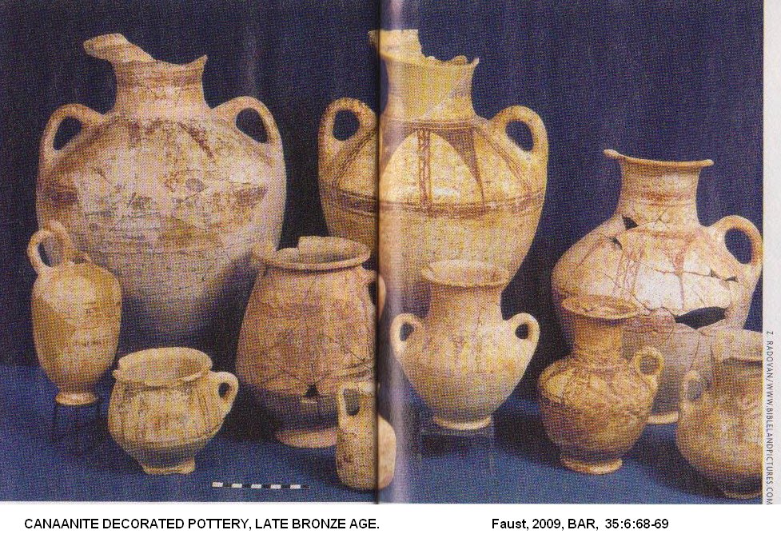

In short, the lack of distinctive Late Bronze Age Canaanite symbols in the highland settlements signifies an active act of differentiation and seems to indicate that the avoidance of those traits—and even the emergence of the egalitarian ethos itself—gained significance at this time. Circumcision and the avoidance of pork are the only patterns that seem to be associated only with the differentiation from the Philistines in a later period (Faust, 2009:92).

It thus appears that the beginning of the settlement process in the highlands on both sides of the Jordan River in the second half of the 13th century B.C.E. was accompanied by hostile relations between the highland settlers on the one hand, and the Canaanite city-states and their Egyptian overlords on the other. The former were apparently pushed (or restricted) to the highlands by an Egyptian administration that was strengthening its hold over Canaan at the time. The highland settlers had an asymmetrical relationship with the powerful Egyptian overlords and the Canaanite cities. Asymmetrical relations between groups typically result in the creation of distinct ethnic identities, and it is therefore likely that the highland settlers would have developed their own identity under these circumstances. This is the Israel that is mentioned in the Merneptah Stele (Faust, 2009:92).
PHOTO LINK: MERENPTAH STELA 011: Stele in shadowed light with illulminated "Israel" text. This is not a great shot of the stele, but it is very artistic photo
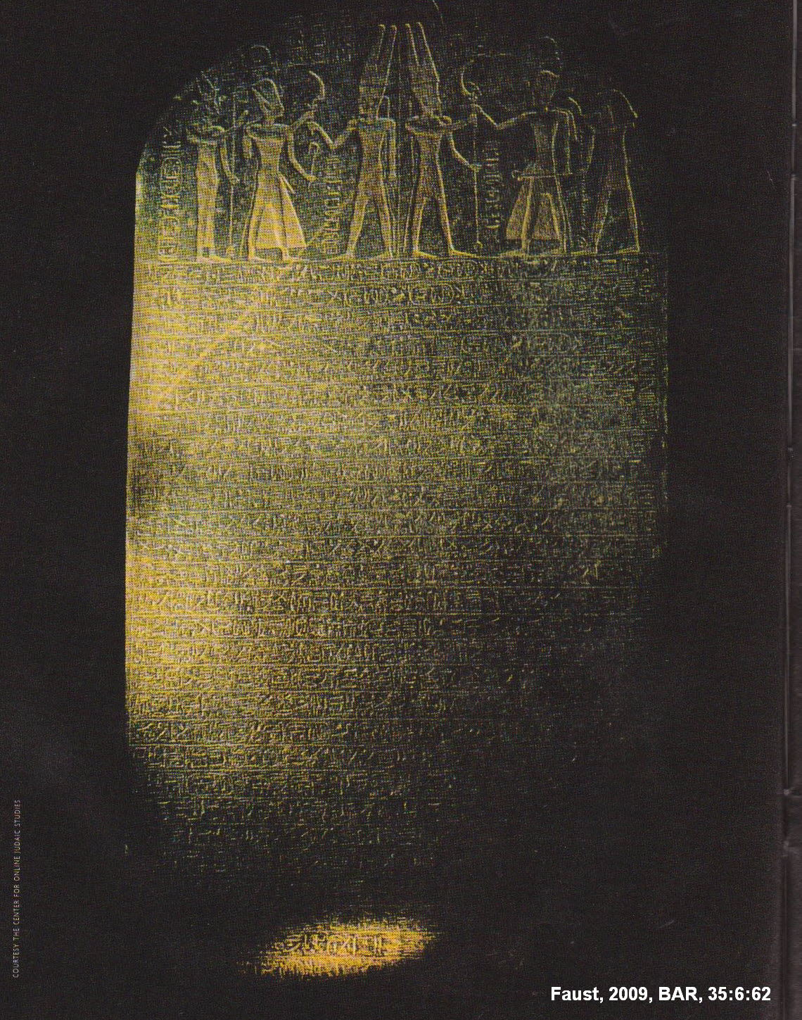

This highland group defined itself as egalitarian in contrast to the highly stratified and diverse Canaanite society, and therefore avoided the use of imported or decorated pottery that was prevalent in Canaan at the time. Decorated and imported wares were a kind of nonverbal communication of Canaanite society in the Late Bronze Age. The differences were important to the various groups living there at the time. Complete avoidance of imported and decorated wares transmitted a strong message of difference (Faust, 2009:92).

PHOTO LINK: POTTERY IRON AGE I 001: Iron Age I pottery from Biblical World in Pictures slide #BA127
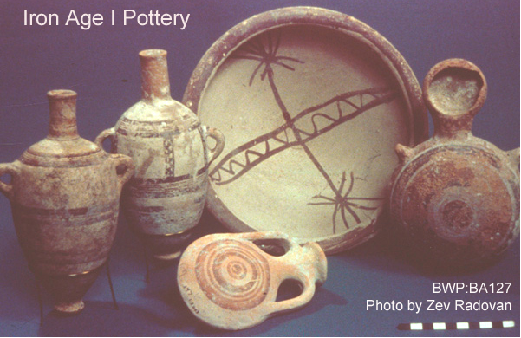

PHOTO LINK: COLLAR RIM JARS 002: Collar rimed storage jar, Iron Age I, simple and undecorated
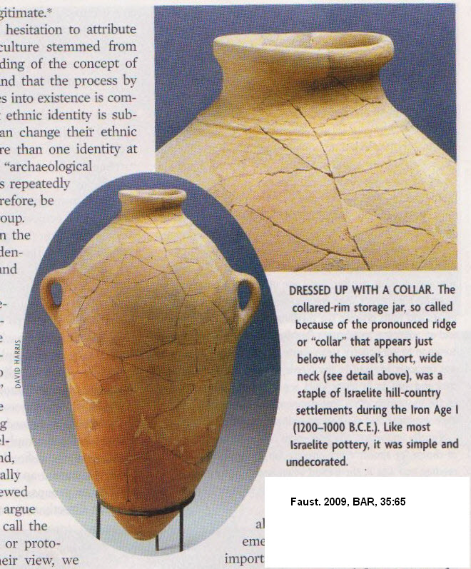

During the 12th century the Egyptian rulers withdrew from the Canaanite territories. The Canaanite city-state system that characterized the Late Bronze Age was weakened. Egypt lost whatever influence it had in the highlands. At this point, the highland settlers had little interaction with the people of the lowlands. With the absence of any significant external "other," the highland settlers maintained a symmetrical relationship among themselves, that is, each group of settlers interacted with similar groups and had no connection with a larger or stronger group from outside the highlands. Since it is agreed that ethnic consciousness is promoted by asymmetrical or hierarchical relations between groups, it is likely that the symmetrical relationship that characterized this time period promoted the emergence of "simpler" forms of identity (sometimes labeled totemic identities). We may refer to these as "local" or "tribal" identities (Faust, 2009:92).

During the 11th century B.C.E., the highland population once again confronted a powerful external "other"—the Philistines. By that time the Philistines had an economic interest in various regions of Judah and probably also southern Samaria. This strong external pressure once again led the highlanders to stress their ethnic identity, this time in relation to the Philistine "other." In the new ethnic negotiation that ensued, many of the former relevant traits were renegotiated and stressed anew (i.e., undecorated pottery, avoidance of imported pottery, and even the egalitarian ethos), along with new components that were deemed appropriate in the new context (e.g., circumcision and the avoidance of pork). All this left its mark on Israelite identity for hundreds of years, often through a repetitive process of negotiation and renegotiation. Some of those patterns are visible even today (Faust, 2009:92).

PHOTO LINK: POTTERY IRON AGE II 001: Two photos comparing simple Highland Pottery Iron Age II with decorated Philistine pottery Iron Age II
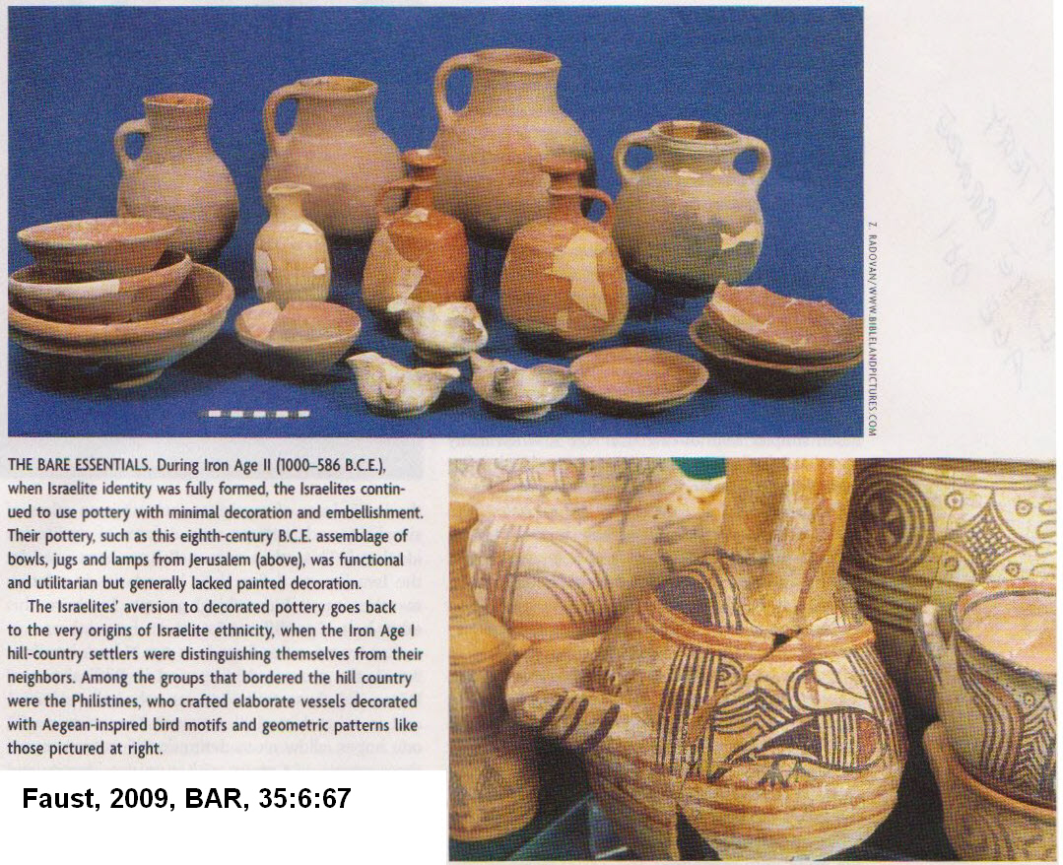

The "Israel" that is mentioned in the Merneptah Stele is indeed the "Israel" of the Iron Age. And it can be identified archaeologically. The rich archaeological database, and its analysis with appropriate tools, allows us to trace the Israelites and to decipher many of the internal and external processes that characterized the group from the beginning of the Iron Age onward (Faust, 2009, 93-94).

Traditional Military Overthrow

The traditional and conservative description of the Conquest of Canaan is that it was mostly a military operation. According to this popular theory, the "Hornet" of Exodus 23:28, Deuteronomy 7:20 and Joshua 24:12 was Thutmose III. He "softened up" the Canaanites of coastal Palestine circa 1470 BC. This set up opportunity for Israelites to invade and capture the hill-country cities, which may have been weakened by loss of trade and military support with coastal neighbors. When lowland cities tried to come to rescue of hill-country cities, they were easily defeated (Livingston, 1988).

PHOTO LINK: BA078 Bronze Blades, EB and MB
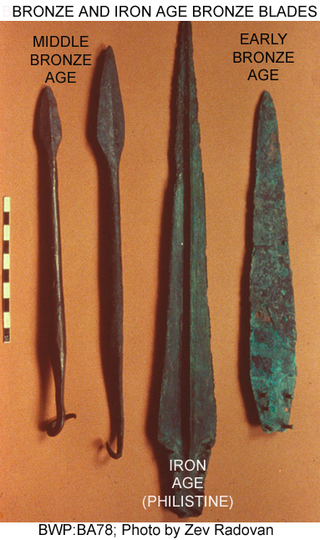

PHOTO LINK: BA077 Mold for Bronze Axe Heads, 12-11th centuries BC
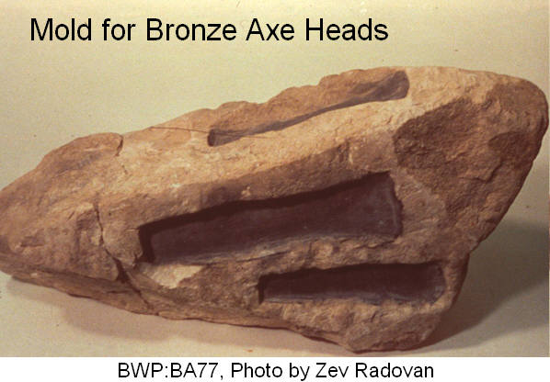

Assimilation-Infiltration

The theory that the “Conquest” was due to assimilation and infiltration of peaceful Israelite immigrants into earlier Canaanite culture is described by Silberman (1992).

Assimilation theories are based in part on the Tell el-Amarna Letters which describe conflicts with 'Apiru (=Hebrews?, but see discussion below under “Peasant Revolt Theory”) circa 1350 BC, 100 years before the “Conquest” (Late Date, c. 1250 BC). In Palestine, there is a wide distribution of 136 simple farming communities (Early Iron Age) the remains of which lie above destruction layers of cities of the Late Bronze Age (1550-1200 BC). This stratigraphy together with paleoenvironmental information indicate that there was gradual population movement from the desert fringe into the interior valleys and finally to the hill-country during the Early Iron Age (Silberman, 1992).

PHOTO LINK: JERICHO 015 Drawing of wall collapse Israelite entry
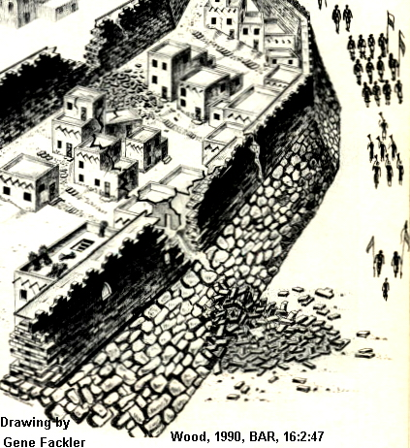

PHOTO LINK: ‘APIRU 001 Tell et-Amarna letter cuneiform tablet. 'Apiru lead by Lab'ayyu (See ABOVE, ctrl+click to follow link)

According to the assimilation theory, "Israel" was a small group of villagers of pastoralists living in the hill-country, not a strong 12-tribe league. Israel originated through a loose federation of tribes who infiltrated Canaan over a long period of time. No massive immigration from the outside is needed to explain sudden establishment of Israelite settlements. Early Israelite population was about 20,000 (not the 2 million suggested by the 600,000 warriors mentioned in the Exodus stories. Demographic shifts of Early Iron Age Palestine are linked to wider socio-economic disruptions, not Israelite military activity. The thickly settled, numerous, fortified towns of circa 1750 BC are followed by sharp population drop circa 1550 BC in Middle Bronze Age IIC. In the Late Bronze Age, (1550-1200 BC) large cities along the coast and in major valleys continued to flourish, but 90% of the hill-country settlements were abandoned. The remaining 10% were smaller in size. Hill-country farmers became pastoralists on the fringe of desert (opposite the traditional sequence). This change in lifestyle would be difficult to see in the archaeological record. A symbiosis between pastoralists and large city states was disrupted shortly after 1250 BC due to collapse of centralized governments. Wandering herders then occupied abandoned hilltops for their permanent settlements in the Early Iron Age: this was the Early Israelites (Silberman, 1992).

A historical memory of this migration and infiltration is found in Ezekiel (16:3) "Your origin and your birth were in the land of Canaan" (Silberman, 1992). Evidence for some kind of assimilation is also found in changes in ethnicity of some individuals as described in different portions of the Hebrew Bible, for example:

Original Description | Adjusted Description
Obed-edom the Gittite | transformed to a Levite
1 Chron 13:13 | 1 Chron 15:17
1 Chron 13:13 | 2 Chron 25:24
Carites | transformed to Levites
2 Kings 11:4 (with gloss at 2 Kings 11:10 to give weapons to Levites) | 2 Chron 23:1-21

Gadites defect and assimilate to David in 1 Chron 12:8.

The Assembly at Shechem

The idea that Israel was a confederation of various groups was introduced in Chapter 5 (“Early Judahism”). The key event in this evolution was the convention at Shechem described in Joshua 24. Lemaire (2007:31):

Even though the texts we have were recomposed by various later redactors, and actual historical event was probably the basis of the proposed alliance with Hebrew groups that were not part of the Exodus, and thus did not know YHWH. Joshua tells the people to revere YHWH and to “put away the gods that [ther] ancestors served beyond the River [that is the Eurphrates] ….gods of Amorites.’ (Joshua 24:14-15). These were probably the Bene-Jacob wo arrived from northern Mesopotamia; Joshua tells them to give up their ancestral god (probably Pahad), the “god of their fathers,” and thus commit themselves to the service of YHWH alone (Joshua 24:23; Genesis 35:2,4)

Once again, the surviving texts point to an association of some of the early Israelites with Amorite traditions

Peasant Revolt

The theory that the “Conquest” was a slow "invasion" of the hill-country while the Canaanites kept the good valley land and fortified cities is described by Callaway (1983) and also by Mendenhall and Gottwald as cited by Zertal (1991). See also Mendenhall, 1962; 1986; Gottwald,1979; Dever, 2003; 2007; Faust, 2007 and Van der Steen, 1996. All cited by Rainey, 2008:84.

It is postulated that Canaanite renegades revolted against their urban oppressors. Leaving Canaanite cities in the western part of Palestine and the Valley of Jezreel, the Canaanite underclass fled east and south to the central hill-country (Zertal, 1991).

PHOTO LINK: JUDGES 001 Map Settlements in Canaan's central hill-country during Iron Age I (1200-1000 BC)
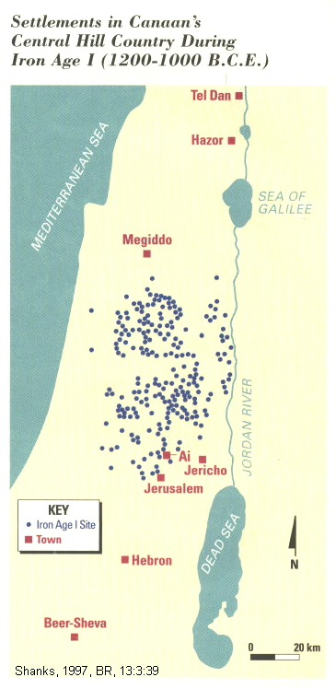

Joshua 17:16,18 states that "The tribe of Joseph said 'The hill-country is not enough for us; yet all the Canaanites who dwell in the plains have chariots of iron, not only those in Beth Shean and its villages but also those in the Valley of Jezreel'...the hill-country shall be yours, for though it is a forest [heavily vegetated] you shall clear it and possess it to its farthest boarders."

PHOTO LINK: BETH SHEAN 001 Panorama of Beth Shean (See ABOVE, ctrl+click to follow link)

Settlements at this time in the hill-country used rainwater cisterns to supplement wells. There are 102 small hillside settlements that are known, among them Ai and Raddana. Of these 90 were newly founded. Peasant Revolt supporters say that 'Apiru in Egyptian records is not a term for the Hebrews or any ethnic group. Instead, it is said to be indicative of a social class. Late Bronze Age societies of Canaan where highly stratified. ‘Apiru ideology (borrowing from Israelite monotheism) provided a basis for native Canaanites to unite in order to throw off rule of aristocracy which used a pantheon of divinities to legitimize the king's power. Canaanites, when they joined this ideology, exacerbated the rebellion and this mixed group became "Israelites." The rebels had no extensive trade networks, except in metals, which were obtained as ingots and fabricated on site. They were isolated, highly individualistic communities without political cohesion (Zertal, 1991; Rainey, 2008a).

PHOTO LINK: ‘APIRU 001 Tell et-Amarna letter cuneiform tablet. 'Apiru lead by Lab'ayyu (See ABOVE, ctrl+click to follow link)

PHOTO LINK: AMARNA TABLETS 002 Many colored tablets
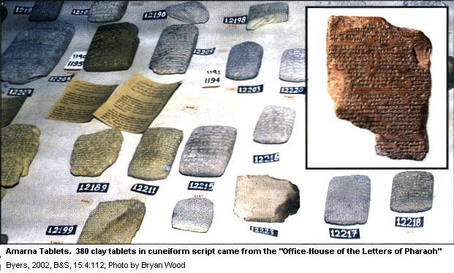
The theory that a Peasant Revolt lead to destruction of the Bronze Age cities was applied to Zuckerman to her investigations at Hazor. The common dwelling surrounding the LBIII Canaanite city were not destroyed when the administrative and cultural centers of the city were.

PHOTO LINK: HAZOR 061 Rebel dwelling not destroyed in lower city
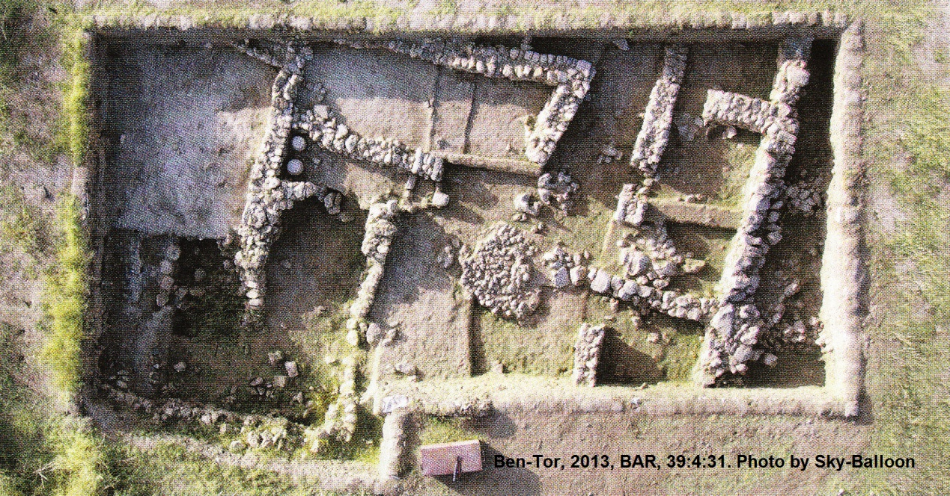

‘Apiru and Hebrew

The people named ‘apiru (or habiru) in the Amarna Letters, and other Egyptian records, have been interpreted as being early Israelites. The connection between ‘Apiru and the Israelites is now questioned. 'The true Semitic form of the word is obscured by the Akkadian syllabic script of the Amarna Letters and other cuneiform documents. The word often transliterated is really 'apiru meaning "dusty, dirty." (Rainey, 2008b:55).

PHOTO LINK: CUNEIFORM 001 Amarna letter, Late Bronze age with habiru, or ‘apiru
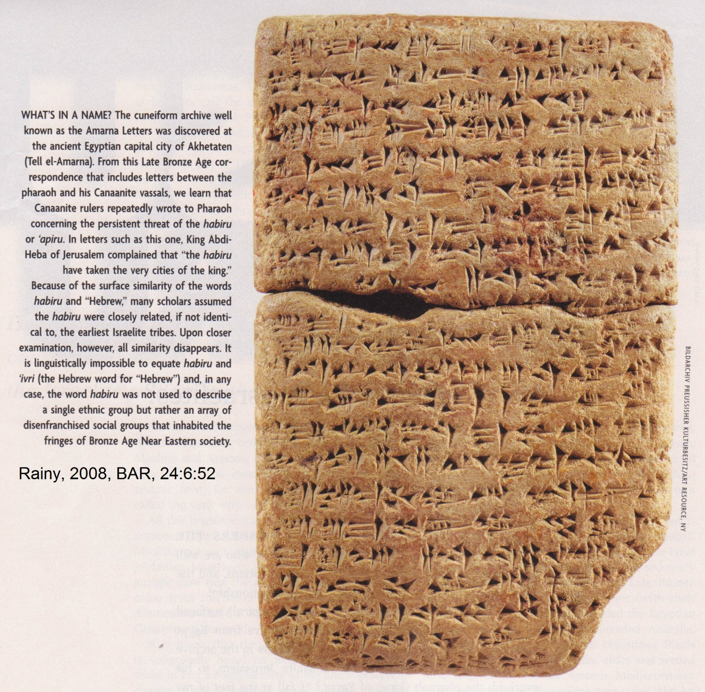

In the late 19th century, an archive of cuneiform tablets was discovered in Egypt. These tablets are now known as the Tell et-Amarna Letters, after the culturally stratified hill where they were found. Seven of the letters are from Abdi-Heb, king of Canaanite Jerusalem, to his overlord, the pharaoh (king) of Egypt. The Amarna tablets have phrases such as the following:

“ have plundered all the lands of the king”
“the habiru have taken the very cities of the king”
[If the Pharaoh does not send archers], “the land of the king will be desert to the habiru.”
[The Pharaoh is not sufficiently helpful to me]. “I am treated like a habiru.”

In English, “habiru” sounds similar to “Hebrew.” But this similarity is deceiving.

There are now hundreds of references to habiru known from the following areas:

Egypt
Nuzi (beyond the Tigris)
Syria
Canaan
Anatolia

There is an 8.5-inch high square cuneiform prism from Anatolia that lists 438 names of habiru. The term habiru is known from documents dating from the 18th to 12th centuries BC. This is a 600 year period, and the meaning of the term habiru probably evolved. In general, however, the term habiru, in most contexts, is uniformly a social, not an ethnic description. Since the term habiru is applied to individualsfrom several different areas, who are living in different circumstances, the habiru do NOT belong to a single linguistic (or ethnic) group (Rainey, 2008b:52).

When the term habiru it always refers to persons of inferior social status. The term has a negative, derogatory, connotation. Here are some of the terms associated with habiru:

-mutineer
-pauper
-servants
-slaves
-robber

The term habiru can refer to individuals, but sometimes as member of a group. These can be groups of servants or slaves. Or it can refer to members of robber bands who attack and plunder, especially in times of disintegrating rule, as happened when the Hyksos invaded Egypt. In some documents, the habiru seem to have been individuals recruited into the militia as mercenaries. As an incentive, some habiru mercenaries were given lands and estates (Rainey, 2008b:52).

The habiru are never described as pastoralists, and they are never referred to as belonging to tribes. Since the early Israelites were clearly pastoralists, and had a tribal character from the beginning, it is difficult to see how habiru could be a term used to describe them (Rainey, 2008b:53).

Linguistic studies of the term habiru indicate that it is not related at all to the Israelite word “‘ivri” we translate as “Hebrew” (Rainey, 2008b:55 citing Rainey, 1987:539-541).

Pottery

Objections to the Peasant Revolt theory include surveys in Galilee and ancient Ephraim and Judah, which show no evidence for a major demographic shift from coastal cities to the hill-country (Zertal, 1991).

PHOTO LINK: JUDEAN WILDERNESS 006 Khirbet Mazin, Biblical Middin of Joshua 15:61 in Ephriam
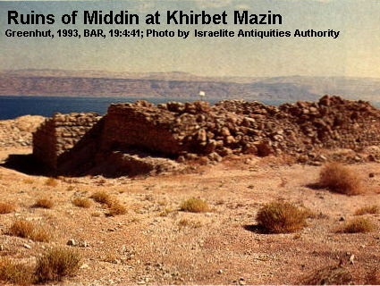

The Peasant Revolt theory is based on pottery traditions of the Iron Age I hill county settlements.

PHOTO LINK: HILL-COUNTRY 002 Map of Iron Age I settlements of the Levant (1200-1000 BC).
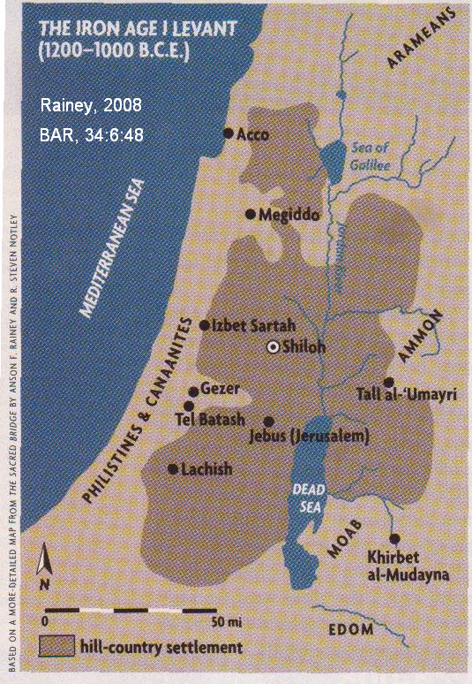

PHOTO LINK: COLLAR RIM JAR 001 Pithos of Iron Age I from Isbet Sarah, Meggiddo and Tall al ‘Umayri.
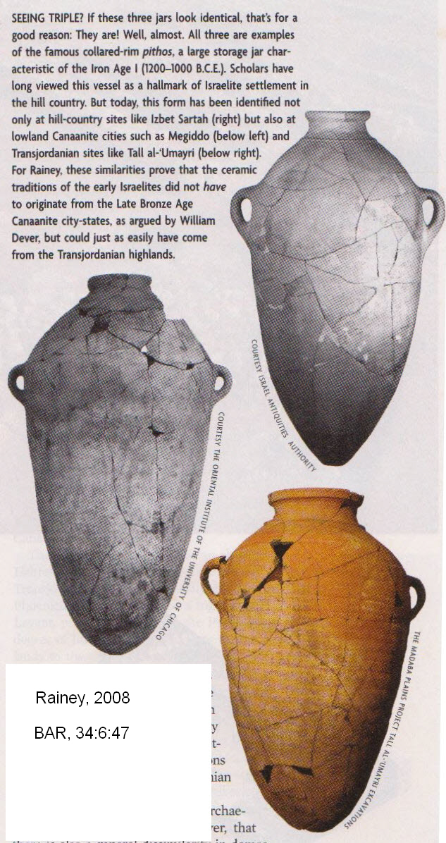

Collar-rim jars were thought to be diagnostic of Israelite presence (Dever, 2003). They were used by the coastal Canaanites in the west (Gezer, Lachish and Megiddo) during the 13th century BC (Late Bronze Age). They also were used by the Hill-country peoples (Izbet Sarah and Shiloh) in the 12th century BC. This relationship indicated to Peasant Revolt theorists that the Hill-country occupants (early Israelites) came from the coastal Canaanite cities. (Rainey, 2008a:46-47).

But Collar-rim jars are also found in sites east of the Jordan, including Tall al-‘Umayri. These also date from Iron Age I. So it is possible that the Hill-country people acquired their pottery traditions from the east, in the Transjordanian plateau and the Jordan Valley (Rainey, 2008a:47).

Four Room House

There is a distinctive house design called the “Four Room House” that is common in the Hill-country settlements.

PHOTO LINK: FOUR ROOM HOUSE 027 Pillared four room house Tel Masos with cut-away drawing.
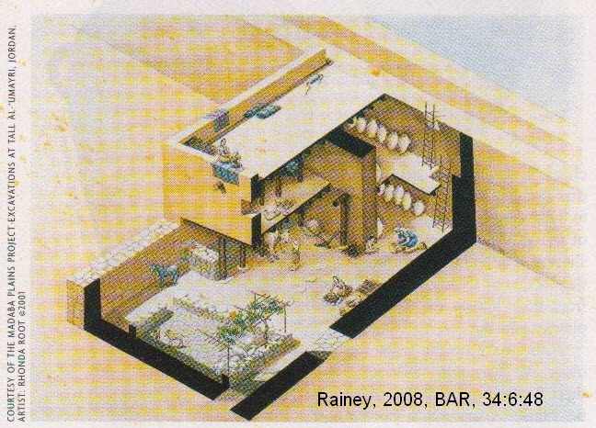

This building style had rows of pillars that separated it into three long rooms and one short room on one end of the other three. They date, in the Hill-country, from Iron Age I and II. This same architectural style is also present in coastal plain cities of the same age (Tel Harasim, Tell Lachish, and Tel Batash). This same style was also being used, in Iron Age I and II at settlements in Transjordan (Tall al-‘Umayri) and at Khirbet al-Mudayna al ‘Aliya on the southern Moabite plateau. (Rainey, 2008:49). Prior to discovery of the eastern Transjordanian houses, the similarity between Hill-country and coastal plain sites suggested migration of the Israelites from the west. Another problem for the Peasant Revolt theory, is that coastal Canaanite sites such as Acco, tel Keisan, Tel Yoqne’am and Tell Qiri, and Meggido all had continuous occupation from the 13th to 11th centuries. There is no signs of cities being destroyed and abandoned as a result of a Peasant Revolt (Rainey, 2008a:50).

East of Jordan Theory

The Bible indicates the Israelites originated from east of the Jordan. Abram (later Abraham) emigrated from Ur to Haran, a site in the modern “Jezirah” of northeastern Syrians (Gen. 11:27-32). Biblical traditions stress the close affinity of the early Israelites with the Arameans of the Syrian desert. The early Israelites are not described as having close relations to the city-dwelling Canaanites or Amorites. The search for Isaac’s wife, for example, describes the servant’s journey east, back to Aram-Naharaim, the city of Nahor, Abraham’s grandfather (Gen. 24:10). The bride found for Isaac is described as an Aramean (Gen. 25:20). Similarly, the wives of Jacob (Rachael and Leah) are daughters of “Laban the Aramean” (Gen. 31:20-24). Laban was Abraham;’s nephew (Rainey, 2008a).

The Bible describes the type of society the early Israelites came from: they were pastoralists. Joseph told Pharaoh that “My brothers and my father’s household…are shepherds. They have always been breeders of livestock, and they have brought with them their flocks and herds and all that is theirs (Gen. 46:31-34; also Gen. 47:3-4). When the Israelites left Egypt, they passed through the land of Edom and assured them that they would pay for any water the Israelite cattle drank (Num. 20:19, 32:1; Rainey, 2008a:46).

Pottery

Pottery traditions that used to suggest that the hill-country inhabitants of Iron Age I, the early Israelites came from western coastal cities. New data now suggest that these pottery traditions could also have originated in the east (see discussion above; Rainey, 2008a:47).

Four Room House

The four-room house style of architecture is another feature of the Iron Age I Hill-country that was thought to be diagnostic of early Israelites. This architectural style is also found in eastern Transjordan sites (Tall al-‘Umayri) and at Khirbet al-Mudayna al ‘Aliya on the southern Moabite plateau (see discussion above; Rainey, 2008:49). This data for four room houses suggest that the Hill-country people of Iron Age I migrated from the east. (Rainey, 2008a:47)

Diet

The Hill-country people of Iron Age I, did not have pigs. In contrast, the western Philistines who lived on the coastal pain did raise pigs. Pig bones are, to some degree, typical of the older Canaanite coastal plain sites too. There is no climatic or ecologic reason why pigs could not be raised in the Hill-country. This pattern is not what would be predicted by the Peasant Revolt Theory which says the early Hill-country settlers (early Israelites) migrated from the west (Rainey, 2008a:49).

The steppe land east of Jordan, however, wound not have been conductive to pig raising. The geography of that area is too rugged for pigs. That area is more suited for raising easier-to-move animals, like sheep and goats. The eastern steppe is hotter also. This is hard on pigs, who do not have sweat glands. Sheep and goats, on the other hand, have protective coats for the steppe-grazing habitat (Rainey, 2008a:49).

“This may explain the absence of pigs in the culinary diet of the hill-country settlers; they were not accustomed to raising pigs because they did not have them in their former habitat on the eastern steppe. Indeed, the cultural/religious ideology that seems to have accompanied the prohibitions on eating pork, preserved in Biblical kosher laws, probably derives from a rejection of the values of the sedentary Canaanite and Philistine religions. In cultures around the eastern Mediterranean, pigs were sacred to the deities of the underworld and were sacrificed to them. That this was true for the Aegean suggests that it could have been equally true of Philistia.” (Rainey, 2008a:49).

Linguistics

The Hebrew language is more like the eastern Transjordanian languages (Aramaic, Moabite) than those of the western Canaanite coastal plain (Phoenician). This similarity suggests that the Israelites originated from the east, and not from the west. (Rainey, 2008a:49-50).

Hebrew and Aramaic borrowed the 22 letter Phoenician (Canaanite) alphabet. They had to add some letters because Hebrew has 25 consonants, and Aramaic had at least 26. The Hebrews made some letters polyphonal (Rainey, 2008a:49).

“All this linguistic material provides a very strong argument for classifying ancient Hebrew and Moabite not as Canaanite dialects, but as Transjordanian languages. And this provides a nearly airtight case that the speakers of ancient Hebrew came from the same area as the Moabites, the Ammonites and the Arameans—and not from the Canaanite cities on the coastal plain.” (Rainey, 2008a:50).

Immigration and Climate Cycles

When climate warms and precipitation decreases, drought occurs. Pastoralists, like the early Israelites, were forced to move to towns or cities for survival in response to these climatic change. This behavior is documented in Egyptian texts of the Ramesside period (13th-12 centuries BC). In the 19th century AD, this happened to Bedouin groups. Like the Nile Delta, the Tigris and Euphraties Valley, the Lebanese Beqa’ Valley, and the Jezreel Valley, were all areas that pastoralists immigrated to during prolonged drought cycles. In the Hill-country, and plateaus of the southern Levant, this phenomenon also occurred during the 13th and early 12th centuries BC. At this time, there was explosive growth in the number of small campsite-like settlements in the following areas:

Uplands of Upper Galilee
Lower Galilee
Hill-country of Manasseh and Ephriam
Hill-country of Judah
Biblical Negev

This same phenomena was happening on the eastern side of the Jordan Valley also.

“Another anthropological insight places the emergence of the Israelites in a still-broader context. All across the eastern Mediterranean and the Near East, there were massive invasions of the sedentary areas by outsiders at the end of the Late Bronze Age (about 1200 B.C.E.). The Libyans (with their constituent tribes or nations) invaded the Egyptian Delta. The Phrygians/Mushku invaded Anatolia. The Sea Peoples (including the Philistines, Sikels and others) destroyed Canaanite cities and settled in a long swath on the eastern Mediterranean coast, excluding the Phoenician port cities. Hordes of Arameans stormed into northern Syria and Mesopotamia. In each of these cases, a new ethnic group, fully conscious of its ethnicity, found a new homeland. In the same way, the new immigrants into the hill-country areas of Galilee, Samaria and .Judea brought with them a consciousness of their own ethnic identity There is no reason to doubt the principal assumption of the Biblical tradition that the ancient Israelites migrated as pastoralists from east of the Jordan.” (Rainey, 2008:50).

Shahu

The social identity of peoples of the eastern Transjordan and the Hill-country are called shasu in Egyptian texts and inscriptions of the Late Bronze Age. Word shasu may have meant “pastoralist” or “plunderer”. They were nomads (pastoralists) who “lived in symbiosis with sedentary populations, but were prone to violence in times of distress” (Rainey, 2008b:53).

The oldest known shasu Egyptian inscription dates to the 15th century BC. There are several different shasu lands identified in Egyptian topographical lists. Shasu are known from the Amarna Letters. In those tablets, the shasu speak Akkadian. In Akkadian, a shasu pastoralist-nomad in Canaanite society was calls sutu. The sutu may have been Egyptian mercenaries in the Lebanese Beqa’, near Damascus. At that city, the texts describe a place called ‘Ain-Shasu (Rainey, 2008b:53-54).

In the hypostyle hall at Karnak, a place that is dated to 1291 BC (reign of Seti I), there is an inscription that describes shasu pastoralists on the mountain ridges of Canaan. They disregard Egyptian laws. A similar text tells of a conflict between shasu and Egyptian forces in northern Sinai or the western Negev (Rainey, 2008b:54).

PHOTO LINK: SHASHU 002 Depictions of shasu on Merneptah’s battle reliefs, Karnak
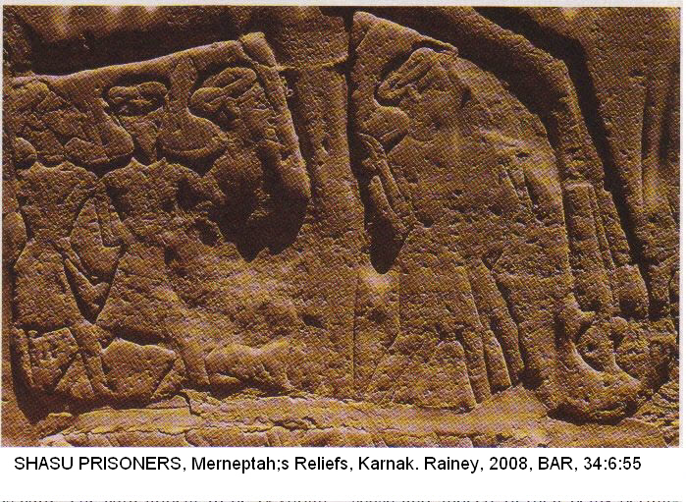

The Papyrus Anastasi VI, dating from the 13th century BC describes a relocation of “shasu tribes…in order tokeep them alive and in order to keep their cattle alive.” This aspect of Egyptian policy to outsiders, and pastoralists particularly, indicate a willingness of the Egyptian government to allow peoples of the Levant to temporarily settle in the eastern Egyptian Delta for grazing. This was the same area referred to as the land of Goshen where Jacob’s sons took flocks during times of drought (Gen. 42-245).

PHOTO LINKl SHASHU 001 Prisoner

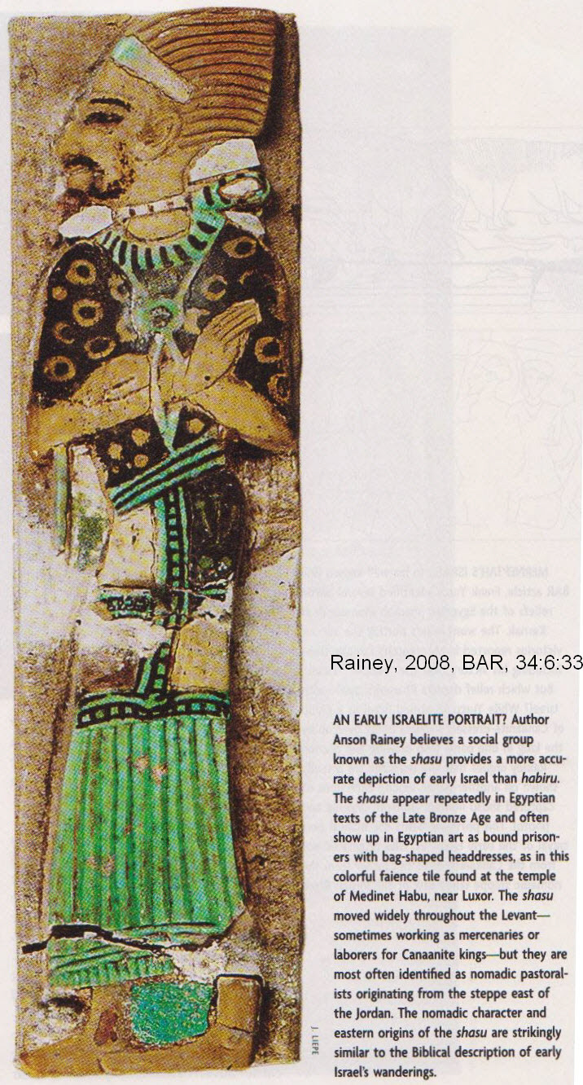

PHOTO LINK SHASHU 003 Papyrus Anastasi VI allowing shashu to pass into Egypt to graze animals in times of drought.
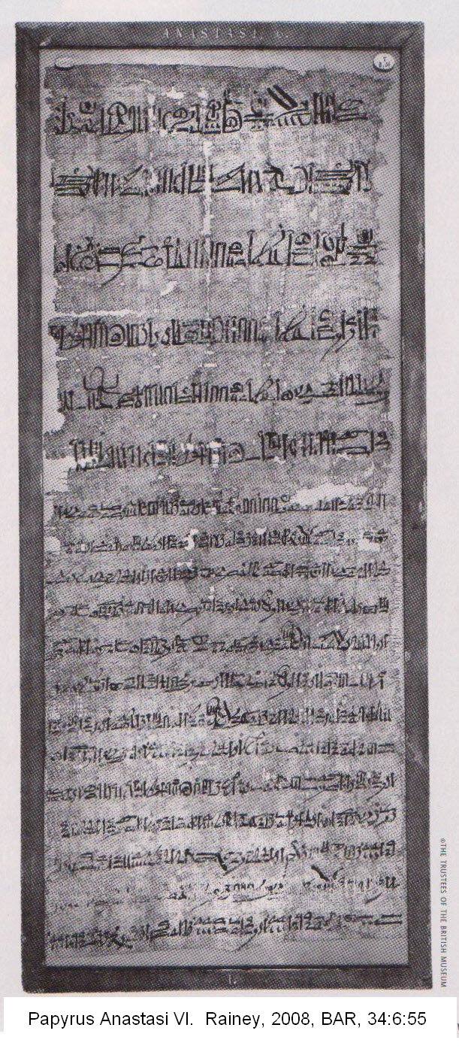

“These shasu were the main source of early hill-country settlements in Canaan that represent the Israelites settling down. The earliest hill-country settlements from Iron Age I sprang up in marginal areas where pastoralists could graze their flocks and engage in dry farming (Rainey, 2008b:54-55).

“This same thing was happening elsewhere in the Levant. In the shasu tribes, we may well find the origins of not only the Israelites, but also their eastern neighbors, including the Midianites, Moabites and Edomites. The pastoralists from the steppe lands all around the Fertile Crescent were driven into more settled areas at the same time as the Israelites were emerging in the hill-country of Canaan. Israel was simply one group among many shasu who were moving out of the steppe lands to find their livelihood in areas that would provide them with food in times of drought and famine.” (Rainey, 2008b:54-55).

Synthesis Theory

The end of Middle Bronze Age II (MBII) was about 1550 BC. At that time, civilizations collapsed all around the Mediterranean due in part to climatic variations (Stiebing, 1994). City states had become small and weak by 1250 BC (late date). The Conquest began with partly successful military victories (ala Jericho, Ai) circa 1450 BC, but the Israelite federation's autonomy was maintained through assimilation and revolt over temporary, minor, rulers. The Synthesis Theory suggests that some biblical descriptions of partitioning of land are exaggerated. Biblical population figures for the Israelites are interpreted to be inflated or poetic.

PHOTO LINK: ESN097 Tel Masos (Aerial) Several houses were joined to create a protective perimeter of buildings in the Early Iron Age.
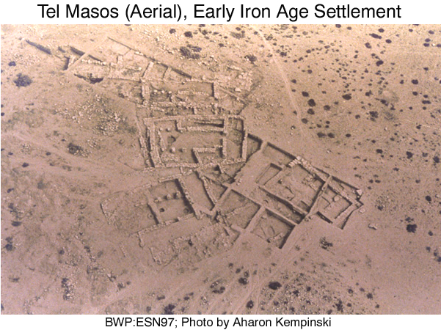

PHOTO LINK: GA040 Dan, Model of Middle Bronze Age Gate (SEE ABOVE, p. 30)

POTTERY STYLES

Pottery is funamental to understanding the Conquest. When the Israelites arrived, the Canaanites they displaced had a set of mundane, utilitarian pottery forms (Shanks and Dever, 1996:32).

PHOTO LINK: POTTERY 024 Canaanite, Late Bronze Age, 1550-1200 BC
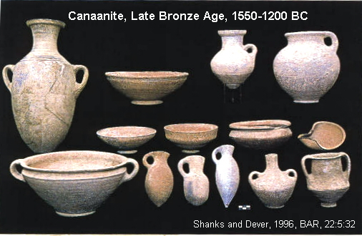

The Israelites adopted or copied many of the earlier Canaanite forms. This is in contrast to contemporaneous pottery from the coastal Philistines. The Philistine Bichrome ware, with it’s diagnostic red and black decorations appear along with the Philistines about 1175 BC (Shanks and Dever, 1996:33).

PHOTO LINK: POTTERY 025 Philistine Bichrome Ware late 12th century BC
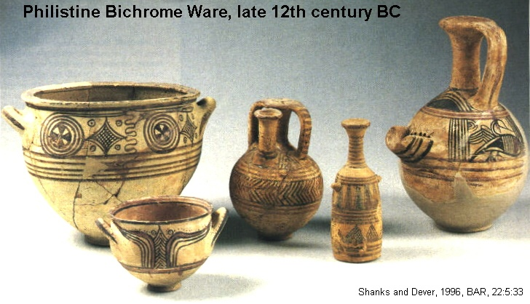

CROSSING OF THE JORDAN

The first step in the Conquest was the crossing of the Jordan River is described in Joshua 3:16. It has some similarities to the crossing of the Re(e)d Sea (Wood, 1987, 1990).

PHOTO LINK: JORDAN RIVER 001 Aerial photo of Jordan meanders
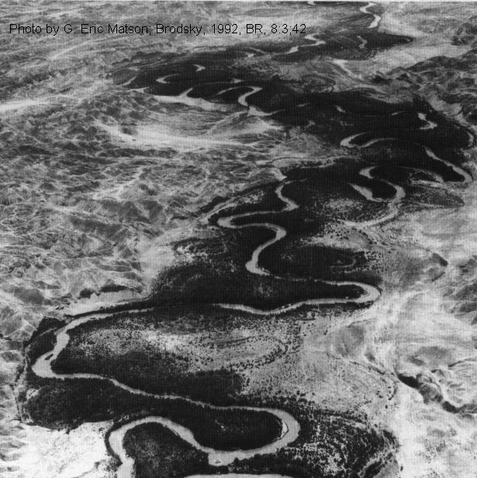

PHOTO LINK: JORDAN RIVER 002 Panorama of Jordan river
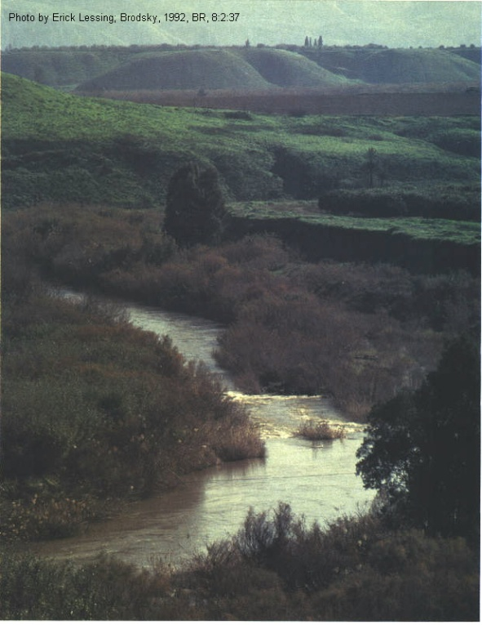
PHOTO LINK: JORDAN RIVER 003 Map of Jordan River
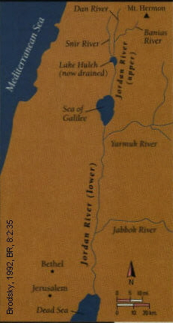

PHOTO LINK: JORDAN RIVER 004 Thickets of the Jordan
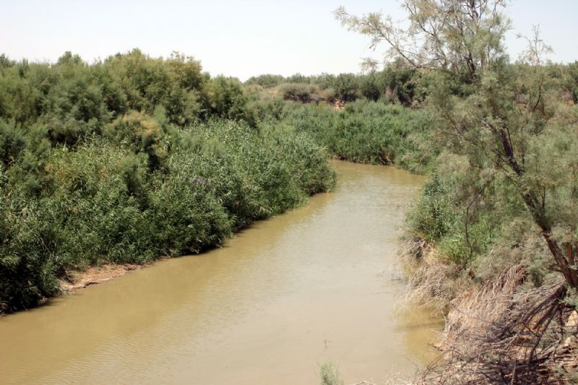

PHOTO LINK: JORDAN RIVER 005 Jordan entering Sea of Galilee
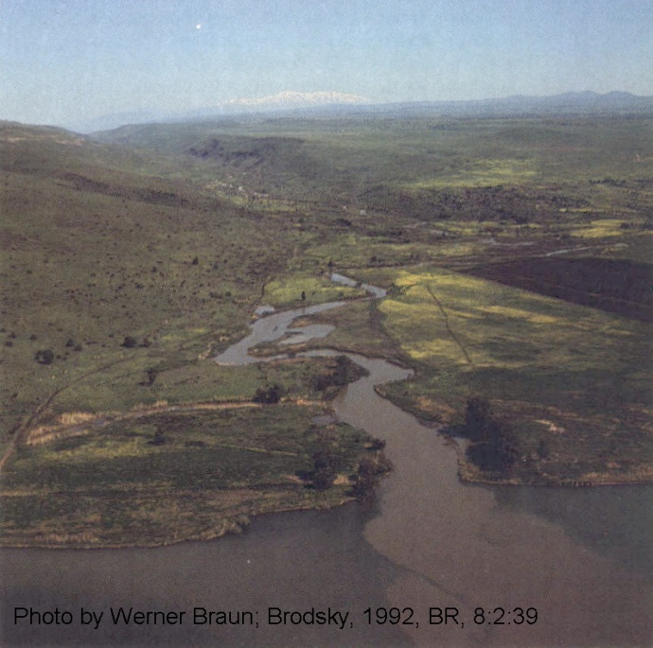

PHOTO LINK: BA007 Jordan River with view across Jordan Valley toward the mountains of Gilead
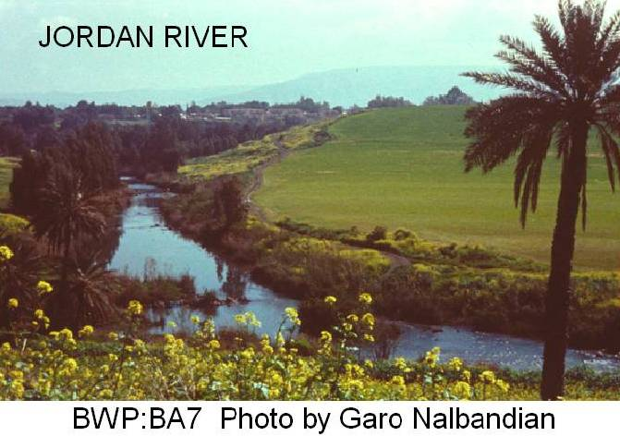

PHOTO LINK: BA002 Waterfall at Source of Jordan
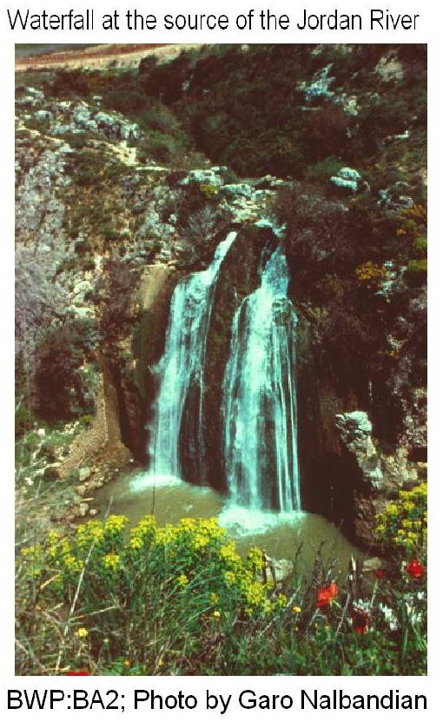

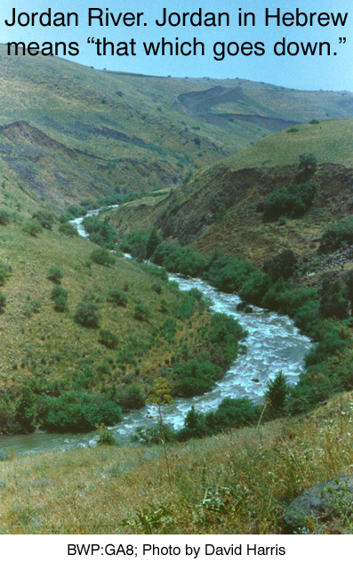
PHOTO LINK: GA008 Jordan River
There are two sections to the Jordan, an upper Jordan north of the Sea of Galilee and a lower Jordan between Galilee and the Dead Sea. The Upper and Lower Jordan River valleys are not well suited for farming due to annual flooding (Brodsky, 1992). The lush “thickets of the Jordan” (Photo link JORDAN RIVER 003) are deceptive. The land grows marsh vegetation but crops do not survive annual flooding. At flood time, the Jordan is not possible to traverse, but in the dry season, you can wade across it (Wood, 1987, 1990).

It is postulated that the drying up of the Jordan at flood stage was caused by an earthquake, which resulted in a landslide damming up the Jordan for a short period of time at Adam, modern Damiya. Similar events were recorded in 1267 AD when the river was dammed for 10 hours and in 1927 AD when it was stopped for 21.5 hours. Other stoppages are known in AD 1906, 1834, 1546, 1267 and 1160 (Wood, 1987, 1990).

PHOTO LINK: DAMIYA 001 Location map
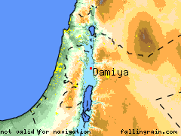

PHOTO LINK: DAMIYA 002 Detailed location map
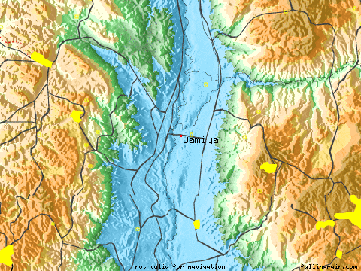

PHOTO LINK: LANDSLIDE 001 Layou River, Dominica, 1997
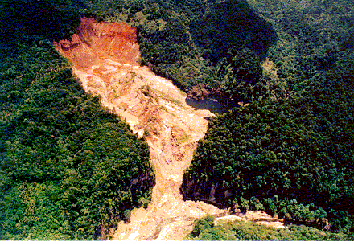

PHOTO LINK: LANDSLIDE 002 Yigongzangbu River 2000
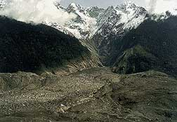

PHOTO LINK: LANDSLIDE 003 Yigongzangbu River 2000 sketch map
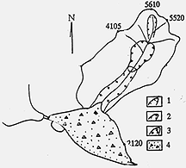

PHOTO LINK: LANDSLIDE 004 Yigongzangbu River 2000
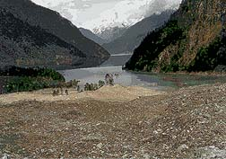

JERICHO

Neolithic settlement in 8000 BC makes Jericho the one of the oldest cities and also one of the lowest at 670 ft below sea level. It was strategically located, guarding the heartland of Canaan. Any invasion of the central hill-country from the east would first have to capture Jericho (Livingston, 1988).

PHOTO LINK: JERICHO 041 Location Map (See ABOVE, ctrl+click to follow link)

PHOTO LINK: BA066 Neolithic Tower, Jericho
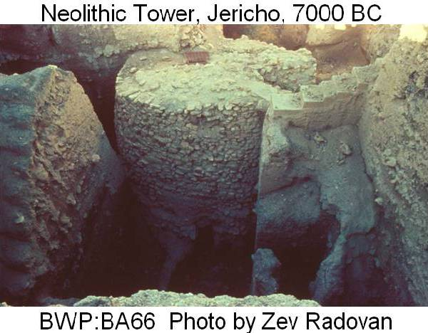

PHOTO LINK: BA076 Flint arrowheads, Neolithic Jericho

The conquest of Canaanite Jericho is discussed by Cross (1992); Livingston (1988,1990); and Wood (1987,1990, 1999).

PHOTO LINK: JERICHO 028 Aerial photograph (See ABOVE, ctrl+click to follow link)

PHOTO LINK: JERICHO 012 Panorama views of Jericho
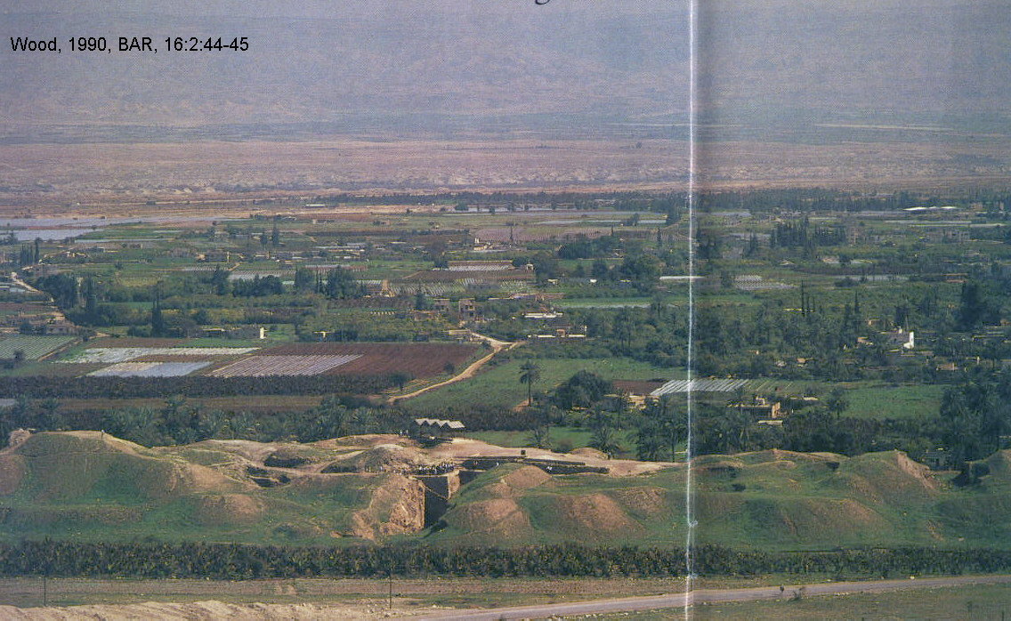

PHOTO LINK: BA009 Judean wilderness east of Jerusalem
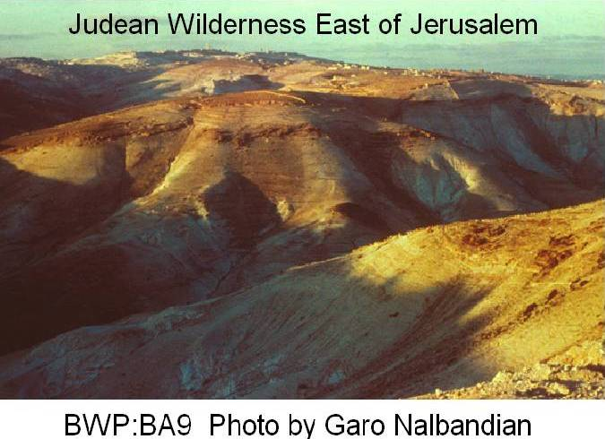

Tell-es Sultan is the site of ancient Jericho, near a spring on the western edge of the Jordan Valley, just north of the Dead Sea.

PHOTO LINK: BA011 Spring of Jericho
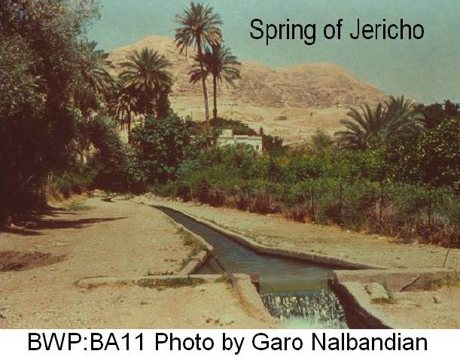

PHOTO LINK: JERICHO 029 Plan of Jericho
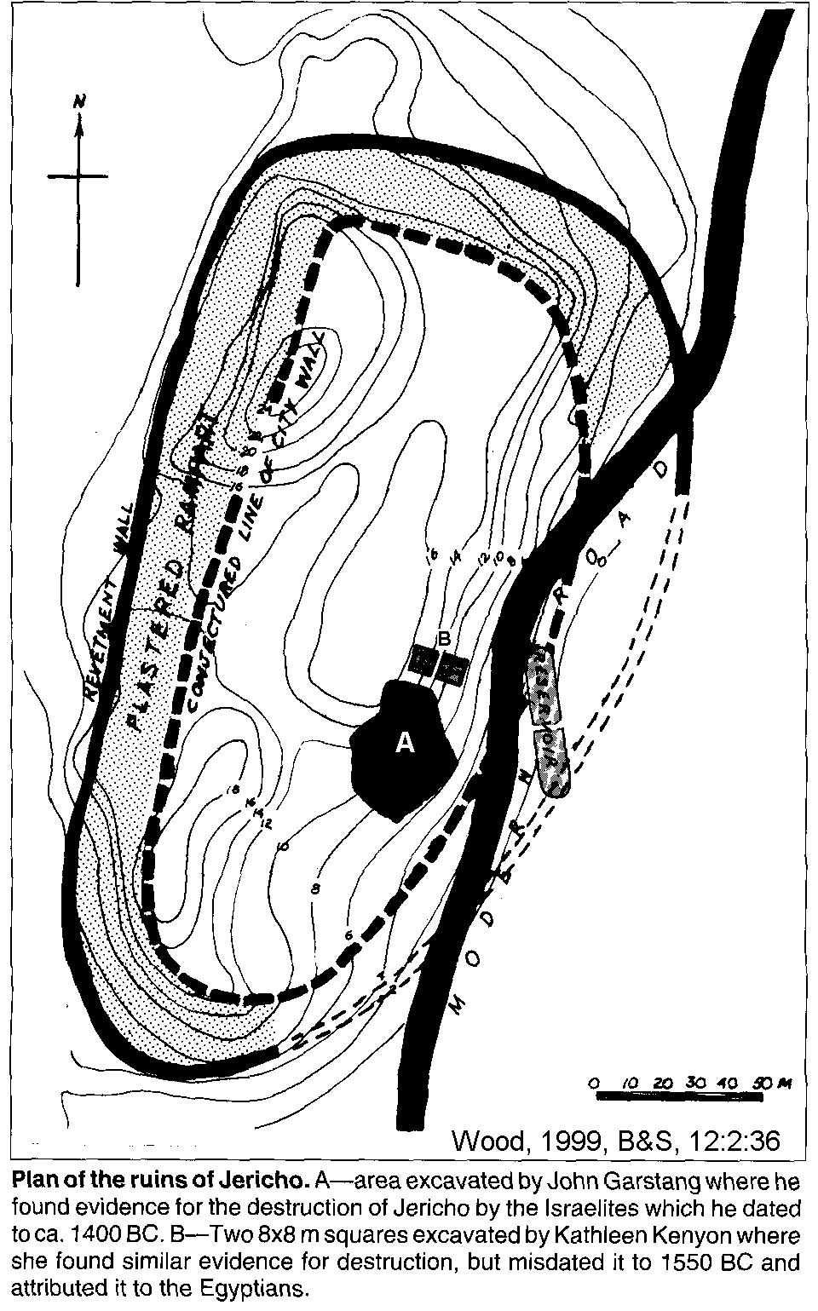

PHOTO LINK: JERICHO 013 Plan of City IV
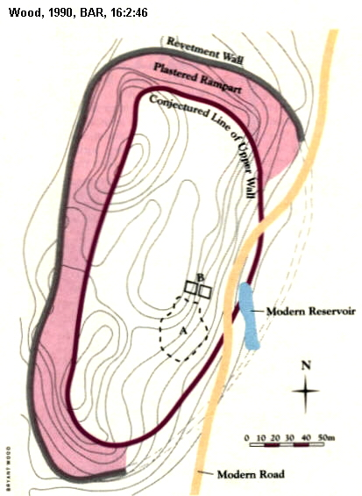

Liberal (minimalist) scholars tend to take the position that Jericho was not destroyed by Israelites (c. 1250 BC), but by earlier invaders. They point out that there is no evidence (yet) for movement of people from the Jordan Valley into Judah's territory during Iron Age I (Zertal, 1991, p.47). Conservative and, particularly, fundamentalist (maximalist) scholars say that Jericho was destroyed by a miracle (or miraculously timed earthquake) and by Joshua’s army just as it says in the book which bears his name. Cross, commenting on this view said:

"I have never understood why literalists and fundamentalists wish to explain away divine miracles by searching for natural or scientific explanations. To get rid of God in order to preserve the historicity of a folkloristic narrative strikes me as an instance of robbing Peter to pay Paul" (Cross, 1992, p. 24)

Likewise, liberal scholars think the Jericho/Ai stories are etiological, designed to explain the ruins of those cities (Zertal, 1991, p.47). These stories were a invented history for the purpose of glorifying the house of David. According to this view, Jericho did not exist at the end of the 14th century (1400 BC, end of LB1) or the end of the 12th century BC (1200 BC), or if it did, it was only a small village (Franken, 1965; cited by Wood, 1999a).

In defense of an Israelite destruction, conservatives say the Biblical account circa 1400 BC fits Jericho's location, environment, time of year and people. It was a real historic victory elaborated in an epic. They postulate that the early Israelite military victories and the formation of the 12-member league was very rapid (100-200 years) and completed by late 12th and 11th centuries BC (Wood, 1990, 1999).

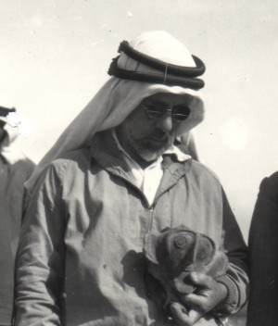
Garstang

John Garstang between 1930 and 1936 found a double wall around Tell-es Sultan which he dated to the late 15th-early 14th centuries BC (Late Bronze Age), agreeing with the conservative interpretation of a Conquest circa 1400 BC (Livingston, 1988).

PHOTO LINK: GARSTANG 001 John Garstang 1879-1956 in Arab costume (RIGHT)

PHOTO LINK: JERICHO 007 Kenyon and Garstang excavation areas
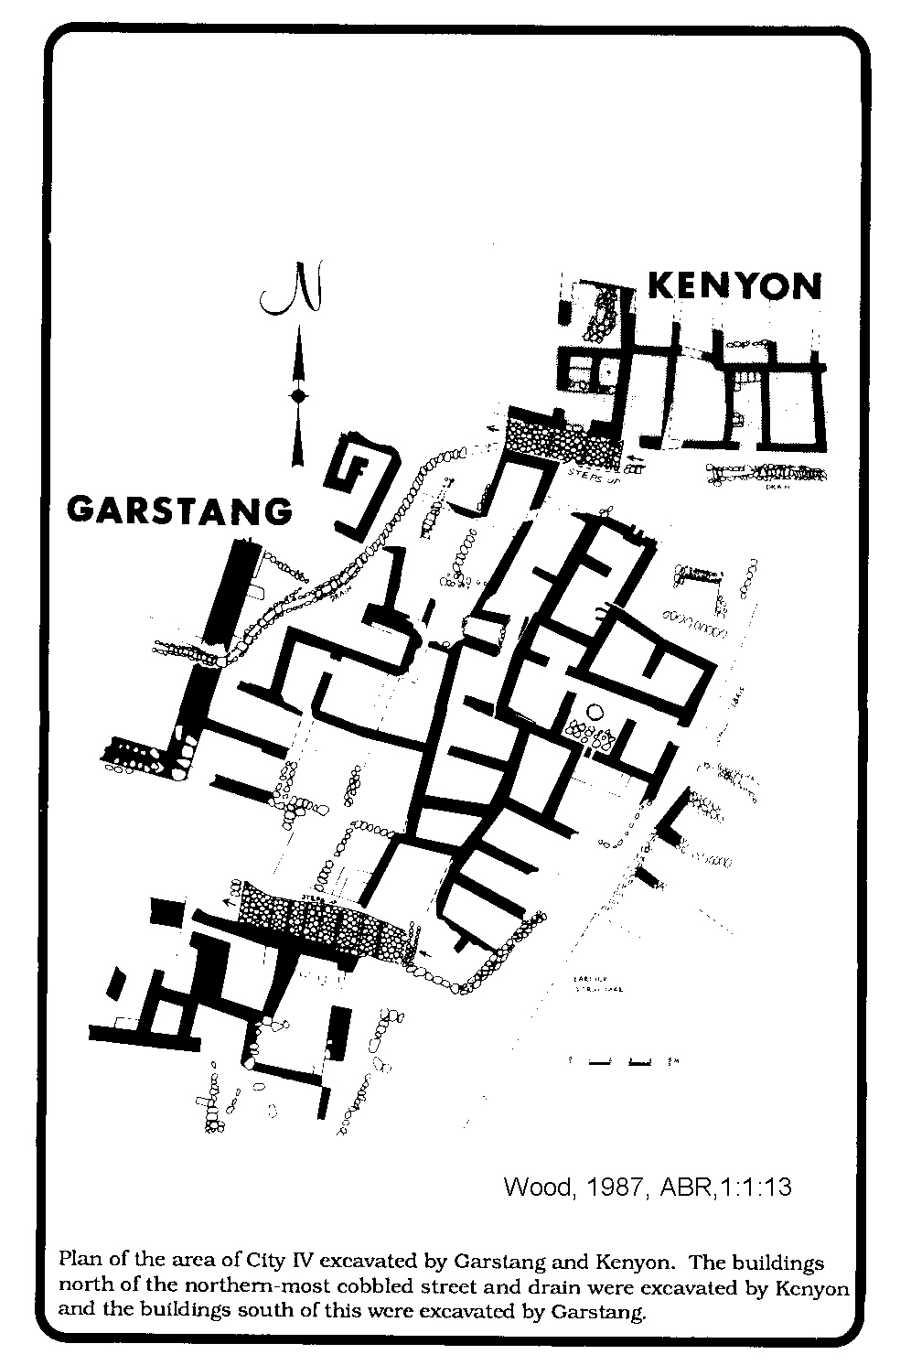

PHOTO LINK: JERICHO 029 Plan showing Garstang’s excavations (See ABOVE, ctrl+click to follow link)

PHOTO LINK: JERICHO 030 Bichrome ware from 15th century BC found by Garstang
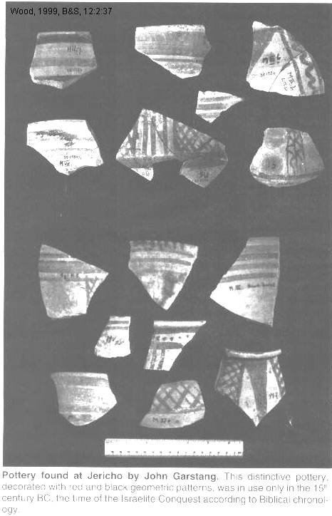

This wall he associated with City IV, which was interpreted as Jericho in time of Joshua. City IV was followed by a period of long abandonment and then a period of "Middle Building" in the late 14th century BC which he associated with palace of Elgon, king of Moab (Judges 3).

PHOTO LINK: JERICHO 008 Middle Building of Garstang
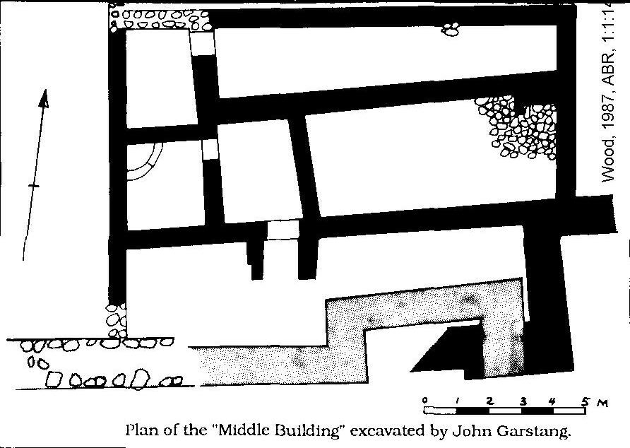

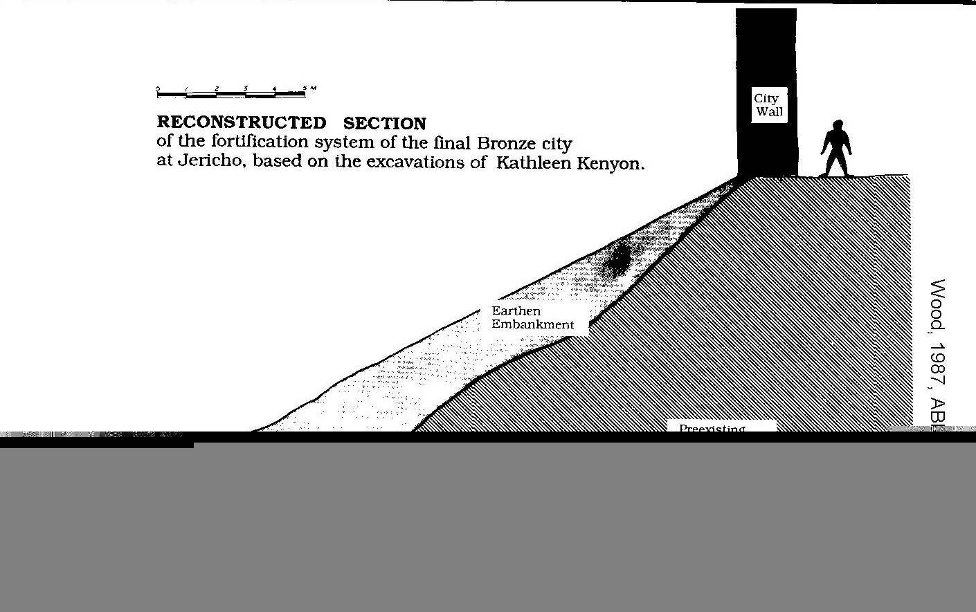

PHOTO LINK: JERICHO 039 Middle Building of Garstang, possible Elgon’s Palace
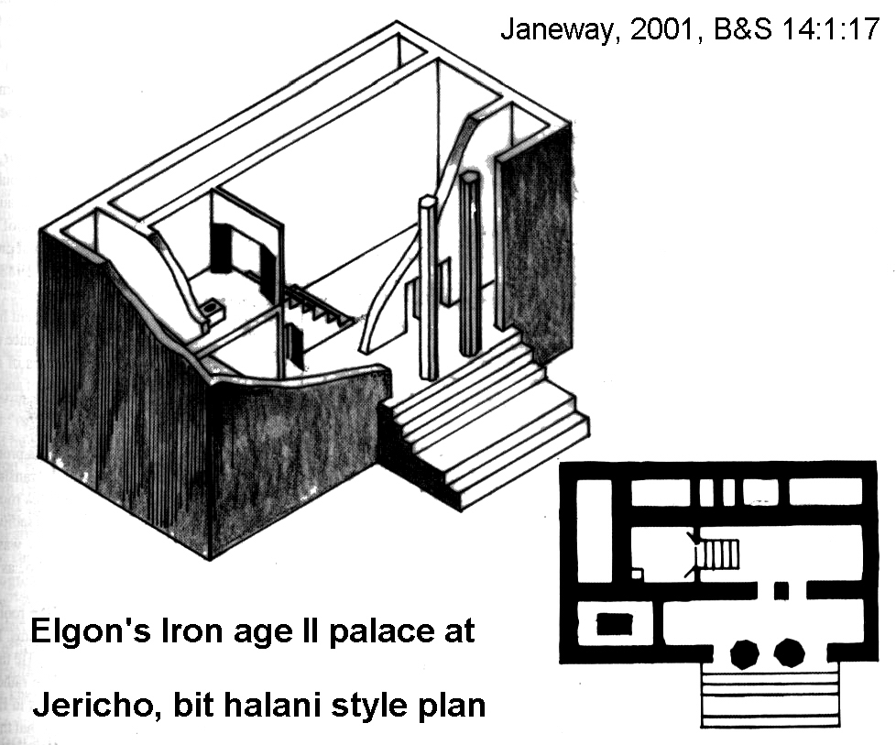

The next occupation of Jericho was in Iron Age during the divided monarchy (Livingston, 1988).

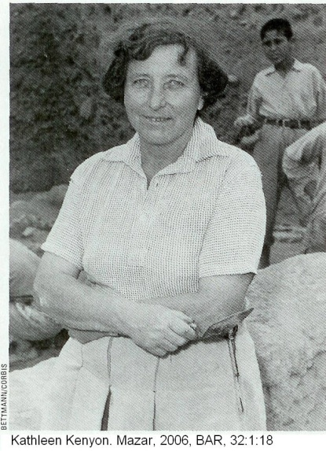
Kenyon

PHOTO LINK: KENYON 001 (RIGHT)

Kathleen Kenyon's 1952-58 re-excavations (Kenyon, 1957, 1981) and re-evaluation of John Garstang's work continues to influence archaeology and biblical studies. She excavated about 1/13th as much as Garstang and largely ignored much of his work. She re-dated the conflagration of Jericho to the 13th century BC basing this date on the absence of specific types of imported pottery. The "Conquest" of Jericho was in 1325 BC when the city had no walls. Destroyed levels of City IV dated to Middle Bronze Age I (MBI) circa 1550 BC (approximately the same time as destructions at Hebron and Lachish, Level VII. (See the Lachish stratigraphic chart at PHOTO LINK: LACHISH 022 Stratigraphic summary chart 13th to 4th centuries BC). Kenyon attributed the destruction of MBI Jericho to the Hyksos or to Egyptians in follow-up campaigns as they pursued the fleeing Hyksos (Livingston, 1988).

PHOTO LINK: JERICHO 001 Excavation of wall, MB age
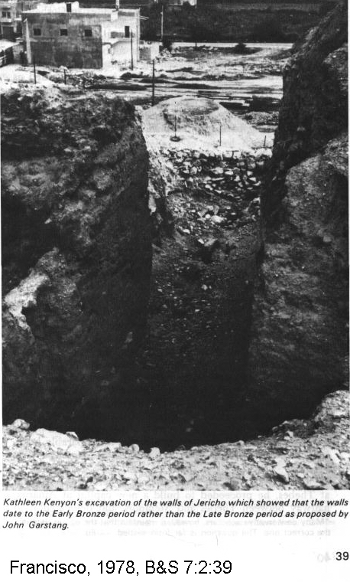
PHOTO LINK: JERICHO 002 Revetment wall of City VI excavated by Kenyon
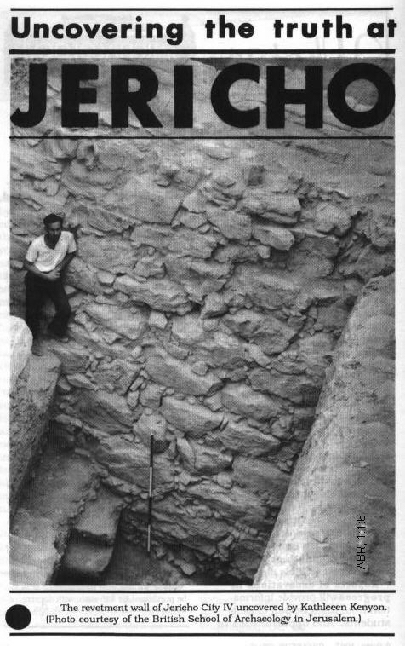

PHOTO LINK: JERICHO 004 Portion of Bronze Age City
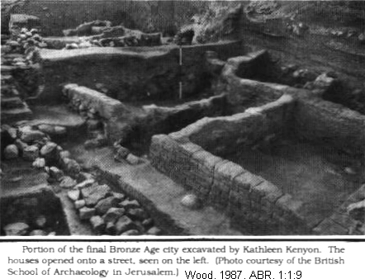

PHOTO LINK: JERICHO 005B Pottery from Bronze age
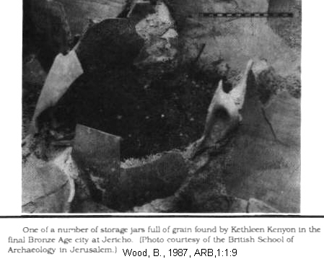

PHOTO LINK: LACHISH 022 Stratigraphic summary chart 13th to 4th centuries BC
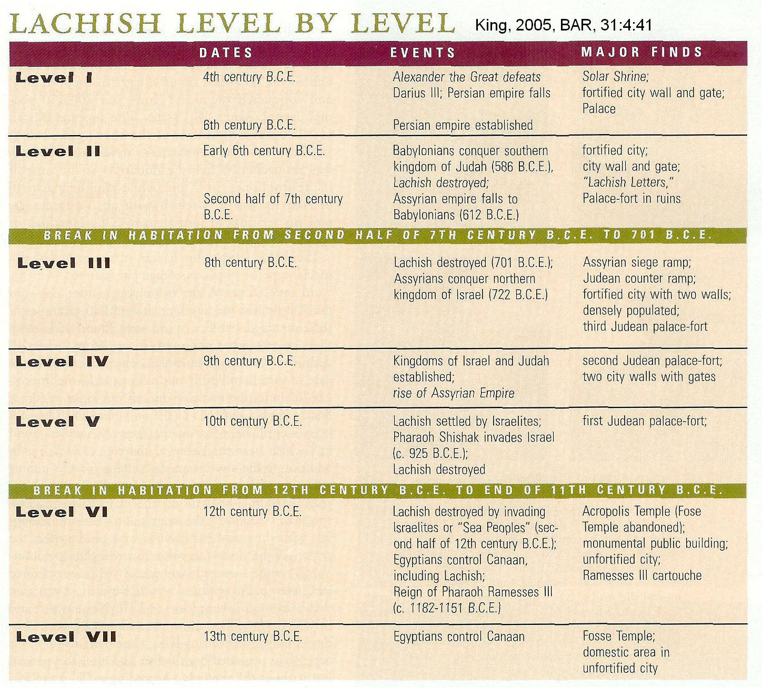

Kenyon accepted and confirmed Garstang's "Middle Building" date of late 14th century BC. She re-dated Garstang's double wall on top of the tell to a time 1,000 years earlier in Early Bronze Age. This was more or less the same conclusion of Sellin and Watzinger had based on crude excavation methods of 25 years earlier (Livingston, 1988).

PHOTO LINK: JERICHO 024 (Cross Section) of Stone Revetment wall showing collapsed mud-brick upper wall.
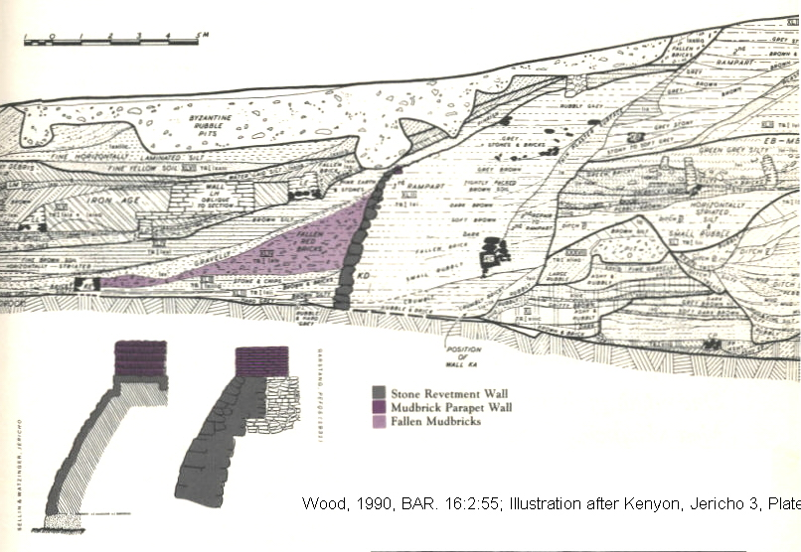

PHOTO LINK: JERICHO 025 (Photograph) of Stone Revetment wall showing collapsed mud-brick upper wall. SEE JERICHO 002 (ABOVE), P. 75.

Critique of Kenyon

Livingston (1988,1990); and Wood (1987,1990) provide the following critique of Kenyon’s conclusions:

Pottery

At Jericho, local Late Bronze Age I (LBI) pottery (1550-1400 BC), Egyptian scarabs, stratigraphical considerations and C-14 dating indicate that city IV was still in existence into 1400 BC. So Kenyon's date for the destruction of Jericho of 1325 is too late. Kenyon misread local pottery of City IV as Middle Bronze Age I. It should have been dated to LBI. She had a date of destruction which was wrong by 75 yrs. Reinterpretation of the pottery indicates a date of circa 1400 BC, in agreement with Early Date theory.
.
Further, some imported pottery was found at Jericho, contradicting Kenyon's argument of a late date based on absence of Cypriot bichrome ware.

PHOTO LINK: POTTERY 006 Philistine bichrome ware
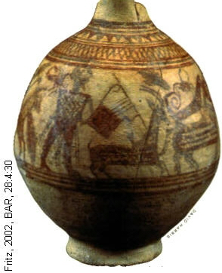
PHOTO LINK: JERICHO 021 Pottery from Jericho, Cypriot bichrome ware
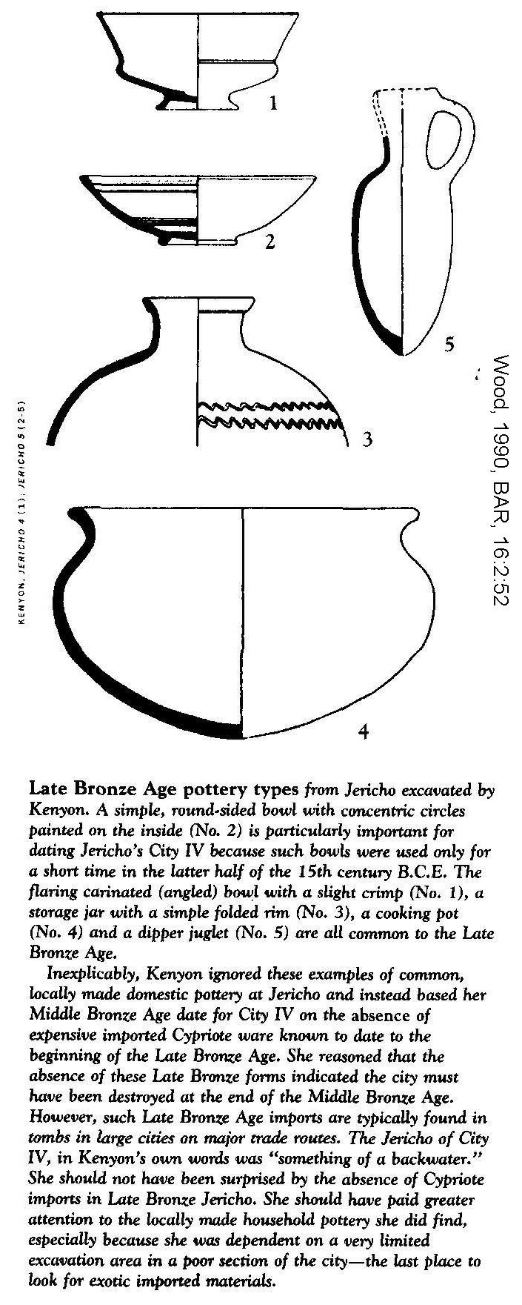
Both Kenyon and Garstang dug in poor quarters of the city where exotic and expensive bichrome ware would NOT be expected in abundance. But, ironically, Garstang's reports show considerable quantity of pottery decorated with red and black paint. These appear to be imported Cypriot bichrome ware, the kind that Kenyon said she could not find and the absence of which was central to her dating the destruction of City IV to the 16th century BC.

Full grain jars

Full grain jars show that the siege was short and that it occurred at harvest time (e.g. in the spring) in accordance with Joshua 2:8, 3:15, and 5:10. Inhabitants had no time to flee with foodstuffs. This observation contradicts Kenyon's theory that Egyptians destroyed City IV because they normally attacked prior to harvest when food supplies inside the fortified cities were at their lowest.
PHOTO LINK: JERICHO 023 Pottery from Jericho, Cypriot bichrome ware
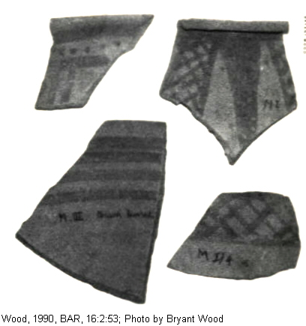

PHOTO LINK: JERICHO 019 Storage Jars
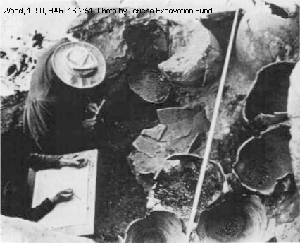

PHOTO LINK: JERICHO 020 Storage Jars

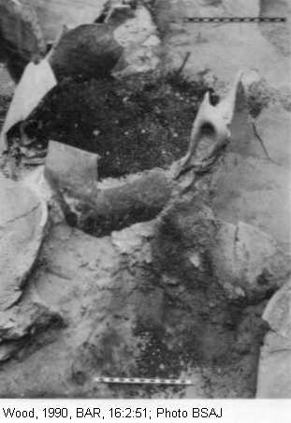
Stratigraphy

From Middle Bronze Age II (Phase 32, 1650-1550 BC) to the destruction of City IV there are 20 architectural phases with 3 major and 12 minor destructions. Using Kenyon's date of 1550 BC for the destruction of City IV, all this stratigraphy developed in only about 100 years. According to Wood (1990, 1999) , that is too short a time to have development of this extensive stratigraphy.

Collapsed Wall

Excavations of revetment wall at base of mound show "fallen red bricks piling nearly to the top of the revetment wall" which came down from a now-eroded and collapsed upper red mud brick wall as described in Josh 6:20 ("the wall fell down flat"). The amount of fallen-down bricks in Kenyon's excavation are enough to have come from an upper wall 6.5 feet wide and 12 feet high. This pile of fallen bricks made a natural causeway for Israelites use to go "up into the city" (Josh 6:20).

PHOTO LINK: JERICHO 002 Revetment wall (See ABOVE, ctrl+click to follow link)

PHOTO LINK: JERICHO 026 Collapsed wall
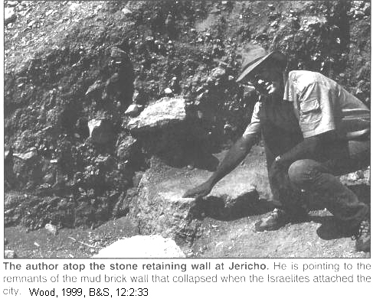
PHOTO LINK: JERICHO 036 Garstang Storage Jars with grain
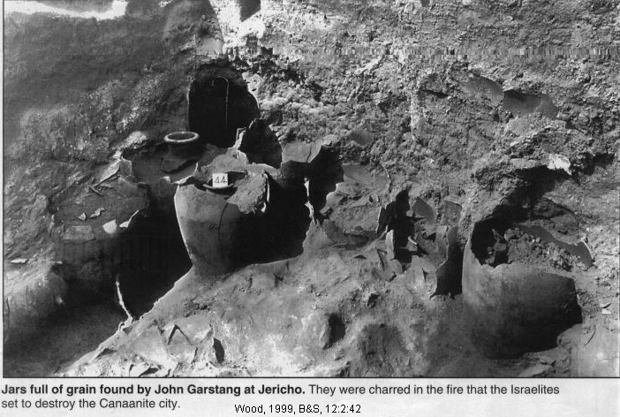
PHOTO LINK: JERICHO 035 Cross Sections
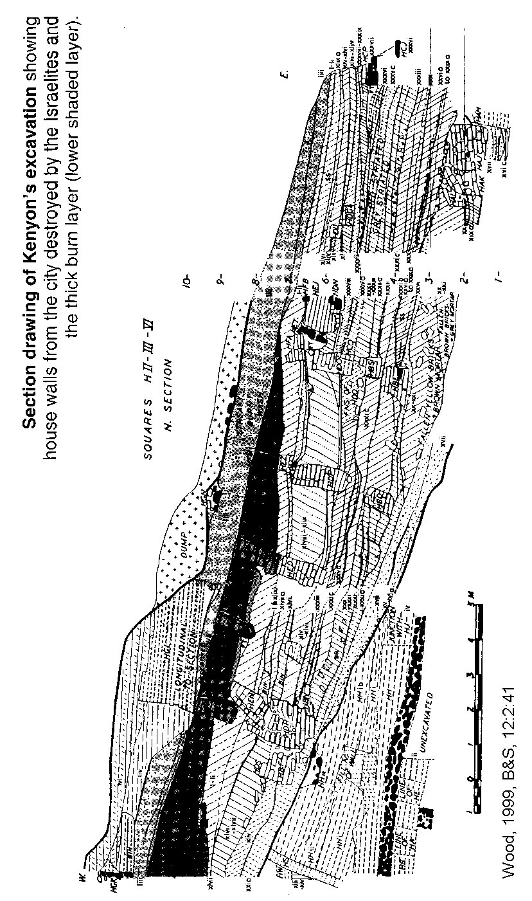

PHOTO LINK: JERICHO 027B Retaining wall
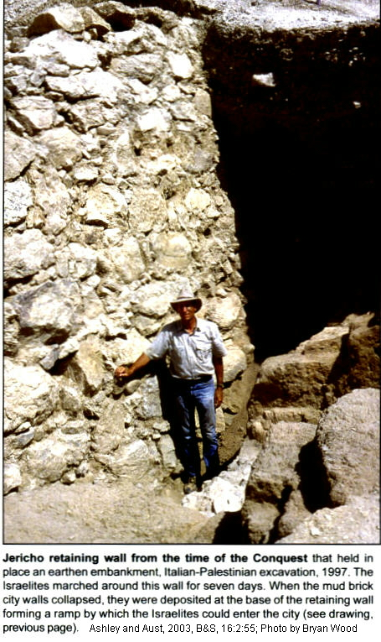

PHOTO LINK: JERICHO 031 Cross section
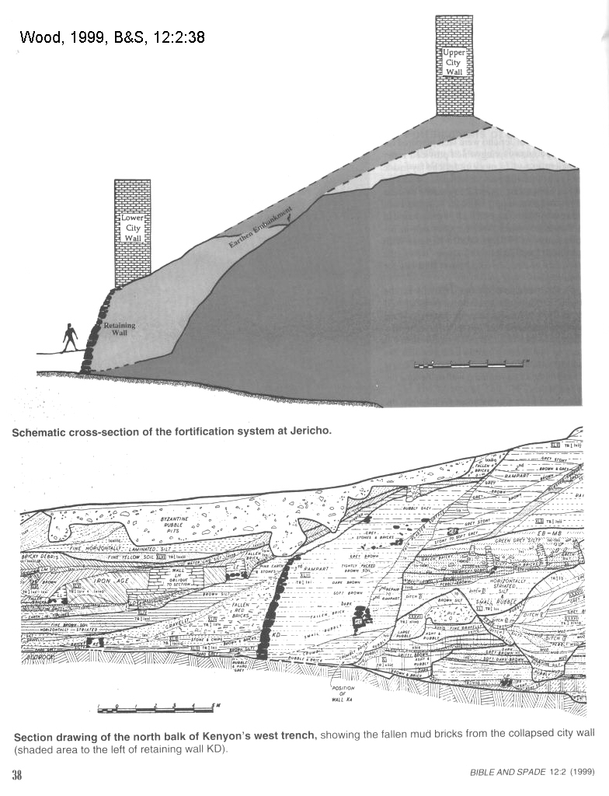

PHOTO LINK: JERICHO 015 Drawing Israelites marching around walls with earthquake fault (See ABOVE, ctrl+click to follow link)

There is evidence for earthquake activity associated with the collapse of the wall. But the Bible does not mention an earthquake in association with the destruction of Jericho. Surely, such an event would have been recognized and recorded. Later editors of the Book of Joshua may have omitted reference to an earthquake in order to magnify the miraculous nature of the conquest of the city.

The destruction of City IV was complete, with one meter or more of destruction debris over entire excavation area. So Garstang was right about the destruction date of City IV, after all. But distinctive Israelite material culture is not found in abundance in Canaan until about 150 to 200 years later. This is why most scholars reject a Conquest date as early as 1400.

Egyptian Scarabs

Wood also points to the presence of Egyptian scarabs and seals in the cemetery northwest of Jericho as evidence that the city was occupied continuously from the 18th to early 14th centuries. These scarabs contradict Kenyon’s interpretation that the city was abandoned after 1550 BC. Scarabs are known from the reigns of Tutmosis III (c. 1504-1450 BC) and Amenhotep III (c. 1386-1349 BC; Wood, 1990, p. 53).

PHOTO LINK: JERICHO 022 Scarabs
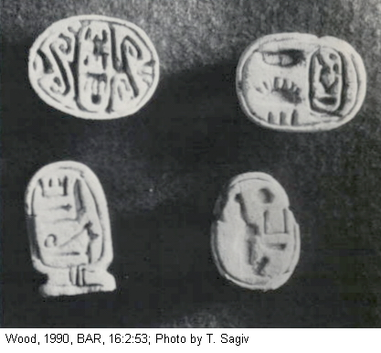

The "Middle Building" of Garstang and "Phase 54" of Kenyon agree with biblical record in Judges 3:12-13 in date and short duration of occupancy as described in Judges 3:29,30.

Critique of Wood

A critique of Wood’s argument for the traditional date for the Jericho destruction by Israelites in c. 1407 BC was made by Bienkowski (1990). He says that the absence of Cypriote imports is significant and that Wood's criticism of Kenyon’s work is misplaced. Bienkowski contends that the roles of Hyksos and Egyptians in cir 1550 BC are irrelevant to date of Jericho's destruction.

Wood uses five vessel types that he claims are LBI. But these pottery types have long period of use and are not diagnostic of MB or LB ages. The MB city destructions ranged from 1600 to 1500 BC. The Jericho pottery is fast-wheel pottery from MBII, not LBI. Wood's identification of scraps of Cypriot bichrome ware in Garstang's field notes is wrong.

This bichrome ware is really LBII painted ware. Binkowski says that Wood’s stratigraphic argument is wrong because identification of diagnostic MBIII pottery is not possible between 1800 and 1550 BC, and a MBII/III subdivision cannot be made at the Jericho site. The scarabs from the XVIIIth dynasty could have remained in circulation (or even be made) long after kings themselves had died. All MB Jericho tombs were reused in LBII. So contamination from older burials is possible, and the XVIII dynasty scarab is not an accurate age marker for the Jericho destruction. The scarab of the obscure Hyksos king Maibre Sheshi suggests that the last use of the cemetery was circa 1600 BC. Furthermore, C-14 date confirming a LBI date is from contaminated material brought down to the level of City IV from above.

PHOTO LINK: JERICHO 030B Bichrome ware from 15th century BC found by Garstang
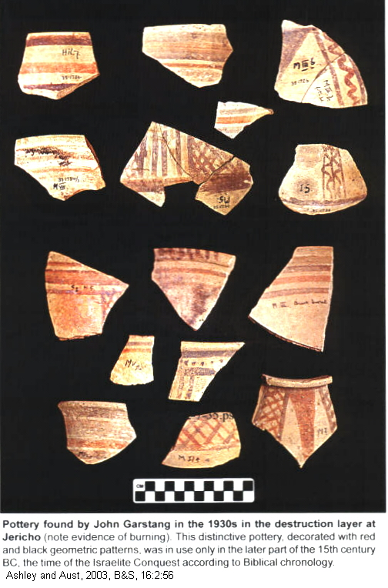

PHOTO LINK: JERICHO 009 LBIB pottery from City IV
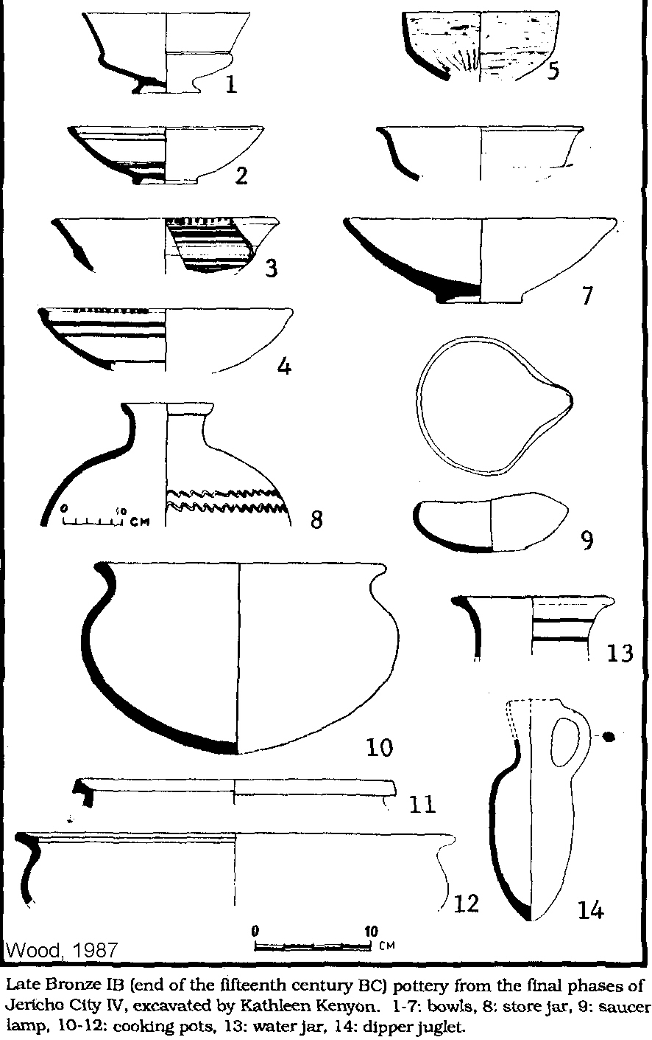

Wood’s answer to Bienkowski

Wood’s answer to Bienkowski (Wood, 1990) is this: Local pottery should take primacy over absence of LB1 Cypriot imports when dating the destruction at Jericho. Bienkowski and Wood agree that the Hyksos eviction from Egypt has no relevance in dating destruction of City IV at Jericho. According to Wood’s ceramic analysis, subtle differences in pottery characteristics make it possible to distinguish MB and LB forms at Jericho. Correlations made by stratified analysis at Jericho are superior to unstratified analysis of tomb deposits from Gibeon tomb 30. Bienkowski falls into same trap as Kenyon: using unstratified tomb pottery to date a stratified occupational deposit. Pottery correlations Wood makes with LBI parallels at Ashdod and Hazor are appropriate. Those sites are well within the trading sphere of Jericho. Other LBI parallels are found at Lachish Fosse Temple I, Shechem XIV, Mevorakh XI, and Megiddo VIII.

PHOTO LINK: LACHISH 003 Plan of LB Temple (Fosse Temple I) (See ABOVE, ctrl+click to follow link)

Bienkowski's comparison of a MB (Middle Bronze Age) storage jar from Gibeon tombs is really a much smaller water jar. The change from "fast" to "slow" pottery wheels occurred between LBI (Late Bronze Age I) and LBII (Late Bronze Age II), NOT between end of MB and LBI. Bienkowski misidentifies black and red pottery fragments as "standard LBII painted ware". Local LBII wares had poor fabric with large grits and incomplete firing. Jericho bichrome pottery is pink-buff and has a well-levigated fabric common to Cypriot bichrome ware. It also has several classic Cypriot bichrome ware motifs. Bienkowski misidentifies sites from which pottery came by sloppy reading of Garstang's record keeping procedures. Wood's examples supporting a LBI date of the sherds came from erosional layers above and below the "Middle Building" and not from in situ deposits within the building which was in use for only a generation or so. Regarding the stratigraphy, Wood points out that 30 years of research have shown that subdivision of MB is possible. It can be deduced with some precision that MBII ended 1650-1550 BC. The scarabs found at Jericho City IV suggest that those of popular pharaoh's like Tuthmosis III and Amenhotep III served amuletic purposes after their deaths. But that is not true of Hatshepsut. After her death, she was maligned and her name systematically obliterated from monuments and inscriptions. Therefore, her scarab at Jericho indicates that its destruction was LBI. Regarding the radiocarbon data, Kenyon's field records show she took the sample from a destruction layer 3 ft. thick. It is unlikely that she would have taken an unrepresentative sample of City IV's destruction.

C-14 Dating of City IV

In 1995 Hendrik J. Bruins and Johannes Van der Plicht published data from high-precision radiocarbon measurements made on eighteen samples from Jericho. Six of these samples were charred cereal grains from the City IV destruction. This study concluded that City IV was destroyed in c. 1550 BC. This is 150 years earlier that the early traditional date (defended by Wood) of 1407 BC. (http://www.biblicalchronologist.org/answers/bryantwood.php ; Jan. 2, 2006). It is 350 years earlier than suggested by late-date researchers like Kenyon who thought City IV was destroyed c. 1200 BC.

An alternative theory was proposed Gerald E. Aardsma. He suggested that the Conquest occurred c. 2400 B.C., not c. 1400 B.C. (Aardsma, 1996 and http://www.biblicalchronologist.org/answers/bryantwood.php ; Jan. 2, 2006).

PHOTO LINK: JERICHO 043 Chronologic summary chart with C-14 dates Chronologic chart with C-14 dates ; http://www.biblicalchronologist.org/answers/bryantwood.php ; Jan. 2, 2005
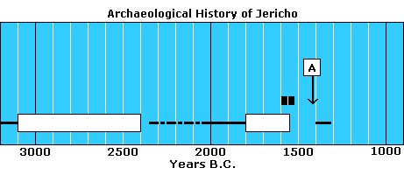

Jericho Attack Rituals

There were several rituals associated with fall of Jericho The Israelite activities of marching, blowing trumpets and shouting were imitations or mockery of Canaanite religious practice in same way that Plagues of the Exodus were commentary on Egyptian religious practice. The name Jericho (Yeracho) is derived from the Canaanite god Yerach. He was the moon god. The sun god was female. Her name was Shamash. (Livingston, 1990). In later cultures (Greek, Roman), those roles got reversed. The male primary deity became god of the sun, and the female deity became god of the moon.

Tyre's Enthronement Ritual on New Year's Day may have been similar to fertility rituals at Jericho. The Enthronement Ritual lasted eight days and included an acting out of the resurrection of the god Melcart by the king. This equality of god and king at Tyre is denounced in Ezra 28:2. The moon god, Yerach, was chief Canaanite deity at time of Conquest. His consort was the moon goddess Shamash. Later Yerach became Baal and Shamash became Asteroth. Yerach was worshiped at two centers, Bit-Yerach on the southwest shore of Sea of Galilee and Jericho. At time of Conquest, Jericho (name comes from Yerach = "moon") was the dominant deity of the two. (Livingston, 1990)..

PHOTO LINK: ASHERAH 010B Hand of God inscription "Blessed..by Yahweh..and his asherah" Iron Age II (1000-586 BC) Khirbet el-Kom; photo and drawing
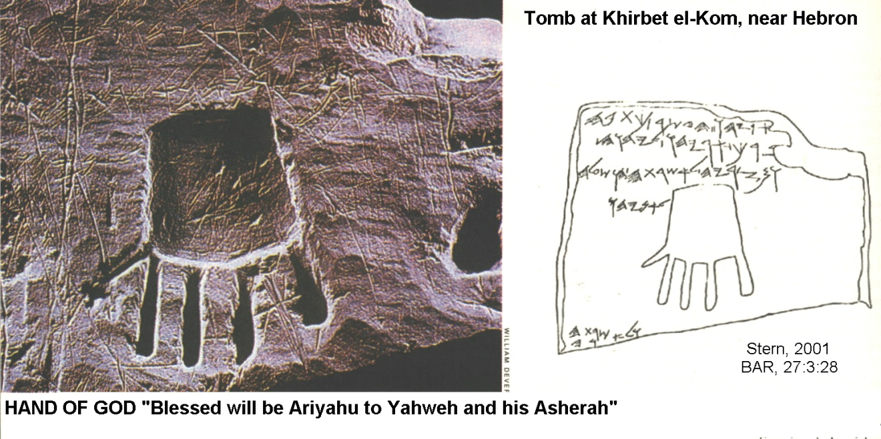
PHOTO LINK: AR 012 Two hands upraised toward crescent moon at Hazor

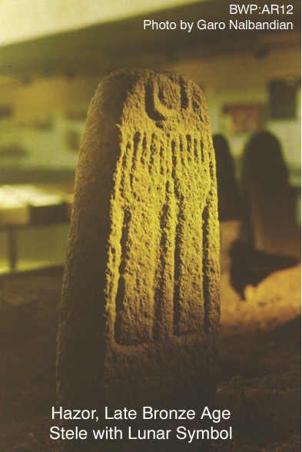
Israel was commanded to destroy the Canaanite religious-political system (Ex23:24,32,33; Deut 7:23-26). Victory at Jericho would embolden Israelites to take on other kings and cities of Canaan. Israelites needed assurance the Yahweh would lead, protect and give them victory. Total destruction (genocide) was necessary because of Jericho's immorality that included child sacrifice, homosexuality, bestiality and grotesque blood ritual. The Ugarit Legend of Keret is a model of cult ritual at Jericho (Livingston, 1990):

"To the places of the gods he goes on foot
The king shall go on foot
Seven times to all of them"

There are several parallels in this ritual to the Jericho story. God promised to give kings of Canaanites into hands of Joshua. Killing the "son of god" or god-king would paralyze the city's religio-political system. At time of the "attack" on Jericho, an annual spring cult ritual and/or feast involving the "divine" king may have just finished or have been ready to be performed. Following the attack, Israel held its great feast: the Passover. In Joshua 6:9 and in Legend of Keret, people march once a day for 6 days around the city and 7 times on the 7th day. This is followed by a loud shout. Then gold and silver are "devoted" to God. In both stories, a woman (Rahab) is saved, becomes mother of a king and saves two messengers (Livingston, 1990). Parallels between the two stories are listed below:

Verse |  | Text of Joshua 6 | Comments
1 | No one went out or came in | lines 111-113
2 | King and mighty men "given" to Joshua
9 | Men of war first | 86-88;
 | All the people | 85-104
 | Trumpets | 92-93
10 | No noise until the last day | 116, 119-120
14 | Six day march | 106-108
15 | Early on the seventh day | 118
 | Seven times on seventh day | 114-115 | (two seven day periods mentioned)
16 | Shout | 119-122 | (Engnell: "sham fight," p. 168)
19 | Gold and silver are "devoted" | 126-127,138-139
25 | Rahab saved (Israel "got" a woman) | 142-153
 | She became mother of a king | 152-153
 | She had saved the two messengers | 124-125,136

AI

After the Battle of Jericho, the Israelites continued their invasion westward and attacked the hill-country city of Ai. The first attack was a failure (Joshua 7:2-6). That was due to disobedience and greed in defying God’s ban on keeping plunder of Jericho (Joshua 7:1). After Acan’s disobedience was discovered and his execution (Joshua 7:14-26), a second battle of Ai took place and the Israelites prevailed (Joshua 8:1-29).

PHOTO LINK: AI 002 Battle Map of Second Campaign of Ai
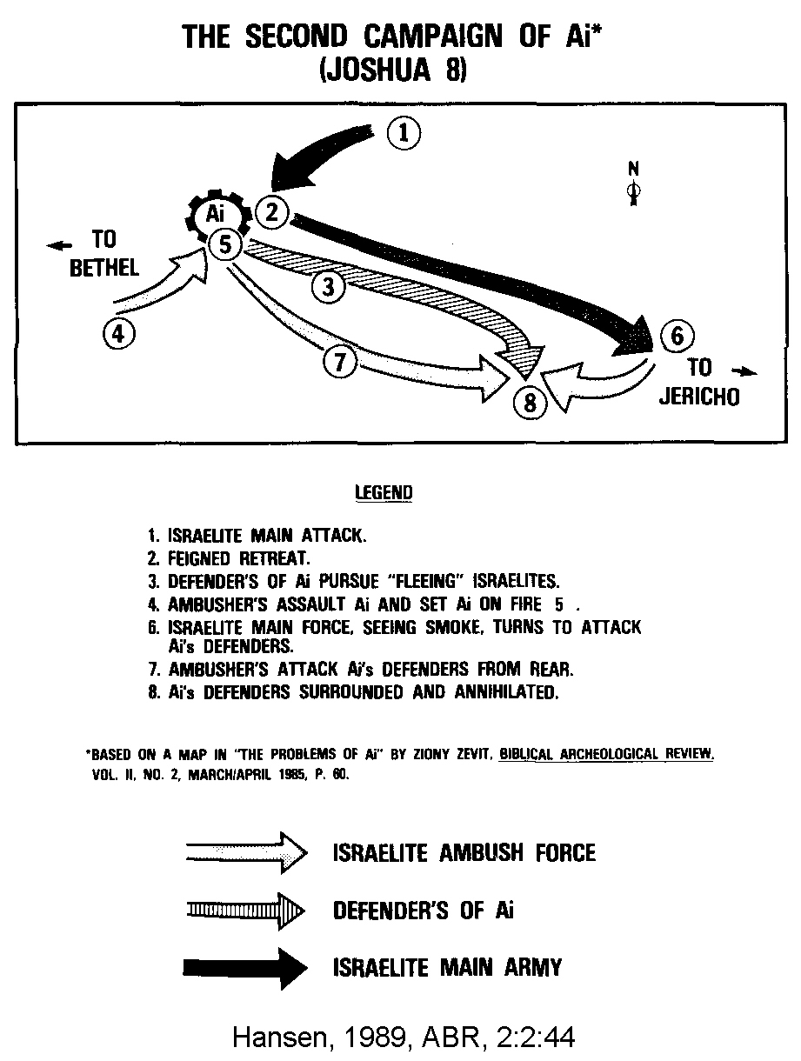

The location of Biblical sister cities Ai and Bethel are disputed (see map in Hanson, 1989, p.46):

PHOTO LINK: AI 010 Regional Map of cities relating to Ai

PHOTO LINK: AI 003 Map of Ai area (See ABOVE, ctrl+click to follow link)

PHOTO LINK: AI 001 Aerial photograph of Khirbet-Nisya (See ABOVE, ctrl+click to follow link)

PHOTO LINK: AI 006 Kh Nisya and Kh el-Maquatir
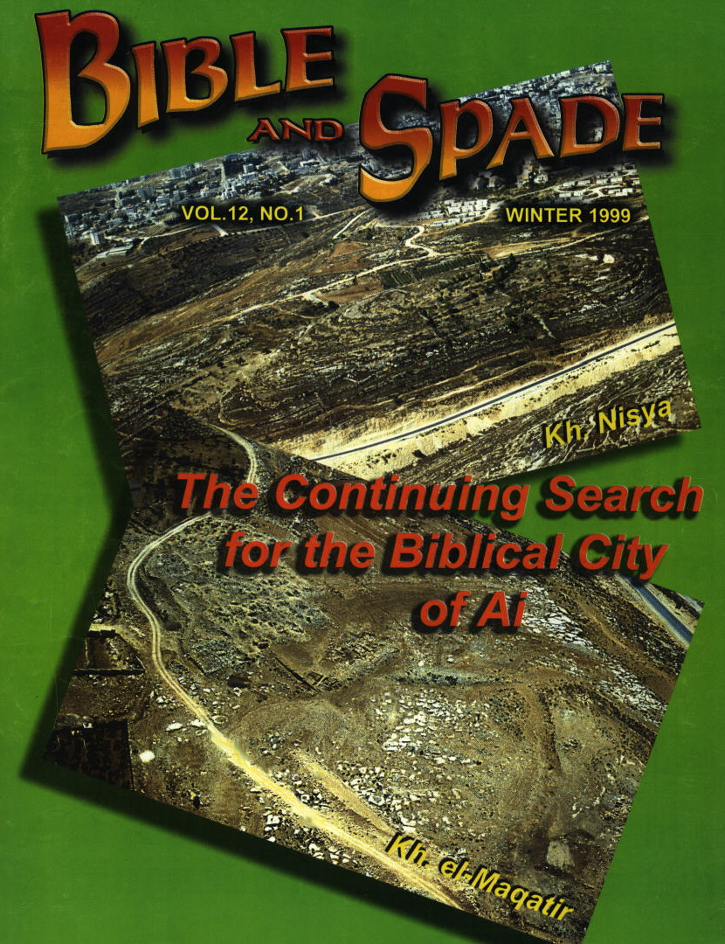

Biblical Name | Present Site  (Liberal-minimalist,  c. 1250 BC) | Present Site  (Conservative-maximalist,  c. 1400 BC)
Bethel | Beitin | El-Bireth
Ai | et-Tell | Khirbet Nisya or Khirbet el Maqatir

Ai must be east of Bethel and there must be a mountain (Hebrew “har”) between them. This topographic situation fits the conservative interpretation better than the liberal one.

PHOTO LINK: AI 004 Topographic cross section showing two theories for locations of Ai and Bethel.
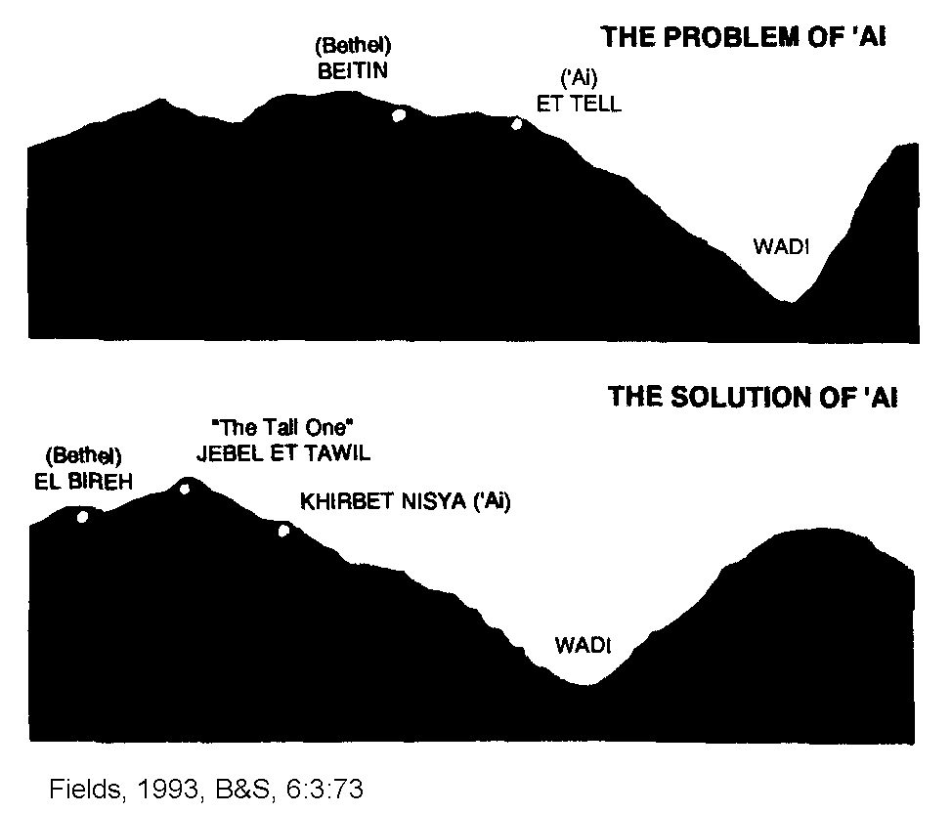

Et-Tell (Minimalist site for Ai)

PHOTO LINK: AI 014 et-Tell liberal Ai
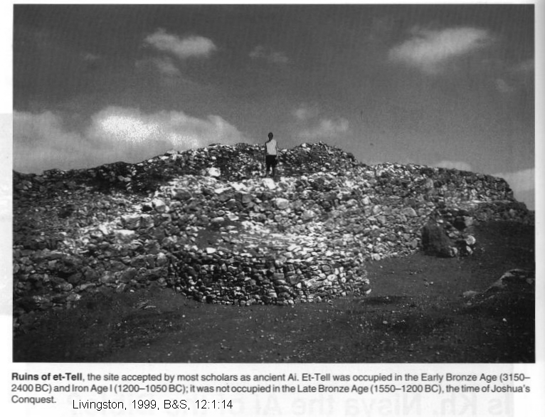

PHOTO LINK: AI 007 Aerial view et-Tell (liberal site of Ai)
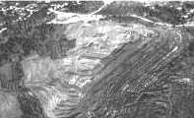

On this site, Israelite farmers at built small structures and terraces on ruins of an older city c. 1200 BC. The settlement had 150 people living in it at time of Judges (Callaway, 1983). The people lived in primitive conditions but with bronze metallurgy. Bathing was rare: compare Genesis 27:6 where Esau is identified by his smell (body odor). The village was abandoned in 1050 BC (Livingston, 1988, 1990). The site does not have many of the occupation levels it should have to be a candidate for Biblical Ai (see tables, below).

PHOTO LINK: AI 005 Vertical aerial photo Ai site 4 mi east of Raddana, bronze age (See ABOVE, ctrl+click to follow link)

Beitin (Minimalist site for Bethel)

This site is on a relatively level area without strategic control of travel routes in the area. One road goes from Beitin to Jericho and a road to Nablus goes past it (Livingston, 1988, 1990).

PHOTO LINK: AI 011 Modern Beitin = or not = Bethel
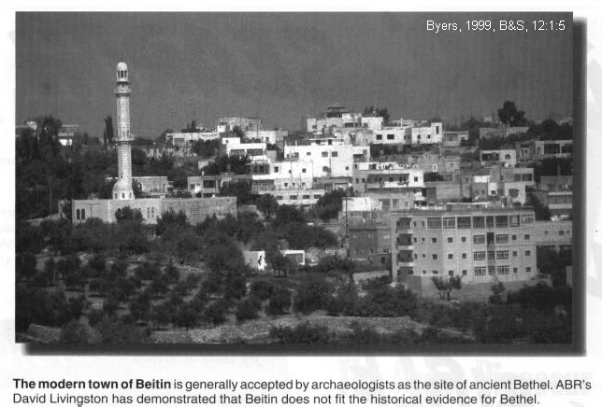

PHOTO LINK: BEITIN 001 Location Map
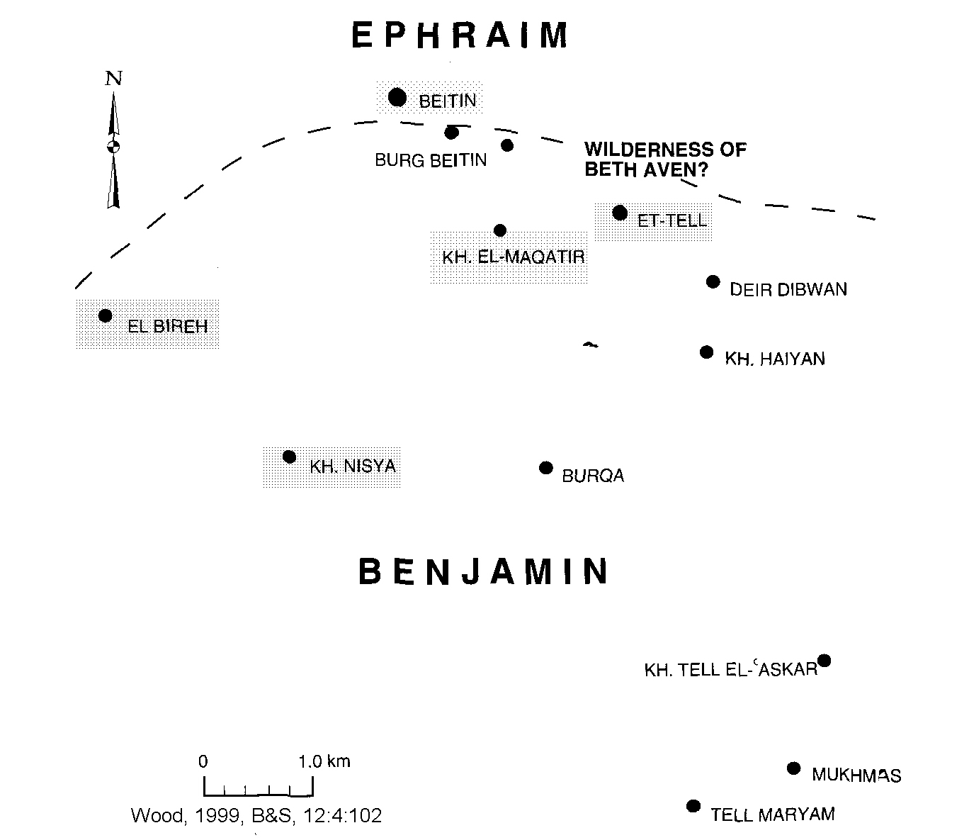

Excavations by Kelso (1968) revealed a Middle Bronze Age and Late Bronze Age fortress with well-built stones 3.5 m (11.5 ft) wide. It was a comparatively small site of 3.3 acres (Wood, 1999d:103)

PHOTO LINK: BEITIN 002 MB-LB Fortress

PHOTO LINK: BETHEL 001 Location Map

Abundant LBI pottery was found at this site including a red bowl with concentric red circles diagnostic of LBIB (second half of 15th century BC). Iron age remains are abundant, reflecting occupancy during the time of Saul.

PHOTO LINK: BEITIN 003 LBI Pottery
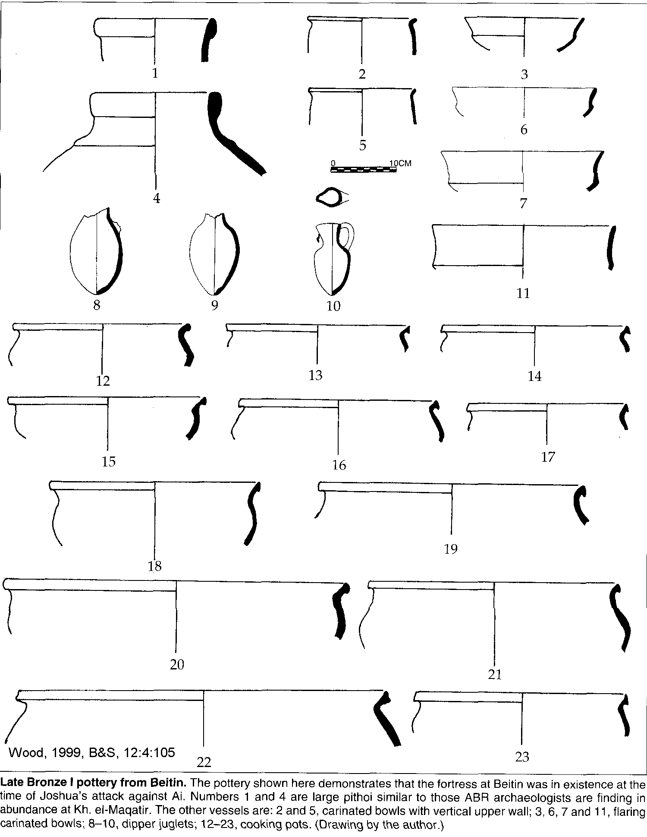

The location of Beth Aven is described in Joshua 7:2 and 18:12-13 as being located northwest of Bethel. In 1 Samuel 14:23 it is described as west of Micmash (modern Mukhmas). Beitin is in the right place and has archaeological materials of the right age to be the Biblical Beth Aven (Wood, 1999d).

PHOTO LINK: BEITIN 004 Aerial photo
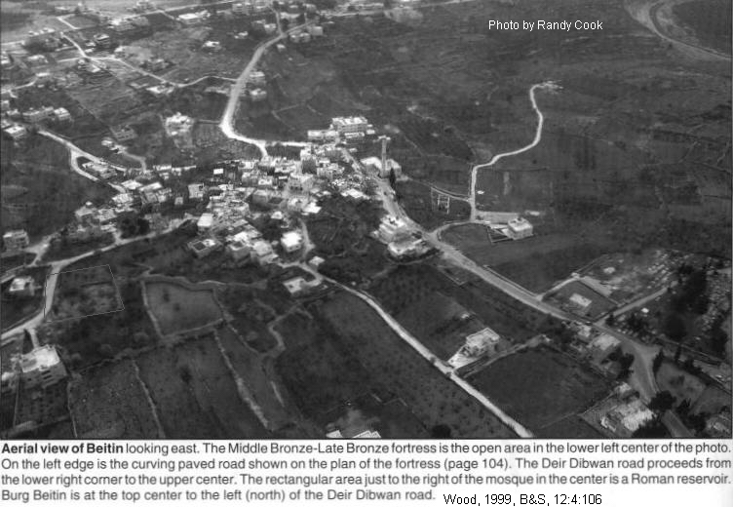

PHOTO LINK: BEITIN 005 NW view down Wadi Gayeh
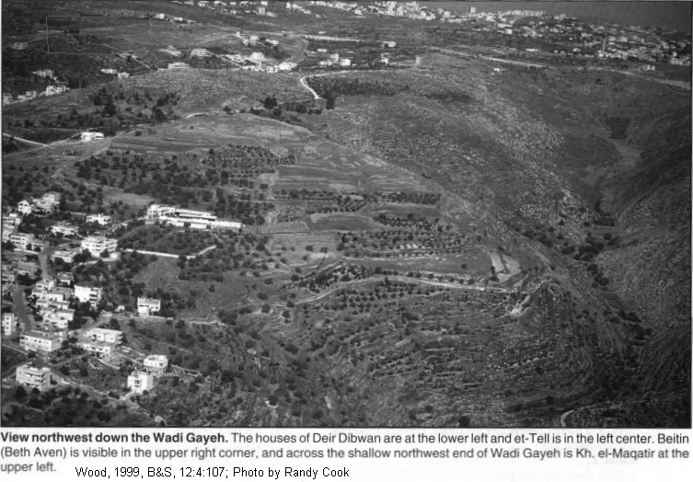

El-Bireh (Maximalist site for Bethel)
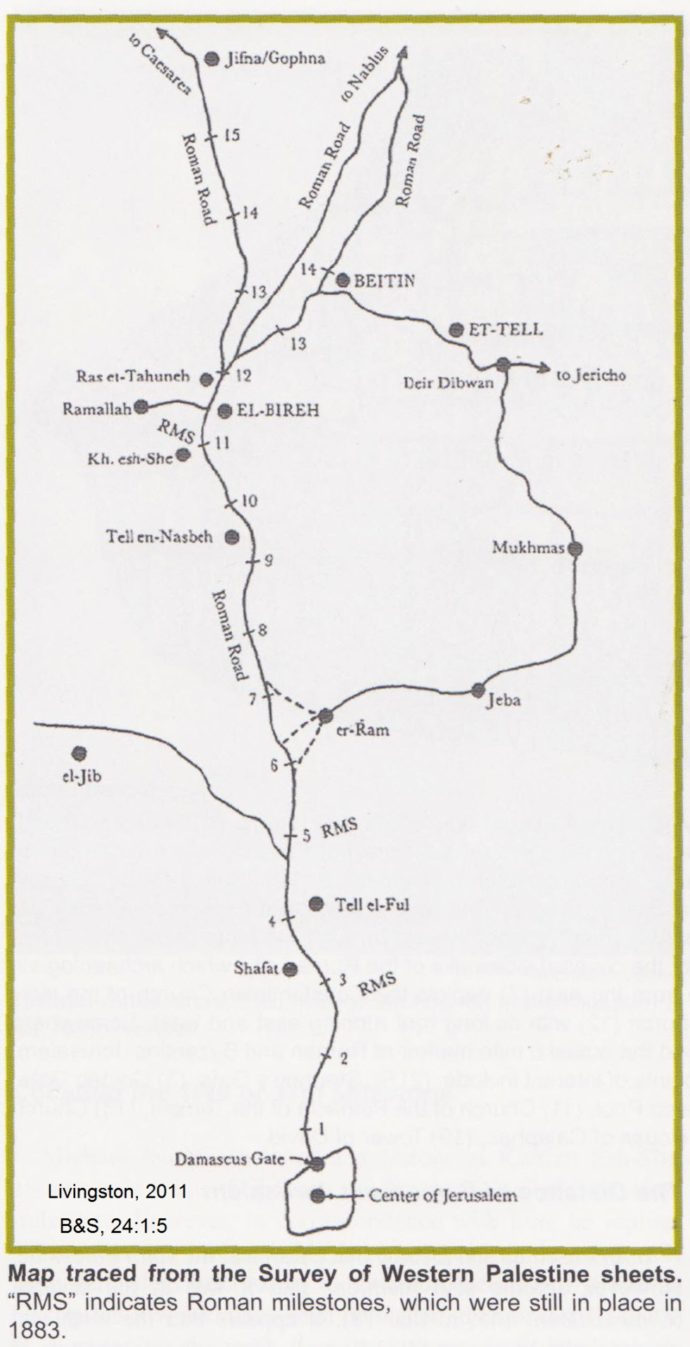
El-Bireh has the required topography and is the right distance from Jerusalem to be Bethel. It is located on a road between Jericho and Shechem which converge at a narrow "hourglass" ridge (Livingston, 1988, 1990).

PHOTO LINK: AI 012 Modern Bireh = ABR's Bethel (See ABOVE, ctrl+click to follow link)

PHOTO LINK: A1 003 Map of Ai area (See ABOVE, ctrl+click to follow link)

The locations of Roman mile stone markers and documents describing the distance of Bethel form Jerusalem supports the identification of El-Bireh as Biblical Bethel (Livingston, 2011).

PHOTO LINK: BETHEL 002 Map of Roman mile stones with cities: Jerusalem, El-Bireh, Beitin, Et-Tell

PHOTO LINK: BETHEL 003 Roman Mile Stone and David Livingston
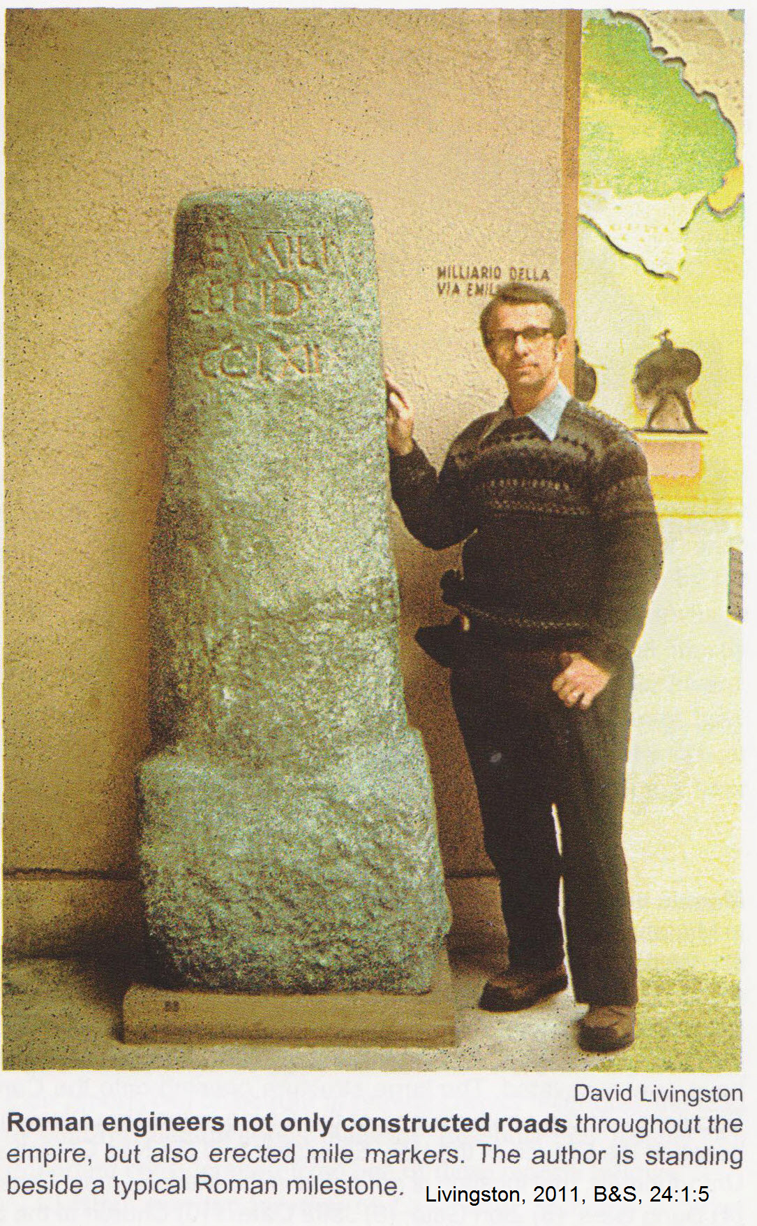

PHOTO LINK: BETHEL 004 Stone wall surrounding to of Ras-et-Tahuneh in modern El-Bireh. Candidate for ancient Bethel.
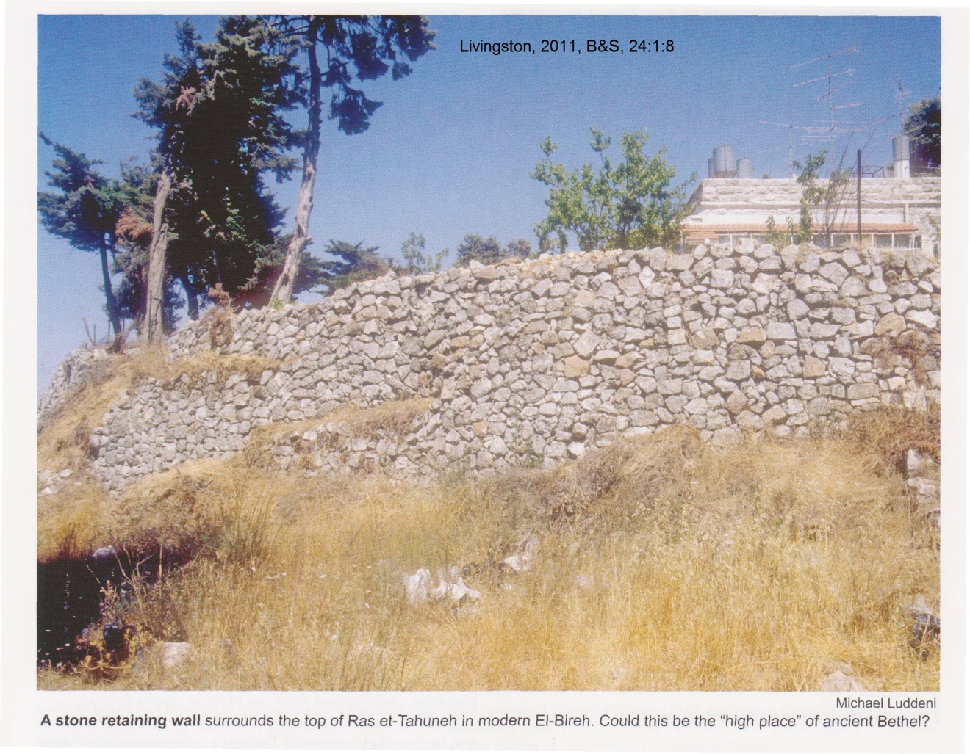

Khirbit Nisya (Maximalist site for Ai)

PHOTO LINK: AI 001 Aerial photo of Ai (Kh. Nishya) (See ABOVE, ctrl+click to follow link)

PHOTO LINK: AI 013 Aerial view of Kh Nishya = Livingston's Ai
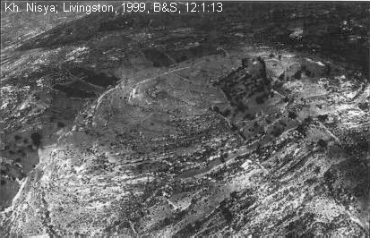

PHOTO LINK: AI 008 Aerial view Kh Nisya

PHOTO LINK: AI 015 Kh Nisya from the east
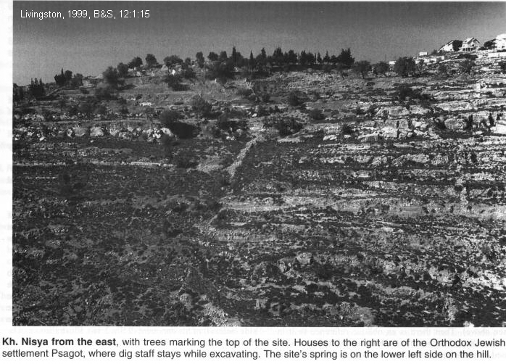

At Khirbit Nisya, excavations show considerable material from MBIII into LBI (2000-1400 BC) with some EB material. A MB Canaanite fortress has been uncovered there. These include MBIIA,B and C; LBI local ware (no imports); The Iron Age I and The Iron Age II artifacts to the end of (Israelite?) occupation (586 BC). Persian and Hellenistic pottery, coins are found in later stratums. There is also Roman and Byzantine and Arabic materials. To be a candidate for Ai, a site must have remains from Patriarchal times (MB), the Conquest (LB), the Divided Kingdom (Iron Age II, IA II), and from the time of return from exile (Persian). Kh. Nisya has material from each of these eras. (Livingston, 1988, 1990, 1999).

PHOTO LINK: AI 017 Kh Nisya Middle Bronze Age Artifacts
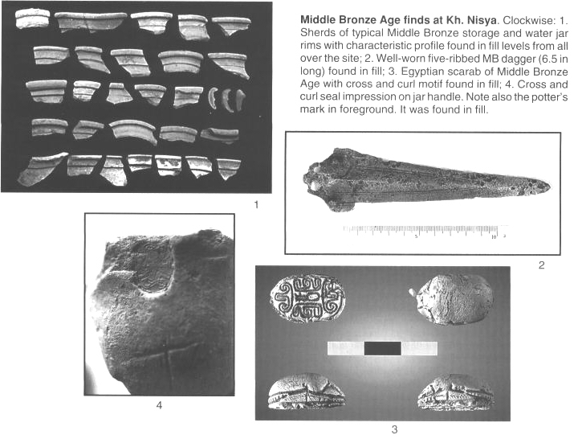

PHOTO LINK: AI 016 Kh. Nisya artifacts from Persian Period
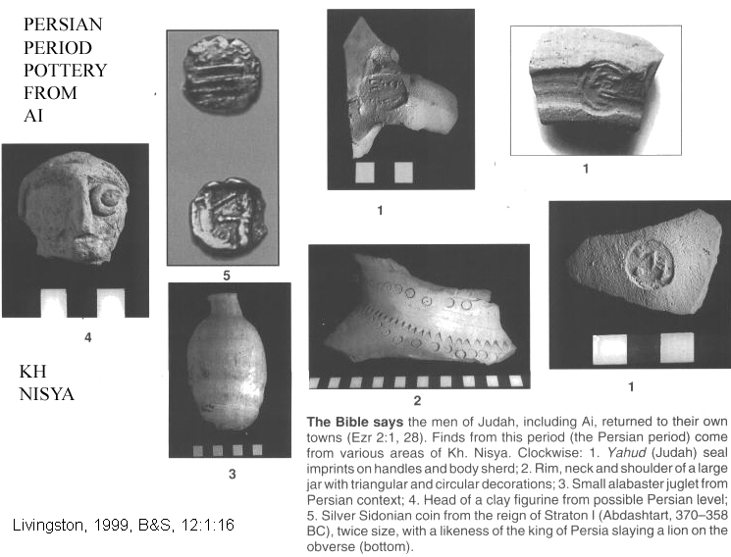

No buildings are known at Khirbit Nisya that are earlier than the Hellenistic period. Instead of building up a mound, each succeeding civilization cleared the area down to bedrock, obliterating older materials. There are no walls or gate complex as required by the biblical story. There is evidence for occupation for the time of Abraham (MB1; Livingston, 1988, 1990, 1999).

Military tactics at Ai were considered by Hansen (1989). At Ai, a minor defeat was followed by a major victory (see map of second campaign of Ai in Hansen, 1989, p.44 and Zevit: 1985, p.60).

PHOTO LINK: AI 004 Topographical cross sections Khirbet Nisya vs. et-Tell (See ABOVE, ctrl+click to follow link)

PHOTO LINK: AI 002 Battle Map of Second Campaign (See ABOVE, ctrl+click to follow link)

The location of El Bireth and Kirbet-Nisya are more strategic than Beitin and et-Tell from military point of view. El Bireh is at narrow part of "hourglass" connecting road on a north-south watershed system at junction of "Way to Beth Horon" while Beitin is on a side road 2 miles away from main watershed. Kirbet-Nisya, if it were an eastern outpost for El-Bireth, would provide intelligence on activities in the Jordan Valley. This important tactical ability is not as good at et-Tell and it is not as accessible to its sister city Beitin as El-Bireth is to Kirbet-Nisya (Livingston, 1988, 1990, 1999).

Livingston (1999, p.17) produced a comparison chart, reproduced with modifications below:

Kh. Nisya | Kh. Nisya | Biblical Ai | Biblical Ai | et-Tell | et-Tell
Archaeologi- cal Periods | Dates | Reference | Dates | Archaeologi- cal Periods | Dates
Early Bronze | unclear |  |  | Early Bronze | 3100-2400
Middle Bronze I | ?=2000 BC | Gen. 12:8 Abraham | 2000? BC |  | UNOCCUPIED
Middle Bronze II | 2000-1550? |  |  |  | UNOCCUPIED
Late Bronze I | 1550-1400 BC | Joshua 8  Ai destroyed | 1420-1400 BC |  | UNOCCUPIED
Late Bronze II | UNOCCUPIED |  | UNOCCUPIED |  | UNOCCUPIED
Iron I | 1250-1000 BC | Judges 1  Bethel taken (Ai rebuilt?) | 1300? BC | Iron 1 village | 1220-1050 BC
Iron II | 1000-586 | Isaiah 10:28 Assyrians pass through? | 730 BC | Calloway (193:40) | Abandoned after 1050 BC
Persian | 516-332 BC | Ezra 2:28  Exiles return | 516 BC |  | Never Resettled
Persian | 516-332 BC | Nehemiah 11:31  Ai resettled | 445 BC
Hellenistic I | 332-152 BC | No reference | Not deserted
Hellenistic II (Hasmonen) | 152-65 BC
 | UNOCCUPIED
Early Roman (Herodian) | 65 BC-AD 70 | 1 Maccabees 9:50; Josephus | Vespasian took Bethel (and Ai?) AD 68
 | UNOCCUPIED
Byzantine I and II | AD 350-640 | Eusebius (“Ai is deserted”) | AD 330?
Arab | AD 640-800
 | ABANDONED

The following observations support the identification of Kh. Nisya as Ai:

1. Topographic setting: with a mountain between it anD Bethel, deep valley to the north, hiding place for ambush, decent leading to Jericho
2. It is smaller than Gibeon (et-Jib, Joshua 10:2)
3. It is near Bethel

Khirbit el-Maqatir (Maximalist alternative site for Ai)

Another candidate for the Ai of Joshua is Kh. el-Maqatir, southwest of et-Tell. The Ai of Joshua’s time was a relatively small settlement, smaller than Gibeon (Joshua 10:2; see Wood, 1999b)

PHOTO LINK: AI 009 Aerial view Kh el Maqatir = Wood's Ai
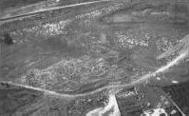

PHOTO LINK: KH EL-MAQATIR 015 Oblique aerial view of Khirbet el-Maqatri
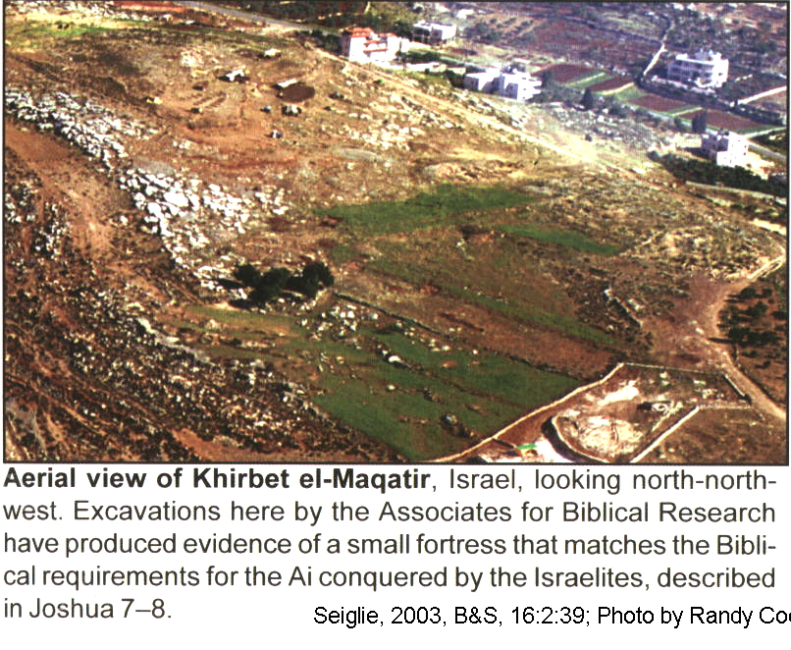

Factors supporting this identification are:

Typographical requirements for Biblical Ai:

-Strategic setting at northern outpost of Jerusalem and southern city-states on the boarder with the Shechem (an early Israelite ally) territory (Wood, 1997, cited by Wood, 1999b).
-Near Beth-Aven (=Beitin, Joshua 7:2)
-East of, and not far from Bethel (=El Bireh, Joshua 7:2, Joshua 12:9)
-Near a Stone Quarry (“S^{e}varim”, Joshua 7:5)
-Stone Quarry is on a decent from Ai (Joshua 7:5)
-There is high ground north of the site that has military tactical value (Jebel Abu Ammar, Joshua 8:11)
-There is an ambush site on the west (Wadi Seban, Joshua 8:9)

PHOTO LINK: AI 018 Location map with Ai, Betin, El Bireh, Kh. et-Tell and Kh. el-Maqatir
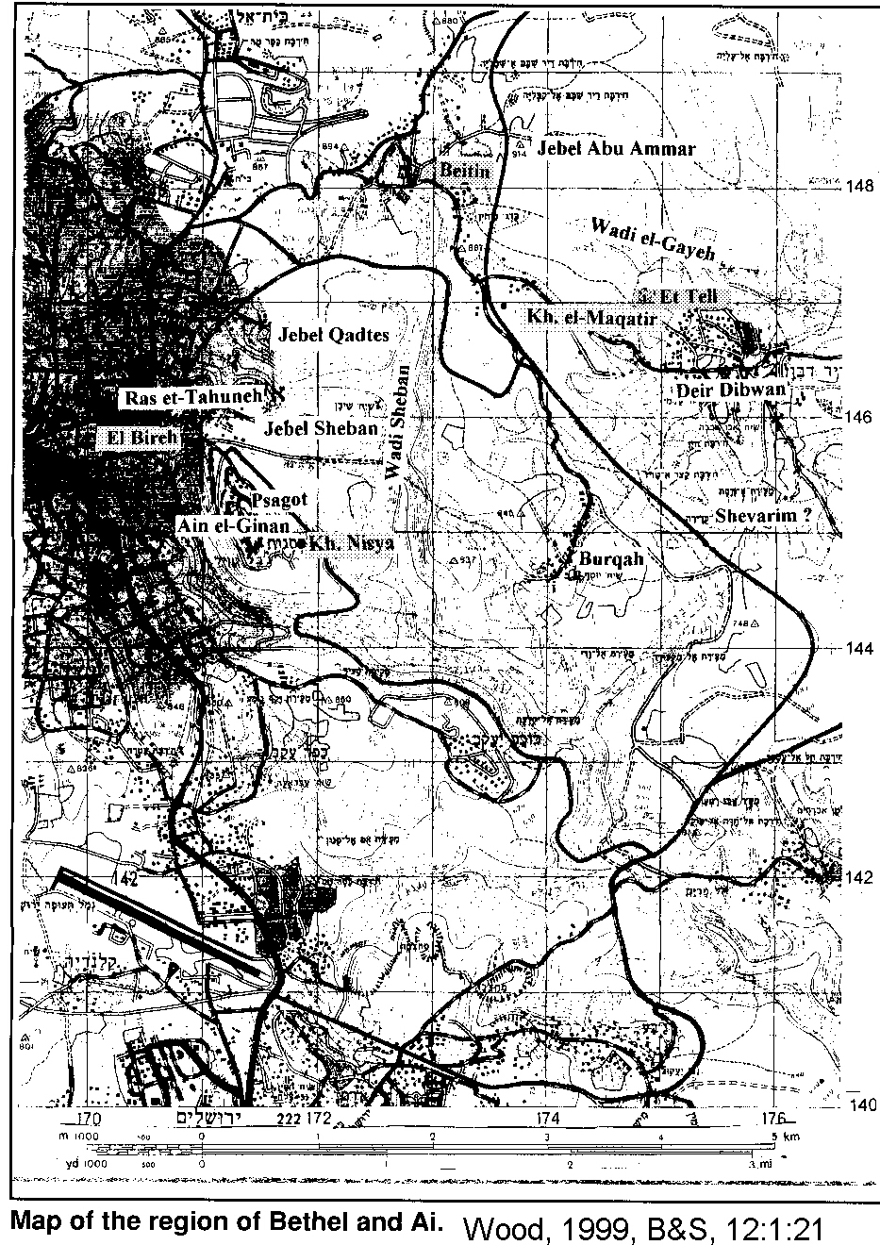

PHOTO LINK: AI 021 Stone Quarry
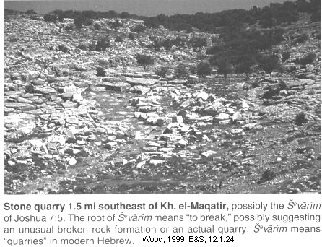

Archaeological requirements for Biblical Ai:

The Ai of Joshua must have the following characteristics:

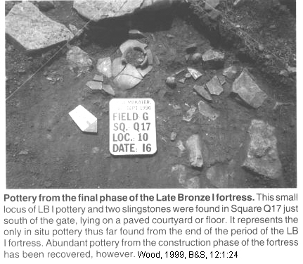
1-Occupied at time of the Conquest (LBI period)
2-Smaller than Gibeon (1.7 acres; Joshua 7:3; 10:2)
3-Fortified (Joshua 7:5; 8:29)

PHOTO LINK: AI 022 Pottery of LBI fortress Kh el-Maqatir
(RIGHT)

PHOTO LINK: AI 023 Plan of LBI fortress at Kh el-Maqatir (See ABOVE, ctrl+click to follow link)

PHOTO LINK: AI 024 LBI fortress SW wall at Kh el-Maqatir
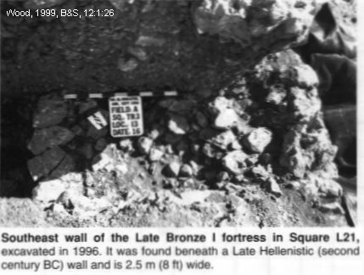

PHOTO LINK: AI 025 LBI fortress SW wall at Kh el-Maqatir 1998
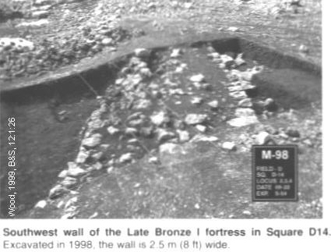

PHOTO LINK: AI 026 LBI fortress terrace wall at Kh el-Maqatir 1998
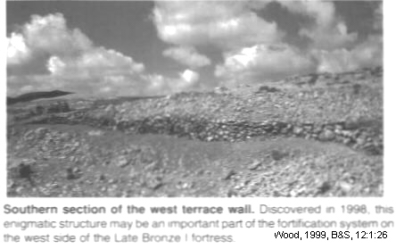

PHOTO LINK: AI 027 LBI gate socket stone at Kh el-Maqatir 1995
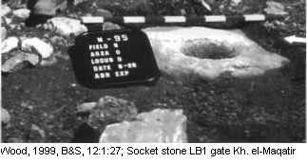

PHOTO LINK: AI 028 Plan of LBI gate with socket stones at Kh el-Maqatir 1996
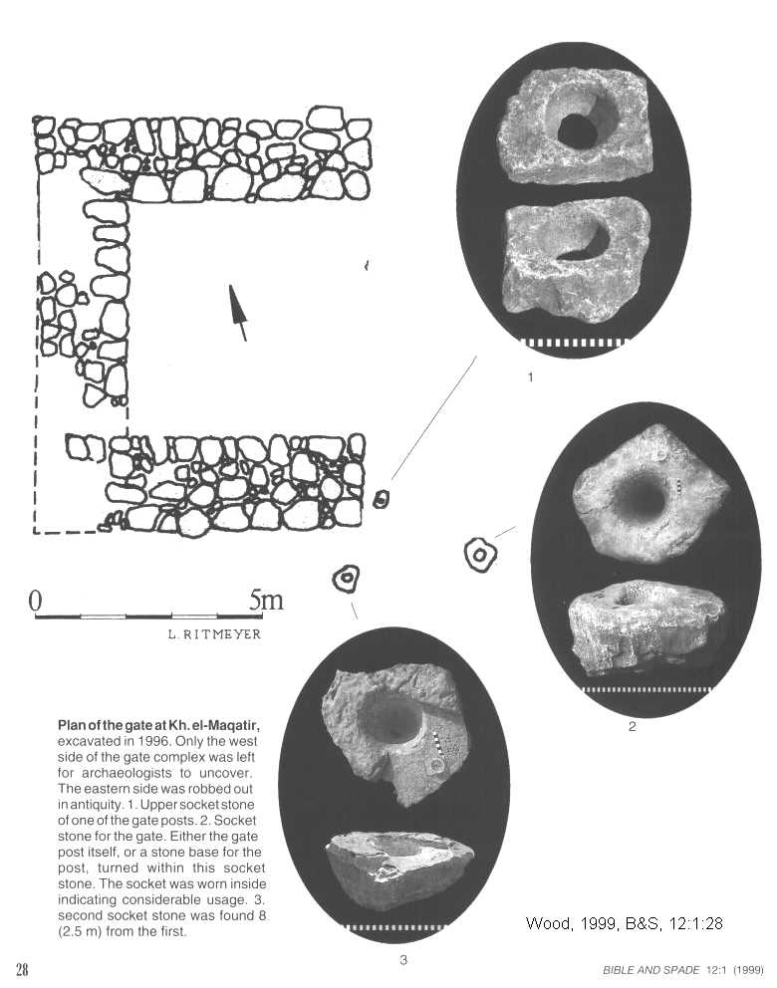

PHOTO LINK: KH EL-MAQATIR 009 Plan of LB1 fortress (See ABOVE, ctrl+click to follow link)

There is a massive (14 ft wide, originally 40 ft high) curving north wall with a gate complex from LBI at Khirbit el-Maqatir (Wood, 1999:109).

PHOTO LINK: KH EL-MAQUATIR 001, North Wall of LBI Fortress
(See ABOVE, ctrl+click to follow link)

PHOTO LINK: KH EL-MAQUATIR 003, LB1 Fortification wall robbed out for Hasmonean wall
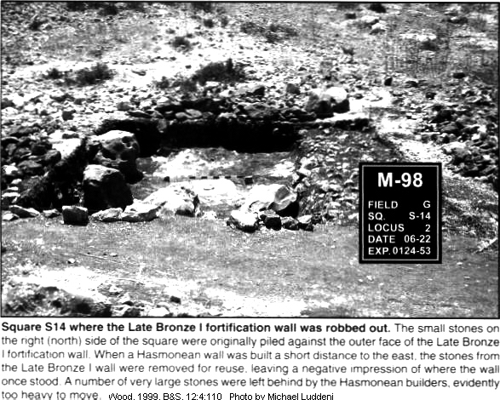

PHOTO LINK: KH EL-MAQUATIR 004, North side of LBI fortress looking east
PHOTO LINK: KH EL-MAQUATIR 012, West wall of LB1 fortress
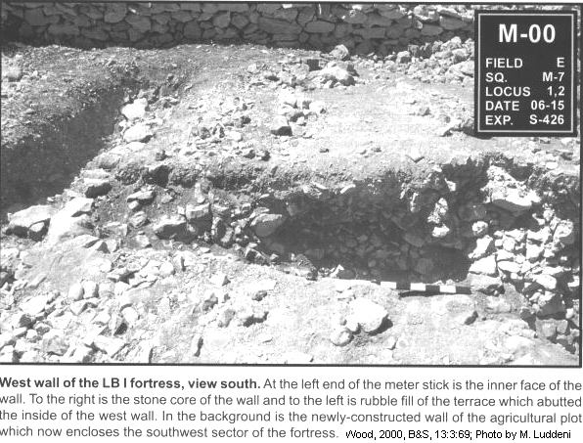

4-Gate on North Side

PHOTO LINK: AI 027 LBI gate socket stone at Kh el-Maqatir (See ABOVE, ctrl+click to follow link)

PHOTO LINK: AI 028 Plan of LBI gate with socket stones at Kh el-Maqatir 1996 (See ABOVE, ctrl+click to follow link)

PHOTO LINK: KH EL-MAQUATIR 002 Curving North wall
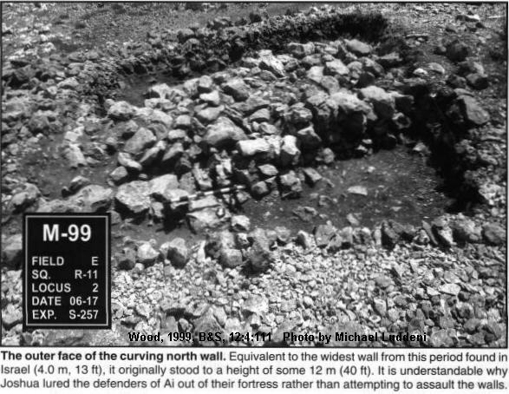

5-Destroyed by Fire (Joshua 8:19-20, 28)

A 4-inch thick ash layer above the flagstone pavement of the LB1 fortress shows that it was destroyed in LB1 by fire. The conflagration is also indicated by re-fired pottery and calcinations of bedrock (Wood, 2000:69,70).

PHOTO LINK: KH EL-MAQATIR 010 Pavement with 4 inch ash layer
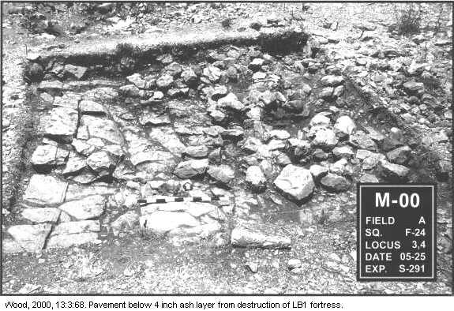

PHOTO LINK: KH EL-MAQATIR 011 Megalithic stones on flagstone pavement above ash layer
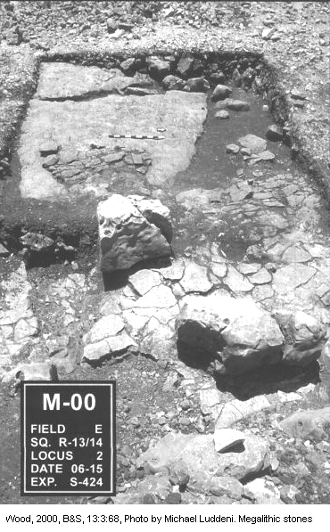

6-A ruin forever (Joshua 8:20)

PHOTO LINK: AI 009 Aerial view Kh el Maqatir = Wood's Ai (See ABOVE, ctrl+click to follow link)

PHOTO LINK: KH EL-MAQATIR 015 Oblique aerial view of Khirbet el-Maqatri (See ABOVE, ctrl+click to follow link)

During the 2009-2010 seasons at Khirbet el-Maqatir the west wall of the 15th century BC Late Bronze Age I Fortress was excavated (Wood, 2011:10).

PHOTO LINK: AI 034 West wall of 15th century BC fortress
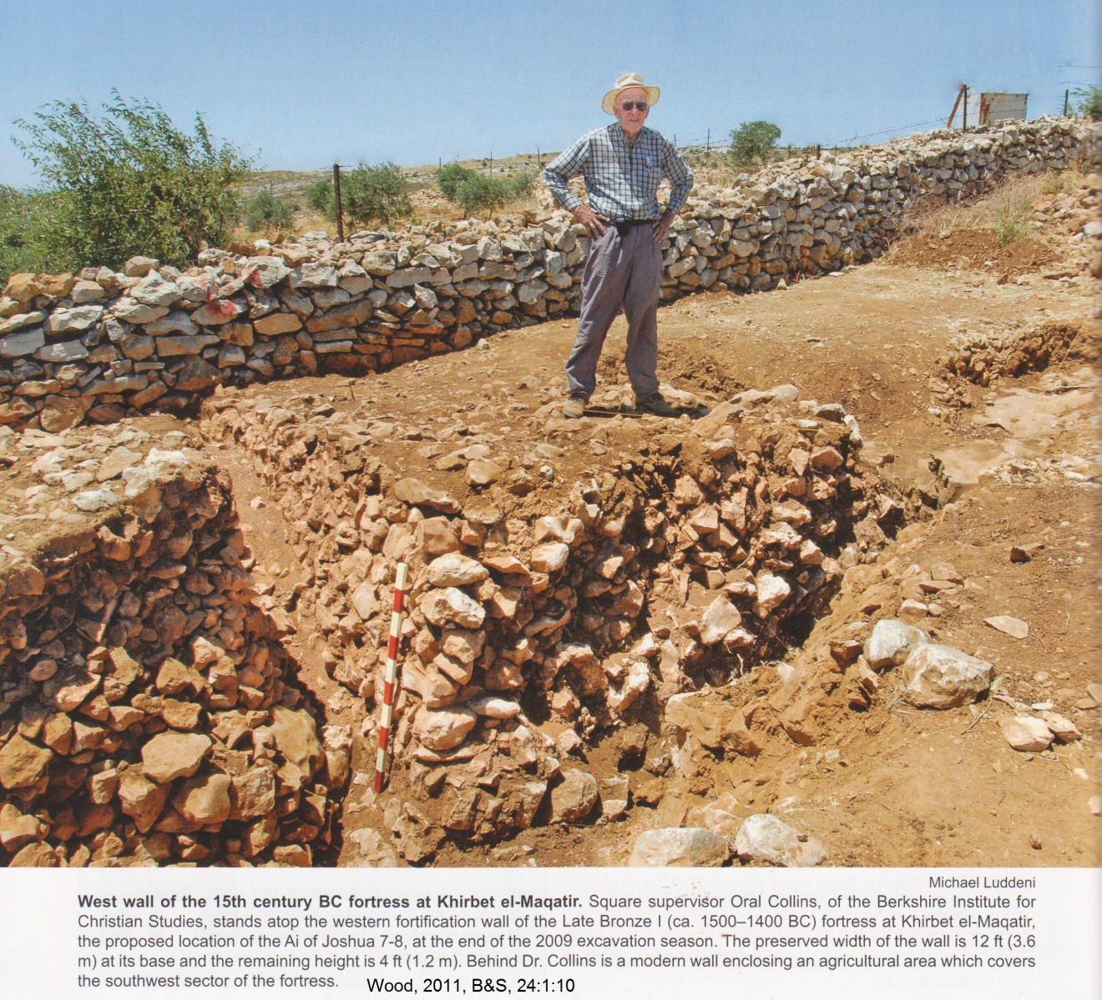

PHOTO LINK: AI 035 Plan of the gate area on the north side of the LB I fortress
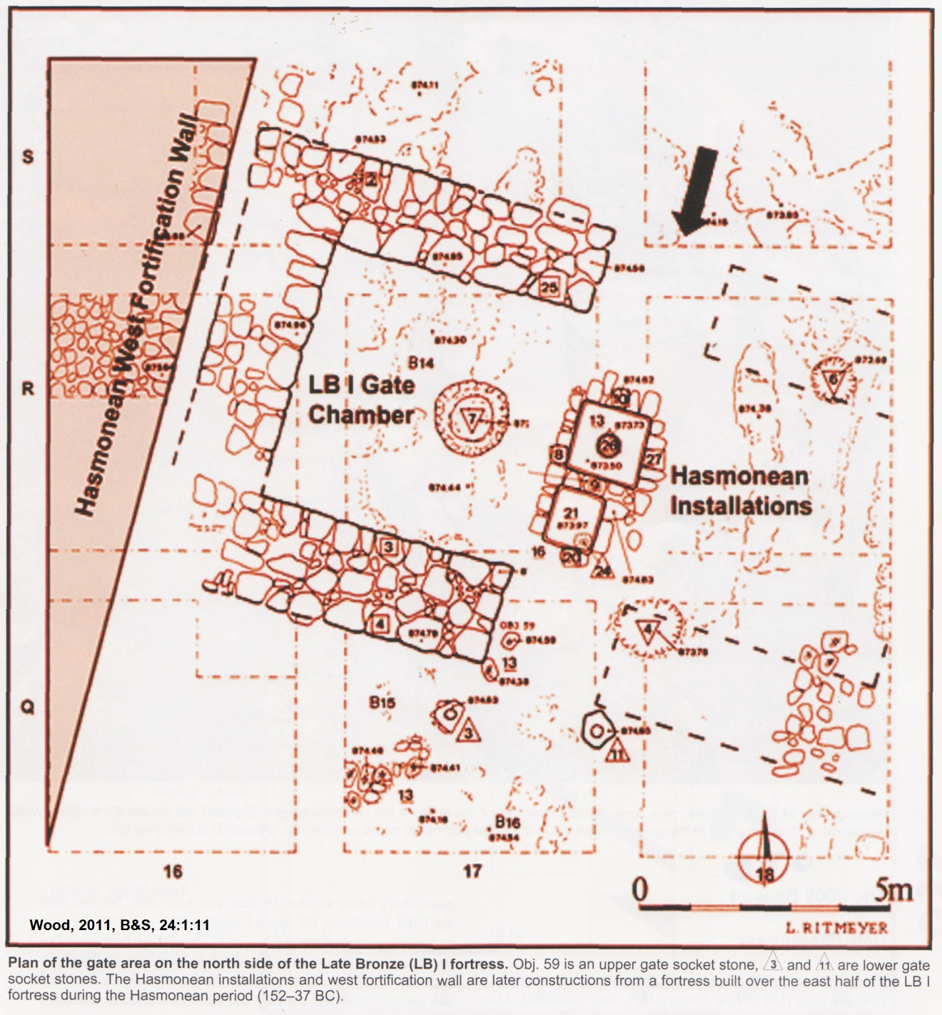

PHOTO LINK 036 Passageway of the LB I gate
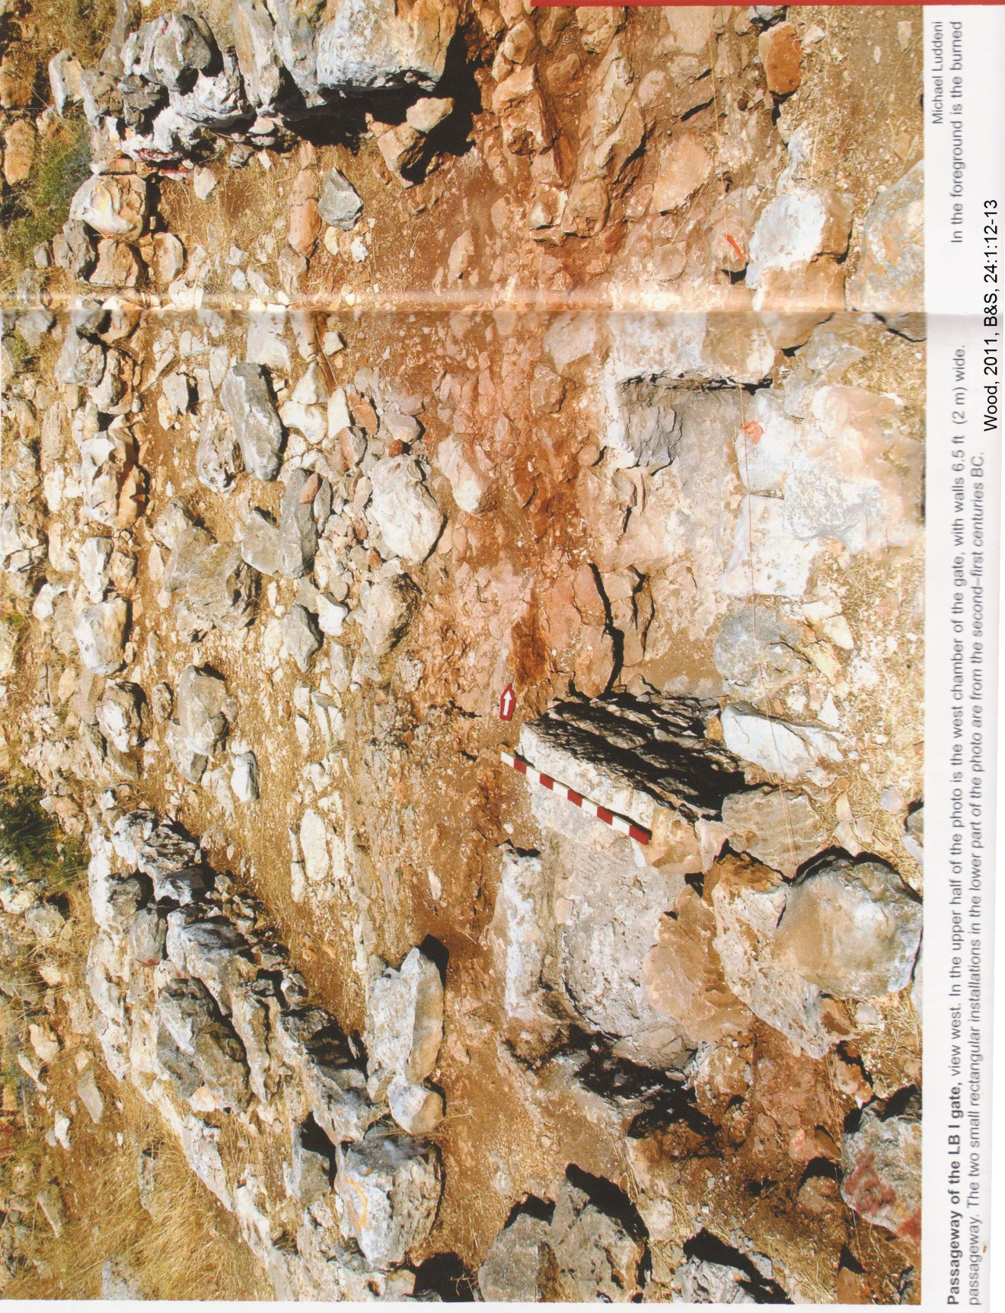

PHOTO LINK: AI 037 Plan of the LB I gate and walls inside gate
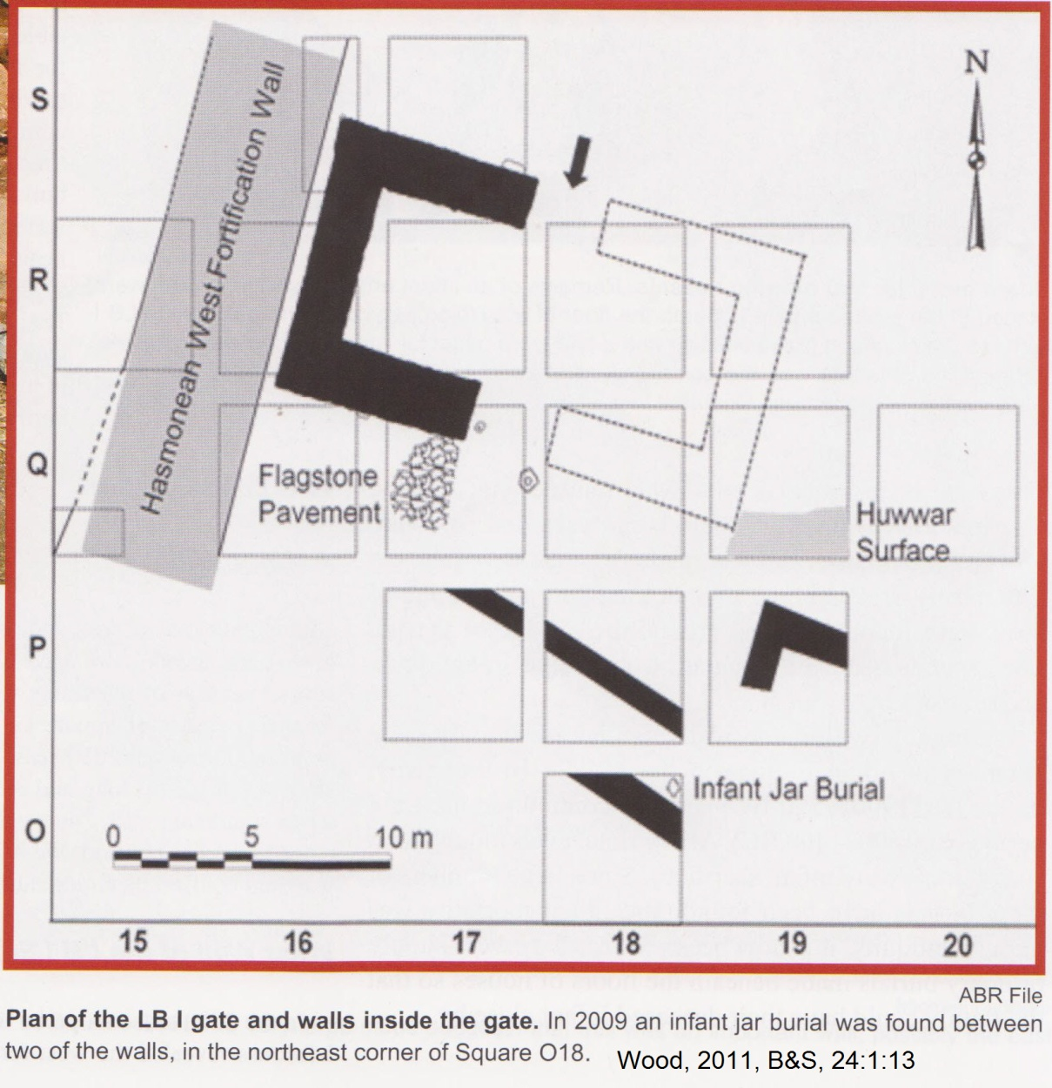
PHOTO LINK AI 039 South Section through the west LB I fortification wall and later Hasmonean addition
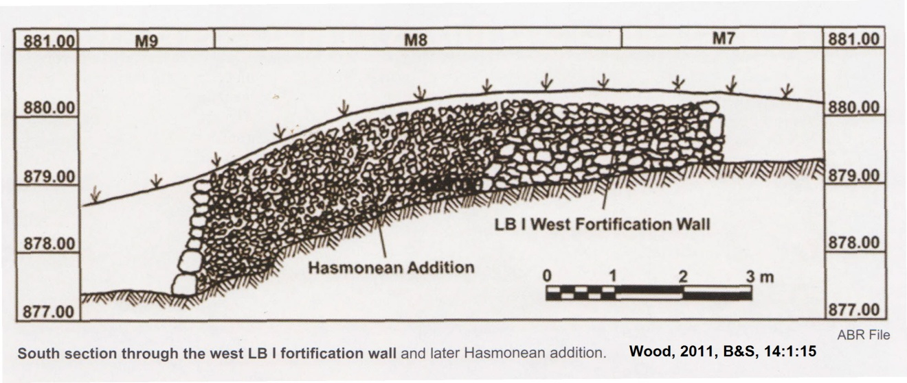

Miscellaneous Finds at Kh. El-Maqatir

1. Pit
PHOTO LINK: KH EL-MAQATIR 005, Iron Age 1 pit from time of Eli and Samuel
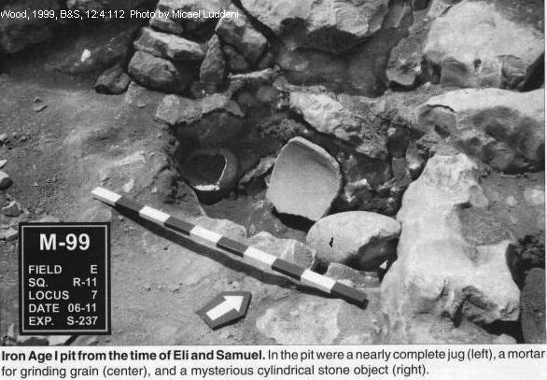

2. Circular granary

PHOTO LINK: KH EL-MAQUATIR 006, Circular granary from Hasmonean period
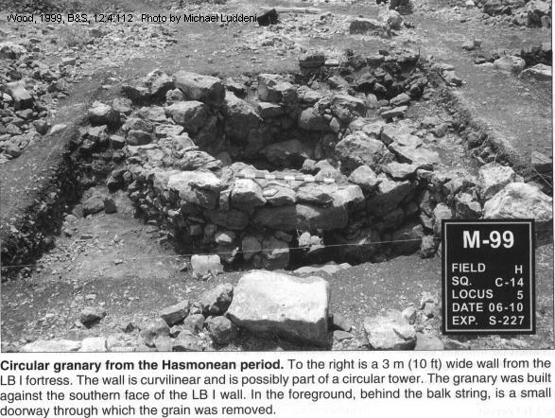

3. Jug

PHOTO LINK: KH EL-MAQUATIR 007, Jug from 11th century BC
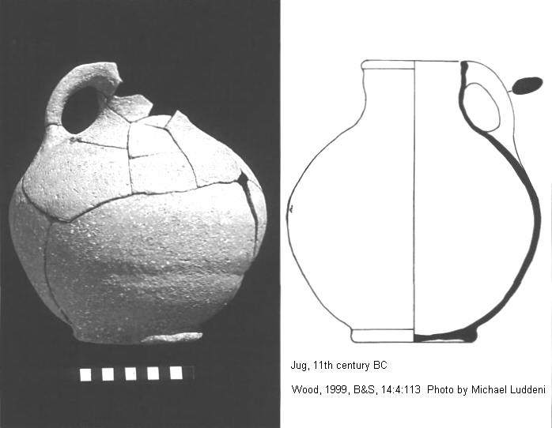

4. Enigmatic cylindrical object

PHOTO LINK: KH EL-MAQUATIR 008, Enigmatic cylindrical object from 11th century BC
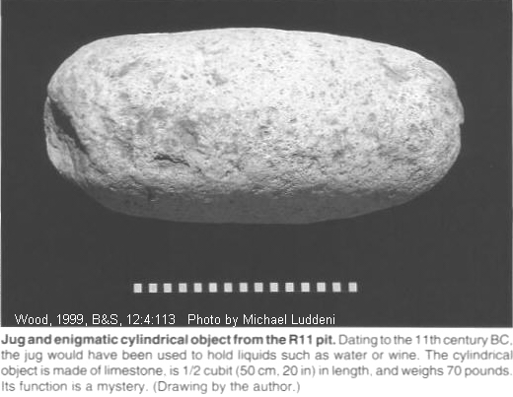

MT EBAL AND JOSHUA'S ALTER

After the victory in the 2nd Battle of Ai, Joshua erected an alter on Mount Ebal (Joshua 8:30-31; Zertal, 1985, 1986; Kempinski, 1986). Zertal says he has found the open-air alter (bamot) described in Joshua 8:30-35 and Deuteronomy 27:4-8. This interpretation is based on the following:

The alter follows the construction guidelines of Exodus 20:26 and has no steps. Two Egyptian scarbs date the site precisely. Collar rimmed jars and "man face" pottery handles of 13th-12th centuries BC are at the site. Level I is 1200-1150 BC and Level II 1225-1200 BC. These periods cover the time of Biblical stories of Deborah and Barak and Judge Gideon. An incense burner (ritual chalice found) was found at the bottom of alter (Zertal, 1985, 1986; Kempinski, 1986) .

PHOTO LINK: AR042 Alter on Mt. Ebal
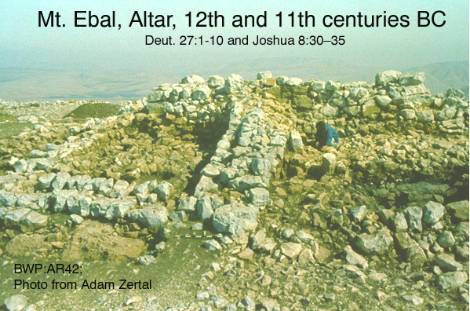

PHOTO LINK: AR043 Drawing of Alter on Mt. Ebal
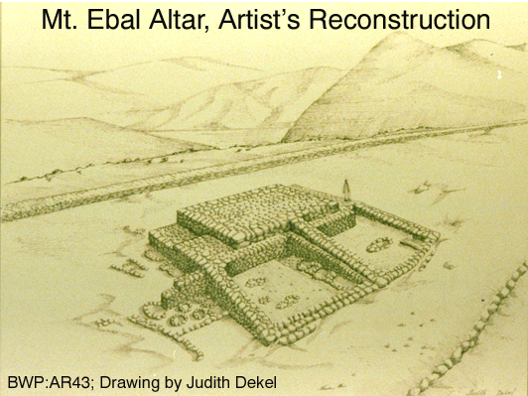

PHOTO LINK: MANASSEH 012 Alter and bahma on Mt. Ebal per Josh 8:33-34
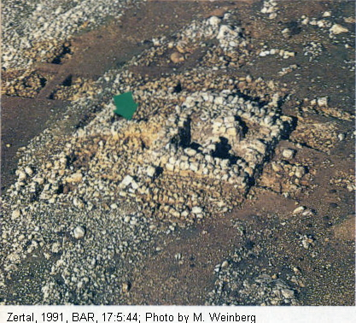

PHOTO LINK: MANASSEH 013 Aerial photo of Mt. Ebal and Mt. Gerizim
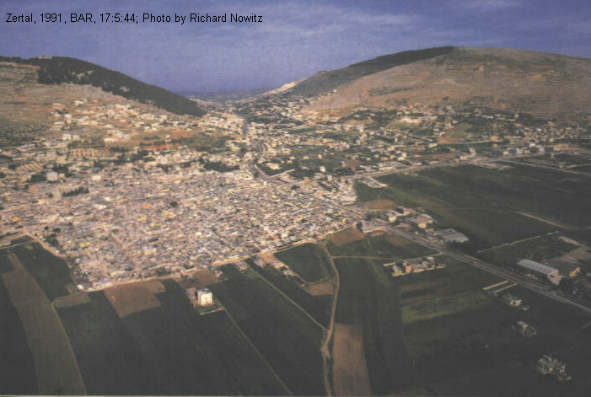

PHOTO LINK: POTTERY 005 Collar rimmed jar: Israelite or Canaanite?
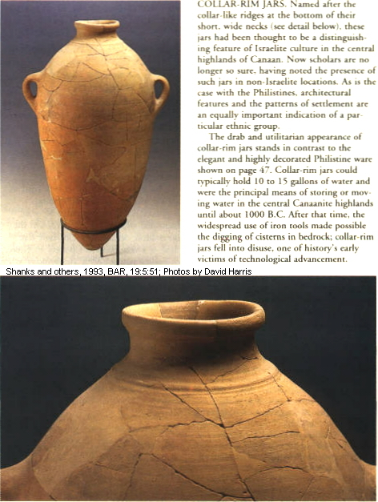

PHOTO LINK: SHILOH 002 Collar rimed pottery from time of Eli
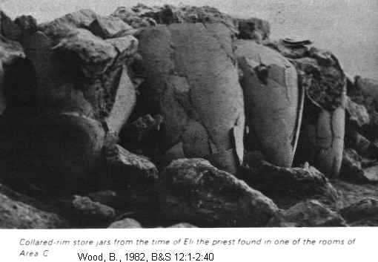

PHOTO LINK: MT EBAL 001 Aerial photo of Mt. Ebal and Mt. Gerizim

Identification of this site as Joshua’s alter is contested by Kempinski (1986) who says it is a watchtower. The "Ramp" at the site is too narrow to be used as access to the alter access, and is actually an eroded wall. An early cult center was replaced by storehouse and then by watchtower. Coogan (cited by Shanks, 1988) agrees with cultic site interpretation, but says that it may not be Israelite.

MT GERIZIM, MT EBAL, AND SHECHEM

The recitation of the law and blessings on Mt Ebal and recitation of curses on Mt Gerizim described in Josh. 8:32-35 occurred in about 1406 (Early Date) in the Late Bronze age, LB IB. At this time, the city of Shechem, situated in the valley between Mt Ebal and Mt Gerizim, corresponds to Level XIV of Tel Balata (Campbell, 1993:1347; Toombs, 1992:1178, cited by Hansen, 2005:37)

PHOTO LINK: SHECHEM 003 Location map of Shechem, Megiddo, Tyre and Jerusalem (See ABOVE, ctrl+click to follow link)

PHOTO LINK: SHECHEM 013 Aerial photo of Shechem ruins
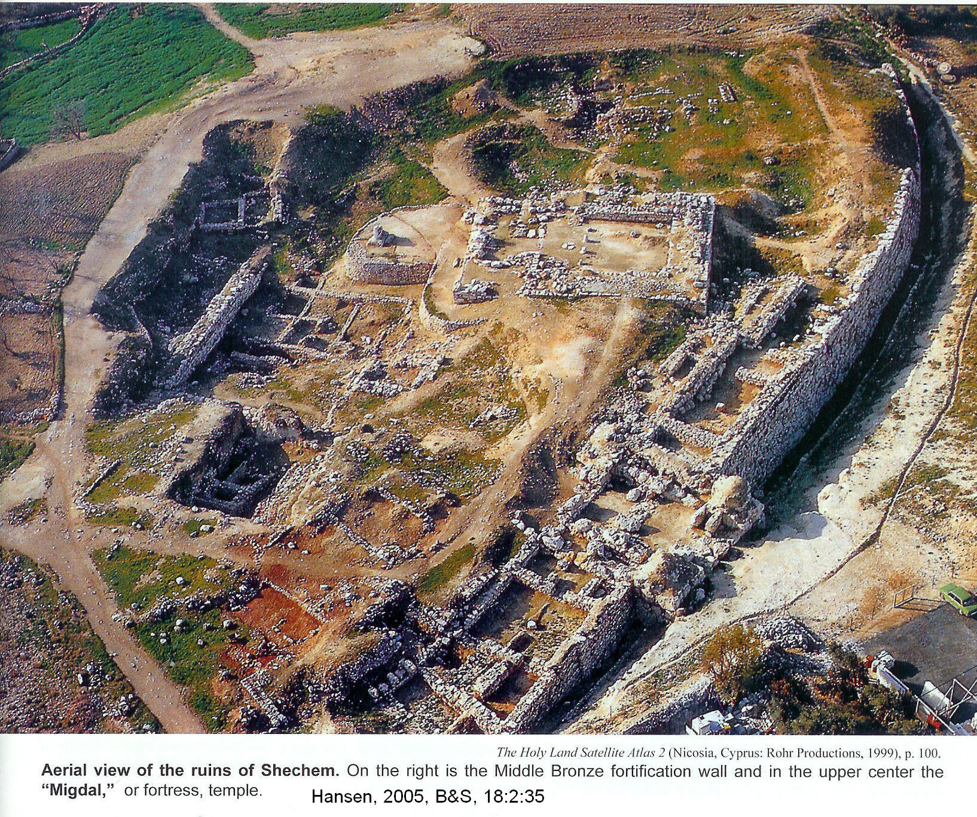

PHOTO LINK: SHECHEM 012 Plan of Shechem and Jacob's Well
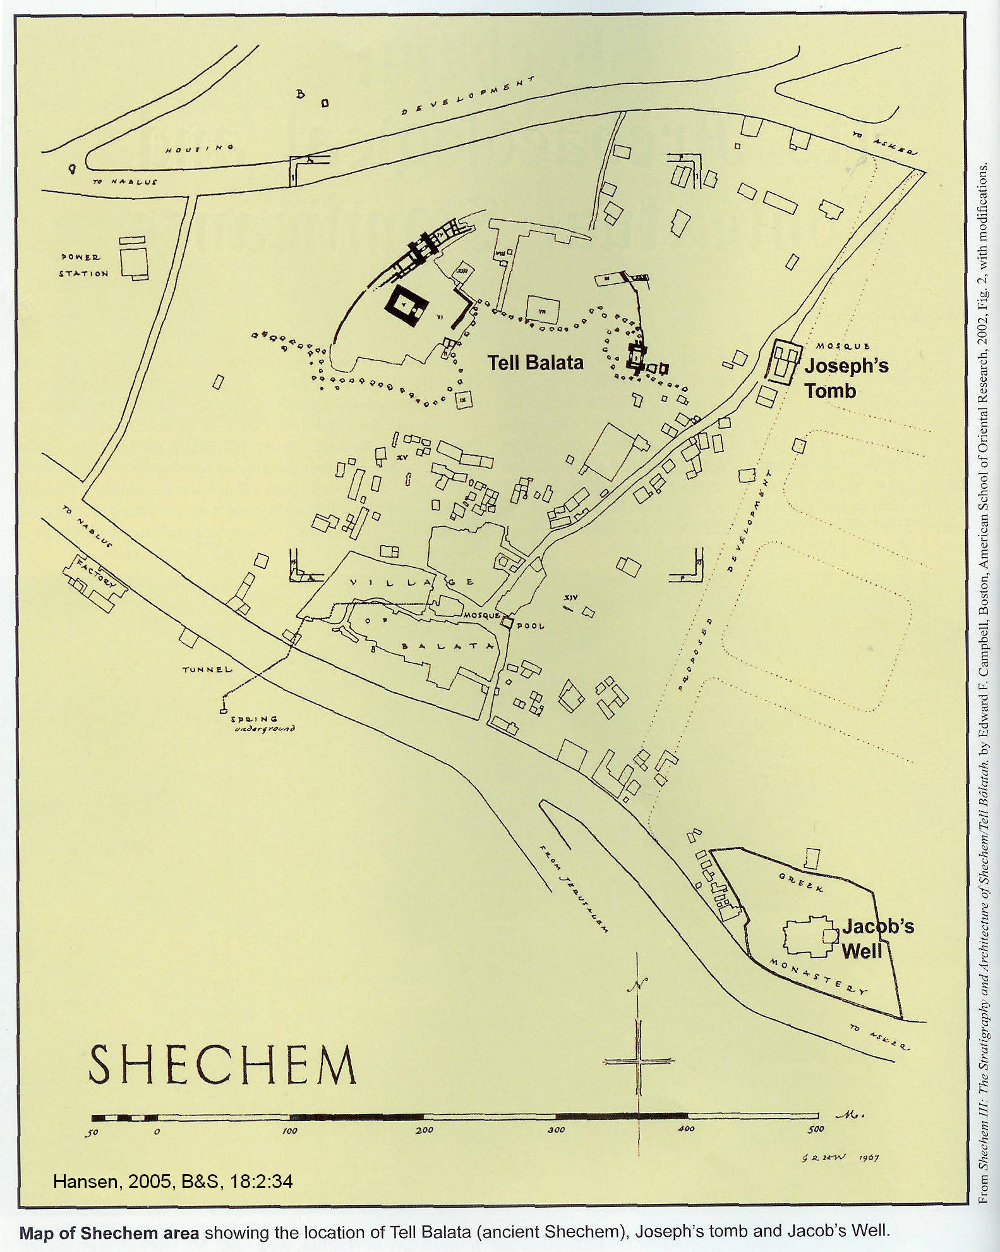

PHOTO LINK: MT GERIZIM 003 Aerial photo of Mt Gerizim and 5th century AD octagonal church
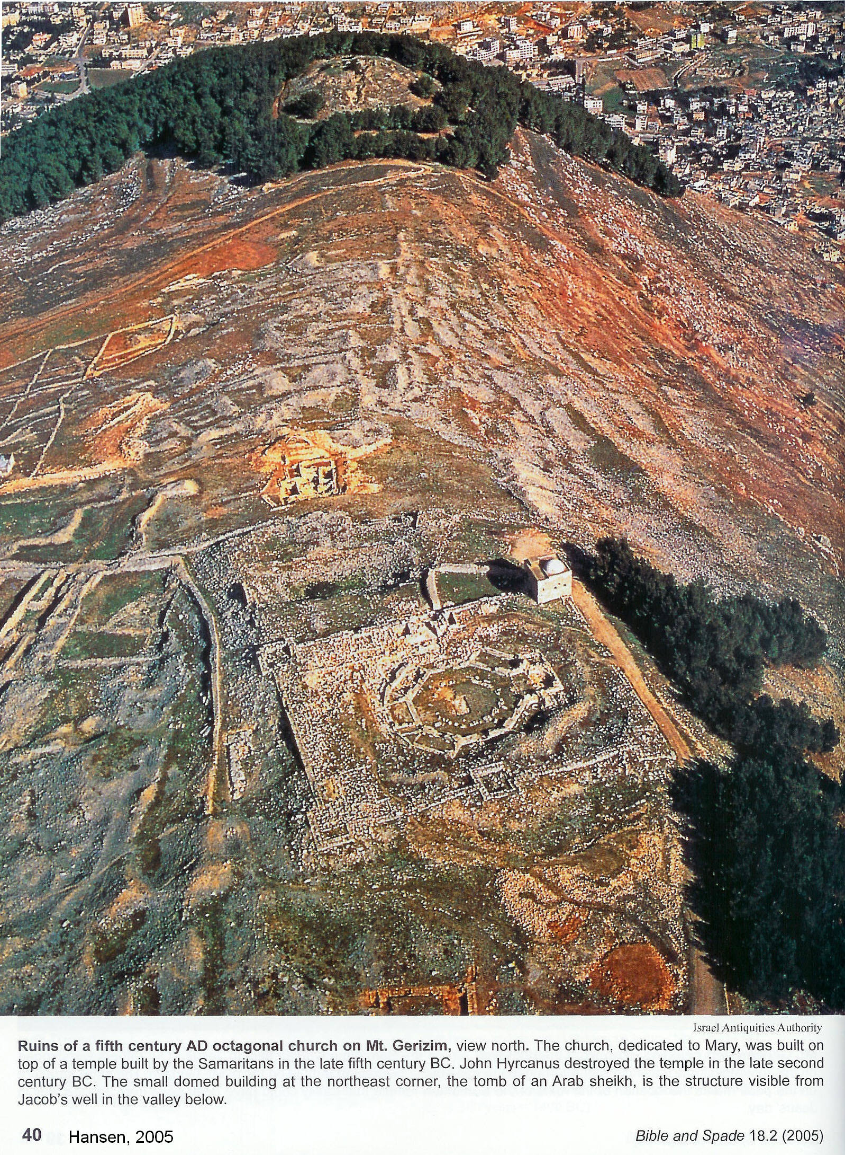

Between the time of Jacob (Levels XXII-XXI) and the time of Joshua (Level XIV), a period of some 350 years, the city had grown and had been fortified with earthen embankments and cyclopean wall fortifications. The city had been destroyed around 1540 BC. The destruction is evidenced by a debris layer up to 5.25 ft (1.6 m) deep. That destruction is attributed to an Egyptian military campaign by Ahmose I or Amenhotep I (Toombs, 1992:1182, cited by Hansen, 2005:37).

After the Egyptian destruction of Shechem, it was rebuilt about 90 years later in LB I as Level XIV. The Level XIV city included reconstruction of city defensive walls and homes. A well built, fortress-type temple was also constructed at this time. It was this city that Joshua encountered when he arrived to read the Law per Moses’ instructions (Hansen, 2005:27).

Joshua 8:33, 35 suggests that the city of Shechem of Level XIV became inhabited by both Israelites and Shechemites:

“All Israel, aliens and citizens alike…were standing on both sides of the ark of the covenant…there was not a word…that Joshua did not read to the whole assembly of Israel, including…the aliens who lived among them.”

The aliens mentioned here were the Shechemites. After the conquest, Shechem became and important Israelite city and was one of only three Israelite Cities of Refuge on the west side of the Jordan. It was also a Levitical city (Joshua 20:7; 21:21). There is no description of a military overthrow of Shechem (Hansen, 2005:27).

PHOTO LINK: CITIES OF REFUGE 002 Cities of Refuge and Levitical Cities
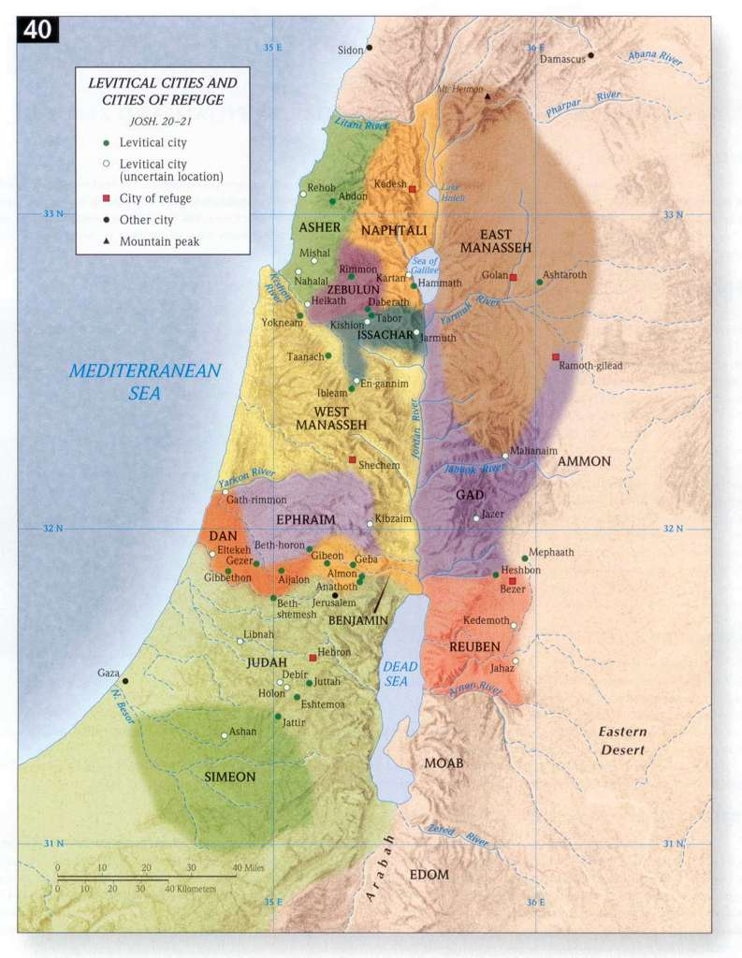

The El Amarna letters provide additional information about the situation at Shechem in the LB period. In the mid-14th century, the kings of Shechem were criticized by other Canaanite rulers for cooperating with an invading group call the Habiru. Many conservative scholars equate Habiru with “Hebrew” (Wood, 1997; 2003, cited by Hanson, 2005:38). However, the relationship between Habiru and Hebrew is not an indisputably strong one, and many researchers discount any relationship between Habiru and the Israelites.

PHOTO LINK: AMARNA LETTERS 008 Letter of Labayu, king of Shechem to Amenhotep III
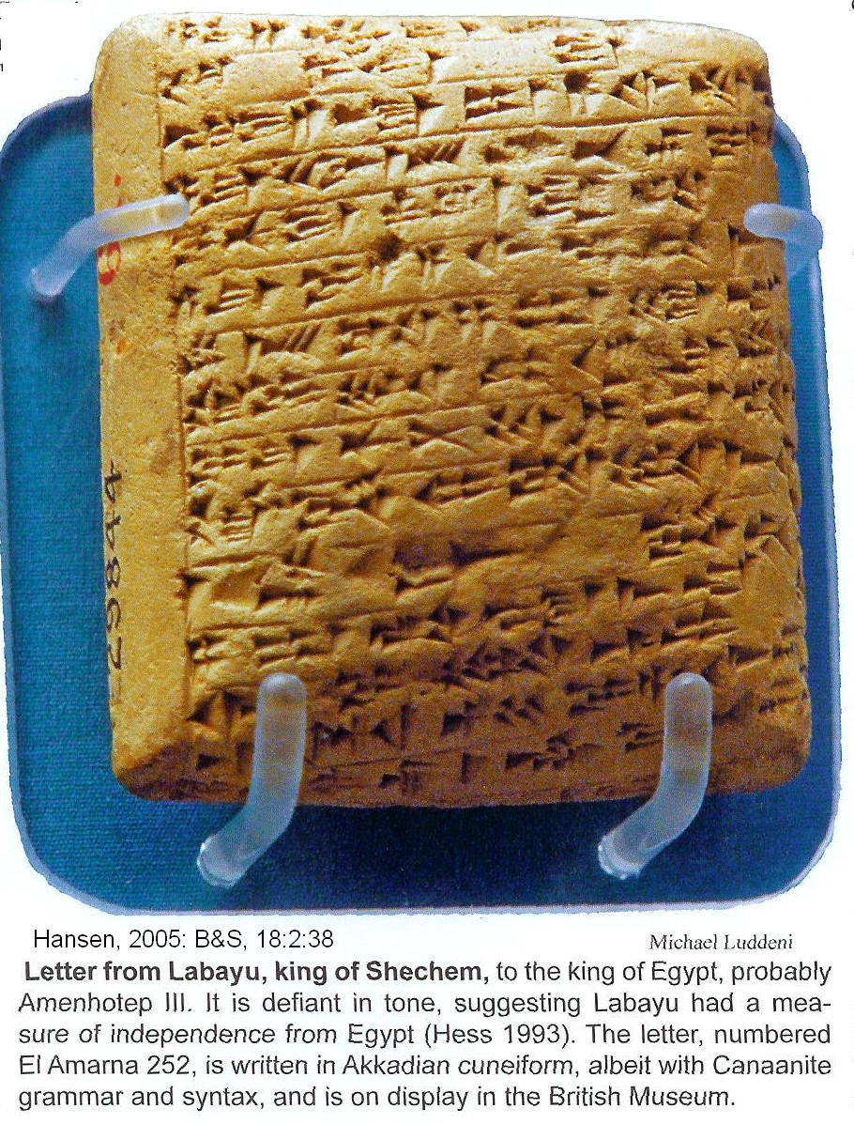

The Shechem covenants (c.1404 and 1390? BC)

The first Shechem covenant was made early in the Conquest, as directed by Moses (Josh 8:30-35). A second Shechem covenant was made at end of Joshua's life (Josh 23, 24). A Hittite-like structure is used these covenants which include the following elements (Livingston, G., 1995):

Hittite treaty | Joshua 8 (c.1404 BC): Moses Covenant
1. Offerings of sacrifice | 30-31 ; Alter and offerings
2. Writing of the law on stones | 32 ; copy of law engraved on blocks of stone
3. A blessing on the people | 34-35 ; Blessings and curses
4. Reading of the law and the curses and blessings | 34-35 ; Blessings and curses

Hittite treaty | Joshua 23-24 (c. 1390 BC): Joshua Covenant
1. Offerings of sacrifice | 24:24 ; People promise to worship
2. Writing of the law on stones | 24;26-27 ; copy of law made and witness stone erected
3. A blessing on the people | 23:9; 24:19-20 ; Blessings and curses
4. Reading of the law and the curses and blessings | 24:27 ; hearing the words, Blessings and curses

PHOTO LINK: SHECHEM 002 Entrance to great masseba
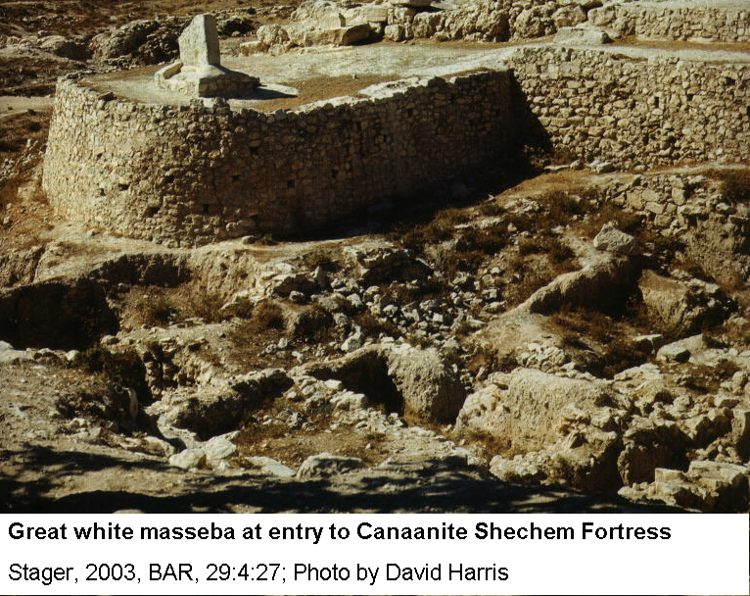

PHOTO LINK: SHECHEM 008 Great white masseba at Shechem
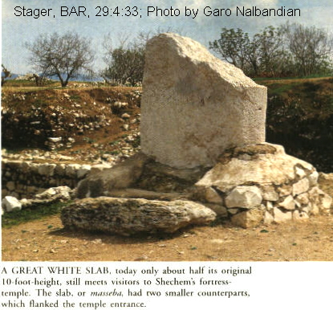
PHOTO LINK: SHECHEM 010 Ruins of MB age Shechem

PHOTO LINK: SHECHEM 015 Massebah, standing stone in front of Shechem fortress-temple
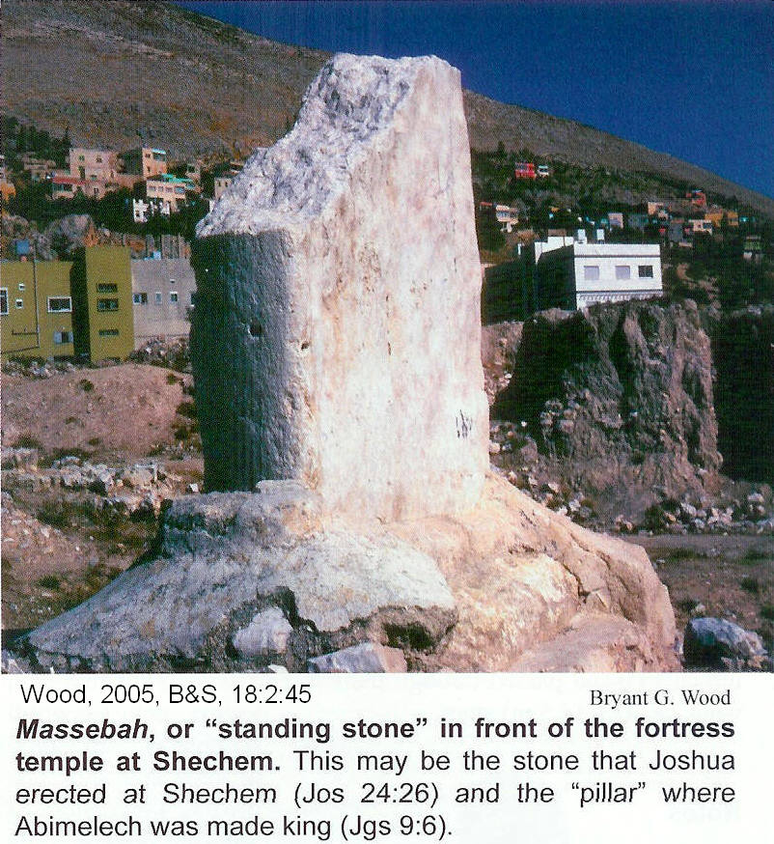

Joseph’s Second Burial and Shechem (1404 BC)

Joseph’s initial internment in Egypt was at his retirement home in at Tell el-Dab^{c}a (Tell el-Daba; Wood, 1997:55 cited by Byers, 2005:4). As was his wish, his body was exhumed during the Exodus and after the Conquest was re-buried by Joshua at Shechem:

“And Joseph’s bones, which the Israelites had brought up from Egypt, were buried at Shechem in the tract of land that Jacob bought for a hundred pieces of silver from the sons of Hamor, the father of Shechem. This became the inheritance of Joseph’s descendants” (Joshua 24:32).

The traditional location of Jacob’s tomb is at Tel Balata. That site was destroyed in October 2000 during hostilities between Palestinian Arabs and the State of Israel (Hansen, 2005:38).

Following the Shechem Covenant, the Book of Joshua 9 and 10 describe the conquest of southern cities

THE SOUTHERN CAMPAIGN (1404 BC)

PHOTO LINK: CONQUEST 011 Block diagram: of the central and southern campaigns http://www.studylight.org/se/maps/browse.cgi?st=46 ; Jan. 10, 2005
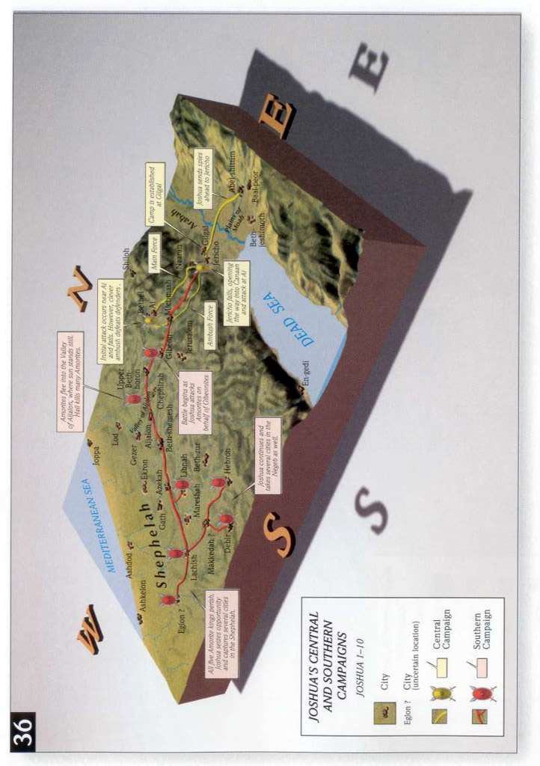

PHOTO LINK: CONQUEST 010 Conquests of Joshua http://www.studylight.org/se/maps/browse.cgi?st=50#040 ; Jan. 10, 2006
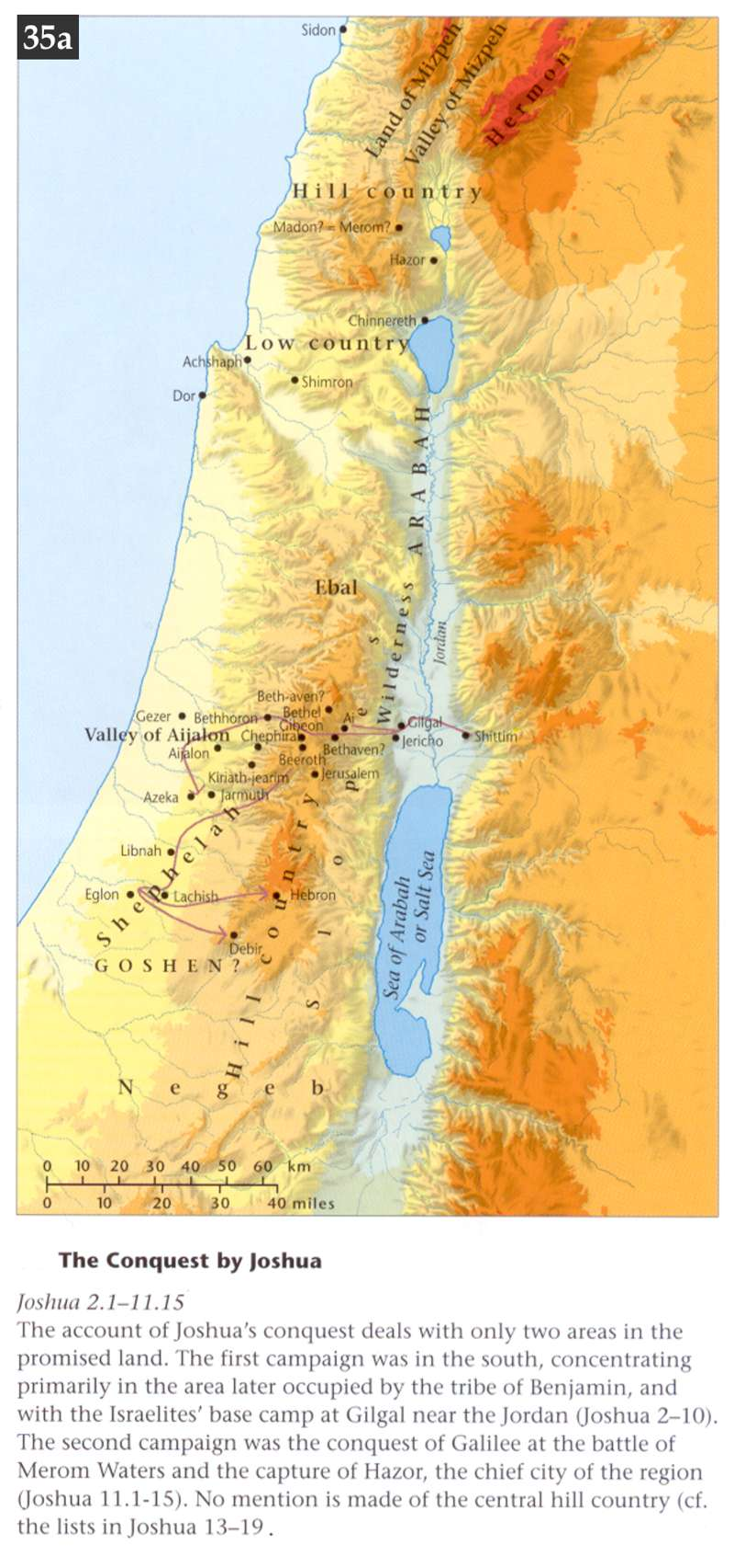

Treaty with the Gibeonites

Joshua 9 tells of a ruse by the Gibeonites to avoid extermination. The leaders came to Joshua and offered to be the Israelite’s slaves, saying they were from a “distant country”. Joshua accepted their servitude with an oath. Three days after the treaty (covenant) was made, the Israelites learned they were neighbors living in the cities of Gibeon (Gabaon) , Kepirah, Beeroth and Kiriath-jearim. Although angry, the Israelites respected their oath and consigned the Gibeonites to “chop wood and draw water for the community” (Josh 9:21)

PHOTO LINK: GIBEON 006 Location map: http://www.bible-history.com/geography/ancient-israel/israel-first-century.html ; Oct. 15, 2005
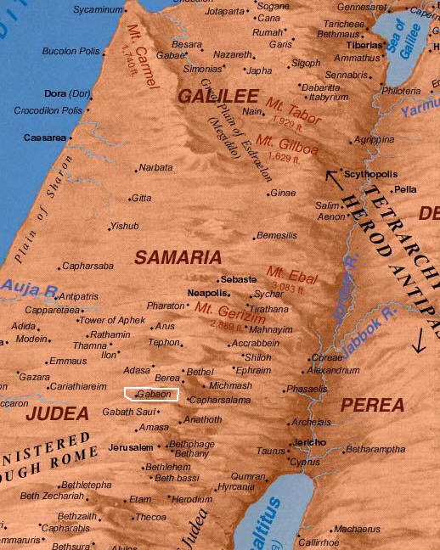

PHOTO LINK: GIBEON 007

In the photograph below, the modern village of el-Jib is on the north, left side of this hill. The undeveloped southern end covers the Biblical city of Gibeon. The valley surrounding the hill is where the Amorite army gathered to attack Gibeon. The hills in the background are the ones that Joshuah’s army, coming up from the Jordan Valley, crossed and then attacked the Amorites dispersing them.

PHOTO LINK: BA056 Iron Age Water Pool and Shaft, Gibeon (Tell el-Jib)
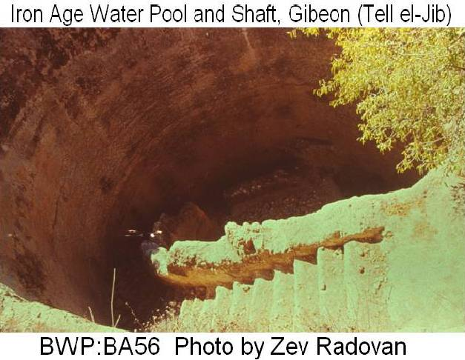
PHOTO LINK: GIBEON 002 Bird's eye view of pool with steps
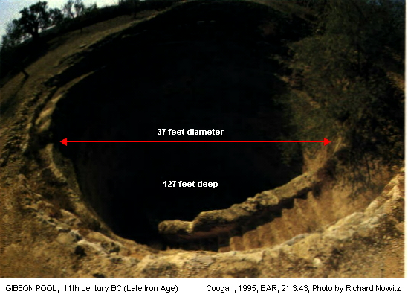

PHOTO LINK: GIBEON 003 Cross Section of pool, city wall, tunnels and spring
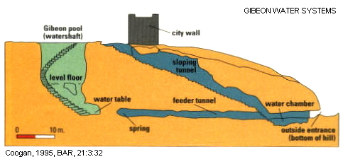
PHOTO LINK: GIBEON 004 Lithograph, Long Day of Joshua
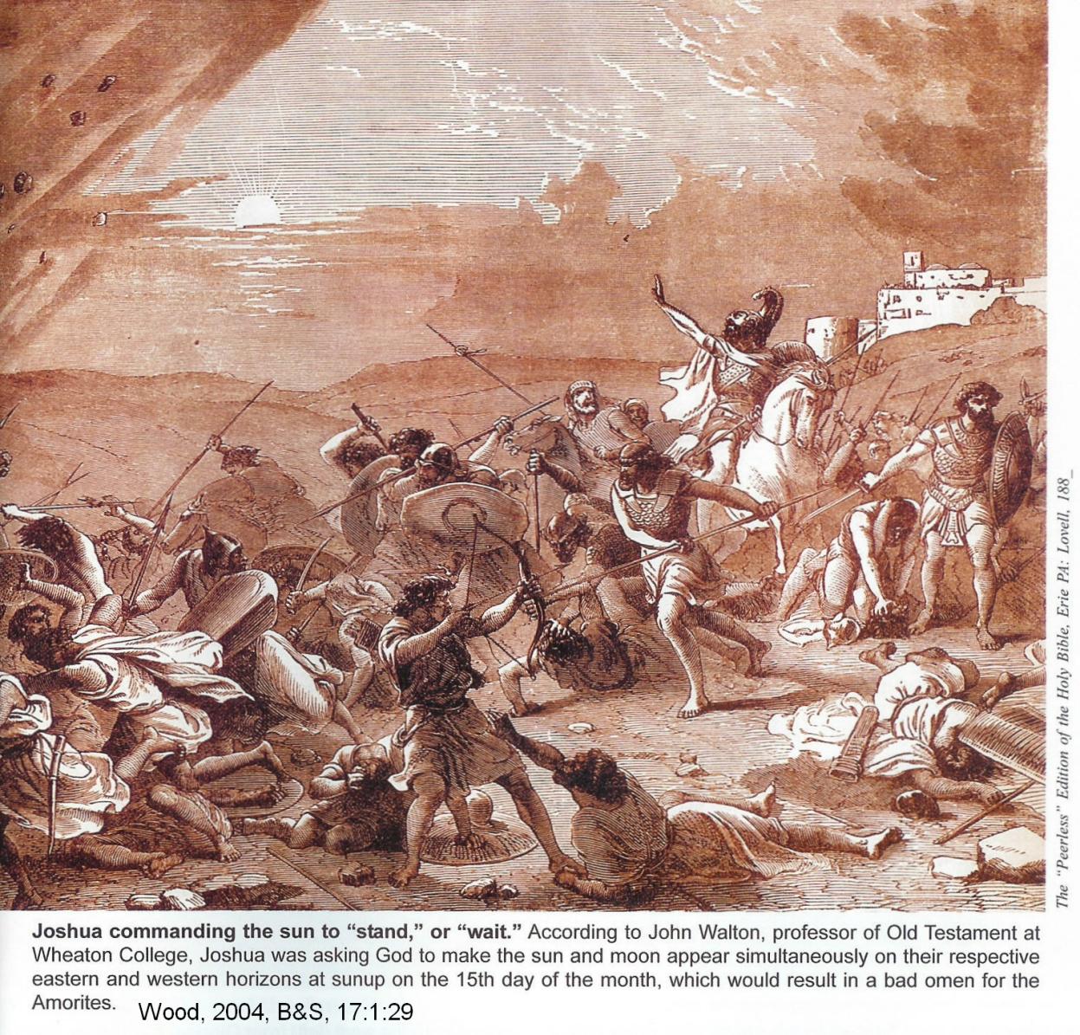

PHOTO LINK: GIBEON 005 Oblique aerial photo of Tel Gibeon
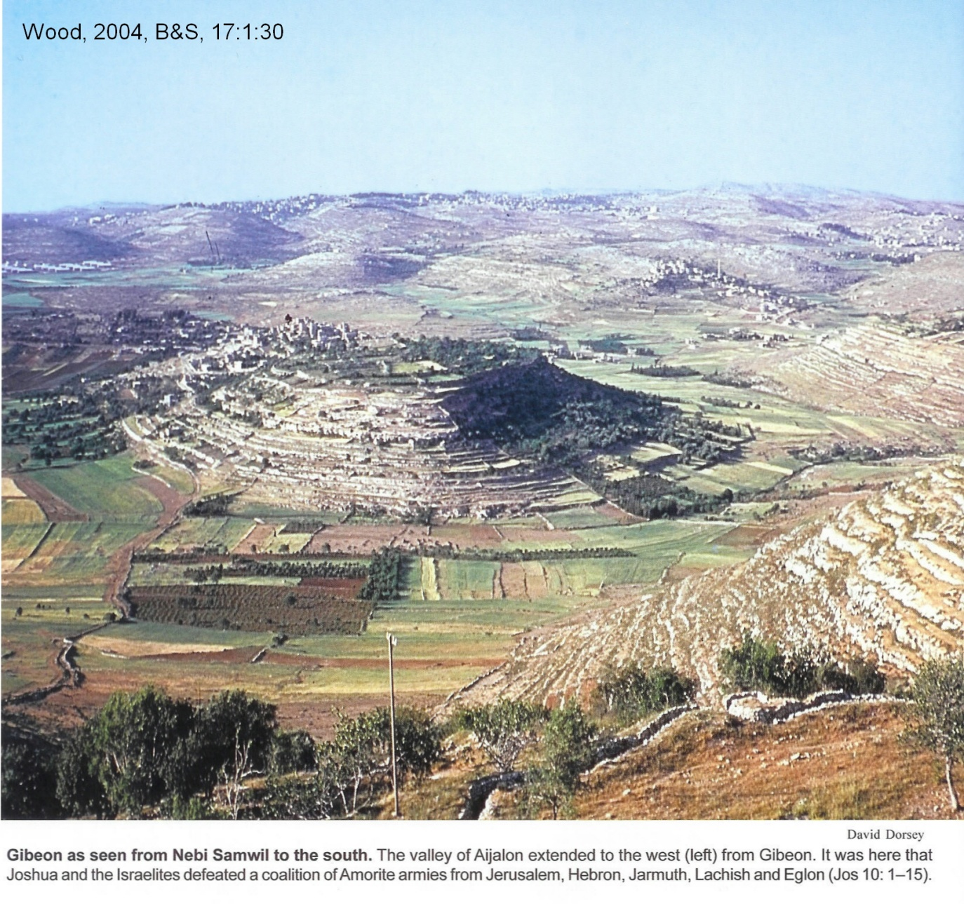

When the king of Jerusalem, Adoni-zedek, learned of the Gibeonite treaty and the destruction of Ai, he formed an alliance with four others: 1) Hoham king of Hebron, 2) Piroam king of Jarmuth, 3) Japha king of Lachish, and 4) Debir king of Elgon. They attacked the Gibeonites who called on Joshua for help. The Israelites “pursued them down the pass of Beth-horon and kept up the slaughter as far as Azekah and Makkedah”. As if the military activity was not enough, “the Lord hurled great hailstones at them out of the sky” (Josh. 10:11) and more died from the hailstones than by the Israelite sword.

Gibeon is 5.5 miles (8.9 km) north of Jerusalem. It is situated on a small limestone hill on which is the modern Arab village of el-Jib. It is adjacent to the east-west road that crosses the Benjamin plateau. This road leads east to Jericho in the Jordan Valley. To the west, the road goes to Gezer on the Mediterranean coastal plain. The Beth Horon road is the only road mentioned by name in the Bible (1 Sam 13:18; Josh 10:10; 1 Kings 9:17; 2 Chron. 8:5). Gibeon is strategically located at the eastern head of a gradual descent to the coastal plain known as the Beth Horon pass (Hansen, 2007:3).

PHOTO LINK: GIBEON 008 Central Benjamin plateau
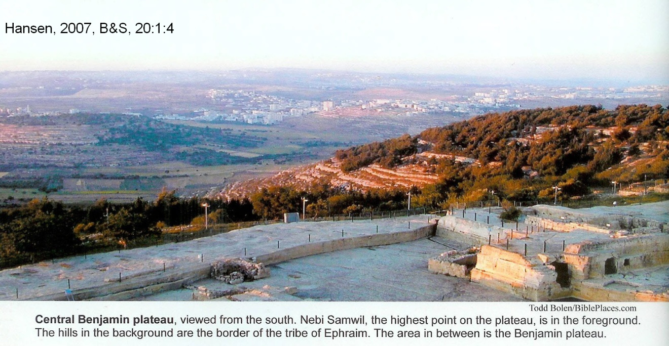
PHOTO LINK: BETH HORON ROAD 001 Central Benjamin plateau
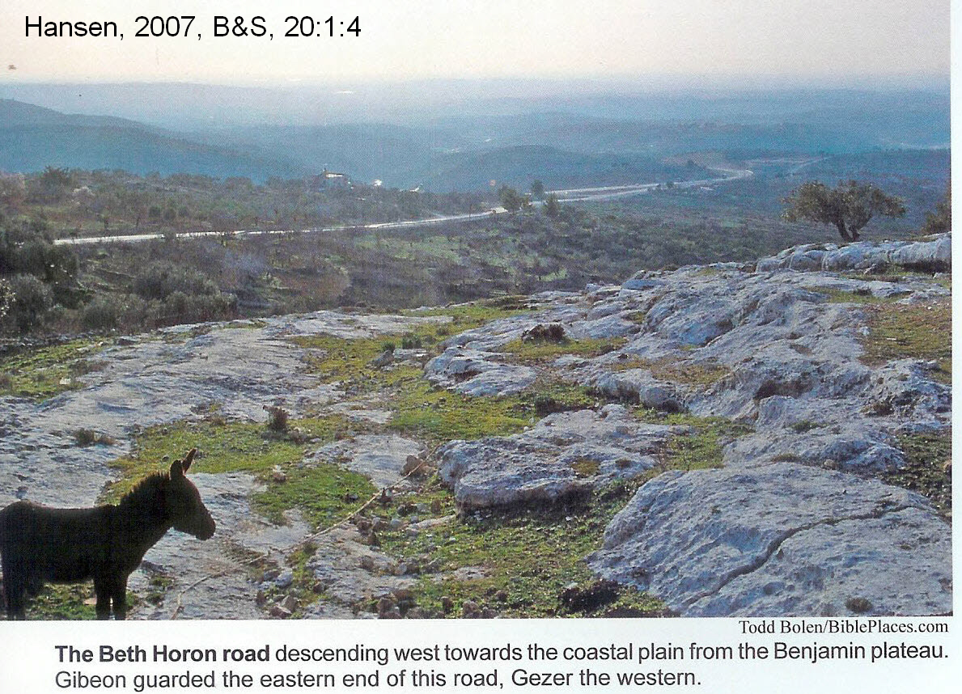

PHOTO LINK: BETH HORON ROAD 002 Road ascending west toward the coastal plain from the Benjamin plateau
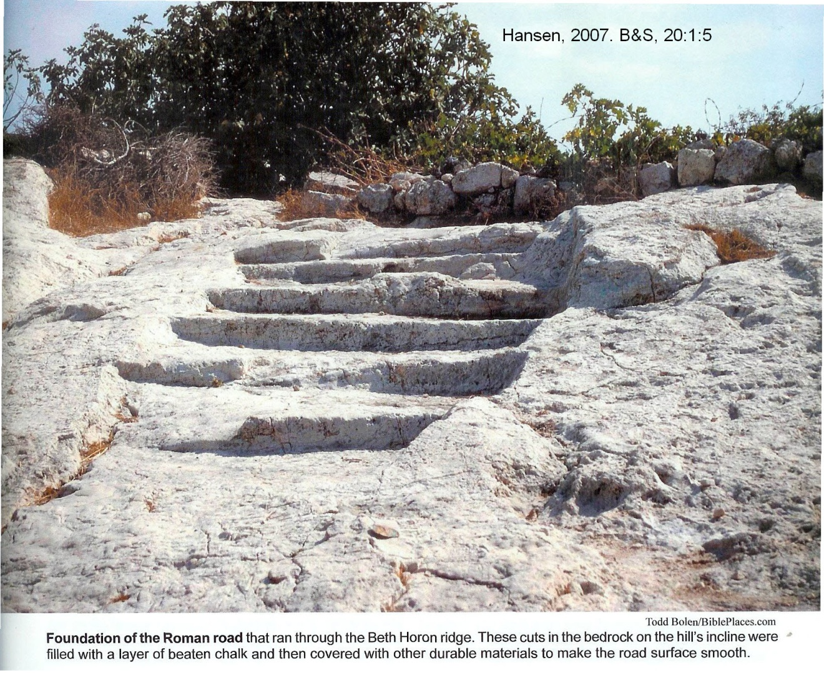

PHOTO LINK: BETH HORON ROAD 003 Map of road: ; http://www.specialtyinterests.net/map_beth_horon.html; April 17, 2007
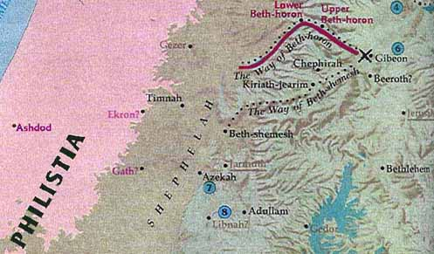

From Gibeon, invading armies could go south and attack Jerusalem, or north to attack Shechem, Bethel or Shiloh (Hansen, 2007:4)

Periods of occupation at Gibeon are summarized in the table, below (Hansen, 2007:6 citing Prichard, 1993:511)

Period | Dates | Type of occupation
Middle Bronze Age I | ca 2200-2000 BC | Minor, seasonal ?
Middle Bronze Age II | ca 2000-1550 BC | Small colony on top of hill
Late Bronze Age | ca 1550-1200 BC | Some pottery in adjacent tombs, no physical defenses (conquest period)
Early Iron Age | ca 1200-1000 BC | Fortified city with massive walls 10 to 11 ft wide (United Monarchy)
Iron Age IIC | ca 700-586 BC | City at zenith of prosperity, prodigious wine production

Long day of Joshua

The defeat of the five kings Amorite alliance was made possible by a supernaturally prolonged day of battle (Josh. 10:13-15). The five kings fled to a cave at near the city of Makkedah. Joshua executed the five kings and then attacked Makkedah city, killing that city’s king, people and “every living thing in the city” (Josh. 10:27).

Libna and Lachish
After the genocide at Makkedah, Joshua and the Israelites attacked and left no survivors at Libna and then Lachish (Josh 10:29-32).

PHOTO LINK: LACHISH 034 Location Map (RIGHT)

The important city-state of Lachish is southwest of Jerusalem at a mound named Tell Lachish and Tell ed-Duweir. During Kingdom of Judah, it was the most important Judean city after Jerusalem. There are several destruction levels at Lachish including ones of Sennacherib (701) and Nebuchadnezzar (588/6). The 701 destruction is portrayed in a unique set of stone reliefs from Sennacherib's royal palace at Nineveh. After the Neo-Babylonians, Persians took control of Lachish into the 5th-4th centuries BC when it was a district capital. Then Lachish was deserted (Ussishkin, 1987, 1979).

PHOTO LINK: LACHISH 002 Plan of Lachish
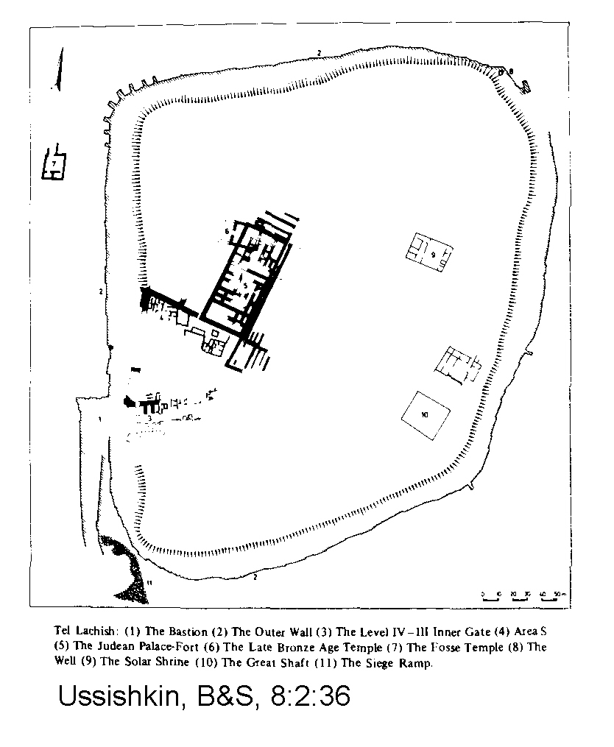
Lachish has a Canaanite Temple "Foss Temple" with three identified building phases. This temple has a floor plan similar to Canaanite temples in Alalach and Hazor (Ussishkin, 1987, 1979).

PHOTO LINK: LACHISH 003 Plan map of LB Temple at Lachish (See ABOVE, ctrl+click to follow link)

PHOTO LINK: LACHISH 004 Photo of LB Temple at Lachish
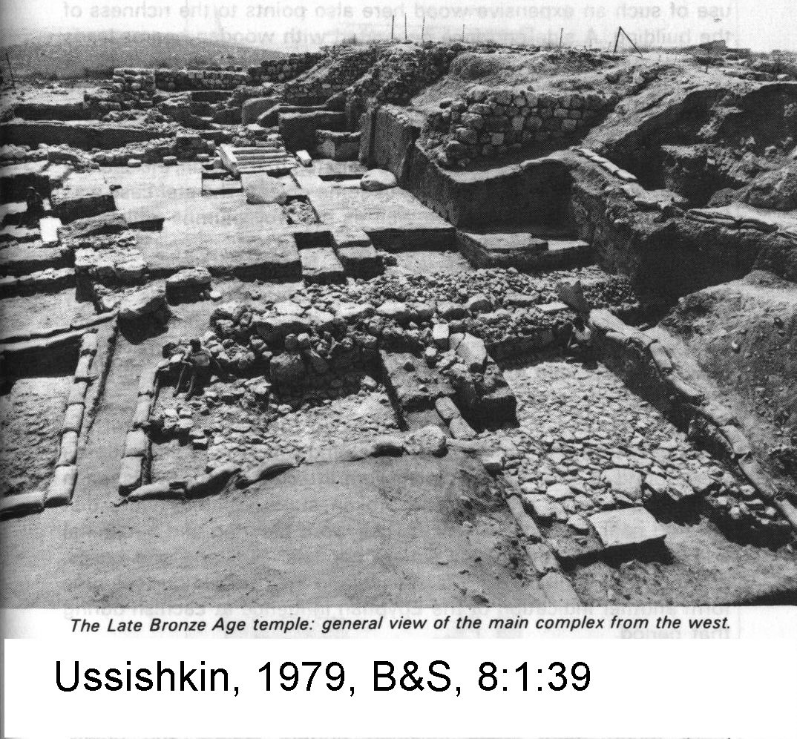
Canaanite Level VI at Lachish, with its Iron Age Palace-Fort, was destroyed by fire along with a new temple on the acropolis which had replaced the Foss Temple. An Egyptian cartouche of a 20th dynasty pharaoh was found in Level VI debris. So this city was destroyed around 1150 BC or even later. This destruction is too late to be due to the Conquest by either the Early (1400 BC) or Late (1250 BC) theories unless the Conquest is re-dated and lengthened. This assumes Joshua destroyed Lachish, which in NOT stated in the Bible (Ussishkin, 1987, 1979). However, the Bible does not indicate that Canaanites, after being annihilated by Israelites had renewed prosperity under Egyptian aegis as shown by Level VI.

Significantly, there is no known Philistine painted pottery, despite Lachish's proximity to coastal territory traditionally controlled by "Sea Peoples" (=Philistines; Ussishkin, 1987, 1979).

PHOTO LINK: LACHISH 005 Plan of Judean Palace-Fort at Lachish
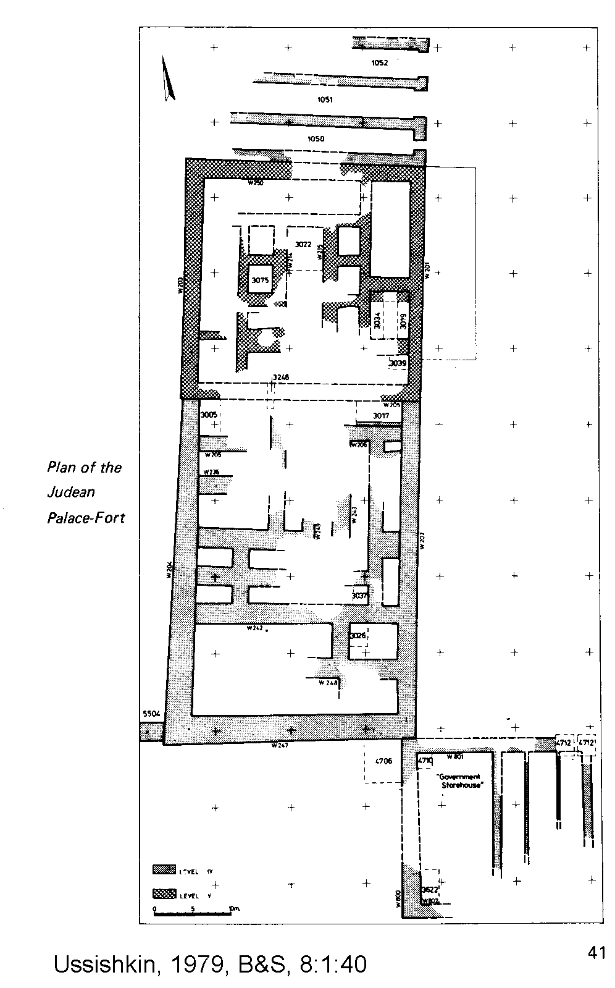

PHOTO LINK: LACHISH 006 Photo of Judean Palace-Fort at Lachish
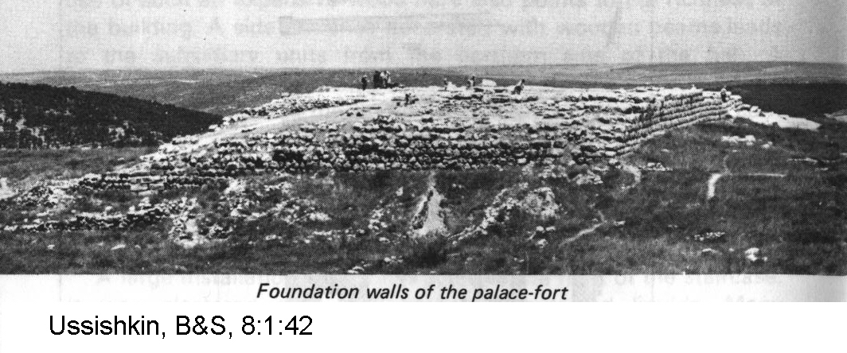

The earlier Canaanite Level VII was destroyed by fire (like level VI). An earlier Foss Temple (III) also destroyed at this time (13th cent. BC, 1200-1300). The Foss Temple was oriented east-west. Its main hall had dimensions 49 feet x 40 feet, in 3 sections. The temple was constructed of expensive cedar logs and there was a central raised cella and an antechamber. This temple is similar in plan to King Solomon's temple (p.188-189). It is also similar to Egyptian temples at Deir el-Medina (Ussishkin, 1987, 1979).

PHOTO LINK: LACHISH 003 Plan map of LB Temple at Lachish (See ABOVE, ctrl+click to follow link)

PHOTO LINK: LACHISH 004 Photo of LB Temple at Lachish (See ABOVE, ctrl+click to follow link)

There was no city wall for Canaanite cities VI or VII (Late Bronze Age). The Middle Bronze Age Palace, of the 16th century BC was destroyed by fire (Ussishkin, 1979). This included the cedar logs (Ussishkin, 1987, 1979). The 16th century destruction would be too early for the Israelite invasion per the Early Conquest Theory of cir 1406 BC.

Gezer
The city of Gezer, under the command of king Horam, tried to help Lachish against the invading Israelites. Both were defeated (Josh. 10:33). This site is also known as Tel el-Jazari, Tel Gezer, Tel Jeser, Tell Jezer, Abu Shusheh, Gazara, Gazer, and Gazru (http://www.bibleplaces.com/gezer.htm ; Jan. 7, 2006).

PHOTO LINK: GEZER 013 Location map: http://www.bible-history.com/geography/ancient-israel/israel-first-century.html ; Oct. 15, 2005. Modified to show location of Gazara = Gezer
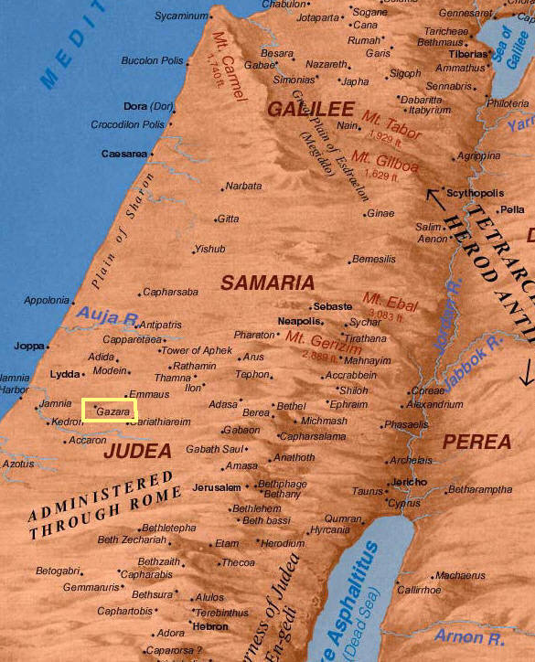

PHOTO LINK: GEZER 008 View of tell from the south
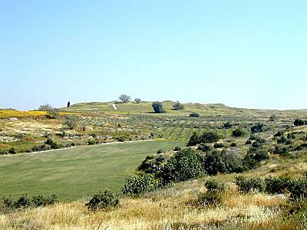

Gezer is situated near the International Coastal Highway and guarding the primary route into the Israelite hill-country, Gezer was one of the most strategic cities in the Canaanite and Israelite periods. Gezer is a prominent 33-acre site that overlooked the Aijalon Valley and the road leading through it to Jerusalem. The tell was identified as biblical Gezer in 1871 by C. Clermont-Ganneau who two years later found the first of many boundary stones inscribed with the city's name (http://www.bibleplaces.com/gezer.htm ; Jan. 7, 2006).
Gezer was one of the most important Canaanite cities in the Middle Bronze period (2000-1500 B.C.), as attested by the significant archaeological remains. The city was protected by a large wall which included a massive tower. Fifty-two feet in width, this tower is the largest structure in any defensive system in this period (http://www.bibleplaces.com/gezer.htm ; Jan. 7, 2006).

PHOTO LINK: GEZER 009 MB tower, 2000-1500 BC
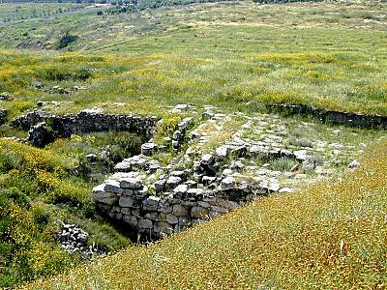
Built with a stone foundation and a mudbrick superstructure, this city gate was constructed about 1650 B.C. and is of the typical style of the period. This gate was connected to a four meter wide city wall which likely had 25 or more rectangular towers. The Middle Bronze city was probably destroyed by Thutmose III in his invasion c. 1477 B.C. (http://www.bibleplaces.com/gezer.htm ; Jan. 7, 2006).
Gezer was assigned to tribe of Ephriam (Josh. 16:3) but latter allotted to priestly family of Kohath (Josh. 21:21). Seven courses of LB II age wall were found. This is consistent with a pattern of Late Bronze Age (LBII) destructions throughout Palestine (Silberman, 1992, p.24). LB II destruction could be interpreted as support of the Early (Conservative) date for the conquest. Tombs at Gezer in Cave 10A have 88 individuals with average life span on 27.5 years. They were farmers. (Wood, 1991. p. 106)

The High Place at Gezer was considered to be one of the most significant archaeological discoveries in Palestine by Coogan (1995). It has a row of large upright stones that are similar to descriptions given in Genesis 31:43-54; Joshua 10:33 and 24:25-27; Judges 1:29; 1 Kings 9:15-17 and 1 Chron. 4:16 (Coogan, 1995).

PHOTO LINK: GEZER 004 High Place with witness stones
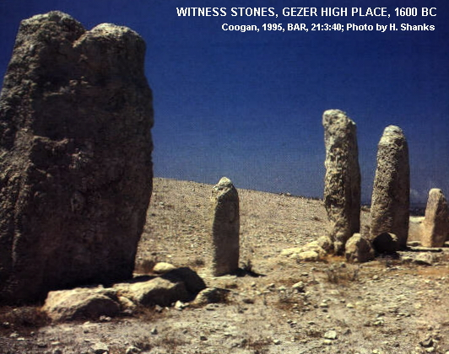

Eglon and Hebron

The next cities to fall were Eglon and Hebron (Josh. 10:3-37) In all these attacks, Joshua always killed the king. These kings had only recently been coroneted, as their predecessors had died at the Cave of Makkedah only a few days (months?) earlier.

PHOTO LINK: HEBRON 001 Location map: http://www.bible-history.com/geography/ancient-israel/introduction.html; June 26, 2005
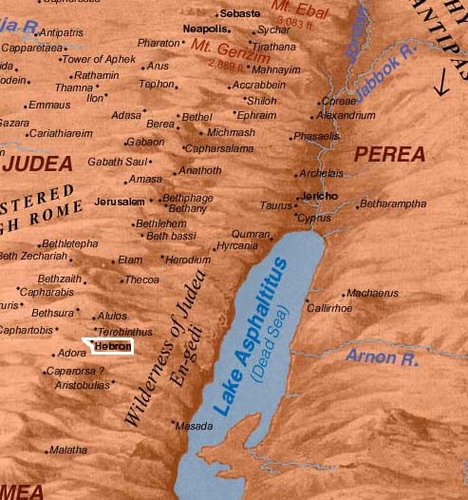

PHOTO LINK: HEBRON 002 Location map Hebron Beer-Sheba Jerusalem Ashkelon
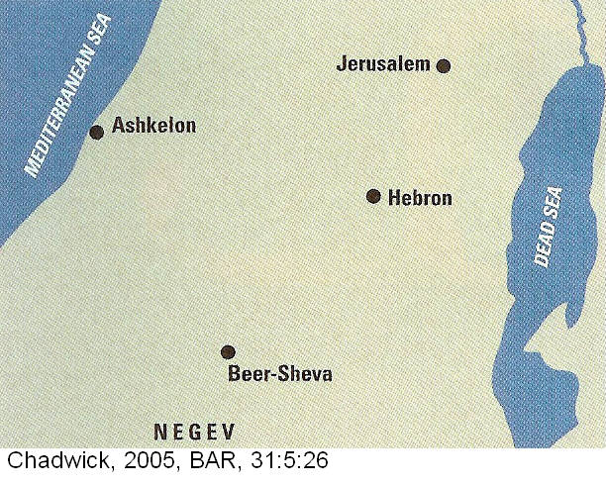

The Book of Joshua says that during the Conquest, the Israelites captured Hebron (Joshua 10:3-10, 36-37). Archaeological excavations at Hebron have shown Late Bronze Age occupation in six different areas The city was thriving in the LBII period.

PHOTO LINK: HEBRON 010 Pottery sherds LB Hebron
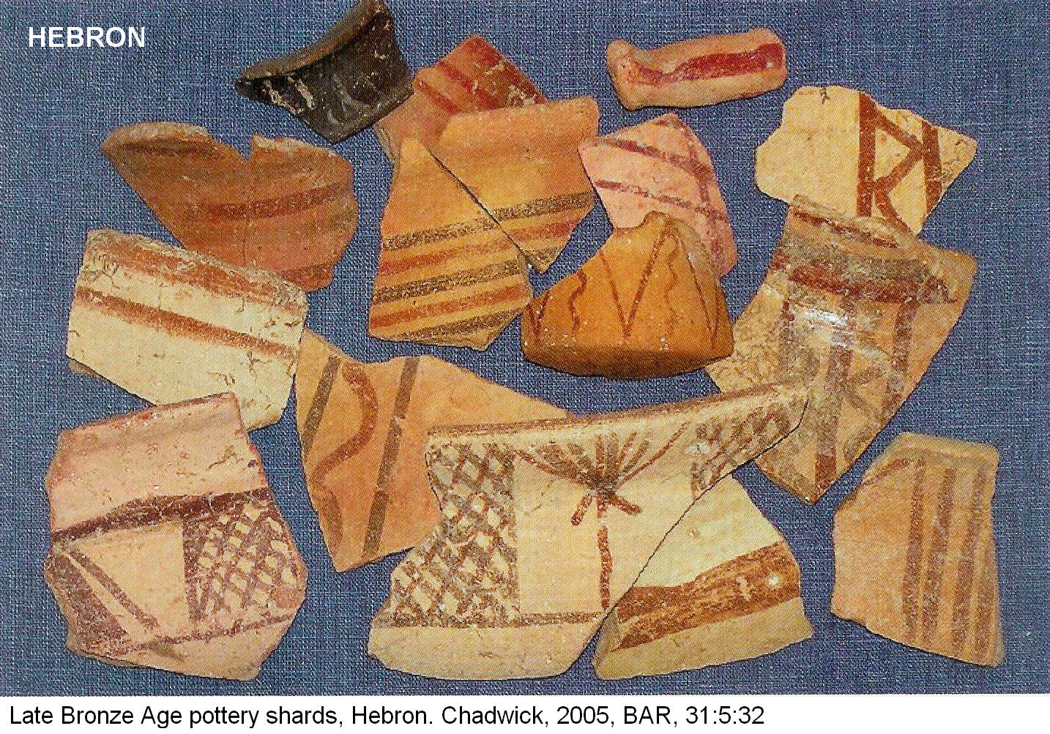

Some homes built in MB show occupancy through LB. A scarab of Pharaoh Rameses II (1290-1224 BC) was found in Room 1096 from the LBII period. A looted LB burial cave (Tomb 2) south of the city wall was also identified and dated to this period. Another burial cave north of the city contained 53 burials that included scarabs of Pharaohs Thutmoses III (1479-1425 BC) and Amenophis III (1391-1353; Chadwick, 2005:31)

PHOTO LINK: HEBRON 009 Scarab limestone Rameses II from Hebron
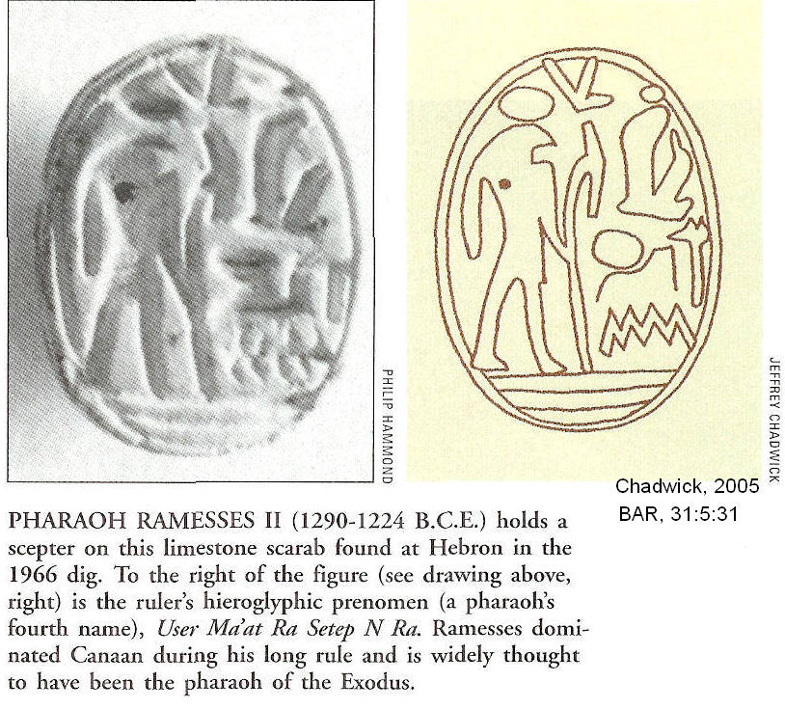

According to Chadwick (2005:31) “All in all, the evidence is strong that Hebron was a thriving city in the Late Bronze Age just before the time the Bible says Israelites captured it.” This conclusion assumes a late date for the Conquest of c.1250 BC.

Early date advocates (c. 1400 BC) would interpret the data from Hebron as indicative of destructions associated with the era of the Judges

Debir
After the destruction of Hebon, the Israelites attacked and defeated Debir (Josh 10:39). Debir was located on the frontier area between the Judean Hill-country and the Negev. The name Debir is an alternate name for Kiriath-sepher and Kiriath-sannah (Josh 15:15, 49). It was situated eight miles southwest of Hebron and two miles north of Socoh (Succoth; http://www.ancientsandals.com/overviews/debir.htm., Jan. 7, 2006).
The Bible indicates that Debir is located in hill-country of southern Judah. Liberal "minimalist" scholars say it is situated in lowlands at Tell Beit Mirsim and that the Bible is wrong. Later excavations at Khirbet Rabud, in the southern hill-country, found evidence of Canaanite city from the beginning of 14th century BC below Israelite remains that extended up to the divided monarchy. The city had a wall 12 ft thick around a city complex of 12.5 acres. The ecology and topography of the site correspond to biblical descriptions of Debir in Joshua 15. Two subterranean chambers accessed by well shafts are located less than 2 miles from Khirbet Rabud. They correspond to "upper" and "lower" springs [heb guloth] mentioned in Josh 15:19 (Wood, 1973).

The conquest of the southern part of the Promised land is summarized in Josh. 10:40-42:

“So Joshua massacred the population of the whole region – the hill-country, the Negev [southern desert], the Shephelah [southern foothills of Judah, between the Hill-country and the Coastal Plain], the watersheds – and all their kings. He left no survivor, destroying everything that drew breath, as the Lord the God of Israel had commanded. Joshua carried the slaughter from Kadesh-barnea to Gaza, over the whole of Goshen and as far as Gibeon.”

The Israelites then returned to a staging area for the next phase of conquest in Gilgal.

PHOTO LINK: HILL-COUNTRY 001 Satellite photo of Hill-country with cities labeled : http://www.ancientsandals.com/mapcuts/map_hill_country_judah_ot.jpg ; Jan. 7, 2005
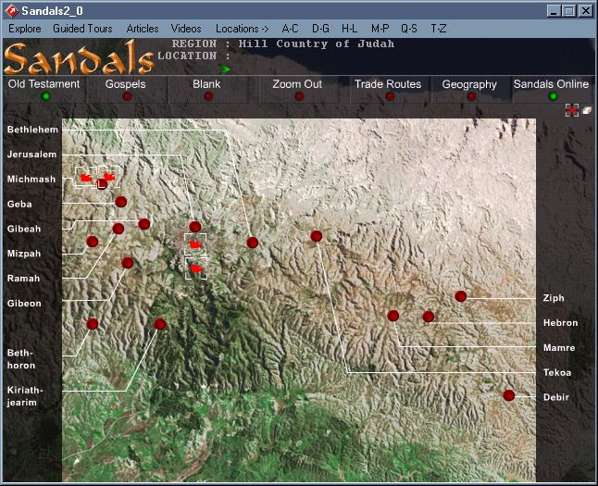

THE NORTHERN CAMPAIGN

PHOTO LINK: CONQUEST 012 Map of the Northern Campaign: http://www.studylight.org/se/maps/browse.cgi?st=46 ; Jan. 10, 2005
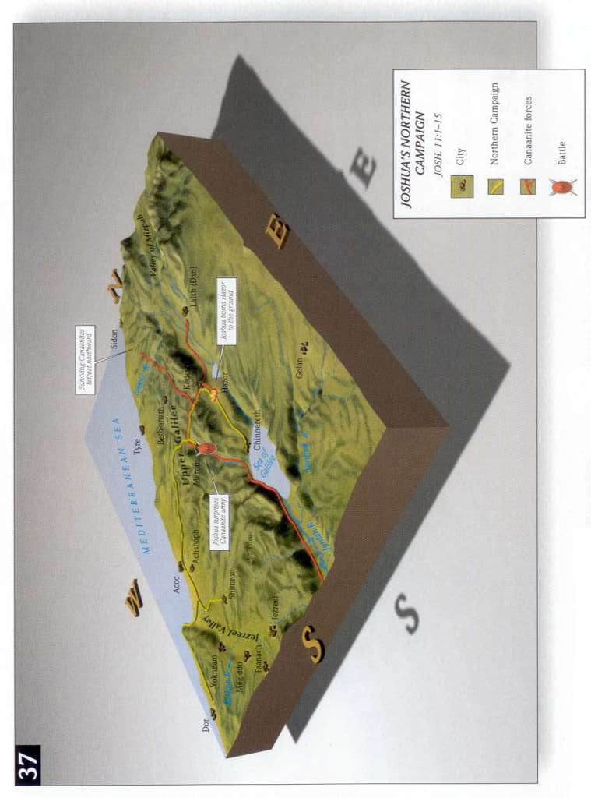

Joshua 11 is a record of the Israelite interactiona withn northern “kingdoms” of:

-Jabin, king of Hazor
-Jobab, king of Madon
-Unnamed kings of Shimron and Akshaph
-Unnamed northern kings in the Hill-country
-Unnamed kings in the Arabah opposite Kinnereth [between the Dead Sea and Gulf of Aquaba]
-Unnamed kings in the Shephalah
-Unnamed kings “in the district of Dor on the west”

-Unnamed Canaanites to the east and west
-Amorites
-Hittites
-Perizzites
-Jebusites
-Hivites below Hermon in the land of Mizpha

Battle of Merom

Joshua 11:5-9 tells of the defeat of the Northern Canaanite alliance by the Israelites at Merom. The Israelites pursued them “as far as Greater Sidon, Misrephoth on the west, and the Val of Mizpah on the east”.

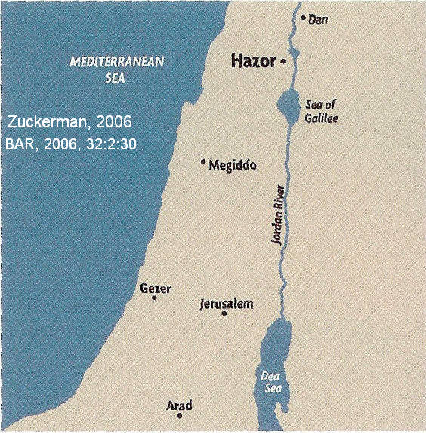
Hazor

After the Battle of Merom, Joshua turned his attention to the towns of the Northern Canaanite alliance. Hazor was on a major trade route connecting to Mesopotamia.

PHOTO LINK: HAZOR 037 Location map of Hazor (RIGHT)

PHOTO LINK: HAZOR 003 Location map of Hazor with caravan routes to Babylon
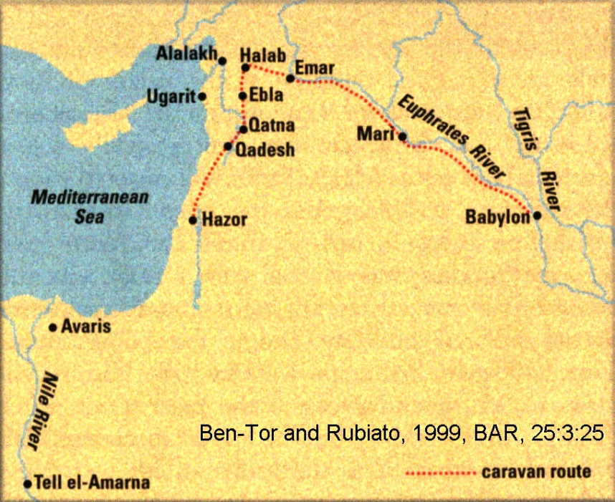
PHOTO LINK: HAZOR 015 Aerial photo of Hazor
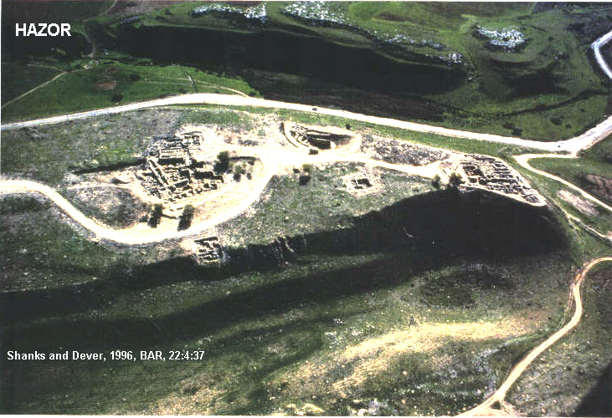
PHOTO LINK: HAZOR 035 Aerial photo of Hazor
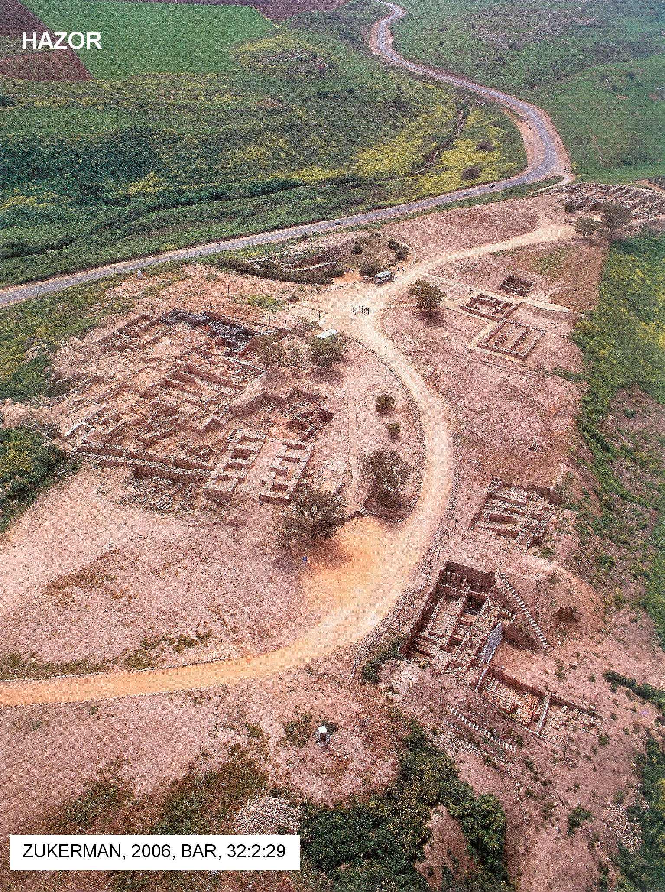

During the Late Bronze Age at Hazor there were three periods of urbanization and two destructions. Who was responsible for these urbanizations and destructions? Scholars are of various opinions.

Bronze Age Stratigraphy and Chronology at Hazor

The stratigraphy of Late Bronze Age (LB) Hazor showing different interpretations of who destroyed Hazor is summarized in the tables below. The tables are adapted from Petrovich, 2008 and Collins, 2011:80. Both the upper and lower cities at Hazor share this chronologic and stratigraphic condition.

Proponents of the Late Date Conquest theory posit that LB-I Hazor was destroyed by Thutmosis III and LB-III Hazor by Joshua. Early Date Conquest advocates theorize that Joshua destroyed LB-I Hazor,(Joshua 11) and that LB-III Hazor was destroyed by Deborah and Barak (Judges 4: 23-24).

Was Hazor destroyed twice? If it was, the earlier LB-1 destruction could be from the Conquest period, and the later LB-III period could be from the period of the Judges.

Late Date Conquest (Yadin, 1972, 1975; Ben-Tor, 1990, 2006, 2013; Ben Tor et al, 1999; Hoffmeier, 2007)

AGE | DATE (BC) | THUTMOSIS III | JOSHUA | DEBORAH AND BARAK
LB-I | 1483-1400 | YES | NO | NO
“Habitation Gap” | 1400-1375
LB-II | 1400-1290
LB-III | 1290-1177 | NO | YES | NO

Early Date Conquest (Petrovich, 2008, Collins, 2011, Wood, 2005, 2007)

AGE | DATE (BC) | THUTMOSIS III | JOSHUA | DEBORAH AND BARAK
LB-I | 1483-1400 | NO | YES | NO
“Habitation Gap” | 1400-1375
LB-II | 1400-1290
LB-III | 1290-1177 | NO | NO | YES

The LB-1 conflagration is shown by a burn layer on Hazor’s northern slope with ash and fallen mud-bricks, (Petrovich, 2008:501, cited by Collins, 2011:80). The LB-III destruction by fire is evidenced by charred wooden beams, cracked basalt, and layers of ash (Petrovich, 2008:502) and remains of a burned palace (Freiling, 2005:18, cited by Collins, 2011:80).

The Egyptian Pharaohs during the Late Bronze Age were (Petrovich, 2008):

Egyptian Pharaoh | Dates BC
Thutmosis III | 1506-1452
Amenhotep II | 1455-1418
Thutmosis IV | 1418-1408

The Mycenean Pottery at Hazor includes the following types (from Petrovich, 2008:505-506, cited by Collins, 2011:82):

Pottery Type | Dates (BC) | Late Bronze Age | Presence at Hazor
Early Mycenaean III A:1 | 1425-1400 | End of LB-1 | Present
Early Mycenaean III A:2 | 1400-1375 | Beginning of LB-II | None found
Late Mycenaean III A:1 | 1375-1300 | Late LB-II | Present

This distribution in time and place of Mycenaean pottery indicates that the LB-1 city at Hazor was destroyed before 1400 BC. This is after the reign of Thutmosis III. Therefore, the LB-1 city could not have been destroyed by him (Collins, 2011 citing Aling, 2010, personal communication).

Furthermore, Thutmosis III’s successor, Amenhotep II attacked Hazor in Year 3 of his reign (ca 1452 BC). This is known from a military conquest list for Amenhotoep II. Summarizing the situation, Collins (2011:81) says:

“Hazor would not have existed as a conquest-worthy city less than a decade after Thutmosis III's death, however, if that pharaoh had destroyed the LB I city and initiated its early LB II habitation gap. Thus the existence of this gap renders it impossible to date the LB I conquest to the reign of Thutmosis III, considering that Hazor was an operative city a few years after his death. In the words of Petrovich, the LB I habitation gap "renders a conflagration under Thutmosis III and a subsequent invasion/conquest under Amenhotep II mutually exclusive. an impossible chain of events" (Petrovich, 2008: 504-505).”

PHOTO LINK: HAZOR 047 Excavations in Area M at Hazor
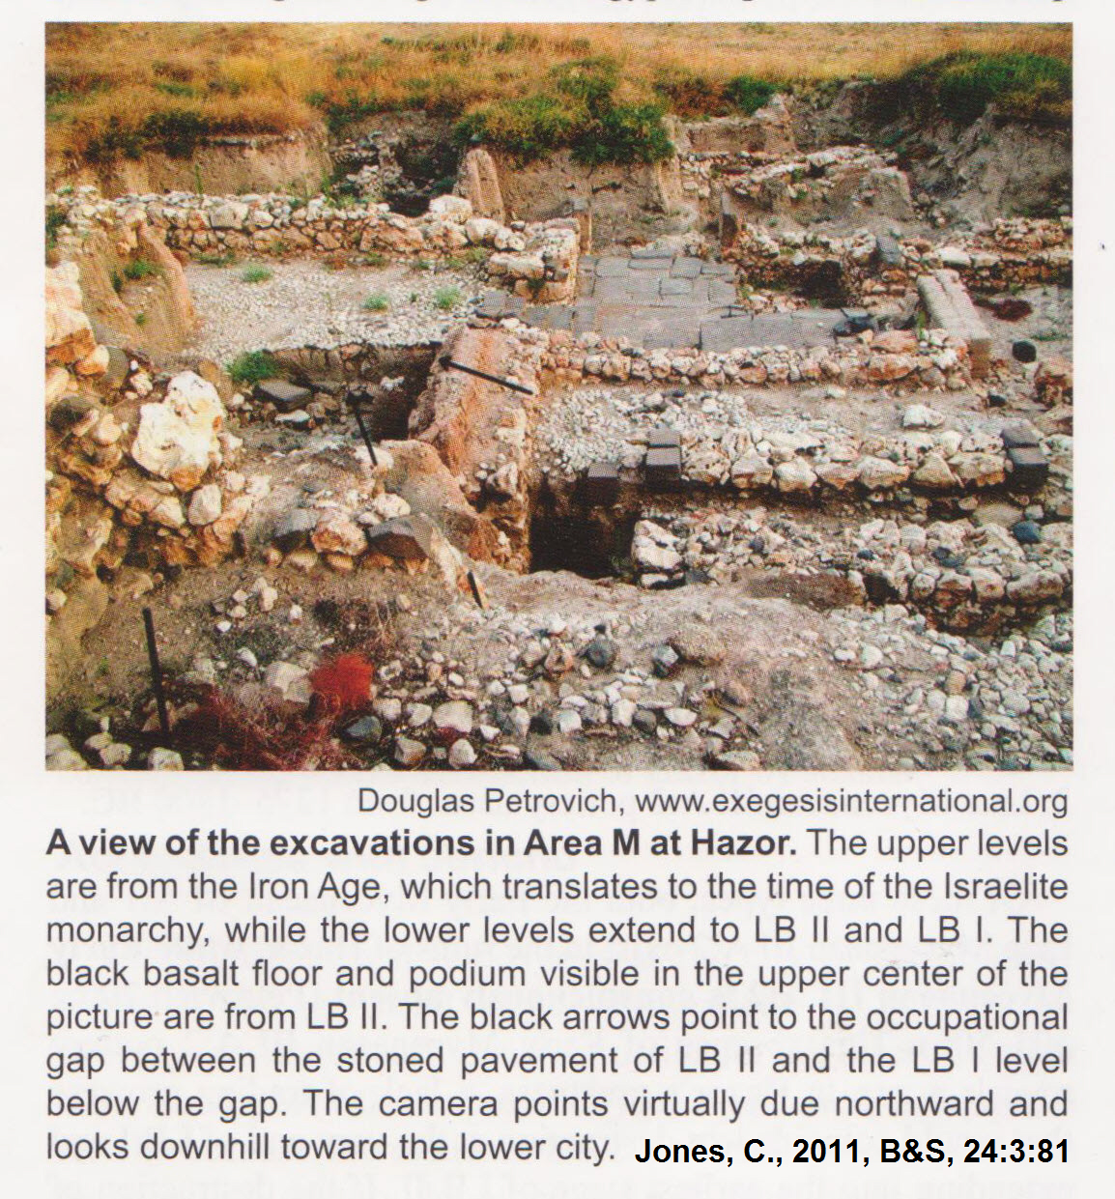

PHOTO LINK: HAZOR 048 Occupational gap between LB-I and LB-II layers at Hazor.
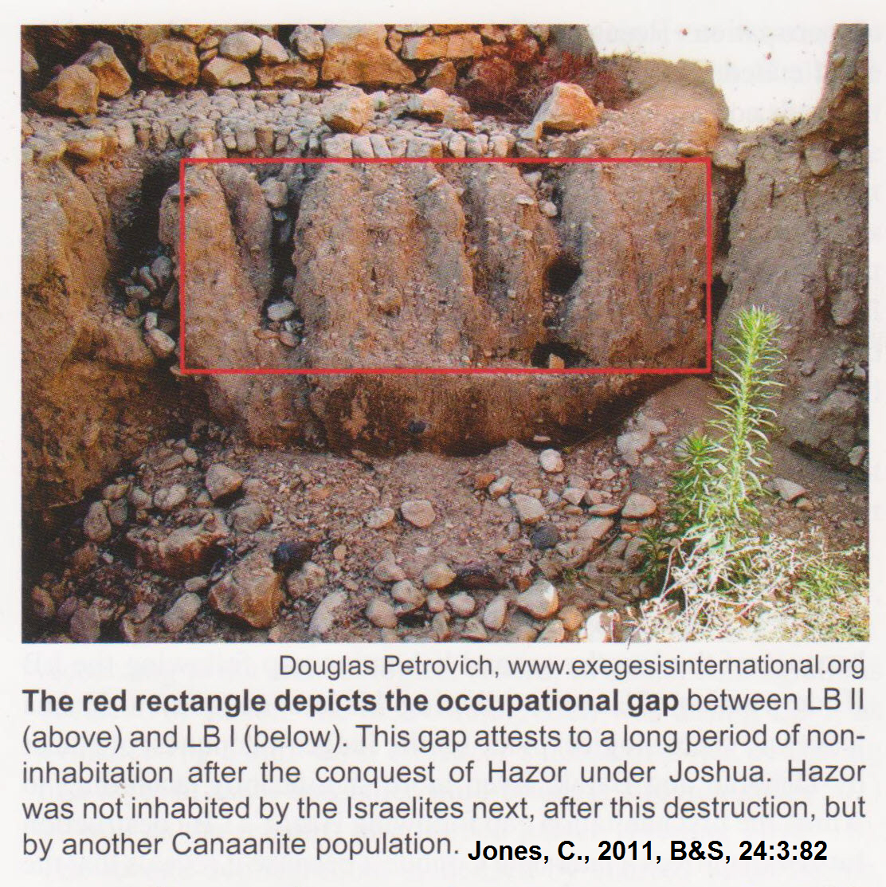

PHOTO LINK: HAZOR 049 Close-up of the LB-I to LB-II transition.
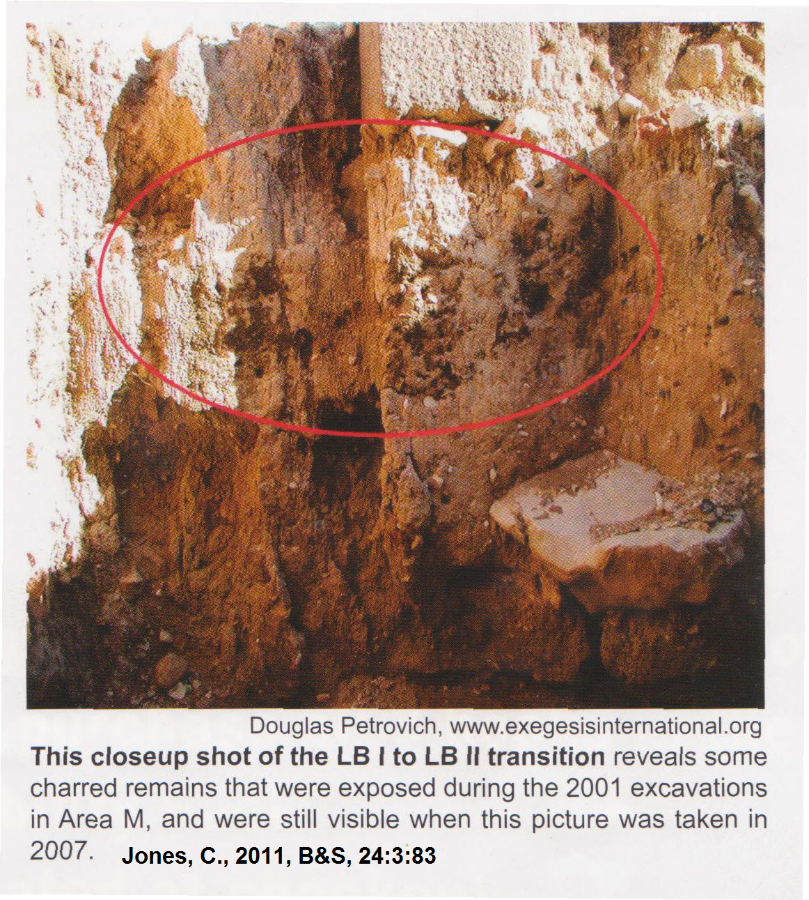
PHOTO LINK: HAZOR 001 Plan of Hazor
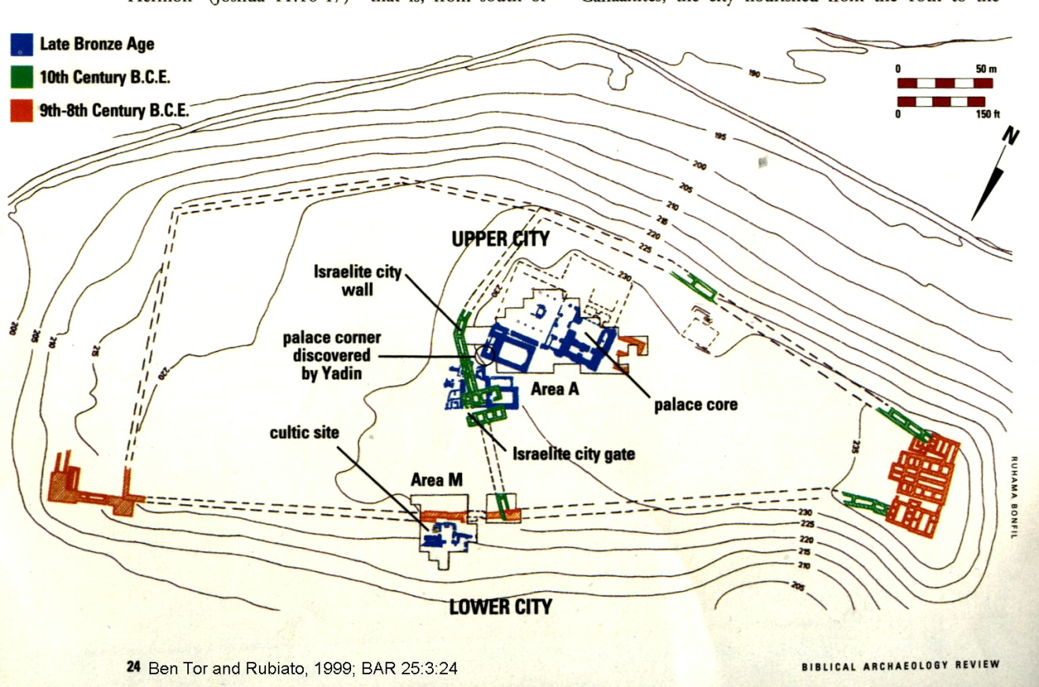

PHOTO LINK: HAZOR 036 Plan of Hazor
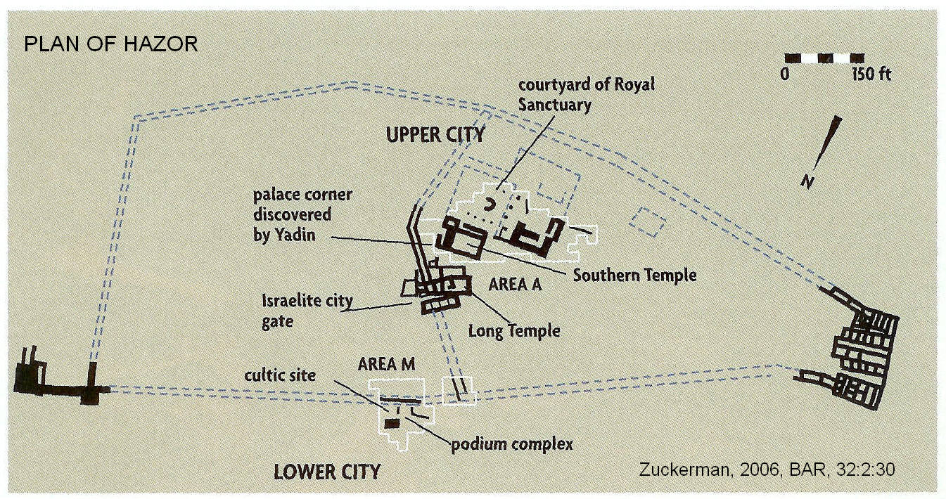

PHOTO LINK: HAZOR 022 Plans of Hazor 18th to 8th century BC
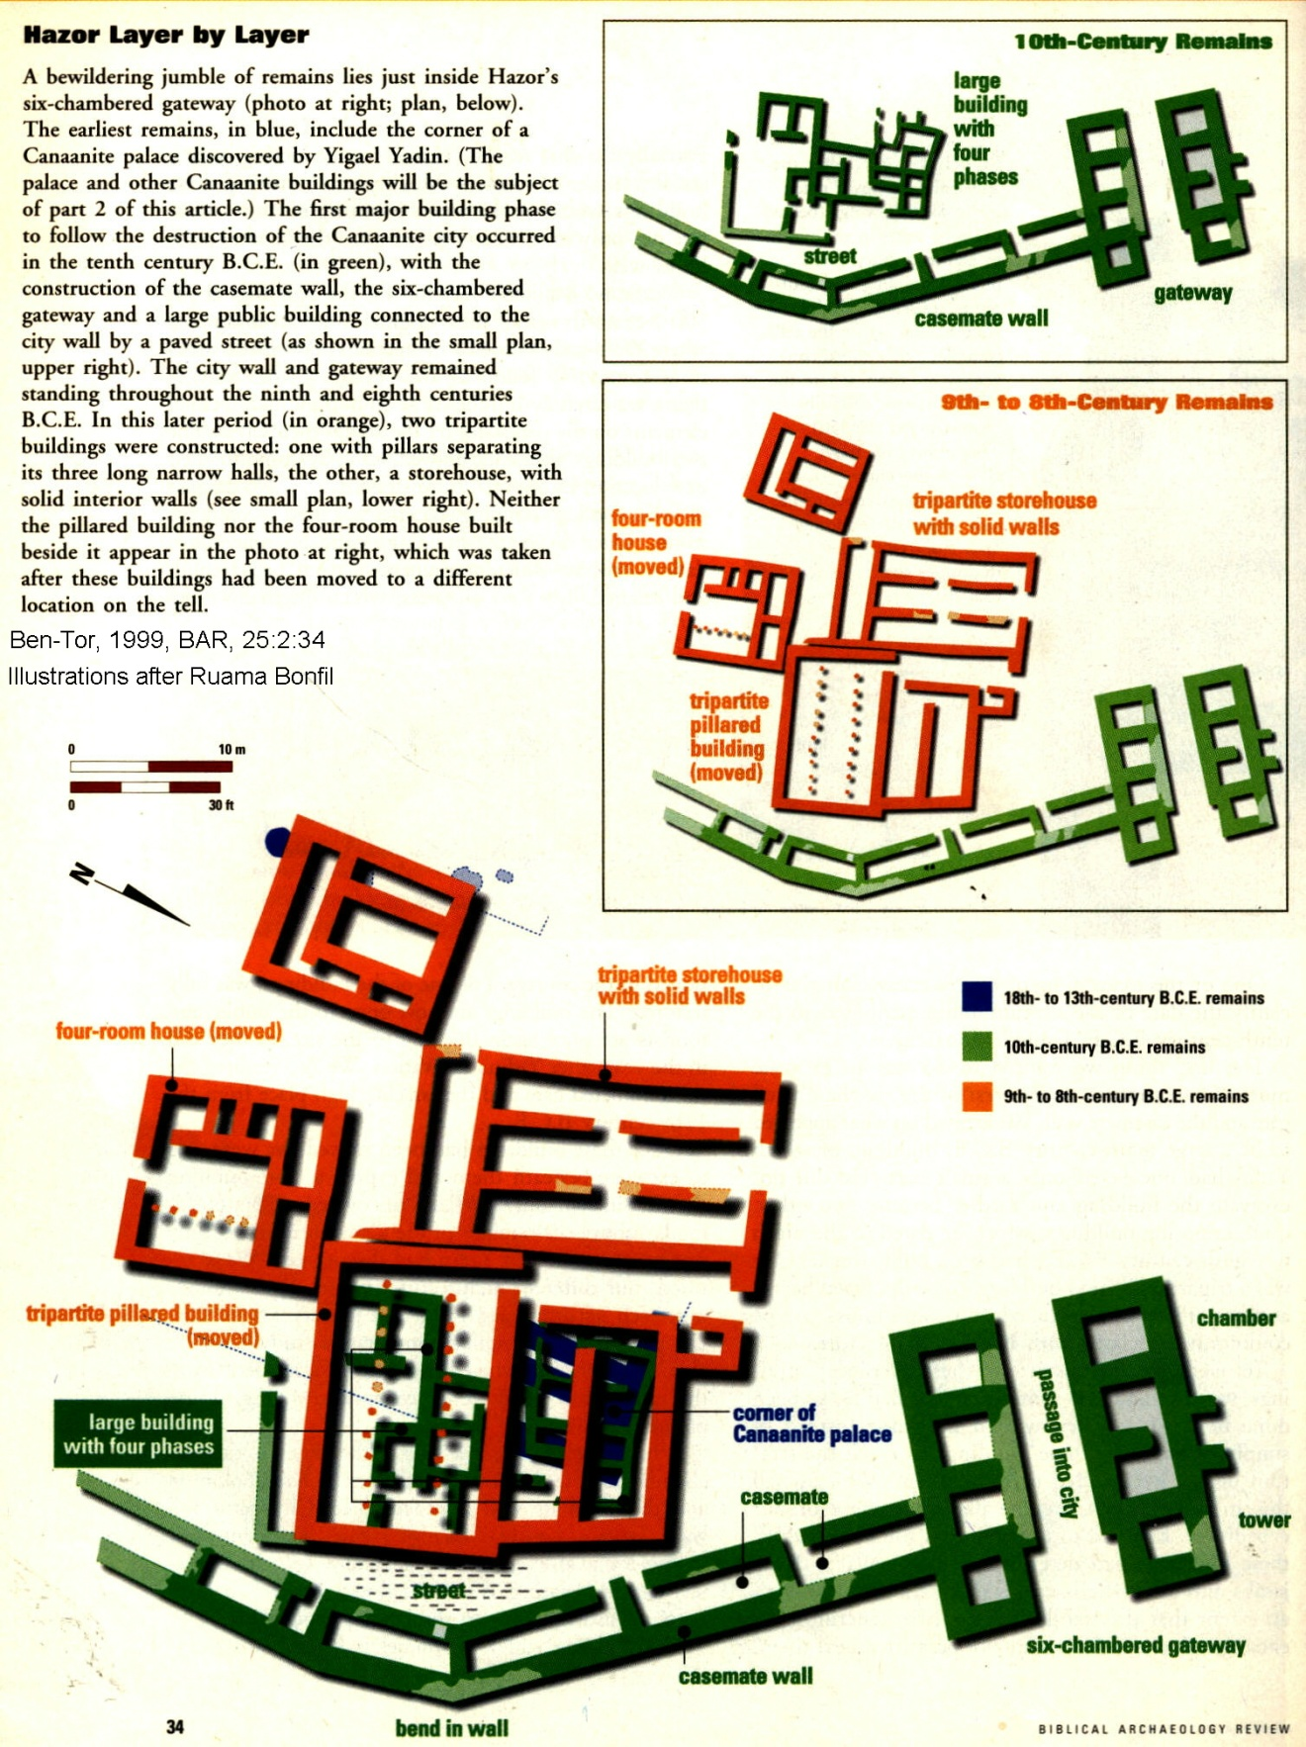

PHOTO LINK :HAZOR 052-a Annotated aerial photo and plan of the Canaanite city

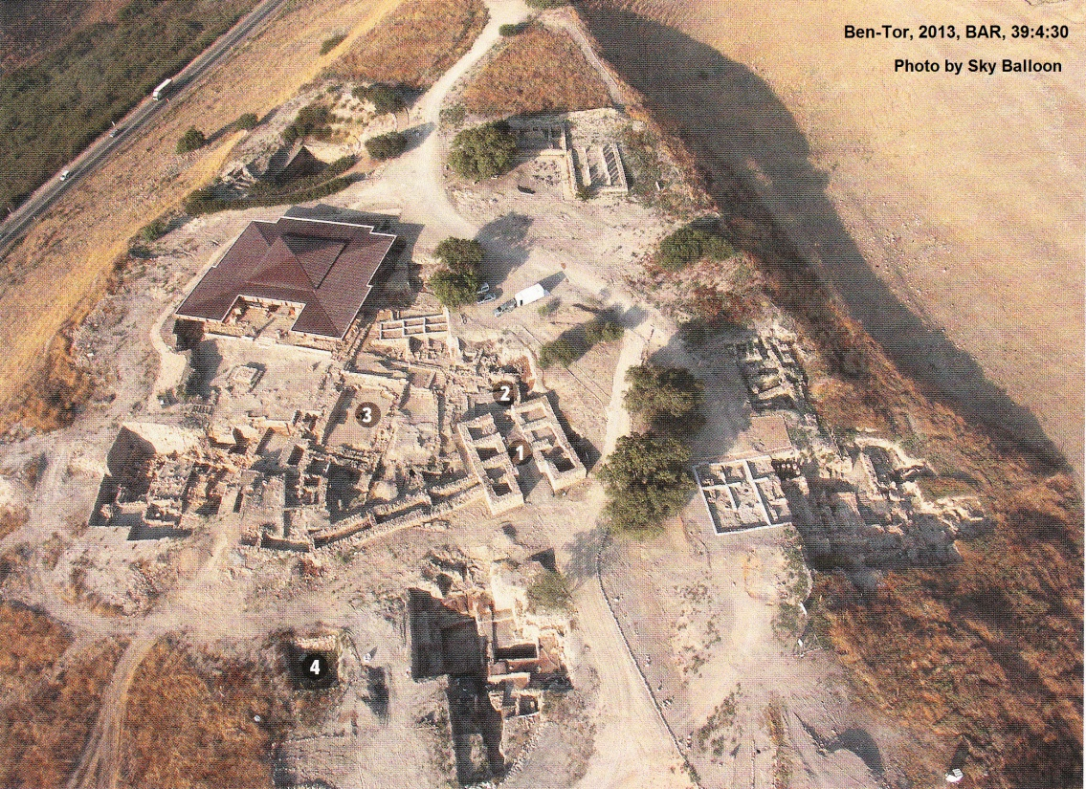

PHOTO LINK :HAZOR 052-b Annotated plan of the Canaanite city
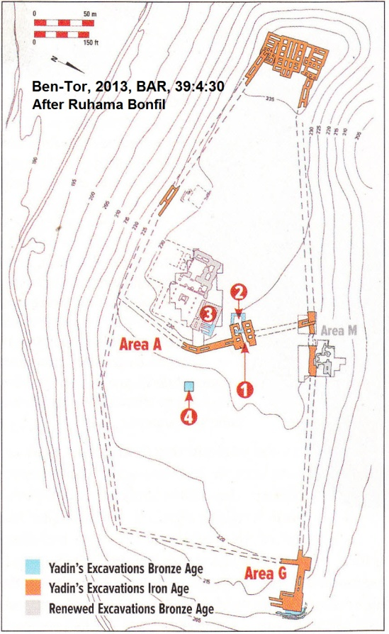

PHOTO LINK: HAZOR 002 Artist’s rendition of Canaanite Hazor gateway
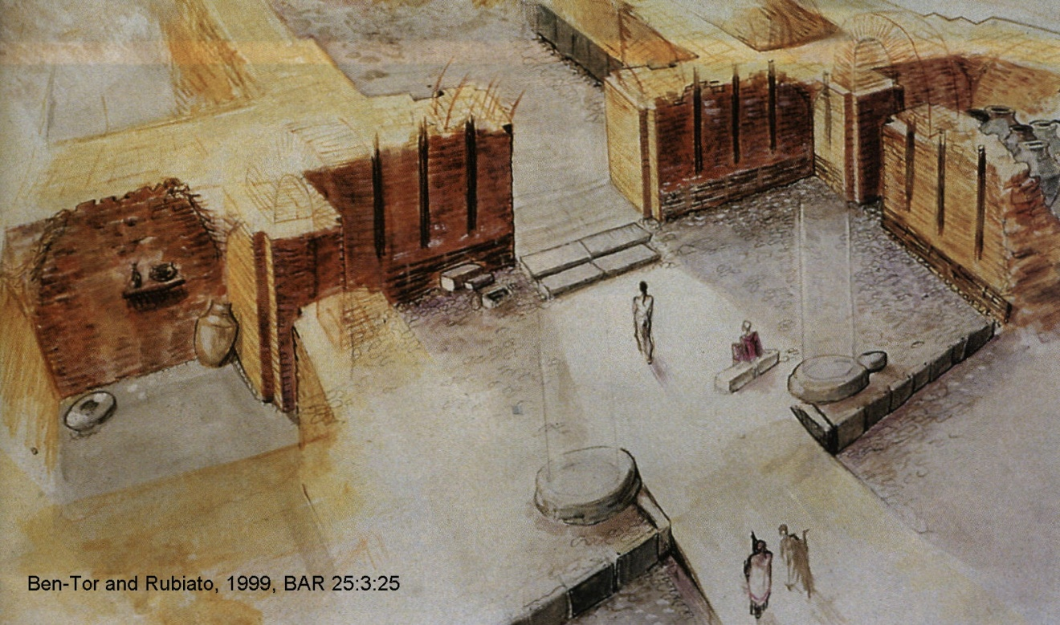
PHOTO LINK: HAZOR 032: MB to LB wall in area A-5
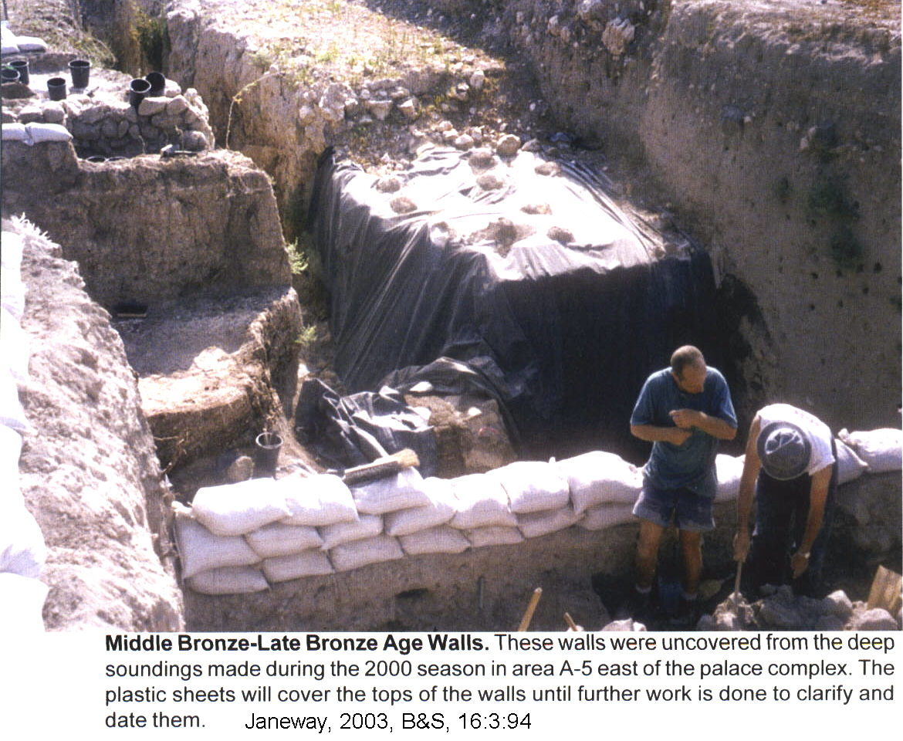

PHOTO LINK: HAZOR 005 Hazor storage area
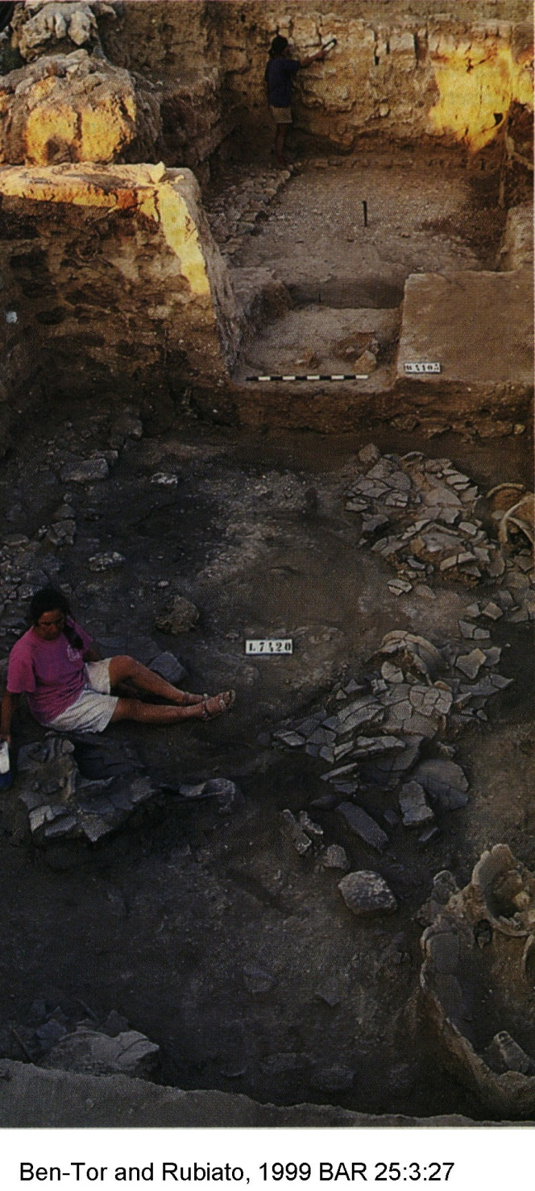
Hazor had defensive walls that had been built in the Middle Bronze Age and were in use though the Late Bronze Age (Ben-Toor, 2003:247-248, cited by Janeway, 2003:95).

The architecture of the Canaanite palace (or temple) at Hazor resembles the Syro-Mesopotmian palace at Alalakh and indicates the cultural similarity between the two cities (Ben-Tor and Rubiato 1999a, 1999b).

PHOTO LINK: HAZOR 006 Plans of Hazor and Alalakh palaces
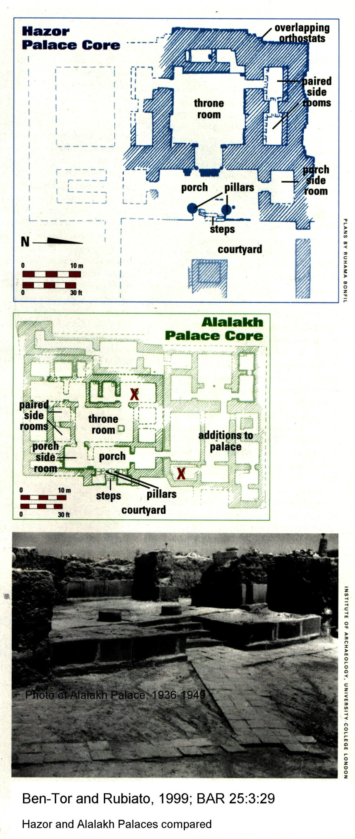
PHOTO LINK: HAZOR 022C Plan of Hazor showing 18th to 13th century Canaanite palace
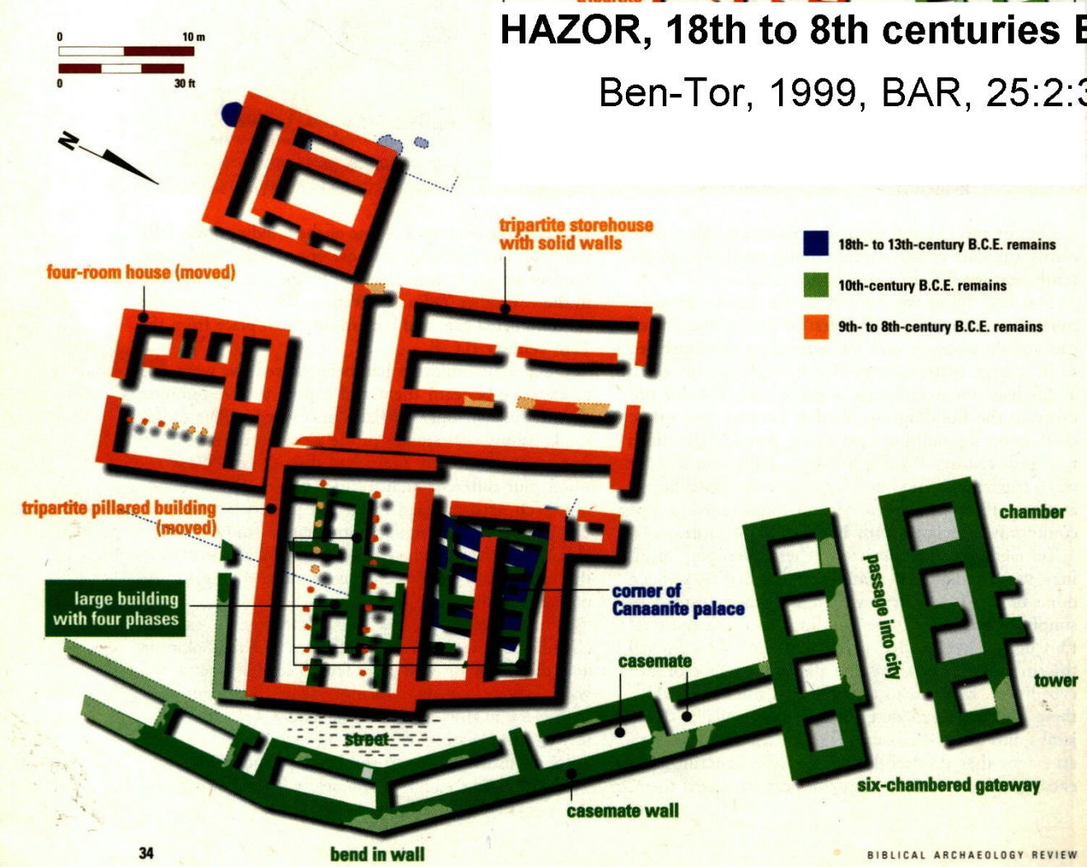

PHOTO LINK: HAZOR 004 Hazor Palace core (40'x40')
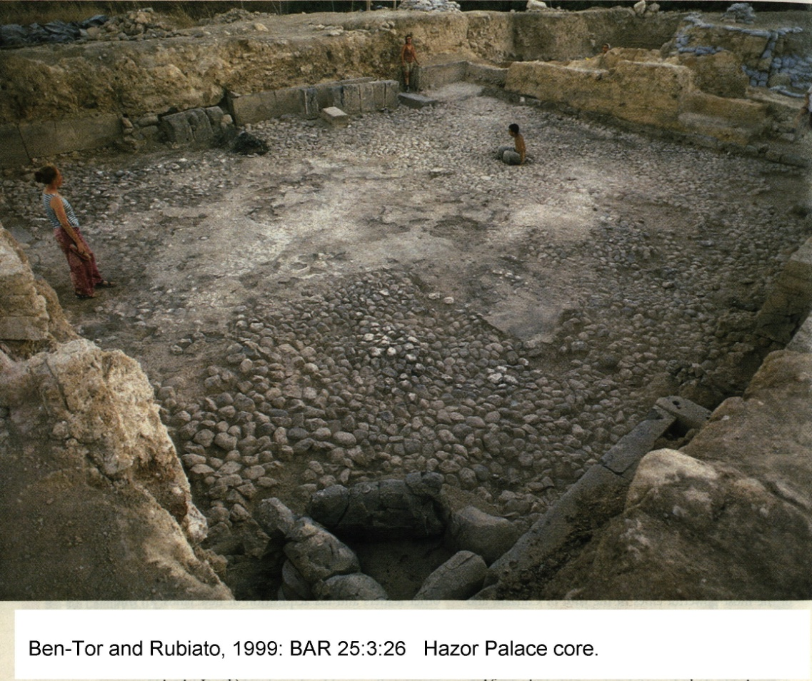
PHOTO LINK: HAZOR 030 Canaanite Palace Courtyard
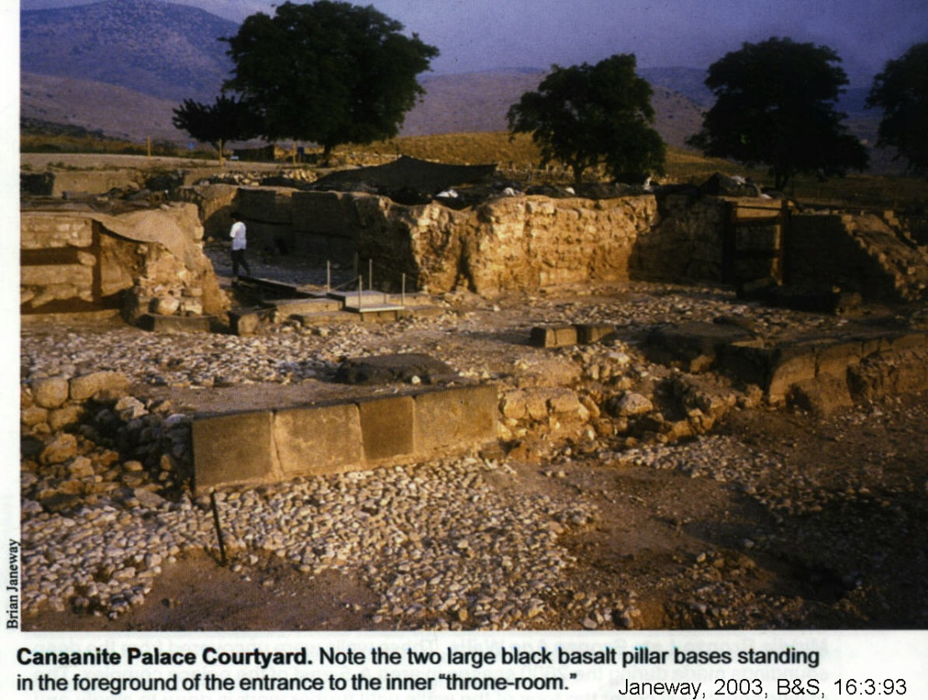

PHOTO LINK: HAZOR 033 Canaanite Palace (or temple) Interior showing pine beam reconstruction
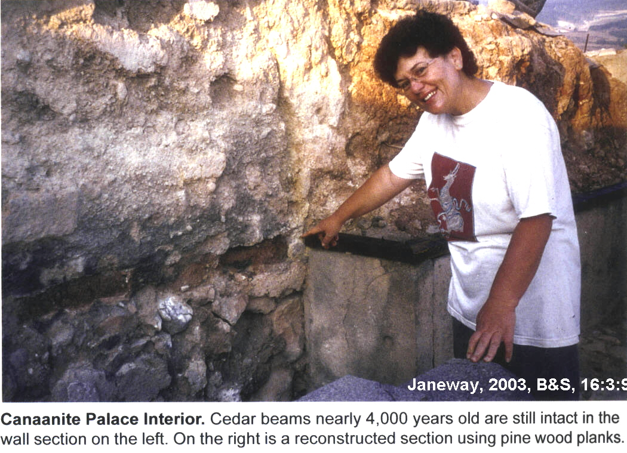

PHOTO LINK: HAZOR 034 Canaanite Palace (or temple) Interior which cracked basalt foundation and reconstructed pine beams and mud-brick
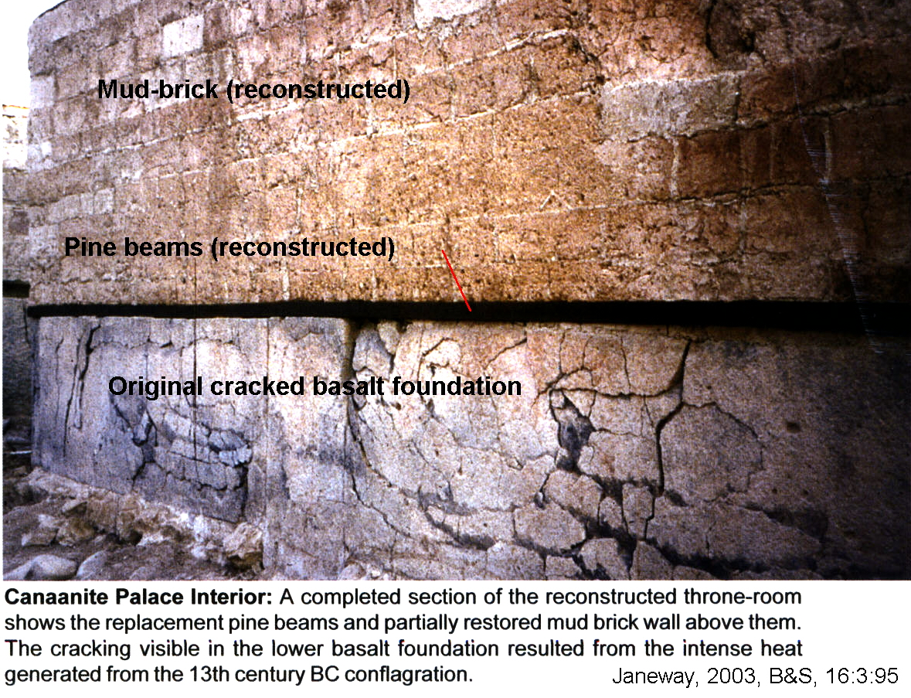

Joshua 11:10-14 says that the Israelites burned Hazor and killed everyone in it including King Jabin. The city was destroyed by fire in LB-II period. This 13th century Canaanite city could have been destroyed by Joshua (Late Date, Yadin’s view), or if Yadin’s date of 1230 BC is correct (Yadin, 1979, 1975), by one of the Judges (Janeway, 2003).

PHOTO LINK: HAZOR 014 Jabin's Palace, destroyed by Deborah and Barak (Jgs 4:24)
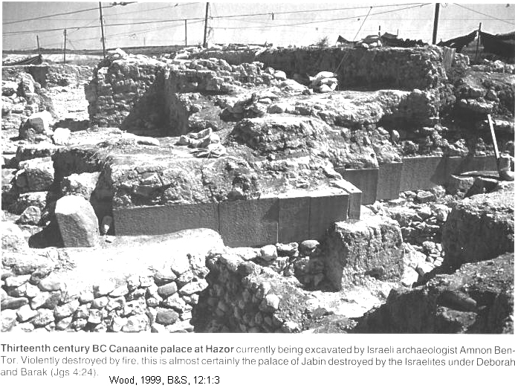

PHOTO LINK: HAZOR 042 Southern Temple and incense burners and chalices
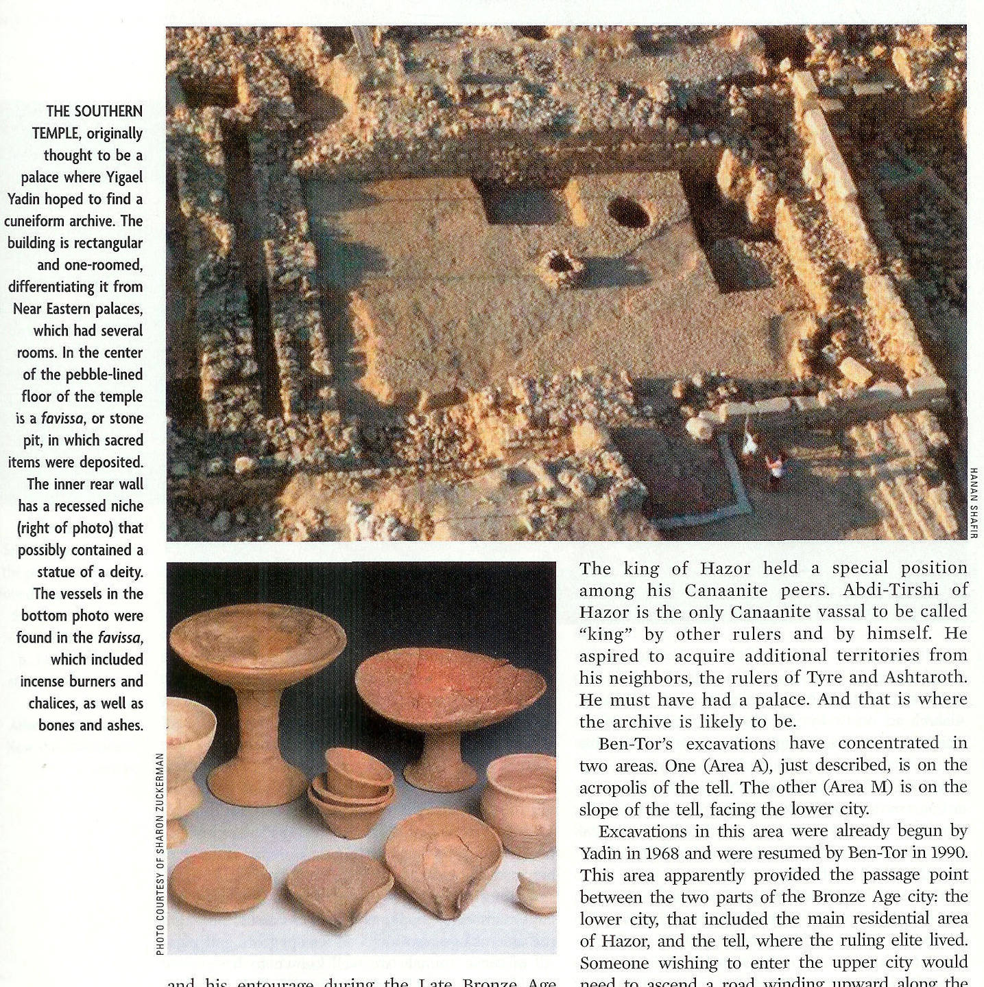

PHOTO LINK: HAZOR 031 LB II Destruction debris: burnt bricks, stone and timber
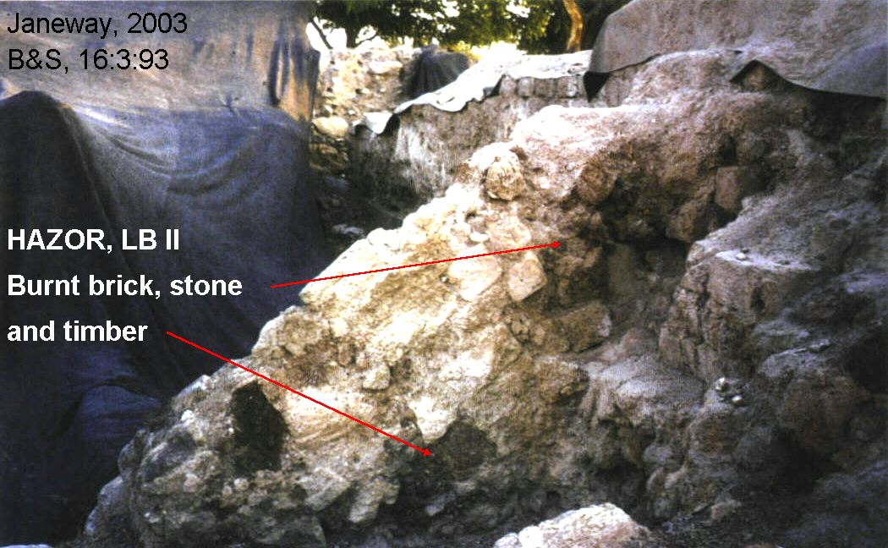

PHOTO LINK: HAZOR 032 MB to LB Age walls in Area A-5 (See ABOVE, ctrl+click to follow link)

PHOTO LINK: HAZIOR 058 Burning of Cerimonial Palace broken pithoi in forground. Olive oil in the pithoi contributed to the fire.

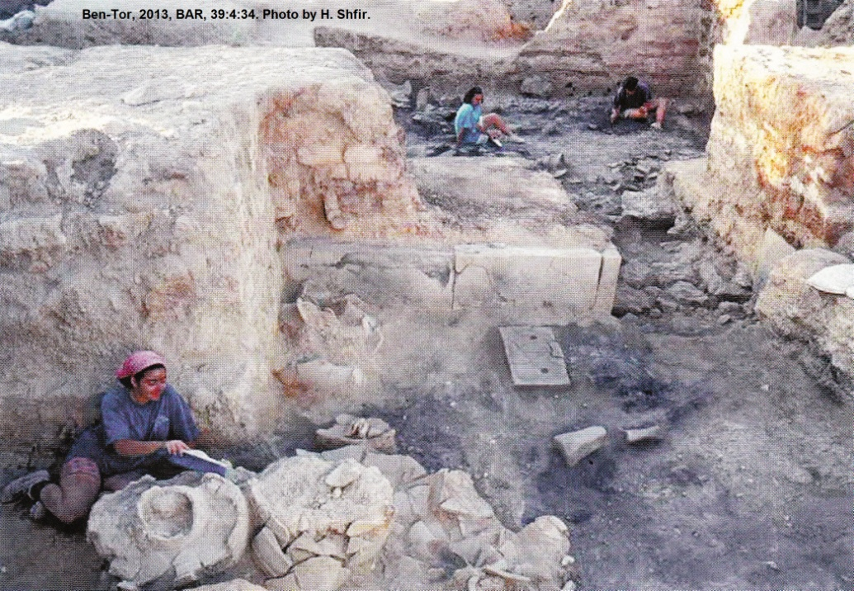

PHOTO LINK: HAZOR 059 Melted clay vessels indicating temperature of 2,370 degrees Fahrenheit.

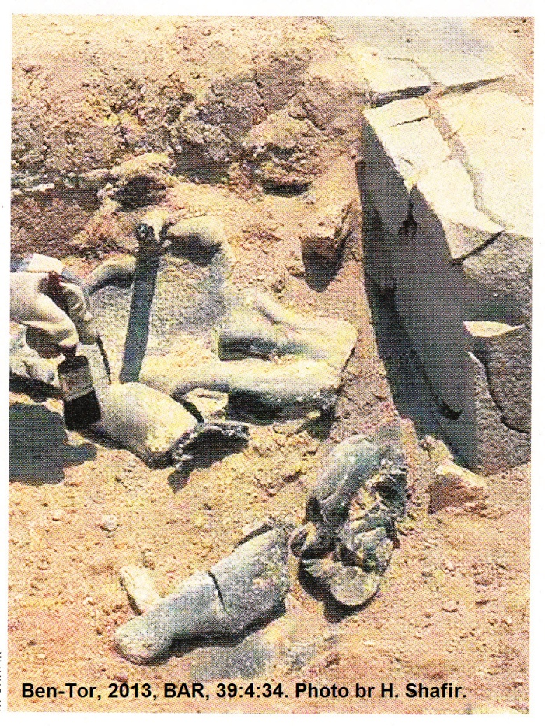

The Canaanite palace was never re-leveled and built over with newer construction, as happened elsewhere on the Hazor acropolis. This may have been due to the imposed ban on new building reflected in Joshua 6:26 (Janeway, 2003:95).
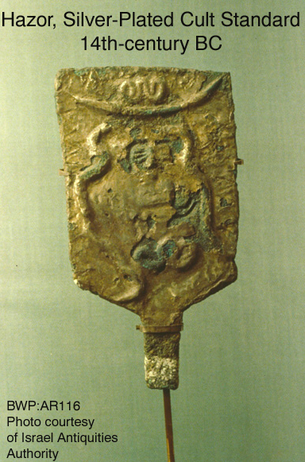
PHOTO LINK: AR116 Hazor, Silver-Plated Cult Standard, 14th century BC

The Canaanite city was destroyed by people who also deliberately destroyed the city’s temple and cult objects in the 14th or 13th centuries BC. Among the statues destroyed was the largest one ever found in Israel, a 3-foot high basalt figure smashed to nearly a hundred pieces. Some cult objects were buried, possibly in an effort to save them from destruction. The mutilated statues are both Egyptian and Canaanite and suggests that then destroyers of Canaanite Hazor were not followers of either Egyptian or Canaanite religions (Ben-Tor and Rubiato 1999a, 1999b, Collins, 2011:80).

PHOTO LINK: HAZOR 007 Vandalized Egyptian statue
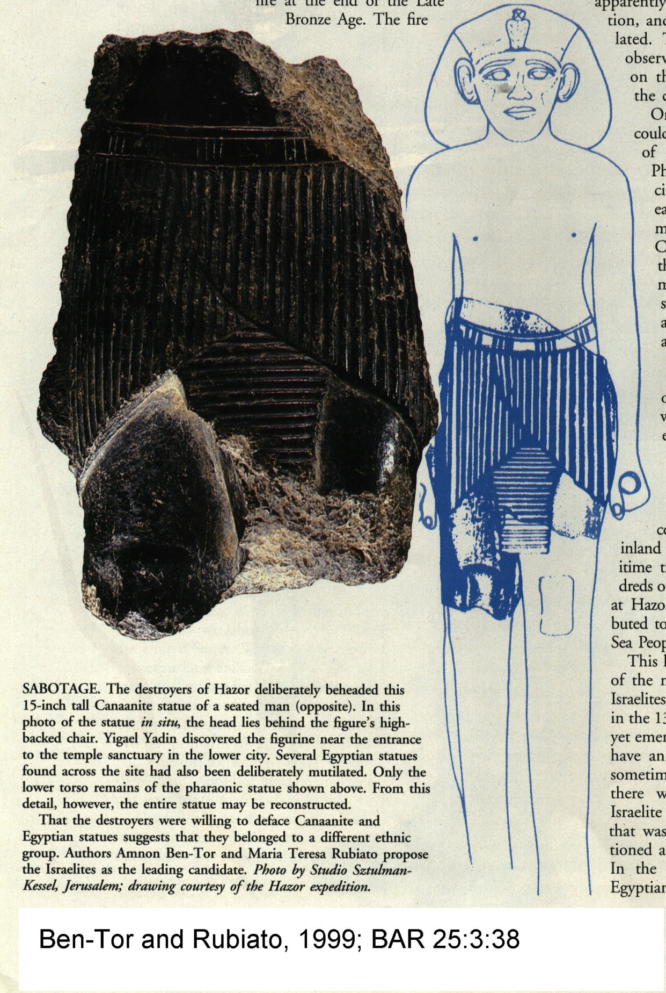

PHOTO LINK: HAZOR 008 Vandalized Canaanite figure on chair
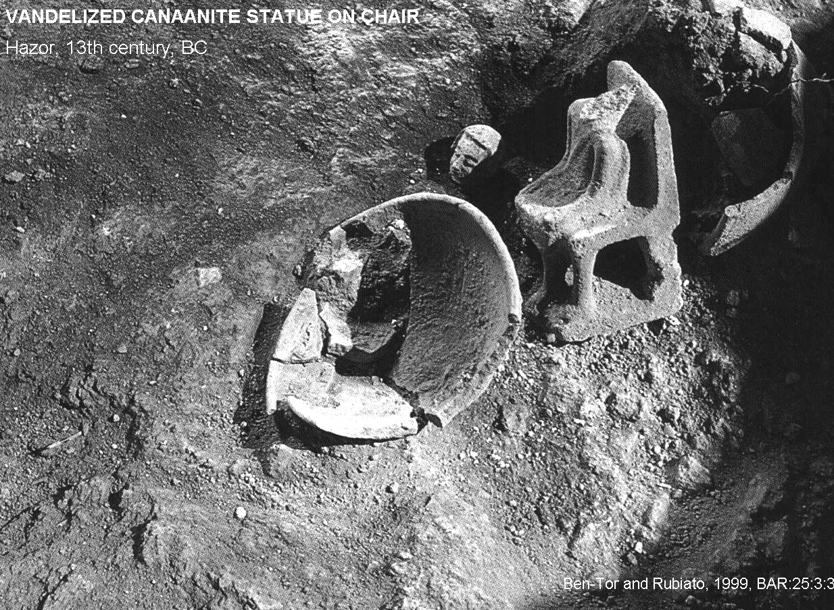

PHOTO LINK: HAZOR 010 Head of Vandalized Canaanite figure
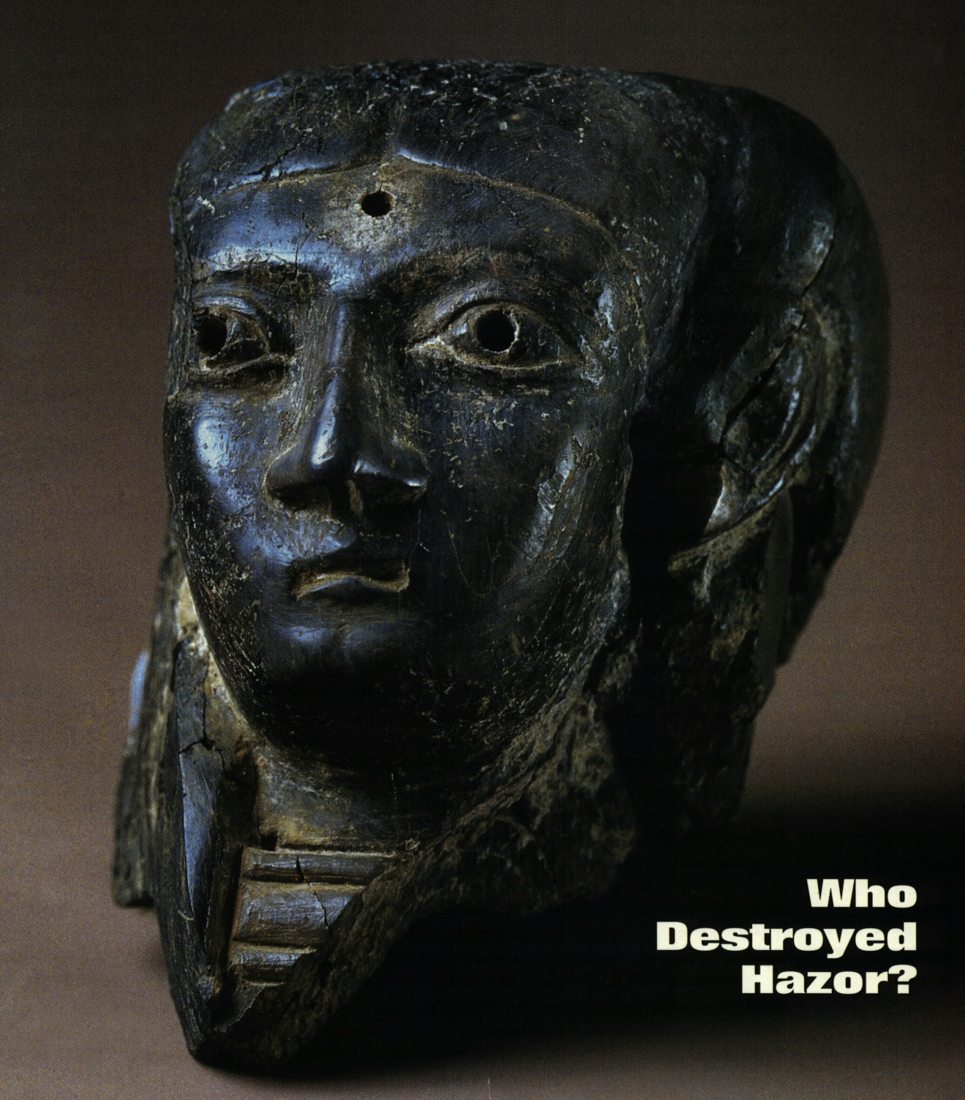.
Hazor has been interpreted as a site that Israelites settled in after the Canaanite city was destroyed by fire (Fritz, 2002; Ben-Tor, 1999:31).

PHOTO LINK: HAZOR 013 Pits from Israelite “squatters” after Canaanite city destroyed.
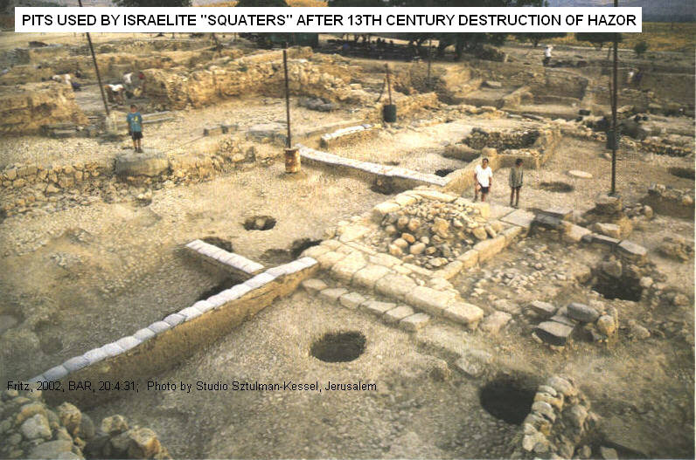

PHOTO LINK: HAZOR 020 Israelite Settler Pits

There are some LB I destruction areas at Hazor that could be assigned to Joshua (according to the Early date theory). These areas include a “royal temple” (migdol fortress style) excavated in the 1968 season. It was destroyed “at some time in the Late Bronze I” and never again restored (Yadin, 1972:103; Ben-Tor, 1993:640, cited by Janeway, 2003:95). A “huge pit” in Area A also reveals LB destruction. Ben-Tor (2000:248-249) attributed this earlier destruction to Thutmose III (c. 1483 BC; Janeway, 2003:95).

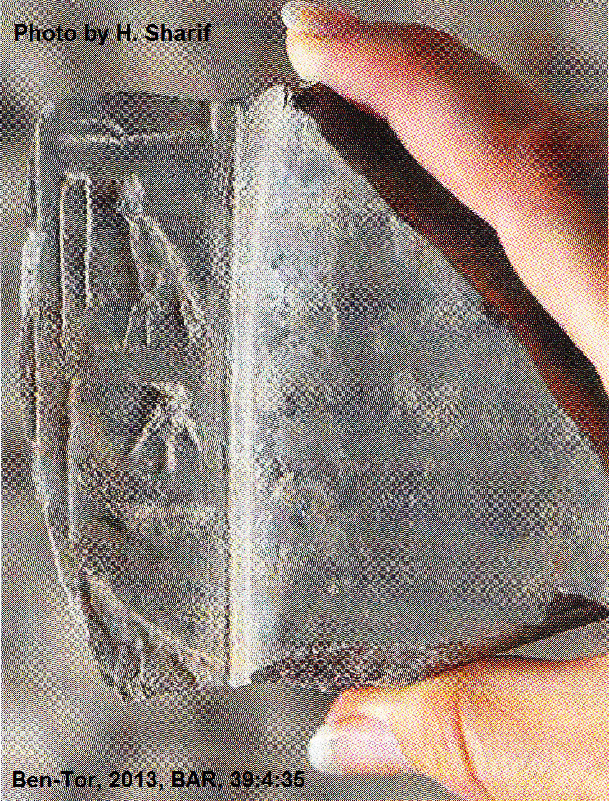
Rahotep-Ramesses II fragment

Under the rubble of a mudbrick wall that collapsed during the destruction of the last Canaanite city at Hazor was found a small fragment of a possible offering table. The hieroglyphs on this fragment suggest it was dedicated to Rahotep, the high priest of Pharaoh Ramesses II. This would date the final destruction of the Canaanite city occurred as late as 1250 BC (Ben-Tor, 2013:35). This would support the Late Date theory for the Conquest of Canaan.

PHOTO LINK: HAZOR 060 Hieroglyphic fragment of Rahotep, high priest of Ramesses II (right).

Hivites and Anakim

A summary of the Northern Campaign is made in Joshua16-23. The “Hivites who lived in Gibeon” are singled out as a city that “came to terms” with the Israelites. All others were “taken by storm”. After the conquest of the Northern Alliance, Joshua turned his forces on the Anakim who were destroyed in the hill-country, but survived in the Philistine coastal cities of Gaza, Gath and Ashdod.

One of the Hivite towns that made up the Hivite coalition that surrendered to Joshua ws Kiriath Jearim (Hansen, 2007:10).

PHOTO LINK: KIRIATH JEARIM 001 location map: http://www.bible-history.com/map_israel_judah/judah_the_southern_kingdom.html ; April 7, 2006

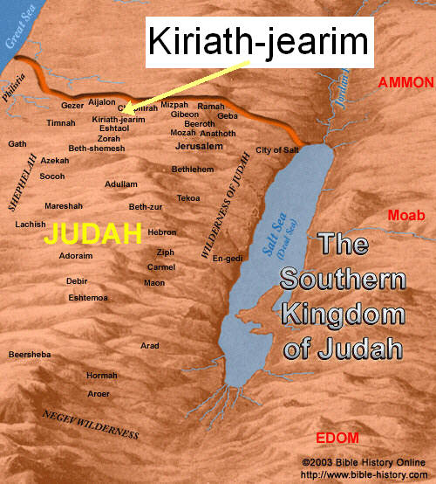

PHOTO LINK: KIRIATH JEARIM 002 Photograph of tell: Hanson, 2007, B&S, 20:1:10
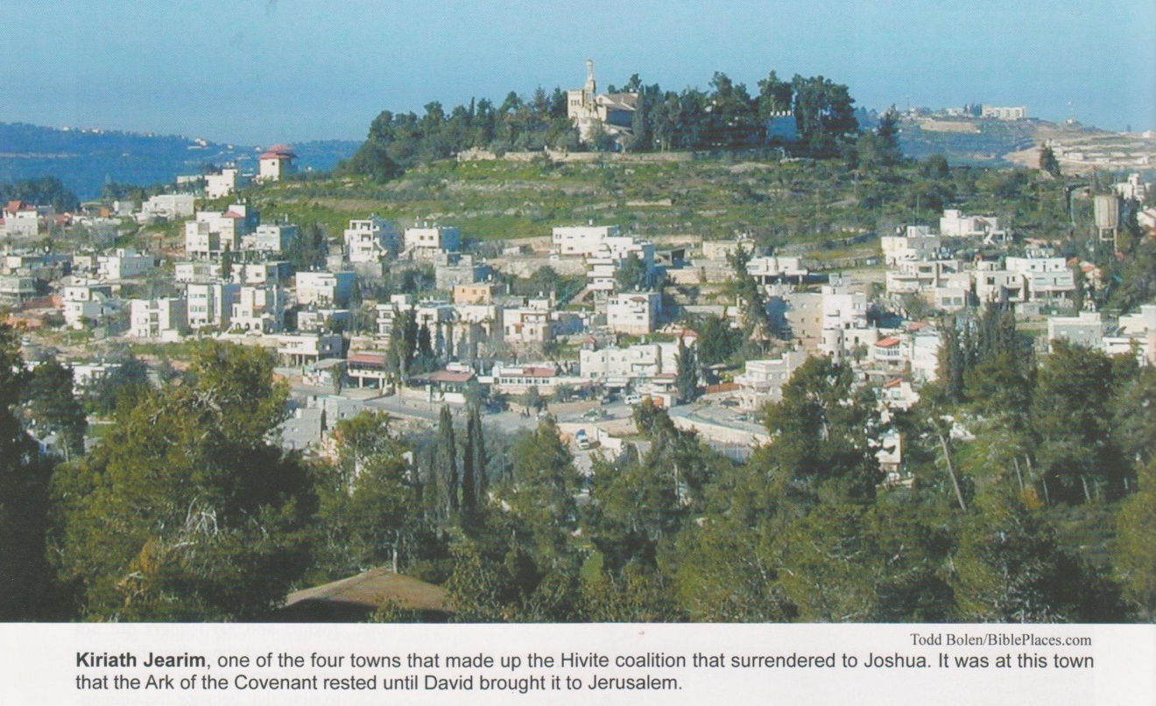

DEFEAT OF THE KINGS OF CANAAN

Joshua 12 contains a list of kings defeated in the Conquest who ruled lands and cities:

“Beyond the Jordan, toward the sunrise [east], from the gorge of Arnon [Moabite territory] as far as Mount Hermon [in the west] and all the Arabah [between the Dead Sea and the Gulf of Aqabah]” (Josh. 12:1)

-Sihon, king of Amorites, who lived in Hesbon
-Og, king of Bashan, survivor of the Rephaim who lived in Ashtaroth and Edrie, he ruled over Mount Hermon

“Beyond the Jordan, to the west, from Baal-gad in the Vale of Lebanon as far as the bare mountain that leads up to Seir” (Josh. 12:7)
ETHNIC GROUP
Hittites
Amorites
Canaanites
Perizzites
Hivites
Jebusites

31 “KINGS” OF:

CITY-STATE
Adullam
Ai
Akshaph
Aphek
Aphek-in-Sharon
Arad
Bethel
Debir
Dor in the district of Dor
Eglon
Gaiam-in-Galilee
Geder
Gezer
Hazor
Hebron
Hepher
Hormah
Jarmuth
Jericho
Jerusalem
Jokneam-in-Carmel
Kedesh
Lachish
Libnah
Madon
Makkedah
Megiddo
Shimron-meron
Taanach
Tappuah
Tirzah.

DIVISION OF THE LAND (c. 1398 BC)

PHOTO LINK: CONQUEST 008 Tribal allotments
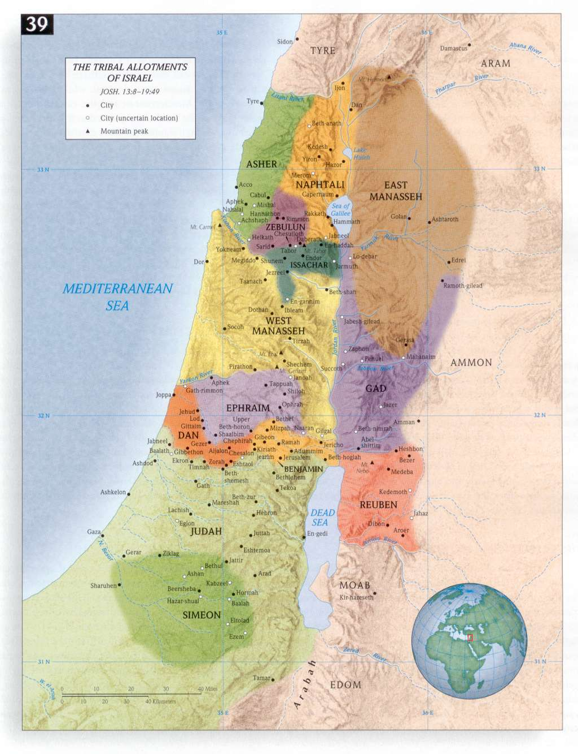

PHOTO LINK: MAP 12 TRIBES OF ISRAEL 001
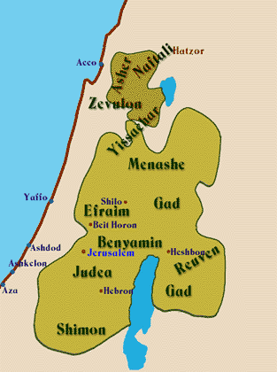

The division of the land when “Joshua had become very old” is recorded in Joshua 13. This division was premature (or prophetic) because, in the words of Yahweh, “much of the country remains to be occupied” (Josh. 13:2). The division was made through chance by the casting of lots.

Unoccupied territories and cities

The “unoccupied” territory at this time was

The Philistine pentapolis (Gaza, Ashdod, Ashkelon, Gath, Ekron)
Geshurite and Maacathite country
Districts of Avvim on the south
Canaanite holdings from low-lying land of the Sidonians as far as Aphek
Amorite frontier
Gebalites and all the Lebanon to the east from Baal-gad under Mt. Hermon as far as Lebo-hamath.

PHOTO LINK: MAP 12 TRIBES OF ISRAEL 002 Map of Tribes , http://members.aol.com/Wisdomway/twelvetribes.htm July 17, 2005
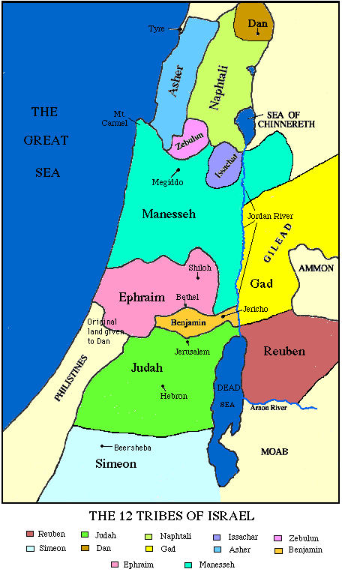
PHOTO LINK: CONQUEST 007 Unconquered lands at end of 7 year Conquest : http://www.studylight.org/se/maps/browse.cgi?st=50#040 ; Jan. 10, 2006
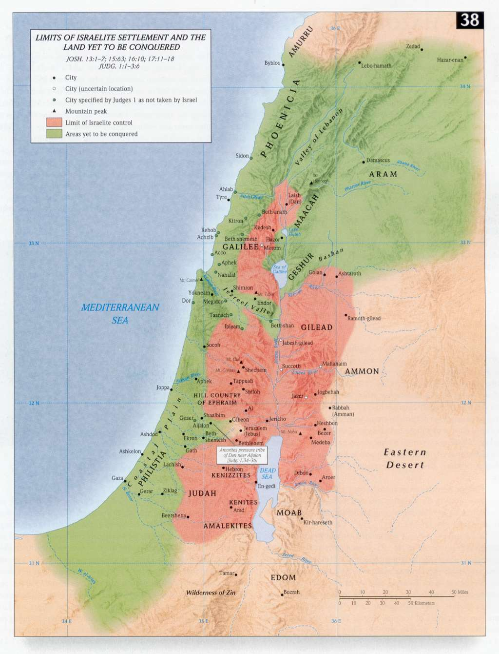

Absent from the list of conquered places in the Promised Land are several prominent cities like Megiddo

Megiddo

During the Conquest-Judges periods, there were four destructions at Megiddo that have been discovered by archaeological excavation but for which no literary records survive. Three of these destructions occurred between the Late Bronze Age (1550-1200 BC) the Iron Age I (1200-1000 BC; Nor and Ron, 1997).

PHOTO LINK: BA112 Late Bronze Cuneiform Writing on Tablet, Megiddo, 15th-14th century
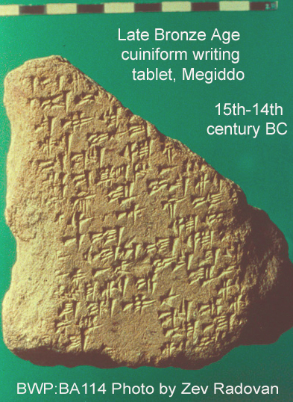

PHOTO LINK: MEGIDDO 006 Location map of Megiddo with Via Maris
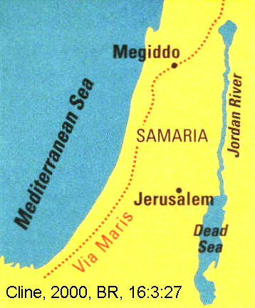
The first layer of destruction separates Megiddo Stratum IX from the later Stratum VIII. This early destruction has been attributed to invading Israelites (Wood), and to Thutmoses III (Kenyon). Nor and Ron (1997) attribute this destruction level to an earthquake.

A second destruction layer (between Stratum VIIA and Stratum VIB) dates to 1250 BC. This date approximates the Israelite Conquest Late-Date theory. This destruction level is 4 ft deep. Fallen walls at Megiddo and contemporaneous destruction at other nearby sites suggest that this level also was the result of an earthquake. An unwalled, poorly and hastily constructed settlement was built on top of the ruined city (Davies, 1986 cited by Nor and Ron, 1997).

PHOTO LINK: MEGIDDO 005 Aerial photo of Megiddo
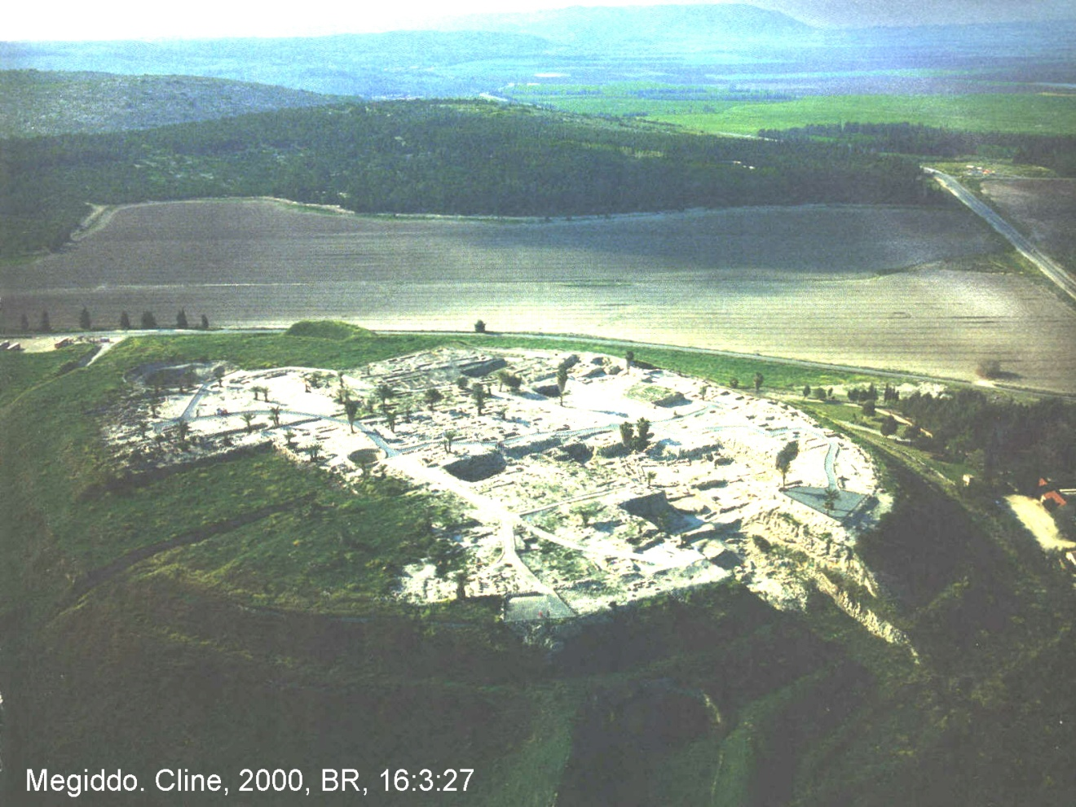

PHOTO LINK: MEGIDDO 007 Aerial photo of Megiddo
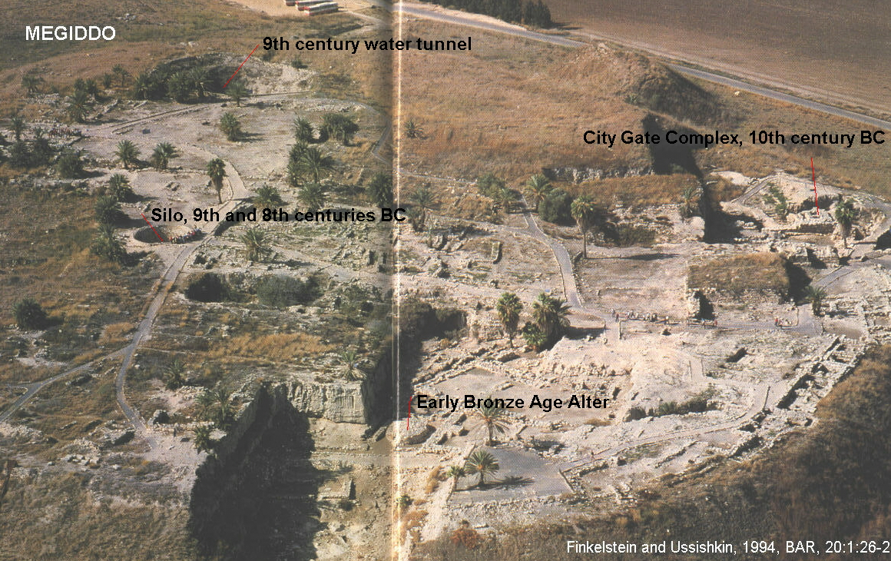

Tribal Allotments

Moses had given guidelines for dividing the land in Num. 34. There was a special set of instructions for the land of the Gad, Reuben and the half-tribe of Manasseh (Num. 32) in regions east of the Jordan River.

PHOTO LINK: JORDAN RIVER 001 (See ABOVE, ctrl+click to follow link)

PHOTO LINK: JORDAN RIVER 002 (See ABOVE, ctrl+click to follow link)

PHOTO LINK: JORDAN RIVER 003 (See ABOVE, ctrl+click to follow link)

PHOTO LINK: JORDAN RIVER 004 (See ABOVE, ctrl+click to follow link)

PHOTO LINK: JORDAN RIVER 005 (See ABOVE, ctrl+click to follow link)

PHOTO LINK: JORDAN RIVER 006
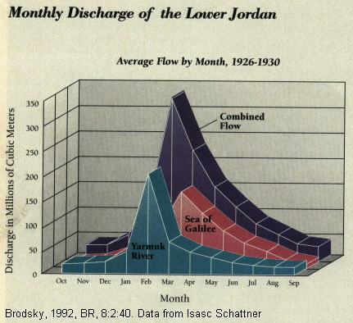

PHOTO LINK: JUDGES 002 Map of Palestine and travels of Wen-Amon
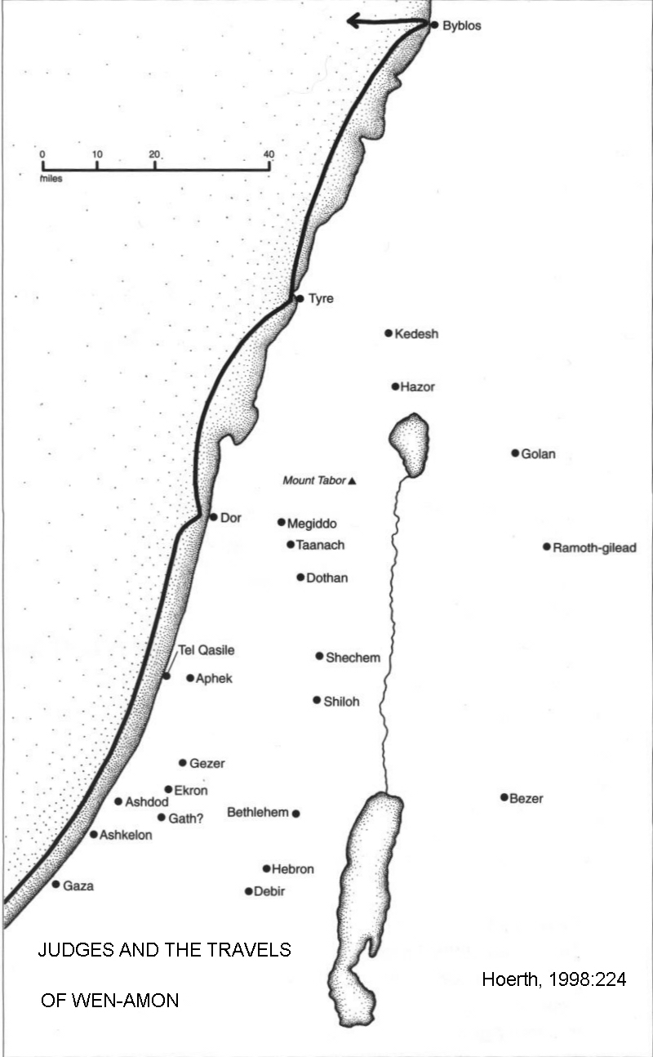

The book of Joshua has several traditions about land allotment (compare Josh. 14-17 with Josh. 18-19), and disputes arose as the division of the land was implemented, causing some amendments (Josh. 17:14-15). The division of the land at Shiloh described in Joshua 18-19 reflects an idealized hope for what the land would be like under Israelite government with people and leaders obeying all the prescriptions of the Sinai and Shiloh Covenants. In reality, there would be numerous battles, wars in indigenous Canaanites, pagan nations and civil war within the Israelite 12-tribe confederation of the Promised Land throughout the period of the Judges. As Joshua 22:33-34 indicates, civil war within the Israelite confederation was always a smoldering possibility.

The tribe of Levi received no territory (Joshua 21:1-42). Instead they were given forty-eight cities including six “Cities of Refuge” (Joshua 20:1-9, Kedesh, Shechem, Hebron, Bezer, Ramoth-gilead and Golan). The cities were more-or-less evenly distributed throughout the Promised Lands.

PHOTO LINK: JUDGES 003 Map showing where the Judges lived
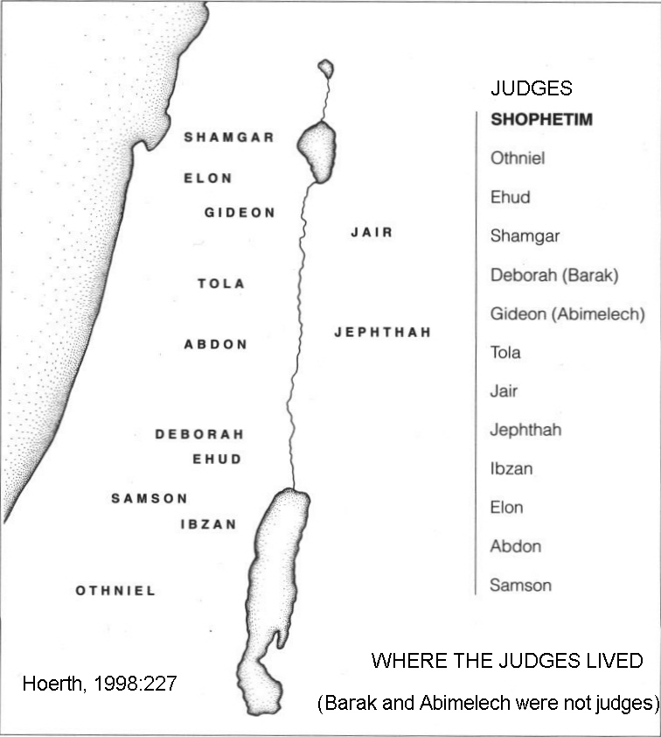

PHOTO LINK: JUDGES 001 Map Settlements in Canaan's central hill-country during Iron Age I (1200-1000 BC)

To the Israelites, the casting of lots was an acceptable means of determining the will of Yahweh during the period of the Judges. This method was used to determine what tribal boundaries would be and what cities they would control (Joshua 18:11; 19:1,10,17,24,32,40
The initial tribal allotments are listed in the following verses:

TRIBE | ALLOTMENT DESCRIPTION
Levi | No allotment (Josh. 13:14)
Lowlands of Moab east of the Jordan River
Reuben | Josh 13:15-23
Gad | Josh 13:24-28
Manasseh (half tribe, by Joseph) | Josh 13:29-31
Lands in Canaan
Hebron for Caleb | Josh. 14:6-15
Judah | Josh. 15::1-63
Joseph (Manasseh and Ephriam) | Josh. 16:1-4 and 17:14-18
Ephriam (half tribe, by Joseph) | Josh. 16:5-10
Manasseh (half-tribe, by Joseph) | Josh. 16:10 to 17-13

A community meeting of the Israelites was called at Shiloh, their primary religious capital, where the Tabernacle had been stationed (Josh. 18.1) A survey of the remaining Canaanite territory was made, and that information used in the casting of lots to identify the tribal allotments in Canaan for the remaining tribes.

PHOTO LINK: TABERNACLE 002 Painting
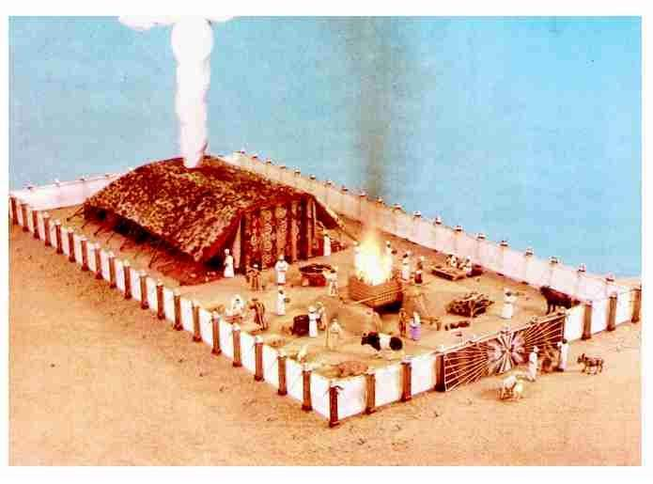

TRIBE | ALLOTMENT DESCRIPTION
Benjamin | Josh. 18:11-28
Simeon | Josh. 19:1-9
Zebulun | Josh. 19: 10-16
Issacar | Josh. 19: 17-23
Asher | Josh. 19:24-31
Nephtali | Josh. 19:32-39
Dan | Josh. 19:40-48
Timnath-serah for Joshua | Josh. 19:49-50

At the end of Joshua’s life, the Israelites had gained a foothold in the Promised Land. But many important large city-states retained their power and autonomy.

City of Salt

In the tribal allotments described in Joshua, at the end of the list of places assigned to Judah the following is recorded:

This is the inheritance of the tribe of the children of Judah...In the wilderness; Beth Arabah, Middin, Secacah, Nibshan, the City of Salt, and Ein-Gedi; six cities with their villages (Joshua 15:220, 61-62).

These cities have been found along the west side of the Dead Sea, named "Sea of Salt" in Old Testament times (Gen. 14:3; Num. 34:12). They were not present during the Conquest or during the period of the Judges. They date from the Iron Age II (1000-586 BC). The lists of cities found in Joshua do not reflect conditions in Joshua's time. They describe the situation that had developed after the fall of Samaria to the Assyrians in 722 BC. They can be interpreted as contemporary prophetic statements, or as projections of current events back into the Joshua narrative. For additional information about these cities, see "Uzziah and the City of Salt" in Chapter 18 (Late Divided Kingdom).

CITIES OF REFUGE AND CITIES OF THE PRIESTS

Joshua 20 is a list of six cities for the religious sanctuary of persons who commit involuntary manslaughter. The cities appear in similar descriptions Numbers 35:1-34 and Deuteronomy 4:41-43; 19:1-10.
The cities were identified by Levitical family and were dispersed among the twelve tribal allotments.

Kohathites: descendants of Aaron. Kohah was the second son of Levi.
Gershonites
Merarites

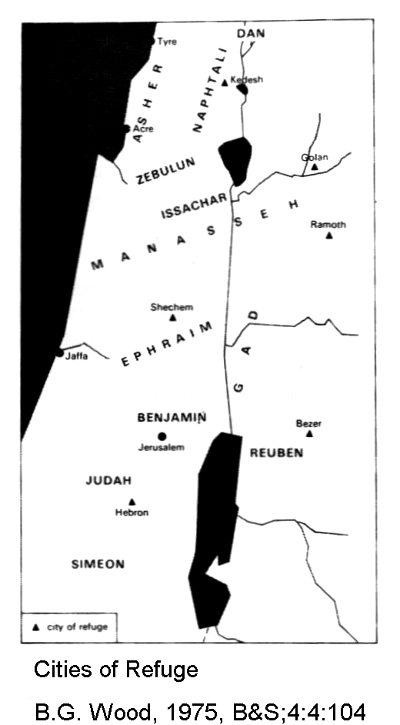
Six cities, three on each side of the Jordan, were set apart by Moses and Joshua as places of asylum for those who had committed manslaughter. Those east of the Jordan were Bezer in Reuben, Ramoth Gilead in Gad, and Golan in Manasseh (Deut 4:41-43); those west of the Jordan were Hebron in Judah, Shechem in Ephraim, and Kedesh in Naphtali (Josh 20:7-8). To shelter the person guilty of manslaughter from the "avenger of blood," provision was made that the principal roads leading to these cities should always be kept open. No part of Palestine was more than 30 miles (50 km.) away from a city of refuge--a distance that could easily be covered in one day. Cities of refuge were provided to protect a person until his case could be properly decided. The right of asylum was only for those who had taken life unintentionally. Willful murderers were put to death at once (Compton’s Interactive Bible, 1998).

PHOTO LINK: CITIES OF REFUGE 001 Map (ABOVE)

PHOTO LINK: CITIES OF REFUGE 002 Map of Cities of Refuge and Levitical Cities : http://www.studylight.org/se/maps/browse.cgi?st=50#040 ; Jan. 10, 2

Joshua 21 is a description of 48 cities allotted to the Kohathite, Gershonite, and Merarite clans of the Levitical priestohood.

ALTER OF WITNESS AT THE JORDAN

Joshua 22 is a curious tale about a near civil war between tribes east of the Jordan (Reuben, Gad and Manasseh) and those west of it. After the Council of Shiloh (Josh. 18), the surveys of the lands west of the Jordan, the allocations for the western tribes (Joch. 18-19), disposition of cities of refuge (Josh. 20) and cities of the priests (Josh. 21), the tribes with allotments east of the Jordan were dismissed.

PHOTO LINK: CONQUEST 008 Map of the allotments (See ABOVE, ctrl+click to follow link)

They came to “Geliloth by the Jordan and built a great alter…for all to see.”

This event was interpreted as an act of secession from the 12-tribe Israelite league, or perhaps rejection of the religious tabernacle center at Shiloh and its leadership.

“All the community of Israel assembled at Shiloh to advance against them with a display of force” (Josh 22:12). A peace delegation lead by Phinehas son of Eleazer confronted the Eastern Tribe leadership.

The Eastern Tribe representatives replied that they never intended the alter for sacrifice, but as a “witness between us and you, and between our descendants after us” (Josh. 22:28).

Witness stones are common in the Old Testament. The erection of Massebot (standing stones) occurred in the Neolithic, Chalcolithic, and early Bronze age periods in the Levant.

PHOTO LINK: MASSEBOTH 002 Eilat 6th to 5th millennium BC
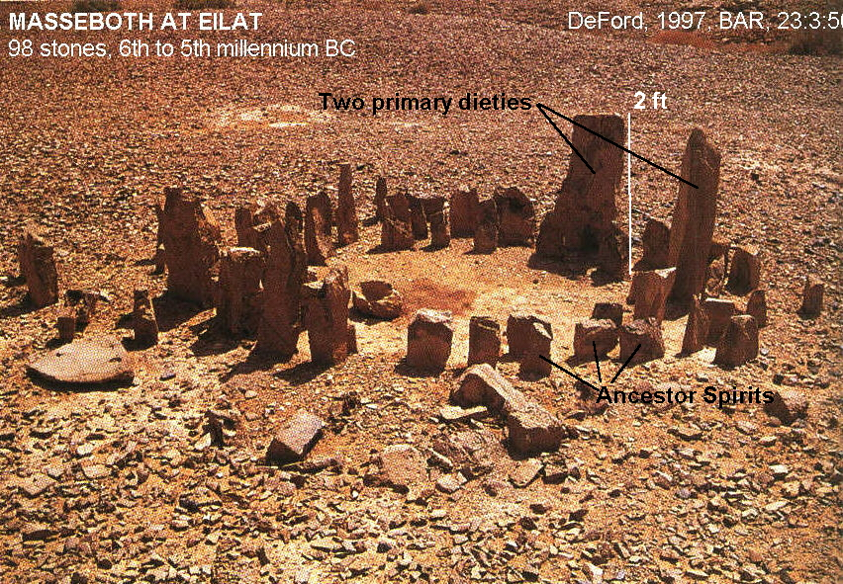

PHOTO LINK: MASSEBOTH 010 Rosh Zin, Negev 11,000 BC w carved base
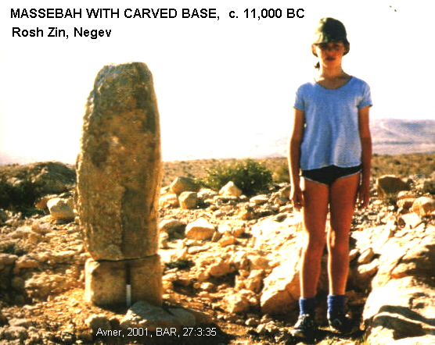

Several Biblical characters built altars. It is not always indicated whether or not these persons sacrificed on the altars.

BIBILICAL CHARACTER | VERSE | EVENT AND LOCATION OF ALTAR | SACRIFICE DESCRIBED?
Noah | Gen 8:20 | after the Flood | Whole offerings “ritually clean beasts and birds of every king”
Abraham | Gen 12:7-8 | at Shechem and the terebinth-tree of Moreh after his call to leave Haran | No sacrifice described
Abraham | Gen. 13:18 | at Hebron and the terebinth of Mamre after he separates from Lot | No sacrifice described
Abraham | Gen. 22:9 | near Beer-Sheba after the near-sacrifice of Isaac | Ram, caught in thicket, is sacrificed
Isaac | Gen 26:25 | After his departure from Abimelech at Beer-Sheba after Yahweh appeared to him there. | No sacrifice described.
Jacob | Gen 33:20 | After his peace making with Esau at Shechem. | No sacrifice described. The altar is named El-Elohey-Israel
Jacob | Gen. 35: 1,3,7 | After Simeon and Levi murder Hamor and his son for the rape of Dinah, at command of God (El) at Bethel | No sacrifice described
Moses | Ex. 17:15 | After the Battle of Rephidim and defeat of the Amelekites | No sacrifice described
Moses | Ex. 24:4 | At the foot of Mt. Sinai after Moses is given elaborations of the Law | 12 sacred pillars are erected. Whole offerings of bulls are made.
Balaam | Num. 23: 1, 14 | At Heights of Ball, near Ar of Moab in preparation to curse the Israelites | Seven alters are prepared, seven bulls and seven rams prepared for sacrifice.
Balaam | Num. 23:29 | At summit of Peor overlooking Jeshimon after Balaam delivers his oracle | Seven alters are prepared, seven bulls and seven rams prepared for sacrifice.
Joshua | Josh. 8:30-31 | After defeat of Ai on Mt Ebal | Whole offerings and slaughtered shared-offerings
Reubenites, east of Jordan | Josh. 22:10 | At Geliloth by the Jordan River after the Council of Shiloh | No sacrifice described. Alter is not used for sacrifice, described as an altar of Witness
Gideon | Judges 6: 26-27 | After his call at the terebinth of Ophrah. Gideon tears down his father’s altar to Baal and makes one for Yahweh to the “proper pattern” | Yearling bull sacrificed using wood from sacred pole that stood beside the destroyed altar.
People of Israel | Judges 21:4 | After near genocide of the tribe of Benjamin at Mispah | Whole offerings and shared-offerings
Samuel | 1 Sam. 7:17 | After defeat of the Philistines at his home in Ramah | No sacrifice described
David | 2 Sam. 24: 21,25 | After David’s unauthorized census, at Jerusalem, at threshing floor of Araunah the Jebusite | Oxen sacrificed as whole offering and shared-offerings
Solomon | 2 Chron. 4:1,19 | Bronze altar in front of Jerusalem Temple | No sacrifice described when altar built, later whole offerings made on it
Jeroboam at Bethel (1Ki 12:33) | 1 Kings 12:33 | At Bethel after golden calves are set up there and at Dan, after secession of the Northern tribes | Whole offerings made. Man of God makes prophecy that Josiah will make sacrifices of the bodies of the priests of the hill-side shrines
Ahaz | 2 Kings 16:10-12 | After making an alliance with Tiglath-pileser of Assyria, Uriah told to build an alter following Assyrian pattern, at Jerusalem Temple | Burnt whole offerings, grain-offerings, and drink-offerings, blood of shared-offering

JOSHUA’S FAREWELL EXHORATION

Joshua’s final instructions to Israel, his burial (c. 1390 BC), and that of Eleazar the priest are in Joshua 24. The exhortation includes warnings of intermarriage, association with Canaanites, and worship of other gods. A second covenant at Shechem was made at this time. A “great stone” was set up “under the terebinth in the sanctuary of the Lord” as a witness monument to commemorate this covenant. A great white masseboth still stands at Shechem.

PHOTO LINK: SHECHEM 015 Great white stone

Second Shechem covenant

Joshua 23-24 contains Joshua's farwell address at Shechem. It is a renewal of the Sinai covenant. As part of the ritual, Joshua erected a standing stone (Joshua 24:26). In the time of the Divided Kingdom, the use of standing stones (massebot), high places (bamot) and sacred trees/groves to mark holy places in the countryside would be discouraged as too pagan by the "good" kings of Judah.

PHOTO LINK: SHECHEM 003 Location map of Shechem, Megiddo, Tyre and Jerusalem (See ABOVE, ctrl+click to follow link)

PHOTO LINK: SHECHEM 013 Aerial photo of Shechem ruins (See ABOVE, ctrl+click to follow link)

PHOTO LINK: SHECHEM 004 Massaba and fortress
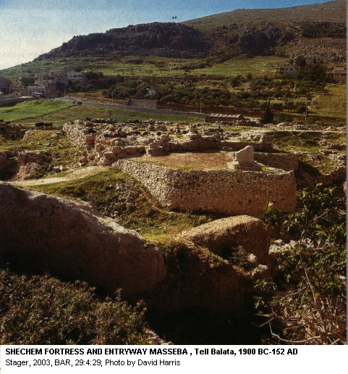

The pillared houses of the Cisjordan are actually of the three-room house type. The houses in the Negev of Judah at Tel Masos were of the classic four-room plan (Rainey, 2008:84)

