CHAPTER 15: THE JUDGES PART 02
Contents
CHRONOLOGY 1614
The number 40 1615
NAMES IN JUDGES 1616
Deborah 1616
Barak 1616
Avinoam 1617
Heber 1618
Yael 1618
Shamgar 1619
Sisera 1619
Theophoric names 1619
CASUALTY REPORTS 1619
ISRAELITE OR CANAANITE? 1622
Collar-Rimmed Jars 1624
The Four-Room House 1625
Four Room Burial Houses 1636
Four Room House in Egypt during Iron Age I 1638
SETTLEMENT DISTRIBUTION PATTERNS: 13th to 11th centuries BC 1645
Terrace Farming 1646
Cisterns 1647
Storage Silos 1648
Settlement Administration 1649
Reubenites and Tell al 'Umayri 1649
Manesseh (1750-1000 BC) 1655
Pharoah Amenhotep III (1410-1377 BC) 1670
Shiloh and the Philistines (circa 1400-1250 BC) 1670
ISRAEL UNDER THE ELDERS (1390?-1381 BC) 1674
Pharaoh Amehnotep III (1410-1377 BC) 1674
Judah-Simeon Alliance 1675
Battle of Bezek (c. 1380 BC) 1675
Calib, Othneil and the Seige of Debir (1373-1334 BC) 1678
Failures Elsewhere 1679
Rebuke at Bokim: Suspension of the Covenant 1681
Israelite apostasy and defeats by "Raiders" 1681
OPPRESION BY CUHSAN-RISHATHAIM OF MESOPOTAMIA (1381-1373 BC) 1683
Pharoah Amenhotep III (1410-1377 BC) 1683
Tell el-Amarna tablets (1410 to 1358 BC) 1684
JUDGE OTHNIEL (1373-1334 BC) 1687
Pharoah Amenhotep V (Akhenaten) (1377-1358 BC) 1688
Dan (circa 1370 BC) 1689
The Benjamite Civil War (circa 1360? BC) 1697
Pharoah Tutankhamun (1358-1349 BC) 1699
Pharoah Ay (1349-1345 BC) 1702
OPPRESSION BY ELGON OF MOAB (1334-1316 BC) 1702
Pharoah Horemheb (1345-1318 BC) 1704
Moab 1707
Moabite Religion 1712
Khirbat al-Mudayan 1715
Pharoah Rameses I (19th Dynasty started) 1722
Egyptian Temple at Jerusalem 1723
Pharoah Seti I 1729
JUDGE EHUD (1316-1237 BC) 1731
Battle of the Fords of Moab (1316 BC) 1735
Pharoah Rameses II 1736
Battle of Kadesh (1279 or 1273 BC) 1747
JUDGE SHAMGAR (1265?-1245? BC) 1758
OPPRESSION OF JABIN II OF HAZOR (1257-1237 BC) 1758
DEBORAH AND BARAK (1237-1198 BC) 1759
Pharaoh Merenptah (1234-1222 BC) 1761
Merenptah Stele (circa 1230 BC) 1762
Merenptah Battle Reliefs at Karnak and the Merenptah Stele 1762
Ashkelon 1770
Gezer 1774
Yano’am 1778
Famine, Merenptah, and the Sea Peoples: End of the Late Bronze Age 1792
Barak and Deborah at the Battles of Haro-sheth Ha-goyim and el-Ahwat (circa 1200 BC) 1793
el-Ahwat and the Shardana (Sheriden) Sea Peoples 1800
Hazor in the Late Bronze Age IIB (c. 1220-1230 BC) 1809
Hazor in the Iron Age I (1200-1000 BC) 1811
Confusion in Egypt (1122-1195 BC) 1811
OPPRESSION BY MIDIANITES (1998-1191 BC) 1812
Pharoah Rameses III (20th Dynasty begins, 1195-1164 BC) 1812
JUDGE GIDEON (1191-1151 BC) 1813
Battle of the Hill of Moreh 1814
Gideon after the Battle of the Hill of Moreh 1818
CANAANITES, PHILISTINES AND THE “SEA PEOPLES” 1820
Archaeological Setting of the Philistines and Sea People 1820
Archeological Finds at Philistine Sites 1823
Pottery 1828
Architecture 1833
Textiles 1833
Biblical History of the Philistines 1834
Sea Peoples Expelled by Egypt, Philistia re-enforced by them (circa 1190 BC 1838
Mycenaean Connection 1839
Sovereignty 1839
Land or Sea Invasion? 1840
Effects of the Sea Peoples Invasion 1845
The Philistines (or Israelites?) at other Sites 1846
Rameses III and the Sea Peoples (1175 BC) 1849
Tell el-Farah 1854
Ekron 1858
Dor 1862
Period of Egyptian Weakness, Rameses IV to Rameses XI, (1164-945 BC) 1871
JUDGE (AND WANT-TO-BE KING) ABIMELECH (1151-1159 BC) 1871
Shechem (circa 1125 BC) 1871
Siege of Thebez 1882
JUDGE TOLA AND JUDGE JAIR 1882
Book of Ruth 1882
OPPRESSION BY AMMONITES 1884
JUDGE JEPHTHAH (1087-1081 BC) 1885
Abel-Keramim at Tell el-‘Umeiri 1885
The Ephriam-Gilead Civil War (c. 1087 BC) 1886
TRAVELS OF WEN-AMON (circa 1087-1081 BC) 1887
JUDGE IBZAN (1081-1075 BC) 1890
JUDGE ELON (1075-1065 BC) 1890
JUDGE ABDON (1065-1058 BC) 1890
OPPERSSION BY PHILISTINES 1890
SAMSON (1069-1049 BC) 1890
Samson and the Danite Migration 1893
Cave of Etam 1893
Samson and the House of Dagon 1897
JUDGE SAMUEL 1900
Priest or Levite? Beginning of a Feud 1901
Battle of Ebenezer (1047 BC) 1901
^{c}Isbet Sartah ostracon 1903
Travels of the Ark after the Battle of Ebenezer (1047 BC) 1904
‘Opalim 1905
Beth Shemesh 1907
Revival and Assembly at Mizpah (1069 BC) 1910
Battle of Mizpah-Beth Car (c 1069 BC) 1916
JUDGES JOEL AND ABIJAH 1916
KING SAUL (1043-1011 BC) 1919
Covenant of Kingship 1920
Battle of Jabesh (1043 BC) 1921
Gilgal 1924
BAMOT OF THE CONQUEST-JUDGES ERA 1927

The period of Judges covers the period from the end of a 7-year conquest to the kingship of Saul (1390-1043 BC). The Israelites were ready to settle down on the Promised Land. The political and religious center became Shiloh in the central hill country. The Tabernacle was permanently stationed there, reflecting Yahweh’s promise of Deut. 12:11 that there would be a permanent site “for his name to dwell.” This would be Israel’s center of worship for the next 400 years (Hoerth,1998:224).

OPPRESSION BY MIDIANITES (1998-1191 BC)

Still not learning their lesson, after 40 years of peace (Judges 5:31) the Israelites returned to their wicked ways and were oppressed by the Midianites who ruled them for seven years (Judges 6:1). Thhe Midianites, along with Amelekites and other eastern peoples, raided the country at harvest time stealing livestock and destroying crops.

PHOTO LINK: MIDIAN 003 Map of Midian and possible site for Mt Sinai
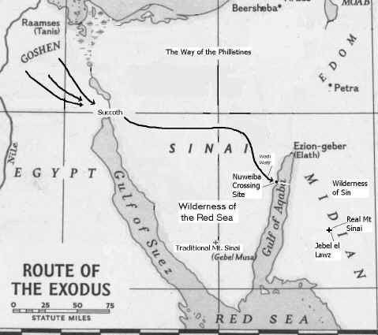

Pharoah Rameses III (20th Dynasty begins, 1195-1164 BC)

This Pharaoh delayed the Sea People's invasion of the Delta. His armies may have invaded Palestine, but that is matter of debate (see discussion, below).

PHOTO LINK: BETH SHEAN 002 Basalt bust of Rameses III (1118-1153 BC); Higginsbothan, BAR, 24:4:CD; Photo pby Zev Radovan
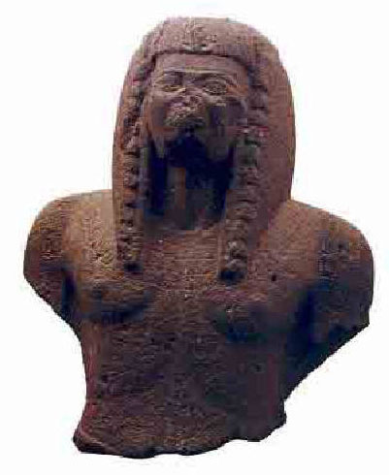
PHOTO LINK: RAMESES III 001 Medinet Habu Temple Amun Thebes Rameses III in smiting pose
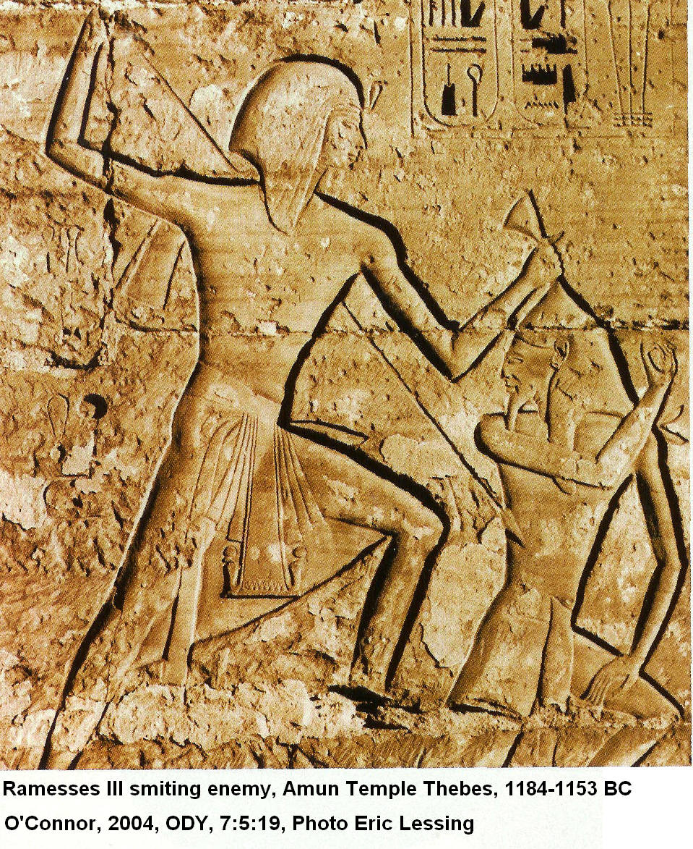

JUDGE GIDEON (1191-1151 BC)

Gidion was a reluctant hero. His call came through an "Angel of Yahweh" who "sat down under the oak of Ophrah" to deliver Yahweh's message (Judges 6:14). Gideon took down his father's altar to Ba'al and Asherah pole, built a "proper" altar to Yahweh and then sacrificed thereon using the Asherah pole as firewood. In doing so he obeyed Yahweh's commandment in Exodus 34:13. But he did it at night to escape notice "because he was afraid of his family" (Judges 6:27). The family and community became angry when they learned about the destruction of Ba'al's altar and the associated Aherah's pole. Gideon was rescued by Joash's oratory. Gideon, still unsure of his call, asked God for two signs for reassurance. When God granted his requests, he prepared for battle.

Battle of the Hill of Moreh

The Hill of Moreh (Judges 7:2), is also called "Little Hermon" because its profile resembles that of Mount Hermon. It is located in the eastern part of the Jezreel Plain.

PHOTO LINK: MOREH HILL OF 001 Arab village of Nianon north slope of Hill of Moreh
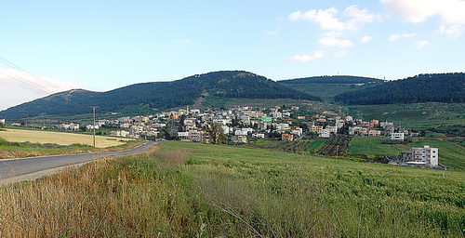

Prior to the battle, 32,000 Israelites had assembled at the spring of Harod. After a series of tests, God reduced the ranks down to 300. Meanwhile, the coalition of Midianites, Amalekites and "other eastern peoples" had amassed in the valley "...thick as locusts. Their camels could no more be counted than the sand on the seashore" (Judges 7:12) This was done as an object lesson to show the Israelites that victory comes from God, not from themselves. Dividing into three companies, they surrounded the Midianite camp and "at the beginning of the third watch" blew trumpets and smashed jars. With torches and trumpets they shouted "A sword for the Lord and Gideon" (Judges 7:20). The disoriented newly awakened Midianite soldiers turned on each other and retreated "to Beth Shitta toward Zarerah as far as the boarder of Abel Meholah near Tabbath." This stratagem of confusing the enemy so they self-destruct is a literary-historical motif seen throughout Judges and Samuel. With the coalition armies in retreat, the Israelite reservists from Naphtali, Asher, and Ephriam were called out. They pursued the Midianites while seizing various crossing points on the Jordan River to prevent escape. As part of the mopping-up program, troops from Ephriam were called to secure Jordan River crossings "as far as Beth Barah" (Judges 7:24). Two Medianite leaders, Oreb and Zeeb were killed and their heads bought to Gideon, a practice adopted 400 years later by the Assyrians.

PHOTO LINK: ASSYRIAN BRUTALITY 004 Sennacherib head piles
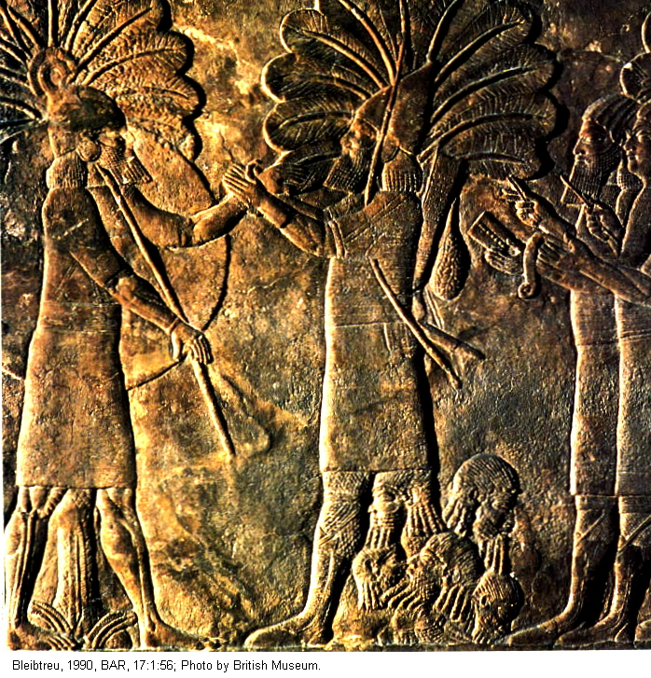

PHOTO LINK: ASSYRIAN BRUTALITY 007 Stakes with 8 heads of victims of Shalmaneser III
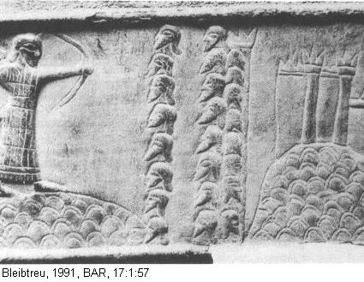

While pursuing the armies of Zebah and Zalmunna, Gideon asked for food and supplies from the towns of Succoth and Peniel, both of which refused. The incident shows the degree of disunity extant in Israel at this time. Gideon pronounced curses upon those towns and left to pursue his foes. His army then made a surprise attack on the Midianites at Karkor where 15,000 soldiers survived out of an original coalition army which had already suffered 120,000 casualties. Zeba and Zalmunna were captured and executed. As for the leaders of Succoth and Peniel, "He took the elders of the town and taught the men of Succoth a lesson by punishing [executing?] them with desert thorns and biers. He also pulled down the tower of Peniel and killed the men of the town" (Judges 8:17).

PHOTO LINK: EXODUS ROUTE 014 Tell el-Maskhuta, ancient Succoth excavations
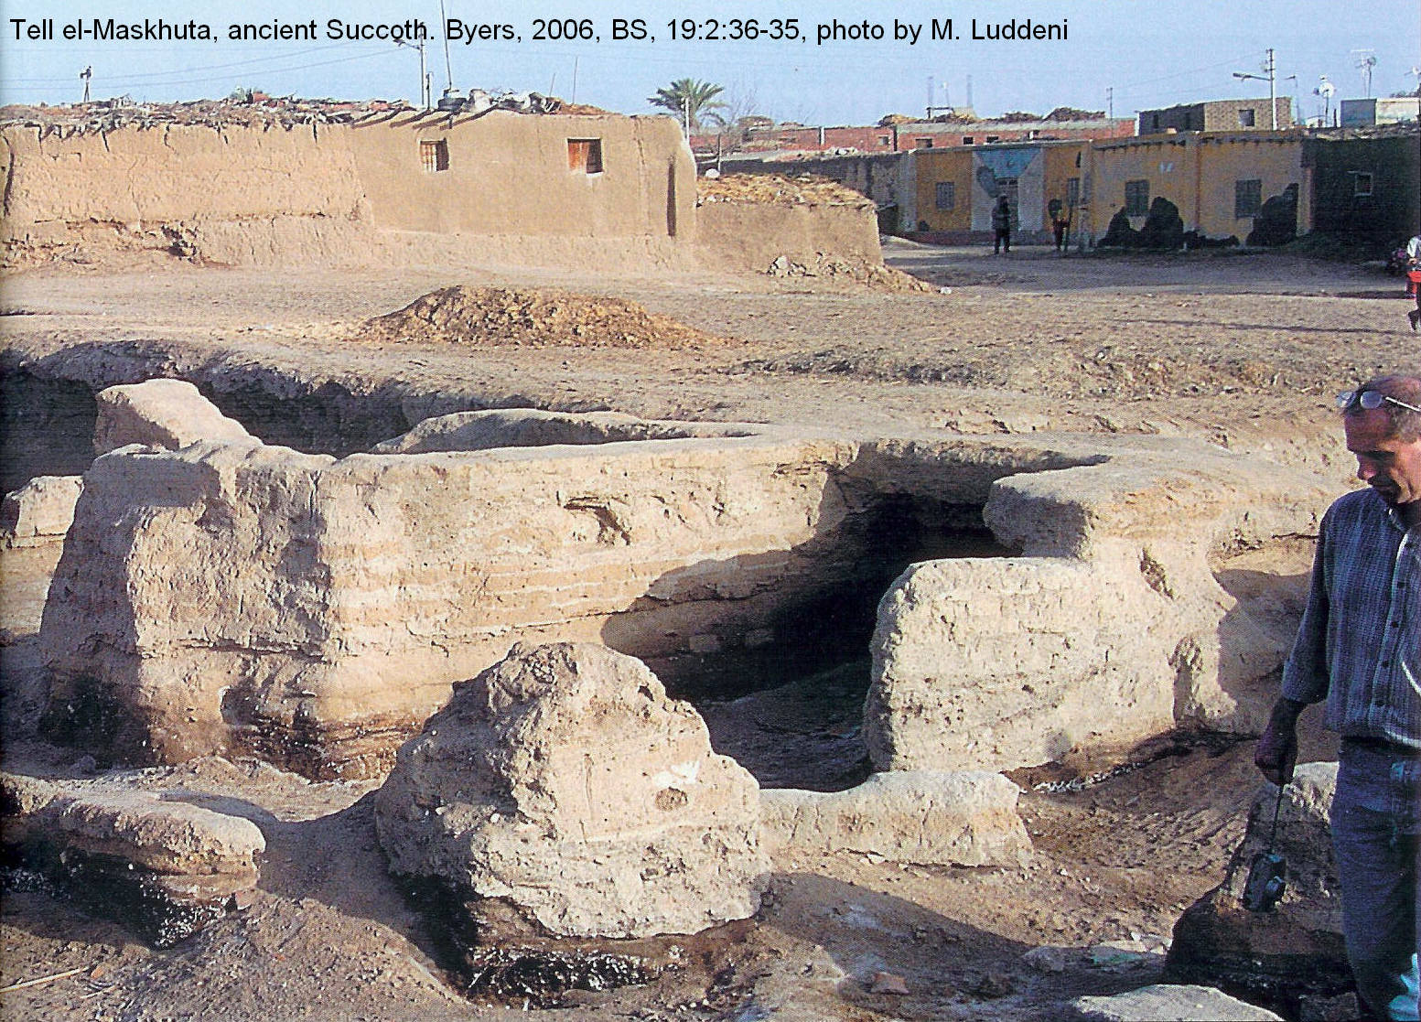

SOD&GOR 037 Map of Jordan Valley north of the Dead Sea showing the Plain of the Valley of Jericho and the Plain of the Jordan between Zarethan and Succoth
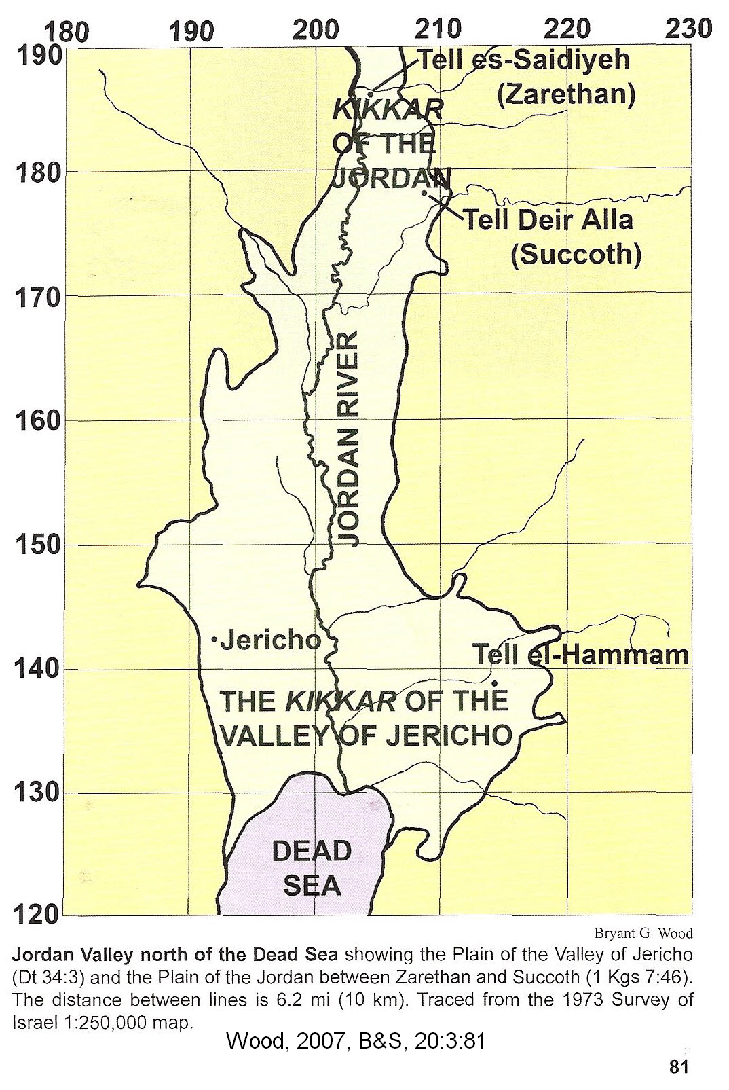

Gideon after the Battle of the Hill of Moreh

After this show of ruthlessness, the Israelites asked Gideon to be king and to establish a dynasty. He refused saying "The Lord will rule over you". But he accepted a gold ring from every soldier's share of plunder and made a gold ephod (breastplate) which he kept as a family heirloom by placing it at the sacred place in Ophrah. Ironically "All Israel prostituted themselves by worshiping it there, and it became a snare to Gideon and his family” (Judges 8:27).

PHOTO LINK: URIM AND THUMMIM 001 Illustration of High Priest wearing breastplate

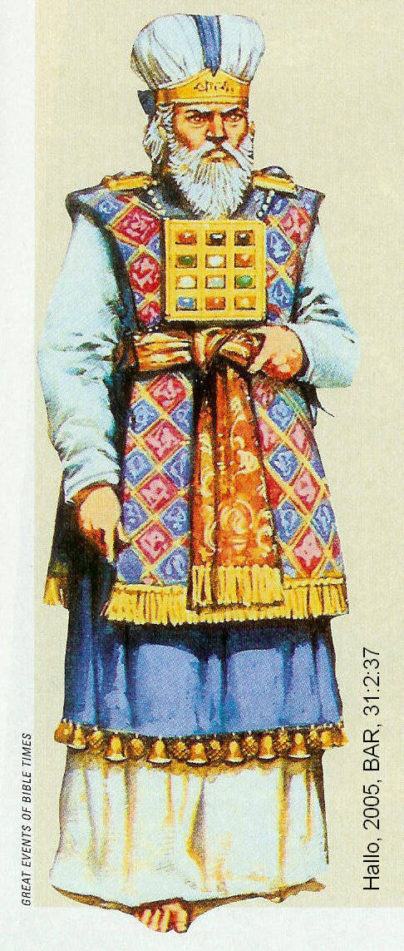

In the end, Ba'al's altar and Asherah's pole were replaced by a golden ephod as religious icons. It was during this time of dis-orthodoxy that Eli was born (1165 BC). He would later play a role in the life of Samson. Such was the apostasy of Israel during this period. In spite of being spiritually “clueless”, Israel enjoyed freedom for another 40 years (Judges 8:28). When Gideon died, Israel returned full-force to worship of Ba’al-Berith.

CANAANITES, PHILISTINES AND THE “SEA PEOPLES”

The Period of the Judges is also the period of interaction between the Israelites, Canaanites, and Philistines.

Archaeological Setting of the Philistines and Sea People

The Canaanites of Syria-Palestine in the third and second millennia BC, occupied the regions later controlled by Israelites and Philistines. As the Canaanites became urbanized, they built great Bronze Age fortified city-states at the following sites (Hackett, 1997, cited by Gitin, 2005):

Acco
Dan
Dor
Gezer
Hazor
Lachish
Jericho
Megiddo
At the beginning of the 12th century BC, migrations of seafaring tribes (“Sea Peoples”) from the Aegean swept through the eastern Mediterranean, the Hittite Empire (Turkey), Palestine and Egypt. They migrated by land and sea, crossing the southern part of Asia Minor, and then heading south along the coast of Canaan (Syria and Palestine). They destroyed cities and whole cultures, moving throughout the Levant and onward down to Egypt. The Bronze Age civilizations of the Mediterranean basin all came to an end in the 12th century at the end of the Bronze Age. (Burdajewicz, 1990, cited by Gitin, 2005:66; Dalman, 2004:13).

PHOTO LINK: SEA PEOPLES 004 Map of Mediterranean showing Sea People cities
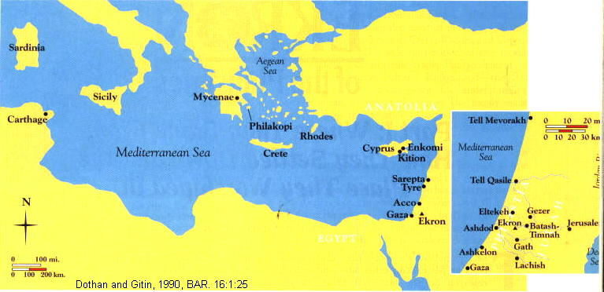

PHOTO LINK: SEA PEOPLES 009 Sea People's march of destruction to Egypt
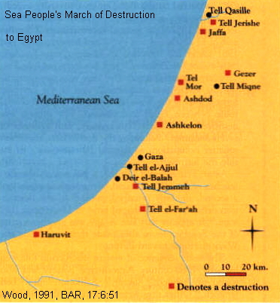

PHOTO LINK: SEA PEOPLES 010 Map of Sea People Invasions from Greece
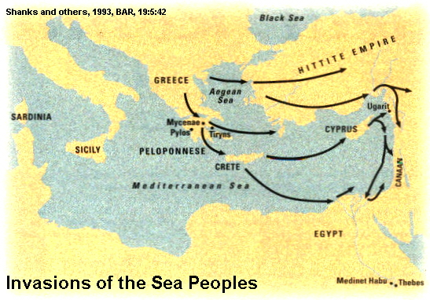

PHOTO LINK: SEA PEOPLES 013 Map of sea invasion routes
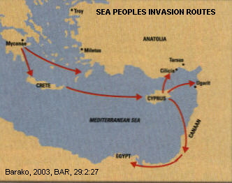

PHOTO LINK: SEA PEOPLES 023 Map of Sea People Invasions in the Mediterranian
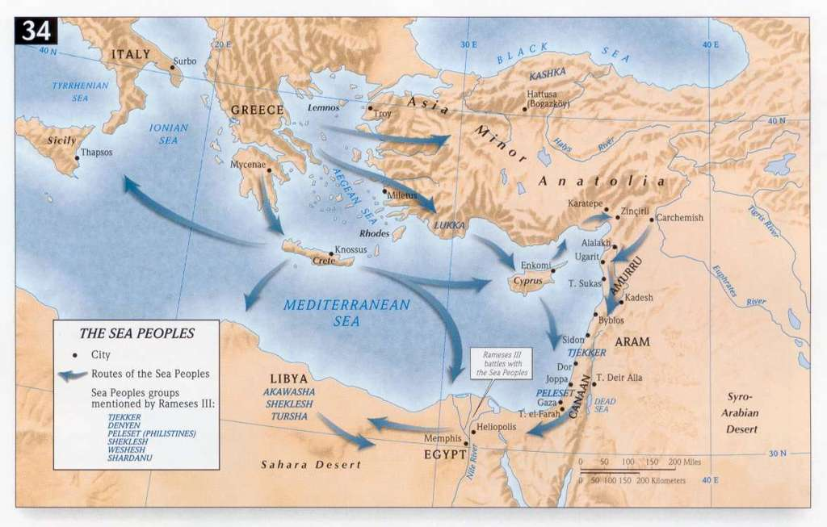

The Sea Peoples invasions marked the transition from the well-developed Late Bronze Age Aegean palace economies, with centralized politico-economic systems, to more provincial state-oriented, decentralized economic systems of the Iron Age nation-states. These included Philistia, Phoenicia, and Israel (Sherrat, 1998, cited by Gitin, 2005:66).

Archeological Finds at Philistine Sites
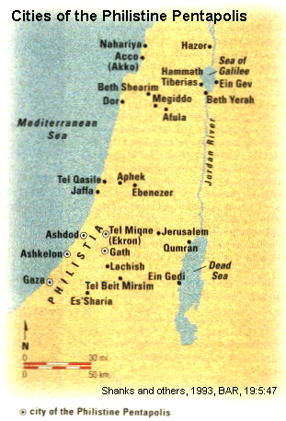
The archaeological record of “Philistine” cities are now coming to light. All five of the major Philistine cities (Gath, Gaza, Ashkelon, Ashdod, Ekron) have been excavated. The northern border of Philistia was at Tell Qasile (Stern, 1993a, p.27; Mazar, 1984). In the 12th and 11th centuries, these cities were (Bright 1972, cited by Gitin, 2005:67):
Ashdod
Ashkelon
Ekron
Gath
Gaza

The Philistine Pentapolis was a major political and economic power in the region, and threatened the existence of the Israelite tribes during this period (Bright, 1972, cited by Gitin, 2005:67).

PHOTO LINK: PHILISTINE 008 Map of Philistine Pentapolis (RIGHT)

PHOTO LINK: AR053 Tell Qasile Philistine Temple, 12th and 11th centuries BC
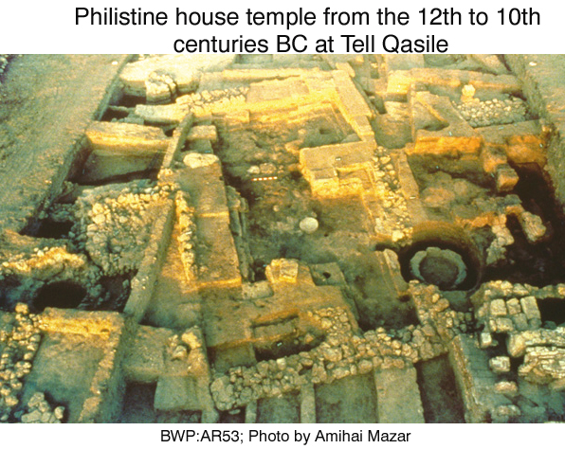
PHOTO LINK: AR106 Tell Qasile, Philistine Ceramic Cult Stands, 11th or 10th cent BC
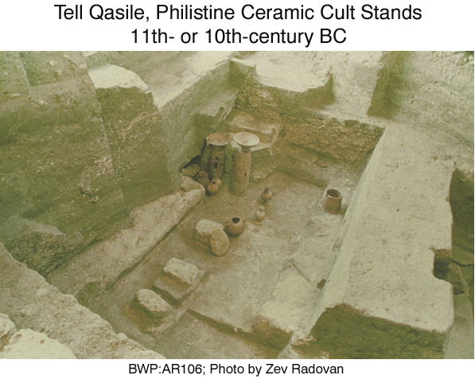

Sea Peoples of Ashkelon, Gezer and Yanoam, along with Israelites, were defeated during a campaign in Canaan by Pharaoh Merenptah II (1212-1202 BC) . These military victories are recorded in wall reliefs at the temple of Karnak Thebes (See discussion, above and Stager, 1991a).

PHOTO LINK SEA PEOPLE 005: Battle relief Merenptah victories
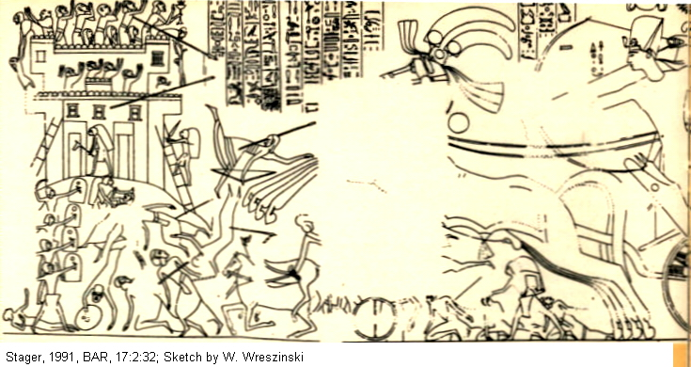

After the Late Bronze Age collapse and upheaval, many of the Canaanites were absorbed into emerging Philistine and Israelite settlements and cities. Around 1000 BC, during the time of King David, the Canaanite remnant populations of the coastal plain (in what is today Lebanon and northern Israel) controlled a number of port cities. These cities included Tyre and Sidon. The people in these city-states later became known as “Phoenicians”, a name meaning “the purple-dye people”. This cognomen derived from they were a major producer of highly valued purple dye made from murex shells (Moscati, S., 1968, cited by Gitin, 2005:66-67). Thus, the ethnic and cultural successors to the Canaanites, were the Phoenicians (Bondi, 1988, cited by Gitin, 2005:66).

PHOTO LINK: PHONECIA 009 Murex shells on seabed
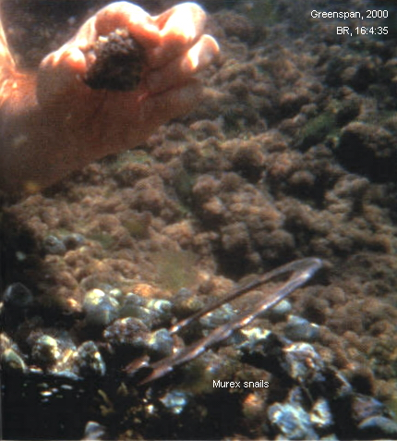

PHOTO LINK: AR017 Ashdoda anthropomorphic figurine-chair
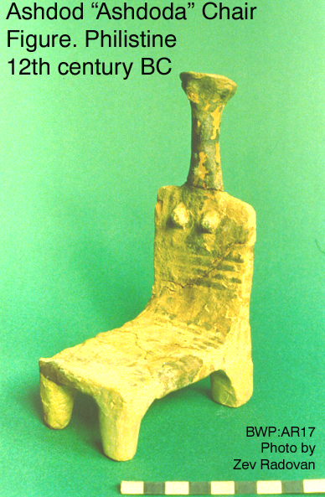

PHOTO LINK: PHONECIA 010 Dye vats and stained pottery from Dor and blue wool from Judean caves of 2nd Jewish Revolt of 132-135 AD.
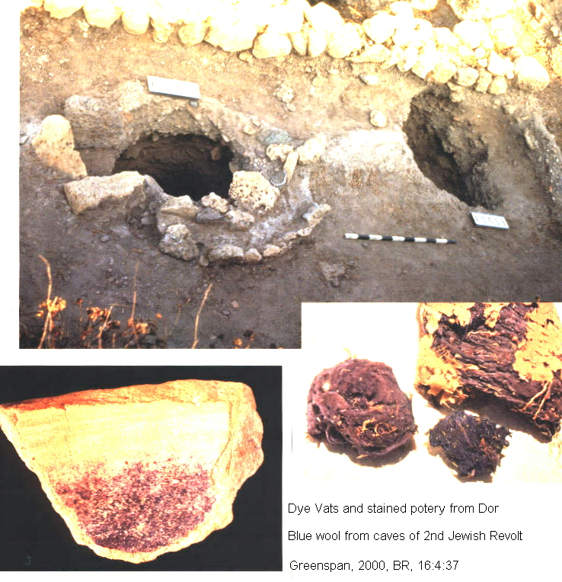

PHOTO LINK: PHONECIA 007 Dye demonstration yellow solution turns white wool blue from Murex snail

Around 1000 BC, the Philistine pentapolis was conquered by Egyptians (Pharaoh Siamon), or the Israelites. These people later evolved into the Phoenician culture. After this time, distinctive Philistine markers disappeared. These included Philistine anthropomorphic figurines, like the “Ashdoda” chair.

Pottery

Another distinctive cultural Philistine marker is their pottery. Philistine monochrome pottery had decorated bands and elaborate designs. Philistine bichrome ware had spiral and bird designs.

PHOTO LINK: POTTERY 007 Philistine monochrome
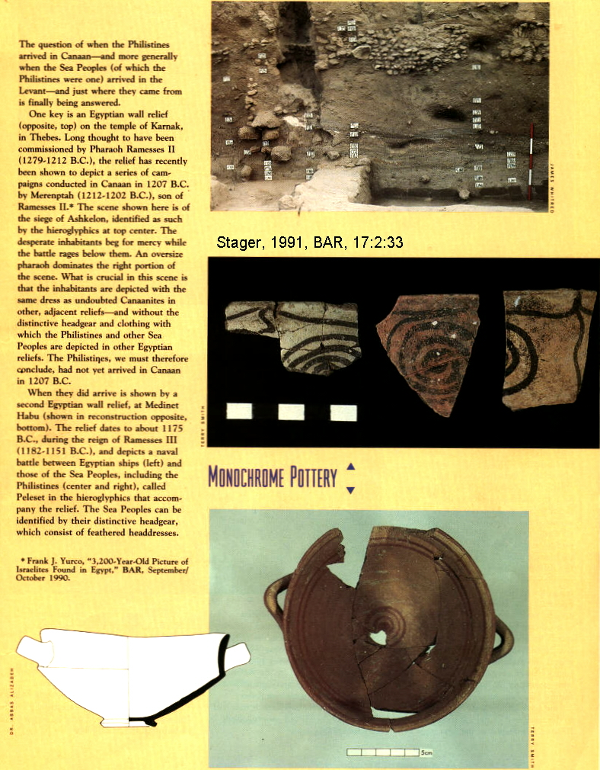

PHOTO LINK: POTTERY 006 Philistine "bichrom ware"
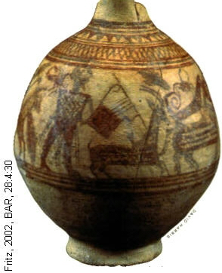
PHOTO LINK: EKRON 018 Philistine bichrome ware with geometric and stylized bird motifs
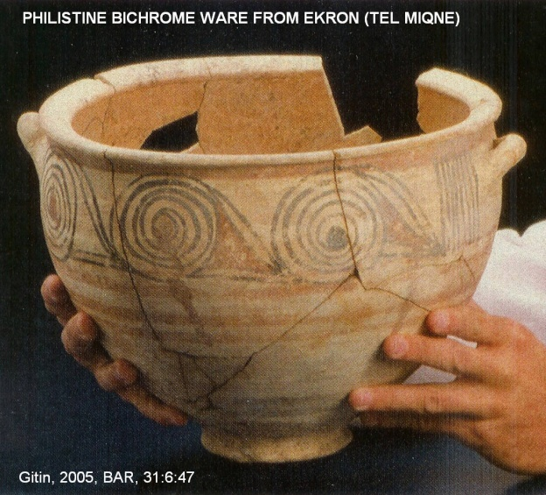

The connection between the Philistines and the Aegean is recognized by similar pottery types (Mycenaean IIIC-1b type) made locally in the Philistine Pentapolis (Ashdod, , Ekron, Gaza, and Gath). This type of pottery is found in Canaan only after the Philistines arrived.

PHOTO LINK: PHILISTINE 011 Cites of the Philistine Pentapolis (See ABOVE, ctrl+click to follow link)

PHOTO LINK: SEA PEOPLES 015 Mycenaean IIIC-1b pottery from Cyprus and
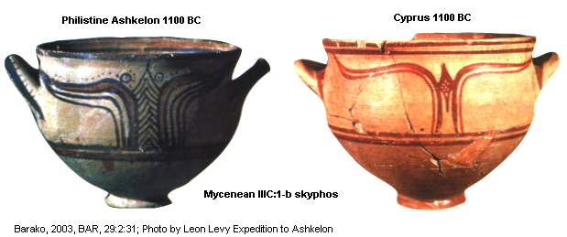

PHOTO LINK: BA099 Iron Age Incense Stand with Musicians, Philistine Ashdod, 10th century BC
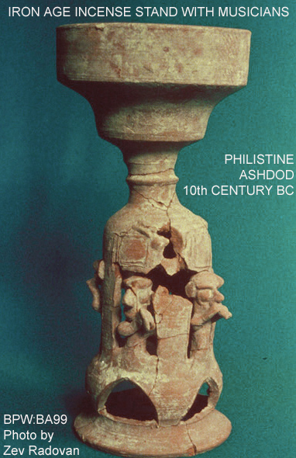
PHOTO LINK: BA128 Iron I Philistine Pottery, Ashdod
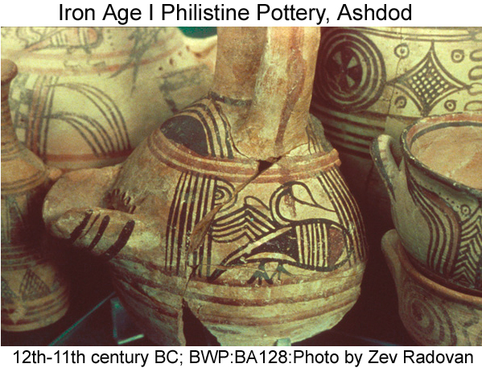

Another indication of the Philistine arrival is their cooking pots. At Ekron, Aegean-style, globular, one-handled cooking jugs dated to the Iron Age are found alongside Canaanite pots that have everted, triangular-profile rims which were used back into the Late Bronze Age (c. 1400-1200 BC; Killebrew, 1998 cited by Barako, 2003:30). The kalathos, a shallow bowl with flat horizontal handles, also from Cyprus and the Aegean region, appear at Philistine Pentapolis cites at this time (Barako, 2003:30).

The pottery of Philistine sites in Canaan, such as Ashkelon, show a evolution from Mycenean IIIC1 monochrome (c. 1175 BC) to Philistine monochrome varieties (c. 1150 BC). This “second generation” Philistine monochrome pottery assimilated Canaanite, Egyptian and other artistic motifs. Later, at Ashkelon Philistine bichrome ware developed and replaced the earlier monochrome ware. (Stager, 1991a; Wood, 1991). Other pottery differences are: 1) Philistines jugs and craters are often painted with swans and red/black geometric designs and 2) their jugs had strainer spouts. These strainers may had the function of removing mulch from their barley beer (Hoerth, 1998:234)

PHOTO LINK: ASHKELON 001 Panorama of digs (See ABOVE, ctrl+click to follow link)

PHOTO LINK: POTTERY 007 Mycenaean monochrome ware (See ABOVE, ctrl+click to follow link)

PHOTO LINK: POTTERY 008 Philistine bichrome ware
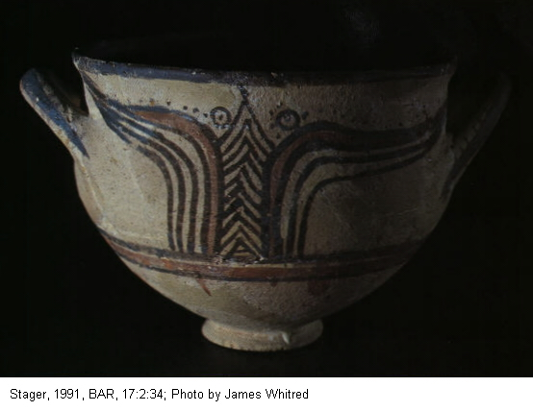

PHOTO LINK: POTTERY 009 Philistine bichrome ware
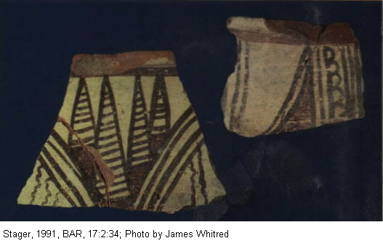

PHOTO LINK: POTTERY 018 Philistine pottery jugs and craters (See ABOVE, ctrl+click to follow link)

PHOTO LINK: AR010 Middle Bronze Age Silver Calf (Philistine Ashkelon) (See ABOVE, ctrl+click to follow link)

Architecture

Architecturally, the presence at Philistine sites of Aegean-type monumental circular hearths flanked by pillars (megaron- style) in large rooms point to and origin from Mycenaean Greece. The megaron-type architecture includes a long central hall, hearth, side rooms, and entrance with a porch flanked by pillars of pilasters These hearths are found in the Aegean and adjacent regions in the LB Age (c. 1200 BC). They are found in Israel ONLY at Philistine sites, beginning around 1175 BC (Gitin, 1998, cited by Gitin, 2005:67; Malkin, 1987 cited by Barako, 2003:64).

PHOTO LINK: MEGARON HOUSE 001 Drawing of a megaron house

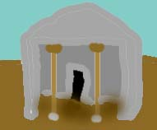
PHOTO LINK: MEGARON PALACE 001 Photo of megaron palace at Pylos
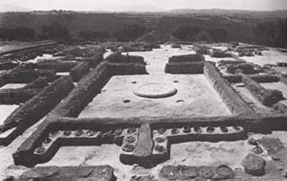

The cultic function of these hearths was to bear a sacred flame from the mother city (in the Aegean) that was carried to colonial sites early in the Philistine invasion (Malkin, 1987 cited by Barako, 2003:64).

Textiles

Along with the Philistine invasion came their traditional ways of making cloth. This is indicated by the presence of loom weights at several sites and suggests that the invasion involved families, not just soldiers (Barako, 2003:32).

PHOTO LINK: SEA PEOPLES 016 Loom weights from 1400-1100 BC
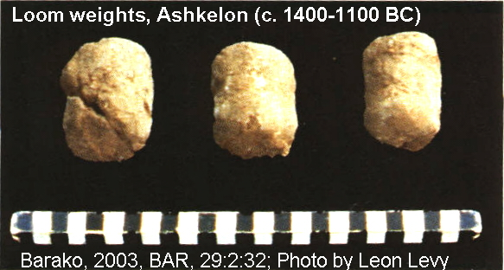

End of the Philistines in the Archaeological Record

These cultural markers, the artwork, pottery, textiles and architecture, all disappeared after 1000 BC. (Gitin, 1998, cited by Gitin, 2005:67)

Biblical History of the Philistines

Philistines are descendants of Mizriam (Genesis 10:14; 1 Chron 1:12; ). They are associated with Caphtor (present Crete) in Jeremiah 47:4, Amos 9:7, 1 Chron 1:12 and Deuteronomy 2:23. The Mediterranean Sea was called “Sea of the Philistines” (Exodus 23:31). These connections to Crete and the Mediterranean support the idea that they were a sea-faring people. They are “Kerthites” in 1 Samuel 30:14-16, Ezekiel 25:16 and Zephaniah 2:4. Another name for them is “Casluthites” (Genesis 10:14, 1 Chron. 1:12). Philistine inhabitants of Gaza, Ashdod, Ashkelon , Gath and Ekron are called “Avvites” (Avvim, NEB, Joshua 13:3).

PHOTO LINK: BA128 Iron I Philistine Pottery, Ashdod (See ABOVE, ctrl+click to follow link)

The “Philistine” king of Gerar, Abimeleck I, attempted to marry Abraham’s “wife-sister” Sarah in Genesis 20, and Abraham’s son, Isaac, pulled as similar trick on Abimeleck II in Genesis 26. These patriarchal references to “Philistine” refer to peoples living in areas later occupied by what later biblical editors recognized as Philistine.

The “Way of the Philistines” was avoided by Israelites during their Exodus from Egypt (Exodus 13:17). Again, this term has been retroactively attached to the coastal road linking Canaan and Egypt in the Exodus account by later editors, because Philistines did not exist as a separate people during the time of the Exodus (this is true of both Early or Late date reconstructions).

PHOTO LINK: PHILISTINES 013 Map of Way of the Philistine, and other possible Exodus routes
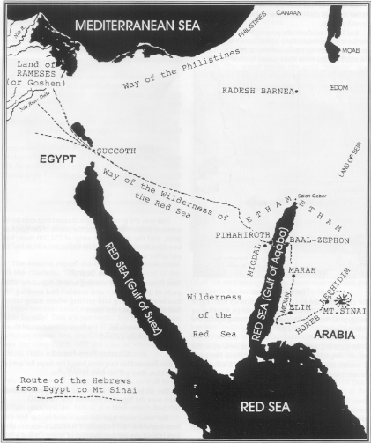

During the early years of the Judges, Judge Shamgar killed 600 Philistines in one day with an oxgoad (Judges 3:31).

During the leadership of Samson, Israel was governed by Philistines for 40 years (Judges 13:1). In the Battle of Ebenezer, Philistines captured the Ark of the Covenant (1 Samuel 4). It was later returned after having caused the Philistines many difficulties (1 Samuel 5 and 6). Then, after a spiritual revival, Samson defeated some Philistines and returned control of Ekron and Gath to the Israelites (1 Samuel 7:14).

PHOTO LINK: GATH 003 Map of travels of the Ark of the Covenant when under Philistine control (See ABOVE, ctrl+click to follow link)

PHOTO LINK: AR132 Capernaum, Synagogue decoration: Wheeled Ark
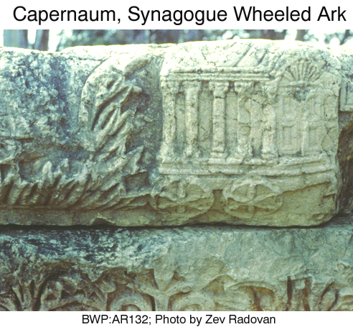

The encounter of David and Philistine Goliath is told in 1 Samuel 17 (see discussion in Chapter15). David went on to kill 200 more of them in 1 Samuel 18:22-30. After that, Saul began to persecute David. Saul sought to kill David who had found refuge among the Philistines, under King Ashish (1 Samuel 21:10, 27:2-12, 28:1-2, 29). David would later fightds as a mercenary for King Ashish.

PHOTO LINK: SAUL 005 Map of David and Goliath encounter
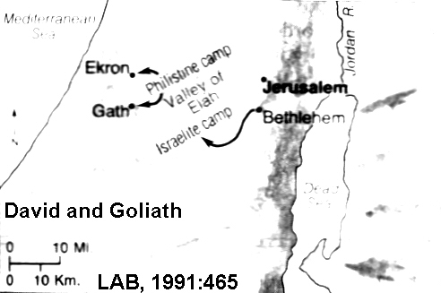

PHOTO LINK: PHILISTINE 006 Relief of Philistine soldier with distinctive head dress

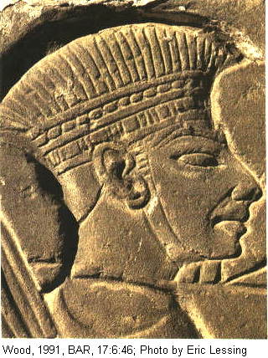
The Philistines killed King Saul and his sons (1 Samuel 31:1, 1 Chronicles 10:1). They are later conquered by David at the battle of Baal Perazim (2 Samuel 5:17-20), the battle of the Valley of Rephaim (2 Samuel 5:21; 1 Chron. 14:8-16) and the battle of Pas Dammin (2 Samuel 23:9).

The Philistines paid tribute to Israel during the reign of King Jehoshaphat of Judah (2 Chron. 17:11). Philistines were also defeated by King Hezekiah (2 Kings 18:8).

Along with the Israelites, Philistines cities were conquered by neo-Babylonian king Nebuchadrezzar (also called Nebuchadnezzar). The Philistine Pentapolis fell in 604. Later, in 586 BC, Jerusalem fell to his armies. Both Philistines and Israelites were exiled to Babylon. Unlike the Israelites, nothing is ever heard of the Philistines again. The areas and towns they occupied were taken over by a new group of coastal Canaanites, the Phoenicians (see Divided Kingdom: Phoenician Era; Stager, 1991b).

Sea Peoples Expelled by Egypt, Philistia re-enforced by them (circa 1190 BC)

The bulk of the Sea Peoples invasion happened after the Sea Peoples were expelled from Egypt by Rameses III in his eighth year (1176 BC, see discussion below). Finkelstein proposed lowering the date of the invasion to 1126 BC, a disputed interpretation (Barako, 2003:64). The invasion occurred after the Palatial, or Palace period of the Mycenaean-Aegean world which ended in destruction, along with many other Near East cultures. This pivotal year: c.1200 BC marks the end of the Late Bronze Age and the beginning of Iron Age I. In the Mycenean-Aegean world, artifacts of Iron Age I are described as being from the Post-Palatial Period and pottery as Late Hellaic IIIC (Yasur-Landau, 2003, 35).

Mycenaean Connection

PHOTO LINK: SEA PEOPLES 010 Map of Sea People Invasions from Greece (See ABOVE, ctrl+click to follow link)

PHOTO LINK: SEA PEOPLES 013 Map of sea invasion routes (See ABOVE, ctrl+click to follow link)

The Philistines were a variety of “Sea People”, Mycenaean Greeks, who migrated en mass to Canaan about 1175 BC (Stager, 1991). The Mycenaean connection is illustrated by findings of art in Philistine cities depicting legends found in the Iliad and the Odyssey

PHOTO LINK: PHILISTINE 001 mold of Odysseus and Scylla
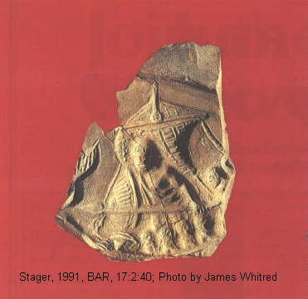

PHOTO LINK: PHILISTINE 002 impression from mold of Odysseus and Sea Monster Scylla
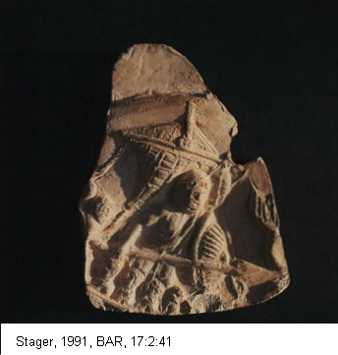

There is an on-going debate about how the Sea Peoples got to Palestine. Some think they came in their ships (Barako, 2003) while others think most of them came by land, through Anatolia (Yashur-Landau, 2003).

Sovereignty

There is also an on-going debate about Sea People sovereignty. Some think after a series of battles with Egyptians, they became Egyptian mercenaries and settled in Canaan, later to be forced seaward by the emerging Israelites under King David (Maeir and Ehrlich, 2001:24, Dalman, 2004:13). Others view them as an autonomous Sea People who never allied themselves with Egypt (Wood, 1991).

Land or Sea Invasion?

The population in the Philistine Pentapolis, with a total urban area of 180 acres may have been home to 18,000 people. The ships of the era had the capability of moving large cargoes, as is indicated by cargoes of copper "oxhide" ingots weighing up to 15 tons (Barako, 2003:33).

PHOTO LINK: SEA PEOPLES 017 Copper oxihide ingot.
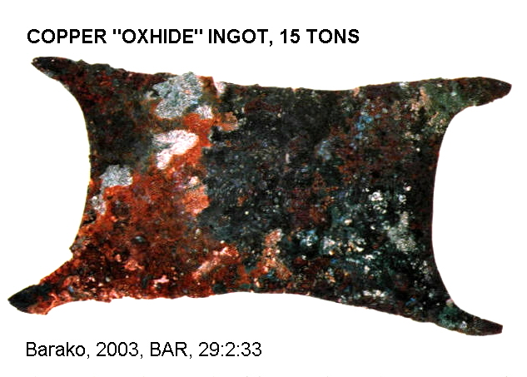

The king of Carmesh asked the king of Ugarit to send 450 metric tons (2000 kor) of copper which arrived in one or two trips by a single ship. That was a distance of 110 miles (Holftizer and Soldt, 1998, cited by Barako, 2002:64). By analogy, one ship could carry 225 metric tons of people and belongings. Armadas in the LB Age could be large. A Ugarit tablet records a request from a commander to the king of Ugarit for 150 ships (Dietrich and others, 1976; Hoftijzer and van Soldt, 1998:336-337. cited by Barako, 2003:64). A Hittite tablet reports that 100 ships brought grain to a vassal ruler in the Hittite Empire (Klengel, 1974, cited by Barako, 2003:64). And in the Iliad, Homer says that Mycenae and it's 11 vassal states sent 100 ships to Troy (Iliad 569-580, 612-614; cited by Barako, 2003:64).

PHOTO LINK: SEA PEOPLES 018 Uluburun shipwreck, Turkey c. 1306 BC
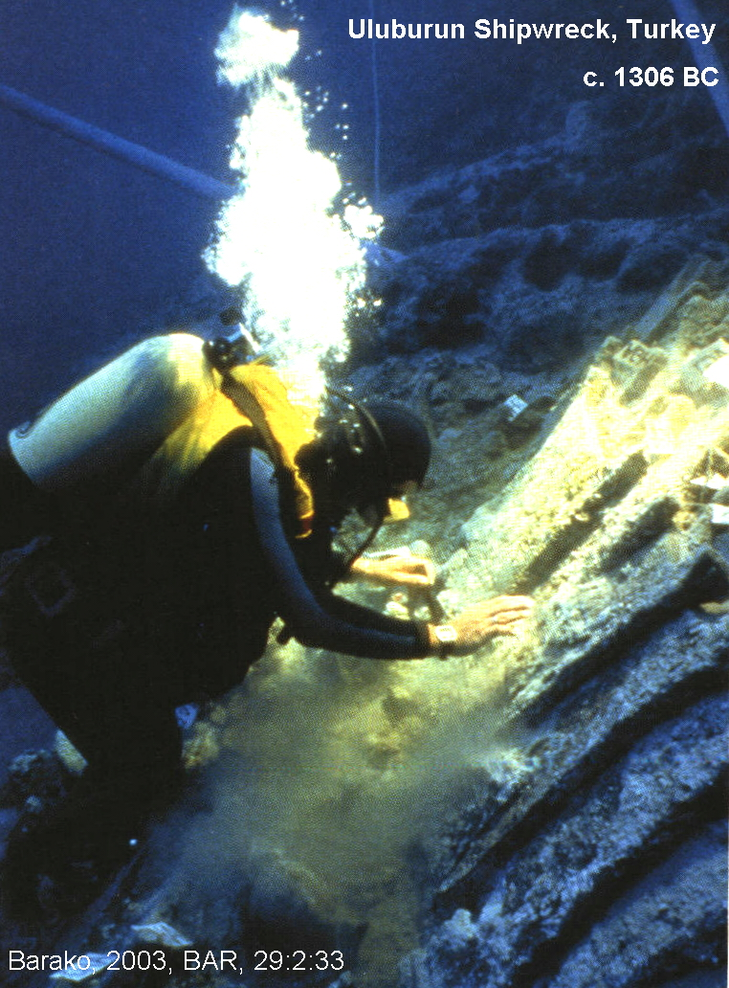
The LB age reliefs and other depictions show ships with 50 rowing stations ("penteconter"). So a fleet of 100 ships would be transporting 5,000 people. A quick invasion involving thousands of settlers would have been possible (Barako, 2003).

The theory that the dominant means of arrival of the Sea Peoples in Canaan was by land is based on the following:

1) There is no evidence of the high Mycenaean Palatial culture in Canaan: no palatial structures or Cyclopean walls, no linear B script, no elite art, frescoes or seal engravings.

2) The character of the earliest Philistine artifacts is typically Post-Palatial Late Helladic IIIC, not Palatial Late Helladic IIIB. The artifacts are humbler, simpler, made by refugees of a destroyed sophisticated civilization.

3) The hearths in Ekron and Ashdod are poor facsimiles of the magnificent hearths in the Mycenaean palaces

4) There is very little archaeological evidence for extensive maritime activity at the earliest Philistine sites in the Pentapolis such as anchors, depictions or ships, or imported 12-century pottery to indicate that trade was occurring.

The situation is very different in northern Israel at this time where seafaring was occurring at Dor. There is a 13th-12th century BC quay at Dor that is the only harbor installation ever found dating to the migration period (Rabin 1991; Stern, 1994 cited by Yasur-Landau, 2003)

SEA PEOPLES 019 Photo of hearth at Mycenaean palace at Pilos
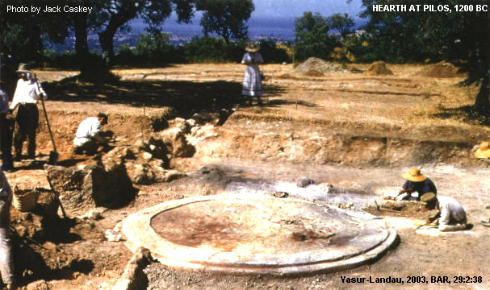

SEA PEOPLES 020 Photo of hearth at Ekron
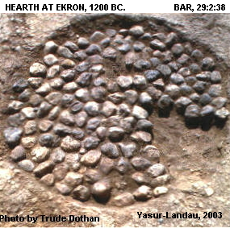

SEA PEOPLES 021 Drawing of hearth at Mycenaean palace at Pilos
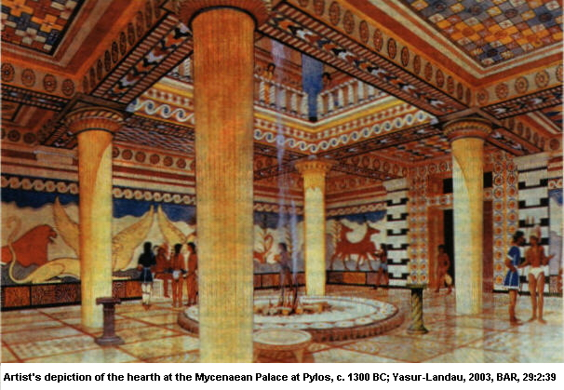

The capacity of the Aegeans to conduct a mass migration would have been curtailed following the destruction of their city-sates, and passage through Anatolia and Syria, would have been possible because those civilizations also were destroyed and lost control of their trade routes. Maritime expeditions for settlement of distant lands are described in some Linear B tablets from Pilos during the height of the Palatial Period. These describe the difficulty of conducting such an operation. It is unlikely that the people of the Post-Palatial period would have been able to do it (Yasur-Landau, 2003).

Unlike today, maritime travel was an expensive way to move large amounts of people and materials. That is why Alexander the Great (4th century BC), the first Crusaders (11th century AD) and the Pilgrim of Bordeaux (333 AD) all used a land route to get from the Aegean to the Levant (Yasur-Landau, 2003).

That the inland route to Canaan was largely open in the 12th century BC is indicated by an inscription from Rameses III's mortuary temple at Medinet Habu which tells of the all of the civilizations in Anatolia to the "Sea Peoples":

"No land could stand their arms, from Hatti [Hittites], Kode [Cilicia], Carchemish, Arzawa and Alashiya on" (Wilson, 1969 cited by Yasur-Landau, 2003)

The oared galley of the Post-Palatial period used by the Sea Peoples was long and narrow. It was a fighting ship, not a cargo ship. It had no deck. The small space between the two rows of rowers was not big enough for oxen, carts of the other paraphernalia that would have been required for a group of invader/settlers. The reliefs of sea battles at Medinet Habu reflect this: they boats contain warrior-sailors only. There are no women or children. In contrast, images of the land battles, reflecting conditions in Anatolia, have women carrying children, teenagers, and non-combatant men (Sweeney and Yasur-Landau, 1999 cited by Yasur-Landau, 2003:67). These images tell of a pattern of slow migration of an entire population, one of family settlements by farmers.

PHOTO LINK: SEA PEOPLES 022 Drawing of Medinet Habu battle relief with women and children in ox carts
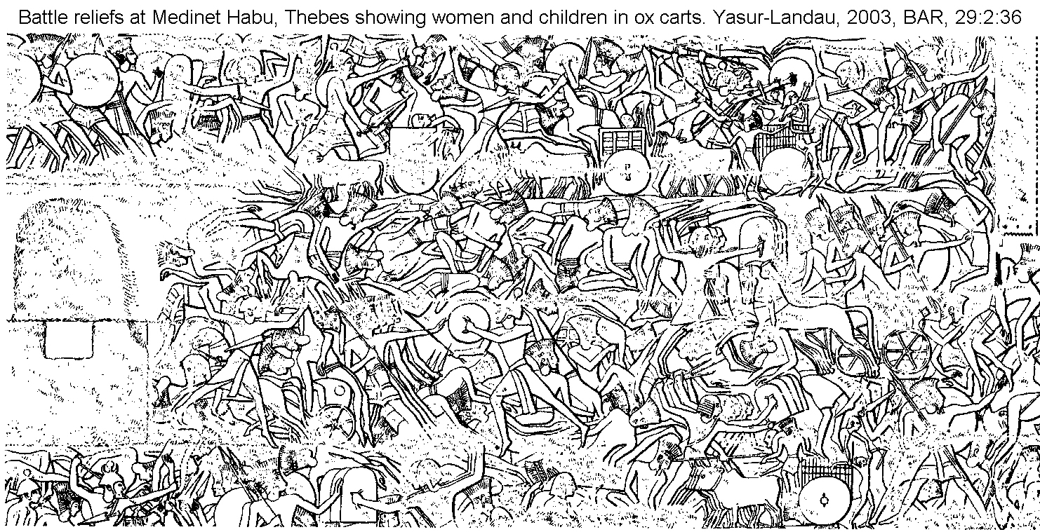

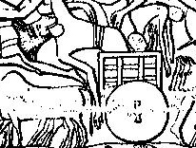
The establishment of the Philistines in Canaan may have originated as amphibious assaults to create bridgeheads. Later, invasion/migration by land occurred to these points of destination (Bietak, 1993; Stager, 1995; cited by Yasur-Landau, 2003:67).

Effects of the Sea Peoples Invasion

The effects of the Sea People migration on the history of the Israelites were great. Prior to arrival of the Sea Peoples, Israel’s highlands had been occupied only by a small population of scattered farmers. Some scholars think these people were of various non-Israelite ethnic groups (Mazar, 1986:38, cited by Dalman, 2004:14). If Israelite, this group is the people identified as “Israel” in the Merenptah stele (Dalman, 2004:14.)

When the Sea People invaded the coastal plain, they settled into what later became the Philistine Pentapolis. The Canaanites they displaced generally escaped northward into Syria while the coastal Israelites escaped east into the highlands. The expelled Israelites brought a new style of architecture (the 4-room house), and new systems of water management (cisterns replaced collar-rimmed storage jars) to the highlands. About 300 new highland settlements have been identified from this period (Bimson, 1991:4, cited by Dalman, 2004:14). The early Iron Age (IA) settlements continued into IA II (Dalman, 2004:14).

PHOTO LINK: FOUR-ROOM HOUSE 005 Illustration of four-room house with downstairs stables (See ABOVE, ctrl+click to follow link)

PHOTO LINK: DAN 005 Diagram of collar-rimmed jar
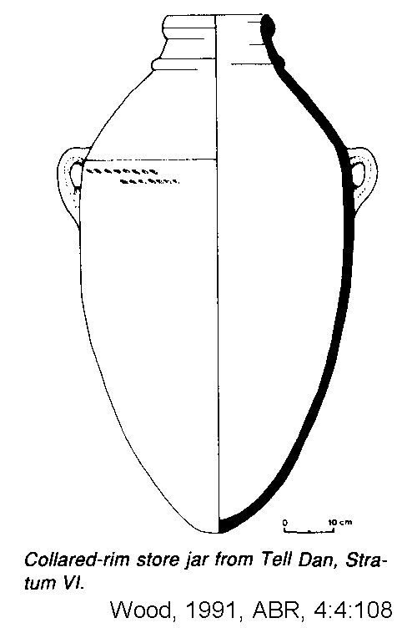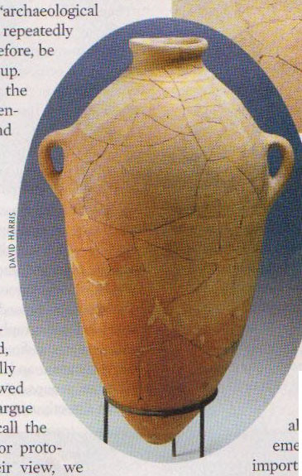

The Philistines (or Israelites?) at other Sites

Philistine presence at other sites in the Levant is conjectural. The Late Bronze age city of Megiddo (Stratum IX-VIIA; 1550-1130 BC) ) may have been destroyed the Philistines and afterwards occupied by them (Stratum IX-VIA; Finkelstein and Ussishkin, 1994:41). A hord of ivory carvings was excavated from the VIIA level at Megiddo, the latest of which date to the time of Rameses III (first half of 12th century; Finkelsterin and Ussishkin, 1994:40).

PHOTO LINK: MEGIDDO 014 Ivories from Megiddo LB Age 1550-1150 BC
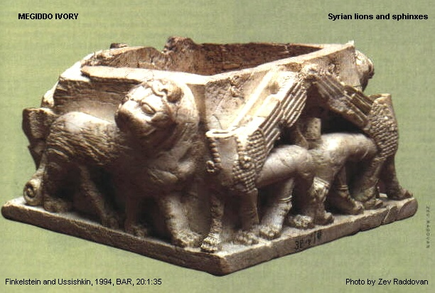

PHOTO LINK: MEGIDDO 015 Ivory of enigmatic figure

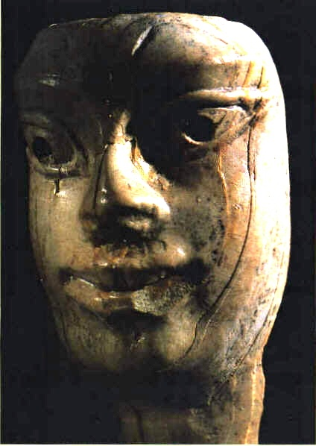

PHOTO LINK: MEGIDDO 015B Ivory of duck head
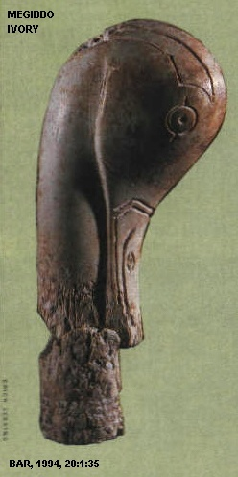

PHOTO LINK: GA027 Megiddo, Ivory Plaque, 1140-1130 BC
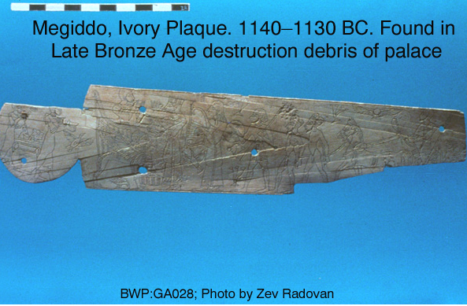

PHOTO LINK: GA029 Megiddo, Ivory Winged Bes, 1350-1150 BC
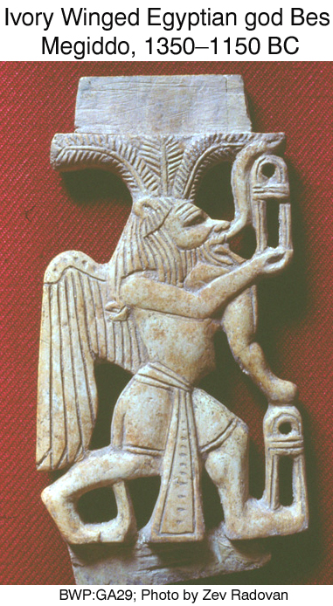

Yohan Aharoni argued that the city of Megiddo VIIA was destroyed by the Israelites (Finkelstein and Ussishkin, 1994:42).

Rameses III and the Sea Peoples (1175 BC)

PHOTO LINK: BETH SHEAN 002 Basalt bust of Rameses III (1118-1153 BC) (See ABOVE, ctrl+click to follow link)

Under the reign of Rameses III (1182-1151), in about 1175 BC, the Peleset Sea People (=”Philisitines”) were repelled from Egypt in a great naval battle (Stager, 1991a). This battle was memorialized in the mortuary temple of Rameses III at Medinet Habu.

PHOTO LINK: SEA PEOPLE 011 Rameses III mortuary temple at Medinet Habu
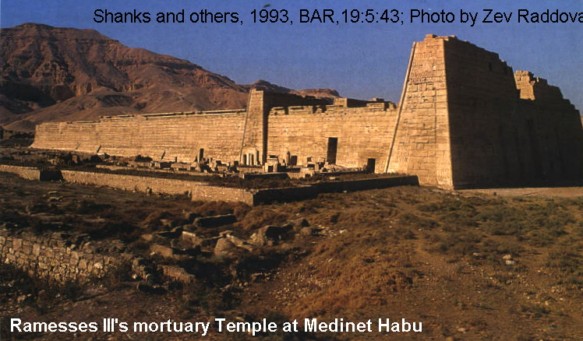

PHOTO LINK: SEA PEOPLE 001 Wall relief and painting of wall relief of naval battle at Medinet Habu
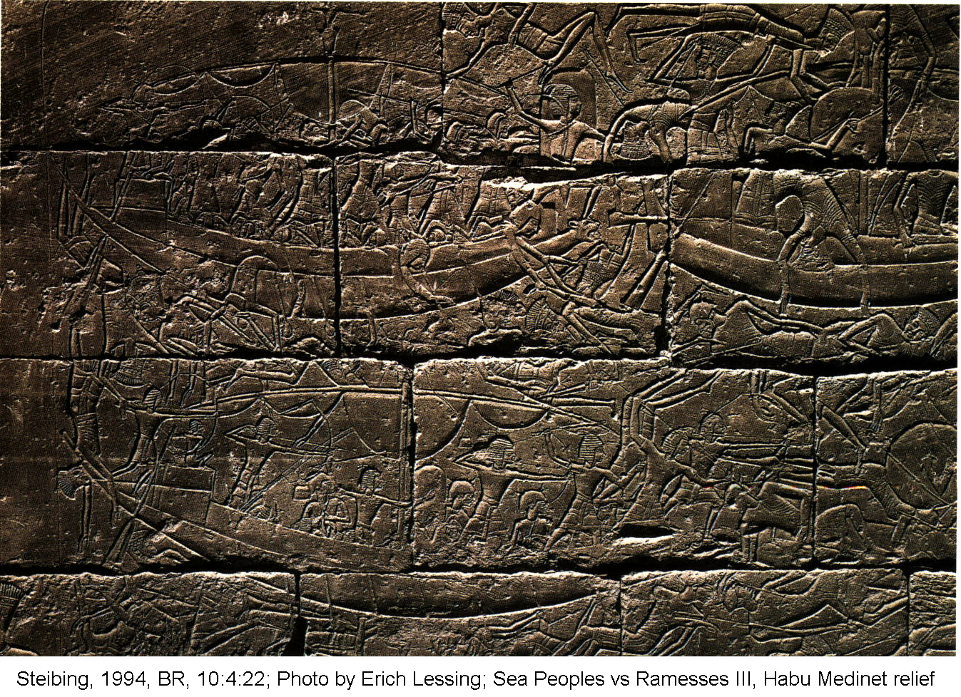
PHOTO LINK: SEA PEOPLE 002 Painting of wall relief and painting of wall relief of naval battle at Medinet Habu
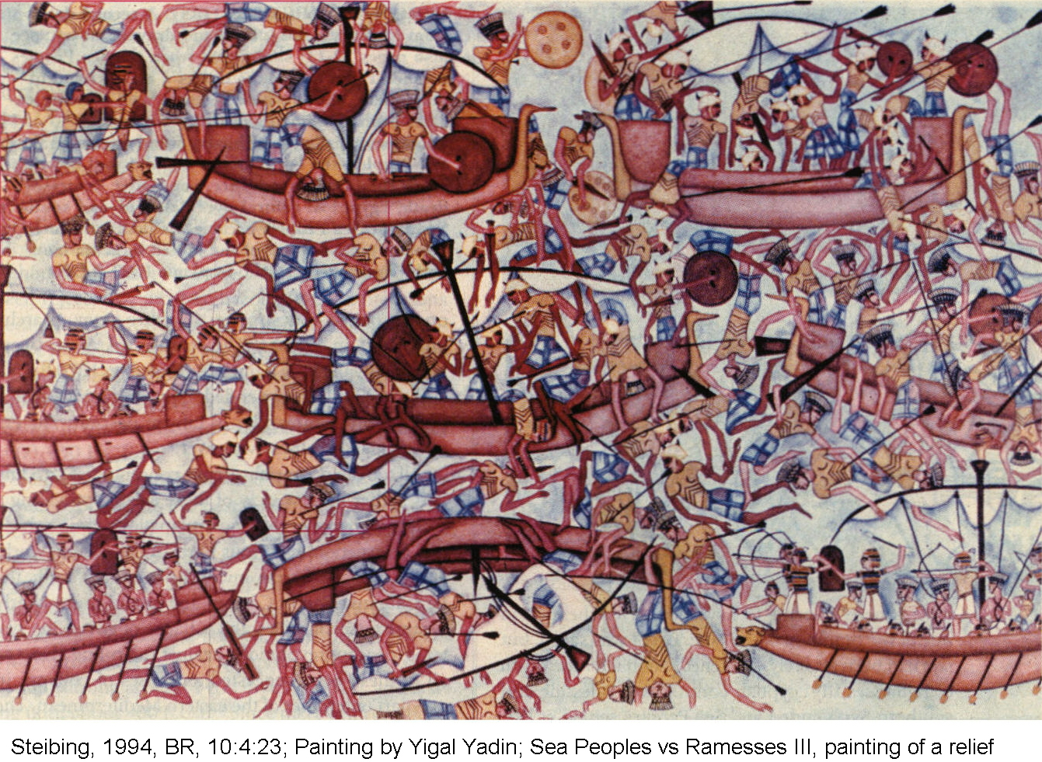

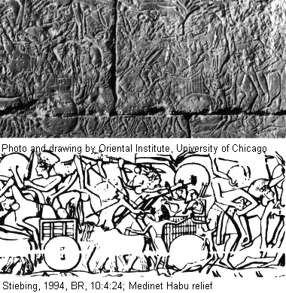
PHOTO LINK: SEA PEOPLE 003 Relief and drawing of relief showing women and children at the naval battle at Medinet Habu
Rameses III described the invasion of the Sea Peoples in his “War Against the Sea Peoples”. This relief states that:

“In year 8 under the majesty of Rameses III [c. 1175 BC]...The foreign countries [Sea Peoples] made a conspiracy in their islands. All at once the lands were removed and scattered in the fray. No land could stand before their arms, from Hatti [Hittite, Turkey], Kode [Cilicia], Carchemish, Arzawa and Alashiya [Cyprus] on, being cut off at [one time]. A camp [was set up] in one place in Amor [Amurru]. They desolated its people, and its land was like that which has never come into being. They were coming forward toward Egypt, while the flame was prepared before them. Their confederation [of Sea Peoples] was the Philistines, Tjecker [=Sikils], Shekelesh, Denye(n) and Weshesh land united” (Stager, 1991a).

Eventually, Sea Peoples (Hyksos) would conquer lower Egypt. Rameses III was able to hold them off as the following continuation of the “War Against the Sea Peoples” inscription indicates:

They laid their hands upon the…lands as far as the circuit of the earth, their hearts confident and trusting: "Our plans will succeed!"

I organized my frontier.., prepared before them ... I have the river mouths prepared like a strong wall, with warships, galleys, and coasters … manned completely from bow to stern with valiant warriors carrying their weapons. The troops consisted of every picked man of Egypt. They were like lions roaring upon the mountaintops. The chariotry consisted of runners, of picked men, of every good and capable chariot-warrior The horses were quivering in every part of their bodies, prepared to crush the foreign countries under their hoofs. I was the valiant Montu [Egyptian war god] standing fast at their head, so that they might gaze upon the capturing of my hands ...

Those who reached my frontier, their seed is not, their heart and their soul are finished forever and even those who came forward together on the sea, the full flame was in front of them at the river mouths, while a stockade of lances surrounded them on the shore. They were dragged in, enclosed, and prostrated on the beach, killed, and made into heaps from tail to head. Their ships and their goods were as if fallen into the water. (ANE 1:185-186; ANET 262-263, cited by Horeth, 1998:232-233)

These accomplishments of Rameses III are also recorded on the Papyrus Harris I.

PHOTO LINK: HARRIS PAPYRUS 1 001 Thebian Section (See ABOVE, ctrl+click to follow link)
PHOTO LINK: HARRIS PAPYRUS 1 003 Memphite Section (See ABOVE, ctrl+click to follow link)

It describes the enslavement of Sherden, Weshesh and Libyan Sea Peoples by Rameses III. Collumn 77, lines 3-6 contain this report:

“ I caused that they [the Libyans] cease to tread upon the borders of Egypt. I carried off the ones whom my knife spared: numerous captives, their woman and their children like hundreds of thousands, their herds in the number of tens of thousands, I established their leaders in strongholds upon my name. I gave to them commanders of hosts and tribal leaders, they being branded and made into slaves, they being stamped with my name, and their woman and their children being treated likewise” (Schulman, 1964 quoted by Wood, 1991).

The treatment of Shoshu (Shasu) Bedouin captives of Edom (whom some suggest are proto-Israelites) in the Trans-Jordan by Rameses III was harsh:

“I destroyed the people of Seir [Edom] among the Bedouin tribes, I razed their tents; their people, their property, their cattle as well, without number, pinioned and carried away in captivity, as the tribute of Egypt, I gave them to the Ennead of the gods, as slaves for their houses (Wilson, 1969 quoted by Wood, 1991).

PHOTO LINK: EDOMITE 001 Map of Edomite expansion into Judah
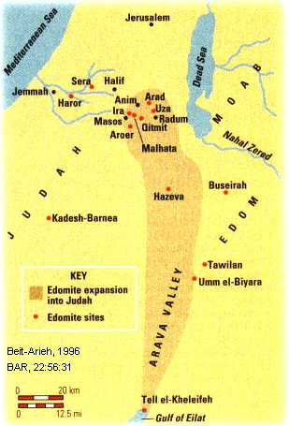

Some scholars think that the Sea People/Peleset defeat of 1175 BC resulted in vasseldom for them and resulted in migration to Canaan under the suffrage/support of Rameses III whom they served as garrison troops. A competing theory is that the Sea People’s failure to conquer Egypt caused them to shift military theater and invade Canaan (Singer, 1992; Wood, 1991,p.48).

The cities on the southwest coastal region of Canaan all have destruction levels at the end of Late Bronze Age (LB). Then Agean-style pottery (Mycenean IIIC:1b) appears in the stratigraphic records. These pottery are found in poor squatter phases of occupation following LB destruction of Egyptian or Canaanite towns. This monochrome ware gives way, after a few decades, to Philistine bichrome ware which is abundant at these sites for another 200 years (Wood, 1991,p.50).

PHOTO LINK: POTTERY 008 Philistine bichrome Ashkelon late 12th century (See ABOVE, ctrl+click to follow link)

PHOTO LINK: POTTERY 009 Philistine bichrome fragments (See ABOVE, ctrl+click to follow link)

Tell el-Farah

An example of this destruction of Egyptian settlements by Sea People is at Tell el-Farah. There a building with Egyptian architecture and Egyptian artifacts (cartouches) in Tell el-Farah that was destroyed in the early part of the 12th century BC (probably 1177 BC). Squatter settlement followed with crude circular pits containing Aegean-style pottery. Later a new city was build upon the older one. This sequence of events is identical to those identified at Site A-289 of the northern Sinai (Oren, 1987 cited by Wood, 1991).

PHOTO LINK: SEA PEOPLES 009 Map of Sea People destructions, including Tell el-Farah (See ABOVE, ctrl+click to follow link)

PHOTO LINK: SEA PEOPLES 007 Building YR at Tell el-Farah
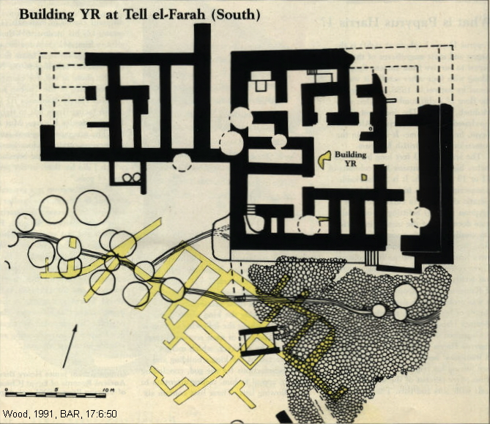

PHOTO LINK: SEA PEOPLES 008 Cartouch at Tell el-Farah.
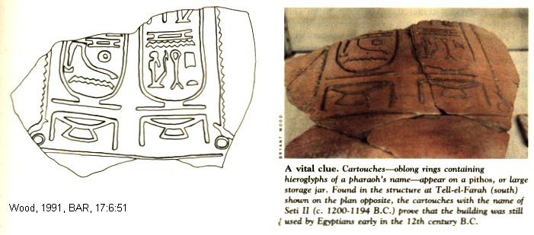

The pottery dating from the earliest squatter phase is locally made, but is of Aegean design. This indicates that immigrants made this pottery from local clay using patterns and styles they learned in their Aegean homelands. This pattern of invasion and settlement of Sea Peoples in coastal Canaan is seen (from north to south) at Tell Jerishe, Jaffa, Gezer, Tel Mor, Ashdod, Ashkelon , Tell Jemmeth, Tell el-Far-ah and Haruvit. This was a widespread pattern of invasion and conquest, not of peaceful settlement of selective Egyptian garrisons. The Philistines occupied prime agricultural coastal lands that were along the major coastal land rout, adjacent to Egypt’s sea-lane and included Egypt’s primary administrative center of the northern territories, Gaza (Wood, 1991).

While coastal cities that were formerly under Egyptian influence fell to Philistine settlement, Egyptians maintained control of inland cities (Beth-Shean, Megiddo, Lachish, Tell esh-Sharia) for several decades after the Philistine invasion.

The general picture that emerges is this: An invasion started in the north and there was a systematic destruction of coastal Egyptian and Canaanite cities that extended all the way to the borders of Egypt. The advance was stopped by Rameses III as depicted in naval battle reliefs at Medinet Habu and in the Papyrus Harris 1. The retreating Philistines took up residence in the south-west coastal region of Canaan. Here the Philistines developed a new trading maritime-based empire that lasted for 150 years until the arrival of the Israelites. The Philistines had skirmishes with the Israelites throughout the periods of the Conquest-Judges. It was not until about 1000 BC that King David succeeded in overpowering them (Wood, 1991).

PHOTO LINK: PHILISTINE 007 Antrhopoid coffin in grotesque style showing Egyptian influence
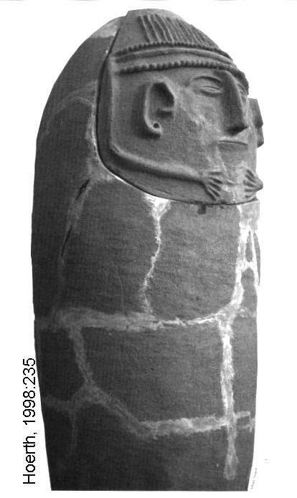

This theory was criticized by Rainey (1992) who believes the great sea battle described in the Karnak wall reliefs happened in coastal Palestine and that the Egyptians did colonize conquered Sea People settlements . He thinks the theory described by Wood is too simplistic and fails to fit many of the archaeological facts for sites along the coastal trade routes between Sea People settlements and Egypt.

Ekron

Ekron is one of five principle cities of the Philistines (Joshua 13:3). It was part of the early allotment to Judah during the Conquest (Joshua 15:11 and 45, Judges 1:18).

PHOTO LINK: MAP 12 TRIBES OF ISRAEL 002
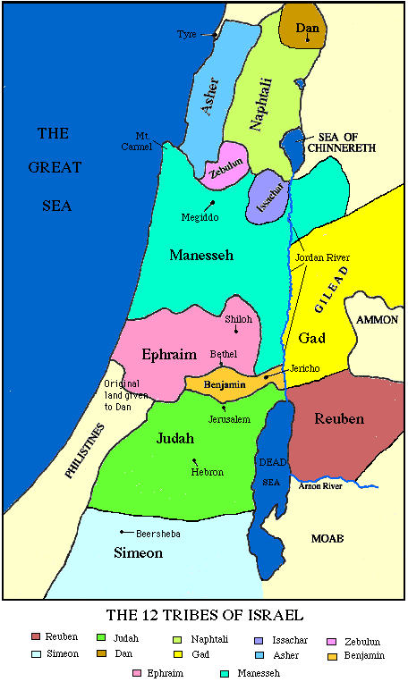

Later, it was assigned to the tribe of Dan (Joshua 19:43). After being captured in the Battle of Ebenezer, Ekron was one of the cities where the Ark of the Covenant was taken (1 Samuel 5:10). A temple to the city patron god Baal-Zebub was built at Ekron (2 Kings 1:2). Throughout its history, Israelite prophets spoke against the city including Jeremiah (25:50), Amos (1:8), Zephania (2:4) and Zacheriah (9:5).

PHOTO LINK: EKRON 003 Remains of Tower, large ashlars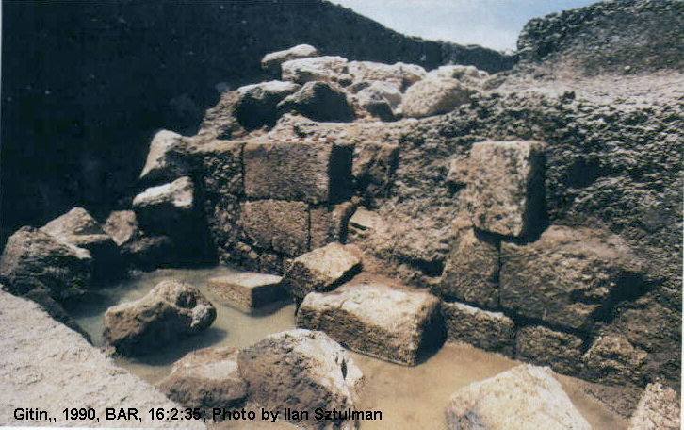
PHOTO LINK: EKRON 009 Map of Tel Miqne-Ekron
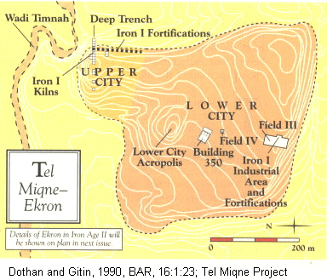

PHOTO LINK: EKRON 004 Location map showing Cyprus Philistine sites
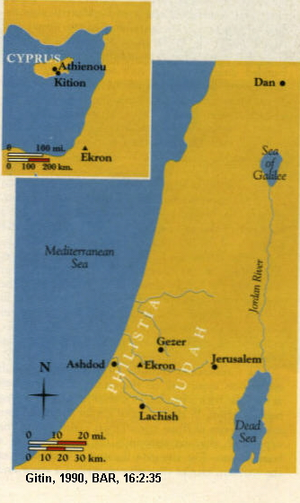
PHOTO LINK: EKRON 013 Aerial photo of Tel Miqne, Biblical Ekron
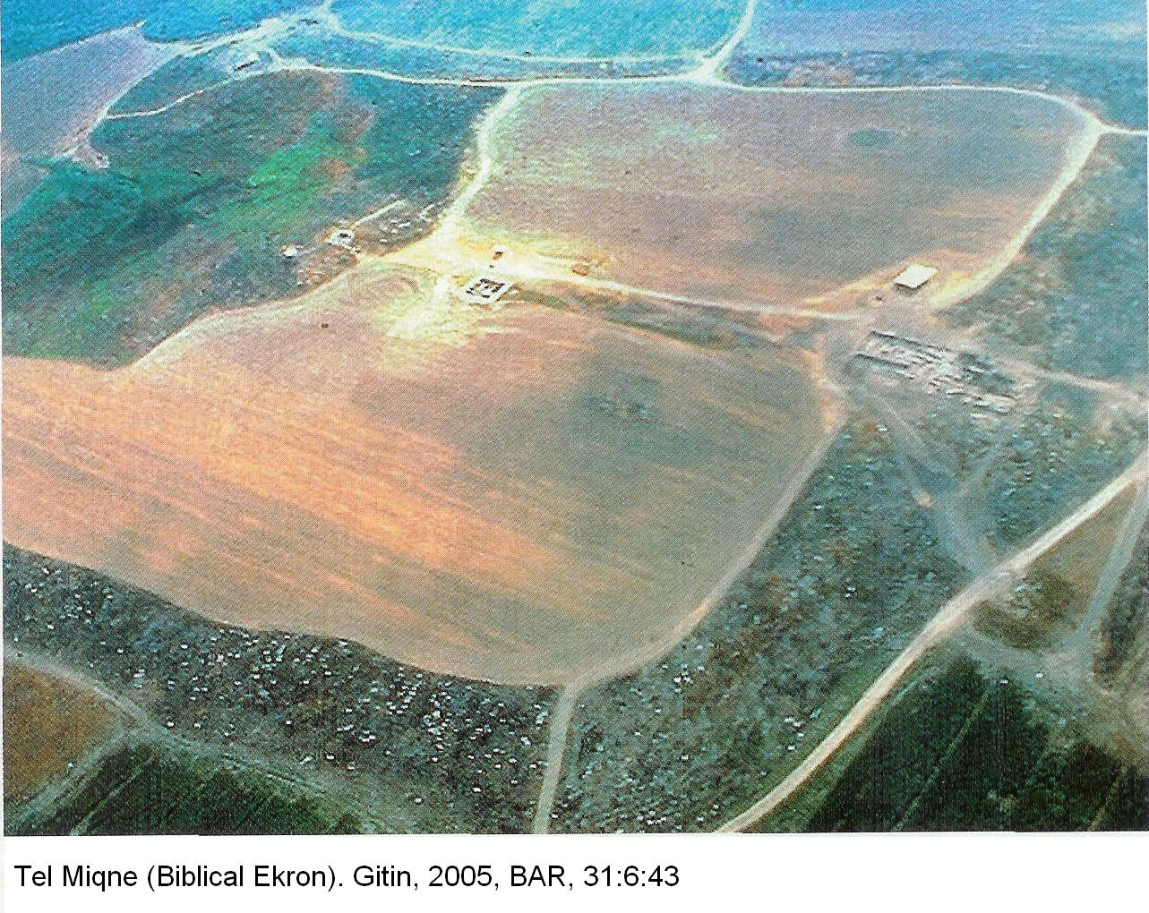
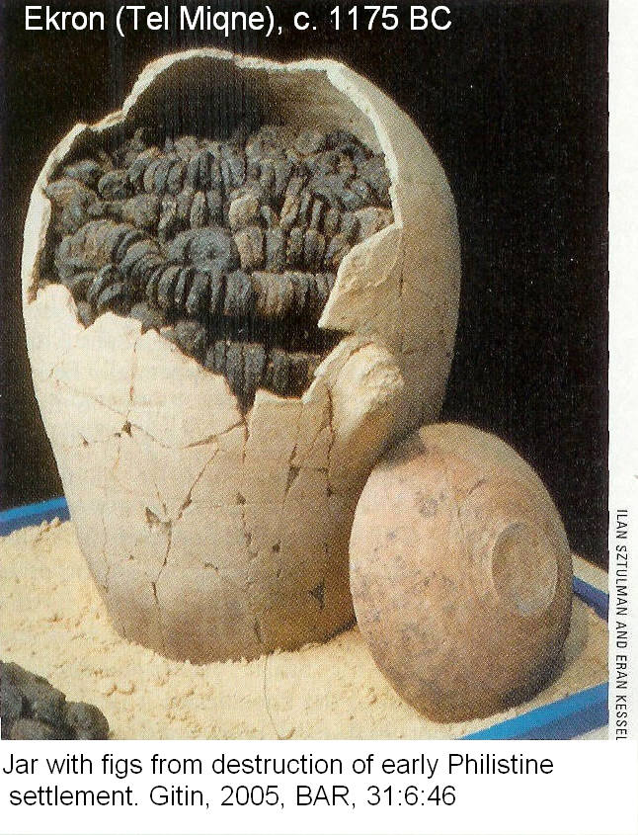
The Philistines came to Tel Miqne (later named Ekron) about 1175 BC. At that time, there was an un-walled 10-acre Canaanite settlement there (Stratum VIII), which the Philistines destroyed. One of the Caananite storage buildings from Stratum VIII had jars filled with figs (Gitin, 2005:45)

PHOTO LINK: EKRON 017 Jar of figs from destruction of Canaanite Tel Miqne by Philistines c. 1175 BC (LEFT)

On the ruins of the Canaanite settlement, the Philistines rebuilt the acropolis, and also the lower tell. That portion of the tell had been destroyed centuries earlier in the Middle Bronze Age (16th century BC). They created a 50-acre urban center with massive fortifications, monumental buildings, pottery factories, and cultic areas (Strata VII-IV). Ekron, prospered until about 1000 BC when it was destroyed (Gitin, 2005:45). The destruction is attributed to Egyptian Pharaoh Siamon, or the Israelites (Dothan, 1990, cited by Gitin, 2005:45). The same fate overtook other cities of the Philistine pentopolis at this time.

The artifacts at Ekron indicate that the Philistines had a prosperous, refined culture, with many beautiful artistic endeavors. These and their distinctive architectural designs disappeared from Ekron about 1000 BC

Dor

Dor and Canaanites (2000-1200 BC)

Tell Dor is an important archaeological site because it has 45 feet of archaeological stratigraphy spanning a time period from the 20th century BC to 332 BC. Dor is a very ancient Canaanite city on the coast of Palestine, about 8 miles (13 km) north of Caesarea.
PHOTO LINK: DOR 001 Aerial photo
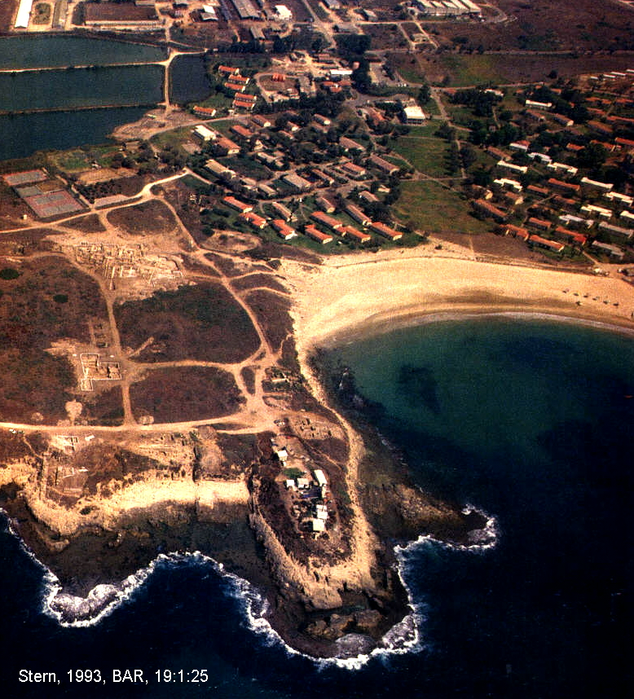

PHOTO LINK: DOR 002 Location maps
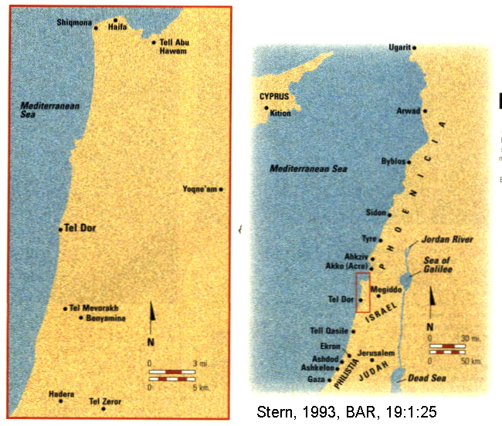

The earliest archaeological datum (20th century BC, Middle Bronze Age III) is of a Canaanite city that pre-dated arrival to coastal Canaan of the Sea People. Canaanite presence extended into the Late Bronze Age (1500-1200 BC, during period of the Judges). Pottery and Egyptian seals from this period have been found at Dor (Stern, 1993a, p.25). Abraham (2165-1942 BC) may have known of this early Dor from his travels to Haran (Whitcomb, 1968).

PHOTO LINK: DOR 004 Mycenaean pottery and Egyptian seal; Stern, 1993a, BAR, 19:1:29
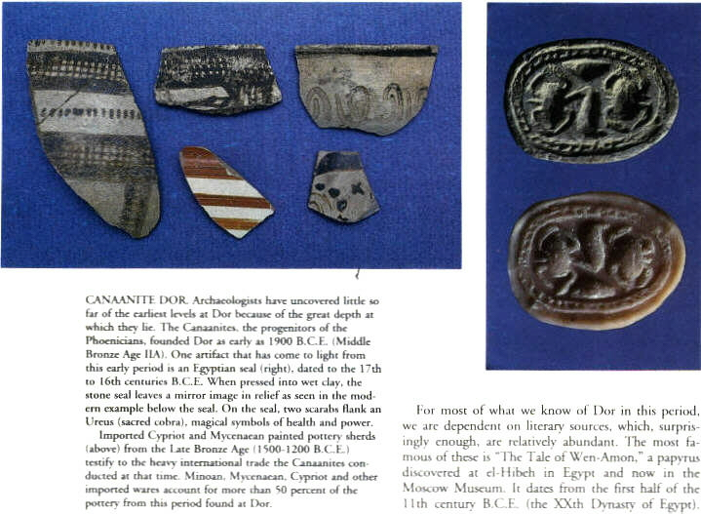

In the lowest Canaanite levels excavated so far, over 50 percent of the pottery is imported Minoan, Mycenaean and Cypriot ware (Stern, 1993a, p. 25).

Dor and the Sikils (1150-1050 BC)

The Egyptian records about the Sea Peoples, discussed above (Merenptah Battle Reliefs at Karnak and the Merenptah Stele) indicate that the Sea Peoples who attacked Palestine and Egypt at the beginning of the 12th century BC included the Philistines, Sikils, Sherden, Shekelesh, Denyen, and Weshesh. Three or four of these settled in coastal Palestine. From south to north they were: Philistines, Sikils, Sherden and Denyen. This last tribe, Yigael Yadin suggested was a Sea People who became the Israelite tribe of Dan (Stern, 1993, p.26).

The principle city of the Sikils (who came from Sicily) was Dor. Joshua 11:2 and 12:23 refer to this site as "Naphoth Dor." Naphoth Dor was one of several cities rallied by King Jabin of Hazor to fight the Israelites at the battle of the Waters of Merom (c. 1390 BC) in Joshua 11:1-12 (Stern, 1993a, p.26).

Although Joshua won that battle, and the king of Dor was taken prisoner (Joshua 12:3), the town of Dor was not occupied by Israelites (Joshua 11:11-13; Judges 1:27; Compton’s Interactive Bible). This pattern of military destruction but with no re-habitation by the victors happened to other large Canaanite cities in the Jezreel Valley during the Conquest/Judges period (1405-1043 BC; Whitcomb, 1968, Stern, 1993a, p.26).

During period of the Judges, the territory around Dor became part of the allotment for the tribe of Asher (Joshua 19:24-31) and later Manasseh (Joshua 17:11), but not the city itself. About this time, an inscription about Rameses II (13th century BC) mentioned Dor as a city on the Via Maris. A more detailed inscription of Rameses III (1182-1151) describes how he repulsed the Sea Peoples attack on Egypt in about 1180 BC (Stern, 1993a, p.26). In a bit of hyperbole, the inscriptions and relief indicates that the Denyen, Philistines and Sikils were "destroyed". About this time, a Ugaritic text describes Sikils as pirates who live on their ships (Stern, 1993a, p.27).

PHOTO LINK: PHILISTINE 003 Medinet Habu naval battle relief Rameses III
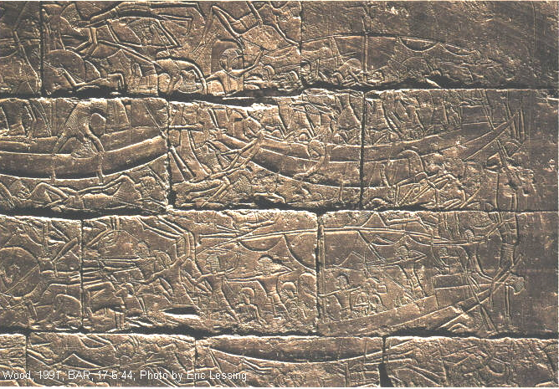

PHOTO LINK SEA PEOPLE 002 Painting of wall relief and painting of wall relief of naval battle at Medinet Habu (See ABOVE, ctrl+click to follow link)

The "Onomasticon of Amenope", which dates from the 12th or early 11th centuries BC contains a list of names. This list describes "Ashkelon, Ashdod, Gaza, Asher...Sherden, Sikils and Philistia." As we saw above, key Philistine cities were the first three in this list. The fourth, Asher, may have been under Israelite control at this time, as part of their inheritance of territory in the Acre valley (Stern, 1993a, p.27).

Hammoth Dor (hot spring of Dor) is identfied as a Levitical city for the sons of Gershon in Joshua 21:32. Hammoth Dor may be identical with Hammath (Jos 19:35), a city of the tribe of Naphtali. The town is called Hammon in 1 Chronicles 6:76 (Comptons Interactive Bible).

The relationship between Sikil culture and the Philistines to the south is not well understood. Much of the information we do have about the Sikils comes from an Egyptian story called "The Tale of Wen-Amon". It gives information about what Palestine was like in the 11th centrury BC. The story is a description of a failed purchasing expedition by a priest from the temple Amon in Karnak. The priest, Wen-Amon, journeys through Dor on this way to Biblos to purchase supplies for the temple. The story indicates that Sikils were in Dor with a large fleet in the 11th century. This period included the Judgeships of Gidion (commenced 1191 BC) and several others, up to the coronation of King Saul in 1043 BC (Whitcomb, 1968).

The Sikils lived in the northern Sharon plain, with Sherden (who came from Sardinia) to the north (Acre Valley), and Philistine territory to the south (Tell Qasile; Stern, 1993a, p.27).

PHOTO LINK: JUDGES 002 Map of tribal allotments and the travels of Wen-Amon.
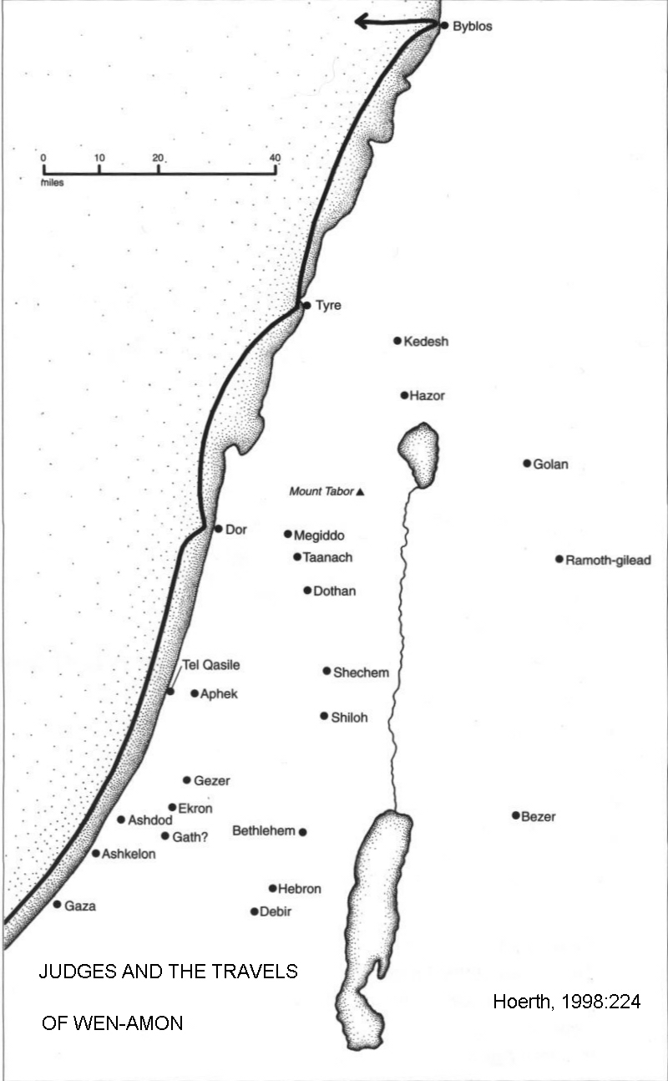

PHOTO LINK: DOR 006 Sikil City wall 12th century BC
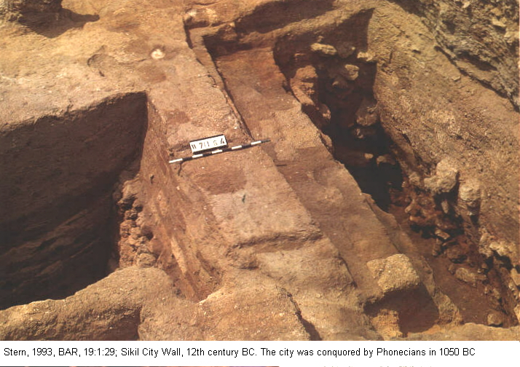
PHOTO LINK: AR053 Tell Qasile Philistine Temple, 12th and 11th centuries BC (See ABOVE, ctrl+click to follow link)

PHOTO LINK: AR106 Tell Qasile, Philistine Ceramic Cult Stands, 11th or 10th cent BC (See ABOVE, ctrl+click to follow link)
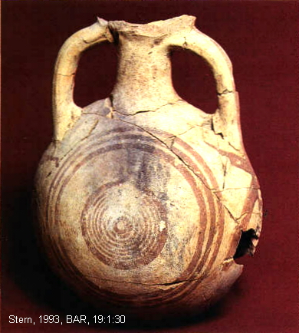
The Sikil city had a 12th-century massive fortification wall and rampart that is the largest ever discovered in Palestine during this period. In spite of these defenses, the Sikil city at Dor was destroyed by fire which left a 6-foot thick ash and charcoal layer dating to about 1050 BC (Stern, 1993a, p.28)

PHOTO LINK: DOR 008 Sikil pilgrim flask pottery (RIGHT)

PHOTO LINK: DOR 005 Sikil City burnt remains area G
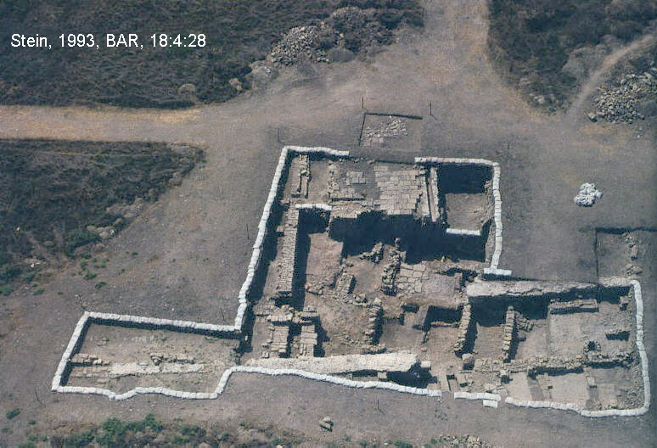

PHOTO LINK: DOR 007 Sikil destruction layer carbonized earth and pottery
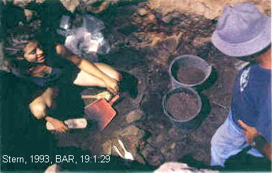

The identity of the destroyers of Sikil Dor is unknown. The time of destruction is at the end of the period of Judges and the beginning of wars leading to a united Israelite monarchy. Artifacts from Dor from the 12th and 11th centuries BC include pottery that is similar to Philistine bichrome ware and incised cow scapula.

PHOTO LINK: DOR 009 Sikil pottery geometric designs
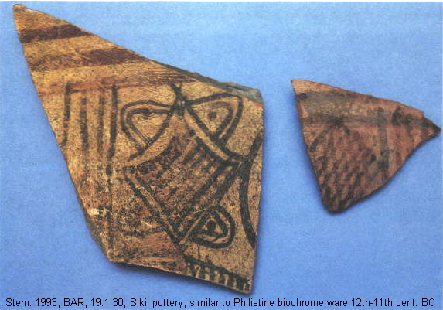

PHOTO LINK: DOR 010 Cow scapula-musical or cultic instrument
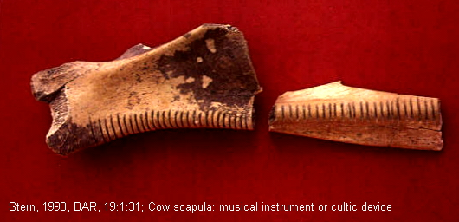

The function of the incised cow scapula is debated. It may be part of a musical instrument or a cultic device associated with divination.

Dor and the Phoenicians

The destruction of Dor in circa 1050 BC coincides with several other destructions in the Acre Valley and on the northern coast (Akhziv, Tell Keisan, Tell Abu Hawam, Megiddo, Yoqne'am and Tell Mikhal). After all this destruction, the next phase of occupation at these sites is by a people with Phoenician material culture (Stern, 1993a, p.30).

Stern attributes the circa 1050 destructions to Phoenicians from Tyre, Sidon, Byblos and/or Arwad (Phoenician cities that never surrendered to Sea Peoples). Those four cities were a base upon which Phoenician culture expanded. To the south, in Philistine country, the Phoenicians came in peace as traders. In the north, the Sikils of Dor, the Sherden of Acre (Acco), and Sea Peoples other cities were conquered in war by the Phoenicians (Stern, 1993a, p.30). Thus did the Phoenicians begin a cultural march that eventually took their influence to Cyprus, the northern coast of Palestine, Spain and Northern Africa. It was in this era of cultural flux that King David appeared on the scene (More of that story about Dor will be told in Chapter 15, "The Golden Age").

Period of Egyptian Weakness, Rameses IV to Rameses XI, (1164-945 BC)

After Rameses III, Egyptian power and fortunes declined. Eventually the country broke up into independent states and Sea Peoples occupied the Delta (Hoerth, 1998:238).

JUDGE (AND WANT-TO-BE KING) ABIMELECH (1151-1159 BC)

Shechem (circa 1125 BC)

In Judges 9, Abimelech, son of Gidion tried to make himself king over Israel and establish the dynasty that his father, Gideon (Jerub-Baal) refused to establish. With support of his mother's Canaanite clan, he hired mercenaries and then committed ritual murder of his 70 brothers on the altar of Yahweh that his father had built at Ophrah. Abimelech governed Israel for three years (Judges 9:22). After an anti-Abimelech faction lead by Gaal son of Ebed came to Shechem, Abimelech organized an ambush against his own people. Abimelech captured the town, burned its tower (containing 1,000 people), and sowed Shechem's field with salt (Judges 9:45-49). Archaeological surveys indicate that the city was destroyed violently circa 1125 BC. There are ruins of temple of Ba’al Berith [or El-berith, "Lord of the Covenant"] there (Wood, 1982; 2005:46, Stager, 2003).

PHOTO LINK: SHECHEM 003 Location Map
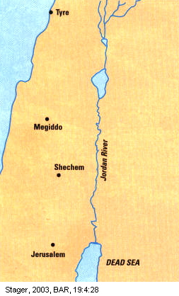
PHOTO LINK: JUDGES 008 Map of the fall of Abimelech
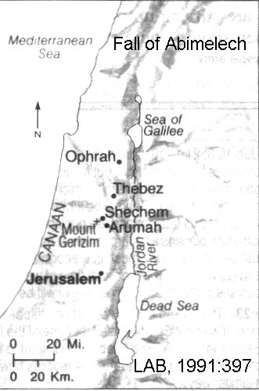

PHOTO LINK: SHECHEM 013 Aerial photo
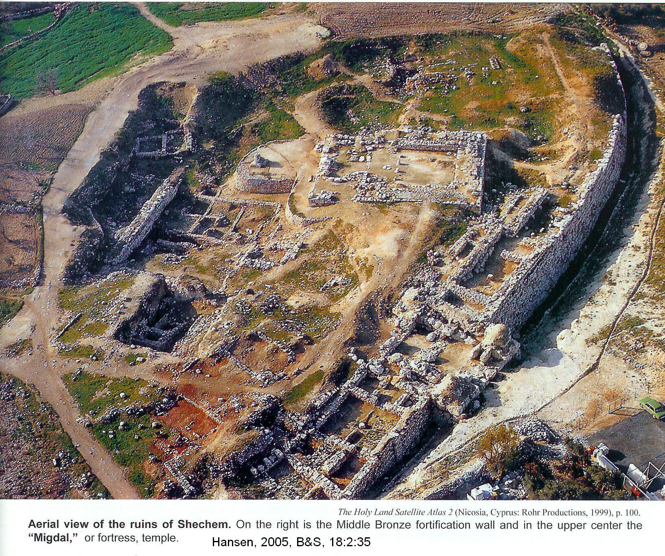

PHOTO LINK: SHECHEM 001 Temple of Baal Berith at Shechem
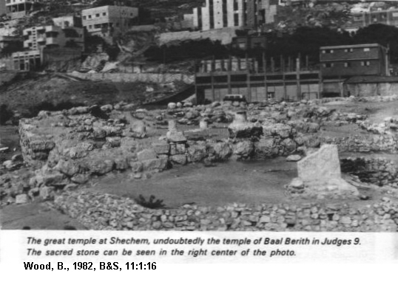

PHOTO LINK: SHECHEM 010 Ruins of MB age Shechem
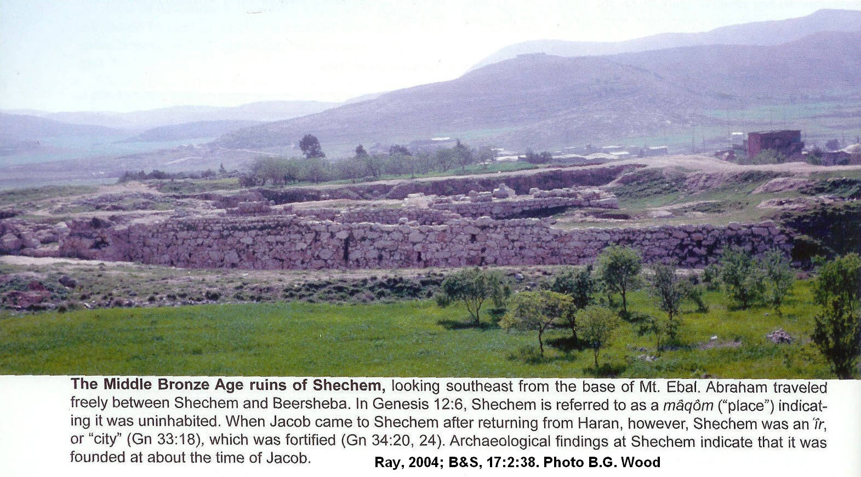

The ancient city of Shechem is located at Tell Balata, near modern Jordan. The site was excavated between 1956 and 1973 by the G.E. Wright, Drew-McCormick Expedition. Expedition reports were re-interpreted by Stager (2003). The Temple that Abimelech destroyed is now considered to be a Canaanite temple that the Israelites occupied after their conquest of the city (Level XI, Hansen, 2005:38). This Migdal (Tower/Fortress) and temple existed at Shechem from the Middle Bronze Age (1650-1550 BC) into the Iron Age I (1200-1100 BC; Stager, 2003). The city walls at Shechem had lengths of 54 ft x 65 ft. These walls were 6 ft thick (Wood, 1983).

PHOTO LINK: SHECHEM 005 Aerial photo and plans of Shechem fortress and temple and late public building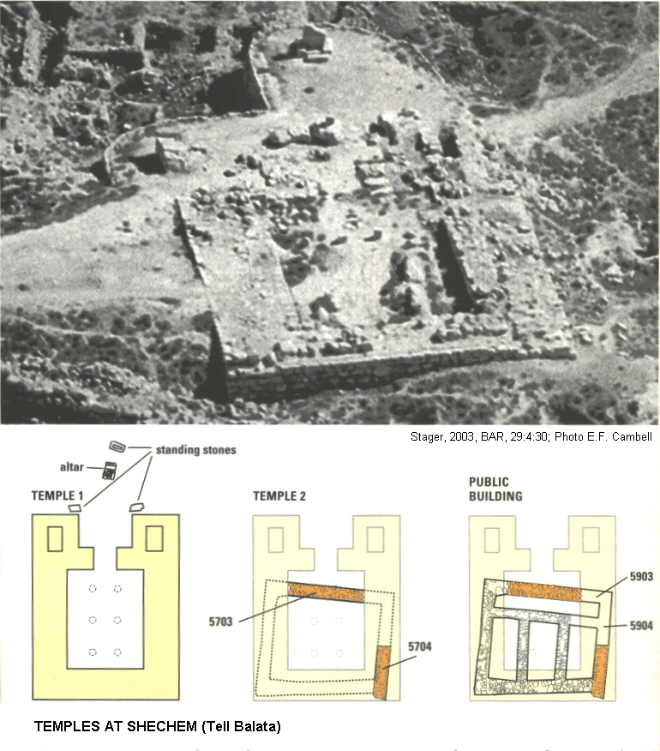

In front of the Shechem fortress-temple stood a monumental stone of white limestone called Masseba 1. Now 5 feet high, it once was twice that size. That great white masseba was flanked by two smaller massebot (Stager, 2003:31). Wood (1983) speculated that this larger stone is the one set up by Joshua (Joshua 24:26).

PHOTO LINK: SHECHEM 009 Painting of the Shechem fortress-Temple
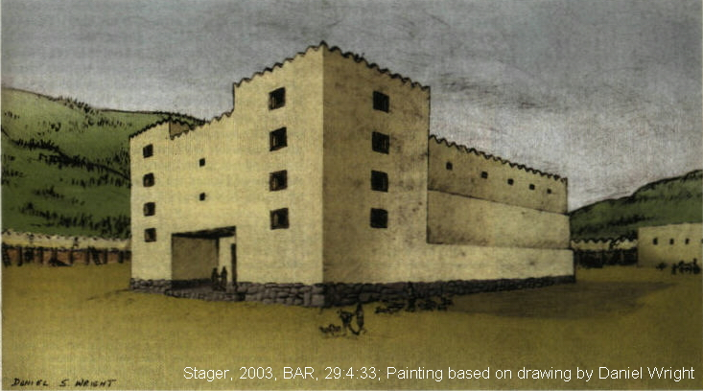

PHOTO LINK: SHECHEM 002 Great white masseba in front ot Shechem fortress
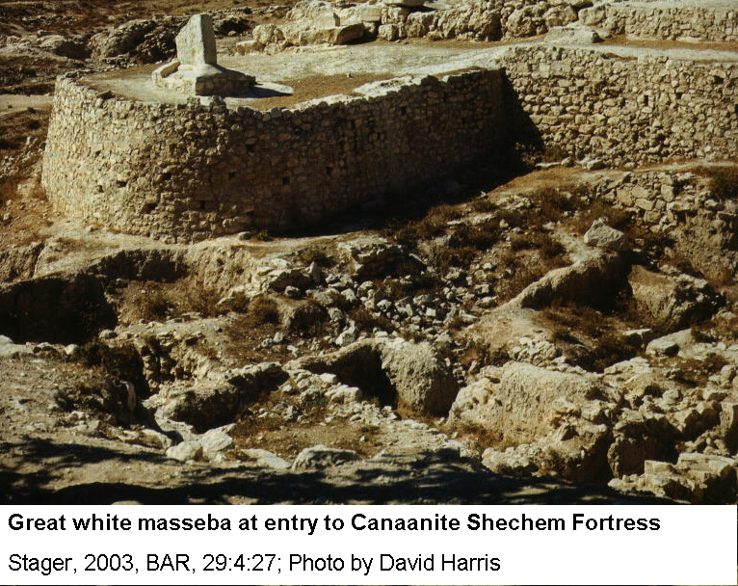

PHOTO LINK: SHECHEM 004 Great white masseba and platform in front of Shechem fortress
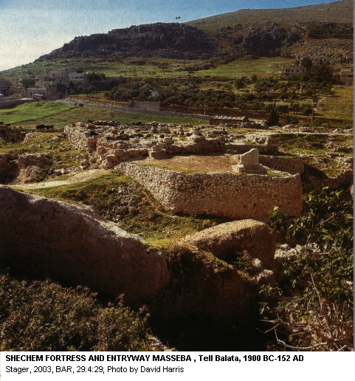

PHOTO LINK: SHECHEM 015 Great white masseba in front of Shechem temple-fortress
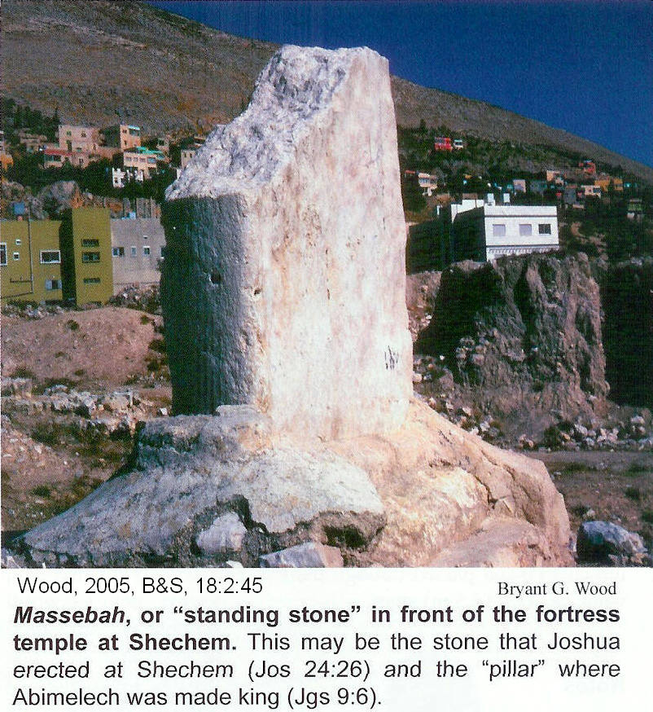

The association of sacred stones and sacred trees was discussed in Chapters 5 and 6. When Abimelech was made king, he was anointed "beside the Oak-of-the-Pillar [masseba] (Judges 9:6). This is probably the Great white masseba show in the three illustrations, above. The oak that was next to this masseba may have been the same tree (or an offspring) mentioned as the "Oracular Oak"(Oak of Moreh) in Genesis 12:6. Abraham received a promise to inherit this land one day at the Oracular Oak at Shechem. Jacob buried his people’s earrings and images of "alien gods" "under the terebinth [oak] which is a Shechem" (Gen. 35:4). The sacred oak known was known as as the "Oak-of-the-Diviners" in Judges 9:37.

The Shechem temple is the largest yet found in Canaan. It had dimensions of 70 x 86.3 feet). It has foundations 17 ft thick that supported a multistoried superstructure of mud bricks and timbers. On the east, two towers, containing stairwells to the upper stories flanked the entrance. On the inside of the foundations, are two rows of columns, with three columns in each row (Wood, 2005:45).

PHOTO LINK: SHECHEM 014 Plan of temple, standing stones and altar.
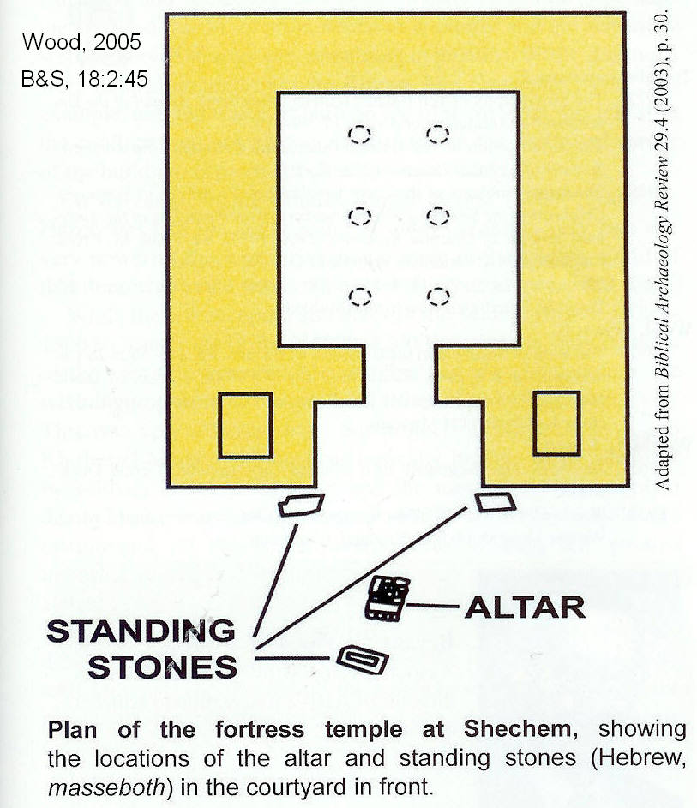

This arrangement divided the space inside the temple into a nave and two side aisles (Stager, 2003:29-31; 1999:2430245, cited by Wood, 2005:45)

There was a large courtyard in front of the Fortress-Temple with a large earthen and stone altar. This alter had dimensions of 7.2 x 5.4 ft. and was 1.1 ft high. A monumental massebah stood in 6.6 ft to the southeast of the altar. It is 4.8 ft wide, 1.4 ft thick, and has a present height of 4.8 ft. high. It once was taller (Wood, 2005:45).

The place in the Shechem temple of El-berith (or Baal-berith, Judges 9:46) where Abimelech killed 1000 leaders of its community is described as the seriah. Stager interprets this to mean the areas along the flanks of the Temple between pairs of supporting walls. This architecture is similar to that of the Jerusalem Temple (1 Kings 6-7) and the temple at 'Ain Dara in Syria.

PHOTO LINK: SHECHEM 006 Double walls at temple of 'Ain Dara, Syria
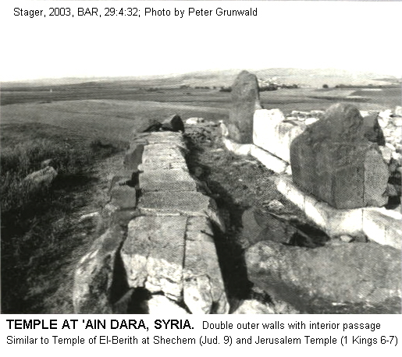
PHOTO LINK: SHECHEM 007 Plan of temple of 'Ain Dara, Syria
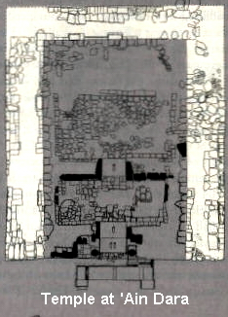

The city gate of Shechem is where Gaal, leader of the opposition forces, and Zebal, the governor of Sheshem watched the approach of Abimelech’s army (Judges 9:34-40). This gate complex was excavated on the east side of Tell Balata (Seger, 1997:22; Toombs, 1992; Boling, 1975:179; Wright, 1965:71-76; Cambell and Ross, 1963:16, all cited by Wood, 2005:45). This gate has a two-way entrance with a paved courtyard. The courtyard is 26.2 ft x 21.5 feet and in situated between the two entry ways. The entryways were each 11 ft wide and separated by a 21 feet of courtyard. On either side of this courtyard are guardrooms with stairways leading to upper levels. To access the city, one had to approach from the south along a cobbled street, then turn left, and pass through one of the two entryways (Wood, 2005:46)..

PHOTO LINK: SHECHEM 016 Double gateway complex on east side of Shechem
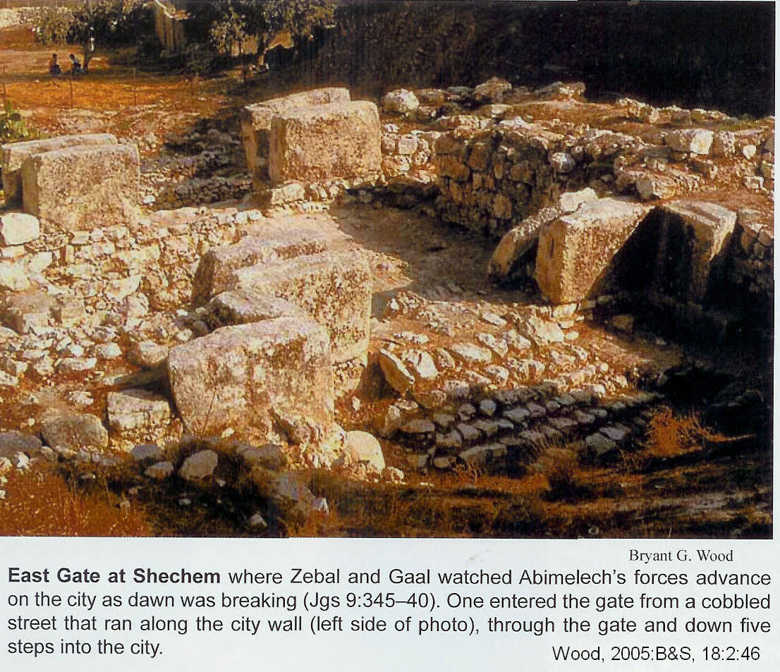

After Abimelech and his followers destroyed Shechem, around 1100 BC (Campbell, 1993:1352, cited by Hansen, 2005:38; Wood, 2005:46), the religious center for Israel shifted south to Shiloh. It remained there for 500 years until supplanted by Solomon's Temple at Jerusalem (Stager, 2003:68).

If Campbell (1993) and Stager (2003) are correct in assigning the destruction of Shechem Level XI to 1100 BC, the Early Date of 1400 BC for the Conquest is corroborated. This is because what is recorded in the next episode in Judges, in the story of Jephthah’s diplomacy with an Ammonite King. In that story, Jepthah tells the king that the Israelites had been in land east of the Jordan River for “300 years” (Judges 11:21-26). Hansen (2005:38) summarizes:

“Thus, if Abimelech destroyed Shechem ca 1125-1100 BC (Judges 9), and if Abimelech was a contemporary of Jepthah, the Conquest would have occurred 300 years earlier, in ca 1400 (1100 BC + 300 years = 1400 BC).”

Siege of Thebez

Moving on to Thebez, Abimelech captured the town and stormed ita tower into which the citizens had retreated. A woman dropped a millstone on his head, killing him thus fulfilling Jotham's curse (Judges 9:6-21). "When the Israelites saw that Abimelech was dead, they went home" (Judges 9:55).

JUDGE TOLA AND JUDGE JAIR

Judges Tola and Jair lead Israel after the death of Abimelech. Tola provided leadership for 23 years from 1149-1126 BC. Tola was succeded by Jair who ruled for 22 years from 1126 to 1105 BC (Judges 1:2-3; Whitcomb, 1968). It was during this time that Boaz and Ruth were married (circa 1120 BC). Near the end of Jair's judgeship, Eli became priest at Shiloh (SEE MAP NEXT PAGE) where he served from 1107 to 1167 BC. Apparently there was little apostasy in Israel extant during this period.

Jephthah said that Israel dominated the country of Ammon for 300 years before the Ammonite oppression began (Judges 11:26, see discussion below).

Book of Ruth

The Book of Ruth fits into the peaceful period of Judges, prior to Ammonite oppression. It was written after Judges was compiled, but before the birth of Solomon because the genealogy of Ruth 4:13-22 stops at David. Some episodes in Ruth describe social practices that had become out of style by the time of the United Monarchy, so the writer had to explain the traditions (gleaning, using a sandal as a pledge in 4:7, and closing city gates at night; Hoerth, 1998:238).

PHOTO LINK: SHILOH 009B Location map
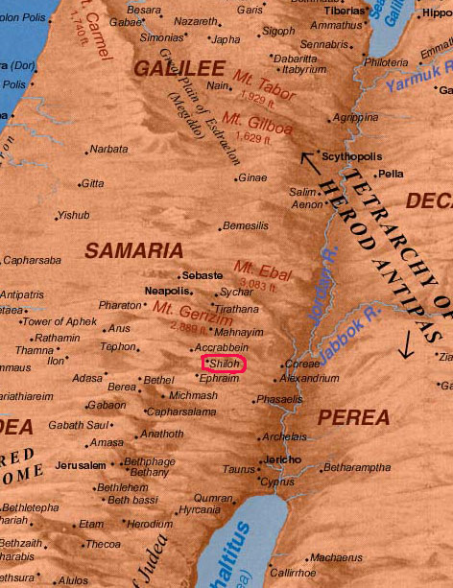

OPPRESSION BY AMMONITES (Eastern Israel Only, 1105-1087 BC)

Abimelech contributed to the apostasy of Israel, but there was a revival of sorts under leaders like Eli during the judgeships of Tola and Jair. When Jair died, Israel again "did evil in the eyes of the Lord. They served the Baals and the Ashtoreths, and the gods of Aram, the gods of Sidon, and the gods of Moab, the gods of the Ammonites and the gods of the Philistines" (Judges 10:6). Collectively these foreign nations oppressed the land of Israel east of Jordan River in "Gilead the land of the Amorites" (Judges 10:8) for eighteen years. The Amorites had been defeated 300 years earlier by Joshua. The 10th-century BC Ammonites crossed the Jordan and attacked the tribes of the west (Judah, Benjamin, Ephriam). At this point of desperation, the nation again cried out for a deliverer, and "got rid of the foreign gods among them" (Judges 10:16).

The Ammonites were descended from an incestuous union between Lot and his daughter (Gen. 19:30-38). They have conflicts with the Israelites throughout the Exodus-Conquest (Numbers 21:21-23), the period of the Judges (Judges 3:13; 10:7-8; 11; 1 Sam 11) and the United Monarchy (Saul, 1 Sam 14:47; David 2 Sam 8:12,10; Herr, 1993:28). While Israel fell to Assyrians and Judah fell to the Babylonians, the Amorites kept their kingdom until the arrival of the Persians in 550-330 BC (Herr, 1993:29).

PHOTO LINK: AMMONITE 003 Map of Ammonite sites

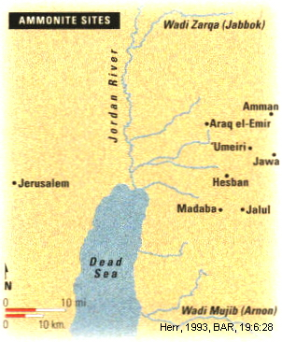
PHOTO LINK: JUDGES 009 Jephtha’s victories
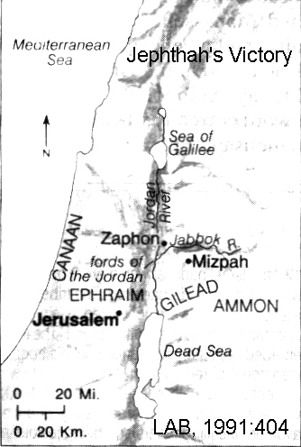

JUDGE JEPHTHAH (1087-1081 BC)

Jephthah's father had a country named after him (Gilead), but his mother was a prostitute. Jephthah's legitimate siblings drove him out of the house at an early age and he settled in Tob "where a group of adventurers gathered around him" (Judges 11:3). Some years later, when the Ammonites made war on Israel, the elders of Gilead summoned Jephthah back from exile to lead the resistance. Upon assuming command, Jephthah and the King of Ammon corresponded. Jephthah reminded the King of Ammon about encounters Moses had with his forbearers during the Exodus (Num. 21:21-29; 22:2; Deut. 2:8; Joshua 24:9) and the disastrous consequences that were effected against Ammonites at that time. The message was rejected so Jephthah convened a war council a Mizpah of Gilead.

In his enthusiasm, after the council, Jephthah made a rash vow to the Lord to make a burn offering of "whatever comes out of the door of my house to meet me when I return" (Judges 11:31). After defeating 20 towns "from Aroer to the vicinity of Minnith" (Judges 12:33), Jephthah came home to see his daughter coming out of the door of his house dancing to great him. His unnamed daughter accepted her fate. The story illustrates the power of the vow in Israelite society and may also reflect some acceptance of pagan practices of child sacrifice during this period

Abel-Keramim at Tell el-‘Umeiri

The Ammonite Biblical city of Abel-Keramim of Judges 11:33 has been found at Tell el-'Umeiri. The site is associated with Jepthah's victory over the Ammonites. The buildings and artifacts there date to the EB period (c.2500 BC), the MB period (c.1600 BC) and from Iron Age I (12th century BC; Shanks, 1993).

PHOTO LINK: AMMONITE 004 Plan of administrative buildings at Tell el-'Umeiri
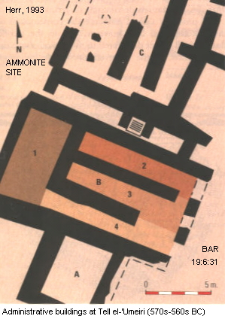

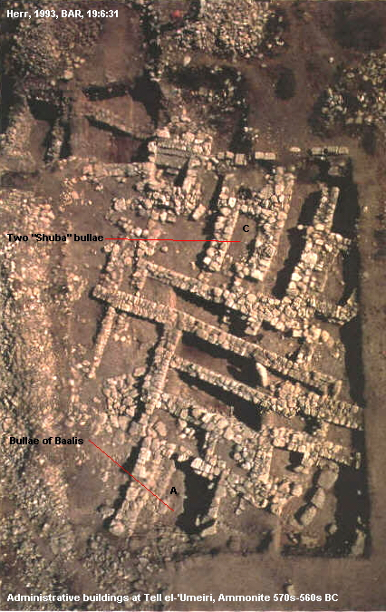
PHOTO LINK: AMMONITE 005 Bird's eye photo of administrative buildings at Tell el-'Umeiri

The Ephriam-Gilead Civil War (c. 1087 BC)

Soon after his defeat of Ammon, Jephthah was assaulted by forces from Israelite Ephriam who crossed the Zapon and demanded to know why they were not invited to participate in the campaign against Ammon, presumably wanting a share of booty. Jephthah explained that he had asked for assistance from Eprhriam, but none came. Dissatisfied, a civil war ensued in which dialect was used as a means of identifying friend from foe (Judges 12:5-6). The war casualties for Eprhraim where 42,000 killed. Gilead's losses were not stated. Afterwards, Jephthah lead Israel for six more years, then died in Gilead (Judges 12:7).

TRAVELS OF WEN-AMON (circa 1087-1081 BC)

About the time of Jephthah, an official of the Karnak temple at Amon was sent to Byblos to obtain lumber for the ceremonial barge of Amon (Horeth, 1998:238).

PHOTO LINK: BYBLOS 002 Location map; http://www.google.com/imgres?...; Aug. 1, 2010
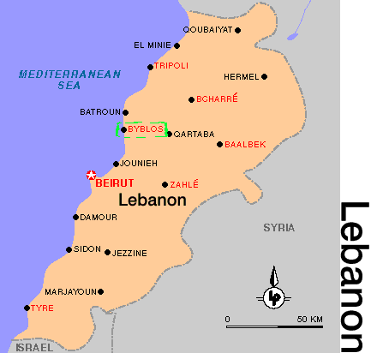

Byblos was an ancient city of Phoenicia, on the Mediterranean Sea, near present-day Beirut, Lebanon. Extensive archaeological investigations, begun in 1921, indicate that Byblos is one of the oldest continuously inhabited cities in the world, with remains of civilizations dating from about 5000 BC. The city was the principal city of Phoenicia and an important seaport during the 2nd millennium BC, when it exported cedar and other woods to Egypt. The name Byblos, applied by the Greeks to papyrus, which they imported from Byblos, is the source of the word Bible. Gebal was the biblical name for the city; the Book of Ezekiel (see 27:9) mentions the maritime pursuits of its inhabitants. The city of Byblos is now occupied by a Lebanese village called Jubayl (http://www.galenfrysinger.com/byblos.htm ; March 27, 2006)

The journey to Byblos took Wen-Amon to Dor at a time when Sea Peoples were had a powerful presence along the coast and the kingdoms of Palestine were feeling independent (Horeth, 1998:238).

Dor was discussed on pages 191-196 of this chapter.

In Dor, Wen-amon was provided food. But his timber and money were stolen. Demanding an investigation that never matured, he went on to Tyre and then to Byblos. There he appropriated money and threatened to hold it until his timber and money were returned:

And the Prince of Byblos sent to me, saying "Get out of my harbor!" And I sent to him saying, "Where should I go to?...If you have a ship to carry me, have me taken to Egypt again!" So I spent twenty-nine days in his harbor, while he spent the time sending me every day to say "Get out of my harbor" (ANE 1:18; ANET 26, cited by Horeth, 1998:238)

Finally, Wen-Amon got and audience with the prince of Byblos:

And I found him sitting in his upper room, with his back turned to a window...And he... said to me: "On what business have you come?" So I told him: "I have come after the woodwork for the great and august bark of Amon-Re, king of the gods. Your father did it, your grandfather did it, and you will do it too!" So I spoke to him. But he said to me: "To be sure, they did it. And if you give me something for doing it, I will do it! Why, when my people carried out this commission, Pharaoh... sent six ships loaded with Egyptian goods, and they unloaded them into their storehouses! You_-- what is it that you're bringing me--me also?" And he had the journal rolls of his fathers brought, and he had them read out in my presence, and they found a thousand deben of silver and all kinds of things in his scrolls.

So he said to me: "If the ruler of Egypt were the lord of mine, and I were his servant also, he would not have to send silver and gold, saying: 'Carry out the commission of Amon!' There would be no carrying of a royal gift, such as they used to do for my father. As for me--me also--I am not your servant! I am not the servant of him who sent you either! If I cry out to the Lebanon, the heavens open up, and the logs are here lying on the shore of the sea!"

PHOTO LINK: BYBLOS 001 View of Seaport
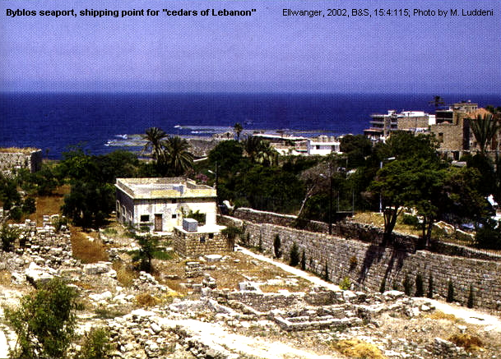

After more badgering, a letter was sent to Egypt, and more money (in the form of trade goods) was sent to Byblos. The resulting shipment was of linen, papyrus, cowhides, ropes, lentils and fish. This was a much less "royal" gift than was given in earlier Egyptian administrations. The payment was accepted and Wen-Amon got his lumber. Then, just as the shipment of timber was leaving, eleven Phoenician boats appeared. Fearing piracy, Wen-Amon asked for a meeting:

And he stood in their midst, and he said..."What have you come for? And they said to him: "We have come after the blasted ships which you are sending to Egypt with our opponents!" But he said to them "I cannot arrest the messenger of Amon inside my land. Let me send him away, and you go after him to arrest him" (ANE 1:23, ANET 29, cited by Horeth, 1998:239).

Wen-Amon escaped (with his timber?) from the harbor and came ashore again in Cyprus. Then the story breaks off. The extant part of the story indicates that at this time, Egyptian influence throughout the Middle East was weak (Horeth, 1998:239).

JUDGE IBZAN (1081-1075 BC)

Ibzan was from Jerusalem. He had an unusual policy of giving his daughters in marriage to Israelites outside his clan. This may have created more unity of the tribes and acceptance of Ibzan's authority. He lead the tribes in eastern Israel for 7 years (Judges 12:8-10).

JUDGE ELON (1075-1065 BC)

This judge lead the tribes in eastern Israel for 10 years. The writer/editor of Judges had little to say about him (Judges 12:11).

JUDGE ABDON (1065-1058 BC)

This judge came from Pirathon. He lead the tribes in eastern Israel for eight years and had 70 donkeys (Judges 12:13).

OPPERSSION BY PHILISTINES (Western Israel only, 1087-1047 BC)

Following the Israel-Ammonite war, western Israel (because of apostasy) was ruled by Philistines for forty years (Judges 13:1). This oppression in the west occurred while Jephthah was freeing eastern Israel from Ammonite control and during the eastern judgeships of Ibzan, Elon and Abdon (see above).

SAMSON (1069-1049 BC)

Samson's unnamed mother was promised a son by "the angel of the Lord" upon condition that she was to refrain from alcohol during her pregnancy. Her son was to be a Nazirite deliverer, dedicated to the Lord. Upon hearing his wife's story, Samson's father, Manoah, prayed for additional instructions. The angel returned and provided them. During the angelic visit, Manoah asked "What is your name, so that I may honor you when your word comes true?" (Judges 13:17). Israelite society had become so plagued with polytheism and syncretism, they didn't recognize the true living creator God when he was encountered, and didn't even know his name!

The motif of knowing God’s true name is theological thread throughout the Old Testament. Yahweh (English “Lord”) called Abraham in Gen 12:1. Moses asked who he should say was calling him to lead the Israelites out of bondage in Ex. 3:13. God answered say “Yahweh that is who Yahweh” sent you. The concern God has for his name is shown in verses like 1 Kings 9:6-7, “then I will cut off Israel from the land I have given them and will reject this temple I have consecrated for my Name.” In the period of the Judges, with competing nationalistic religions, there may have been a dualism in god names. One set was used by the average person and another by the priests. To know God's true "name" was to know him and to know his character (see Exodus 3:13-15; 6:3).

PHOTO LINK: JUDGES 010 Samson's Ventures
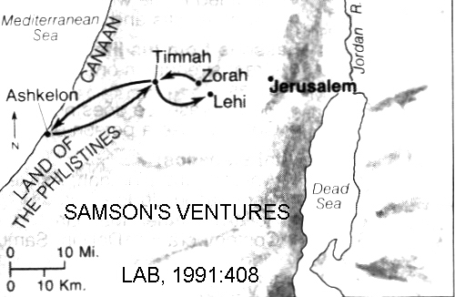

Samson then did something you wouldn't expect of a person "dedicated to Yahweh" to do: he violated prescriptions of the Torah and married a "young Philistine woman" (Judges 14:1) who later is "given to his friend" (Judges 14:20), another violation of Torah. The story of Judges 14-15 is ripe with Phoenician motifs and has similarities with Mycenaean epics. Powerful Samson is Israel's version of Mycenaean Hercules.

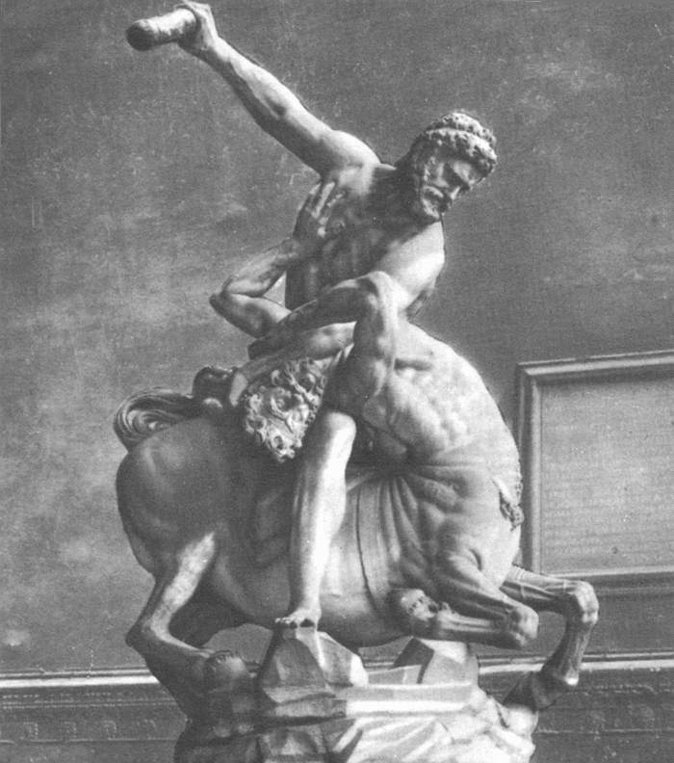
PHOTO LINK: HERCULES 001 Marble statue of Hercules killing a minotaur; Marble statue of Hercules killing minotaur ; http://www.wga.hu/art/g/giovanni/bologna/hercules.jpg ; April 1, 2006

PHOTO LINK: HERCULES 002 Painting of Hercules killing hydra; Painting Hercules killing hydra ; http://www.irtc.org/ftp/pub/stills/2004-02-29/ljc_herc.jpg ; April 1, 2006
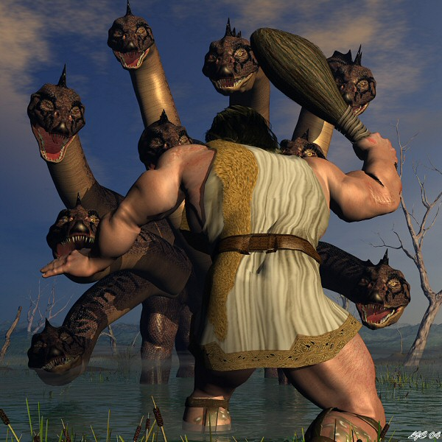
PHOTO LINK: HERCULES 003 Comic painting of Hercules by P. Andrews; Comit painting Hercules by P. Andrews ; http://images.google.com/imgres?imgurl=http:// writing.fsu.edu/cwc/fa01/kashm9/public_html/ hercules.jpg&imgrefurl=http://writing.fsu.edu/ cwc/fa01/kashm9/public_html/index10.html&h= 548&w=450&sz=63&tbnid=n2d3ftZIvvcJ:&tbnh= 130&tbnw=106&hl=en&prev=/images%3Fq%3 Dhercules%26hl%3Den%26lr%3D&start=3&sa= X&oi=images&ct=image&cd=2 ; April 1, 2006

Samson and the Danite Migration

The stories about Samson are set in the early part of the settlement and conquest of Canaan by the Israelites. Samson was from the tribe of Dan. That tribe migrated early in the history of the Israelite confederation from the southern hill country to a coastal area in the northeast. This migration involved several battles involving Philistines and Judah (Roskoski, 2008:12)

Cave of Etam

In the Samson stories, the Cave of Etam is mentioned several times. It was where Samson lived after he directed a slaughter of Philistines (Judges 15:8, 11).

There was town in Judah named Etam. That town was located between Bethlehem and Tekoa (Khirbet-el-Khokh; 1 Chron 4:3). This Judahite town of Etam was rebuilt by Rehoboam (2 Chron 11:6) and is named in LXX of Joshua 15:59. There was another village named Etam near En Rimmon in Simeon (1 Chron 4:32; Compton’s Interactive Bible, 1998). Neither of these settlements are near the Cave of Etam (Roskoski, 208:12 citing George Cooke, 1918:146 and Arthur Cundall, 1968:170). A candidate for the cave is ‘Araq Isma’in. This site is in the eastern Sorek Valley, east of Beth-shemesh and about half way between Eshtaol to the north and Lehi to the south.

PHOTO LINK: SAMSON 010 View of Zorah toward Eshtaol
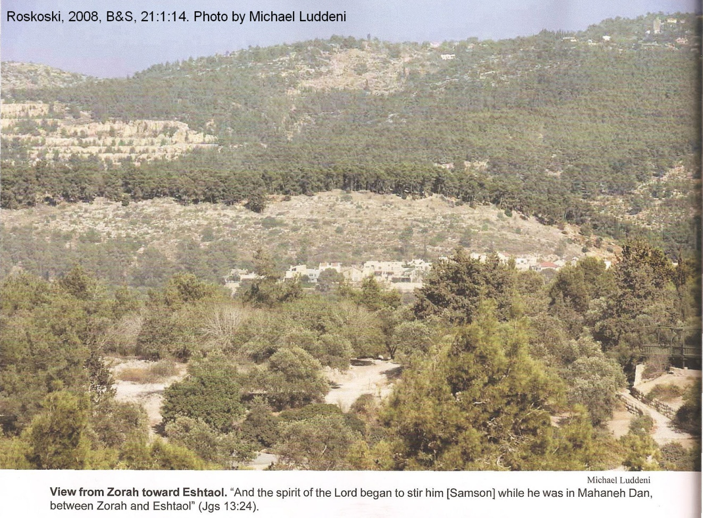
PHOTO LINK: SAMSON 009 Map of Samson's travels
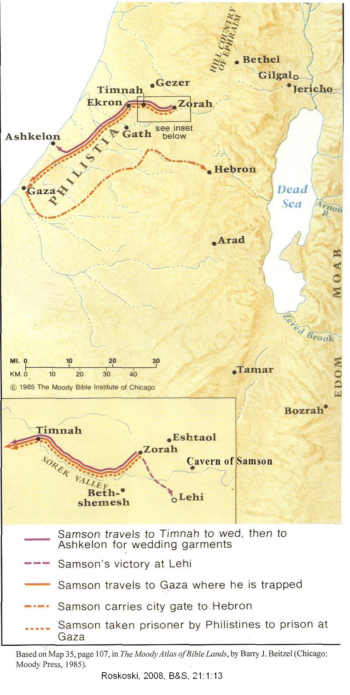

PHOTO LINK: SAMSON 011 Sorek Valley, looking East
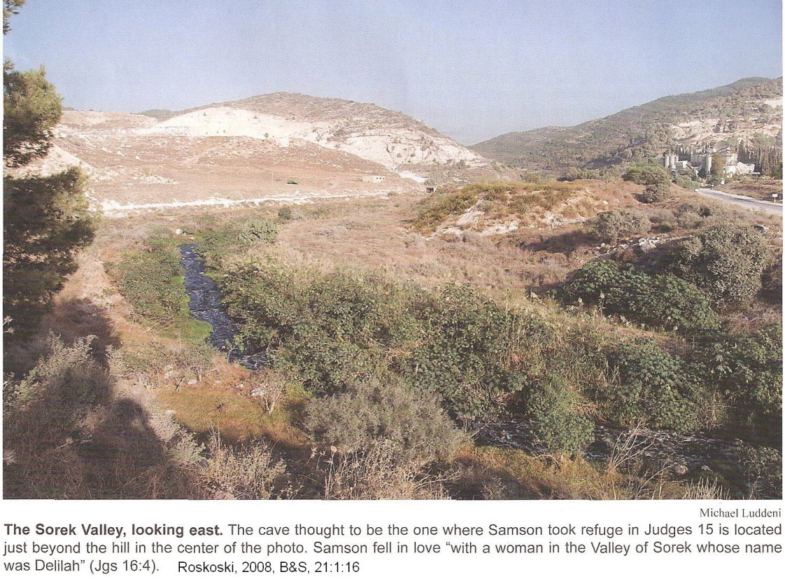
PHOTO LINK: SAMSON 012 Distant view of "Cave of Samson" in the Sorek Valley
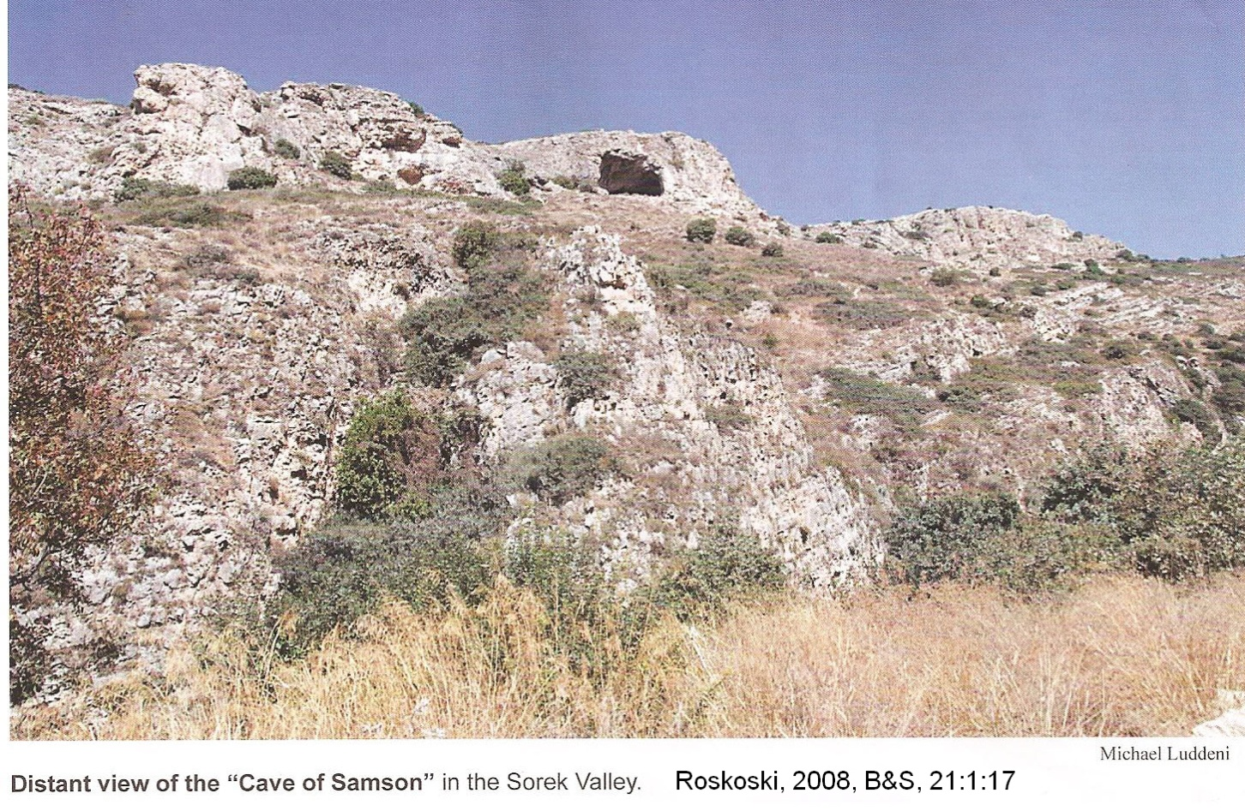
The whole career of Samson seems a subterfuge to kill Philistines. The jawbone of an ass was a particularly effective weapon for him (Judges 15:15-16). Samson led Israel for 20 years (Judges 15:20; 16:31) until his unnecessary, unfortunate and tragic fling with another Philistine woman: Delilah (Judges 16). Nazerites where forbidden from cutting their hair. The original "hippies", it was a sign that they belonged to Yahweh. Samson's superhuman strength left him when Delilah cut his hair. Delilah lived in the “Valley of Sorek”, north of Gaza, west of Jerusalem, in the Philistine coastal plain. But Samson literally "brought down the house" in the final act of his life. He pulled the Philistine temple at Gaza down on himself and his enemies (Judges 16:30).

PHOTO LINK: JUDGES 011 Map of Samson and Delilah
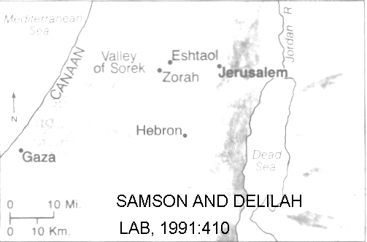

PHOTO LINK: SAMSON 007 Line drawing of Samson pulling down pillars of Gaza Philistine temple; http://www.christiananswers.net/q-abr/abr-a006.html ; April 1, 2006

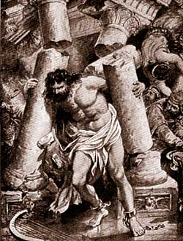
PHOTO LINK: PHILISTINE 004 Drawing of Philistine temple at Tel Qasile
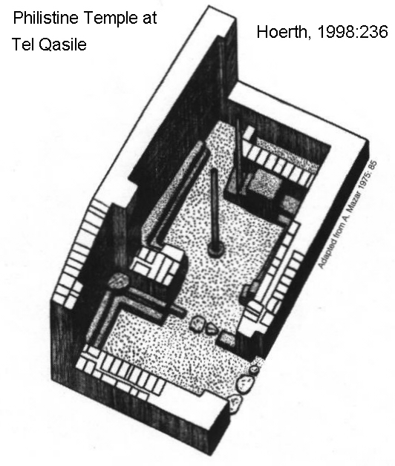

Samson and the House of Dagon

The site of Tell Qasile is an early 10th century BC Philistine temple made of sun-dried bricks with a room originally supported by 2 wooden pillars. There are benches surrounding room in temple complex with an altar. This has a geometry that is similar to the one described for the Temple which Samson destroyed in Judges 16 (Livingston, 1974; Wood, 1974, Roskoski, 2005).

PHOTO LINK: AR053 Tell Qasile Philistine Temple, 12th and 11th centuries BC
PHOTO LINK: AR106 Tell Qasile, Philistine Ceramic Cult Stands, 11th or 10th cent BC

PHOTO LINK: TELL QASILE 001 Photo taken during excavations
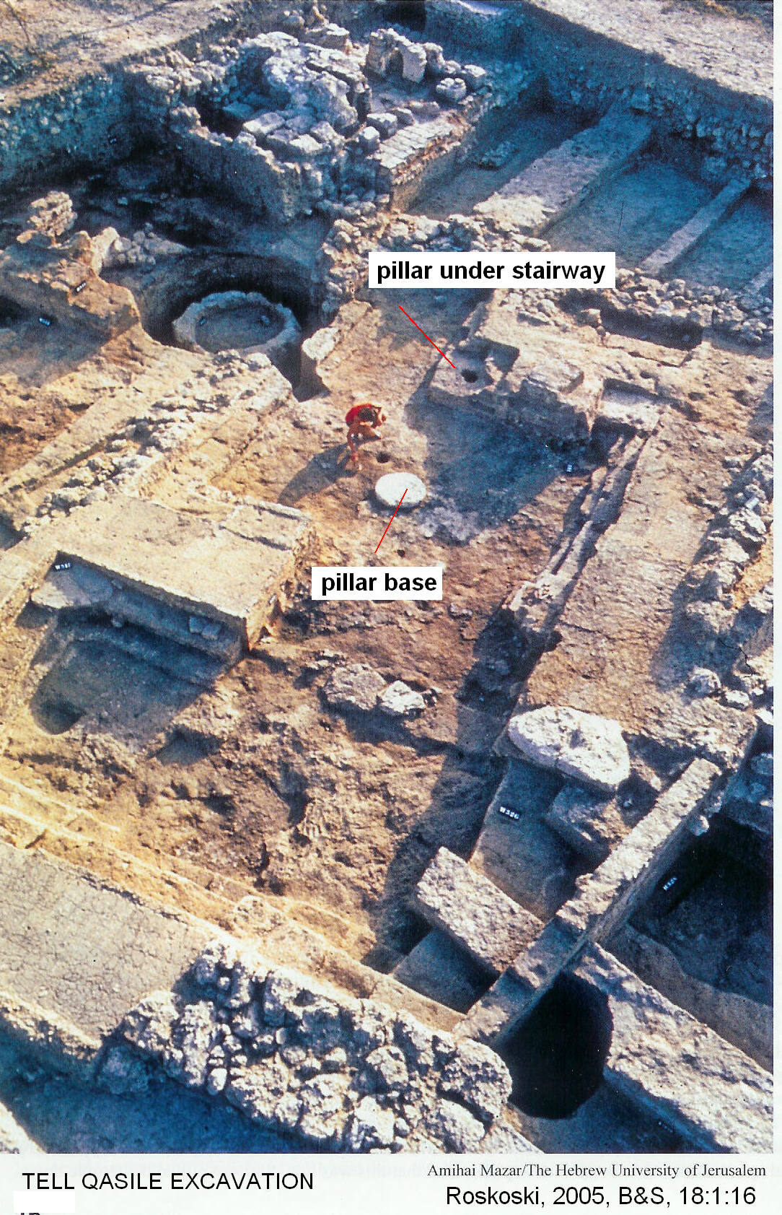

PHOTO LINK: TELL QASILE 002 Twin pillar foundations
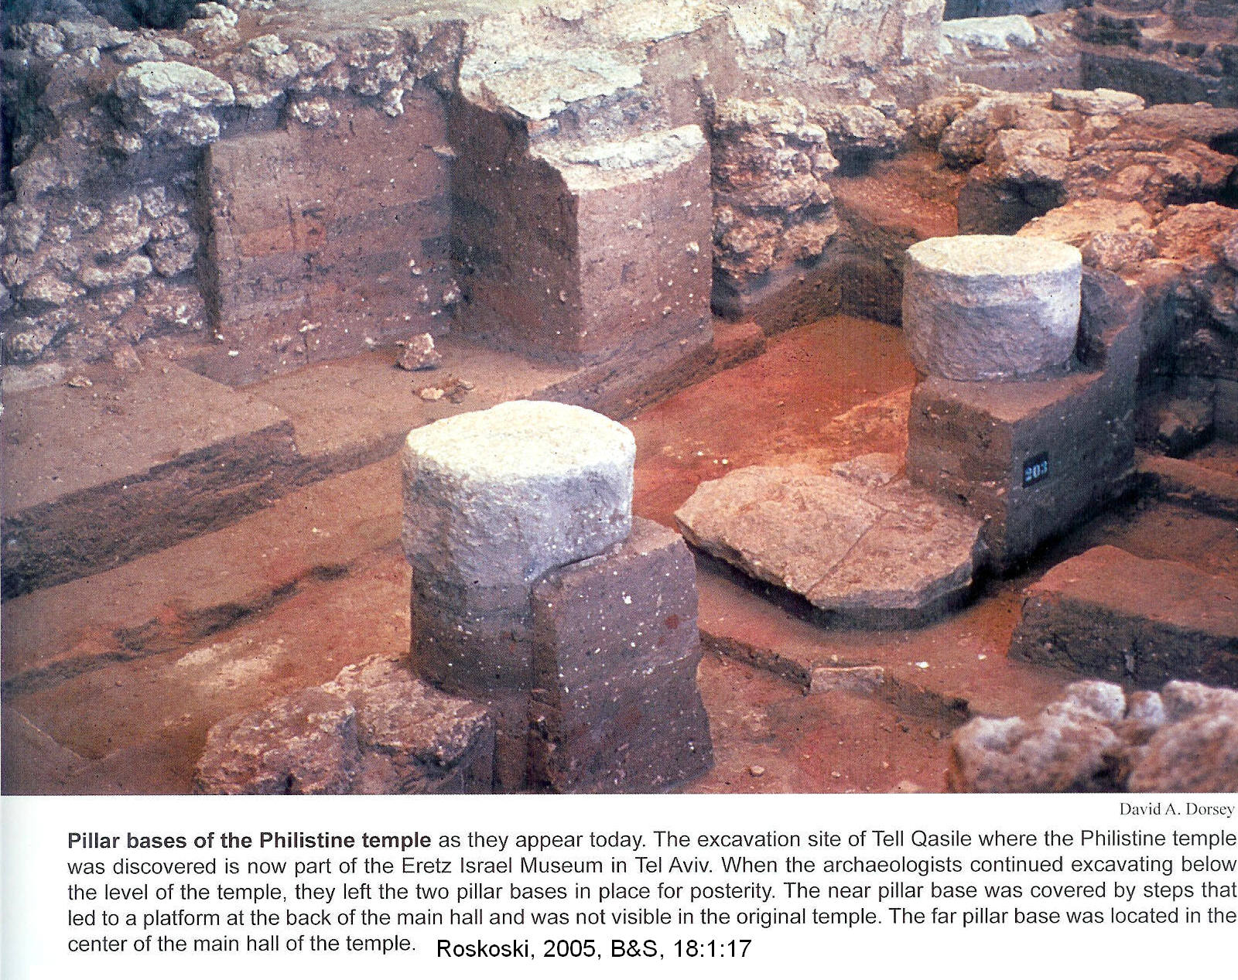

JUDGE SAMUEL (In Bethel, Gilgal, Mezpah, 1067-1020? BC)

Samuel was the son Elkana, an Ephriamite. Elkana had two wives, Peninnah who gave him several children, and Hannah who was barren. Hanna prayed for a child, promising to dedicate him to the Lord. This was a similar scenario as the events that surrounded the birth of Israel's Hercules: Samson (Judges 13:2-5), except that in this case Hanna initiates the conversation (1 Sam. 1:9). Eli the priest at Shiloh thought her drunk (1 Sam 1:10) but accepted the child into Yahweh's service upon his being weaned (1 Sam 1:24).

PHOTO LINK: JUDGES 014 Map of Hannah journey to Shiloh (See ABOVE, ctrl+click to follow link)
PHOTO LINK: SHILOH 009 Location map (See ABOVE, ctrl+click to follow link)
PHOTO LINK: SHILOH 004 Aerial photo of Tell Shiloh and tabernacle plateau (See ABOVE, ctrl+click to follow link)
PHOTO LINK: SHILOH 008 Ruins of Shiloh (See ABOVE, ctrl+click to follow link)

Priest or Levite? Beginning of a Feud

Eli had two wicked sons. Like their father, they were also Levitical priests, who enjoyed their status by heritage. But they extorted the people they were supposed to serve, and had sex with female shrine attendants (1 Sam 2: 12-17, 22). This practice was common among Canaanites and Babylonians, but not endorsed by early (or late) Hebrew religious tradition. Despite Eli's fatherly (but not too stern) advice, the sons continue to sin and an unnamed "man of God" appeared to make an administrative change in priestly function that would set the stage for political infighting among Israel's religious leaders for the next 400 years. The monopoly on religious ministry enjoyed by Levites would be ended, and (with the impending death of Eli's two sons), the priesthood would pass to non-Levites, like Samson the Ephriamite.

This infighting can be deduced from the phrase "the priests and the Levites'' in Kings and Chronicles. That pluralism in religious function finds it's justification in the events of 1 Samuel 2 and 3. Prior to 1 Samuel, the term "Priest" was a special category of Levitical service for ritually pure ministers who performed sacrifices. The term "Levite" was applied to the rest of the religious professionals who were in charge of music, cult paraphernalia, and community services.

Battle of Ebenezer (1047 BC)

The Battle of Ebenezer happened in the days of the prophet Samuel (1 Samuel 4). It was a victory for the "Philistines" and lead to realization by the Israelites that they needed a centralized government with a king. It occurred at a site named Aphek, at the headwaters of the Yarkon river, 15 miles east of modern Tel Aviv. Philistine pottery from mid 11th century BC was found there. Three 3 kilometers to the east is Izbet Sartah (^{c}Isbet Sartah). Excavations at this site exposed a small village with Israelite 4-room houses and stone-lined pits that were abandoned in the mid-11th century BC. Was this the house of Ebenezer, or one of his parishioners, abandoned at time of Philistine victory? (Wood 1982).

PHOTO LINK: JUDGES 015 Map of travels of the Ark
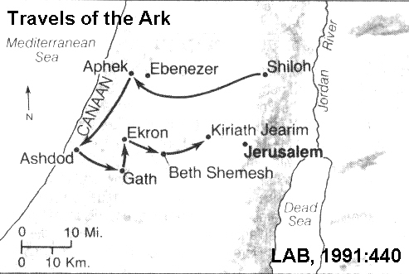
PHTO LINK: IZBET SARTAH 001 4-ROOM HOUSE
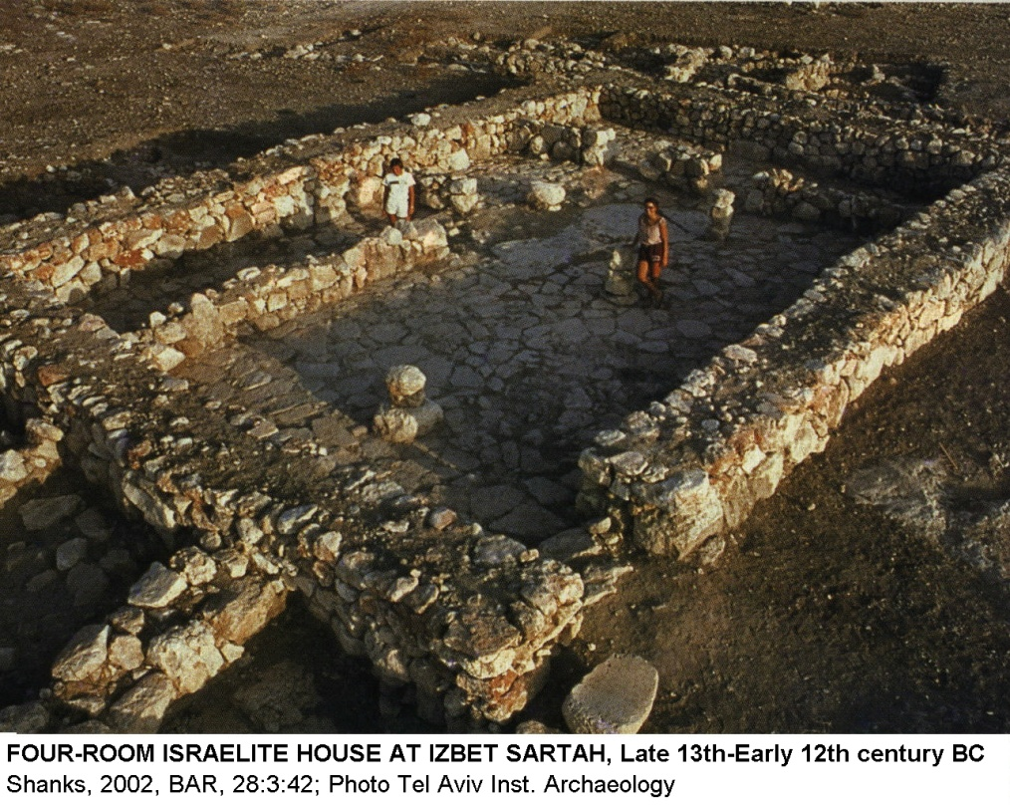

^{c}Isbet Sartah ostracon

The ^{c}Isbet Sartah ostracon may have a connection to the Ebenezer story (Kochavi, 1977). The ostracon was excavated from a small early Iron Age fortress in the low foothills just a few miles east of Aphek (the first city to take the Ark after it's capture). This may have been the site of Israelite camp before the Battle of Ebenezer. The ostracon is palm-sized with 5 lines of inscription, with an abcdeciary at the end.

PHOTO LINK: IZBET SARTAH OSTRACON 001 Photo
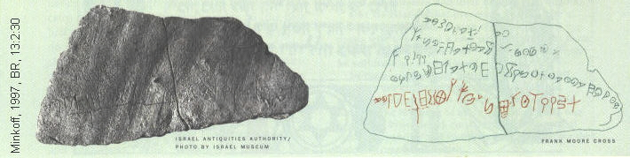

PHOTO LINK: IZBET SARTAH OSTRACON 004 Photo and drawing

Shea's translation is:

line 1: Unto the field we came /, (unto) Aphek from Shiloh
line 2: The Kittim took (it and) came to Azor, / to Dagon lord of Ashdod, (and to) Gath
line 3: (It returned to) Kiriath-Jearim
line 4: The companion of the footsoldiers, Hopohni, came to tel/l the elders "a horse has come (and) upon (it is my) brother for us to bury
line 5: the alphabet

Kittim were originally from Cyprus, later the term was used to mean any group of persons coming from the coast of Palestine. The word could be translated "Sea Peoples" = Philistines.

Azor not mentioned in 1 Samuel, but is listed in Sennacherib's Assyrian inscriptions.

Kiriath-Jearim is a place were the Ark took up a long-term residence. On the ^{c}Isbet Sartah ostracon the order of the names are reversed; Jearim-Kiriath. Shea thinks this reversal indicates the return of the Ark to the Israelites

The history given in line 4 should come after between lines 1 and 2. Hophni is mentioned in 1 Samuel 4:3 who came back with bad news. The dead man on the horse would be Phinehas, son of Eli the priest

Palaeographers date the text of the ostracon to 12th century BC. But the Battle of Ebenezer took place in 11th century (1085-1075 BC, conservative early dates). Shea says palaeographers should refine their dating of these scripts downward. Liberals (late date) say the early 12 century date exempts the ostracon from having biblical ramifications. The ostracon has crudely shapes of letters. Their uneven size and distribution on the ostracon and the alphabet in line 5 suggest that this is a school boy's homework.

Travels of the Ark after the Battle of Ebenezer (1047 BC)

In the first battle of Ebenezer, there were 4,000 Hebrew casualties (1. Sam 4:1-3). The Ark of the Covenant was brought to the battlefield from Shiloh because the Israelites had come to understand the Ark as a sort of celestial good luck charm and even worshiped it as an idol. They hoped that its presence would insure a victory (Shea 1990).

PHOTO LINK: ARK OF COVENANT 001 Map showing route of Ark’s journey (See ABOVE, ctrl+click to follow link)

PHOTO LINK: GATH 003 Travels of the Ark (See ABOVE, ctrl+click to follow link)
PHOTO LINK: ARK OF COVENANT 002 Model of Ark of the Covenant; t ; http://www.biblepicturegallery.com/Frames.htm?members/Member_page.php ; April 1, 2006
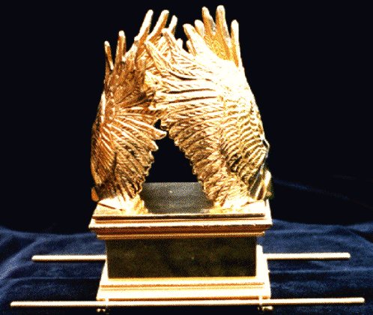

In spite of the Ark's presence, a second defeat resulted in the Ark's capture by the Philistines and the Israelites lost 30,000 foot soldiers. Eli's two wicked sons, priests Hophni and Phinehas died (1 Sam. 4:11). When Eli heard the news he fell back in his chair, broke his neck and died too (1 Sam. 4:18). Meanwhile, Phinehas's wife died in labor giving birth to Icabod (Hebrew "no glory"; 1 Sam. 4:19-21). The Ark was taken to Ashdod, then Gath, and then Ekron were plague came upon each city (1 Sam 5:1-12). The Ark was sent back to Israelites at Beth-Shemesh after 7 months in enemy hands (1 Sam 6:1, 13-14; Shea 1990). Along with the Ark came a Philistine gift of five golden mice and five golden “ ‘opalim” (hemorrhoids).

PHOTO LINK: AR132 Capernaum, Synagogue decoration: Wheeled Ark (See ABOVE, ctrl+click to follow link)

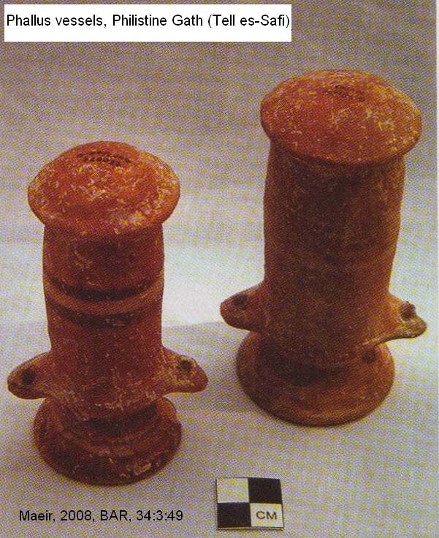
‘Opalim

The disease that afflicted the Philistines (1 Samuel 6), and caused them to return the Ark to the Israelites, is translated “hemorrhoids” in most bibles. Maeir (2008) suggested that the Hebrew word “’opalim” referred to erectile disfunction, and that the “golden hemorrhoids” were actually golden phallus totems.

PHOTO LINK: PHALLUS 001 Philistine phallus vessel, Gath = Tell es-Safi (LEFT)

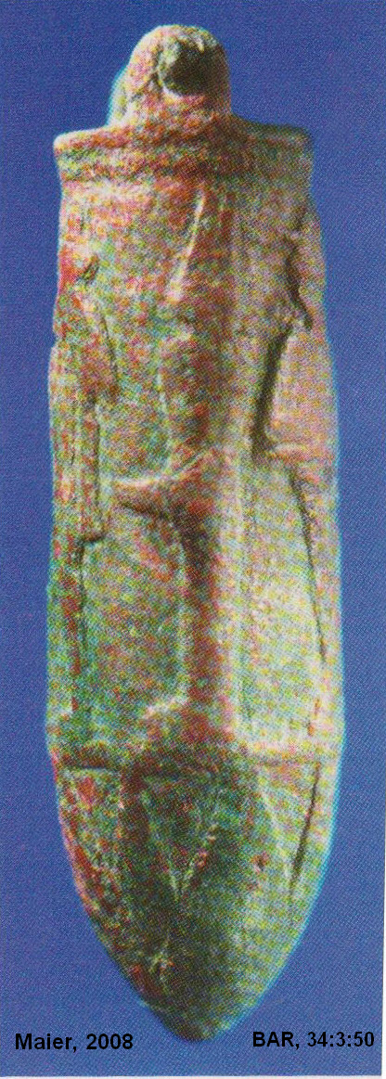
PHOTO LINK: PHALLUS 002 Bronze phallus Philistine Gath with image of Min

PHOTO LINK: PHALLUS 003 Bronze phallus Philistine Ashkelon 7th century BC
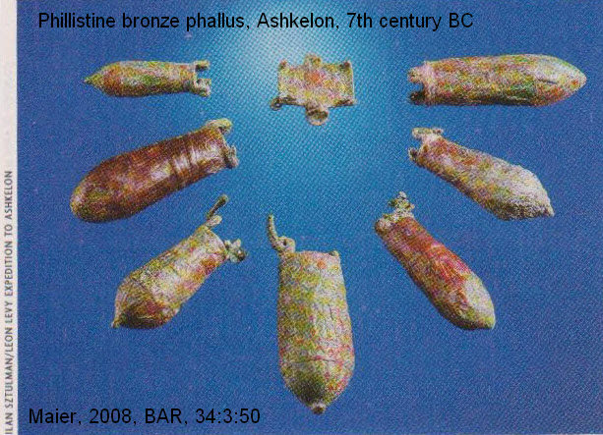

PHOTO LINK: PHALLUS 004 Ceramic phallus and in situ photograph, Gath = Tell es-Safi, Iron Age

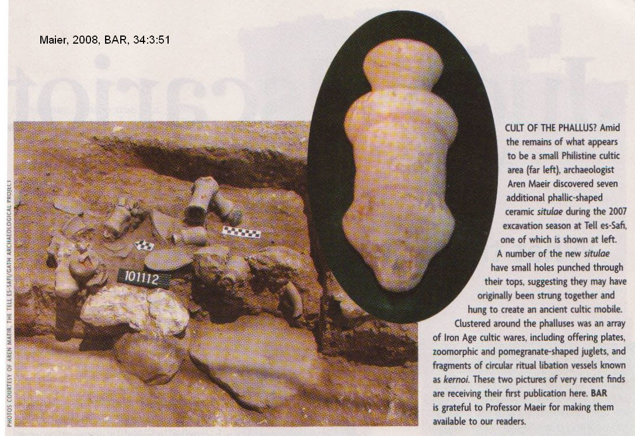

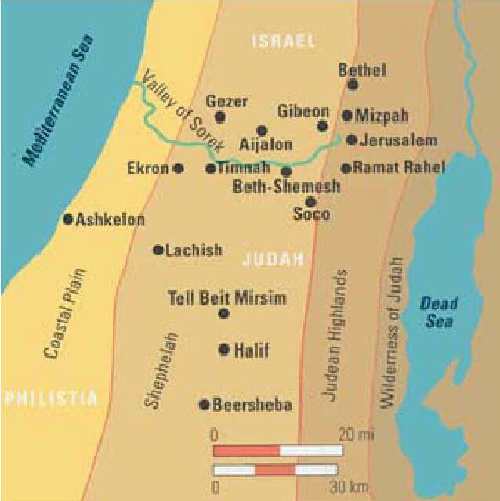
Beth Shemesh

The city where the Philistines gave up the Ark is Beth Shemesh. It is is near Zoar (Samson's birthplace*). in the Shephelah foothills between the Mediterranean coastal plain and the Judean highlands. It was included in the tribal allotment of Dan (Joshua 19:41), and is described as a town on the northern boarder of Judah (Joshua 15:10; Bunimovitz and Lederman, 1997).

PHOTO LINK: BETH SHEMESH 003 Location map and geographic zones; Bunimovitz and Lederman, 1997, BAR, 23:1:CD; Photo by S. Bunimovitz (RIGHT)

PHOTO LINK: BETH SHEMESH 001 Panorama; Bunimovitz and Lederman, 1997, BAR, 23:1:CD; Photo by S. Bunimovitz

PHOTO LINK: BETH SHEMESH 002 Ain Shems Excavations 1928-1931; Bunimovitz and Lederman, 1997, BAR, 23:1:CD; Photo by S. Bunimovitz
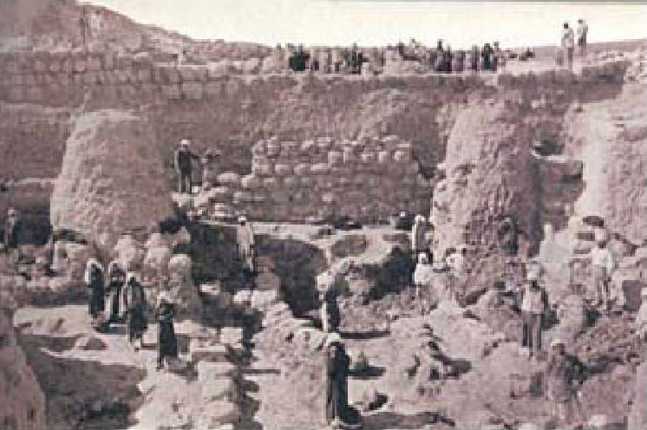

The name "Beth Shemesh" means "House of the Sun", a possible reference to a temple of a Caananite sun-god (Bunimovitz and Lederman, 1997). When the empty ox cart came into Beth Shemesh, the people sacrificed the oxen in thanksgiving for the Ark's return (1 Sam 6:12-14).The Ark was accompanied by a "guilt offering" from the Philistines of 5 cast gold tumors and 5 gold rats (1 Sam. 6:4-5).

Iron Age I artifacts dominate Beth Shemesh. A building named the "Patrician House" contained Iron Age I pottery and gold jewelry. This building had wooden roof beam supports that are Caananite.

PHOTO LINK: BETH SHEMESH 004 Plan of Beth Shemesh; Bunimovitz and Lederman, 1997, BAR, 23:1:CD; Photo by S. Bunimovitz

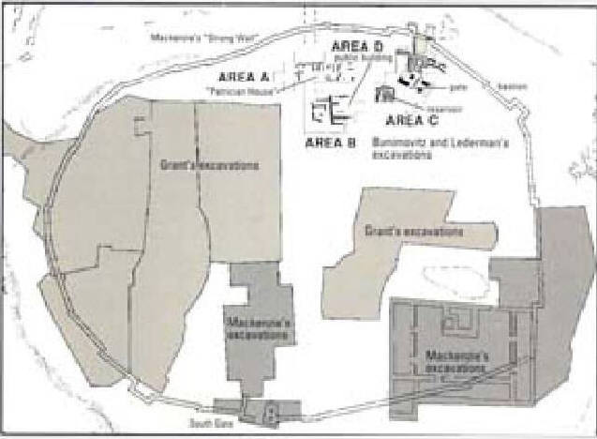
PHOTO LINK: BETH SHEMESH 005 'Strong Wall" at Beth Shemesh, bastion for Solomon's fortress and tunnel of MacKenzie
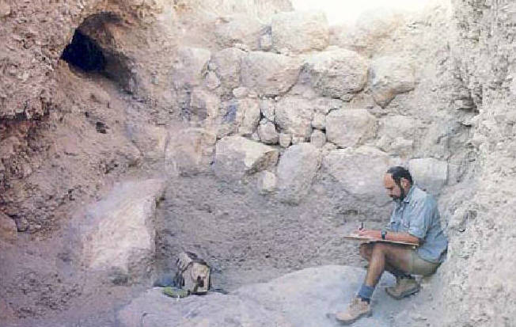

PHOTO LINK: BETH SHEMESH 006 Gold earring and jewelry Iron Age I; Bunimovitz and Lederman, 1997, BAR, 23:1:CD
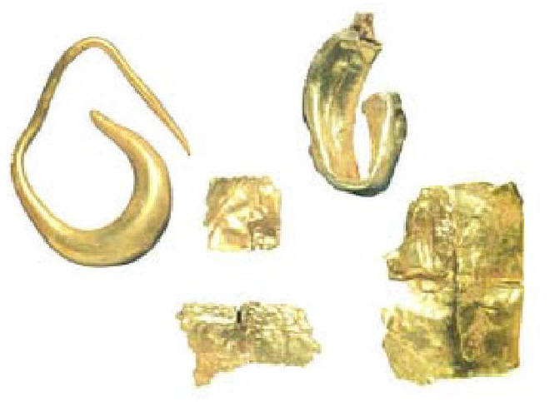
The Patrician House and other 12th-century buildings were destroyed by fire. The city was rebuilt quickly and used square monolithic stone roof supports, a diagnostic feature of Israelite settlement. In Iron Age II (1000-586 BC) this architectural feature would spread throughout Judah and Israel. In this later period, collar-rim pithoi storage jars, another Israelite cultural marker, are common (Bunimovitz and Lederman, 1997).

PHOTO LINK: DAN 005 Collar-rimmed storage jars (See ABOVE, ctrl+click to follow link)
PHOTO LINK: POTTERY005 Collared rimmed pots from Iron Age I Jordan: Canaanite or Israelite? (See ABOVE, ctrl+click to follow link)

Over 6,000 animal bones were excavated from the "Patrican House". Only 1% of them were pig bones. In contrast, Iron Age I pig bone percentages are higher at contemporaneous Philistine sites (Akron, 19%; Tel-Miqne/Ekron, 18%; Tel Batasha/Timna, 8%). These observations suggest an early Israelite presence in a city built in Canaanite architectural tradition (Bunimovitz and Lederman, 1997).

PHOTO LINK: AR052 Timna, Midianite Hathor Temple. Late 14th-early 13th century BC
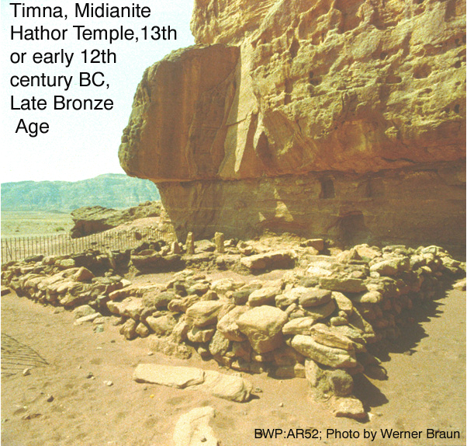

PHOTO LINK: ESN065 Faience Leopard Head; Timna
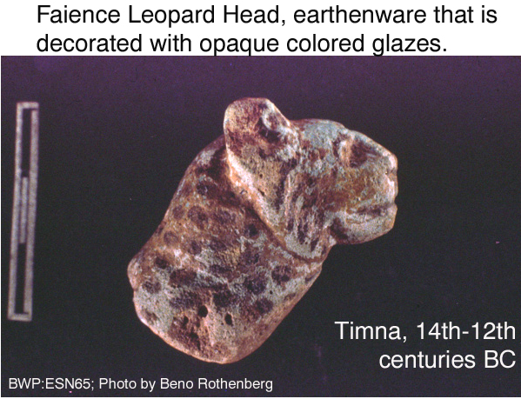

PHOTO LINK: ESN061 PHOTO LINK: ESN61 “King Solomon’s Pillars”; Timna Valley, southern end of the Dead Sea.
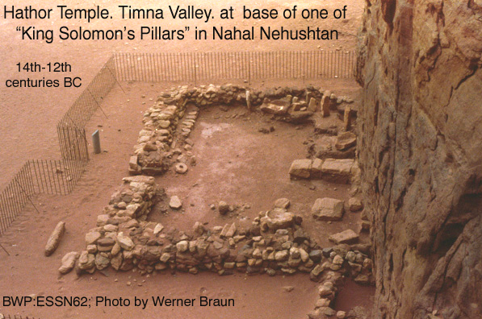

From Beth Shemesh the Ark was taken to Kiriath- Jearim and stayed there for 20 years (1 Sam. 7:2).

Revival and Assembly at Mizpah (1069 BC)

Samuel initiated a religious revival of the still-oppressed Israelites. They once again rid themselves of foreign gods and rededicate themselves to Yahweh. Receiving a promise of blessing from Samuel, they assembled at Mizpah and Samuel interceded for them. He has now assumed both religious and political leadership of Israel. It is what Israel needed to unify them at that time. The location of biblical Mizpah is debated. Bunimovitz and Faust (2002) think it was at Tel en-Nesbeh while Magen (2008) suggests Nebi Samwil.

PHOTO LINK: FOUR ROOM HOUSE 007 4-room house at Mizpah-Tel en-Nesbeh Building 1 (See ABOVE, ctrl+click to follow link)

PHOTO LINK: FOUR ROOM HOUSE 008 4-room house at Mizpah-Tel en-Nesbeh Building 2
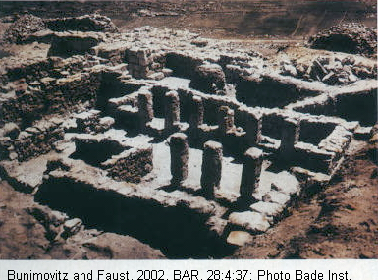

PHOTO LINK: MIZPAH 001 Aerial photo of Mizpah at Tell en-Nasbeh (See ABOVE, ctrl+click to follow link)
PHOTO LINK: MIZPAH 002 Location map of Tell en-Nashbeh (Mizpah) (See ABOVE, ctrl+click to follow link)

PHOTO LINK: MIZPAH 006 Plan of Mizpah showing Stratums I, 2 and 3
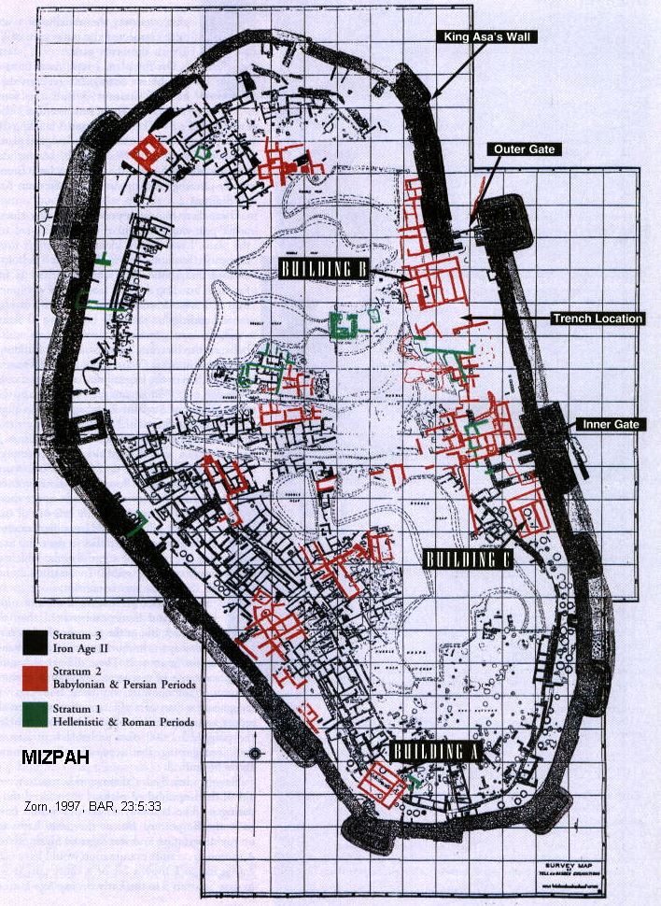

PHOTO LINK: MIZPAH 010 Plan of Israelite Mizpah (Tell al-Nasba)
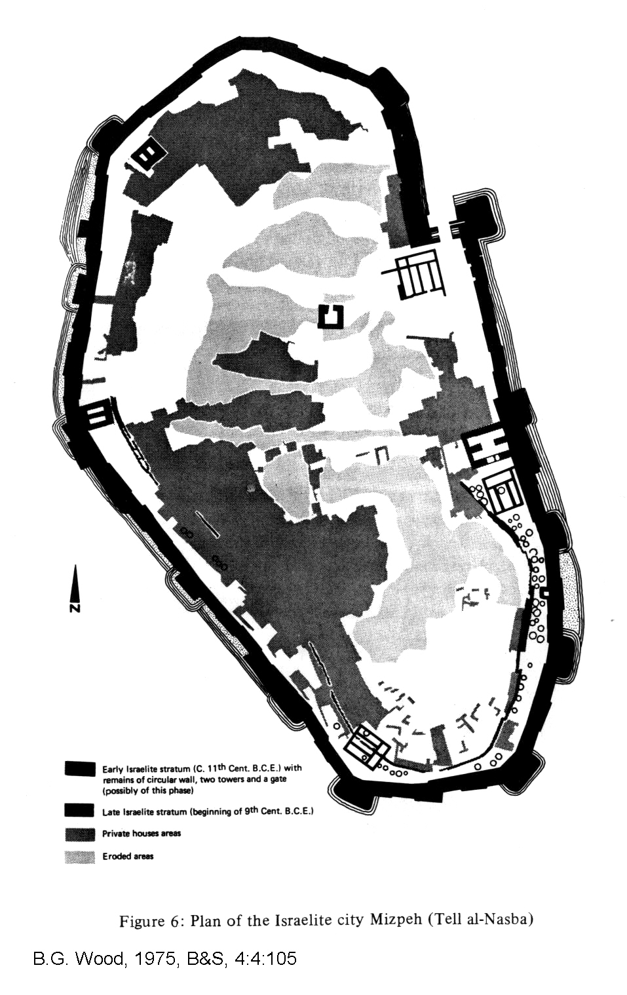

PHOTO LINK: NEBI SAMWIL 001 Excavations
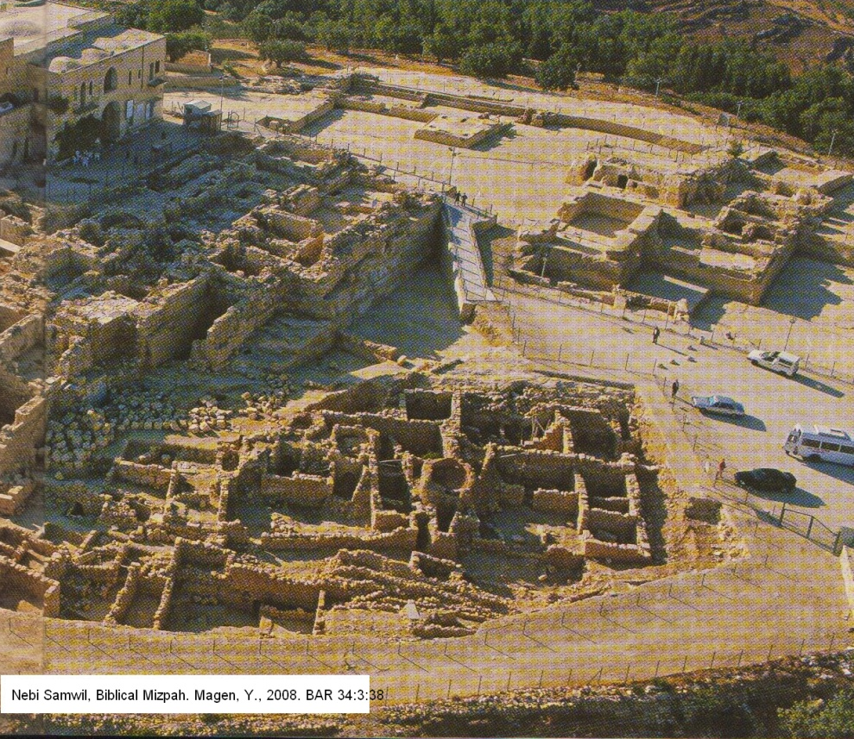
PHOTO LINK: NEBI SAMWIL 002 Location map
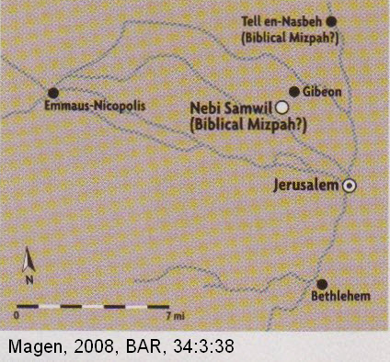

PHOTO LINK: NEBI SAMWIL 005 Quarry
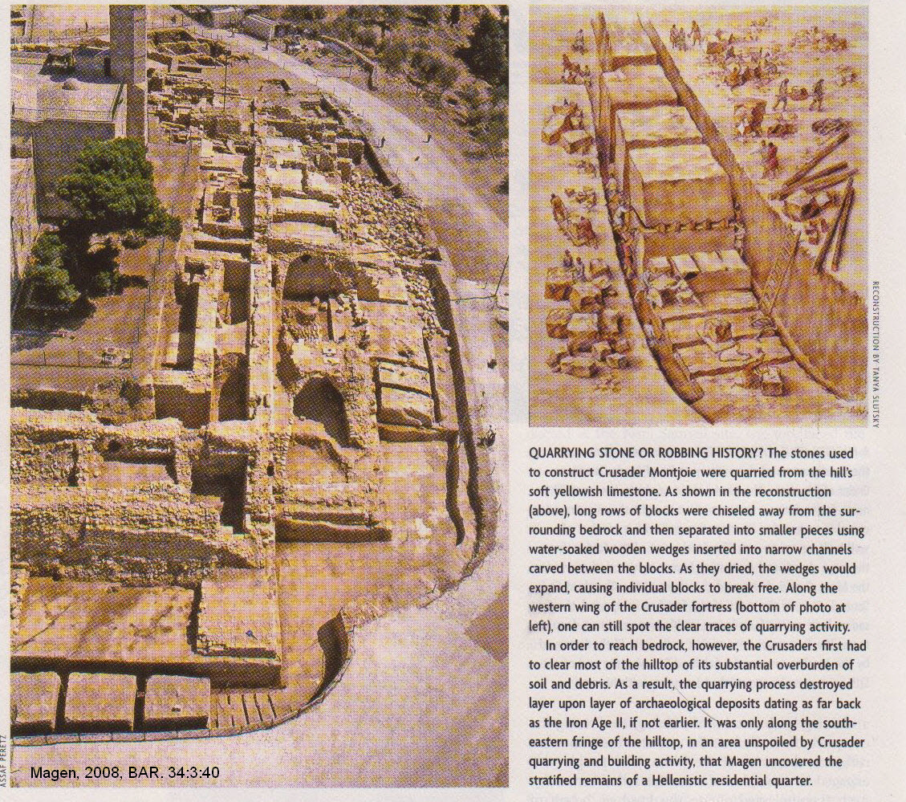

PHOTO LINK: NEBI SAMWIL 003 Excavations
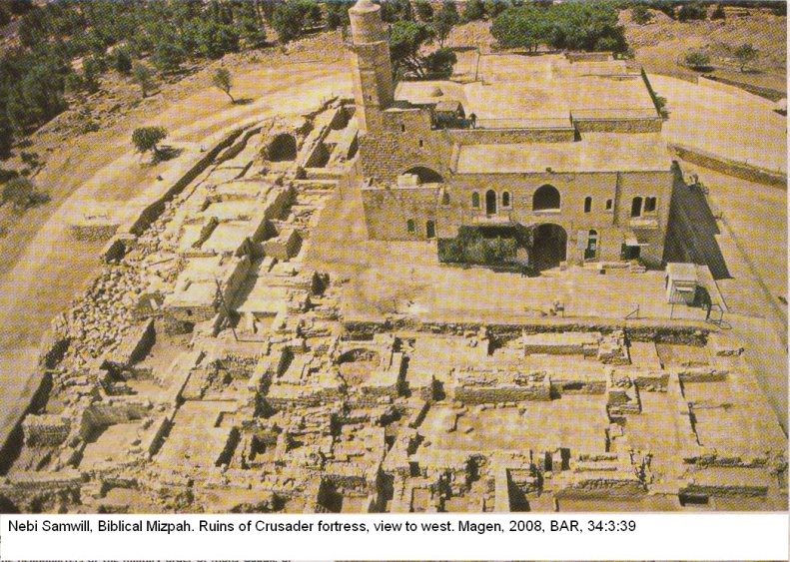

Battle of Mizpah-Beth Car (c 1069 BC)

As soon as the Philistines heard of the Mizpah assembly, they mustered for attack assuming they could repeat the victories they won at Ebenezer 20 years earlier. This time, however, the "Lord thundered... against the Philistines and threw them into such a panic that they were routed...the Israelites rushed out of Mizpah and pursued the Philistines slaughtering them along the way to a point below Beth Car" (1 Sam. 7:10-11). Following this battle, Samuel went on to re-capture the Philistine towns "from Ekron to Gath" and "delivered the neighboring territory". Furthermore, on the eastern front "there was peace between Israel and the Amorites" (1 Sam. 7:14).

Samuel judged Israel and kept the Philistines at bay for the rest of his life. He became a kind of judicial circuit rider moving between Bethel, Gilgal and Mizpah each year (1 Sam. 7:15-16). His physical presence contributed to Israelite nationalism and religious orthodoxy.

JUDGES JOEL AND ABIJAH (In Beer-sheba, 1048?-1943 BC)

Sometime around the time of the Battle of Ebanezer, Samson appointed his sons, Joel and Abijah to be judges in Beer-Sheba. They did not follow in Samuel's ways. Instead, they were like Eli's wicked sons: They sought dishonest gains, bribes, and perverted justice.

PHOTO LINK: ESN 091 Aerial photograph of Beer-Sheba
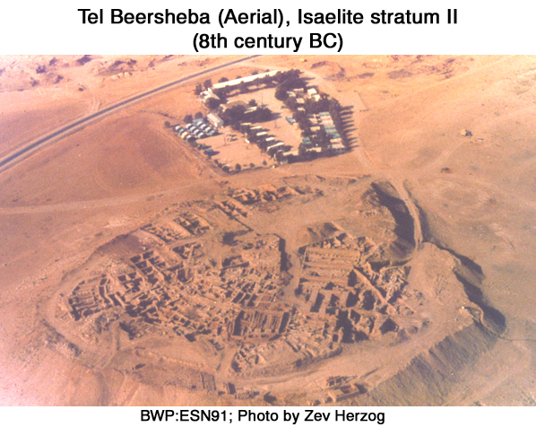
PHOTO LINK: ESN 092 Trench Through Fortifications, Beer Sheba
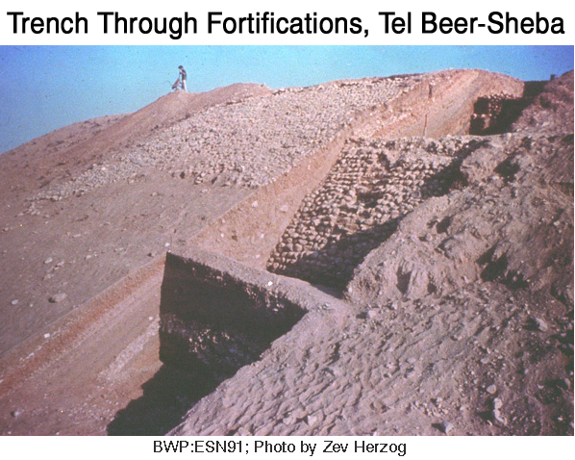

PHOTO LINK: DAVID 011 Location map of Zitlag and Beer-Sheba
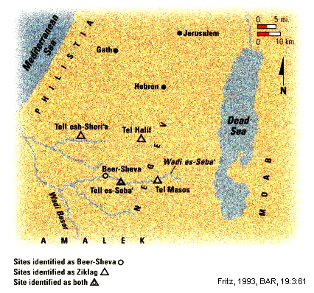

Because of this, the Israelites demanded a king to lead them (1 Sam. 8:1-5; 1Ch 6:28; Compton's Interactive Bible, 2005). Joel and Abijah proved that Ephriamite priests could be as evil as the Levite priests Hophni and Phinehas had been (1 Sam. 2:12-16, 22). Disgusted with the priesthood, the people sought a secular leader, a king (1 Sam 8:4-6).

PHOTO LINK: BA054 Iron II Four-room House Beersheva
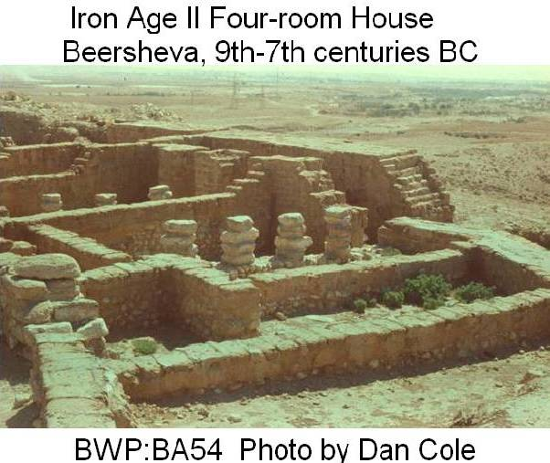

KING SAUL (1043-1011 BC)

Samuel was an effective and popular leader. But like Eli, he had two sons whom he could not control and in whom he could not impart dedication to Yahweh and Torah. Neither was going to succeed him as a national leader. Popular dissatisfaction with the corrupt priesthood contributed to the rise of kingship in Israel. The compiler of 1 and 2 Samuel describes the institution of kingship in uncomplimentary terms, equating it with a rejection of Yahweh's direct authority over them individually. Ideally, Yahweh should be king. Given the general spiritual immaturity of the people, kingship was granted to Israel as a kind of consolation: necessary but not wanted by Yahweh.

Samuel, at Yahweh's direction, laid out the consequences of kingship: Their freedom would be restricted. They would be taxed and become slaves to the king. In the end, Samuel warned "you will cry out for relief from the king you have chosen, and the Lord will not answer you" (1 Sam. 8:18). The people ignored the advice because they want to be "like the other nations, with a king to lead us and to go out before us and fight our battles" (1 Sam. 7:18). It was peer pressure on a national scale. What an irony, and from a nation that was supposed to be set apart, chosen, from all the nations in the world.

Samuel had been directed by Yahweh to make Saul king when Saul came to Samuel looking for donkeys at Ramah (1 Sam. 7:17; 10:1-2). He was anointed by Samuel there, but his official selection was made by casting lots using the Urim and Thurim, two plates or flat stones carried by the priests (Exod. 28:30; Num. 27:12-21) at Mizpah (1 Sam. 10:17, 20-21). The Urim and Thurim were designed to answer "Yes" or "No" questions.

PHOTO LINK: URIM AND THUMMIM 001 Illustration of High Priest wearing breastplate

PHOTO LINK: URIM AND THUMMIM 002 Chart of stones in High Priest's breastplate
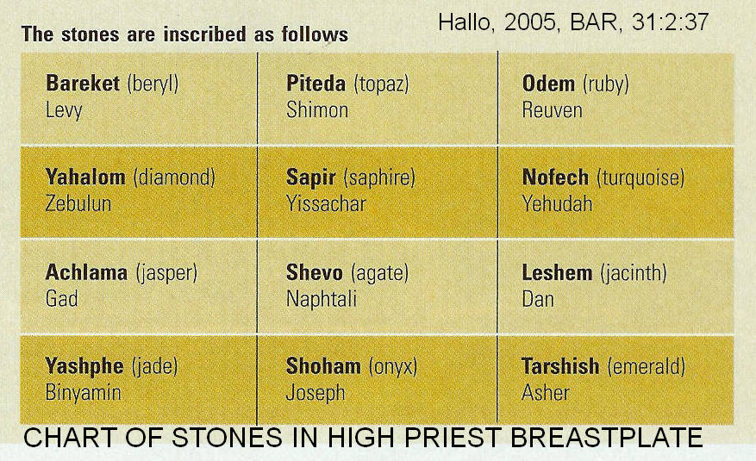

Saul was chosen, and then found among "the baggage", an act that could be interpreted as modesty or incompetence (1 Sam 10:22).

Covenant of Kingship

As part of the coronation ceremonies, Samuel "explained to the people the regulations of kingship. He wrote them down on a scroll and deposited it before the Lord" (1 Sam 10:25). The text of this agreement has not survived, but possibly contains stipulations for each issue identified in Samuel's speech of 1 Sam. 8:10-18.

Battle of Jabesh (1043 BC)

Saul returned home to Gibeah with his supporters while naysayers refused to give gifts (money) to support the new monarchy (1 Sam. 10:27).

PHOTO LINK: SAUL 003 Illustration of Saul's palace fortress at Gibeah
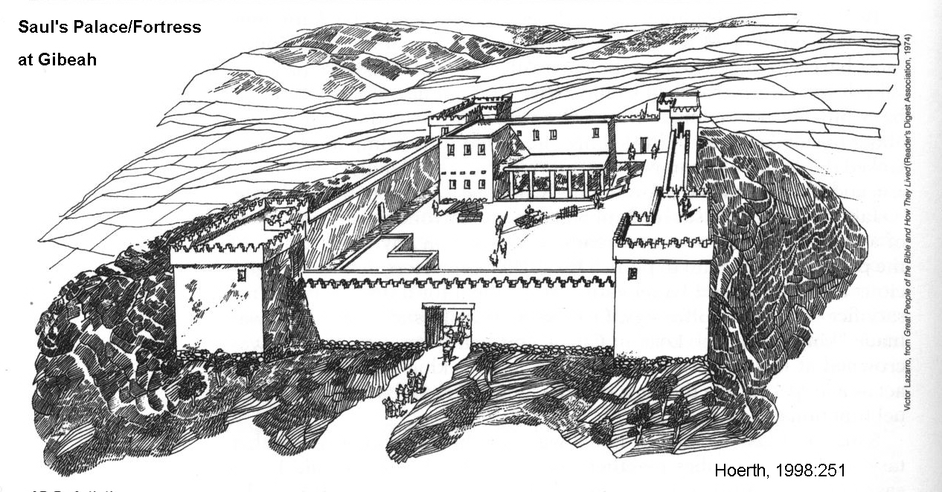

Then Nabash the Ammonite laid siege to Jabesh Gilead and demanded a peace treaty with terms that included gouging out the right eye of every citizen. This practice of maiming a defeated enemy was traditional for Near East cultures of this period. Blinding of one eye is described in Ugaritic literature (Hoerth, 1998:248).

PHOTO LINK: UGARIT 002 Ruins of Eras Shamra at ancient Ugarit capital
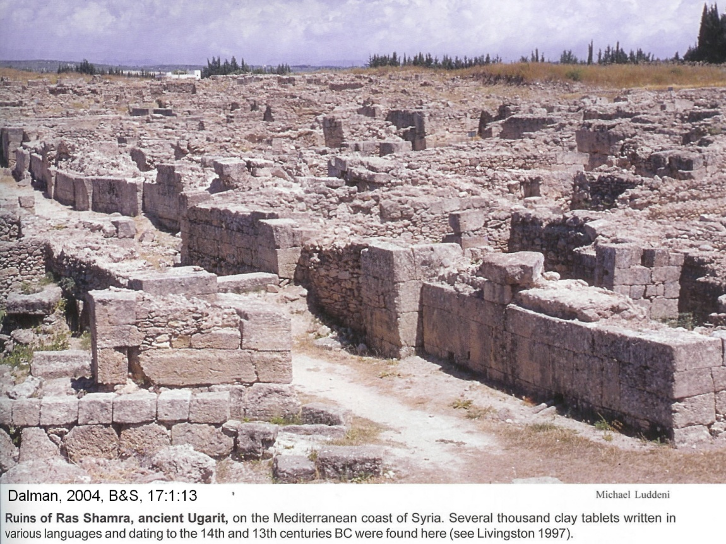
PHOTO LINK: UGARIT 006 Location map of Ugarit
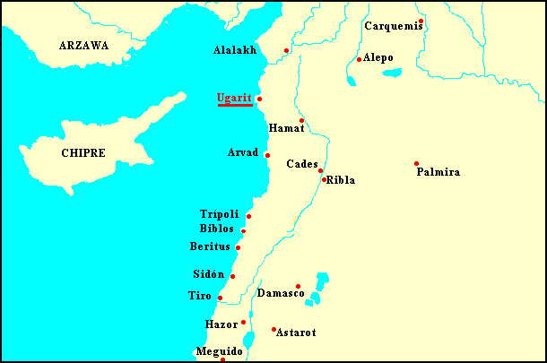

When Saul learned of this mass mutilation, he was plowing (he was a rustic king, after all). Saul demanded that each tribe send their regiments to him at Bezek, about nine miles west of the Jordan river, opposite Jabesh (Hoerth, 1998:248). In terror of what Saul might to do to them, the Israelites complied and assembled a force of 330,000, of which 30,000 were Judeans (1 Sam. 11:1-8).

PHOTO LINK: JUDGES 016 Map of Saul's defeat of the Ammonites
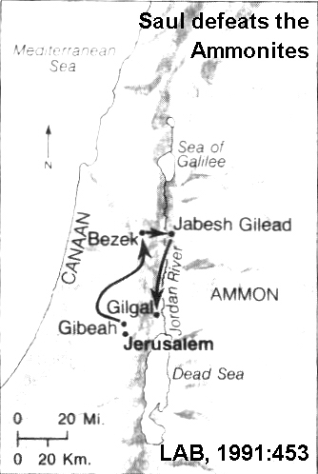

PHOTO LINK: BEZEK 001 Location map
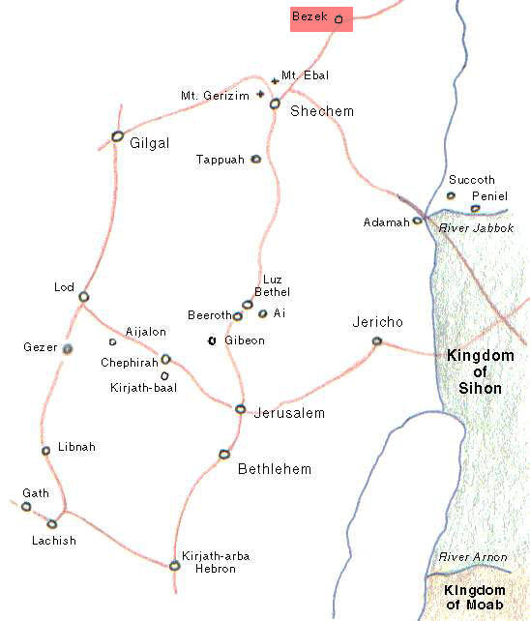

Gilgal

A fortress identified as Saul's administrative center in Gilgal has been found. It had modest dimensions of 170 x 115 feet. Every artifact recovered, including a plowshare was common to the average person of the day. This suggests that Saul was a initially more farmer than ruler (Hoerth, 1998:249).

PHOTO LINK: GILGAL 003 Location map
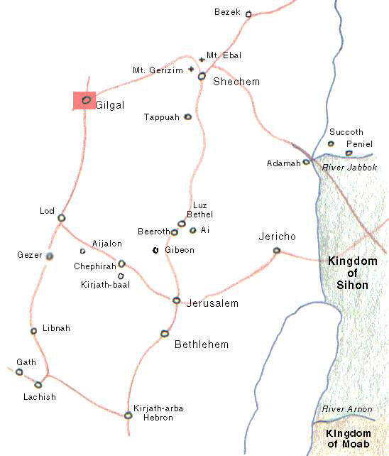

PHOTO LINK: GILGAL 002 Plan of Gilgal, 12th-13th centuries BC (See ABOVE, ctrl+click to follow link)

PHOTO LINK: GILGAL 001 In Manassah, overlooking Wadi Far'ah, Deut 11:30 (See ABOVE, ctrl+click to follow link)

Dividing his forces into three divisions, and attacking between 2:00 and 6:00 AM (Hoerth, 1991:249), Saul defeated and scattered the Ammonite army. His leadership proven, he was re-dedicated as king, this time at Gilead. At this second coronation, everyone "sacrificed fellowship offerings" (1 Sam. 11:14) to support the administration of the new monarchy. 1 Sam. 12 is Samuel's farewell speech. With Samuel’s retirement to Gilgal, the era of the judges came to an end.|

BAMOT OF THE CONQUEST-JUDGES ERA (Nakhai, 1994). See Deut 27:4-8; Josh 8:30-31, 1 Sam 9:11-25, 10:5

LOCATION | DATE | REFERENCES | ARTIFACTS/ COMMENTS
MANNASSEH | 12th cent. BC | Zertal1985; Nakhai 1994 | In territory of Mannasseh. It consisted of simple stonework including a massebah (standing stone) encircled by a stone wall. This is called the Bull Site because of a small bronze bull and fragment of a ceramic incense burner of model shrine found there.
SHILOH | 12th to mid-11th cent. BC | Finkelstien 1986; Finkelstien 1988 | Remnants of a sacred complex now largely destroyed by more recent construction with animal bones and fragments of cultic motifs. Interpreted as a open-air pilgrimage center for central hill country Israelites as described in Judges 21:12; 1 Sam 1:3
MT. EBAL | 12th cent. BC | Zertal 1985;1987; Mazar 1982;1983 | Open-air altar described in Josh 8:30-35 and Deut 27:4-8. Incense burner (ritual chalice) found at the bottom of altar.
HAZOR | 13th or 11th century BC | Yadin 1970; 1975; Beck 1989 | Canaanite city destroyed by Israelites (LATE date). Ceramic jars filled with bronze objects were found under the floor of a small bench-lined room. Incense stands were found in paved areas around the main chamber as if the rooms had cultic function. Valuable objects hidden in floor when the city was attacked

"This diversity is precisely what our model leads us to expect from the disparate tribal groups involved in the lengthy process of settling down and unifying" (Nakhai, 1994:24)

In the era of Judges, religion and places of worship were somewhat idiosyncratic, customized for local needs. Bamah in this era refers to a sacred open place or a sacred structure. For the Israelites, these were legitimate places of worship of Yahweh

This Zoar should not be confused with the “City of the Plain” by that name of Genesis 13:10

