CHAPTER 16: SAUL, DAVID, AND SOLOMON OF THE GOLDEN AGE

Contents

CHARACTER OF HEBREW AND CANAANITE CIVILIZATION DURING THE EARLY UNITED MONARCHY 1931
MINI-EMPIRES DURING THE UNITED MONARCHY 1932
POTTERY SIGNATURES OF THE UNITED MONARCHY 1933
SAUL: (1043-1011 BC) 1934
The Ascension of King Saul (1043 BC) 1935
Qeiyafa Ostracon 1935
Philistines and Iron: The Pym 1939
Ecstatic Dancing 1941
Skirmish at Geba (1043 BC) 1942
Battle of Micmash (1043 BC) 1942
Earthquake during the Battle of Micmash 1944
Jonathan after Micmash 1946
Saul’s Good Years (1043-1015? BC) 1946
Battle of Telaim 1947
Saul rejected as king 1947
Samuel anoints David as King 1947
Saul and the Evil Spirit from the Lord (circa 1013? BC) 1947
David and Goliath: Battle of Elah Valley (c. 1013 BC?) 1948
Rise of David (c. 1013-1011 BC?) 1951
David’s Escape from Saul (c. 1013 BC?) 1954
Saul kills the Priests of Nob (c. 1013 BC?) 1957
Battle of Keilah (c. 1013 BC?) 1958
Encounter between Saul and David in the Cave of the Wild Goats (c. 1013 BC?) 1961
Abigail and Nabal (c. 1013 BC?) 1962
Encounter at the Hill of Hakilah (c. 1013 BC?) 1962
David and King Achish: Ziklag (c. 1013 BC?) 1964
Preparations for the Battle of Gilboa (c. 1012 BC?) 1968
Witch of Endor (c. 1012 BC?) 1970
David and the Amalekites (c. 1012 BC?) 1970
David at Hebron (c. 1007 BC?) 1971
David’s Zitlag (c. 1007 BC?) 1977
The Battle of Jezreel-Gilboa and the death of Saul (1011 BC) 1978
Decapitation in the Levant, Iron Age 1979
David’s Lament for Saul and Jonathan 1986
ISH-BOSHETH AND ABNER (1011-1004 BC) 1988
KING DAVID OF JUDAH (1011-1004 BC) 1989
Battle of the Pool of Gibeon (circa 1005 BC) 1990
Civil War (1011 to 1004 BC) 1994
KING DAVID OF JUDAH AND ISRAEL (1004-971 BC) 1995
David becomes king of all the tribes of Israel (1004 BC) 1995
Jebusite Jerusalem and the City of David (1004 BC) 1995
The Millo (“Stepped-Stone Structure) of David’s Jerusalem (1004-971 BC) 2008
Debates about the Stepped-Stone Structure (1004-971 BC) 2017
Red-Slip Ware 2019
Proto-ionic Capital 2025
History of the Stepped-Stone Structure 2025
David’s Palace (1004-971 BC) and the Large Stone Structure 2031
Amarna Letters and the City of David (1004-971 BC) 2041
Middle Bronze Age Water Delivery System 2048
Gihon Spring Water Supply and Warren Shaft Systems (1900 to 1700 BC, 701 BC) 2056
DAVID’S CONQUEST OF JERUSALEM (c. 1004 BC) 2076
David’s School of Scribes (1004-971 BC) 2077
Ark of the Covenant (1004-971 BC) 2079
Battles of Baal Perazim and Valley of Rephaim (c. 1003 BC) 2080
David’s Prayer 2082
Completion of the Conquest of the Promised Land (c.1003-963 BC) 2083
Damascus (c.1003-963 BC) 2085
Dor (c.1003-963 BC) 2085
Edom (c.1003-963 BC) 2092
Edomite Copper Production at Khirbat en-Nahas 2096
Ekron (c.1003-963 BC) 2108
Gath (c.1003-963 BC) 2114
Geshur (c.1003-963 BC) 2120
Northern Geshur (c.1003-963 BC) 2120
Mitham Leviah of the Northern Geshur (c.1003-963 BC) 2123
Tel Soreq of Northern Geshur(c.1003-963 BC) 2124
Tel Hadar of Northern Geshur (c.1003-963 BC) 2127
Southern Geshur 2133
Tel 'En-Gev (c.1003-963 BC) 2133
Gov or Sha’arayim (Khirbet Qeiyafa, c 1003-963 BC) of the Southern Gesher 2135
Megiddo (c.1003-963 BC) 2142
Alternative Theory for Megiddo VI 2146
Moab (c.1003-963 BC) 2148
Zobah (c.1003-963 BC) 2152
Ammonites (c.1003-963 BC) 2152
Battle of Rabbah (c.1003-963 BC) 2154
Battle of Helam (c.1003-963 BC) 2155
David and Bathsheba (C1004-971 BC) 2156
“House of David": Inscription at Tel Dan 2156
"House of David" In the Mesha Stela 2164
"David" inscription in Egypt 2167
THE REVOLT OF ABSALOM (circa 975 BC) 2170
Battle of the Forest of Ephriam (circa 975 BC) 2173
DAVID'S RETURN TO JERUSALEM AND SHEBA'S REVOLT (circa 975 BC) 2178
King David's Tomb (971 BC) 2178
SOLOMON (971-931 BC) 2186
Adonijah 2186
Power Consolidation (971 BC) 2188
Pharaoh’s Unnamed Daughter (970-960 BC) 2189
SOLOMON'S ARCHITECTURAL ACHIEVEMENTS IN JERUSALEM 2194
Solomon's Jerusalem 2194
Water system 2205
Tombs 2206
Tell el-Armana letters 2207
Pottery 2207
THE TEMPLE MOUNT 2210
Solomon’s Temple, The First Temple (971 BC) 2217
Nehemiah’s Temple, The Second Temple (520-516 BC) 2218
Seleucid-Addition (186 BC) 2222
Hasmonean Extenstion (141 BC) 2223
Herod’s Temple and Expansion (20 BC) 2226
SOLOMON’S TEMPLE 2231
Location of the Temple 2236
Beit Yahweh Ostracon and Solomon's Temple 2248
Temple Furnishings 2249
Location of the Ark in the Temple 2258
Ezekiel's Plan of the Temple 2265
Temple Depicted on Ossuary and Coins 2265
Parallels to Solomon's Temple 2266
Hazor Phoenician Temple 2266
'Ain Dara, Syria 2269
Ta'yinet (Ta'aynat) Temple, Syria 2272
Theology and Political Theory of the Temple 2276
SOLOMON'S ARCHITECTURAL ACHIEVEMENTS OUTSIDE JERUSALEM 2276
Monumental Gateways at Hazor, Megiddo and Gezer 2276
Beer-Sheba of Solomon 2281
Beth Shemesh of Solomon 2282
Cabul of Solomon 2288
Gezer of Solomon 2290
Hazor of Solomon 2297
10th Century Tripartite Buildings at Hazor 2303
Heshbon of Solomon and the Ammonites (c. 970-930 BC) 2306
Lachish of the United Monarchy (c. 1043-931 BC) 2308
Megiddo of Solomon (c. 971-931 BC) 2312
SOLOMON'S STABLES AND TRIPARTITE BUILDINGS 2318
Tripartite Building at Tel Hadar 2323
9th and 10th century Tripartite buildings at Megiddo 2326
Common Features of Tripartite Buildings 2330
SOLOMON'S GOLD 2335
Ophir 2350
QUEEN OF SHEBA 2351
Country of Sheba 2354
The Sabaeans 2356
Sheba the Queen 2356
Religion at Sheba 2357
Commerce and Sheba 2360
Philosophy and Theology 2367

The Israelite Golden Age is the epoch that all Israelites look to for inspiration and was the model for the earthly kingdom that the Messiah was expected to restore. The age was short-lived but glorious. It was ushered in by Saul who became king of a confederation. The kingdom was firmly established and defended by David. It was brought to glory under Solomon. Civil war followed the death of Solomon, and the Israelite golden age quickly faded. The Golden Age is an epic tragedy.

THE REVOLT OF ABSALOM (circa 975 BC)

The wives and sons of David

Wife Sons
1. Micha------------(None)
2. Ahinoa---------------Amnon
3. Abigail--------------------Chileab (died at young age?)
4. Maacah------------------------Absolom
5. Haggith-----------------------------Adonijah
6. Abital-------------------------------------Shephatiah
7. Eglah------------------------------------------Ithream
8. Bathsheba-----------------------------------------Shimea, Shobaab, Nathan, Solomon
9. other wives----------------------------------------------Ibhar, Elishama, Eliphefet, Nogah, Nephag,
Japhia, Elishama,Elada, Ellpheilel, Tamar
10. concubines------------------------------------------------------other sons

Wives and Children of David (2 Sam. 3:2-5; 1 Chron. 3:5-9; adapted from Hoerth, 1998:271)

Amnon (David's oldest son) raped his half-sister, Tamar. In revenge, Amnon was murdered by his half-brother Absalom (2 Sam. 13). Since David's second son, Chileab, is only mentioned in 2 Sam. 3:3, it can be assumed he died at a young age (Hoerth, 1998:270). This made Absolom next in line for the thrown. After the murder of Amnon, Absolom fled to Talmai, king of Geshur for protection.

PHOTO LINK: GESHUR 001 Panorama of Geshur with sea of Galilee (See ABOVE, ctrl+click to follow link)

PHOTO LINK: GESHUR 002 Location map of cities in Geshur Galilee (See ABOVE, ctrl+click to follow link)

The town of Geshur is along the eastern shore of the Sea of Galilee. David longed to see Absolom again, and general Joab arranged for a ruse to make David realize he needed to recall Absolom from exile (2. Sam. 14). Absolom returned to Jerusalem, and after 2 years was finally re-united with David (2 Sam. 14:33).

Absolom was popular with the Israelites: he was considered handsome and without blemish (like a pure lamb, ready for sacrifice). He also had beautiful, thick hair (2 Sam. 14:25-26). Absolom began criticizing his father's judicial practices by speaking to litigators "on the road leading to the city gate" (2 Sam. 15:2). The city gate complex was an administrative center for justice. He would also flatter everyone he met, so that "he stole the hearts of the men of Israel" (2 Sam. 15:6).

PHOTO LINK: MEGIDDO 017 Gate complex. Similar to the gate that Absolom sat at in Jerusalem.
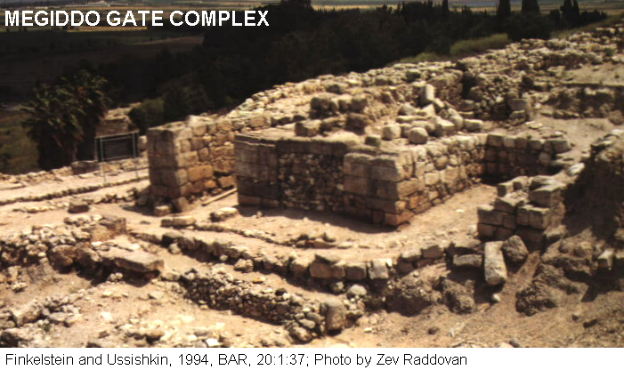

PHOTO LINK: DAVID 006 Map of Absalom's Revolt
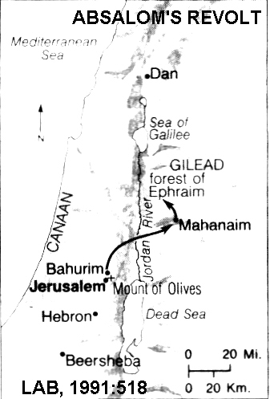

After first getting permission from David to go to Hebron, under the ruse of fulfilling an oath to worship there, Absolom invited an unwitting contingent of 200 men from Jerusalem to accompany him. His following increased, and when David heard of it, David panicked and prepared to flee Jerusalem with his foreign body guard of 600. It became a common practice at this time for Near Eastern rulers to have mercenary foreign nationals as palace troops because they were less likely to be disloyal to a king and had little reason to support his overthrow.

David left Jerusalem with the Ark of the Covenant and a large contingent that included all the Levites. Abiathar offered sacrifices "until all the people finished leaving the city" (2 Sam 15:24). David ordered the high priest Zadok to return to Jerusalem with the Ark and to become spies.

PHOTO LINK: ARK OF THE COVENANT 001 Model (gold)
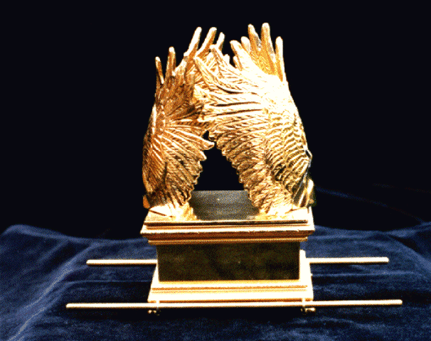

Absolom entered Jerusalem and made plans to make war on his father. One of Absolom's advisors was Ahithopel who may have been Bathsheba's grandfather. Perhaps he never forgave David for seducing his granddaughter and killing Uriah (Hoerth, 1998:271). David retreated to Mahanaim and Absolom's forces followed, crossing the Jordan with a confederate army amassed "from Dan to Beersheba. The size of the army was "as numerous as the sand on the seashore" (2 Sam. 17:11), and lead by Absolom.

Battle of the Forest of Ephriam (circa 975 BC)

David's refugee force was large. In groups of "thousands and hundreds", three divisions were organized and commanded by Joab, Abishaii and Ittai. The location of the battle was on the east side of the Jordan, in a grove called the "Forest of Ephriam" ("ya'ar Efrayim"). This area is also called the "the forest of Lebanon" (1 Kings 7:2; 10:17-21; 2 Chronicles 9:16-20).

PHOTO LINK: FOREST OF LEBANON 001 Giant trees, Iron Oak Forest
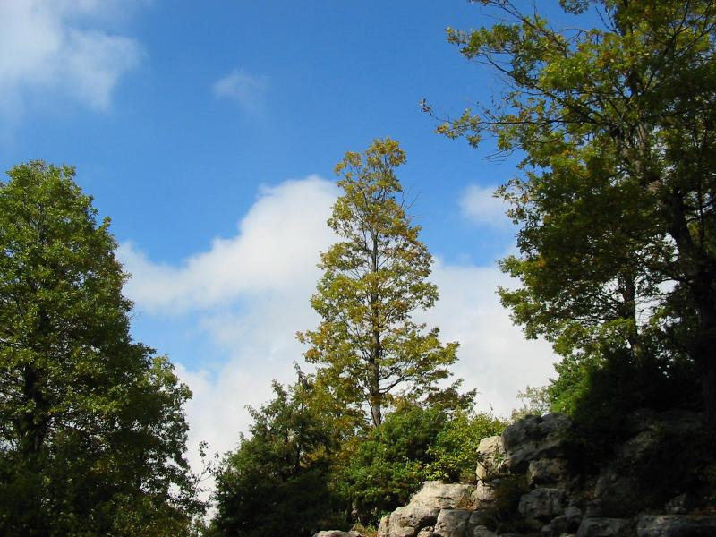
PHOTO LINK: FOREST OF LEBANON 002 Smaller trees
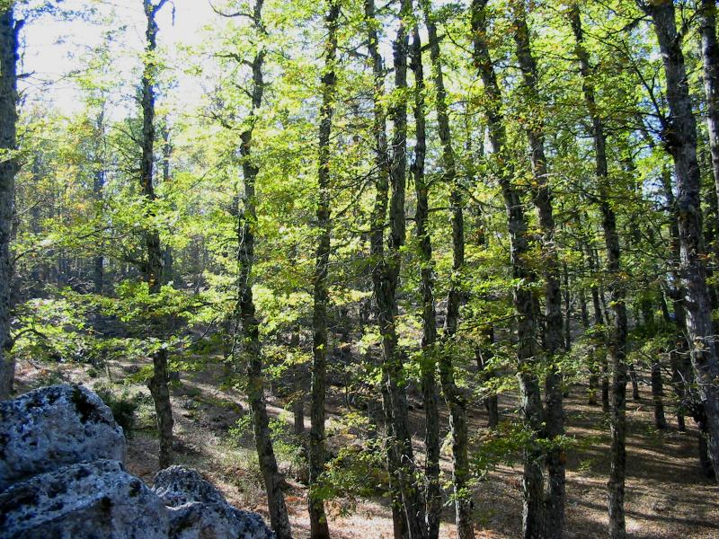

The tribal allotment for Ephriam was on the west side of the Jordan, south of Jerusalem.

PHOTO LINK: CONQUEST 002 Map of tribal allotments
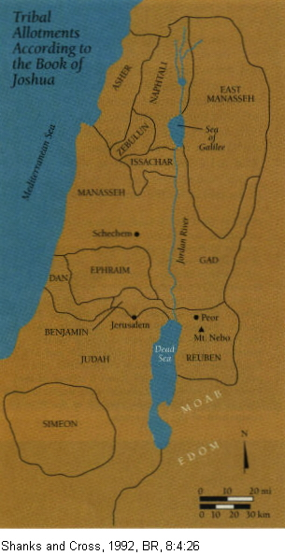

PHOTO LINK: DAVID 007 Map of Sheba's Revolt
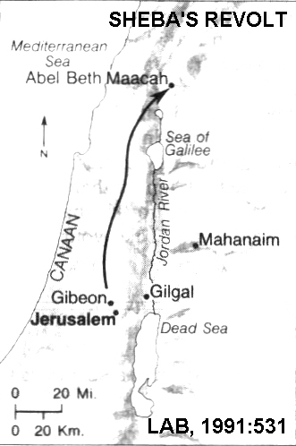

David's forces prevailed and they inflicted 20,000 casualties on the followers of Absalom (2 Sam. 18:6). While fleeing the battlefield, Absolom got his head caught in the branches of an oak tree. General Joab found him and plunged three javelins into his heart while Absolom was still alive. David mourned for Absolom to such and extent that his soldiers felt bad for winning the battle. Joab confronted David who returned to Jerusalem and magnanimously pardoned those who rebelled against him (2 Sam. 19). David replaced his victorious general and long-time confidant Joab with the general who lost the battle, Amasa. This may have been done as a gesture of national reconciliation.

PHOTO LINK: CONQUEST 008 Map of tribal allotments
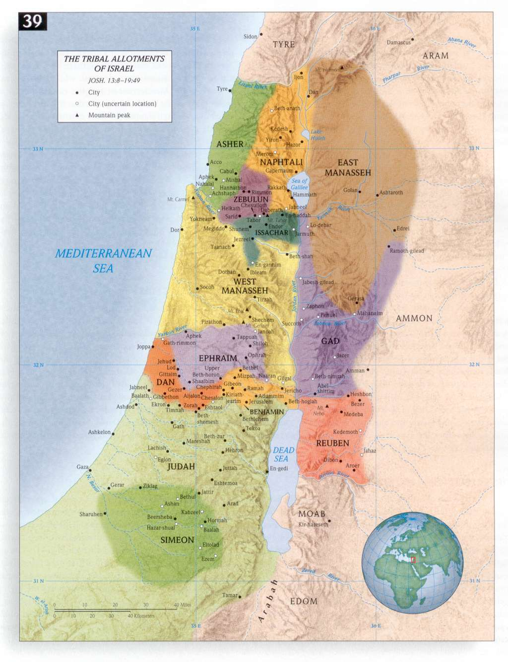

DAVID'S RETURN TO JERUSALEM AND SHEBA'S REVOLT (circa 975 BC)

As David prepared to be re-instated as king, a dispute broke out between men of Judah and the other Israelites as to who would be his chief escort. Then a rebel named Sheba sounded a call of revolt, and "all the men of Israel deserted David to follow Sheba" (2 Sam. 20:1).

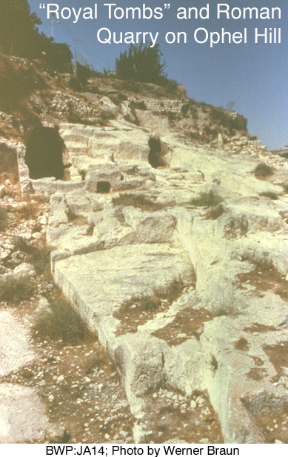
After returning to the Palace, David ordered a muster of the Judean army in three days. His new general, Amasa could not do the job on time, so Amasa was replaced by Abishai who set out with Joab's contingent and others after Sheba. During the chase, Joab murdered his rival, Amasa, with a dagger. When Joab and Abishai caught up with Sheba he and his followers were in the fortress of Abel Beth Maacah, on the east side of the Jordan River and north of the Sea of Galilee. A siege is laid to the city, and the inhabitants, at the advice of a "wise woman", behead Sheba and threw his head over the wall. With that, the rebellion ended, the siege was lifted and everyone returned to their homes. Joab was promoted to commander "over Israel's entire army" (2 Sam. 20:23).

After these events, David's leadership was unchallenged and he died after securing Solomon's succession.

King David's Tomb (971 BC)

The location of King David’s tomb is unknown, and opinion about where it might be has shifted over the years. Nine tombs have been found in southern part of the old City of David. This area is consistent with I Kings 1:51 "David slept with his fathers, and he was buried in City of David." Most burials were outside city walls, because they were unclean (Mishna, Kelim 1.7). Of the 9 tombs, T1 at the summit of the hill is most likely David's tomb. This tomb was partly destroyed by a quarrying operation in Roman and Byzantine periods. Some quarrying may have occurred in the Persian period (by Jews), not necessarily in the immediate vicinity of T1 (Shanks, 1995).

PHOTO LINK: JA014 Jerusalem: “Royal Tombs” and Roman Quarry on Ophel Hill (RIGHT)

PHOTO LINK: JA027 Jerusalem: Excavations West of Temple Mount.
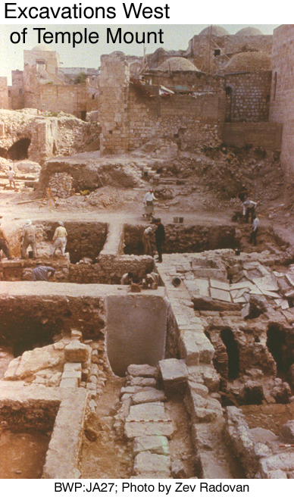

This is in an area where early Iron Age II tombs cut down into the bedrock were uncovered. Since Israelite cemeteries invariably were located outside the city walls, this area must have been beyond the limits of Jerusalem through the 9th century.

The location of the First Temple period tombs was theorized by Charles Clermont-Ganneau as being in the area of a semicircular loop in the southeastern portion of an underground aqueduct built under the direction of king Hezekiah. This aqueduct, termed “Hezekiah’s Tunnel” was 1,750 feet long and connected the Gihone Spring to the Siloam Pool.

PHTOTO LINK: HEZEKIAH’S TUNNEL 050: Photo of Charles Clermont-Ganneau and map of Hezekiah's tunnel showing semicircular "loop". Shank, 2012, BAR 38:6:46.

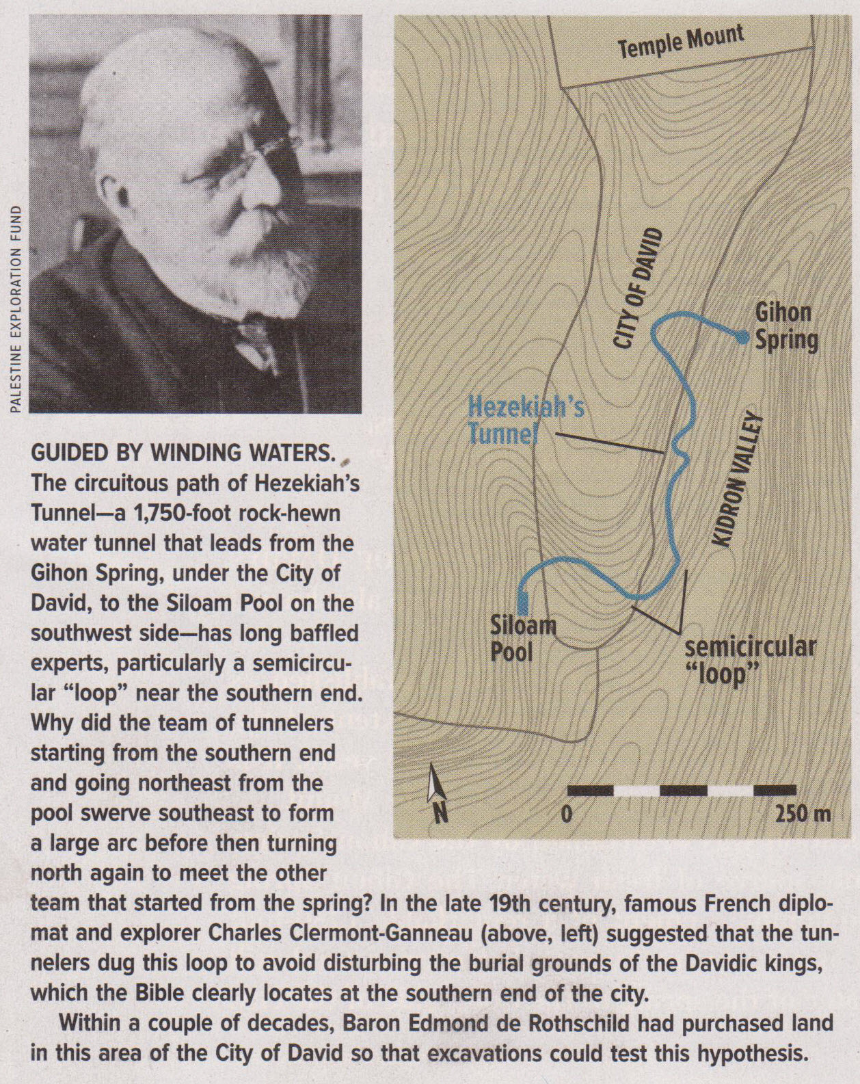

The Clermont-Ganneau theory was tested in 1913-1914 and 1923-1924 by Raymond Weill. He identified several rock-cut features that he interpreted as tombs. He labeled them T-1 to T-8. Of these the most prominent were T-1, T-2 and T-3.

PHOTO LINK: CITY OF DAVID 009: Tombs T-1 through T-8 with hoto of Raymond Weill and his 1913-1914 plan drawing. Shanks, 2012, BAR, 38:6:47.

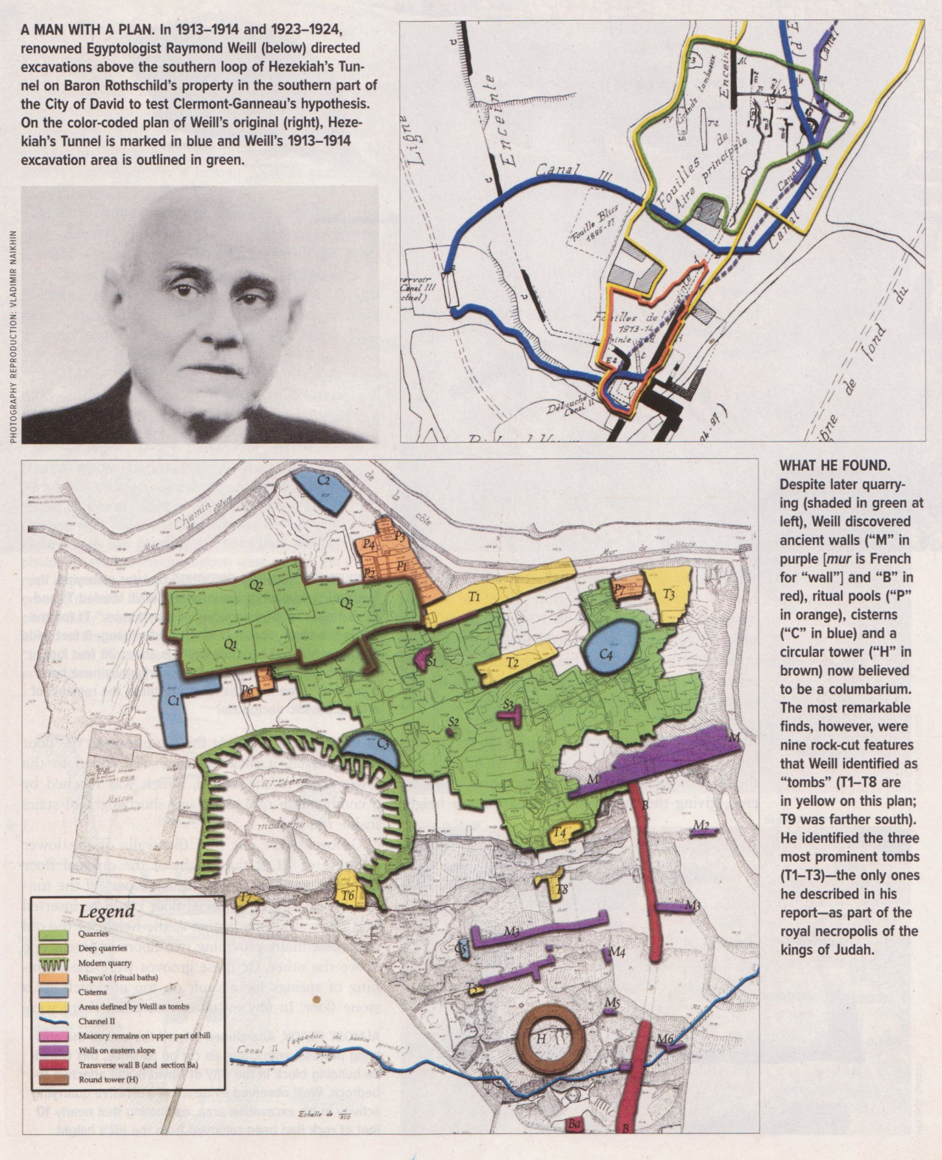

PHOTO LINK: CITY OF DAVID 010: Tombs T-1 and T-2 in Roman era quarry. Shanks, 2012, BAR, 38:6:48.

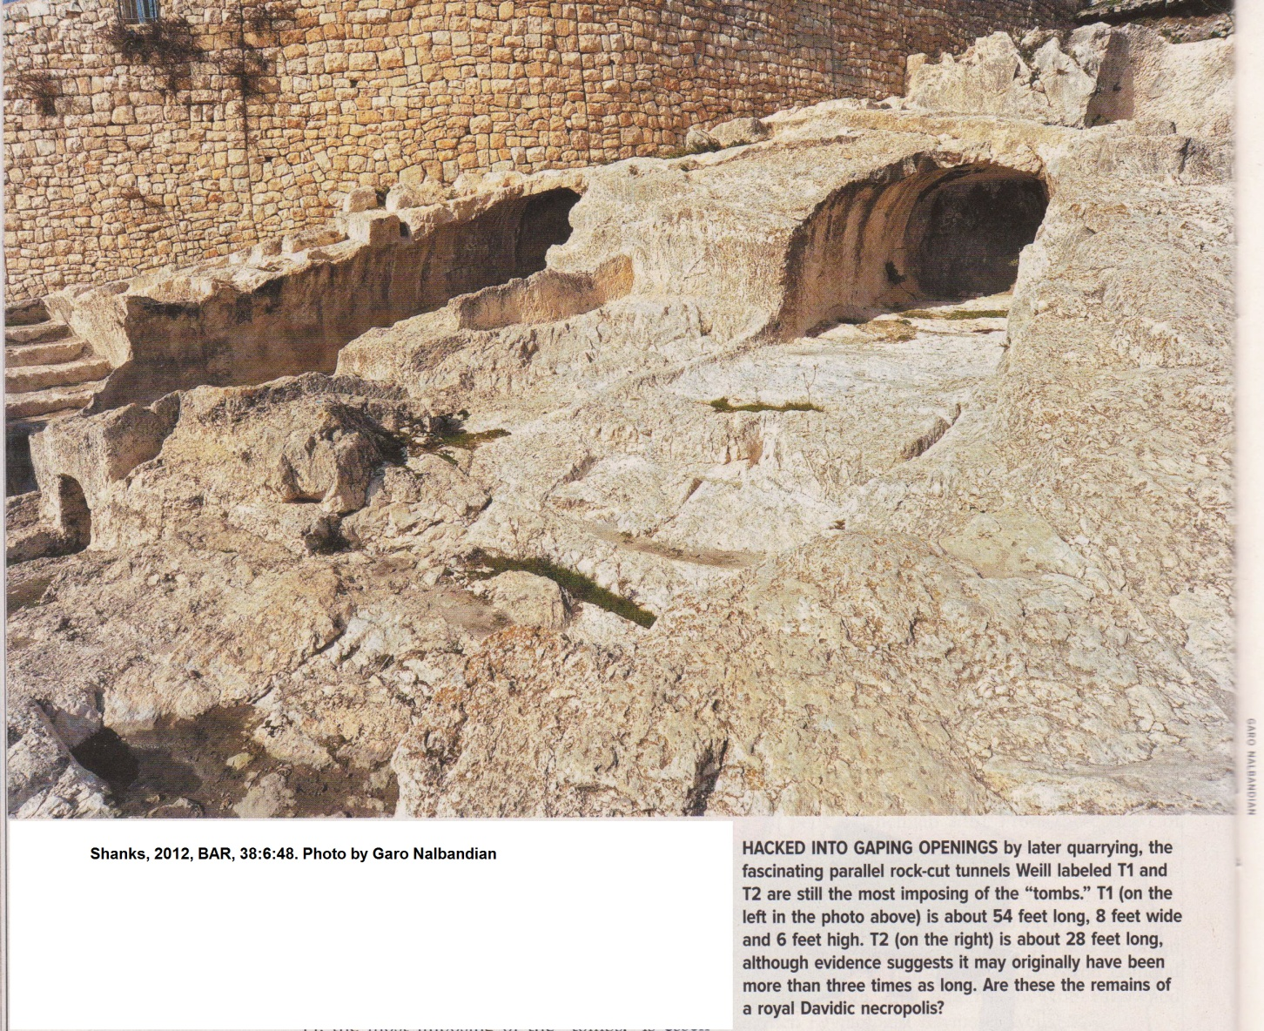

PHOTO LINK: CITY OF DAVID 011: Tomb T-1 photo, plan, profile and cross sections. Shanks, 2012, BAR, 38:6:49.
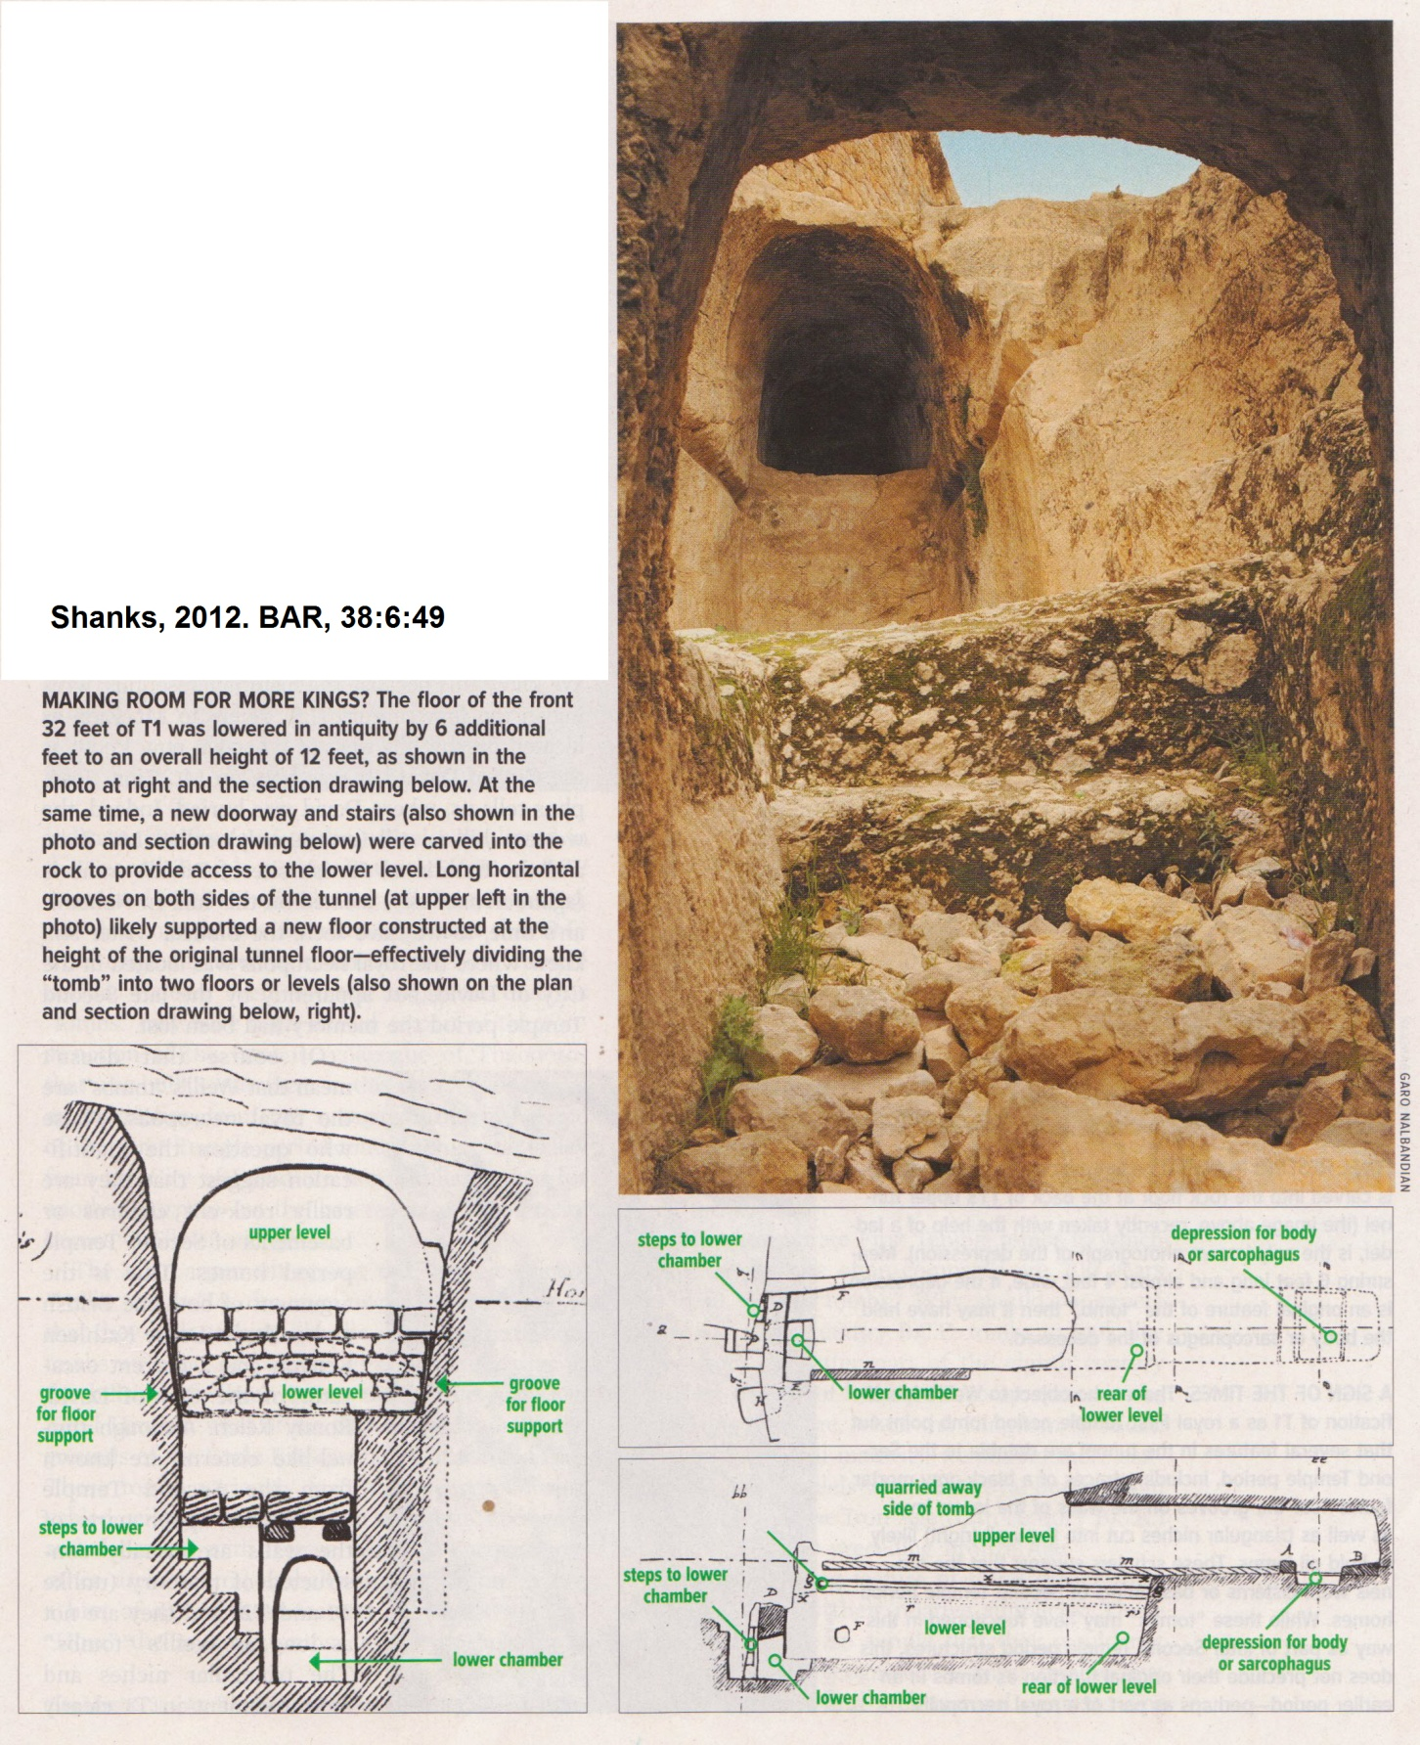

PHOTO LINK: CITY OF DAVID 012: Tomb T-1 rock floor at back of T-1 upper tunnel. Shanks, 2012, BAR, 38:6:50.

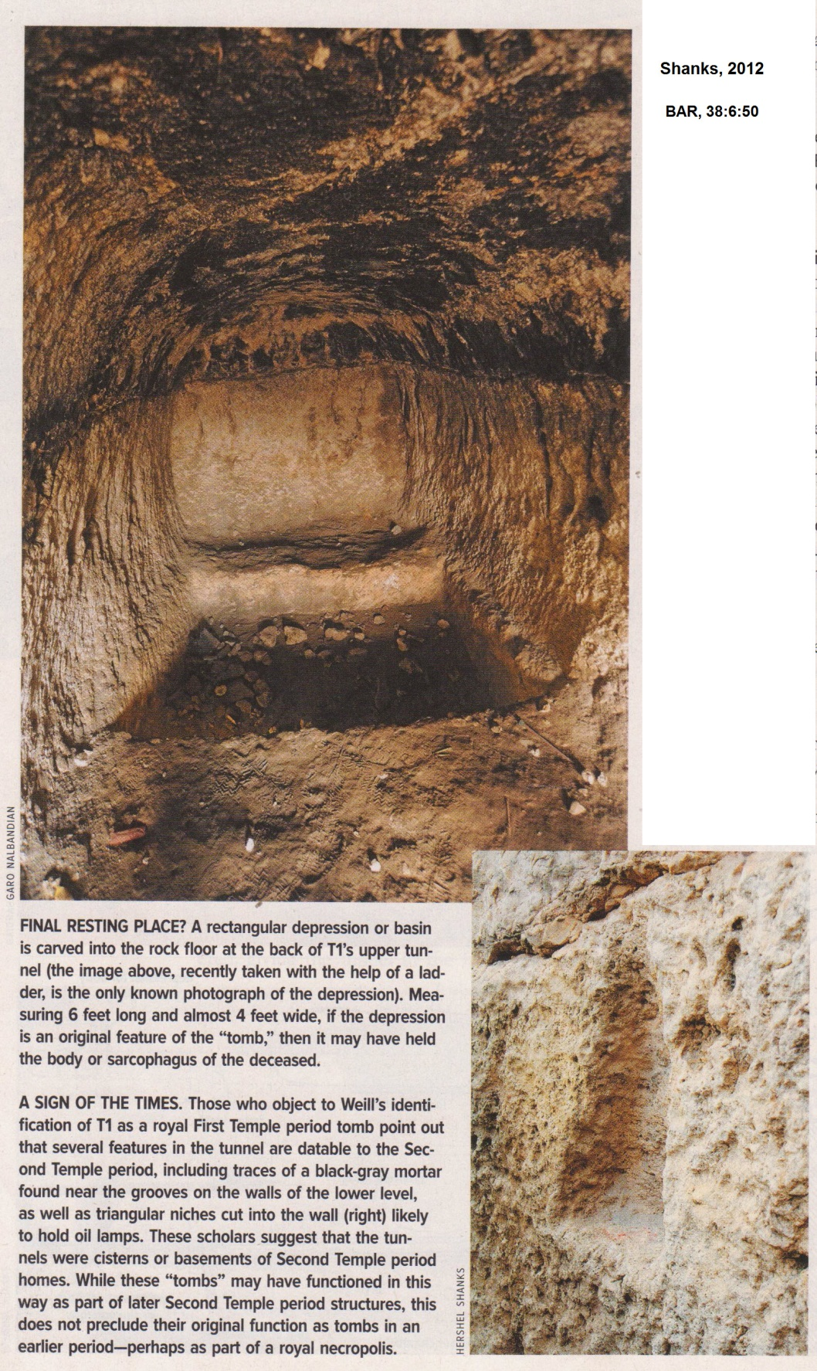

SOLOMON (971-931 BC)

Solomon was Bathsheba's fourth child. He had several older brothers and it is not clear why he was favored over them. There is a long-standing Hebrew tradition that eldest children do not attain to leadership. The younger Cain was preferred over Abel. Issac was younger but surpassed Ishmael. Jacob purchased the birthright and outwitted Esau. Neither Saul nor David were eldest sons.

PHOTO LINK: SOLOMON 008 Timeline 971-931 BC
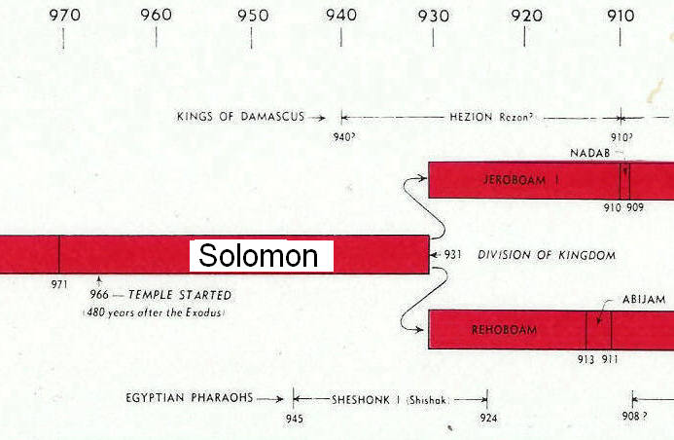

Adonijah

The transition of power from David to Solomon was not a smooth one. When David became old and frail, his fourth son, Adonijah "Put himself forward and said 'I will be king'" (1 Kings 1:5). This man was "very handsome" and more importantly had the support of general Joab and Abiathar the priest. Adonijah and his supporters went to En Rogel (a few hundred feet south of the City of David) and sacrificed on the great stone of Zoheleth. At En Rogel, Adonijah was anointed Israel’s third king.

PHOTO LINK: CITY OF DAVID 001 (See ABOVE, ctrl+click to follow link)

PHOTO LINK: SOLOMON 004 Map of Jerusalem showing two coronation sites (Adonijah and Solomon)
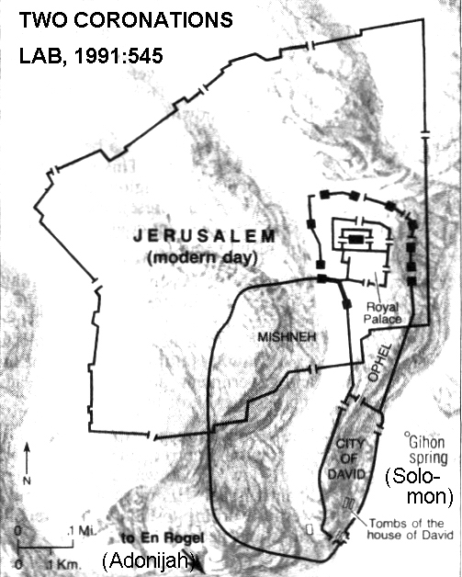
PHOTO LINK: SOLOMON 005 Map of two coronations
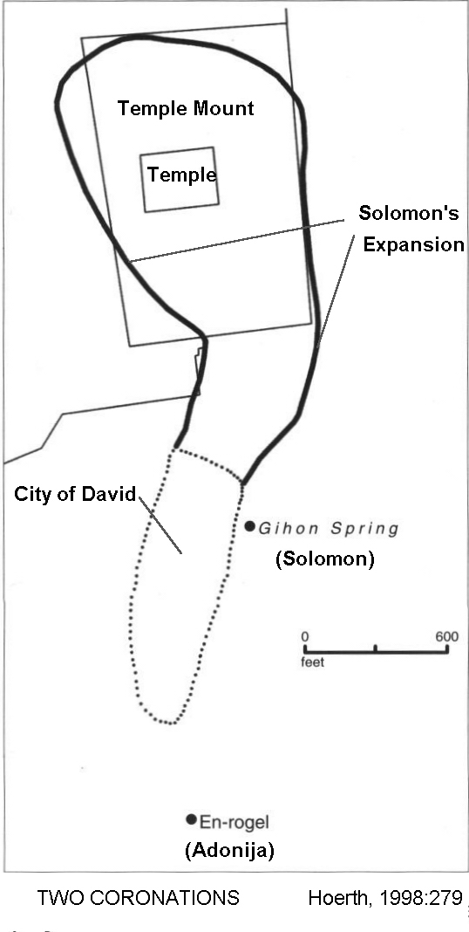

When the prophet Nathan and Bathsheba told David of the events at En Rogel, David proclaimed Solomon his successor. Nathan and Zadok the high priest took Solomon down to the Gihon spring, just outside the northwestern wall of Jerusalem. There they anointed Solomon king (1 Kings 1:38-40).

PHOTO LINK: HEZEKIAH TUNNEL 010 Gihon Spring (See ABOVE, ctrl+click to follow link)

PHOTO LINK: HEZEKIAH TUNNEL 024 Oblique view of Gihon Spring House (See ABOVE, ctrl+click to follow link)

The rival Adonijah faction heard of Solomon's anointing while they were banqueting and quickly disbanded. Adonijah, realizing his danger, fled to an alter David had built (2 Sam. 24:18-25) and grabbed the horns of the alter for sanctuary.

PHOTO LINK: ALTAR 002 Megiddo 10th or 9th century BC (Similar to the one Adonijah grabbed when he fled from David)
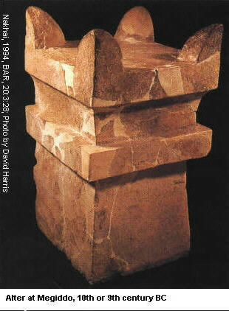
Magnanimously, he was pardoned by Solomon (1 Kings 1:51-53). When Adonijah requested permission to marry David's wife-nursemaid Abishag, Solomon perceived this as another effort to gain the kingship and ordered his execution (1 Kings 2:17-25). At the same time, he sent Abiathar the priest into exile in Anathoth (1 Kings 2:26).

Anathoth was northwest of Jerusalem, near the modern Anata, on the West Bank. Anathoth was one of the cities of refuge, in the tribe of Benjamin (Josh. 21:18). The Jews, as a rule, did not change the names of the towns they found in Palestine; so this town probably derived its name from the goddess Anat. It was the native place of Abieezer, one of David's "thirty" (2 Sam. 23:27), and of Jehu, another of his mighty men (1 Ch 2:3). It was later to become the home of Jeremiah.

So ended the dynasty of priests in the line of Ely as spoken by and unnamed prophet of Yahweh in Shiloh (1 Sam. 2:27-36).

Power Consolidation (971 BC)

Solomon further consolidated his power by executing general Joab who, like Adonijah had sought sanctuary at the horns of the alter (1 Kings 2:28-34).

On his deathbed, David asked Solomon to reverse his pardon of Shimei (1 Kings 2:8-9). This man had cursed David's during his evacuation of Jerusalem when Absalom revolted (2 Sam. 16:5-11). Solomon put him under house probation. When he violated the terms of that probation by going to Gath to recover two slaves, he was executed. With this last pocket of resistance neutralized, the "kingdom was now firmly established in Solomon's hands" (1 Kings 2:46).

Solomon ruled at a time of political-economic weakness in both Egypt (21st Tanite Dynasty, 1090 - 945 BC) and Assyria (Tiglath-Pileser II, 966-935 BC). As a buffer state, Israel prospered under wise leadership of Solomon, who's name means "peace". There were no major wars during his reign (Wood, 1975; Wilson, 1972; Crutchfield, 1990).

Pharaoh’s Unnamed Daughter (970-960 BC)

I Kings 3:1, 7:8, 9:16,24 and 11:1 tell of Solomon's marriage to a daughter of Pharaoh and her dower of the city of Gezer.

PHOTO LINK: GEZER 013 Location Map (See ABOVE, ctrl+click to follow link)

PHOTO LINK: GEZER 003 Plan of Gezer
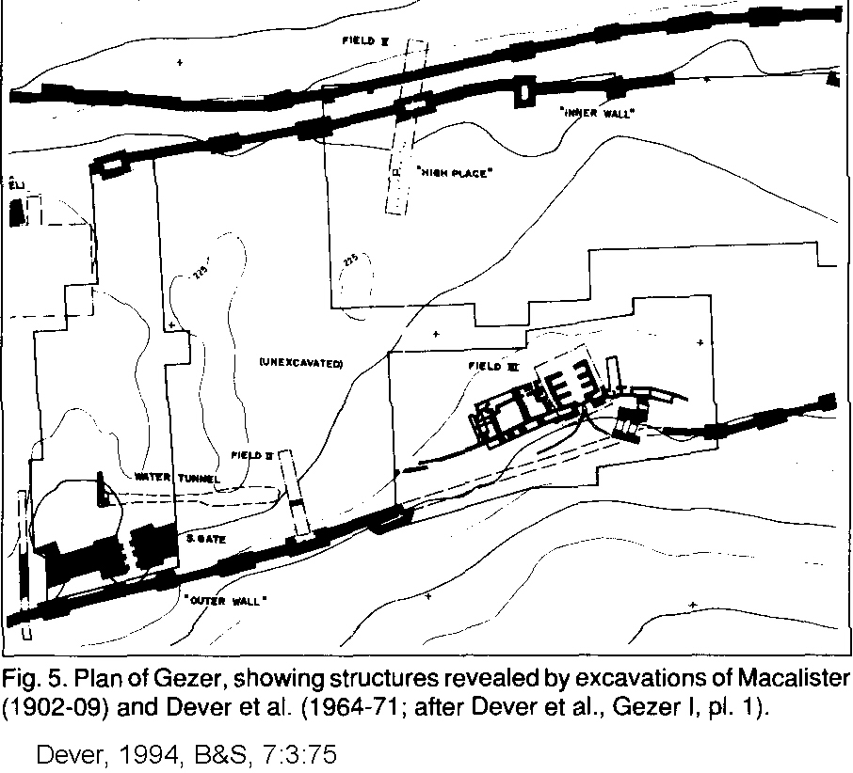

PHOTO LINK: GEZER 008 View of tell from the south; http://www.bibleplaces.com/gezer.htm ; Jan. 6, 2006
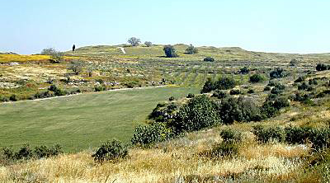

PHOTO LINK: GEZER 005 Solomonic gate at Gezer (See ABOVE, ctrl+click to follow link)

This marriage occurred early in Solomon's reign, within 970-960 BC. The Egyptian Pharaoh at this time was Siamun (979-960 BC) of the XXIst Dynasty (Kitchen 2001:36).

PHOTO LINK: SIAMUN 001 Pharaoh Siamun (979-960 BC) smiting Philistine who holds double-headed ax

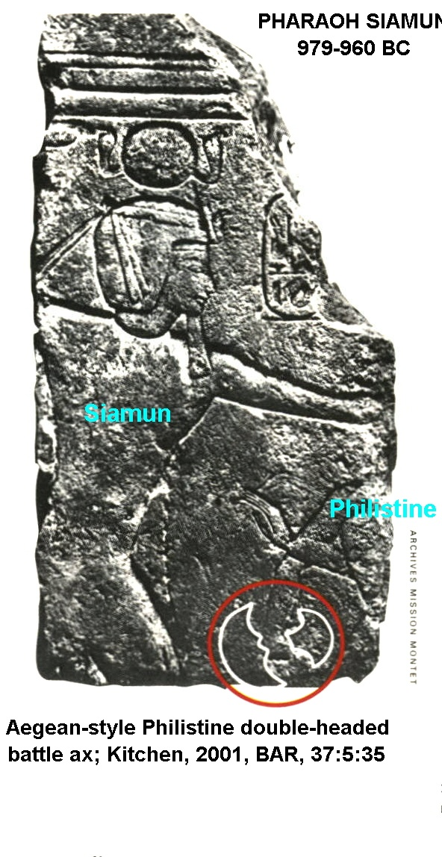
PHOTO LINK: ZOAN 001 Temple of Amun at Zoan, 21st Dynasty, 1055-1004 BC Greek name is Tanis
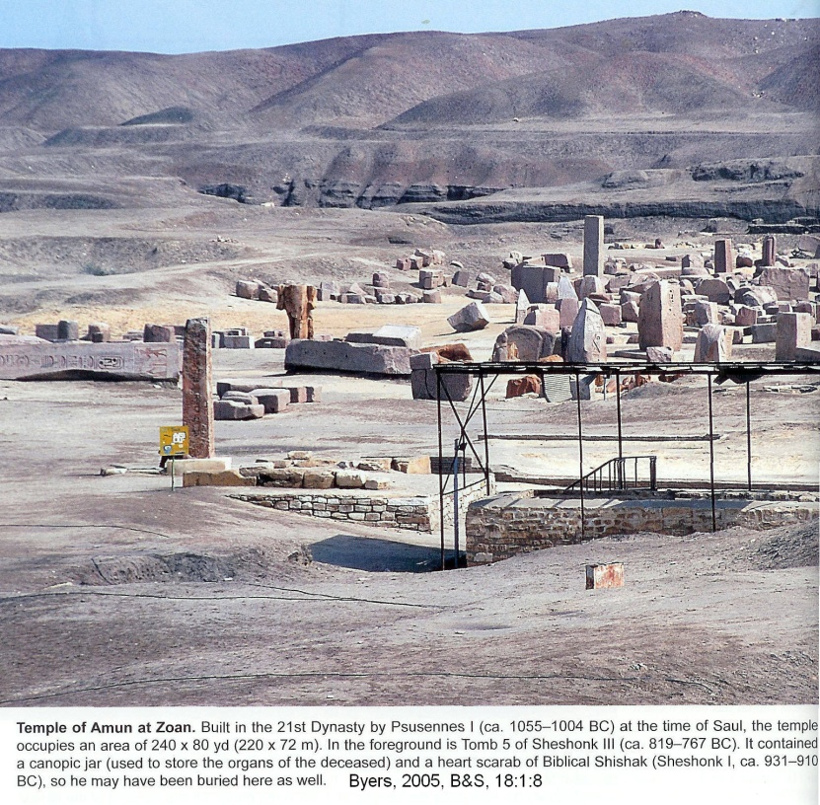

Siamun is the only Pharaoh of the 21st Dynasty to mention military action in the Levant on his monuments. On a triumphal scene at the Temple of Amun in Tanis, Siamun is shown smiting an enemy who holds and unusual crescent-shaped ax (Montet, 1947; Weistein,1998, cited by Kitchen, 2001:26)

PHOTO LINK: SIAMUN 002 Ankhefenmut adores the royal name of pharaoh Siamun in this doorway lintel;; http://en.wikipedia.org/wiki/Siamun; Aug. 31, 2010
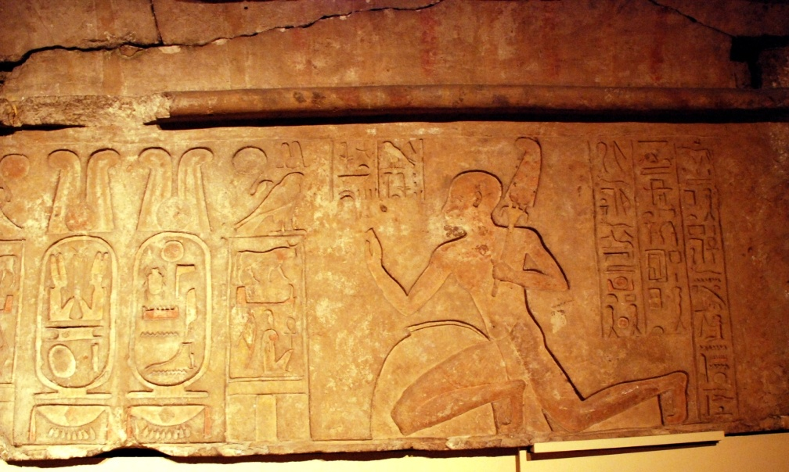

The crescent-shaped double ax is an Aegean weapon and is part of Philistine material culture (Green, 1978; Lance, 1976; and Ash, 1999; cited by Kitchen, 2001:36). Kitchen suggests that the victory relief of Siamun at Tanis (Hebrew, Zoan) is a depiction of a joint military action between Siamun and Solomon to secure the trade route between Egypt and Gaza by evicting the Philistines from Gaza. After this military victory, Siamun gave Solomon the strategically-located city of Gezer (in Gaza) and one of his daughters in marriage to seal the alliance (Kitchen, 2001:36).

Several criticisms have been made about the historical accuracy of the marriage of Pharaoh's daughter to Solomon. This is because Egyptians typically did NOT follow this practice and an inscription by Amenophis III (1389-1349) states "...from of old no [Egyptian] king's daughter has been given to anyone." (Kitchen, 2001:36)

PHOTO LINK: EGYPT 021: Painted relief of Princess Anksenaum, grandaughter of Amenophis III and widow of Tutankhamun, applying unguent to him
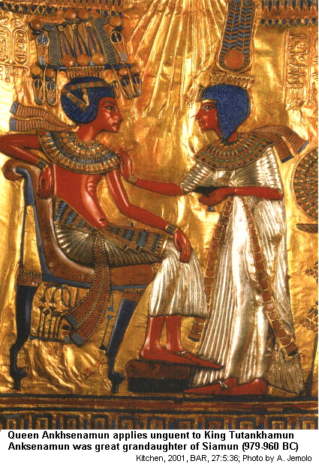

40 years after Amenophis III (also Amenhotep III) ruled, his granddaughter (and widow of Tutankhamun) offered herself in marriage to a Hittite prince to avoid marriage to a commoner. By the 6th century, Egyptian kings reinstated the tradition of marrying royal princesses only to Egyptians (Kitchen, in press and 2001:36). The story of Pharaoh's daughter and Solomon fits within the historical context of 1000-600 BC when Egyptians did marry their daughters to foreigners to cement political, military and economic alliances (Kitchen, 2002:36).

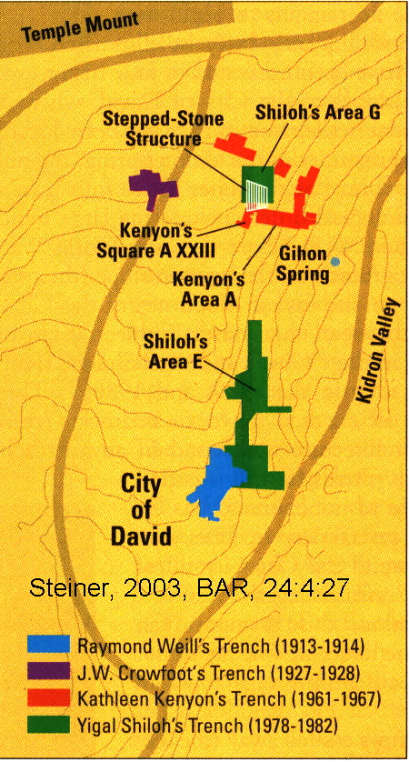
SOLOMON'S ARCHITECTURAL ACHIEVEMENTS IN JERUSALEM

Solomon's Jerusalem

Jerusalem and the City of David have been excavated in several places by different archaeologists at different times using different levels of care and technical sophistication. New excavations are small, and often difficult to conduct because of growth of modern Jerusalem and because of religious-political contstraints.

PHOTO LINK: JA001 Fish-Eye Aerial View of Jerusalem (See ABOVE, ctrl+click to follow link)

PHOTO LINK: JERUSALEM 019 Excavation sites of Kenyon and others (RIGHT)

PHOTO LINK: JA002 Jerusalem Aerial View from South
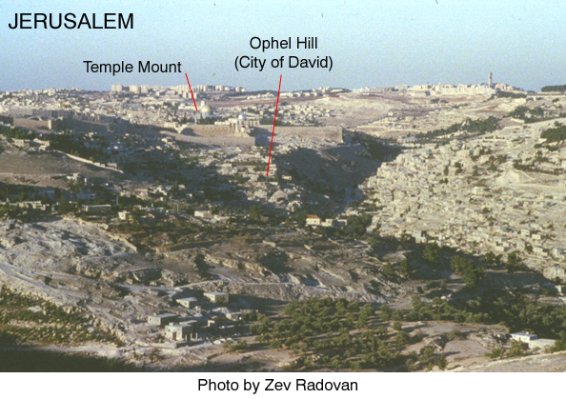

PHOTO LINK: JERUSALEM 011 Stone stepped structure (See ABOVE, ctrl+click to follow link)

PHOTO LINK: JERUSALEM 021 Aerial photo of modern Jerusalem
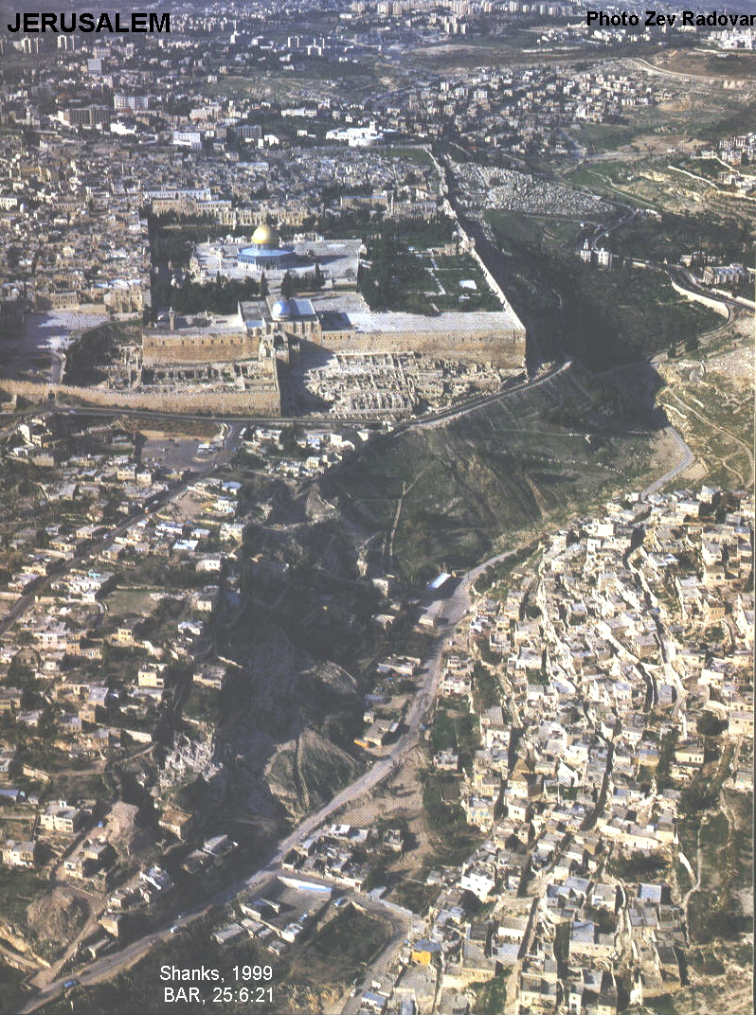

King Solomon was Israel’s greatest builder. He built the Temple (started 966 BC; 1 Kings 6), the palace (1 King 7:1-13), a house for daughter of Pharaoh, the walls of Jerusalem and the “Millo” (1 King 11:27; 1 Kings 9:15,24).

PHOTO LINK: JERUSALEM 007 Map of Jerusalem walls
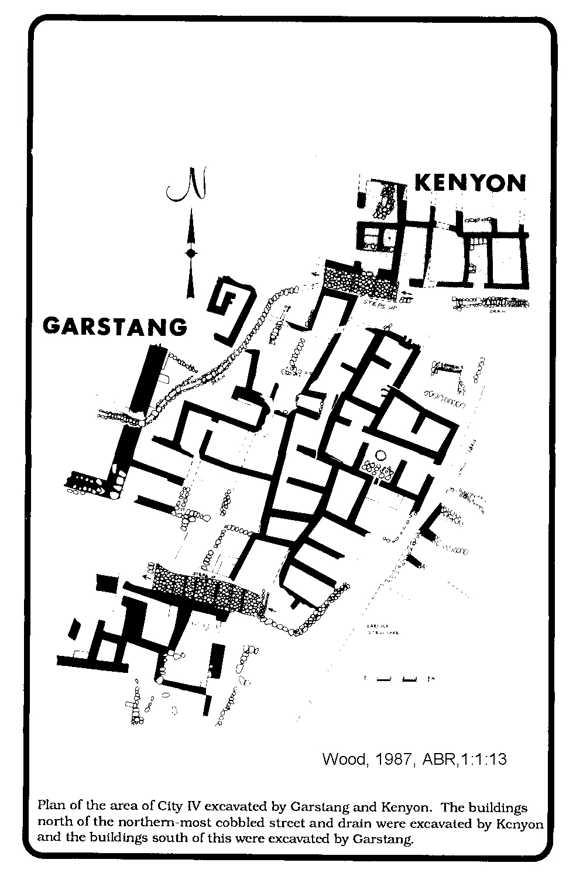

PHOTO LINK: JA003 Jerusalem: Aerial Detail of Ophel Hill and Temple Mount
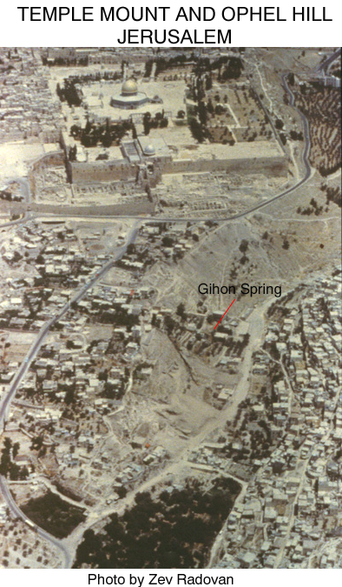

PHOTO LINK: STEPPED-STONE STUCTURE 001 Aerial photo of Temple Mount and close-up oblique aerial photo of the Millo (See ABOVE, ctrl+click to follow link)

PHOTO LINK: WAILING WALL 003 Close up of stones
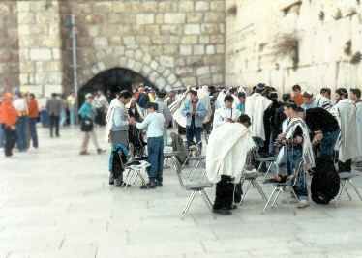
PHOTO LINK: JERUSALEM 002 Fortifications Judean monarchy
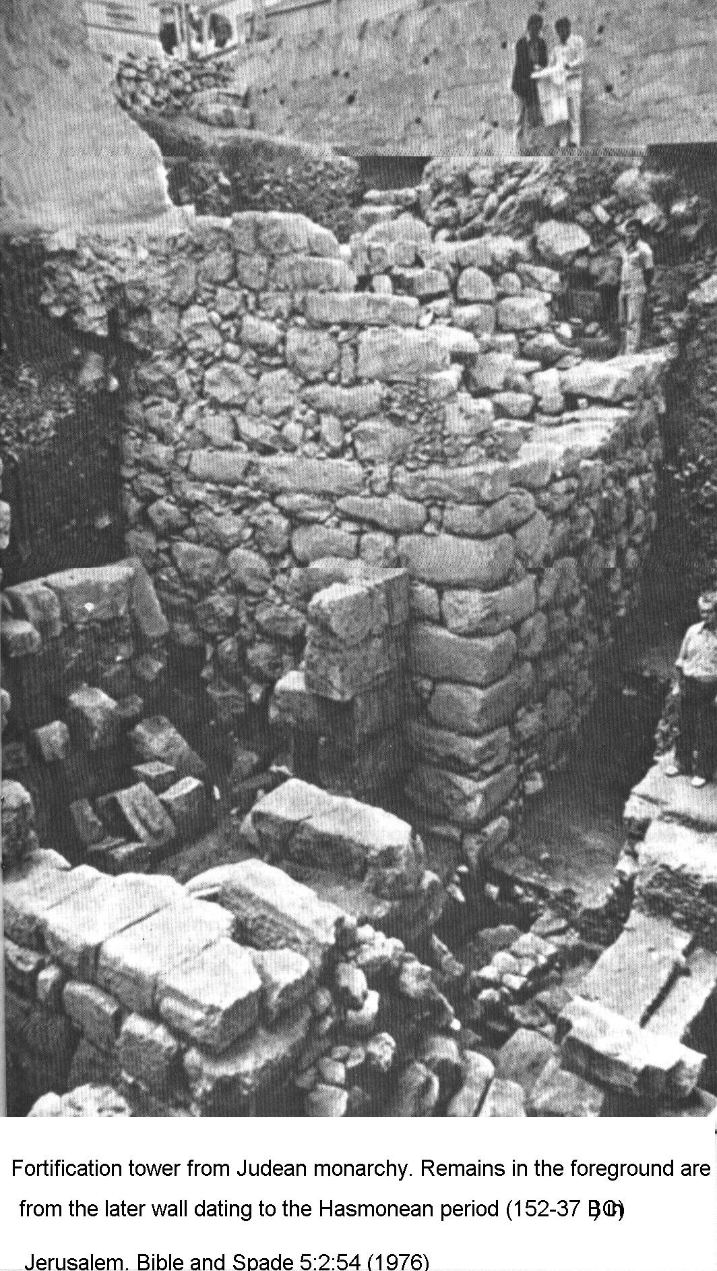

PHOTO LINK: JERUSALEM 003 Stone stepped structure
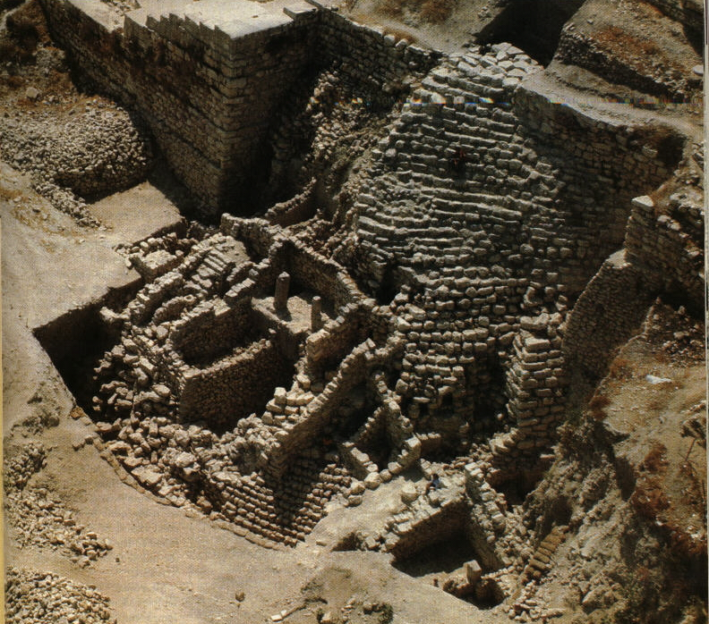

PHOTO LINK: JERUSALEM 013 David's Palace the Millo, artist's depiction
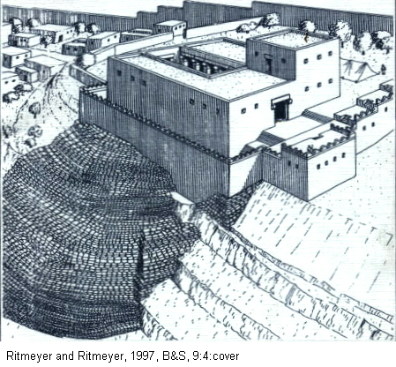

PHOTO LINK: JERUSALAM 014 Stone Stepped Structure, David's Palace
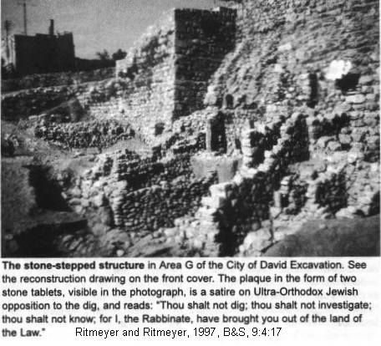

PHOTO LINK: JA012 Jerusalem: Ophel Hill: The Stepped-Structure (See ABOVE, ctrl+click to follow link)

The "Millo" was part of the stabilization platform for David’s palace. It was strengthened on vulnerable north side of city and Solomon thereby "closed up breach of the city of his father David" (1 King 11:27; 1 Kings 9:15,24). Solomon’s buildings have distinctive masonry: large blocks with dressed boarders and rough boss left in the center. These characteristics permit easy distinction with later 1st-century Herodian masonry (started 50 BC). Herodian masonry has borders, but the stones are larger and the central boss is flattened and smoothed. Hellenistic masonry (built before Herodian) is smaller than Solomon's and all 4 corners are dressed. Solomon's building activity was financed by heavy taxation (1 Kings 7:1-12) which contributed to the Kingdom's breakup after his death (Wood, 1975; Wilson, 1972; Crutchfield, 1990).

PHOTO LINK: JERUSALEM 016 Stone Stepped Structure, aerial
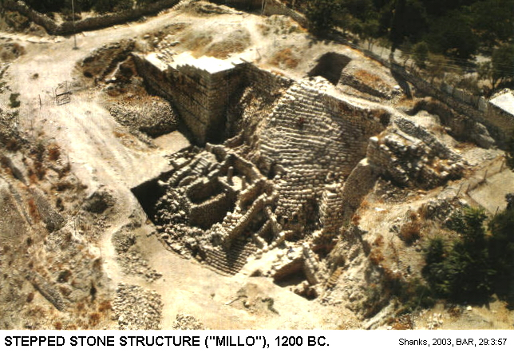
PHOTO LINK: SOLOMON'S TEMPLE 029 Ages of masonry N part of E wall
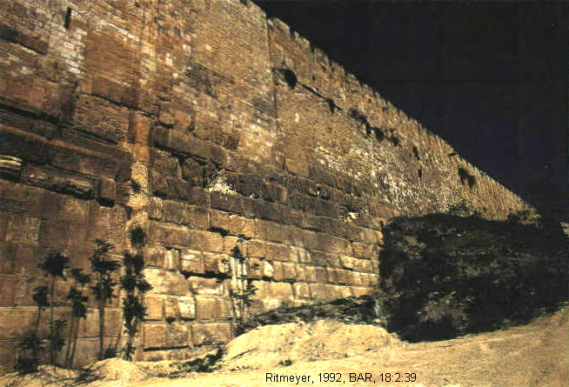

PHOTO LINK: SOLOMON'S TEMPLE 022 Boss styles on masonry of Temple Mount
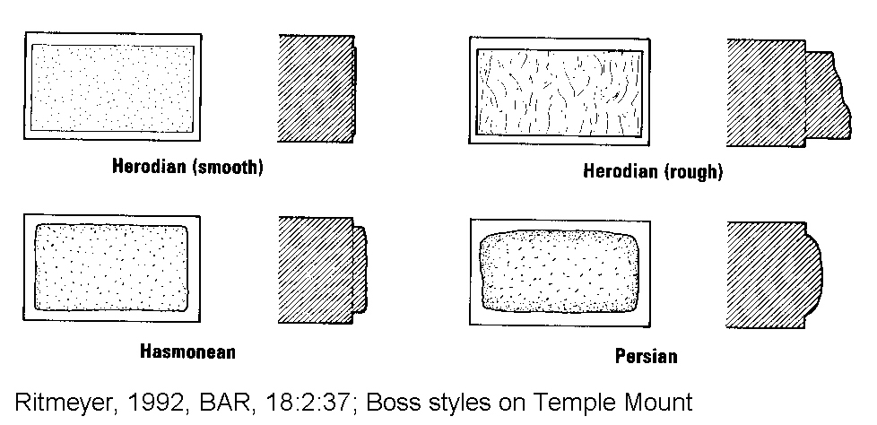

Water system

During the reign of Solomon, the water supply system for Jerusalem included twin fortification towers and a channel way, the Siloam channel, which delivered water 1312 feet from the Gihon Spring to a reservoir at the southern end of the Tyropoeon Valley. This water system may be described in Ecclesiastes 2:4-6 (Ritmeyer and Ritmeyer, 1997). More will be said about modifications to this water system made by King Hezekiah 265 years later (701 BC) in Chapter 19.

PHOTO LINK: HEZEKIAH TUNNEL 042 Plan Hezekiah's tunnel, Gihon Spring, Spring Tower, Stepped-Stone Structure (Water system from Solomon’s time shown in light blue) (See ABOVE, ctrl+click to follow link)

Very little archaeological data exists for the 10th century at Jerusalem. This was the time when Kings David and Solomon reigned over Israel’s “Golden Age”. Because of the lack of data, liberal “minimalists” believe the stories of the United Monarchy are mythological or fabricated (Steiner, 1998; Shanks, 2000).

PHOTO LINK: JERUSALEM 005 3-inch statuette, part of 13th century Egyptian temple (pyramid?)
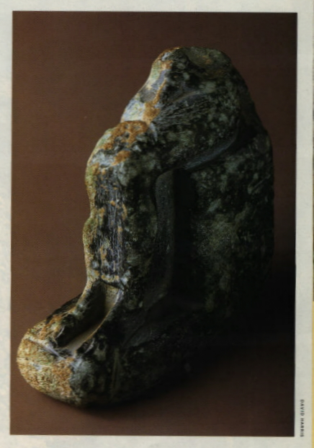

Tombs

There are tombs from the Late Bronze Age tombs outside the city, and the people that were buried in them must have lived in a settlement of some kind, somewhere nearby. A 3-inch statuette discovered north of Jerusalem’s Old City suggests the presence of an Egyptian pyramid at Jerusalem in the Late Bronze Age (Shanks, 2000, p. 14)

Tell el-Armana letters

The Tell el-Armana letters from ‘Abdi-Heba, king of Jerusalem, to the Egyptian pharaoh Akhenaten indicate that Jerusalem (Urusalim) existed as a major city from the 14th century BC (Shanks, 2000, p.16).

PHOTO LINK: JERUSALEM 004 Tell et-Armana letter cuneiform tablet. Correspondence about Urusalem

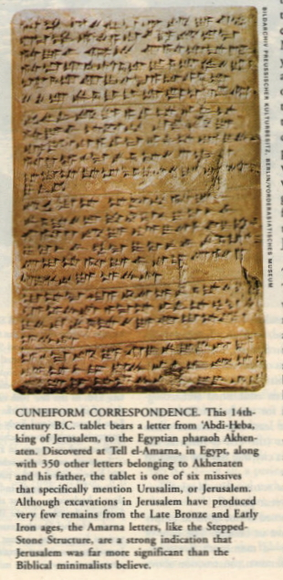
Pottery

While pottery from the 9th to 17th centuries BC is rare in Jerusalem, some has been found. These date both to the Late Bronze Age (Shiloh, 1970's-1980's, Kenyon, 1960's) and to the 10th century from Shiloh (Cahill, 1998). Eilat Mazar found a black juglet on the Ophel (area between the City of David and the southern end of the Temple Mount) that is characteristic of the 10th century. He dates the fortifications and gate above the juglet as from the 10th century and the work of King Solomon who, according to 1 Kings 3:1 fortified the walls of Jerusalem. A 100-foot section of Jerusalem’s Old City wall was discovered in the late 1990's (Shanks, 1999, Nov/Dec BAR). In the Middle Bronze Age (2200-1550), there is evidence of an imposing city wall, two gigantic towers guarding the Gihon Spring and a water channel that runs down the eastern side of the City of David (Shanks, 2000).

PHOTO LINK: JERUSALEM 003 Stepped-Stone Structure 10th or 13th century BC (See ABOVE, ctrl+click to follow link)
PHOTO LINK: JERUSALEM 007 Map of Jerusalem walls and towers, Gihon spring, plastered pool (See ABOVE, ctrl+click to follow link)

PHOTO LINK: JERUSALEM 001 First Century A.D. Jerusalem
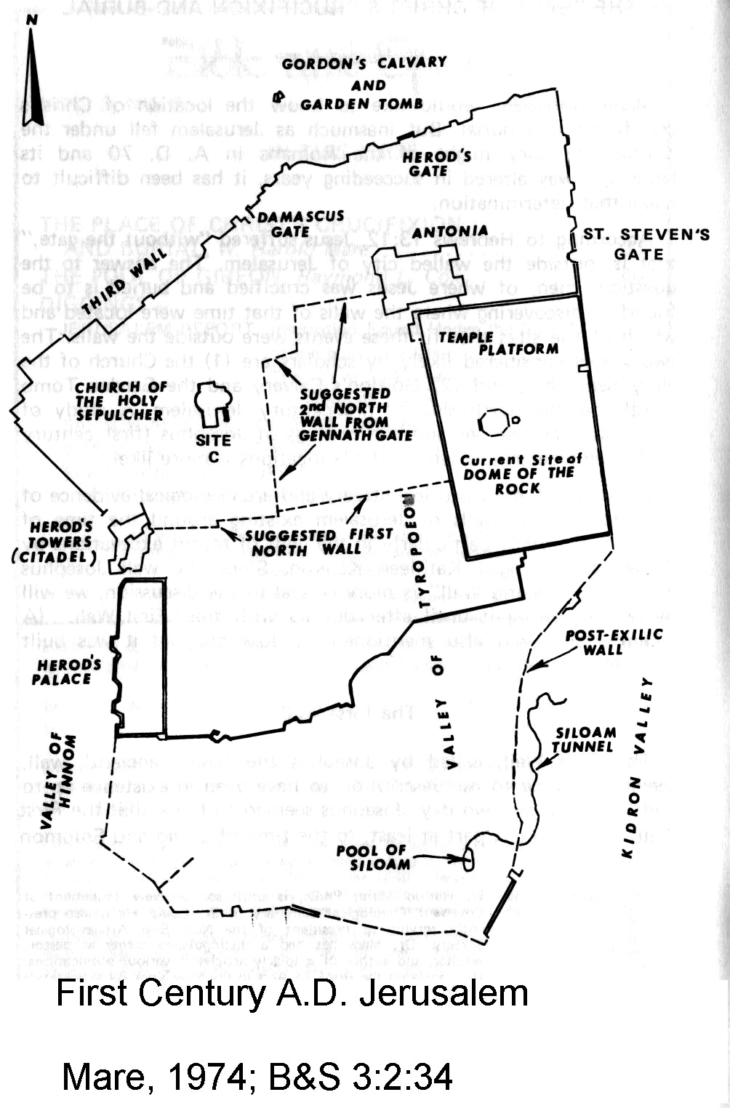

PHOTO LINK: JERUSALEM 010 Jebusite and Davidic Jerusalem map (See ABOVE, ctrl+click to follow link)

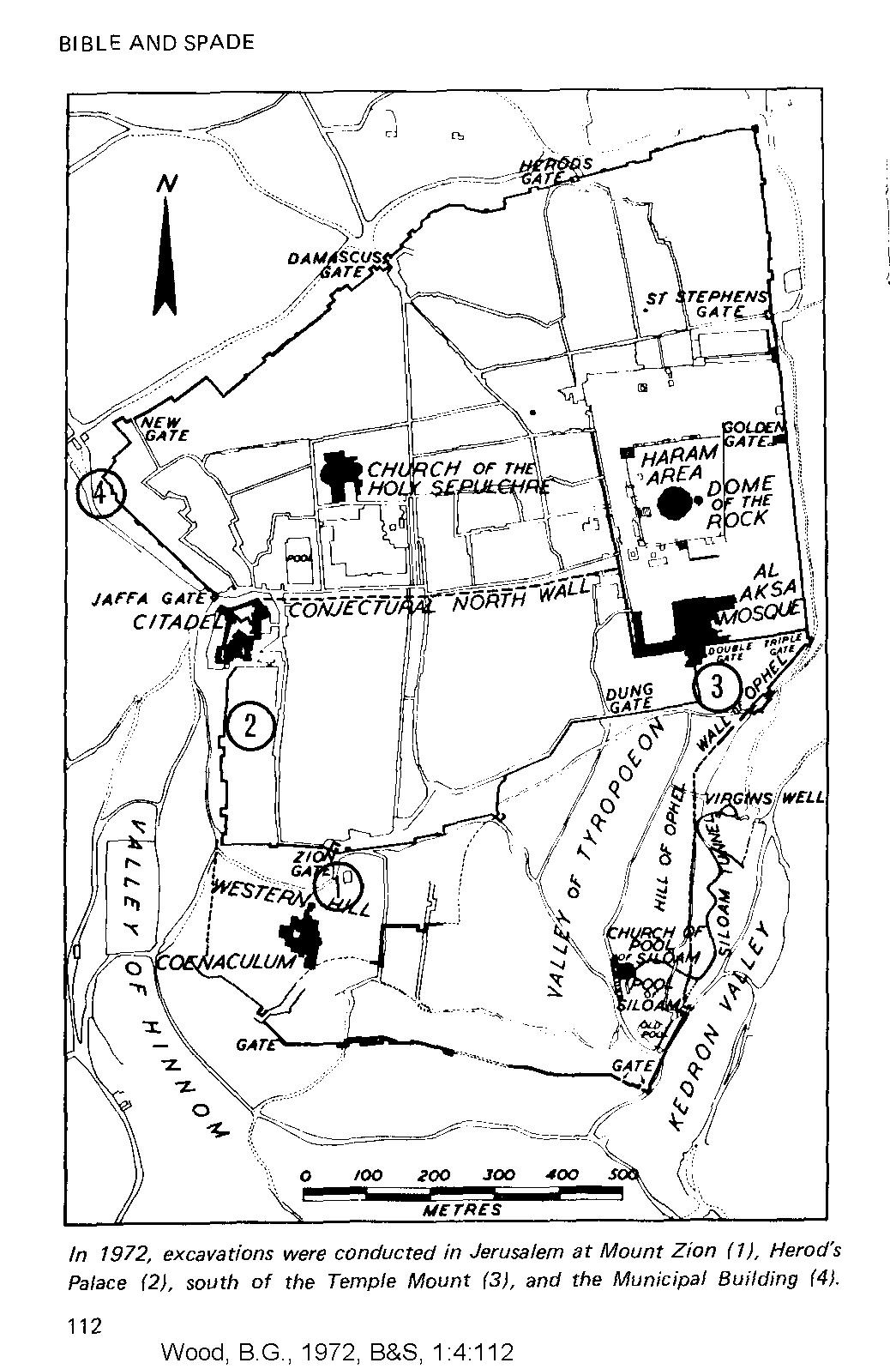

THE TEMPLE MOUNT

The Temple Mount in Jerusalem is now surrounded by urban development. Most of the Temple Mount was destroyed by the Romans in AD 70. Descriptions of it survive in writings of the historian Josephus and in the Middot tractate of the Mishnah, a collection of Jewish oral laws compiled and written down by Rabbi Judah the Prince about 200 AD (Ritmeyer, 1993).

PHOTO LINK: SOLOMON’S TEMPLE 010 Aerial photo of Temple mount
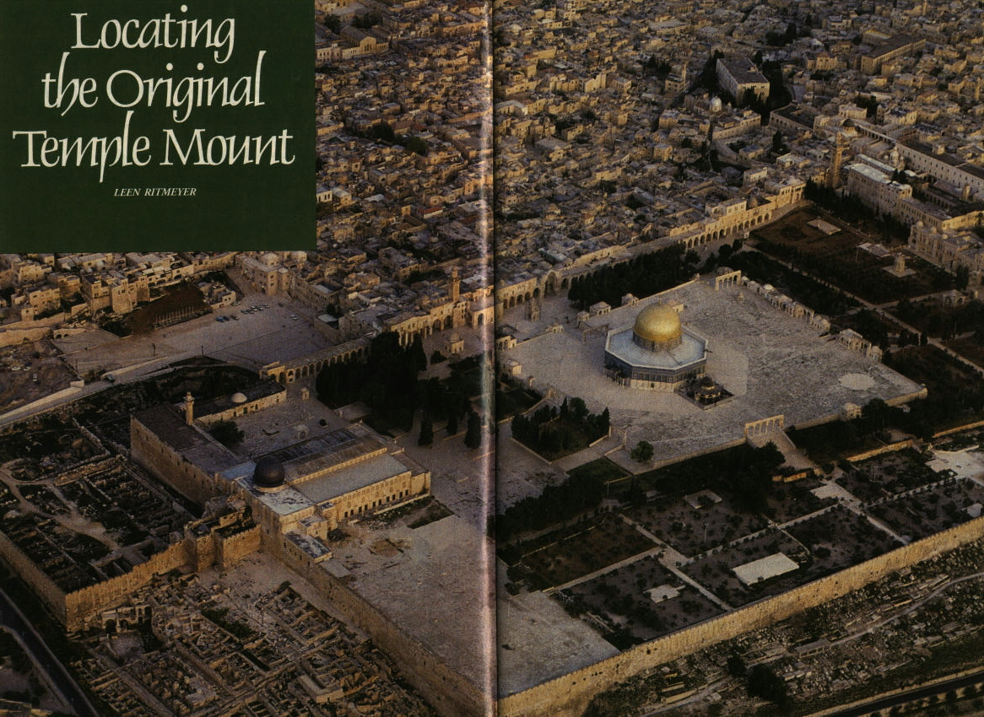

PHOTO LINK: SOLOMON'S TEMPLE 059 Aerial photo of Temple mount from southeast
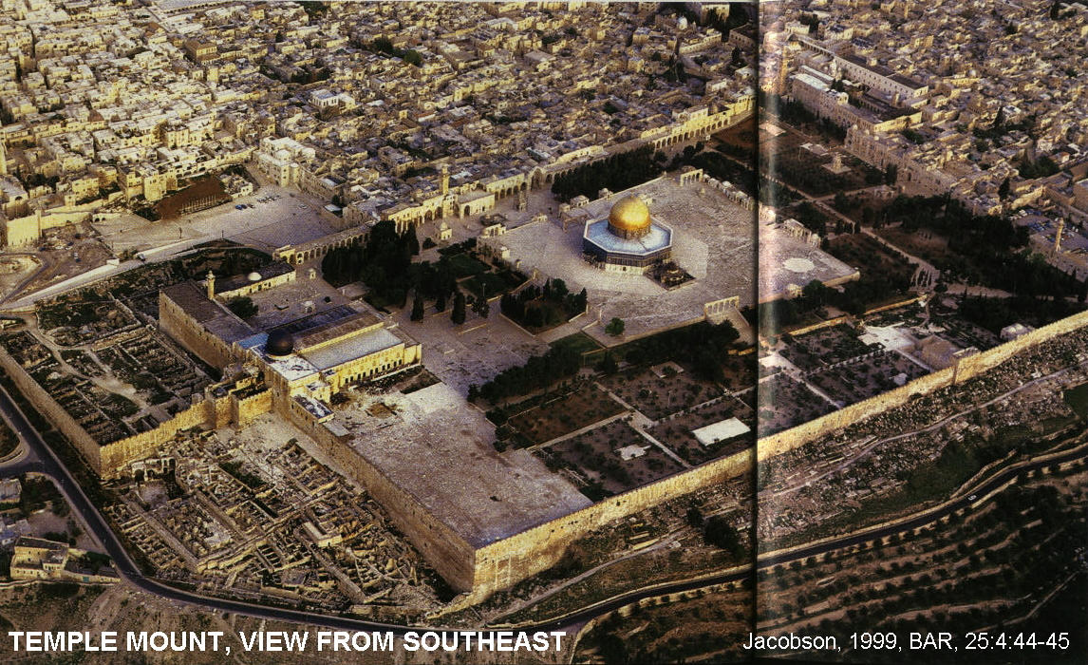
PHOTO LINK: SNT034 Southern Extension of Temple Mount
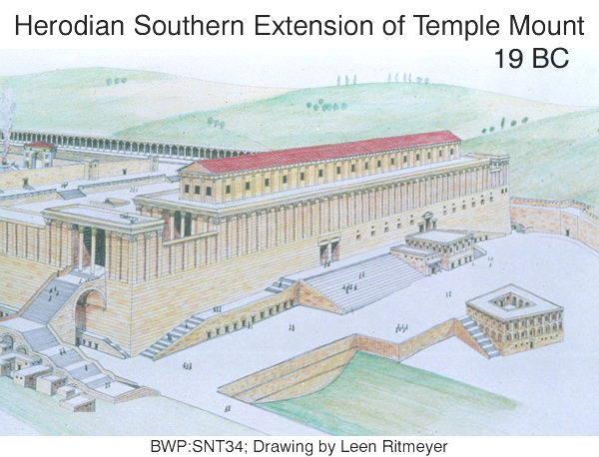

PHOTO LINK: JA003 Jerusalem: Aerial Detail of Ophel Hill and Temple Mount (See ABOVE, ctrl+click to follow link)

PHOTO LINK: JA061 Jerusalem; Mosaic Floor in Herodian House
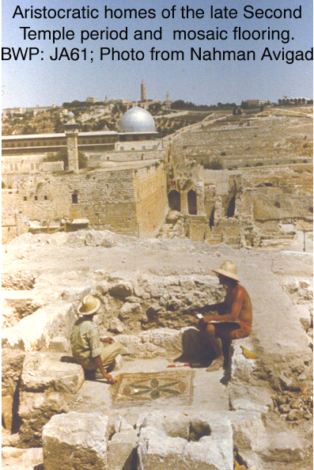
PHOTO LINK: JA052 Jerusalem: Southwest Corner of Temple Mount
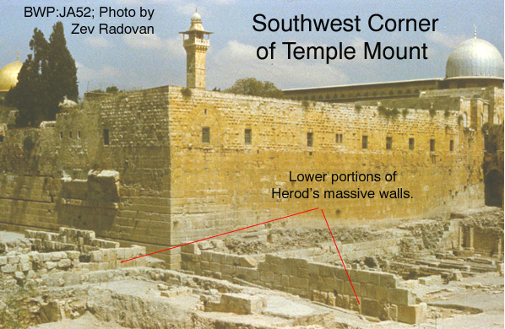
PHOTO LINK: JA055 Jerusalem: “Robinson’s Arch” Stairway: Architect’s Drawing
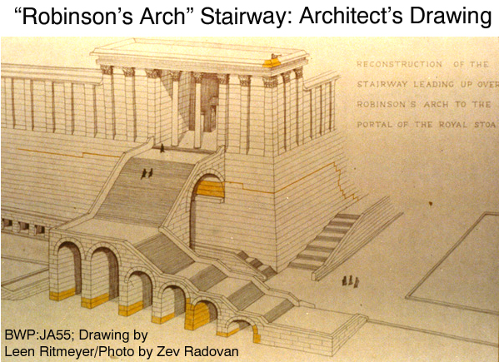

PHOTO LINK: JA054 Jerusalem; Temple Mount; “Robinson’s Arch"
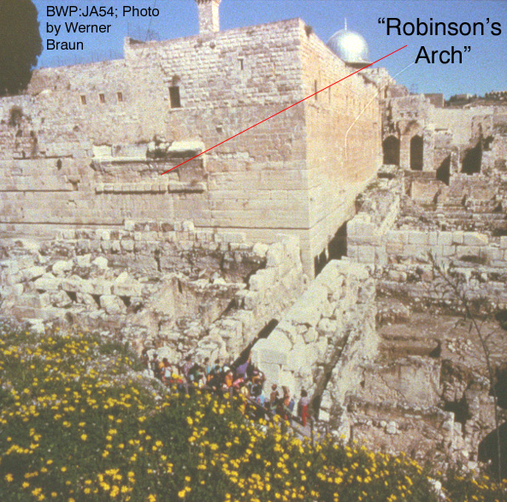

PHOTO LINK: JA056 Jerusalem; Temple mount; “Place of Trumpeting” Inscription
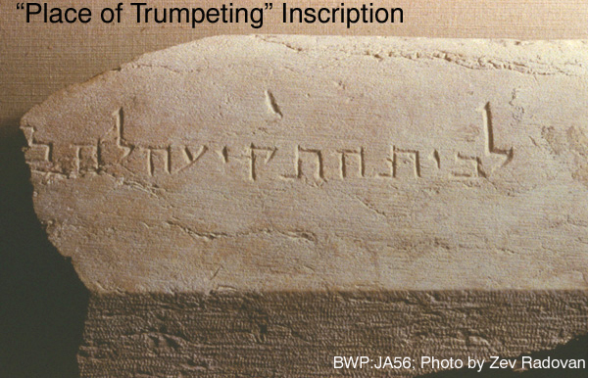

PHOTO LINK: JA057 Jerusalem; Temple mount; “Wilson’s Arch”
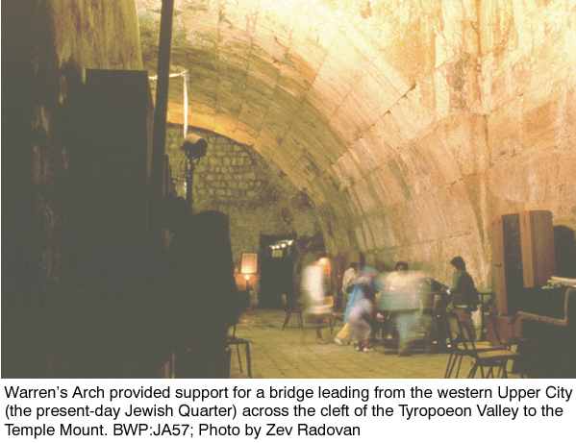

PHOTO LINK: JA058 Jerusalem; Broad Stairs along South Wall of Temple Mount
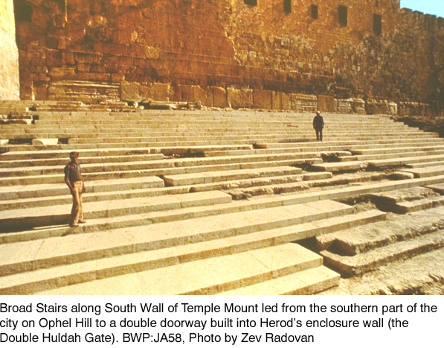

PHOTO LINK: JA059 Jerusalem; Temple Mount; Triple Huldah Gates, built into base of Herod's city
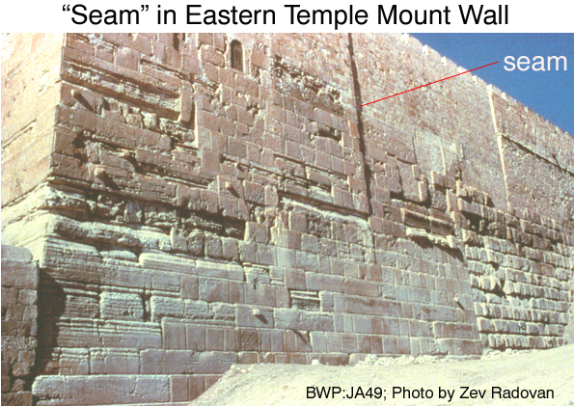

PHOTO LINK: JA060 Jerusalem; Excavations Outside South Wall of Temple Mount, with partly restored stairway leading to Double Huldah Gate
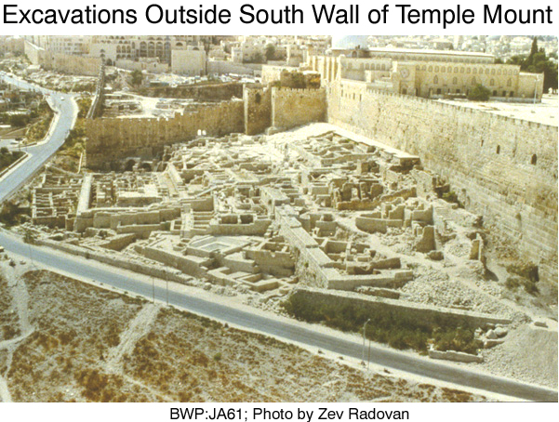

Solomon’s Temple, The First Temple (971 BC)

Except for a few artifacts, almost nothing of original temple of Solomon remain. Construction of the First Temple started in 966 BC (Whitcomb, 1968). The First Temple was destroyed by the Babylonians in 586 BC.

I will review the subsequent archaeological evolution of the Temple Mount through its final destruction in 70 AD and then return to a discussion of the First Temple.

PHOTO LINK: SOLOMON'S TEMPLE 060 Drawing of Temple view from southeast
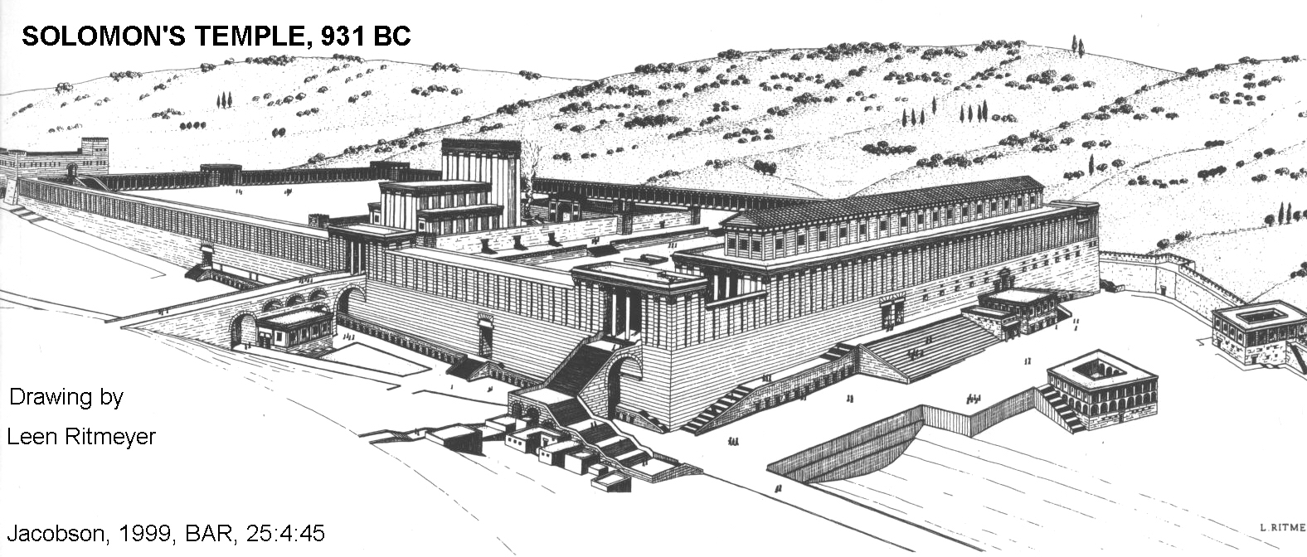

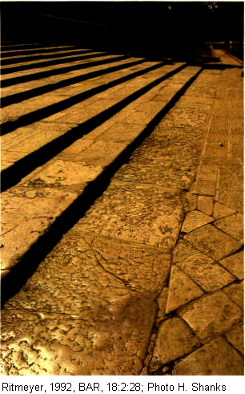
Nehemiah’s Temple, The Second Temple (520-516 BC)

The Second Temple was a poor copy of that original. Work on the Second Temple started in 520 and was competed in 516

The First Temple platform, restored by Nehemiah after the Babylonian Captivity, and part of Second Temple construction, is identified by three observations (Ritmeyer, 1993) :

1) a telltale step at NW corner of the original mount

PHOTO LINK: SOLOMON’S TEMPLE 012 Steps with modern pavement (RIGHT)

PHOTO LINK: SOLOMON’S TEMPLE 013 Step from old photograph before pavement was added
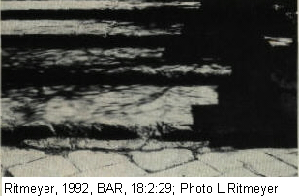

PHOTO LINK: SOLOMON’S TEMPLE 014 Steps leading up to Muslim platform
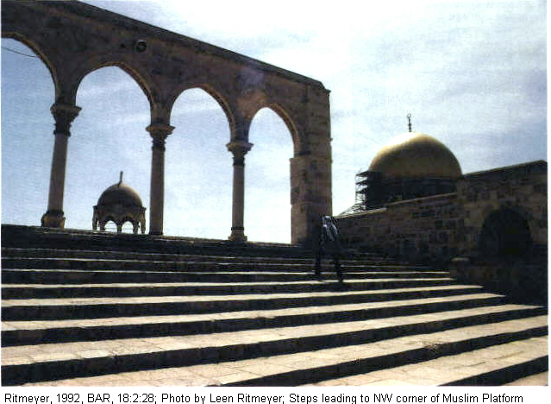

2) offset wall at NW corner of the mount

3) bend in wall at SE corner of the mount

PHOTO LINK: SOLOMON'S TEMPLE 024 Bend in SE wall at Hasmonean extension
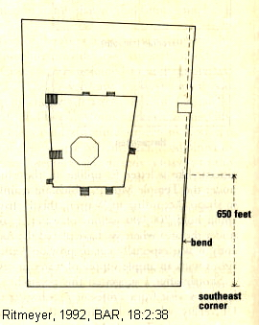

PHOTO LINK: SOLOMON'S TEMPLE 025 S end E wall Herodian addition
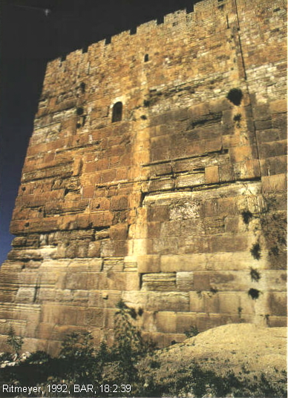

PHOTO LINK: SOLOMON'S TEMPLE 026 Center of east wall Hasmonean extension
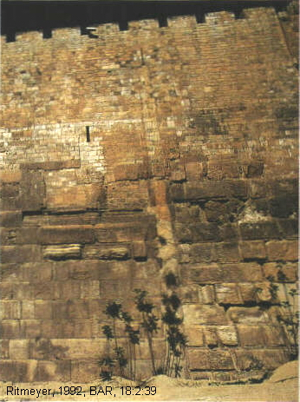

These observations lead to the conclusion that the dimensions of the original Temple Mount were 500 royal cubits square (Ritmeyer, 1993).

Seleucid-Addition (186 BC)

During the Seleucid period (333 to 165 BC), when Jerusalem was ruled by Jews who gave allegiance to successors of Alexander the Great, an extension was made to the southern end of the mount. This is called the Seleucid period addition. The Seleucid rulers where evicted by Judah the Macabee in 165 BC.

PHOTO LINK: SOLOMON'S TEMPLE 015 Original Temple mount and Seleucid Addition
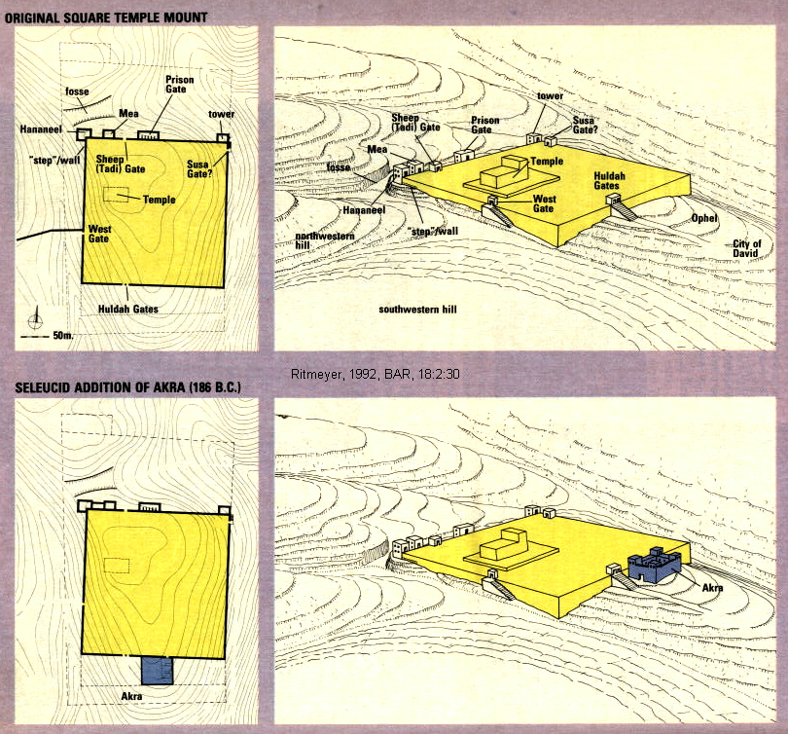

Hasmonean Extenstion (141 BC)

The Hasmonean period was from 165 to 37 BC. Hasmonean rule ended when the Romans re-conquered Palestine and put in place a puppet ruler: Herod the Great. During the time, the Jews expanded the temple mount to the south and constructed a bridge to the west.

PHOTO LINK: SOLOMON'S TEMPLE 016 Hasmonean and Herodian extensions of mount
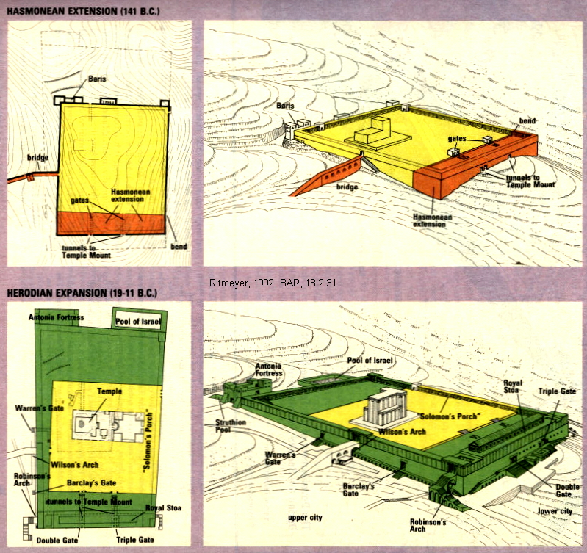

PHOTO LINK: SOLOMON'S TEMPLE 050 Hasmonean and Herodian extensions of mount
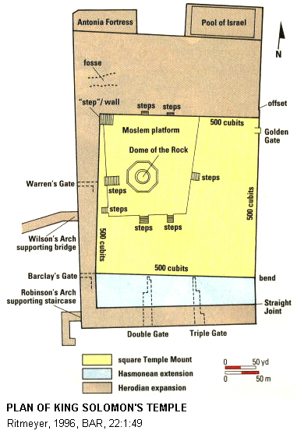

Herod’s Temple and Expansion (20 BC)

The Second Temple was replaced by the temple of Herod the Great who started the new “Second” temple in 20 BC. Some remnants of Herod’s Temple and water systems can still be seen.

There were two entryways to the Temple Mount during Herod’s time from the east called the Double and Triple Gates. The location of these is shown at the bottom of PHOTO LINK: SOLOMON'S TEMPLE 061, below.

PHOTO LINK: SOLOMON'S TEMPLE 064 Photo of Double Gate in 1902

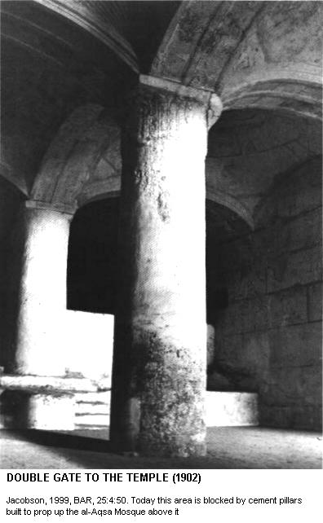
PHOTO LINK: SOLOMON'S TEMPLE 065 Drawing of Double Gate
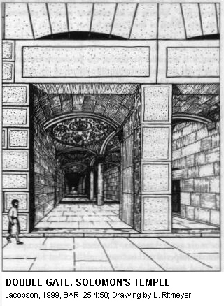

PHOTO LINK: SOLOMON'S TEMPLE 061
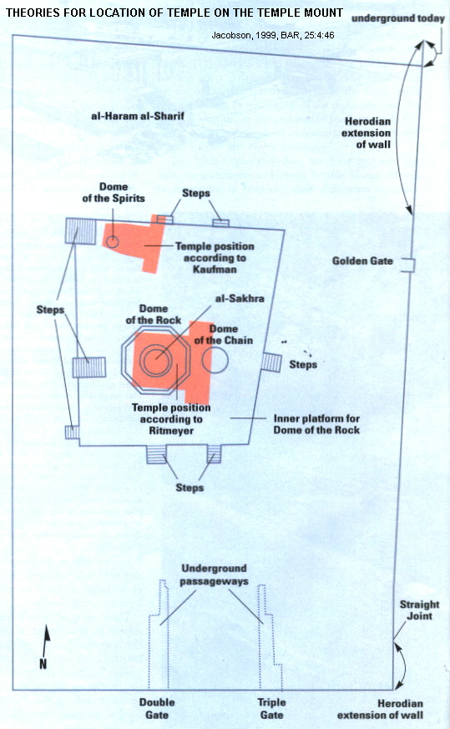

PHOTO LINK: JA059 Triple Gate (eastern Huldah) Gate
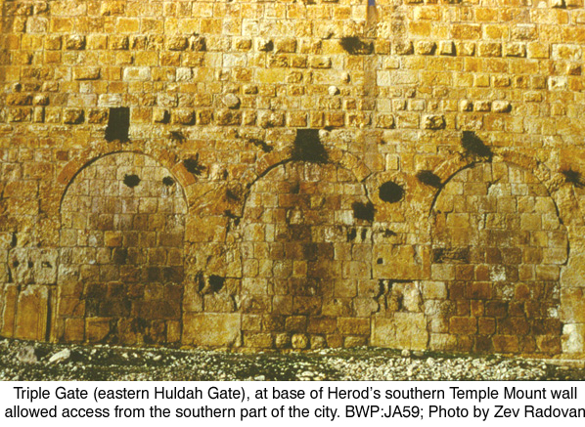

King Herod the Great expanded the Temple Mount. What is dramatically preserved from Herod’s building operations at the Temple Mount is the huge platform Herod prepared to enlarge greatly the sacred precinct around the Temple. To provide additional space on the south side, where the ground dropped off sharply, Herod’s engineers had to raise a retaining wall 129 feet from bedrock filling behind it with rubble and vaulted chambers to support a pavement for courtyards, buildings and colonnaded porticos at the level of the Temple. When they finished, Herod’s engineers had vastly enlarged the area of the Temple Mount, making it one and a half times as large as the Acropolis of Athens.

All reconstructions of the Temple depend on the "seam" between the older Persian and younger Herodian phases of Temple Mount construction.

PHOTO LINK: JA049 Jerusalem: “Seam” in Eastern Temple Mount Wall

PHOTO LINK: JA050 Jerusalem: Close-Up of “Seam” in Eastern Temple Mount Wall
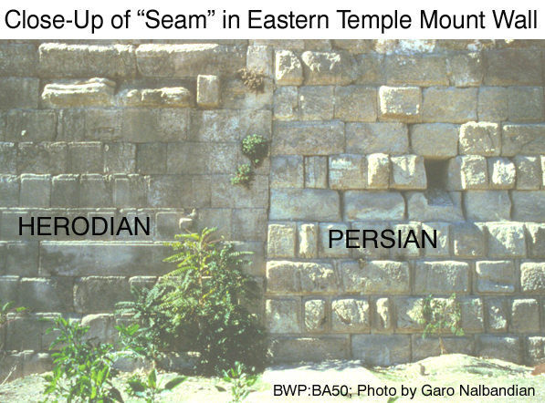

"The resulting podium covered some 36 acres with the new southern portions soaring impressively above the surrounding landscape. All the buildings that once stood on this platform have since disappeared. Most of them were destroyed when Titus Flavius Sabinus Vespasianus (AD 40 - 81) conquered the city in 70 C.E ending the 3rd Jewish Revolt. The Temple Mount itself remained, however, requiring only repairs to some upper portions of the retaining walls to preserve it as the most impressive witness to Herod’s grandiose building program (Biblical world in Pictures, caption to photo JA48).

PHOTO LINK: TITUS 001 Bust of Titus

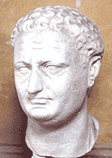
"When Herod’s construction was completed, the southeast corner of the Temple Mount (at the right of the photo, below) provided the most precipitous man-made height in the Holy Land. A person standing along the parapet at that point hovered almost 130 feet above the bedrock and twice that much above the floor of the Kidron Valley directly beyond. The spot became a famous landmark of Jerusalem. Called the “pinnacle” of the Temple, this is where the New Testament Gospel writers envisioned that Satan brought Jesus and tempted him to throw himself down (Matthew 4:5–7). From here, St. James the Less was, in fact, thrown to his death" (Biblical world in Pictures, caption to photo JA048).

PHOTO LINK: JA048 Jerusalem: Herod’s Enlarged Temple Mount
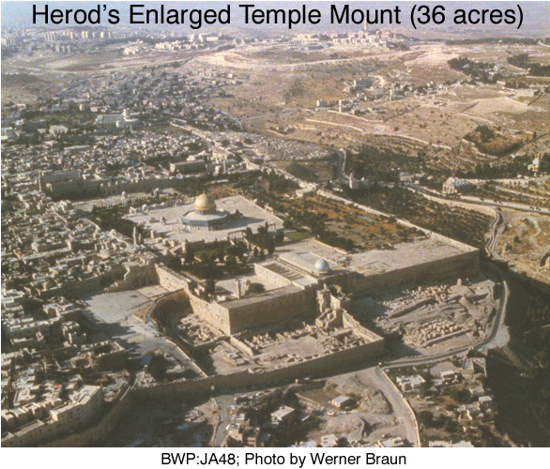

SOLOMON’S TEMPLE

King Solomon’s Temple was primarily a royal chapel, subject to the king's control. Priests were members of royal court. This arrangement protected Solomon from usurping of the kingship by a High Priest as happened at various times in Egypt. There is a description of Solomon’s Temple in 1 Kings 6 and an idealized one in Ezekiel 41. Reconstructions of the temple architecture and interior, plan and side chambers are shown in links below.

PHOTO LINK: AR054 Jerusalem, Solomon’s Temple (Howland-Garber Model)
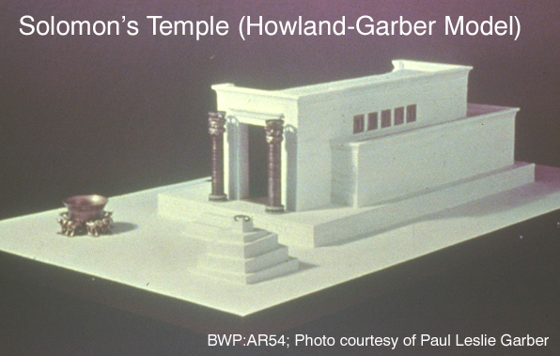

PHOTO LINK: SOLOMON'S TEMPLE 001 Illustrations of interior of temple
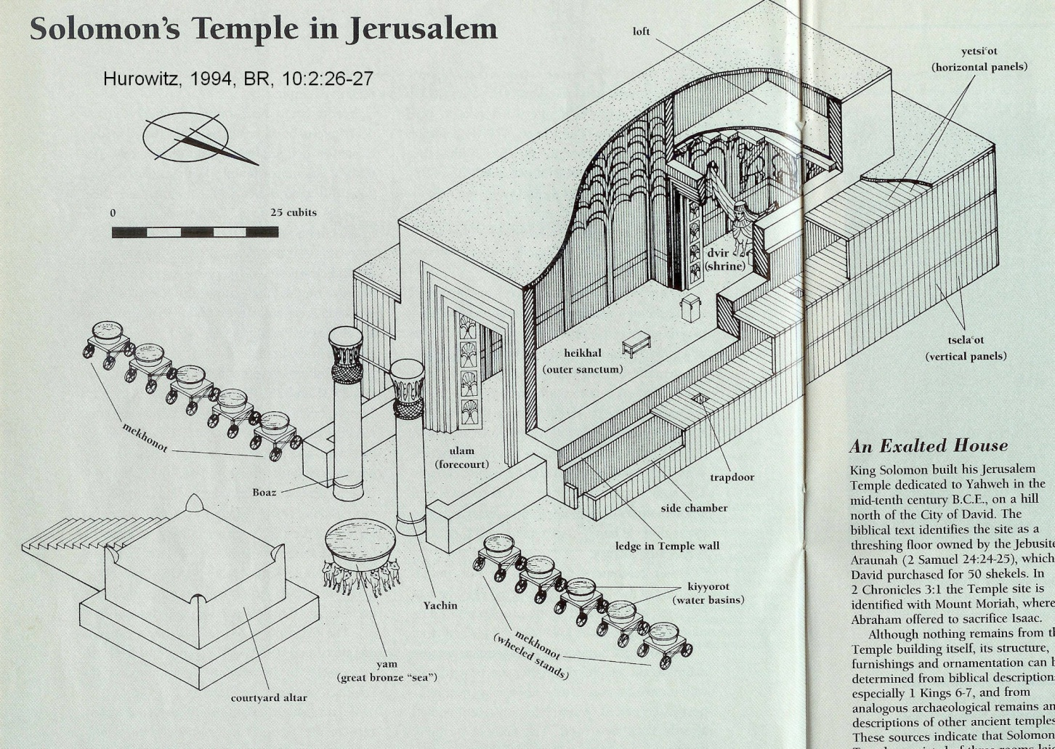

The pagan Phoenician King Hiram of Tyre provided materials and technical advice (1 Kings 9:11). The Phoenician priest Sanchuniathon wrote that Hiram provided the ruler of Judah with building materials in exchange for seaport facilities.

PHOTO LINK: SHECHEM 003 Location map of Shechem, Megiddo, Tyre and Jerusalem (See ABOVE, ctrl+click to follow link)

A similarity is known between the architecture of the tomb at Tamassos in Cyprus and the Jerusalem Temple. 1 Kings 6:31-33 discusses four interlocking olive-wood frames in Solomon’s Temple. This is similar to the construction at the Tamassos tomb.

PHOTO LINK: EKRON 004 Location map showing Cyprus Phillistine sites (See ABOVE, ctrl+click to follow link)

The Temple inner courtyard was off-limits to Gentiles. A Greek inscription from the temple of Herod (destroyed by the Romans in AD 70) was found. It warns non-Jews to stay away from the inner court upon pain of death.

PHOTO LINK: SOLOMON'S TEMPLE 002 Plan of Temple
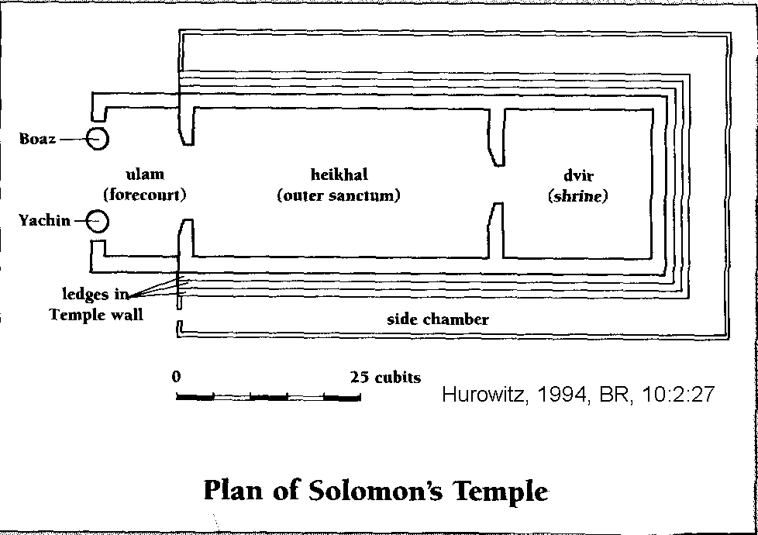

PHOTO LINK: SOLOMON'S TEMPLE 050 Plan of Temple. See ABOVE, ctrl+click to follow link)

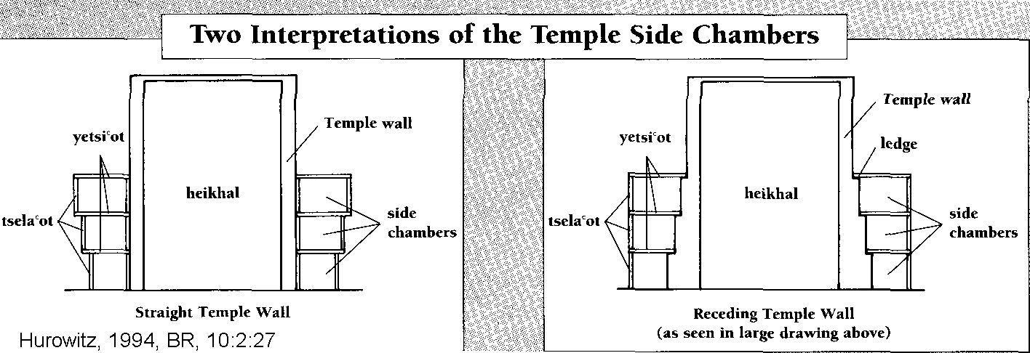
PHOTO LINK: SOLOMON'S TEMPLE 003 Sides of Temple, two interpretations

PHOTO LINK: SOLOMON'S TEMPLE 007 4-fold frames as in 1 Kings 6-31-33
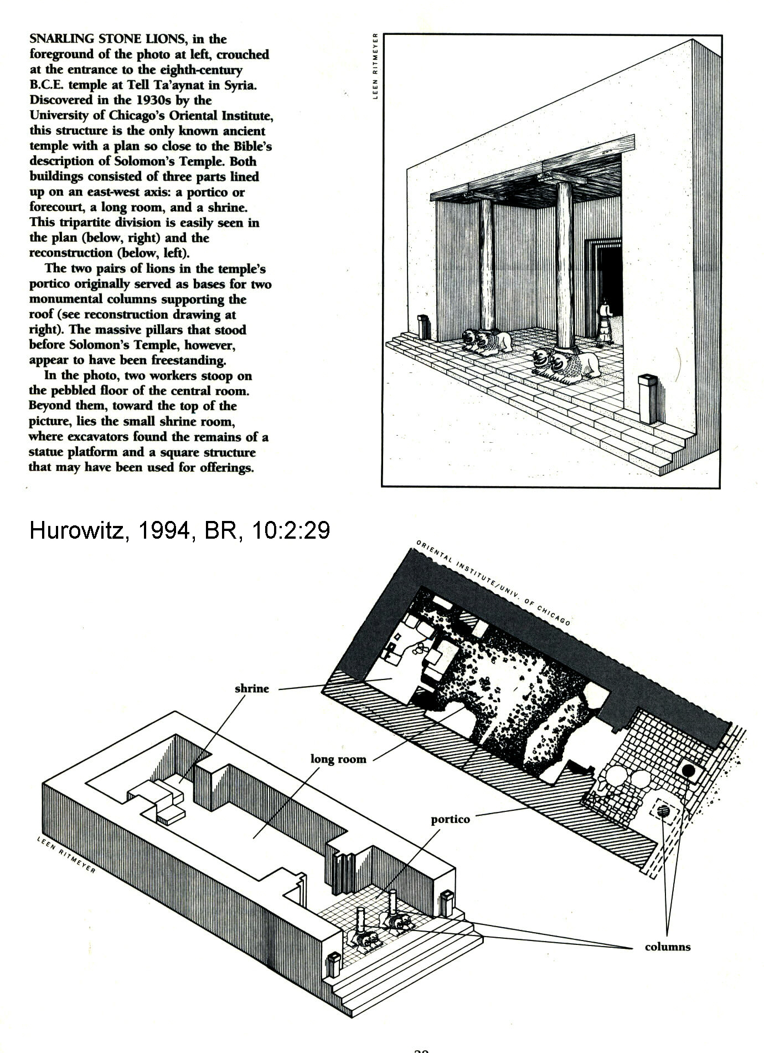
PHOTO LINK: SOLOMON'S TEMPLE 072 Greek inscription and warning
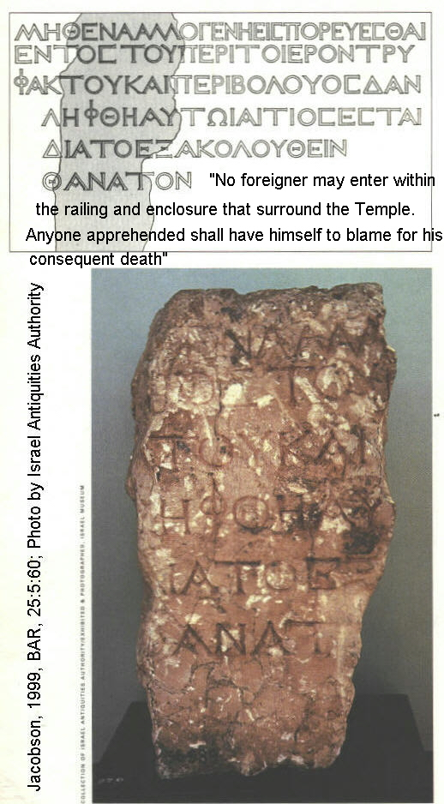

Location of the Temple

Several different theories have been proposed for the location the original Temple have been made. Kaufman (1983, 2000) thought the Temple was near area now occupied by the Dome of the Spirits.

Ritmeyer and Jacobson believe the Temple was centered over the area now occupied by the Moslem mosque es Sakhara aka "Dome of the Rock" (Jacobson, 1999; Ritmeyer, 1993, 2000). The sacrificial alter that stood in front of Solomon's Temple is now occupied by the "Dome of the Chain" (Jacobson, 1999, 2000).

PHOTO LINK: SOLOMON’S TEMPLE 068 Dome of the Rock
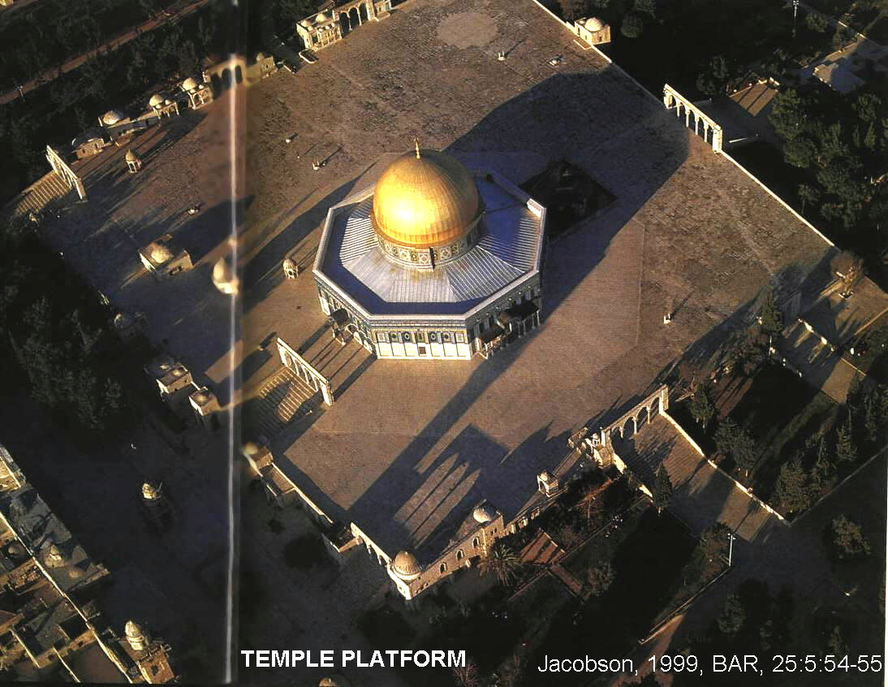
PHOTO LINK: SOLOMON'S TEMPLE 074 Kaufman;s Theory
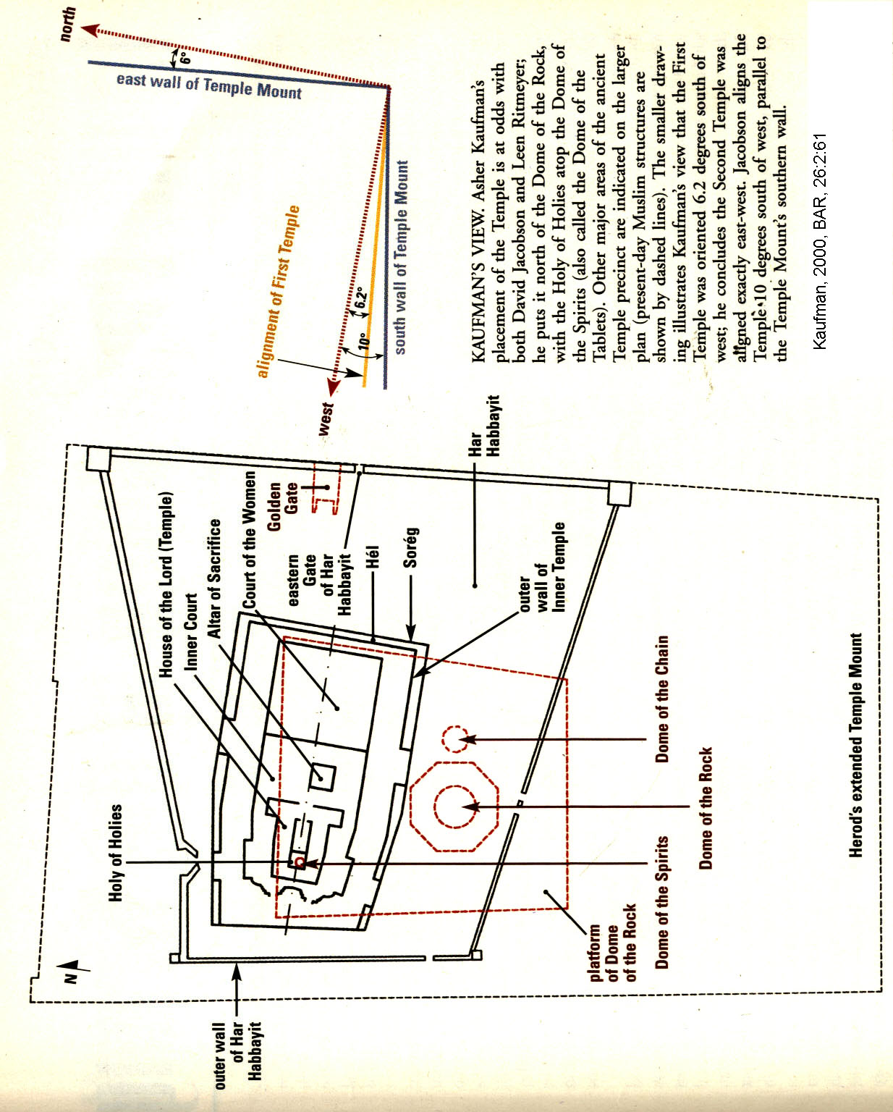

PHOTO LINK: SOLOMON'S TEMPLE 034B Theories of the location of Temple Mount Diagrams Part 1
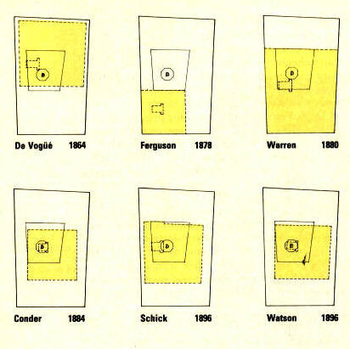

PHOTO LINK: SOLOMON'S TEMPLE 034C Theories of the location of Temple Mount Diagrams Part 2
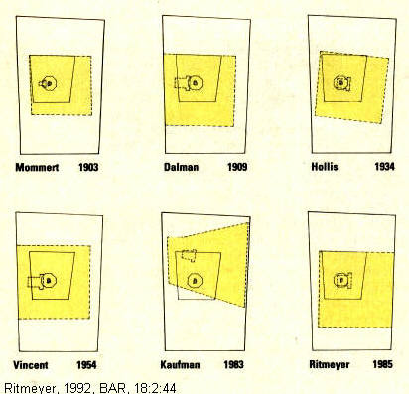

PHOTO LINK: SOLOMON'S TEMPLE 061 Kaufman and Ritmeyer theories for location of Temple. See ABOVE, p. 162 ; (ctrl+click to follow link)

PHOTO LINK: SOLOMON'S TEMPLE 075 3-D Drawing of Ritmeyer's theory
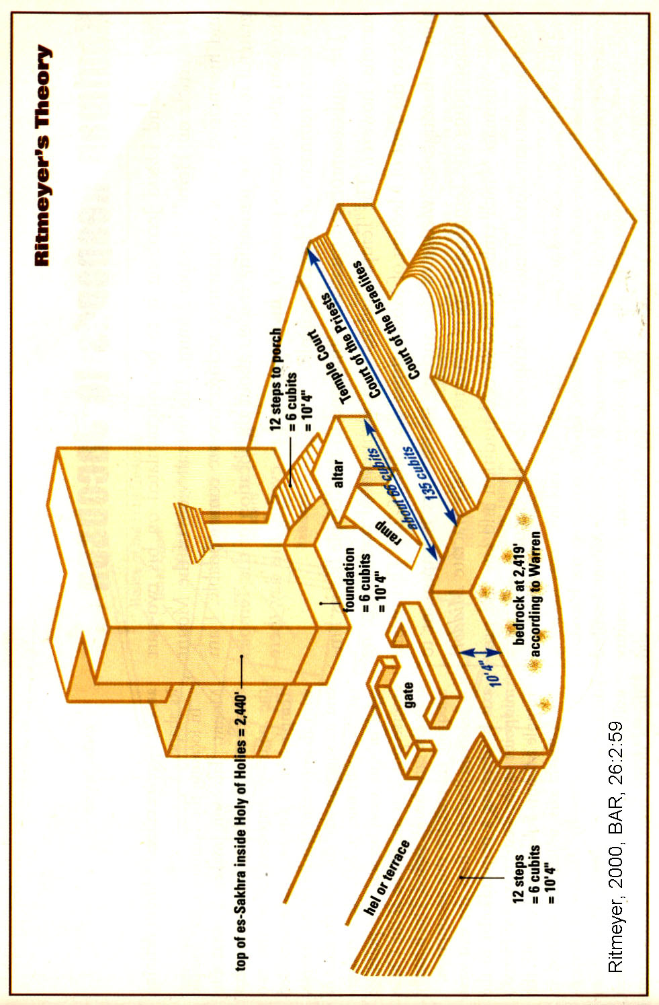

PHOTO LINK: SOLOMON'S TEMPLE 066 Dome of the Rock and Dome of the Chain
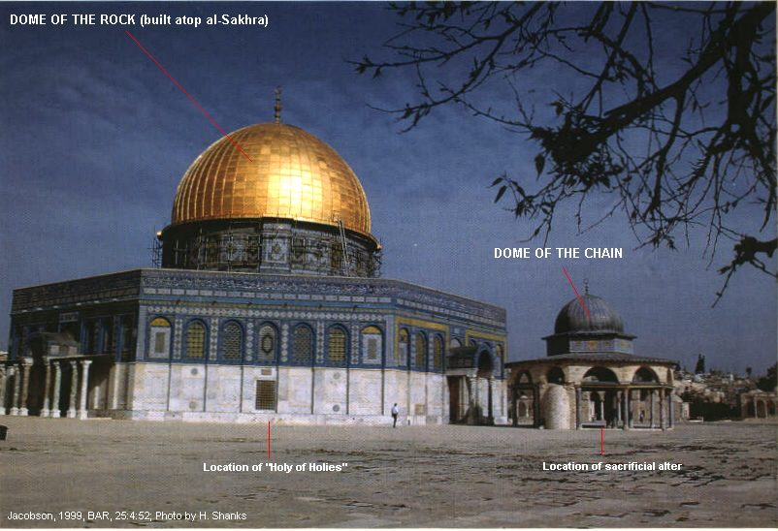

The location of the Temple on the Temple mount was reconstructed by Jacobson (1999b) based on geometric analysis of the present Mount and remnant monumental steps visible in 19th century photographs.

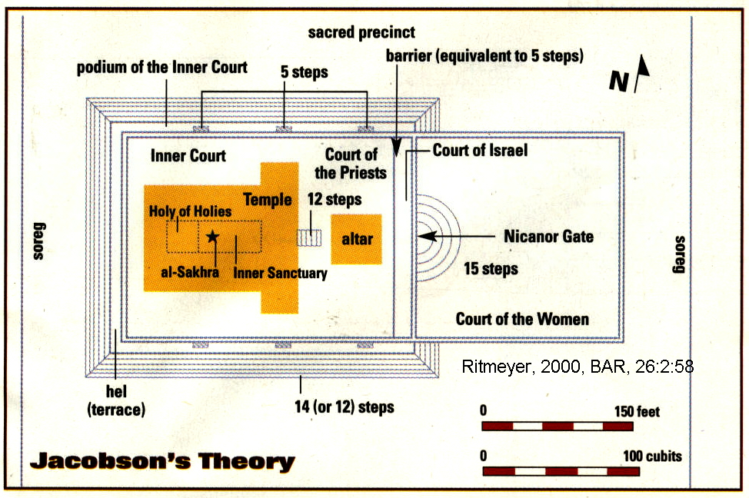
PHOTO LINK: SOLOMON'S TEMPLE 076 Jacobson's theory for location of Temple

PHOTO LINK: SOLOMON'S TEMPLE 076 Plan of Jacobson's theory; See ABOVE, p. 172; (ctrl+click to follow link)

A problem with the Jacobson placement is that it would cut through the Pool of Israel and the Antonia Fortress adjacent to it (Ritmeyer, 2000:56).

PHOTO LINK: SOLOMON'S TEMPLE 069 Plan of Temple precinct on the Temple Mount
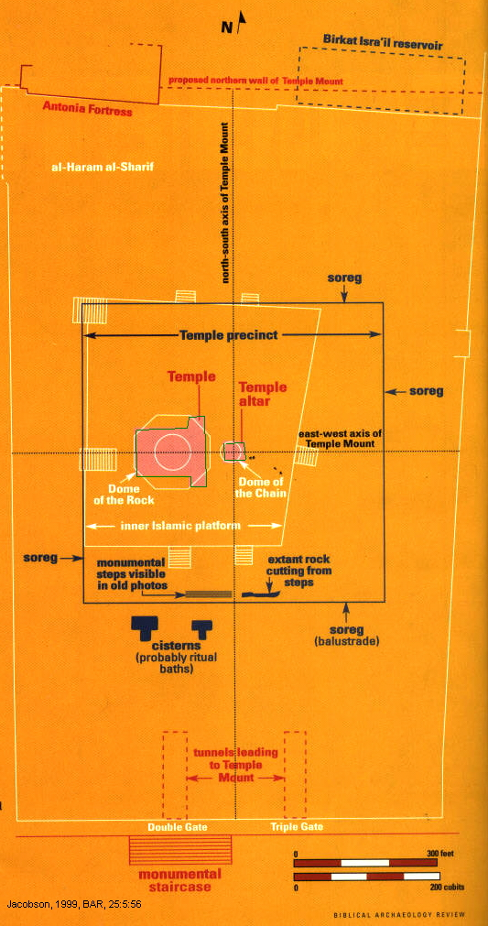

PHOTO LINK: SOLOMON'S TEMPLE 070 19th century and 1999 photo of Dome of the Rock
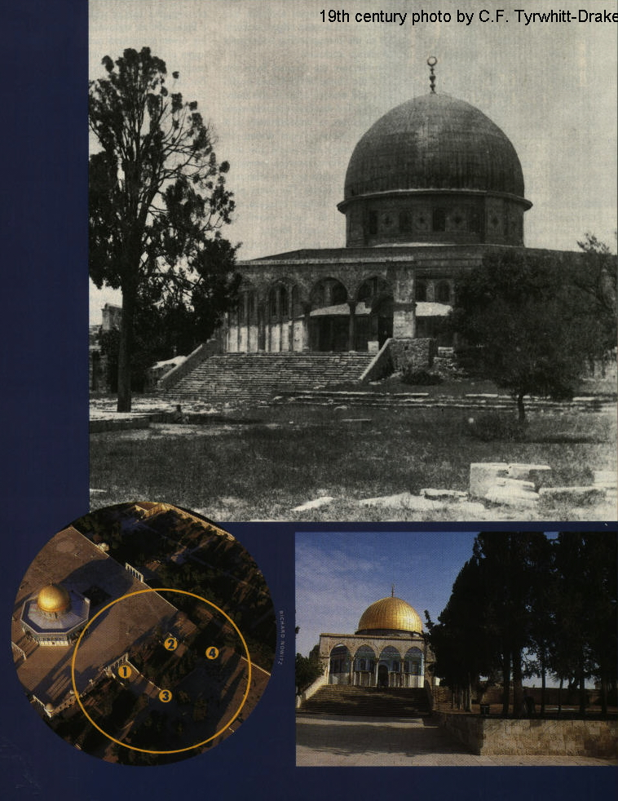
PHOTO LINK: SOLOMON'S TEMPLE 071 19th century and 1999 photo of Dome of the Rock w monumental stairway
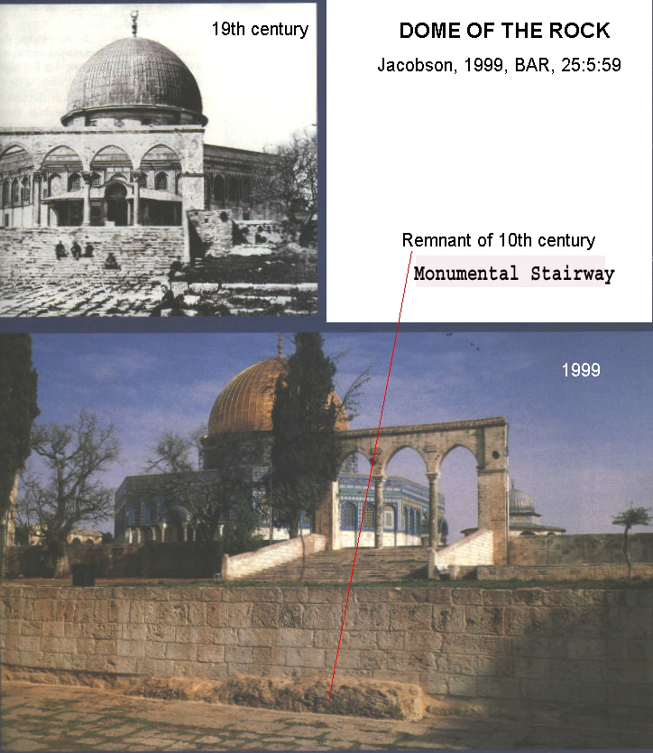

PHOTO LINK: SOLOMON'S TEMPLE 073 Plan and cross section, Jacobson's theory.
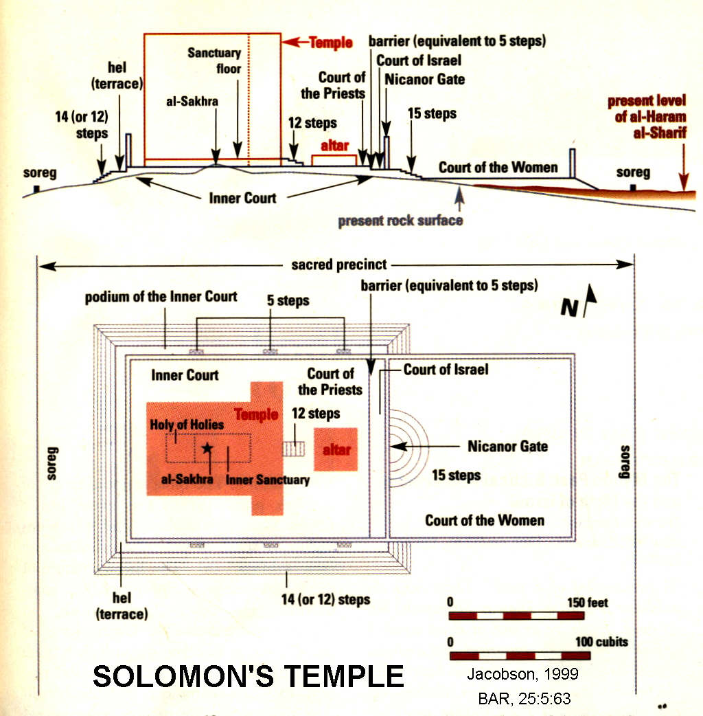

PHOTO LINK: SOLOMON'S TEMPLE 077 Pool of Israel and Antonia Fortress (model)
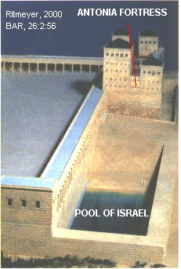

PHOTO LINK: SOLOMON'S TEMPLE 078 Wall of Pool of Israel and northern wall of Temple Mount
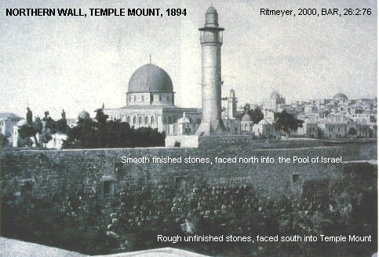

Beit Yahweh Ostracon and Solomon's Temple

An unprovenanced ostracon dating to the late 7th century BC records the oldest known extra-Biblical inscription to mention Solomon's Temple. The date is based on paleographic analysis and on laboratory tests (Scanning Electron Microsope, X-ray microanalyzer, SED/EDS) of the ostracon matrix. Written in Old Hebrew script the ostracon records (Shanks, 1997):

"Pursuant to the order to you of Ashya-hu the king to give the hand of [Z]echaryahu silver of Tarshish to the House (or Temple) of Yahweh, three shekels."

PHOTO LINK: BEIT YAHWEH OSTRACON 001 Photograph of 10.9 x 8.6 cm ostracon
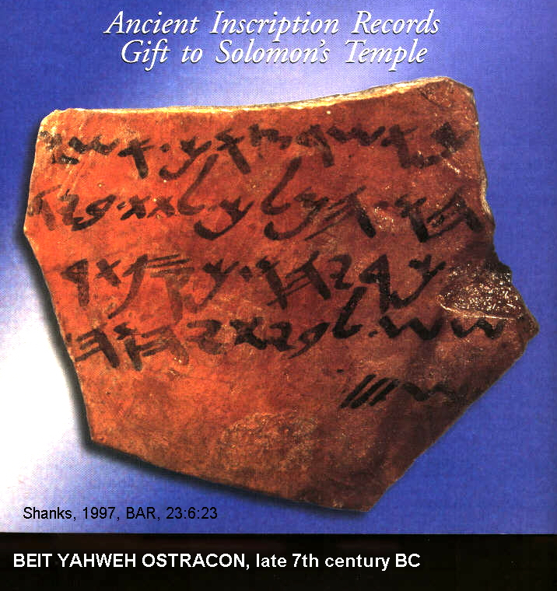

PHOTO LINK: BEIT YAHWEH OSTRACON 002 Text and translation of ostracon
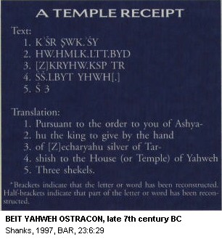

Ashya-hu may be and alternate (reversed) spellings for Yoash and Jehoash (English Joash and Jehoash). The Judean King Joash reigned from 835-796 BC. The Israelite king Jehoash reigned from 803 to 787 BC. Ashya-hu may also be an alternate rendering for King Josiah (640-609 BC). The -yahu suffix is most often associated with names of the kings of Judah and the -yah suffix was used in the names of the Kings of Israel). Paleographer P.K. McCarter picks King Yoash of Judah to be the person mentioned in this ostracon (Shanks, 1997:31).

Temple Furnishings

Temple implements or ritual tools included "flesh-hooks" of 2 Chron 4:16. These were 3-pronged forks. The Temple "spoons" of 2 Chron 4:20 were bowls or dishes, sometimes with an open hand inscribed on the back. In Hebrew kaf means "palm of hand" (Wilson, 1972).

Outside the temple were ten bronze wheeled stands approximately 4.5 feet high called mekhonot in I Kings 7:29). A 13-inch high miniature of these stands was found in Cyprus (Hurowitz, 1994).

PHOTO LINK: AR109 Cyprus, Wheeled Brazier with figure playing lyre

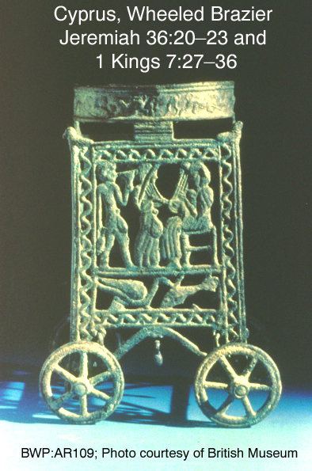
PHOTO LINK: SOLOMON'S TEMPLE 006: Mekhonot, libation stands
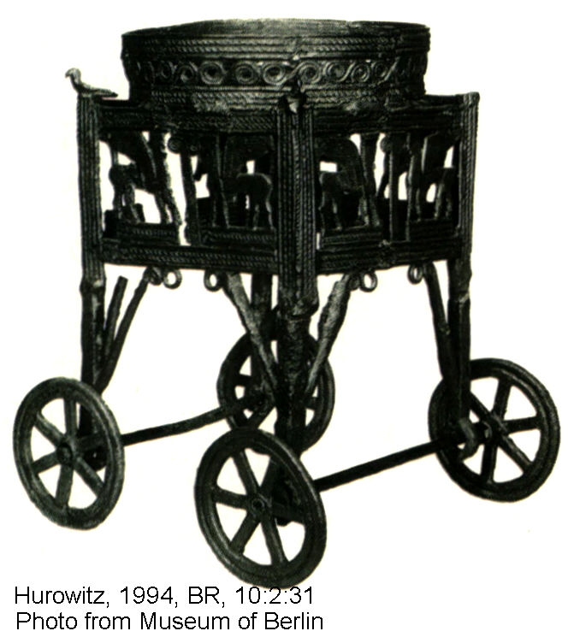
PHOTO LINK: SOLOMON’S TEMPLE 009 8-spoke wheel similar to incense stand of 1 Kings 7:30-33
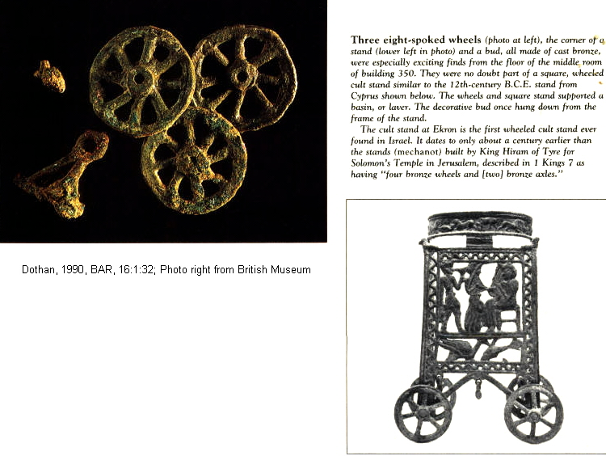

The architecture of the temple is hinted at in 1 Kings 6:31-35 where four interlocking olive-wood frames are described. This is similar to a 4-fold door frame at the entrance to a royal tomb at Tamassos, Cyprus.

PHOTO LINK: SOLOMON'S TEMPLE 007: 4-fold doorway at Tamassos tomb

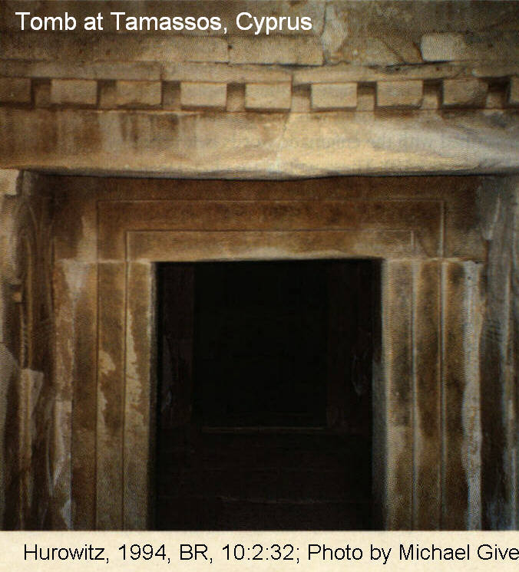
Incense shovels mentioned in 1 Kings 7:45 and 50 are similar to iron incense shovels found at Tel Dan. These are the oldest incense shovels known from Israel.

PHOTO LINK: SOLOMON'S TEMPLE 008: Incense Shovels
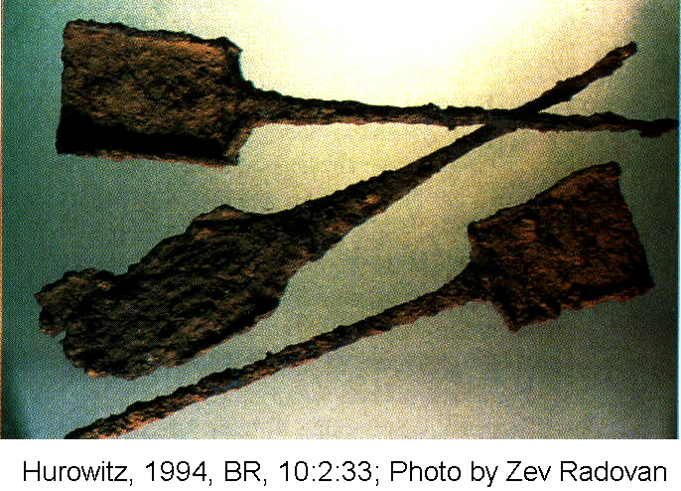

Cherubim were sacred creatures with a bull’s body, human face, and wings like an angel or bird. Two cherubim guarded the Ark of the Covenant with outstretched arms in the Desert Tabernacle (Exodus 36:8) and also in the Holy of Holies of King Solomon’s Temple (1 Kings 6:23-28). This arrangement is similar to practices found In pagan temples where treaty (covenant) documents were often stored at the foot of divine statues. Cherubim are found in a variety of Mesopotamian and Levant cultures: Assyrian, Syrian, and Phoenician examples are shown below:

PHOTO LINK: CHERUBIM 001 Nimrod ivory of Cherubim
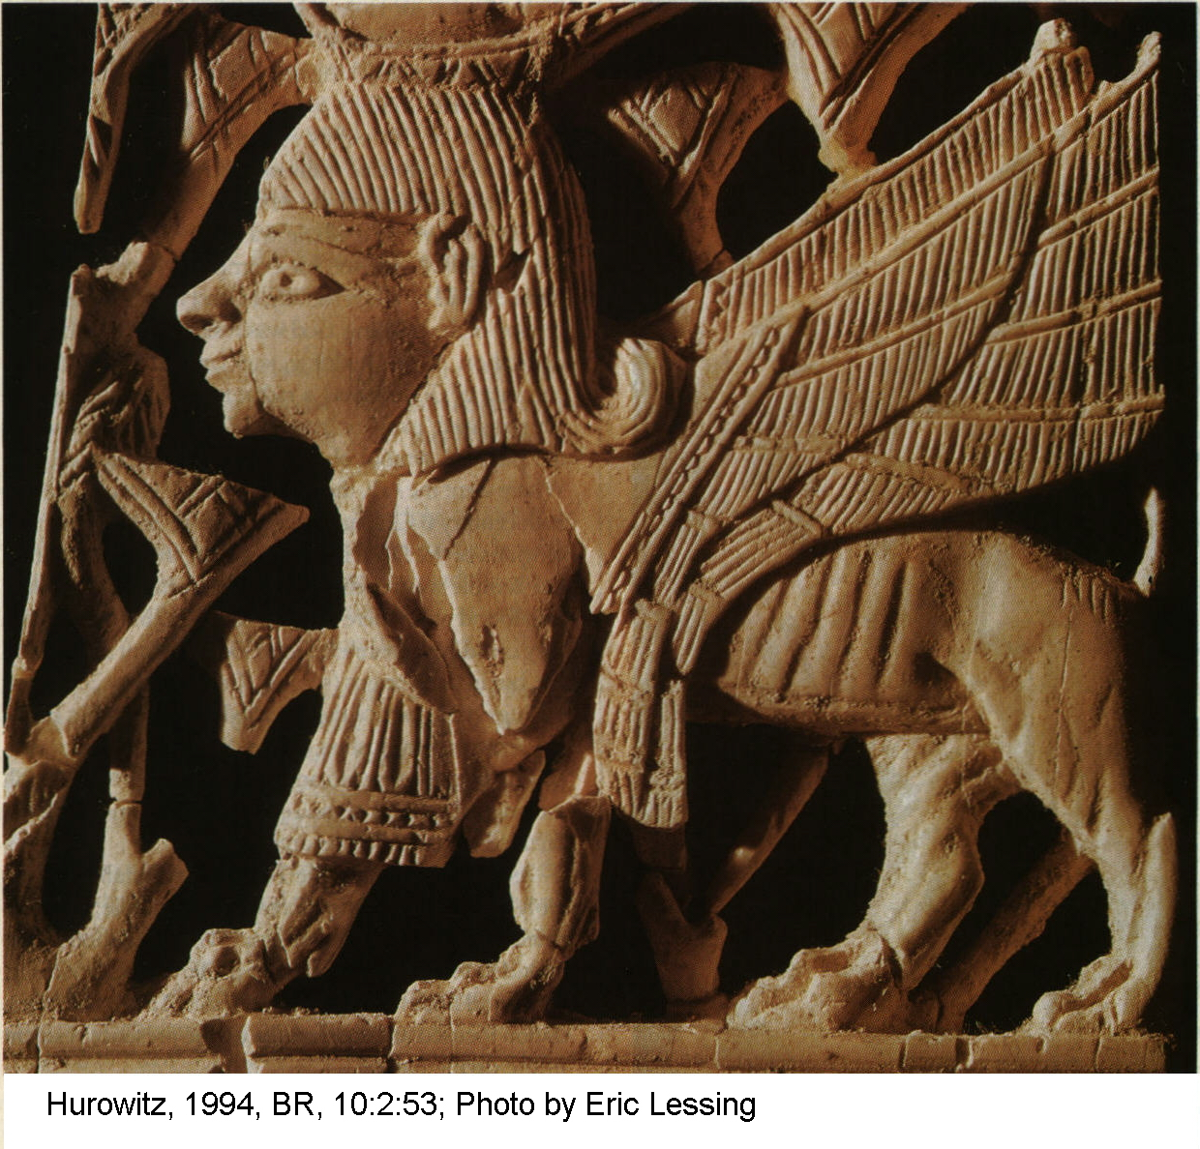

PHOTO LINK: CHERUBIM 002 Ivory Cherubim from Arsian Tash, Syria, 8th century BC
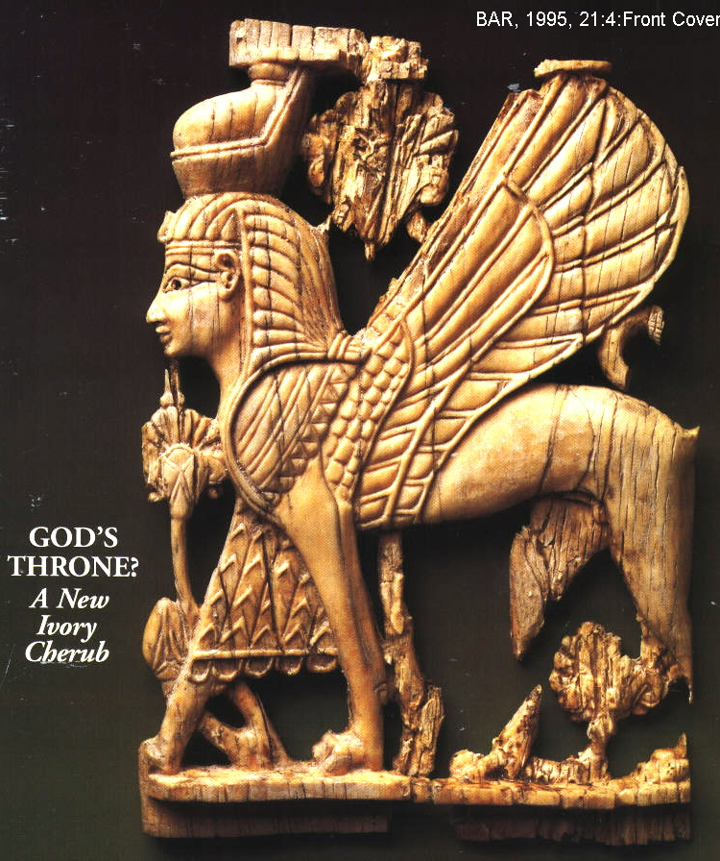

PHOTO LINK: CHERUBIM 003: Bronze cult stand with cherubim, 12th century BC Cypriot-Phoenician
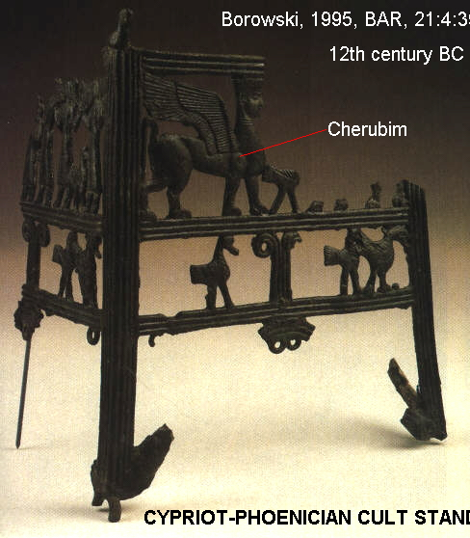

The sphinx is an Egyptian adaptation of the Cherubim motif, where the body of a bull is replaced by the body of a lion (Ornan, 1995). You can detect the difference by the geometry of the tail: In the cherubim, the tail raises up, then goes straight down (like a bull's tail). In the sphinx, the tail curves upward (compare CHERUBIM 003 with the drawing in CHERUBIM 004).

PHOTO LINK CHERUBIM 004: Cherubim (Arsian Tash ivory) vs Sphynix (Nimrud ivory)
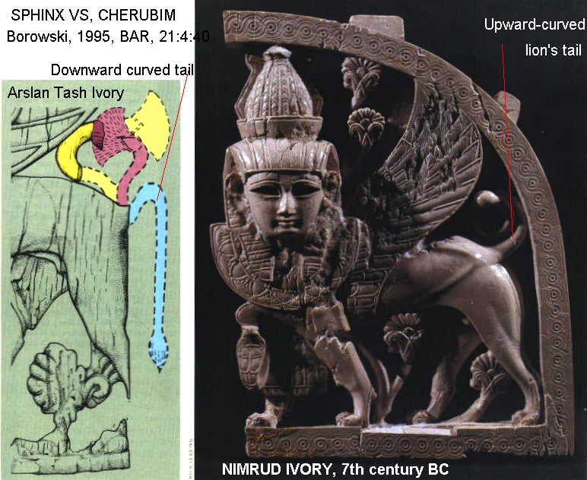

A pomegranate-head scepter was found on the antiquities market and interpreted as a relic of the Jerusalem Temple. The thumb-size pomegranate has the inscription “Holy to the priests, [belonging] to the Temple of [Yahw]h.” There is an on-going debate about its legitimacy (Shanks, 1988a, 1988b, 1992, 2007b). The Israel Museum in Jerusalem purchased the artifact for $550,000 and later determined that the scepter head was authentic, but the inscription was forged (Shanks, 2005:48). A conference in 2007 also yielded mixed interpretations as to the authenticity of artifact and its inscription (Shanks, 2007b).

PHOTO LINK: POMEGRANATE SCEPTER 001 Full photo of scepter

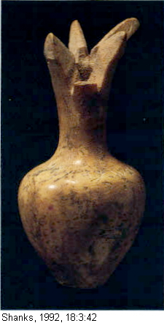
PHOTO LINK: POMEGRANATE SCEPTER 003 Oblique top view
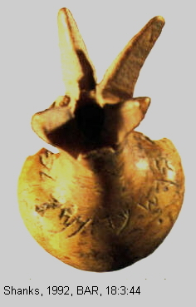

The inscription is fragmentary and the word for Yahweh could just as easily be read “Asherah”.

PHOTO LINK: POMEGRANATE SCEPTER 002 Drawing of text

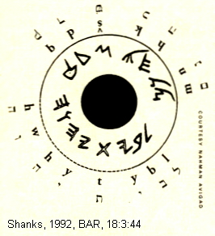

PHOTO LINK: POMEGRANATE SCEPTER 004 Artifact on microscope
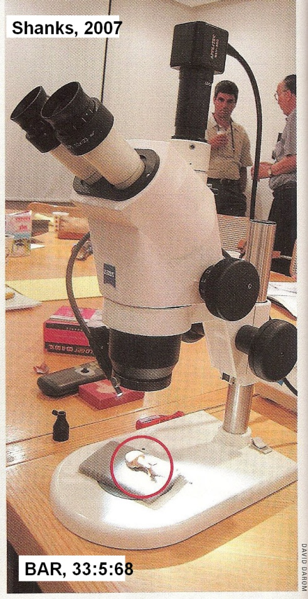

The throne of Yahweh (1 Kings 6:23-28; Exodus 25:17-22) has been compared to a depiction of a throne on an ivory knife handle from Megiddo (12th to 13th century BC, Late Bronze Age; Coogan, 1995:40-41).

PHOTO LINK: MEGIDDO 026 Ivory knife handle with throne
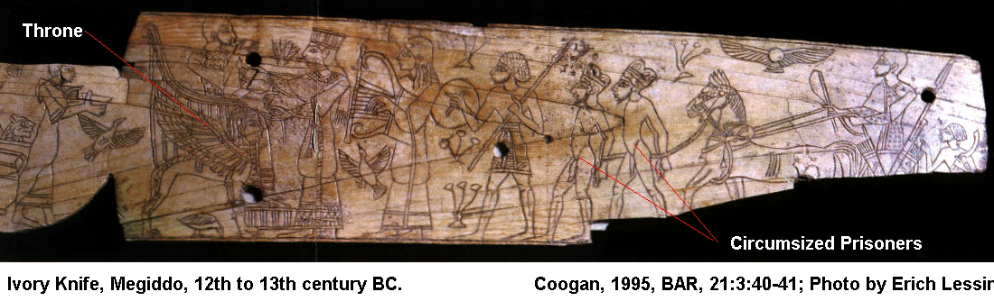

Location of the Ark in the Temple
Although archaeological research is restricted on the Temple Mount and on the Moslem Mosque "Dome of the Rock" (es-Sakhra), the location of the place were the Ark of the Covenant rested has been reconstructed.

PHOTO LINK: ARK OF COVENANT 002 Model of the Ark (right)

PHOTO LINK: SOLOMON'S TEMPLE 049 Dome of the Rock mosque
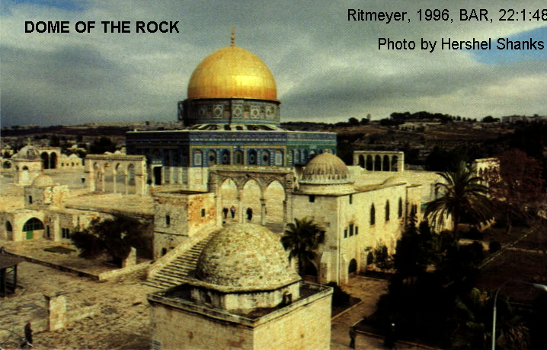

A rectangular foundation cut into bedrock on the north side of the "Dome of the Rock" matches dimensions given for the arc (1.5 x 2.5 cubits; 2ft.7in.x 4ft.4in) as well as it's elevation and orientation relative to the rest of the Temple Mount. The photographs and diagrams in Ritmeyer (1996) are reproduced below:

PHOTO LINK: SOLOMON'S TEMPLE 051 Features of es-Sakhra "Dome of the Rock" and site of Ark
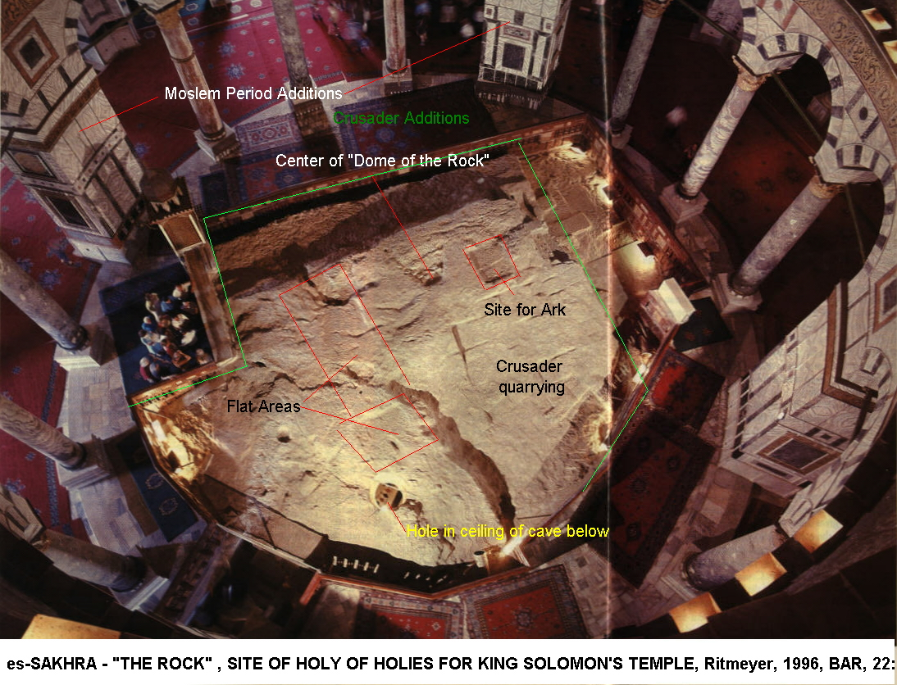

PHOTO LINK: SOLOMON'S TEMPLE 052 Diagram of es-Sakhra "Dome of the Rock" and site of Ark
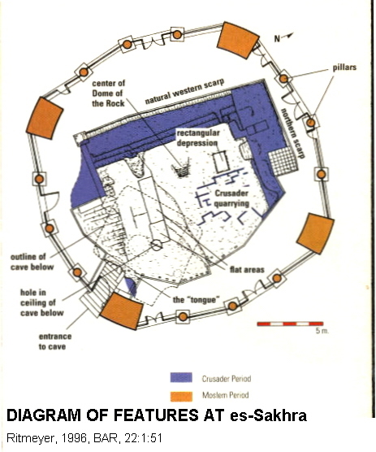

PHOTO LINK: SOLOMON'S TEMPLE 035 Location of Sakhra in temple (see 053)
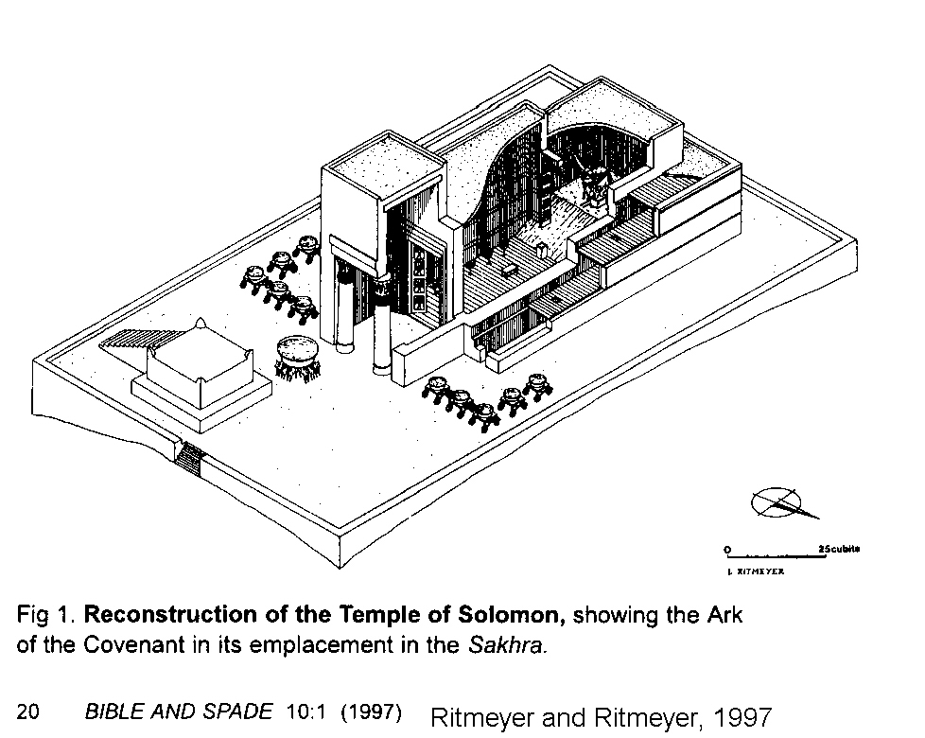

PHOTO LINK: SOLOMON'S TEMPLE 053 Location of Sakhra in temple (see 035)
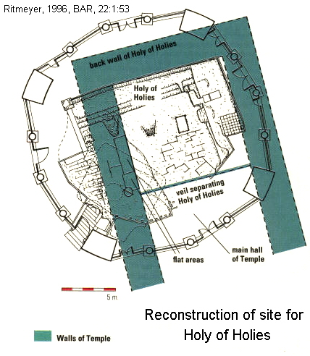

PHOTO LINK: SOLOMON'S TEMPLE 054 Cross section reconstruction of Dome of Rock and Temple
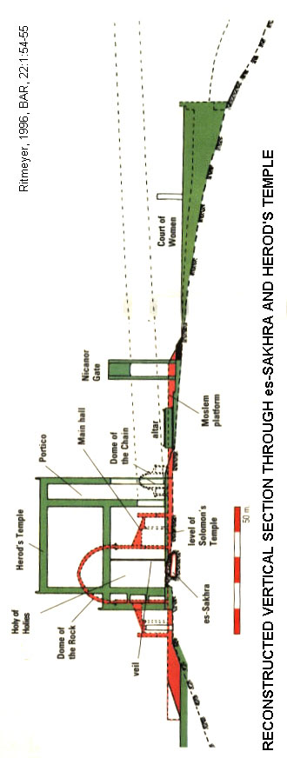

PHOTO LINK: SOLOMON'S TEMPLE 055 Site of Ark of Covenant in es-Sakhra
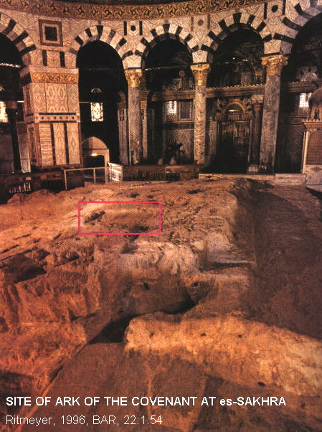

Ezekiel's Plan of the Temple

The Temple Scroll of the Dead Sea Scrolls casts light on the Ezekiel vision (Ezekiel 41) of the Temple including it's layout and dimensions (Livingston, 1980, Wilson, 1972). Ezekiel lived in Babylon during the Exile period (593-536), and was taken there when the Solomon’s temple was destroyed in 586 BC. His description is idealized.

Temple Depicted on Ossuary and Coins

Secondary ossuary (bone box, BAR 33:3:48) burials were common in Jerusalem and its environs between 80 BC and 70 AD. A stylistic, geometric representation of the Temple, with doors closed, is believed to be preserved on one of these ossuary. Coins from the era of the Bar-Kokhba (Second Jewish) rebellion (132 AD) have representations of the Temple (Grossberg, 1996:49).

PHOTO LINK: SOLOMON'S TEMPLE 056 "Yehosah" Ossuary with depiction of front of Temple from cave tombs southeast of Jerusalem
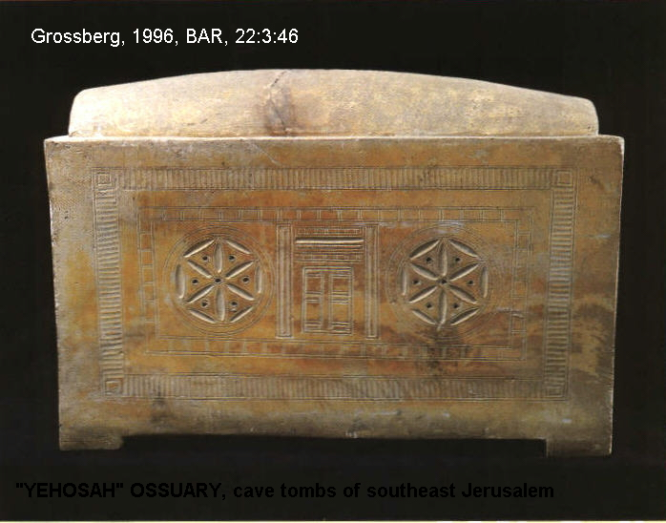

PHOTO LINK: SOLOMON'S TEMPLE 057 Elishiba Ossuary with depiction of front of Temple
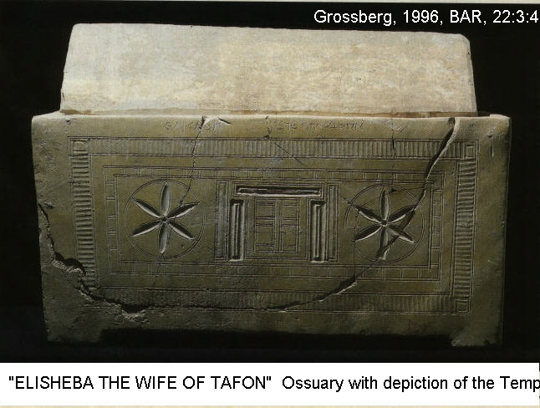

Coins from the Bar-Kokhba rebellion (132 AD) show a similar depiction of the front of the Temple, but with the doors open so that the Table of Shewbread can be seen.

Parallels to Solomon's Temple

Since Solomon's Temple is gone, understanding how it appeared must be reconstructed by analogy with other temples.

Hazor Phoenician Temple

There are similarities between the Old Testament descriptions of Solomon's Temple and the archaeological remains of a Phoenician temple at Hazor in Galilee (Wilson, 1972).

PHOTO LINK: HAZOR 017 Location map of Hazor in Palestine (See ABOVE, ctrl+click to follow link)

PHOTO LINK: SOLOMON'S TEMPLE 058 Bar Kokhba Revolt Coins with temple and shewbread 132 AD.
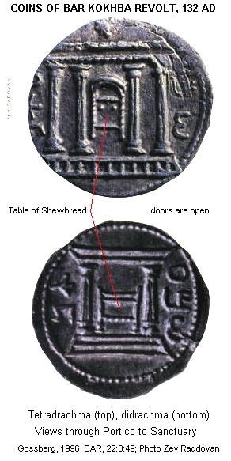

PHOTO LINK: HAZOR 042 Southern Temple and incense burners and chalaces
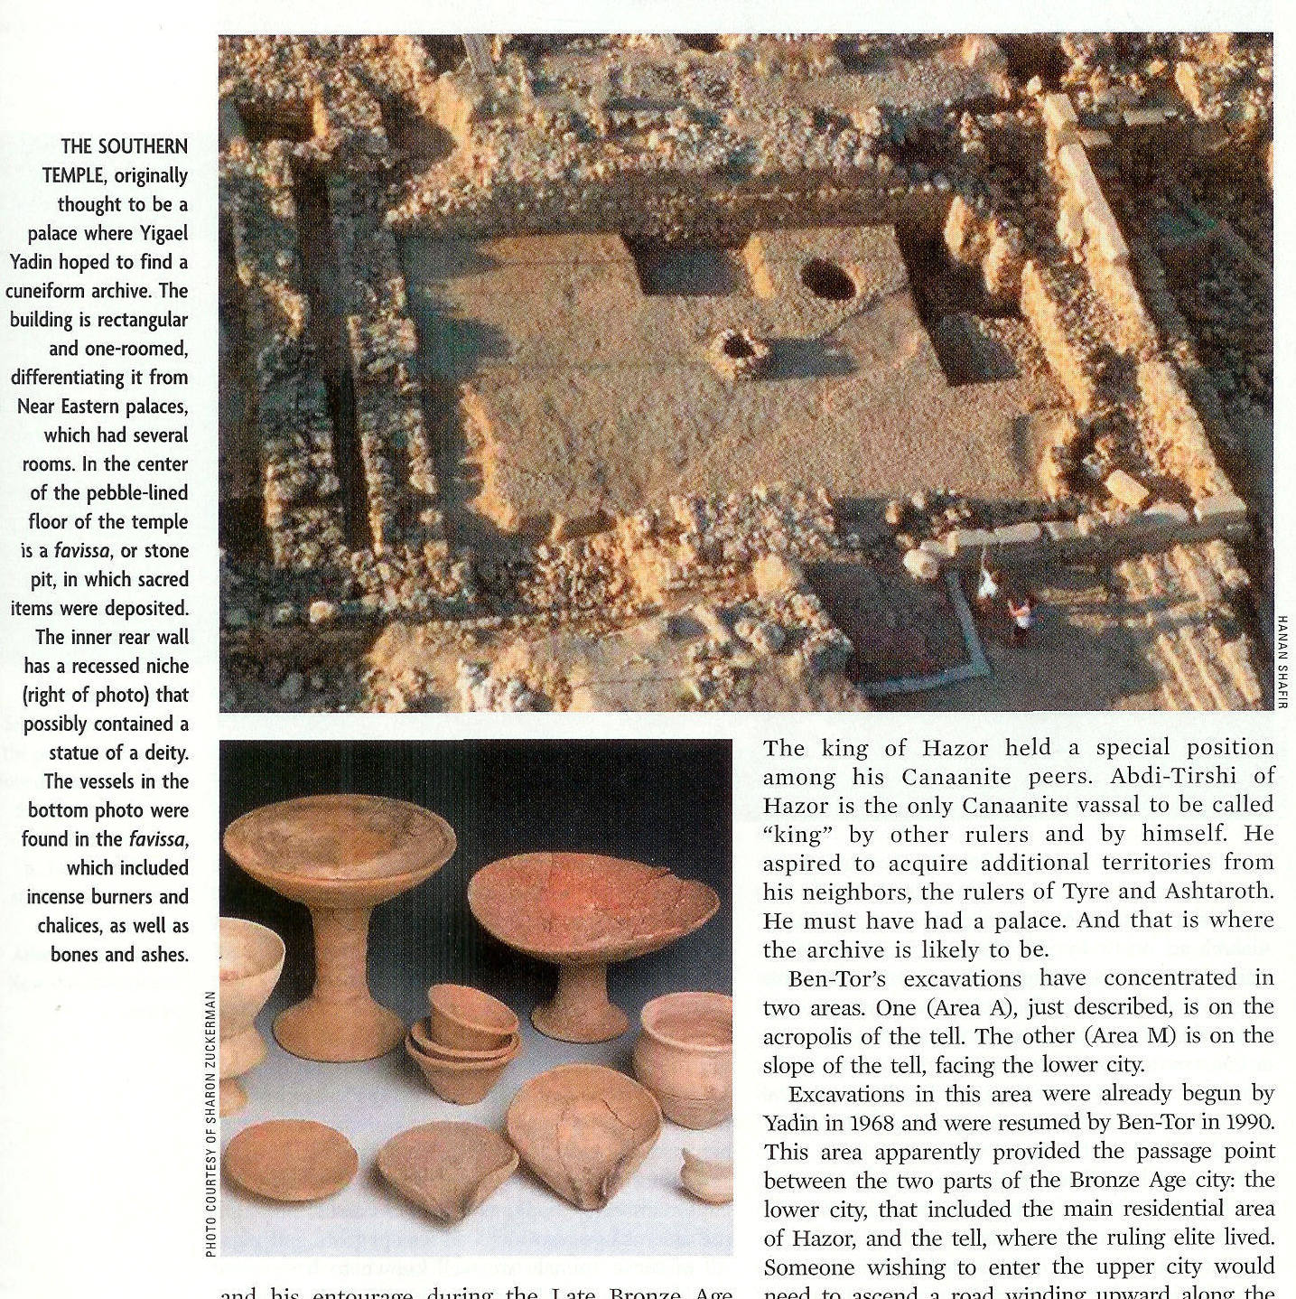

'Ain Dara, Syria

Another parallel to King Solomon’s Temple is the 'Ain Dara temple in Syria (Monson, 2000).

PHOTO LINK: 'AIN DARA TEMPLE 001 Location map

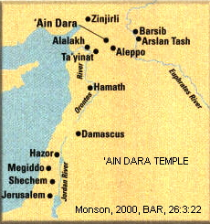

PHOTO LINK: 'AIN DARA TEMPLE 002 Air Photo
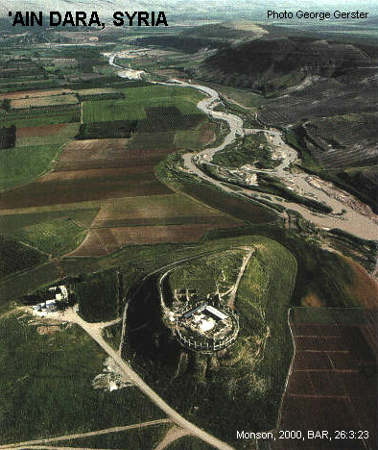
PHOTO LINK: 'AIN DARA TEMPLE 003 Topo map
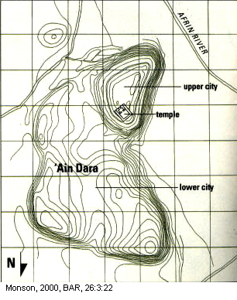

The temple at 'Ain Dara is the most similar of all known temple complexes to King Solomon's Temple. It is the most similar architecturally and also temporally. The 'Ain Dara temple was built about 1300 BC. It was in use and was expanded up to 740 BC. King Solomon's temple was built in 966 BC and flourished until the Babylonian destruction of 586 BC (Monson, 2000). So the two temples were contemporaries between 966 and 740 BC.

PHOTO LINK: SOLOMON'S TEMPLE 003 Side Chambers two interpretations

PHOTO LINK: ‘AIN DARA TEMPLE 005 Corridor similar to 1 Kings 6:5, 8
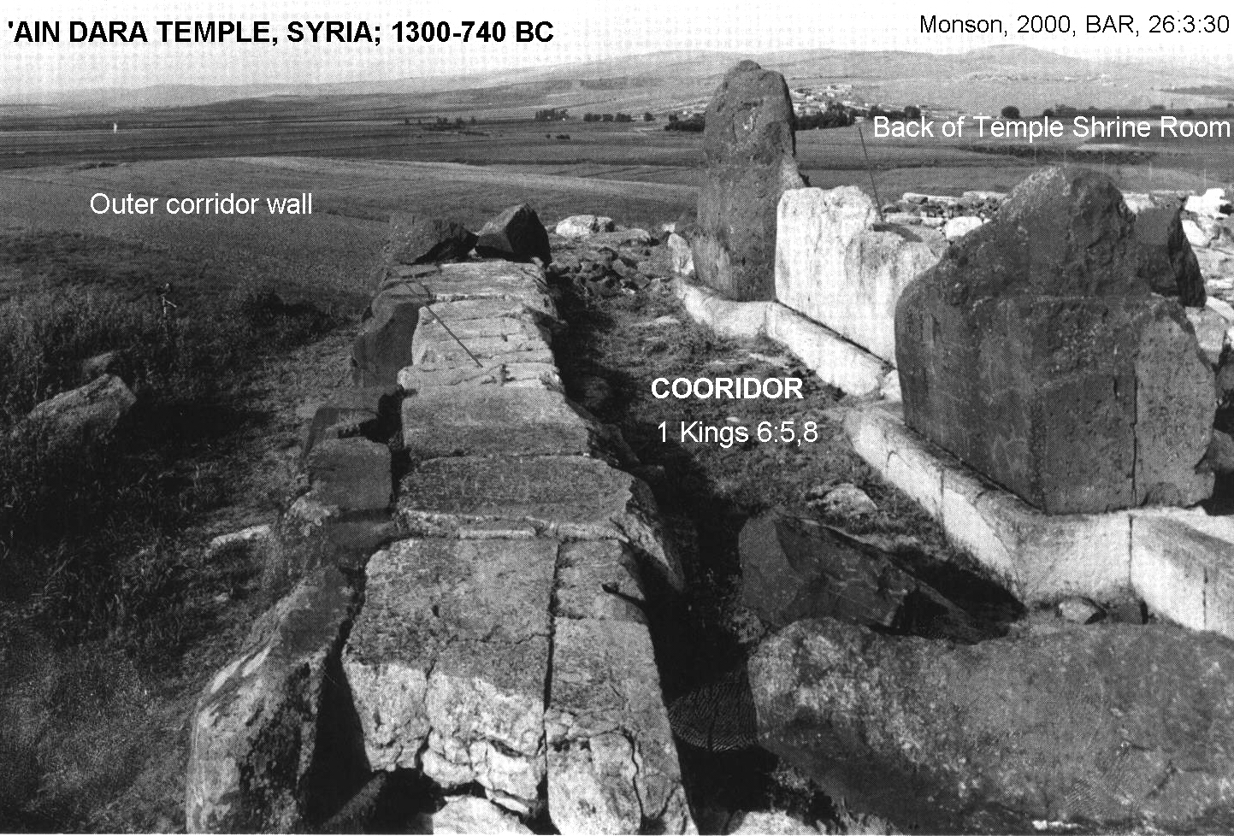

The 'Ain Dara temple also helped scholars understand 1 Kings 6:5,8:

"Against the outside wall of the House -- the ouside walls of the House enclosing the Great Hall and the Shrine -- he built a storied structure; and he made side chambers all around...The entrance to the middle [story of] the side chambers was on the right side of the House; and a return staircase [?] led up to the middle chambers and from the middle chambers to the third story."

Like Solomon's Temple the Syrian temple at 'Ain Dara also had side-room antichambers with a passageway that was entered through a facade (Monson, 2000:30).

PHOTO LINK: 'AIN DARA TEMPLE 004 Plan of temple 1300-740 BC
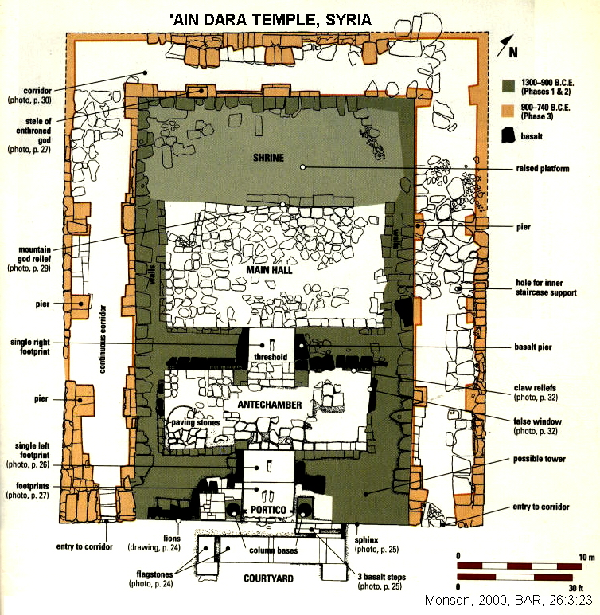

Ta'yinet (Ta'aynat) Temple, Syria

Solomon’s Temple is also similar to the temple at Tell Ta’aynat in Syria (Hurowitz, 1994).

PHOTO LINK: 'AIN DARA TEMPLE 006 Plan comparisons Jerusalem, Hazor and Ta'yinat
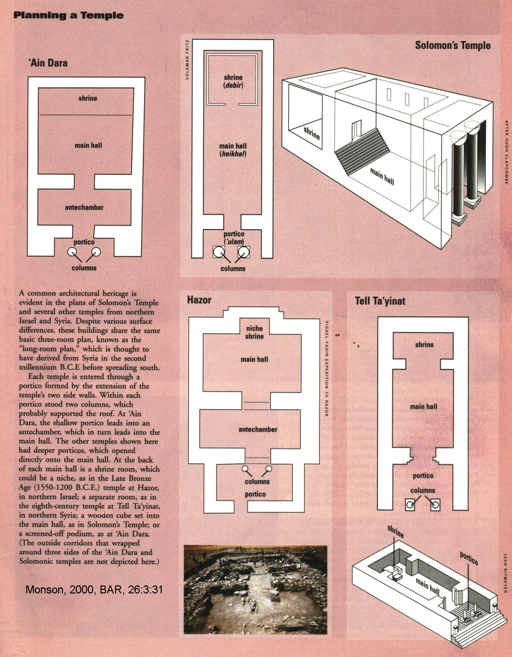

PHOTO LINK: 'AIN DARA TEMPLE 007 Aramaean Temple ruins
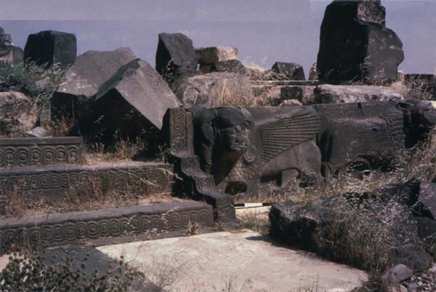

This 8th century BC Phoenician temple, somewhat older that Solomon's Temple, has many shared features. They have the same basic architectural plan with tripartite division of portico/forecourt, a central long room, and a shrine at the rear. At the portico entrance there was two large pillars. These were supporting pillars, whereas Solomon's temple had free-standing pillars named Boaz and Jaquin.

PHOTO LINK: SOLOMON'S TEMPLE 004 Ta'aynat temple drawings and plan

Theology and Political Theory of the Temple

The Temple was built on Mt Moria, where Abraham tried to sacrifice Isaac (Gen. 22:1-39). Later the eastern hill of Jerusalem upon which the Temple was built was called Mount Zion. (Today Mt Zion refers to Jerusalem's western hill because, prior to the 20th century, it was believed the higher western hill was the location of the original city), Mt. Zion is Yahweh's holy mountain. The Temple is where heaven meets earth. It is where man can meet God. The architecture, furnishings and landscaping of the Temple make it a kind of Eden. It reflected cosmological symbolism similar to surrounding civilizations of Egypt, Assyria, and Babylonia (Stager, 2000).

" Israelite kingship is closely linked to this kind of political and cosmological symbolism. On Mt. Zion, the mountain of God, Yahweh met with his council of holy ones and promulgated decrees to the human community under him and the king."

From the earliest civilizations, leaders have represented themselves to their people as sons of the local deity. This triad of creation-king-temple extended to (or was absorbed by) the United Monarchy. In Psalm 2, David the King is pictured as a son of Yahweh (Stager, 2000):

" I have set my king on Zion, on my holy hill"
I will tell of the decree of the Lord:
He [Yahweh] said to me, "You are my son, today I have fathered you.
Ask of me, and I will make the nations your heritage
And the ends of the earth your possession

SOLOMON'S ARCHITECTURAL ACHIEVEMENTS OUTSIDE JERUSALEM

Monumental Gateways at Hazor, Megiddo and Gezer

There was considerable Phoenician architectural influence in Solomon's buildings. They were financed by heavy taxation which built the Palace (1 Kings 7:1-12), Temple and "Royal Cities" of Hazor, Megiddo and Gezer. These 3 had similar gateways complexes (Wood, 1975; Wilson, 1972; Crutchfield, 1990).

PHOTO LINK: GATE COMPLEXES 001
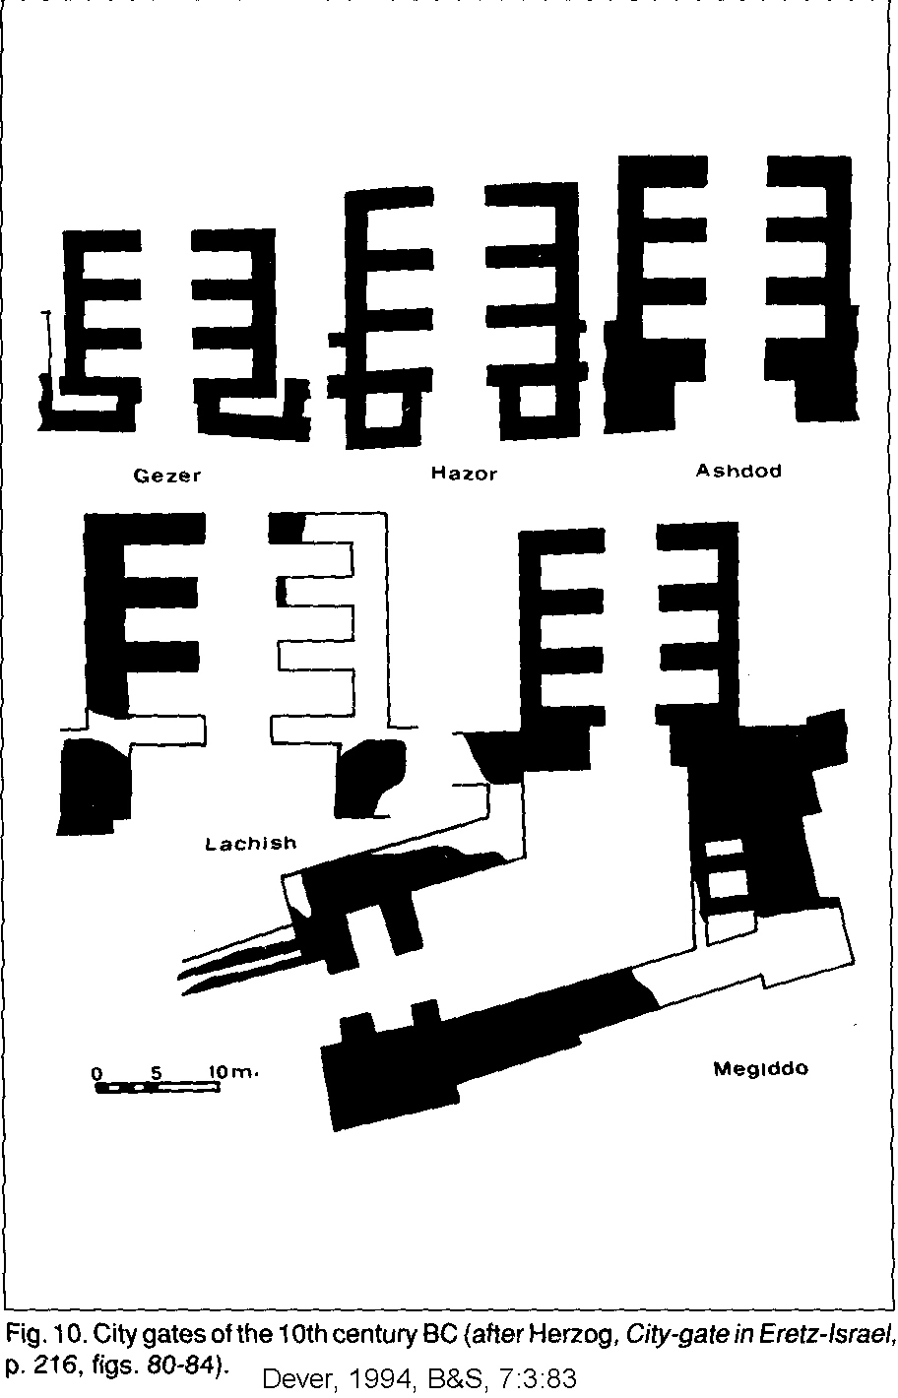

PHOTO LINK: HAZOR 003 Location map of Hazor with caravan routes to Babylon (See ABOVE, ctrl+click to follow link)

PHOTO LINK: HAZOR 027 Solomonic gate
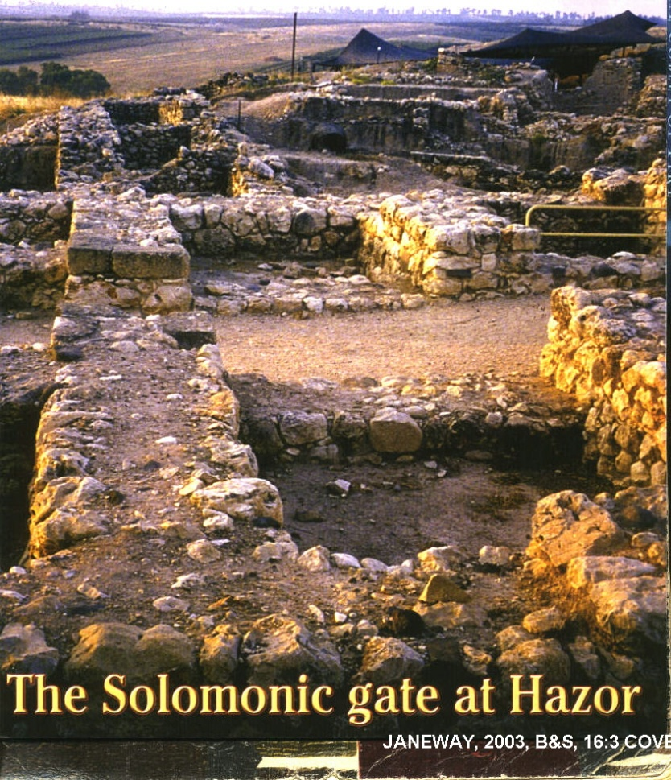

PHOTO LINK: MEGIDDO 006 Location map of Megiddo with Via Maris (See ABOVE, ctrl+click to follow link)

PHOTO LINK: MEGIDDO 038 Gate Complex
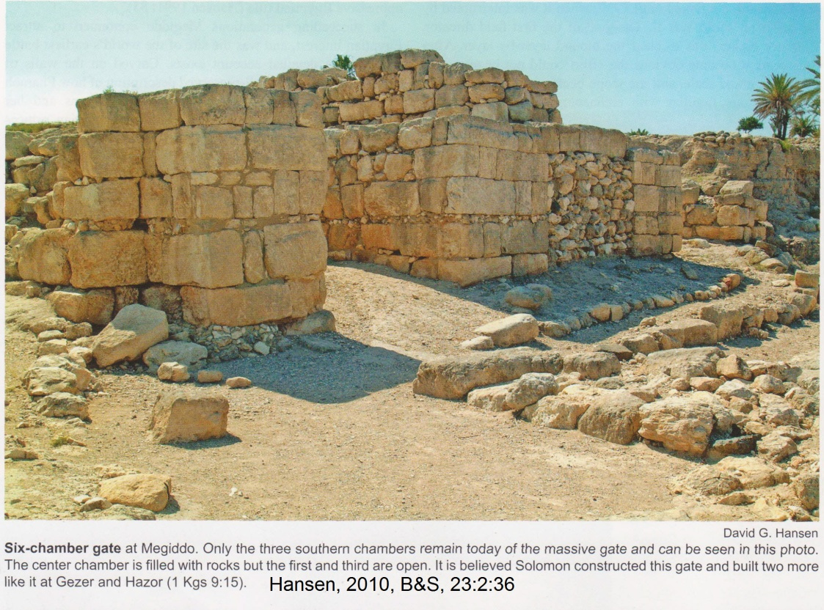

PHOTO LINK: GEZER 013 Location map of Gezer (See ABOVE, ctrl+click to follow link)

PHOTO LINK: GEZER 005 Solomonic Gate at Gezer
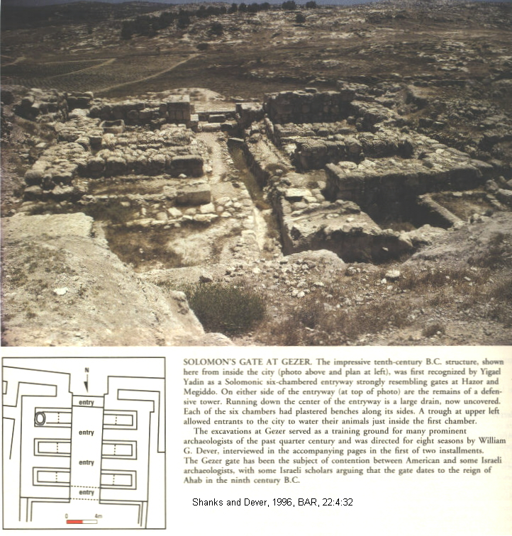

Beer-Sheba of Solomon

The city of Beer-Sheba was a well-planned city from its inception in Solomon's time (10th cent BC) but these buildings followed the overall plan of older city. Beer-Sheba had circular streets. The streets started at city gate, and went all around the town. The city of Solomon’s time had casemate rooms and typical "four-room houses." The city gate was similar to the one at Megiddo (Livingston, 1974).

PHOTO LINK: ESN091 Aerial photo of Beer-Sheba
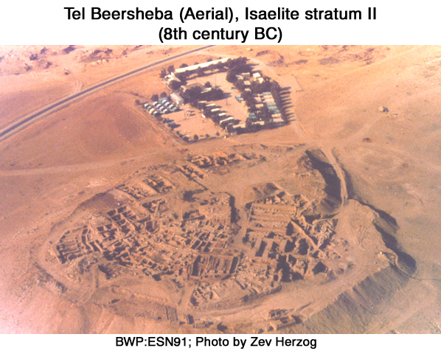

PHOTO LINK: ESN093 The Gate and Storehouses; Beersheba
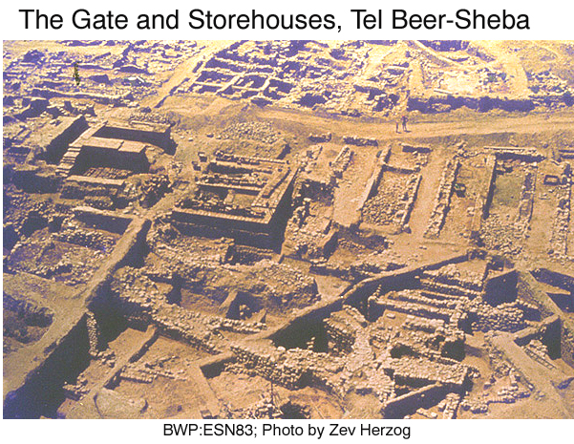

PHOTO LINK: BA073 Iron II Glacis, Beersheba, 9th century BC (See ABOVE, ctrl+click to follow link)

There are three large adjoining buildings which were storehouses for cereals, wine and oil. They could have been stables converted to storehouses. There are two successive sets of pillared buildings, one from the 10th (Solomon) and one from the 9th (Omri-Ahab) centuries BC (Livingston, 1974).

Beth Shemesh of Solomon

Beth Shemesh was part of Solomon's second administrative district (1 Kings 4:1. 9 and Joshua 21).

PHOTO LINK: BETH SHEMESH 001 Panorama; Bunimovitz and Lederman, 1997, BAR, 23:1:CD; Photo by S. Bunimovitz

PHOTO LINK: BETH SHEMESH 003 Location map and geographic zones; Bunimovitz and Lederman, 1997, BAR, 23:1:CD
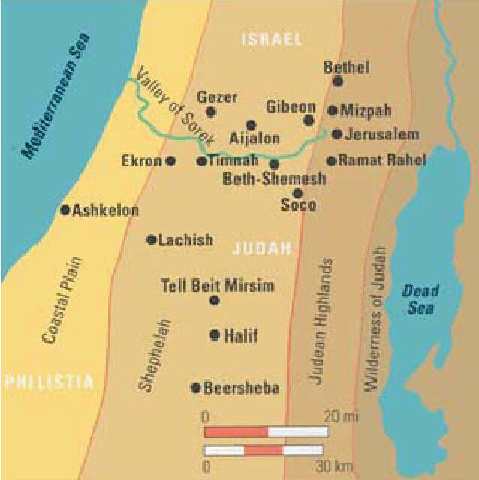

PHOTO LINK: BETH SHEMESH 002 Ain Shems Excavations 1928-1931; Bunimovitz and Lederman, 1997, BAR, 23:1:CD

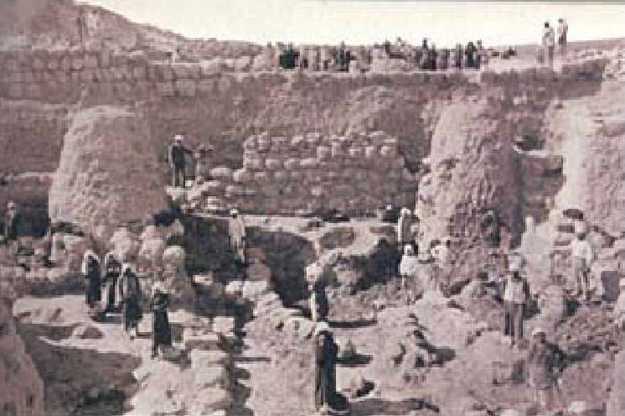

PHOTO LINK: BETH SHEMESH 004 Plan of Beth Shemesh; Bunimovitz and Lederman, 1997, BAR, 23:1:CD
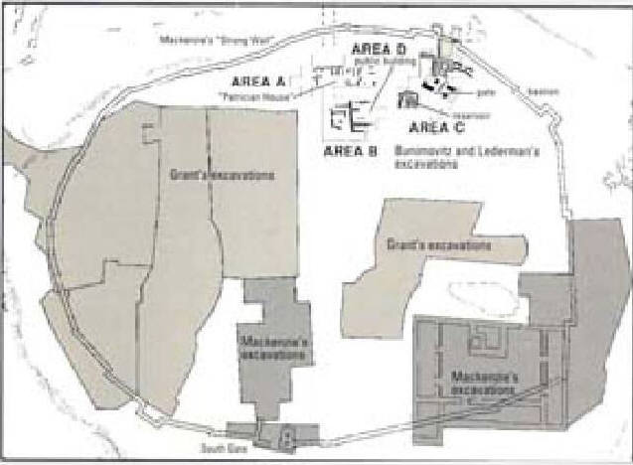

The city has an Iron Age I stepped wall that was part of a bastion for a fortress built by Solomon as late as 1000 BC. This wall protected the city until it's destruction by Assyrian king Sennecherib in 701 BC (Bunimovitz and Lederman, 1997)

PHOTO LINK: BETH SHEMESH 005 'Strong Wall" at Beth Shemesh, bastion for Solomon's fortress and tunnel of MacKenzie; Bunimovitz and Lederman, 1997, BAR, 23:1:CD
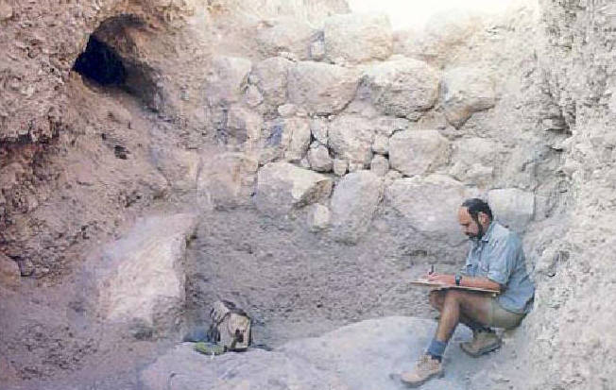

PHOTO LINK: ASSYRIA 042-C Relief of Sennacherib

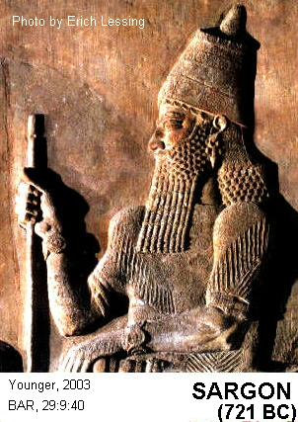
PHOTO LINK: SENNACHERIB 002 Colored drawing of relief at Khorsabad; http://www.bible-history.com/sketches/ancient/sennacherib-khorsabad.html ; June 27, 2006.
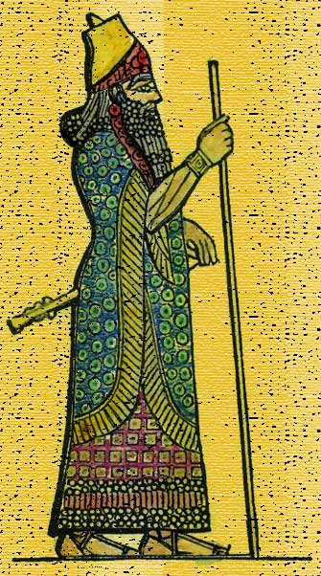

In area B, an olive oil manufacturing building was excavated which had an olive oil press, large crushing basin and three-hole storage jar sunk into the floor. Outside this building was a pressing vat and heavy stone weight (Bunimovitz and Lederman, 1997).

The Iron Age II city was more symmetrically arranged than the older 12th century Canaanite city, with planned, inward-facing homes. A spacious residence may have been an administrative (governor's) center and a tripartite pillared storehouse building was also constructed (Bunimovitz and Lederman, 1997).

A double-sided board game was found at Beth Shemesh with the owner's name engraved on it: Hanan (Bunimovitz and Lederman, 1997).

PHOTO LINK: BETH SHEMESH 007 Hanan family board game, paleo-Hebrew script, 10th century BC; Bunimovitz and Lederman, 1997, BAR, 23:1:CD
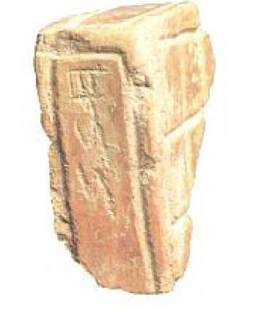

This name also appears on a 12th- century proto-Canaanite ostracon found at Beth Shemesh. At the neighboring town of Tel Batash/Timnah, an incised bowl fragment reads "[Be]n Hanan" (Son of Hanan), (Bunimovitz and Lederman, 1997).

The list of Solomon's administrative districts puts Elon Beth-Hanan immediately after Beth Shemesh. These artifacts, and the Biblical reference, indicate the the Hanan family was influential in the Sorek valley over a period of two centuries (Bunimovitz and Lederman, 1997),

An elaborate cruciform cistern system was built at Beth Shemesh during the United Monarchy.

PHOTO LINK: BETH SHEMESH 008 Diagram of cistern system, 7th century BC; Bunimovitz and Lederman, 1997, BAR, 23:1:CD, drawing by Leen Ritmeyer

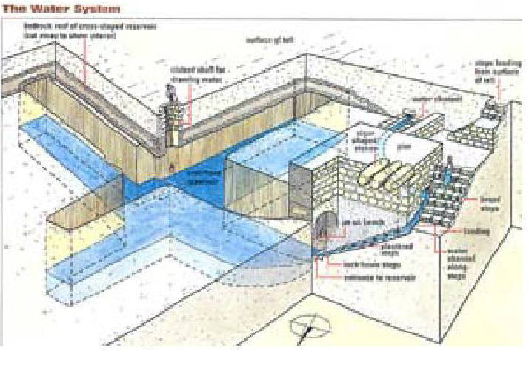
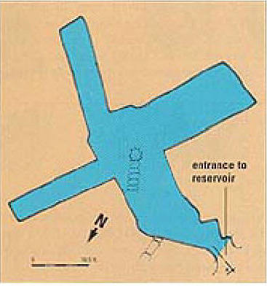
PHOTO LINK: BETH SHEMESH 009 Plan of cistern system, 7th century BC; Bunimovitz and Lederman, 1997, BAR, 23:1:CD, drawing by Judith Dekal

PHOTO LINK: BETH SHEMESH 010 Interior of cistern system; Bunimovitz and Lederman, 1997, BAR, 23:1:CD,
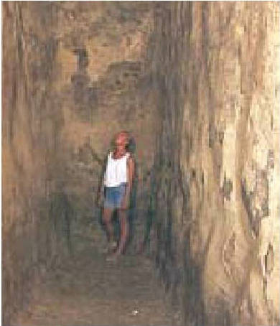

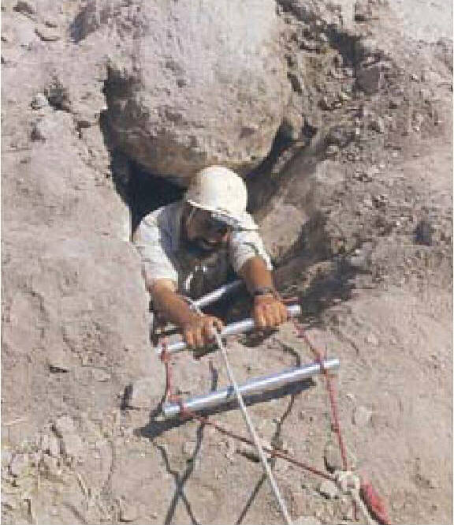
PHOTO LINK: BETH SHEMESH 011 Buried shaft entrance to cistern system, closed by Philistines c. 670 BC; Bunimovitz and Lederman, 1997, BAR, 23:1:CD, photo S. Bunivitz. (RIGHT)

PHOTO LINK: BETH SHEMESH 012 Entrance to cistern system; 7th century BC;
Bunimovitz and Lederman, 1997, BAR, 23:1:CD photo by E. Kessel

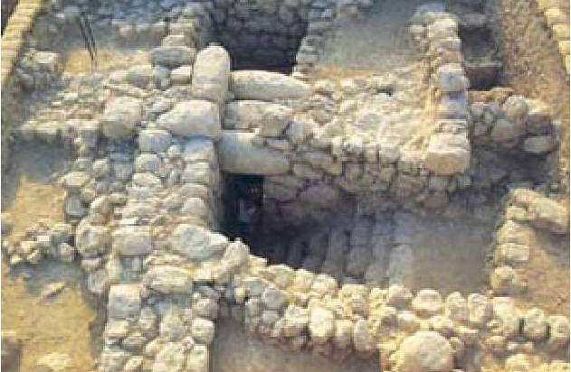

Cabul of Solomon

As a reward for supplying craftsman for the Temple, 20 towns in Galilee were given to Hiram, king of Tyre by Solomon. This was territory formerly under Phoenician administration and was conquered by the Israelites under King David about 930 BC

PHOTO LINK: CABUL 001 Location map

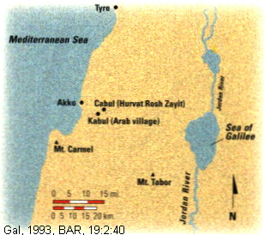

But King Hiram didn't like them (1 Kings 9:10-14). Ancient Cabul of Joshua 13-21 and 19:27 was identified as a site named Hurvat (or Horvat) Rosh Zayitone one mile north of the modern Arab village Kabul (Gal, 1993; Wilson, 1995).

The Hurvat site has 9th and 10th century BC potsherds which places site in the right stratochronographic context to be Solomon's Cabul. This site was a a fortress built by King Hiram to serve as the administrative center when he assumed control of the Acco (later Acre) Plain in the mid-10th century BC. It's ground plan is not like Israelite buildings and may reflect a Syro-Phoenician origin with characteristic Phoenician header and stetcher masonry construction. Cabul has a mid-10th century BC fortress that was destroyed shortly after it was built by an unidentified foe (Gal, 1993). The rest of the history of CABUL is told in Chapter 19.

PHOTO LINK: CABUL 002 Syro-Phoenician fortress destroyed 10th and 9th centuries BC
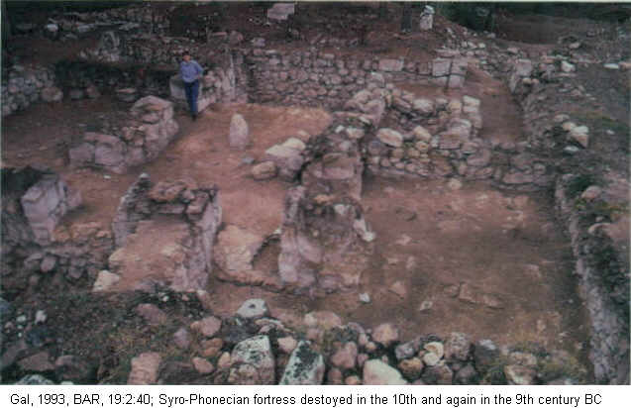

Gezer of Solomon

Gezer is situated near the International Coastal Highway and guarding the primary route into the Israelite hill country, Gezer was one of the most strategic cities in the Canaanite and Israelite periods. Gezer is a prominent 33-acre site that overlooked the Aijalon Valley and the road leading through it to Jerusalem. The tell was identified as biblical Gezer in 1871 by C. Clermont-Ganneau who two years later found the first of many boundary stones inscribed with the city's name (http://www.bibleplaces.com/gezer.htm ; Jan. 7, 2006).

PHOTO LINK: GEZER 008 View from the south; http://www.bibleplaces.com/gezer.htm ; Jan. 6, 2006

PHOTO LINK: GEZER 013 Location map (See ABOVE, ctrl+click to follow link)

Gezer was a buffer-frontier city, constantly under siege by Philistines or Israelites (2 Sam 5:25, 1 Chron 14:16; 20:4). Solomon gained full control of Gezer when he got it from a Pharaoh of Egypt as dowry for one of his wives (Merling and Younker, 1994

There is a six-chambered 10th century BC gate complex at Gezer. When originally excavated, only half of the gate complex had been uncovered. At that time, Dever called it a "Maccabean Castle". By analogy to the gate complexes at Megiddo and Hazor, excavations expanded to the east and the rest of the gate complex was uncovered (Shanks and Dever, 1996:32; Shanks 1998, Merling and Younker, 1994).

PHOTO LINK: GEZER 005 Gate complex

PHOTO LINK: GEZER 003 Plan of Gezer
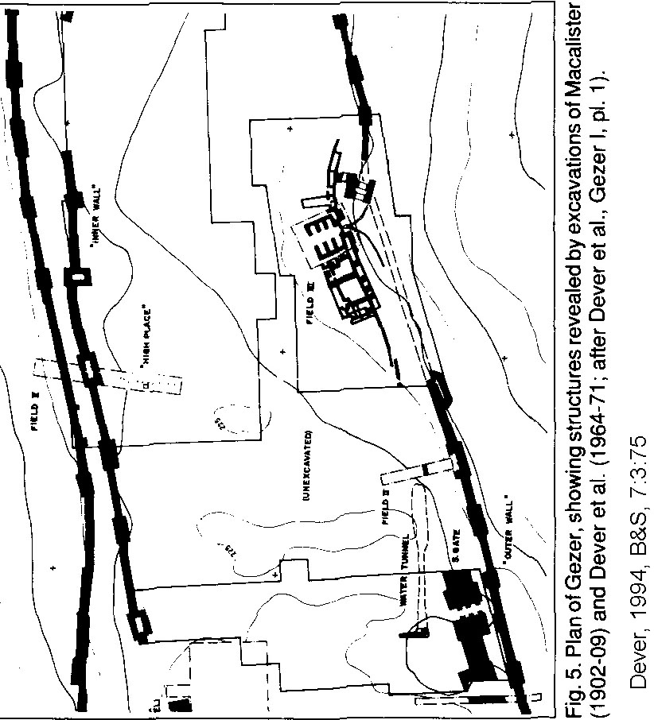

PHOTO LINK: GEZER 006 Dever's half-gate complex
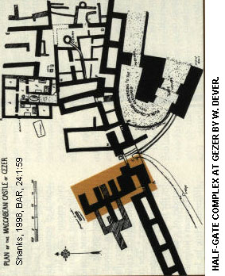

PHOTO LINK: SOLOMON 006 Gate complexes Megiddo Hazor and Gezer 10th cent (or 9th) BC
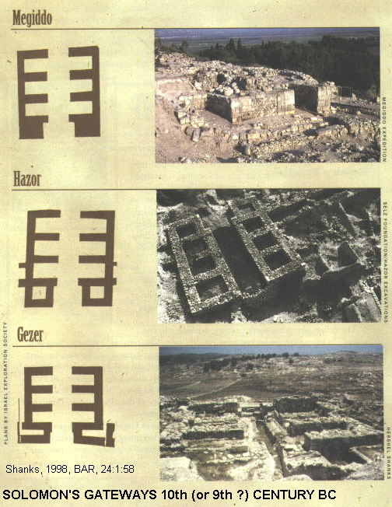

Gezer has red-slipped (unburnished) pottery thought to be diagnostic of Iron Age I and Solomon's building activities. Gezer's outer wall dated to Late Bronze Age.

PHOTO LINK: POTTERY 026 Red-slipped ware, Iron Age II, Tel Rehov (See ABOVE, ctrl+click to follow link)

A destruction level below Solomonic gate correlates with burning of Gezer by the Pharaoh of Egypt in 1 King 9:16. This was same king who later gave Gezer to Solomon as a wedding present (Merling and Younker, 1994).

PHOTO LINK: BA047 Mud brick Wall And Collapse, Gezer
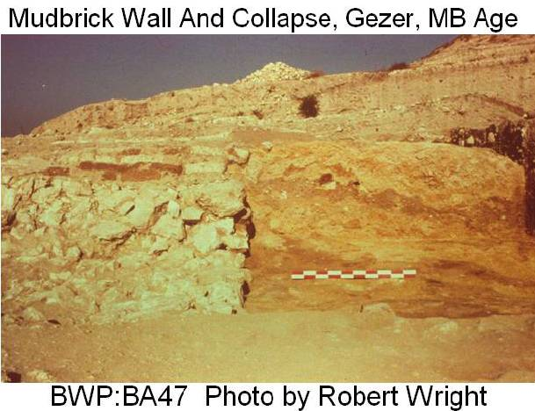

There is younger 8th century BC wall at Gezer. It is associated with the earthquake described in Amos 1:1 (...two years before the earthquake, when Uzziah was king of Judah). The 8th century Gezer wall shows cracking and tilting consistent with an earthquake (Merling and Younker, 1994).

A 10th century date for Gezer is favored by most archaeologists. This would make the gateway at Gezer Solomonic. Other archaeologists date the complex to the time of Ahab (Shanks and Dever, 1996:32; Shanks 1998).
PHOTO LINK: BA071 Early Iron Age Gateway, Gezer, Solomon 10th century BC
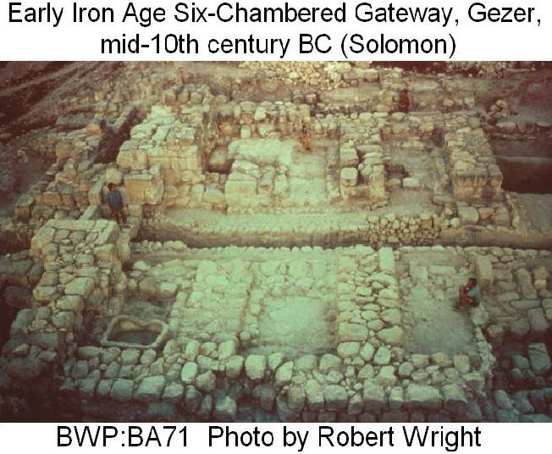

Hazor of Solomon

The city of Hazor is mentioned in 1 King 9:15. Solomon used forced labor to build Hazor, Megiddo and Gezer. The city plans of the gate complexes Megiddo are similar to those at Hazor and Gezer. The Biblical text lead excavators to the gate discoveries at Hazor and Gezer based on prior experience at Megiddo.

PHOTO LINK: HAZOR 003 Location map of Hazor. (See ABOVE, ctrl+click to follow link)

PHOTO LINK: HAZOR 019 Aerial photo
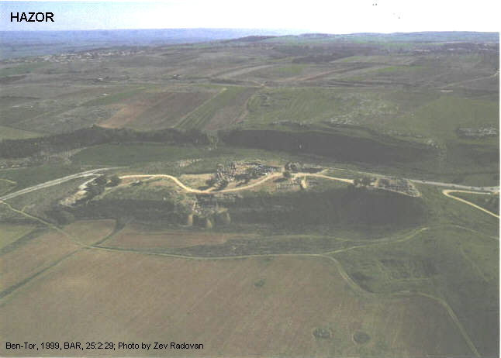

PHOTO LINK: HAZOR 002 Artist's rendition of Canaanite Hazor gateway
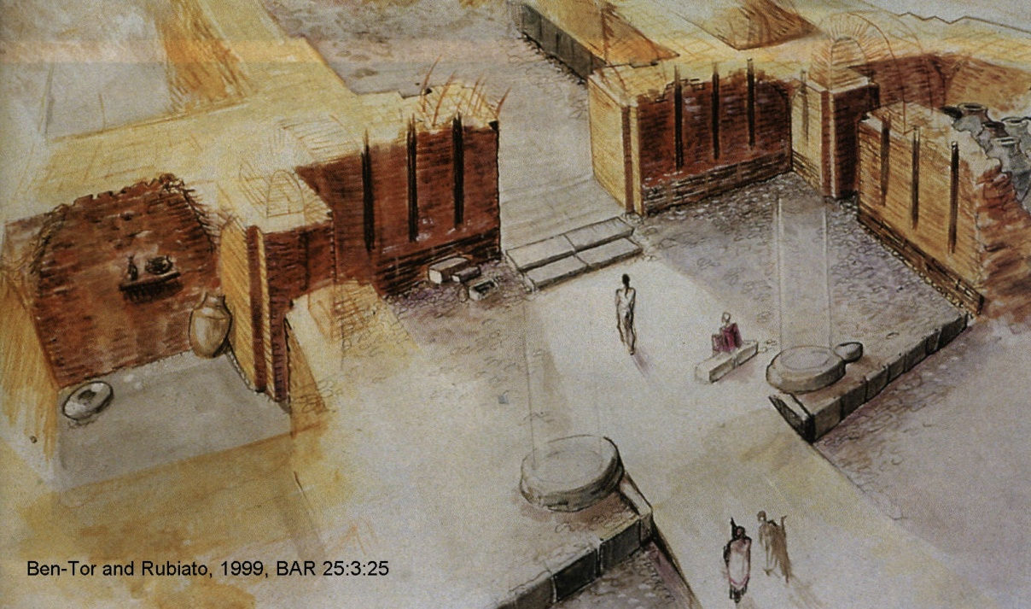

PHOTO LINK: HAZOR 001 Plan of Hazor, LB, 10th and 8th-9th centuries BC
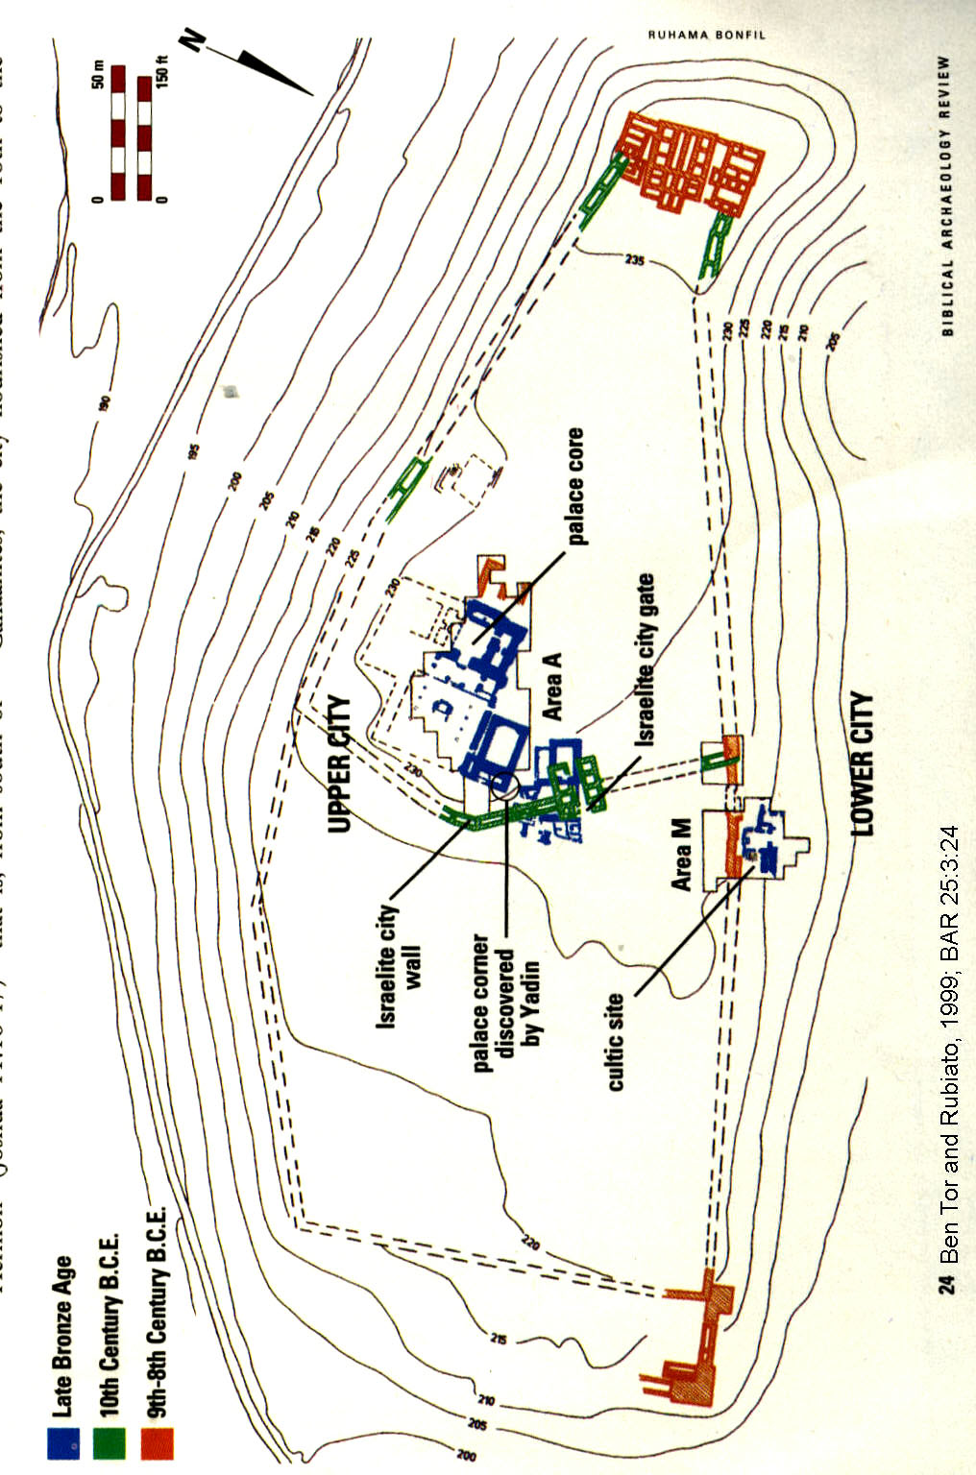

PHOTO LINK: HAZOR 004 Hazor Palace core (40'x40')
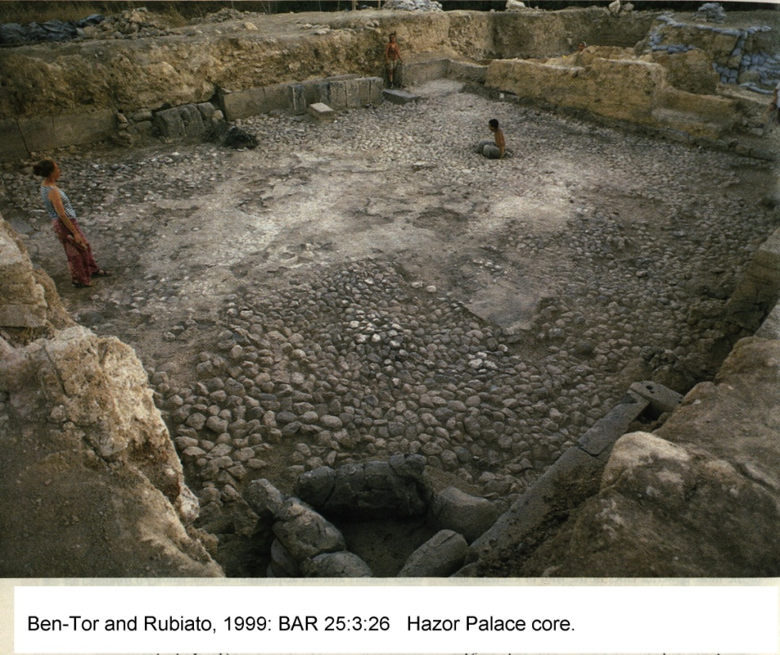

PHOTO LINK: HAZOR 007 Plans of Hazor and Alalakh palaces

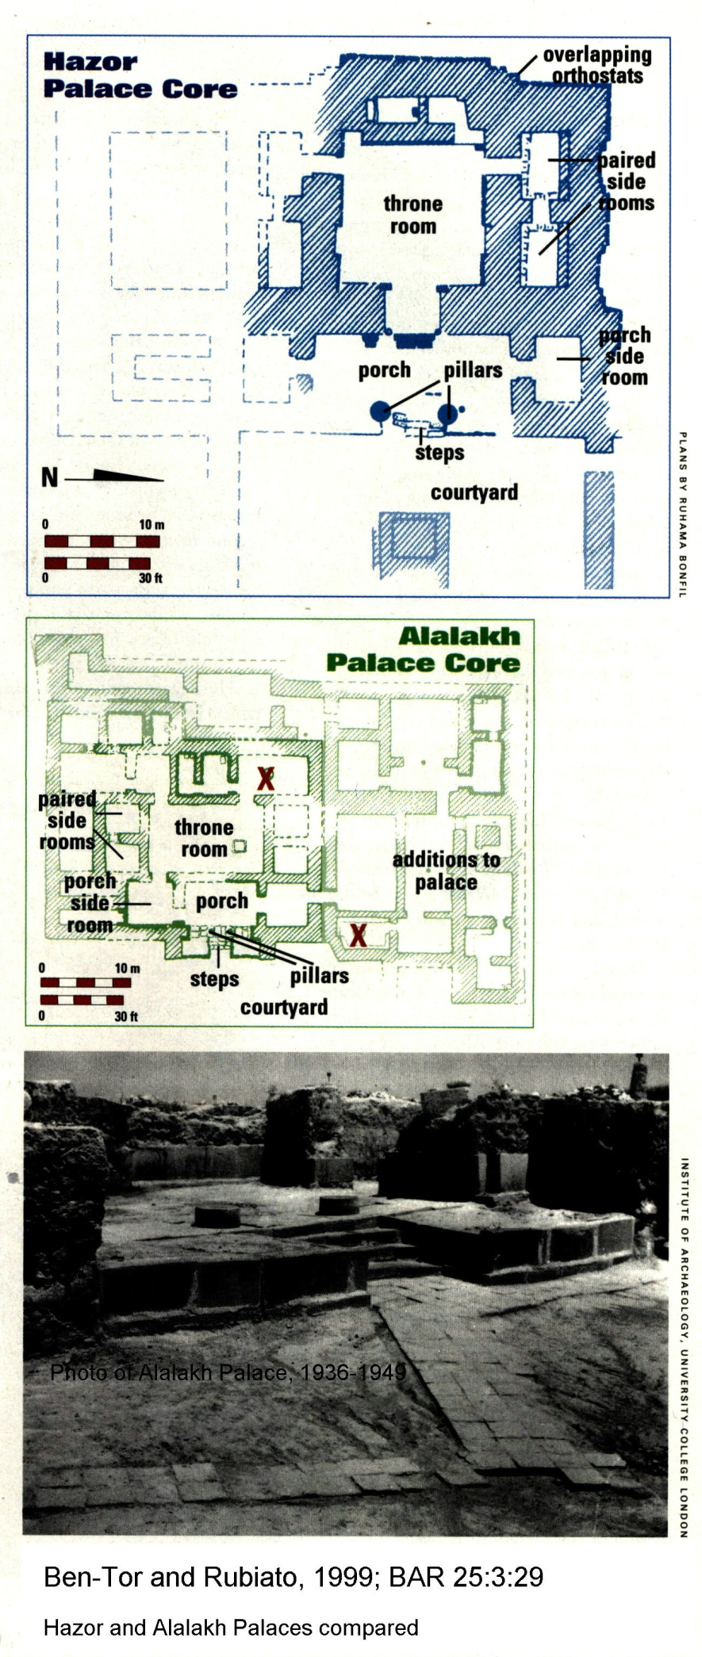
PHOTO LINK HAZOR 006 Broken Jars
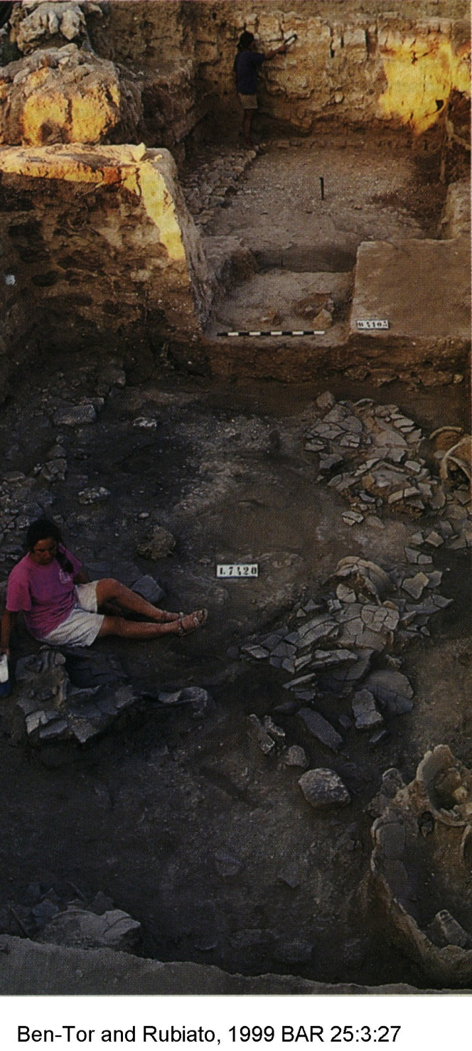

The city of Hazor had been destroyed in the 13th century (see Chapter 13). It was rebuilt in the 10th century, during the reign of David, Solomon or Jeroboam I (of Israel), with a large six-chambered gate, tower complex, and surrounding cassmate walls. This city had a population of between 800 and 1000 people (Ben-Tor, 1999).

PHOTO LINK: HAZOR 016 Six-chamber 10th-century BC gate complex
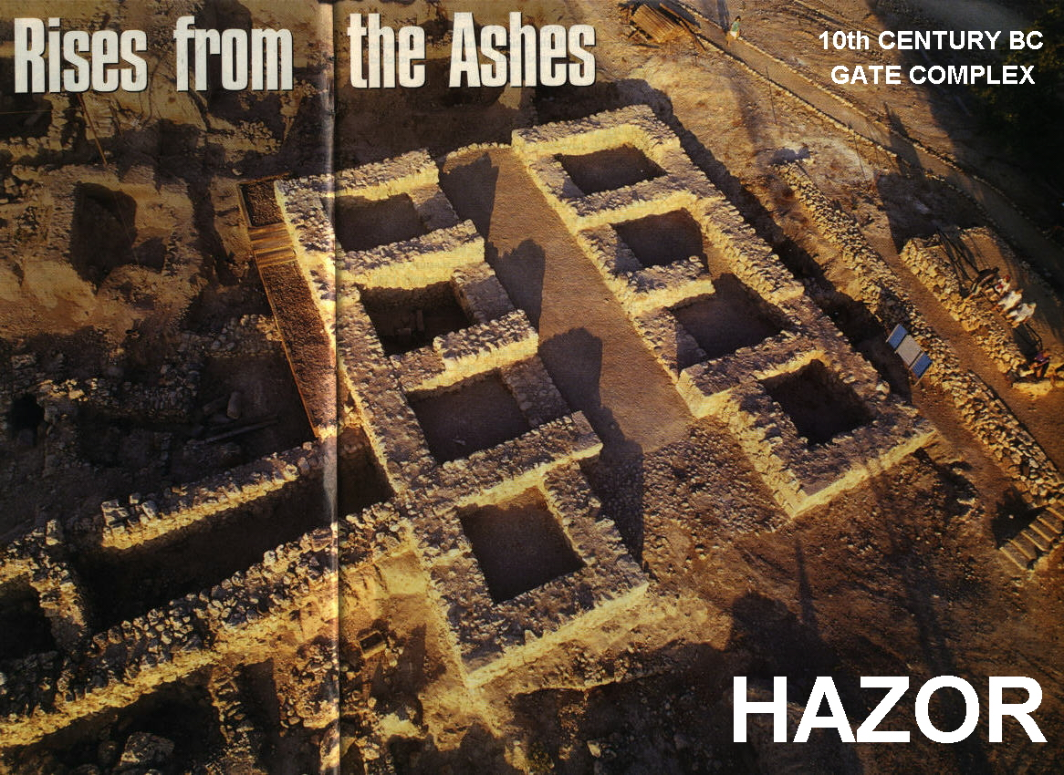
PHOTO LINK: BA055 Iron II Pillared Storehouse, Hazor
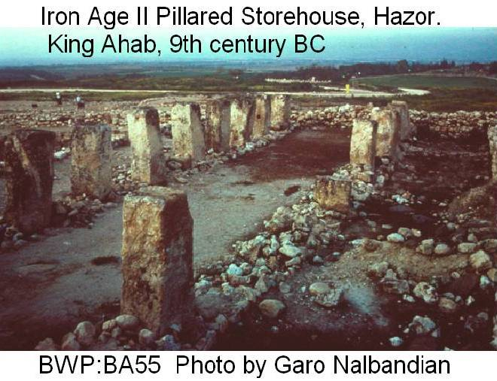
PHOTO LINK: HAZOR 018 Topographic map and plan of 10th and 9th century BC city walls and gates
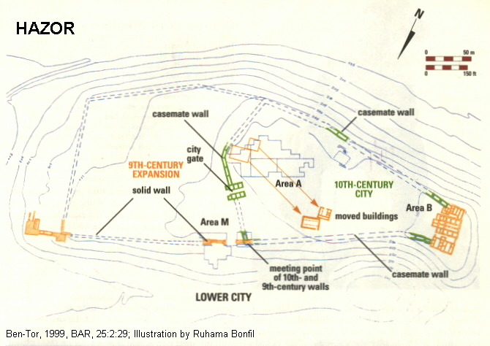

10th Century Tripartite Buildings at Hazor

The 10-th century BC city featured two tripartite buildings, one of which was removed and re-assembled off-site in order to excavate underlying 18th to 13th century BC statums. The reassembled building had four different architectural phases and was in use from the second half of the 10th century to the beginning of the 9th century BC. These dates are confirmed by both pottery and stratigraphy of the site (Ben-Tor, 1999).

PHOTO LINK: HAZOR 021 Reconstructed tripartite building from 10th century BC
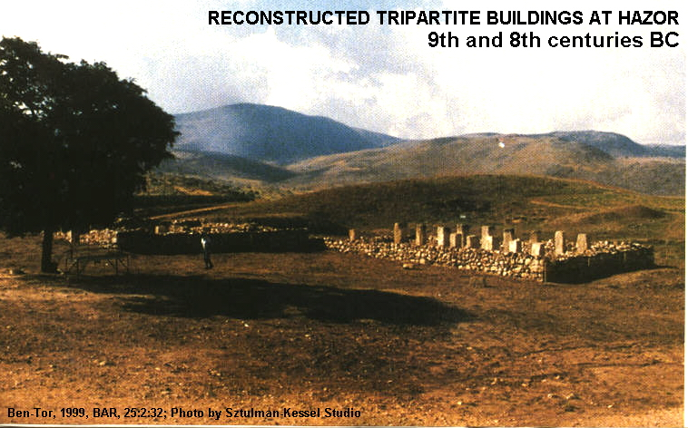

PHOTO LINK: HAZOR 024 Pottery from 10th to early 9th century BC
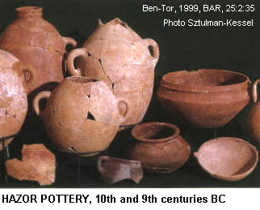

PHOTO LINK: AMMONITE 003 Map of Ammonite sites (Heshbon=Hesban)
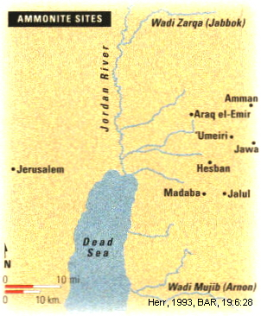

During the 9th century, the city was expanded to twice it's earlier size (see Chapter 17).

Heshbon of Solomon and the Ammonites (c. 970-930 BC)

A twenty-foot deep plastered reservoir at Tell Hesban may be the "pools of Heshbon" of Song of Songs (of Solomon) 7:4. The pool was built in the 9th or 8th centuries BC and has pottery fragments from the 5th and 4th centuries BC. These show a continuous Ammonite presence throughout the Assyrian and Babylonian empires (Herr, 1993).

PHOTO LINK: HESHBON 001 Tell Hesban = biblical Heshbon of Num. 21:21-32
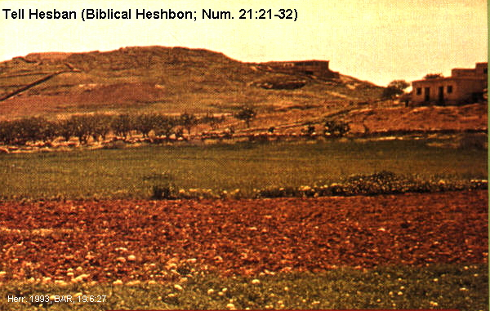
PHOTO LINK: SCRIPTS 037 Osctacons form Heshbon
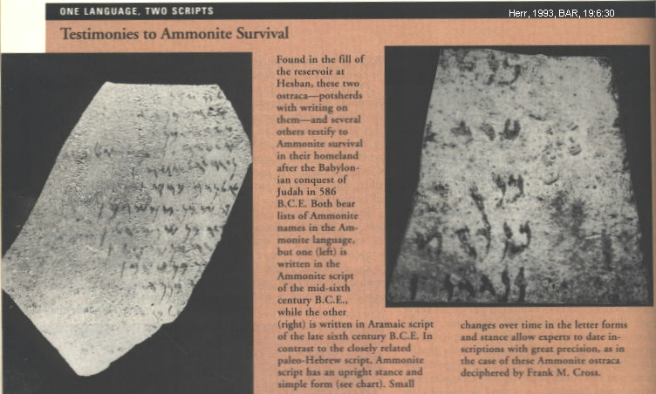

PHOTO LINK: HESHBON 002 Pools of Heshbon
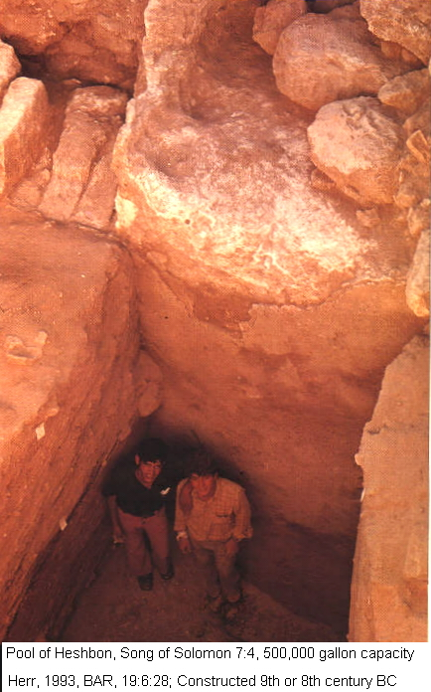

Lachish of the United Monarchy (c. 1043-931 BC)

During the Conquest period, Lachish was destroyed in 1130 (LB) by Philistine Sea Peoples. That destruction level is called Level VI.

PHOTO LINK: LACHISH 001 Location Map
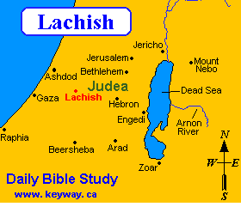
PHOTO LINK: LACHISH 004 Photo of LB main complex Lachish
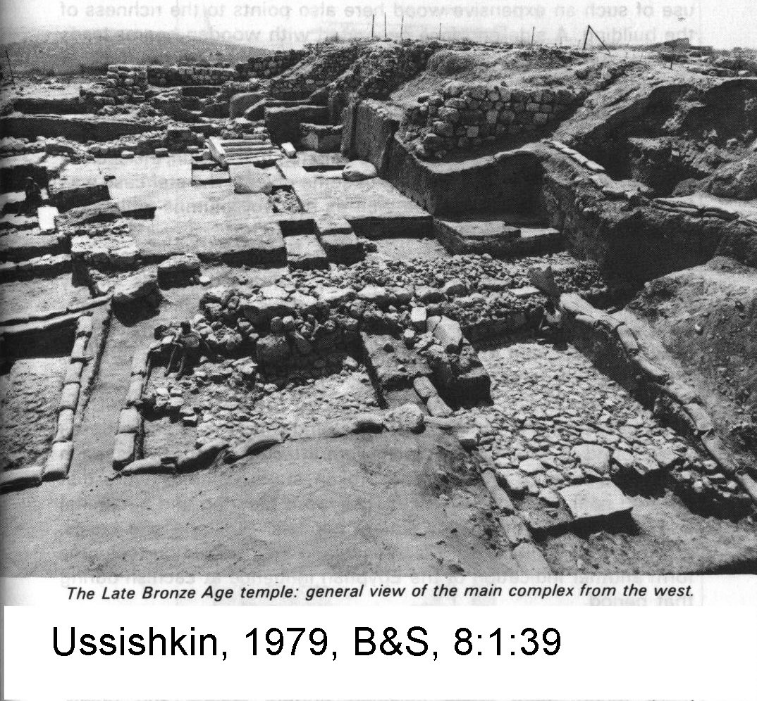
PHOTO LINK: LACHISH 013 Aerial photo
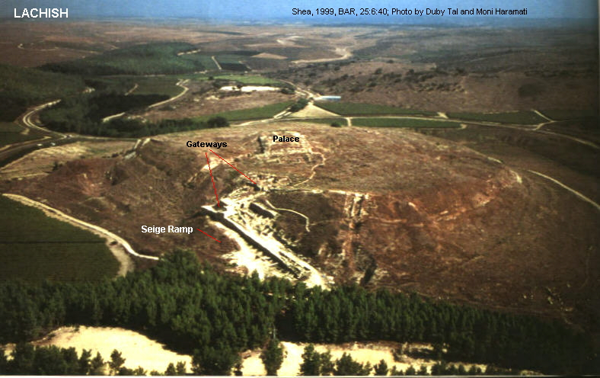
PHOTO LINK: MEGIDDO 009 Location Map
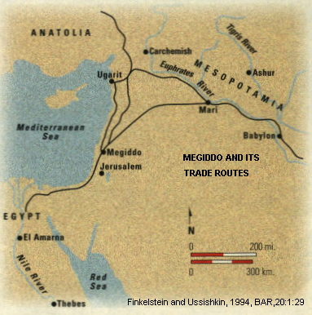

PHOTO LINK: LACHISH 003 Plan map of LB Temple at Lachish
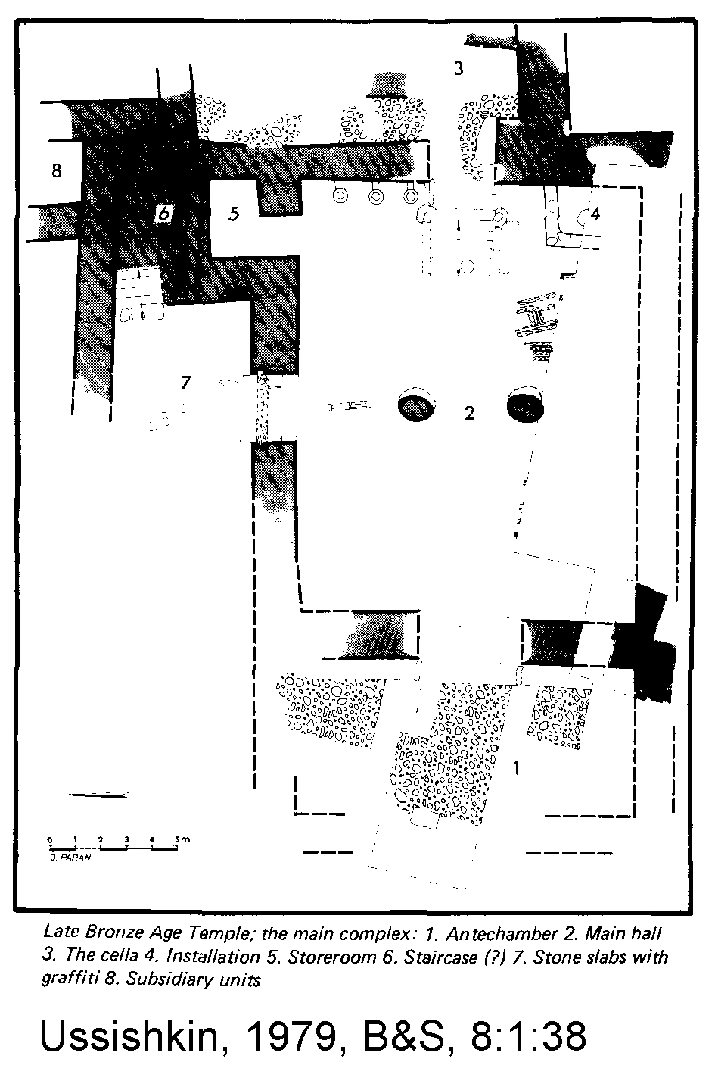

During the United Monarchy, Lachish was settled by Israelites in Level V. Scant information is available for this level, except that the town was unfortified. This Iron Age town may have been destroyed by Pharaoh Sheshonq (Biblical Shishak) about 935 BC in the early period of the Divided Kingdoms (King, 2005:40-41).

PHOTO LINK: LACHISH 022 Stratigraphic summary chart 13th to 4th centuries BC
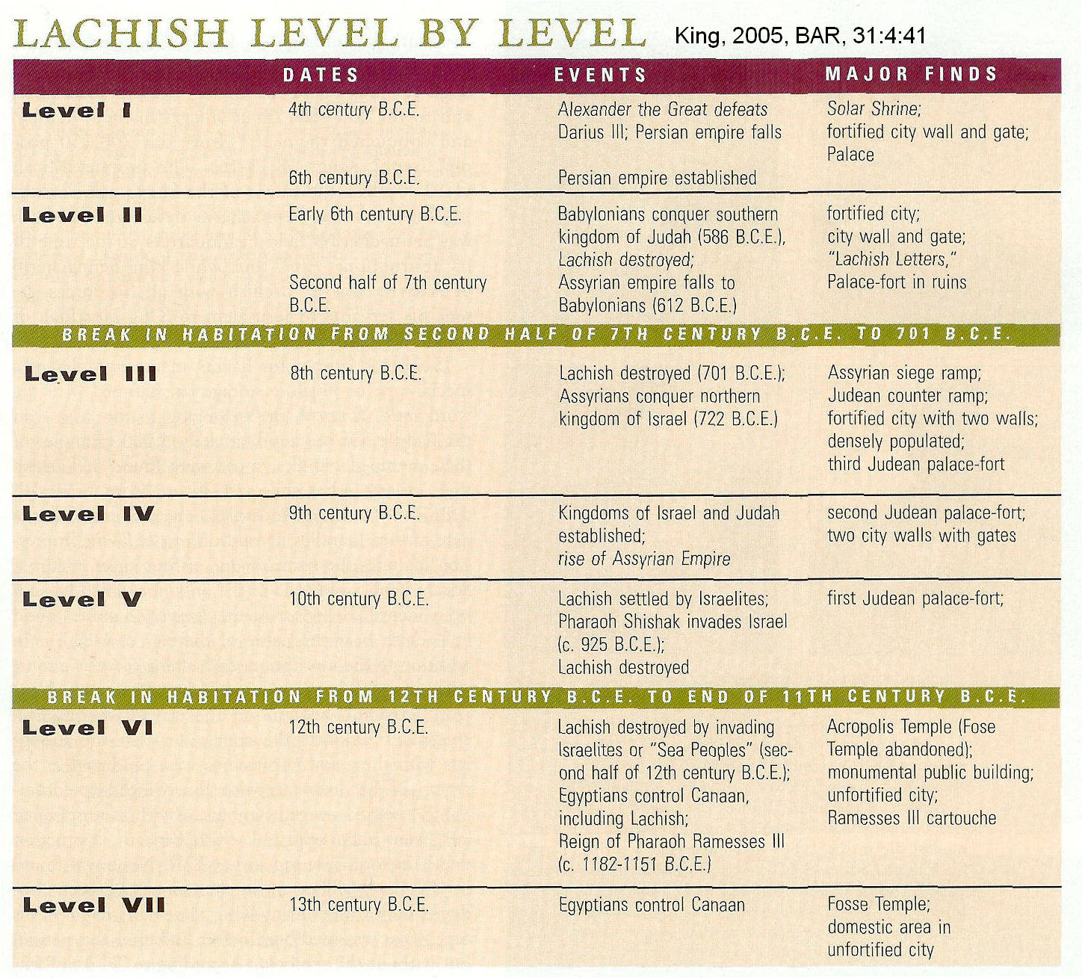

Megiddo of Solomon (c. 971-931 BC)

Meggido (Stratum VA-IVB) is one of the most important archaeological sites in Israel built by Solomon. It has fortifications and monumental gate complexes. There is a six-chambered gate and a two-chambered gate. The age of the six-chambered gate complex is either from the time of Solomon or from the reign of Ahab-Omri. The two-chamber gate, down hill from the six-chambered gate, is from Solomon's time (Finkelstein and Usshishkin, 1994:37).

PHOTO LINK: MEGIDDO 006 Location Map (See ABOVE, p.196; ctrl+click to follow link)

PHOTO LINK: MEGIDDO 005 Aerial Photo
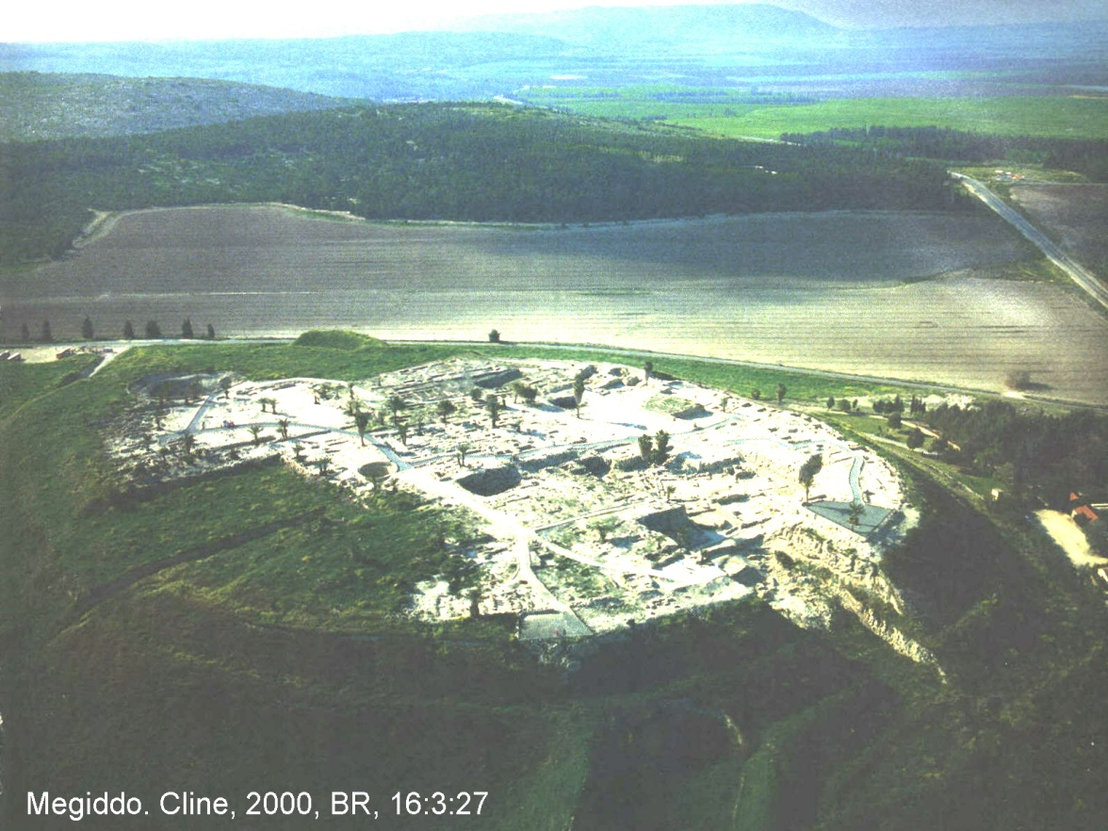

PHOTO LINK: MEGIDDO 007 Aerial Photo
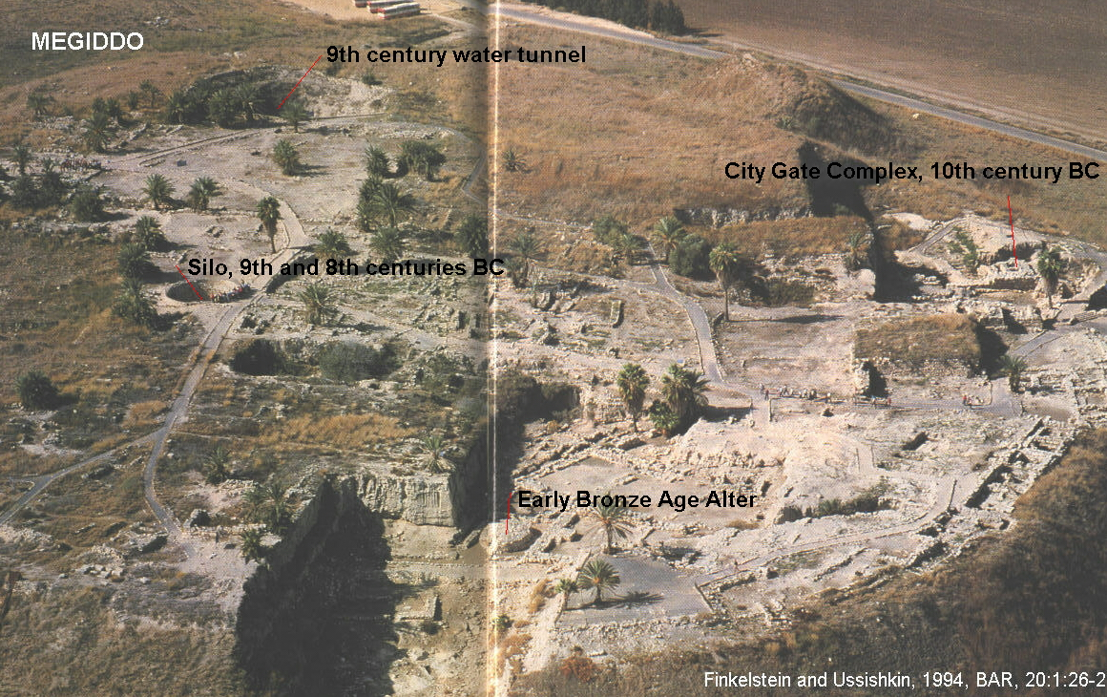

PHOTO LINK: MEGIDDO 017 Gate Complex.

PHOTO LINK: MEGIDDO 018 Gate Complex Modle
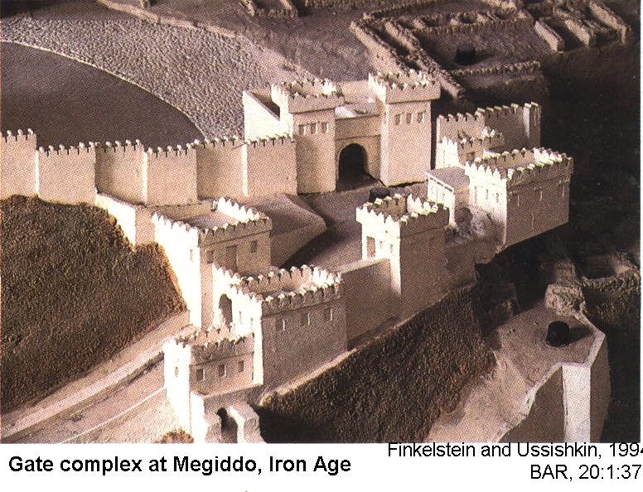

Solomonic Megiddo had several large buildings, including two (or three) palaces. One palace floorplan covers 650 square yards and the other covers 590 square yards (Wood, 1975; Wilson, 1972; Crutchfield, 1990). The proto-ionic capitals at Megiddo where like those at Jerusalem.

PHOTO LINK: MEGIDDO 016 Proto-Ionic capital from time of Solomon
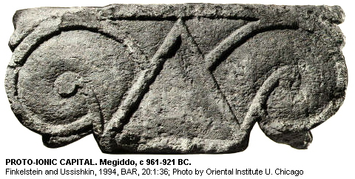

PHOTO LINK: JERUSALEM 020 Proto-Ionic capital from Solomon’s destroyed temple
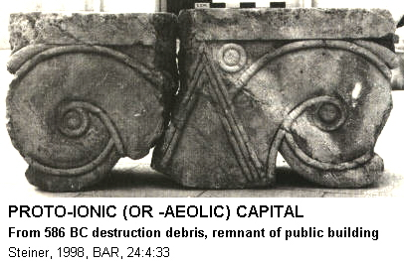

PHOTO LINK: MEGIDDO 019B Plan of Solomonic Megiddo
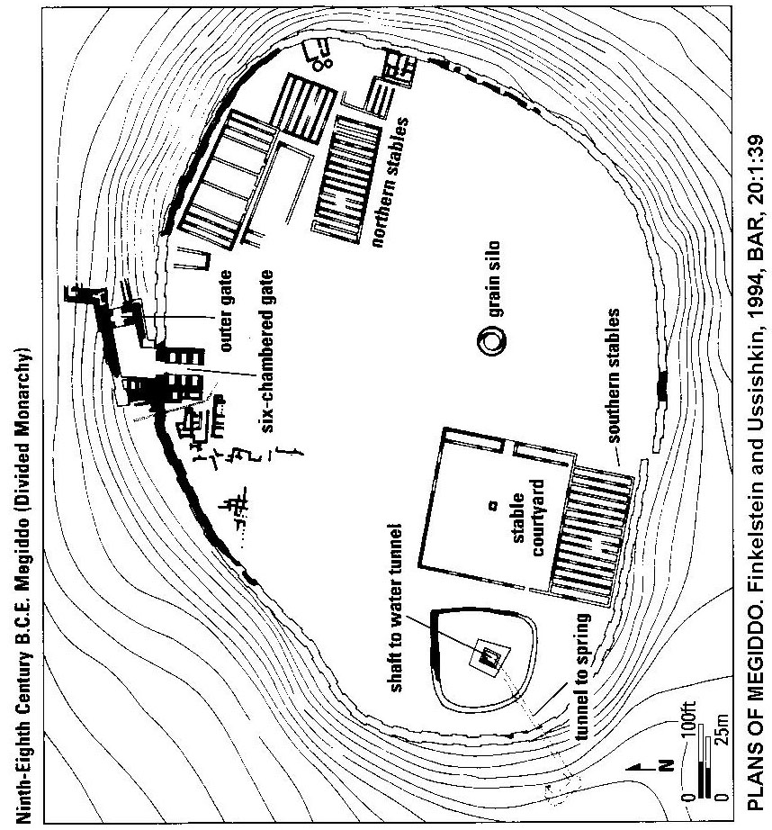

Solomon's Megiddo had a gallery that passed through the city wall by a postern gate to a spring to the southwest, outside the city (Finkelstein and Ussishkin, 1994:43).

PHOTO LINK: BA057 Iron II Water Tunnel, Megiddo, 9th century BC
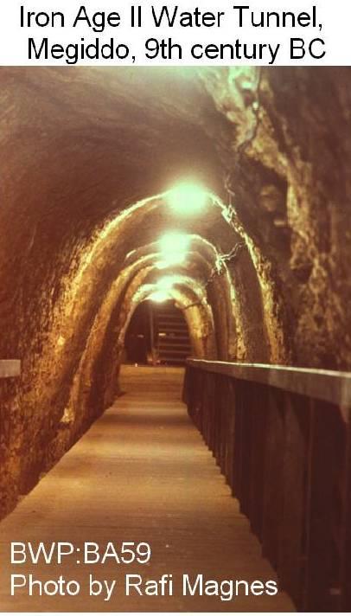

PHOTO LINK: MEGIDDO 025 Photo of walls to Solomon's stables 10th century BC and c. 1200 BC occupation
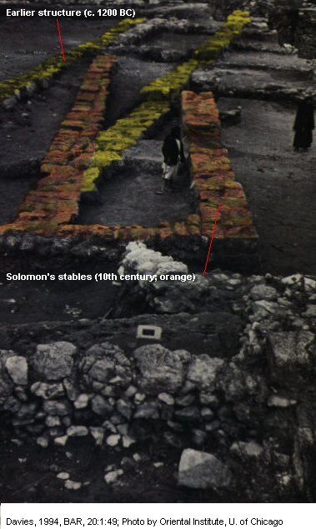

SOLOMON'S STABLES AND TRIPARTITE BUILDINGS

Tripartite pillared buildings appear in the archaeological record of Israel from late 11th to 7th cent BC (Judges to Divided Monarchy).

PHOTO LINK: TRIPARTITE 001 Tel Hadar, Iron Age I Tripartite building
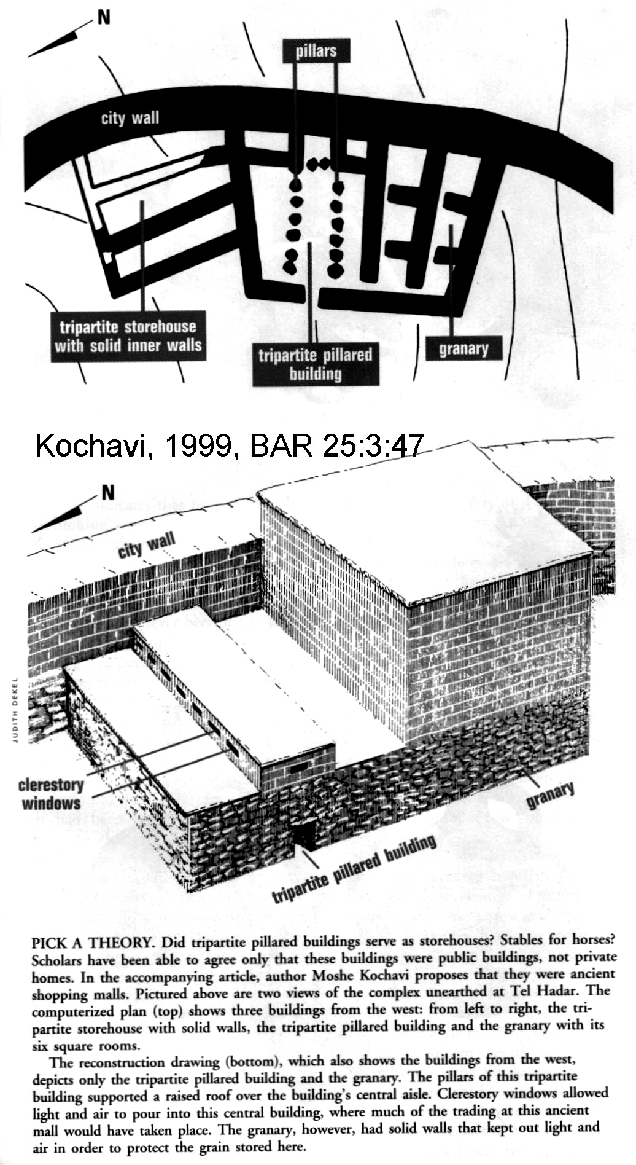

PHOTO LINK: TRIPARTITE 009 Map of cities with tripartite buildings
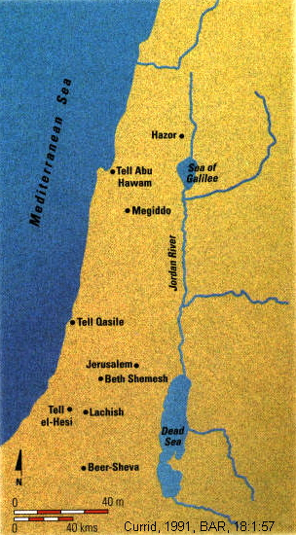

PHOTO LINK: ESN099 Restored Pillared Wall; Tel Masos, Early Iron Age
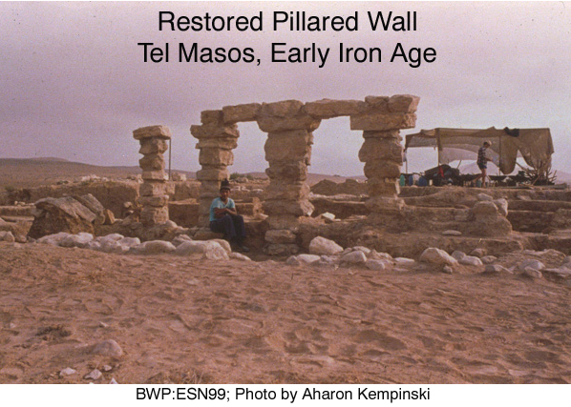

Two good example of a tripartite buildings are found at Hazor
PHOTO LINK:TRIPARTITE 006 Aerial photo of Hazor
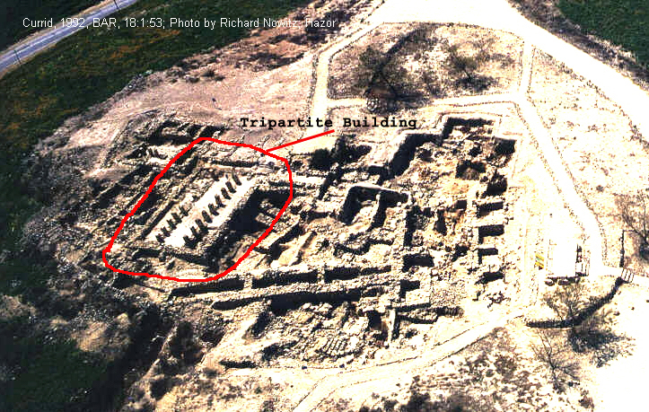

PHOTO LINK:TRIPARTITE 007 Hazor ground view of tripartite building
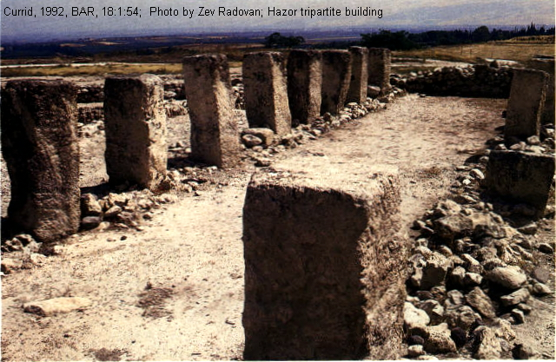

PHOTO LINK: HAZOR 022 Plan of Hazor showing tripartite buildings
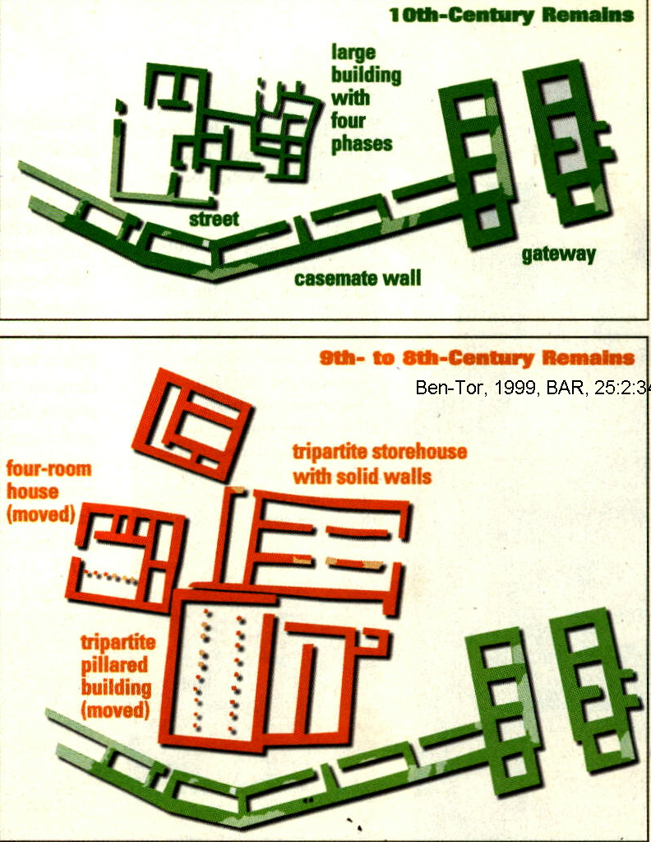

PHOTO LINK: HAZOR 023 Photograph of 18th to 8th century structures including tripartite building
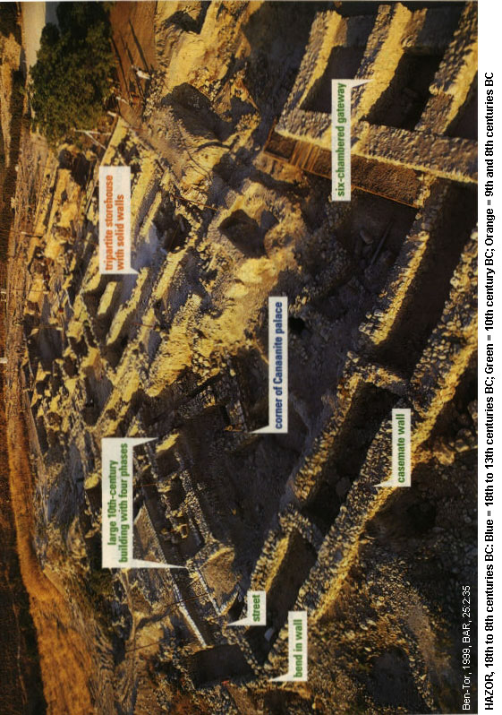
Many tripartite buildings are Israelite, built after the 10th century. Non-Israelite tripartite buildings have been found at Tel Hadar (Geshurite), Tell Abdu Hawam, Haifa bay (Canaanite/Phoenician), Tell Qasile (Philistine) and Tell Masos, Negev (Amalakite).

Tripartite Building at Tel Hadar

The tripartite building at Tel Hadar was associated with an adjacent granary.

PHOTO LINK: TRIPARTITE 015 Tel Hadar 65-by-40 ft multipurpose storage building
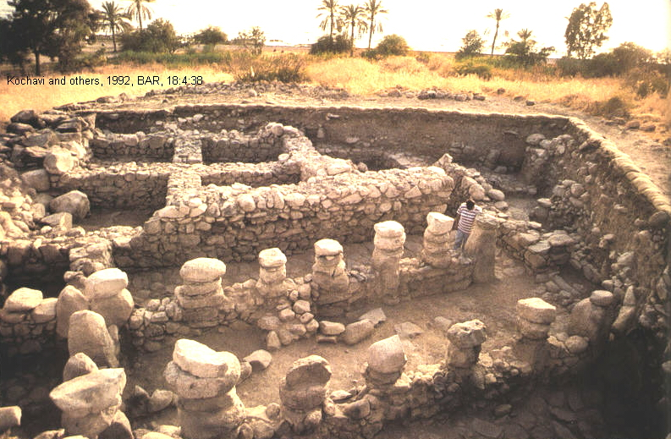

PHOTO LINK: GESHUR 008 Tel Hadar burnt granary 11th century BC
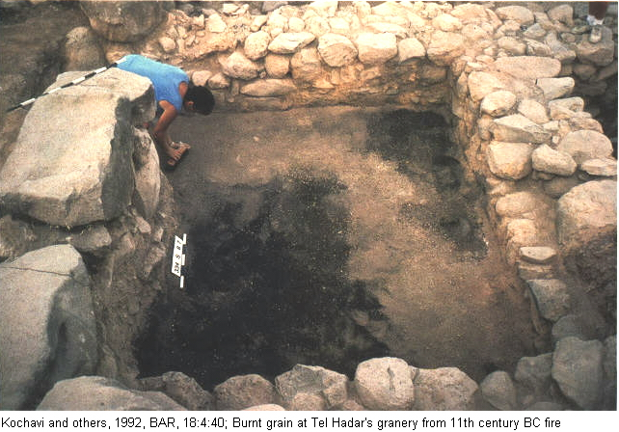

PHOTO LINK: GESHUR 009 Tel Hadar pottery in tripartite building
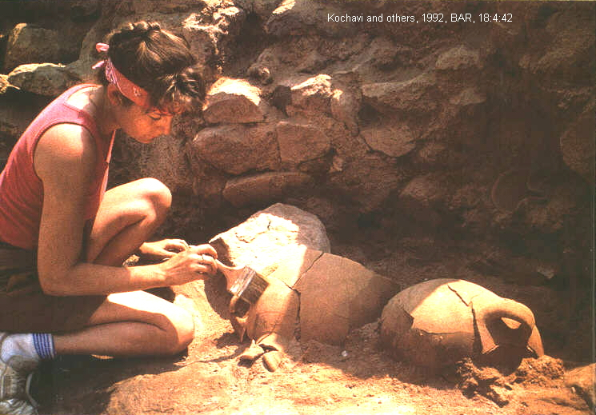
PHOTO LINK: TRIPARTITE 016 Tel Hadar building plan drawings
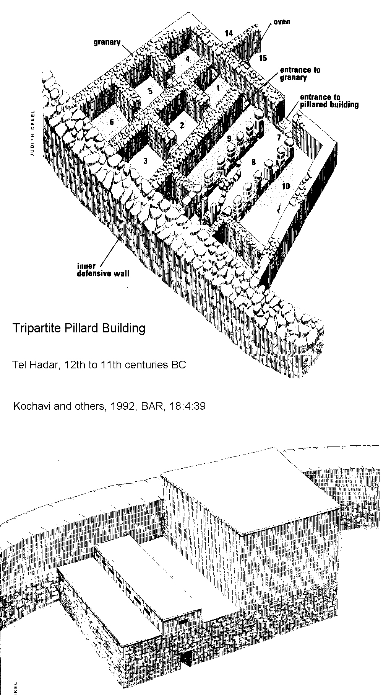

That building was destroyed by fire in the 11th century, possibly during the wars that were fought during the rise of King David after the death of Saul (Kochavi and others, 1992:40).

9th and 10th century Tripartite buildings at Megiddo

Tripartite buildings at Megiddo have been interpreted as "King Solomon's stables" and also as storehouses. The primary tripartite buildings at Megiddo date to the time of Ahab or Omri, not Solomon (Finkelstein and Usshishkin, 1994:40). But Solomonic tripartite building may underlie these later structures (Davies, 1994).

PHOTO LINK: MEGIDDO 024 Plan of Ahab and Solomon's stables
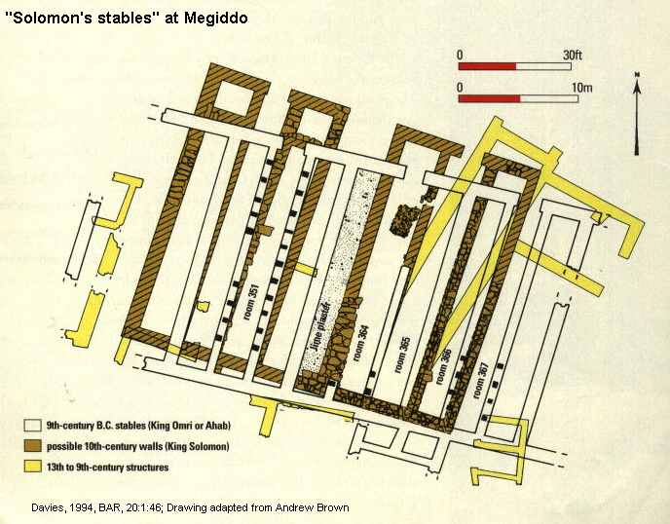

PHOTO LINK: TRIPARTITE 011 Building at Megiddo
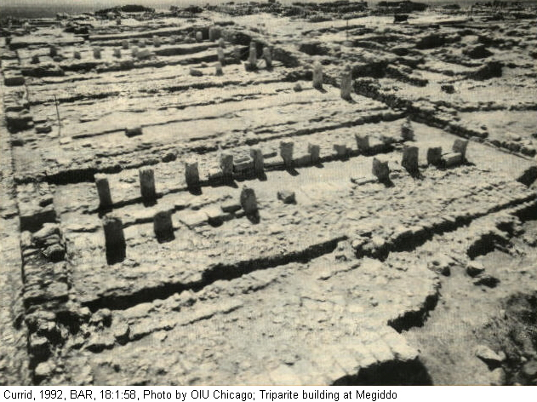

PHOTO LINK: TRIPARTITE 012 Building at Megiddo one of five
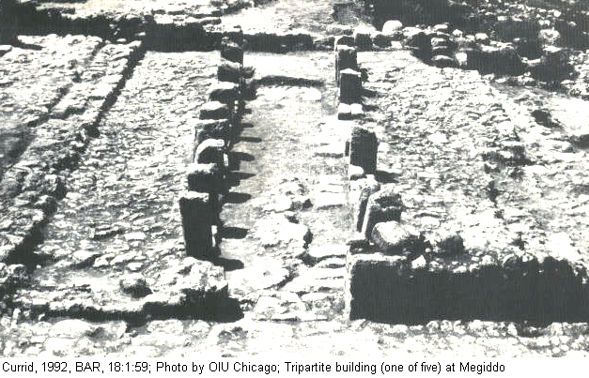

PHOTO LINK: TRIPARTITE 014 Manager and tether poles at Megiddo
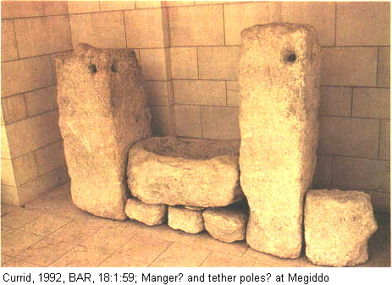

PHOTO LINK: TRIPARTITE 019 Drawing of storehouses at Megiddo
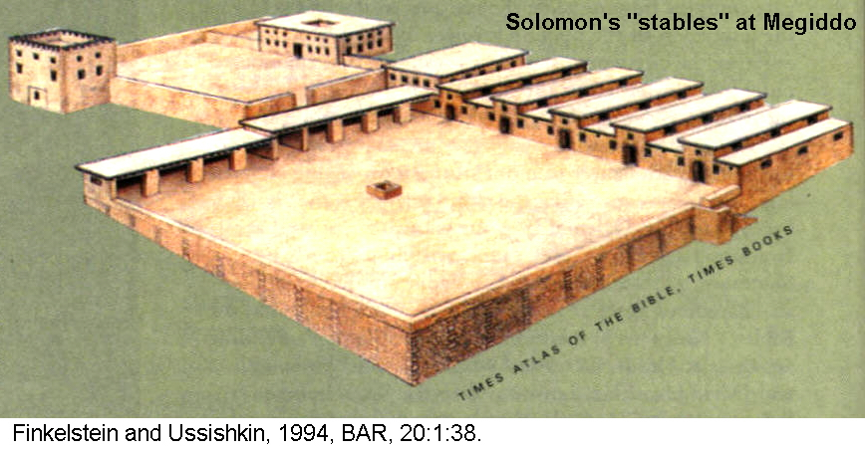

PHOTO LINK: TRIPARTITE 018 Feeding trough and tether holes at Megiddo

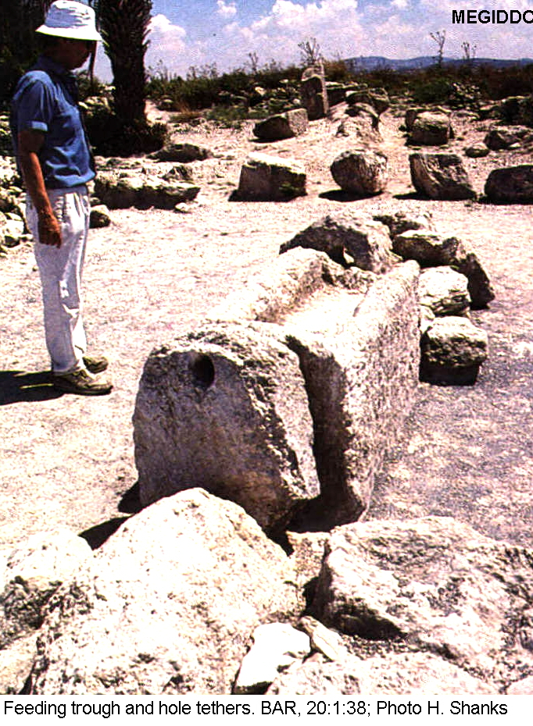
PHOTO LINK: TRIPARTITE 004-B Map showing location of tripartite buildings, trade routes and harbors
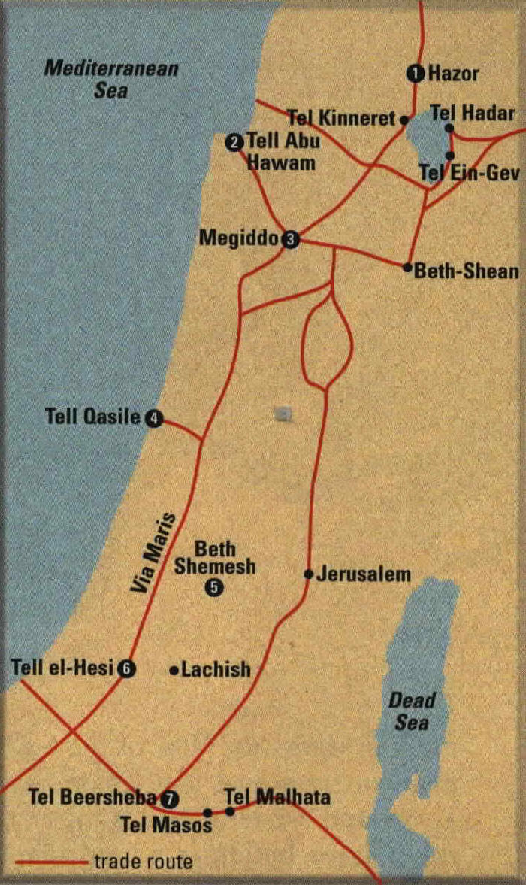

Buildings identified as stables at Megiddo (during the United Monarchy), could have held 450 horses. At Megiddo, there was a complex of five tripartite buildings .

There is continuing debate about these buildings. The tripartite buildings have been interpreted, at various sites, as barracks, storehouses or bazaars (Kochave, 1999) and not stables at all. At Meggido, the "Stables" were originally dated to Solomon's Era (10th cent. BC), but later identified by pottery (etc.) as from time of Omri and Ahab. Further study of Megiddo indicated that older buildings used as stables may exist beneath those 9th century buildings of Ahab/Omri. The stone basins were interpreted as mangers. Some pillars in these buildings have holes in them which are said to have been used to tether horses. In one of the "stalls" at Megiddo, markings on one side of the troughs are believed to be made by the "cribbing" or nipping behavior of horses (Deborah Cantrell, cited by Shanks, 2003).

PHOTO LINK: TRIPARTITE 017 Cribbing behavior marks on troughs at Megiddo
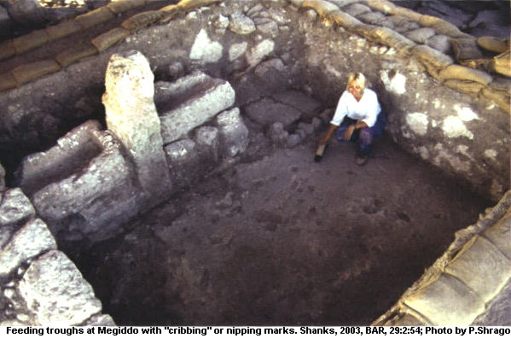

PHOTO LINK: MEGIDDO 019 Plan of 9th century BC Megiddo with Northern and Southern stables (See ABOVE, ctrl+click to follow link)

Common Features of Tripartite Buildings

The architectural design of these buildings is similar. There are solid exterior walls with two rows of colonnades that divide the structure into three semi-equal divisions (Kochavi, 1999:50; Currid, 1992:55).

PHOTO LINK: TRIPARTITE 004 (Plan comparisons at 7 sites)
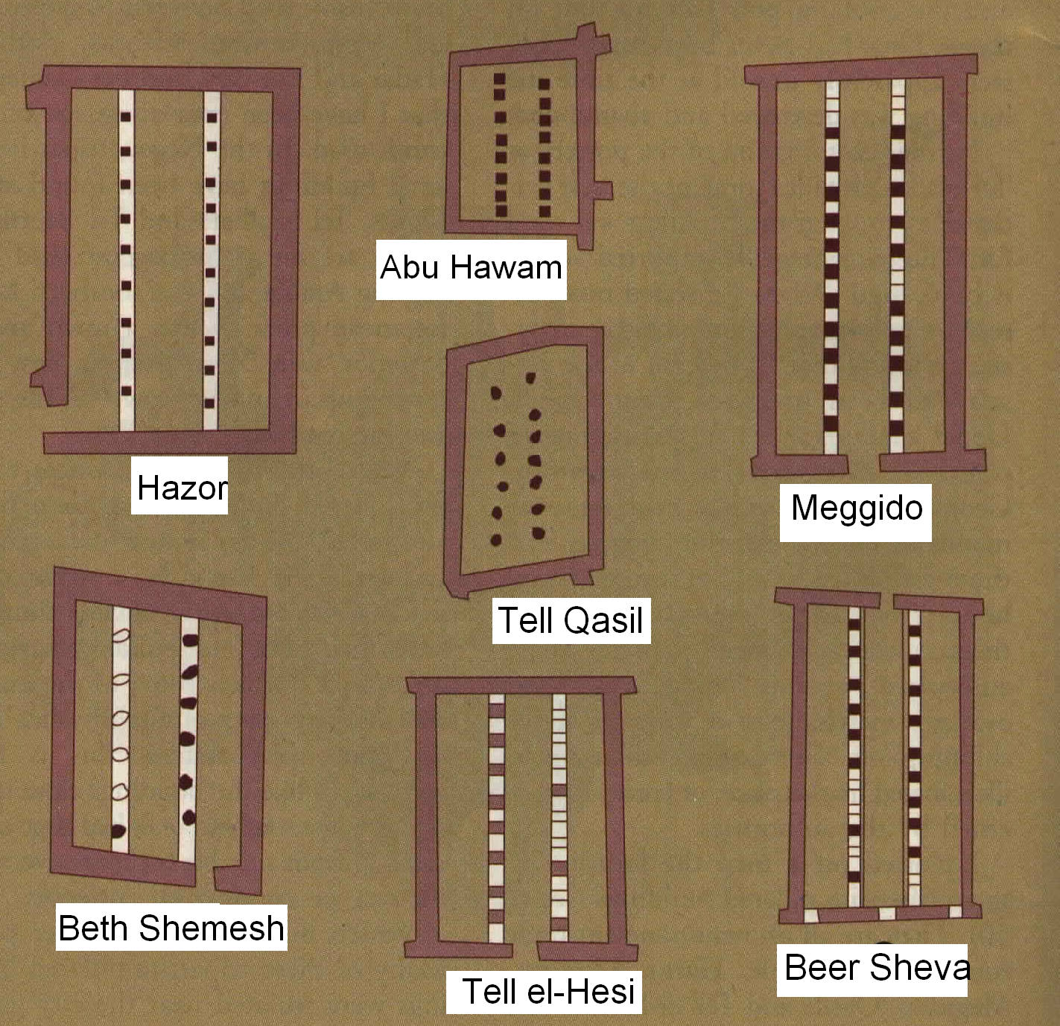

PHOTO LINK: TRIPARTITE 008 Plans of 8 different buildings
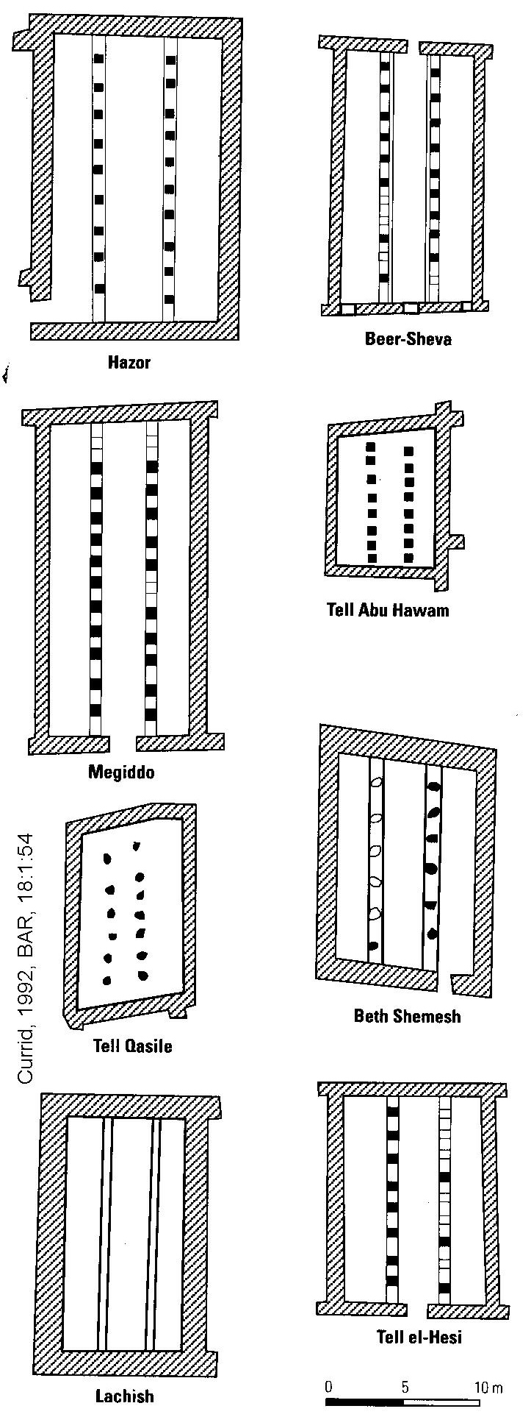

PHOTO LINK: TRIPARTITE 010 Drawing of tripartite building at Beer-sheva
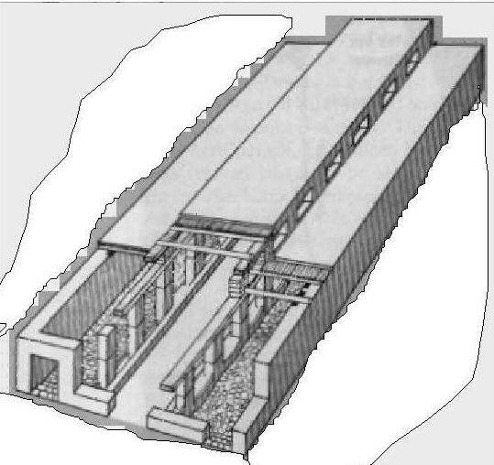

Most are located within public sectors near city gates or public squares and close to outer limits (wall) of the city. They were erected as independent structures that had an important communal function. The size varies from 25x25 ft (Tell Avu Hawam) to 40x88 ft (Megiddo). Floors of the two side rooms are generally different from floor of the central hall. The side isles are generally cobblestone and the central isle is stamped earth. Building access was by a gently inclined ramp (rather than by steps as with most public buildings of the period).The entrance was usually through one central doorway in the shorter-sided wall. No roofs survive, but were probably of clerestory design (Davies, 1994; Currid, 1992; Wilson, 1972; Kochave, 1999).

The architecture of the tripartite buildings, if of clerestory design, would have provided light and allow air to circulate throughout the building, because of the wide open spaces formed by the two central rows of columns (Davies, 1994; Currid, 1992; Wilson, 1972; Kochave, 1999).

Although stables are a biblically-appealing interpretation of tripartite buildings, there is no evidence in them of long-term presence of horses or chariots such as urine chemicals (phosphoric anhydride) in the soil, or equine paraphernalia. These buildings are found in the center of cities. It is unlikely that smelly stables would be in placed there (Davies, 1994; Currid, 1992; Wilson, 1972; Kochave, 1999).

The tripartite buildings sometimes are found adjacent to granaries (Tel Hadar, Kochave, 1999; Hazor, Ben-Tor, 1994).

The floors of tripartite buildings often have many storage jars, but few bowls or other types of pottery.

PHOTO LINK: TRIPARTITE 003 Tel Hadar, Phoenician and Greek pottery
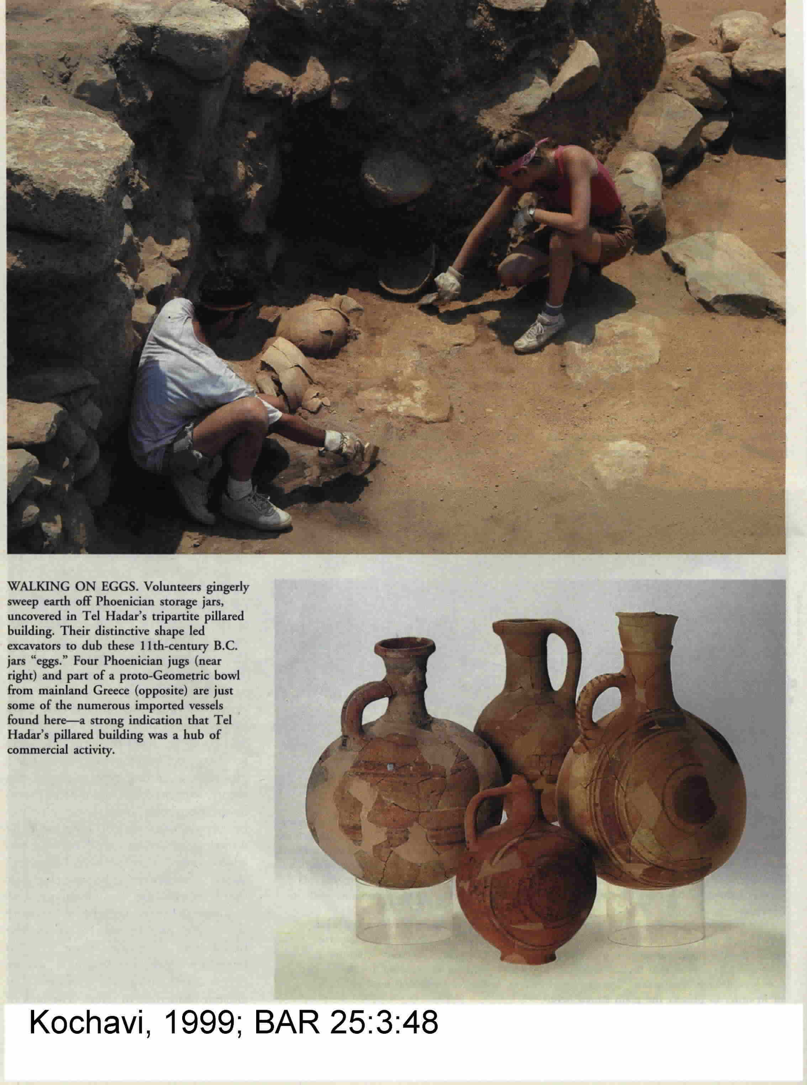

When bowls or lamps are found, they are generally unused. This absence of bowls and lamps, the most common kind of pottery found in homes, suggests the are not barracks. A high percentage of vessels are imported. Tripartite buildings are found in cities that lie along the intersections of trade routes or at harbors. Often the tripartite buildings are found near city gates, which are traditional sites for bazaars in many Oriental cities (Herr, 1988) (Davies, 1994; Currid, 1992; Wilson, 1972; Kochave, 1999). These observations suggest that the tripartite buildings are generally storehouses.

SOLOMON'S GOLD

The Old Testament has tales about Solomon’s gold and the uses to which it was put. There is no extant direct evidence of these uses, but they can be understood by analogy with contemporary artifacts from other sources.

PHOTO LINK: GOLD 001 Mask of Tutankhamen
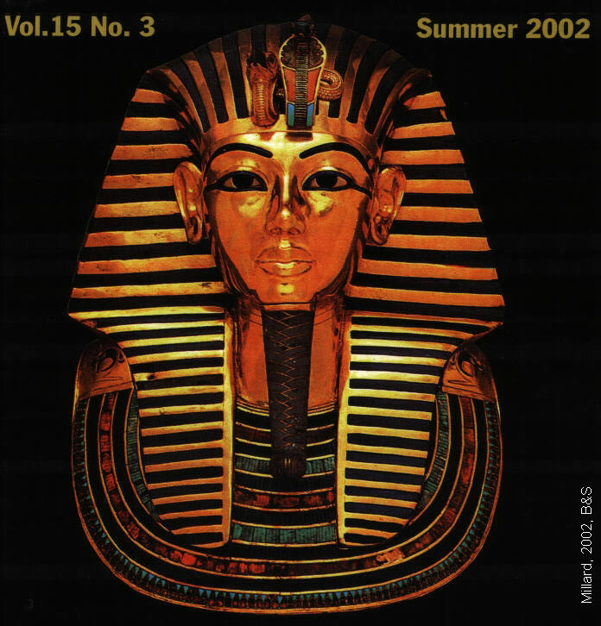

PHOTO LINK: GOLD 002 Gold from Ur 2500 BC
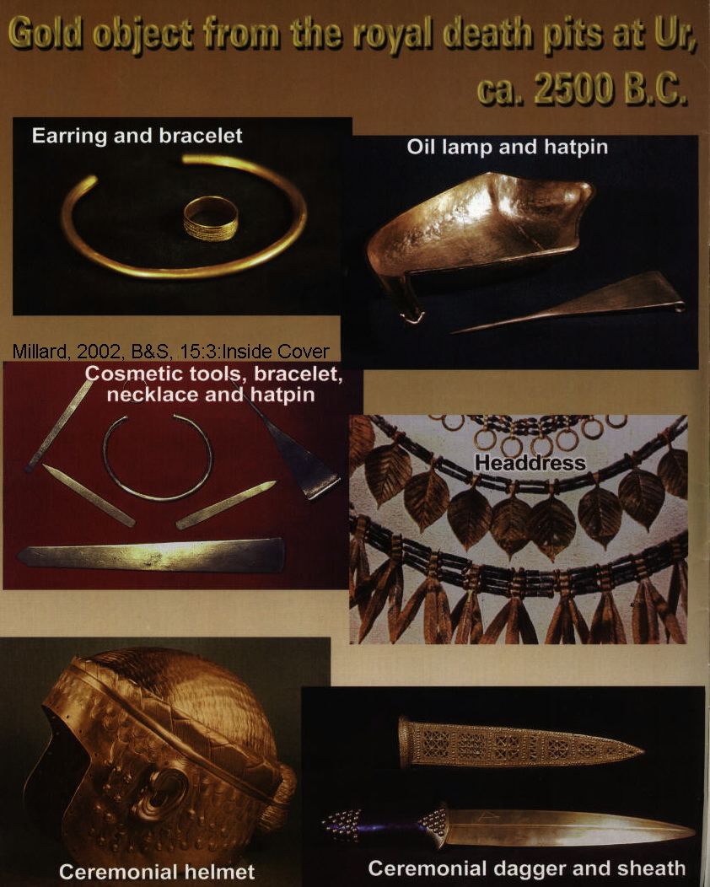

PHOTO LINK: GOLD 003 Gold Bull from Ur 2500 BC
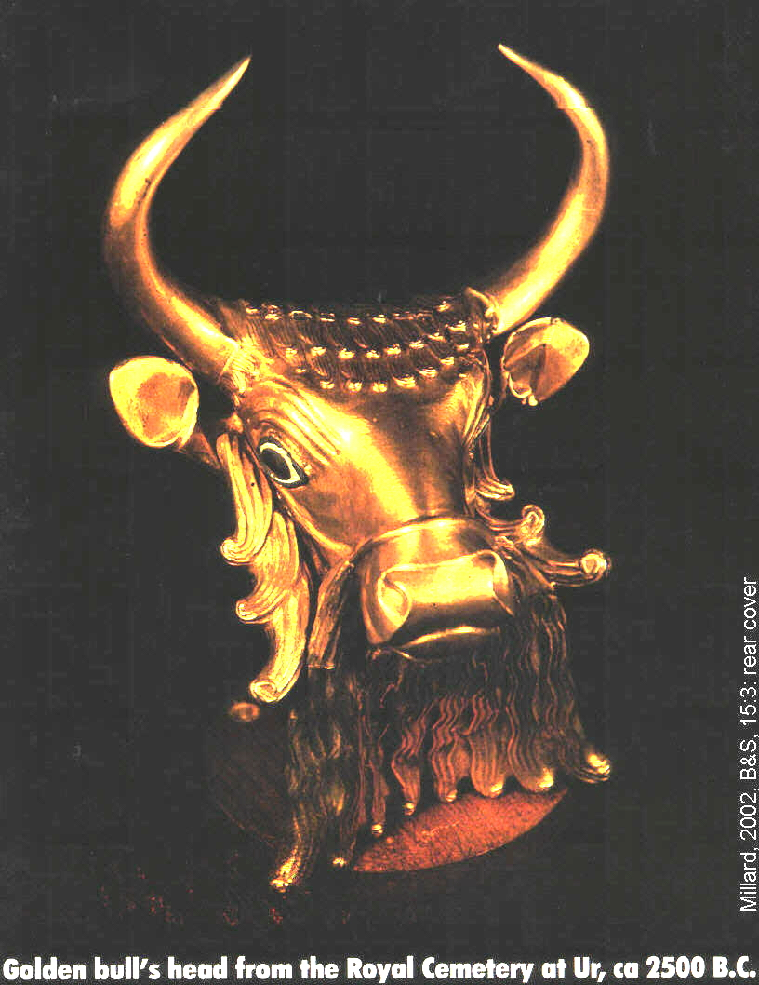

As 1 Kings tells it, Solomon seemed unable to control his excesses. Reared in a palace, he loved luxury. When Israel launched its first maritime expeditions, he used them to gather such exotica as gold, ivory, apes, peacocks, and silver. He plated the floor of the temple with gold and gilded over fine cedar and precious ivory with gold. He fashioned militarily useless shields out of gold (Compton’s Interactive Bible, 1998).

Solomon’s gold shields were contained 4,000 lbs (2 tons) of gold. He had an annual income of 666 talents of gold (almost 25 tons, 1 Kings 10:14; Millard, 1982, 1994; Kitchen, 1994). The Queen of Sheba and Hiram of Tyre each gave Solomon about 9,000 lbs (120 talents) of gold each. These amounts of gold are considered to be unhistorical hyperbole by liberal scholars. An inventory of gold use by other civilizations in the Levant at that time indicate that they used similar amounts of gold in similar ways.

The golden goblets of 1 Kings 10:21 are similar to ones found at Ur cir 2600 BC. The golden furniture found in Egyptian burials and are described in Babylonian cuneiform texts and have been found in excavations of the burial temples of Tutankhamen (1331 BC) and Queen Hetepheres (ca. 2600 BC). Solomon’s golden shields (1 Kings 10:17, 2 Chron 9:16) find equivalent descriptions in Sargon's prisms (buried in foundations of Khorsbad palace, north of Nineveh), which also describes golden shields as part of palace furnishings. A relief by Sargon Ii describes his victory over the Urartian city of Musasir in 714 BC. That relief says that six gold shields were taken from the Musasir temple. The Egypian pharaoh Osorkon I gave 383 tons of gold and silver to the gods (Millard, 1982, 1994; Kitchen, 1994).

PHOTO LINK: ASSYRIA 044 Nimrud Prism of Sargon II describing repopulation of Samaria with Assyrians
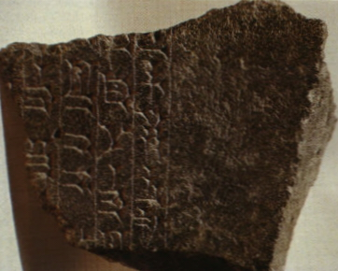

PHOTO LINK: SARGON II 002; Relief portrate; http://www.bible-history.com/assyria_archaeology/archaeology_of_ancient_assyria_archaeological_discoveries.html; Aug. 16, 2006 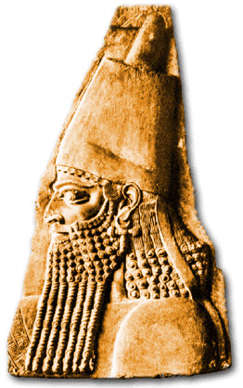

PHOTO LINK SOLOMON’S GOLD 001 Assyrian relief with shield trophies of war resembling Solomon's gold shields
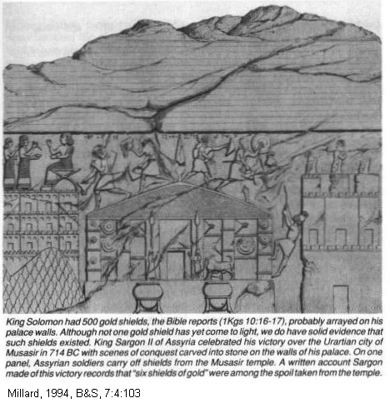

PHOTO LINK: SOLOMON’S GOLD 002 Egyptian hieroglyphs King Osorkon 1, in 921 BC gave 383 tons gold and silver
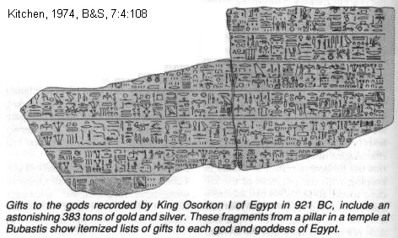

Solomon also gold-plated parts of the Temple. This practice was common throughout Egypt and Mesopotamia as illustrated in the table, below:

Civilization | Ruler | Date | Building | Gold Use | Reference
Old Babylonia | Enmetena (Entemena) | 2400 BC | Lagash temple | "covered it with gold and silver | Millard, 2002  Cooper, 1986: 67  La.5.27; cf La 5.6
Assyria | Esarhaddon | 7th Century BC | restored shrine of Ashur | plated doors with gold and "coated the walls with gold as plaster | Millard, 2002  Borger, 1956
Israel | Northern Kings | 7th and 6th Centuries BC | Samaria | Nimrud ivories, once covered with gold | Millard, 2002
Israel | Solomon | 9th Century BC | From Sheba (1 Kings 10:10) | 120 talents (3.9 tons) | Millard, 2002
Israel | Solomon | 9th Century BC | From Tyre (1 Kings | 120 talents (3.9 tons) | Millard, 2002
Israel | Solomon | 9th Century BC | From Ophir (1 Kings 9:28) | 420 talents (13.6 tons) | Millard, 2002
Israel | Solomon | 9th Century BC | Annual revenue (1 Kings 10:34) | 666 talents (21 tons) | Millard, 2002
Assyria | Ashurbanipal | 669-633 BC | Palace at Nineveh | "I clad its walls with gold and silver" | Millard, 2002  Thompson, 1931:29
Assyria | Shalmaneser III | 859-824 BC | Tribute from Kings of Carchemis | 3 talents gold and 1 mana (1lb) per year | Millard, 2002
Assyria | Tiglath-pileser III | 745-727 BC | Tribute from Hoshea and from Tyre | 10 talents gold from Hoshea, 4.4 tons from Tyre | Millard, 2002
Assyria | Sargon II | 714 BC | Booty from Temple of Haldi, chief god of Urartu in Musasir | "six gold shields...by weight 5 talents and 12 minas of red gold" | Millard, 2002
Assyria | Sargon II | 714 BC | Booty from Babylon | 5 tons gold, 52 tons silver, "incalculable amounts of bronze and iron, precious stones in heaps..." | Millard, 2002
Syria | Adad-nirari III | 811-872 BC | Damascus surrender | 1,320 lbs gold, 68 tons of silver | Millard, 2002
Babylonia | Nebuchadnezzar | 6th century BC | buildings and shrines in Babylon | "I clad [them] in gold and made them as bright as day | Millard, 2002  Landon, 1912:178
Babylonia | Nabonidus | 555-539 BC | buildings and shrines in Babylon | "I clad its walls with gold and silver and made them to shine like the sun" | Millard, 2002  Landon, 1912:178
Egypt | Various | Various | Various buildings and monuments | gold covering attachments | Millard, 2002  Lacue, 1956
Egypt | Tuthmosis III | ca 1450 BC | Temple of Sacred Boat, Karnak | 12 columns 11 ft high, covered with cold | Millard, 2002
Egypt | Tuthmosis III | ca 1450 BC | Another hall at Karnak | 14 columns to roof 52 feet high | Millard, 2002
Egypt | Tuthmosis III | ca 1450 BC | Cleopatra’s Needle | top or top 1/2 covered with gold | Millard, 2002  Engelbach, 1923  Habachi, 1978
Egypt |  |  | Other monuments  Various mines and tribute | 180 ft high, top or top 1/2 or all surface covered with gold plating. | Millard, 2002  Vercutter, 1959
Egypt | Tuthmosis III New Kingdom | 1490-1436 BC | Shrine for Amun at Dier-el-Bahri | "plated with gold and silver", including the floor | Millard, 2002
Egypt | Tuthmosis III New Kingdom | 1490-1436 BC | Temple of Amun in Karnak | 13.6 tons as lumps and rings of gold | Millard, 2002
Egypt | Amenophis III | 13th century BC | Temple of Montu in Karnak | 2,242 tons gold | Millard, 2002
Egypt | Amenophis III | 13th century BC | Temple of Amun at Thebes | "plated with gold and silver throughout, its floor is adorned with silver, all its portals are of gold" | Millard, 2002
Egypt | Amenophis III | 13th century BC | Temple at Soleb | Like the Temple of Amun at Thebes and "all portals are of gold" | Millard, 2002
Egypt | Letter to Pharaoh | 1340 BC | Assyrian request for gold | "Gold in your land is like dust, one simply gathers it up" | Moran, 1992  Millard, 2002
Egypt | Tutankhamen | 1325 BC | Tomb | gold throne, gold shrine housing sarcophagus, Gold plated coffin, gold mask for mummy, plating is 0.01 to 0.09 mm thick. | Millard, 2002  Lucas, 1962
Egypt | Rameses | 1279-1213 BC | Mortuary temple at Abydos | doors "mounted with copper and gilded with electrum" | Millard, 2002
Egypt | Rameses III | 1183-1152 BC | Various temples | doors "mounted with copper and gilded with electrum" | Millard, 2002
Egypt | Rameses III | 1183-1152 BC | Shrine at Medinet Habu | gold shrine with silver pavement, doorposts of fine gold | Millard, 2002
Egypt | Rameses III | 1183-1152 BC | Temple at Karnak | "great doors of fine gold" | Millard, 2002
Egypt | Rameses III | 1183-1152 BC | Sacred barge: 223 ft long | cedar timbers overlaid with gold to the water line | Millard, 2002
Egypt | Osorkon I | 924-889 BC | Devotion to gods of Heliopolis | 53 tons gold, 205 tons silver | Millard, 2002  Kitchen, 1996
Greece | Sculptor Pheidias | 438 BC | 34ft high statue of Athena | plated with gold, 1 ton | Millard, 2002  Sutherland, 1959

References to gold-plated temples were found in the records of Esarhaddon of Assyria (680-669 BC) who restored the shrine of Ashur and plated its doors with gold and "coated the walls with gold as if with plaster" (Millard, 1982, 1994; Kitchen, 1994).

PHOTO LINK: ASSYRIA 032 Stele of Esarhaddon 681-669 BC
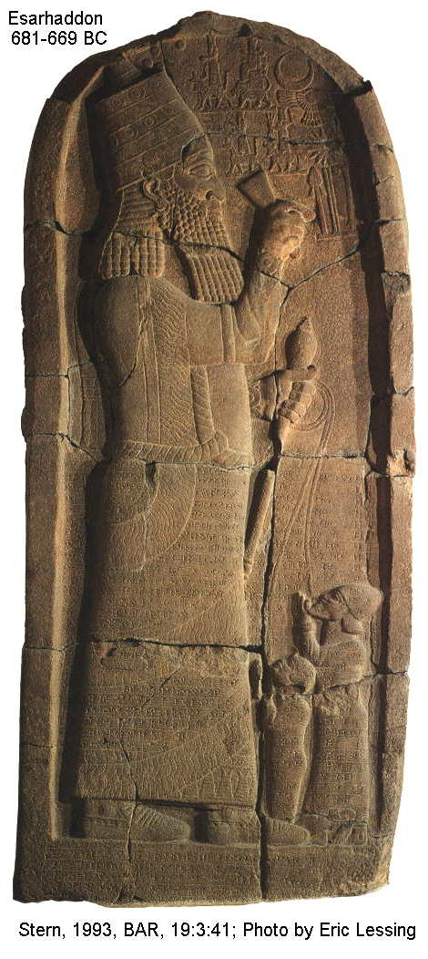
PHOTO LINK: THUTMOSIS III 001 Statue of Pharaoh Thutmosis III
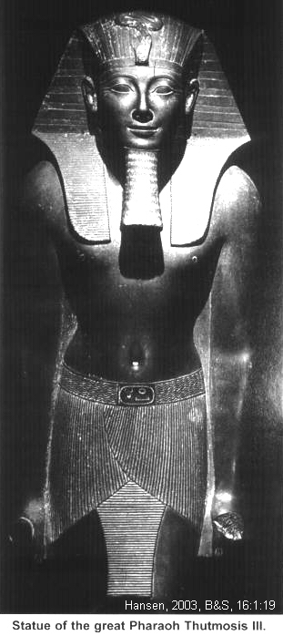

Nabonidus of Babylon (555-539 BC) had the temple of Sin at Harran "...clad its walls with gold and silver, and made them shine like the sun” (Millard, 1982, 1994; Kitchen, 1994).

PHOTO LINK: NABONIDUS 001 Tablet with Nabonidus chronicle and description
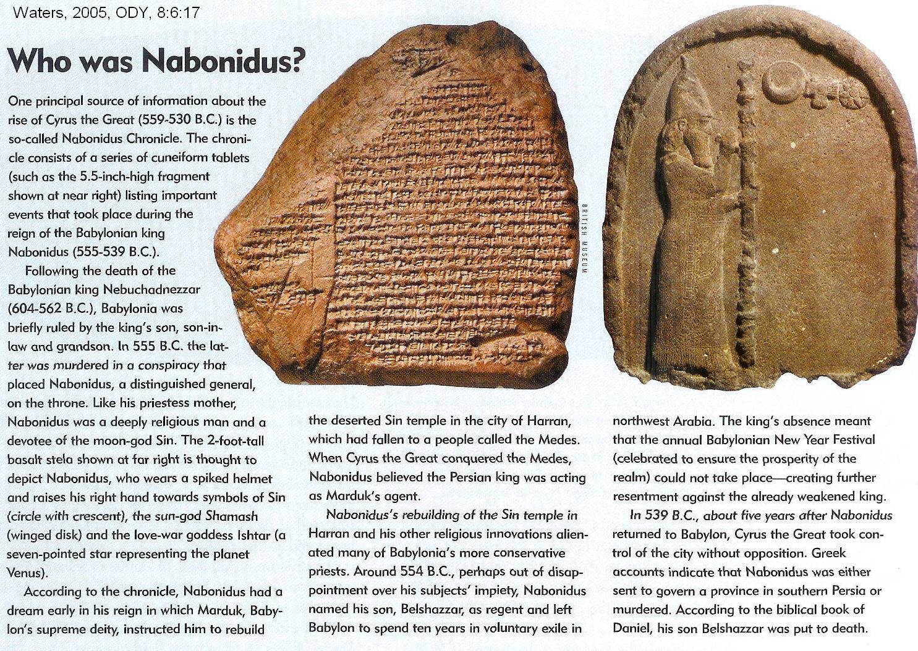

Egyptian pharaoh Amenophis III (also named Amenhotep III, ca. 1386-1349 BC) at Temple of Amun at Thebes "plated with gold throughout, its floor adorned with silver [and] all its portals with electrum" (Millard, 1982, 1994; Kitchen, 1994).

PHOTO LINK: AMENHOTEP III 001 Bust of Amenhotop III
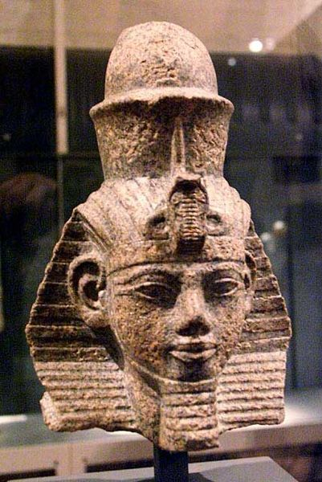
PHOTO LINK: RAMESES III 001 Bust of Rameses III
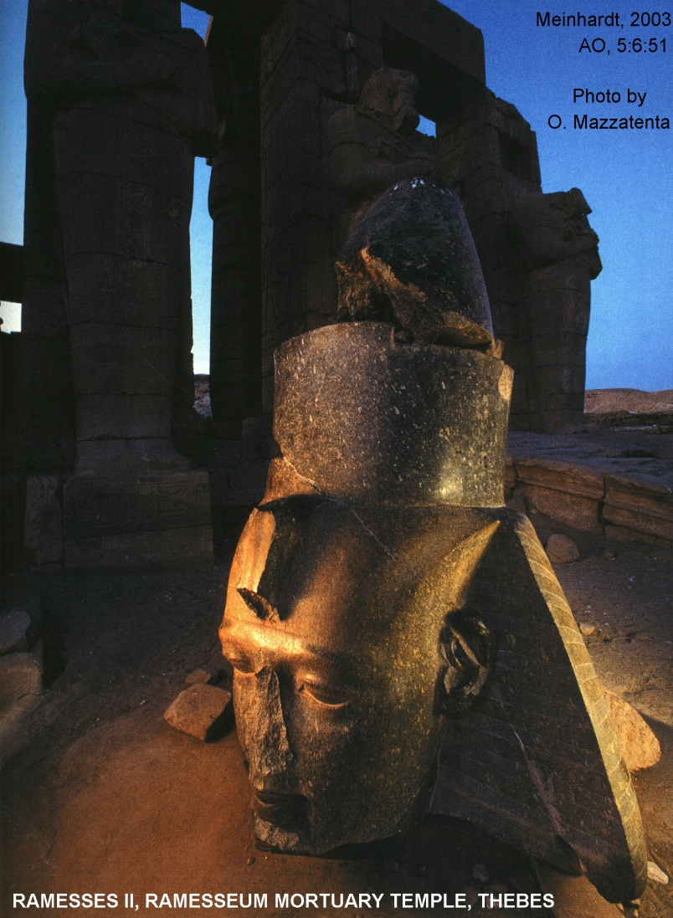

PHOTO LINK: AMUN 001 Entrance to table of Amun at Thebes
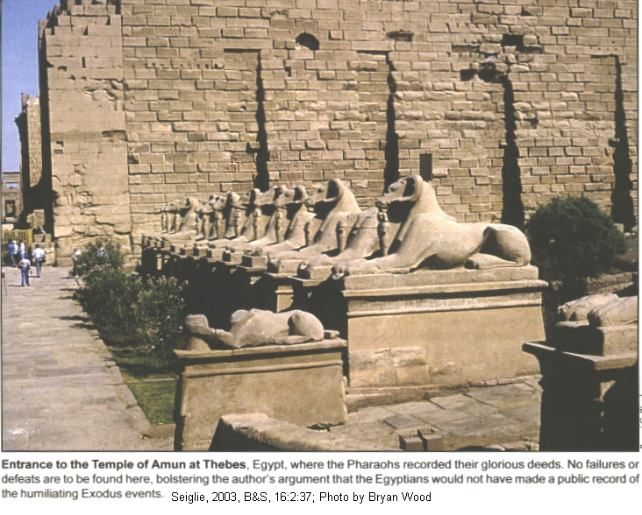

Rameses III (ca.1185-1154 BC) built a shrine at Medinet Habu with a pavement of silver and door posts of fine gold (Millard, 1982, 1994; Kitchen, 1994).

PHOTO LINK: MEDINET HABU 002 Oblique view or temple complex at Medinet Habu opposite Luxor
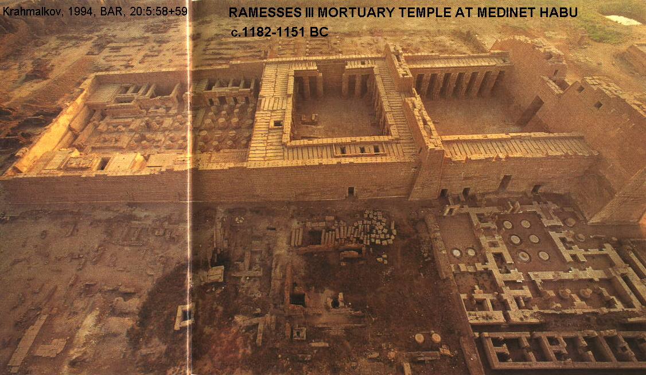

Thuthmosis III (ca 1479-1425 BC) plated pillars at Temple of the Sacred Boat at Karnak with gold. This is evidenced by narrow slits in the pillars, doorways, shrines and obelisks that supported the gold leaf (Millard, 1982, 1994; Kitchen, 1994).

PHOTO LINK: KARNAK 020 Entrance to Karnak Temple
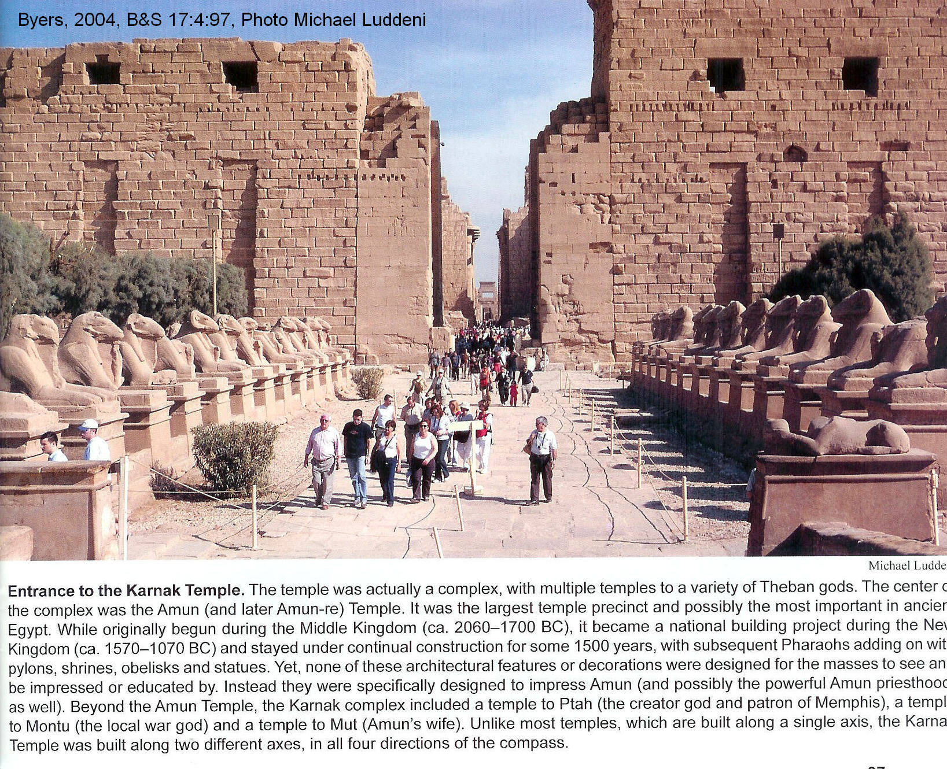

Egyptian records indicate that 152,107 deben (1 deben = 91 grams) or 13.5 tons were presented to the temple at Karnak. This amount of gold is similar to the gold that Solomon used. His gold shields were contained 4,000 lbs (2 tons) of gold. He had an annual income of 666 talents of gold (almost 25 tons) reported in 1 Kings 10:14 (Millard, 1982, 1994; Kitchen, 1994).

The Queen of Sheba and Hiram of Tyre each gave Solomon about 9,000 lbs (120 talents) of gold each. Tiglath-pileser III of Assyria received 12,000 lbs (150 talents) of gold as tribute from Tyre in 730 BC. (Millard, 1982, 1994; Kitchen, 1994).

Sargon II of Assyria gave 13,000 lbs (154 talents) of gold to gods of Babylonia. Greek historians Herodotus and Pausanias write of similar large caches of gold. They wrote that Sargon II of Assyria gave 154 talents of gold to the gods of Assyria, and that Pharaoh Osorkon I in 921 BC gave 383 talents of gold and silver to the gods. Much of this may have come from the sacking of Jerusalem 4 years earlier by his father Shishak (Shoshenq I) of I Kings 14:25-26 (Kitchen, 1994, p.108)

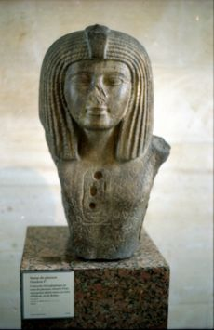
PHOTO LINK: OSORKON I 001; Bust from Byblos 19th Dynasty; http://en.wikipedia.org/wiki/Osorkon_I; Aug. 26, 2006

PHOTO LINK: SHISHAK 005 Relief at Amun temple Karnak
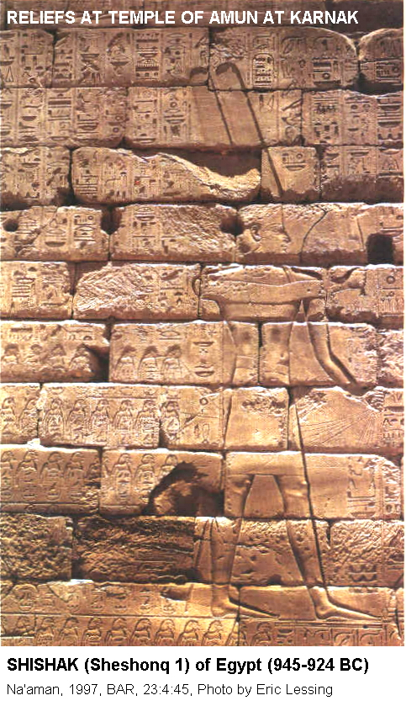

Alexander the Great got 1,180 tons of gold from Susa and almost 7,000 tons in the whole of Persia. A tabulation of these gold inventories is made below:

Tons of Gold in Antiquity

Solomon | Alexander (Persia)
From Sheba 3.9 | From India 10.5
From Tyre 3.9 | In Susa 1,178
From Ophir 13.6 | In Persia 6,942
Osorkon (Egypt | Tyre
Gifts to the gods | Paid to Tiglath-pileser 4.4
gold 1.8
silver 6.5
lazuli 53
 | Musasir
 | Gold and silver and lapis In palace 1.0
Tuthmosis III | Tuthmosis III
silver 178 | Booty of 20 yrs 11.3
gold and silver 205

Ophir

The personal name Ophir is for a descendent of Joktan in Gen 10:29 and I Chron 1:23. Some scholars consider Ophir to be a place-name for the present-day region of Somalia on the East-African Coast (Maisler, 1951; King, 1994). Others think Ophir was in the southern Arabian Peninsula in the present country of Yemen (Philemon, 1990)

Ophir is almost always associated with gold (I Ki 9:28; 10:11; 22:48; I Ch 20:4, 2 Ch 8:18, 9:10; Job 22:24, 28:16; Psa 45:9; Isa 12:12). One thought to be mythical, it's historicity was documented by an 8th century BC ostracon found at Tell Qasil in modern Tel Aviv which bears the inscription "gold from Ophir for Beth-horon 30 shekels" (Maisler, 1951; King, 1994).

PHOTO LINK: TEL QASIL 001 Ruins with column foundations; Ruins with pillar supports; http://www.shorter.edu/Images/academics/Israel_08/Day01.jpg; Sept. 10, 2010.
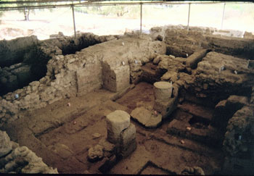

PHOTO LINK: TEL QASIL OSTRACON 001 Ostracon; http://www.lmlk.com/jpgs/ostracon_qasile.jpg, Sept. 10, 2010
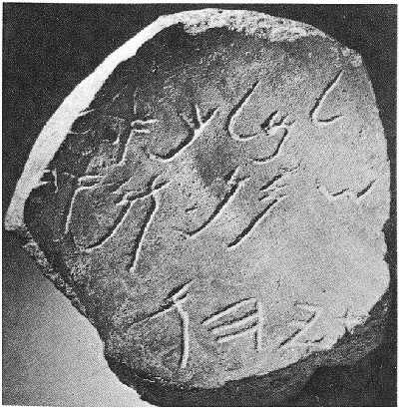

QUEEN OF SHEBA

The Biblical “Queen of Sheba”, like her country, were once thought to be mythical inventions. Sheba is now identified as from one of four ancient "Spice Kingdoms" of Arabia (Wilson, 1972; Philemon, 1990).

PHOTO LINK: SHEBA 002 Map of frankincense and myrrh trade routes
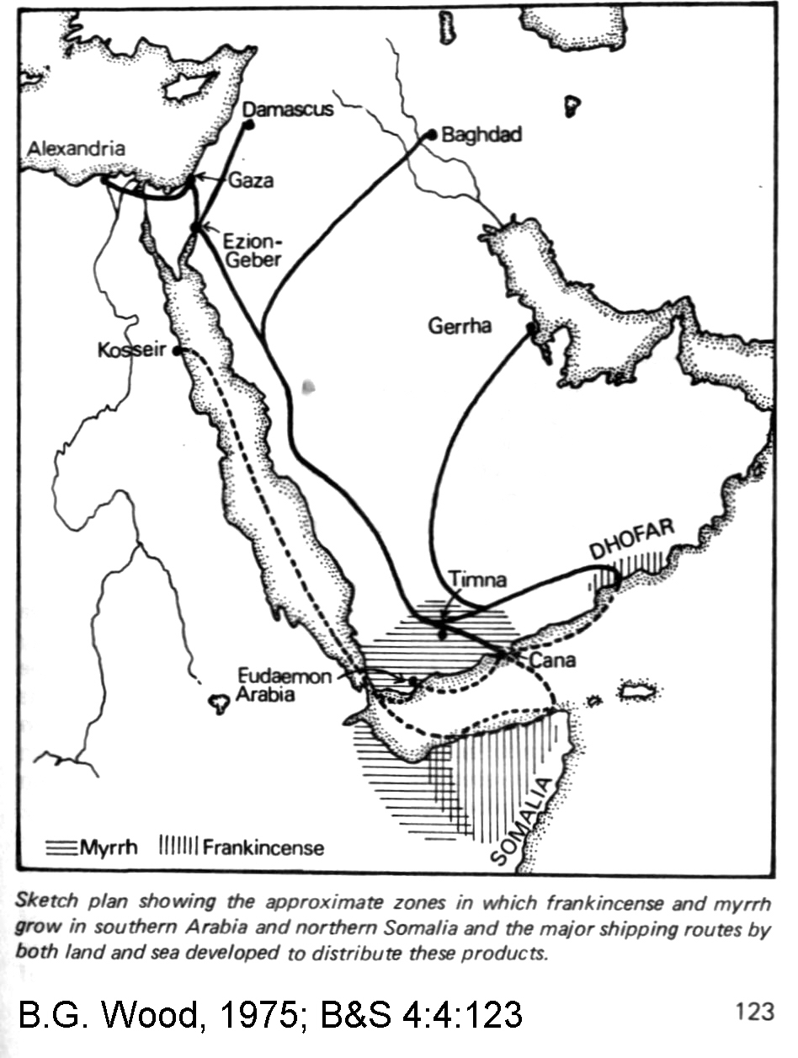
PHOTO LINK: SOLOMON 001 Forts and trade routes in Negev during reign of Solomon
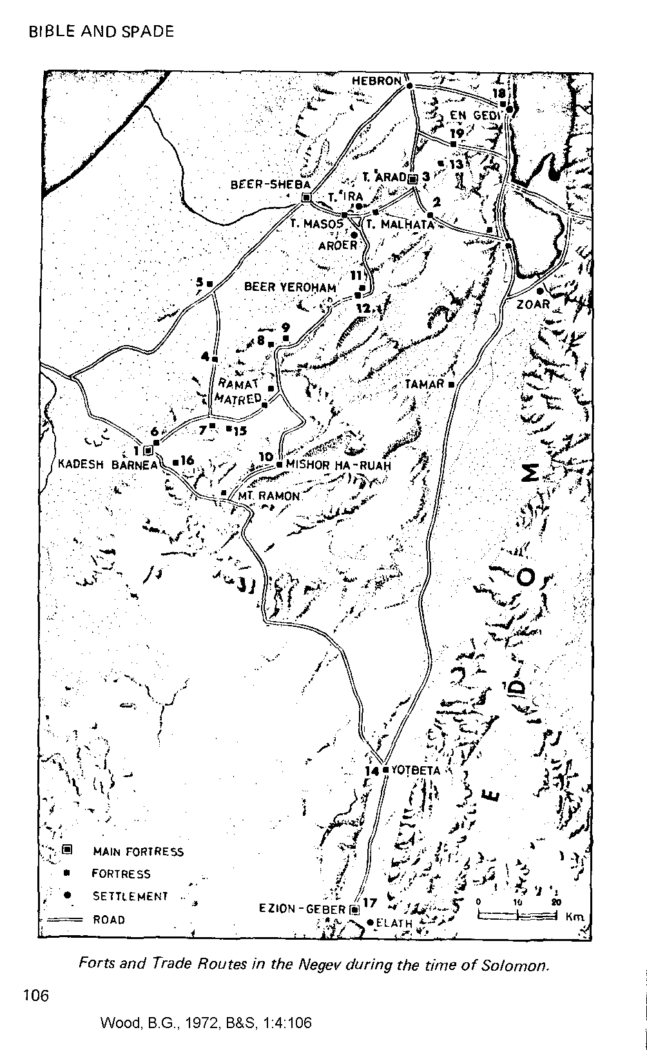

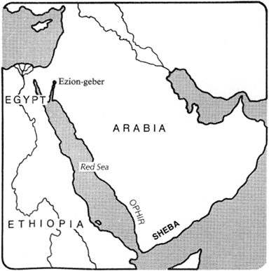
Country of Sheba

The country Sheba or Saba, whose name means Host of Heaven and peace, was Abyssinia. Located in southwest Arabia on the eastern tip of the Red Sea, Sheba occupied 483,000 square miles of mountains, valley and deserts in the area of present day Yemen. Some historians claim that Ethiopia, on the western end of the Red Sea, was also part of Sheba's territory (Philemon, 1990).

PHOTO LINK: SHEBA 003 Location Map (RIGHT)

PHOTO LINK: YEMEN 001 Location map of Yemen
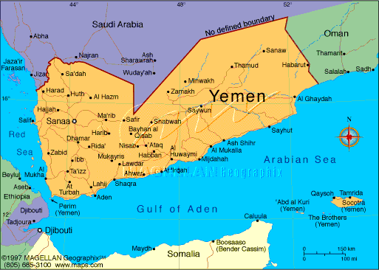

PHOTO LINK: ETHIOPIA 002 Location map of Ethiopia
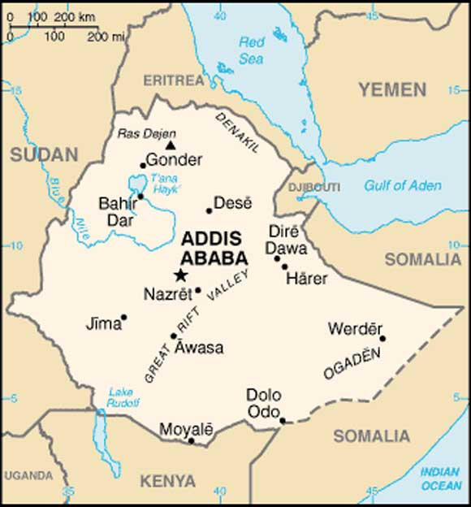

Sheba was a wealthy country, advanced in irrigation techniques and hydraulic power. Its people, the Sabaeans, built dams as high as 60 feet and large earthen wells which contributed to their thriving agriculture and beautiful gardens. Sheba was rich in gold and other precious stones. Its incense and exotic spices were sought by neighboring kingdoms (Philemon, 1990).

Because of its isolation, Sheba was secure from military invasion for at least 500 years, and was independent and at peace with its neighbors during the 11th and 10th century B.C. History reveals that at least five kings preceded the Queen of Sheba - among them Iti'amra and Karibi-ilu. Yet Arabian documents portray all of Arabia as matriarchal and ruled by queens for over 1000 years. In Ethiopia, the Kebra Negast refers to a law established in Sheba that only a woman could reign, and that she must be a virgin queen (Philemon, 1990).

The Sabaeans

The Sabaeans have been described as a tall and commanding people, both woolly-haired and straight-haired. Semitic in origin, they are believed to have been descendents of the Cush of the Bible. The sacred Ethiopian book which establishes the founder of the Ethiopian dynasty as the son of Solomon and Sheba, suggests that the Sabaeans were black. "Ye are black of face - but if God illumineth your hearts, nothing can injure you," priest Azariah says to the Queen and her people in the Kebra Negast. (Philemon, 1990).
The Sabeans came from Southern Arabia in what now is Yemen. They were also called the Himyarites or the Yemenites. The Sabaeans were a Semitic people who, at an unknown date, entered Southern Arabia from the north. Sabaean civilization began as early as the 10th-12th century BC. The Sabaean rulers are mentioned in Assyrian annals of the late 8th and early 7th centuries BC, but Sabaean inscriptions are dated to the 6th century BC (AJAE, 2000)
The Old Testiment describes Sabeans in four of its passages:
Job 1:15; "And the Sabeans fell upon them, and took them away; yea, they have slain the servants with the edge of the sword; and I only am escaped alone to tell thee."
Isaiah 45:14; "Thus saith the LORD, The labour of Egypt, and merchandise of Ethiopia and of the Sabeans, men of stature, shall come over unto thee, and they shall be thine: they shall come after thee; in chains they shall come over, and they shall fall down unto thee, they shall make supplication unto thee, saying, Surely God is in thee; and there is none else, there is no God. "
Ezekiel 23:42; "And a voice of a multitude being at ease was with her: and with the men of the common sort were brought Sabeans from the wilderness, which put bracelets upon their hands, and beautiful crowns upon their heads."
Joel 3:8; "And I will sell your sons and your daughters into the hand of the children of Judah, and they shall sell them to the Sabeans, to a people far off: for the LORD hath spoken it."

Sheba the Queen
According to Ethiopian legend, Sheba the Queen was born in 1020 B.C. in Ophir, and educated in Ethiopia. Her mother was Queen Ismenie. Sheba’s father was chief minister to Za Sebado and succeeded him as King. One story says that as a child Sheba (called Makeda) was to be sacrificed to a serpent god, but was rescued by the stranger 'Angaboo. Later, her pet jackal bit her badly on one foot and leg, leaving lasting scars and deformity. When her father died in 1005 B.C., Sheba became Queen at the age of fifteen. Contradictory legends refer to her as ruling for forty years, and reigning as a virgin queen for six years. In most accounts, she never married (Philemon, 1990).
PHOTO LINK: SHEBA 006: Painting of Queen of Sheba before Soloman at his court "Solomon and the Queen of Sheba" by Italian artist Giovani Demin, 19th century.
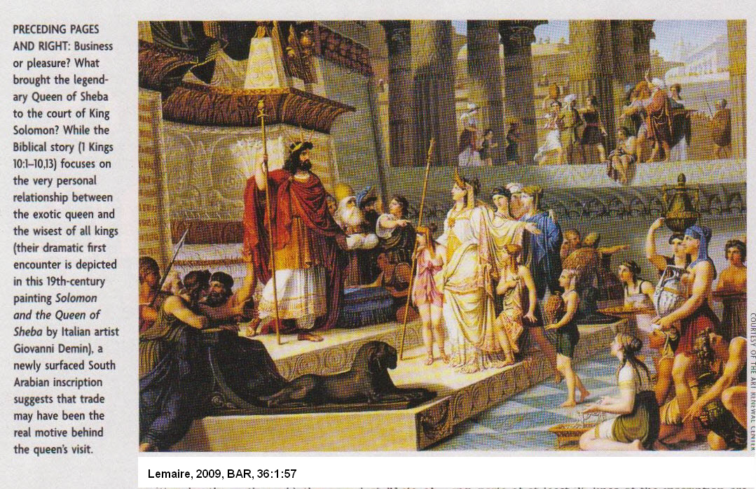
Sheba was known to be beautiful (despite her damaged ankle and leg), intelligent, understanding, resourceful, and adventurous. A gracious queen, she had a melodious voice and was an eloquent speaker. Excelling in public relations and international diplomacy, she was a also competent ruler. The historian Josephus said of her, "she was inquisitive into philosophy and on that and on other accounts also was to be admired." (Philemon, 1990; Josephus, Flavius, JEWISH ANTIQUITIES, translated by Ralph Marcus, Harvard U Press, Cambridge, 1937, Book VIII, chapter 6:5, p.226).

Religion at Sheba

The people of Sheba, at their capitol Mahram Bilqis (also known as the Temple Awwam) near Marib, worshiped the moon god Ilumquah in a temple with fountains from which water flowed into a temple courtyard (Wilson, 1972; Philemon, 1990).

Since Sheba was a center of astronomical wisdom and the Queen or King was chief astronomer/ astrologer, religious life involved worship of the Sun and Moon. Shams was the Sun god.
In the Kebra Negast, the Queen tells Solomon, "We worship the sun...for he cooketh our food, and moreoever he illumineth the darkness, and removeth fear; we call him "our King," and we call him "our Creator....And there are others among our subjects.... some worship stones, and some worship trees, and some worship carved figures, and some worship images of gold and silver." (Philemon, 1990).

The Great Goddess who dwelt in the sacred black aniconic stone was given the title Shayba by the Arabic-Aramaen people. Shayba represented the Moon in its threefold aspect - waxing, (maiden), full (pregnant mother), and waning (old wise woman or crone). But the primary Sabaean Moon god was Ilmukah or Ilumguh, identified with the god Sin of Assyro-Babylonian mythology. Sin was portrayed as an old man with an azure beard, the color of lapis lazuli, and a turbaned head. Wearing a crown shaped like a full moon, Sin rode a crescent moon-boat from which he navigated the night sky. Also called He-Whose-Deep-Heart-No-God-Can-Penetrate, he dispersed evil and darkness, and inspired his believers with dreams and prophecies (Philemon, 1990).

A Moon goddess worshipped by the Sabaeans was Astarte, or Ashtart, whom they called Astar, which means "womb." The giver and destroyer of life, Astar was Queen of Heaven and Mother of all Deities. Arriving from heaven as a ball of fire, and accompanied by a lioness, she was pictured with horns, and a disc of the sun above her forehead (Philemon, 1990).

The earliest known Arabian temple at Marib was called Mahram Bilqus, "precincts of the Queen of Sheba." In Arab lore, this queen was named Bilqus or Balkis; in Ethiopia, Makeda (also Magda, Maqda and Makera), meaning "Greatness." Years later, the historian Josephus, referred to her as Nikaulis, Queen of Ethiopia and Egypt.

PHOTO LINK: SHEBA 004 Temple of Ilumque at Mahram Bilgus near Marib
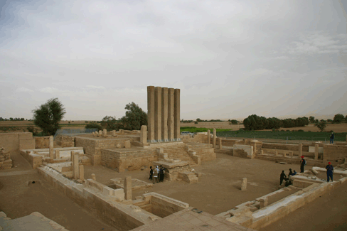

PHOTO LINK: SHEBA 005 Plan of Temple of Ilumque at Mahram Bigus near Marib
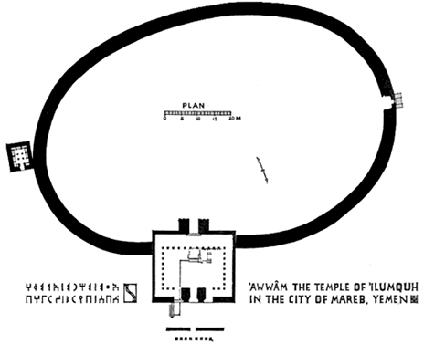

Excavations at Marib found inscriptions in an alphabetic script that originated in Palestine (Wilson, 1972).

PHOTO LINK: MARIB 001 Inscription near sluice gates of Marib dam
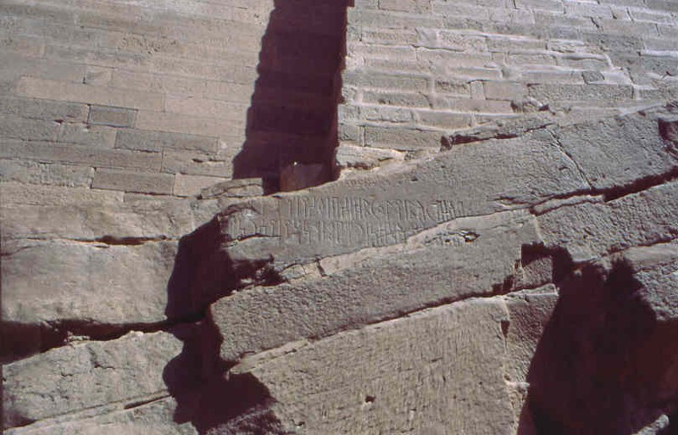

Commerce and Sheba

Sheba and Jerusalem were trading partners. With the introduction of the camel as a transportation mechanism, (earlier they were used only for luxury transport or royalty) a new source of wealth came to Solomon and those with whom he traded. (1 Kings 10:15; Wilson, 1972).
.
PHOTO LINK: CAMEL 001 Ammenemes III stella of Wadi Nasib (RIGHT)
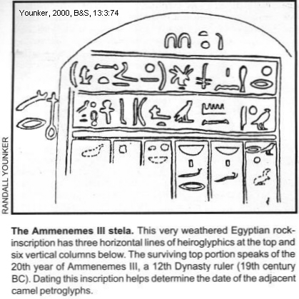

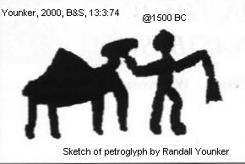
PHOTO LINK: CAMEL 002 Petroglyph in Wadi Nasib

PHOTO LINK: CAMEL 004 Two modern camels
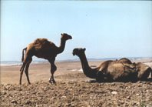

PHOTO LINK: CAMEL 005 Black robe Arab and camel caravan
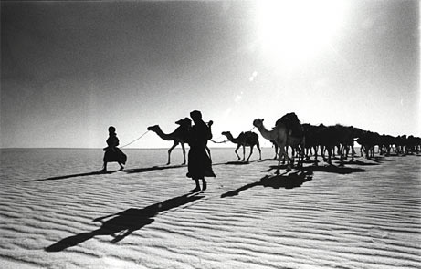

Solomon was able to capitalize on the political environment of his time and made Israel a commercial and economic power. Solomon built a series of forts to protect the Sheba to Ezion-geber (seaport, later called Elath) trade route in the Negev. These forts included Arad, Beer-sheba, and Kadesh-barnea (Wilson, 1972).

PHOTO LINK: SOLOMON 001 Forts and trade routes in Negev during reign of Solomon; (See ABOVE, ctrl+click to follow link)

PHOTO LINK: ARAD 005 Location map of Arad 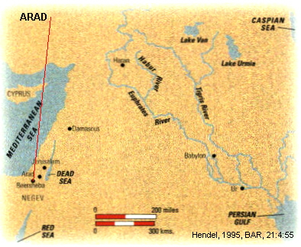
PHOTO LINK: ESN087 Iron Age Fortress; Arad
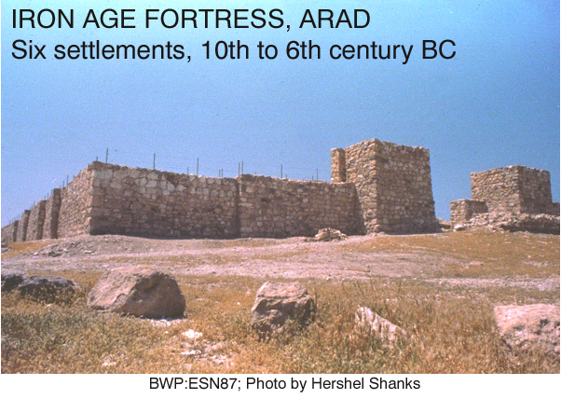

Sheba engaged in a lucrative caravan trade. By 1000 B.C., camels frequently traveled the 1400 miles up the "Incense Road" and along the Red Sea to Israel (Philemon, 1990).

PHOTO LINK: SHEBA 001 Sketch plan of Arabia showing archaeological sites and kingdoms
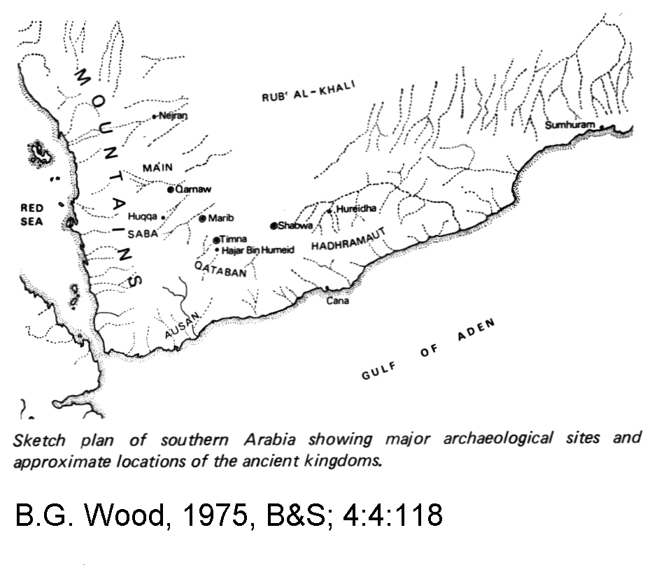

PHOTO LINK: SHEBA 002 Map of frankincense and myrrh trade routes ; (See ABOVE, p.241; ctrl+click to follow link)

PHOTO LINK: SOLOMON 001 Forts and trade routes in Negev during reign of Solomon; (See ABOVE, p.244; ctrl+click to follow link)

Caravans traveled only 20 miles a day, so trading expeditions between Jerusalem and Sheba took six months. The journeys from Sheba went across the desert sands of Arabia, along the coast of the Red Sea, up into Moab, and over the Jordan River to Jerusalem (Philemon, 1990)

The spices of Sheba were highly prized. Frankincense, an offering to the gods, was heaped on funeral pyres, and given as an antidote for poison, and as a cure for chest pains, hemmorrhoids and paralysis. Myrrh, an ingredient in fragrant oils and cosmetics, was used in preparing bodies for burial, for healing ear, eye and nose ailments, and inducing menstruation. Other Sabaean spices were saffron, cummin, aloes and galbanum (Philemon, 1990).

PHOTO LINK: FRANKINCENSE 001 Painting; http://www.botanical.com/botanical/mgmh/f/franki31-l.jpg; July 27, 2006
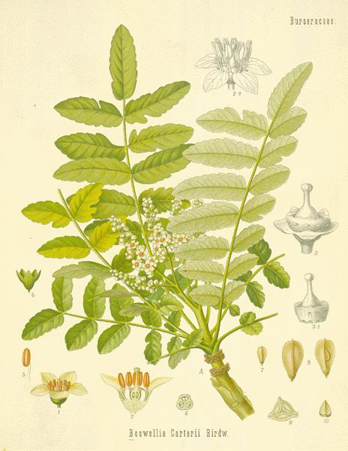

PHOTO LINK: FRANKINCENSE 002 Map of Frankincense trade route; ; tp://images.search.yahoo.com/search/images/view?back=http%3A%2F%2Ftravel.yahoo.com%2Fp-travelguide-12799168-land_of_frankincense_salalah-i%26action%3Dimgsearch%26page%3D1&imgcurl=www.panspantry.co.uk%2Fmideast.jpg&imgurl=www.panspantry.co.uk%2Fmideast.jpg&rurl=http%3A%2F%2Fwww.panspantry.co.uk%2Ffrncense.htm&rcurl=http%3A%2F%2Fwww.panspantry.co.uk%2Ffrncense.htm&name=mideast; July 27, 2006

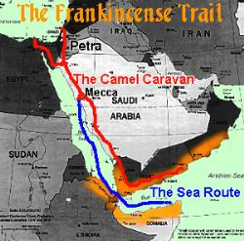

PHOTO LINK: MYRRH 001 Myrrh tree and harvester
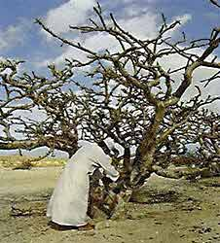

PHOTO LINK: MYRRH 002 Painting
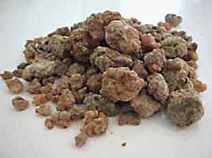

A 25-line south-Arabian inscription was “discovered” in the antiquities market in 2009 (Lemaire, 2009; Bron and Lemaire, 2009, cited by Lemaire, 2009:59).

This inscription describes a trading expedition of the kingdom of Sabaea (Biblical Sheba) to “HGR YHD”, the “towns of Judah”. The inscription mentions a contemporary “war of Chaldea and Iawan”. Based on that phrase, the inscription is dated at 600 BC (Lemaire, 2010, cited by Lemaire, 2009:58).

PHOTO LINK: SHEBA 008: 25-line South Arabian inscription mentioning trade expedition of the kingdom of Sabaea (Biblical Sheba) to the “towns of Judah”
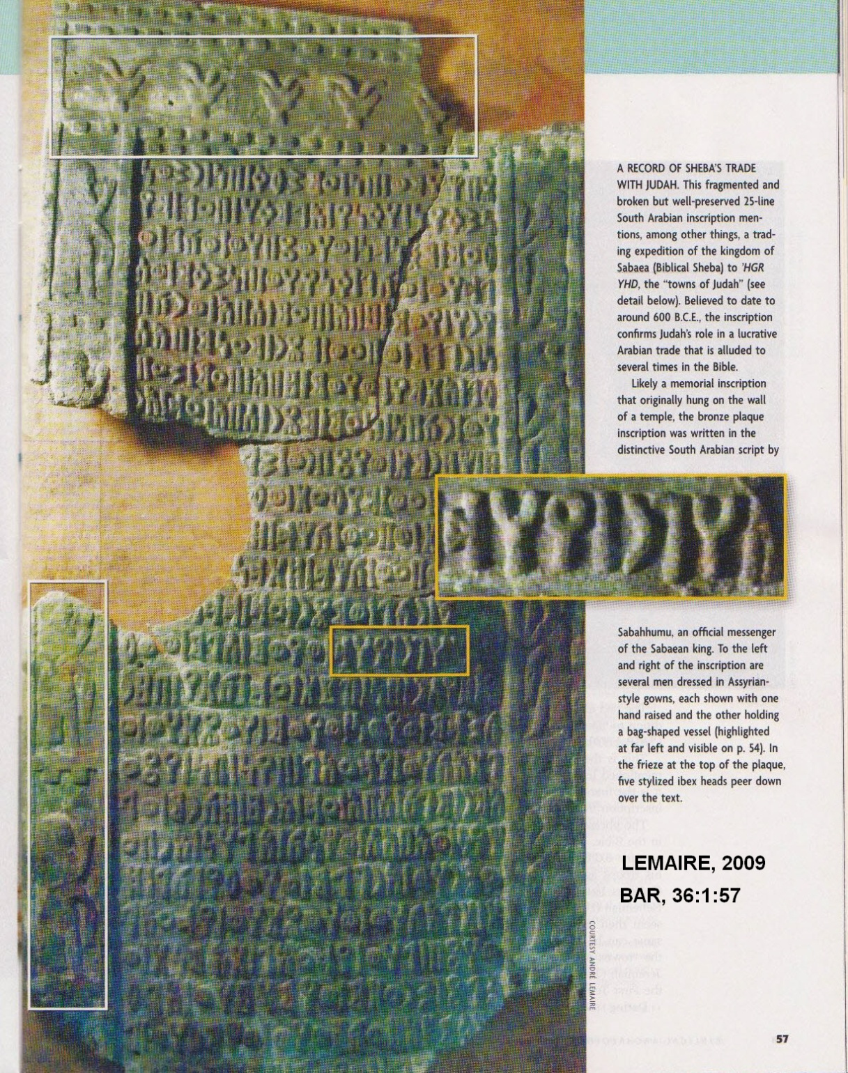

Philosophy and Theology

The Queen of Sheba’s “hard questions" (1 Kings 10:1) reflects great flowering of literature of this period of classical Hebrew prose (see Proverbs, Ecclesiastes, and Song of Songs). Later Jewish literature told of riddles that the Queen asked of Solomon. An example follows (Midrash Hachefez, quoted in Rappoport, p. 128, Ginzberg (1913), p.147, Ginzberg (1956), p.563, and Frankel, p.234-5, cited by Philemon, 1990):

"What is the ugliest thing in the world, and what is the most beautiful? What is the most certain, and what is the most uncertain?" Solomon replied, "The ugliest thing...is the faithful turning unfaithful; the most beautiful is the repentant sinner. The most certain is death; the most uncertain, one's share in the World to Come."

SYNCRETISM OF THE UNITED MONARCHY
There was widespread syncretism in Israel during the reigns of David an Solomon. High places of worship have been found at a number of sites from this time period. See chart, below

BAMOT ("High Places") OF THE UNITED MONARCHY (See 1 Kings 3:2-3):

LOCATION | DATE | REFERENCES | ARTIFACTS/COMMENTS
MEDDIGO | 10th century BC | Ussishkin, 1989 and Stern 1990, and Nakhai, 1994 | Two buildings were sanctuaries (Building 338 and Shrine 2081) and contained limestone horned alters and round limestone offering-tables and stands and basalt three-legged mortars with pestels and small jugletts. In building 338 there were square ceramic shrines and a primitive mail figure Shrine 2081had a round stand on a fenestrated base and burned grain near the alters and a bowl of sheep/goat astragali (knuckles).
TAANACH | 10th century BC | Lapp, 1964 and 1968 and Rast, 1978 and Nakhai, 1994 | A small Israelite community under David. This community was rebuilt by Solomon but its cult structure is poorly preserved. It’s scale and cult objects (astagali and figurine mold and ceramic vessels and stands) and location near a cultic oil installation suggest public usage.
LACHISH | 10th century BC | Aharoni, 1975 and Nakhai, 1994 | Cult Room 49 yielded the following: limestone horned altar and ceramic vessels. The cult objects were similar to the ones of similar age at Taanach and Megiddo.
TEL QASIL | early 10th century BC | Mazar, 1980 and Nakhai, 1994 | attributed to David who captured it from the Philistines. Later stratums IX-VIII show expanded settlement and partial reconstruction of the Stratum X temple. Israelites may have used the old Philistine temple as their own religious center.
BETH-SHEAN | 10th century BC | James, 1966 and Ottosson, 1980 and Nakhai, 1994 | Iinitial construction under David as a southern temple and fortress complex numerous cult objects including exotic ceramic stands.
TELL EL-MAZAR | late 11th to late 10th century BC | Yassome, 1984 and Nakhai, 1994 | In the Jordan Valley is a 3-chambered sanctuary bordered on the south by a large courtyard contained embedded stone basin and numerous late 10th cent BC vessels including 2 chalices and fenestrated ceramic stand and ovens and stone table.
TELL 'AMAL | 10th century BC | Levy and Edelstein, 1972 | Near Beth-Shean is a farming dying and weaving center. Founded by David (Stratum IV) and part of Solomon's 20th administrative district (Stratum III). Has a 3-room building used for domestic and cult activity with votive vessels and chalices and tambourine-playing figurine and ceramic and stone cult stands.

