CHAPTER 19: LATE DIVIDED KINGDOM (841-722 BC)

Contents

JEHU OF ISRAEL (842-841 BC) 2633
Jehu and Hazael of Damascus 2635
SHALMANESER III (859-824 BC) 2636
Assyria's Second Expedition to Palestine (841 BC) 2636
Cabul and Shalmaneser III (859-824 BC) 2643
QUEEN ATHALIAH OF JUDAH (841-835 BC) 2646
JOASH (JEHOASH, YEHOASH) OF JUDAH (835-796 BC) 2648
JEHOAHAZ OF ISRAEL (814-798 BC) 2653
Adad-nirari III of Assyria (803 BC) 2653
JEHOASH (JOASH) OF ISRAEL (798-782 BC) 2656
Defeat of Ben-Hadad III (c. 800 BC) 2657
Defeat of Jehoash of Israel by Adad-Narari III of Assyria (796 BC) 2661
AMAZIAH OF JUDAH (796-767 BC) 2663
Invasion of Edom and the fortress of Sela/Petra (793 BC) 2666
War with Jehoash of Israel: Battle of Beth-shemesh (c. 767 BC) 2673
Beth Shemesh of king Amaziah or king Uzziah 2675
JEROBOAM II OF ISRAEL (783-753 BC, or 774-748 BC) 2677
Dan of Jeroboam II (782-753 BC) 2680
Samaritan Ostraca of Jeroboam II 2683
JONAH (c. 785-770 BC) 2684
UZZIAH (AZARIAH) OF JUDAH (792-740 BC or 767-739 BC) 2686
Uzziah’s Army 2693
Uzziah’s Elath 2696
Uzziah in the Negev 2696
Uzziah’s Leprosy 2698
Seals from Uzziah’s court 2699
Uzziah Inscription 2700
Beth Shemesh of king Uzziah (or king Amaziah) 2701
Uzziah and the City of Salt (Iron Age II, 1000-586 BC 2701
Uzziah’s Megiddo and Hazor 2714
Uzziah’s Earthquake, 750 BC 2717
AMOS (c. 765-755 BC) AND HOSEA (c. 755-712 BC) 2717
Uzziah’s earthquake 2721
ZECHARIAH OF ISRAEL (753 BC) 2723
SHALLUM OF ISRAEL (752 BC) 2724
MENAHEM OF ISRAEL (752-742 BC) 2726
PEKAHIAH OF ISRAEL (742-740 BC 2730
JOTHAM OF JUDAH (750-732) 2731
PEKAH (PEQAH) OF ISRAEL (740-732) 2733
Tiglath-Pileser III (745-727 BC) and Pekah 2733
Attack on Media and Urartu (c. 733 BC) 2735
Attack of Philistia (c. 733 BC) 2737
Attack of Damascus (c. 733 BC) 2737
Attack of Hattina (738 BC) 2737
Attack of Samaria (c. 733 BC) 2740
Attack of Cabul (740-732 BC) 2745
Attack of Hazor (C. 733 BC) 2748
Hazor Water System 2752
Attack of Dan (C. 733 BC) 2754
Attack of Dor (740-732 BC) 2762
Overthrow of Pekah by Tiglath-piler III (732 BC) 2764
AHAZ OF JUDAH (735-716 BC) 2766
Edom and Philistia Revolt against Ahaz 2767
First Isaiah and Ahaz (739 to 690? BC) 2772
The Judean-Assyrian Alliance: Ahaz and Tiglath-pileser III (745-727 BC) 2773
TIGLATH-PILESER III AND PHARAOH IUPUT II (745-715 BC) 2778
ASSYRIAN DEPORTATION POLICY AND THE SAMARITANS 2778
HOSHEA "KING" OF ISRAEL (732-722 BC) 2779
Shalmaneser V (727-722 BC), the fall of Shechem (727 BC) and Samaria (722 BC) 2780
SARGON II (722-705 BC) 2790
Second Battle of Qarqar (720 BC) 2797
Sargon II's Brutality (722-705 BC) 2802
ASSYRIAN REBUILDING PROGRAMS (722-650 BC) 2809
Assyrian Hazor 2810
Assyrian Ashdod 2812

CHAPTER 19: LATE DIVIDED KINGDOM (841-722 BC)

Following Hoerth (1998), the Late Divided Kingdom began with Jehu of Israel and ended with the fall of the Northern Kingdom under the Assyrians.

PHOTO LINK: TIMELINE 850-790 BC (Hoerth, 1998).
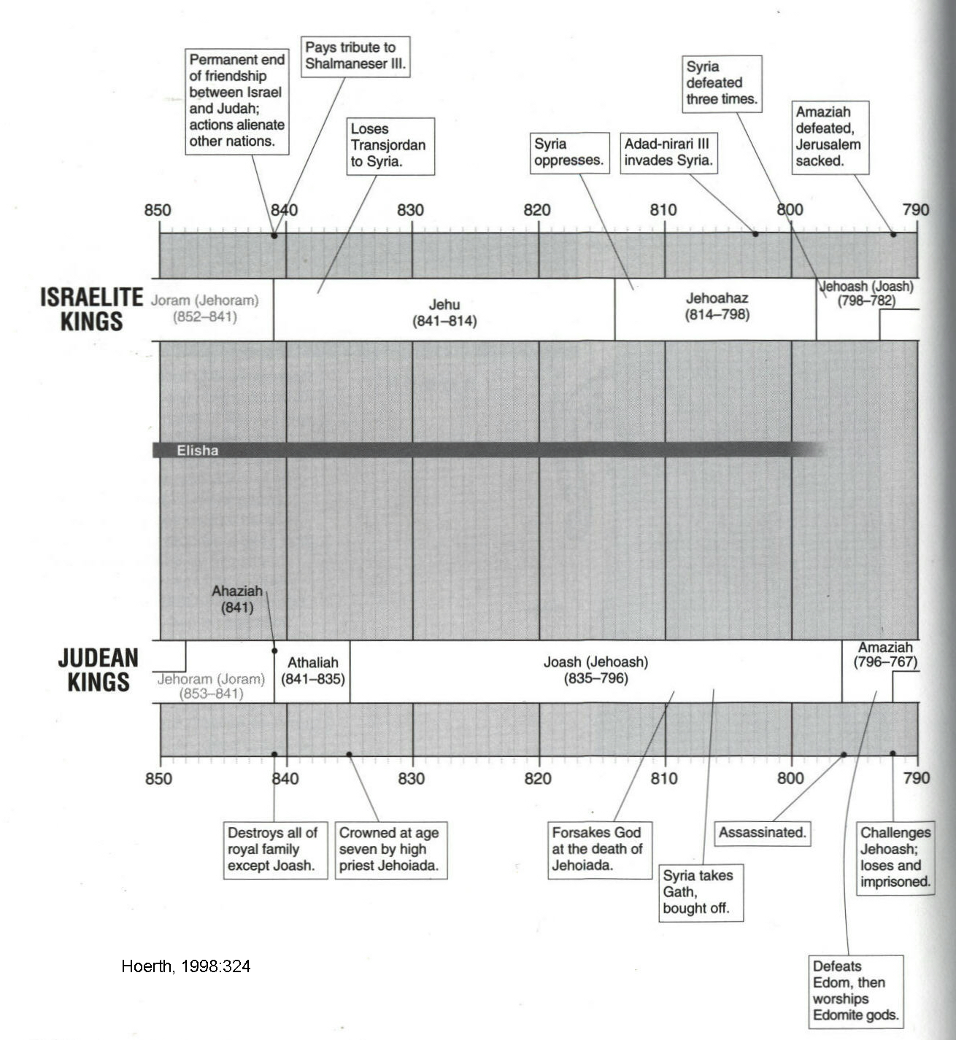

PHOTO LINK: TIMELINE 790-720 BC (Hoerth, 1998)
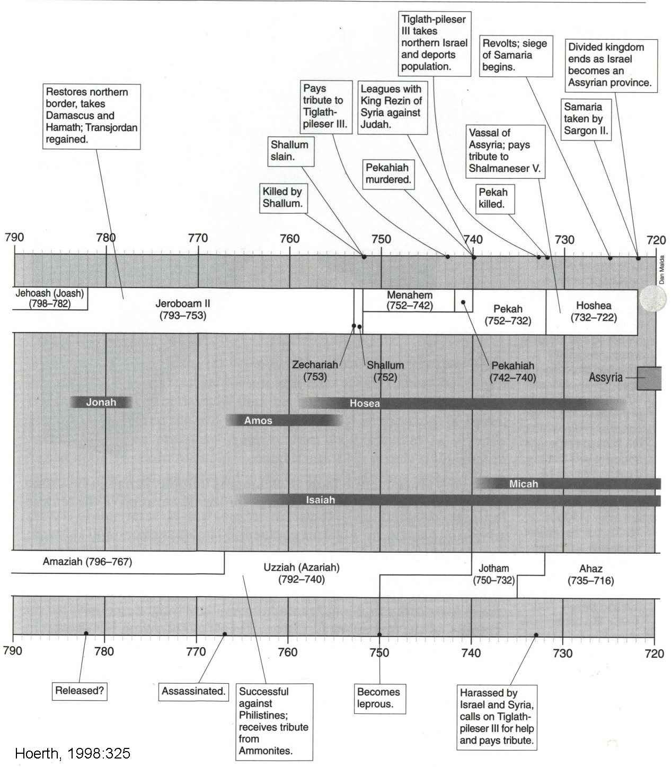

JEHU OF ISRAEL (842-841 BC)

PHOTO LINK: JEHU 001B Timeline (Whitcomb, 1968)
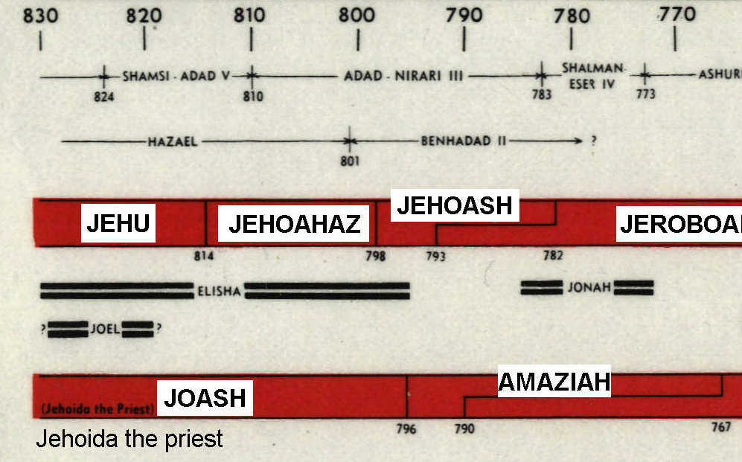

PHOTO LINK: JEHU 002B Timeline (Whitcomb, 1968)
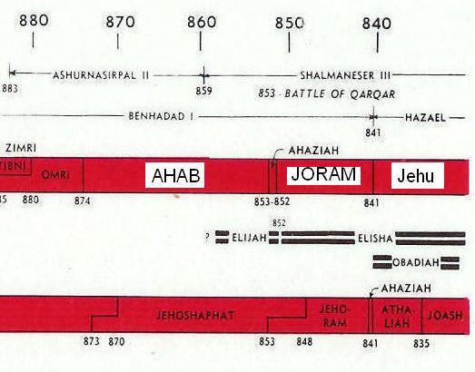

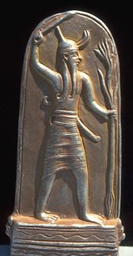
The bloody coup of General Jehu in 841 BC (2 Kings 9 and 10) was described at the end of Chapter 18. Jehu was commander of Samaritan King Joram's army and was instructed by Elisha to murder Joram of Israel, thus ending the Omri royal line (2 Kings 9-10). Following this murder and coup d'etat, Jehu lead a massacre of all of the family and confidants of Ahab. Jehu established Israel’s 4th dynasty which would last just over 100 years. This dynasty included kings Jehoahaz, Joram, and Jeroboam II.

Following the purges of Ahab’s family, Jehu eliminated Baal worship (2 Kings 10:18-27) in order to reduce competition for political-economic power from that priesthood (Hoerth, 1998:3221).

But Jehu did not destroy the golden calf shrines at Bethel and Dan (2 Kings 10:28).

PHOTO LINK: BAAL 003 Relief, Phoenician sun god ; http://www.pantheon.org/areas/gallery/mythology/middle_east/judaic/baal.html ; Feb. 2, 2006 (ABOVE)
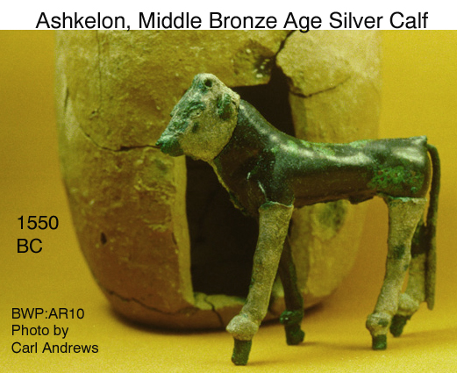

PHOTO LINK: AR010 Silver calf Ashkelon MB 1550 BC. (RIGHT)

After killing all potential opposition in Israel he found himself in a strategically poor position: He had alienated the usually friendly Phoenician city-states. Judah was no longer an ally because it was lead by Queen Athaliah who was the mother of the leader Jehu had killed (Ahaziah). Jehu had an unfinished war on his hands with Aram (Syria) after the Israelites lifted the siege of Ramoth-giliead.

Jehu and Hazael of Damascus

Although Jehu had a relatively long reign of 28 years, he was dominated by (and may have been vassal to) Hazael of Damascus (Aram-Syria) and lost all his holdings in the Transjordan to that nation (Hoerth, 1998:322).

PHOTO LINK: ARAM 004 Map of Aram and Damascus

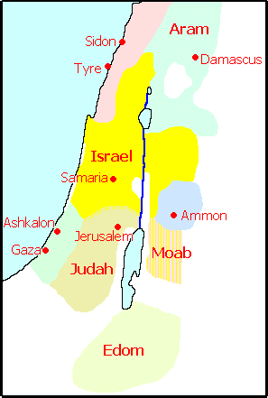
PHOTO LINK: HAZAEL OF DAMASCUS 001 Statuette of Hazael; http://www.bible-history.com/archaeology/israel/2-hazael-king-of-syria-bb.html, Sept. 22, 2010
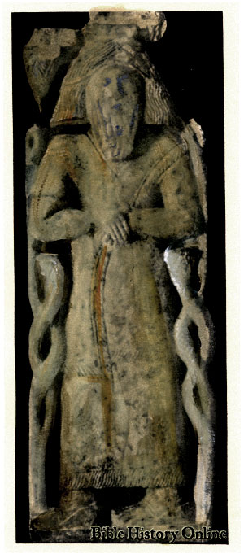

The decline of the Northern Israelite Kingdom, due to its isolationism, continued. The weakness eventually resulted in Jehu’s capture by the Shalmaneser III and the Assyrians. After 28 years of rule, he died and was succeeded by his son Jehoahaz.

SHALMANESER III (859-824 BC)

PHOTO LINK: SHALMANESER III BLACK OBELISK 008 Map of Shalmaneser III's Assyrian Empire
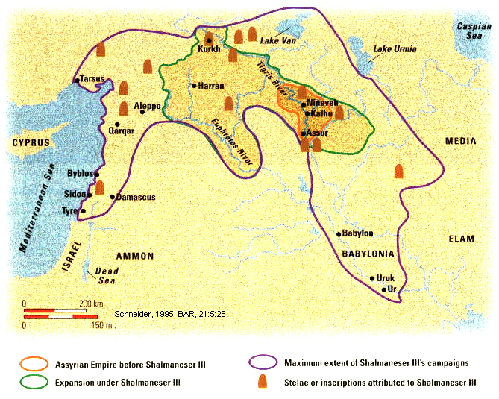

Assyria's Second Expedition to Palestine (841 BC)

Shalmaneser III attacked Israel again in 841 BC, the year of Jehu’s ascension. His first attack happened during the time of Ahab. Shalmaneser III is not mentioned as such in the biblical narrative for the first attack (1 Kings 16:29-22:40; 2 Chron 18:1-34), or in the description of Jehu’s kingship in 2 Kings 9:1-35 during his second attack.

This time, no coalition opposed him as had happened at the Battle of Qarqar (Karkar) 12 years earlier. Instead, the one friend of Israel, King Hazael of Damascus went up against on the Assyrians alone and lost 16,000 soldiers, 1,121 chariots and 470 riding horses (ANE1:191; ANET 280; illustration 15:9 cited by Hoerth, 1998:321).

Although Damascus withstood the subsequent siege, the surrounding landscape was devastated. Shalmaneser III then proceeded further west and, according to his records, captured or collected tribute from Phoenician “Tyre, Sidon and from Jehu, son of Omri” (ANE1:191; ANET 280; illustration 15:9 cited by Hoerth, 1998:321).

Shalmaneser III’s expedition of conquest is recorded on the "Black Obelisk", or "Obelisk of Shalmaneser" found at Nimrud (Biblical Calah; Wood, 1991b)

PHOTO LINK: SHALMANESER III BLACK OBELISK 001 Full view of obelisk (LEFT)
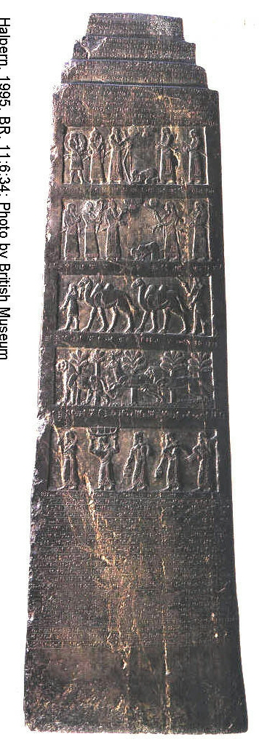

PHOTO LINK: SHALMANESER III BLACK OBELISK 002 Close up of 2nd panel with prostrate Jehu
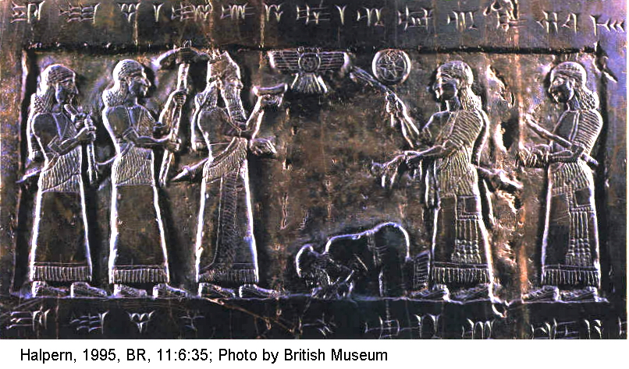
PHOTO LINK: SHALMANESER III BLACK OBELISK 004 Sketches of 4 registers
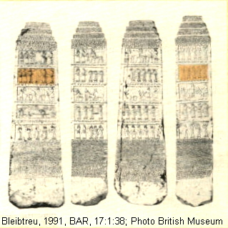

The full text regarding Jehu reads:

"I marched as far as the mountains of Hauran [i.e. northern Transjordan] destroying, tearing down and burning innumerable towns, carrying booty away from them which was beyond counting. I [also] marched as far as the mountains of Ba'li-ra'si which is a promontory [lit:at the side of the sea] and erected there a stele with my image as king. At that time I received the tribute of the inhabitants of Tyre, Sidon, and of Jehu, son of Omri." (Pritchard, 1969, p.281)

This defeat is alluded to in Hosea 10:14-15. In these verses, Shalman is a name for Shalmaneser III. Beth-arbel (vs 14) is a large mound (tell) near the modern city of Irbid in northern Jordan. The term Ba'li-ra'si of the "Black Obelisk" may refer to Mount Carmel or Ras en-Naquara at the mouth of the Dog River in central Lebanon.

PHOTO LINK: MT CARMEL 001 Map (red oval)
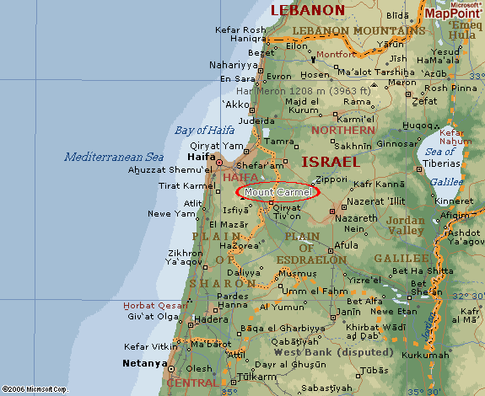

PHOTO LINK: MT CARMEL 002 Southern end of Mt. Carmel; http://www.bibleplaces.com/images/Mt_Carmel_southern_end_tb_n052500.jpg; Sept. 22, 2010
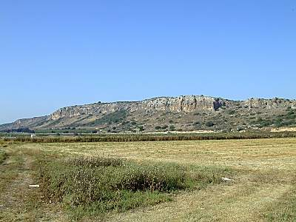

The Obelisk has a depiction of Jehu (or genetic tribute bearer) bowing before Shalmaneser III, followed by 13 Israelite porters bearing tribute has an inscription above the prostate figure which reads:

"The tribute of Jehu, son [or descendants, successors] of Omri: I received from him silver, gold, a golden saplu-bowl [goblets and pitchers], a golden vase with pointed bottom, golden tumblers, golden buckets [vessels], tin, a staff [scepters] for a king, [and] wooden puruhtu [javelins ?] (Pritchard, 1969, p.281 and Boyd, 1990, p.61; also ANE 1:192; ANET 282 cited by Hoerth, 1998:321).

The biblical chapters about the Ahab/Jehu conflict always use the phrase "House of Ahab". The phrase "House of Omri" is never mentioned. The inscription on the Black Obelisk calls Jehu "Son of Omri" (Schneider, 1995). But Jehu had no dynastic relationship to Omri. Jehu was a grand step-nephew of King Ahab of Israel through his (Jehu’s) grandfather Nimshi. Nimshi was father of a man named Jehoshaphat (not the king of Judah). Nimshi was a step-brother of Ahab through Omri, by a different mother. The genealogical relationship to Jehu was through this other wife of Omri, who’s son Nimshi was Jehu’s grandfather. This is how Jehu could be simultaneously son of Jehoshaphat and also a “son (descendent) of Omri”. That is why in 2 Kings 9:2,14 Jehu is referred to as "Jehu son of Jehoshaphat son of Nimshi". This is the only king of Israel to have his grandfather's name recorded in his patronymic. If Jehu claimed descent from Omri, the inclusion of his grandfather's name may have been necessary to establish this genealogical link (Schneider, 1995).

PHOTO LINK: SHALMANESER III BLACK OBELISK 010 Chart of Jehu’s ancestry
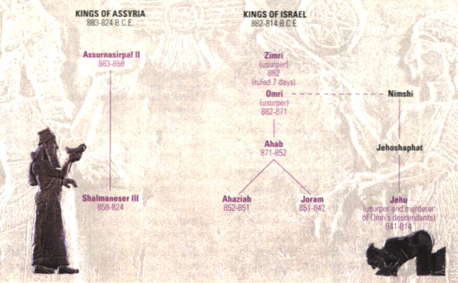

All this suggests that the Black Obelisk is correct: that Jehu was indeed a "son" of Omri”.. According to this reconstruction, the House of Omri did NOT come to an end with the death of Joram, but of course the house of Ahab did. Clan relationships are shown below (See Schneider, 1995:31):

The pictorial depiction of Jehu on the Black Obelisk was challenged by Ziffer (2013).

But there are severe problems with the suggestion that we have here a portrait of Jehu. As noted, Jehu's tribute is described in the second panel from the top. The top panel relates to the "tribute of Sua of Gilzanu." Gilzanu is in the vicinity of Lake Urmia in the far eastern part of the Assyrian empire. Israel is in the far west, on the Mediterranean Sea.

Jehu and Sua/Asu are from lands far from the Assyrian center. They are dressed identically, in a short-sleeved, fringed garment fastened at the waist by a belt. Even their headgear is identical. They lack any specific features to distinguish them from one another. Sua kneels with his hands and beard touching the ground near the king's feet in great humility. Hovering above the kneeling figure in both scenes, a winged disc and star are juxtaposed.

Surely this cannot be an individual portrait of Jehu nor even an Israelite.
The great scholar of Mesopotamian art Edith Porada has suggested that the artistic arrangement of the registers of the Black Obelisk refers to the territorial expansion of the Assyrian Empire from east to west.' Michelle Marcus notes that the lands on the registers were consciously selected because they were the farthest east and west Shalmaneser had reached. These lands functioned as a geographical resume of the king's accomplishments.

Carrying the image further, Swiss scholars 0th-mar Keel and Christoph Uehlinger have observed that east and west have been defined visually by the placement of the winged disc in the reliefs: to the right of the star, interpreted as the morning star in the case of Gilzanu, representing east, where the sun rises and, in the case of Israel, representing west, where the sun sets, to the left of the star, interpreted as the evening star.3

Israeli scholar Nadav Na'aman has pointed out that of the two kings of Gilzanu who paid tribute to Shalmaneser during his reign, Upu and Sua, the latter was selected because his name was homophonic (similarly pronounced) with Iaua, the Assyrian rendering of Jehu.4 Hence, not only did geography play a role in the selection of the vassal kings, but also their names were deliberately selected as a literary device in this masterfully propagandistic work of art. Had it not been for the labels, the tribute-bearers of the submissive kings, of identical appearance, would have remained anonymous.

The tribute-bearers in the Black Obelisk are simply generic tribute-bearers (Ziffer, 2013: 42-43).

KINGS OF ASSYRIA KINGS OF ISRAEL
883-824 BC 882-814 BC
----------------------------------------------------------------
Assurnasirpal II Zimri
883-389 (usurper)
 882
 (ruled 7 days)
 |
 Omri----------------Nimshi
 (usurper) |
 882-852 |
 | |
 .Ahab. |
 .871-852. Jehoshaphat (not the Judean king)
 . .
Shalmaneser III Ahaziah Joram Jehu
858-824 852-851 851-842 (usurper and murderer
of Omri's descendants)
841-814

PHOTO LINK: ASSYRIA 003 chart of Omrid Dynasty, Wood, 1972, p.56
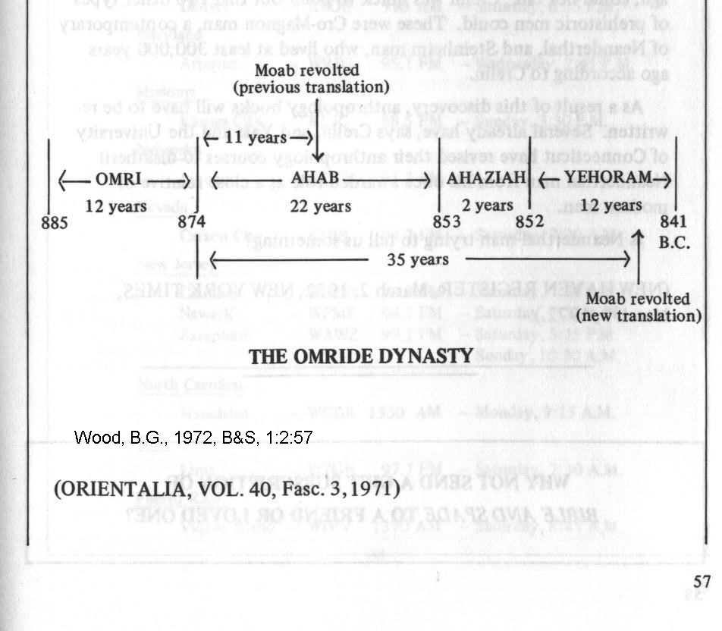

Cabul and Shalmaneser III (859-824 BC)

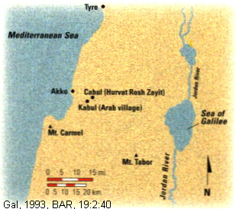
Following of the destruction of a mid-10th century fortress at Cabul (which Solomon had given to King Hiram of Tyre, 1 Kings 9:10-14), a second fortress dating to the late 10th-early 9th century was built. The later fort was completely destroyed in the middle of the 9th century BC, probably in 841 B.C., by Assyrian king Shalmaneser III (Gal, 1993; Wilson, 1995).

PHOTO LINK: CABUL 001 Location map (LEFT)

The abundance and variety of storage containers from the 9th century fortress at Cabul indicate that it was an administrative center and storage facility (Gal, 1993).

PHOTO LINK: CABUL 005 Three storage jars at Cabul 9th century BC
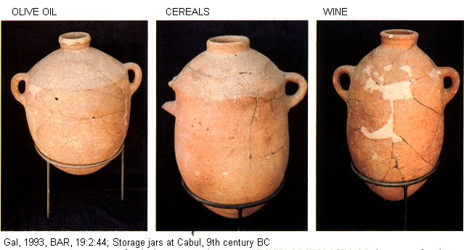

PHOTO LINK: CABUL 003 9th century BC fortress drawing and plan
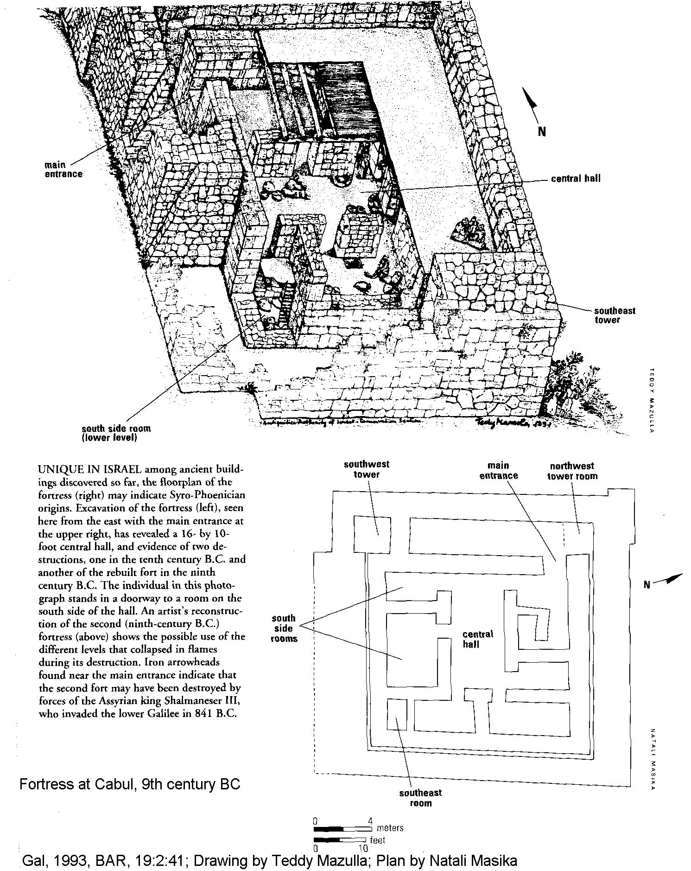

An Israelite olive oil manufacturing settlement was build in the 8th century atop the 9th century destruction layer.

PHOTO LINK: CABUL 004 Israelite olive oil settlement on top of 9th cent BC fortress.
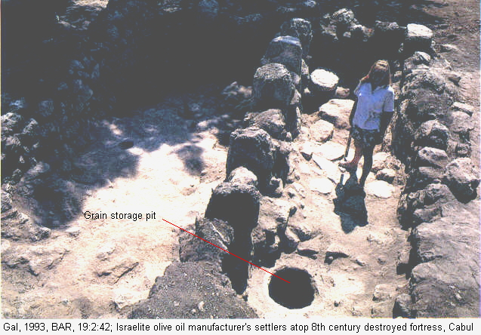

QUEEN ATHALIAH OF JUDAH (841-835 BC)

PHOTO LINK: ATHALIA QUEEN 001 Timeline (Whitcomb, 1968)
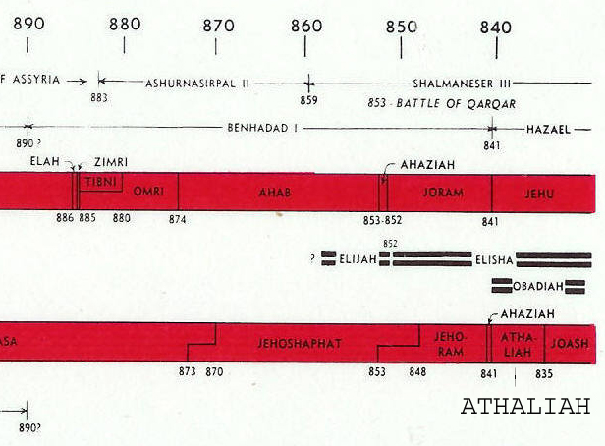

Athaliah was the only woman who ever reigned over Judah (see 2 Kings 8:18, 25-28; 11:1-20; 2 Chron 22:1-23:21; 24:7). She was the daughter of Ahab (king of Israel) and Jezebel (a devotee of Baal). Omri (king of Israel) was her grandfather, and Jehoram (also named Joram, king of Judah) was her husband. After the death of their son Ahaziah, Athaliah reigned six years. She put to death all Ahaziah's sons (2 Kings 11:1) except Joash, Jehosheba, sister of Ahaziah and wife of Jehoiada the High Priest hid in the Temple. Then, in the seventh year, Jehoiada conspired to put Jehoram on the throne. Coming into the temple to see what the excitement meant, Athaliah found that the coronation had already taken place. She was allowed to leave the temple, that it might not be defiled with her blood, but was killed as she went out the door (2 Kings 11:3-16; Compton’s Interactive Encyclopedia, 1996). The Chronicler gave her this epitaph: "The whole people rejoiced and the city was tranquil. That is how Athalia was put to the sword." (2 Chron 23:21).

PHOTO LINK: SOLOMON'S TEMPLE 014 Steps to NW corner of Muslim Platform (possible area where Athaliah was executed)
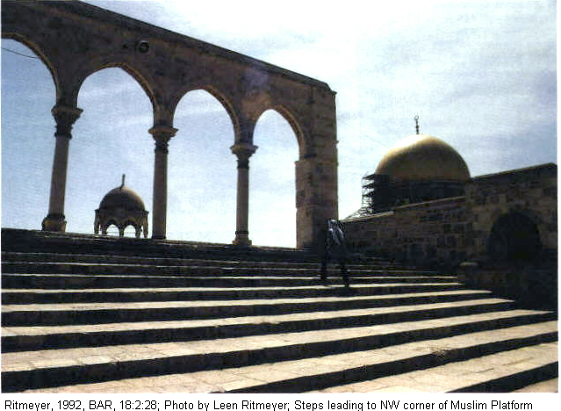

JOASH (JEHOASH, YEHOASH) OF JUDAH (835-796 BC)

Joash is also known as Jehoash (also Yehoash). There was an Israelite King with this same name (see below). Following Hoerth (1998), I use Joash for the Judean king and Jehoash for the Israelite king to reduce confusion.

Joash was only seven year's old when he became king in the coup arranged by Jehoiada the High Priest which resulted in the death of his mother (2 Chr. 23:1-15). Between the age of 7 and sometime in his teenage years, the government was probably run by Jehoiada (2 Kings 12:2). During this time, Jehoiada "made a covenant between the Lord and the whole people and the [young] king" (2 Chron 23:16). During this revival, "they went into the temple of Baal and pulled it down: they smashed its alters and images, and they slew Mattan the priest of Baal before the alters (2 Chron. 23:17). Although never officially a king, when he died, Jehoiada the Priest was buried with the kings in the City of David (2 Chron. 24:16).

PHOTO LINK: ALTAR 003 Beersheba c 715 BC Hezekiah reform. Similar to the type of alter before which Mattan was executed.
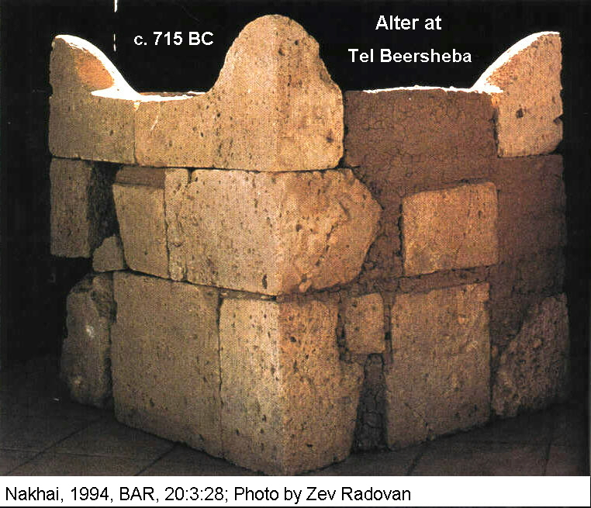

PHOTO LINK: BAAL 002 Bronze w gold foil statuette Megiddo
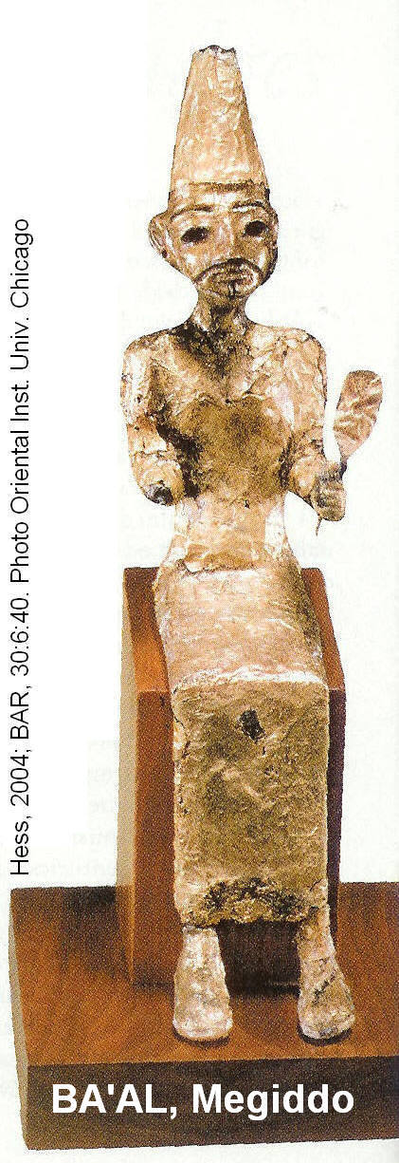
PHOTO LINK: BAAL 003 Relief Phoenician sun god; (See ABOVE, ctrl+click to follow link)

One of Joash's first acts was a religious reform to eliminate Baal worship. Later on as a young adult, he decided to restore Solomon's temple, which had been neglected since the days of Jehoshaphat. That effort was never brought to fruition, so in his twenty third year as king (about 812 BC), he ordered a new and more successful plan of Temple modernization.

PHOTO LINK: SOLOMON'S TEMPLE 081. Model
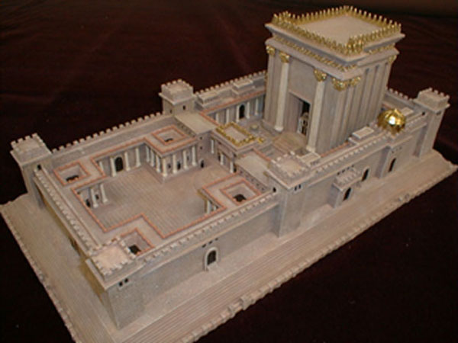
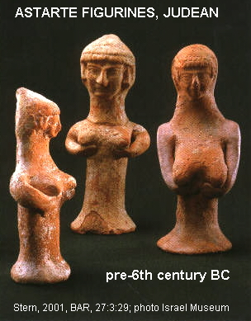
Despite ordering the Temple's restoration, after the death of Jehoiada, Joash abandoned worship of Yahweh there and (following bad advice of the leading men of Judah) instead served "the Asherim and the idols " (2 Chron.. 24:17-18).

PHOTO LINK: ASHERAH 012-B Astarte-Asherim figurines Judean pre-6th cent BC (LEFT)

PHOTO LINK: ASHERAH 002B Qudshu alias Asherah with fertility goddess Mim
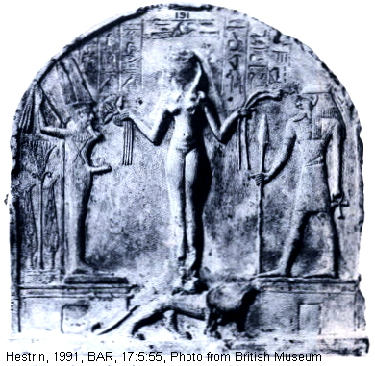

The apostasy was condemned by the prophets and by Zechariah, the son of good High Priest Jehoiada. Joash ordered Zechariah put to death and he was stoned in the Temple courtyard (2 Chron 24:21-22).

PHOTO LINK: SOLOMON'S TEMPLE 075 3-D depiction Ritmeyer Theory
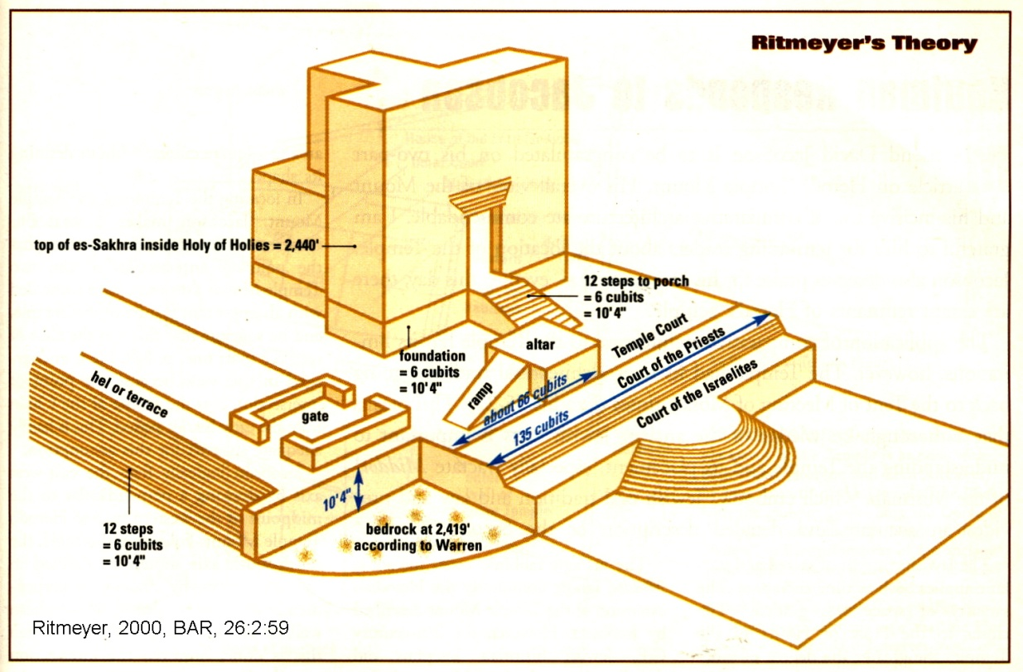

Within a year of Zechariah's death (806 BC), the army of Syria invaded Judah, captured the city of Gath and threatened Jerusalem. That army "massacred all the officers, so that the army ceased to exist (2 Chron. 24:23) Joash was forced to pay tribute from his own treasuries and also from the Temple.

Joash was assassinated in 796 BC by "his own servants...they killed him on his bed" (2 Chron. 24:25). Like other apostate kings, he was buried in the City of David, but not "in the burial place of the kings" (2 Chron. 24:26).

A controversial inscription bearing part of King Joash’s (Jehoash of Judah's) name appeared in 2003. Geologic testing of the artifact indicates that it is authentic, but epigraphers believe it is a forgery (Shanks, 2003).

PHOTO LINK: JEHOASH (OF JUDAH) INSCRIPTION 001 Tablet
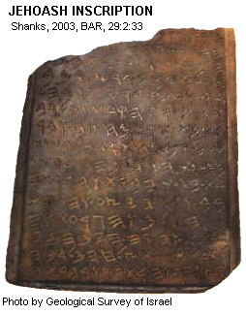

PHOTO LINK: JEHOASH (OF JUDAH) INSCRIPTION 002 Translation
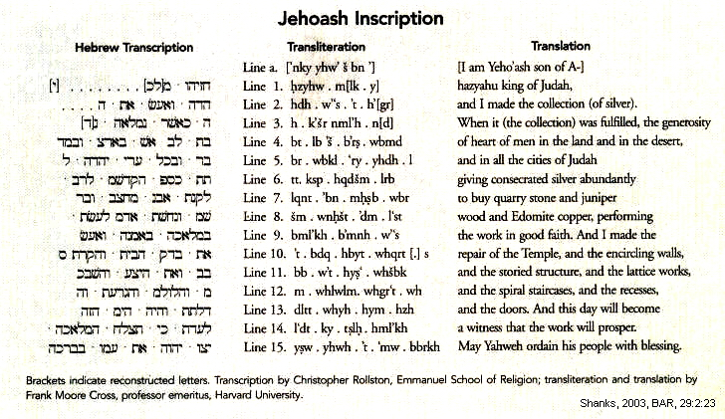
The inscription has 15 lines. The translation by Frank Moor Cross as related by Shanks (2003:23) is as follows:

a. [I am Yaho'ash son of A-]
1. hazyahu king of Judah.
2. and I made the collection (of silver).
3. When it (the collection) was fulfilled, the generosity
4. of heart of men in the land and in the desert,
5. and in all the cities of Judah
6. giving consecrated silver abundantly
7. to buy quarry stone and juniper
8. wood and Edomite copper, performing
9. the works in good faith. And I made the
10. repair of the Temple, and the encircling walls
11. and the storied structure, and the lattice works,
12. and the spiral staircases, and the recesses,
13. and the doors. And this day will become
14. a witness that the work will prosper
15. May Yahweh ordain his people with blessing

The inscription is similar to information contained in 2 Kings 12:5-6 and 12:12-13. The inscription has been declared a forgery by paleographers (Shanks, 2003) and linguists (Greenstein, 2003). A minority of scholars are unimpressed by epigraphic arguments against its authenticity (Freedman, 2004). In 2008 a group of geologists and archaeologists concluded that the inscription was authentic (Ilani et all, 2008; Shanks, 2009). This was based on presence of gold globules1 to 4 micrometers in size within the patina.

JEHOAHAZ OF ISRAEL (814-798 BC)

PHOTO LINK: JEHOAHAZ 001 Timeline (Whitcomb, 1998)
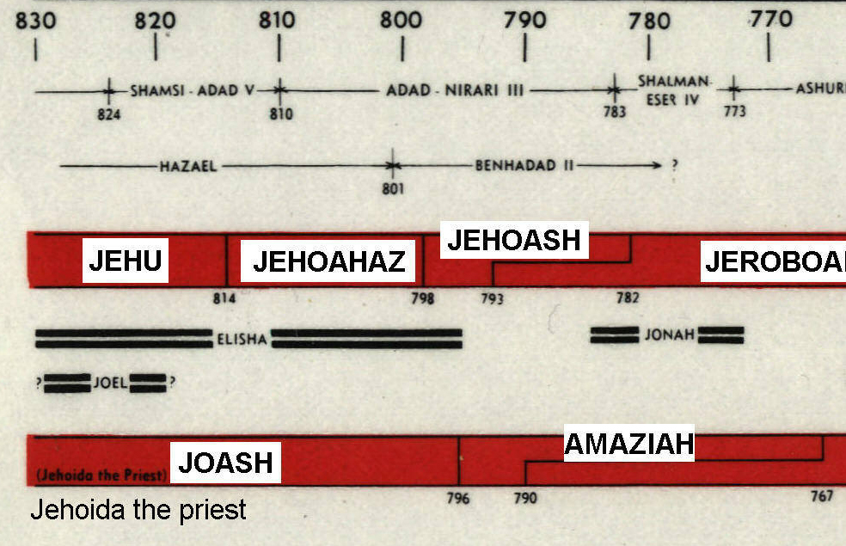

Jehu's son, Jehoahaz was also under the dominion of Syrian kings Hazael and Ben-hadad (2 Kings 13:3). Jehoahaz was an evil apostate king, but he called to the Lord for help and was delivered by an unnamed champion (2 Kings 13:5). Despite being saved by Yahweh, Jehoahaz and his nation continued their syncretism and henoism by Asherah worship.

Adad-nirari III of Assyria (803 BC)

The unnamed deliverer of Jehoahaz of Israel was probably King Adad-nirari III of Assyria. In about 803 BC he brought his armies into Aram (Syria; ANET 281-282 cited by Hoerth, 1998:327). The records of Adad-nirari give an account of this invasion:

I marched against the country...I shut up [the] king of Damascus in Damascus, his royal residence. The terror-inspiring glamour of Ashur [chief God of Assyria] overwhelmed him and he seized my feet, assuming the position of a slave of mine. Then I received in his own palace in Damascus, his royal residence, 2,300 talents of silver corresponding to 20 talents of gold, 5,000 talents of iron, garments of linen with multicolored trimmings, a bed inlaid with ivory...and countless other objects being his possession.

Adad-nirari III (also Adad-narari III) was King of Assyria from 811 to 783 BC. He was the son and successor of Shamshi-Adad V, and was apparently quite young at the time of his accession, because for the first five years of his reign his mother Sammuramat acted as regent, which may have given rise to the legend of Semiramis (http://www.arikah.net/encyclopedia/Adad-nirari_III; Sept. 13, 2006).
Adad-nirari's youth, and the struggles his father had faced early in his reign, caused a serious weakening for the Assyrian rulership over Mesopotamia, and gave way to the ambitions of the most high officers, the governors and the local rulers (http://www.arikah.net/encyclopedia/Adad-nirari_III; Sept. 13, 2006).
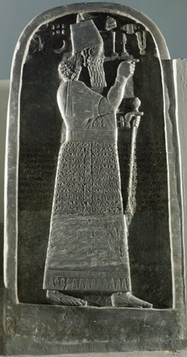
According to Adad-nirari's inscriptions, he led several military campaigns with the purpose of regaining the strength Assyria enjoyed in the times of his grand-father, Shalmaneser III. According to the eponym canon, he campaigned in all directions until the last of his 28 years of reign, and he was the builder of the temple of Nabu at Nineveh. Among his actions was a siege of Damascus in the time of Ben-Hadad III in 796 BC, which led to the eclipse of the Aramaean Kingdom of Damascus and allowed the recovery of Israel under Jehoash (who paid the Assyrian king tribute at this time) and Jeroboam II (http://www.arikah.net/encyclopedia/Adad-nirari_III; Sept. 13, 2006).
In spite of Adad-nirari's vigor, Assyria entered a several decades long period of weakness following his death (http://www.arikah.net/encyclopedia/Adad-nirari_III; Sept. 13, 2006).

PHOTO LINK: ADAD-NARARI III 001 Relief on gravestone (LEFT)

PHOTO LINK: ADAD-NARARI III 002 Treaty monument
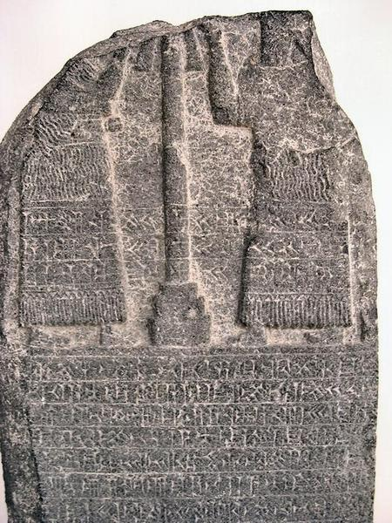

For once, the hated and feared Assyrians did something to help Israel. But that good luck would not last. After a seventeen year reign, Jehoahaz was succeeded by Jehoash of Israel.

JEHOASH (JOASH) OF ISRAEL (798-782 BC)

PHOTO LINK: JEHOASH 001 Timeline (Whitcomb, 1968)
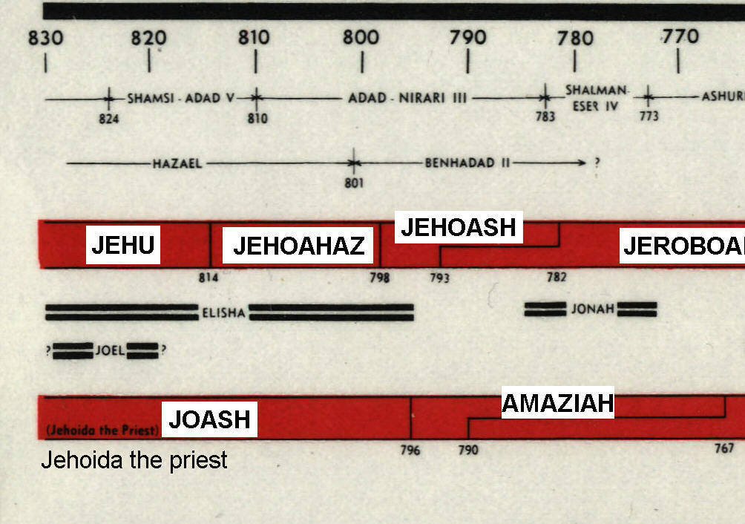

Jehoash is also known as Joash or Yehoash). There was a Judean King named Joash (or Jehoash) who ruled 835-796 (see above). Following Hoerth (1998), I use Joash for the Judean king and Jehoash for the Israelite king to reduce confusion.

PHOTO LINK: JEHOASH 002 Timeline (Hoerth, 1998)
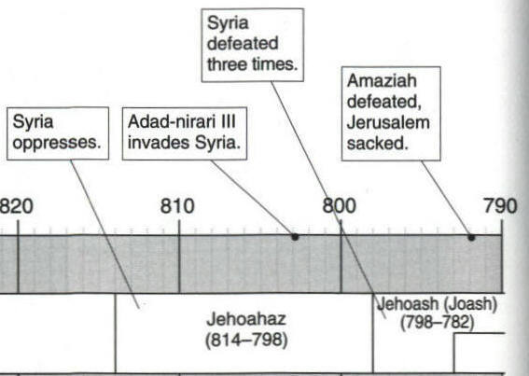

At the beginning of the 8th century BC, political fortunes of both Israel and Judah began to improve. The Old Testament tells of no interaction between Elisha and either of the earlier kings of Israel, Jehu or Jehoahaz. During the early part of the reign of Jehoash of Israel, a terminally ill Elisha prophesied to him that Aram (Syria) would be defeated 3 times (2 Kings 13:14-19). Shortly thereafter, Hazael of Aram died and was succeeded by his less capable son Ben-Hadad (2 Kings 13:24; Hoerth, 1998:328).

Defeat of Ben-Hadad III (c. 800 BC)

The name Ben-Hadad III appears three times in 2 Kings 13 (verses 13,24, and 25). He was a contemporary of Amaziah king of Judah (796-767 BC) and Jehoash king of Israel (798-782 BC). During the reigns of Hazael and Ben-Hadad (Bir-Hadad), Israel was subject to Aram (2 Kings 13:3). The death of Hazael and his succession by Ben Hadad about 800 BC is recorded in 2 Kings 13:24. The next verse (2 Kings 13:25) tells of Joash's (Jehoash's) three victories over Ben-Hadad III in the early 8th century BC (Wood, 2000:89). Details of these battles are not given in the Bible.

This Aramean king is known from two other sources outside the Bible: the Zakkur Stela and an inscription from the reign of Assyrian king Adad-narir III mentioned in the section "Jehoash King of Israel", above (See p. 24-25 and PHOTO LINK: ADAD-NARARI III 001 Relief on gravestone; ctrl+click to follow link)
PHOTO LINK: ZAKKUR STELE 001 Photo of from Lovre Museum; http://www.insecula.com/loeuvre/photo_ME0000043156.html; Sept. 13, 2006

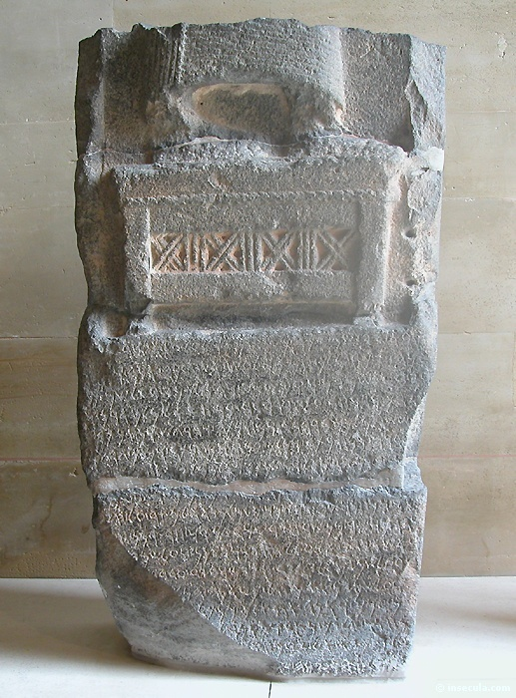
The Zakkur Stela was a memorial inscription set up by Zakkur, king of Hamath and Luash. These where sister city-states in central Syria. It describes how an attack on Hadrach (capital of Luash?) by an alliance of kings lead by Ben-Hadad was repulsed (Rosenthal, 1969:655-656, cited by Wood, 2000).

Hadrach is mentioned in Zechariah 9:1 and Hamath is a boundary landmark for Solomon's kingdom (2 Chron. 8:4).

Archaeological findings at Gath add important information to the career of Ben-Hadad III.

An unusual dry siege moat encircles Tell es-Safi (Gath). It is 1.5 miles long, 25 feet wide (at the top) and 20 feet deep. The moat is 13 feet wide at it's base which contains Iron Age II pottery. This is the first such moat ever discovered. They were constructed by besiegers to keep residents from escaping and from receiving supplies. The moat also discouraged counter-attacks. This dry moat offensive siege strategy is described in two ancient texts: 1) Tutmosis III's siege of Megiddo in 1482 BC and 2) the siege of Syrian Hadrach by Bir-Hadad (Ben-Hadad III) son of Hazael c. 800 BC. The later is recorded in the Zakkur inscription, described above. The pottery in the lowest parts of the trench is similar to types from northern Israel or southern Syria. This may be due to the attack of Gath by Aramean troops of King Hazael described in 2 Kings 12:18. This would be consistent with the Zakkur description which tells of the use of the dry siege moat by Hazael's son Bur-Hadad (Ben-Hadad III; Maeir and Ehrlich, 2001:30-31).

PHOTO LINK: GATH 003 Map of travels of Ark when in Philistine control

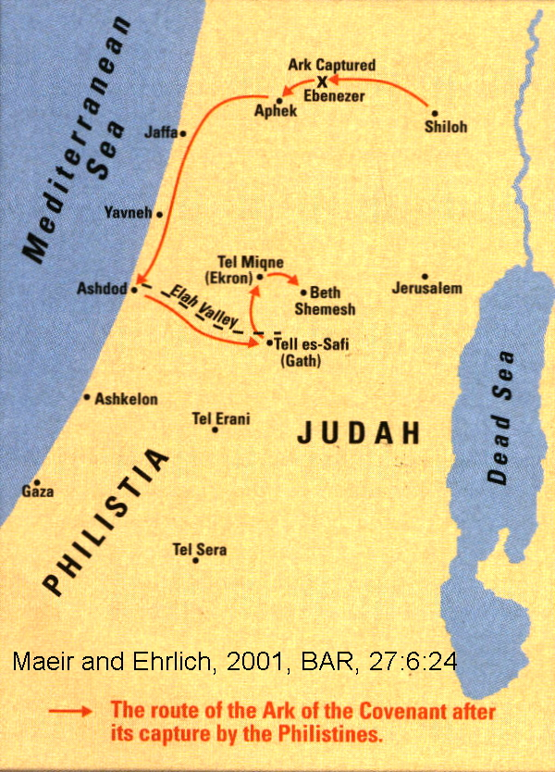

PHOTO LINK: GATH 005 Dry siege moat at Gath - Tell es-Safi 1.5 miles long, 20 ft deep, 25 ft wide
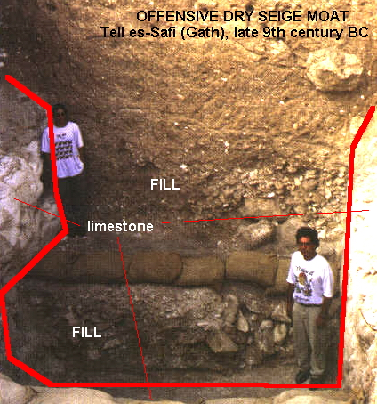

PHOTO LINK: GATH 004 Photo Tell es-Safi early 20th cent BC
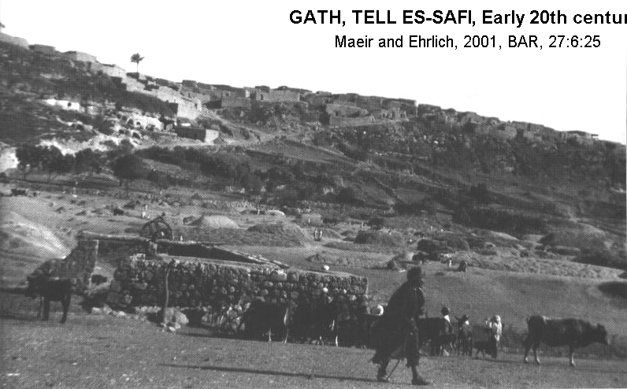

Defeat of Jehoash of Israel by Adad-Narari III of Assyria (796 BC)

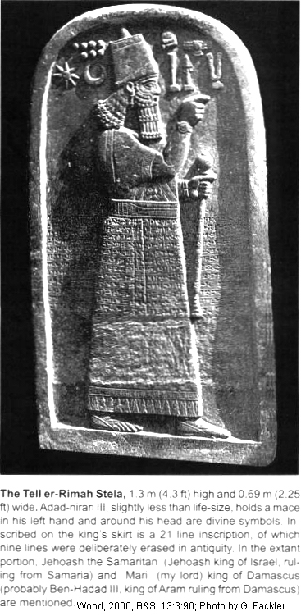
The Bible tells of Jehoash’s military successes against Ben-Hadad of Syria (2 Kings 13:24) and Judah (2 Kings 14:8-14), but not of his defeat by Assyria. The Stele of Assyrian King Adad-Nirari III (ca 811-782 BC) found at Tell al-Rimah in Iraq tells of this defeat:

“I received the tribute of Jehoash the Samaritan, of the Tyrian [ruler] and the Sidonian [ruler]. (Page, 1996; Wood, 1991b; 2000:90).

Tell al-Rimah (also named er-Rimah) was a small fortified Assyrian provincial center 65 km west of Nineveh in modern Iraq. The stele of Adam-Nirari III tells of his defeat of the king of Mari, (Ben-Hadad III, Aramean of Damascus). The stele has no date recorded on it, but the campaign is believed to have occurred in 796 BC (Wood, 2000:90). This date comes from two other sources describing the same campaign, the Calah Slab and Saba's inscriptions (Oppenheim, 1969; Pitard, 1987, cited by Wood, 2000).

PHOTO LINK: ASSYRIA 024 Tell er-Rimah Stela of Adad-narari III (RIGHT)

PHOTO LINK: ADAD-NARARI III 004 Stela of Adad-Nirari III at Tell al-Rimah mentioning tribute of Jehoash the Samaritan CA 800 BC.
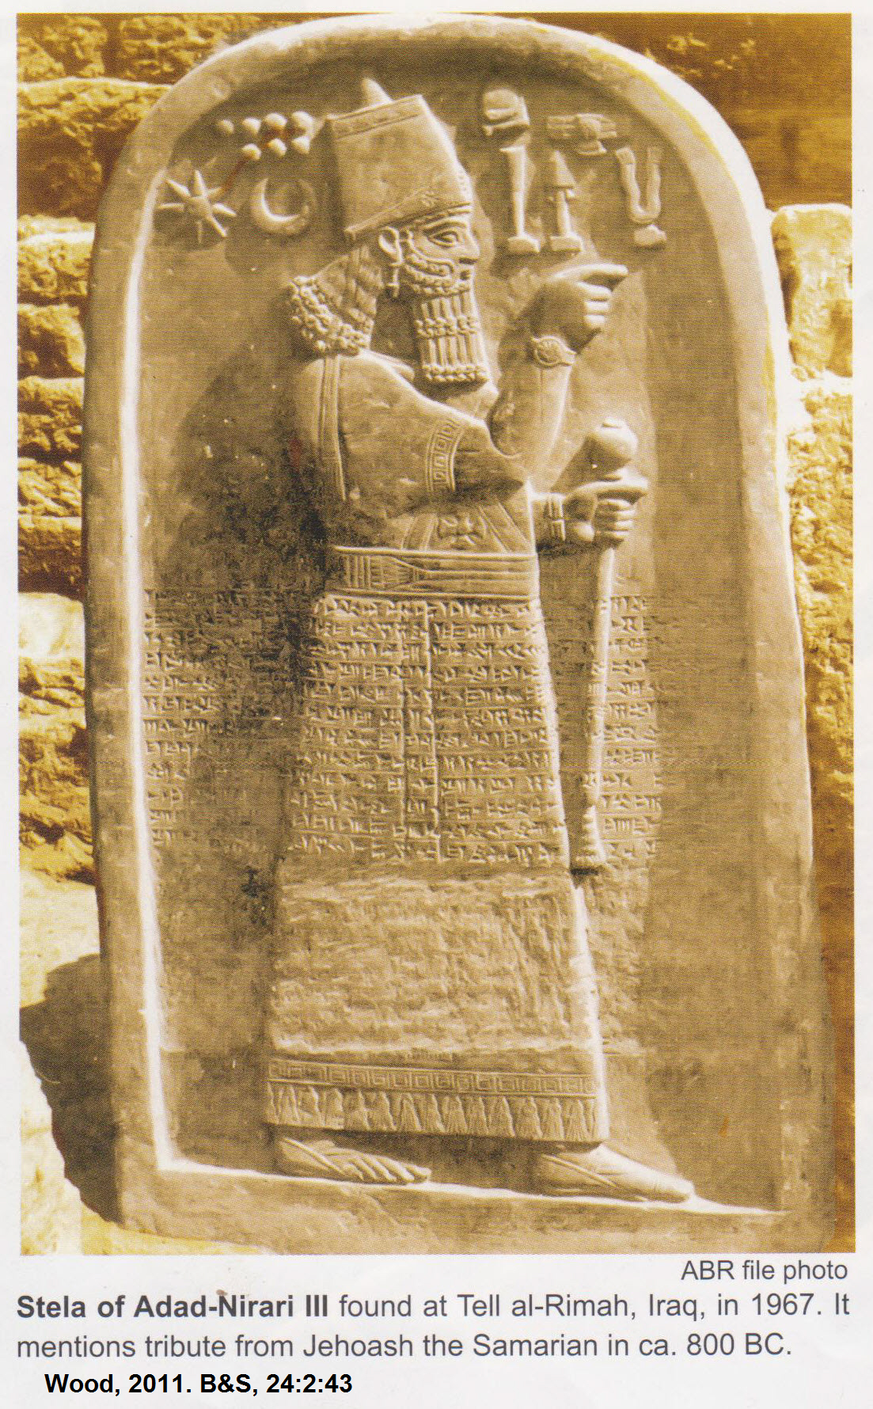

AMAZIAH OF JUDAH (796-767 BC)

PHOTO LINK: AMAZIAH OF JUDAH 001
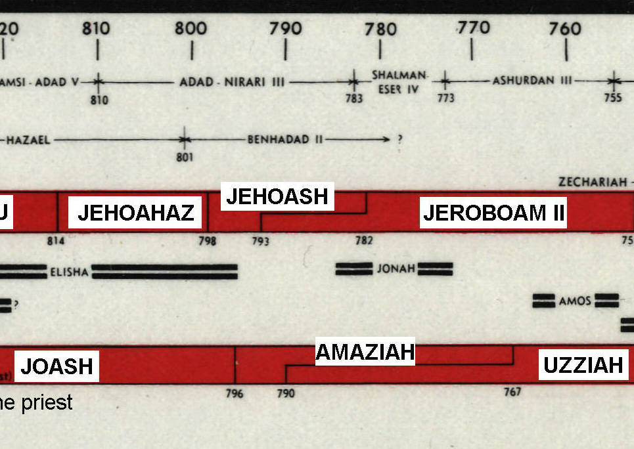

Amaziah was faithful to Yahweh (at first), but like his father Joash, he allowed rural hill top shrines to remain "and the people still continued to slaughter and burn sacrifices there" (2 Kings 15:4). The editors of Kings championed centralized worship in Jerusalem, so kings that allowed worship and sacrifices outside of the Temple (as many of the common people wanted) were criticized. After consolidating power, he took revenge against the servants who had murdered his father Joash, but spared their children (2 Kings 14:6). As the city expanded, the city's cemetery was moved to hills outside the city's new walls.

PHOTO LINK: JA029 Jerusalem: Israelite Tomb Antechamber, 8th century BC
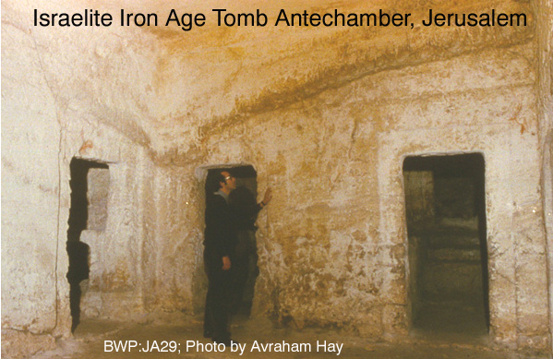

PHOTO LINK: JA030 Jerusalem: Israelite Tomb Burial Chamber
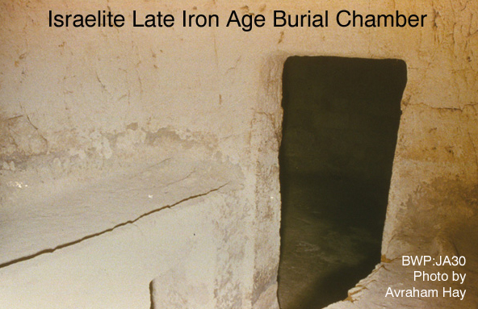

PHOTO LINK: JA031 Jerusalem: Israelite Tomb Repository
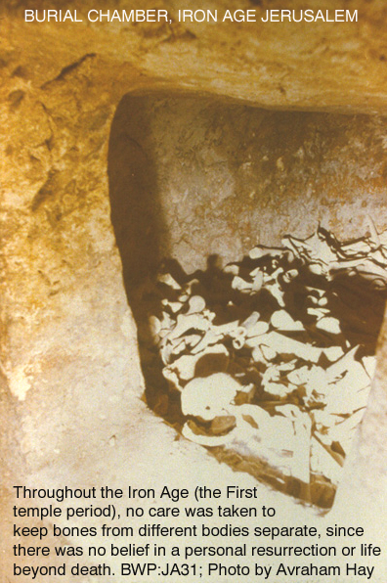

Invasion of Edom and the fortress of Sela/Petra (793 BC)

In 793 BC, Amaziah successfully invaded Edom and the fortress of Sela (modern Petra).

PHOTO LINK: PETRA 001 Palace tomb at Petra; http://www.raingod.com/angus/Gallery/Photos/MiddleEast/Jordan/Petra/images/PalaceTomb.jpg; Sept. 15, 2006
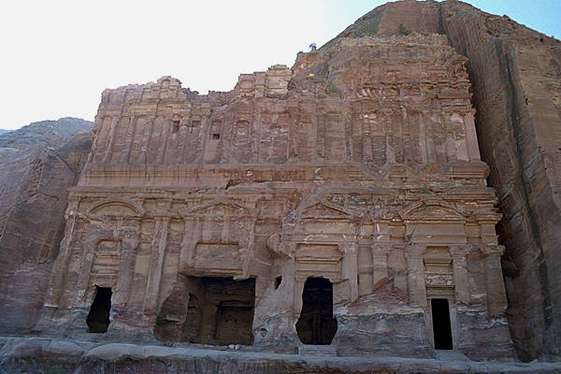

PHOTO LINK: PETRA 002 Royal tombs at Petra; http://www.raingod.com/angus/Gallery/Photos/MiddleEast/Jordan/Petra/images/Sextius.jpg; Sept. 15, 2006
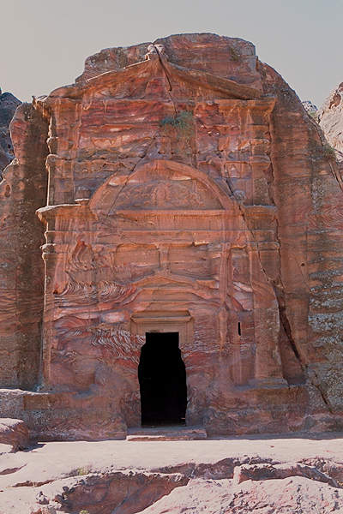

PHOTO LINK: PETRA 003 The Siq Khazneh narrow passageway to enter Petra; http://www.raingod.com/angus/Gallery/Photos/MiddleEast/Jordan/Petra/images/SiqKhazneh.jpg; Sept. 15, 2006
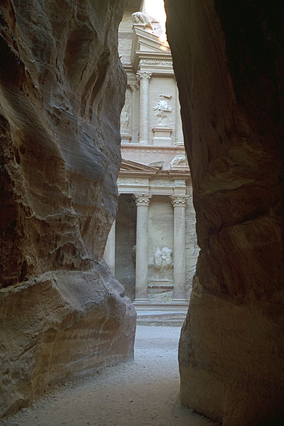

PHOTO LINK: PETRA 004 Location map
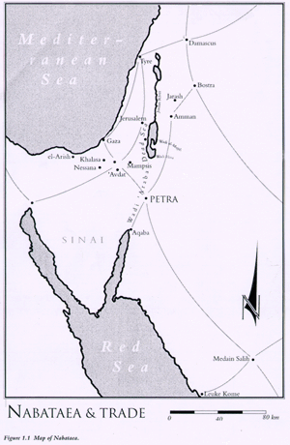

Amaziah started the invasion with allied Ephriamite troops from Israel, but an unnamed "Man of God" warned against using them. Epriam is south of Manasseh and north of Judah (see map p. 40).

PHOTO LINK: MAP 12 TRIBES OF ISRAEL 002
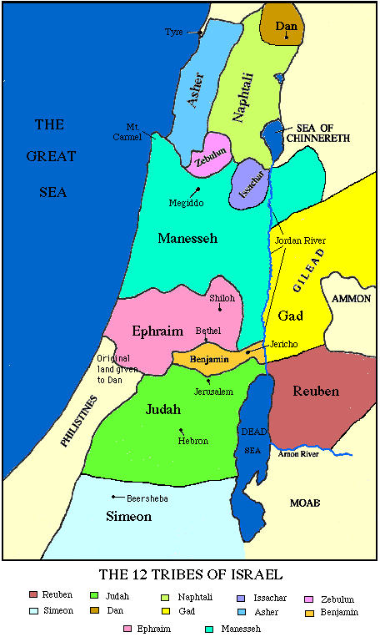

If Amaziah did use the Ephriamite troops, this would cause God to "overthrow you in battle". Amaziah followed that advice and dismissed the troops, causing humiliation and anger. Amaziah marched on to the Valley of Salt (i.e Dead Sea), won the battle and threw 10,000 Edomites over a cliff.

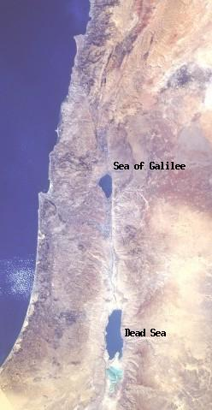
PHOTO LINK: DEAD SEA 013 Dead Sea-Sea of Galilee satellite photo

PHOTO LINK: DEAD SEA 018 Archaeological sites around the Dead Sea
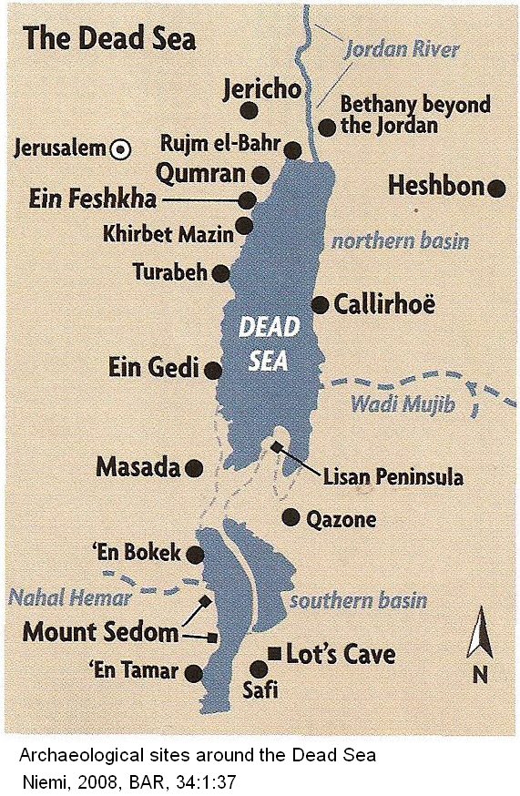

PHOTO LINK: DEAD SEA 002 Salt saucers on pillars
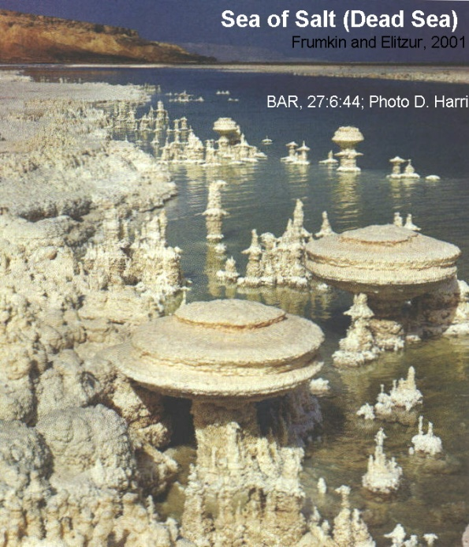

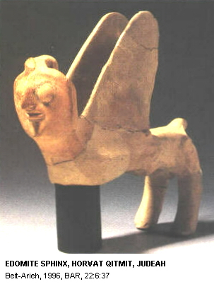
Meanwhile, his insulted Ephriamite "allies," made their way home. The Ephriamites "raided the cities of Judah from Samaria to Beth-horon, killing 3,000 and taking spoils” (2 Kings 14:7; 2 Chron. 25:7-12). Later, Amaziah would retaliate. While Edom became a vassal state of Judah, Amaziah made himself vassal to Edomite religion by abandoning Yawehism and worshiped the Edomite pantheon (2 Chron. 25:14).

PHOTO LINK: EDOM 004 Winged Edomite sphinx found at Horvat Qitmi (RIGHT)

PHOTO LINK: AR062 Horvat Qitmit Edomite Shrine, Religious center in Negev
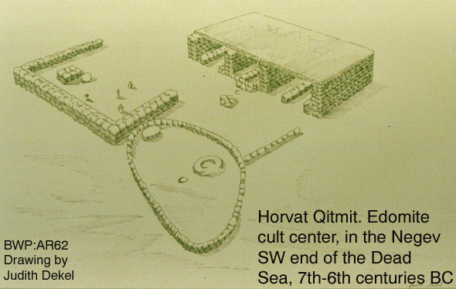

War with Jehoash of Israel: Battle of Beth-shemesh (c. 767 BC)

PHOTO LINK: JEHOASH 001 Timeline (Whitcomb, 1968); (See ABOVE, ctrl+click to follow link)

Upon returning to Jerusalem from his conquest of the Edomites, Amaziah turned his attention to Israel and issued challenge to a battle. Jehoash responded to the challenge with a warning in the form of a parable. The warning was rejected. The battle between Amaziah of Judah and Jehoash of Israel was engaged in Judean territory at Beth-shemesh.

PHOTO LINK: BETH SHEMESH 003 Location map
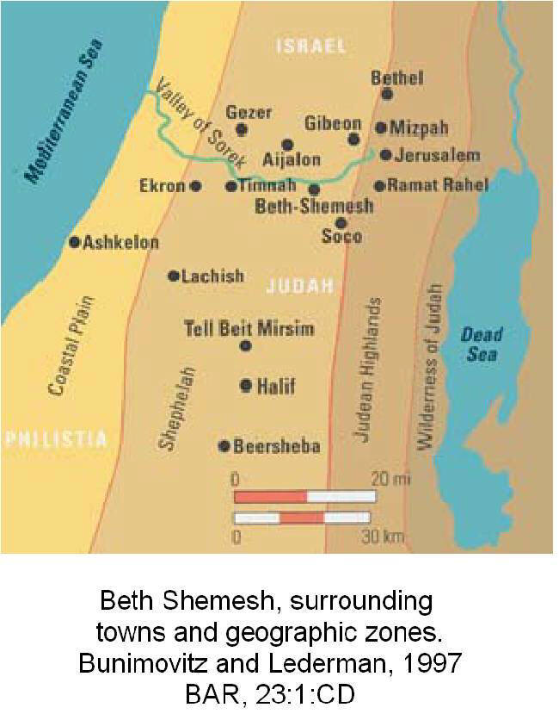

PHOTO LINK: BETH SHEMESH 001 Panorama; Bunimovitz and Lederman, 1997, BAR, 23:1:CD

The Judean forces where routed and fled to their homes. Amaziah was captured by Jehoash who took him to Jerusalem. There, Amaziah was apparently one of the hostages, and his imprisonment initiated the co-regency of Uzziah. Upon the ascension of Jeroboam II on Israel's throne, Amaziah of Judah was released from prison. He fled from a conspiracy in Jerusalem and was killed at Lachish (2 Kings 14:19).

PHOTO LINK: LACHISH 031 aerial photo
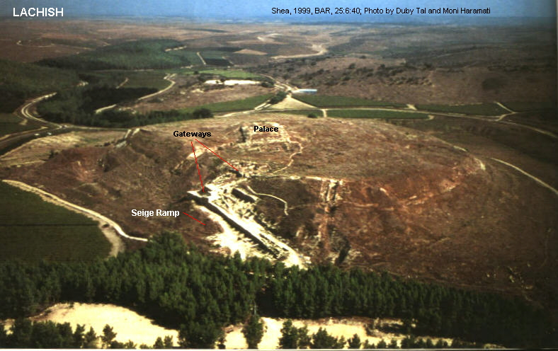

PHOTO LINK: LACHISH 034 Location map of Lachish
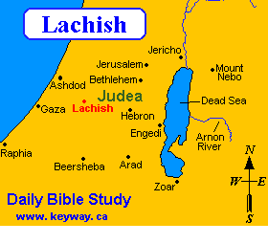

PHOTO LINK: LACHISH 006 Photo of Judean Palace-Fort at Lachish (site where Amaziah was killed)
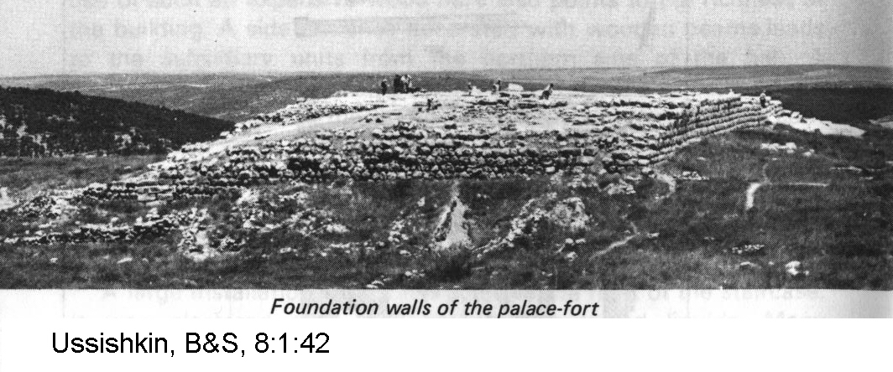

Beth Shemesh of king Amaziah or king Uzziah

During the reign of Amaziah, a double gate complex may have been built at Beth Shemesh. It could also have been built by king Uzziah when he expanded his kingdom into Philistine territory (Bunimovitz and Lederman, 1997).

PHOTO LINK: BETH SHEMESH 002 Ain Shems Excavations 1928-1931; Bunimovitz and Lederman, 1997, BAR, 23:1:CD
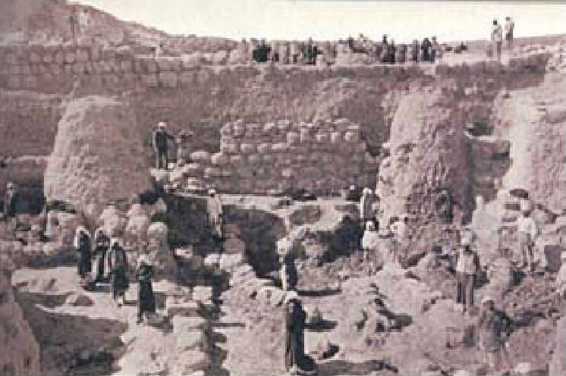

PHOTO LINK: BETH SHEMESH 004 Plan of Beth Shemesh; Bunimovitz and Lederman, 1997, BAR, 23:1:CD
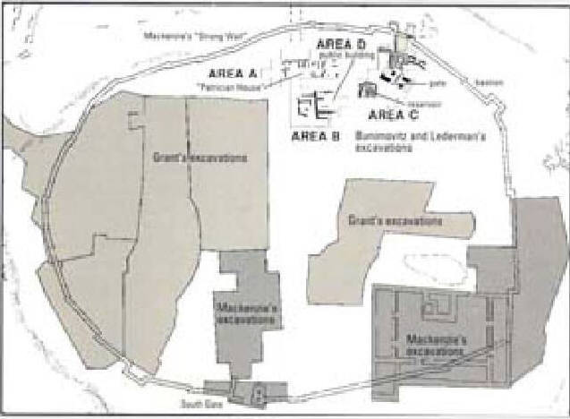

JEROBOAM II OF ISRAEL (783-753 BC, or 774-748 BC)

PHOTO LINK: JEROBOAM II 003 Timeline (Hoerth, 1998).
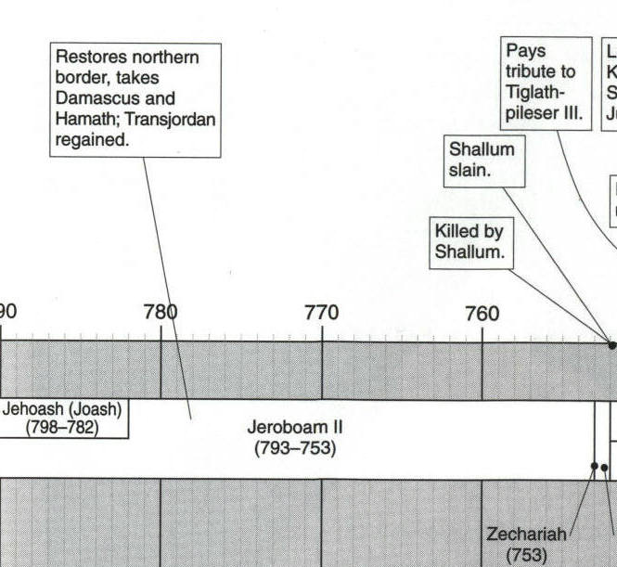

Jeroboam II succeeded his father Jehoash and continued his father's apostate policies. He "re-established the frontiers of Israel from Lebo-hamath [Entrance of Hamath] to the Sea of the Arabah [Dead Sea]" in fulfillment of the prophecy of Jonah of Gath-hepher (2 Kings 14:25, this is the same Jonah of "big fish" fame).

Hamath was the capital of one of the kingdoms of Upper Syria of the same name, on the Orontes, in the valley of Lebanon, at the northern boundary of Palestine. Hamah is beautifully situated on the Orontes, 32 miles north of Emesa, and 36 south of the ruins of Assamea. The kingdom of Hamath comprehended the great plain lying on both banks of the Orontes from the fountain near Riblah to Assamea on the north, and from Lebanon on the west to the desert on the east. The "entrance of Hamath" (Num. 34:8), which was the north boundary of Palestine, led from the west between the north end of Lebanon and the Nusairiyeh mountains.
(http://www.christiananswers.net/dictionary/hamath.html, Sept. 16, 2006)

PHOTO LINK: JEROBOAM II 004 Timeline (Whitcomb, 1968)
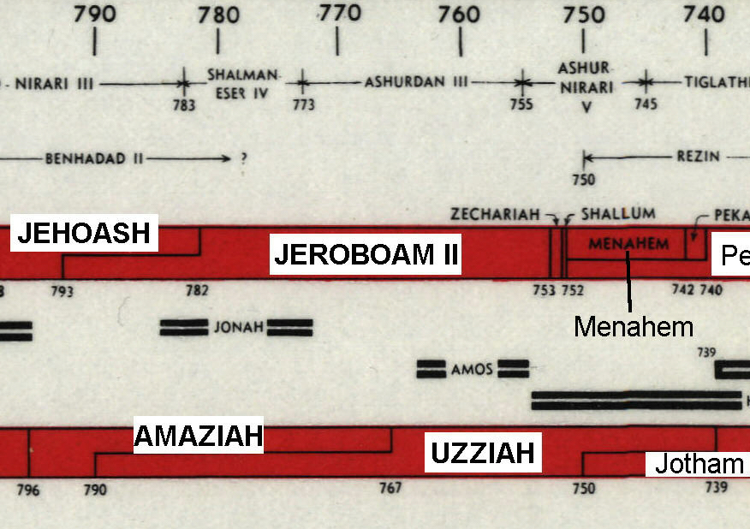

Jeroboam II also "recovered Damascus and Hamat in Jaudi for Israel" (2 Kings 14:28). The "Entrance of Hamath" is probably the valley to the east-southeast of Damascus, and the "Sea of Arabah" is the Dead Sea. Jeroboam II took advantage of an international climate wherein Assyria was weakened and preoccupied with Armenia, while Aram (Syria) had not recovered from the earlier attacks of Adad-narari III (Hoerth, 1998, 329).

A Seal of Shema, reading "[Belonging] to Shema servant of Jeroboam" was found at Megiddo in 1904. It was made of japser and was sent to the Turkish Sultan in Istanbul. Unfortunately, it has disappeared. A bronze copy of it was made, however, and is now in the Rockerfeller Museum in Jerusalem. The seal had eliptical dimensions of 3.7 cm x 2.7 cm. The artistic motif of the seal is a roaring lion. This "Jeroboam" of this seal was the person we refer to as Jeroboam II, king of Israel. Shema is not mentioned in the Bible, so we don't know anything else about him. The workmanship of the original seal suggests he was a high-ranking official (784-748 BC Lemaire, 1995; 793-753 BC Wood 2000b).

PHOTO LINK: BULLEA SHEMA 001 Seal of Shema servant of Jeroboal II
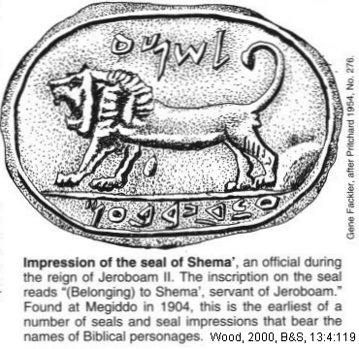

PHOTO LINK: JEROBOAM II 001 Seal of Shema servant of Jeroboam II
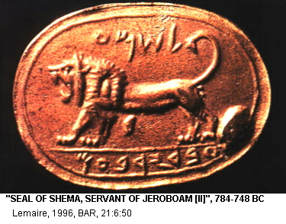

PHOTO LINK: GA027 Megiddo, Lion Seal of Shema

Dan of Jeroboam II (782-753 BC)

Jeroboam II, like Ahab before him, expanded the high place (bamot) at Dan. New steps where added, and two long rooms called leshakot (singular lishkah) which served as offices. These rooms were also features of the Jerusalem Temple (Ezra 8:29; 1 Chron. 9:26; Biran, 1998:40).

PHOTO LINK: DAN 006 Aerial Photo
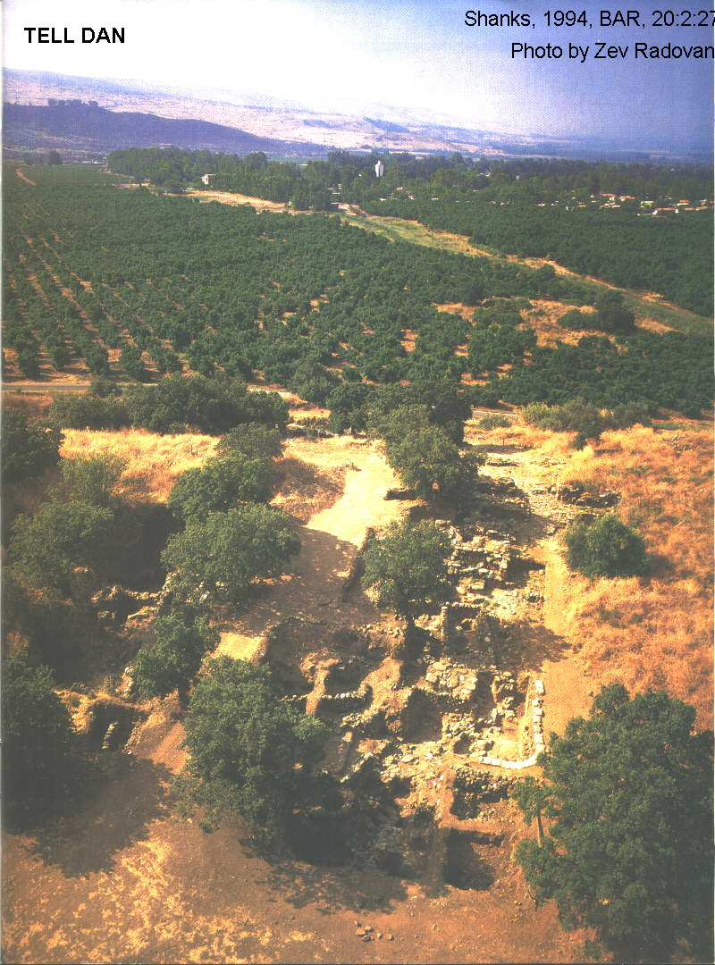

PHOTO LINK: DAN 007 Location Map
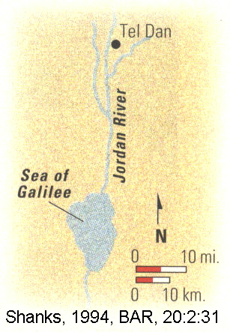
PHOTO LINK: AR101 Tel Dan, Lishkah Altar, 9th Century BC
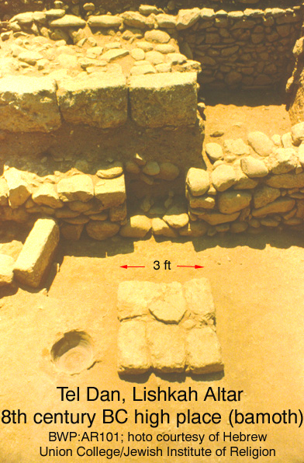

PHOTO LINK: DAN 017 Topographic map and plan
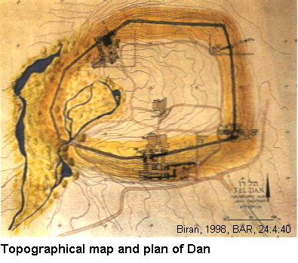

PHOTO LINK: AR044 Dan high place
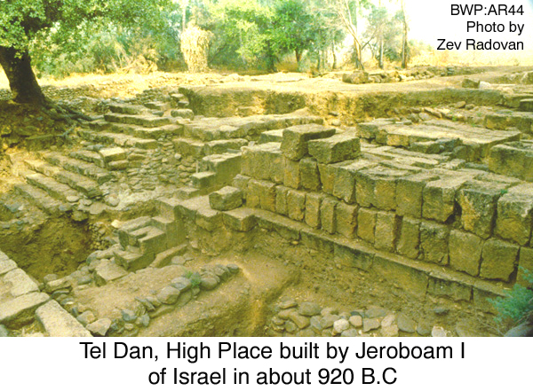

PHOTO LINK: GA045 Dan, Platform (bamah) at City Gate, 9th cent BC
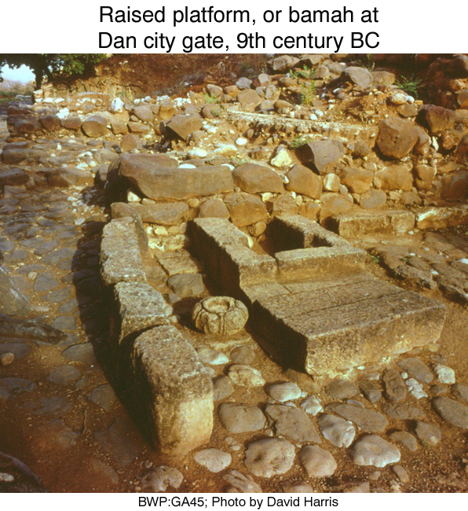

From the Jeroboam II period, three long-handled iron shovels used to supply coal to the altar, two incense altars and a bronze scepter head were found (Biran, 1998:40).

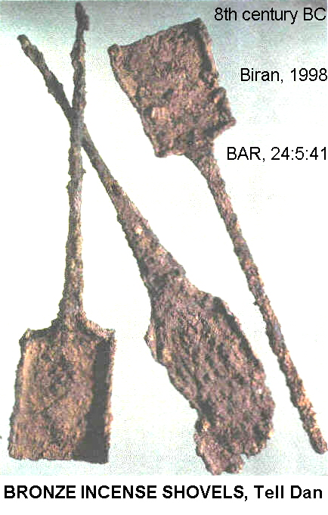
PHOTO LINK: DAN 019 Three iron shovels used for coal

PHOTO LINK: GA046 Dan, Scepter Head, 9th cent BC
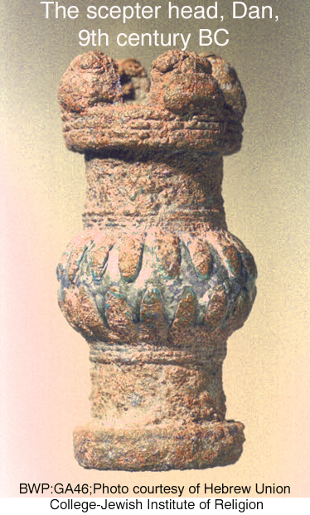

Samaritan Ostraca of Jeroboam II

A large collection of pottery shards used for writing were found scattered beneath the floor of a Samaritan administrative building [at Dan?] had been used as temporary records for wine and cosmetic oil inventories. These ostraca date from the reign of Jeroboam II and illustrates the "good life" which the prophet Amos denounced (Amos 6:4-6). Nearly all the clans of the tribe of Manasseh are named, showing that those tribal groups still had social organization in Jeroboam II's day (Biran, 1998).

JONAH (c. 785-770 BC)

PHOTO LINK: JONAH 001 Line drawing; Jonah and great fish; http://thegospelcoalition.org/blogs/rayortlund/files/2010/01/jonah1.jpg; Sept. 23, 2010
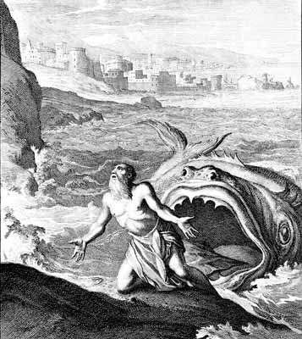

Jonah's prophecy of restoration for Israel (2 Kings 14:25) would have been a popular one among those Jews living in Samaria at the time. In this setting, it is understandable that he would flee from an assignment to faraway Niniveh.

PHOTO LINK: NINEVEH 002 Location map
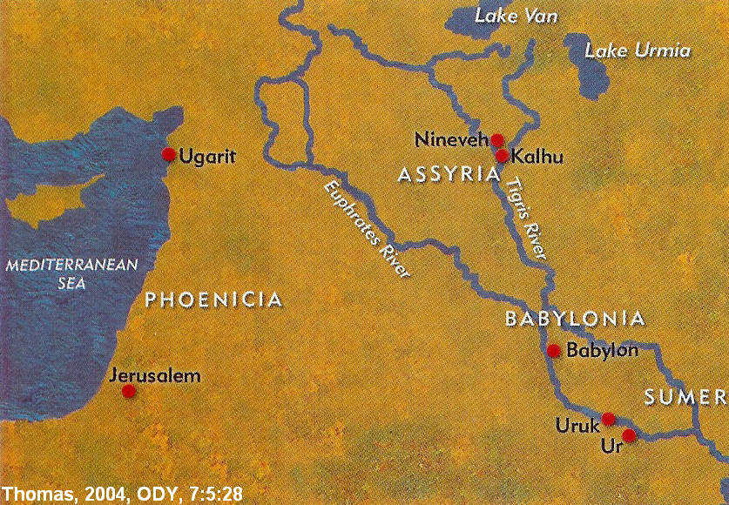

PHOTO LINK: NINEVEH 003 Painting of Nineveh; http://www.crystalinks.com/nineveh.html, July 17, 2006
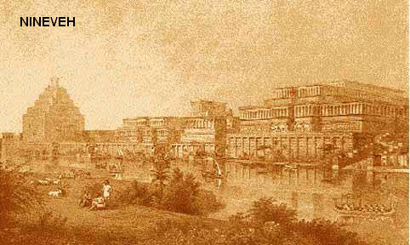
PHOTO LINK: NINEVEH 004 Kuyunjik palace mound at Nineveh; http://www.crystalinks.com/nineveh.html; Sept. 10, 2006
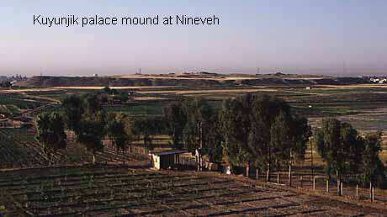

During the early years of the reign of Rehoboam II, Assyria was a weakened nation. Jonah, like many in Samaria and Judah, were not eager for an Assyria recovery. Yahweh's offer of forgiveness conditioned only on Assyrian repentance was the last thing a good Jew would want (Jonah 4:2). Nineveh’s acceptance of Jonah's message didn't guarantee it lasting peace with Judah or Israel, however.

Some people go to great lengths to show how a human could survive in the body cavities of certain types of whales. I think they miss the point of the story. It is a parable. The people that created it did not think of it as a historical record, and neither should we.

UZZIAH (AZARIAH) OF JUDAH (792-740 BC or 767-739 BC)

PHOTO LINK: UZZIAH 001 Timeline (Whitcomb, 1968)
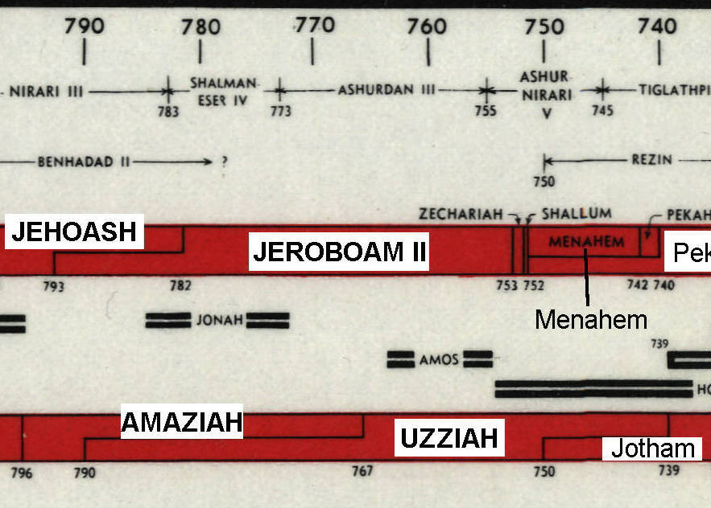

With Amaziah's murder in 767 BC at Lachich, Uzziah became sole king of Judah at the age of sixteen. He had an exceptionally long reign of fifty-two years (2 Kings 15:1-7; 2 Chron. 26). Like his father (Amaziah) and grandfather (Joash), Uzziah was devoted to Yahweh, but permitted rural worship at hill-top shrines (2 Kings 15:4).

PHOTO LINK: DAN 016 Bahmot Platform of Jeroboam 938 to 907 BC close up
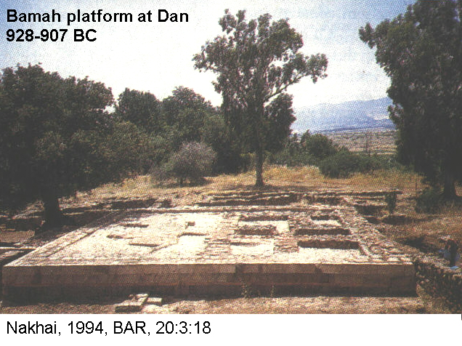

Uzziah took advantage of weakness of the Edomites and Arabs to the south and built up the military and restored the territory to Judah (2 Kings 14:22; 2 Chron. 26:11-15).

PHOTO LINK: EDOM 013 Map
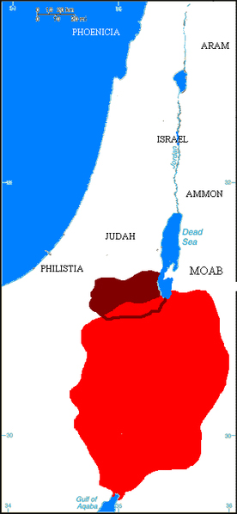

PHOTO LINK: KINGS HIGHWAY 001
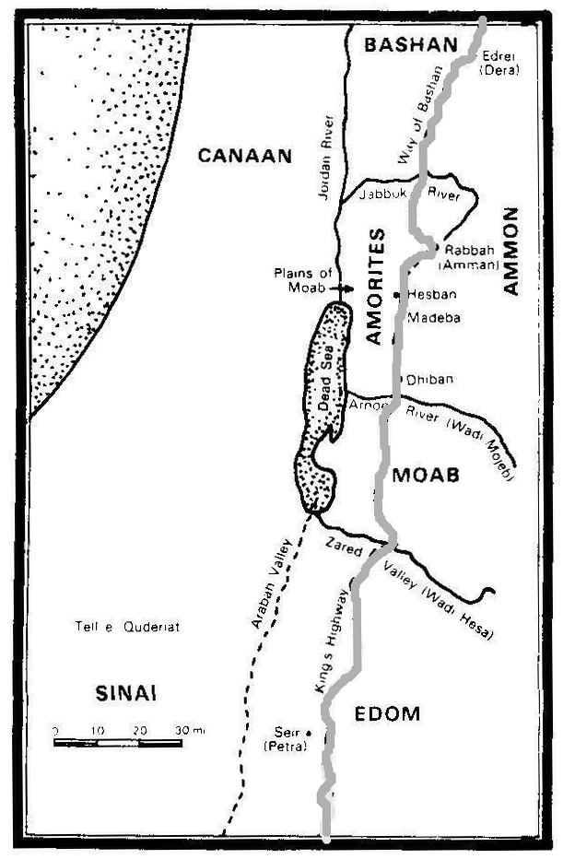

PHOTO LINK: KINGS HIGHWAY 002; Map of Kings Highway and Via Maris; http://en.wikipedia.org/wiki/Image:Ancient_Levant_routes.png ; Aug. 26, 2006. King’s Highway in red.
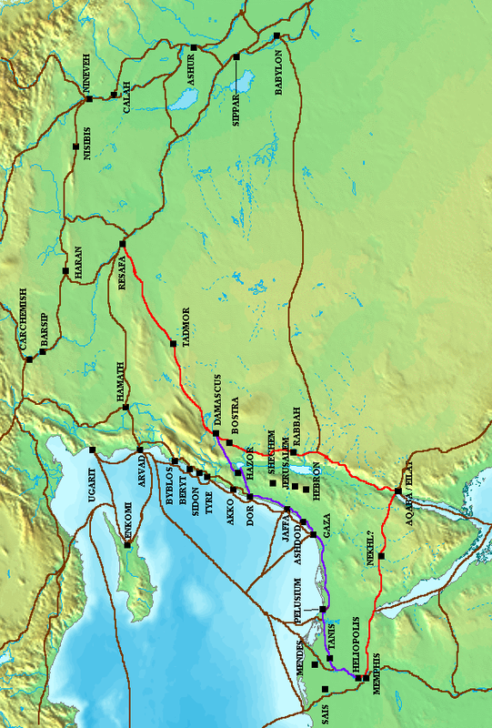

He conducted a military campaign against the Philistine coastal cities of Gath, Jabneh and Ashdod. He also established new cities in Ashdod's territory.

PHOTO LINK: PHILISTINE 014 Map of Philistine cities and expansion
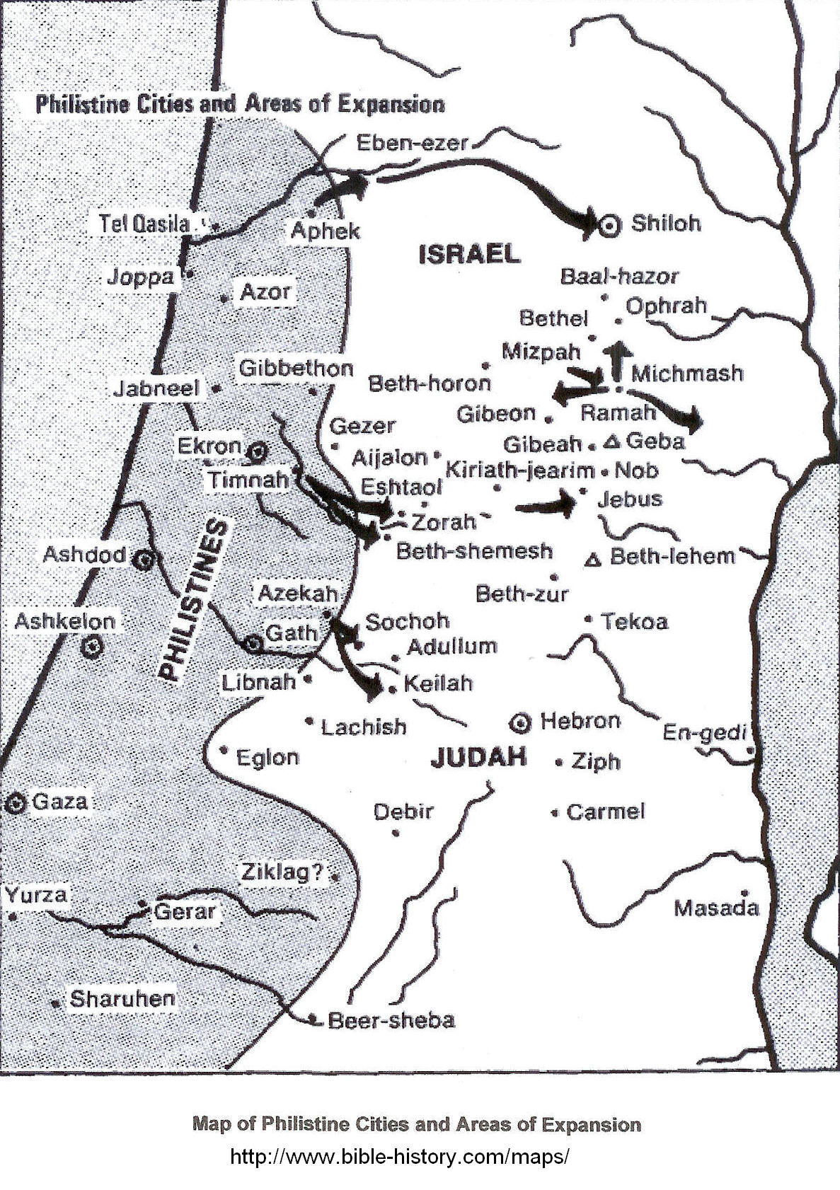

PHOTO LINK: PHILISTINE 008 Map of the Philistine Pentapolis
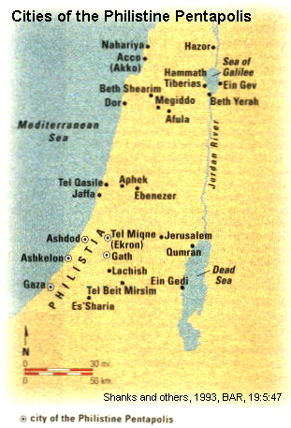

To the east, Uzziah had success against Arabs in Gur-baal and against the Meunites. The location of Gur-ball is uncertain. The Meunites were trading nomads of the Transjordan (Wood, 200b). He received tribute from the Ammonites .

PHOTO LINK: AMMONITE 011 Map of Jephthah’s invasion routes into Ammon.
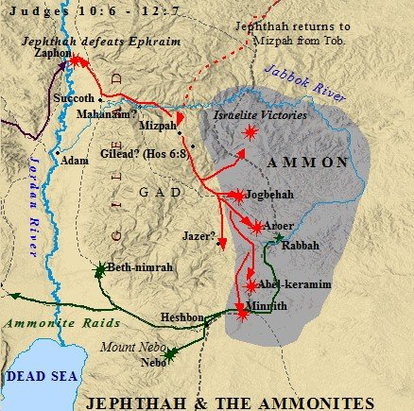

Uzziah also embarked on a fortification program for Jerusalem and expanded agricultural production in the Shephelah plain by improving the irrigation system (1 Chron. 26:6-10).

PHOTO LINK: BETH SHEMESH 003-B Geographic zones of Israel (includes the Shephelah) (See ABOVE, p .43; ctrl+click to follow link)

Uzziah’s Army

Uzziah built up his army with conscripts form every family and conducted a census under adjutant-general Jeiel to see that each family provided its share of soldiers. He also built war siege engines, towers and catapults (2 Chron. 26:15).

PHOTO LINK: SIEGE TACTICS 006 Battering rams&moving siege tower
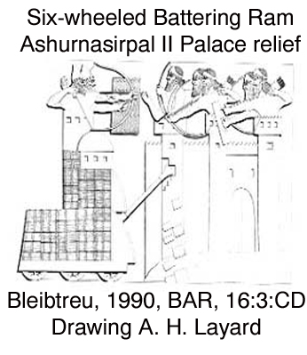

PHOTO LINK: SIEGE TACTICS 007 Battering rams&gate Sargon II Palace

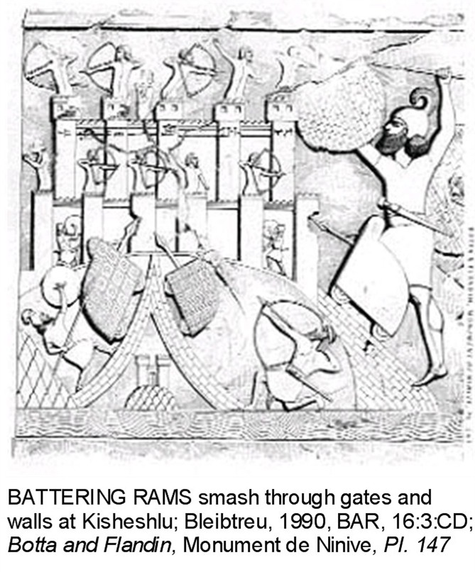
PHOTO LINK: LACHISH 021 Chains to deflect battering ram
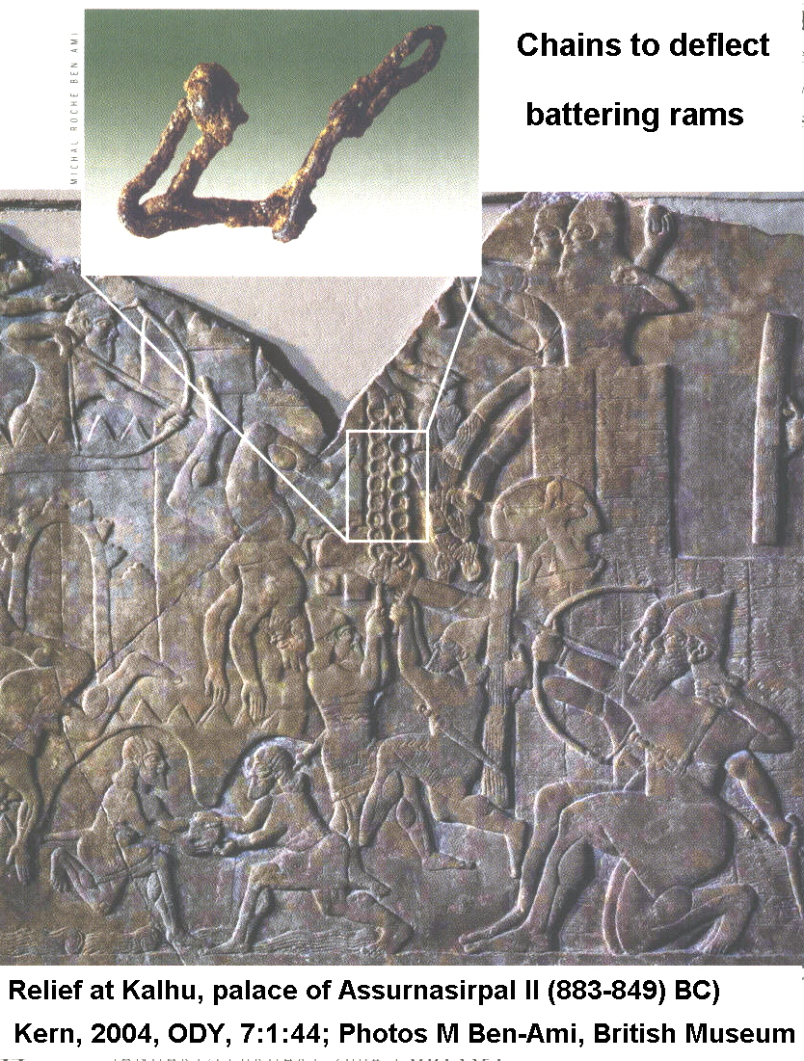

Uzziah’s Elath

Other building activities of Uzziah included creation of a seaport at Elath (Ezion-Geber) and he rebuilt towns in Philistia (2 Chron. 26:2, 6-10).

PHOTO LINK: ELATH 001-B Map (Eilat in map, below at bottom of map, at the north end of the Gulf of Acaba.
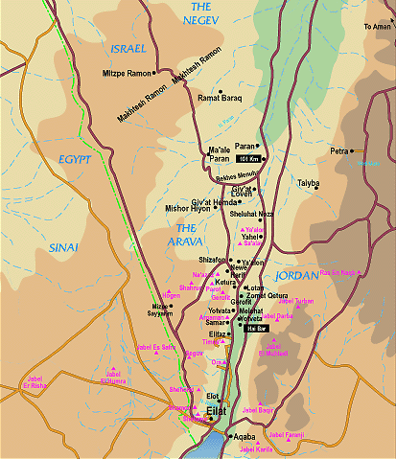

PHOTO LINK: PHILISTINE 008 Map of the Philistine Pentapolis; (See ABOVE, p. ; ctrl+click to follow link)

Uzziah in the Negev

Uzziah also reinforced fortresses in the Negev. An example is the fortress at Tell 'Ain el-Qudeirat.
PHOTO LINK: ESN053 Tell ’Ain el-Qudeirat (Aerial), 784-733 BC
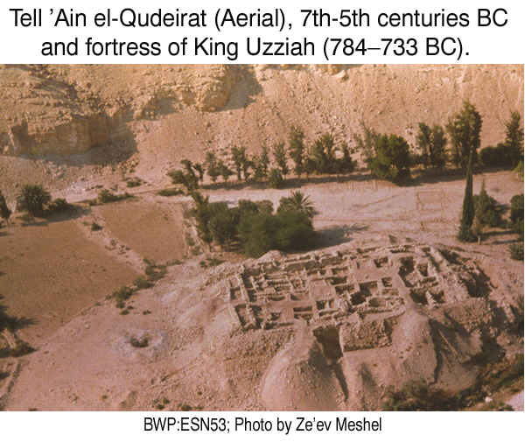

PHOTO LINK: ESN054 Tell ’Ain el-Qudeirat, spring, exterior walls and towers
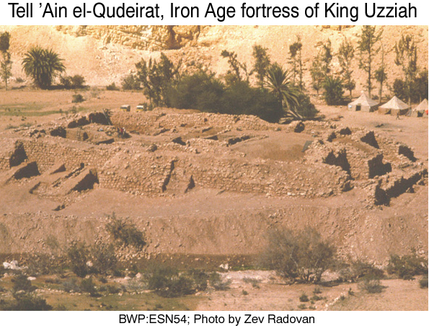

PHOTO LINK: NEGEV DESERT AND SINAI 001; Satellite photo of Negev and Sinai ; http://www.science.co.il/images/satellite/f/Negev-STS037-151-124.jpg ; Nov. 7, 2005
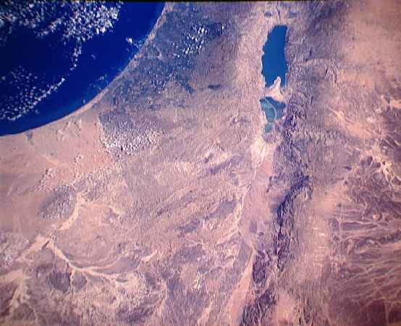

Uzziah’s Leprosy

Uzziah's military and domestic achievements lead to pride and he attempted to perform priestly duties in the Temple. He was accosted by the high priest and 80 other priests and told to desist. Upon refusal, the Lord stuck him with leprosy of the forehead, which he had the rest of his life. Uzziah retired in quarantine to his own house and was "relieved of all his duties and excluded from the House of the Lord" (2 Chron. 26:21).

Uzziah died in the turbulent year 740 BC, the same year Pekah murdered Pekahiah of Israel (see those stories below). Because of his leprosy, he was not interred in the burial-ground of the kings. Uzziah was succeeded by his son Jotham.

PHOTO LINK: JOTHAM 001: Signet ring of Jotham excavated at Elath

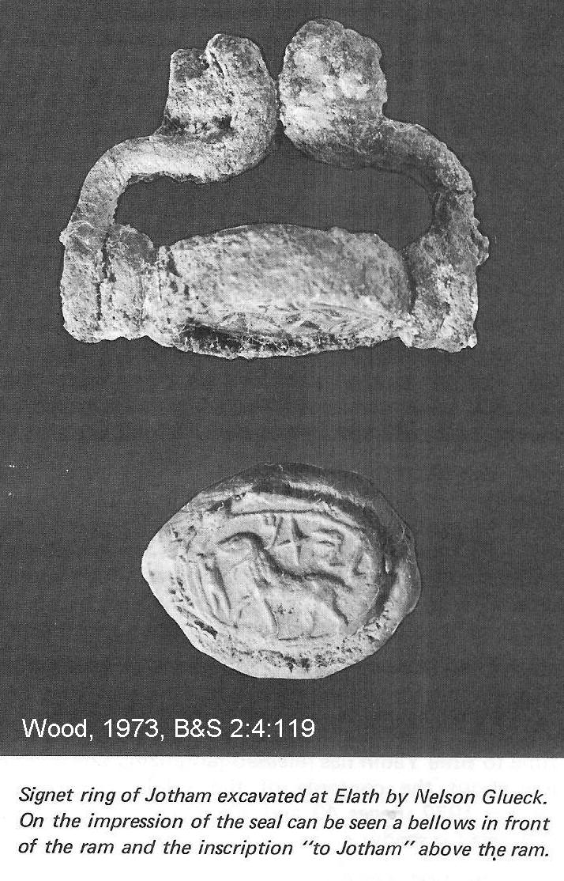
PHOTO LINK: SEAL OF ABIAH 001 Servant of Uzziah
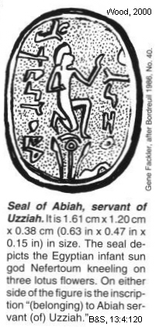

Seals from Uzziah’s court

Two seals from the court of Uzziah have been found. Today both are in the Louvre museum in Paris. One of the seals is made of agate, has an Egyptian motif and reads: "Belonging to Abiah, servant [of] Uzziah." Both names on this agate seal contain shortened forms of Yahweh. Abiah means "my father is Yahweh", and Uzziah means "my strength is Yahweh" (Wood, 2000b).

The second seal is a two-sided seal. One side depicts a man carrying a staff with the name "Shebaniah". On the other side are solar winged disks with duplicated inscriptions above and below it reading "[belonging] to Shebaniah servant [of] Uzziah." The name Shebaniah appears in 1 Chron. 14:24 as an official from the time of David. It means "Return, pray, O Yahweh" (Bordreuil, 1986, No. 41 cited by Wood, 2000b).

Uzziah Inscription

The name Uzziah also is found on an inscription from the second temple period, after the Jews return from Babylonian captivity (130 BC-70 AD). The origin of this inscription is unknown. Today it is at the Russian Convent on the Mount of Olives were it was acquired in the late 1800's (Albright, 1931 cited by Wood, 2000b:120). The inscription reads: "Hither were brought the bones of Uzziah king of Judah -- do not open!"

PHOTO LINK: UZZIAH INSCRIPITION 001 Hither were brought the bones of Uzziah king of Judah, do not open!
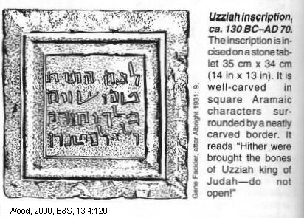

Beth Shemesh of king Uzziah (or king Amaziah)

During the reign of Amaziah, a double gate complex may have been built at Beth Shemesh. It could also have been built by king Uzziah when he expanded his kingdom into Philistine territory (Bunimovitz and Lederman, 1997).

PHOTO LINK: BETH SHEMESH 001 Panorama; (See ABOVE, ctrl+click to follow link)
PHOTO LINK: BETH SHEMESH 003 Location map and geographic zones; (See ABOVE, ctrl+click to follow link)
PHOTO LINK: BETH SHEMESH 002 Ain Shems Excavations 1928-1931; (See ABOVE,ctrl+click to follow link)
PHOTO LINK: BETH SHEMESH 004 Plan of Beth Shemesh; (See ABOVE, ctrl+click to follow link)

Uzziah and the City of Salt (Iron Age II, 1000-586 BC)

In the tribal allotments described in Joshua, at the end of the list of places assigned to Judah the following is recorded:

This is the inheritance of the tribe of the children of Judah...In the wilderness; Beth Arabah, Middin, Secacah, Nibshan, the City of Salt, and Ein-Gedi; six cities with their villages (Joshua 15:20, 61-62).

These cities have been found along the west side of the Dead Sea, named "Sea of Salt" in Old Testament times (Gen. 14:3; Num. 34:12). They were not present during the Conquest or during the period of the Judges. They date from the Iron Age II (1000-586 BC). The lists of cities found in Joshua do not reflect conditions in Joshua's time. They describe the situation that had developed after the fall of Samaria to the Assyrians in 722 BC. They can be interpreted as contemporary prophetic statements, or as projections of current events back into the Joshua narrative (Greenhut, 1993).

The "Wilderness of Judah" is a strip of land 50 miles long and 12 to 15 miles wide extending from the mountains east of Jerusalem to the Dead Sea (Greenhut, 1993).

PHOTO LINK: JUDEAN WILDERNESS 001: Wilderness panorama
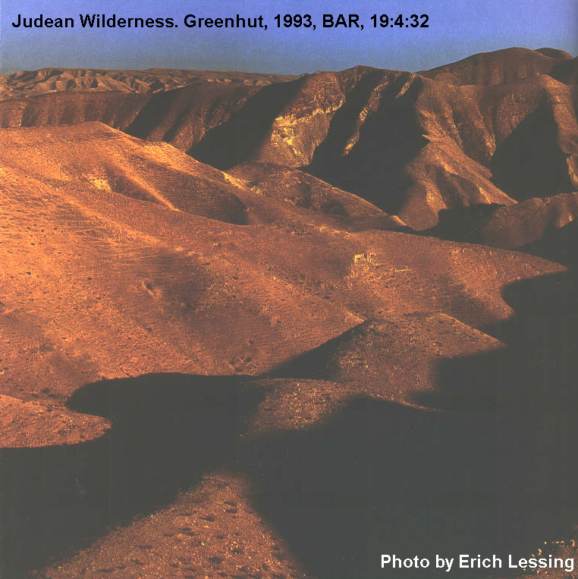

PHOTO LINK: JUDEAN WILDERNESS 002: Map of western Dead Sea region showing locations of cities
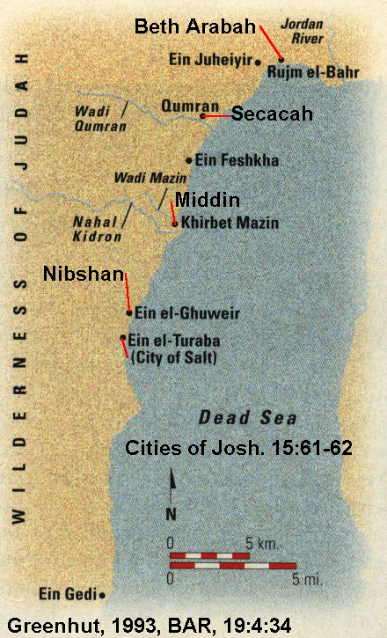

PHOTO LINK: JUDEAN WILDERNESS 003 Aerial photo of Ein Feshkha
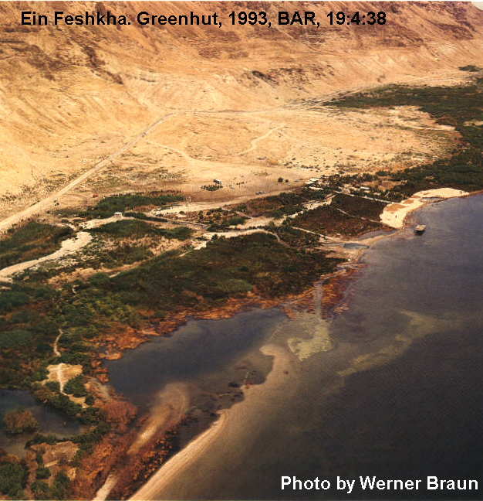

In ths 12 miles, elevation changes from 4,000 feet above sea level to 1,083 feet below sea level. This gives rise to rapidly changing biozones. The level of water in the Dead Sea fluctuates with climatic changes over the centuries. Water diversions by modern hydraulic and agricultural engineers lowered the level of water in the Sea by 35 feet from 1896 to 1982 (Klein, 1982, cited by Greenhut, 1993).

PHOTO LINK: DEAD SEA 006 Chart changes in level 4000 BC-2000 AD
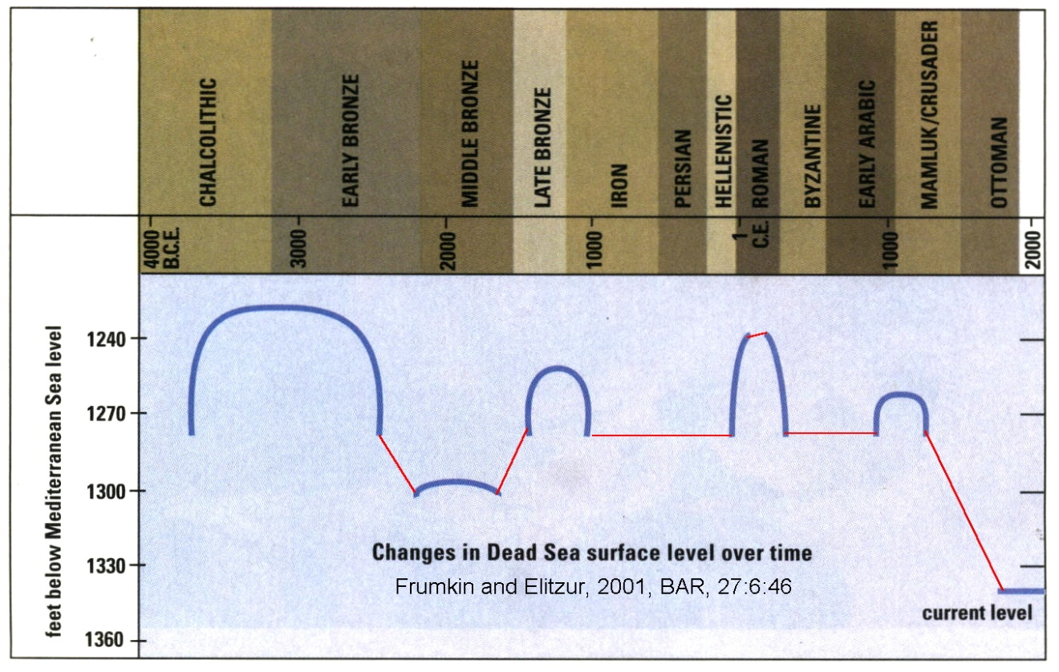

PHOTO LINK: DEAD SEA 012 Cross section
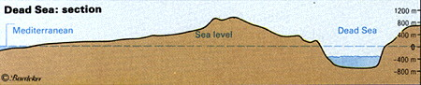

PHOTO LINK: QUMRAN 008 Aerial illustrating height of possible Dead Sea
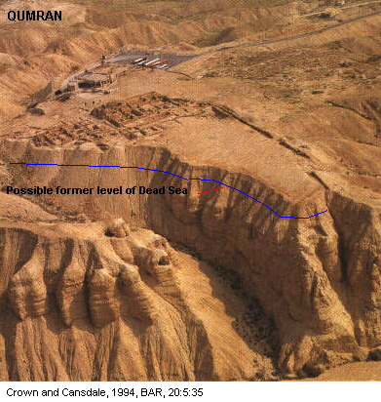

Climate change has caused the coastal strip of lowland area along the western shore of the Dead Sea to disappear during many time periods. When the level of water in the Dead Sea is low, it exposes fault-controlled freshwater springs at the base of the mountains. It was here that oasis developed and hence settlements. The settlements controlled trade routes connecting Jerusalem, mountain and desert settlements. They were fortified and "they resembled forts more than cities". These forts were established in the 8th century and abandoned after the Babylonian destruction of Jerusalem in 586 BC (Greenhut, 1993).

PHOTO LINK: JUDEAN WILDERNESS 002 Map of cities of Josh 15vs61-62; (See ABOVE, ctrl+click to follow link)
PHOTO LINK: ESN053 Tell ’Ain el-Qudeirat (Aerial), 784-733 BC; (See ABOVE, ctrl+click to follow link)
PHOTO LINK: ESN054 Tell ’Ain el-Qudeirat, spring, exterior walls and towers; (See ABOVE, ctrl+click to follow link);

While the climate is hot and unfriendly, the region supported a salt and bitumen (asphalt) industry, farming and animal husbandry during Iron Age II. The oasis provided opportunity for limited irrigation. Nomads continue traditional herding practices that go back to Old Testament times The correspondence of biblical names to archaeological sites is shown below (Greenhut, 1993):

Name in Joshua 15: 61-62 | Archaeological Site
Beth Arabah | Rujm el-Bahr ("the Sea Port") and freshwater spring Ein Juheiyir
Middin | Khirbet Mazin, south of freshwater spring Ein Feshkha. It is close to the mouth of the Kidron Valley, opposite Wadi Mazin
Secacah | Qumran
Nibshan | Freshwater spring Ein el-Ghuweir
City of Salt | Ein el-Turabah
Ein Gedi | Ein Gedi; Major oasis on the Dead Sea

PHOTO LINK: JUDEAN WILDERNESS 003 Aerial photo of freshwater springs at Ein Feshkha ; (See ABOVE, ctrl+click to follow link)

PHOTO LINK: JUDEAN WILDERNESS 004 Freshwater springs at Ein Gedi;
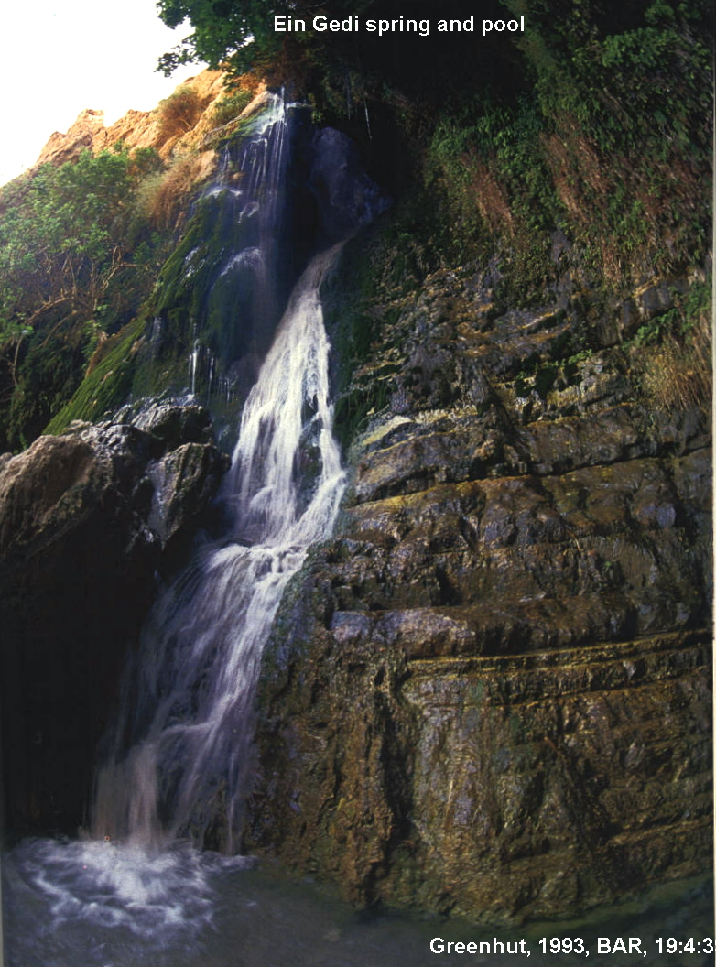

PHOTO LINK QUMRAN 005 Aerial photo (Secacah)
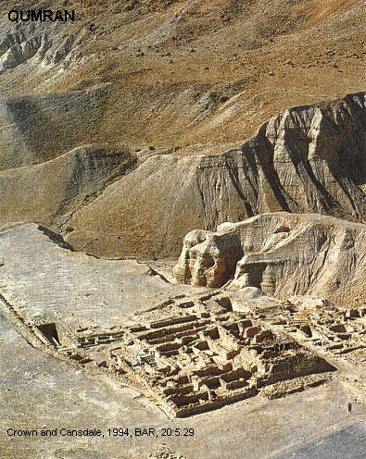

The establishement of these small cities in Iron Age II is associated with the building activities of King Uzziah of Judah (770-739 BC) whom 2 Chron. 26:10 says "built towers in the wilderness." They indicate centralized state-organized strategic planning and organization. Architectural features are similar at all the sites, and large ashlar blocks, not found locally, were brought from common mountain quarries and wadis to each site (Greenhut, 1993).

PHOTO LINK: JUDEAN WILDERNESS 005 Salt formations in the Dead Sea waters
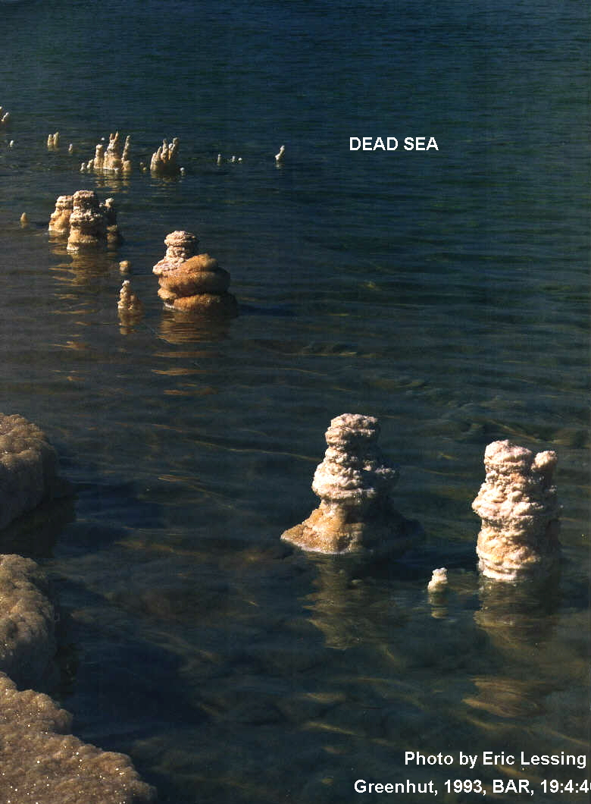

PHOTO LINK: JUDEAN WILDERNESS 006 Ruins of Khirbet Mazin = Middin
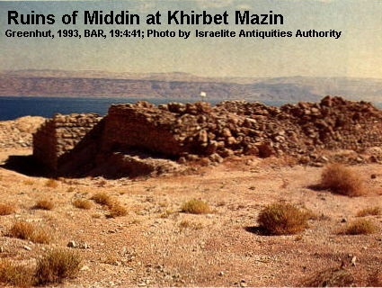

The City of Salt was a fort settlement with facilities for salt processing and storage. Salt was a valuable commodity in ancient times. Roman soldiers were paid with salt rations (salaria, hence our English "salary"). It was a required for certain Temple offerings and ceremonies (Leviticus 2:13; Mishna Middoth 5:3). Salt was used as a preservative for food, an essential in epochs without refrigeration. It was also used in leather tanning and for medical purposes. In Ezekiel's day, newborn babies were rubbed with it (Ezekiel 16:4; Greenhut, 1993).

PHOTO LINK: JUDEAN WILDERNESS 007 Ruins of Ein el-Ghuweir = Nibshan
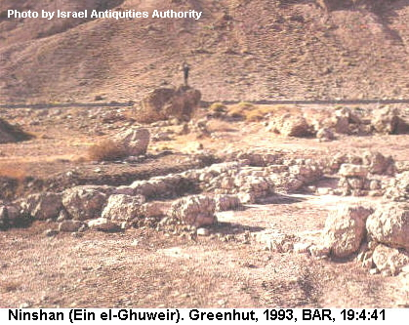

PHOTO LINK: JUDEAN WILDERNESS 008 Ruins of fort City of Salt
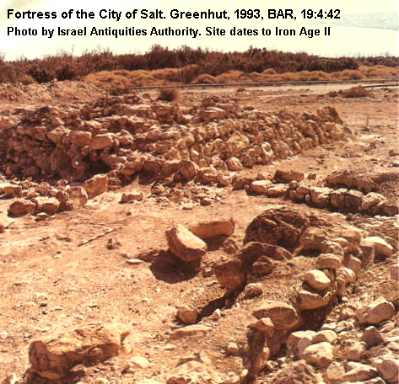

PHOTO LINK: JUDEAN WILDERNESS 009 Plan of fort at City of Salt
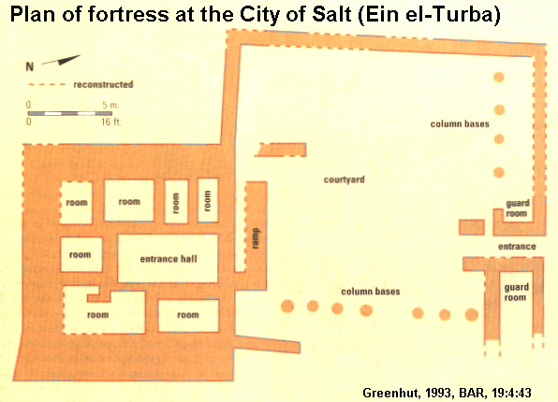

Uzziah’s Megiddo and Hazor

Sometime after the city's attack by Sheshonq I (Biblical Shishak) in 925, BC, the city of Megiddo experienced it's fourth major unexplained destruction, perhaps by earthquake. Hazor was also destroyed at this time.

Nur and Ron (1997:54) suggest that this destruction occurred during the reign of Uzziah as recorded in Amos 1:1 and Zechariah 14:4-5.

PHOTO LINK: UZZIAH 001 Timeline (Whitcomb, 1968); (See ABOVE, ctrl+click to follow link)
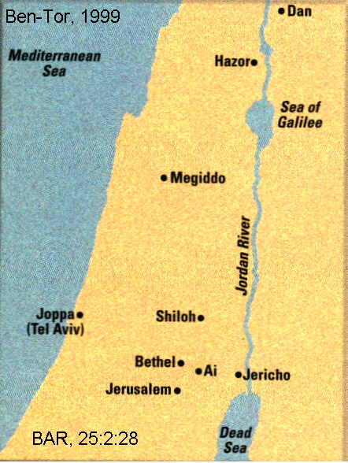
HAZOR 017 Location map of Hazor in Palestine (shows location of Megiddo and Hazor)

PHOTO LINK: SHISHAK 002 Victory stele at Temple of Amun at Karnak
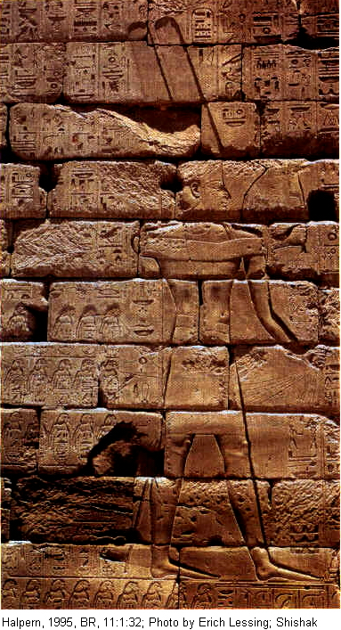

PHOTO LINK: GA022 Hazor, Aerial View
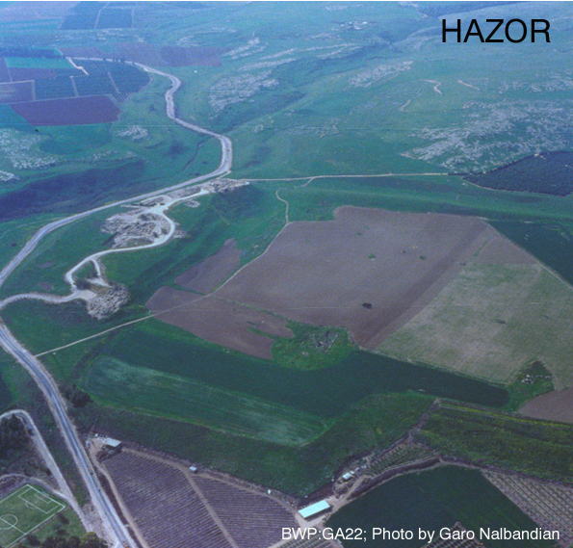

PHOTO LINK: HAZOR 019 Aerial photo
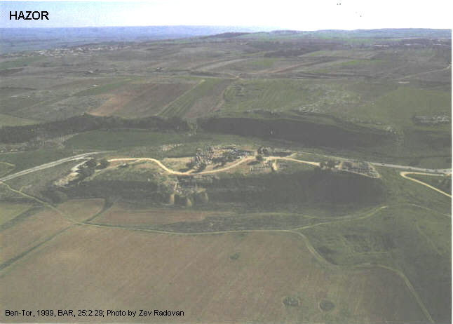

PHOTO LINK: GA032 Megiddo, Silo, 780-650 BC
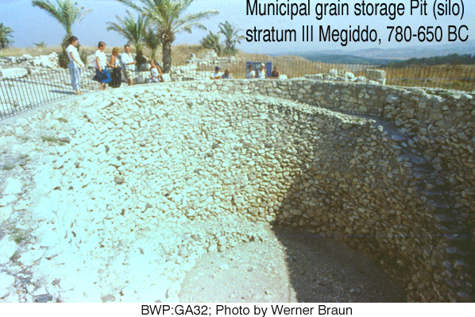

PHOTO LINK: GA026 Aerial photo of Megiddo
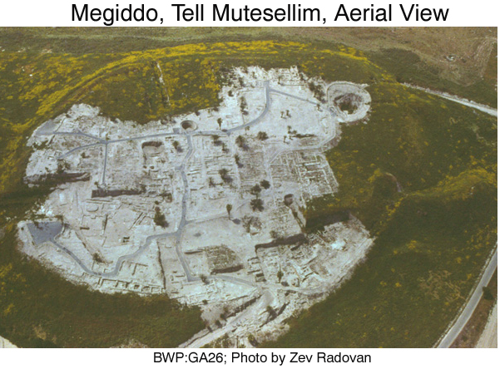

Uzziah’s Earthquake, 750 BC

There are two Biblical references to an earthquake in the time of Uzziah:

Amos 1:1

1The words of Amos, one of the shepherds of Tekoa--what he saw concerning Israel two years before the earthquake, when Uzziah was king of Judah and Jeroboam son of Jehoash was king of Israel.

Zechariah 14:4-5 ,

“…and the Mount of Olives will be split in two from east to west, forming a great valley, with half of the mountain moving north and half moving south. 5You will flee by my mountain valley, for it will extend to Azel. You will flee as you fled from the earthquake in the days of Uzziah king of Judah.”

This earthquake is estimated to have been a 7.8 to 8.2 magnitude quake (http://en.wikipedia.org/wiki/Uzziah, Oct. 15, 2012).

AMOS (c. 765-755 BC) AND HOSEA (c. 755-712 BC)

During the prosperous times of Jeroboam II and Uzziah, Amos and Hosea preached in Israel. Hosea's ministry lasted up to the Fall of Samaria.

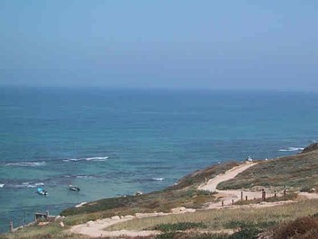
Amos, a sheepherder (or businessman who dealt in sheep) was called to serve in the cult city of Bethel. There he spoke against surrounding pagan countries, his own native Judah and, of course Israel. With the economic expansion that accompanied larger boarders and peace, the rich could afford winter houses along the warm Mediterranean coast or shores of Galilee and summer homes in the cooler Hill Country.

PHOTO LINK: MEDITERRANIAN SEA 001 http://www.gemsinisrael.com/e_article000079508.htm, Se[t. 22, 2010.

The city of Apollonia and its fort were situated on the cliffs of the Sharon plain, overlooking the Mediterranean Sea (ABOVE)

PHOTO LINK: BA005 Sea of Galilee and Surrounding Hills
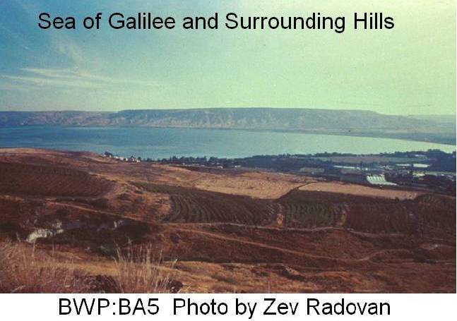

PHOTO LINK: GA001 Sea of Galilee
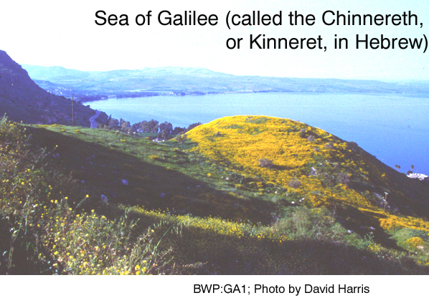

Such was the climate of injustice and inequality (Amos 6:4-7). His preaching against the rampant syncretism and henoism of Israel lead to complaints from the high priest of Bethel who requested his deportation back to Judah (Amos 7:13).

PHOTO LINK: AI012 Modern Bireh = ABR's Bethel
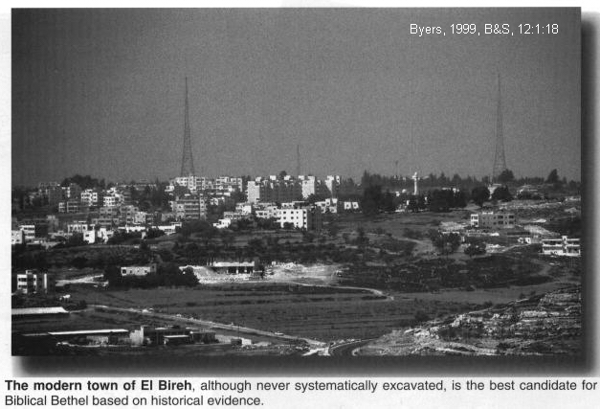
PHOTO LINK: BETHEL 001 Location map
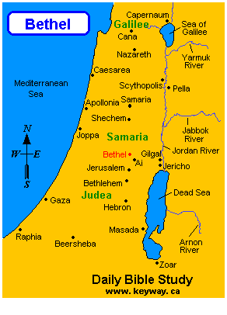

Hosea was a citizen of Israel. The first three chapters tell of his life-in-parable about love and forgiveness for an adulterous wife as a metaphor for God's attitude toward His people. The remainder of Hosea's book is a collection of sermons preached in the last few years before the Fall of Samaria.

Uzziah’s earthquake

The prophet Amoz described an earthquake during the reign of Uzziah in Amos 1:1. That earthquake may also have been documented by Amoz’s contemporary, Isaiah, in Isaiah 2:19-21: “..when He arises to shake the earth mightily”. This earthquake was remembered 250 years later by the prophet Zechariah. He said “You shall flee as you fled from the earthquake in the days of Uzziah king of Judah” (Zech 14:5).

There is evidence of this earthquake in arhaeological excavations at the following sites (Franz, 2012):

Site | Stratum | Reference
Tel Sheva (Beer Sheva) | Stratum IV | Aharoni, 1973:107-108
Tel Lachish | Stratum IV | Ussishkin, 1997:14-27; Yeivin, 1979:168
Hazor |  | Yadin, 1960:24
Dier ‘Alla |  | Franken and Ibrahim, 1878:68
Tel ‘Erany (near Lachish) | Stratum VI | Yeivin, 1979:168
Tel Gezer | Outer wall | Dever, 1992:30; Younker, 1991:28
‘En Hazeva (Tamar in Aravah) | Gate area, Stratum V | Cohen and Yisrael, 1995:231

Regional studies of earthquakes for the Northern Kingdom in the mid-eighth century BC are described by Dever (1992:27-35) and Franz (2012:78).

A landslide associated with Uzziah’s earthuake is described by Josephus (Antiquities 9:224-225; Franz,2012:78), and verified by modern geologic investigations (Wachs and Levitte, 1983, 1984:118-121; see Franz, 2012:78). Josephus said:

“…half of the eastern hill [of the Mount of Olives] was broken off and rolled for statdes [2400 ft, 730m] till it stopped at th3e eastern hill [the City of David} and obstructed the roads and royal gardens [in the Kidron Valley].”

Paleoseismic studies for the Middle East include those of Amiran (1951:223-46; 1952:48-65; 1996:120-130) and Amiran, Arieh and Turcotte (1994:260-305). The data from these and other studies lead Austin and others (2000:666-667) to conclude that the epicenter of Uzziah’s earthquake was northeast of Hazor in Lebanon. They estimated the magnitude of the earthquake at 8.2 on the Richter scale (Austin and others, 200:667-669). See Franz, 2012:79.

PHOTO LINK: UZZIAH’S EARTHQUAKE 001: Outer wall at Tel Gezer showing evidence of earthquake
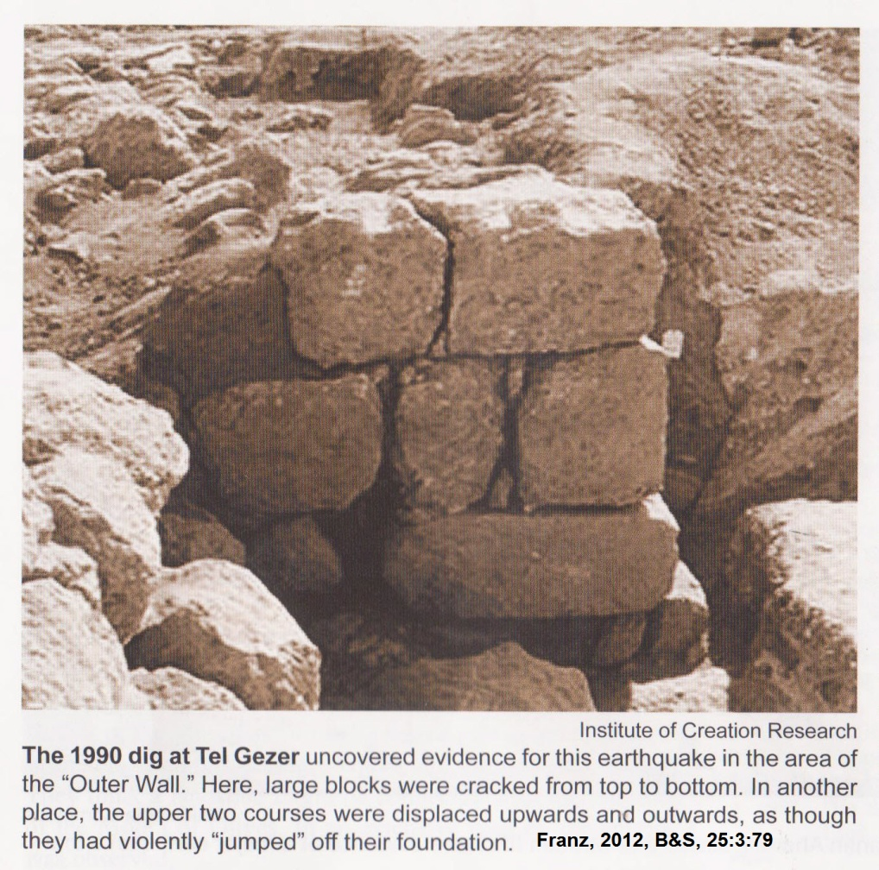

PHOTO LINK: UZZIAH’S EARTHQUAKE 002: Tel Sheva (Beer Sheva) showing evidence of earthquake in Statum III.
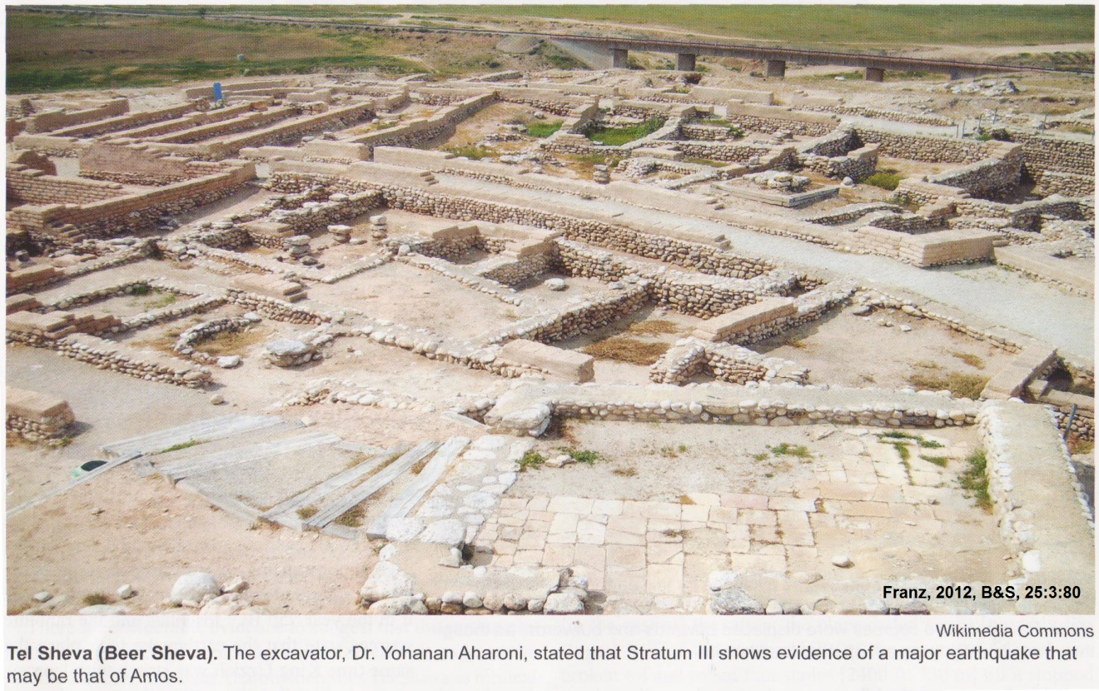

ZECHARIAH OF ISRAEL (753 BC)

PHOTO LINK: ZECHARIAH 001 Timeline 753 BC (Whitcomb, 1968)
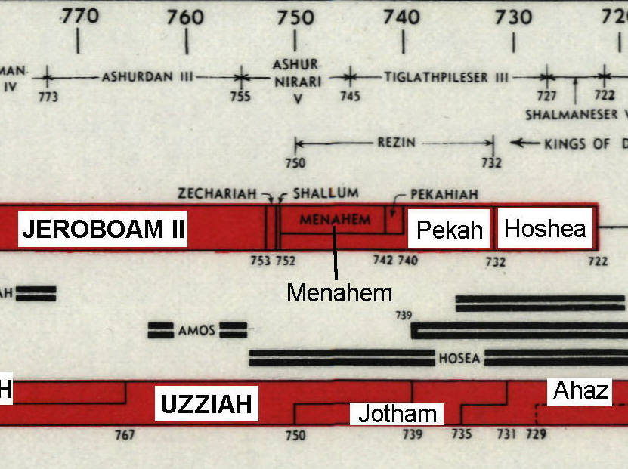

After Jeroboam II, most of the remaining Israelite kings were assassinated. Under the leadership of Jeroboam II, Israel had become a strong and prosperous nation, in spite of his personal apostasy and national syncretistic leanings. After Jeroboam II, the nation of Israel fell into a morass of disunity and civil war. Then came a final defeat by and absorption into the Assyrian Empire in 722 BC. Zechariah became king during the reign of Uzziah (Azariah) of Judah. The son of Jeroboam II reigned only 6 months before he was assassinated in the city of Ibleam. This happened as a result of a conspiracy lead by Shallum who also usurped the throne (2 Kings 15:10).

SHALLUM OF ISRAEL (752 BC)

Shallum became king of Israel when Uzziah of Judah was in his 39th reginal year. After only one month in office, a civil war upon Samaria was declared by Menahem who, starting his campaign in Tirza, attacked Samaria, killed Shallum and usurped the thrown (2 Kings 15:14).

PHOTO LINK: TIRZA 003 Aerial photo
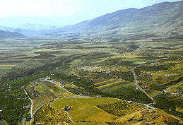

PHOTO LINK: TIRZA 004 Ruins
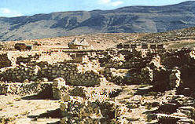
PHOTO LINK: TIRZA 002 Location map
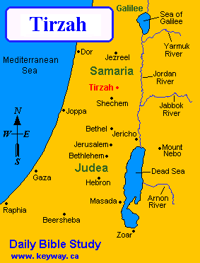

MENAHEM OF ISRAEL (752-742 BC)

PHOTO LINK: MENAHEM 001 Timeline 752-742 BC (Whitcomb, 1968)
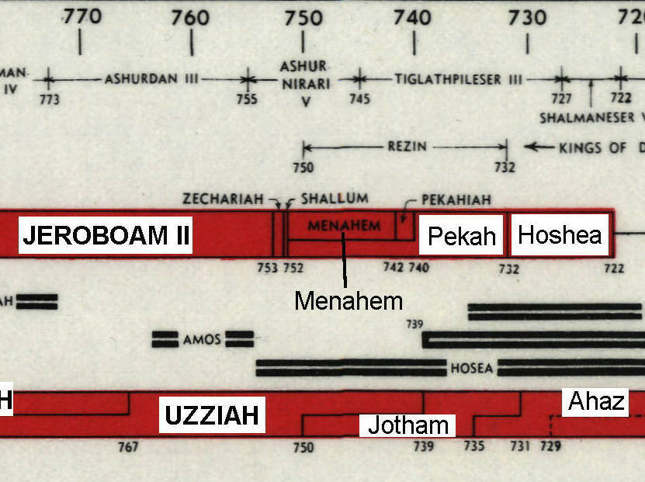

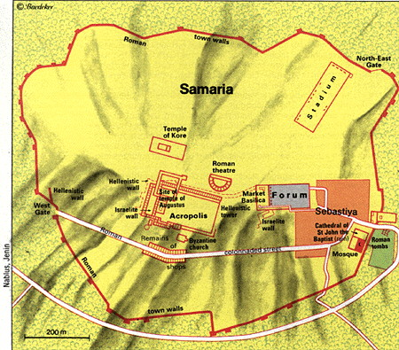
Following his successful siege of Samaria, Menahem began another campaign from Tirza.

PHOTO LINK: SAMARIA 002 Plan (LEFT)

PHOTO LINK: SAMARIA 003 Location map
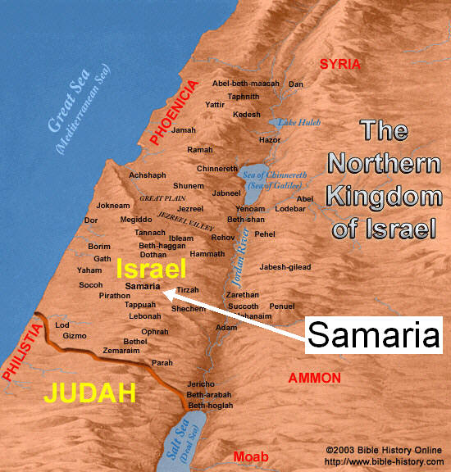

This time he destroyed Tappuah and its territory. Tappuah was a border town of Manasseh, probably about 5 mi (8.1 km) NW of Shiloh. The town was attacked "because it had not opened its gates to him, and he "ripped open all the pregnant woman" (2 Kings 15:16). Under this tyrant, civil war genocide was not to be confined to political competitors.

PHOTO LINK: SAMARIA 004 Ruins of Ahab’s palace
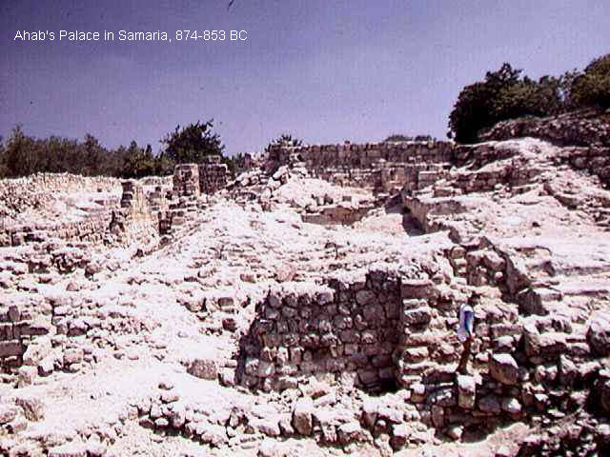

PHOTO LINK: TAPPUAH 001 Location map of Tappuah; http://www.genesisfiles.com/Bible_Map_TUVWXYZ.htm#G; Sept. 16, 2006
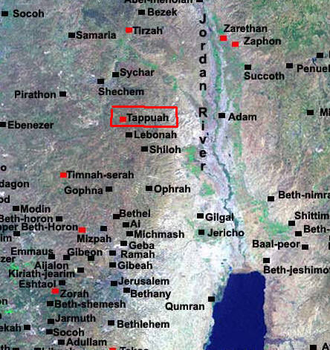

Menahem is mentioned in the Iran Stele which records information about Tiglath-pileser's 9th year (737 BC; Wood, 2001:23).

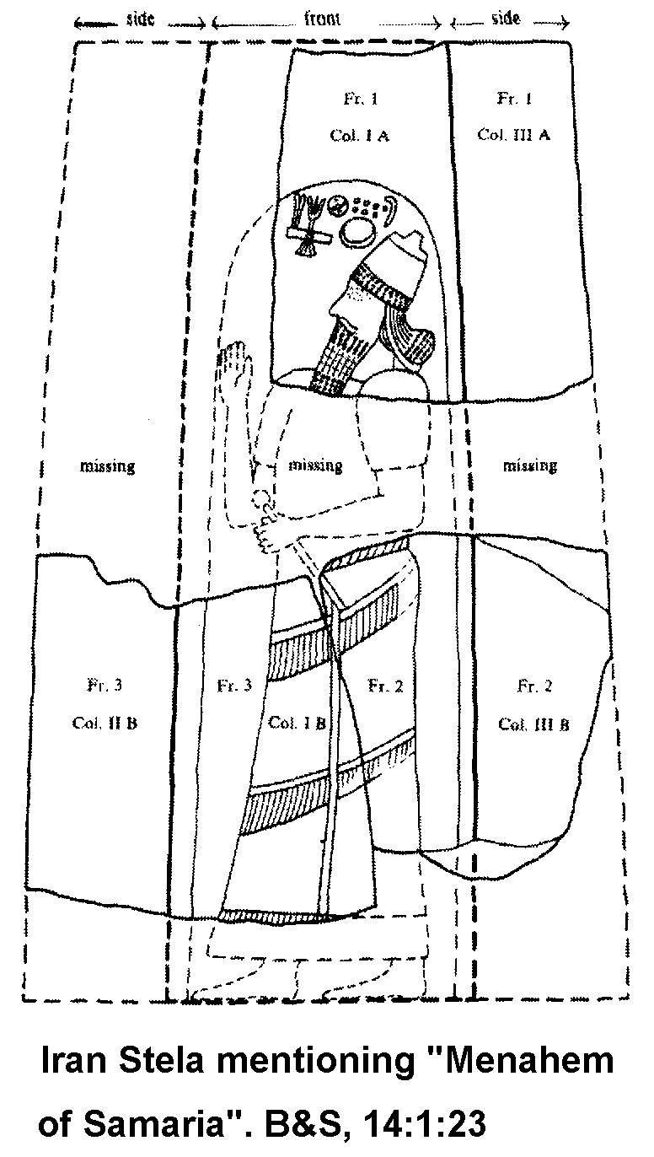
PHOTO LINK: ASSYRIA 027 Iran Stele mentioning Menahem of Samaria on inscription of Tiglath-pileser
PHOTO LINK: SHEKEL 001 Bronze weight 8th century BC inscribed with Hebrew "Shekel" 0.57 ounces
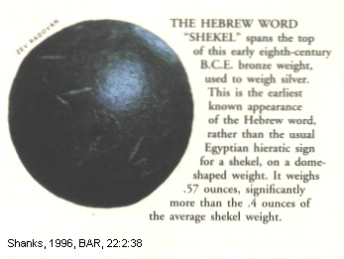

In order to generate the required tribute, Menahem issued a per capita tax of 5 shekels of silver, the standard price of a slave (Wise, 1993:255, cited by Hoerth, 1998:334). From that tax, King Menahem of Samaria gave Tiglath-pileser III 75,000 lbs of silver in tribute (1 Kings 15:19-20; Wood, 1991; Grayson, 1975; Pritchard, 1969).

As a result of the tribute, Assyria quit its attacks on Israel, and marched on to Phoenicia. Menahem died about a year later. The economic pressures of Assyrian vassalage lead to revolt by Pekah (see below).

PEKAHIAH OF ISRAEL (742-740 BC)

Uzziah (Azariah) of Judah was still on the thrown when Pekahiah succeeded his father Menahem as king of Israel. He enjoyed that station for only 2 years before being killed in another military coup, this time by a conspiracy of only fifty Gileadites lead by Pekahiah's lieutenant, Pekah (Peqah). The "attacked him in Samaria and in the citadel of the royal palace, killed him and usurped the throne" (2 Kings 15:25).

PHOTO LINK: PEKAHIAH 001 Timeline
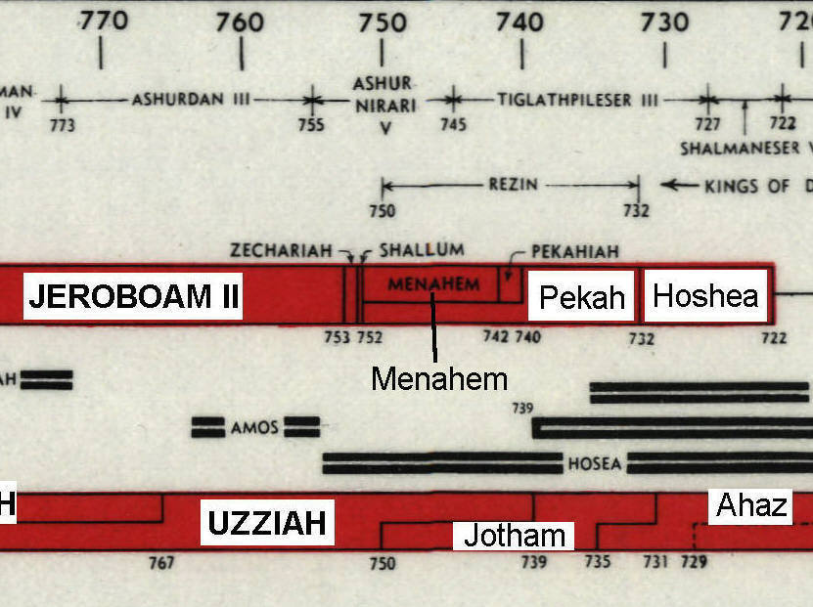

PHOTO LINK: SAMARIA 003 Location map; (See ABOVE, p 92; ctrl+click to follow link)
PHOTO LINK: SAMARIA 004 Ahab's palace (site of Pekahiah’s assassination); (See ABOVE, p.94; ctrl+click to follow link)

JOTHAM OF JUDAH (750-732)

Jotham's co-regency ended upon the death of Uzziah and he ascended the thrown of Judah in 740 BC. Like his father, he "did right in the eyes of the Lord" (2 Kings 15:34), but continued a policy of tolerance toward the rural hill-top cult centers (2 King 15:35). He also "constructed the upper gate of the house of the Lord" (2 Kings 15:36).

During Jotham's reign, Judah was attacked by a coalition of King Pekah of Israel and King Rezin of Damascus (2 Kings 15:37). The outcome of that conflict is not described in Kings or Chronicles. Apparently, it was a stalemate.

PHOTO LINK: JOTHAM 002 Timeline
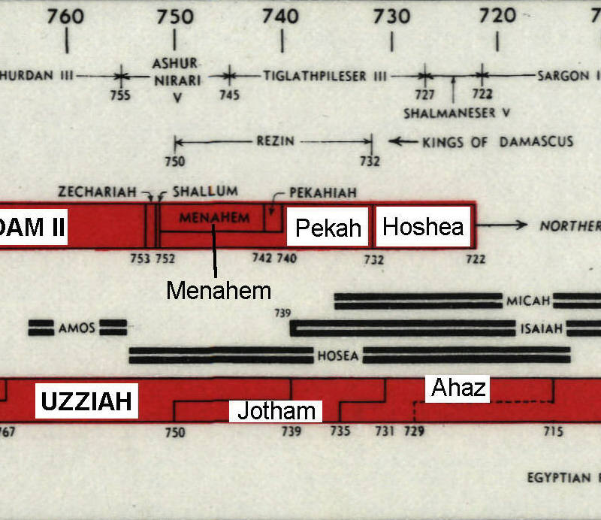

PHOTO LINK: DAMASCUS 001 Map
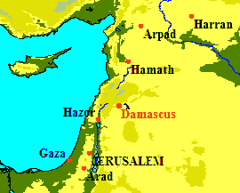

Jotham was succeeded by his son, Ahaz. A signet ring of Jotham has been found (Wood, 1973).

PHOTO LINK: JOTHAM 001 Signet ring of Jotham; (See ABOVE, p. 96; ctrl+click to follow link)

PEKAH (PEQAH) OF ISRAEL (740-732)

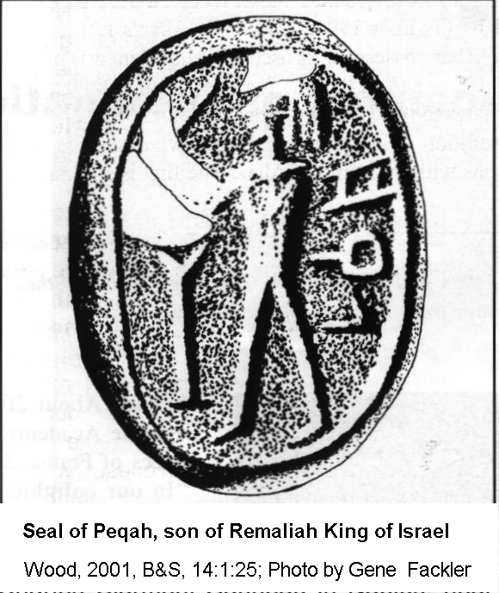
Pekah (Peqah) came to the throne of Israel two years after Jotham became king of Judah in Jerusalem upon the death of Uzziah. Almost immediately, in 740 BC, Pekah and Rezin of Damascus solidified their anti-Assyrian league. Pekah ruled for 20 years (2 Kings 15:25,27-30). After Jotham of Judah died, Pekah and Rezin asked his son, Ahaz of Judah, to join them in an alliance against Assyria. As told below, this alliance failed and Pekah lost his life to Hoshea (who assassinated him), and his nation to Assyria (who made Hoshea their vassal; 2 Kings 15:30; 16:5; 2 Chron. 28:6-8; Isaiah 7:1; Tadmor, 1994 cited by Wood, 2001:25).

PHOTO LINK: SEAL OF PEQAH 001 Second known pictorial representation of a king of Israel of Judah (ABOVE).

Tiglath-Pileser III (745-727 BC) and Pekah

By the time of Pekah, Assyria had grown strong and imperialistic again under Tiglath-Pileser III. He is known by his Babylonian name, "Pul" in the Old Testament. This ruler’s Akkadian name was Tukulti-apil-esharra meaning "my help is the son of Esharrah."

PHOTO LINK: ASSYRIA 026 Tiglath-pileser III raveger of Israel
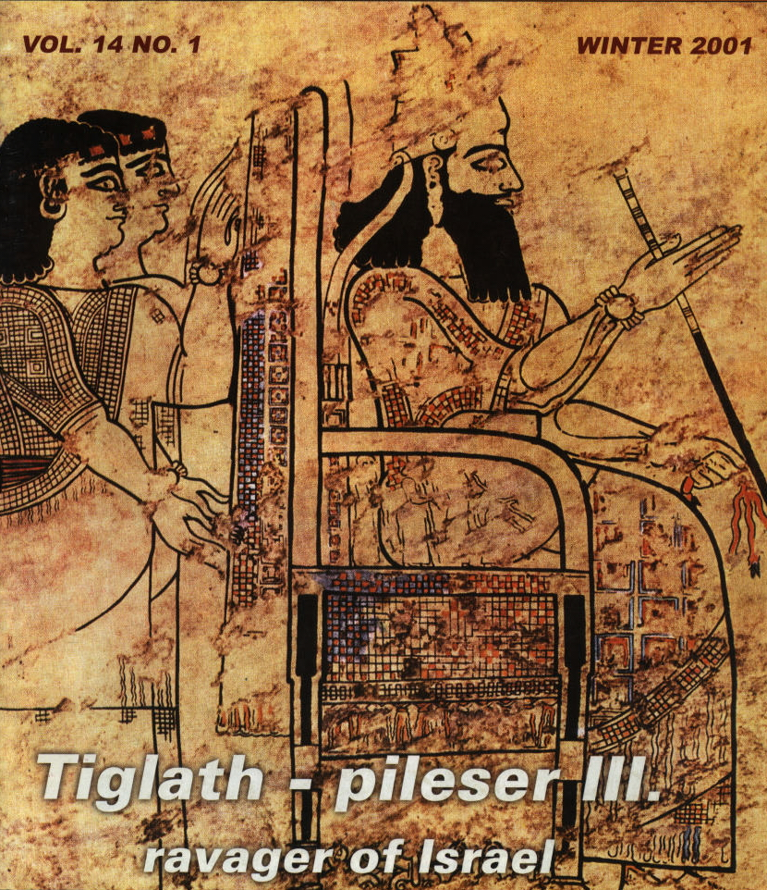

PHOTO LINK: TIGLATH-PILESER III 001 Tiglath-Pileser profile from bas-relief at Nimrud
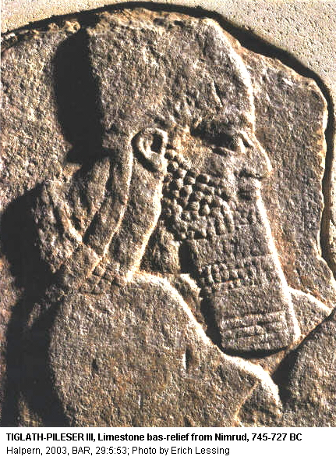

Attack on Media and Urartu (c. 733 BC)

In 743, Tiglath-Pileser III began a western campaign, conquering or receiving tribute from the smaller countries along the way. Between 737 and 735 BC, Tiglath-pileser III marched his armies through Media and Urartu (ANE, 1:193-194; ANET, 283-284 cited by Hoerth, 1998:333).

The Medes (Modern Persian Madha) were an Iranian people, who lived in the north, western, and northwestern portions of present-day Iran, and roughly the areas of present day Tehran, Hamedan, Azarbn, north of Esfahan, Zanjan, and Kurdistan. This region was known in Greek as Media (Μηδία). By the 6th century BC, the Medes were able to establish an empire that stretched from Aran province (the modern-day Republic of Azerbaijan) to north and Central Asia and Afghanistan (http://en.wikipedia.org/wiki/Medes, Sept. 19, 2006)

Urartu (Biainili in Urartian) was an ancient kingdom in eastern Anatolia, centered in the mountainous region around Lake Van (present-day Turkey). It existed from about 1000 BC, or earlier, until 585 BC. The name may correspond to the Biblical Ararat. (http://en.wikipedia.org/wiki/Urartu, Sept. 20, 2006)

PHOTO LINK: URARTU 001 Map of Nairi Kingdom later Armenia
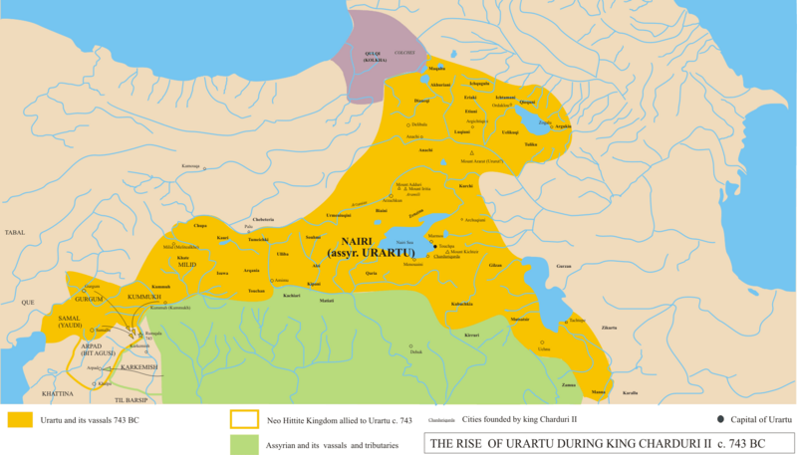

PHOTO LINK: URARTU 002 Utartu cuneiform
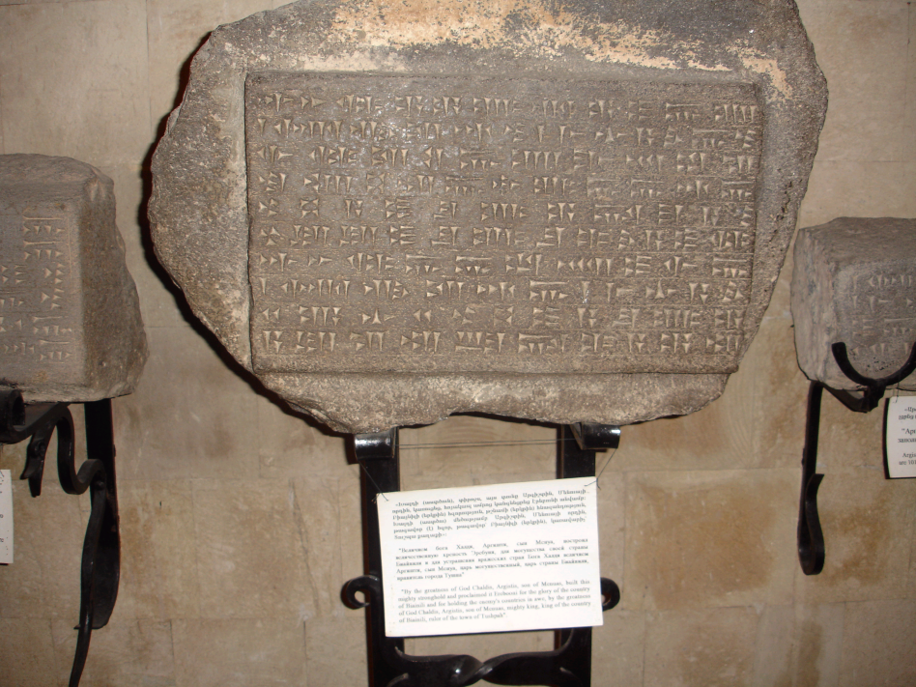

Attack of Philistia (c. 733 BC)

Then, in 734 BC, Tiglath-pileser III turned westward. First in his sights was Philistia and the Israelite coastal settlements. Gaza and all the other coastal towns fell (ANE, 1:193-194; ANET, 283-284 cited by Hoerth, 1998:333).

PHOTO LINK: PHILISTINE 008 Map of the Philistine Pentapolis; (See ABOVE, ctrl+click to follow link)

Attack of Damascus (c. 733 BC)

Then Tiglath-pileser moved northeast to Resin to attack the king of Damascus (Younger, 2003:38). From his annals, Tiglath-pileser III recorded (ANE, 1:193-194; ANET, 283-284 cited by Hoerth, 1998:333):

I received tribute from...Razon of Damascus, Menahme of Samaria, Hiram of Tyre**, Sibittibili of Byblos...to wit: gold, silver, tin, iron, elephant hides, ivory, linen garments with multicolored trimmings, blue-died wool [of Phoenicia] ebony wood, boxwood wood, whatever was precious enough for a royal treasure; also lambs whose stretched hides were dyed purple and wild birds whose spread-out wings were died blue, furthermore, horses, mules, large and small cattle, male camels, female camels with their foals...

PHOTO LINK: DAMASCUS 001 Location map; (See ABOVE, ctrl+click to follow link)

[(With) the blood of his] war[riors] I dyed a reddish hue of the river...his courtiers, charioteers and ...their weapons I smashed; and ...their horses...I captured his warriors, archers, shield-and lance-bearers[ and I dispersed their battle array. That one (i.e. Resin), in order to save his life, fled alone; and he entered the gate of his city [like] a mongoose. I impaled his chief ministers; I made his country behold [them]. I set up my camp around the city for 45 days; and I confined him like a bird in a cage. His gardens, ...orchards without number I cut down; I did not leave a single one (Younger, 2003:38).

Attack of Hattina (738 BC)

Tiglath-pileser III invaded the Aramean Neo-Hittite kingdom of Hattina in 738 BC. This invasion is known from excavations at Tell Ta’yainat in Turkey. The Neo-Hittite city at this site, at this time, was named Kunulua. It’s king, Qalparunda, is featured on the Black Obelisk of Shalmaneser wherE he is shown bringing tribute. This obelisk also shows the subjugation of Israelite King Jehu. These are the result of Assyrian domination in the 9th century BC.

PHOTO LINK: QALPARUNDA 001 Tribute from Qalparunda of Hattina (Kunulua) on the Black Obelisk of Shalmanesser III
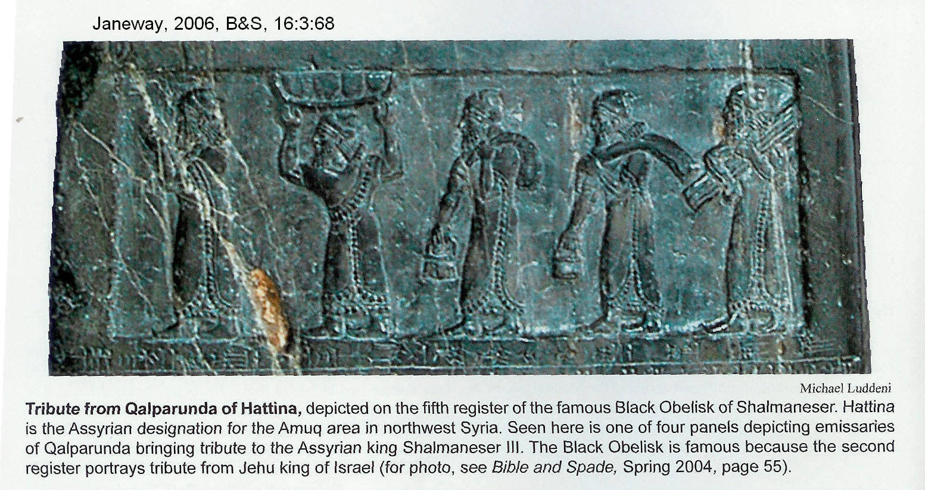

PHOTO LINK: QALPARUNDA 002 Drawing of Neo-Hittite hieroglyphic inscription of the name of Qalparunda in a Luwian inscription
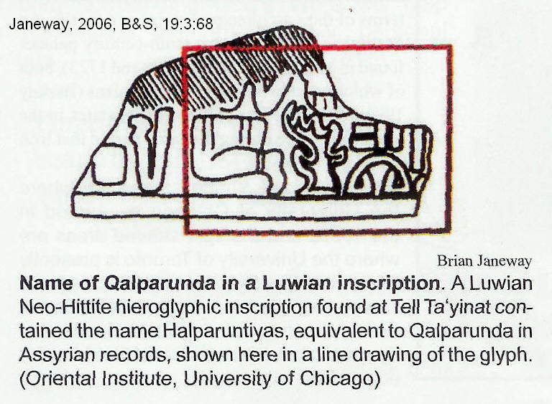

Assyrian presence and domination is shown by Assyrian-style reliefs found in secondary use in the Eastern Citadel Gate of Kunulua.

PHOTO LINK: ASSYRIAN BRUTALITY 015 Soldier with head of an enemy.
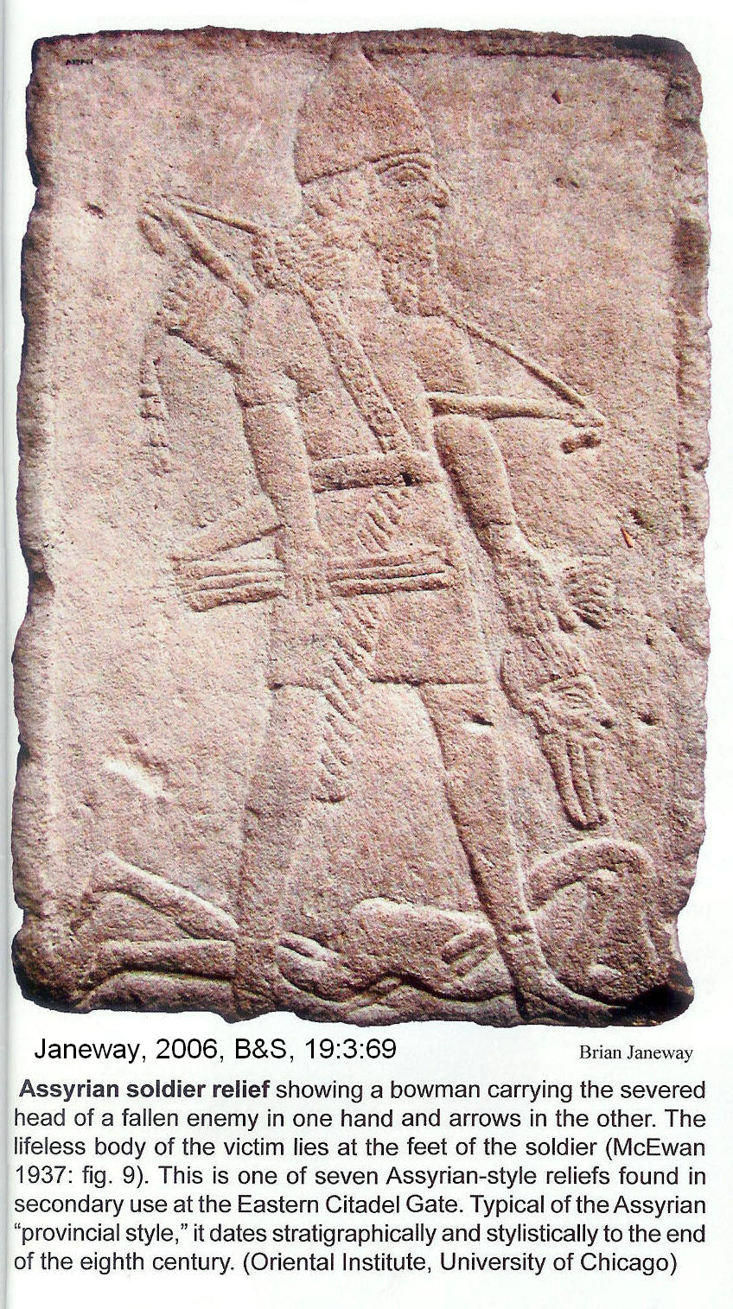

Tell Ta’yinat (Kunulua) expanded to 86 acres in the 9th and 8th centuries. Then the city lost its independence to Tiglath-pileser III (738 BC). He deported the population and resrettled people from the eastern part of the Assyrian empire in Kunulua.

Attack of Samaria (c. 733 BC)

PHOTO LINK: SAMARIA 003 Location map; (See ABOVE, ctrl+click to follow link)

The annals of Tiglath-pileser III also record his invasion of Samaria:

As for Menahem [the Jew of Samaria], I overwhelmed him like a snowbird and he...fled like a bird, alone, and bowed to my feet. I returned him to his place and imposed tribute upon him, to wit: gold silver, linen garments with multicolored trimmings.

PHOTO LINK: PHILISTINE 011 Map of cities of the Philistine Pentapolis
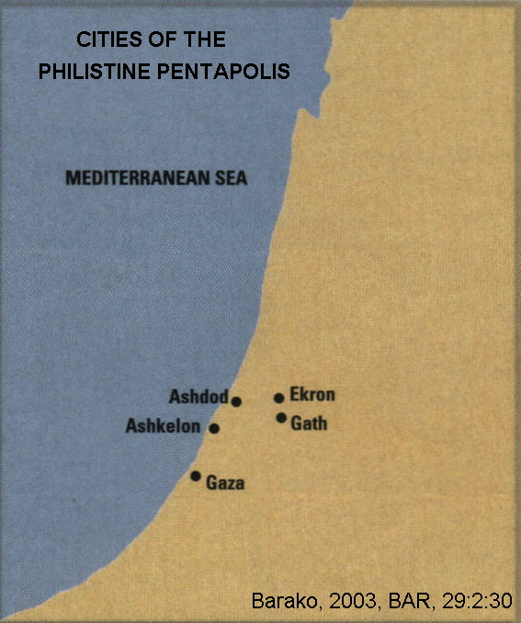

When the siege of Damascus was ending, while Pekah was King of Israel, Tiglath-Pileser moved two armies into Israel: one into Transjordanian Gilead and the other into Galilee. The conquest of Gilead is described in 1 Chron. 5: 6 and 26 (see Younger, 2003:41):

"So the God of Israel stirred the spirit of Pul king of Assyria, even Tiglath-pileser [III] king of Assyria, who deported the Reubenites, the Gadites and the half-tribe of Manasseh [the Transfordanian tribes]. He brought them to Halah, Habor and Hara, and the river of Gozan [in Assyria] (where they are) to this day."

PHOTO LINK: MAP 12 TRIBES OF ISRAEL 002; (See ABOVE, ctrl+click to follow link)

This first Assyrian deportation is also described in 2 Kings 15:29:

"In the days of Pekah King of Israel, Tiglath-pileser [III] King of Assyria came and took Iyyon, 'Abel-Beth-Na-acah, Yanoah, Kedesh and Hazor -- Gilead and Galilee -- all the land of the Naphtali; and he deported the people to Assyria"

The deportations of Tiglath-pileser III reduced the population of Lower Galilee region from 17,600 to almost nothing. The deportation was uni-directional and no Assyrians or other peoples were reintroduced to the area. (Gal, 1992, cited in Younger, 2003:41).

PHOTO LINK: GALILEE 001 Wildflowers overlooking extinct volcano that marks Tel Qarnei Hittin
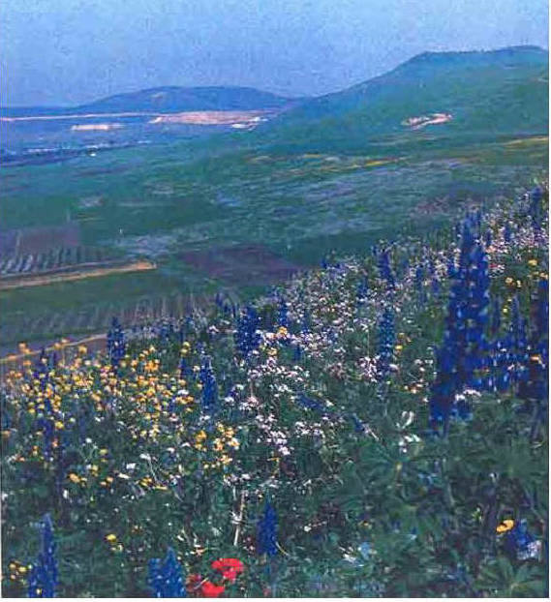

PHOTO LINK: GALILEE 002 Map showing location of Lower Galilee in Palestine
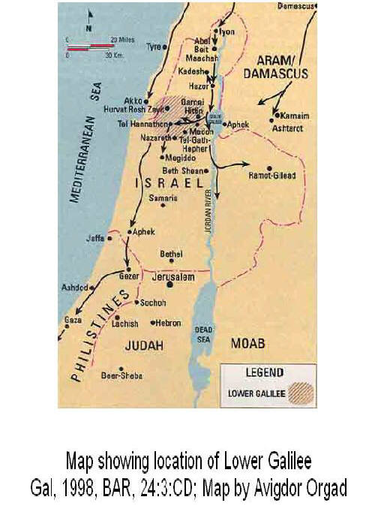

PHOTO LINK: BA005 Sea of Galilee and Surrounding Hills; (See ABOVE, ctrl+click to follow link)
PHOTO LINK: GA001 Sea of Galilee

The population decrease is shown in the archaeological record for this area, Gal (1998) observes:

“Another major site is Tel Qarnei Hittin, the Horns of Hattin, which lies west of Tiberias, overlooking the Sea of Galilee.

The tell is actually a twin-peaked volcanic hill. I conducted a small excavation here and found a walled city from the Late Bronze Age encompassing the southern summit. A major conflagration destroyed the city in the late 13th century B.C.E. A 12th-century B.C.E. collar-rim jar, typical of Israelite settlement sites, was found in a pit dug into this destruction layer, suggesting that the Israelites conquered the city. A second wall, which encloses the entire site, dates from the tenth to the eighth centuries B.C.E. and points to the existence of an Israelite city, built on the remains of the Late Bronze Age city, comparable in size to Megiddo. This city, however, remains unexcavated. In addition to the major sites, many smaller fortified cities were established at this time. Rural villages sprung up around almost every water source.

The archaeological evidence from these sites and others (Tel Mador, Hurrat H. Malta and Hurvat Rosh Zayit) shows that Lower Galilee reached the peak of its development during the United Monarchy, in the tenth century B.C.E. Then there is a large gap in occupation in Lower Galilee beginning in the late eighth century B.C.E. We observed this break not only in the pottery collected during the survey, but also in the excavations at sites such as Tel Mador, Hurvat Rosh Zayit and Tel Gath-Hepher. A similar occupational gap has been confirmed at major sites in Upper Galilee, such as Hazor and Kinneret. The flourishing settlement system that had lasted for more than two centuries was destroyed and abandoned. Lower Galilee was practically deserted by the end of the eighth century.

The destruction of the region almost certainly resulted from the large-scale campaigns carried out by Tiglath-pileser III.”

Attack of Cabul (740-732 BC)

Like the entire Galilee, the village of Cabul was destroyed and its inhabitants deported/exiled to Assyria by Tiglath-pileser III who conquered the Northern Kingdom in 733-732 BC (Gal, 1993, p.84).

PHOTO LINK: GALILEE 002 Map of Palestine showing location of lower Galilee; (See ABOVE, ctrl+click to follow link)
PHOTO LINK: KERNOS 001 From Phonecian Cabul 9th century BC
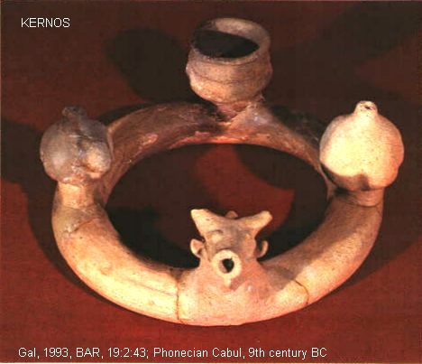

PHOTO LINK: POTTERY 016 Phoenician horse-jar 9th cent BC Cabul
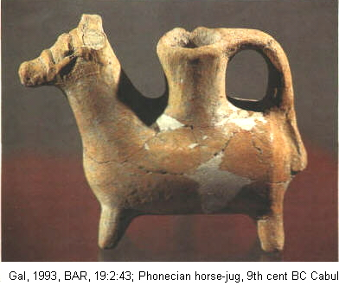
PHOTO LINK: CABUL 001 Location Map

PHOTO LINK: CABUL 002 Syro-Phonecian fortress destroyed 10th and 9th centuries BC
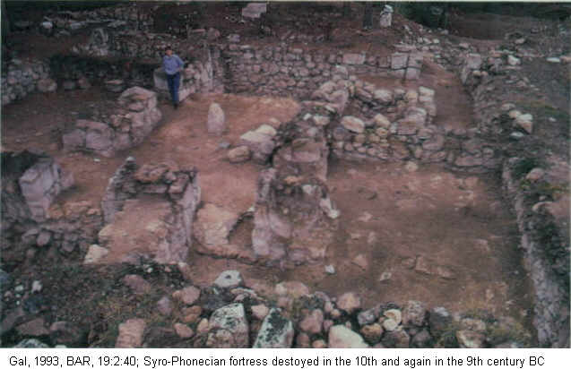
PHOTO LINK: CABUL 004 Israelite olive oil settlement on top of 8th cent BC fortress

Attack of Hazor (C. 733 BC)

From its zenith of development in the 9th century, Hazor declined in size and in quality of it's architecture into the 8th century BC. The destruction of Hazor by Tiglath-pileser III in 732 BC is well-documented (Ben-Tor, 1999:60).

PHOTO LINK: GA022 Hazor, Aerial View; (See ABOVE, ctrl+click to follow link)
PHOTO LINK: HAZOR 019 Aerial photo; (See ABOVE, ctrl+click to follow link)
PHOTO LINK: HAZOR 017 Location map of Hazor in Palestin

2 Kings 15:29-30 says that the inhabitants of Hazor that survived were deported to Assyria. Excavations at Hazor indicate that the city experienced a resettlement by Israelites shortly after it was destroyed, even though the city defenses were no longer usable. People lived inside and outside the city walls. Hazor never recovered from the Assyrian invasion. Its business and governmental influences were transferred to Dan which replaced Hazor as the region's main population center (Ben-Tor, 1999:32, 60).

PHOTO LINK: HAZOR 018B Topographic map and plan of 10th and 9th century BC city walls and gates
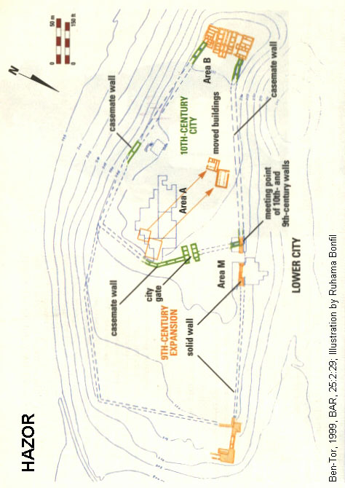

PHOTO LINK: HAZOR 023B Oblique photo showing 18th to 8th century BC structures
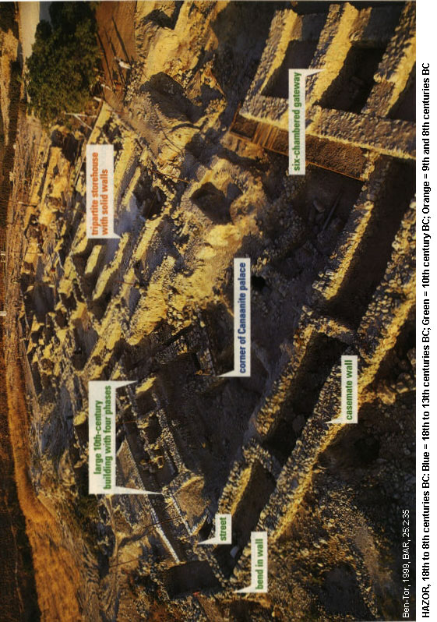

PHOTO LINK: HAZOR 022 Plans of Hazor, 18th to 8th century BC
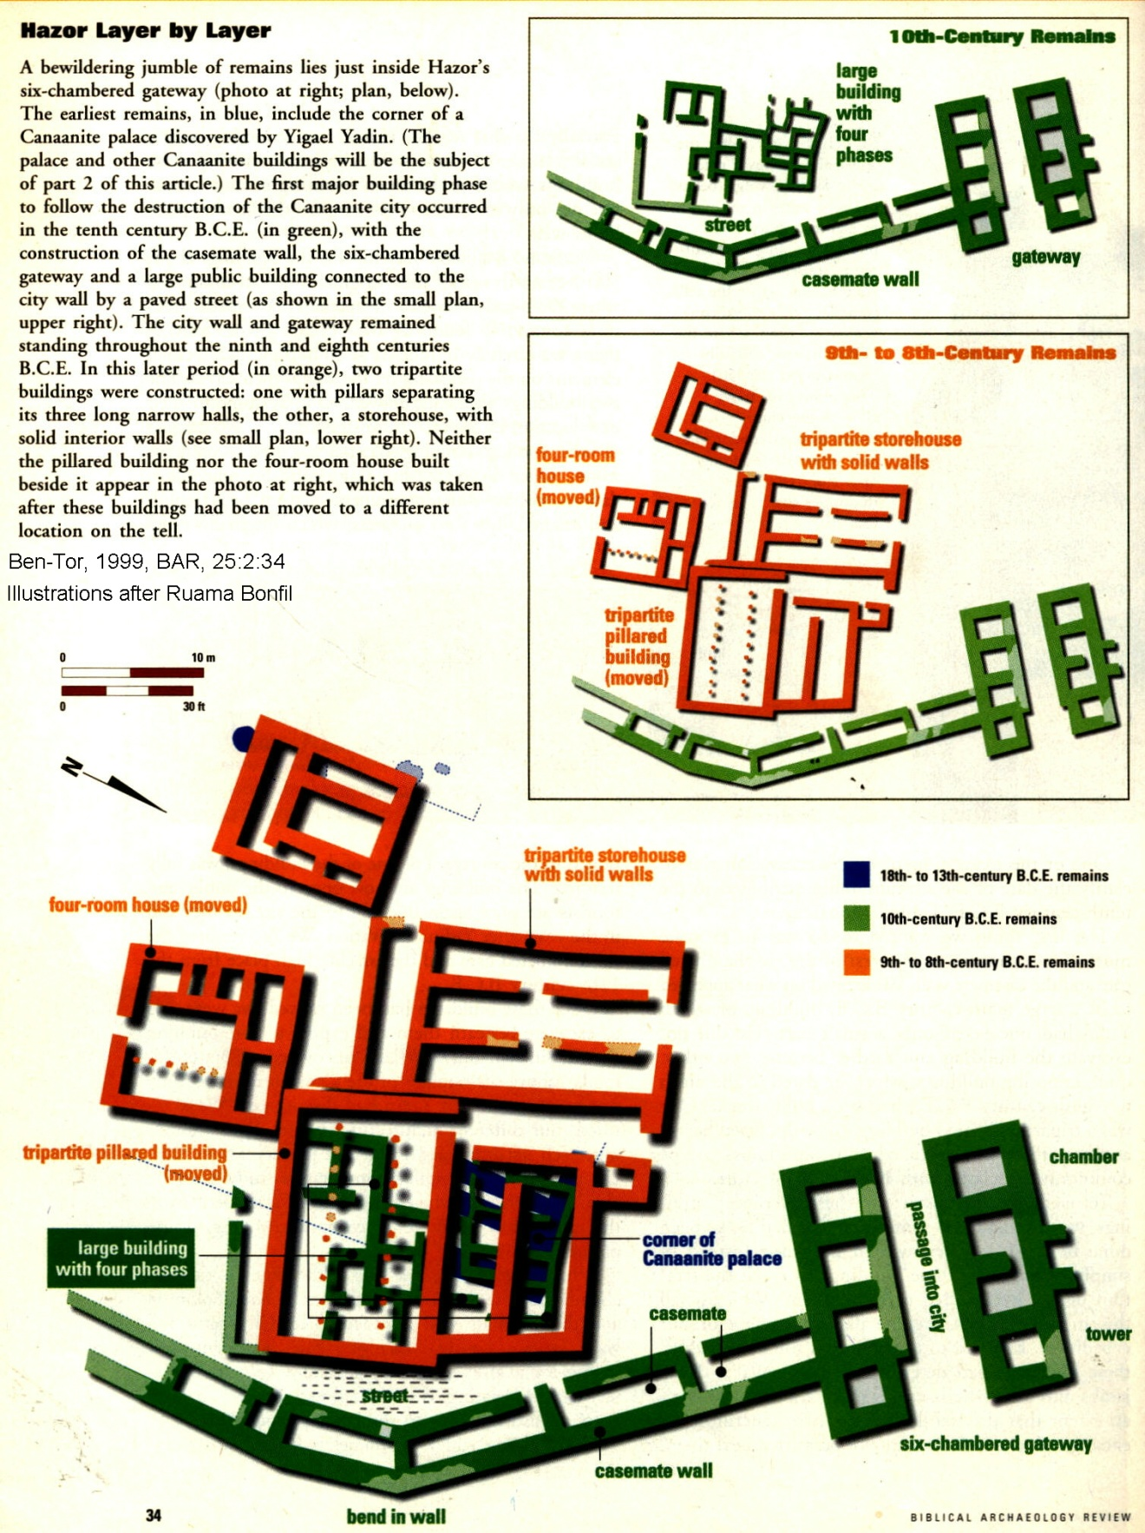

Hazor Water System

Like many Iron-Age cities, Hazor had a water source that was outside the city. In order to have access to water during times of siege, the residents of Israelite Hazor excavated an underground water system inside the city. The original plan of this water system appears to have been to dig a shaft downward to the level of the spring, and then tunnel horizontally over to it. But in the case of Hazor, there is a major tectonic feature called the Hula Western Boarder Fault (HWBF) that runs in a north-south direction under the eastern part of the city. This fault is the western part of the Dead Sea Rift group of faults that separate the African (Sinai) tectonic plate to the west from the Arabian plate to the east. The HWBF allowed artesian (pressurized) water to migrate up the fault zone and saturated the area around it. Engineers found this zone in the shaft and then followed this saturated water along a sloping tunnel to the fault where they constructed a water collection chamber (Weinberger et. al, 2010).
PHOTO LINK: HAZOR WATER SYSTEM 001 Fault at water collection chamber. Arrows show sense of displacement; Weinberger et. al, 2010,BAR, 36:5:65.
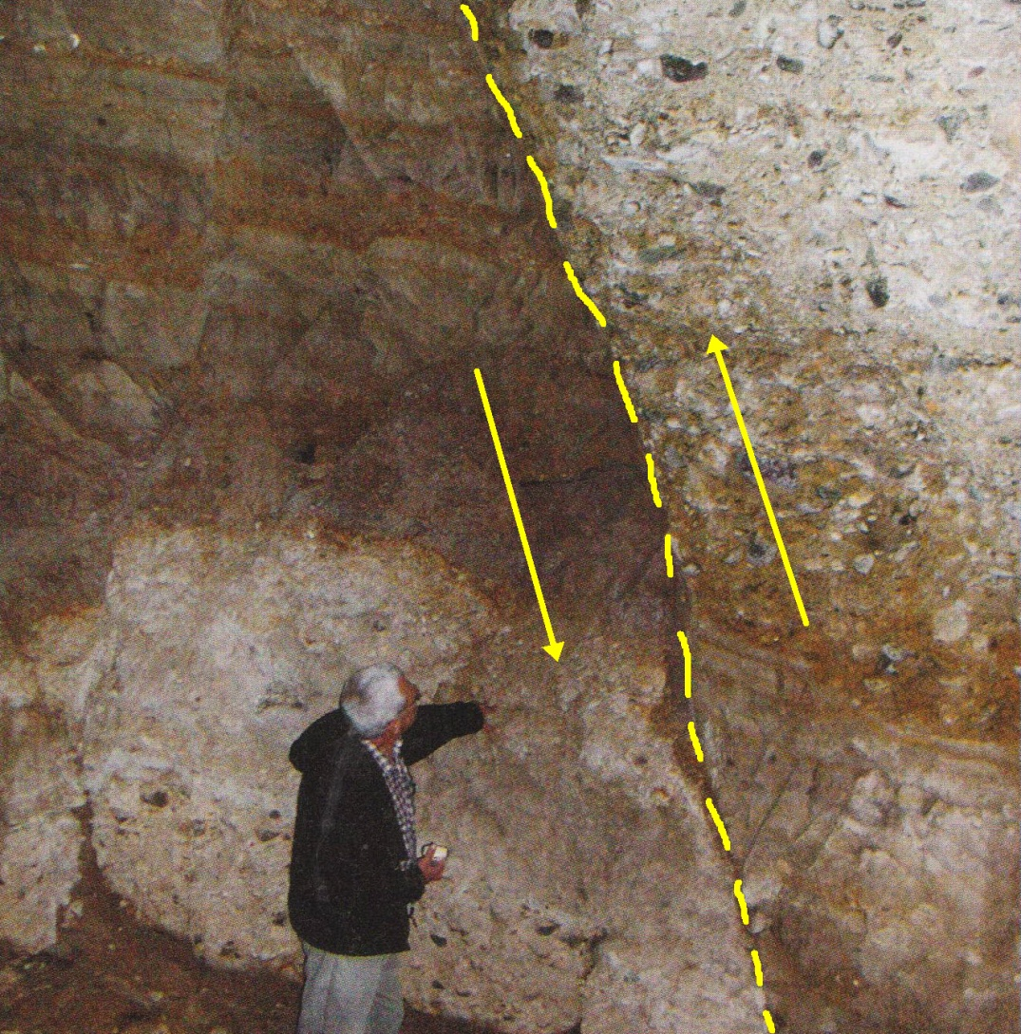

PHOTO LINK: HAZOR WATER SYSTEM 002 View of shaft from above
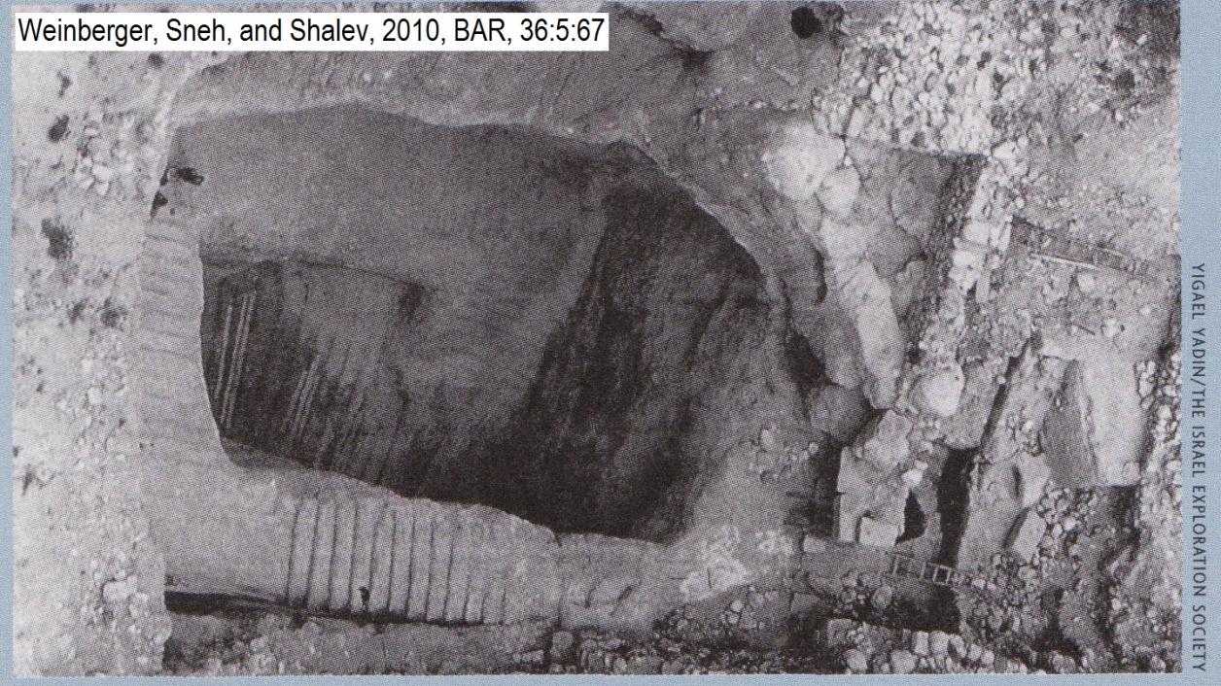

PHOTO LINK: HAZOR WATER SYSTEM 003 Sloping Tunnel
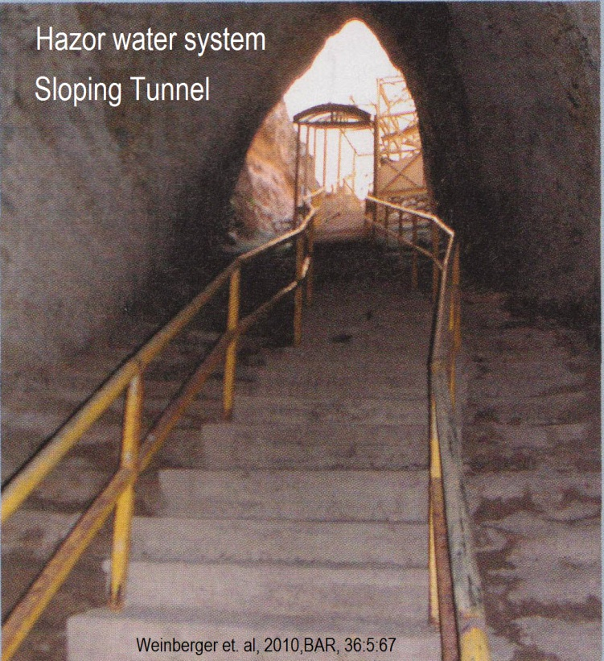
PHOTO LINK: HAZOR WATER SYSTEM 004 Map of Hazor showing location of Hula Western Fault
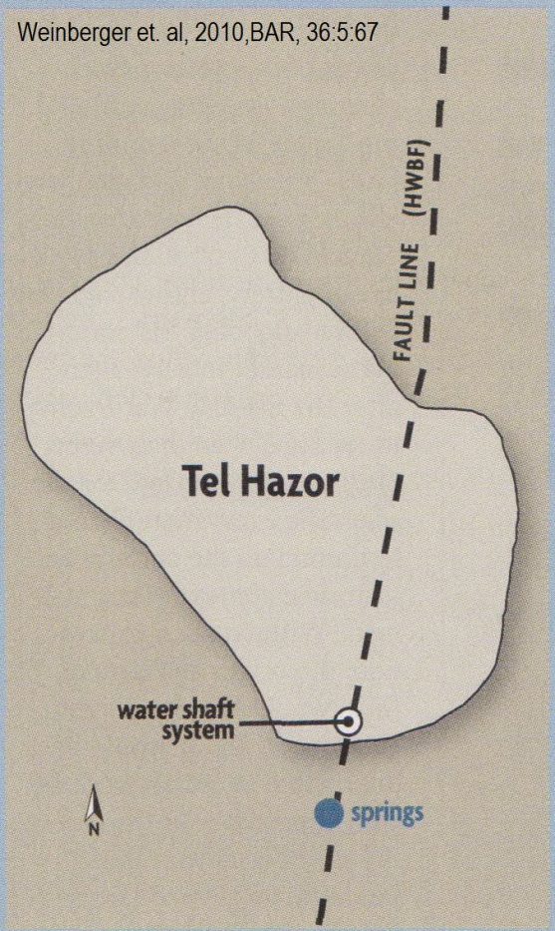

PHOTO LINK: HAZOR WATER SYSTEM 005 Aerial Plan and Cross Section
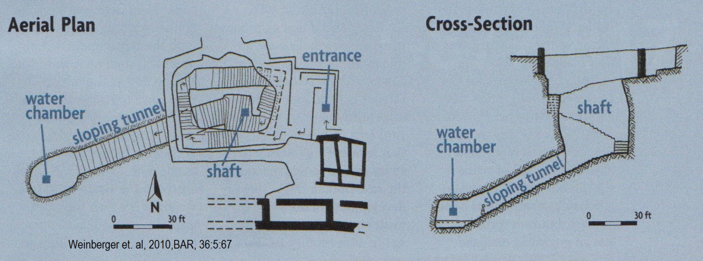

Attack of Dan (C. 733 BC)

On his way to Damascus, Tiglath-pileser III, destroyed Israelite Dan (Shanks, 1994).

There was a royal sacred high place (bamot) at Dan. It was first expanded by Jeroboam I (931-910 BC). The city was destroyed by the Assyrian Tiglath-pilser III (8th century BC). Under the, collapsed debris of the city wall were found three smaller massebot (standing stone) shrines (Biran, 1998).

PHOTO LINK: DAN 015 Platform of Jeroboam 938 to 907 BC
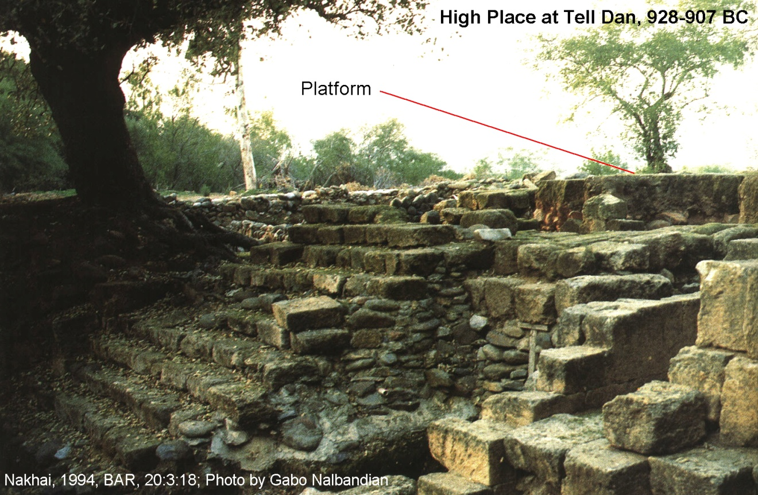

PHOTO LINK: DAN 016 Bahmot Platform of Jeroboam 938 to 907 BC close up; (See ABOVE, p. ; ctrl+click to follow link)

PHOTO LINK: DAN 021 Plan and location of four massebot
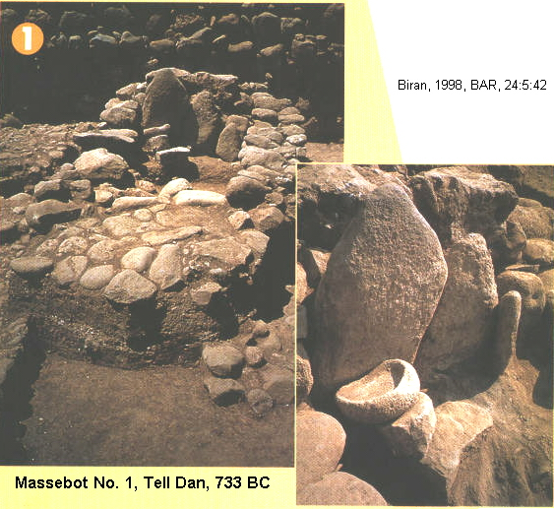
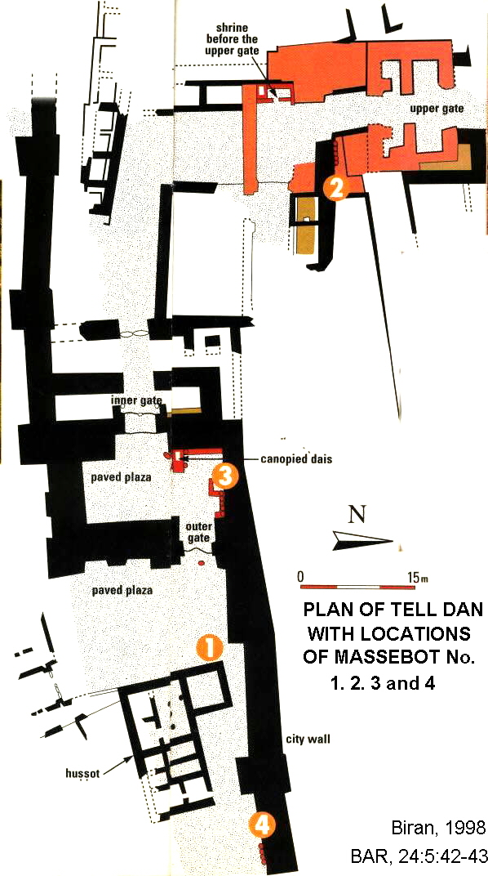

PHOTO LINK: DAN 021.2.3.4 Massebot No. 2,3,4
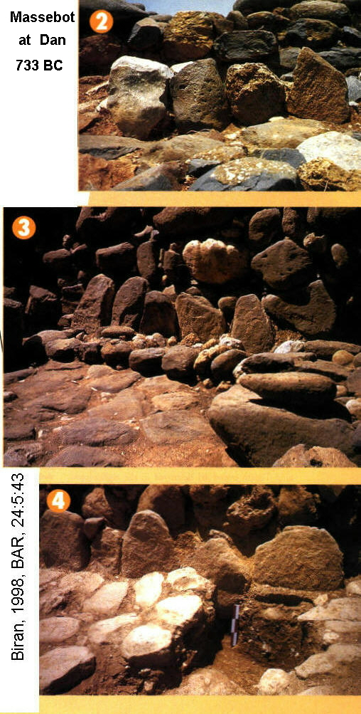

Standing stones are known from the Neolithic Negev. Their presence in Iron Age Dan suggest a persistence of popularity in Israelite religion

PHOTO LINK: MASSEBOTH 005 Single stone in rock circle Negev Eila
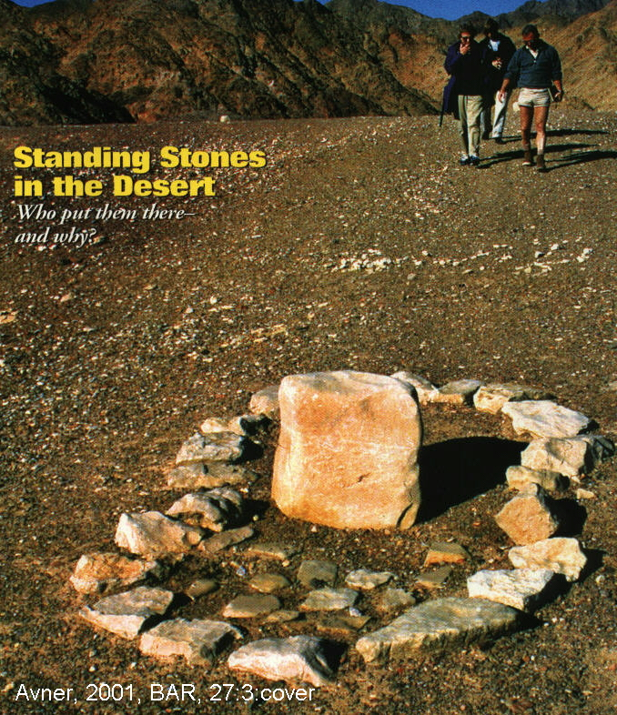

Associated with Massebot No. 2 was a kunestine ashlar block with a rectangular depression. Biran (1998:45) suggests this depression was used for libation ceremonies. This massebot was near the upper city gate and may represent a “high places (bamot) of the gates” described in 2 Kings 23:8 (Biran, 1998).

PHOTO LINK: DAN 020: Limestone libation basin (cracked in half)
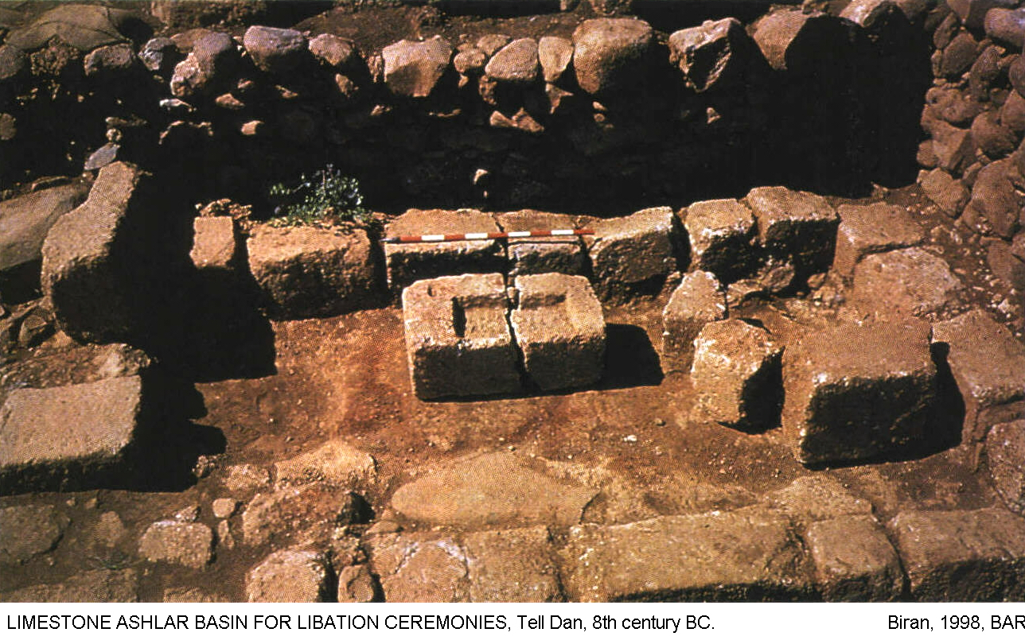

Bamot (hillside shrines) and massebot like these were condemned by Josiah and other reformers (2 Kings 23:8; Biran, 1998).

Massebot No. 1 dates to the seventh century BC. Worship practices continued at Dan after the destruction of its defenses by Tiglath-pileser III (Biran, 1998:45).

Israelites persisted in their syncretism and henotheism even after their conquest by the Assyrians.

PHOTO LINK: DAN 008 Jar handles from destruction of Dan by Tiglath-pileser III
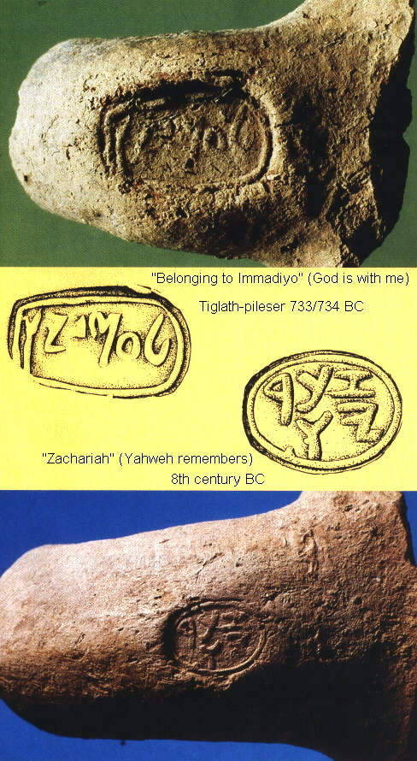

PHOTO LINK: DAN009 Gate complex, first temple period, destroyed by Tiglath-pileser III
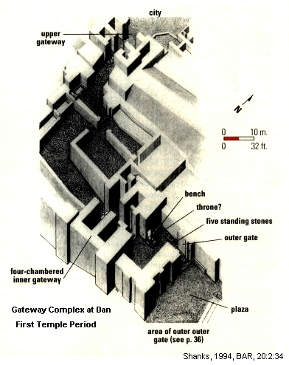

Having taken "Iyyon, Abel-beth-maacah, Janoah, Kedesh, Hazor, Gilead and Galilee with all the land of Naphtali" (2 Kings 15: 29-30), including coastal territory between Phoenicia and Philistia, Tiglath-pileser "deported the people to Assyria" (2 Kings 15:31).

Attack of Dor (740-732 BC)

Tiglath-Pileser III destroyed Dor in 733 BC. After it's defeat, the city was quickly re-built. Ahab's four-chambered gate complex was replaced by a two-chambered gate and the offset-inset protective city wall was renovated. Assyrian presence at Dor is indicated by acylinder seal of imported reddish granite carved with a common Assyrian motif of the king standing in the center and fighting two horned griffins (Stern, 1993c).

PHOTO LINK: DOR 002 Location maps
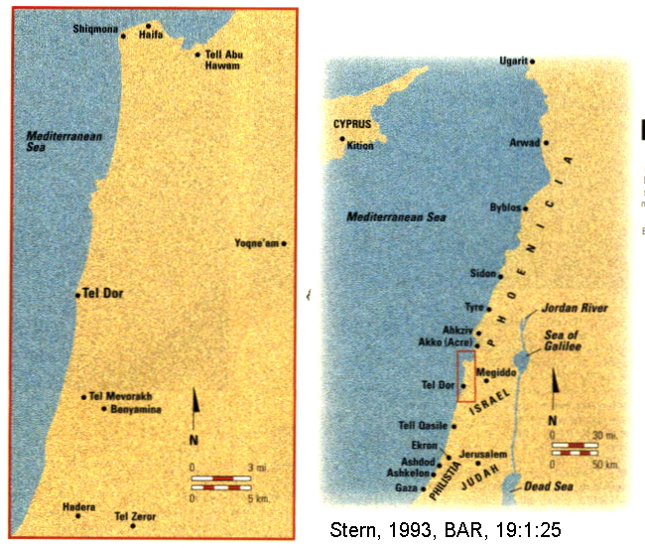

PHOTO LINK: DOR 001C Aerial photo
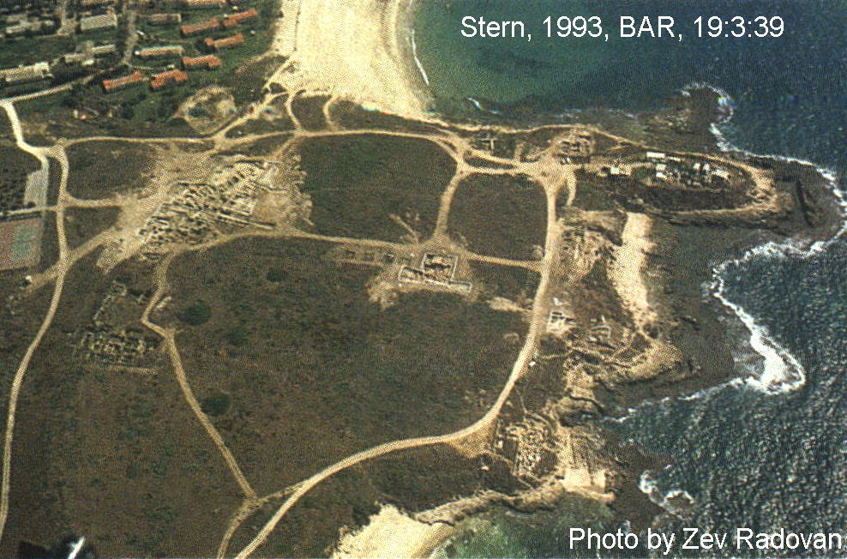

PHOTO LINK: DOR 018 Cylindar seal from Dor
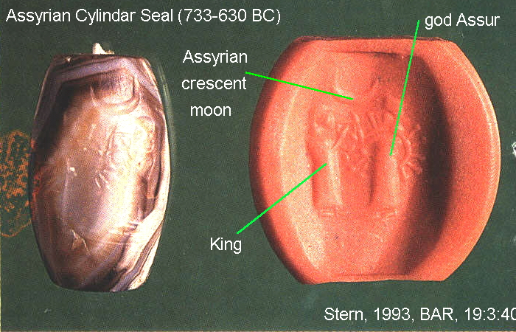

A second stamp seal from this period, perhaps belonging to an Assyrian official of provincial Dor was found,

PHOTO LINK: DOR 019 Stamp seal from Dor
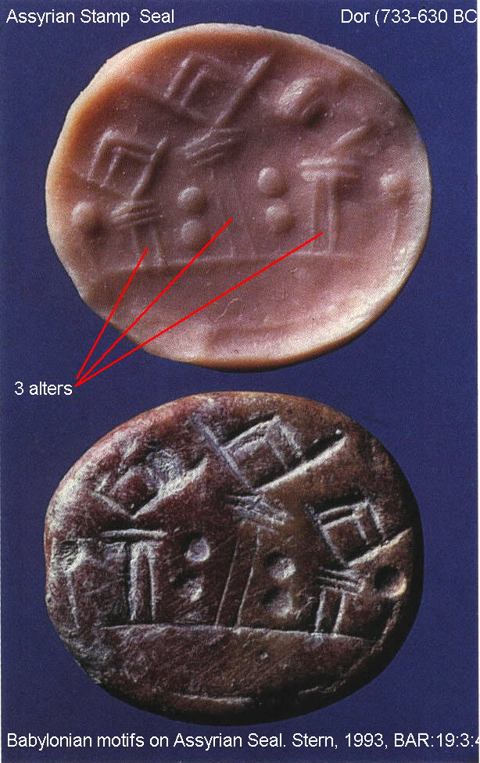

Assyrian control of Dor lasted to about 630 BC, when an unknown force conquered the city. Candidates for this new ruler are one of the Phoenician kings (of Tyre or Sidon), or possibly Josiah who died in battle at Megiddo in 610 or 609 BC. This new ruler (Josiah, or an unknown Phoenician king) administered Dor until the arrival of the Neo-Babylonians in 600 BC (Stern, 1993c).

Overthrow of Pekah by Tiglath-piler III (732 BC)

The deportations described in 1 Chron. 5:26 and 2 Kings 15:29 are also recorded in Assyrian victory inscriptions (Younger, 2003:41):

"I carried off [to] Assyria the land of Bit-Humria (Beth Omri = "House of Omri, Israel"), [...its] 'auxiliary [army,] ...all of its people...[I/they killed] Pekah, their king, and I installed Hoshea [as king] over them, I recieved from them 10 talents of gold, x talents of silver..."

Younger (2003:41) relates that two other fragmentary inscriptions state that Tiglath-pileser,

"...leveled 16 districts of Bit-Humria (Beth Omri, Israel)", and took a total of 13,520 captives, primarily from Lower Galilee, who "with their possessions I carried off to Assyria" (Hallo and Younger, 1997-2000; cited by Younger, 2003:70).)

The Biblical version (2 Kings 15:30) of fall of Pekah says that:

"Hoshea son of Elah conspired against Pekah son of Remaliah, attacked him, and killed him"

The Chonicler relates (1 Chron. 5:26):

“So the God of Israel stirred up the spirit of Pul king of Assyria (that is, Tiglath-Pileser king of Assyria), who took the Reubenites, the Gadites and the half-tribe of Manasseh into exile. He took them to Halah, Habor, Hara and the river of Gozan, where they are to this day. “

PHOTO LINK: ASSYRIA 039 Residents of Astartu (Ashtaroth) going into Exile under Tiglath-pileser III, Nimrud Palace relief
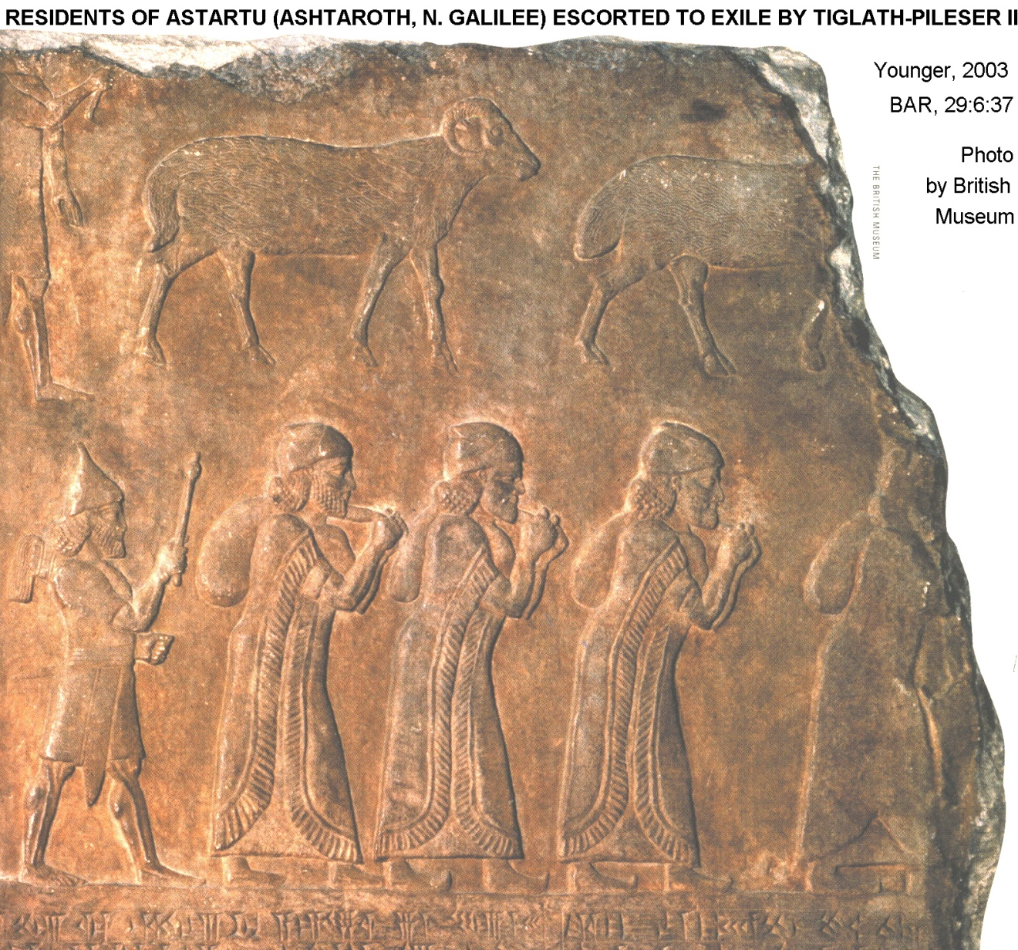

PHOTO LINK: ASSYRIA 041 Map of Assyrian deportation programs Tiglath-pileser III, Shalmaneser V, and Sargon II; Younger, 2003, BAR, 29:6:39
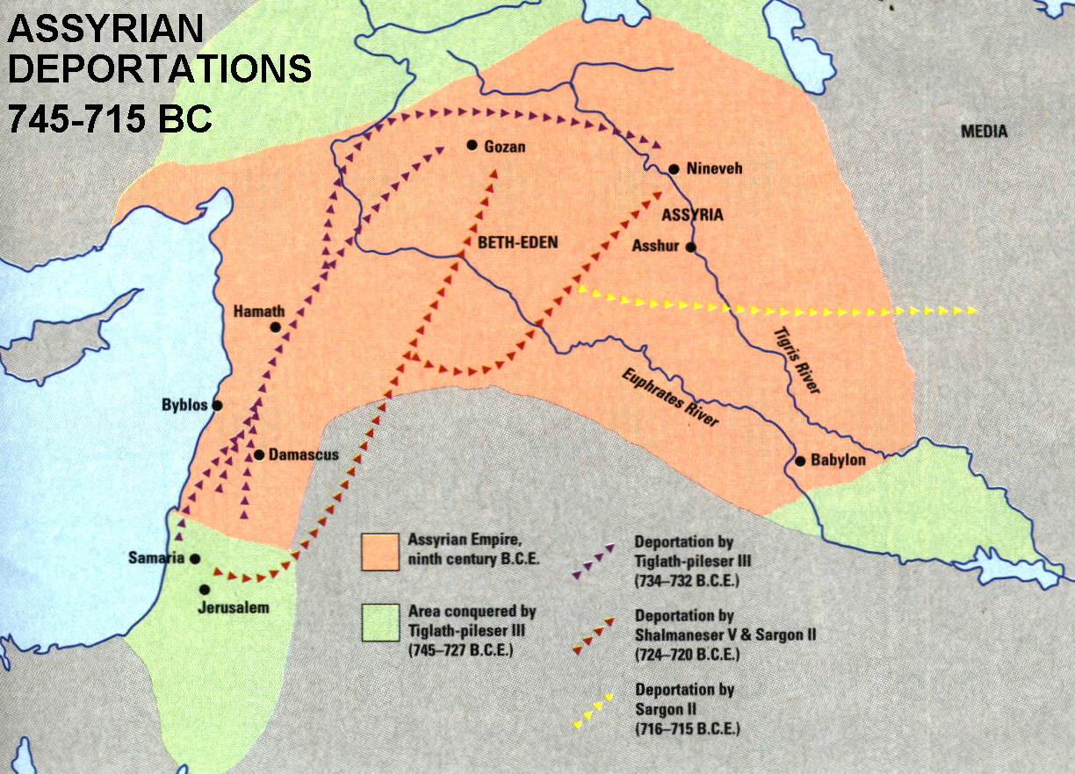

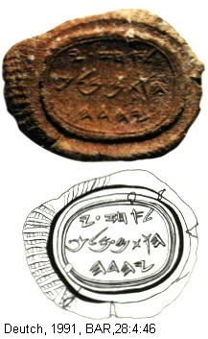
AHAZ OF JUDAH (735-716 BC)

In the turbulent international events of 733 BC, following the death of Jotham, Ahaz became king of Judah supported by a pro-Assyrian political party (Hoerth, 1998:337). As a consequence, Ahaz refused to join the anti-Assyrian Israel-Aramean league of Pekah and Rezin of Damascus. So they attacked Jerusalem in order to force cooperation (2 Kings 16:5; Hoerth, 1998:334).

PHOTO LINK: BULLAE AHAZ 001 Clay seal of King Ahaz of Israel (RIGHT)

Edom and Philistia Revolt against Ahaz

Seeing this opportunity to revolt, the king of Edom (a Judean vassal at that time) "recovered Elath and drove the Judeans out of it (2 Kings 16:6).

PHOTO LINK: ELATH 001-B Map of Eiliat-Elath-Eliat; (See ABOVE, ctrl+click to follow link)

Moreover, the Edomites "invaded again and defeated Judah and [had] taken away prisoners (2 Chron. 25:17).

PHOTO LINK: EDOM 001 Map of Edomite expansion into Judah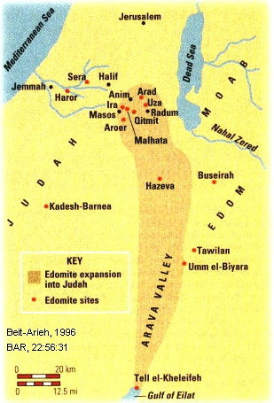

PHOTO LINK: AR062 Horvat Qitmit Edomite Shrine, Religious center in Negev; (See ABOVE, ctrl+click to follow link)
PHOTO LINK: ESN61 Hathor Temple, Timna Valley
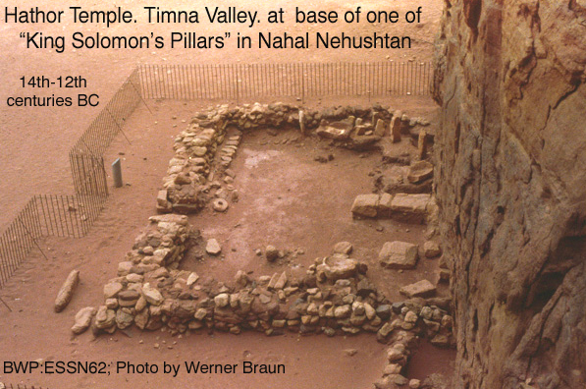2
PHOTO LINK: ESN061 “King Solomon’s Pillars”; Timna Valley, southern end of Dead Sea
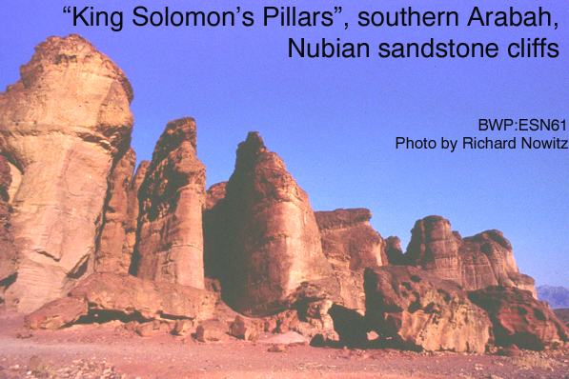

Likewise, the Philistine vassal states "raided the cities of Shephelah and of the Negev of Judah and had captured Beth-shemesh, Aijalon, Gederoth, as well as Soco, Timna and Gimzo and their villages and occupied them” (2 Chron. 28:17-18).

PHOTO LINK: PHILISTINE 008 Map of the Philistine Pentapolis; (See ABOVE, ctrl+click to follow link)
PHOTO LINK: BETH SHEMESH 003-B Location map and geographic zones; (See ABOVE, ctrl+click to follow link)
PHOTO LINK: BETH SHEMESH 005-B Strong wall bastion for Solomon fortress; Bunmovitz and Lederman, 1997, BAR:21:1:CD
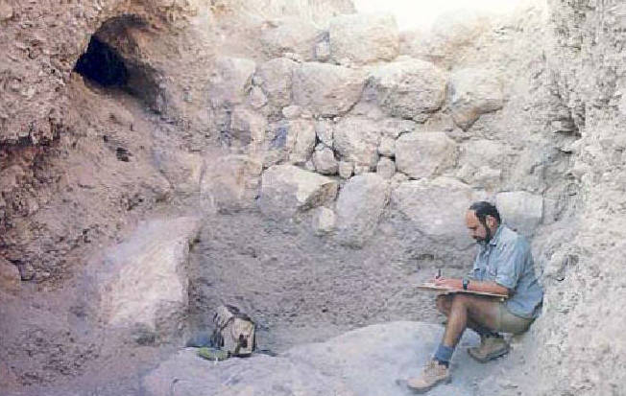

PHOTO LINK: AIJALON 001 Location map
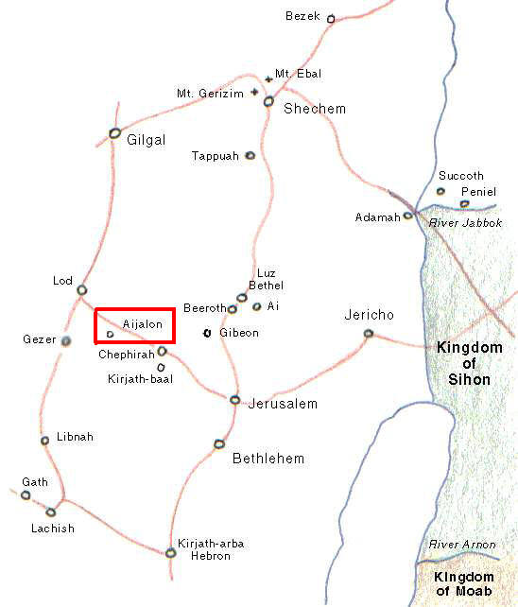

PHOTO LINK: TIMNA 007 Location Map; http://www.bibleplaces.com/timnavalley.htm ; Dec. 19, 2005
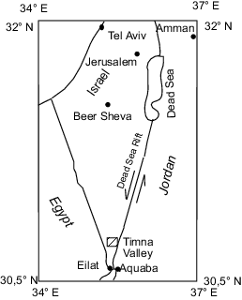

PHOTO LINK: TIMNA 001 Tima Valley
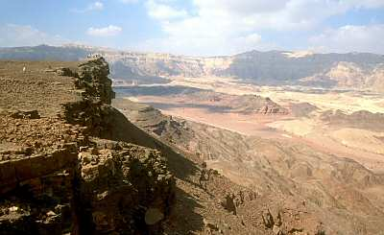

First Isaiah and Ahaz (739 to 690? BC)

It was in this time of uncertainty that the prophet Isaiah met with King Ahaz. In c.735 BC, Isaiah found Ahaz inspecting Jerusalem's southern water supply system (Hoerth, 1998:338). Isaiah offered words of encouragement: if Ahaz trusted in the Lord, Aram and Samaria would not succeed with their planned invasion of Judah. (2 Chron. 7:3-9). On another occasion, "the Lord spoke to Ahaz" (presumably through Isaiah) and offered to fulfill any sign Ahaz requested. Ahaz turned down the offer, and the Lord's answer came as a prophecy of the Messiah:

"Listen house of David! Are you not content to wear out men's patience? Must you also wear out the patience of God? Therefore, the Lord himself will give you a sign: A young woman is with child, and he will bear a son, and [you] will call his name Immanuel" (2 Chron. 7:14).

As told below, Ahaz refused Isaiah's advice and instead trusted to Assyria for his country's salvation.

The Book of Isaiah is a compilation of several literary sources. The Isaiah who lived "in the reigns of Uzziah, Jotham, Ahaz and Hezekiah, kings of Judah" (Isaiah 1:1) lived from 739 to about 690 BC (Whitcomb, 1968). He is responsible for most of the material in Isaiah chapters 1-39. A discussion of 2nd and 3rd Isaiah is made in Chapter 21.

Most fundamentalists and some evangelicals think there was only one Isaiah.

The Judean-Assyrian Alliance: Ahaz and Tiglath-pileser III (745-727 BC)

In desperation, with his country falling apart, Ahaz sent messengers asking the King of Assyria, the hated Tiglath-Pileser III, to come to his rescue (2 Kings 16:7).

PHOTO LINK: ASSYRIA 008 Tiglath-Pileser in relief
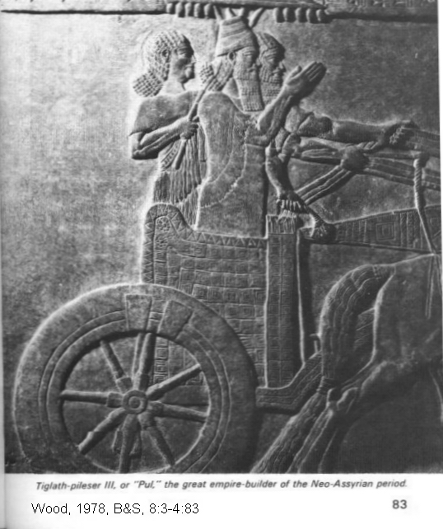
PHOTO LINK: ASSYRIA 026 Tiglath-Pileser III colored wall painting; (See ABOVE, ctrl+click to follow link)

The messengers where successful in developing a treaty and Assyria did support Judah against Egypt in 732 BC. To pay for the protection of Assyria, Ahaz stripped the palace and robbed Solomon's Temple of treasures dedicated to God (Hoerth, 1998:338). The tribute that Tiglath -pileser III received from Ahaz is recorded in an inscription summarizing the first 17 years of Tiglath-pileser's reign (Wood, 2001:24).

PHOTO LINK: ASSYRIA 028 Summary tablet of Tiglath-pileser III
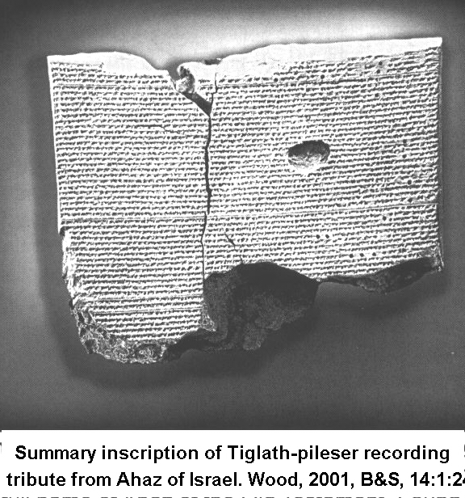

The description of the Judean-Assyrian alliance described in the Annals of Tiglath-pileser III can be compared to 2 Kings 15:29-30 and 16:7-9 and 1 Chron 5:6. The Assyrian text reads:

"[I received] the tribute of .... Jehoahaz (Ahaz) of Judah...I lay siege to and conquered the town of Hadara, the inherited property of Rezin of Damascus, the place where I was born. I brought away prisoners 800 of its inhabitants with their possessions...their large and small cattle. 750 prisoners from Kurussa,...prisoners from Irma, 550 prisoners from Metuna I brought away. 592 towns...of the 16 districts of the country of Damascus I destroyed making them look like hills of ruined cities over with the flood had swept...(Grayson, 1975, p.282).

"Israel...all its inhabitants and their possessions I led to Assyria. They overthrew their king Pekah and I placed Hoshea as king over them. I received from them ten talents of gold, 1000 talents of silver as their tribute and brought them to Assyria (Pritchard, 1969, p.283-284).

The compiler of Kings (2 Kings 15:29-30) relates:

29In the time of Pekah king of Israel, Tiglath-Pileser king of Assyria came and took Ijon, Abel Beth Maacah, Janoah, Kedesh and Hazor. He took Gilead and Galilee, including all the land of Naphtali, and deported the people to Assyria. 30Then Hoshea son of Elah conspired against Pekah son of Remaliah. He attacked and assassinated him, and then succeeded him as king in the twentieth year of Jotham son of Uzziah

The Chronicler (1 Chron 5:6, 26) had this to say:

6….and Beerah his son, whom Tiglath-Pileser king of Assyria took into exile. Beerah was a leader of the Reubenites…26So the God of Israel stirred up the spirit of Pul king of Assyria (that is, Tiglath-Pileser king of Assyria), who took the Reubenites, the Gadites and the half-tribe of Manasseh into exile. He took them to Halah, Habor, Hara and the river of Gozan, where they are to this day.

In 734-732 BC, Tiglath Pileser III made Megiddo (Assyrian Magiddu) the provincial Assyrian capital (Stratum III). Assyrian Megiddo featured two new elaborate public buildings near the city gate. These had central rectangular courtyards surrounded on all sides by halls and rooms (Finkelstein and Ussishkin, 1994:43).

PHOTO LINK: MEGIDDO 006 Location map wiv Via Maris
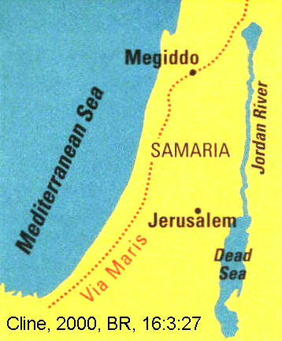

PHOTO LINK: MEGIDDO 031 Oblique low altitude photo opposite gash
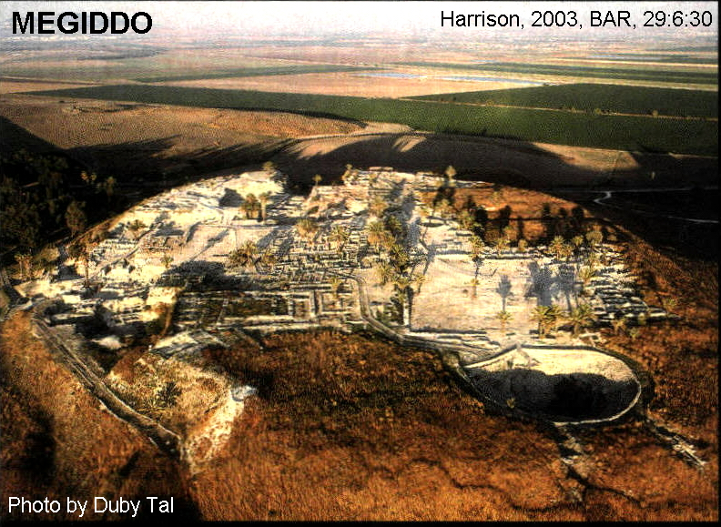

PHOTO LINK: MEGIDDO 018-C Gate complex model
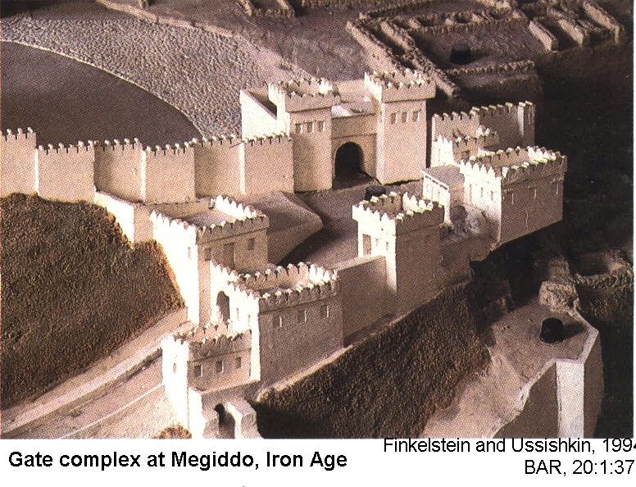

The price to Judah of it's alliance with Tiglath-pileser III was enormous, both economically and spiritually. Money (tribute) was not enough to satisfy the Assyrians. They also insisted on religious domination. Following architectural plans provided by Tiglath-pileser III, Uriah the priest and Ahaz completely re-arranged the Jerusalem Temple complex and changed religious ritual practices there (2 Kings 16:10-19).

11So Uriah the priest built an altar in accordance with all the plans that King Ahaz had sent from Damascus and finished it before King Ahaz returned. 12When the king came back from Damascus and saw the altar, he approached it and presented offerings on it.

Despite his domination by Tiglath-pileser III, Shalmaneser V and Sargon II, Ahaz apparently had some freedom of action against the Philistines. This is inferred from Isaiah 14:28-31 where the Philistines are cautioned against premature rejoicing (Hoerth, 1998:341). Then Ahaz died and was succeeded by his son Hezekiah.

TIGLATH-PILESER III AND PHARAOH IUPUT II (745-715 BC)

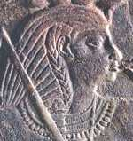
During this time Iuput II was Pharaoh (Twenty-third dynasty of Egypt; 754 BC - 715 BC). Iuput II ruled in the Delta from Leontopolis. He was an ally of Osorkon IV and Tefnachkt in the 24th Dynasty against another ruler, Piankh in the 25th Dynasty. This is a confusing period, with many kings ruling in different regions of Egypt. From the look of it, just about anyone could (and did!) claim to be pharaoh. Since people didn't know what happened fifty miles from their own farm, it probably worked to have a "king" in each region -- although there is little to support the idea that they worked together. (http://www.phouka.com/ pharaohpharaoh/dynasties/dyn23 /07iuput2.html, Sept. 26, 2006)

PHOTO LINK: IUPUT II 754-720 BC 001 Pharaoh of the 23rd Dynasty; Relief of Iuput II; http://www.narmer.pl/dyn/23en.htm; Sept. 27, 2006 (ABOVE)

ASSYRIAN DEPORTATION POLICY AND THE SAMARITANS

Being satisfied, Tiglath-pileser III then moved on to conquer Damascus and then annexed half of Israel after defeating Pekah of Israel and placed Hoshea on the "throne" of the northern provinces (Wood, 1991; Grayson, 1975; Pritchard, 1969).

PHOTO LINK: DAMASCUS 001 Location map; (See ABOVE, ctrl+click to follow link)

This practice marked a turn in Assyrian stratagem. Rather than killing off conquered peoples, they began deportation (as conquered slaves) and importation of their own people in order to establish Assyrian culture and permanent empire in the conquered territories. This resulted in creation of a new people with a pattern of mixed worship: the Samaritans (2 Kings 17:24-41). The only area Pekah had left to rule following these events was Ephriam and the land northward as far as the Esdraelon Valley (Valley of Jezreel; Hoerth, 1998:334).

PHOTO LINK: GA004 Plain of Jezreel between Megiddo and Mt Carmel;
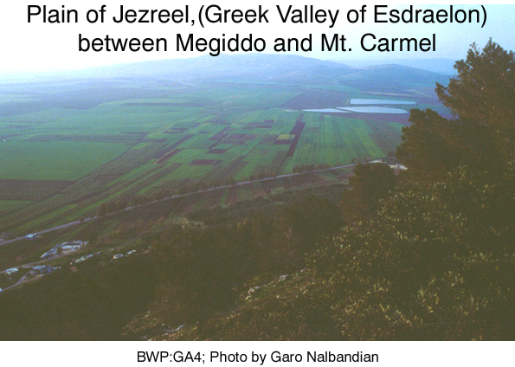

HOSHEA "KING" OF ISRAEL (732-722 BC)
PHOTO LINK: HOSHEA KING 003 Timeline 732-722 BC
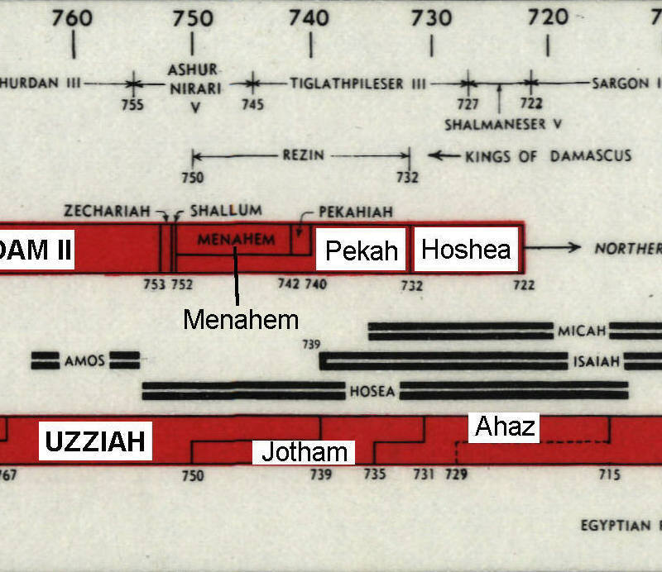
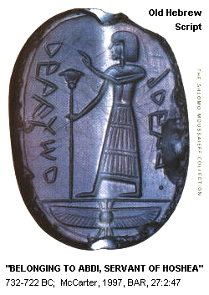
Following the disastrous Israelite-Aramean alliance and defeat by Tiglath-pileser III, Pekah was murdered in another conspiracy by Hoshea who "attacked him, killed him and usurped the throne in the 20th year of Jotham son of Uzziah [of Judah]" (2 Kings 15:30). As told in the Annals of Tiglath-Pileser III (cited above), he takes the credit for placing Hoshea on the throne.

A seal of (a minister of) King Hoshea (732 or 731-722 BC), the last king of Israel before it was destroyed by the Assyrians has been found. This king's name in Hebrew (HWS') is the same as the prophet Hosea. The minister's name is 'BDY=Abdi a short version of English Obadiah (Lemaire, 1995).

PHOTO LINK: HOSHEA KING 001 Seal of official of King Hoshea of Israel (RIGHT)

Shalmaneser V (727-722 BC), the fall of Shechem (727 BC) and Samaria (722 BC)
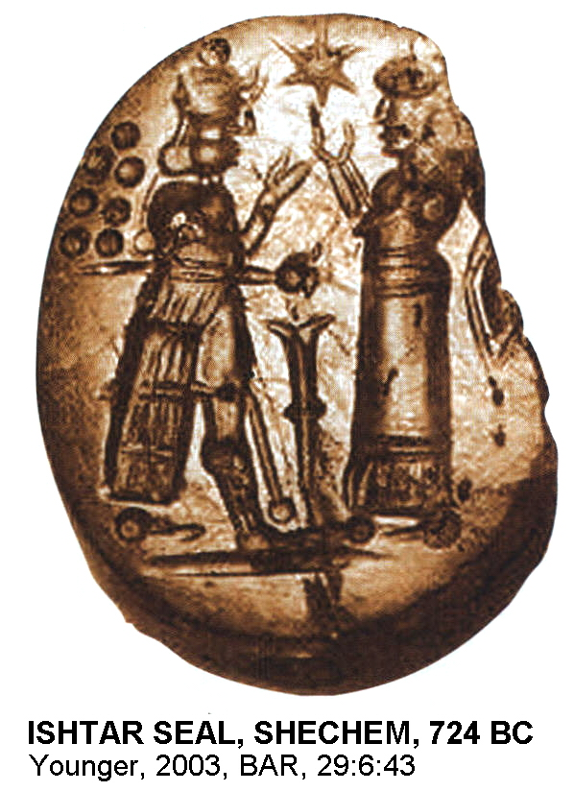
Shalmaneser V was the son of the Assyrian king Tiglath-pileser III. Shalmaneser V became king in 727 BC (Shea, 1999:39; Younger, 2003:41) and ruled for only 5 years. Like many vassal states, upon the death of Tiglath-pileser III, King Hoshea of Israel rebelled in 724 BC. In response, Shalmaneser V arrested Hoshea, put him in prison and mounted an invasion. He attacked Shechem burning it to the ground. The remnants of the city are preserved in Statum VII at Shechem. Among the debris was found an Assyrian seal with a depiction of the warrior-goddess Ishtar. G.E. Wright, the chief excavator dated the destruction of Shechem to 724 BC based on this artifact (Younger, 2003:41).

PHOTO LINK: ASSYRIA 043 Seal of Ishtar, Shechem Stratum VII 727 BC (RIGHT)

PHOTO LINK: SHECHEM 003 Location map of Shechem, Megiddo, Tyre and Jerusalem

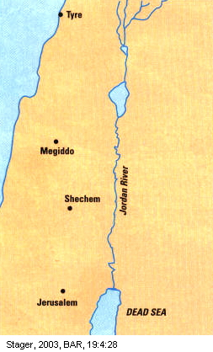

PHOTO LINK: SHECHEM 012 Plan of Shechem and Jacob's Well
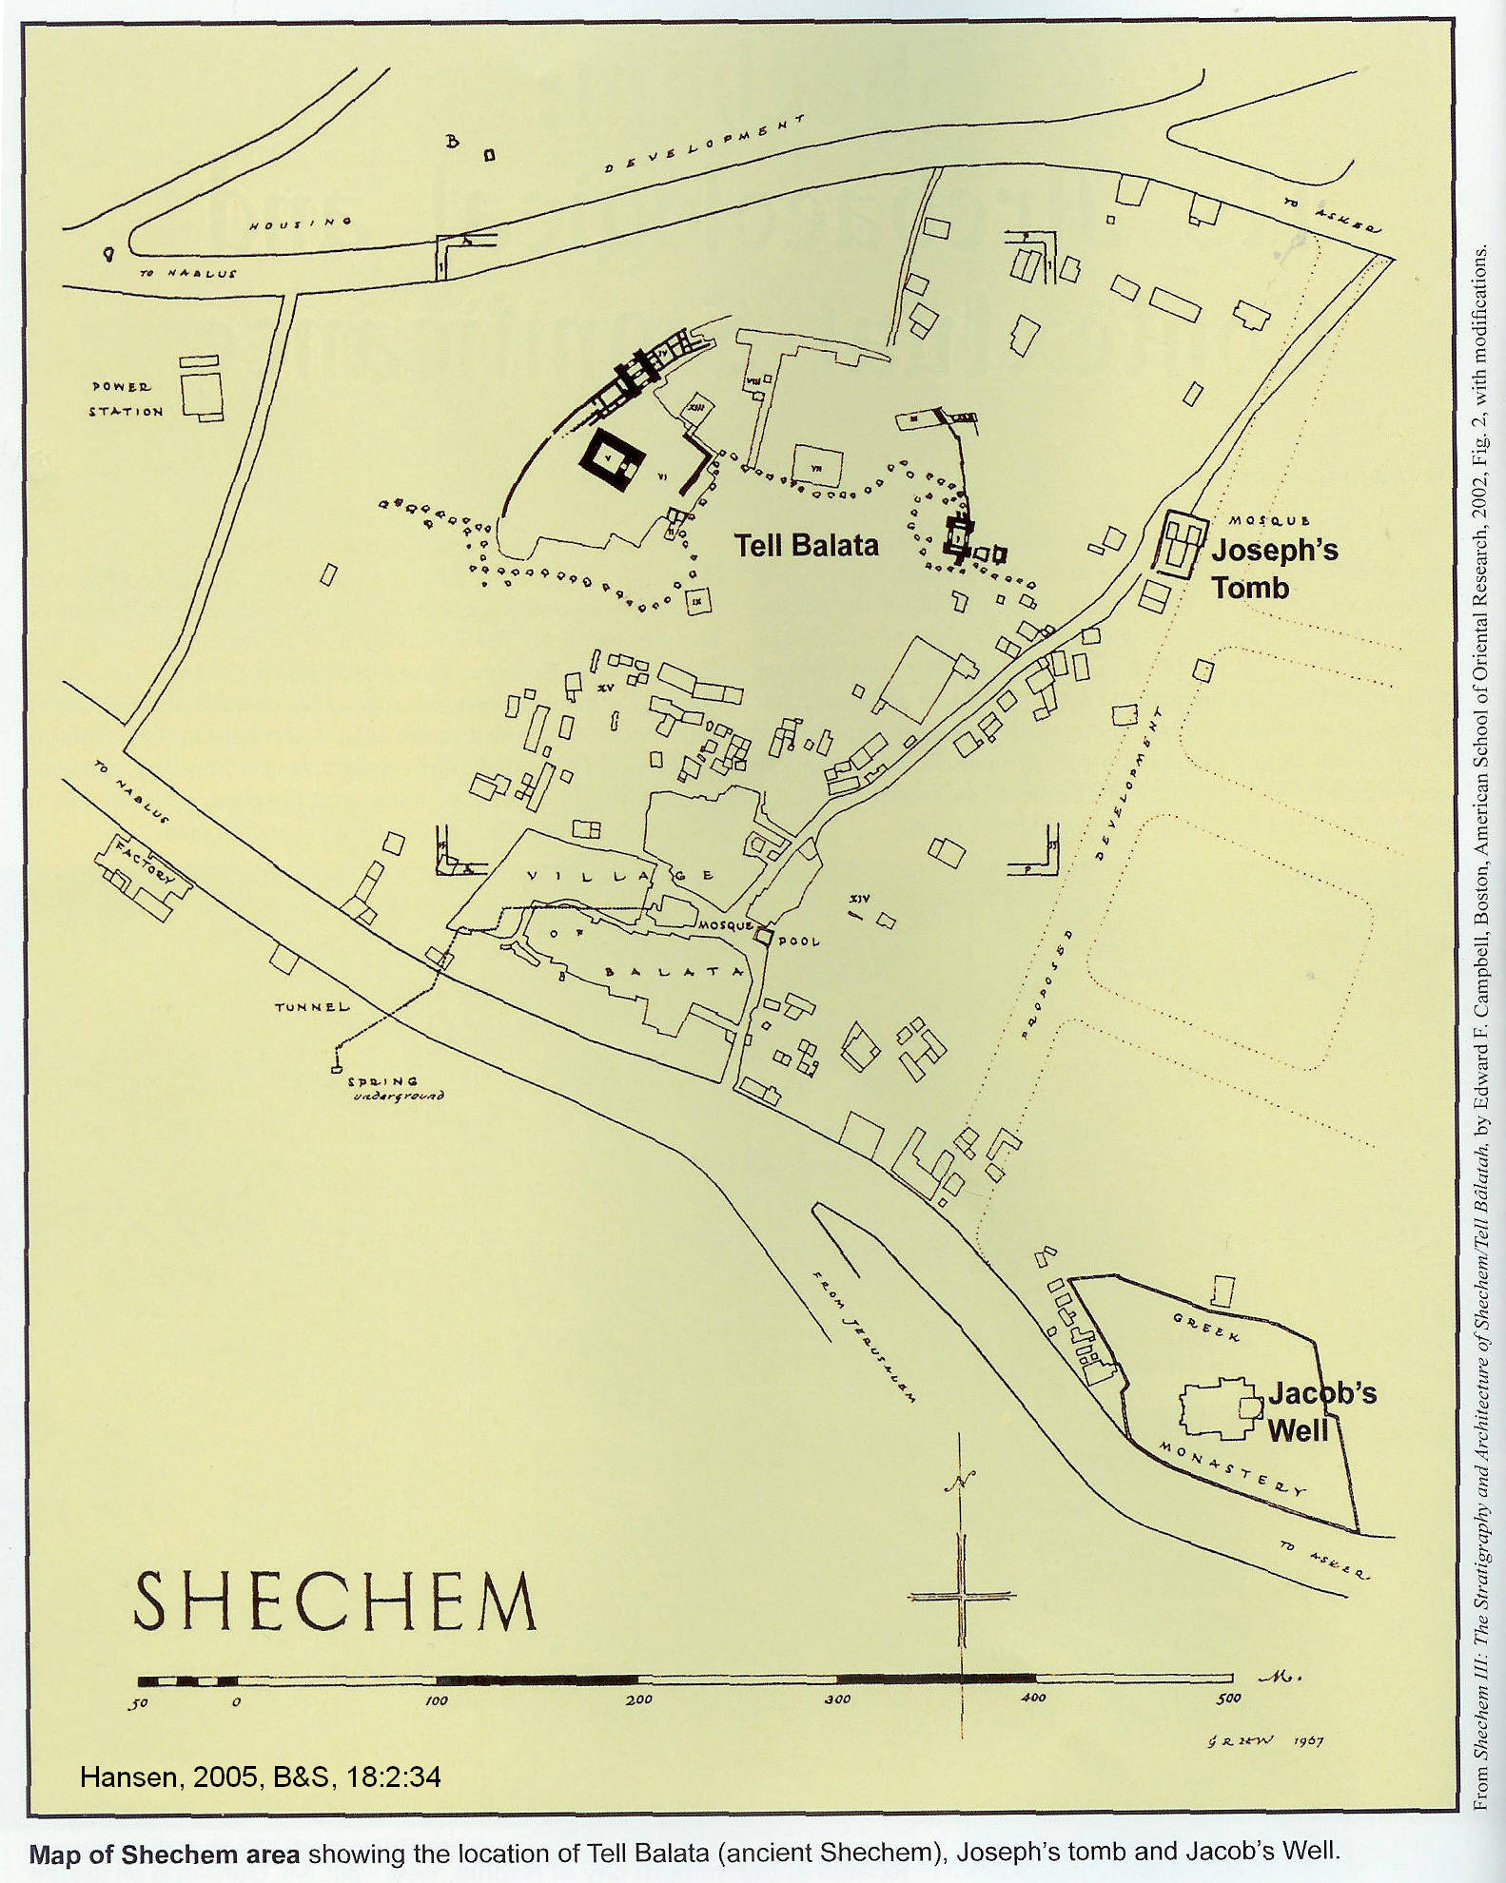

PHOTO LINK: SHECHEM 013 Aerial photo of Shechem ruins
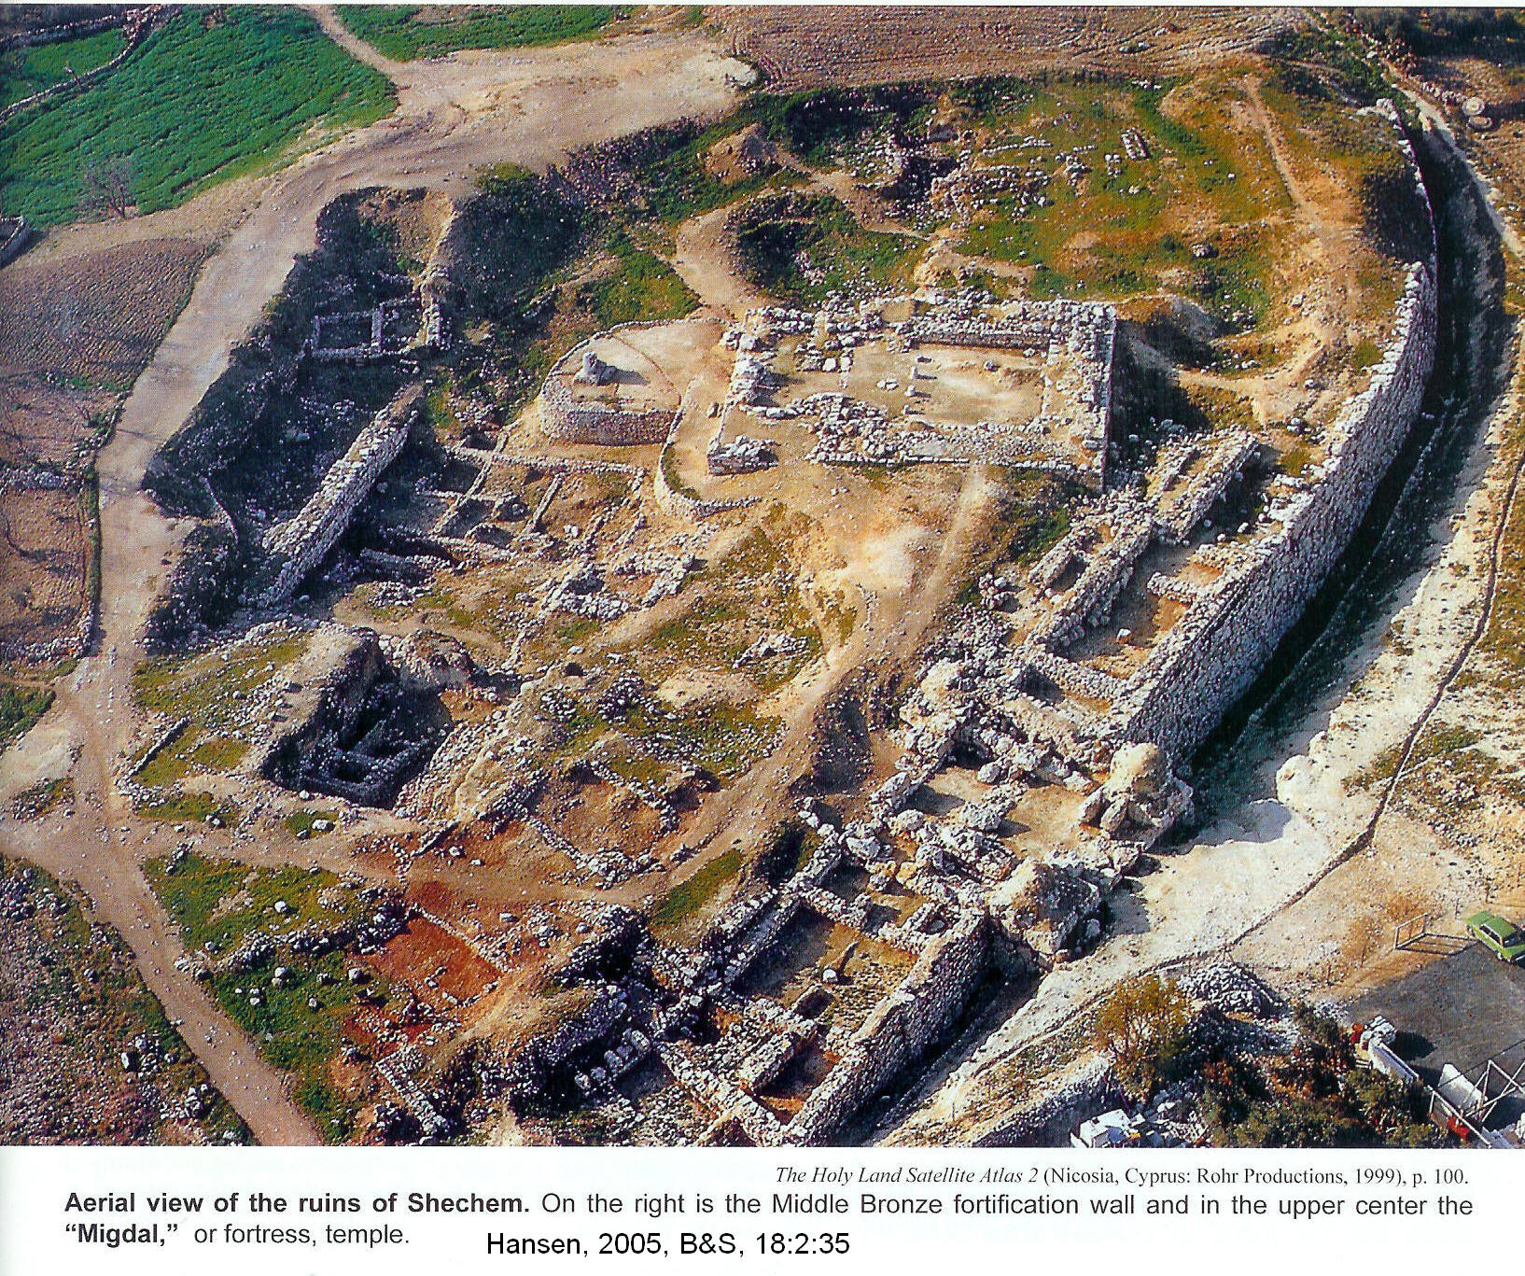

The Biblical city of Shechem is at Tell Balata. The modern name of the city is Nablus. The stratigraphic level at Tell Belata corresponding to the Assyrian destruction of 722 (or 724, Hansen, 2005) is Level VII (Toombs, 1992:1185, cited by Hansen, 2005:39).

PHOTO LINK: SHECHEM 011 Pass at Shechem modern Nablus Mts Gerizim+Ebal
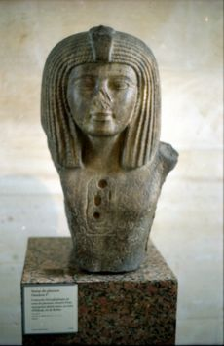
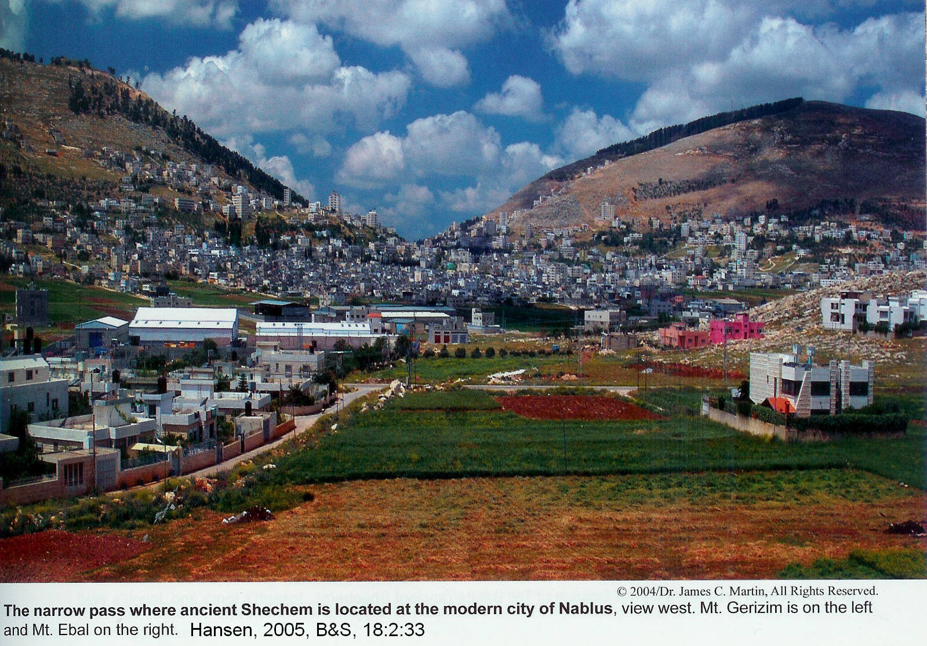

After the destruction of Shechem, the Assyrians imported people from other conquered lands into the region, as was their common practice (2 Kings 17:23-24). This immigration resulted in a mixture of Yahwehism and foreign beliefs which, in time, evolved into the Samaritan community (2 Kings 17:25-30; Matt. 10:5, Luke 9:52, 10:53; John 4:7-40, 8:48; Acts 8:25).

PHOTO LINK: OSORKON 001 Carving of bust and upper torso from Byblos 19th Dynasty; http://en.wikipedia.org/ wiki/Osorkon_I; Aug. 26, 2006

After destroying Shechem, Shalmaneser V laid siege to Samaria for 3 years (2 Kings 17:4-5; 18:11).

“4But the king of Assyria discovered that Hoshea was a traitor, for he had sent envoys to So [Sais, Osorkon] king of Egypt, and he no longer paid tribute to the king of Assyria, as he had done year by year. Therefore Shalmaneser seized him and put him in prison. 5The king of Assyria invaded the entire land, marched against Samaria and laid siege to it for three years. 6In the ninth year of Hoshea, the king of Assyria captured Samaria and deported the Israelites to Assyria. He settled them in Halah, in Gozan on the Habor River and in the towns of the Medes. “

The city fell in early spring or late summer of 722 BC, (but Shalmaneser V's successor Sargon II took credit for it) just prior to Shalmaneser V's death (Wood, 1991; Grayson, 1975; Pritchard, 1969). The inhabitants were deported to Assyria and "settled them in Halath and on the Habor, the river of Gozan, and in the cities of Media" (2 Kings 17:6). This was a fulfillment of the prophecy of Ajijah who said that Israel would be exiled "beyond the Euphrates" (1 Kings 14:15-16).

PHOTO LINK: SAMARIA 003 Location map
PHOTO LINK: ASSYRIA 009 Wall at Samaria, destroyed by Shalmaneser V

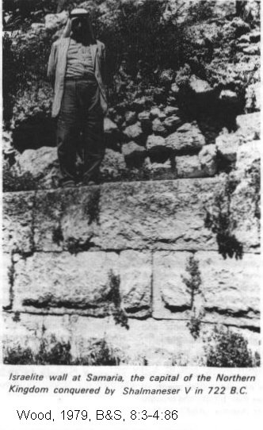
PHOTO LINK: SARGON II 002 Relief portrait
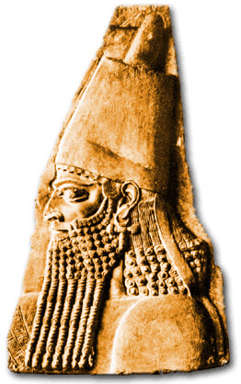

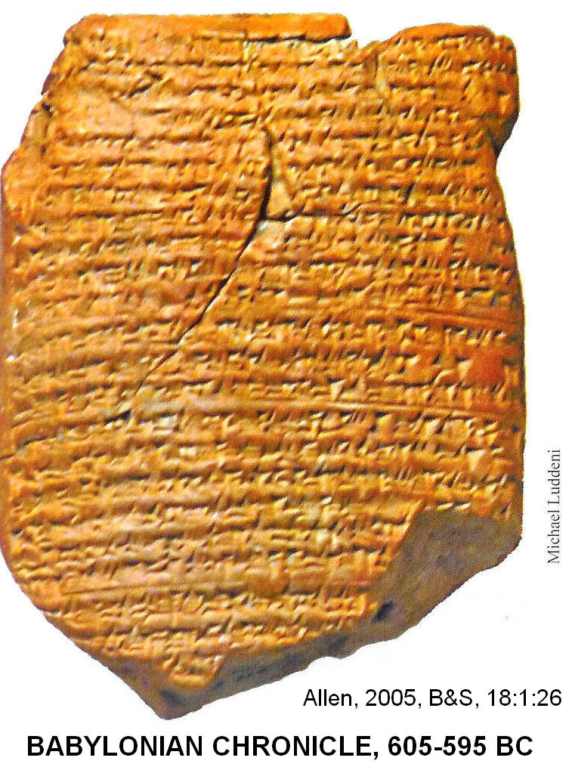

PHOTO LINK: BABYLONIAN CHRONICLES 002 Tablet from Babylonian Chronicles for 605-595 BC, Babylon (RIGHT)

PHOTO LINK: ASSYRIA 011 Sargon II
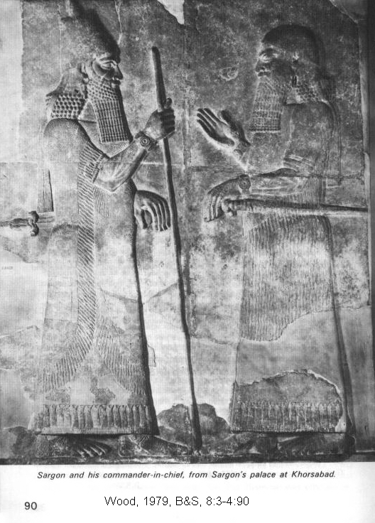

PHOTO LINK: ASSYRIA 010 Sargon II's Palace at Khorsabad
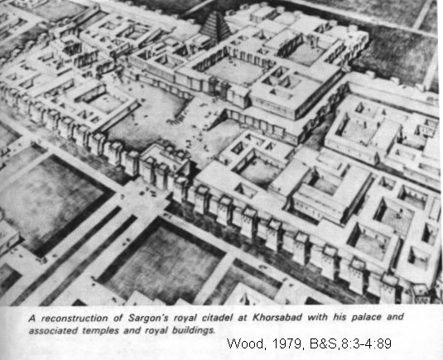
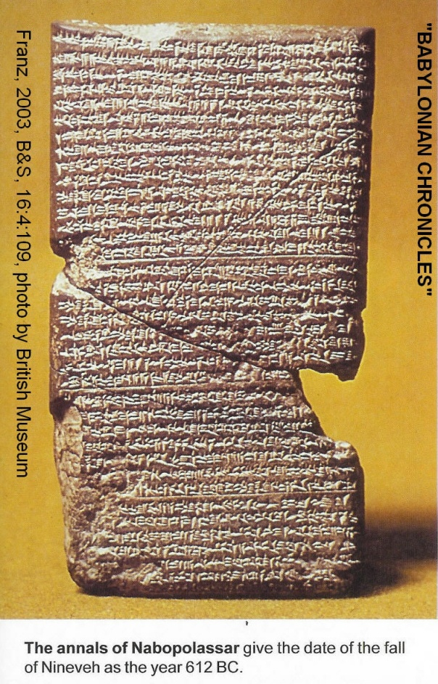
Babylonian Chronicles and inscriptions from Sargon II's palace at Khorsabad give complementary information about Assyrian contacts with Israel (compare 2 Kings 17:3-6, 24). The Babylonian Chronicles state:

"On the 25th day of the month of Tebet Shalmaneser (V) ascended the throne in Assyria (and Akkad). He ravaged Samaria. The fifth year: Shalmaneser (V) died in the month of Tebet. For five years Shalmaneser (V) ruled Akkad and Assyria (Grayson, 1975, p.73).

PHOTO LINK: BABYLONIAN CHRONICLES 001 Annals of Nebopolasser give fall of Nineveh at 612 BC (RIGHT)

PHOTO LINK: MAP DIVIDED KINGDOM 001 Divided Kingdom after the fall of Samaria
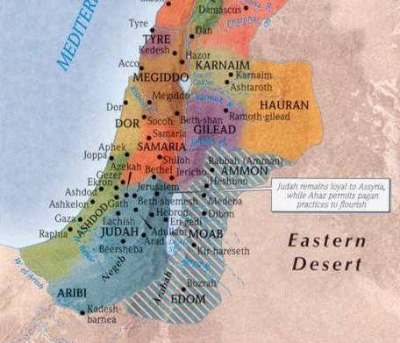

SARGON II (722-705 BC)

Sargon means "the legitimate". He was Shalmaneser V's brother. Sargon II is not in the Assyrian king lists. He is mentioned in Isaiah 20:1 which was the only source for information about him until 1840's when his palace was discovered and excavated at Khorsabad (Dur Sarrukin; Wilson, 1972a, Roux, 1976, Wood, 1991, Grayson, 1975; Pritchard, 1969).

PHOTO LINK: KHORSABAD 001 Plan of city walls, inner city and citadel; http://oi.uchicago.edu/OI/PROJ/KHO/Khorsabad_Plan_72dpi.html; Oct. 2, 2006
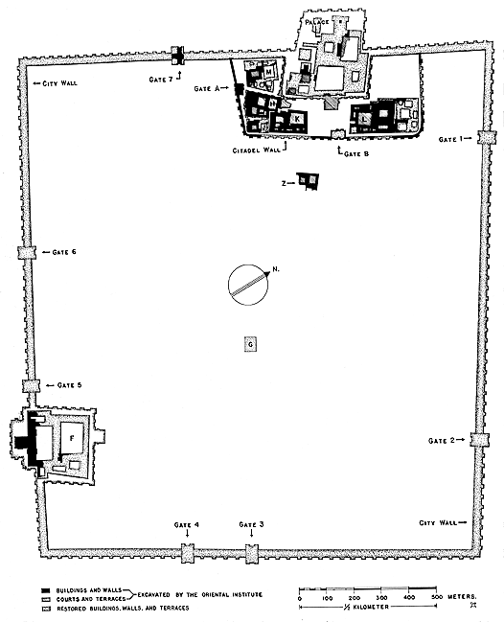

PHOTO LINK: KHORSABAD 002 Plan of Palace; http://www.ecai.org/Iraq/HistoricSites/SitePlanImages/KhorsabadSitePlan.jpg, Sept. 24, 2010
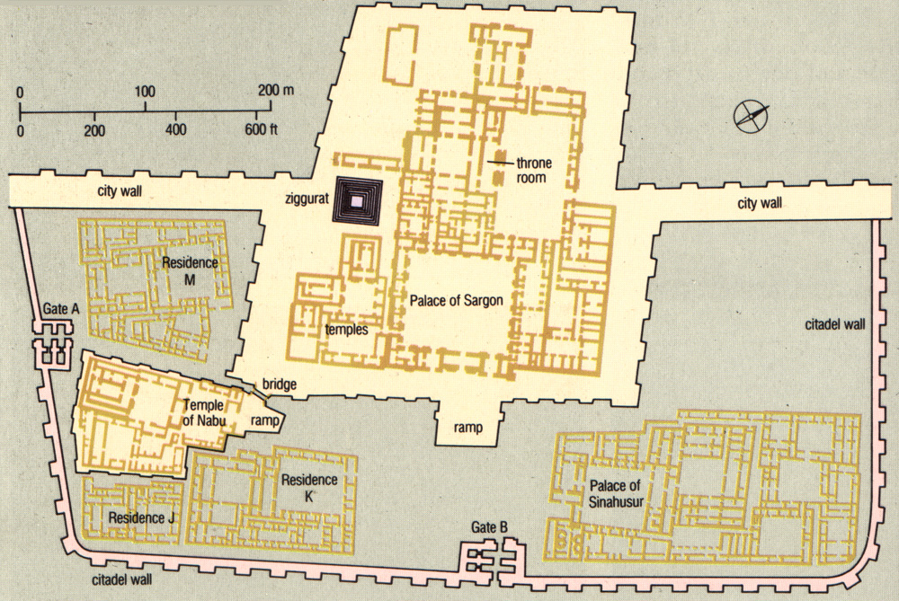

KHORSABAD 003 Large Mythical Creatures; http://iws.collin.edu/rfender/plates/ancient/Sargon%20II%27s%20citadel,%20Khorsabad,%20Limestone,%208th%20Cent.%20BC.jpg; Sept. 24, 2010
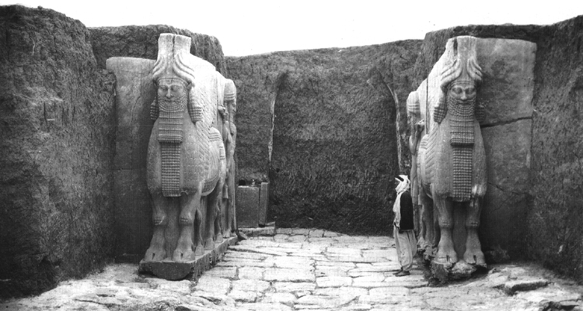

PHOTO LINK: KHORSABAD 004 Ruins of Khorsabad; http://www.bloganavazquez.com/wp-content/uploads/2008/12/khorsabad04.jpg; Sept. 24, 2010
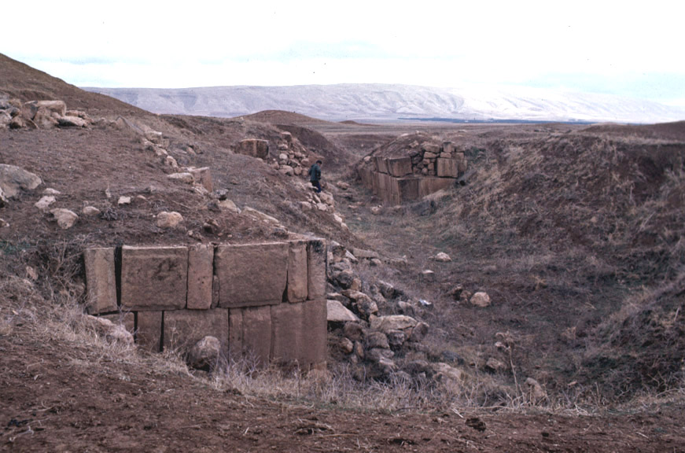

Before 1840, scholars of the Old Testament texts confused Sargon II with Shalmaneser. But the excavations showed that Sargon II did campaign against Ashdod and did have a "Tartan", i.e. commander-in-chief, just as was indicated by Isaiah (Wilson, 1972a, Roux, 1976, Wood, 1991, Grayson, 1975; Pritchard, 1969).

PHOTO LINK: SARGON II 001 Sargon II and dignitary relief

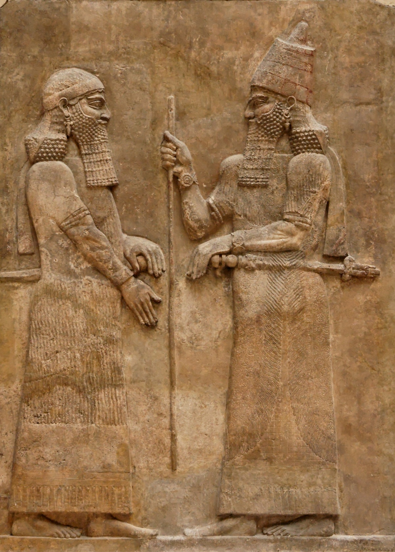

PHOTO LINK: SIEGE TACTICS 005 Sargon II Palace at Khorsabad burning city of Kishesim in Zagos mountains
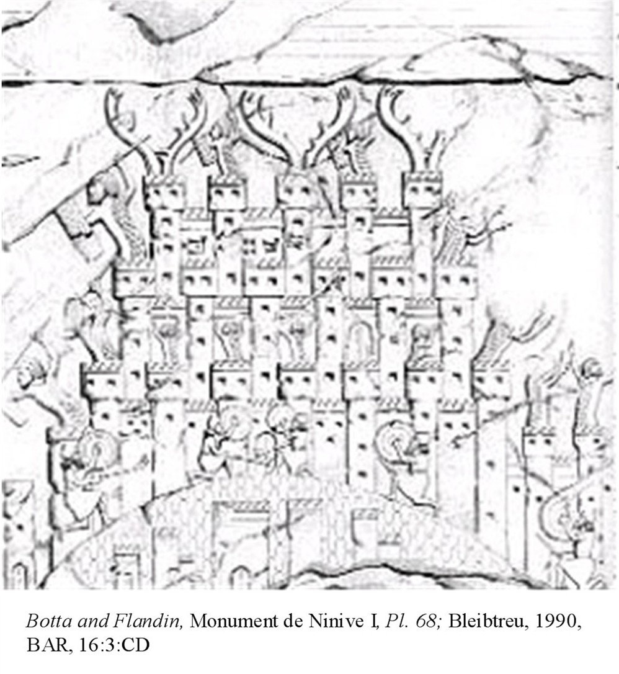

PHOTO LINK: ASSYRIA 011 Relief of Sargon at Khorsabad; (See ABOVE, ctrl+click to follow link)
PHOTO LINK: ASSYRIA 041 Map of Assyrian deportation programs Tiglath-pileser III, Shalmaneser V, and Sargon II; (See ABOVE, ctrl+click to follow link)

Sargon II set up his own fortress at a new site 15 mi northeast of Nineveh, near the modern town of Khorsabad in northern Iraq. It was square in plan with a royal palace, temple dedicated to Nabu and sumptuous houses for high-ranking officials. The palace was on a 50 foot-high platform with 200 rooms and 30 courtyards. There was also a ziggurat. The city was briefly occupied, but never completed or fully inhabited (Hoerth, 1998:336). It was abandoned after Sargon II's death which occurred in war with Tabal (705 BC; Roux, 1976; Wood, 1991; Grayson, 1975; Pritchard, 1969).

PHOTO LINK: ZIGGURAT 002 Painting of a ziggurat; http://www.crystalinks.com/ziggurat.html; Oct. 5, 2006
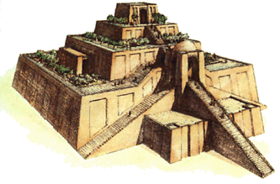

Second Battle of Qarqar (720 BC)

PHOTO LINK: QARQAR 001 Map of the battle
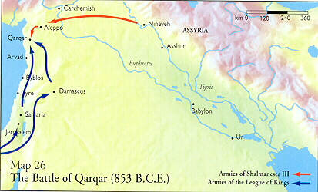

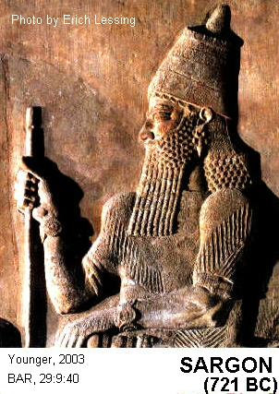
Soon after Sargon II came to the throne, a rebellion broke out in Syria-Palestine. King Yau-bi'di of Hamath organized a western coalition against Assyria that included what remained of Samaria. The western coalition met the Assyrians and were decisively beaten by them at the Second Battle of Qarqar in 720 BC. An earlier western alliance fought Assyrian Shalmaneser III in this exact same spot in 853 BC.” (Younger, 2003:42). I refer to that as the “First Battle of Qarqar

PHOTO LINK: ASSYRIA 042-B Relief Sargon II
(RIGHT)

Commemorating this victory, the "Great Summary Inscription" (also called Sargon's Display Inscription) states:

"At the beginning of my royal rule, ...the town of the Samaritans I besieged, [re-]conquered...for the god...who let me achieve this my triumph...I led away as prisoners 27,290 inhabitants of it and equipped from among them soldiers to man 50 chariots of my royal corps...The town I rebuilt better than it was before and settled therein people from countries which I myself had conquered. I placed an officer of mine as governor over them and imposed upon them tribute as is customary for Assyrian citizens, and I imposed upon them the (same) tribute as the previous king (Shalmaneser V)" (Pritchard, 1969, p.284 and Younger, 2003:42).

The Second Battle of Qarqar is also recorded on the Nimrud Prism.

PHOTO LINK: ASSYRIA 044 Nimrud Prism telling or repopulation of Samaria with Assyrians
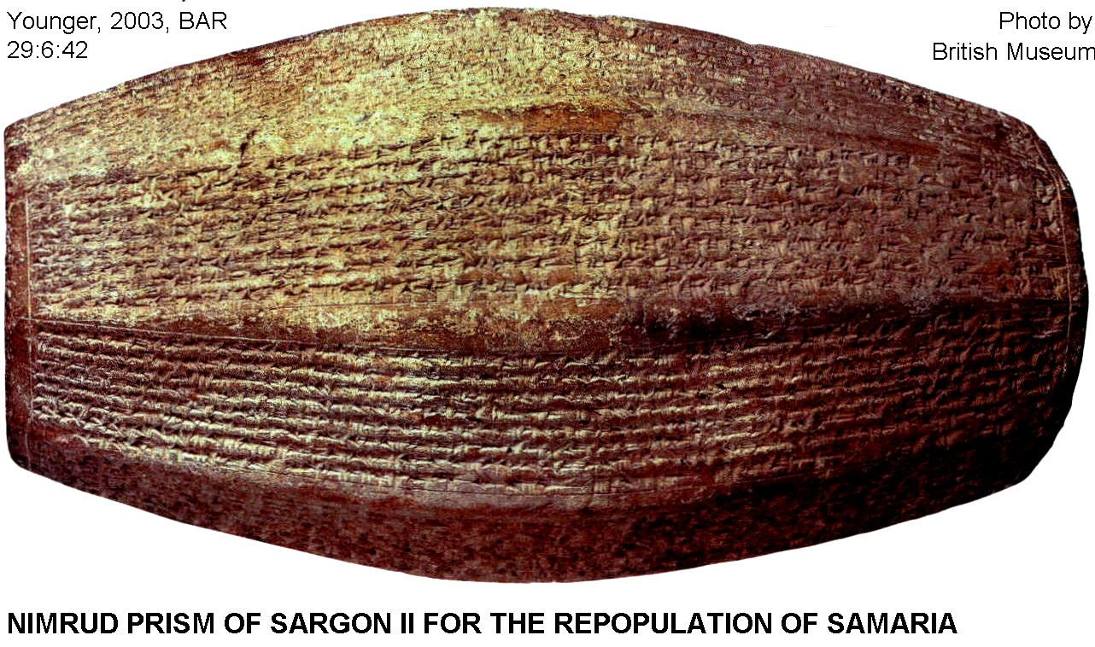

"In this record it is told how Sargon II deported and resettled Israelites "in the midst of Assyria", and also how "I repopulated Samarina (Samaria) more than before. I brought into it people from countries conquered by my hands. I appointed by eunuch as governor over them. And I counted them as Assyrians." (Hallo and Younger, 1997-2000:295-296; cited by Younger, 2003:66).

Concerning Sargon II's activities in Philistia, the Sargon's Display Inscription says :

"In a sudden rage I marched quickly--even in my state-chariot and only with my cavalry which never, even in friendly territory, leaves my side--against Ashdod, his (Azuri's) royal residence, and I besieged and conquered the cities of Ashdod, Gath and Asdudimmu" (Pritchard, 1969, p.46, compare Isaiah 20:1).

PHOTO LINK: SARGON II 005 Nimrod Inscription
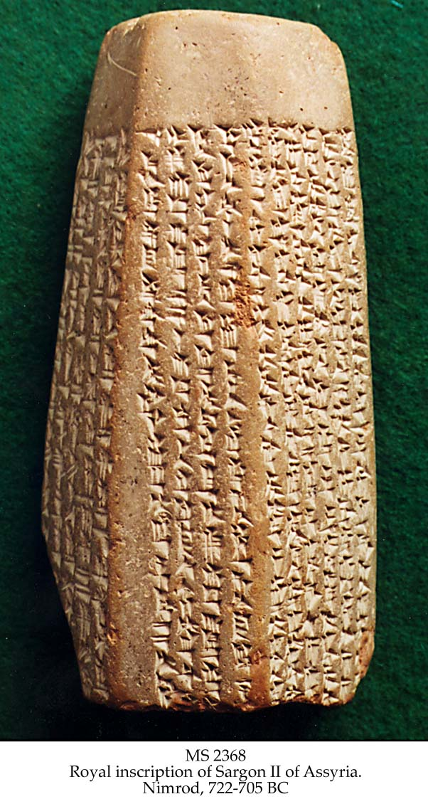

PHOTO LINK:PHILISTINE 011 Map of cities of the Pentapolis; (See ABOVE, ctrl+click to follow link)

Three fragments of a basalt stele memorializing Sargon's conquest of 712 BC found at Ashdod in 1973 (Wood, 1991; Grayson, 1975; Pritchard, 1969).

PHOTO LINK: ASHDOD 001 Map
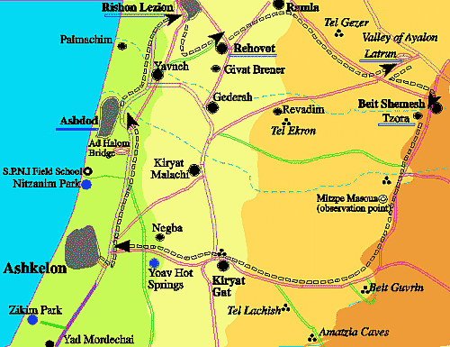

PHOTO LINK: ASSYRIA 004 Memorial stele from Ashdod, conquered by Sargon II in 711 BC
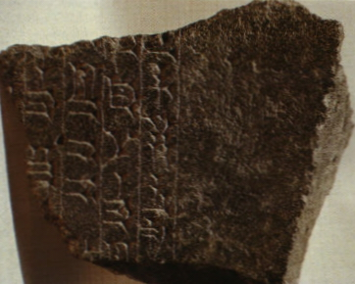

When Sargon II conquered Medina in 716 BC, additional Israelites were deported to that new Assyrian province. Hence, Israelite deportations under the Assyrians took place from 734 to 716 BC (Younger, 2002:42).

PHOTO LINK: MEDINA 001 Map
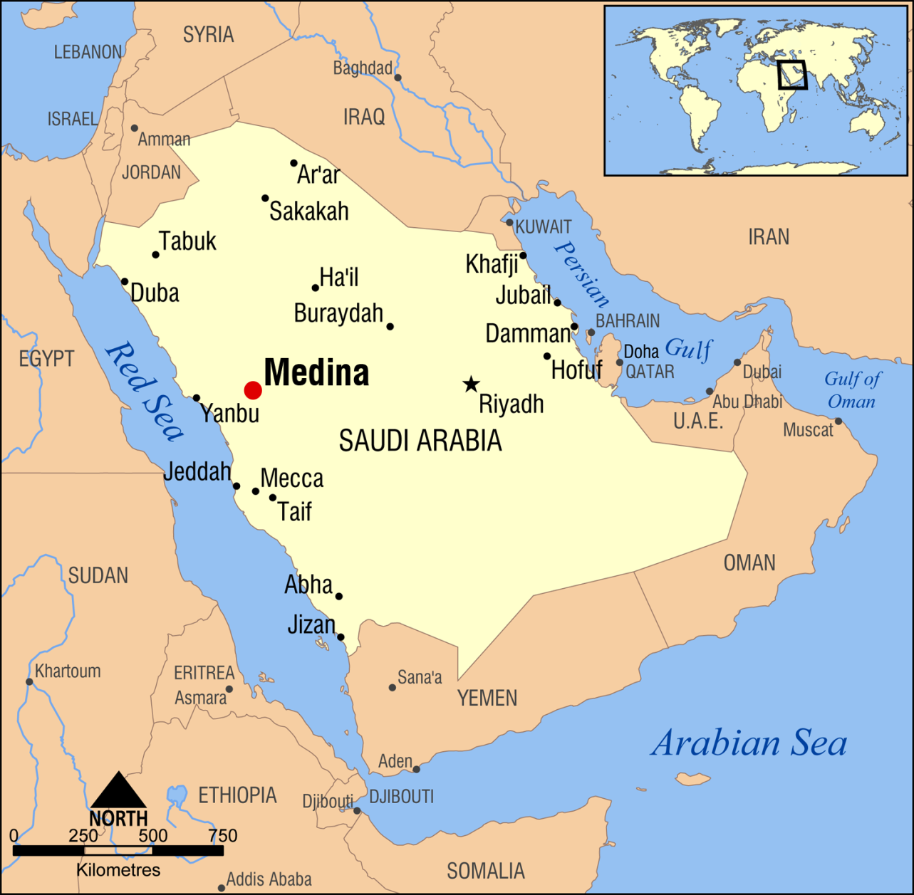

Israelites deported by the Assyrians were made slaves, agricultural workers, but some became military personnel, bureaucrats, officials, priests, skilled laborers and merchants. A few rose in Assyrian society to high rank. One Samaritan named Sama' became "commander of teams" of horseman, a person of great influence within the families of Sargon and Sennecherib. The person identified as rab shaque ("Rabshakeh") was ambassador for the Sennacherib in 2 Kings 18 was Hebrew-speaking, and possibly Israelite. Persons with Israelite names (ending in -Yau, e.g. Ahzi-Yau, Same'-Yau) are known from the administrations of Esarhaddon and Ashurbanipal. Israelite assimilation into Assyrian society is evidenced by contracts and deportation records for feeding and providing medical care to deportees (Younger, 2003:45).

Sargon II's Brutality (722-705 BC)

The Assyrians practiced a form of psychological warfare without pity or mercy. Sargon II made huge pits filled them with wood and set them afire. Then he forced his captives to march into the pit to be burned alive.

Some were skinned alive.

PHOTO LINK: ASSYRIAN BRUTALITY 010 Elamites being flayed alive, Sennecherib's palace at Niniveh
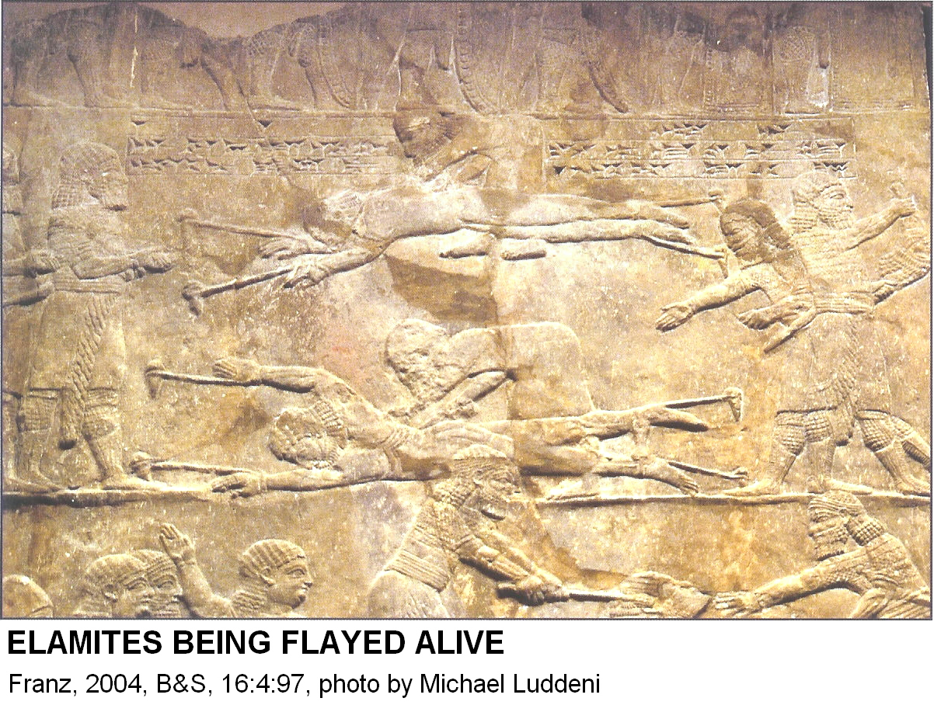

PHOTO LINK: ASSYRIAN BRUTALITY 001 Ashurbanipal flaying of Elamites
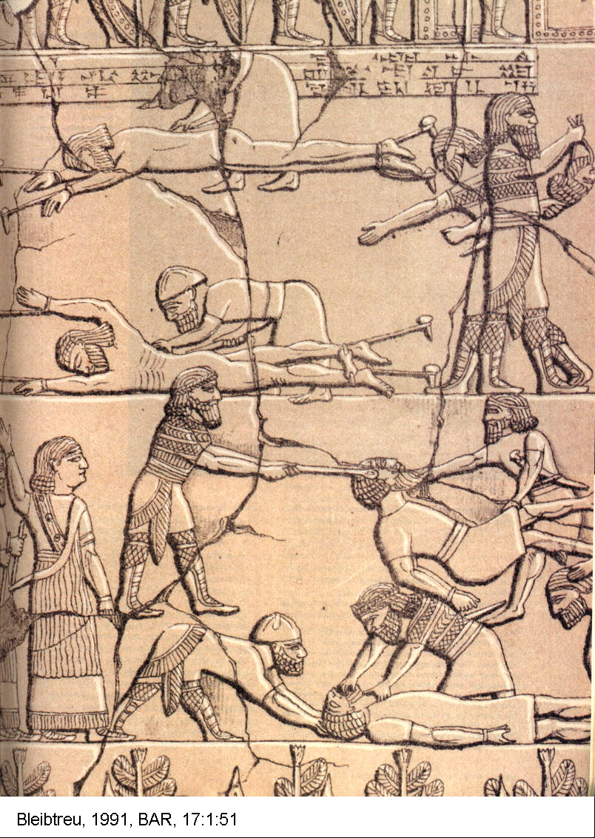

Their bodies were hung as monuments and were heads hung on trees to "dry out."

PHOTO LINK: ASSYRIAN BRUTALITY 009 Banquet relief of Assurbanipal (668-627) with head of Elamite King Teumman in tree
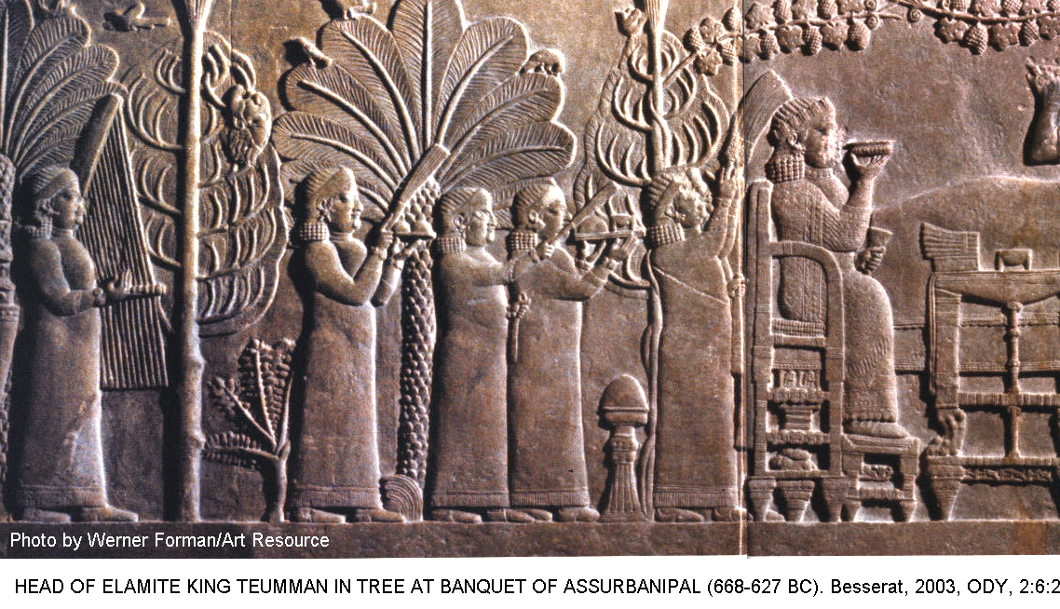

PHOTO LINK: ASSYRIAN BRUTALITY 005 Ashurbanipal head hunting
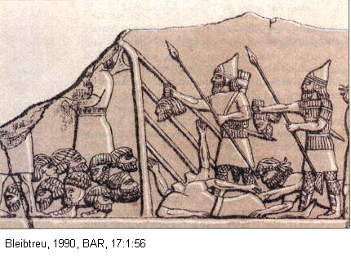

PHOTO LINK: ASSYRIAN BRUTALITY 004 Sennacherib headhunters and Ashurbanipal head trophies
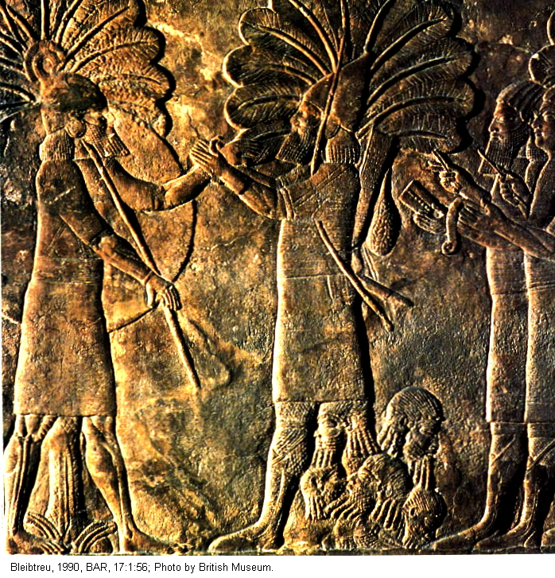

PHOTO LINK: ASSYRIAN BRUTALITY 008 Relief of soldiers with enemy heads

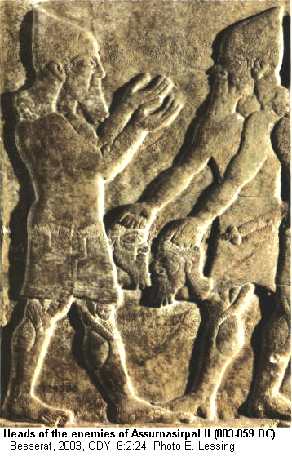

Live prisoners were impaled on stakes and then erected upright, an early form of crucifixion.

PHOTO LINK: ASSYRIAN BRUTALITY 003 Sennacherib impaling of men from Lachish on stakes
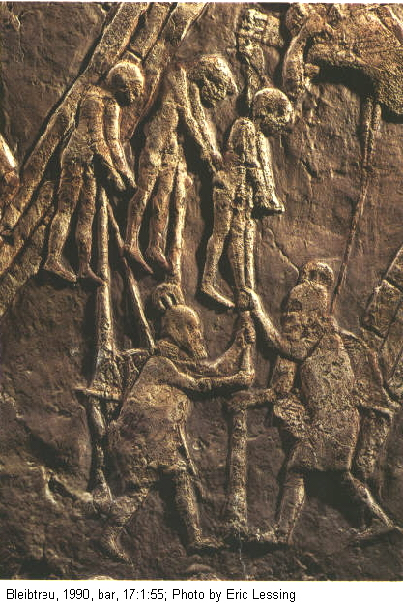
PHOTO LINK: ASSYRIAN BRUTALITY 007 Stakes with 8 heads of victims of Shalmaneser III
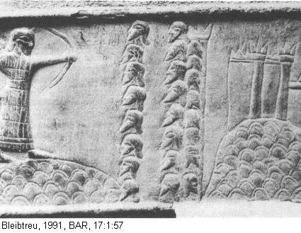
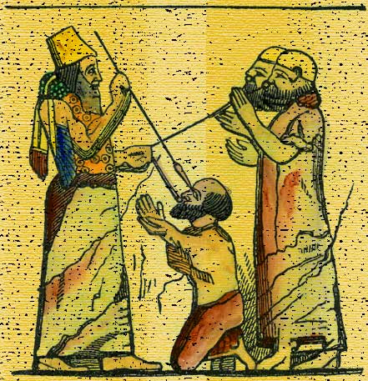
Prisoners were tied by hooks or rings through their tongues and jaws. On forced marches, if prisoners fell, they had tongues torn out by roots or jaws ripped open

PHOTO LINK: ASSYRIAN BRUTALITY 014-B Blinding of prisoners and hook in mouth.

Living prisoners were blinded (Zedekiah in 2 Kings 25:7; Boyd, 1990).

Bodies were dismembered.

PHOTO LINK: ASSYRIAN BRUTALITY 006 Dismembered and displayed victims
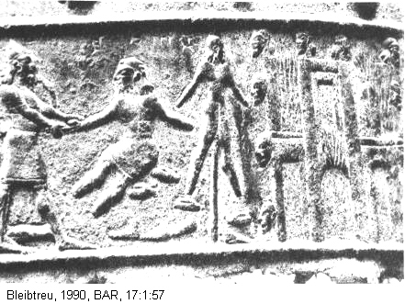

Bones of ancestors were ground burned.

PHOTO LINK: ASSYRIAN BRUTALITY 012 Prisoners grinding bones dead ancestors
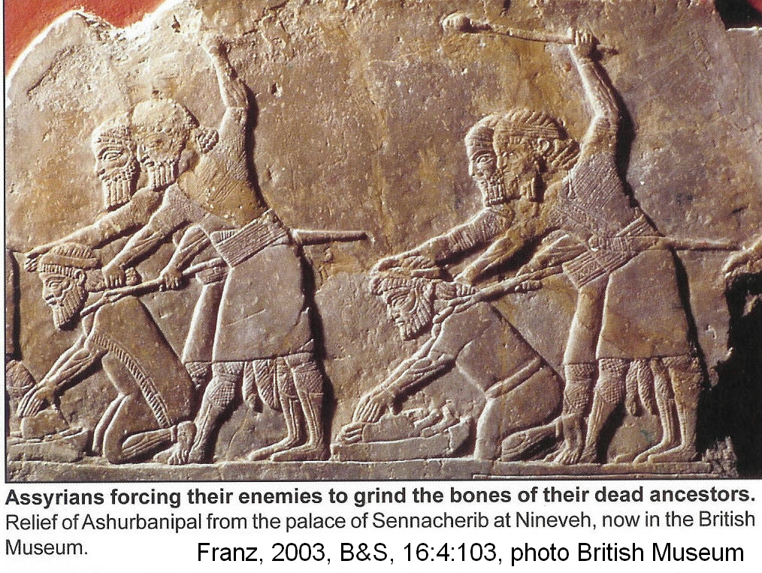

These atrocities are depicted in Sargon's wall reliefs, and in the palaces of other Assyrian rulers. The reliefs can be compared to descriptions of Assyrian atrocities in Ezekiel 38:4; 2 Kings 19:28 and 2 Chron 33:11 (Boyd, 1990).

ASSYRIAN REBUILDING PROGRAMS (722-650 BC)

When the Assyrians destroyed Israelite cities, many of them were rebuilt with Assyrian architectural designs. An example is the open-court design of city administrative centers, as the one rebuilt at Hazor. These kinds of improvements appear in the archaeological record of Palestine in the late 8th century BC (Stern, 2000:40).

Assyrian Hazor

PHOTO LINK: MAP DIVIDED KINGDOM 001 Divided Kingdom after the fall of Samaria; (See ABOVE, ctrl+click to follow link)
PHOTO LINK: GA022 Hazor, Aerial View; (See ABOVE,B ctrl+click to follow link)
PHOTO LINK: HAZOR 019 Aerial photo; (See ABOVE, ctrl+click to follow link)
PHOTO LINK: HAZOR 026 Photo and plan of 8th century Hazor with large open court design following Assyrian destruction
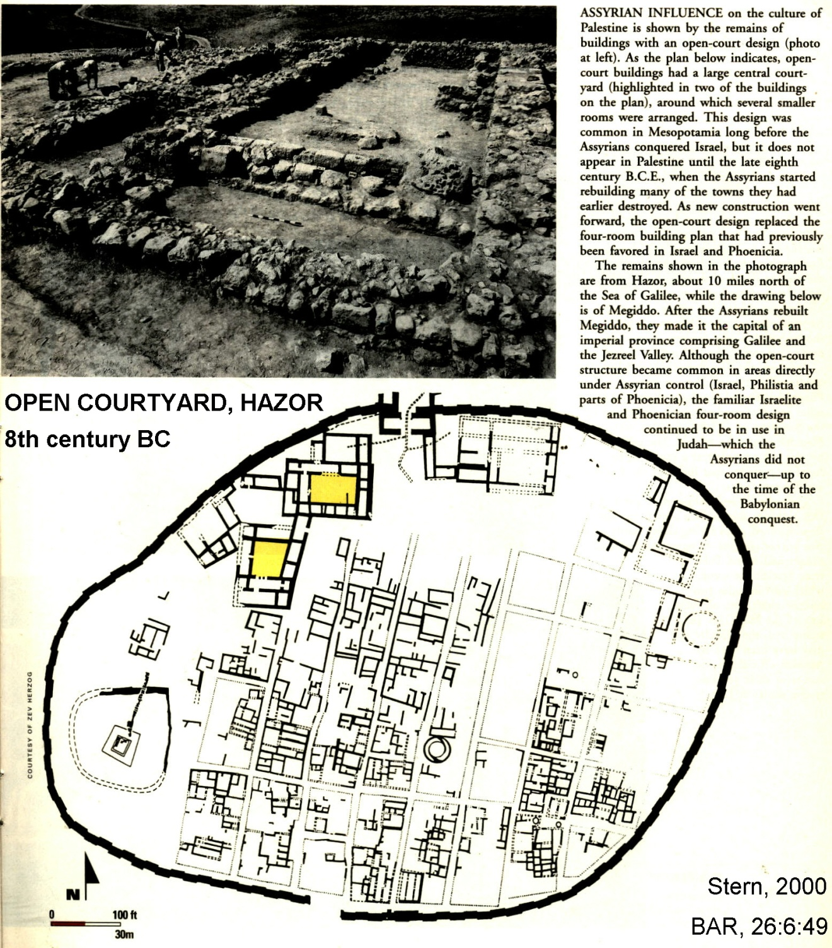

The Assyrian rebuilding presence is also identified by characteristic pottery forms and cylinder seals (Stern, 2000:50-51).

PHOTO LINK: POTTERY 027 Assyrian vessels post-conquest Dor, 8th century BC
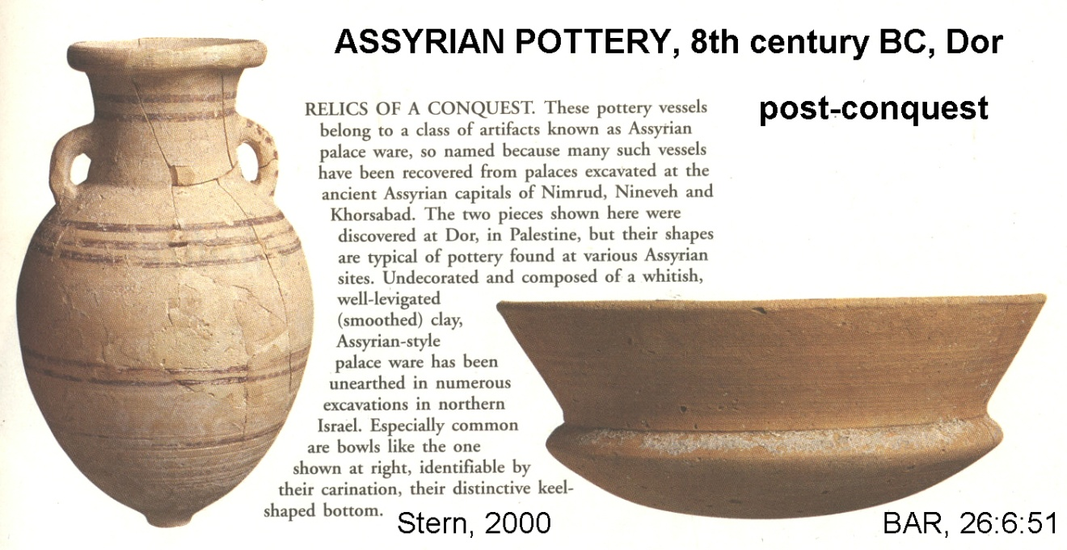

PHOTO LINK: ASSYRIA 036 Assyrian post conquest Dor 8th cent BC
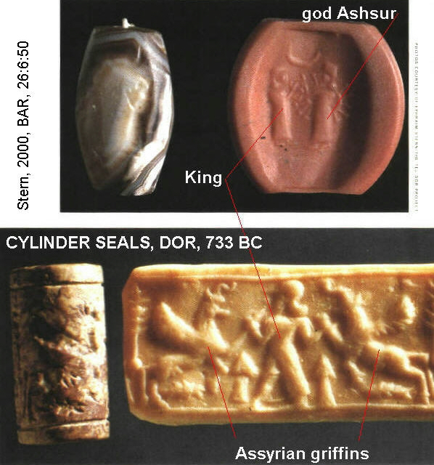

Assyrian Ashdod

In 2003, an Assyrian Palace was discovered in Ashdod, dating to the late 8th century BC (Shanks, 2007:56).

PHOTO LINK: ASHDOD 003 Assyrian Palace along railroad tracks BAD FILE
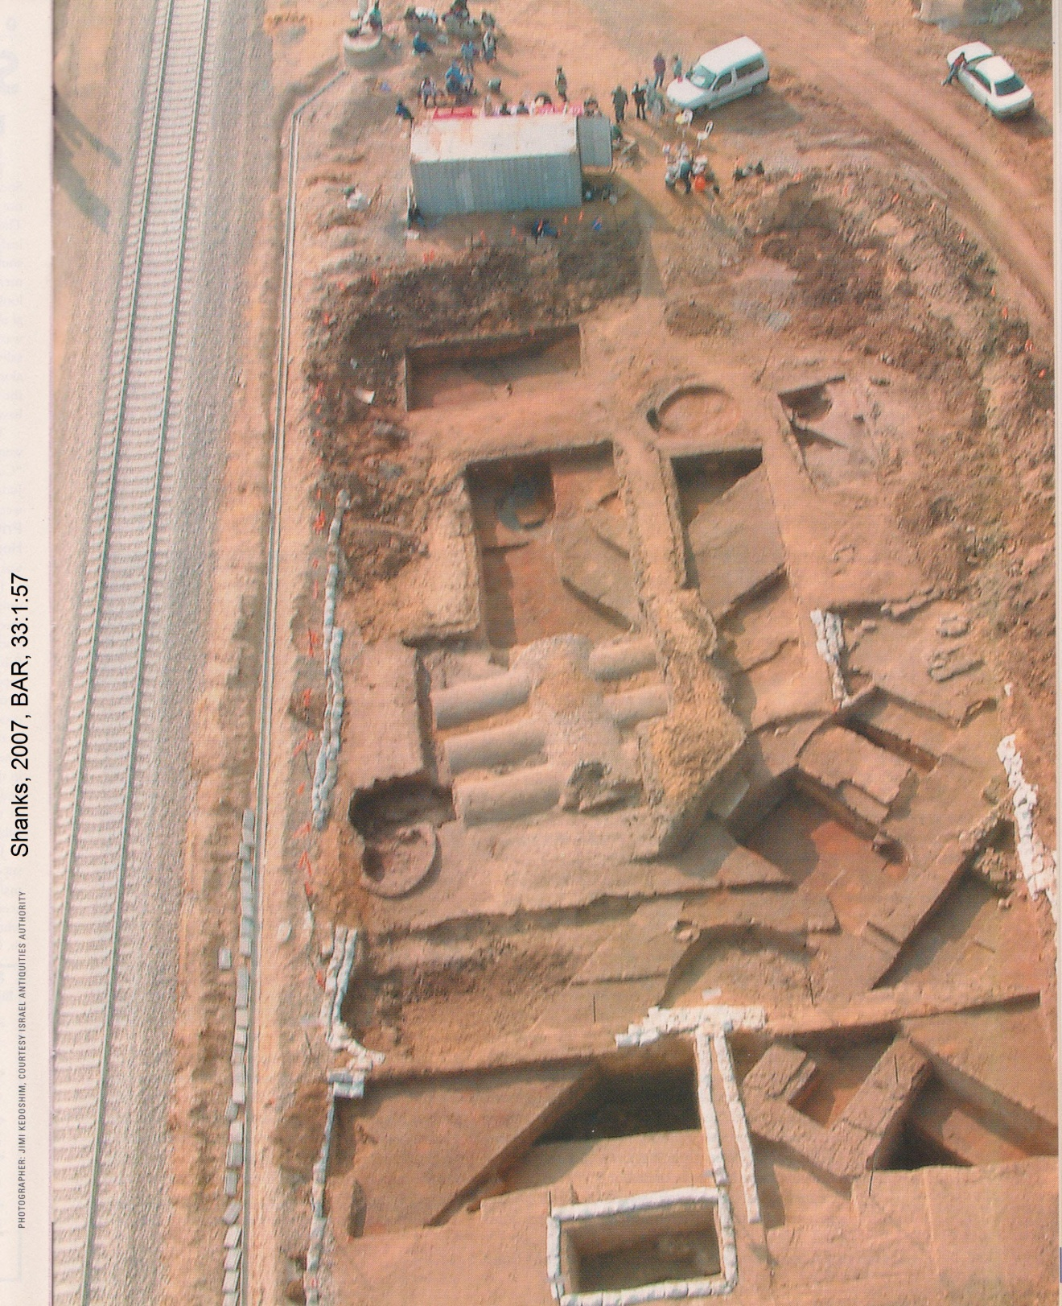

After the fall of Samaria and deportation of the Northern Tribes to Assyria (final deportation 721 BC, 2 Kings 17:5-6) by Sargon II, the Assyrians invaded Egpt. In 713 BC, the Philistine city of Ashdod maid an alliance with neighboring states, and Sargon attacked it (Isaiah 20:1). According to the Assyrian records, Sargon replaced the former ruler of Ashdod (Aziru) with his own brother (Ahimetu). When the Assyrian army withdrew, the people of Ashdod rebelled again (this time against Ahimetu). The new popular ruler was Yamani. So Sargon attacked again, this time sending the Ashdod citizens into exile. The Assyrian records name two puppet-kings of Ashdod, Mitinti and Ahimelech. During this time of vassalage, Ashdod became a provincial center of government for Philistia and the southern Assyrian empire (Shanks, 2007:58-59).
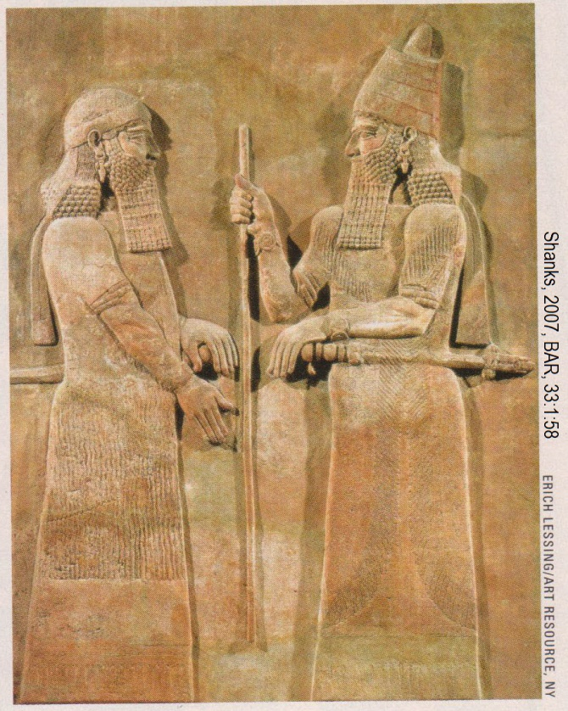
PHOTO LINK: SARGON II 007 Sargon II and court official from reliefs at his Khorsabad palace, now in the Louvre (RIGHT)

During excavations of Ashdod in the 1960’s and 1970’s, no large Assyrian buildings were uncovered. Three small cuneiform inscriptions (the largest is 9 inches in the largest direction) were found from at least one victory stele of Sargon II (Shanks, 2007:59).

PHOTO LINK: SARGON II 006 Fragments of victory stele from Ashdod
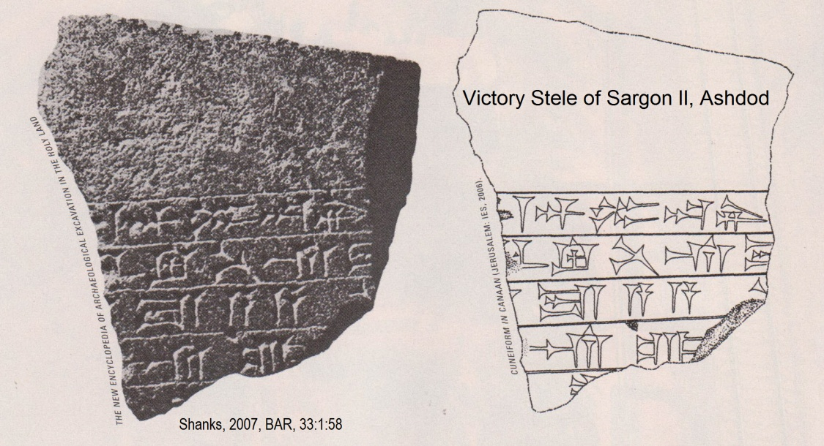

The Assyrian palace at Ashdod covered 2.5 acres. The palace was build on a level, manmade podium that is nearly 10 feet high on one side and 6 feet high on the other, It was made from square reddish-brown mudbricks measuring 15 in x 15 in. This style and size of construction materials is similar to those in neo-Assyrian structures in Assyrian Mesopotamia (Shanks, 2007:59).

PHOTO LINK: ASHDOD 004 Palace platform
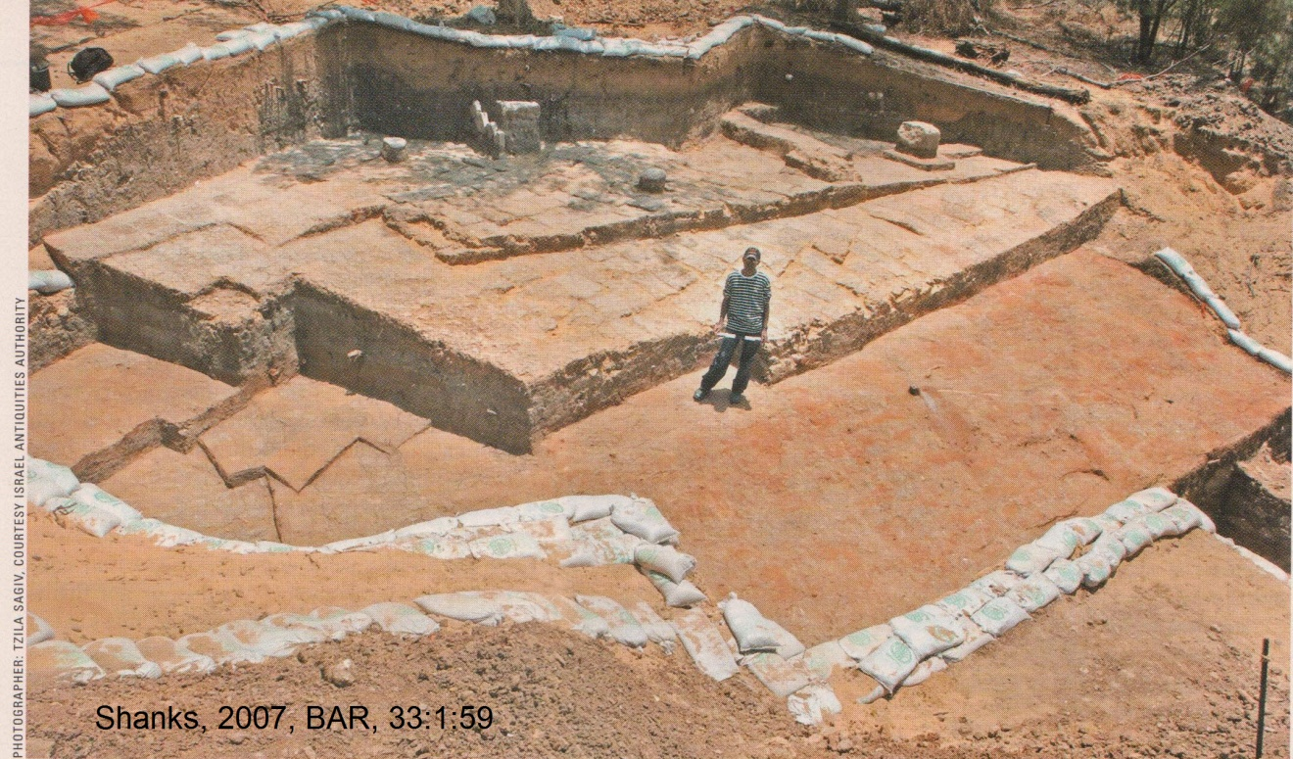

The walls of the Assyrian Ashdod palace were also made of square, reddish-brown mudbricks. The walls of this palace were 10 feet thick. There was a large internal courtyard (98 feet from north to south) that is a typical Assyrian architectural design (Shanks, 2007:59).

PHOTO LINK: ASHDOD 005 Reddish-brown mud bricks

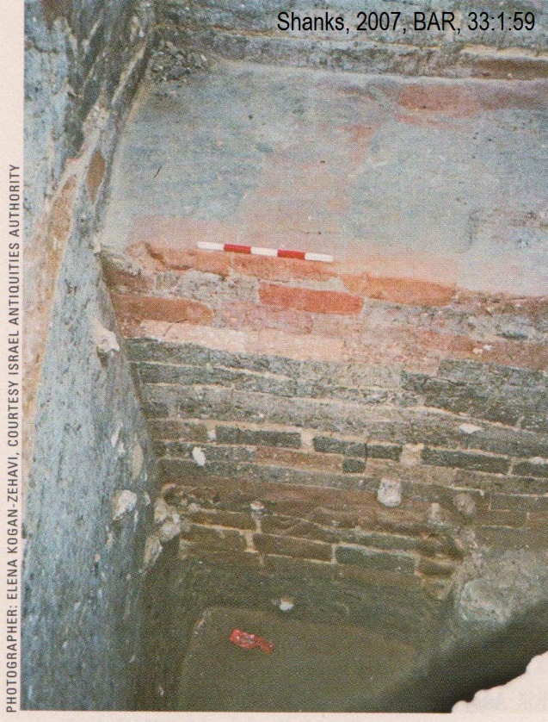
PHOTO LINK: ASHDOD 006 Bathtub-shaped basin
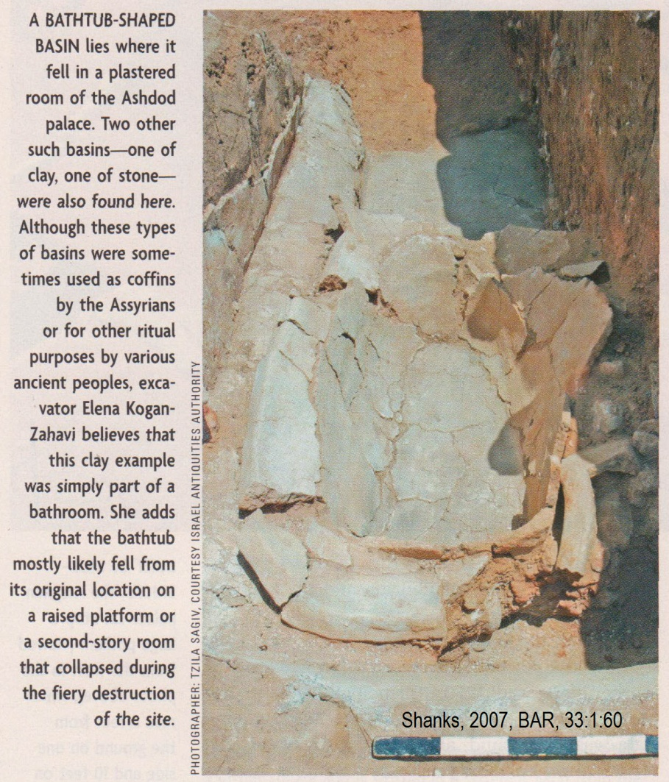

An interesting feature of the palace was that it had several bathtub-shaped basins (Shanks, 2007, 60).

The Assyrian palace at Ashdod underwent some alterations in a later, 7th century stratum, and then was destroyed by fire (Shanks, 2007:60).

Pekah "road with the king in his chariot", a term indicating he was second in command (Hoerth, 1998:334)
Not the same Hiram who helped build King Solomon's Temple

