PHYSICAL GEOLOGY LAB

GLACIERS
Dr. Gregg Wilkerson and Michael Oldershaw

Glaciers are masses of ice that is made from the accumulation, compaction and recrystallization of snow. In order to make a glacier, snow has to accumulate for some time, and that requires not so much harsh winters but mild summers where the snow does not melt.

In our simplified look we will consider two types of glaciers, ice sheets and valley or alpine. Ice sheets are glaciers that cover very large areas and the two major ones are Greenland and Antarctica. These are sometimes referred to as continental ices sheets. Ice sheets generally flow outward due to the exertion of gravity on the thicker ice in the center of the sheet.

During our most recent ice age that ended about 10,000 years ago, ice sheets covered a large part of the globe, including the northern third of the U.S. The Great Lakes are glacial features carved from this series of events. Where did the water come from to make all that ice? Another way to ask the same question; what happens to sea level during an ice age? Here is a clue to the answer: Antarctica contains about 2/3 of the world’s fresh water, and if melted would increase sea level by an estimated 60-70 m.

Valley glaciers are so named because they occupy former stream valleys, and flow down from an accumulation of ice at the top of the valley. They are also called alpine glaciers because they are found in the mountains.

Budgetary Considerations
Just like any bank account, a glacier’s activities expand or contract depending on a budgetary balance between the zone of accumulation (at the top of an alpine glacier or the center of an ice sheet) and the zone of wastage (at the toe or end of the glacier). If more ice accumulates than is lost to falling into water (calving), melting, or sublimation (ice evaporation), then the glacier will advance over time. This is a long-term balance, the glaciers advance or retreat over decades or centuries.
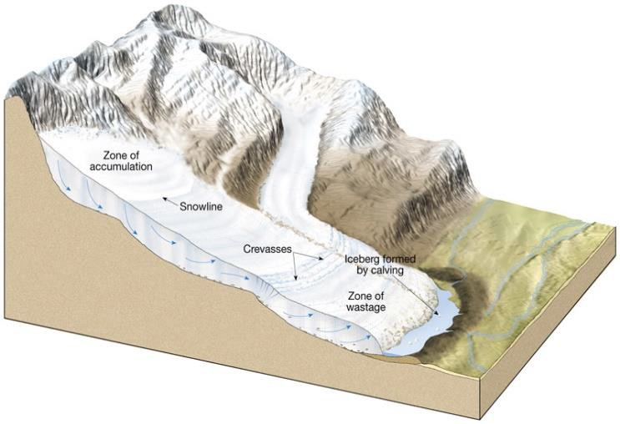

Glacial Features

Glaciers create distinctive features by both sculpting the landscape and leaving deposits of material carried or shaped by glacial movement. Glaciers move in two ways, one is by plastic deformation of the ice itself where the ice actually changes shape. The other is by sliding along the earth underneath.
Because they can be very thick and very heavy, this sliding is highly erosive and can cut deeply into whatever it is moving across. Further, the ice is very dirty and carries a lot of already eroded material, including along the base.

Although it is ice, the friction causes melting along the base and there is liquid water under the glacier. When the movement stops the base water freezes into any cracks in the rocks below. When the move starts again, the glacier plucks the rock loose.

Erosive Features
These are features produced by the glaciers cutting into material.

- Glacial Striations are grooves cut into rock. They can tell the direction of flow.
- Glacial Polish is produced when the glacial smooths underlying rock, in some case to a near mirror finish.
- Glacial Trough or “U”-shaped valley is produced by alpine glaciers deepening and widening existing stream valleys.
- Truncated Spurs are the result of a glacial trough cutting across smaller tributary valleys and leaving triangular shapes.
- Hanging Valleys are made in the same fashion; when a tributary valley is cut by a larger trough, the valley is left hanging high above the floor of the larger trough.
- Aretes are knife-like ridges between adjacent troughs or cirques.
- Cirques are bowl-shaped valleys carved by the top of the glacier where the ice accumulates. They have distinctive circular shape and steep walls making them easy to see on a topo map.
- Horns are needle-like peaks carved by 3 or more cirques eroding toward one another. The Matterhorn in Switzerland is a horn. The one in Disneyland is not really a glacial feature and has longer lines.
- Tarns are lakes in the middle of cirques, formed by the glacier cutting into the cirque.
- Pater Noster Lakes are formed by the glacier’s uneven erosion as it carves a valley. This leaves dips that fill with water forming a chain of lakes.
- Fjord (fiord) is a drowned glacial trough. Remember that sea level question up above? During an ice age, sea level drops, after the ice age the troughs cut down to the sea are now under water.

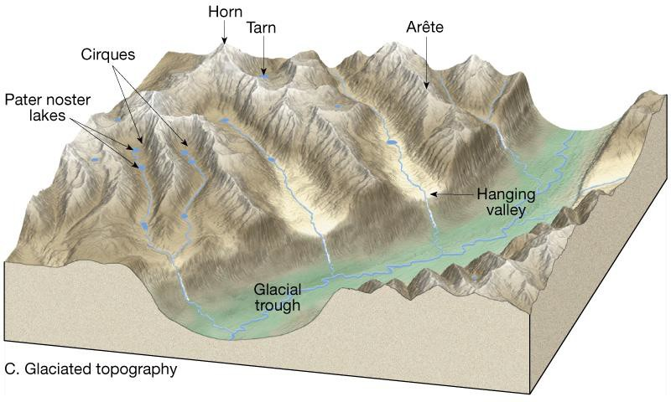

Depositional Features
Because they erode so much, glaciers move a lot of material from place to place. Most of this material is deposited directly by the glacier and is called till. Till is primarily found in moraines or deposits made by the movement of the glacier. Moraines are named by which part of the glacier produced them. It is easiest to see this with a valley glacier that is always moving downhill and is always pushing, dragging, or carrying lots of dirt and rocks. This material can be pushed to the end of the glacier or off to the side or left behind when the glacier melts. Where the glacial budget allows stability, the day-to-day downhill movement will make sizable linear piles that form the moraines.

- End Moraine is produced by the toe of a glacier.
- Recessional Moraine is also from the toe, but formed during a period of glacial retreat.
- Terminal Moraine is also a toe moraine, but it marks the farthest advance of the glacier. When people study the last ice age they use moraines to see the history and have found 4 main ages that can be further divided into more than 20 minor events.
- Lateral Moraine is formed by the sides of a glacier.
- Medial Moraine is a lateral moraine formed when two glaciers come together. In large glaciers with lots of tributaries, the medial moraines look like stripes running parallel to the ice flow.
- Ground Moraine is the moraine left behind by a glacier that is not stable, perhaps in retreat.

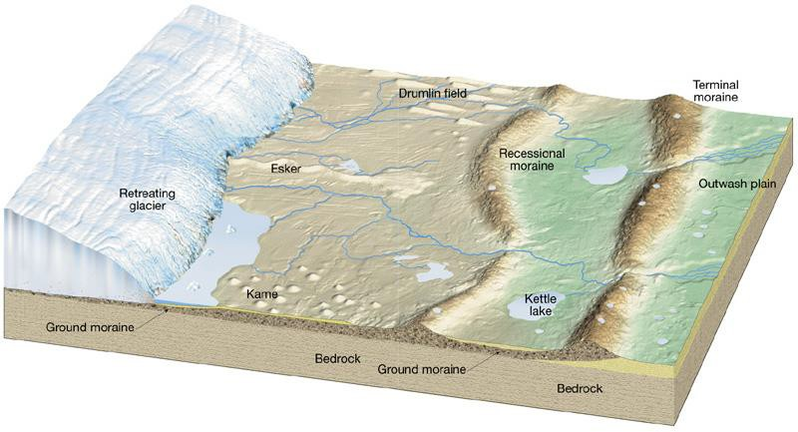

Ice Contact Deposits
These are formed when glacial sediment is reworked either by the glacier or by other currents.

- Kame is a pile of debris left behind by the glacier. The material accumulated in a depression on the top of the glacier.
- Esker is a stream deposit feature from a stream that was running under the glacier. These are pretty large features that may hundreds of feet high and stretch for miles in a snake-like pattern.
- Drumlins are rounded, elongate hills that are taller and broader at one end (the upstream side). They are formed as a glacier reshapes till as it advances again. They typically occur in groups.

- A kettle is not a deposit, but a depression left by the glacier. These dents may be filled with water and they are called kettle lakes.

Names:

Exercises
- Yosemite Valley Shaded Topographic Map
- What forms the following waterfalls?

  - Bridalveil Fall

  - Nevada Fall

  - Upper Yosemite Fall

- What is Emerald Pool Basin (below Nevada Falls)?

- What depositional feature marks the junction of the Merced and Tenaya Rivers?

- What partially filled the Yosemite basin with sediment?

- Based on your answer above, was Mirror Lake part of the now filled in Lake Yosemite (explain your answer)?

Kingston, Rhode Island 7.5’ Topographic Map

- What glacial feature forms the hill that crosses the map from east to west just south of Worden Pond?

- What glacial features are the ponds on this hill (Tucker, Long, White, and Wash Ponds)?

- What glacial features are Great Neck and Tobey Neck?

- If Green Hill and Blackberry Hill are both kames, what additional description can you add to your answer about the hill in question 1 (hint, did this feature form as the glacier advanced?)?

