MINES AND WINES OF SAN LUIS OBISPO COUNTY

SAN JOAQUIN GEOLOGICAL SOCIETY
TBA
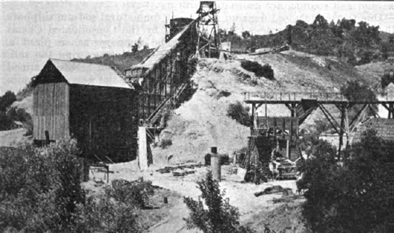

FRIDAY
6:00 PM Cambria Pines Resort (Optional)
www.cambriapineslodge.com
2905 Burton Dr., Cambria, CA 93428
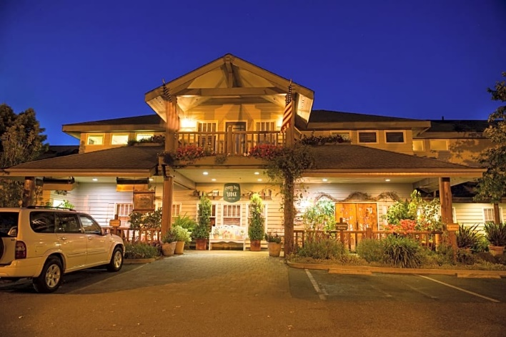

SATURDAY
8:00 AM Cambria City Beach
https://www.californiabeaches.com/beach/shamel-park/
Windsor Blvd and Pembrook Dr., Cambria, CA 93428
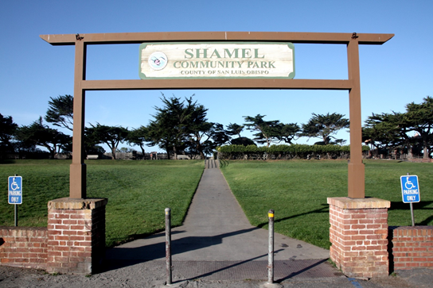

8:30 AM Stolo Vinyards and Winery
www.stolofamilyvineyards.com
3776 Santa Rosa Creek Rd, Cambria, CA 93428
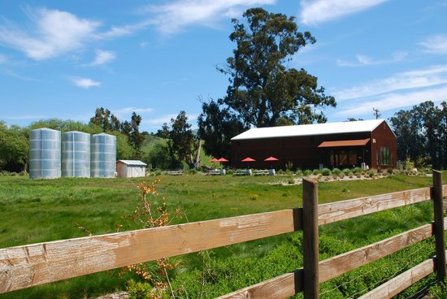

10:00 AM Klau-Buena Vista Superfund Site (Mine Remediation)
https://cumulis.epa.gov/supercpad/cursites/csitinfo.cfm?id=0903986
344 KLAU MINE RD., Adelaid, CA 93446
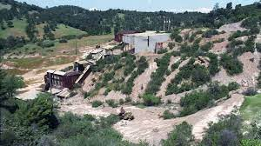
11:30 AM Tolo Cellars
http://www.tolocellars.com/
9750 Adelaida Road, Adelaid, CA 93446
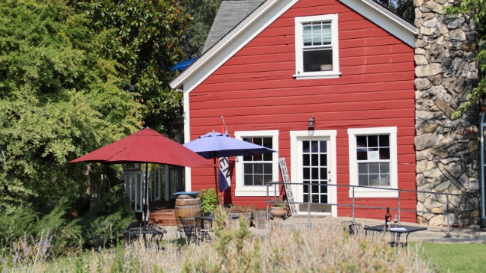

1:00 PM Pasolivo Olive Oil
https://www.pasolivo.com/visit-pasolivo.html
8530 Vineyard Dr., Paso Robles, CA
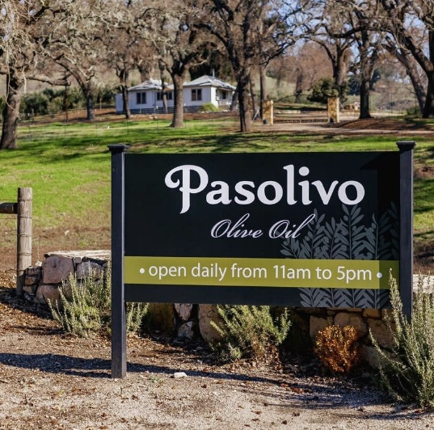
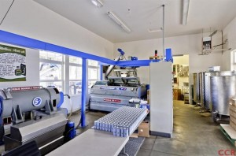

2:00 PM Tooth and Nail Winery Castle
https://www.toothandnailwine.com/
3090 Anderson Road, Paso Robles, CA 93446
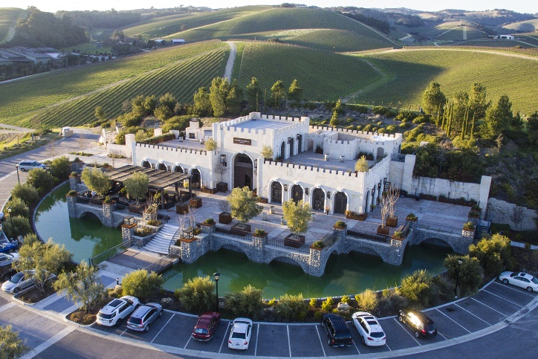

3:00 PM Calcareous Vineyard
https://www.yelp.com/biz/calcareous-vineyard-paso-robles
3430 Peachy Canyon Rd, Paso Robles, CA 93446
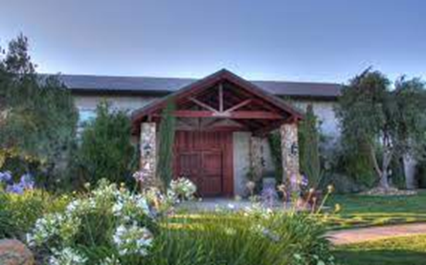

4:00 PM Ancient Peaks Winery (Santa Maria)
https://pasowine.com/member/ancient-peaks-winery/
22720 El Camino Real, Santa Margarita , CA 93453
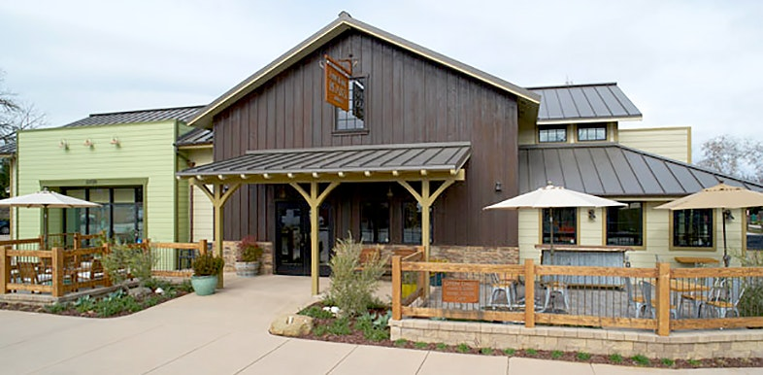

5:00 PM Rinconada Mercury Mine
https://www.atlasobscura.com/places/rinconada-mercury-mine
BLM and USFS
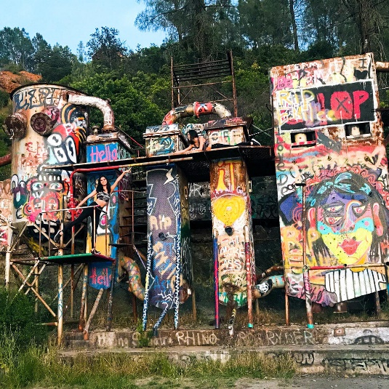

6:00 PM Poso Saloon (BBQ dinner + dancing)
https://www.facebook.com/pozosaloon1/
Pozo Saloon, 90 W Pozo Rd, Santa Margarita, CA 93453
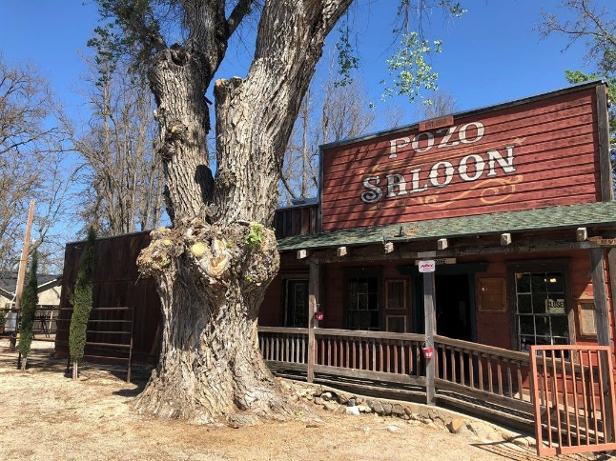

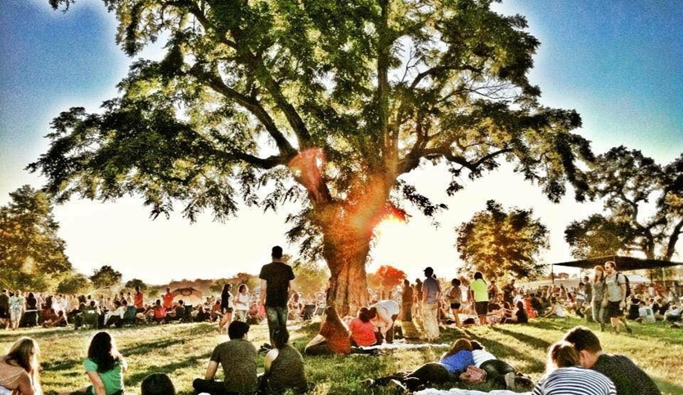

TO REGISTER FOR THIS FIELD TRIP

Dr. Gregg Wilkerson
yosoygeologo@gmail.com
661-218-7694

