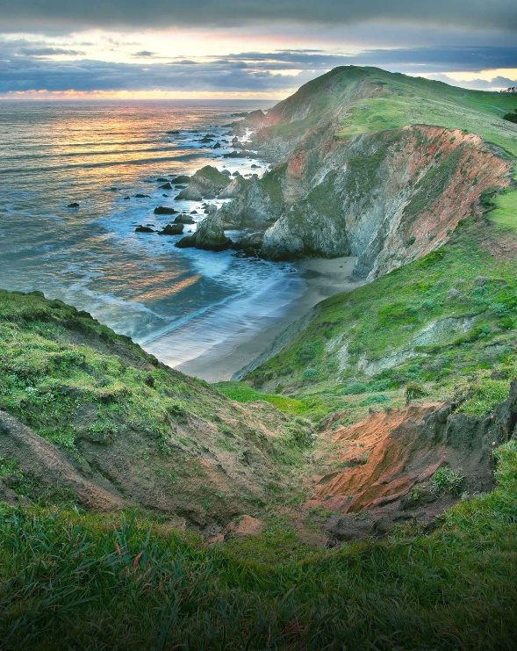
GEOLOGIC FIELD TRIP
POINT REYES NATIONAL SEASHORE
AUGUST 10, 2019

Dr. Gregg Wilkerson
yosoygeologo@bak.rr.com
FOR CSUB GEOLOGY CLUB

8:00 am City Park, Novato, California
8:30 am Novato quarry; Novato Quarry terrane; broken formation
9:30 am Classic "knocker" topography typical of Franciscan melange.
10:30 am Pillow Basalts, Nicassio Reservoir terrane, Black Mountain
11:30 am Point Reyes visitor center; San Andreas Fault. Earthquake Trail and Mount Wittenberg
2:00 pm Kehoe Beach; granitic basement and overlying transgressive marine sequence.
3:30 pm Drakes Beach; diatomaceous mudstone, upper Miocene/Pliocene Purisima Formation.
4:30 pm (optional) Point Reyes lighthouse; Paleocene/Eocene turbidites; submarine channel
5:30 pm Oil Seeps
6:30 pm Hot Springs
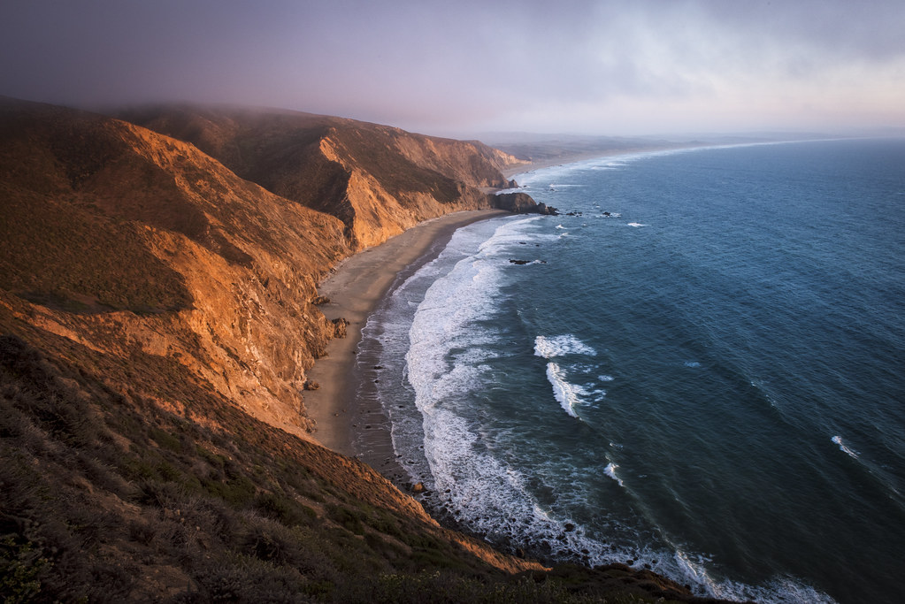
WHAT WILL I SEE?
-Unique geologic formations
-San Andreas Fault
-Point Reyes Lighthouse
-Spectacular beaches, flora and fauna and photographic vistas

WHAT IS REQUIRED?
-Positive attitude for learning and adventure
-Dependable transportation
-Experienced safe driver
-Food, Water
-Boots, Long-leg pants, hat sunscreen, sunglasses

REFERENCES
http://www.ncgeolsoc.org/past-field-trips/geology-of-the-point-reyes-area/

