PHYSICAL GEOLOGY LAB
10B DESERTS
Dr. Gregg Wilkerson and Michael Oldershaw

QUIZ

White Sands National Monument

Go to http://www.greggwilkerson.com/quiz-for-deserts.html

Download

A-Generalized Dune Map for White Sands National Monument
B-Geologic Brochure for White Sands National Monument
C-Geologic Map of White Sands National Monument and Surrounding Area
D-Geologic Map of White Sands National Monument with location of the Heart of the Sands viewing area
E-Geologic Report for White Sands National Monument

Watch the video at

https://youtu.be/FXu4NssqvGQ

Read the Brochure “B-Geologic Brochure for White Sands National Monument”

Scan through the Geologic Report
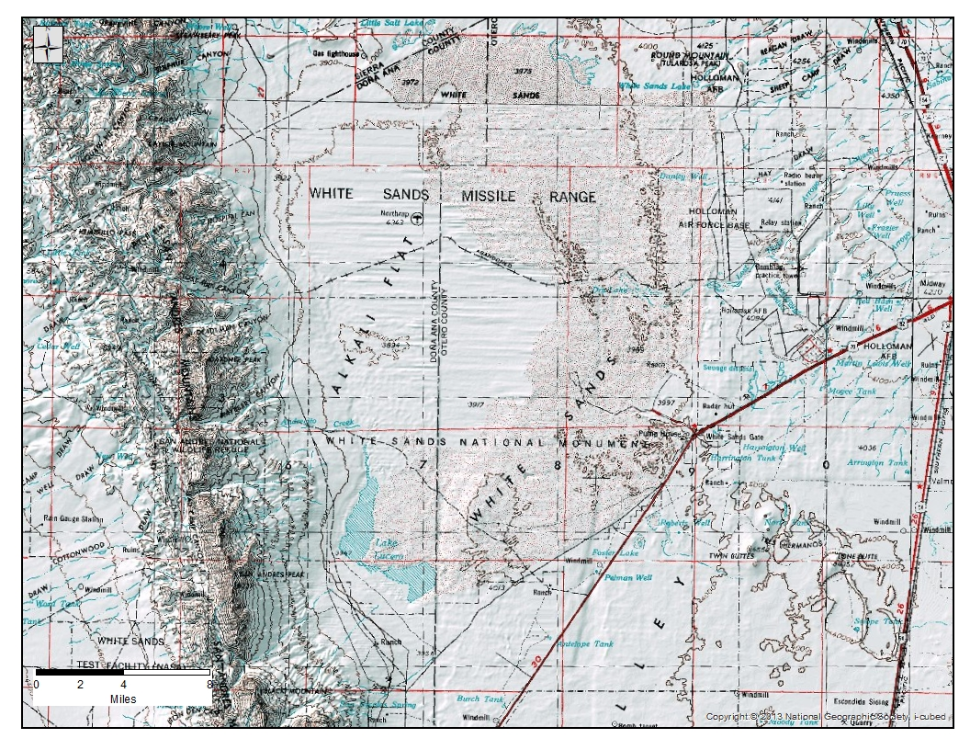
Figure 1. Topographic map of White Sands National Monument.
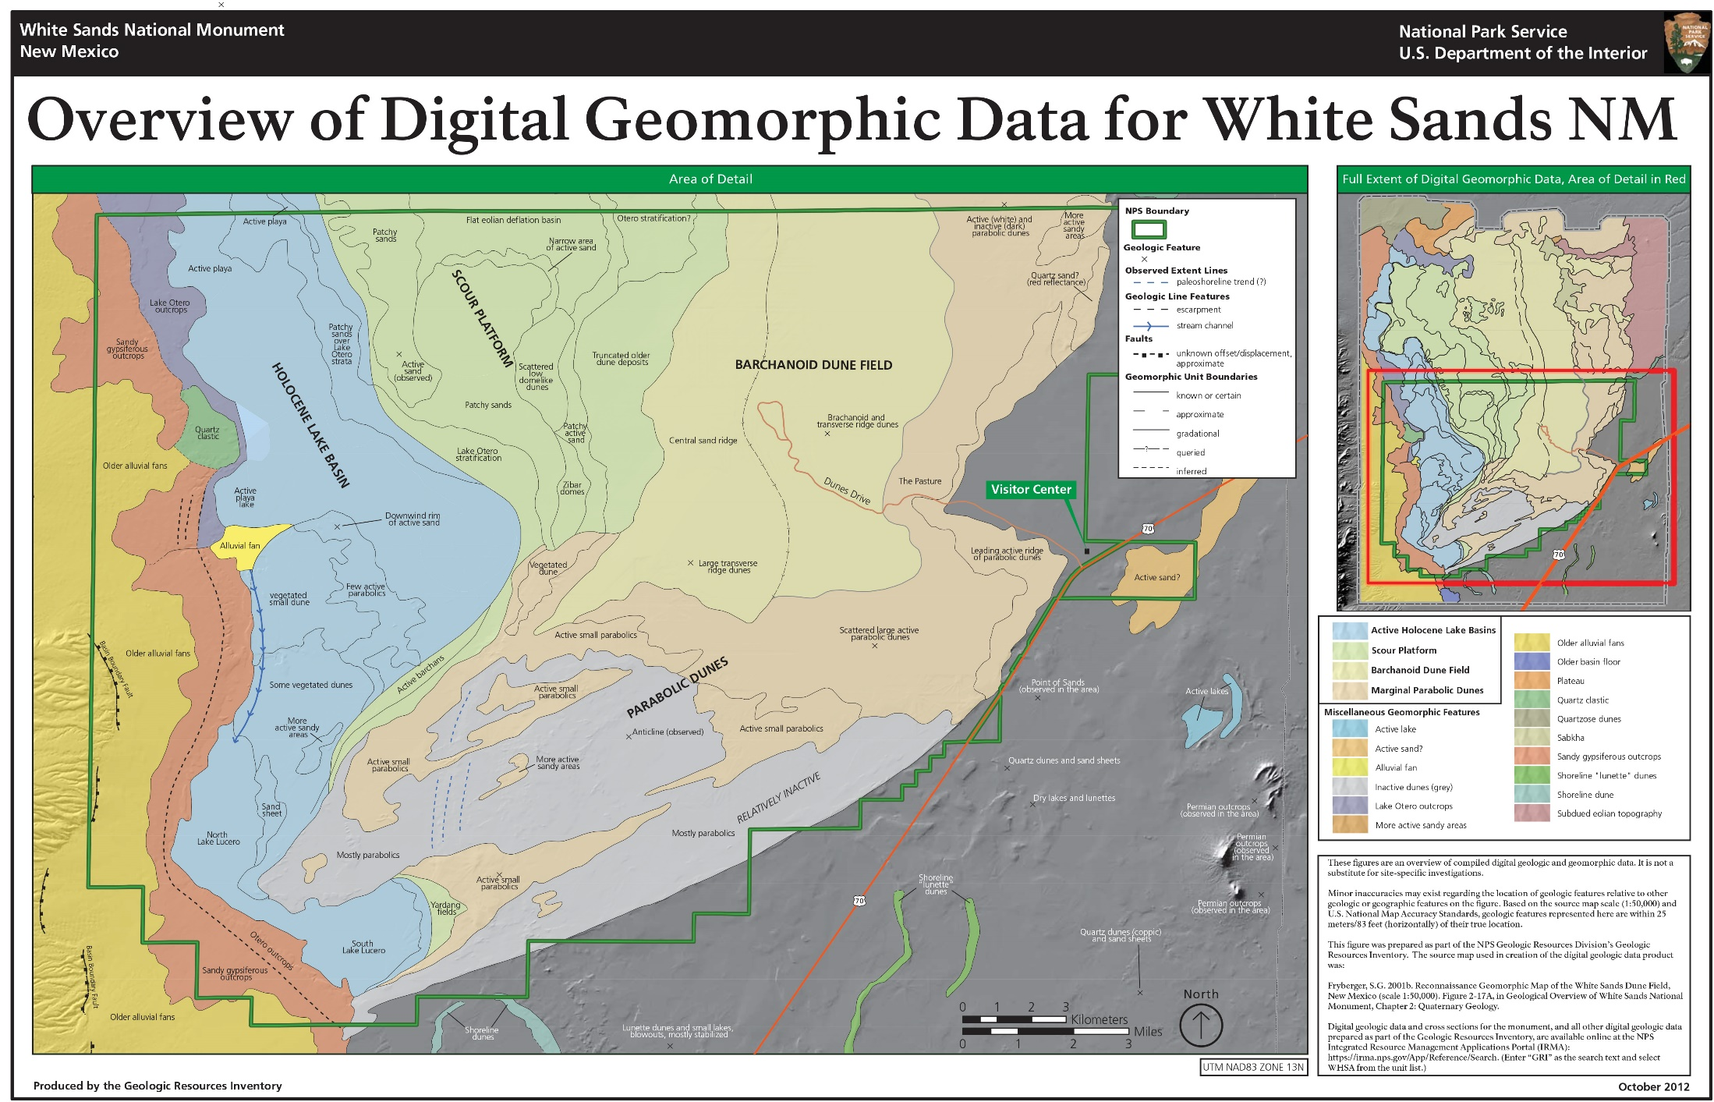
Figure 2. White Sands overview map
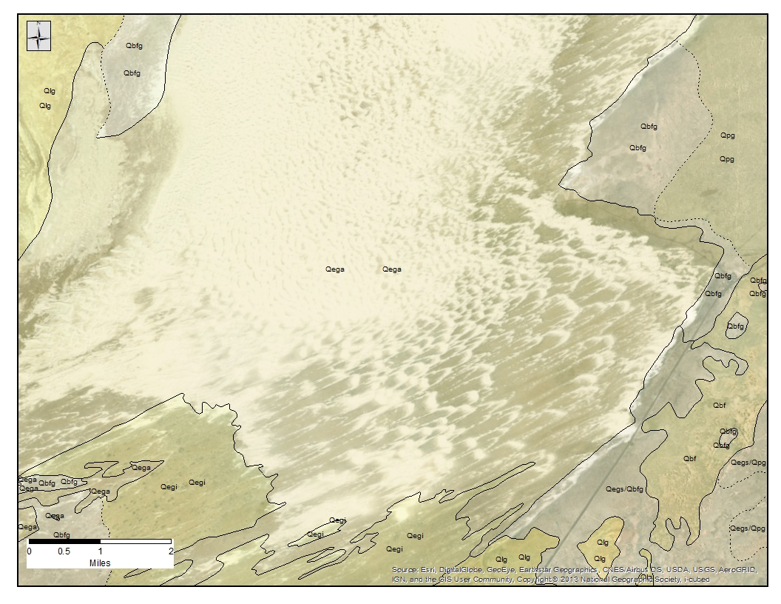
Figure 3. Geologic map of White Sands National Monument dune field.
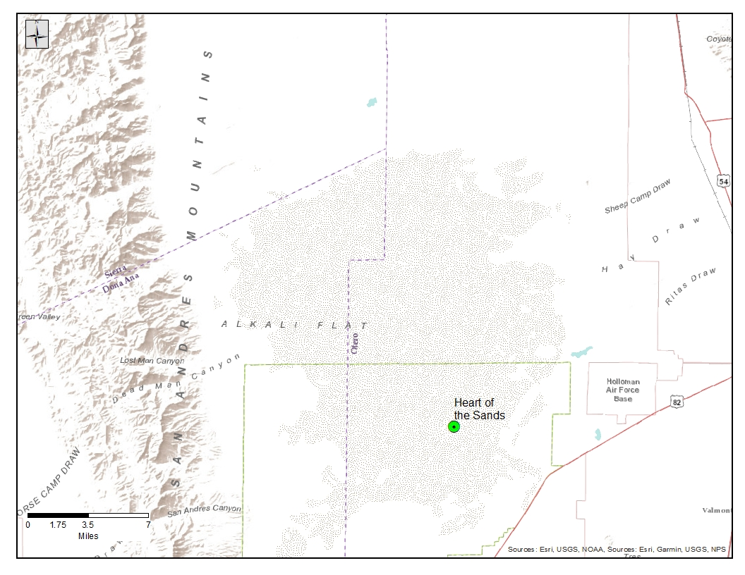
Figure 4 Shaded relief map of White Sands National Monument.
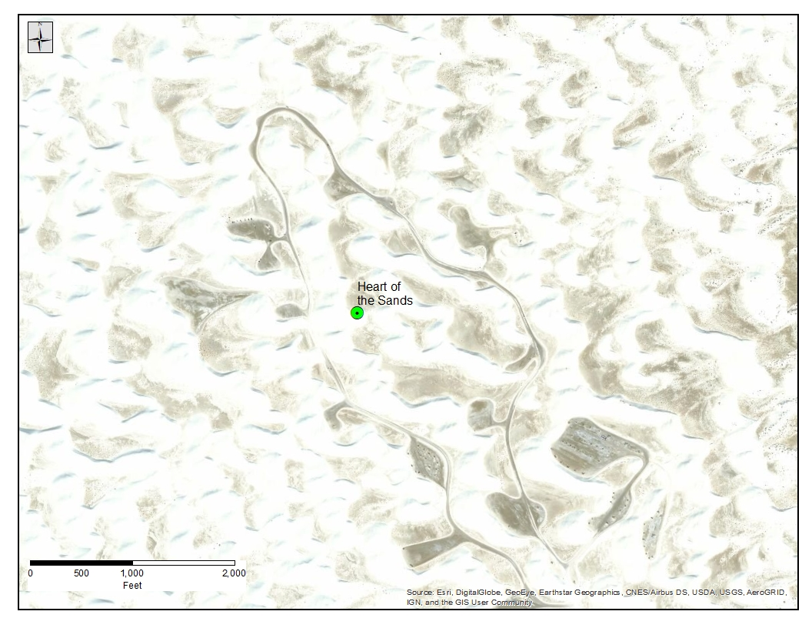
Figure 5. Aerial photo of Heart of the Sands viewing area.
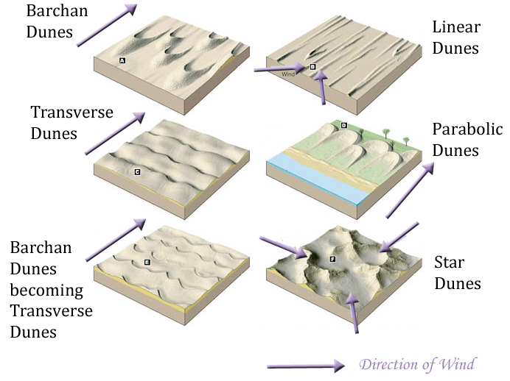
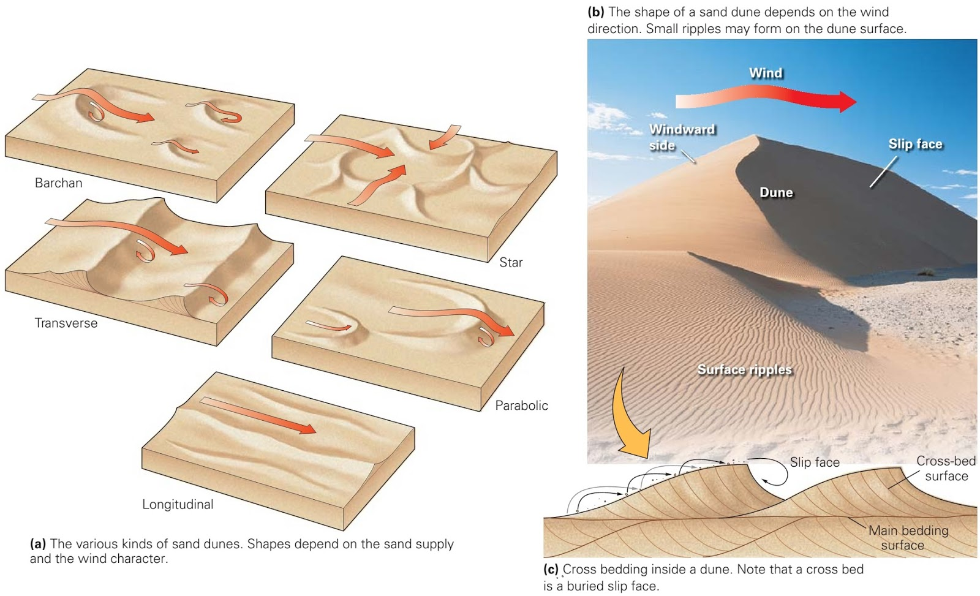
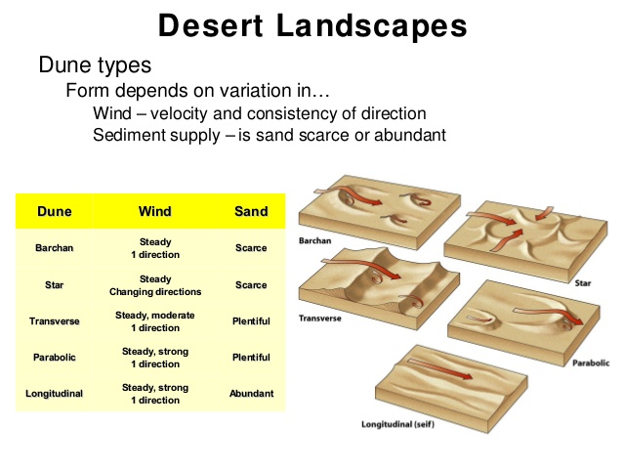
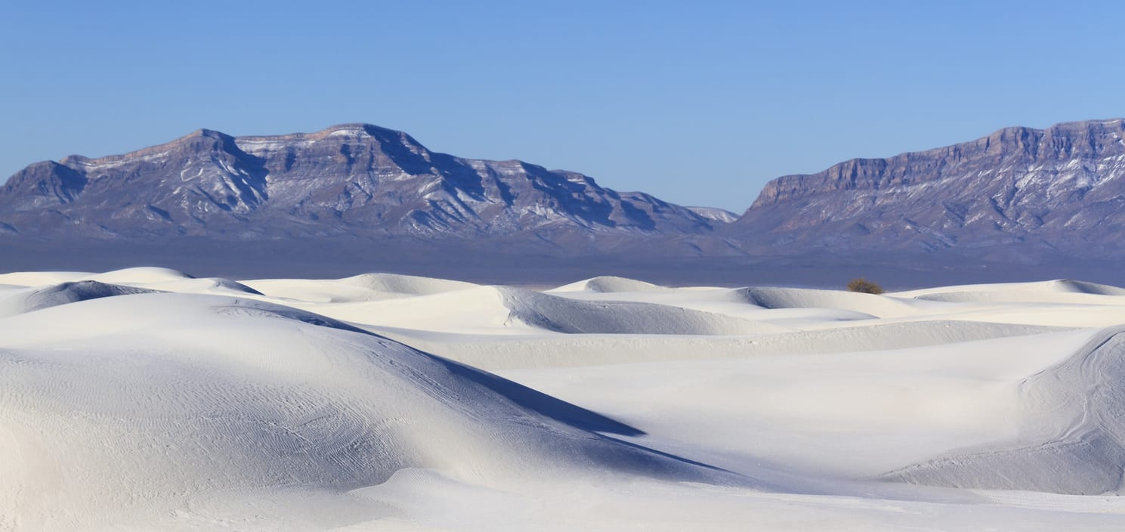
Figure 6. White Sand dunes with San Andreas Mountains in background.
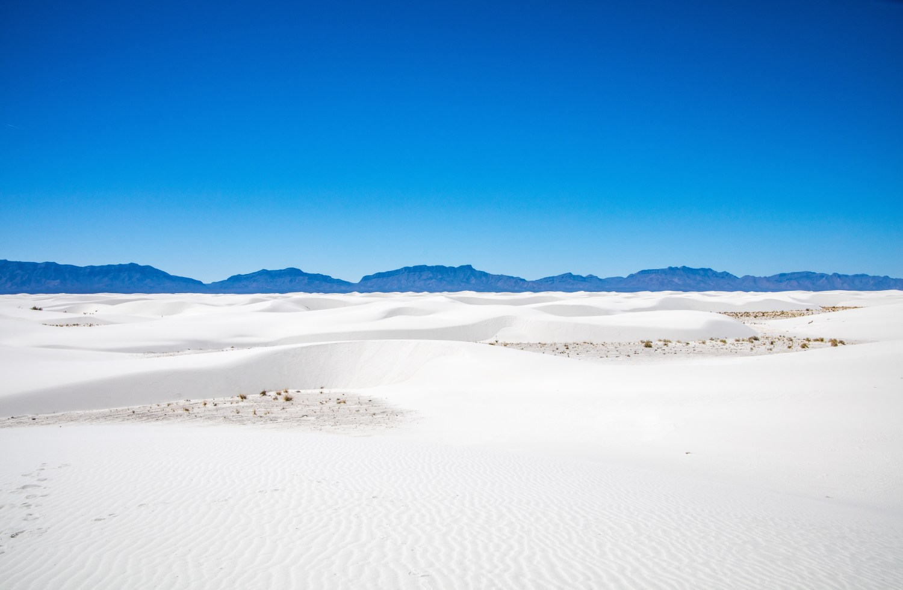
Figure 7. White Sands dunes looking west toward the San Andreas mountains.
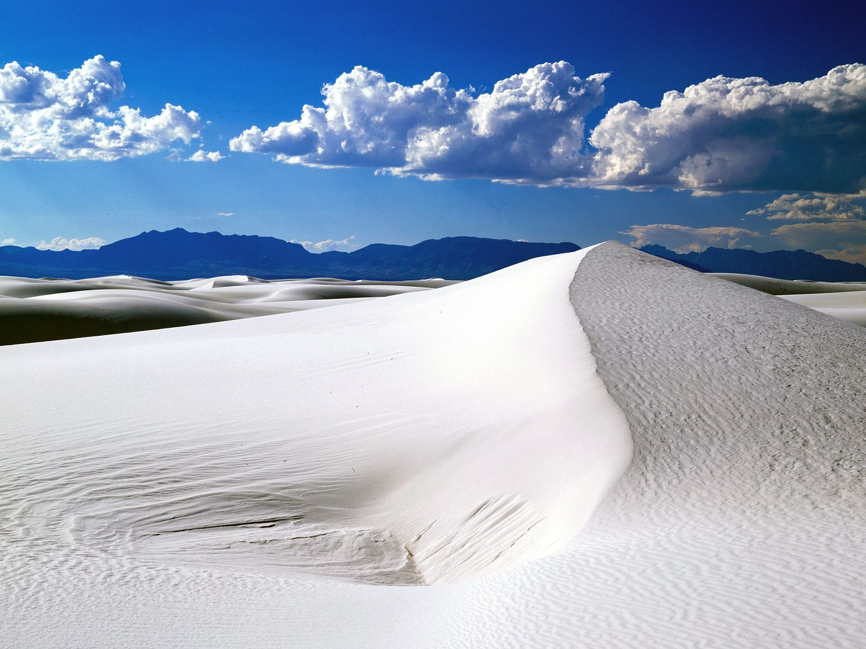
Figure 8. Sand Dune.
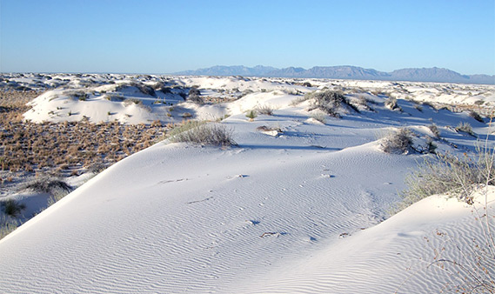
Figure 9. Partly stabilized sand dunes.
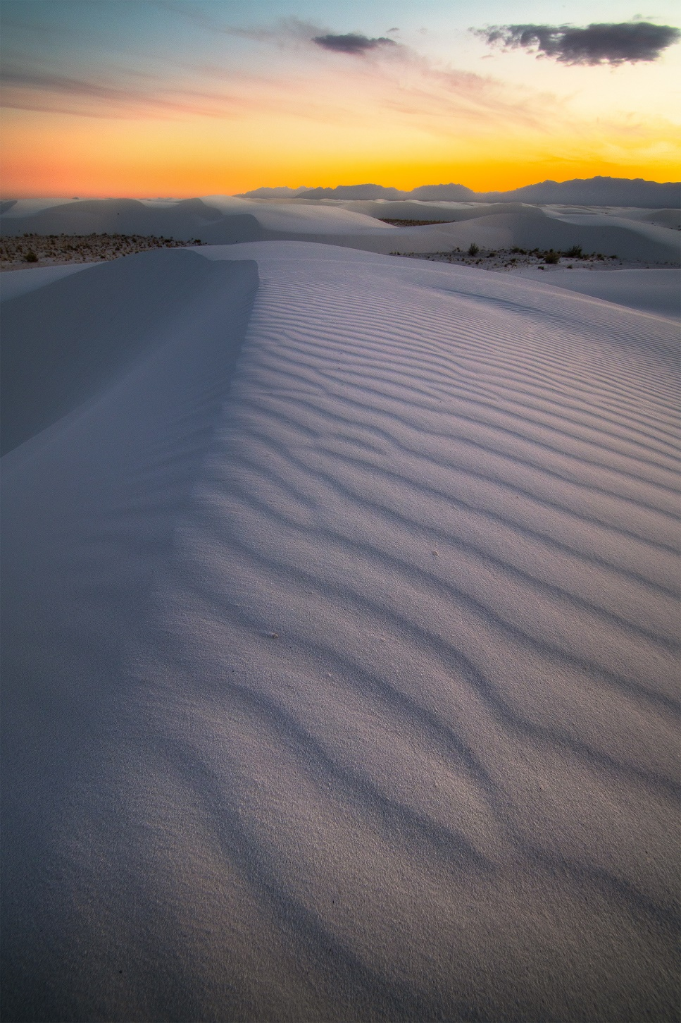
Figure 10. Sand dunes at sunset.
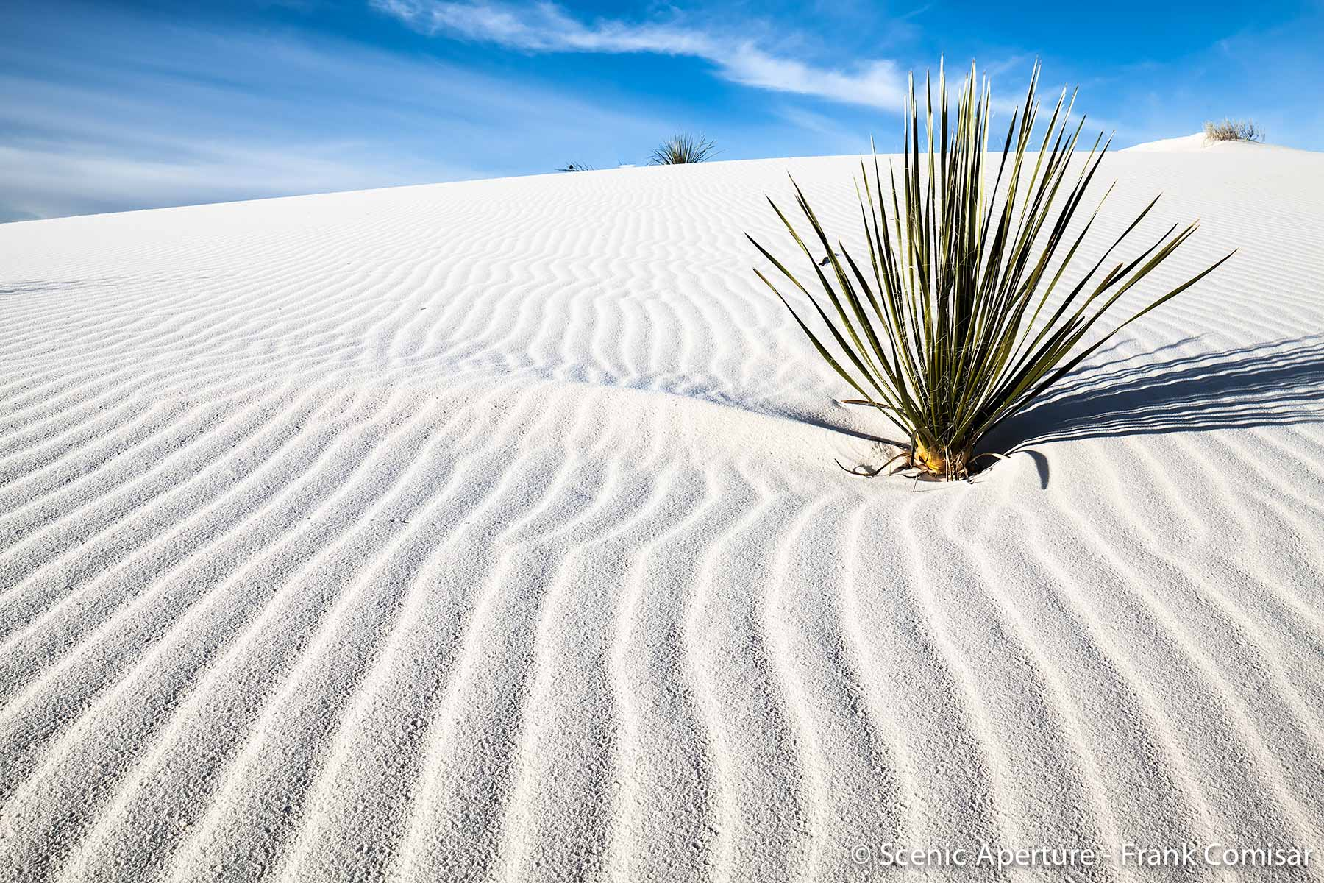
Figure 11. Sand dune with lone yucca plant.
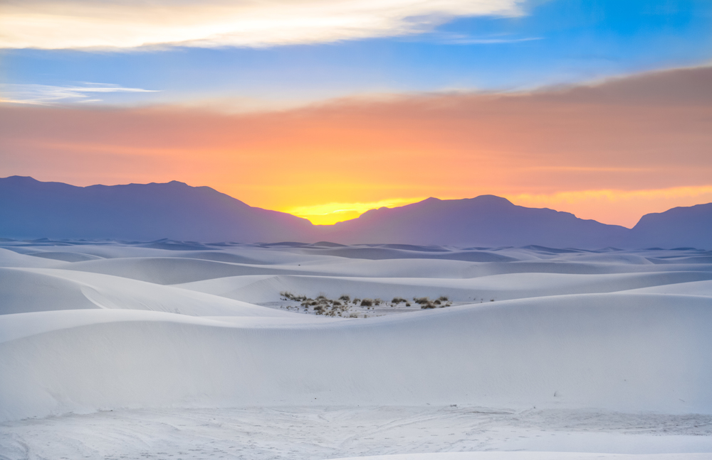
Figure 12. Sand dune face at sunset.
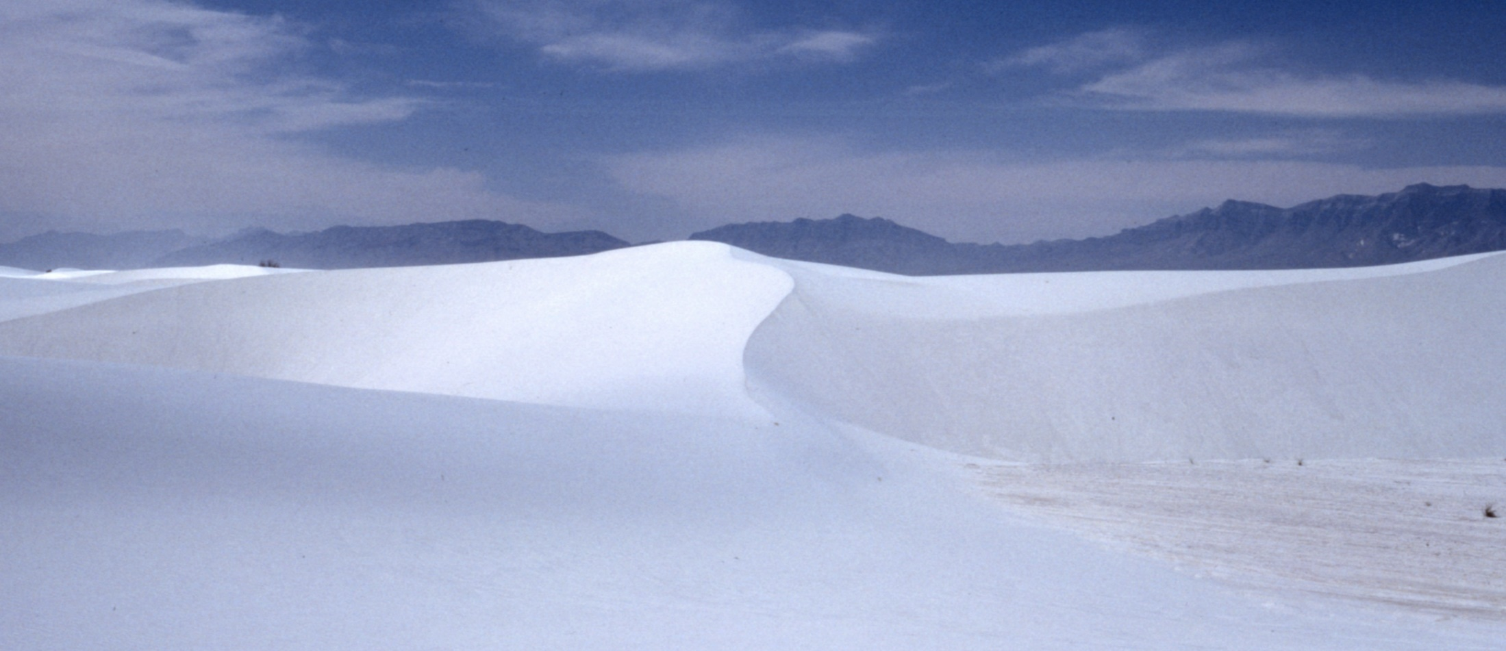
Figure 13. Bilateral sand dune.
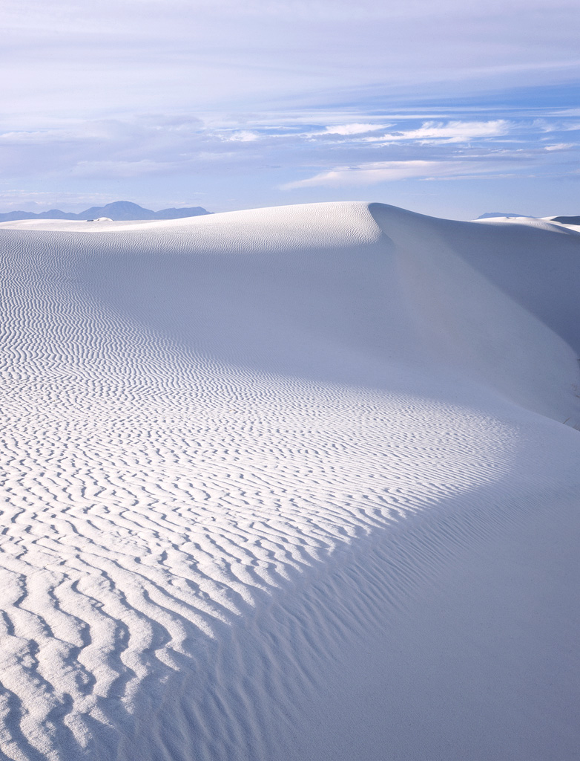
Figure 14. Sand dune with steep windward face.
QUESTIONS

1-How did the dunes form at White Sands National Monument?
PUT YOUR ANSWER
HERE

2-Why are the dunes white?
PUT YOUR ANSWER
HERE

3-Look at Figure 1. Print out Figure 1. Use the scale at the bottom of the map in figure 1 to estimate the east-west and north-south dimensions of the White Sands dune field. What are the dimensions?
PUT YOUR ANSWER
HERE

4-Look at Figure 2. List the varieties of sand dunes illustrated on this map
PUT YOUR ANSWER
HERE

5-Look at Figure 3. The geologic symbol for the dune field is Qega. Now open up the file for C-Geologic Map of White Sands National Monument and Surrounding Area. Zoom in and pan over to the legend on the right side of the map. Explain what the symbol Qega means
PUT YOUR ANSWER
HERE

6-Look at Figure 4. Why is Alkali Flat between the dunes and the mountains?
PUT YOUR ANSWER
HERE

7-Look at Figure 5. Print out Figure 5. Use the scale to determine the average size of the sand dunes. Your answer should be in feet.
PUT YOUR ANSWER
HERE

8-Look at Figure 6. Why are there no dunes on the mountains?
PUT YOUR ANSWER
HERE

9-Look at Figure 7. Explain where vegetation is located
PUT YOUR ANSWER
HERE

10-Look at Figure 8. Look at the left side of the sand dune. Is this part of the dune moving toward the camera or away from it?
PUT YOUR ANSWER
HERE

11-Look at the right side of Figure 8. It this part of the sand dune moving to the right or to the left?
PUT YOUR ANSWER
HERE

12-Look at Figure 9. What is stabilizing the dune field?
PUT YOUR ANSWER
HERE

13-Look at Figure 10. Which way is the dune moving? To the left or to the right?
PUT YOUR ANSWER
HERE

14-Look at Figure 11. Look at the diagrams of sand dune types between Figures 5 and 6, above. Is the sand in Figure 11 moving to the left or to the right? (Hint, which side of the sand ripples is steep and which is gradual?)
PUT YOUR ANSWER
HERE

15-Look at Figure 12. Is the sand dune in the foreground moving to the west or to the east (Hint, the photo is taken at sunset. Where does the sun set, in the west or in the east?).
PUT YOUR ANSWER
HERE

16-Look at Figure 13. Is the left part of this sand dune moving toward the camera or away from it?
PUT YOUR ANSWER
HERE

