PHYSICAL GEOLOGY LAB
10A GLACIERS
Dr. Gregg Wilkerson and Michael Oldershaw

QUIZ

Glaciers of Glacier National Park

Go to http://www.greggwilkerson.com/quiz-for-glaciers.html

Download

A-Geologic map of Glacier National Park
B-Map of moraines and glacial features of Glacier National Park
C-Geologic map of Glacier National Park showing location of Mount Jackson
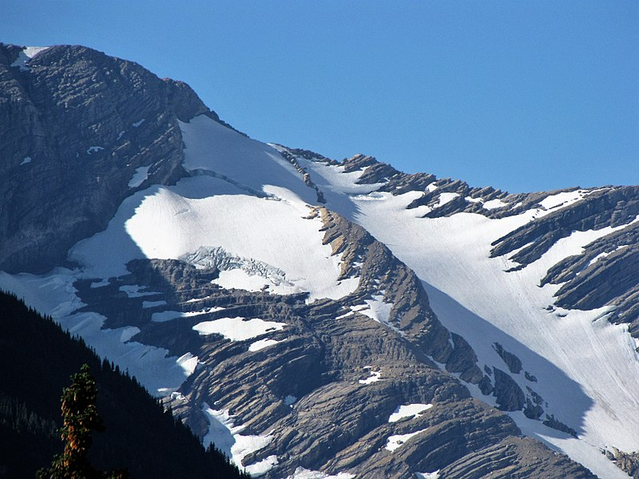
Figure 1. Remnant of Jackson Glacier
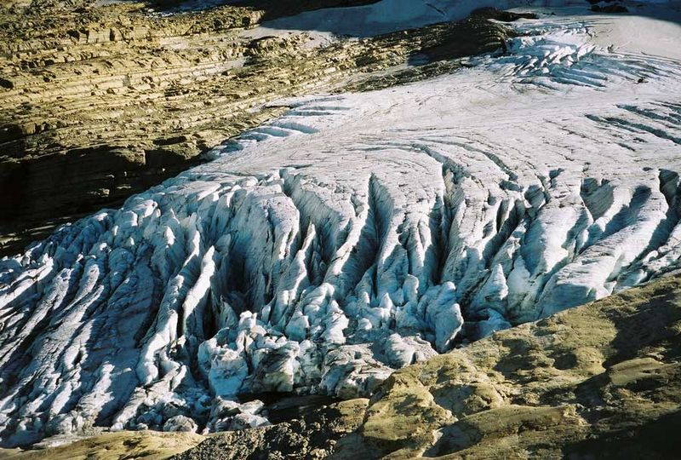
Figure 2. Crevasses on Jackson Glacier
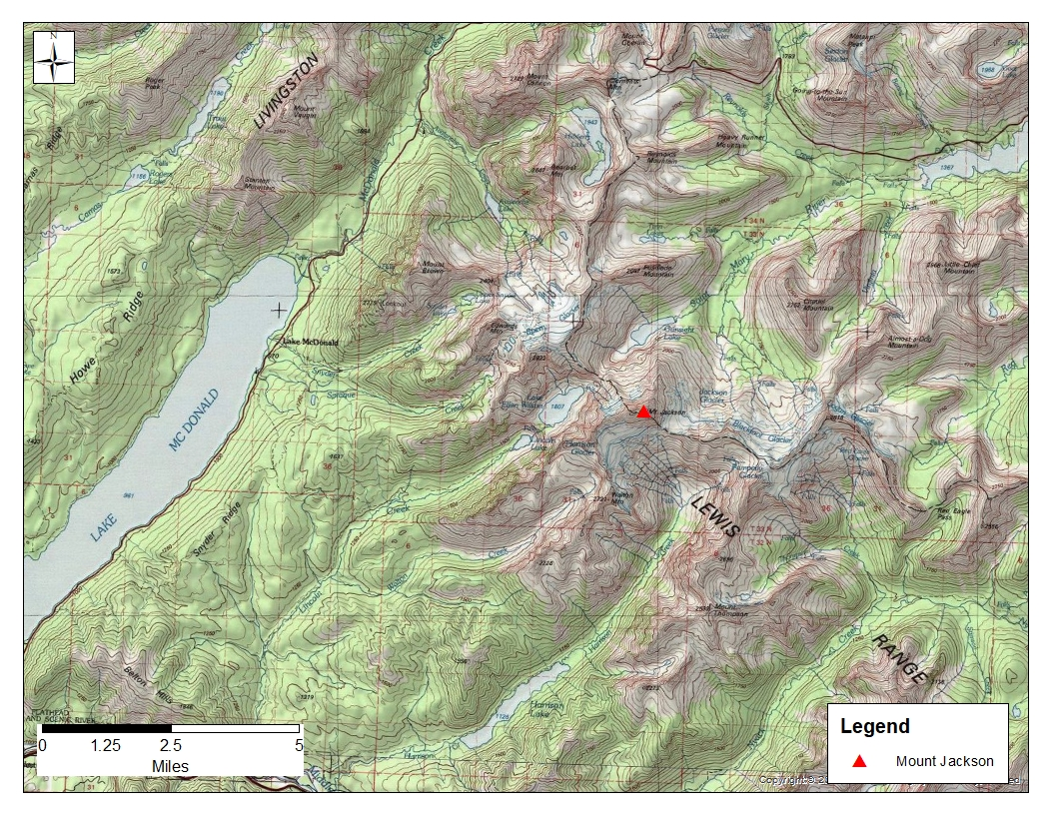
Figure 3. Mount Jackson and surrounding areas.
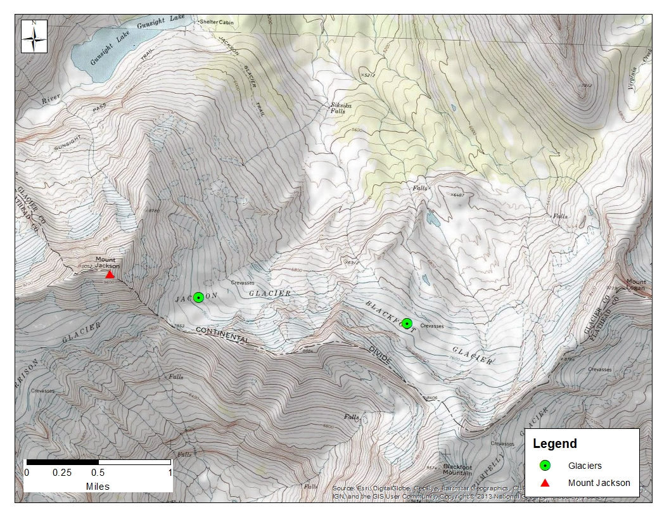
Figure 4. Topographic map of Jackson and Blackfoot glaciers
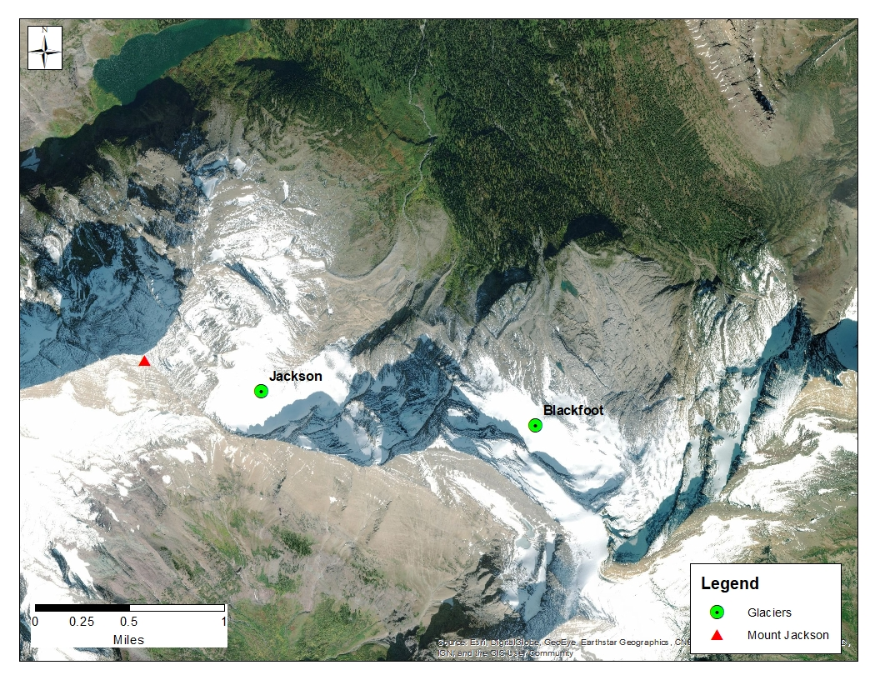
Figure 5. Aerial photograph of Jackson and Blackfoot glaciers illustrating glacial retreat (in blue shad)
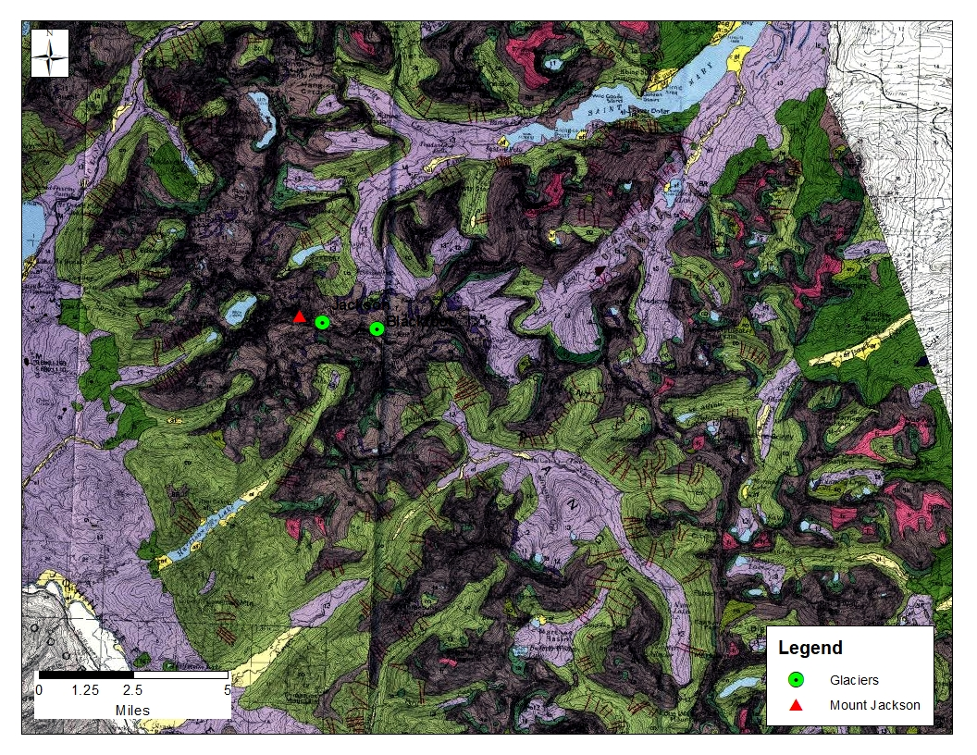
Figure 6. Geologic map of the Mount Jackson area.
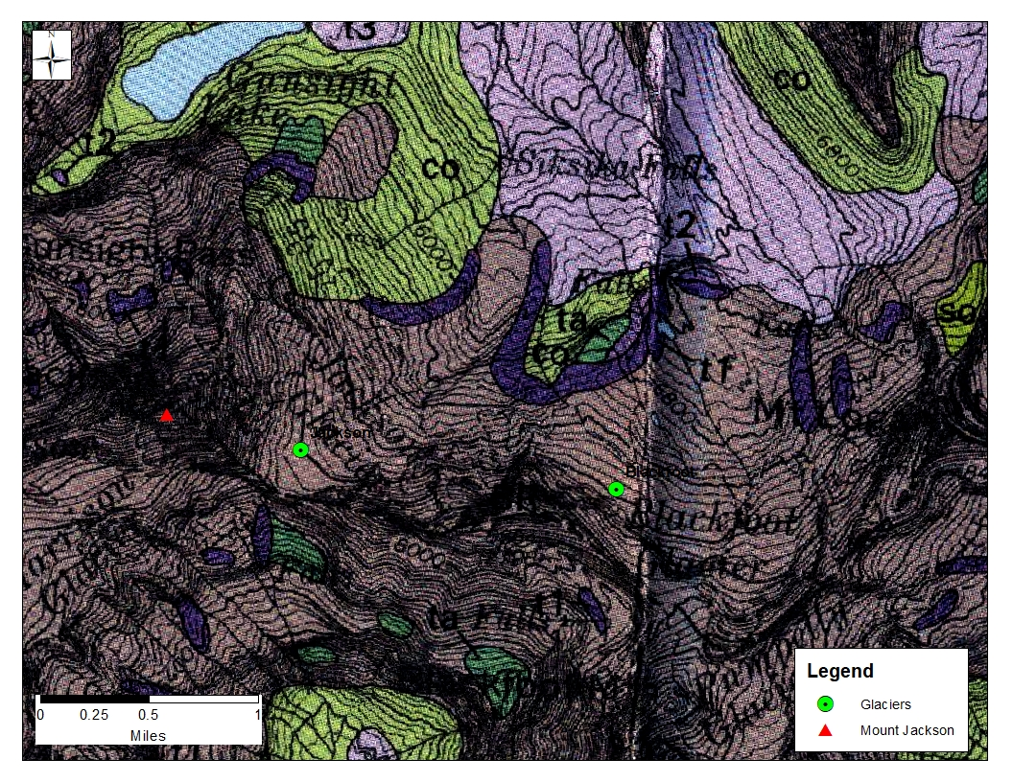
Figure 7. Geologic map of the Jackson and Blackfoot glaciers.
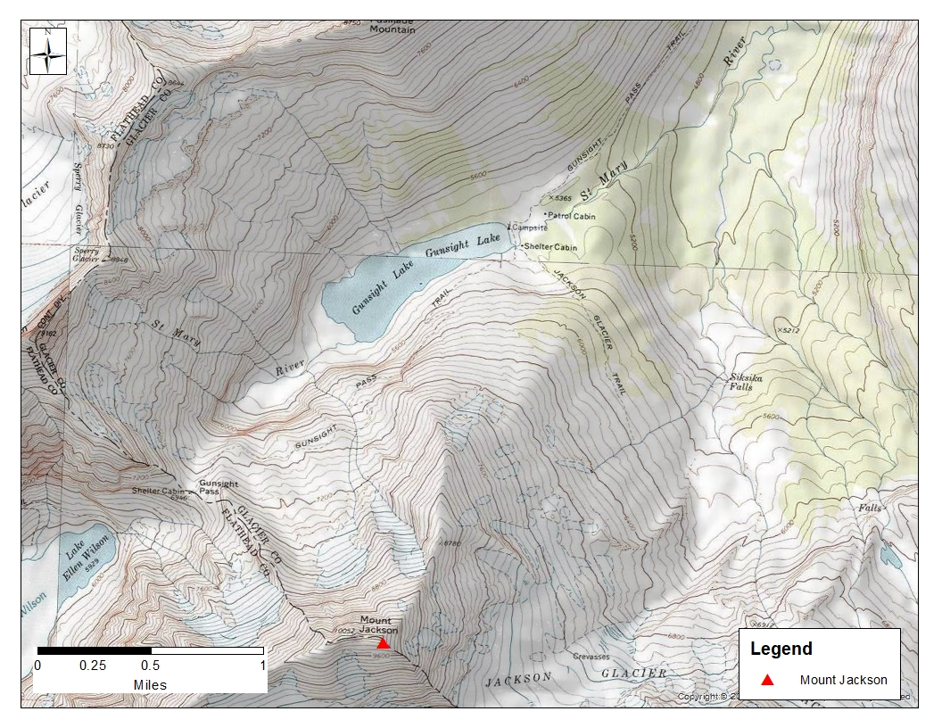
Figure 8. Topographic map of the Gunsight Lake area
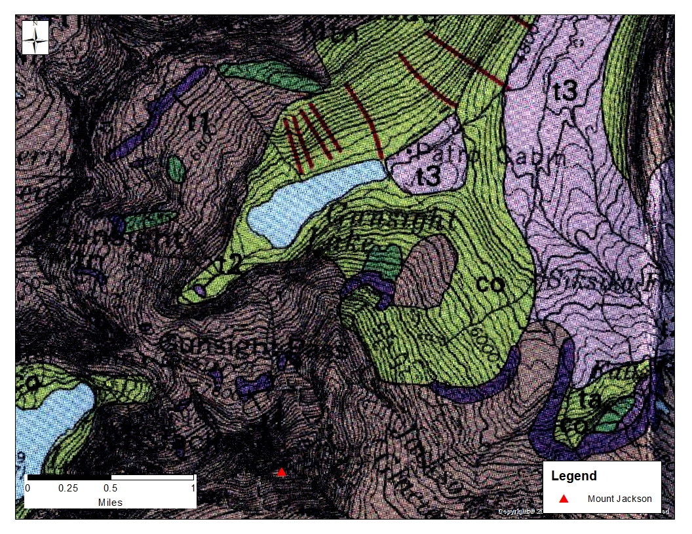
Figure 9. Geologic map of the Gunsight Lake Area
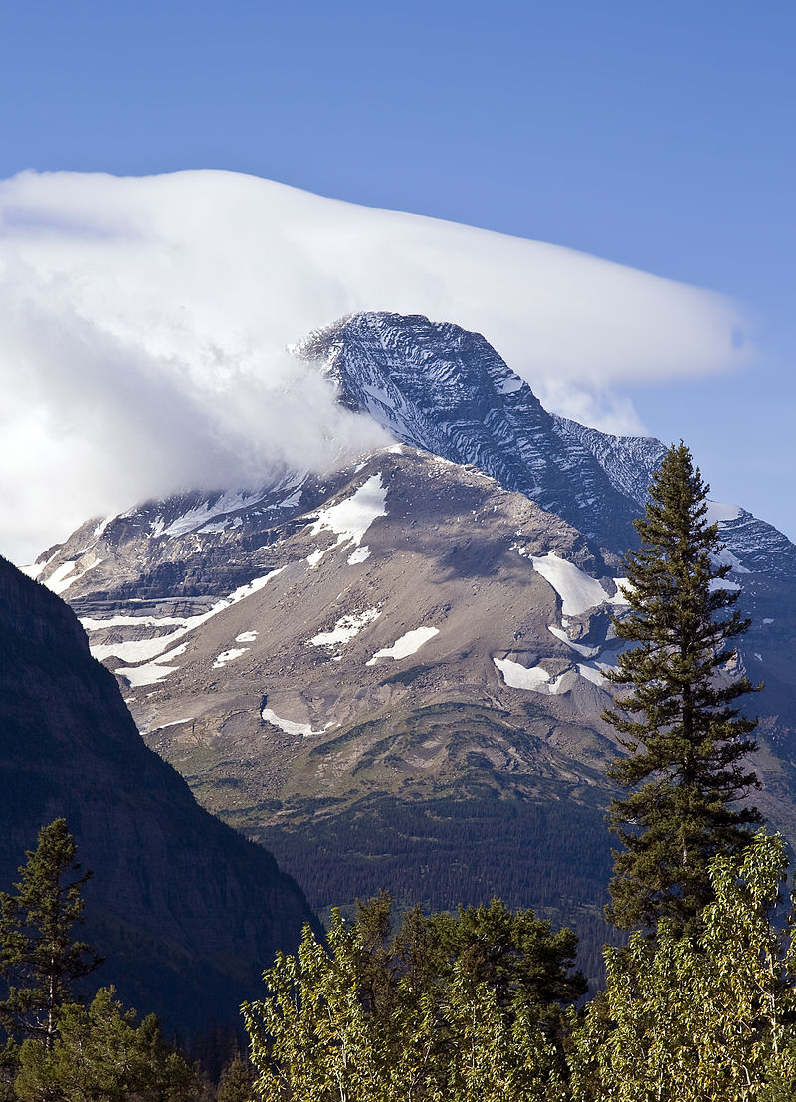
Figure 10. Mount Jackson
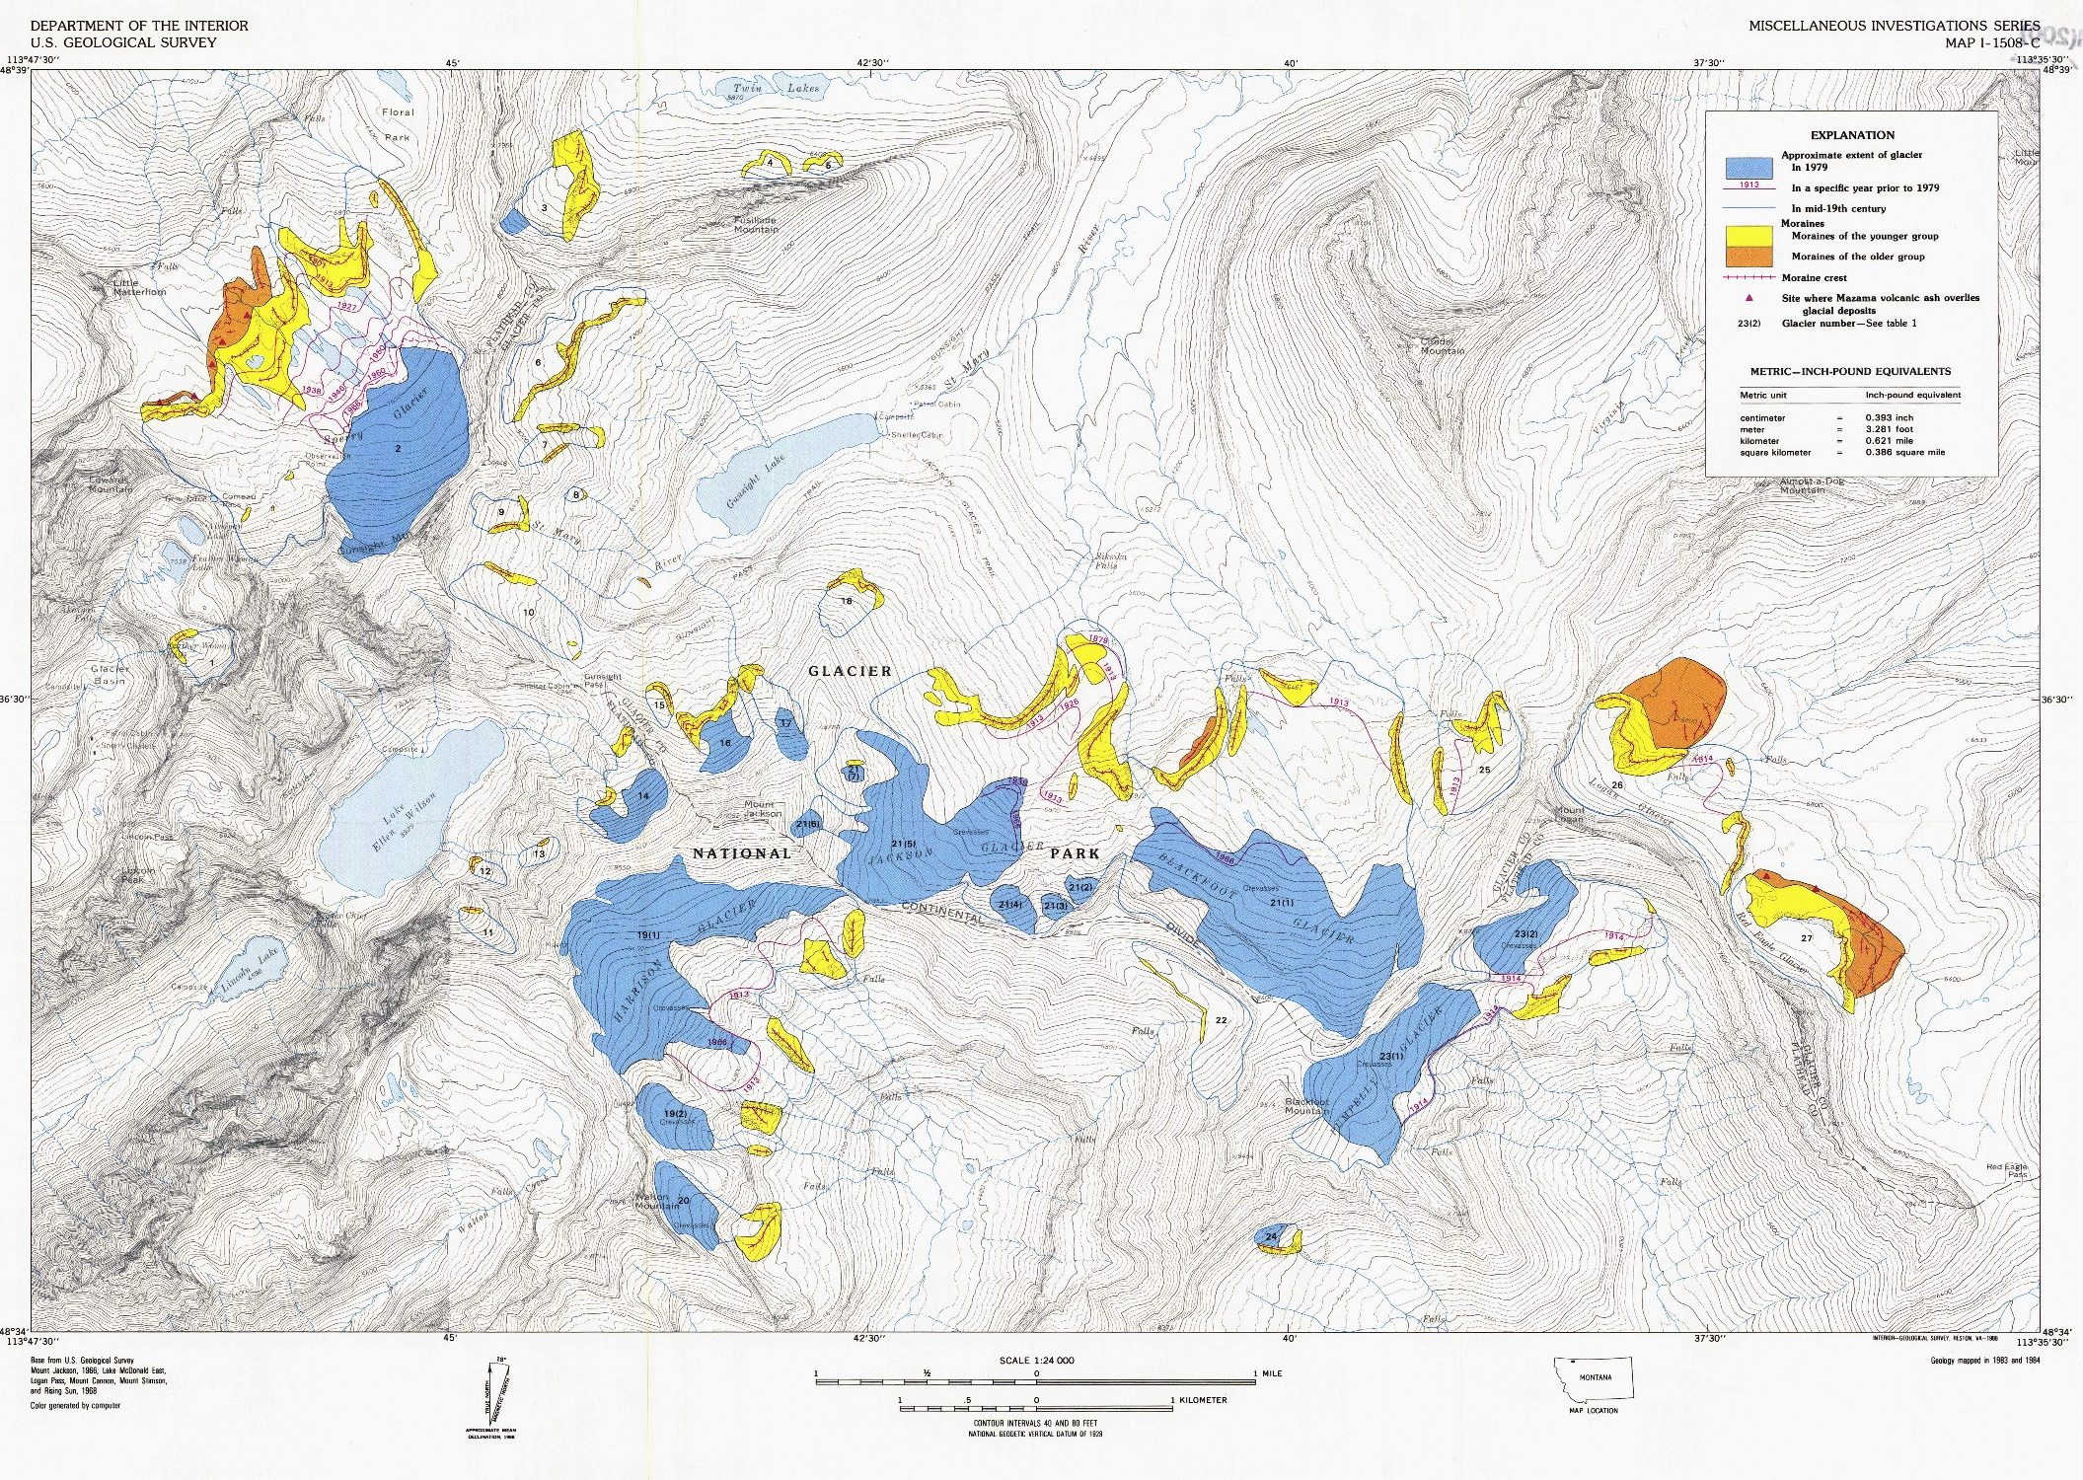
Figure 11. Map of glacial features for Glacier National Park.
View the then-and-now photographs of melting and retreating glaciers at
https://www.nps.gov/glac/learn/nature/melting-glaciers.htm
QUESTIONS
1-Use the Geologic map of Glacier National Park and figures #6 and #7 to complete this sentence:
Jackson and Blackfoot glaciers are resting atop the __________________ geologic formation
PUT YOUR ANSWER
HERE
2-Look at Figure 3. Which direction does water flow out of Lake McDonald?
PUT YOUR ANSWER
HERE
3-Look at Figure 3. Mount Jackson is situated on what important geographic feature?
PUT YOUR ANSWER
HERE
4-Look at Figures 3 and 10. What is the name of the glacial landform for Mount Jackson?
PUT YOUR ANSWER
HERE
5-Look at Figure 4. What direction do the Jackson and Blackfoot glaciers flow?
PUT YOUR ANSWER
HERE
6-Look at Figure 4. Precipitation landing on the Jackson and Blackfoot will eventually flow to the _______________________
PUT YOUR ANSWER
HERE
7-Use the Geologic map of Glacier National Park and figures #6, #7 and #9 to complete this sentence:
“The green areas are labeled ______________ and represent _______________”
“The purple areas are labeled ________________ and represent _________________”
“The brown areas are labeled ______________ and represent___________________”
PUT YOUR ANSWERS IN THE BLANK SPACES, ABOVE
8-Look at Figures #8 and #9. At the “Campsites” and “Shelter Cabin” in Figure 8 there is a natural dam that ponds water behind it to form Gunsight Lake. What is the name of this glacial feature?
PUT YOUR ANSWER
HERE
9-Look at Figure #9. Find the narrow red lines. Using the legend in the Geologic map of Glacier National Park, identify what these red lines represent.
PUT YOUR ANSWER
HERE
10-Look at the map B-Map of moraines and glacial features of Glacier National Park. Zoom in and pan to “Harrison Glacier.” The blue areas of this map show the extent of glaciers in 1979. To the southeast and under Harrison Glacier is a red line with the number 1913. This line represents the southeastern extent of Harrison Glacier in 1913. Now go to the bottom of the map and answer this question
What is the contour interval for this map?
PUT YOUR ANSWER
HERE
11-Estimate the average contour for the southeastern edge of Harrison Glacier in 1913. Write that elevation
HERE
12-Estimate the average contour for the southeastern edge of Harrison Glacier in 1970. Write that elevation
HERE
13-Calculate the estimated average change in elevation of the lower southeastern edge of Harrison Glacier between 1913 and 1979
PUT YOUR ANSWER
HERE
14- Print out Figure 11 on page 12. Using the scale bar at the bottom of the map on page 12, measure the average distance of the retreat of Sperry Glacier from 1901 to 1979.
PUT YOUR ANSWER
HERE

